Programming Fundamentals and Unit Testing

Regular Exam – 5 November 2023

3. Unit Test Method: Characters Range
Test a given method which takes in two characters and finds all characters between the two.

Examples
Input | Output
a  d | b c
#  : | $ % & ' ( ) * + , - . / 0 1 2 3 4 5 6 7 8 9
C  # | $ % & ' ( ) * + , - . / 0 1 2 3 4 5 6 7 8 9 : ; < = > ? @ A B
A  B | No output
B  A | No output
B  A | No output
A  C | B
D  G | E F
X  Z | Y

The method is found in the CharacterRange.cs file:
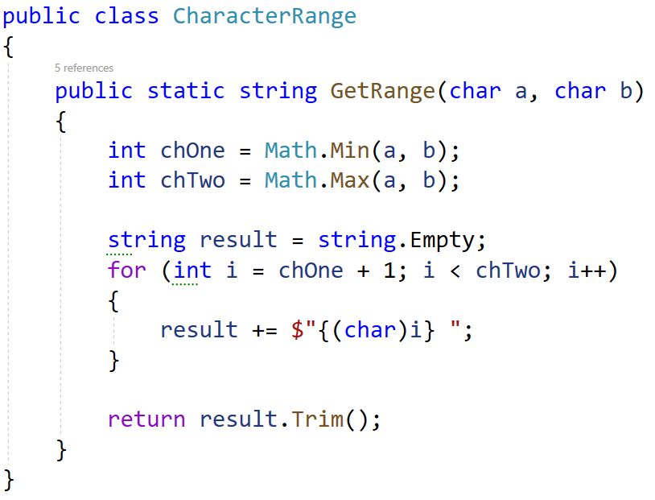
You are given a test file CharacterRangeTests.cs containing 5 empty tests. Implement all the unit tests:
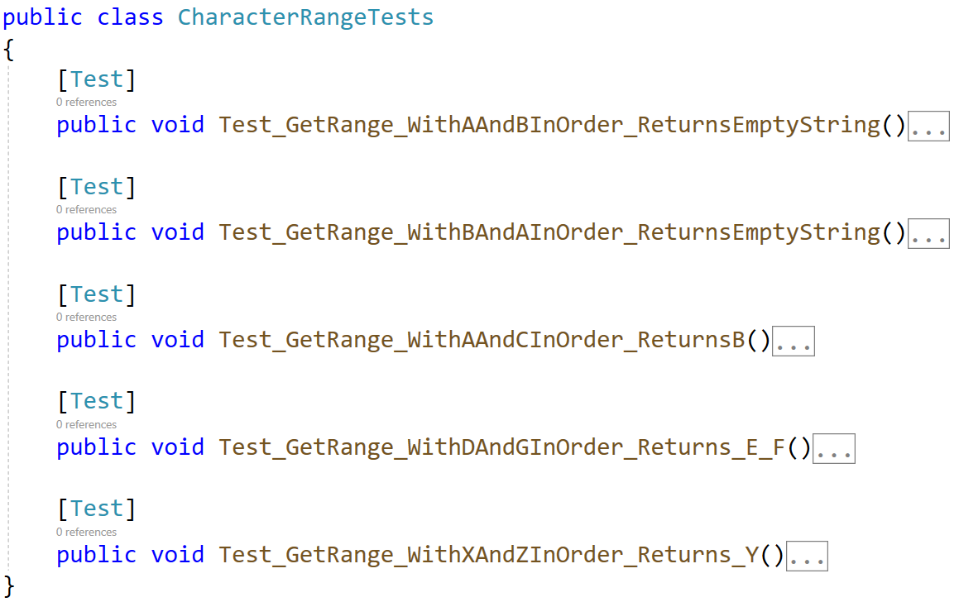
When you are ready make sure your tests run:
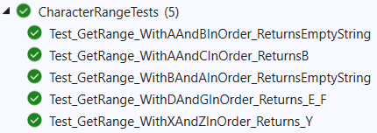
IMPORTANT: DO NOT REMOVE OR CHANGE ANY NAMESPACES AND USINGS.

