Programming Fundamentals and Unit Testing

Regular Exam – 5 November 2023

4. Unit Test Array: Balanced Brackets
Test a given method which takes in multiple amounts of string and finds if the amount of opening brackets are the same as the closing brackets. Method returns true if the brackets are balanced (opening brackets are the same as the closing brackets), otherwise returns false.

Examples
Input | Result |  | Input | Result
{"(", ")","(",")"} | true |  | {")","(", ")"} | false

Input | Result |  | Input | Result
{} | true |  | {"(", ")"} | true

Input | Result |  | Input | Result
{"(", ")", "(", ")", ")"} | false |  | {")", "("} | false

The method is found in the BalancedBrackets.cs file:
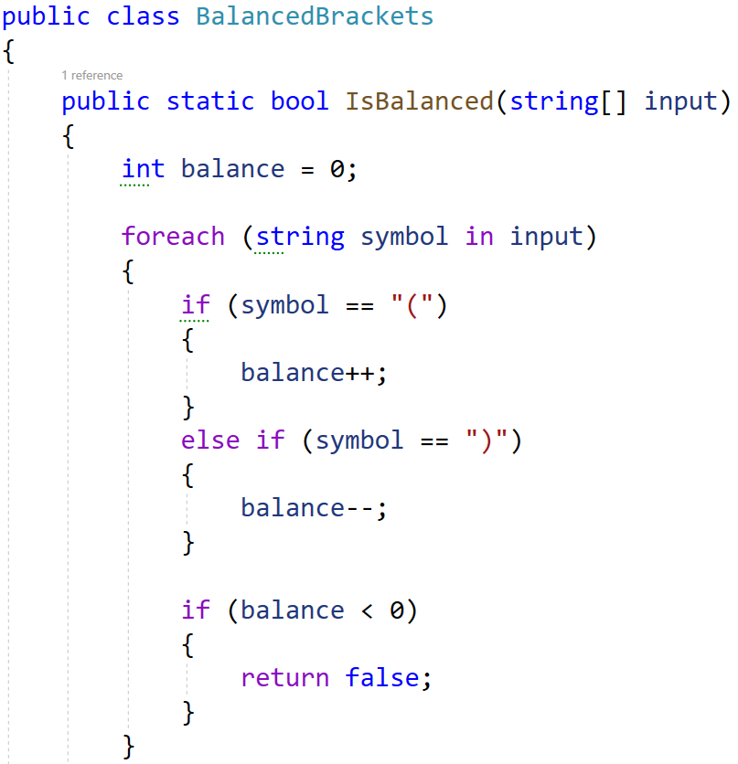
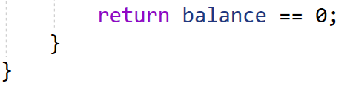
You are given a test file BalancedBracketsTests.cs containing 5 empty tests. Implement all the unit tests:
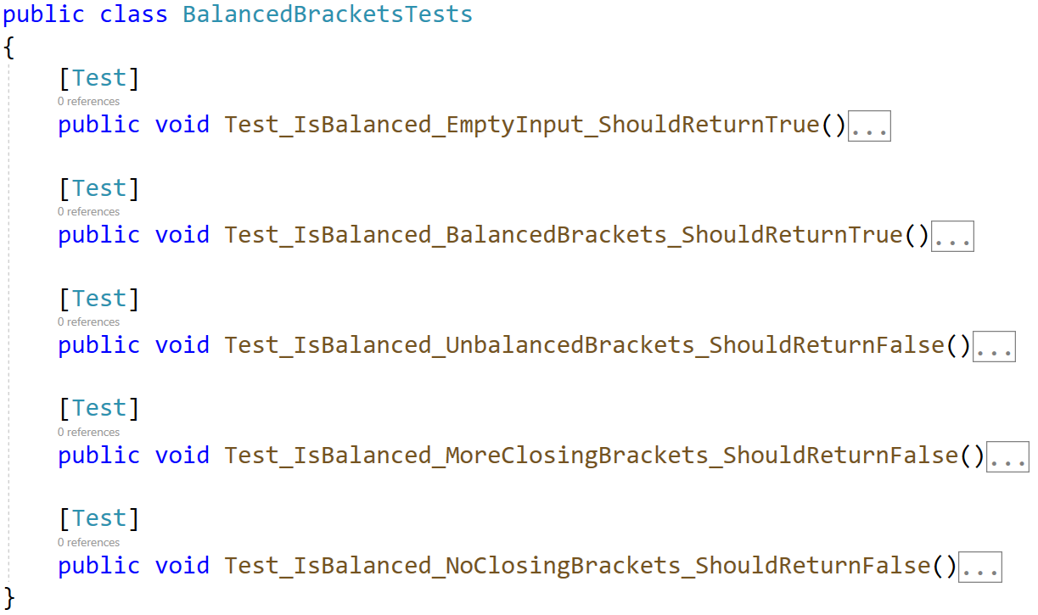
When you are ready make sure your tests run:
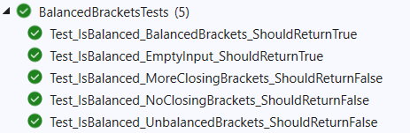
IMPORTANT: DO NOT REMOVE OR CHANGE ANY NAMESPACES AND USINGS.

