Programming Fundamentals and Unit Testing

Retake Exam – 20 December 2023

3. Unit Test Method: Password Validator
Test a given method which takes in a string and finds if given string matches a valid password based on some rules.

Examples
Input | Output
Pass123 | Password is valid
Short | Password must be between 6 and 10 characters
Inv@Pass | Password must consist only of letters and digits
NoDigits | Password must have at least 2 digits
ValPass123 | Password is valid

The method is found in the PasswordValidator.cs file:
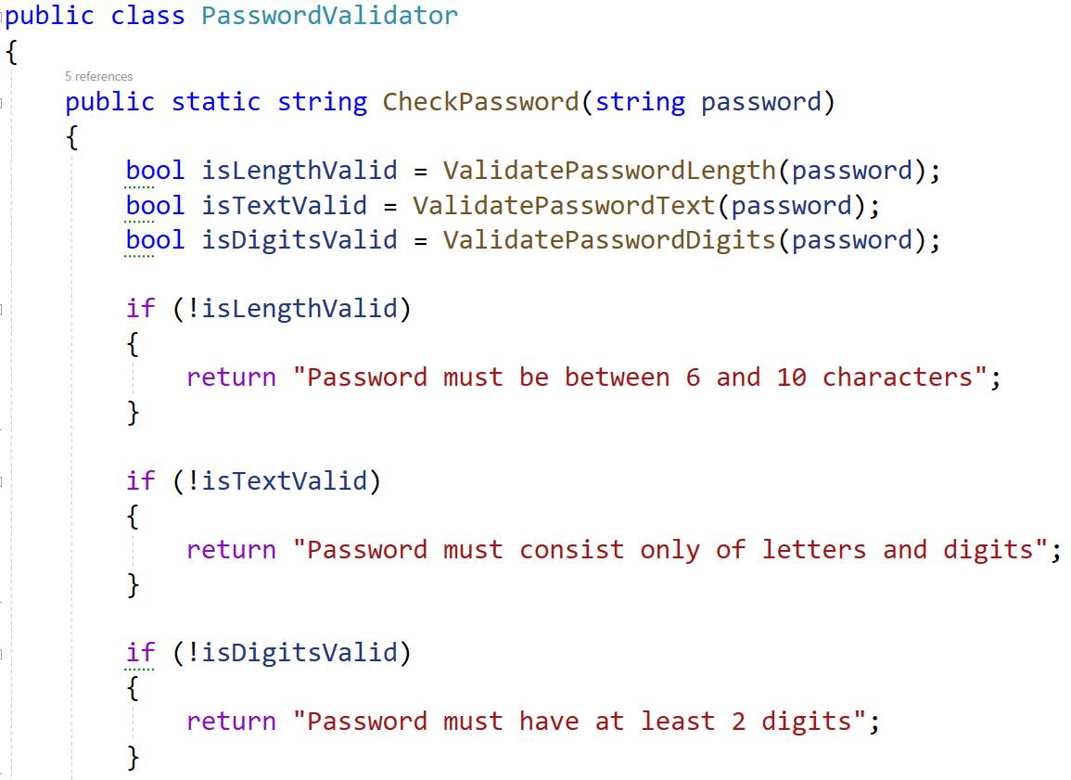
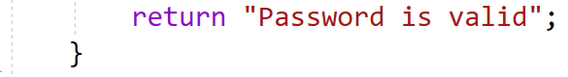
The other methods are helper methods to validate the password:
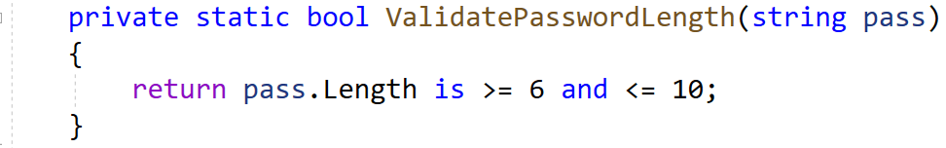
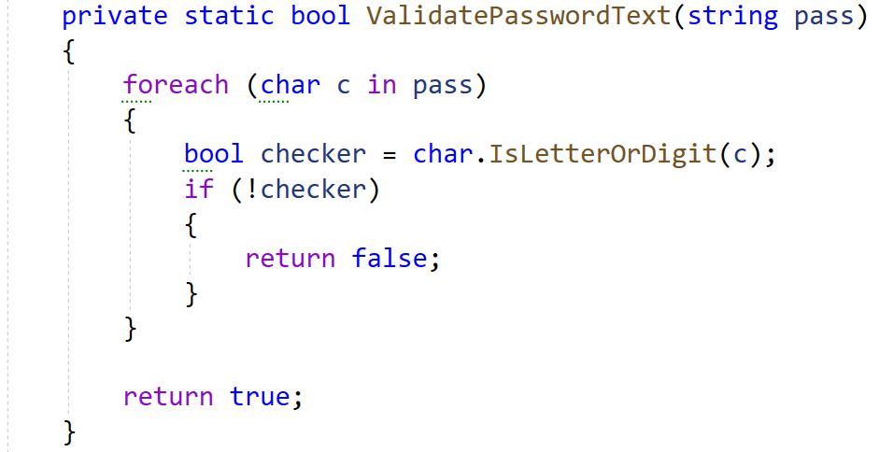
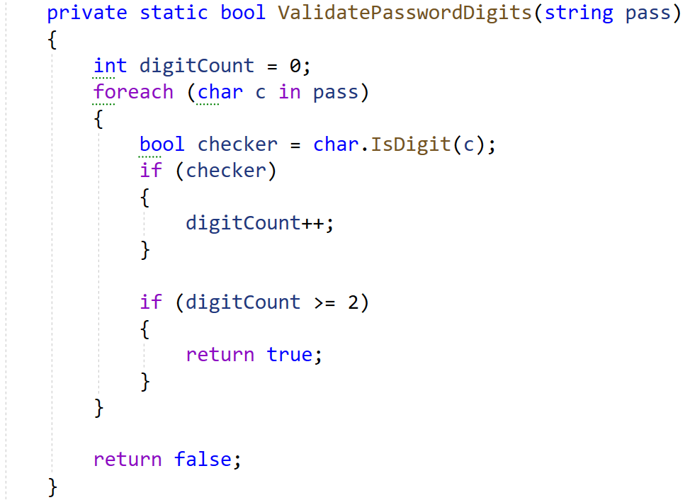
You are given a test file PasswordValidatorTests.cs containing 5 empty tests. Implement all the unit tests:
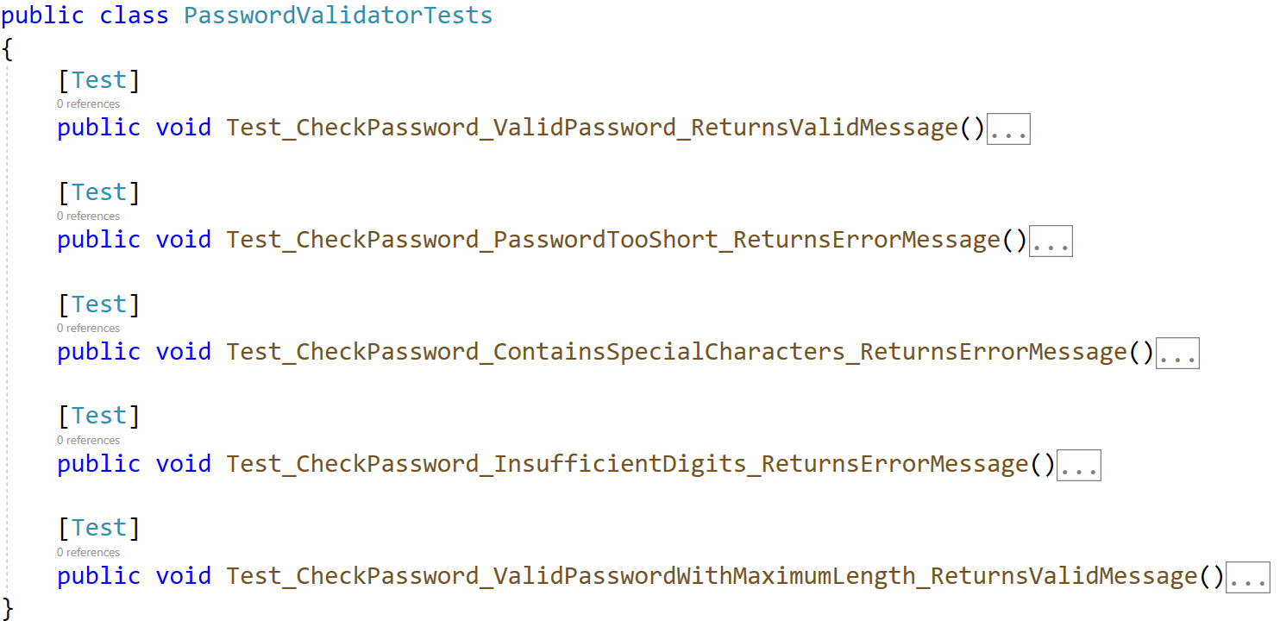
When you are ready make sure your tests run:
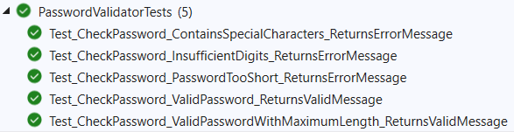
IMPORTANT: DO NOT REMOVE OR CHANGE ANY NAMESPACES AND USINGS.

