Programming Fundamentals and Unit Testing

Retake Exam – 20 December 2023

4. Unit Test List: Messaging
Test a given method which takes in a list of integers and a string and for each element of the list it calculates the sum of its digits and takes the element, corresponding to that index from the text.
If the index is greater than the length of the text, it starts counting from the beginning.
The method is found in the Messaging.cs file:
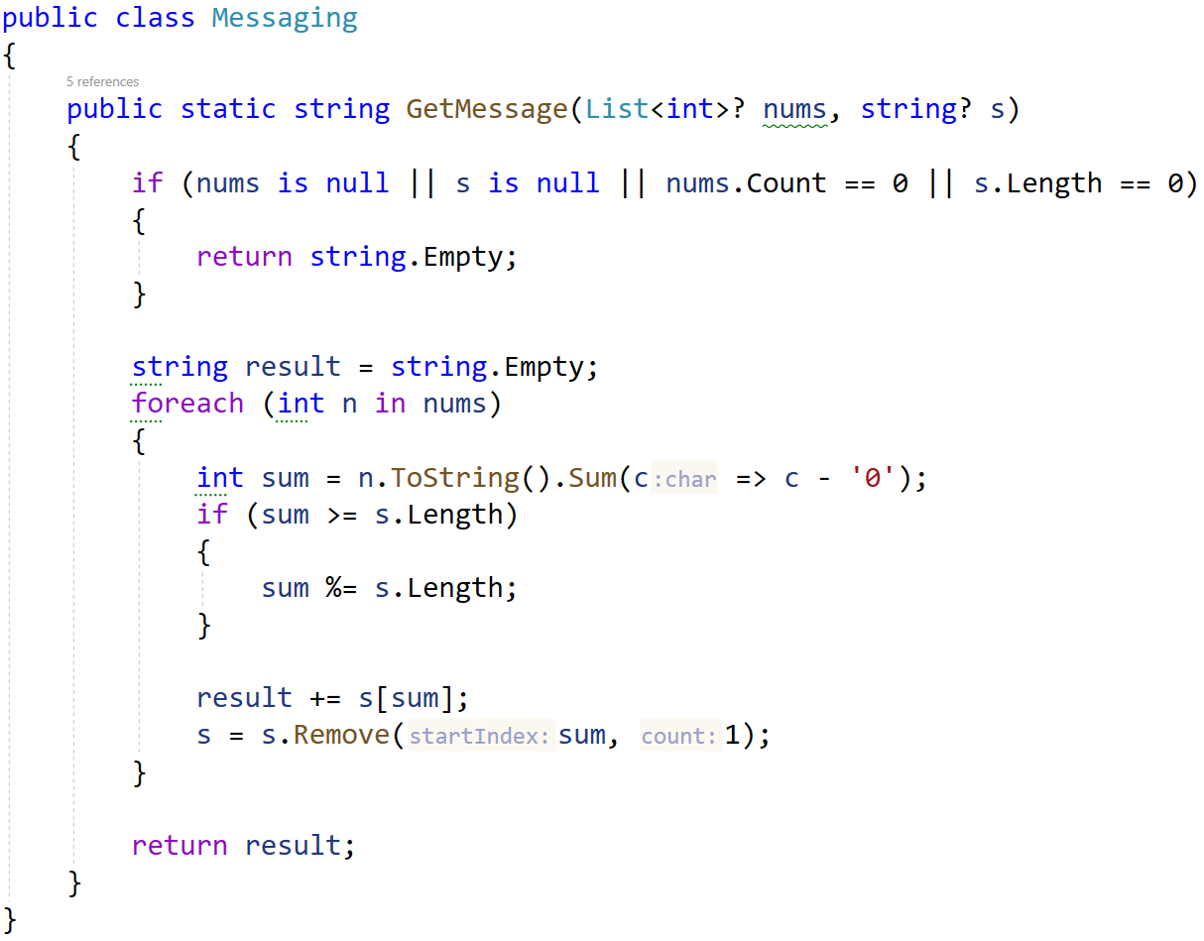
You are given a test file MessagingTests.cs containing 5 empty tests. Implement all the unit tests:
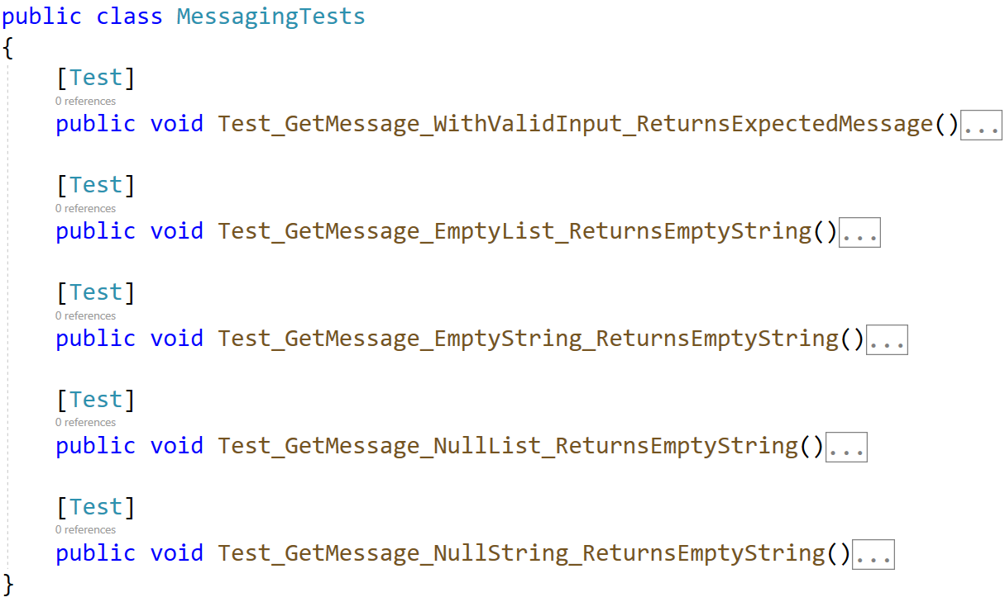
When you are ready make sure your tests run:
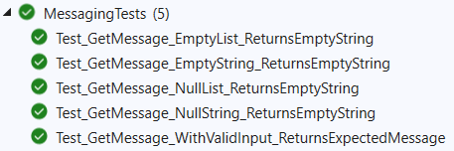

IMPORTANT: DO NOT REMOVE OR CHANGE ANY NAMESPACES AND USINGS.

