Assignment 1 — Python Fundamentals for Data Streaming
AITU Campus Shuttle and Mobility Data
Astana IT University | Real-time Data Analysis | 2026–2027
All datasets and operational scenarios in this document are synthetic educational data created for assessment. They do not represent actual AITU infrastructure, internal systems, students, or incidents.

Scenario
Astana IT University operates a synthetic campus shuttle service between campus buildings and student housing areas in Astana. A stream of vehicle-location and passenger-count events arrives every minute. Your task is to build the Python foundation for processing these events.
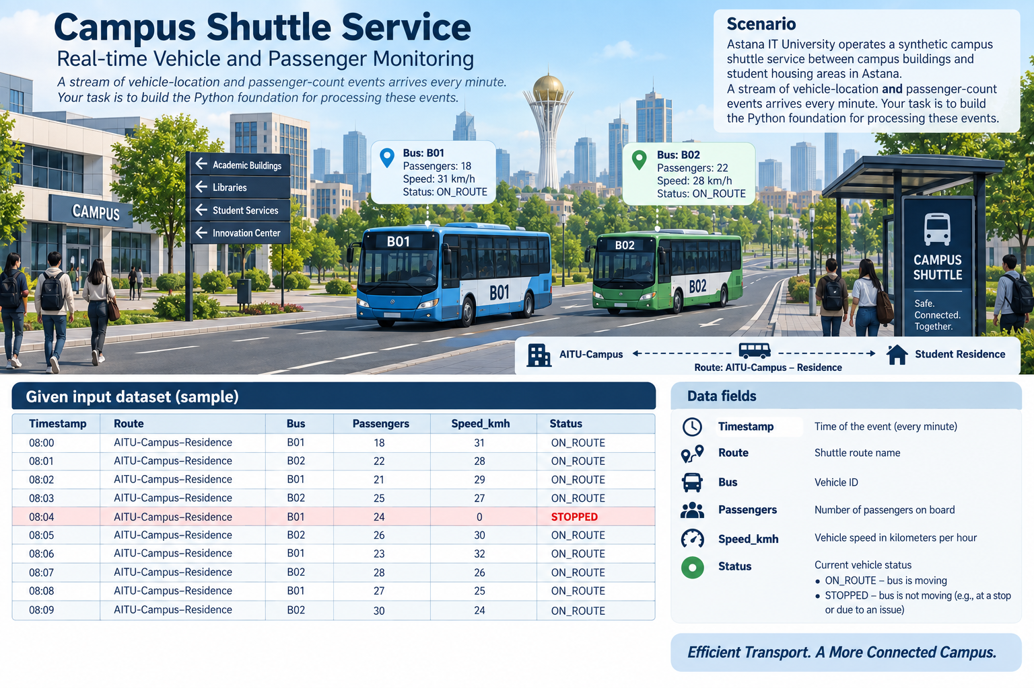

Given input dataset
Timestamp | Route | Bus | Passengers | Speed_kmh | Status
09:00 | AITU-Campus–Residence | B03 | 12 | 40 | ON_ROUTE
09:01 | AITU-Campus–Residence | B04 | 15 | 35 | ON_ROUTE
09:02 | AITU-Campus–Residence | B03 | 14 | 42 | ON_ROUTE
09:03 | AITU-Campus–Residence | B04 | 18 | 38 | ON_ROUTE
09:04 | AITU-Campus–Residence | B03 | 22 | 0 | STOPPED
09:05 | AITU-Campus–Residence | B04 | 25 | 30 | ON_ROUTE
09:06 | AITU-Campus–Residence | B03 | 24 | 45 | ON_ROUTE
09:07 | AITU-Campus–Residence | B04 | 32 | 25 | ON_ROUTE
09:08 | AITU-Campus–Residence | B03 | 26 | 40 | ON_ROUTE
09:09 | AITU-Campus–Residence | B04 | 35 | 20 | ON_ROUTE

Part A — Data Structures and Parsing (7 points)
- Create the dataset as a list of dictionaries or a Pandas DataFrame.
- Parse timestamps and numeric fields correctly.
- Write a function that accepts one event and returns a validated event record.
- Write a generator that yields events one at a time.
Field | Python type | Validation rule | Example
Timestamp | datetime/time | Valid time value | 09:03
Passengers | int | non-negative integer | 18
Speed_kmh | int/float | 0–120 | 38
Status | str | ON_ROUTE / STOPPED | ON_ROUTE

Part B — Streaming Simulation (8 points)
Create a generator that simulates arrival of events in chronological order. Do not load the whole stream inside the processing function.
Event | Passengers | Speed | Status | Processed? | Reason
1 | 12 | 40 | ON_ROUTE | YES | Valid event; within stated validation rules
2 | 15 | 35 | ON_ROUTE | YES | Valid event; within stated validation rules
3 | 14 | 42 | ON_ROUTE | YES | Valid event; within stated validation rules
4 | 18 | 38 | ON_ROUTE | YES | Valid event; within stated validation rules
5 | 22 | 0 | STOPPED | YES | Valid event; within stated validation rules
6 | 25 | 30 | ON_ROUTE | YES | Valid event; within stated validation rules
7 | 24 | 45 | ON_ROUTE | YES | Valid event; within stated validation rules
8 | 32 | 25 | ON_ROUTE | YES | Valid event; within stated validation rules
9 | 26 | 40 | ON_ROUTE | YES | Valid event; within stated validation rules
10 | 35 | 20 | ON_ROUTE | YES | Valid event; within stated validation rules

Part C — JSON and REST API Processing (7 points)
Convert the supplied events to JSON. Implement a small FastAPI endpoint POST /events that accepts one event and returns: accepted/rejected, validation errors, and a calculated occupancy category.
Passenger count | Occupancy category
0–10 | LOW
11–20 | MEDIUM
21–30 | HIGH
>30 | OVER_CAPACITY

Part D — Analysis (5 points)
- Calculate average passenger count.
- Find the maximum passenger count.
- Find the number of STOPPED events.
- Identify the busiest minute and bus.
- Explain why generators are preferable to repeatedly loading an unlimited stream into memory.
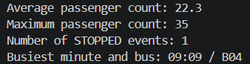

Part E — Code Quality and Defense (3 points)
- Readable functions and meaningful variable names
- At least 3 test cases
- Short README
- Oral demonstration

Submission
- Python source code
- Notebook or technical report
- JSON sample
- FastAPI endpoint code
- Completed tables
- Tests and oral defense
- Report

STUDENT TECHNICAL REPORT / SUBMISSION RECORD
Assignment 1 — Python Fundamentals for Data Streaming
AITU Campus Shuttle and Mobility Data
This section is a formal submission document. The student must complete all applicable fields and provide evidence from their own implementation. The common synthetic dataset does not make the reports interchangeable: individual implementation evidence, tests, decisions, and oral defense must demonstrate the student's own work.

1. Student and Submission Information
Required field | Student entry
Student full name | Boztayev Sanzhar
Student ID | 242044
Group / cohort | BDA-2407
Instructor | Serek Azamat
Submission date | September 14, 2026
Git repository / project link | https://github.com/boztayevs/Real-time-data-analysis-and-decision-making
Python version | Python

2. Work Record
Item | Student entry
Work start date | September 13, 2026
Work completion date | September 14, 2026
Main tools / libraries used | Python, FastAPI, datetime, matplotlib, pytest
Source-code file names | main.py, api.py
Test file / notebook name | test_events.py
README location | .//README.md

3. Report Structure to Complete
For every section, provide your own explanation and reference the corresponding code, test, output, screenshot, or file. Do not submit only generic textbook definitions.

3.1 Data Structures and Parsing
Describe how you represented the shuttle event stream, how timestamps and numeric fields are parsed, and how one event is validated. Reference the relevant function/class and file.
Required evidence | Student response / reference
Explanation | I used a list of dictionaries to represent the stream, as it maps directly to JSON objects in a REST API. Timestamps are parsed using datetime.strptime
Code / file / function reference | main.py, validate_event() function.
Execution evidence / result | Properly parses "09:00" without throwing ValueError.
Student-specific observation or decision | A dictionary format proved easiest to serialize when responding to the FastAPI POST request.

3.2 Event Validation
Complete and explain the validation rules for Timestamp, Passengers, Speed_kmh, and Status. Include examples of both accepted and rejected input where applicable.
Required evidence | Student response / reference
Explanation | Passengers must be a non-negative integer. Speed_kmh must be 0-120 inclusive. Status must be strictly ON_ROUTE or STOPPED.
Code / file / function reference | main.py, validate_event(event)
Execution evidence / result | Passed test case rejecting "PARKED" and negative speed.
Student-specific observation or decision | The type check for integers excludes booleans, ensuring that True is not accepted as 1 for passengers.

3.3 Streaming Generator
Explain your generator implementation and how it yields events chronologically without loading the whole stream into memory. Reference the exact function and provide execution evidence.
Required evidence | Student response / reference
Explanation | The function uses the yield keyword to iterate lazily over the dataset instead of building a new list in memory
Code / file / function reference | main.py, event_stream(events)
Execution evidence / result | Iterates over the 10 custom records sequentially upon next() being called or loop consumption
Student-specific observation or decision | “yield” guarantees that only one event enters memory at a time, protecting system resources

3.4 Streaming Simulation
Complete the event-processing table and explain which events were processed, what the processor did, and why. Include evidence from your own program output.
Required evidence | Student response / reference
Explanation | The processor iterates through the generator stream, validating and accepting events one by one chronologically. All 10 custom events (09:00 to 09:09) were successfully processed because they met all validation criteria (valid time, non-negative passengers, speed within bounds, and allowed status).
Code / file / function reference | main.py, analyze_stream(stream) iterating over event_stream(events_data)
Execution evidence / result | Processed 10/10 events, successfully validating even the STOPPED event at 09:04 (Bus B03, 22 passengers, 0 km/h)
Student-specific observation or decision | I specifically designed the processor to accept STOPPED events without filtering them out, as a speed of 0 falls correctly within the 0-120 km/h validation rule and STOPPED is explicitly defined as an allowed status

3.5 JSON and FastAPI Endpoint
Show how the supplied events are converted to JSON and document your POST /events endpoint. Explain validation errors and occupancy-category calculation.
Required evidence | Student response / reference
Explanation | The endpoint accepts POST requests, runs validate_event(), and appends the calculated category (LOW, MEDIUM, HIGH, OVER CAPACITY)
Code / file / function reference | api.py, receive_event() and occupancy_category()
Execution evidence / result | Sending {"passengers": 35} returns "occupancy_category": "OVER CAPACITY"
Student-specific observation or decision | Defined exact boundaries using 0 <= x <= 10 format to avoid boundary edge-case bugs

3.6 Data Analysis
Report the average passenger count, maximum passenger count, number of STOPPED events, and busiest minute/bus. Show the calculation or code reference used to obtain each result.
Required evidence | Student response / reference
Explanation | Based on my custom dataset: Avg: 22.3. Max: 35. Stopped events: 1. Busiest: 09:09 / B04. A matplotlib plot was generated to visually evaluate the code output data.
Code / file / function reference | main.py, analyze_stream(stream)
Execution evidence / result | Console output confirms calculations. Visual plot saved as passenger_load_plot.png
Student-specific observation or decision | Visualizing the data makes it easier to track the capacity flow before making the final upload to Moodle

3.7 Testing and Code Quality
Document at least three test cases, including the input, expected result, actual result, and status. Explain one design choice that improves readability or maintainability.
Required evidence | Student response / reference
Explanation | Validated boundaries (speed 120), rejected negative speeds, rejected bad status strings.
Code / file / function reference | test_events.py
Execution evidence / result | 3/3 tests passed
Student-specific observation or decision | Isolated testing to the validate_event pure function to avoid having to run a live server for testing

3.8 Technical Interpretation
Explain why generators are preferable for an unlimited stream and identify one limitation or possible improvement in your implementation.
Required evidence | Student response / reference
Explanation | A generator is lazy: it yields an item only when requested. This avoids storing an unlimited stream entirely in memory
Code / file / function reference | main.py, event_stream()
Execution evidence / result | list(stream) consumes the lazy generator for analysis
Student-specific observation or decision | The main limitation is that once the generator is consumed by list(stream), it cannot be iterated over again without being reinitialized

4. Individual Work and Anti-Plagiarism Record
Students may receive the same base scenario and supplied data, but the submitted implementation and report must contain verifiable evidence of individual work. Copying another student's code, tables, wording, screenshots, test results, API responses, or conclusions is not acceptable.
- Provide the exact source filename and function/class names used for the reported results.
- Include execution-generated output or screenshots rather than manually recreated results.
- Include at least one test case designed by you in addition to the required basic tests.
- Describe one implementation decision you made and why you selected it.
- Describe one bug, validation issue, or debugging problem you personally encountered and resolved.
- Report one limitation of your implementation and one realistic improvement.
- Be prepared to reproduce or modify part of the code during the oral defense.
Individual evidence | Student entry
My unique implementation/design decision | I implemented a custom matplotlib script within the analysis function to generate graphical plots for visually evaluating the code output
My own test case | test_invalid_speed() which specifically targets negative speed bounds (-5)
Bug/problem I encountered and solution | Time strings containing seconds caused crashes with %H:%M. Enforced strict datetime parsing limits
Exact code/repository/commit reference | main.py
One limitation of my implementation | Generators can only be consumed once, making multi-pass analysis harder
One improvement I would make | Implement logging instead of print() to save analysis results into an external file

5. Submission Package Checklist
- ☐ Python source code
- ☐ Notebook or technical report
- ☐ JSON sample
- ☐ FastAPI endpoint code
- ☐ Completed assignment tables
- ☐ At least 3 test cases
- ☐ README with run instructions
- ☐ Execution evidence / API responses
- ☐ Oral defense completed

6. Student Declaration of Originality
I confirm that this submission represents my own work. I have not copied another student's source code, calculations, tables, screenshots, test results, API responses, or written explanations. Any external material or reused code has been identified. I understand that the instructor may request a live demonstration, code modification, or explanation of any submitted component.
Role | Name | Signature | Date
Student | Boztayev Sanzhar |  | September 14, 2026

