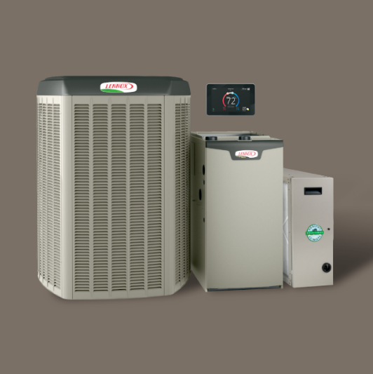

The perfect system should adapt to your life to deliver the ultimate in energy savings and precision temperature control. We agree. And that’s why we’re proud to be a leading provider of innovative, home heating and cooling systems. Our high-efficiency, Lennox® residential air conditioners, furnaces and HVAC systems help maximize comfort while reducing utility costs. Plus, our Lennox air filters, humidifiers and dehumidifiers help create healthier and cleaner indoor environments. Call now to

**Receive up to $1,600 when you purchase the Lennox® Ultimate Comfort System* or enjoy no payments for the first 3 months when you finance a new Lennox® system for as little as $116 a month**!**

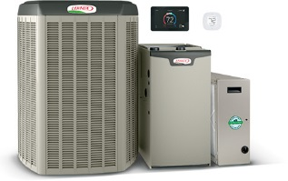**START WITH UP TO $1,150 IN REBATES.\***

Save on a complete qualifying Lennox® home comfort system that includes a gas furnace or blower coil, an air conditioner or heat pump and thermostat. Enjoy additional product rebates when you purchase an iComfort® S30 Smart thermostat, iHarmony ® zoning and a PureAir™ system.

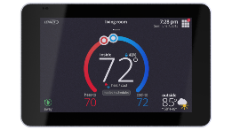**GET UP TO A $150 REBATE ON a WI-FI THERMOSTAT.\***

**OR,** E**njoy no payments for the first 3 months when you finance a new Lennox® system for as little as $116 a month\*\***

Save now on the iComfort® S30 and save every month on utility bills. Anytime

your routine or weather changes, the iComfort S30 smartly adapts to reduce

your energy costs.

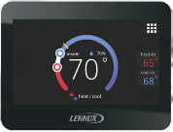

**GET UP TO A $150 REBATE ON ZONING.\***

Enhance your comfort and savings with iHarmony® zoning,

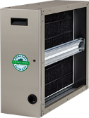a major advance in precision climate control.

**GET UP TO A $150 REBATE ON pUREAIR™.\***

Enjoy more savings and fewer pollutants with a PureAir™ system, which cleans

the air inside your home better than any other single system you can buy.

**Get comfortable now & CALL for details.**

Top of Form

Bottom of Form

*Rebate requires purchase of qualifying items between September 2, 2019 to November 22, 2019. Qualifying items must be installed by November 29, 2019. Rebate claims (with proof of purchase) must be submitted (with proof of purchase) to www.lennoxconsumerrebates.com no later than December 14, 2019. Rebate is paid in the form of a Lennox Visa prepaid debit card. Card is subject to terms and conditions found or referenced on card and expires 12 months after issuance. Conditions apply. See www.lennox.com/terms-and-conditions for complete terms and conditions.

**Offer available September 2, 2019 to November 22, 2019. Offer based on a retail price of $10,000. Requires purchase of qualifying system. Financing available to well-qualified buyers on approved credit. No down payment required. No monthly payment required and no interest is accrued during the 3 month deferral period. After deferral period, the loan is rolled into 6.99% APR for 120 Months with equal monthly payments of $116 a month. Normal late charges apply. Cannot be combined with any other promotional offer. Minimum loan amount $3,000. Maximum loan amount $100,000. You may prepay your account at any time without penalty. Financing is subject to credit requirements and satisfactory completion of finance documents. Any finance terms advertised are estimates only. See Truth in Lending disclosures available from lender for more information.