

Make the ideal choice.
For complete comfort with better performance and efficiency, you should have your home comfort system serviced each year. We can also help you find the Lennox® home air conditioner, furnace or system that ideally suits your needs. All of our residential heating and cooling options are designed for energy savings and comfort, and are built to last. Call today and save with REBATES UP TO $1,500* OR LOW MONTHLY PAYMENT FINANCING.

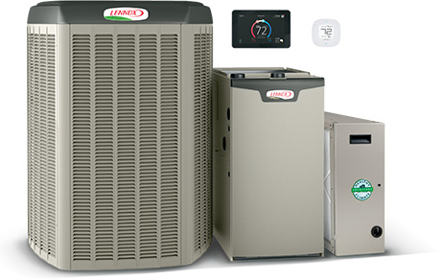
START WITH UP TO $1,200 IN REBATES.*
Save on a complete qualifying Lennox® home comfort system that includes
air conditioner or heat pump, gas furnace or air handler and thermostat.

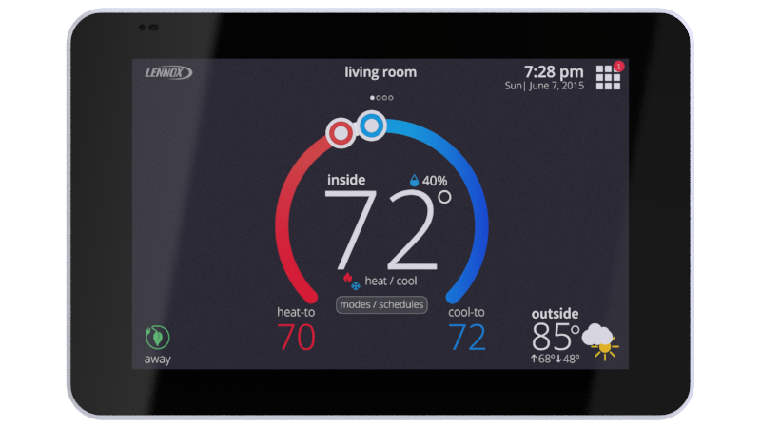
GET UP TO A $100 REBATE ON a WI-FI THERMOSTAT.*
With the Schedule IQ feature, you only need to program the thermostat once. Whenever there's a change in your routine, the iComfort® S30 adapts heating and cooling to match.

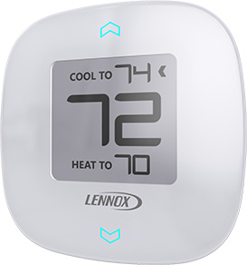
GET UP TO A $100 REBATE ON ZONING.*
Purchase iHarmony® zoning, a major advance in precision climate
control and enjoy savings and custom comfort.

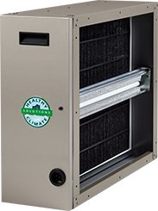
GET UP TO A $100 REBATE ON pUREAIR™.*
Cleans the air in your home better than any other single system you can buy, doesn’t
produce ozone and that means cleaner air in every room.

OR, A LIMITED-TIME FINANCING OFFER
60 MONTHS, EQUAL PAYMENTS, NO INTEREST**
We have the Lennox® financing solution that’s perfect for you, so there’s no need to put off your comfort.

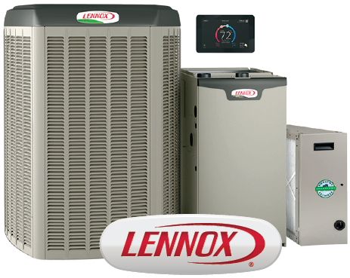

Get comfortable now & CALL for details.

*Some restrictions apply. System rebate offers range from $150–$1,500. Rebate offer is valid January 9, 2017 through February 3, 2017, 2016 with the purchase of qualifying Lennox products. Cannot be combined with any other offer. Additional add–on rebates for iComfort® S30 Thermostat, iHarmony® Zoning System and PureAir™ Air Purification system valid with a qualifying system purchase only. See your participating Lennox dealer for complete details.

***Financing available to well qualified buyers on approved credit at an 0% APR for 60 months, with equal monthly payments. You may prepay your account at any time without penalty. Financing is subject to credit requirements and satisfactory completion of finance documents. Any finance terms advertised are estimates only. Normal late charges apply. See your Truth in Lending Disclosures for more information.

