Freight Rate Prediction — ML Assessment Report
LightGBM model · 48,000 labeled loads (Jan–Oct 2025) · 12,000 scored loads (Nov–Dec 2025)

1. Summary
Posted rates are modeled with a gradient-boosted tree model (LightGBM) on log(posted_rate). On a strictly forward-in-time holdout (train Jan–Aug, predict Sep–Oct) the model reaches MAE $58 / MAPE 2.5% / R² 0.967 on clean rows — less than half the error of a rate-per-mile lookup baseline ($135 MAE). The final model is retrained on all ten labeled months and scores every load in validation.csv plus the fixed Lexington → Fort Wayne December lane.

2. Data exploration — key findings
- Distance dominates. Correlation with posted_rate is 0.91; rate-per-mile tapers from ~$2.67 for short hauls (<330 mi) to ~$1.91 beyond 2,200 mi, so the model needs the nonlinear distance shape, not a single per-mile constant.
- quote_signal is a per-mile quote. quote_signal × distance correlates 0.968 with the rate — the strongest engineered signal in the data.
- market_index is a daily market state. It is nearly constant within a day (per-day σ ≈ 0.025), with a clear annual cycle (peak ~1.30 in May, trough ~0.89 in September) and a strong weekly cycle (weekend dips). Daily mean market_index correlates 0.58 with daily mean rate-per-mile.
- Stable secondary effects. Equipment premium (Reefer $2.38 > Flatbed $2.30 > Dry Van $2.12 per mile), heavier loads price higher, and there is residual upward drift through the year beyond what market_index explains.
- Geography is consistent. Each of the 64 cities has one fixed coordinate pair; road distance ≈ 1.18 × straight-line (haversine) distance. Eight validation cities never appear in training — coordinates let the model generalize to them.

3. Data quality issues and treatment
- Sign-flipped weights (0.6%). 292 training rows have negative weight; their magnitude distribution matches positive rows exactly, so they are sign errors — fixed with absolute value.
- Missing values. weight (0.6%) is median-imputed with an indicator flag; market_index (0.8%) is imputed with its per-date mean (it is near-constant within a day), also flagged.
- Corrupted labels (1.1%). 599 training rows have rate-per-mile outside $0.80–$6.00 (up to $14/mile, down to $0.33/mile), spread uniformly across months and equipment — consistent with random label corruption. They are dropped from training only; reported holdout metrics include them (“all rows”) and exclude them (“clean rows”).

4. Train / validation split approach
The scored set (Nov–Dec 2025) lies strictly after every labeled load (Jan–Oct 2025), so the primary validation must test forward-in-time generalization. I hold out the last two labeled months (Sep–Oct, ~9.5k loads) and train on Jan–Aug (~38k loads). This reproduces the real difficulty: unseen future months, market conditions that drifted from training, and early stopping tuned against future data rather than shuffled data. A shuffled 80/20 split is reported only to quantify the optimism of random splitting (MAE $46 vs $58 — a ~26% gap a random split would have hidden).
Evaluation | MAE ($) | RMSE ($) | MAPE (%) | R²
Temporal holdout — all rows | 103.29 | 631.98 | 4.54 | 0.829
Temporal holdout — clean rows | 58.14 | 255.08 | 2.46 | 0.967
Temporal — rate-per-mile baseline | 134.89 | 638.57 | 6.19 | 0.825
Random 80/20 — clean rows | 46.05 | 214.84 | 1.98 | 0.975
“Clean rows” excludes holdout rows whose label itself is corrupted (rate-per-mile outside $0.80–$6.00); those rows are unpredictable by construction and dominate RMSE. The final boosting-round count is chosen by early stopping on the temporal holdout, then scaled proportionally when refitting on all ten months.

5. Model and features
Model: LightGBM regression on log(posted_rate) (multiplicative errors match how rates scale with distance), 127 leaves, learning rate 0.05, ~160 trees chosen by early stopping, fixed seed. Features: distance (raw, log, haversine), equipment, pickup/delivery city categoricals plus coordinates and lane bearing, cleaned weight, load-level market_index and quote_signal, pooled per-date market aggregates (daily mean and trailing 7-day mean of market_index, daily mean of quote_signal), and calendar fields (month, day-of-week, day-of-year).
Feature importance confirms the EDA story: distance features carry most of the gain, followed by equipment, quote_signal, weight, and the market/seasonality block. A linear model was rejected because the distance taper, equipment × distance interactions, and market nonlinearities are exactly what trees capture cheaply; a neural model adds risk without more data.

6. Fixed December lane prediction
december_chart_inputs.csv provides no market_index or quote_signal, but validation.csv contains ~200 real December loads per day, whose features are given. For each December date, market_index is imputed from the per-date mean of those loads (legitimate: features only, no labels involved), and the per-date market aggregates are computed the same way. quote_signal uses the lane’s Dry Van average (2.02) from 21 historical Lexington → Fort Wayne loads, with day-to-day quote variation entering through the pooled daily aggregate. Predictions land at $820–$843 — inside the lane’s historical $758–$973 range — and reproduce the weekly market cycle (midweek peaks, weekend troughs).
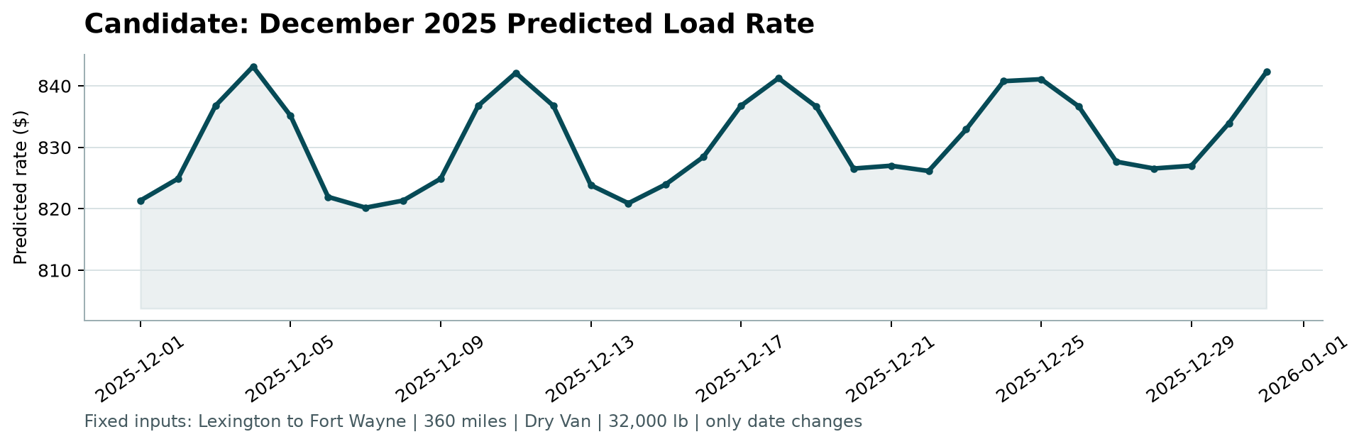
Chart produced by the provided score.py from the committed predictions.

7. Reproducibility
GitHub repository: bp-high/freight_rate. python -m pip install -r requirements.txt, then python src/validate.py (validation experiments), python src/train_predict.py (final model + both prediction files), python score.py --predictions validation_predictions.csv --december-predictions data/december_chart_inputs.csv. All randomness is seeded; reruns reproduce the committed outputs exactly.

