Report on the use of passive acoustic monitoring for analysis of bird trends in Jasper National Park
Alex MacPhail
Brenda Shepherd
Nina Veselka
2026-09-08
Table of contents

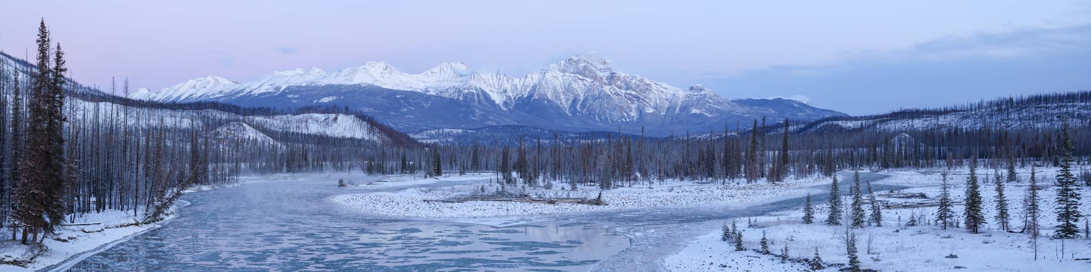
 Note
This report is dynamically generated, meaning its results may evolve with the addition of new data or further analyses. For the most recent updates, refer to the publication date and feel free to reach out to the authors.

1. Project Highlights
- Acoustic recordings from 2007–2026 in Jasper National Park were analyzed to assess bird abundance trends relative to a ±2.5% annual change threshold as part of the Park’s ecological integrity monitoring program.
- A single-visit N-mixture abundance model was applied to 31 alpine and 67 forested species, accounting for detection and observation covariates in each ecoregion.
- Using the aforementioned threshold, long-distance migrants showed the strongest declines (0% alpine, 0% forested), followed by winter residents (100% alpine, 0% forested), while short-distance migrants were comparatively stable (0% alpine, 25% forested).
- Declines were most pronounced among invertebrate feeders (0% alpine, 50% forested) and plant/seed feeders (33% alpine, 0% forested), whereas omnivores were least affected (0% alpine, 0% forested).
- By habitat guild, grassland-shrubland-alpine species showed the steepest declines (% alpine, % forested), followed by habitat generalists (0% alpine, 0% forested) and forest generalists (17% alpine, 17% forested); late succession forest (0% alpine, 33% forested) and wetland species (% alpine, % forested) showed comparatively fewer declines.
- At finer dietary resolution, aerial insectivores exhibited the steepest declines (% alpine, % forested), with additional losses among granivore-herbivores (50% alpine, 0% forested) and aquatic foragers (% alpine, % forested).

2. Land Acknowledgement
We respectfully acknowledge that Jasper National Park is located in Treaty 6 and 8 as well as the traditional lands of the Anishinabe, Aseniwuche Winewak, Dene-zaa, Nêhiyawak, Secwépemc, Stoney Nakoda, Mountain Métis and Métis. We acknowledge the past, present, and future generations of these nations who continue to steward the land.

3. Introduction
Human activities are among the primary drivers of global forest wildlife declines, with habitat fragmentation and loss, climate change, and increased access to sensitive areas exerting compounding pressures on biodiversity — particularly in Canada’s protected areas (Lemieux et al. (2011); Fahrig (2003); Hanski (2011); Mantyka-pringle, Martin, and Rhodes (2012); Abrahms et al. (2023)). In Alberta’s Rocky Mountain Natural Region, these pressures are intensified by increasing wildfire activity, which has significantly affected montane bird communities. Declines in bird abundance across large regions of North America over recent decades (Rosenberg et al. (2019)) underscore the need for systematic, park-wide monitoring.
In 2007, Jasper National Park established a long-term passive acoustic monitoring program to address a central question: has the abundance of forest and alpine birds declined over the duration of monitoring and during the past ten years? The program uses Autonomous Recording Units (ARUs), compact environmental sensors that passively capture vocalizing wildlife such as birds and amphibians (Shonfield and Bayne (2017)), a method growing rapidly in global use (Sugai et al. (2018)). By enabling prolonged surveys with minimal human interference while producing a permanent, archiveable record of the soundscape, ARU-based monitoring is well suited to tracking ecological change at the scale of a national park.
Incidence-based metrics treat a single detection the same as a commonly observed species, obscuring ecologically meaningful differences in population status. Abundance fluctuates more than occurrence and is more directly linked to extinction risk, making it better suited for diagnosing decline and recovery and for capturing the resilience of biodiversity to ongoing environmental pressures. A species-specific decline threshold of 2.5% per year (approximately 20% over ten years) was applied throughout, consistent with the IUCN Vulnerable listing criteria and the Partners in Flight Conservation Urgency benchmark, under which species projected to lose 50% of their population within 30 years (~2.3% per year) are considered high urgency (Rosenberg et al. (2019)).
This report analyzes Jasper’s passive acoustic bird monitoring data from 2007 to 2026. Because birds serve as ecological indicators in both the forest and alpine ecosystems reported in Jasper’s State of the Park Report, separate analyses were conducted for the forested ecoregion (encompassing the montane, lower subalpine, and upper subalpine ecoregions) and the alpine ecoregion. To enhance accessibility and reproducibility, findings are presented in this online report with fully documented code, supporting future updates as data collection methods become further standardized. Recommendations are also provided to refine transcription priorities, improve annual reporting workflows, and evaluate species guild classifications for long-term monitoring.
The objectives of this report are to:
- Describe the data management and processing procedures for acoustic data collected from 2007 to 2026.
- Compare how different data processing methods influence the count of species and individuals detected on recordings.
- Report on trends in bird abundance by species and by guild in the forest and alpine ecoregions, incorporating time-to-first-detection analysis.
  - Summarize results by ecoregion as the percentage of species and guilds declining by ≥2.5% in both forest and alpine regions.
  - Explore methods (e.g., inclusion of covariates and summarizing by guild) to interpret these changes, understanding how birds may be responding to stressors in the park or across their ranges and how changing populations may affect ecosystems.
  - Estimate species richness and diversity trends to determine if they provide insight about bird community conditions.
- Provide recommendations for:
  - Prioritizing previous years’ data for re-transcription to 1SPT;
  - Optimizing annual reporting methods (e.g., baseline comparisons vs. 10-year trends); and
  - Refining methods for evaluating species trends against thresholds and reviewing guilds and traits used in assessments.
  - Facilitate data publication to the public, resource managers, academic institutions, and any other relevant agencies.

4. Methods

4.1 Bird surveys
Monitoring for forest and alpine birds in Jasper National Park has been conducted annually since 2007 across a core set of 129 sites, with 20 sites that were added in 2026 after the Jasper 2024 fire (see Section 4.5.7). To ensure long-term feasibility, sites were clustered along transects, and transects were randomly selected from hiking trails that were at least 500 m away from roads and were at least five kilometers apart. To sample the diversity of birds in the park, transects were stratified by ecological region. Songbird data were collected using autonomous recording units (ARUs; Shonfield and Bayne (2017)) deployed by field staff to capture one 10-minute recording per point count annually. Surveys were scheduled consistently each breeding season in June and early July, starting 30 minutes before sunrise. Technicians walked transects containing nine or ten points, each spaced at least 300 m apart to prevent duplicate detections and ensure independence of locations (but see Section 4.5.1). At each location, the ARU was set up, and technicians moved 10–20 m away to minimize disturbance, allowing at least 11 minutes of recording to capture voice notes and the standardized 10-minute survey period. Five covariates thought to influence detection or abundance were recorded: start time, wind speed (km/h), temperature (°C), cloud cover (overcast, broken, scattered, clear) and recording equipment. Recording equipment varied throughout the course of the study. During the 2021 and 2022 field seasons, paired recordings were collected concurrently at each site using both Wildlife Acoustics SM4 autonomous recording units and the original recording devices (Riverforks CZM or Zoom H2N Pro, depending on site-specific deployment). This dual-recording approach was implemented to support calibration and continuity across equipment types. However, to maintain consistency in data processing, only recordings from the original devices were transcribed and included in the final analyses for those years. Beginning in 2023, recordings were collected exclusively using SM4 units.
Note
The 2012 field season was reduced significantly and was not included in some of the subsequent analyses. Refer to Table 1 for more information.

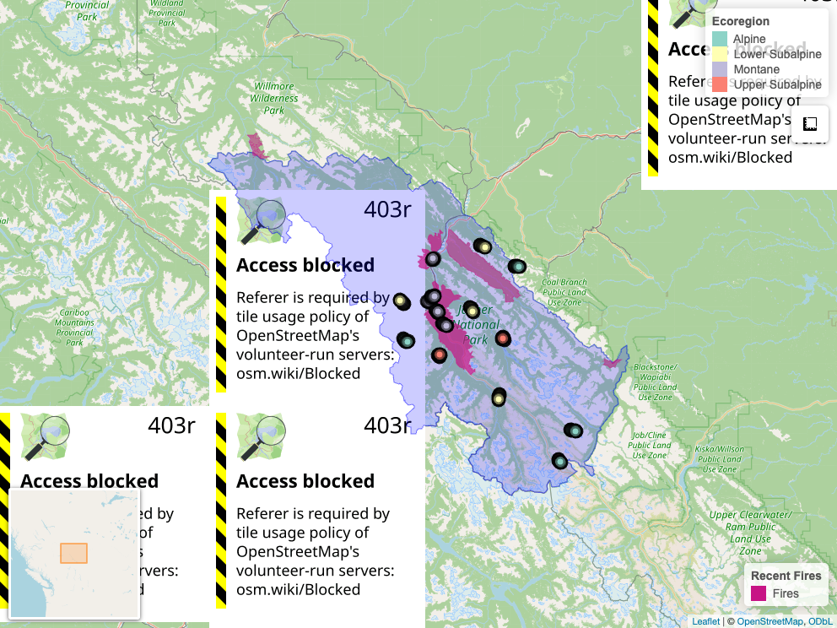
Figure 1: Locations from Jasper National Park ARU EI Monitoring Program.
datatable(janp_locs_table,
options = list(
searching = TRUE,
paging = TRUE,
pageLength = 10
)) |>
formatStyle(columns = colnames(janp_locs_table),
backgroundColor = styleEqual(c("NA"), "lightgray"))
Table 1: Locations surveyed across years. Ones indicated a deployment in that year for that location.
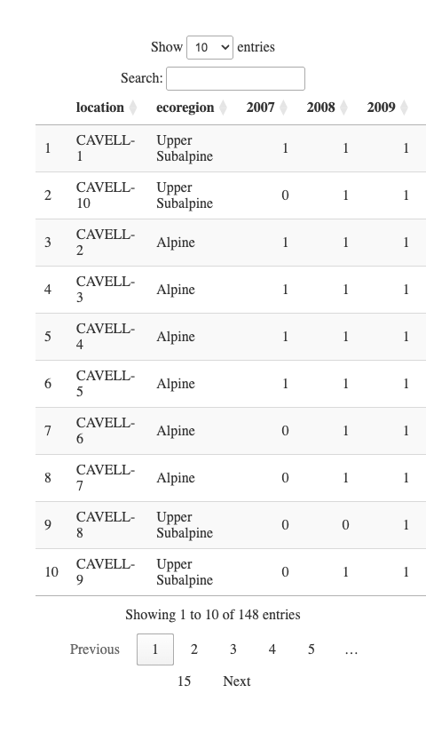
janp_ready_trend |>
select(location, latitude, longitude, ecoregion, elevation) |>
distinct() |>
mutate(new_ecoregion = case_when(
ecoregion %in% c("Alpine") ~ "Alpine",
ecoregion %in% c("Upper Subalpine", "Lower Subalpine", "Montane") ~ "Forested"
)) |>
group_by(location) |>
slice(1) |>
ungroup() |>
mutate(elevation = case_when(location == "CAVELL-5" ~ 2200, TRUE ~ elevation)) |>
mutate(ecoregion = factor(ecoregion, levels = ecoregion_order)) |>
ggplot(aes(x = ecoregion, y = elevation, color = new_ecoregion)) +
geom_boxplot() +
geom_jitter(width = 0.15, size = 3, alpha = 0.8) +
scale_color_manual(
values = c(
"Alpine" = "#7B3F61",
"Forested" = "#2E8B57"
)
) +
labs(
color = "New Ecoregion",
y = "Elevation (m)",
x = "Ecoregion"
) +
theme_bw() +
theme(
plot.title = element_text(face = "bold"),
panel.grid.minor = element_blank(),
legend.position = "right"
)
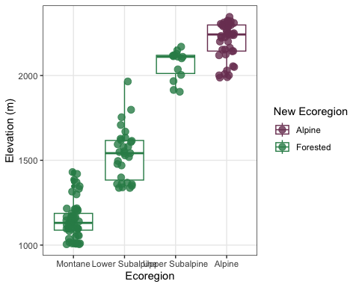
Figure 2: Distribution of locations across elevation gradients. Colours indicate reporting ecoregion for this report.

4.2 Weather variables
To examine the influence of weather on species richness and abundance, species richness and abundance were modeled separately for each ecoregion using Poisson generalized linear models with richness and abundance as responses to temperature, cloud cover, wind, Julian day, and hour of day as predictors. In the alpine ecoregion, richness increased with temperature (β = 0.008, p = 0.03) and declined with wind (β = –0.019, p < 0.001) and hour (β = –0.053, p < 0.001), with additional reductions under clear and scattered sky conditions. In contrast, richness in the forested ecoregion was dominated by a pronounced seasonal decline (Julian day: β = –0.021, p < 0.001), alongside negative effects of wind (β = –0.031, p = 0.011) and hour (β = –0.027, p < 0.001); temperature had no detectable influence. Abundance showed minimal sensitivity to environmental variation; no predictors were significant in the alpine ecoregion, while in the forested ecoregion, only hour exerted a detectable negative effect (β = –0.045, p = 0.006). Temperature and wind were retained in abundance models due to their established influence on avian activity and detection, despite weak effects observed in these exploratory analyses.

4.3 Vegetation variables
[NEW VEGETATION VARIABLES]
Table 2
To account for the severe habitat alteration caused by the 2024 Jasper Wildfire, we manually reclassified the land cover variable for all sites on the TEKARRA and VALLEY5 transects mark as simply “Burned” for the 2025 and 2026 data mark . Assessment of the burn severity classification was not used in this analysis, but field visits and current knowledge would classify the burn as high to severe overall (see also @)
hab_var <- janp_ready_trend |>
mutate(year = factor(year)) |>
select(location, year, ecoregion, landcover, proportion) |>
group_by(location, year, ecoregion) |>
summarise(
landcovers = paste(unique(paste(landcover, sep=" / ")), collapse="; ")) |>
mutate(ecoregion = case_when(ecoregion %in% c("Alpine") ~ "Alpine", ecoregion %in% c("Upper Subalpine", "Lower Subalpine", "Montane") ~ "Forested"))
datatable(hab_var) |>
formatRound(columns = names(hab_var)[sapply(hab_var, is.numeric)], digits = 2)
Table 2: Proportion of landcover within 150 meter buffer at each location in the Jasper National Park dataset.
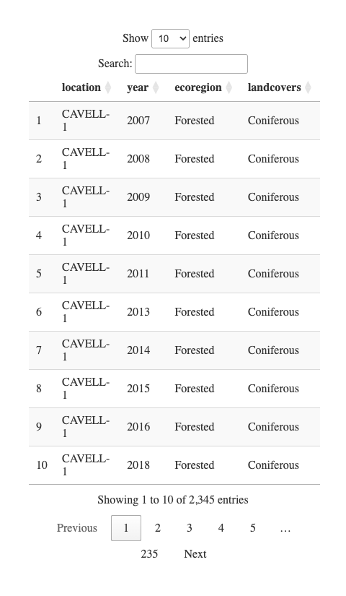

4.4 Data management, processing and quality control
Recordings were clipped and organized to only include the 10-minute count. Before adopting WildTrax in 2021, processing analysts excluded the initial 20 seconds to 1.5 minutes of recordings to reduce human impact on detection probability, then logged the first detection time per species. Recordings are now uploaded as clean 10-minute files with the voice note and observer notes removed. In WildTrax, individuals were counted by users scanning both the spectrogram and listening to the audio output (MacPhail et al. (2026)). Tags of each species-individual were drawn to encompass each signal (Figure 3). Transcribers also had locations photos available to optimize their species identification by having habitat context while processing. To ensure comparability across the 18-year dataset, we harmonized the abundance metrics derived from the differing transcription protocols prior to analysis. For legacy data collected between 2012 and 2020 using the 3-minute interval method, we calculated abundance as the maximum count observed in any single time bin rather than summing across bins. This conservative approach prevents the double-counting of individuals that sing continuously throughout the recording. Conversely, for data processed or re-transcribed using the modern 1SPT protocol (time of first detection of each unique individual of each species; 2007–2011 and 2021–2026), abundance was defined as the total count of unique individuals detected over the full 10-minute duration. Specifically, in WildTrax maximum count of individuals was used (i.e. AMRO1, AMRO2, AMRO3 max of 3 represents 3 individuals total).
transcription_table <- tibble(
Years = c("2012-2020", "2021-2022", "2007-2011, 2023-2026"),
`Transcription Method` = c(
"3 Bins, abundance calculated from the bin with the highest count by species",
"Every new individual is tagged but cap of max 3 individuals.",
"Every new individual is tagged, no cap on abundance."
)
)
# Render the datatable
datatable(transcription_table,
options = list(
searching = TRUE,
paging = TRUE,
pageLength = 10
)) |>
formatStyle(columns = colnames(transcription_table),
backgroundColor = styleEqual(c("NA"), "lightgray"))
Table 3: Transcription methods by year (2007–2026). Historical data (2007–2020) are undergoing re-transcription to align with the standardized protocol used from 2021 onwards.
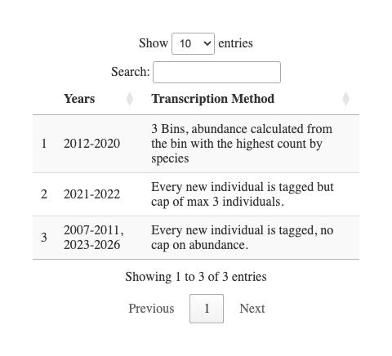
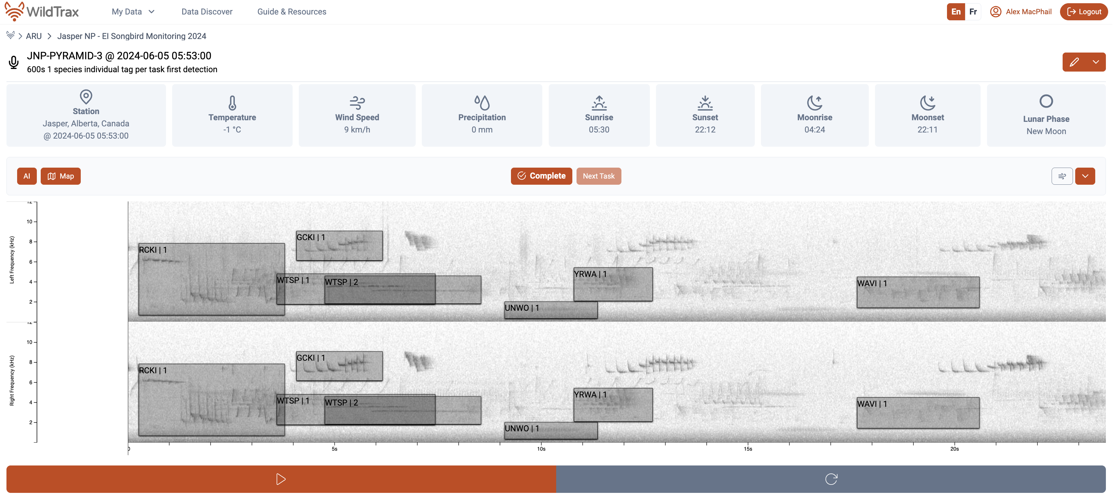
Figure 3: WildTrax Acoustic Processing Interface (Version 2)
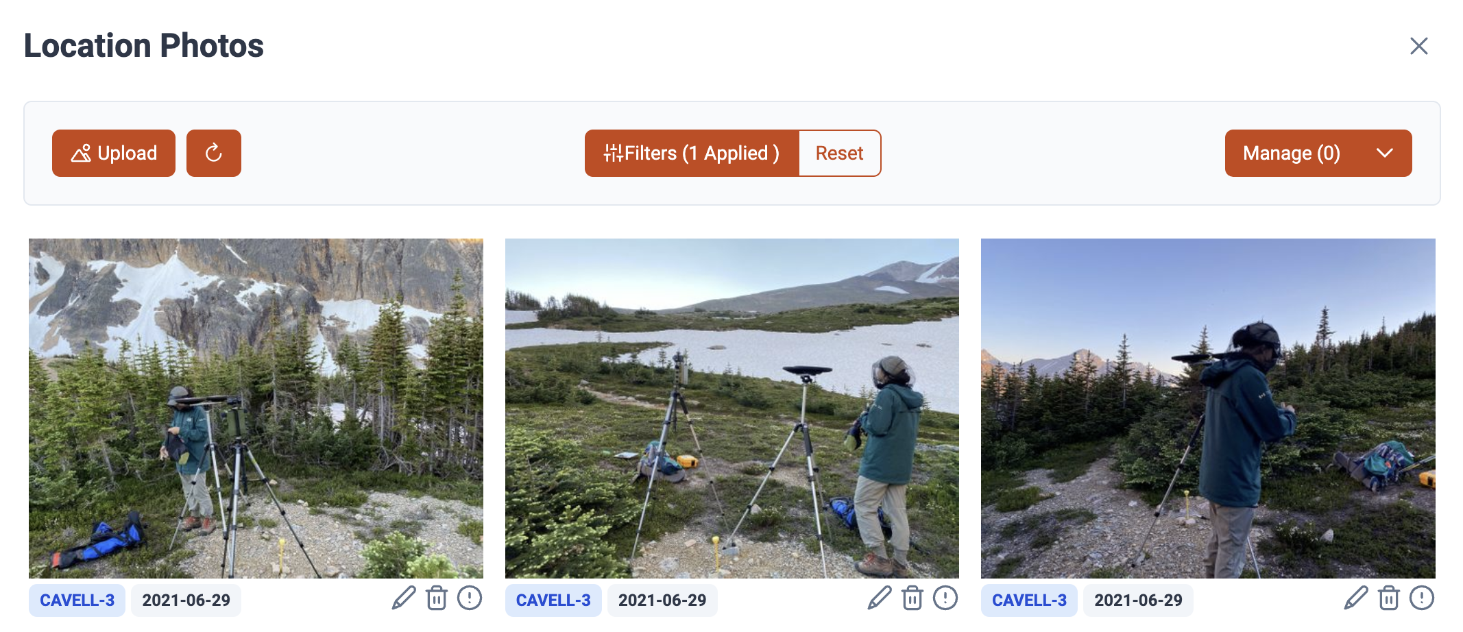 Simultaneously, we evaluated the performance of two acoustic classifiers, HawkEars v.1.0.8 (Huus et al. (2025)) and BirdNET v2.1 and Lite (Kahl et al. (2021)), on the acoustic recordings (Figure 4). Across the recall range, BirdNET-Lite maintained the highest precision, with BirdNET v2.1 closely tracking but consistently lower. HawkEars v1.0.8 performed well at low recall but declined rapidly as recall increased. At low recall, all models exceeded 0.9 precision, with BirdNET-Lite marginally leading. Performance converged at intermediate recall (~0.6–0.75), where precision ranged from ~0.75–0.8. At high recall (>0.8), differences widened: BirdNET-Lite degraded most gradually, BirdNET v2.1 declined more steeply, and HawkEars showed a sharp drop in precision. Overall, BirdNET-Lite demonstrated the most favourable precision–recall tradeoff, particularly under high-recall conditions where false positives increase.
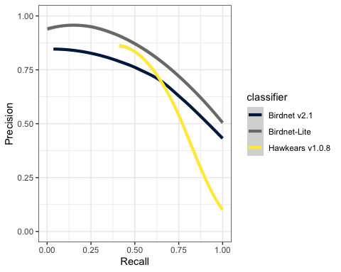
Figure 4: Performance of each acoustic classifier on the Jasper dataset.

4.5 Analytical methods
Note
For the purpose of these analyses, abundance was defined as the count of individuals detected during point counts, rather than as a density x area relationship. All analyses took place in R 4.5.3 ‘Reassured Reassurer’.

Our analysis proceeded in the following steps. We:
- Assessed if the new montane sites were effective reference sites for the montane;
- Evaluated consistency in species identification and abundance estimates across transcription methods and observers; 3, Selected species and grouped species by guild for trend analysis;
- Characterized community composition by the alpine and forest ecoregions;
- Examined the initial effect of the 2024 Jasper Wildfire on bird community composition;
- Modeled temporal changes in functional and community-level diversity; and
- Quantified long-term abundance trends (2007–2026), accounting for detection probability and addressing spatial autocorrelation.
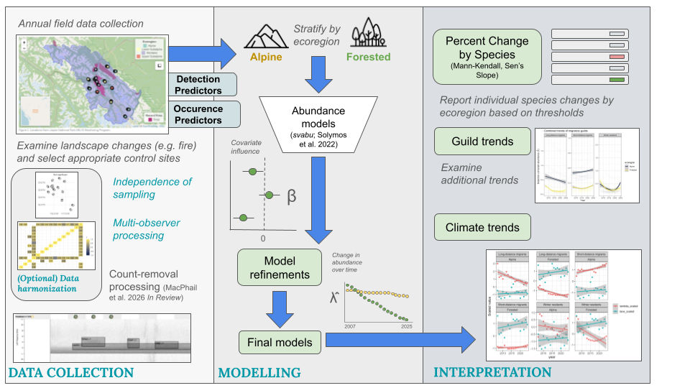
Conceptual model of analytical framework

4.5.1 Location correlation
To inform our subsequent modeling choices, we first evaluated the bird survey data for spatial autocorrelation, in other words, whether survey points close to one another exhibit similar bird counts. To test for this, we calculated a total abundance index for each location and year by summing the maximum number of individuals detected, representing the minimum number of individuals known to be present. Because survey points were typically spaced 300 m apart, we defined spatial neighbor relationships using a 1-nearest-neighbor approach (k = 1) based on great-circle distances. We derived spatial coordinates from geographic point data, excluding non-finite values to ensure valid estimation. Using the spdep R package (R. Bivand and Wong (2018)), we constructed a spatial weights matrix with row-standardized weights to reflect immediate adjacency between points. We assessed global spatial autocorrelation in total abundance using Moran’s I (R. S. Bivand and Wong (2018)) under a randomization assumption. This statistic evaluates whether the landscape is spatially structured—specifically, whether nearby locations tend to have similar abundance values more often than expected by chance. To determine if this dependence was driven by localized clustering, we further calculated Local Indicators of Spatial Association (LISA) using local Moran’s I (Anselin (1995)) which allowed for the identification of potential high–high, low–low, and spatial outlier patterns, with statistical significance evaluated at α = 0.05. While global Moran’s I indicated significant positive spatial autocorrelation across the study area, local Moran’s I revealed no statistically significant clusters. This pattern suggests that similarities in bird counts among nearby survey locations were spread broadly rather than concentrated in distinct hotspots, consistent with spatial dependence arising from gradual, landscape‑scale ecological processes rather than localized aggregations. Therefore, we proceeded by treating the locations as spatially independent.
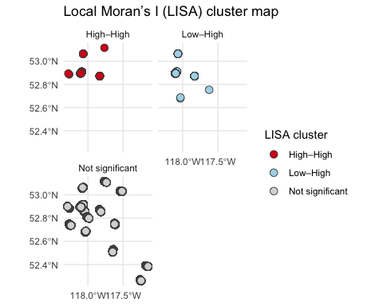

4.5.2 New reference site comparisons
The 2024 Jasper Wildfire severely burned two established acoustic transects (VALLEY5 and TEKKARA). While 41% of the montane (valley-bottom) forest has burned since 2023, two of three transects in this ecoregion were severely burned. The remaining transect is scheduled for Wildfire Risk Reduction treatment. To continue to monitor bird communities in unburned/untreated montane forest, we added two new reference transects in 2025 in the montane (COTTONWOOD and MUSHROOM), and we plan to continue to monitor all transects moving forward. We selected these new transects using Vegetation Resource Inventory data, identifying sites across the montane ecoregion with landcover types that matched the pre-fire dominant land cover types of the burned transect. Final transect placement followed the original sampling design criteria.
To assess whether the new transects were appropriate references for montane transects, we evaluated how similar their species assemblages were to those observed at existing montane transects over the past four years (2023-2026), excluding the TEKARRA and VALLEY5 transects post-fire because these were expected to diverge substantially due to fire severity. Specifically, we compared species detections from the COTTONWOOD and MUSHROOM transects to the distribution of detections across all other montane points to quantify compositional similarity and departure from the montane baseline. Representativeness of control transects was assessed using a multivariate dispersion analysis (PERMDISP) based on Bray–Curtis dissimilarity, with distances of new transects to the montane centroid compared against the distribution of distances among established montane transects. Statistical significance of differences in dispersion was evaluated using a permutation test with 999 iterations.
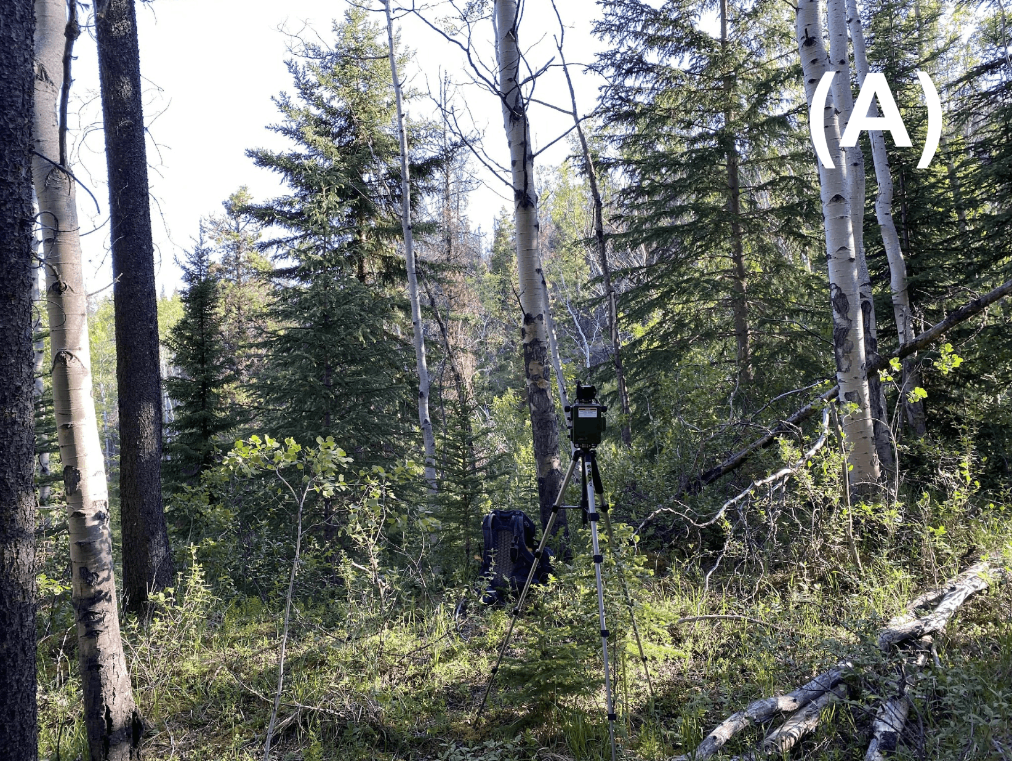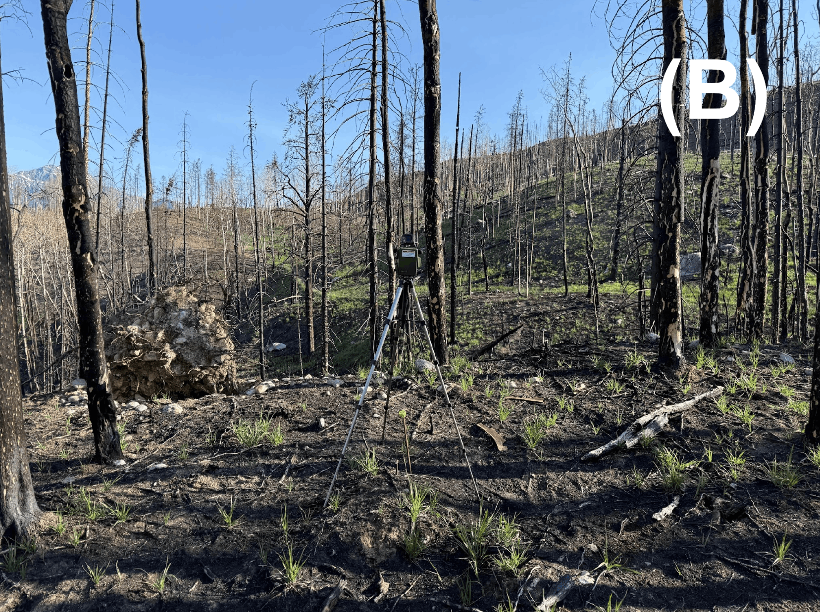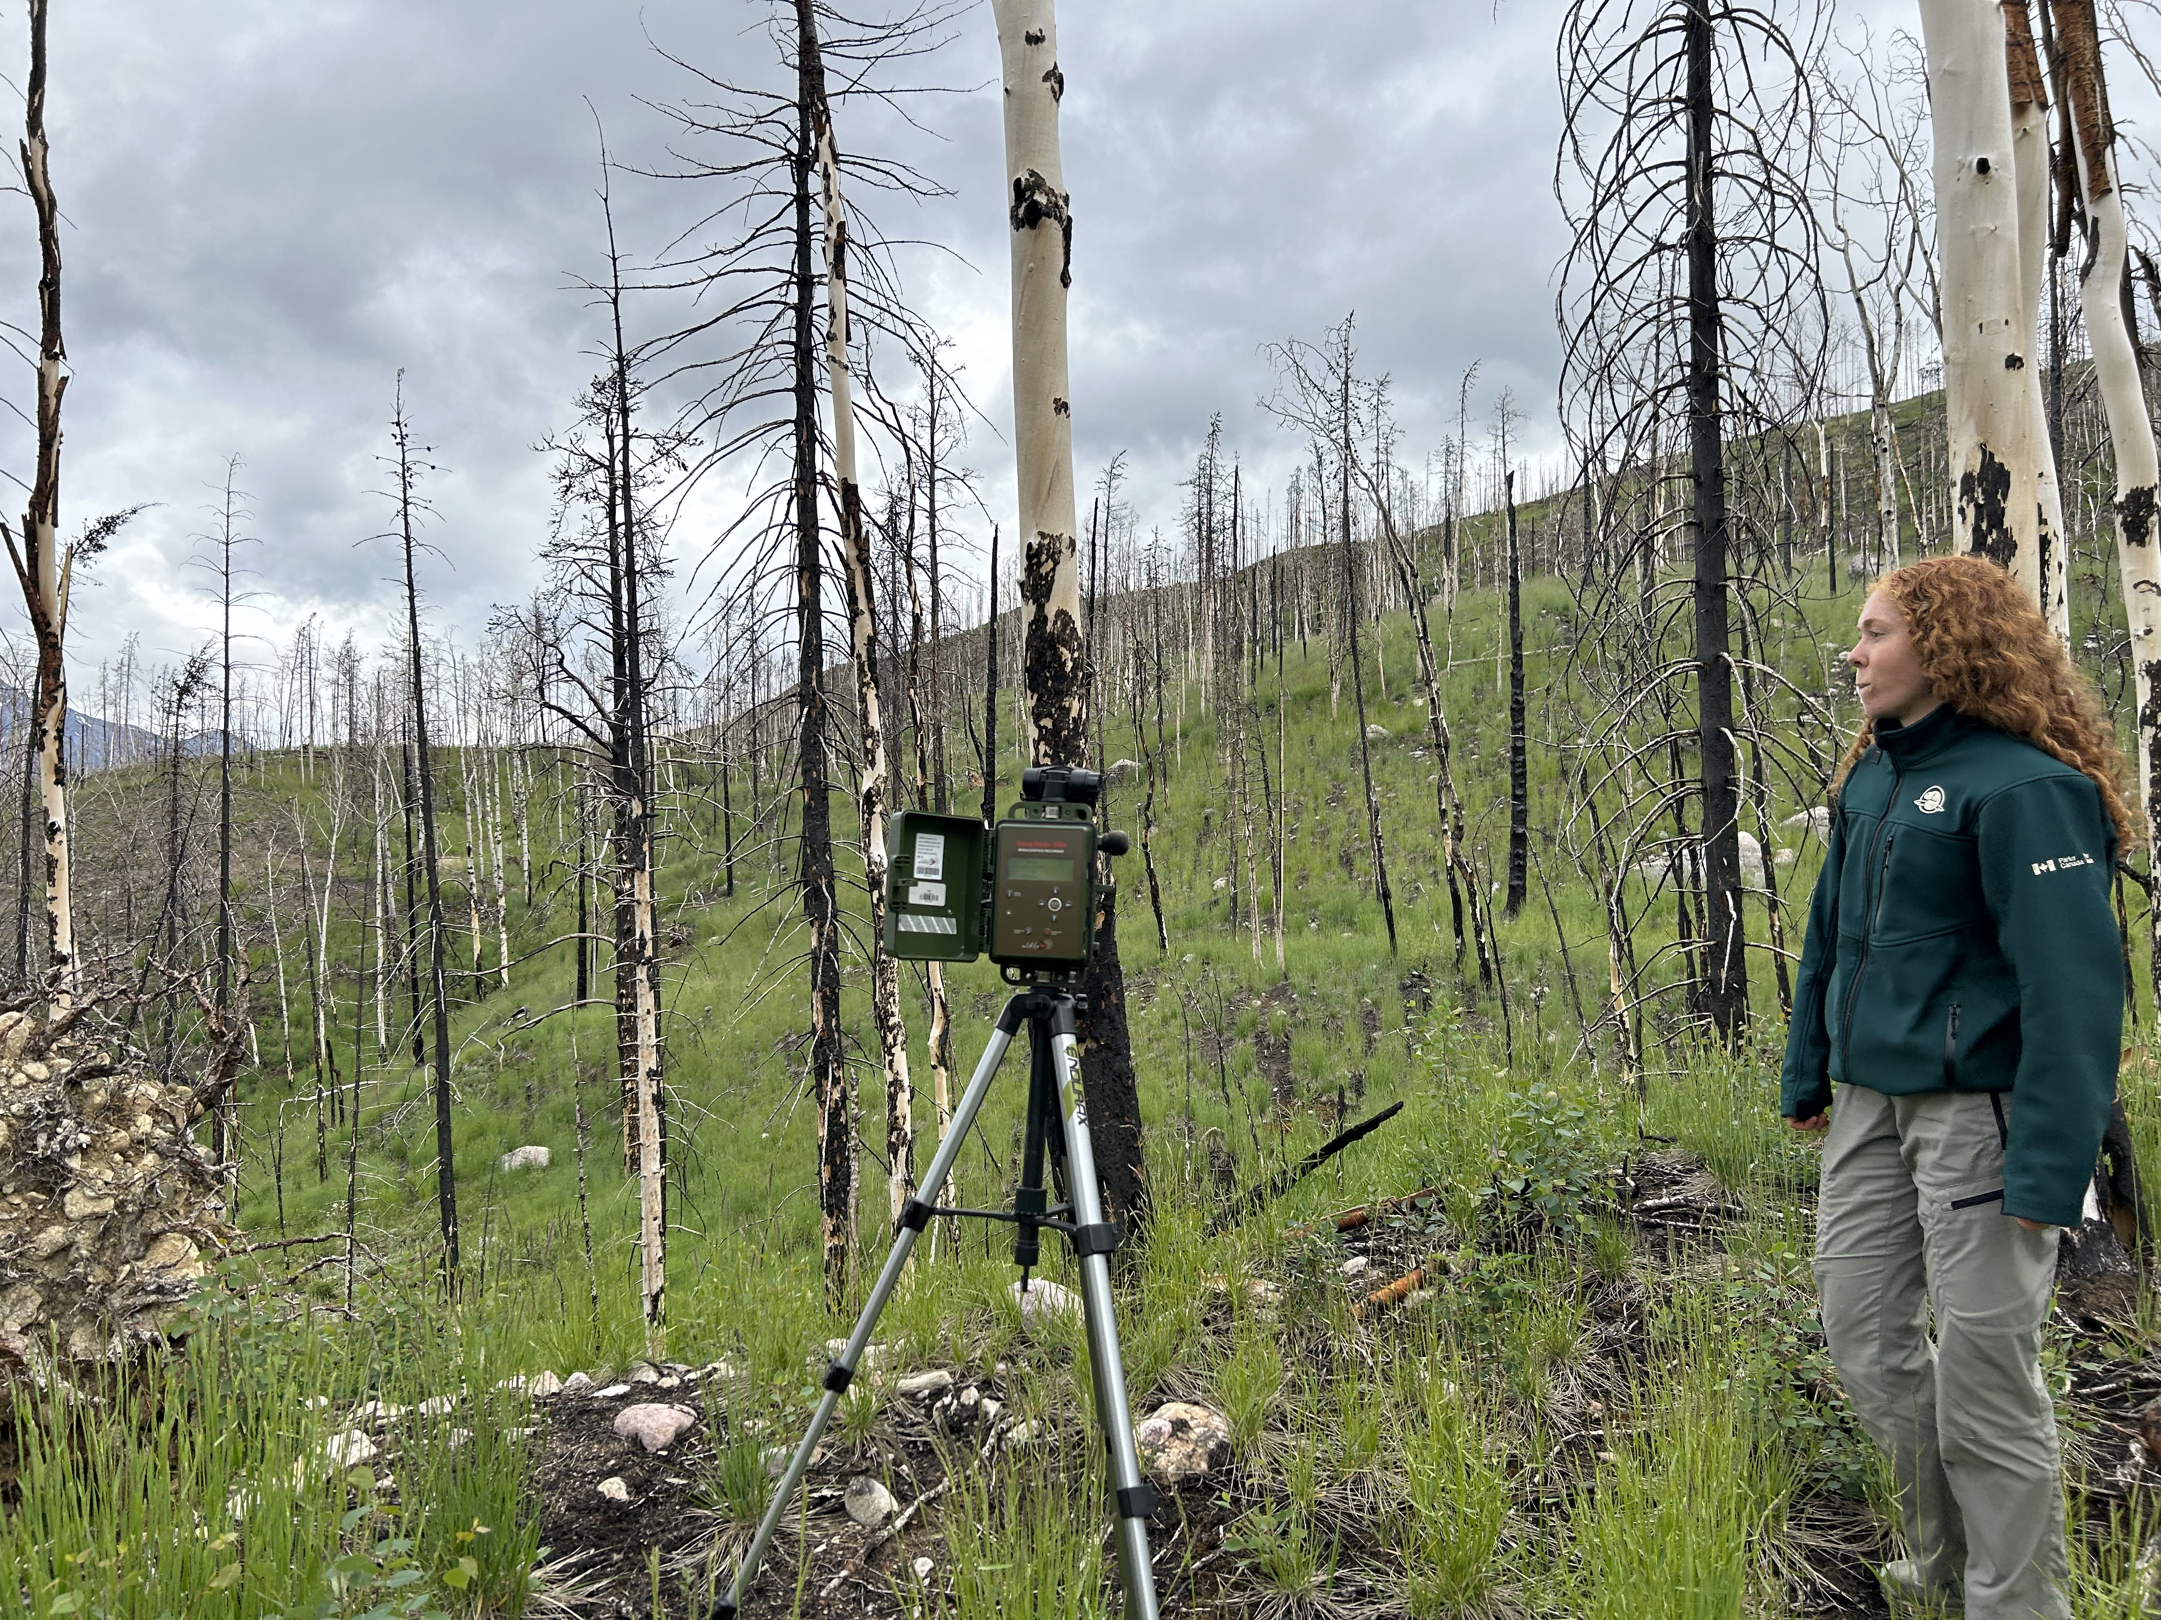
Tekarra 9 site photos views from 2023 (A) pre-fire, 2025 (B) post-fire and 2026 (C) two years post-fire.

4.5.3 Transcription observer comparisons
Transcription methods varied (Table 3) over time. Recordings from 2007 to 2020 were classified by a small number of repeat observers (legacy), while subsequent data were classified by a random selection from many observers (WildTrax). To evaluate consistency between the legacy dataset and the modern WildTrax workflow, we analyzed a subset of recordings processed using both approaches. This included re-processed legacy recordings that 1) enabled total abundance estimates and 2) used new observers in WildTrax, allowing for direct comparison of individual observer performance between the legacy and modern protocols. For each dual-processed recording, we derived the maximum count of individuals per species identified by each specific observer. We used two different metrics to verify data continuity. First, we calculated pairwise Pearson correlations between observers to quantify consistency in abundance estimates and identify systematic deviations in counts. Second, to evaluate consistency in species detection (composition), we binarized the data to presence/absence and calculated Bray–Curtis dissimilarities between individual observers. We then applied hierarchical clustering to these dissimilarity scores to verify that the transition to WildTrax did not introduce observer-specific biases in species identification or community composition.

4.5.4 Selection of species and guilds for trend analysis
The monitoring program dataset produced detections for 77 alpine and 140 montane species. Following recommendations to prioritize species with sufficient statistical power (Prowse et al. (2021)), we restricted our analysis to native terrestrial bird species for which: (a) Jasper National Park is their breeding range; and (b) the total count across all point count sites exceeded 20 individuals (see Table 4). Applying these criteria resulted in a final list of 20 focal species. This selection process retained 90.24% of all individual detections recorded by the program, ensuring that the analysis captured the vast majority of the biological signal while removing rare or vagrant species that would destabilize trend estimates.
To assess trends in species’ abundances and interpret community-level ecological responses, we assigned species to guilds. Guilds are groups of species that respond in similar ways to environmental changes as a result of similar uses of the environment (Doser et al. (2021)). Directional trends in abundant species can strongly influence the trend of the guilds of which these species are members. Given this limitation, trend analyses of ecological guilds often warrant further examination of common patterns of change among species within the guild. For example, if we find large variation in abundance trends across an ecoregion but not across bird guilds, this may suggest a consistent effect on the entire bird community (Doser et al. (2021), which can determine if management should target a whole community, specific guilds or individual species. If all or many species within a guild show similar trends in relative abundance, then factors affecting the guild-related life history attributes deserve attention. Pacifici et al. (2014) recommend using bird guilds in post-hoc assessment. Species were assigned to guilds using the Birds of North America, Elton Traits Database and bird guidebooks. To examine responses by different guild types we assigned birds by migratory guild, Elton trait, dietary guild, and habitat guild (Table 4).

4.5.5 Ecoregion community composition analysis
To characterize bird community composition, we aggregated species-level observations into a species-by-location matrix, populated with the maximum count of each species at each location. Survey points were then classified into two primary ecoregions: alpine and forested. For the purpose of this analysis, the forested category served as a broad aggregate, grouping the upper subalpine, lower subalpine, and montane ecoregions into a single unit that refers to high elevation habitat below and near treeline. We quantified the variation in community composition explained by these two ecoregions using Redundancy Analysis (RDA) in the vegan package (Oksanen et al. (2025)) and visualized species–ecoregion relationships with ordination plots (C. Radhakrishna Rao (1964)). Finally, to test for statistical differences in composition between the Alpine and Montane groups, we performed a permutational multivariate analysis of variance (PERMANOVA; Anderson (2001)). This test was conducted on Bray–Curtis dissimilarities using 999 permutations under a reduced model.

4.5.6 Functional and community-level diversity
To evaluate community-level ecological responses, we examined temporal changes in three complementary diversity metrics: functional diversity, species richness, and community structure. First, we quantified functional diversity using Rao’s Q (C. R. Rao (1982); Laliberté and Legendre (2010)), calculated via the dbFD() function in the FD package (Laliberté, Legendre, and Shipley (2014)). This metric estimates the average difference in functional traits between any two random individuals in the community. We also calculated species richness (number of unique species per location per year) and Shannon’s diversity index (Shannon (1948)), which integrates richness and evenness to describe community structure. These metrics were modeled through time using linear, mixed-effects, and segmented regression models to detect both gradual and threshold-type changes. Results were summarized graphically by ecoregion and functional guild to highlight spatial variation in diversity trajectories.
Table 4: Guilds
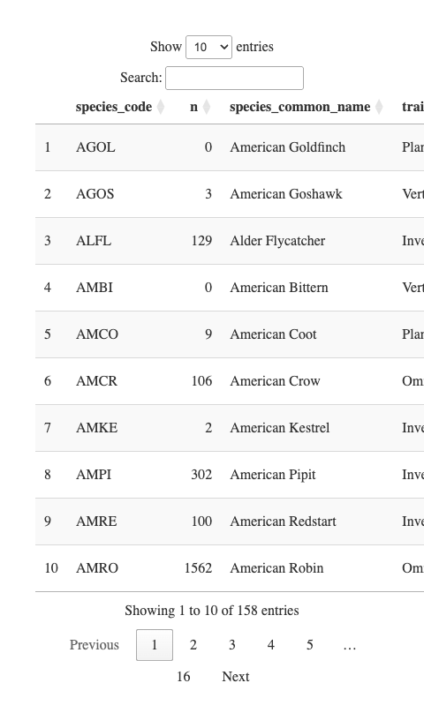

4.5.7 Jasper 2024 fire effects
We characterized the shift in bird community composition on the VALLEY5 and TEKARRA transects post-fire using redundancy analysis (RDA) using the vegan::rda function. We constructed a species-by-site community matrix using maximum abundance counts, restricting the pre-fire baseline to data from the montane ecoregion collected over the three years prior to the wildfire (2022–2024). We then modeled community structure as a function of years since fire with years < 2024 being 0. This constrained ordination allows us to quantify the variation in species assemblages explicitly explained by the fire event and visualize the directional responses of individual species across years.

4.5.8 Trend analysis
To quantify temporal changes in bird populations and community composition from 2007 to 2026, we analyzed trends in species-specific abundance, in forest and alpine ecoregions separately, and grouping species by functional guilds. Analyses were designed to separate biological change from potential sampling and methodological effects, ensuring that observed patterns represented genuine ecological responses. This was achieved through a multi-step framework that (1) evaluated and modeled detection probability and methodological variability, (2) estimated detection-corrected abundance, and (3) evaluated long-term directional trends and associated shifts in functional and community-level diversity.
INSERT Generalized framework model figure

4.5.8.1 Detection-corrected abundance estimation
Abundance was estimated using single-visit N-mixture abundance models implemented in the detect::svabu() function (Sólymos, Lele, and Bayne (2012)). This framework jointly models site-level abundance with observation and detection probability from single-visit counts as conditional likelihood estimates. The package and framework make it easy for users to add and interpret observation and detection covariates which supports logistical considerations for single-visit surveys. We first stratified analyses by ecoregion (alpine vs. forested), fitting separate detection-abundance models given the assumption site characteristics and ecological drivers are different in both ecoregions. Expected abundance per site visit was modelled using the latent abundance component (λ).

4.5.8.2 Alpine model structure
For alpine model selection, we constructed a candidate model set incorporating observation and detection covariates performed model selection ranked via BIC, which applies a stronger penalty for model complexity than AIC and is appropriate for large candidate model sets [CITATION]. We also determined distribution and zero-inflation of each model for each species and assigning the appropriate type prior to model runs. We scaled all continuous variables including year in order to detect temporal abundance trends. Julian date, hour, detection time, data type (method of data processing) were also included as detection covariates.
- **Abundance submodel
- **Detection submodel

4.5.8.3 Forested model structure
In the forest model selection, the candidate model set was again ranked via BIC but included the following ecoregion-specific variables: scaled variables for year, shrub cover, conifer cover, wetlands, herbaceous cover, and rock and soil (bedrock, exposed soil). The burned class exclusive to TEKARRA and VALLEY5 locations in 2026 was added to models but created complexity in the models by variance inflation factor testing.
- **Abundance submodel
- **Detection submodel

4.5.8.4 Percent change evaluation
Temporal trends were quantified using the modified Mann-Kendall test (Mann (1945a); Hamed (2009)), which includes variance correction for autocorrelation between years, and detects monotonic directional change, and Sen’s Slope (Pranab Kumar Sen (1968)), which estimates the magnitude of those trends. Both tests were implemented via the modifiedmk package (Hamed and Rao (1998)) and applied to the detection-corrected abundance estimates (λ̂). Sen’s slope provides an estimate of the median annual rate of change in the abundance index over the time series. To express this rate in a standardized and interpretable way, we converted Sen’s slope to a percent change per year by dividing the estimated slope by the mean annual abundance index across the full time series and multiplying by 100. This metric represents the average proportional change in abundance per year, relative to the long-term mean abundance of the species in that ecoregion. Positive values indicate increasing abundance, while negative values indicate declining abundance. We quantified this percent change as both an annual change in the mean abundance as well as the percentage change across the entire time period. We also quantified annual abundance trends within each ecoregion, grouped by functional guild: diet guild (frugivore, nectarivore, insectivore, omnivore, granivore, and vertebrate-fish-scavenger), habitat guild (forest generalist, habitat generalist, wetland, late-successional forest, and grassland-shrubland-alpine), and migratory guild (long-distance migrant, short-distance migrant, and winter resident).

4.5.8.5 Climate-trend evaluation
Abundance estimates (λ̂) were joined with species-level migratory guild classifications and site-level climate data by location and year. Migratory guild labels were standardized prior to analysis. Data were aggregated to the year × ecoregion × migratory guild level by calculating mean abundance (λ̂) and mean climate variables, including spring temperature Tave), precipitation metrics, and associated anomalies. To facilitate comparison of temporal trends, variables were standardized (z-scored) within the full dataset. Scaled abundance and temperature were visualized over time using linear model fits within each guild–ecoregion combination. To quantify climate–abundance relationships, Pearson’s correlation coefficients (r) were calculated between mean annual temperature (Tave) and mean abundance (λ̂) for each migratory guild within each ecoregion, using one value per year to avoid pseudoreplication.

5. Results
Note
Some of these analyses are still a work-in-progress. Check back soon for updates and additional details.

5.1 New reference site comparisons
Multivariate dispersion was similar between the new reference transects (COTTONWOOD, MUSHROOM) and established montane controls (PERMDISP; F = 0.004, p = 0.956). Although control transects exhibited a slightly higher median distance to centroid (mean = 0.407), their distributions overlapped strongly with those of the new montane reference transects (mean = 0.406), indicating no evidence of increased dispersion or outliers unique to the new sites (Figure 5). This suggests that the new reference transects are not compositionally distinct from existing montane transects and fall within the natural variability of montane bird communities already sampled. Consequently, the addition of these sites is unlikely to introduce systematic bias, supporting their use as valid representatives of montane bird communities for pre- and post-fire comparisons.
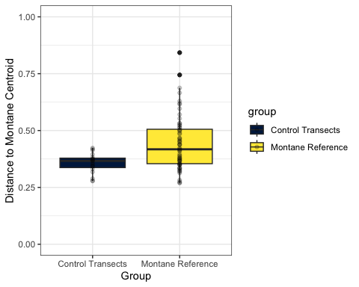
Figure 5: Distances to the montane centroid are similar (distributions overlap strongly) between the control and the montane reference groups.

5.2 Transcription observer comparisons
Analysis of dual-processed recordings indicates that while absolute abundance estimates may vary between observers, the composition of detected species remains consistent. Mean Pearson correlations, visualized as a heatmap in Figure 6, revealed some variability in species presence and counting intensity. Although observers differed in the total number of individuals recorded, they consistently identified the same species as being the most or least abundant. These results help confirm that species identification remained stable across protocols, supporting the decision to pool data for the final analysis (with modern WildTrax results prioritizing where duplicates existed).
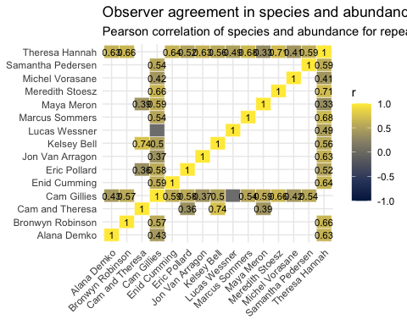
Figure 6: Heatmap of Pearson’s correlation coefficients (r) comparing species detections and abundance estimates among observers processing the same recordings. Positive values indicate agreement, while negative values indicate divergence in species identification and abundance estimates.

5.3 Ecoregion community composition analysis
Figure 7 shows the relationship between species and ecoregion. The PERMANOVA test was performed using Bray-Curtis dissimilarity to assess whether community composition significantly differed between ecoregion groups. The analysis revealed a significant difference in bird community composition between alpine and forest groups (F(1,128) = 52.62, R² = 0.29, p = 0.001 indicating a substantial divergence in species composition between ecoregion groups, justifying the decision to analyse trends separately for these two groups.
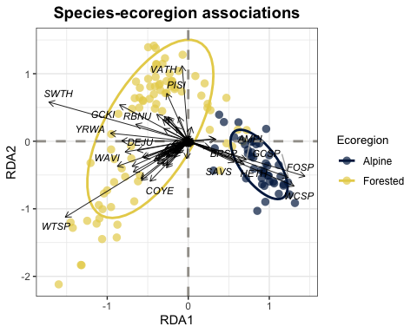
Figure 7: Community matrix of species associations between forested and alpine ecoregions

5.4 Functional and community-level diversity
Rao’s Q averaged between about 8.2 and 10.5 across survey locations, with a clear upward tendency over time Figure 9. The non‑parametric Mann-Kendall test gave Kendall’s τ of 0.32 (p ≈ 0.07), indicating a positive but marginally non‑significant monotonic increase in functional diversity. A breakpoint regression analysis identifies a shift in functional diversity around 2009, suggesting that diversity was relatively low and stable from 2007-2009, then rose to more variable but generally higher values from 2010 onward. Species richness per location is shown in Figure 9 and Shannon’s diversity index over years is shown in Figure 10. Shannon diversity increased slightly over time (β = 0.0063 per year, SE = 0.0015, t = 4.20), after accounting for differences among locations and ecoregions. Montane communities exhibited higher diversity than Alpine (β = 0.28 ± 0.067, t = 4.15), and location-level variation remained substantial (SD = 0.35).
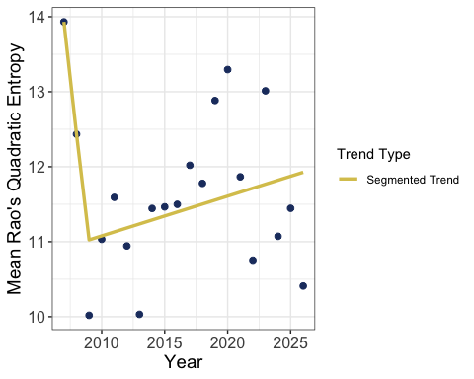
Figure 8: Mean functional diversity (Rao’s Q) over time
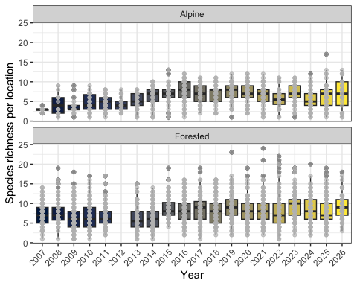
Figure 9: Species richness by year. Data from 2012 were excluded for montane sites because those sites were not sampled that year.
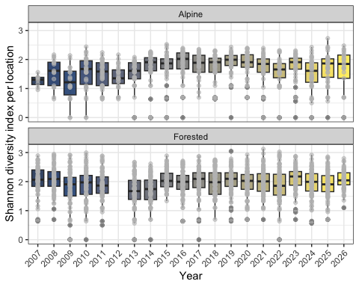
Figure 10: Shannon diversity index across years. Data from 2012 were excluded for forested sites because those sites were not sampled that year.

5.5 Jasper 2024 fire effects
The redundancy analysis (RDA) revealed a progressive reorganization of the bird community in the two years following the 2024 wildfire. Reference, 1-year post-fire, and 2-year post-fire survey points occupy increasingly separated regions along RDA1, the axis constrained by years since fire (Figure 11). Rather than shifting once and stabilizing, post-fire sites continued to diverge from Reference conditions between year 1 and year 2, with almost no overlap between the 2-year post-fire ellipse and the Reference ellipse. This indicates that, at least over this short time frame, the bird community has not begun returning toward its pre-fire composition — the reorganization driven by the fire is still deepening rather than reversing. Notably, the spread of sites within each fire period (ellipse size) was similar across all three groups, suggesting that fire has not made site-to-site composition more variable, but has consistently displaced it in a common direction. Species vectors help characterize this directional shift. Dark-eyed junco (Junco hyemalis, DEJU) again shows the strongest association with post-fire sites, consistent with its known tolerance of reduced canopy cover and simplified forest structure following disturbance. Swainson’s thrush (Catharus ustulatus, SWTH), Warbling vireo (Vireo gilvus, WAVI), Mountain chickadee (Poecile gambeli, MOCH), and Yellow-rumped warbler (Setophaga coronata, YRWA) remain most strongly associated with Reference sites, along with Tennessee warbler (Leiothlypis peregrina, TEWA), Alder flycatcher (Empidonax alnorum, ALFL), Ruby-crowned Kinglet (Corthylio calendula, RCKI), and Blackpoll Warbler (Setophaga striata, BLPW), all species generally tied to intact canopy cover and vertical foliage structure. Common Yellowthroat (Geothlypis trichas, COYE) stood out along PC1 rather than RDA1, indicating its abundance varies with background site-level factors unrelated to time since fire. Together, these results suggest that two years post-fire, the VALLEY5 and TEKARRA bird communities have not shown signs of recovery toward pre-fire composition — the community continues to reorganize around fire-tolerant, open-canopy species such as DEJU, at the expense of canopy-dependent species like SWTH, WAVI, and TEWA.
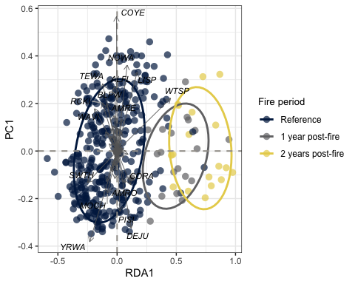
Figure 11: Community matrix of species associations before and after the Jasper 2024 fire on the VALLEY5 and TEKARRA transects. Movement along RDA1 reflects the direction and magnitude of fire-related change in species composition. PC1 captures residual variation in species composition that is not explained by fire period reflecting the background ecological variability among sites.

5.6 Trends

5.6.1 Single-species trends
Single-species trends, and their underlying coefficients with 95% CIs can be found in tabset below and Table 5. The full outline of declines over the entire period can be seen in Figure 12. Across ecoregions during the full study period, the proportion of species in decline differed substantially. In the forested ecoregion, 28 of 67 species exhibited declining trends, corresponding to 41.8% of assessed species. In contrast, the alpine ecoregion showed fewer declines, with 11 of 35 species classified as decreasing, representing 31.4% of species with estimated trends. These results indicate a higher prevalence of declining species in forested systems relative to alpine environments over the study period. However, the number of species with sufficient data to estimate trends was lower in the alpine ecoregion.
Table 5: Summary of trend of species by ecoregion. SOCB stands for ‘Status of Canada’s Birds’ from the according 2024 report.
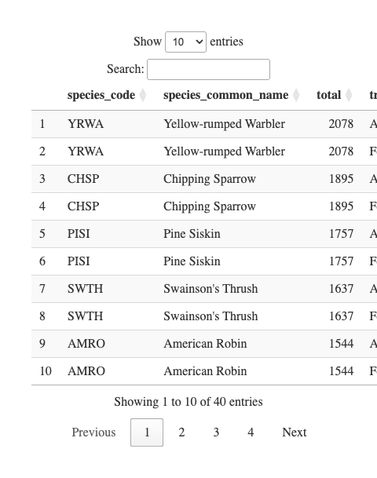

YRWA

CHSP

PISI

SWTH

AMRO
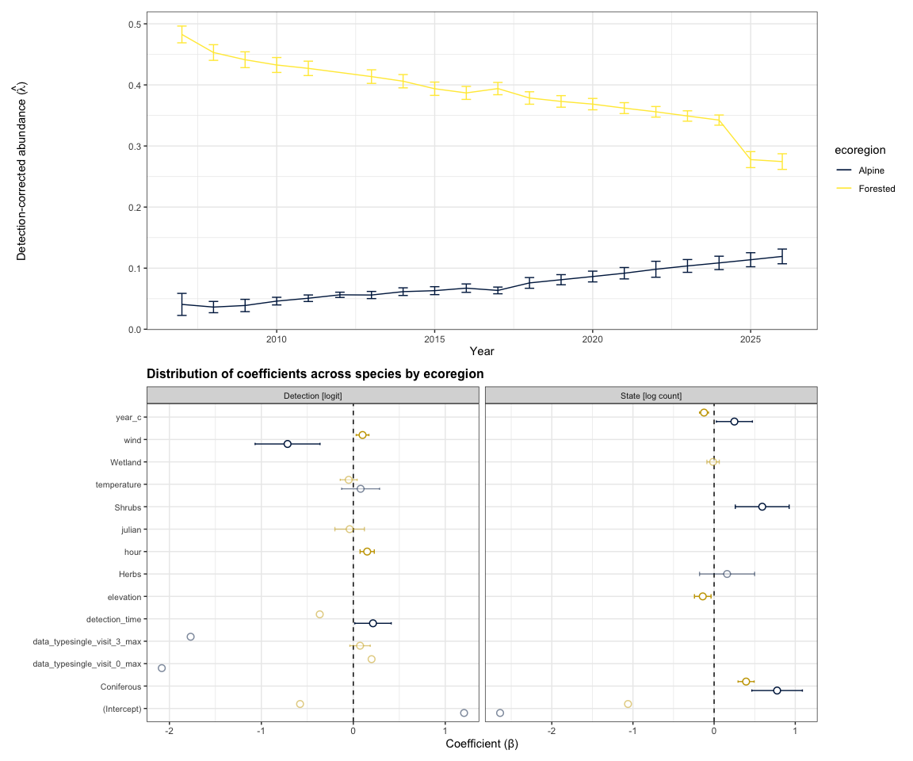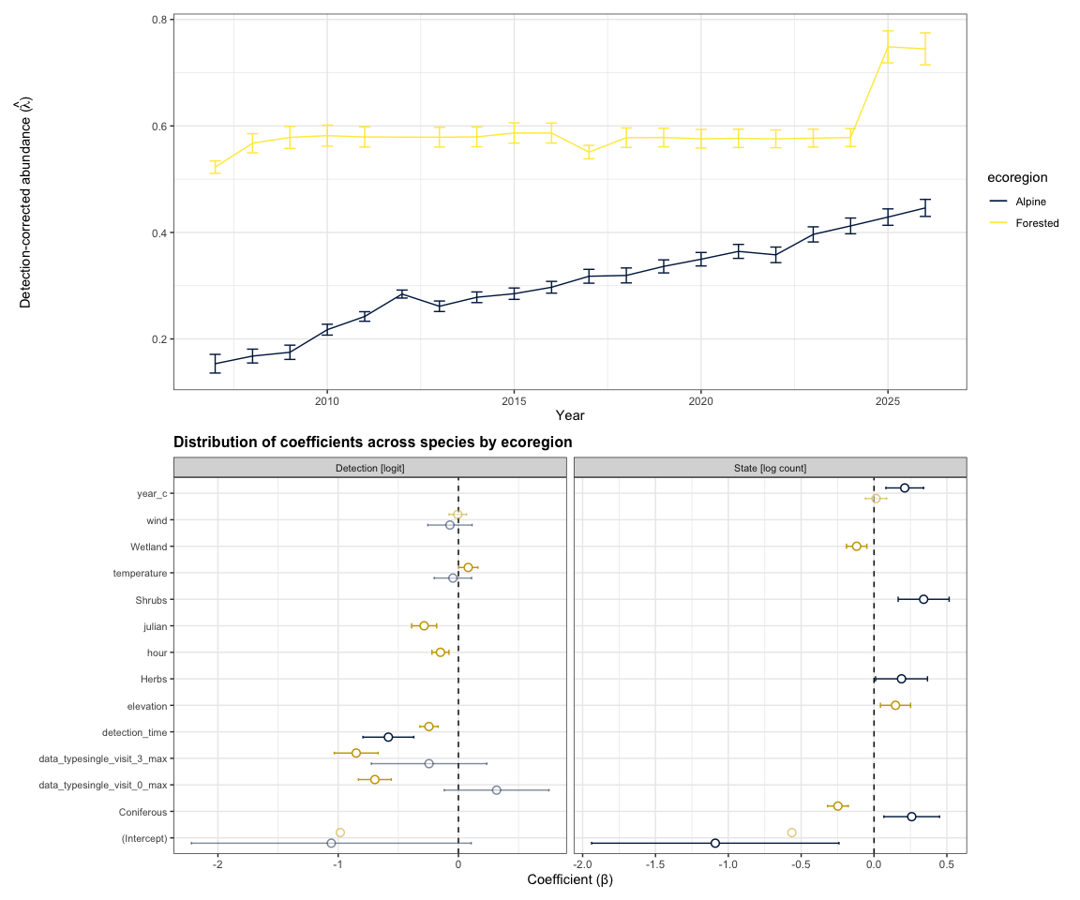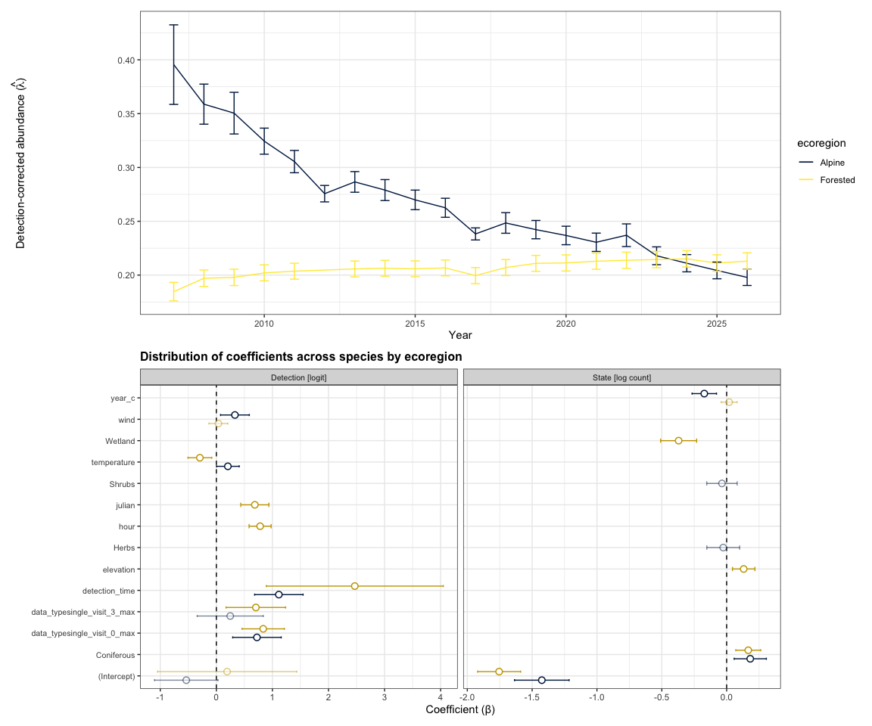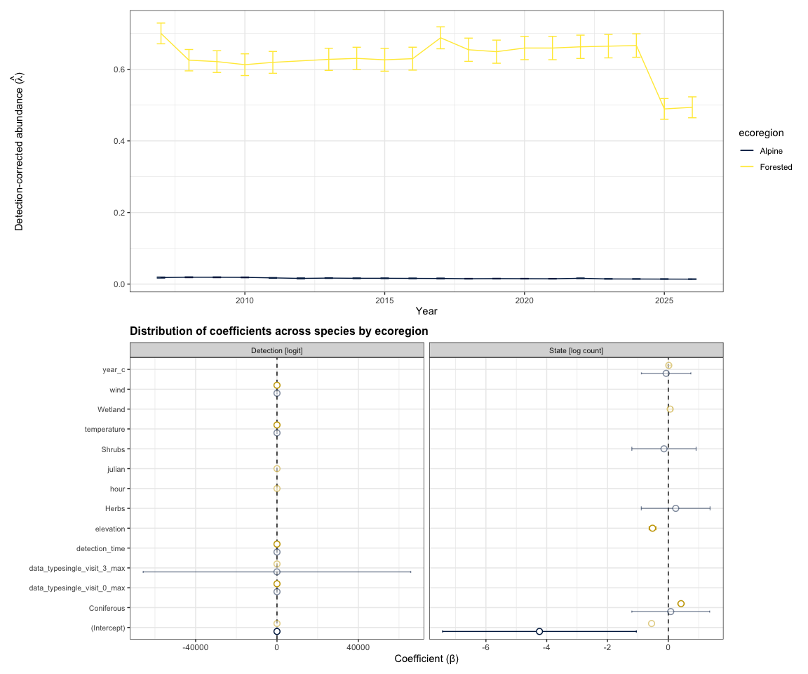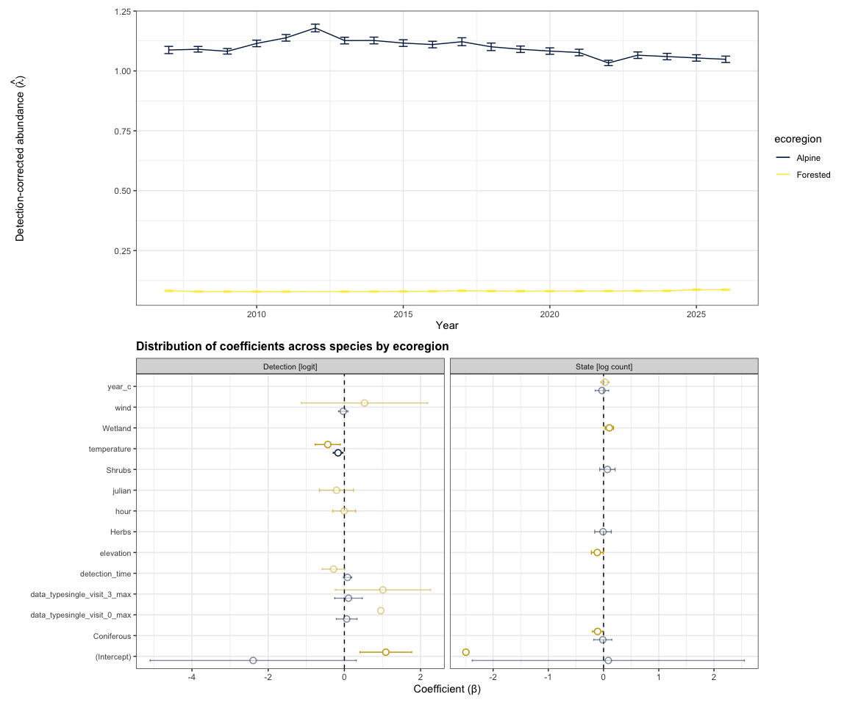
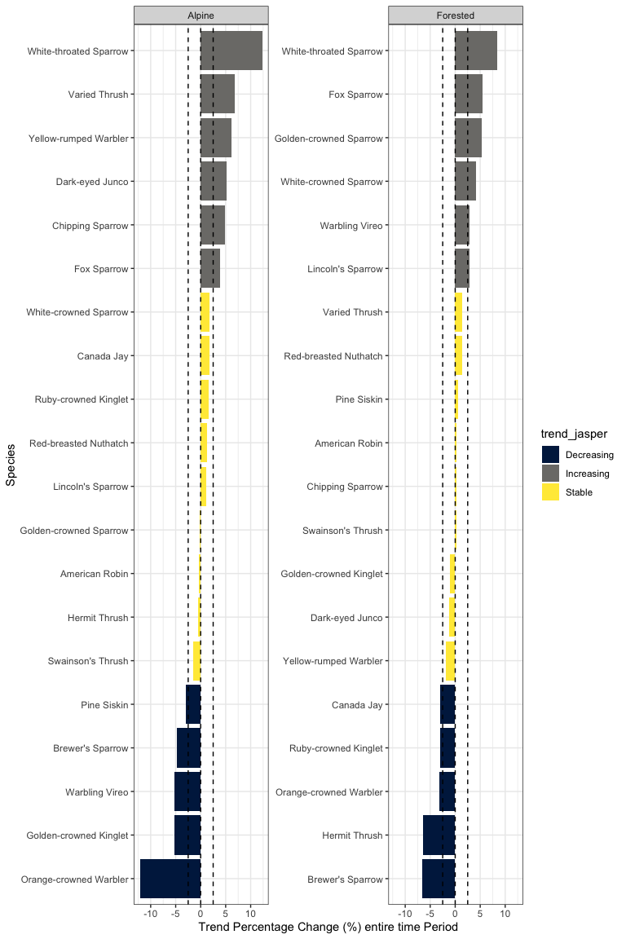
Figure 12: Percent change in average abundance trend per species and ecoregion across the full study period. Colours indicate whether the trend represents an increase (>+2.5%), stable (−2.5% to +2.5%), or decrease (<−2.5%) relative to baseline.

5.6.2 Guild trends
Trends grouped by guild can be found at Figure 13, Figure 14, Figure 15, Figure 16 and associated tables (Table 6, Table 7, Table 8, and Table 9). Across guild classifications, consistent patterns emerged alongside notable ecoregional differences. Declines were most pronounced among long-distance migrants in both ecoregions, indicating that species reliant on migratory connectivity are disproportionately affected regardless of habitat context. In contrast, short-distance migrants showed comparatively low rates of decline, particularly in the forested ecoregion, suggesting greater resilience or stability within regional movement strategies. Winter residents exhibited intermediate but still elevated declines, especially in forested systems. Habitat associations revealed stronger divergence between ecoregions. In alpine environments, interpretation was limited by smaller sample sizes, though forest generalists showed moderate declines, suggesting some sensitivity even among broadly adaptable species. In forested systems, declines were concentrated among grassland–shrubland–alpine species and habitat generalists, pointing to potential pressures on species using open or transitional habitats within predominantly forested landscapes. Late-succession forest species and forest generalists exhibited more moderate declines, while wetland-associated species appeared comparatively stable. Dietary guilds further reinforced these patterns of ecological sensitivity. In alpine systems, declines were most evident among granivore–herbivores, while other feeding guilds showed moderate or uncertain trends due to limited data. In forested systems, aerial insectivores exhibited the strongest declines of any guild, aligning with broader evidence of vulnerability in this group, while granivore–herbivores and insect gleaners also showed notable declines. Other dietary groups, including granivore–insectivores, aquatic species, and omnivores, showed comparatively lower or more variable rates of decline.
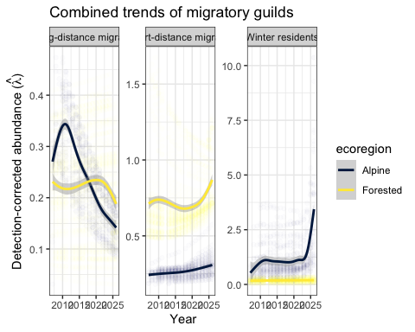
Figure 13: Summary of trend of migratory guilds
Table 6: Summary of trend of species grouped by migratory guild and ecoregion
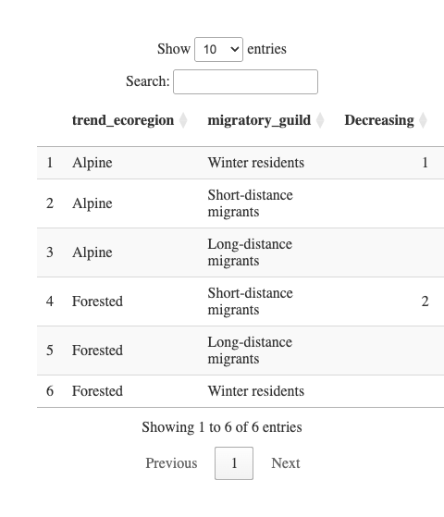
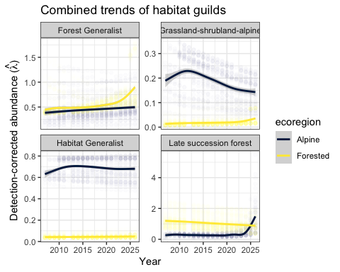
Figure 14: Summary of trend of habitat guilds
Table 7: Summary of trend of species grouped by habitat guild and ecoregion
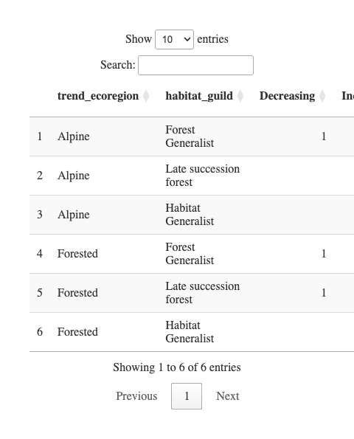
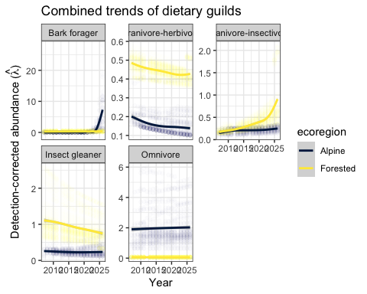
Figure 15: Summary of trend of feeding guilds
Table 8: Summary of trend of species grouped by dietary guild and ecoregion
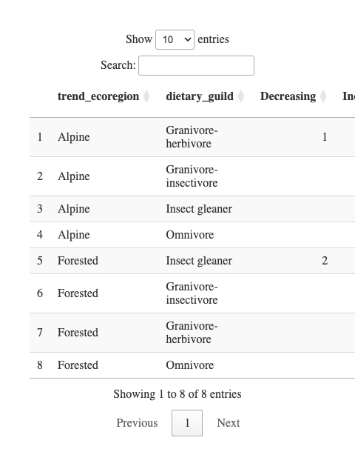
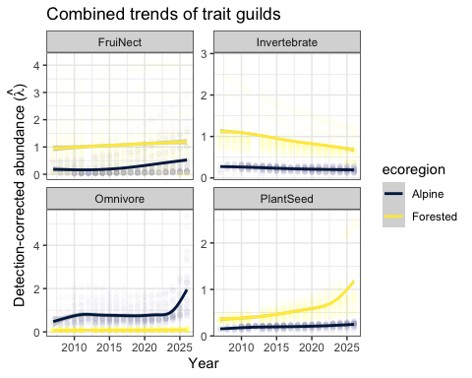
Figure 16: Summary of trend of feeding guilds
Table 9: Summary of trend of species grouped by trait guild and ecoregion
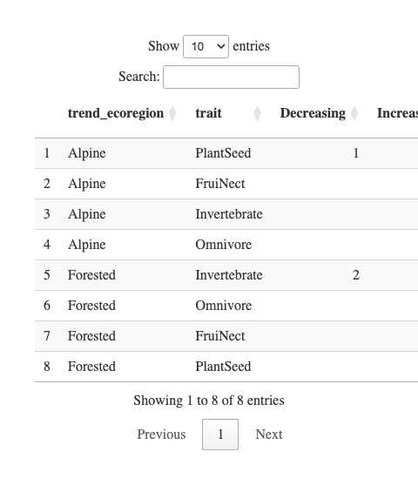

5.6.3 Trends with climate
Correlations between mean annual temperature and abundance were weak and not statistically significant across all migratory guilds and ecoregions (Figure 17, |r| ≤ 0.41, p > 0.05). In alpine systems, winter residents showed the strongest negative association (r = -0.41, p = 0.093), while short-distance migrants exhibited a weaker negative trend (r = -0.17, p = 0.499). Long-distance migrants showed little relationship with temperature (r = 0.08, p = 0.744). In forested systems, all guilds exhibited negative correlations, with the strongest observed in long-distance migrants (r = -0.39, p = 0.123), followed by short-distance migrants (r = -0.31, p = 0.235) and winter residents (r = -0.27, p = 0.293). Overall, these results indicate no statistically supported relationship between temperature and abundance, although the predominance of negative correlations suggests a consistent but weak tendency for abundance to decline with increasing temperature across guilds.
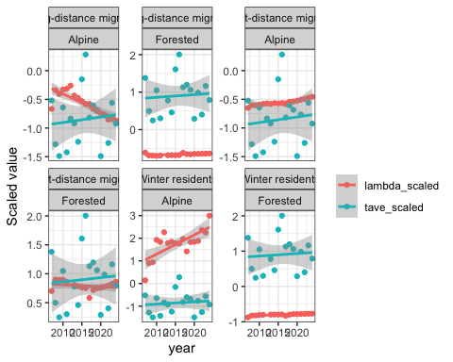
Figure 17: Scaled relationship of abundance estimates with average spring temperature over a 3-year moving window.
Table 10: Pearson’s correlations between average spring temperature using 3-year moving window average.
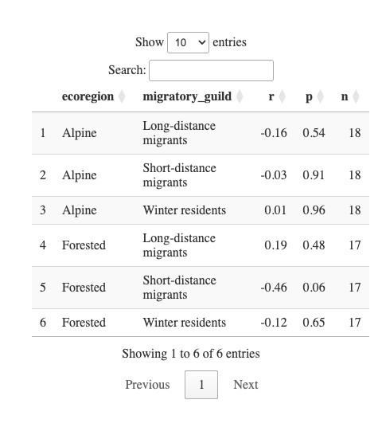

6. Discussion and recommendations

6.1 Flocking and gregarious species
Point count and acoustic surveys are poorly suited to estimating abundance for flocking and gregarious species such as fringillids, corvids, and family-grouped passerines. Detections of these species at a single location often reflect a single flock or family group rather than independent individuals, violating the closure and independence assumptions underlying the svabu framework. As a result, estimated abundance for these species should be interpreted cautiously and may be better understood as an index of presence or activity rather than a reliable count of individuals. This limitation is discussed in detail in Stralberg et al. 2025.

6.2 Limitations of vegetation variables
Habitat covariates were derived from the BC Vegetation Resource Inventory (VRI) for a single reference year (2020) and assigned to survey locations as static attributes. These variables therefore represent a snapshot of vegetation conditions and do not capture the structural and compositional change that occurred across the full study period (2007–2026). Vegetation communities are dynamic: canopy closure, shrub density, and stand structure shift over time through succession and disturbance processes such as wildfire, insect outbreaks, and windthrow. Assigning a fixed 2020 habitat state to detections from 2007 or 2026 means that habitat attributes may not reflect conditions at the time of detection, particularly at locations that experienced notable change during this interval. As a consequence, estimated abundance trends may not fully account for habitat-driven variation in detection probability or location quality over time. This is a recognized limitation of long-term monitoring programs that rely on periodic or single-epoch vegetation inventories, and future analyses would benefit from incorporating temporally dynamic habitat layers to better disentangle habitat change from genuine abundance trend.

6.3 Influence of environmental variables and climate
Weather effects on avian detection are well established but tend to be guild-specific and heterogeneous in direction. Morelli et al. (2022) found that wind negatively affected detection of insectivores and granivores but had no effect on omnivores; opposing responses of this kind are likely to cancel when aggregated across the full community, which may explain the weak weather signals observed in our exploratory GLMs. Despite these muted effects, temperature and wind were retained as covariates in the svabu models given their established influence on avian activity and detectability.
Climate variables beyond immediate survey conditions are not currently included in the svabu models, and this represents a more fundamental gap. Plots of scaled abundance (λ) alongside mean annual temperature suggest potential climate associations across guilds and ecoregions, in several cases, particularly long-distance migrants and winter residents in forested ecoregions, λ and temperature trend in opposing directions over the study period. These are visual associations only and should not be interpreted causally, but they motivate formally incorporating climate into the abundance or detection process in future model iterations.
This is an important next step given the breadth of climate-driven change already documented in bird communities across western North America. Poleward range shifts are estimated at 1.1–2.2 km per year (Martins et al. 2024; Neate-Clegg et al. 2024), upslope elevational shifts average 1.2 m per year — with considerable among-species variability ranging from 10.4 m downslope to 18.1 m upslope — and breeding phenology has advanced by approximately 0.08 days per year (Neate-Clegg et al. 2024). If species are tracking shifting thermal conditions by moving upslope or arriving earlier, abundance trends estimated at fixed monitoring locations may partly reflect distributional change rather than true population change. Incorporating temperature or other climate covariates into the svabu abundance process would allow these signals to be partitioned more cleanly and would substantially strengthen the inferential value of long-term trend estimates.

6.4 Single-species trend models

AMRO

BRSP

CAJA

CHSP

DEJU

FOSP

GCKI

GCSP

HETH

LISP

OCWA

PISI

RBNU

RCKI

SWTH

VATH

WAVI

WCSP

WTSP

YRWA
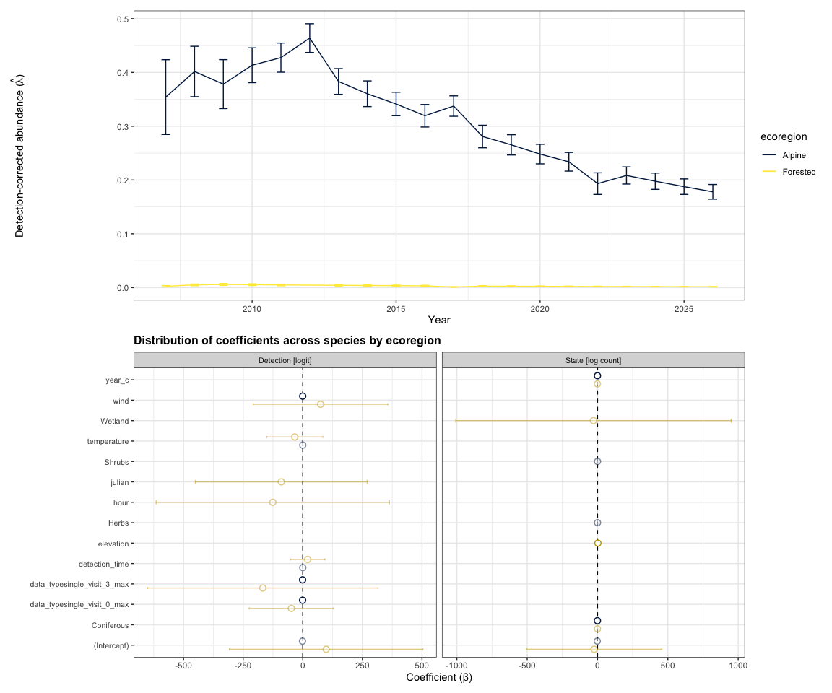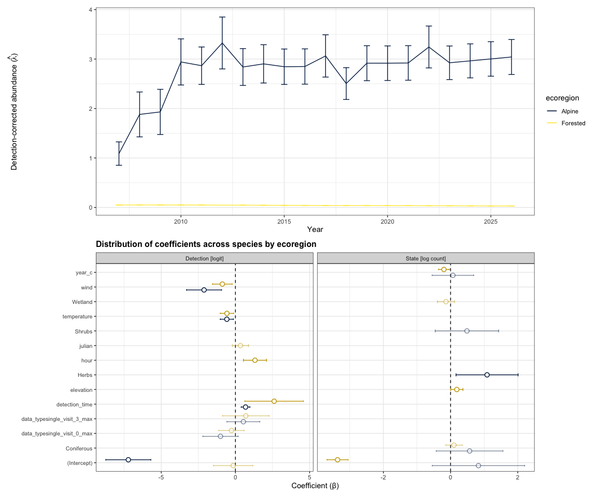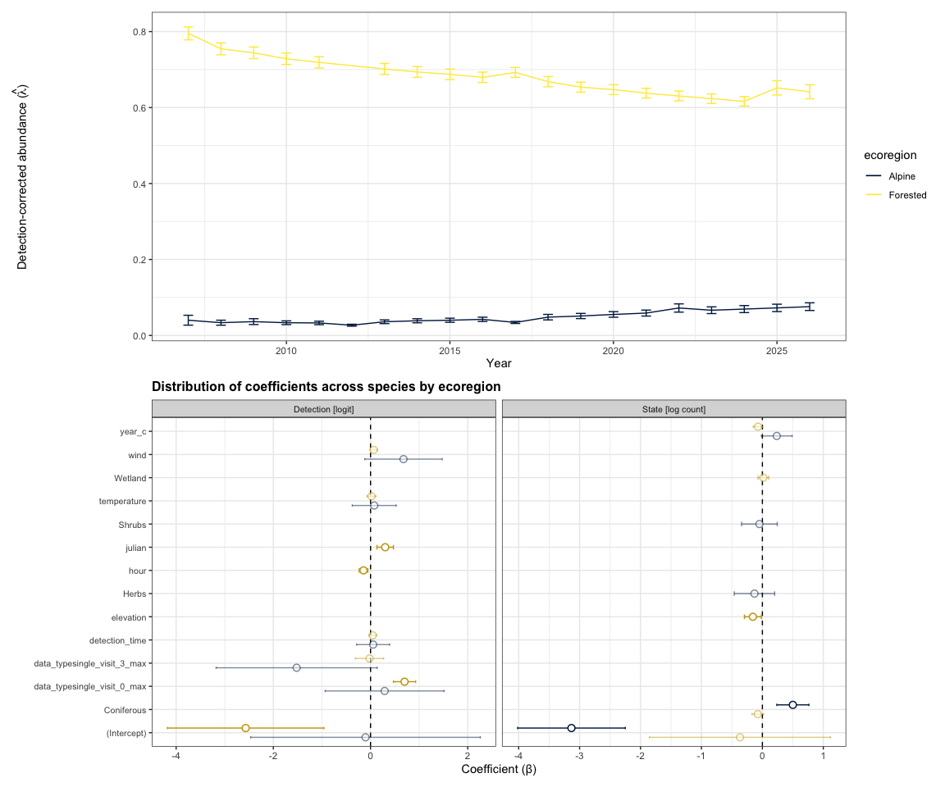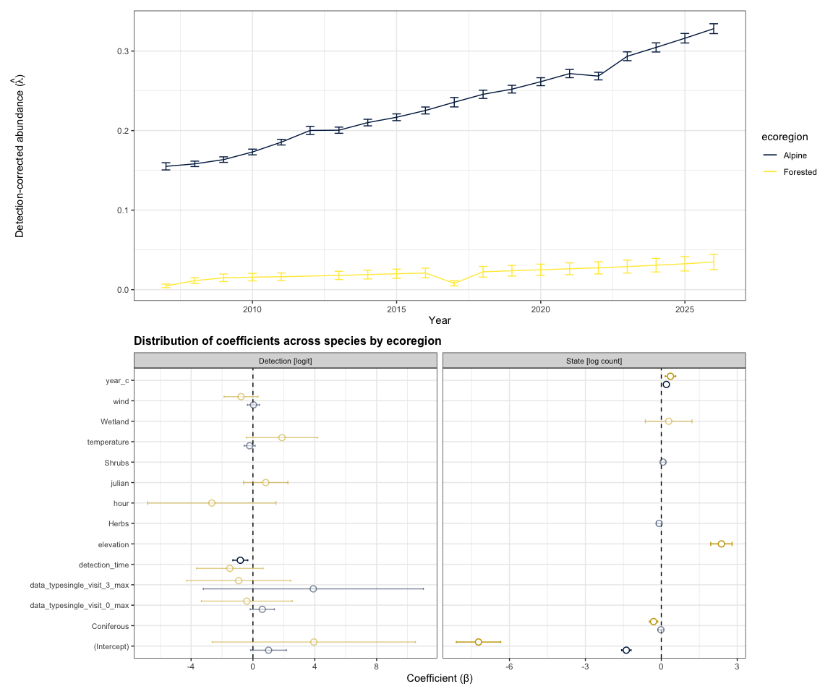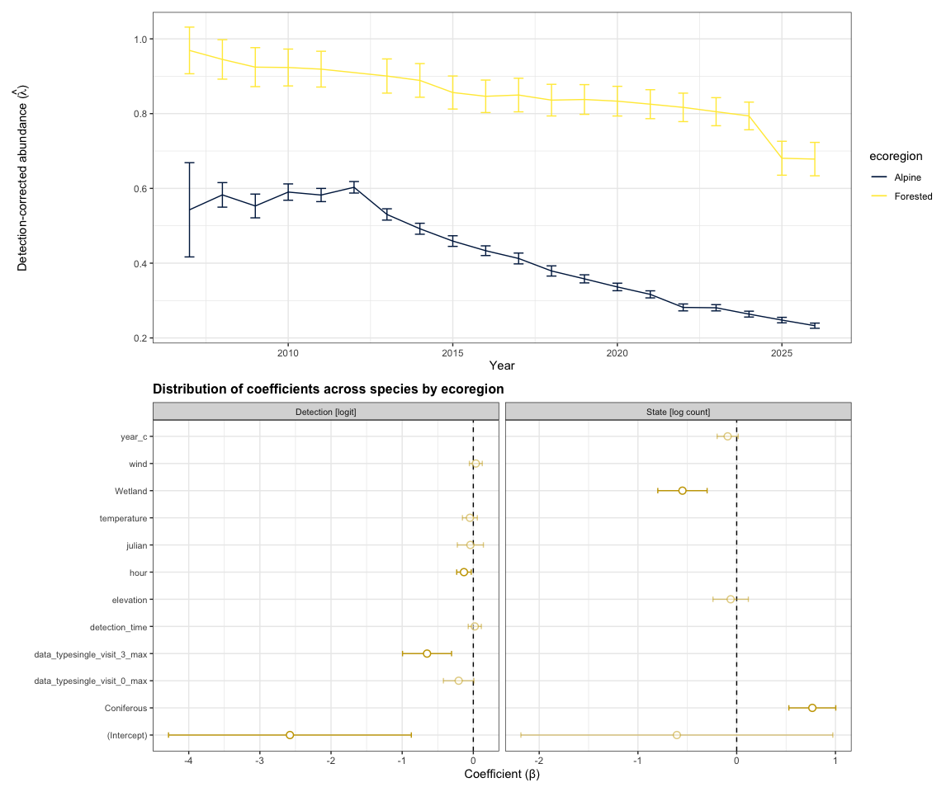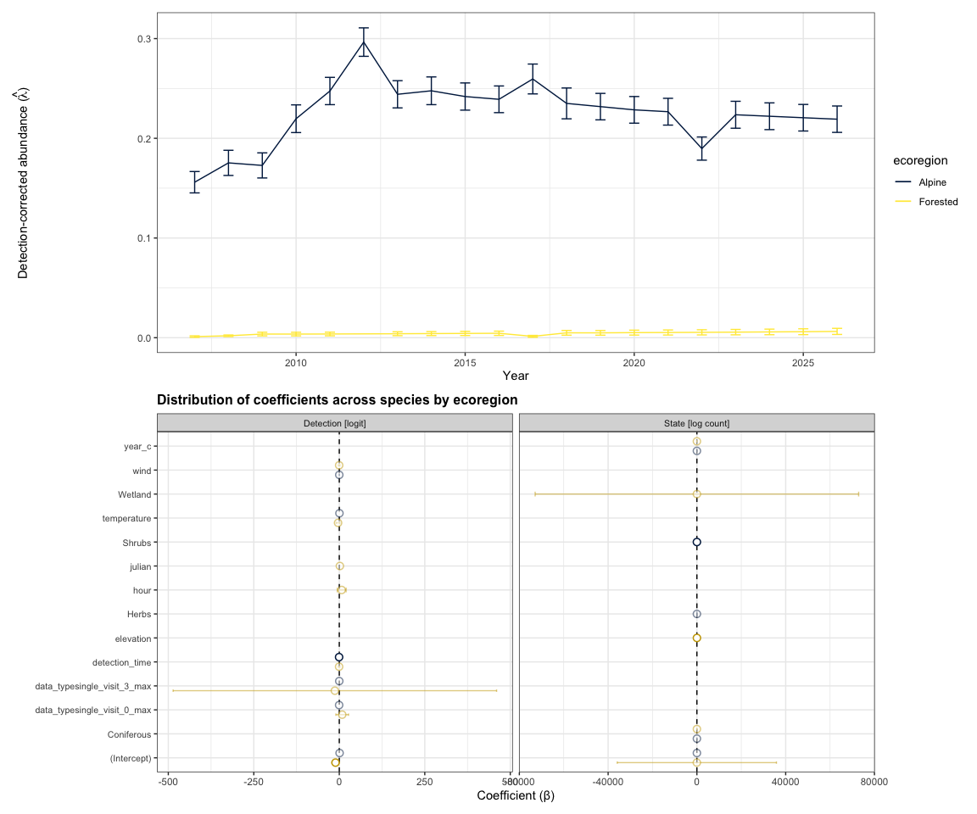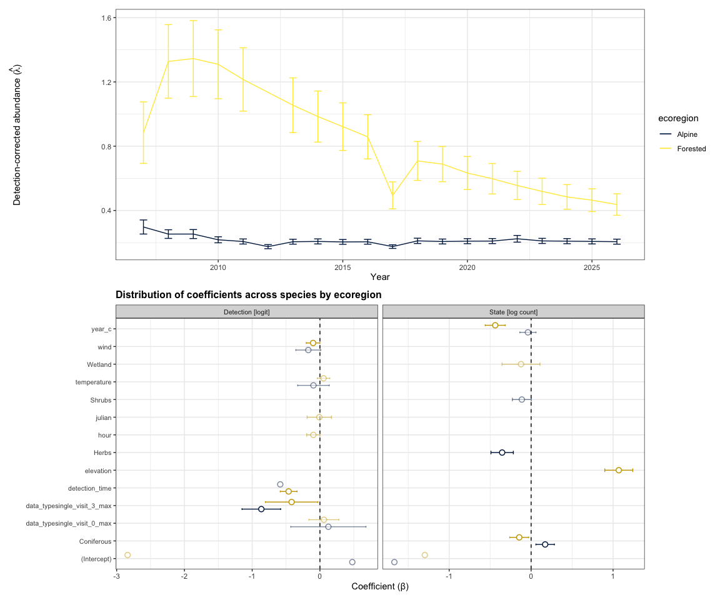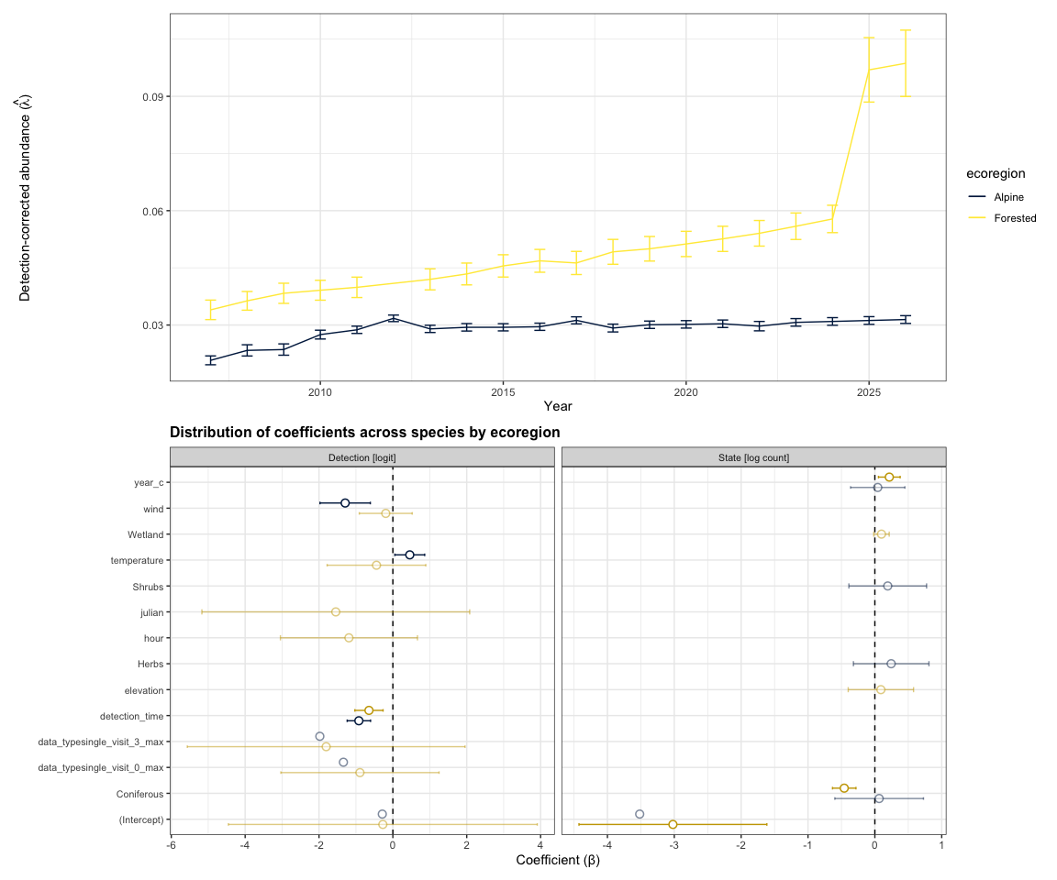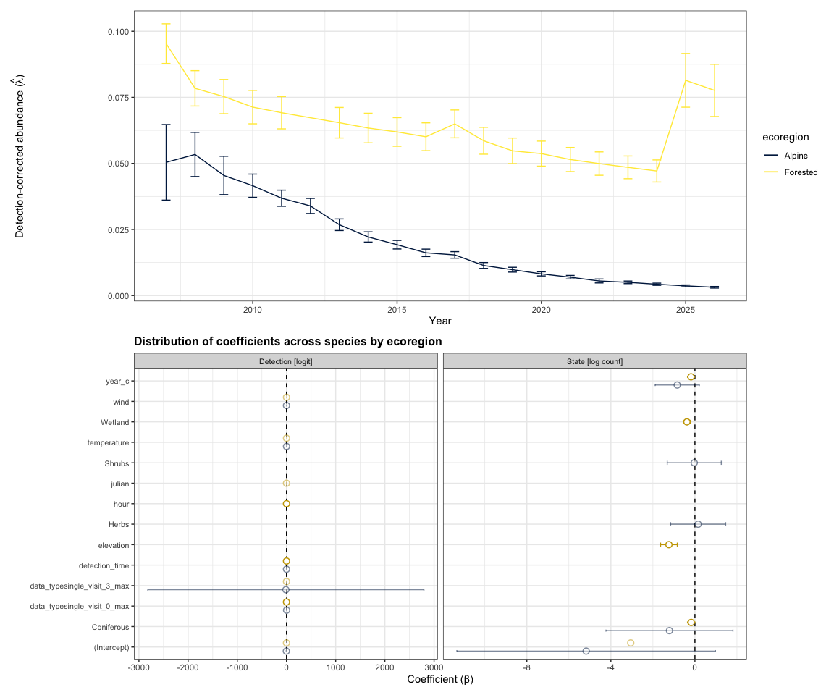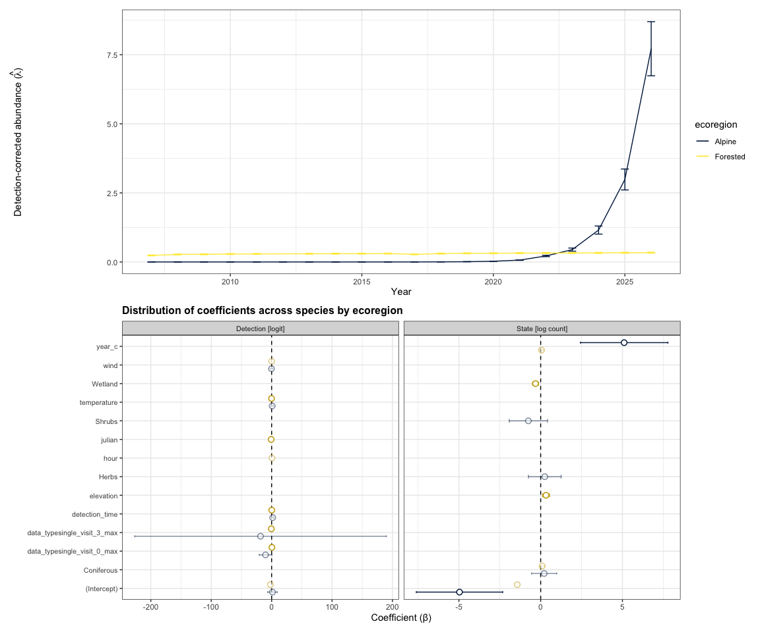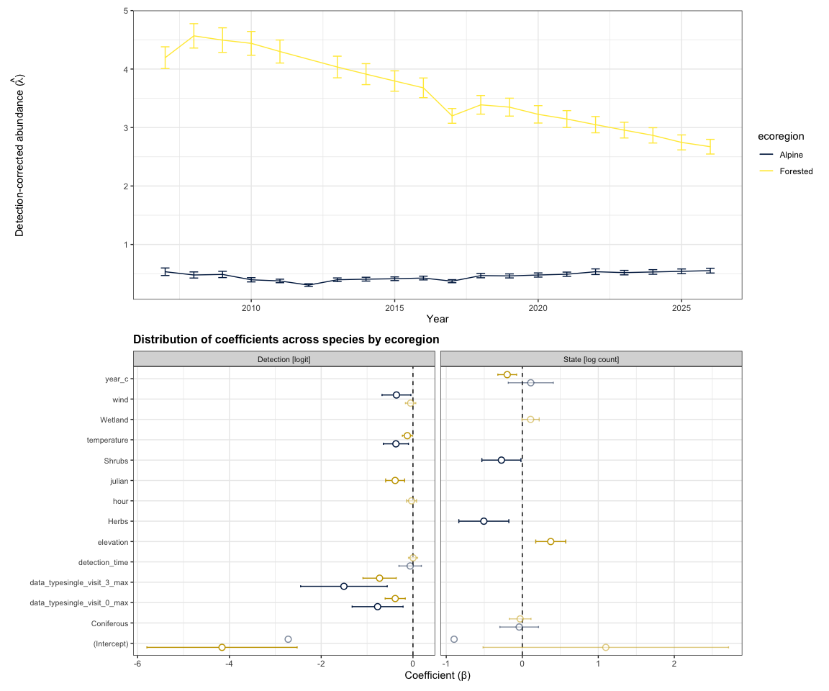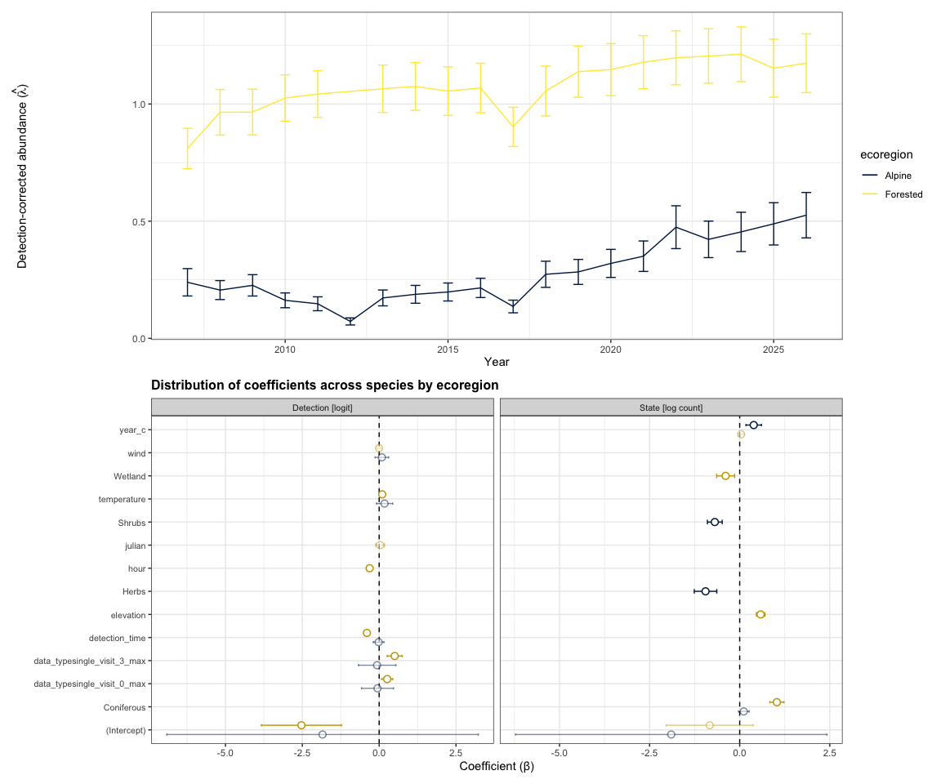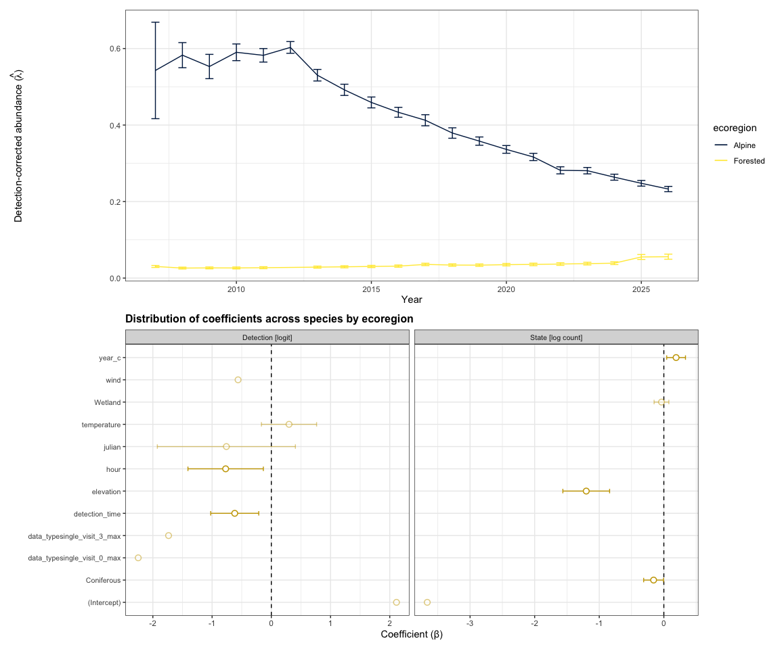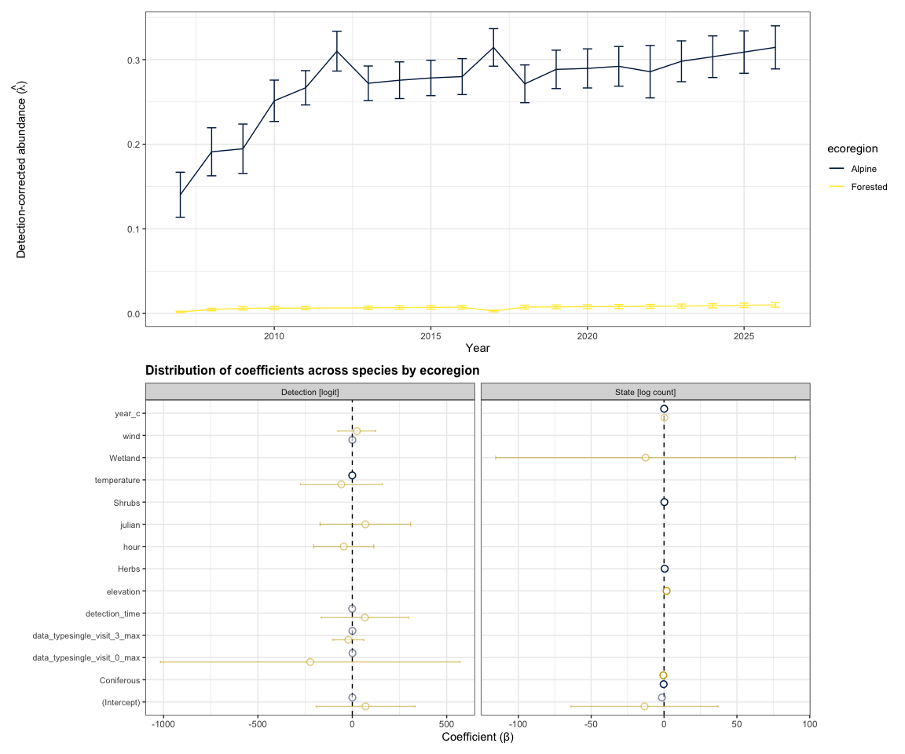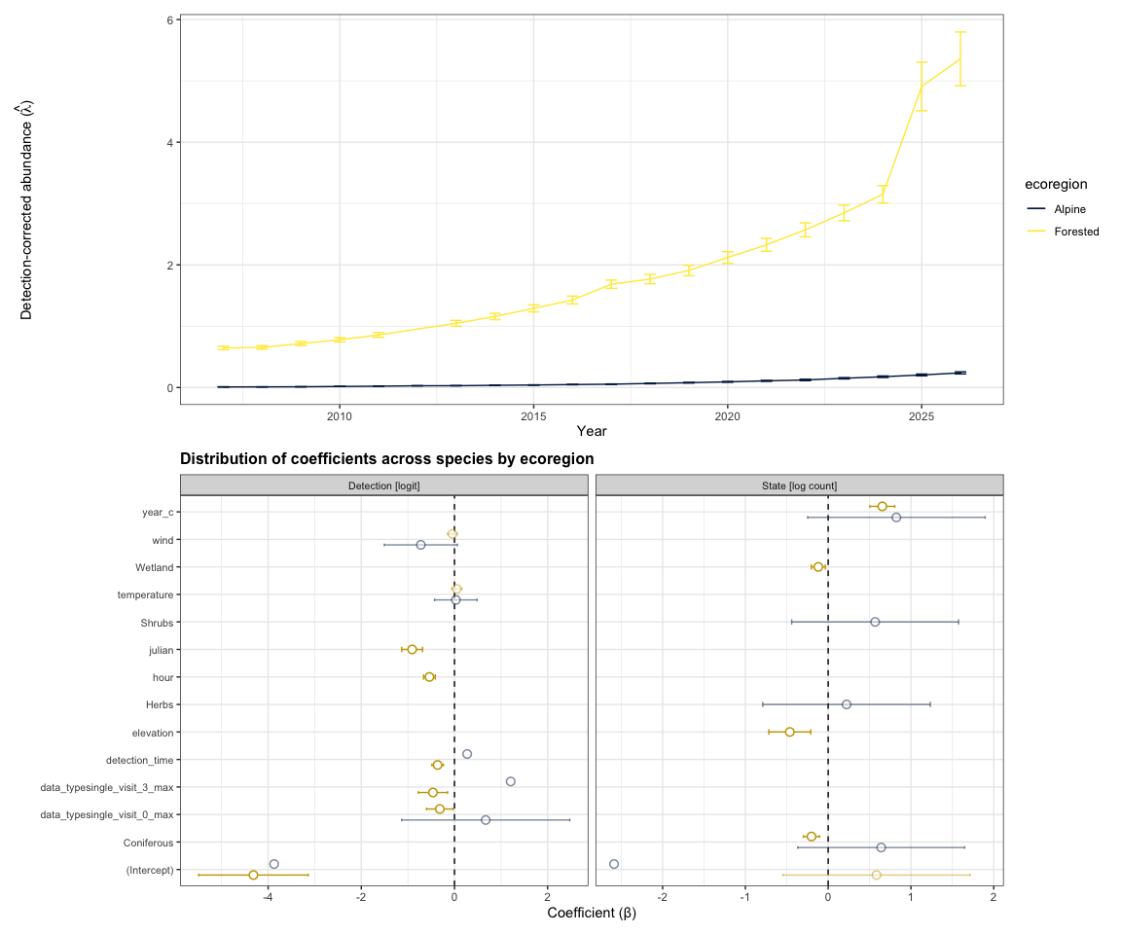
Abrahms, Briana, Neil H Carter, TJ Clark-Wolf, Kaitlyn M Gaynor, Erik Johansson, Alex McInturff, Anna C Nisi, Kasim Rafiq, and Leigh West. 2023. “Climate Change as a Global Amplifier of Human–Wildlife Conflict.” Nature Climate Change 13 (3): 224–34.
Ackleh, Azmy S, Jacoby Carter, Lauren Cole, Tom Nguyen, Jay Monte, and Claire Pettit. 2010. “Measuring and Modeling the Seasonal Changes of an Urban Green Treefrog (Hyla Cinerea) Population.” Ecological Modelling 221 (2): 281–89.
Akaike, Hirotugu. 1974. “A New Look at the Statistical Model Identification.” IEEE Transactions on Automatic Control 19 (6): 716–23. https://doi.org/10.1109/TAC.1974.1100705.
Allan, James R, Oscar Venter, Sean Maxwell, Bastian Bertzky, Kendall Jones, Yichuan Shi, and James EM Watson. 2017. “Recent Increases in Human Pressure and Forest Loss Threaten Many Natural World Heritage Sites.” Biological Conservation 206: 47–55.
Anderson, Marti J. 2001. “A New Method for Non-Parametric Multivariate Analysis of Variance.” Austral Ecology 26 (1): 32–46. https://doi.org/10.1111/j.1442-9993.2001.01070.pp.x.
Anselin, Luc. 1995. “Local Indicators of Spatial Association—LISA.” Geographical Analysis 27 (2): 93–115.
Bates, Douglas, Reinhold Kliegl, Shravan Vasishth, and Harald Baayen. 2015. “Parsimonious Mixed Models.” arXiv Preprint arXiv:1506.04967.
Bates, Douglas, Martin Mächler, Ben Bolker, and Steve Walker. 2015. “Fitting Linear Mixed-Effects Models Using lme4.” Journal of Statistical Software 67 (1): 1–48. https://doi.org/10.18637/jss.v067.i01.
Birds Canada, and Environment and Climate Change Canada. 2024. “The State of Canada’s Birds Report.” Birds Canada; Environment; Climate Change Canada. https://doi.org/10.71842/8bab-ks08.
Bivand, Roger S, and David WS Wong. 2018. “Comparing Implementations of Global and Local Indicators of Spatial Association.” Test 27 (3): 716–48.
Bivand, Roger, and David W. S. Wong. 2018. “Comparing Implementations of Global and Local Indicators of Spatial Association.” TEST 27 (3): 716–48. https://doi.org/10.1007/s11749-018-0599-x.
Cameron, J., A. Crosby, C. Paszkowski, and E. Bayne. 2020. “Visual Spectrogram Scanning Paired with an Observation–Confirmation Occupancy Model Improves the Efficiency and Accuracy of Bioacoustic Anuran Data.” Canadian Journal of Zoology 98 (11): 733–42. https://doi.org/10.1139/cjz-2020-0103.
Dawood, Muhammad. 2017. “Spatio-Statistical Analysis of Temperature Fluctuation Using Mann–Kendall and Sen’s Slope Approach.” Climate Dynamics 48 (3): 783–97.
Devarajan, Kadambari, Toni Lyn Morelli, and Simone Tenan. 2020. “Multi-Species Occupancy Models: Review, Roadmap, and Recommendations.” Ecography 43 (11): 1612–24.
Doser, Jeffrey W, Aaron S Weed, Elise F Zipkin, Kathryn M Miller, and Andrew O Finley. 2021. “Trends in Bird Abundance Differ Among Protected Forests but Not Bird Guilds.” Ecological Applications 31 (6): e02377.
Fahrig, Lenore. 2003. “Effects of Habitat Fragmentation on Biodiversity.” Annual Review of Ecology, Evolution, and Systematics 34 (1): 487–515.
Farnsworth, George L, Kenneth H Pollock, James D Nichols, Theodore R Simons, James E Hines, and John R Sauer. 2002. “A Removal Model for Estimating Detection Probabilities from Point-Count Surveys.” The Auk 119 (2): 414–25.
Gahbauer, Marcel A, Scott R Parker, Joanna X Wu, Cavan Harpur, Brooke L Bateman, Darroch M Whitaker, Douglas P Tate, Lotem Taylor, and Denis Lepage. 2022. “Projected Changes in Bird Assemblages Due to Climate Change in a Canadian System of Protected Areas.” Plos One 17 (1): e0262116.
Garland, Laura, Andrew Crosby, Richard Hedley, Stan Boutin, and Erin Bayne. 2020. “Acoustic Vs. Photographic Monitoring of Gray Wolves (Canis lupus): A Methodological Comparison of Two Passive Monitoring Techniques.” Canadian Journal of Zoology 98 (3): 219–28. https://doi.org/10.1139/cjz-2019-0081.
Government of Alberta. 2022. “Alberta Vegetation Inventory Standards.” Version 2.1.5. Alberta Agriculture, Forestry; Rural Economic Development. https://open.alberta.ca/publications/alberta-vegetation-inventory-standards.
Hamed, K. H. 2009. “Exact Distribution of the Mann-Kendall Trend Test Statistic for Persistent Data.” Journal of Hydrology 365 (1): 86–94. https://doi.org/10.1016/j.jhydrol.2009.01.040.
Hamed, K. H., and A. Ramachandra Rao. 1998. “A Modified Mann-Kendall Trend Test for Autocorrelated Data.” Journal of Hydrology 204 (1): 182–96. https://doi.org/10.1016/S0022-1694(97)00125-X.
Handel, C. M., and M. N. Cady. 2004. “Alaska Landbird Monitoring Survey: Protocol for Setting up and Conducting Point Count Surveys.” Technical Report 2004-3. Alaska Science Center: U.S. Geological Survey.
Hanski, Ilkka. 2011. “Habitat Loss, the Dynamics of Biodiversity, and a Perspective on Conservation.” Ambio 40 (3): 248–55.
Huus, Jan, Kevin G Kelly, Erin M Bayne, and Elly C Knight. 2025. “HawkEars: A Regional, High-Performance Avian Acoustic Classifier.” Ecological Informatics 87: 103122.
Kahl, Stefan, Connor M Wood, Maximilian Eibl, and Holger Klinck. 2021. “BirdNET: A Deep Learning Solution for Avian Diversity Monitoring.” Ecological Informatics 61: 101236.
Kendall, Maurice G. 1975. Multivariate Analysis. Charles Griffin & Company Ltd.
Knight, Elly C, and Erin M Bayne. 2019. “Classification Threshold and Training Data Affect the Quality and Utility of Focal Species Data Processed with Automated Audio-Recognition Software.” Bioacoustics 28 (6): 539–54.
Laliberté, Etienne, and Pierre Legendre. 2010. “A Distance-Based Framework for Measuring Functional Diversity from Multiple Traits.” Ecology 91: 299–305.
Laliberté, Etienne, Pierre Legendre, and Bill Shipley. 2014. FD: Measuring Functional Diversity from Multiple Traits, and Other Tools for Functional Ecology.
Lemieux, Christopher J, Thomas J Beechey, Daniel J Scott, and Paul A Gray. 2011. “The State of Climate Change Adaptation in Canada’s Protected Areas Sector.” The Canadian Geographer/Le Géographe Canadien 55 (3): 301–17.
Loeb, Susan C., Thomas J. Rodhouse, Laura E. Ellison, Cori L. Lausen, Jonathan D. Reichard, Kathryn M. Irvine, Thomas E. Ingersoll, et al. 2015. A Plan for the North American Bat Monitoring Program (NABat). U.S. Department of Agriculture, Forest Service, Southern Research Station. https://doi.org/10.2737/srs-gtr-208.
Loeb, Susan C., Thomas J. Rodhouse, Lee E. Ellison, et al. 2015. A Plan for the North American Bat Monitoring Program (NABat). Asheville, NC: U.S. Department of Agriculture, Forest Service, Southern Research Station. https://doi.org/10.1898/NWN21-10.
Lovett, Gary M. 2013. “When Do Peepers Peep? Climate and the Date of First Calling in the Spring Peeper (Pseudacris Crucifer) in Southeastern New York State.” Northeastern Naturalist 20 (2): 333–40.
MacKenzie, Darryl I., and Larissa L. Bailey. 2004. “Assessing the Fit of Site-Occupancy Models.” Journal of Agricultural, Biological, and Environmental Statistics 9 (3): 300–318. http://www.jstor.org/stable/1400484.
MacKenzie, Darryl I., James D. Nichols, James E. Hines, Melinda G. Knutson, and Alan B. Franklin. 2003. “ESTIMATING SITE OCCUPANCY, COLONIZATION, AND LOCAL EXTINCTION WHEN a SPECIES IS DETECTED IMPERFECTLY.” Ecology 84 (8): 2200–2207. https://doi.org/https://doi.org/10.1890/02-3090.
MacKenzie, Darryl I, James D Nichols, Gideon B Lachman, Sam Droege, J Andrew Royle, and Catherine A Langtimm. 2002. “Estimating Site Occupancy Rates When Detection Probabilities Are Less Than One.” Ecology 83 (8): 2248–55.
MacKenzie, Darryl I, James D Nichols, Mark E Seamans, and RJ Gutiérrez. 2009. “Modeling Species Occurrence Dynamics with Multiple States and Imperfect Detection.” Ecology 90 (3): 823–35.
MacPhail, Alexander G., Corrina Copp, Erin Bayne, Charles Francis, Michael Packer, Chad Klassen, Kevin Kelly, et al. 2026. “WildTrax: A Platform for the Management, Storage, Processing, Sharing and Discovery of Avian Data.”
Mann, H. B. 1945a. “Non-Parametric Tests Against Trend.” Econometrica: Journal of the Econometric Society 13 (3): 245–59.
———. 1945b. “Nonparametric Tests Against Trend.” Econometrica 13 (3): 245–59. https://doi.org/10.1017/CBO9781107415324.004.
Mantyka-pringle, Chrystal S, Tara G Martin, and Jonathan R Rhodes. 2012. “Interactions Between Climate and Habitat Loss Effects on Biodiversity: A Systematic Review and Meta-Analysis.” Global Change Biology 18 (4): 1239–52.
Muggeo, Vito M. R. 2008. “Segmented: An r Package to Fit Regression Models with Broken-Line Relationships.” R News 8 (1): 20–25. https://cran.r-project.org/doc/Rnews/.
Oksanen, Jari, Frank G Blanchet, Roeland Kindt, Pierre Legendre, Peter R Minchin, Robert B O’Hara, Gavin L Simpson, et al. 2010. “Canonical Analysis of Principal Coordinates: A Useful Method of Constrained Ordination for Ecology.” Ecology 92 (3): 597–611. https://doi.org/10.1890/10-0340.1.
Oksanen, Jari, Gavin L. Simpson, F. Guillaume Blanchet, Roeland Kindt, Pierre Legendre, Peter R. Minchin, R. B. O’Hara, et al. 2025. Vegan: Community Ecology Package. https://vegandevs.github.io/vegan/.
Önöz, B., and M. Bayazit. 2012. “The Power of Statistical Tests for Trend Detection.” Hydrological Processes 26 (17): 2809–14. https://doi.org/10.1002/hyp.8438.
Pacifici, Krishna, Elise F Zipkin, Jaime A Collazo, Julissa I Irizarry, and Amielle DeWan. 2014. “Guidelines for a Priori Grouping of Species in Hierarchical Community Models.” Ecology and Evolution 4 (7): 877–88.
Petrikeev, Michael. 2019. “Forest Breeding Bird Abundance and Composition, Kluane National Park Reserve.”
Prowse, Thomas AA, Patrick J O’Connor, Stuart J Collard, Kristian J Peters, and Hugh P Possingham. 2021. “Optimising Monitoring for Trend Detection After 16 Years of Woodland-Bird Surveys.” Journal of Applied Ecology 58 (5): 1090–100.
Rao, C. R. 1982. “Diversity and Dissimilarity Coefficients: A Unified Approach.” Theoretical Population Biology 21 (1): 24–43.
Rao, C. Radhakrishna. 1964. “The Use and Interpretation of Principal Component Analysis in Applied Research.” Sankhya: The Indian Journal of Statistics, Series A 26 (4): 329–58.
Reichert, B., C. Lausen, S. Loeb, et al. 2018. A Guide to Processing Bat Acoustic Data for the North American Bat Monitoring Program (NABat). U.S. Geological Survey. https://doi.org/10.1898/NWN21-10.
Reichert, Brian, Cori Lausen, Susan Loeb, Ted Weller, Ryan Allen, Eric Britzke, Tara Hohoff, et al. 2018. “A Guide to Processing Bat Acoustic Data for the North American Bat Monitoring Program (NABat).” US Geological Survey.
Rosenberg, Kenneth V, Adriaan M Dokter, Peter J Blancher, John R Sauer, Adam C Smith, Paul A Smith, Jessica C Stanton, et al. 2019. “Decline of the North American Avifauna.” Science 366 (6461): 120–24.
Sattar, Q, ME Maqbool, R Ehsan, S Akhtar, Q Sattar, ME Maqbool, R Ehsan, and S Akhtar. 2021. “Review on Climate Change and Its Effect on Wildlife and Ecosystem.” Open J Environ Biol 6 (1): 008–14.
Sedgwick, Philip. 2012. “Pearson’s Correlation Coefficient.” Bmj 345.
Sen, P. K. 1968. “Estimates of the Regression Coefficient Based on Kendall’s Tau.” Journal of the American Statistical Association 63 (324): 1379–89. https://doi.org/10.2307/2285891.
Sen, Pranab Kumar. 1968. “Estimates of the Regression Coefficient Based on Kendall’s Tau.” Journal of the American Statistical Association 63 (324): 1379–89. https://doi.org/10.1080/01621459.1968.10480934.
Shannon, Claude Elwood. 1948. “A Mathematical Theory of Communication.” The Bell System Technical Journal 27 (3): 379–423.
Shonfield, Julia, and Erin M Bayne. 2017. “Autonomous Recording Units in Avian Ecological Research: Current Use and Future Applications.” Avian Conservation & Ecology 12 (1).
Shonfield, Julia, Sarah Heemskerk, and Erin M Bayne. 2018. “Utility of Automated Species Recognition for Acoustic Monitoring of Owls.” Journal of Raptor Research 52 (1): 42–55.
Slough, B., C. Lausen, B. Paterson, et al. 2022. “New Records about the Diversity, Distribution, and Seasonal Activity Patterns by Bats in Yukon and Northwestern British Columbia.” Northwest Naturalist 103: 162–82. https://doi.org/10.1898/NWN21-10.
Slough, Brian G, Donald G Reid, Dafna S Schultz, and Maria C-Y Leung. 2023. “Little Brown Bat Activity Patterns and Conservation Implications in Agricultural Landscapes in Boreal Yukon, Canada.” Ecosphere 14 (3): e4446.
Smith, Adam C, Marie-Anne R Hudson, Constance M Downes, and Charles M Francis. 2015. “Change Points in the Population Trends of Aerial-Insectivorous Birds in North America: Synchronized in Time Across Species and Regions.” PloS One 10 (7): e0130768.
Solick, Daniel I. 2022. “Bat Acoustic Species-Pair Matrix for Western u.s./Canada.” Colorado: Vesper Bat Detection Services.
Solick, Donald I, and Robert MR Barclay. 2022. “Coat Color of Western Long-Eared Bats (Myotis Evotis) Living in Different Environments: A Test of Gloger’s Rule.” Northwestern Naturalist 103 (2): 183–89.
Sólymos, Péter, Subhash Lele, and Erin Bayne. 2012. “Conditional Likelihood Approach for Analyzing Single Visit Abundance Survey Data in the Presence of Zero Inflation and Detection Error.” Environmetrics 23 (2): 197–205. https://doi.org/https://doi.org/10.1002/env.1149.
Sólymos, Péter, Steven M Matsuoka, Erin M Bayne, Subhash R Lele, Patricia Fontaine, Steve G Cumming, Diana Stralberg, Fiona KA Schmiegelow, and Samantha J Song. 2013. “Calibrating Indices of Avian Density from Non-Standardized Survey Data: Making the Most of a Messy Situation.” Methods in Ecology and Evolution 4 (11): 1047–58.
Sólymos, Péter, Steven M. Matsuoka, Steven G. Cumming, Diana Stralberg, Patricia Fontaine, Fiona K. A. Schmiegelow, Samantha J. Song, and Erin M. Bayne. 2018. “Evaluating time-removal models for estimating availability of boreal birds during point count surveys: Sample size requirements and model complexity.” The Condor 120 (4): 765–86. https://doi.org/10.1650/CONDOR-18-32.1.
Sonobat. n.d. “Western North America Bat Acoustic Table.” https://sonobat.com/download/Western_NA_Bat_Acoustic_Table.pdf.
Sugai, Larissa Sayuri Moreira, Thiago Sanna Freire Silva, Jr Ribeiro José Wagner, and Diego Llusia. 2018. “Terrestrial Passive Acoustic Monitoring: Review and Perspectives.” BioScience 69 (1): 15–25. https://doi.org/10.1093/biosci/biy147.
Suthar, Akshit R., Alan R. Biggs, and James T. Anderson. 2025. “A Decadal Change in Shorebird Populations in Response to Temperature, Wind, and Precipitation at Hilton Head Island, South Carolina, USA.” Birds 6 (1). https://www.mdpi.com/2673-6004/6/1/14.
Szewczak, Joe. 2018. “Acoustic Features of Western US Bats.” Arcata, California: Humboldt State University.
Turgeon, Patrick, Steven L. Van Wilgenburg, and Kiel L. Drake. 2017. “Microphone Variability and Degradation: Implications for Monitoring Programs Employing Autonomous Recording Units.” Avian Conservation and Ecology 12. https://api.semanticscholar.org/CorpusID:89959184.
Ware, Lena, C. Lisa Mahon, Logan McLeod, and Jean-François Jetté. 2023. “Artificial Intelligence (BirdNET) Supplements Manual Methods to Maximize Bird Species Richness from Acoustic Data Sets Generated from Regional Monitoring.” Canadian Journal of Zoology 101 (12): 1031–51. https://doi.org/10.1139/cjz-2023-0044.
Yip, Daniel A, Elly C Knight, and Erin M Bayne. 2025. “Contributions of Environmental Conditions and Sound Characteristics to Differences in Perceptibility: Recommendations for Passive Acoustic Monitoring.” Ornithological Applications, September, duaf059. https://doi.org/10.1093/ornithapp/duaf059.

