Report on the use of passive acoustic monitoring for songbirds and seabirds on Lanz and Cox Islands
Alex MacPhail
Kevin Kelly
Victoria Berg
Erica McClaren
Iain Reid
Christine Rock
2026-09-30
Table of contents


 Note
This report is dynamically generated, meaning its results may evolve with the addition of new data or further analyses. For the most recent updates, refer to the publication date and feel free to reach out to the authors.

1. Abstract
Passive acoustic monitoring was conducted on Lanz and Cox Islands to characterize seabird and songbird communities. Autonomous recording units (ARUs) were deployed at 27 locations and analyzed using a combination of classifiers and expert human validation. This report summarizes species presence, temporal patterns of detection, and relative abundance for seabirds and songbirds, and provides spatial representations of detections across both islands. These results establish a baseline to support evaluation of seabird prospecting activity and future changes in avian communities.

2. Land Acknowledgement
The land and sea in the Scott Islands are located within the territories of the Quatsino and T̕łat̕łasikwa̱la First Nations. BC Parks and Environment and Climate Change Canada – Canadian Wildlife Service are working in partnership with Quatsino and T̕łat̕łasikwa̱la First Nations and for this part of the larger project, they would like to express their gratitude to T̕łat̕łasikwa̱la First Nation member Anne Wilson and Quatsino First Nation Guardians, Graem Hall and Damien Walkus, for providing in-field support during deployment and collection of audio recordings on Lanz and Cox Islands. A special thanks to Quatsino First Nation Coordinators, Lyubava Erko and Suzanne Hopkinson and T̕łat̕łasikwa̱la First Nation consultants, Amy Krull and David Steele for facilitating field support.

3. Funding Acknowledgement
This project was funded in part by the BC License Plate program.


4. Introduction
The provincial park, Lanz and Cox Islands, are part of the Scott Islands archipelago. The marine area surrounding the islands are within Scott Islands marine National Wildlife Area, Canada’s first marine National Wildlife Area. The area protects important wildlife habitat, yet bird populations have been negatively affected by the introduced invasive predators that were released onto Lanz and Cox Islands in the 1930’s by fur trappers. As part of a broader initiative, passive acoustic monitoring was implemented to document avian community composition. This report presents the results of these analyses, including species detected, timing of detections, relative abundance metrics, and baseline spatial patterns of occurrence.

5. Methods

5.1 Data collection
Autonomous recording units (ARUs; Shonfield and Bayne (2017)) were deployed in three stages between 2024 and 2025 across Lanz and Cox Islands (Figure 1), with the final data retrieval included in this report taking place in March 2026, with the project still ongoing. Sites were accessed via helicopter. Recordings were collected on a schedule of recording for five minutes every 15 minutes at 44100 Hz until batteries and/or memory cards were depleted or the units were checked and replenished. A total of 243,204 recordings were collected totalling 20,155 audio hours of data (Figure 2).
Note
Several ARU locations were relocated slightly further from the shoreline during the deployment period. Additionally, a subset of units were inadequately secured in 2024, resulting in equipment loss to the ocean and corresponding gaps in the dataset. As a result, recording continuity varies across units, and unit positions are not fixed throughout the study period.

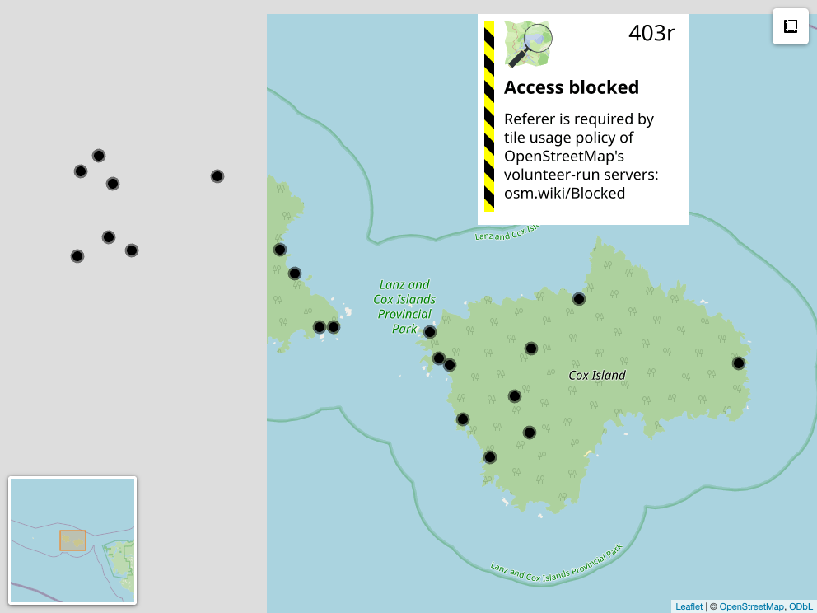
Figure 1: Locations from Lanz and Cox Islands Park ARU Monitoring Program
Table 1: Locations surveyed across years on Lanz and Cox islands. The number 1 under columns 2024 and 2025 indicate a deployment in that year for that location. Note that locations with “L” in the label were on Lanz Island and locations with “C” in the label were on Cox Island.
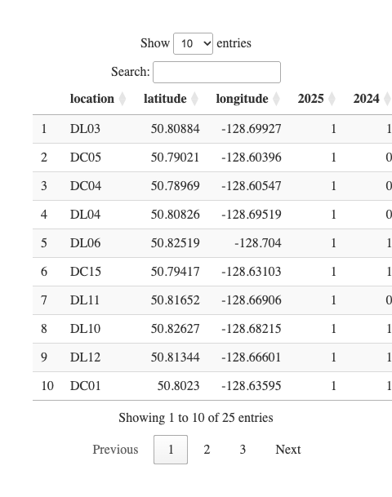
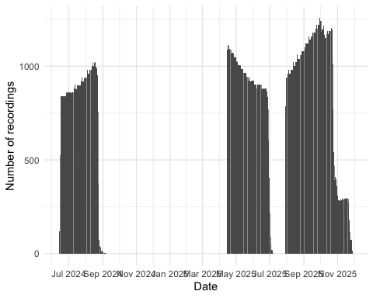
Figure 2: Cumulative daily recordings collected from Lanz and Cox Islands Park ARU Monitoring Program

5.2 Songbird data processing
Acoustic data were uploaded and processed using WildTrax (A. G. MacPhail et al. (2026)). Location names, file metadata, and audio files were validated against deployment records to ensure recordings from each location were consistently named and correctly aggregated across all deployment phases. The WildTrax projects can be accessed here for the songbird processing and here for seabird data processing.
For each sampling location and year, a total of nine randomly-chosen recordings in moderate survey conditions (wind <20 km/h, precipitation <1 mm / hr recorded at the closest weather station at Cape Scott), each 3 minutes in duration, were analyzed to characterize the songbird community. All vocalizing species were identified, and the abundance of each species was estimated using a count-removal framework (Farnsworth et al. (2002)) based on time-to-first-detection, which helps reduce positive bias associated with repeated detections of the same individual within a recording. Recordings were intentionally distributed across diel periods to capture variation in vocal activity. Five recordings were selected during the dawn period (04:00–07:59), when songbird detectability is typically highest. Two recordings were selected during dusk (19:00–22:59), and two during the night (23:00–03:59), allowing for detection of crepuscular or nocturnally active species and providing a more complete representation of the avian community. This standardized temporal sampling design ensured consistent effort across locations and years while maximizing detectability across species with differing activity patterns. Each individual was labeled with what is known as a tag in WildTrax, which is the box (Figure 3) encompassing each acoustic signal in frequency (hertz; Hz) and time (seconds).
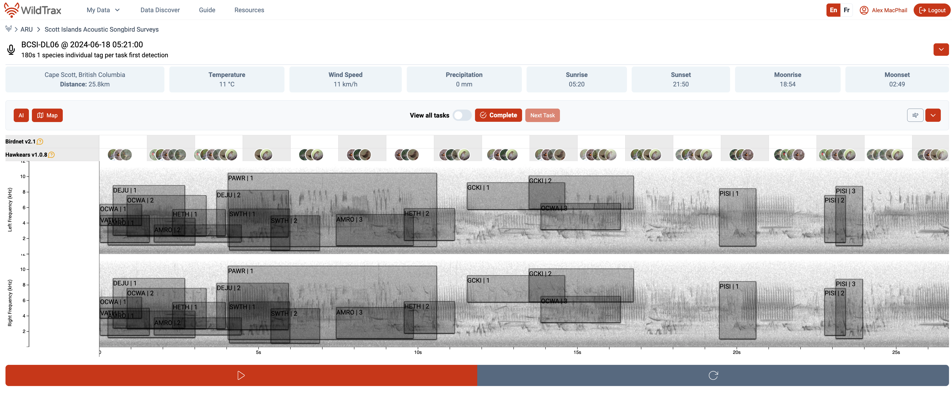
Figure 3: Acoustic processing interface in WildTrax. Each box is a tag and a distinct individual with the species code label and individual number labeled. The tags are made on a spectrogram with is a visual representation of the sound file. Artifical intelligence overlays for BirdNET and HawkEars are also seen above the spectrogram in 1.5 interval windows with confidence score for each species.
Coastal proximity may reduce species detection effectiveness, as wave action and wind-driven noise can mask vocalizations and shrink effective detection distances (Pijanowski et al. (2011)). Therefore, we examined whether distance and cardinal direction to the nearest coastline predicted observed species richness across monitoring locations. We also compared geophonic acoustic indices (Towsey et al. (2017)) against WildTrax noise metrics to establish thresholds for recording processing and to characterize background noise conditions at each site. We modeled maximum noise level as an ordinal response (Low < Medium < High < Extreme) using a cumulative link model with distance to coast and coastline orientation (sine/cosine transformation) as predictors.

5.3 Seabird data processing
We first wanted to assess the accuracy of the current version of the HawkEars (v1.0.8) classifier for three focal marine species in the group for which the classifier already had species included: Common Murre (Uria aalge; COMU), Marbled Murrelet (Brachyramphus marmoratus; MAMU), and Black Oystercatcher (Haematopus bachmani; BLOY). We extracted all recordings from WildTrax in which the classifier detected these species, which yielded a mean score of 0.33 +/- 0.08. A human reviewer then verified each task, confirming detections as either true positives (TP) where the species was audible and confirmed, or false positives (FP) where the identification was incorrect. Using these verified results, we applied the wt_evaluate_classifier() and wt_classifier_threshold() functions from the wildrtrax R package (A. MacPhail, Becker, and Knight (n.d.)) to calculate precision, recall, and F-score. This allowed us to identify the minimum confidence threshold at which classifier performance was deemed acceptable for each species, balancing the trade-off between retaining true detections and excluding false positives. Recordings scoring below this optimized threshold were excluded from subsequent analyses, while those meeting or exceeding it were accepted without further manual review. This approach is consistent with emerging best practices for deploying automated classifiers at scale, where full human review is impractical and a validated threshold provides a reproducible and defensible basis for data inclusion (Knight and Bayne (2019)). Next, we expanded the evaluation of classifier performance using HawkEars 2.0 (hereafter HE2). This updated model, which is not currently implemented within WildTrax, incorporates an expanded seabird species set: Pink-footed Shearwater (Puffinus creatopus ; PFSH), Ancient Murrelet (Synthliboramphus antiquus ; ANMU), Tufted Puffin (Fratercula cirrhata ; TUPU) and Rhinoceros Auklet (Cerorhinca monocerata ; RHAU). We conducted a structured verification of outputs from HE2 by manually reviewing detections and identified any systematic misclassifications, in order to evaluate how the expanded species list influenced both true positive retention and false positive rates.
Positive seabird detection locations from the classification step were spatially intersected with island boundary polygons derived from the Canada Waters 2016 boundary file. Detection intensity across each island was estimated using inverse distance weighting (IDW) interpolation using the gstat R package (Pebesma, Graeler, and Pebesma (2015)). For each survey location, total seabird detections were summed across all species in the target assemblage. A regular 50-m resolution grid was generated across the island extents and masked to land area only, ensuring interpolation was strictly constrained within island boundaries. IDW was computed at each grid cell as a distance-weighted mean of all detection point values, using an inverse square distance weighting function (power parameter = 2). This approach produces a continuous surface where predicted intensity at any location is most strongly influenced by nearby detection points and decays with increasing distance. No landcover covariates were used in the interpolation.

6. Results

6.1 Noise effects
Noisier recordings captured fewer birds (Figure 4). At Low and Medium noise levels, recorders typically detected around 5 individuals per recording, while High and Extreme noise levels roughly halved that, dropping to medians of approximately 3 and 2 individuals respectively. At the noisiest sites, many recordings picked up no birds at all. Occasional bursts of high detections (up to 20 individuals) did occur even under noisy conditions, but these were the notable exception. Not all sites experienced the same noise conditions (Figure 5). Most DC (Cox Island) sites were consistently loud, with the majority reaching High noise levels and DC13 and DC15 hitting Extreme. DL (Lanz Island) sites were generally quieter, with most sitting around Medium noise, though DL02, DL11, DL12, and DL15 also reached High levels. DL06 stood out as the quietest location overall. Several sites also fluctuated across noise categories over the survey period, meaning detection conditions were not always consistent even within a single location. The systematically higher noise at DC sites likely explains some of the lower and more variable seabird detections recorded there compared to DL sites.
Island identity (Lanz vs. Cox Island) did not significantly improve model fit (ΔAIC = 0.07, p = 0.16), nor was there evidence for an interaction between island and distance from coast (ΔAIC = 1.94, p = 0.79), indicating that the relationship between distance to coast and noise level was consistent across islands. Distance to coast showed a clear shift in the probability distribution across noise categories (Figure 6), with the probability of High noise declining substantially with increasing distance, from ~45% at 50 m to ~15–20% near 750 m. In contrast, the probability of Low noise increased steadily with distance, rising from ~5–10% near the coast to ~30% inland. Medium noise remained the most probable category across most distances, peaking around ~50–55% at intermediate distances (~600–800 m), while Extreme noise was consistently rare and declined slightly with distance (~10% to <5%). Coast direction did not appear to play an important role for either Lanz or Cox Islands (Figure 7).
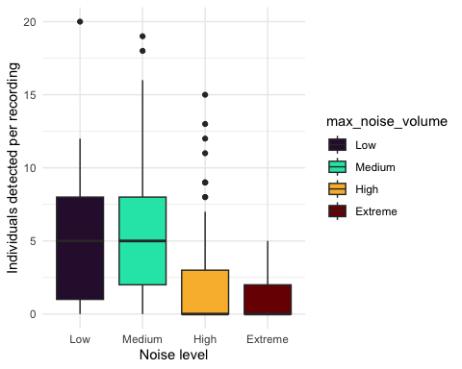
Figure 4: Individuals detected versus environmental noise
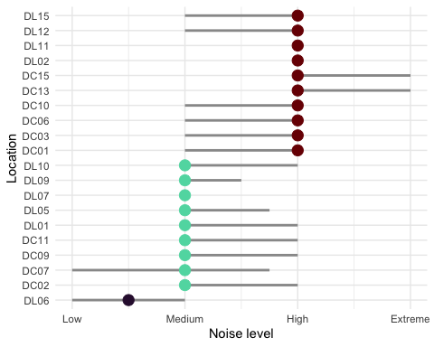
Figure 5: Noise per location on Scott Islands
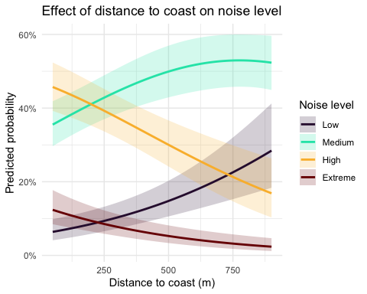
Figure 6: Noise per distance
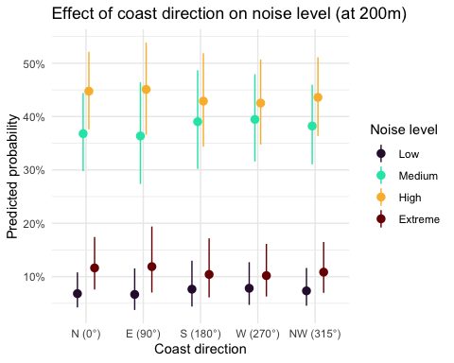
Figure 7: Noise per direction from ARU to coast

6.2 Songbird results
A total of songbird 30 species were found with a summary of detections found at Table 2. Figure 8 describes the relationship of species richness for each location across the two years of surveys. Shannon’s diversity was also calculated (see Figure 9). No significant differences in species richness or Shannon’s diversity were obsvered between years.
Table 2: Count of detections per species
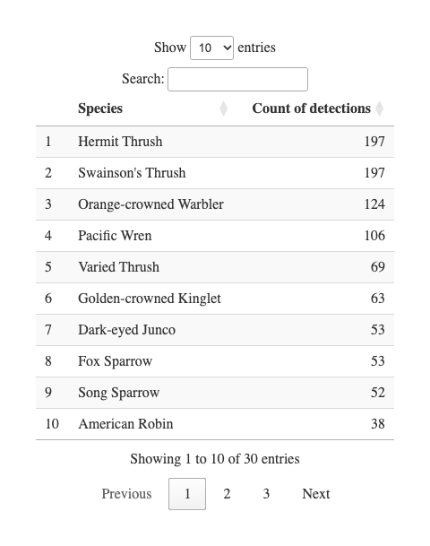
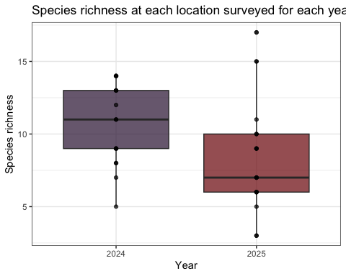
Figure 8: Species richness at forest monitoring locations across years
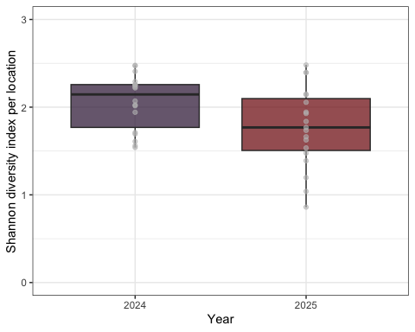
Figure 9: Shannon diversity index over years
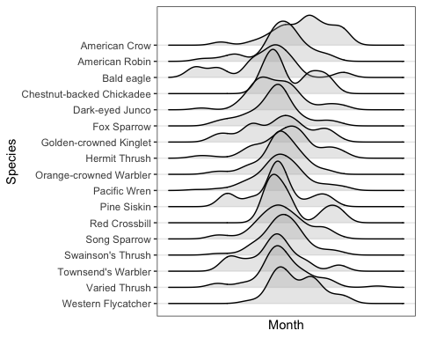
Figure 10: Seasonal detection activity of most commonly detected (n > 3) songbird species

6.3 Seabird results
Precision-recall curves were generated to evaluate classifier performance across all confidence thresholds for both Birdnet v2.1 and HawkEars v1.0.8. At low recall values (≤ 0.25), both classifiers achieved comparable precision (~0.65), indicating that high-confidence detections from either classifier are similarly reliable. As recall increased, classifier performance diverged: Birdnet v2.1 maintained a moderately higher precision across mid-to-high recall values (0.25–1.0), stabilizing around 0.30 at full recall. HawkEars declined more steeply, reaching ~0.13 at high recall, though it exhibited considerable variability across species (wide confidence interval) particularly between recall values of 0.25–0.75. These results suggest that Birdnet v2.1 is more conservative and consistent when detections are aggregated across species, while HawkEars shows greater species-level variability in the precision-recall tradeoff. The optimal operating threshold for both classifiers lies at low-to-moderate recall, where precision remains above 0.50.
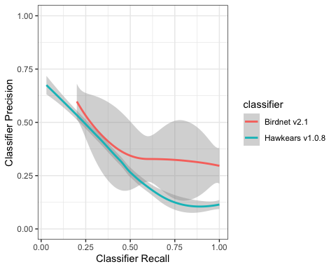
Figure 11: HawkEars 1.0.8 performance evaluation against Birdnet v2.1.
Initial runs of HE2 were conducted yielding 109765 seabird detections in a total of 34229 recordings or 45.13 % of the total audio dataset. The distribution of HE2 scores differs systematically between detections that were ultimately confirmed as true positives and those reassigned during verification, with true positives generally exhibiting higher score distributions across most species. The magnitude of separation between true and false positive outcomes varies among taxa, indicating that HE2 score provides a useful but species-dependent proxy for detection confidence rather than a universal decision boundary. For several species (notably BLOY, CAAU, COMU, and MAMU), true positives tend to cluster at higher HE2 values, while lower-scoring detections are more frequently associated with reassigned calls. This structure suggests that score-based stratification can be used to define species-specific confidence thresholds, where high-score detections can be retained with increasing certainty and lower-score detections represent a continuum of uncertainty rather than binary classification error. Species such as PFSH show comparatively tight separation between true and false positive score distributions, indicating that conservative thresholds can isolate a subset of high-confidence detections with minimal loss of signal. In contrast, species with greater overlap between outcome classes (notably ANMU and RHAU) exhibit weaker discriminative structure in HE2 space, implying that score alone is insufficient for full separation and that more conservative or multi-stage filtering strategies are required for reliable inference for these species. Results can be found in Figure 12 and Table 3.
Across target seabird taxa, performance varies substantially in the verified subset. TUPU had a relatively low number of detections (488 total tags), of which 431 were verified; most reviewed detections fell in lower HE2 regions consistent with reassignment, yielding a verified false positive rate of 82%. RHAU showed similarly elevated misclassification within the verified subset, with 101 verified tags and a verified false positive rate of 91%, consistent with broader overlap in HE2 distributions. ANMU exhibited near-complete collapse of separation within the reviewed subset, with 4288 verified tags and a verified false positive rate of 99%, with 33 detections remaining unreviewed and concentrated in higher-score regions. MAMU and COMU remain the most uncertain due to large proportions of unverified detections, but both show strong skew in HE2 distributions toward higher-score detections among the reviewed subset. For MAMU, 2409 of 15724 tags remain unverified, and the reviewed subset shows a very high false positive rate (99%), indicating that low-to-intermediate HE2 values dominate incorrect assignments. COMU shows a similarly elevated verified false positive rate of 88%, with 3535 unverified detections remaining, though higher HE2 values increasingly concentrate true detections. CAAU is represented by a substantial verified sample of 3822 tags, with the majority of reviewed detections occurring in lower HE2 regions consistent with reassignment, resulting in a verified false positive rate of 75%. Overall, a large number of detections (1884) remain unreviewed, but the observed HE2 structure suggests strong potential for threshold-based separation. PFSH shows comparatively strong concentration of true detections at higher HE2 values, with relatively low misclassification within the verified subset (11708 verified tags, 2% false positive rate), suggesting that conservative HE2 thresholds may retain high-confidence detections effectively even as additional data are incorporated. BLOY shows intermediate performance, with partial but not complete separation in HE2 space. It has 2423 verified tags and a verified false positive rate of 19%, indicating that score-informed filtering would likely improve signal quality but should be applied in a species-specific manner rather than globally.
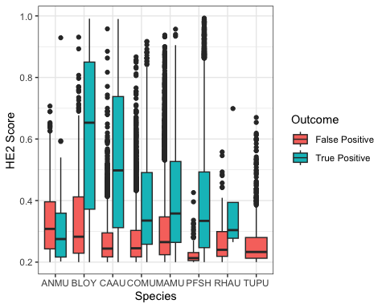
Figure 12: Distribution of true and false positives by score for each detection by HawkEars after human validation.
Table 3: Rates of verification and classification for seabirds under HawkEars v2.0
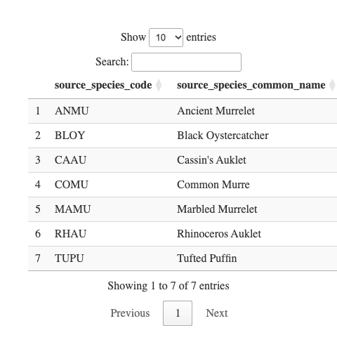
Seabird relative abundance and activity
Spatial patterns of seabird relative abundance across the Scott Islands are shown in Figure 13. Only true positives were used in the detection inference. Detection intensity exhibited strong spatial clustering, with activity concentrated predominantly in the northwestern portion of Lanz Island. Two distinct hotspots were identified in the northwest and west-central areas of Lanz Island, with intensity declining steeply eastward across the island. Cox Island displayed comparatively lower and more spatially uniform detection intensity overall, though notable areas of elevated abundance were observed in both the western and eastern portions of the island. Diel patterns of seabird detections can also be found in Figure 14 and Figure 15. Median julian date of detections was 210 (July 29th) and the most common hours of detections were between dusk hour and before sunrise.
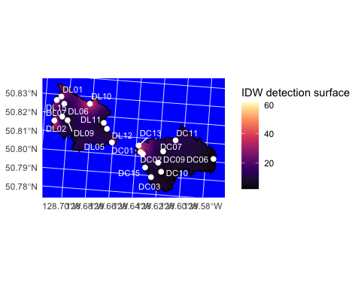
Figure 13: Inverse distance weighted (IDW) interpolation of seabird detection activity across Lanz Island (DL sites) and Cox Island (DC sites), British Columbia. White points show ARU recording station locations; colour indicates the interpolated detection surface, with lighter (yellow) tones representing higher detection activity and darker (purple/black) tones representing lower activity.
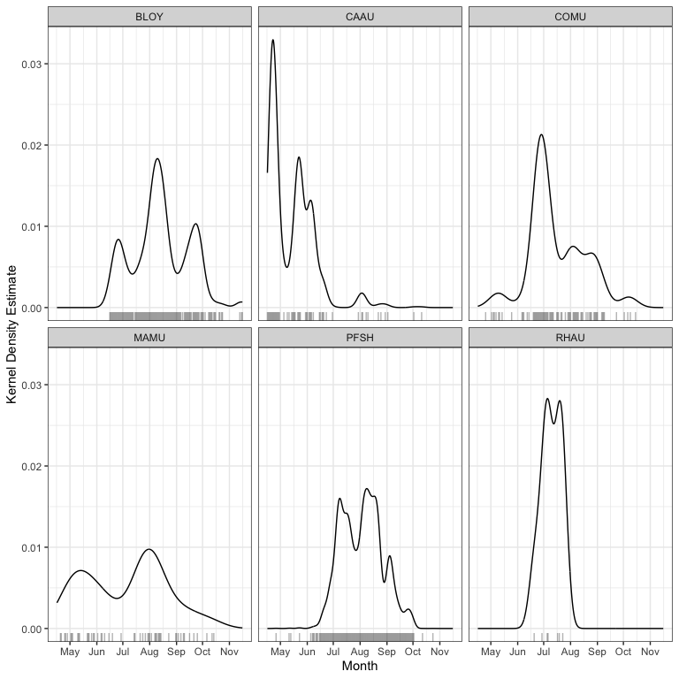
Figure 14: Kernel density estimate of seabird detections on Lanz and Cox Islands by time of year (julian date). Rug plots indicate sample size of detections.
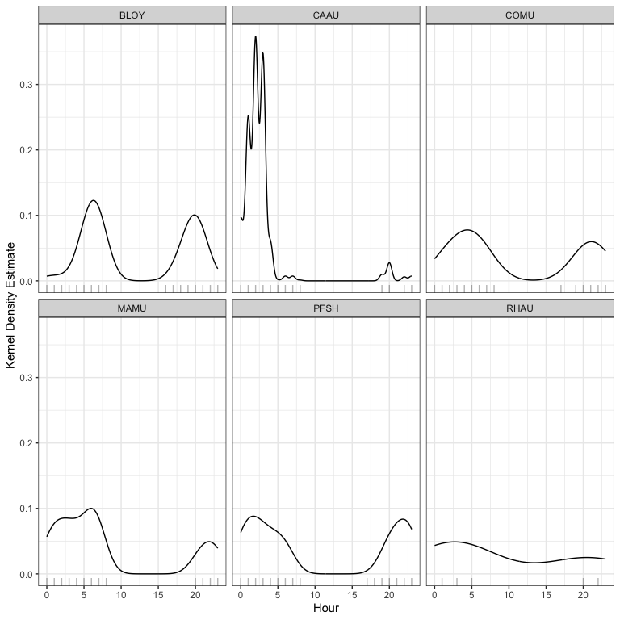
Figure 15: Kernel density estimates of seabird detections by hour of the day (0h00 - 23h00). Rug plots indicate sample size of detections.

7. Discussion and recommendations

7.1 Acoustic classifier performance and seabirds
This program produced a data set of sufficient resolution to support long-term passive monitoring programs, offering a scalable and repeatable method for processing large volumes of acoustic data. Misclassification rates and false positives remain an inherent limitation of the use of multi-species automated classifiers, particularly in field conditions where behavioural overlap between sound categories is common. Seabirds frequently produce detectable acoustic signals across multiple behavioural states simultaneously, vocalization, preening, and on-water activity often co-occur, complicating clean categorical assignment (da Silva Cerqueira et al. (2025)). This reflects the ecological reality of these field recordings rather than a failure of the classification approach, and should be accounted for when interpreting detection outputs.
For future long-term deployments, a sampling rate of 22 kHz is likely sufficient given that the dominant frequencies of seabird vocalizations typically fall below 10 kHz, which would reduce storage requirements and extend battery life without meaningful loss of biological signal (Podolskiy et al. (2024)). A 32 kHz minimum frequency is recommended should songbirds would also like to be simultaneously monitored. It’s worth noting that these classifiers were trained and tested on datasets that included seabirds, but a more reliable assessment of their performance would involve testing them at sites where the species is actually known to be present and successfully breeding.
Overall, these patterns support the use of HE2 score as a probabilistic confidence metric that enables species-specific thresholding. In this framework, detections can be stratified by score into high-confidence subsets suitable for direct ecological inference, while intermediate-score detections represent the primary domain for uncertainty resolution. This helps build maps of species relative abundance later on. It works by pulling out spatial patterns only from the most reliable detections, while keeping the same clear filtering rules for every species.

7.2 Seabird abundance measurements
This study does not attempt to derive absolute abundance or population size estimates for Lanz and Cox Islands; however, the dataset provides a foundation for such analyses in future work. Presence–absence detections can be used as a basis for occupancy modelling or relative abundance indices, particularly when combined with spatially replicated recorder deployments. Notably, the majority of detections consisted of single-individual vocalizations (n = 1 per detection event), suggesting that call rate may serve as a proxy for local activity levels rather than group size. The strait between the two islands also appeared to represent a zone of relatively elevated acoustic activity, potentially reflecting inter-island movement or shared foraging habitat. Continuing to update and enhance mapping the spatial distribution of detections across sites would allow identification of acoustic hotspots, which could inform targeted survey efforts. Interpreting these patterns is further complicated by uncertainty around the nature of seabird activity on these islands. The seasonal distribution of detections does not align with known breeding periods for the target species, suggesting that the acoustic activity captured in this dataset may primarily reflect foraging, feeding, and prospecting behaviour rather than breeding activity, as discussed in Section 7.1. This distinction has direct implications for abundance estimation, as call rates associated with transient or prospecting individuals may not reliably index local population size. Integrating detection data with diel activity patterns (Podolskiy et al. (2024)) may help clarify whether observed variation in call rates reflects changes in abundance, behaviour, or both, and should be a focus of future validation work.

7.3 Coastal monitoring
Passive acoustic monitoring in high geophonic noise environments presents a significant methodological challenge, as abiotic noise sources including wave action, wind, and hydrological activity, can mask biological signals across relevant frequency ranges. The present dataset indicates a gradient in background noise intensity from coastal to inland sites, with the most pronounced transition occurring between the High and Low noise categories. While geophonic noise levels did not directly predict seabird detection rates, their pervasive influence on signal-to-noise ratios warrants careful consideration in site selection and recorder placement. Monitoring stations situated in high-noise environments risk systematic underdetection of target species, potentially biasing occupancy and abundance estimates if not corrected for in subsequent analyses. For the sake of this report, here we refer to noise as natural, environmental noise.
da Silva Cerqueira, Aline, Robin Freeman, Richard A. Phillips, and Terence P. Dawson. 2025. “Automated Classification of Albatross Acoustic Behaviour at Sea: A Free and Open-Source Classifier for Seabird Sounds.” Ecological Informatics 92: 103474. https://doi.org/https://doi.org/10.1016/j.ecoinf.2025.103474.
Farnsworth, George L, Kenneth H Pollock, James D Nichols, Theodore R Simons, James E Hines, and John R Sauer. 2002. “A Removal Model for Estimating Detection Probabilities from Point-Count Surveys.” The Auk 119 (2): 414–25.
Huus, Jan, Kevin G Kelly, Erin M Bayne, and Elly C Knight. 2025. “HawkEars: A Regional, High-Performance Avian Acoustic Classifier.” Ecological Informatics 87: 103122.
Kahl, Stefan, Connor M Wood, Maximilian Eibl, and Holger Klinck. 2021. “BirdNET: A Deep Learning Solution for Avian Diversity Monitoring.” Ecological Informatics 61: 101236.
Knight, Elly C., and Erin M. Bayne. 2019. “Classification Threshold and Training Data Affect the Quality and Utility of Focal Species Data Processed with Automated Audio-Recognition Software.” Bioacoustics 28 (6): 539–54. https://doi.org/10.1080/09524622.2018.1503971.
MacPhail, Alexander G., Corrina Copp, Erin Bayne, Charles Francis, Michael Packer, Chad Klassen, Kevin Kelly, et al. 2026. “WildTrax: A Platform for the Management, Storage, Processing, Sharing and Discovery of Avian Data.”
MacPhail, Alex, Marcus Becker, and Elly Knight. n.d. “wildrtrax: Environmental Sensor Data Management and Analytics to and from WildTrax.” https://abbiodiversity.github.io/wildrtrax/.
Oksanen, Jari, Frank G Blanchet, Roeland Kindt, Pierre Legendre, Peter R Minchin, Robert B O’Hara, Gavin L Simpson, et al. 2010. “Canonical Analysis of Principal Coordinates: A Useful Method of Constrained Ordination for Ecology.” Ecology 92 (3): 597–611. https://doi.org/10.1890/10-0340.1.
Pebesma, Edzer, Benedikt Graeler, and Maintainer Edzer Pebesma. 2015. “Package ‘Gstat’.” Comprehensive R Archive Network (CRAN), 1–0.
Pijanowski, Bryan C., Luis J. Villanueva-Rivera, Sarah L. Dumyahn, Almo Farina, Bernie L. Krause, Brian M. Napoletano, Stuart H. Gage, and Nadia Pieretti. 2011. “Soundscape Ecology: The Science of Sound in the Landscape.” BioScience 61 (3): 203–16. https://doi.org/10.1525/bio.2011.61.3.6.
Podolskiy, Evgeny A., M. Ogawa, Jean-Baptiste Thiebot, Kasper L. Johansen, and Anders Mosbech. 2024. “Acoustic Monitoring Reveals a Diel Rhythm of an Arctic Seabird Colony (Little Auk, Alle Alle).” Communications Biology 7 (1): 307. https://doi.org/10.1038/s42003-024-05954-8.
Shannon, Claude Elwood. 1948. “A Mathematical Theory of Communication.” The Bell System Technical Journal 27 (3): 379–423.
Shonfield, Julia, and Erin M Bayne. 2017. “Autonomous Recording Units in Avian Ecological Research: Current Use and Future Applications.” Avian Conservation & Ecology 12 (1).
Towsey, Michael W et al. 2017. “The Calculation of Acoustic Indices Derived from Long-Duration Recordings of the Natural Environment.”

