**Project Report**

**Project Title:** Survey for Blackboard

**Student Name:** Bhargav Parekh

**Student Id:** #######

**Domain Description**

Online teaching–learning methods have been followed by world-class universities for more than a decade to cater to the needs of students who stay far away from universities/colleges. But during the COVID-19 pandemic period, online teaching–learning helped almost all universities, colleges, and affiliated students. An attempt is made to find the effectiveness of online teaching–learning methods for university and college students by conducting an online survey.

During Covid-19 most of the universities and colleges used Blackboard application for study purpose. Today we are survey regarding blackboard application. Why students like to Blackboard or not? Which problems they faced and other. So, we can easily understand the problems of Students.

**Step: 1 Collect data & rename file**

* Firstly, I created one goggle survey for with the help of 13 questions. Which is included Personal information as well as some information regarding blackboard.
* However, I did not use personal information for survey.

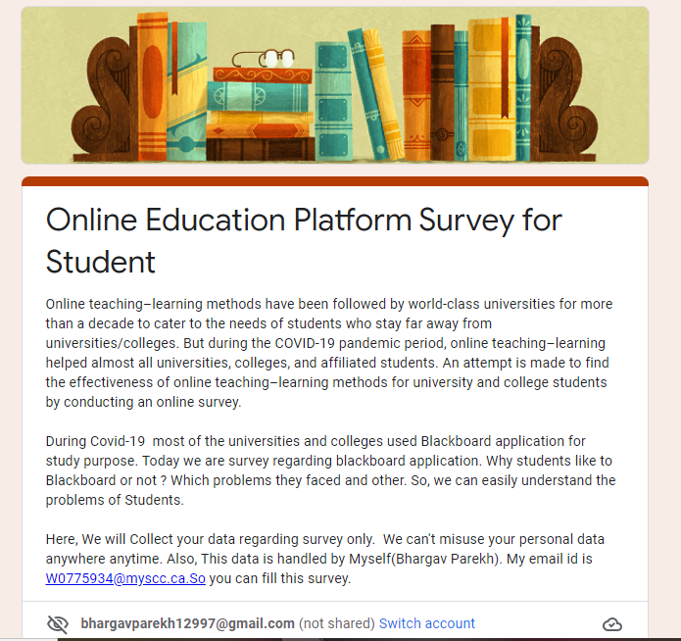

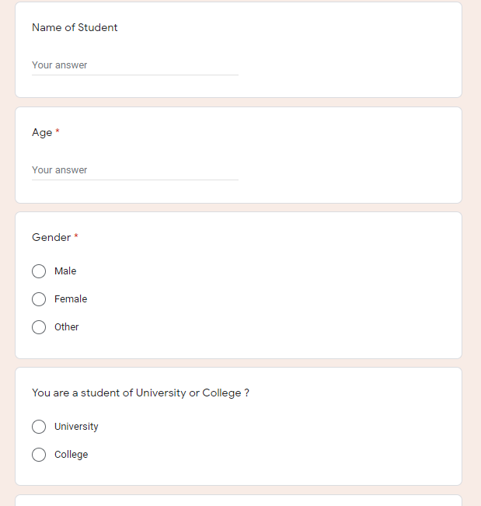

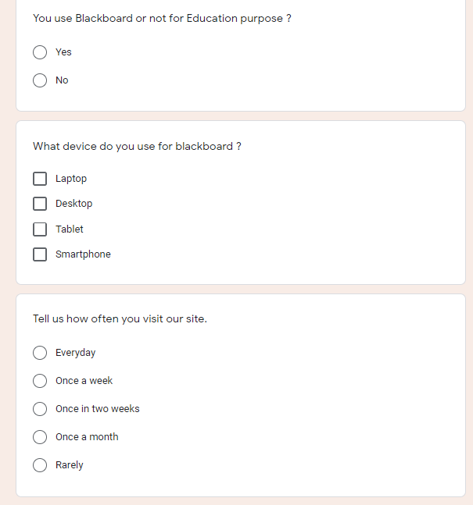

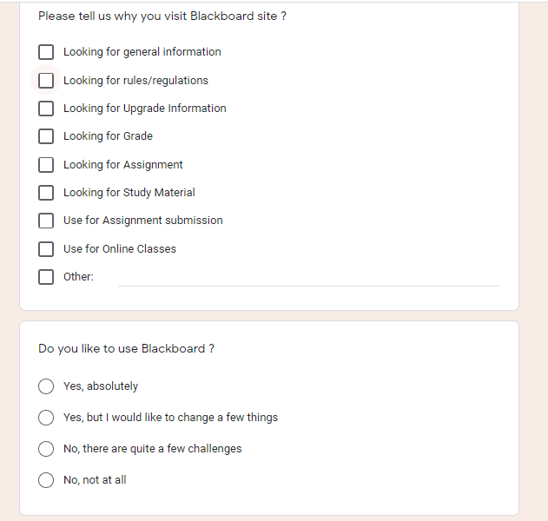

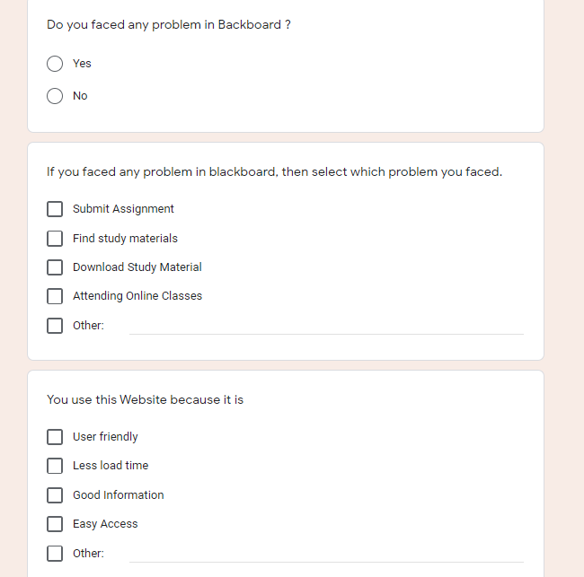

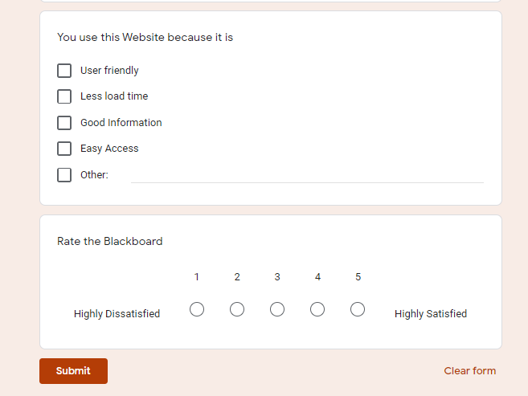

* Secondly, I collect data and then convert data into .csv format.
* Then, rename file and save the file with the name of **Survey1.csv**

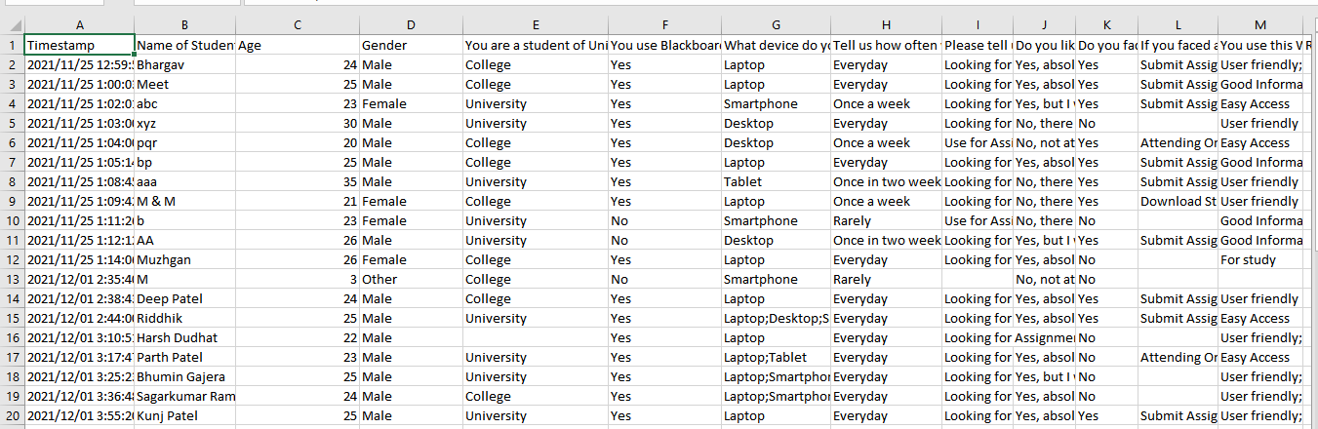

**Step: 2 Cleaning the data & rename survey2.csv**

* In the Cleaning Stage, Firstly I removed Timestamp column because it is unnecessary.
* Also, I removed Name of student column from dataset because it is too personal information and I don’t want to use for survey.
* In excel, I split columns with the help of split column function, which contain more than 1 value in single column.
* Replace null value with None.
* Saved file with survey2.csv

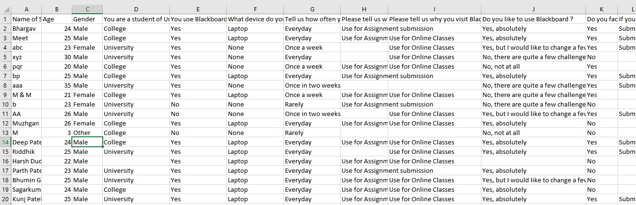

**Step: 3 Create an age group**

* In tableau, I create new column for age group like 16-20,21-25,26-30,31-35 etc.
* Because in survey I collected value only number. So for visualization I created different group.

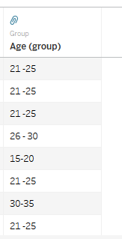

**Step: 4**

* In the next Stage, I created 5 questions, which is answered with the help of visualization.
  1. How often student use blackboard?
  2. Which age group use more Blackboard?
  3. Students faced any problem in Blackboard?
  4. Student like to use blackboard?
  5. Which Device use more for blackboard?

**Step:5**

* In this Step, I created Dashboard with the help of Tableau, which is give the answers of all the questions with the help of visualization.

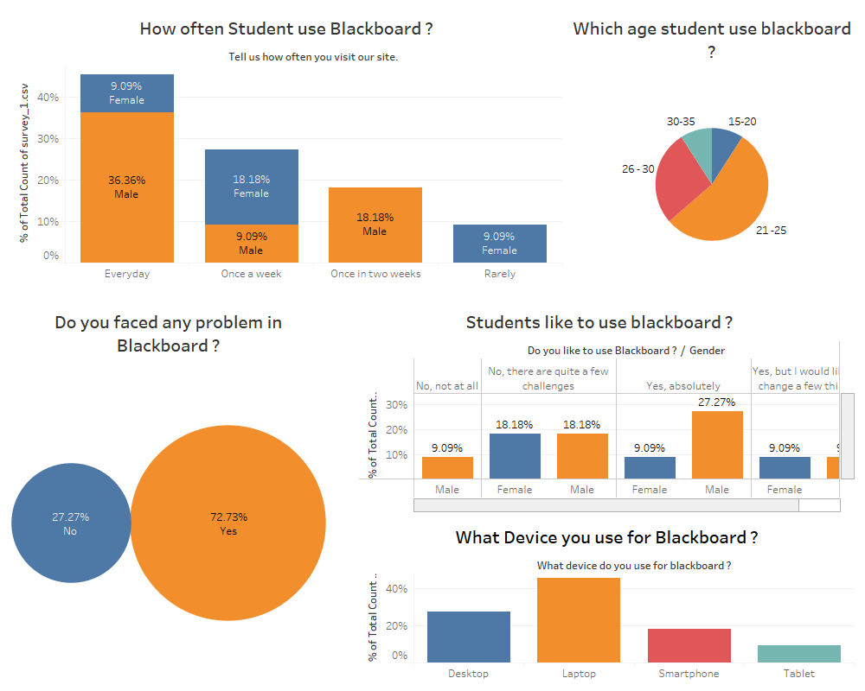

**Conclusion:**

Overall, we can see that with the help of Blackboard survey around 70% of students faced problem in blackboard. Approximately 45% of students use Blackboard daily. While, one-tenth (10%) students use rarely. Interestingly, 10% of rarely users was Female Students. The highest use of blackboard by 21 to 25 age group of students. More than 50% of students like to blackboard site for education purpose, while other students want to few changes in blackboard. The most important things in blackboard used in different devices like Smartphone, tablet, Desktop as well laptop but most of students preferred Laptop for blackboard use.