Java based Flight Reservation System Project

Assignment 5

Regis University

MSSE670 – Java Software Development

Spring 2020 Week 5

04/12/2020

Brenda Palmer

Table of Contents

Introduction 3

Purpose 3

Scope 3

Methodology 3

Software Architecture 3

Eclipse Images 5

Eclipse images of Business Layer SuperType class, Manager classes, MgrTest Classes and ApplicationTestSuite class 5

Eclipse imager of Aggregated JUnit Tests 7

What I Learned 8

# Introduction

The Business Layer is used to create the business logic of the application. This is where the business rules get implemented and applied. The objective for this week is to implement the business logic/rules for my Flight Reservation system with the focus on my use case to book a flight.

## Purpose

The purpose of this assignment is to learn how the Business Layer works, interacts with the Service Layers factory and services all the way down to the Domain objects using Java code.

## Scope

This week’s assignment is focused only on creating the super type, manager classes, creating manager JUnit tests and then to aggregate all three layers: domain, service and business in one test suite.

## Methodology

The methodology used for creating the Service Layer is UML.

# Software Architecture

The Domain Layer was created in Eclipse and the following classes where created:

**SuperType Class:** Manager.java

**Manager Classes:** CustomerAccountManager, LoginManager, SearchFlightInfoManager, ListAvailableItineraryOptionsManager, ReserveItineraryManager and BookItineraryManager.

**Junit Test Classes:** CustomerAccountMgrTest, LoginMgrTest, SearchFlightInfoMgrTest, ListAvailableItineraryOptionsMgrTest, ReserveItineraryMgrTest, BookItineraryMgrTest and ApplicationTestSuite .

# Eclipse Images

## Eclipse images of Business Layer SuperType class, Manager classes, MgrTest Classes and ApplicationTestSuite class

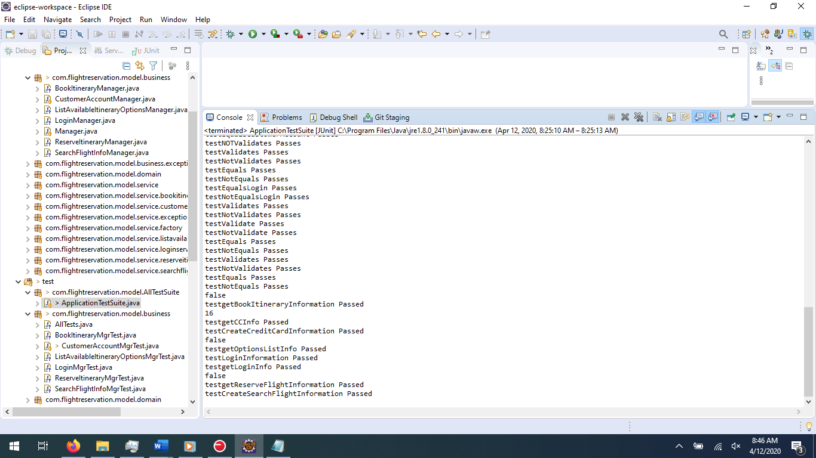

Problems tab:

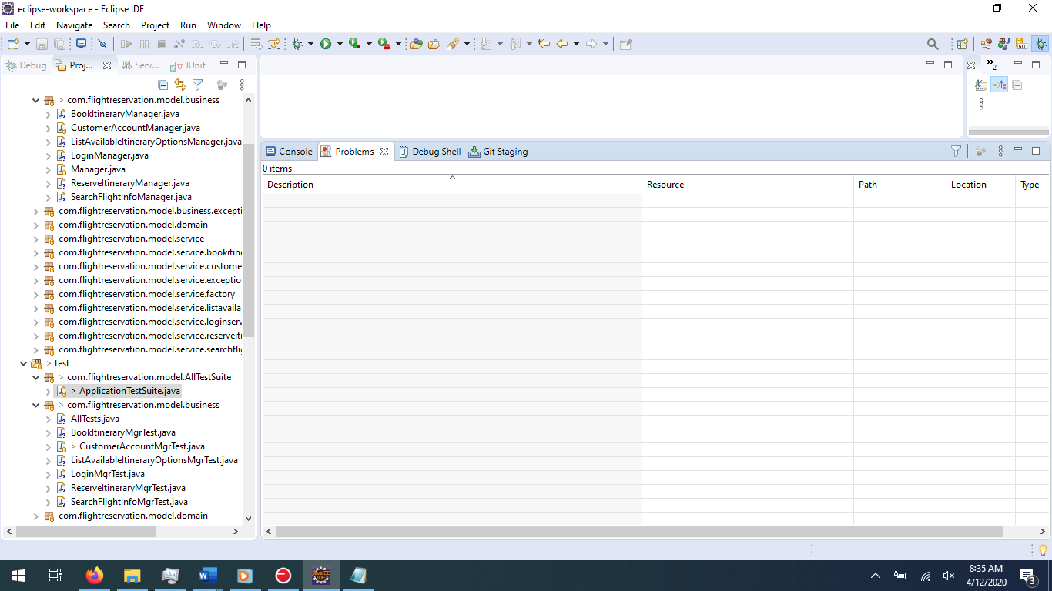

## Eclipse imager of Aggregated JUnit Tests

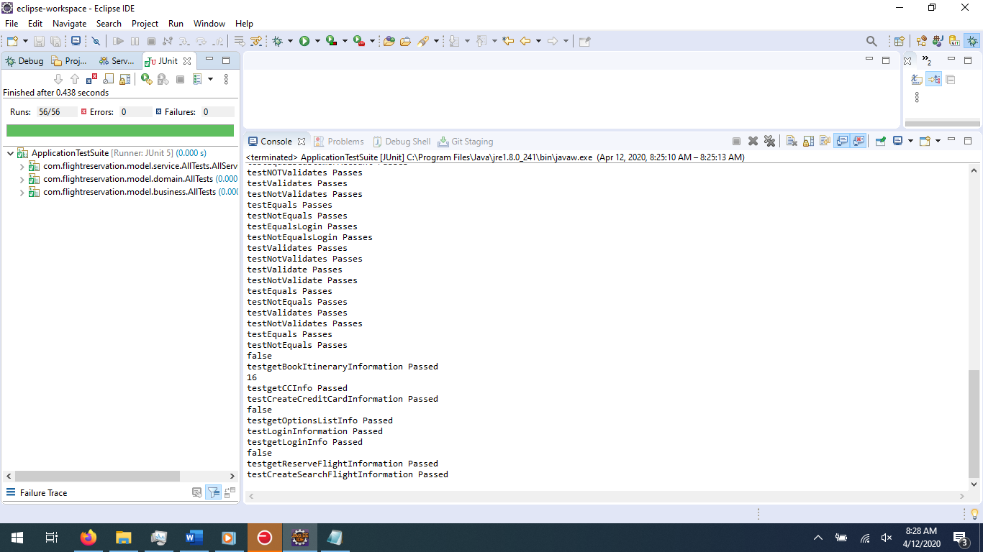

Problems Tab: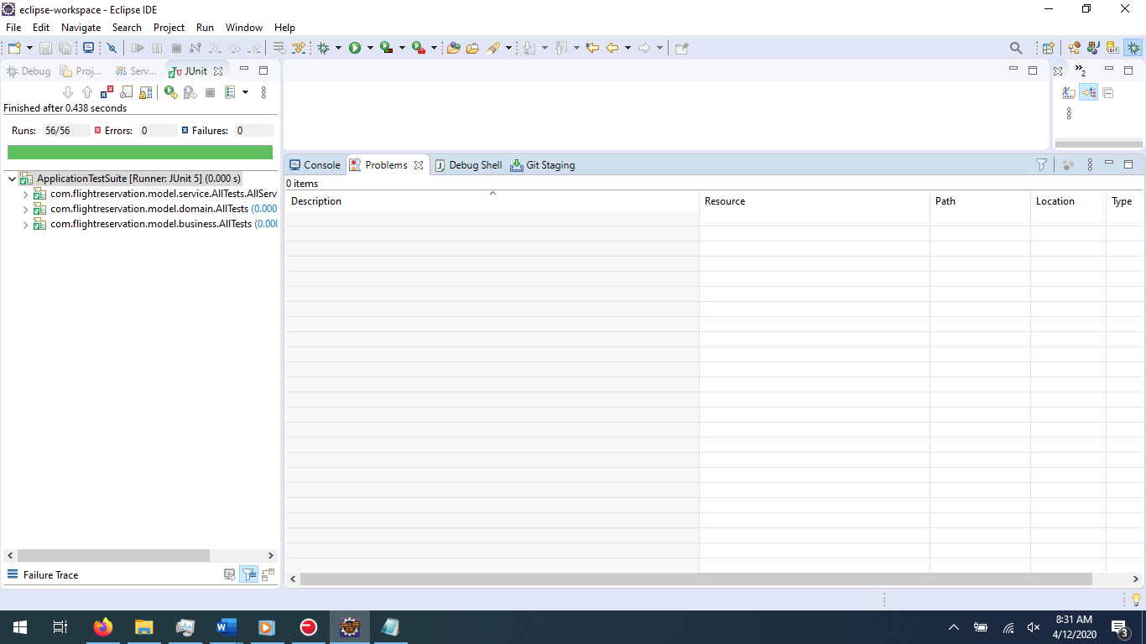

# What I Learned

This week I worked on the Business layer and learned how to implement business logic and rules in the Flight Reservation application. Learning how the business layer is a façade to the presentation layer was new to me. It is nice how the façade can hide the details of the lower levels to keep things well organized, structured and readable. I believe I implemented the business logic and rules correctly in my java application which allowed me to learn more about different ways of architecture programming in java. I look forward to how the presentation layer interacts with the managers in the business layer.