Java based Flight Reservation System Project

Assignment 6

Regis University

MSSE670 – Java Software Development

Spring 2020 Week 6

04/19/2020

Brenda Palmer

Table of Contents

Introduction 3

Purpose 3

Scope 3

Methodology 3

Software Architecture 3

WireFrame of GUI Design’s for all UI classes using Draw.io 4

Eclipse Images 8

Eclipse images of Presentation Layer UI Classes showing no errors or warnings 8

Eclipse image of Presentation Layer GUI 9

CustomerAccountUI 9

LoginUI 9

SearchFlightInfoUI 10

ListAvailableItineraryOptionsUI 10

ReserveItineraryUI 11

BookItineraryUI 11

What I Learned 12

# Introduction

The Presentation Layer is used to represent a UI to the user who interacts with the software system by interacting with the Business Layer’s Manager classes that makes use of the Service and Domain layers. Instead of using JUnit as the user who interacts with the system this time it will be the user interacting with UI to ensure everything functions correctly.

## Purpose

The purpose of this assignment is to learn how the Presentation Layer works, interacts with the Business Layers Manager classes and then how to implement this knowledge into Java code by use of Java’s Swing.

## Scope

This week’s assignment is focused only on creating the UI classes using the Swing technology built into Java.

## Methodology

The methodology used for creating the Service Layer is UML.

# Software Architecture

The Presentation Layer was created in Eclipse and the following classes where created:

**User Interface Classes:** CustomerAccountUI,, LoginUI, SearchFlightInfoUI, ListAvailableItineraryOptionsUI, ReserveItinearyUI and BookItineraryUI.

## WireFrame of GUI Design’s for all UI classes using Draw.io

# Eclipse Images

## Eclipse images of Presentation Layer UI Classes showing no errors or warnings

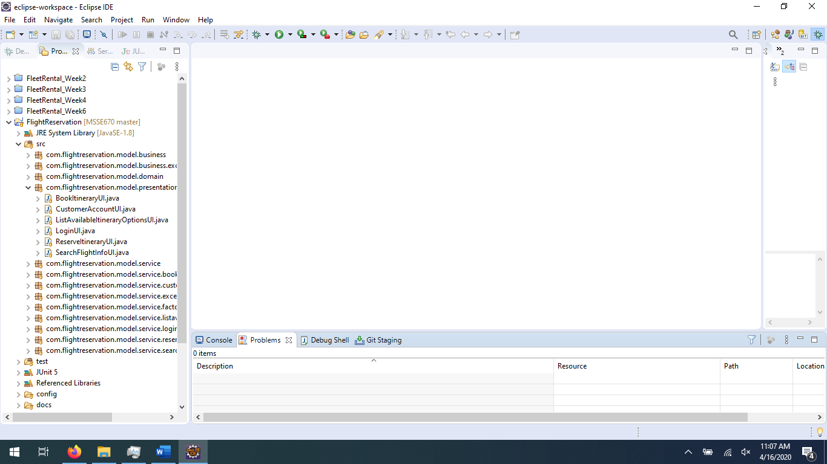

## Eclipse image of Presentation Layer GUI

### CustomerAccountUI

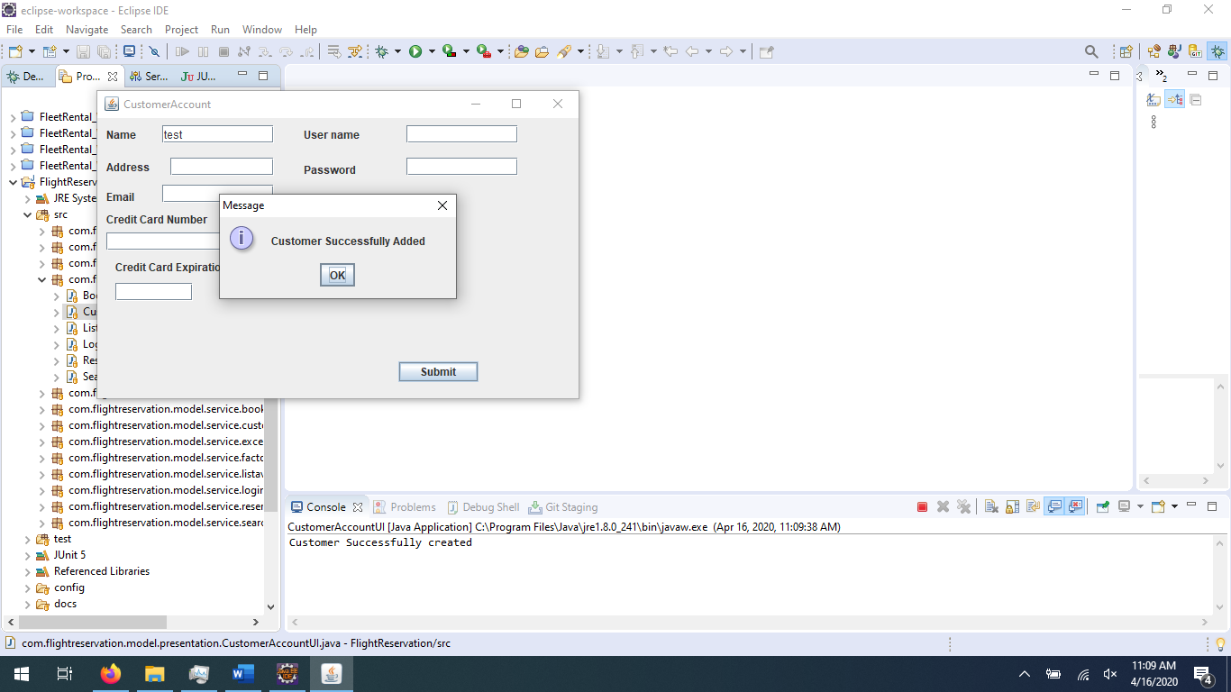

LoginUI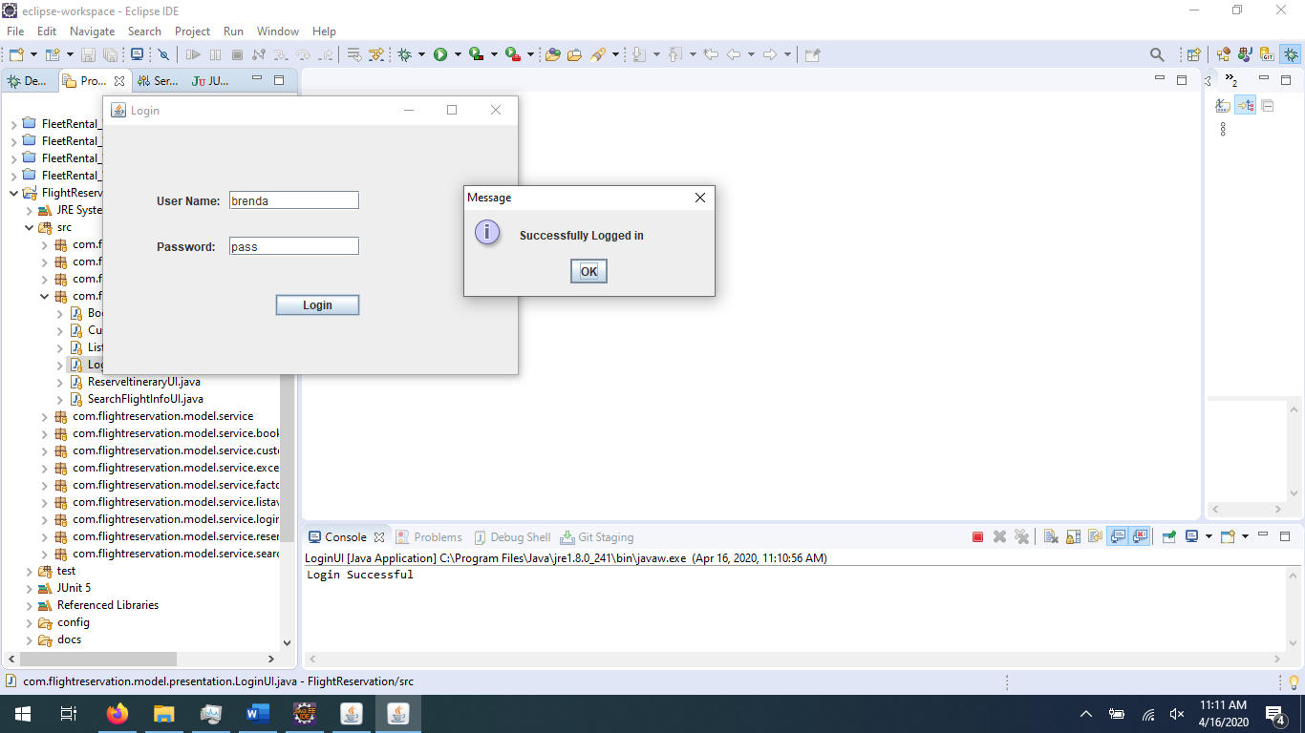

SearchFlightInfoUI

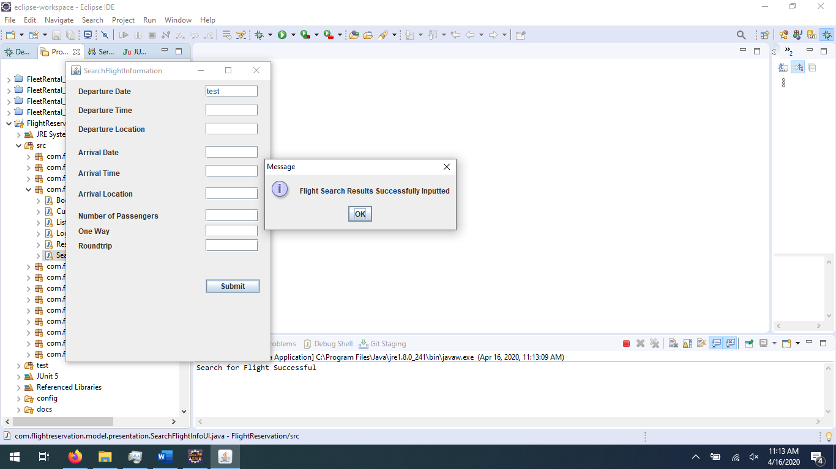

### ListAvailableItineraryOptionsUI

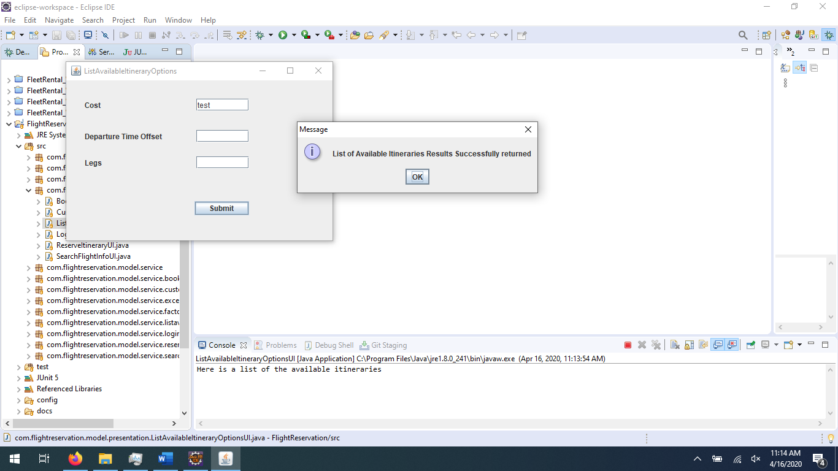

### ReserveItineraryUI

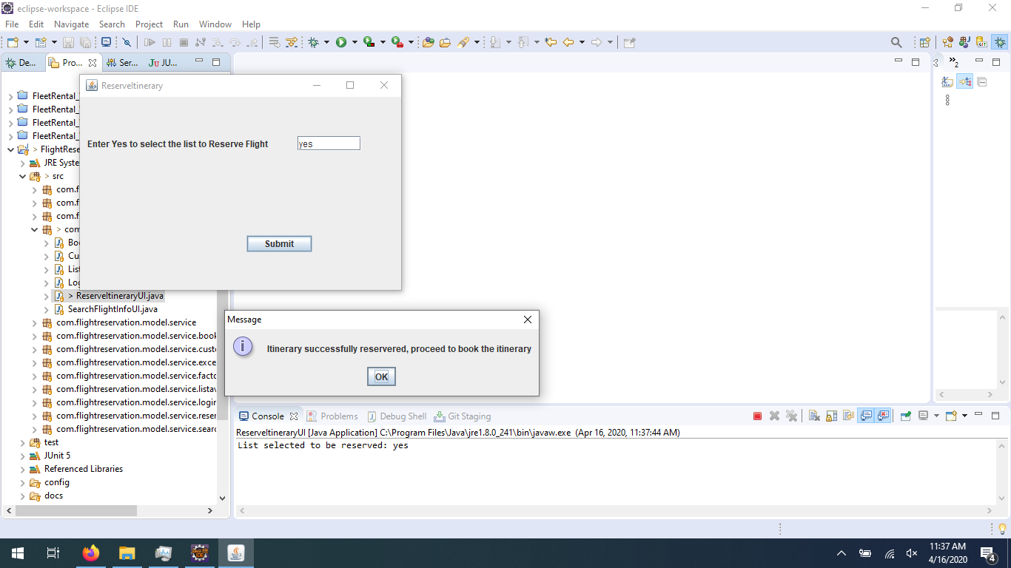

### BookItineraryUI

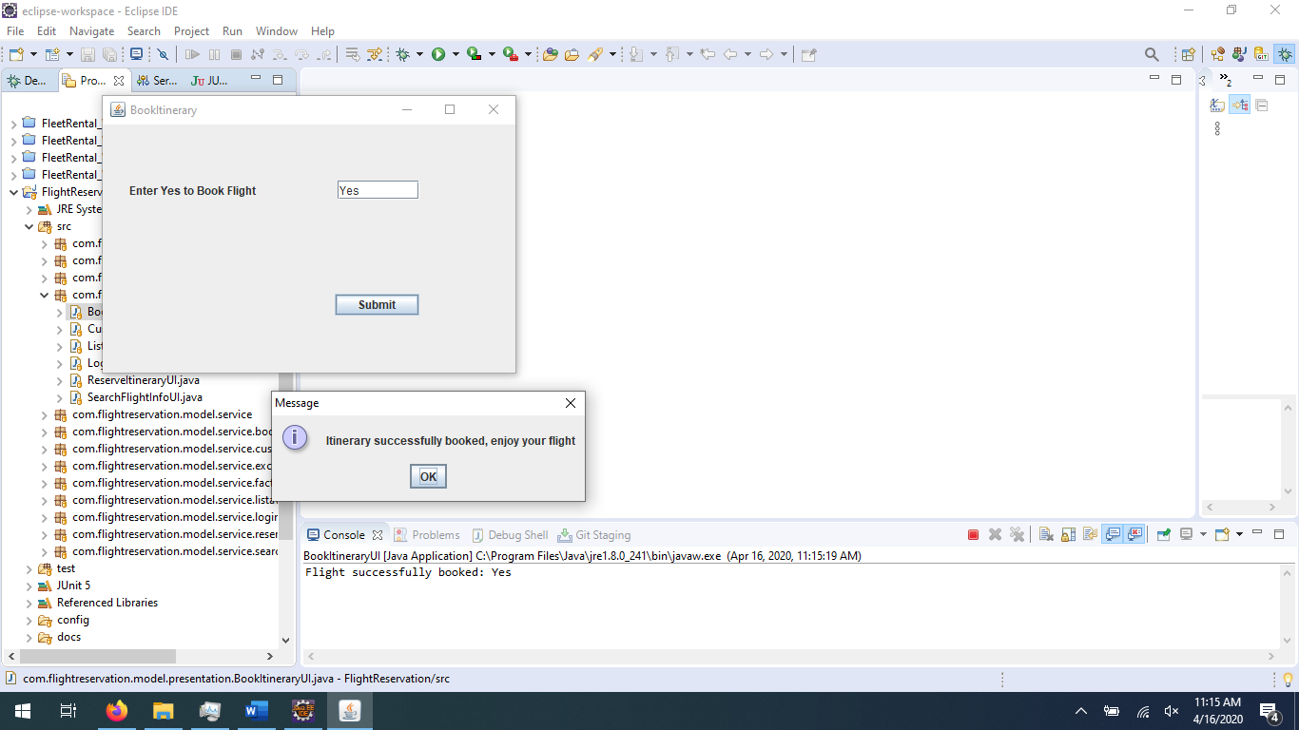

# What I Learned

I have never tried my hand at coding Java GUIs, so this was all new to me. I have heard of Swing but never really knew what it was. This was a fun assignment. I can see how one would try to over do it in GUI design because it is fun to try different layouts, colors, etc… However, for this assignment and the timeframe, I kept it as simple as possible. I never realized creating the widgets would be inside the constructor code block. That was something I didn’t think the constructor could handle. I also learned about event handling and how it is used. I have heard of listeners for automation testing but didn’t know it applied to the GUI. So I learned a lot and enjoyed it too.