Java based Flight Reservation System Project

Assignment 7

Regis University

MSSE670 – Java Software Development

Spring 2020 Week 7

04/26/2020

Brenda Palmer

Table of Contents

Introduction 3

Purpose 3

Scope 3

Methodology 3

Software Architecture 3

Eclipse Images 4

Eclipse images of Presentation Layer MainUI Class 4

Problems tab: 5

Eclipse images of the Use Case Menu 6

Login Use Case 6

CustomerAccount Use Case 7

SearchFlightInfomation Use Case 7

ListAvailableItineraryOptions Use Case 8

ReserveItinerary Use Case 8

BookItinerary Use Case 9

# Introduction

The Iterative Development phase is where we identify each important item(s) in the different N-Tiered layers and then implement another use case by doing another iteration. For this week’s assignment we need to have more than the Login use case and the 1st priority use case and then to create a menu in the Presentation layer that has 3 or more use cases. When the user of the system selects a use case from the menu and clicks on it, the working GUI for the use case should appear and be functional.

## Purpose

The purpose of this assignment is to learn how the Iterative Development works and then how to implement this knowledge into Java code.

## Scope

This week’s assignment is focused on creating the MainUI class that will implement the SWING menu for all the use cases I have implemented so far. From the beginning I have been using more than two use cases in all my layers and Professor Abu Matar said it was alright not to implement anymore use cases in my Flight Reservation system, since I already have 6 uses cases, which includes the Login use case.

## Methodology

The methodology used for creating the Iterative Development is UML.

# Software Architecture

The Iterative Development was created in Eclipse and the following class was created:

**Presentation Layer Class:** MainUI

# Eclipse Images

## Eclipse images of Presentation Layer MainUI Class

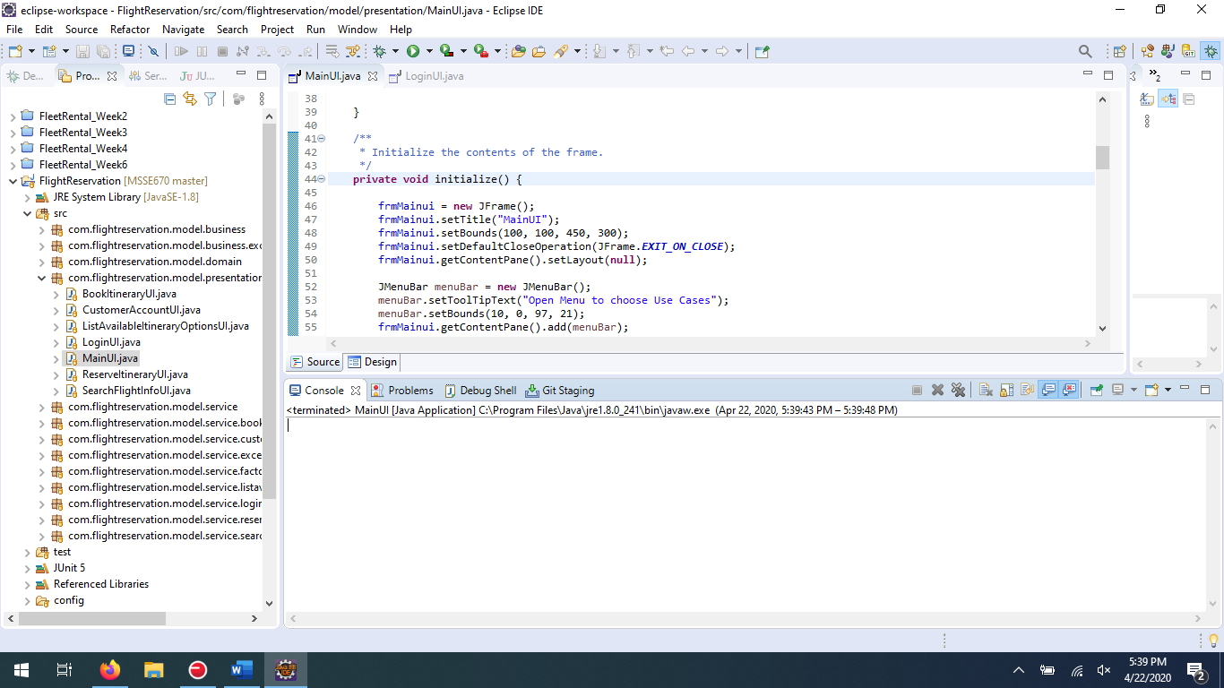

### Problems tab:

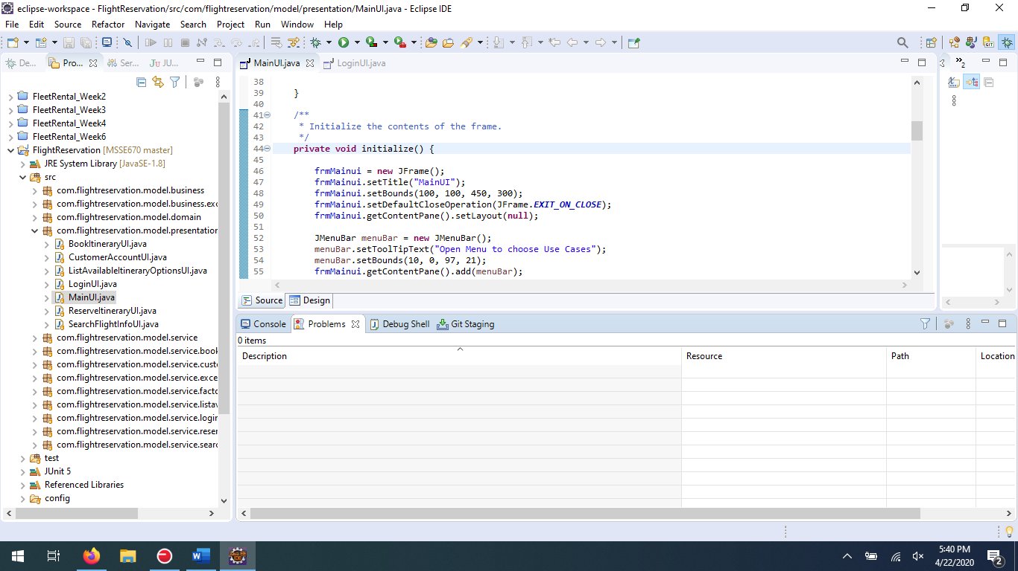

## Eclipse images of the Use Case Menu

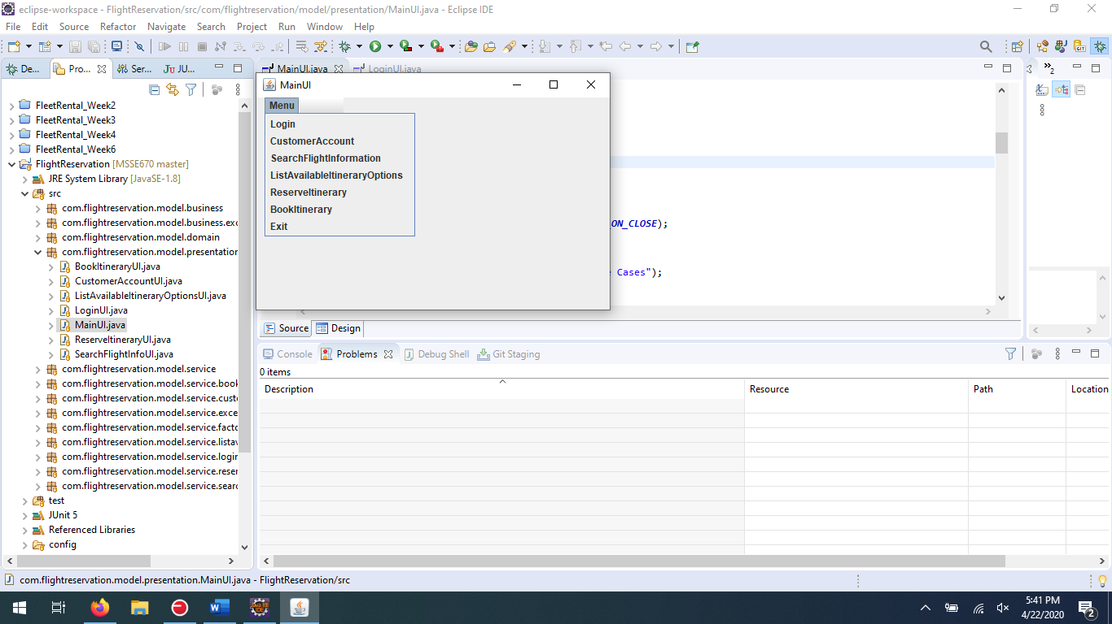

### Login Use Case

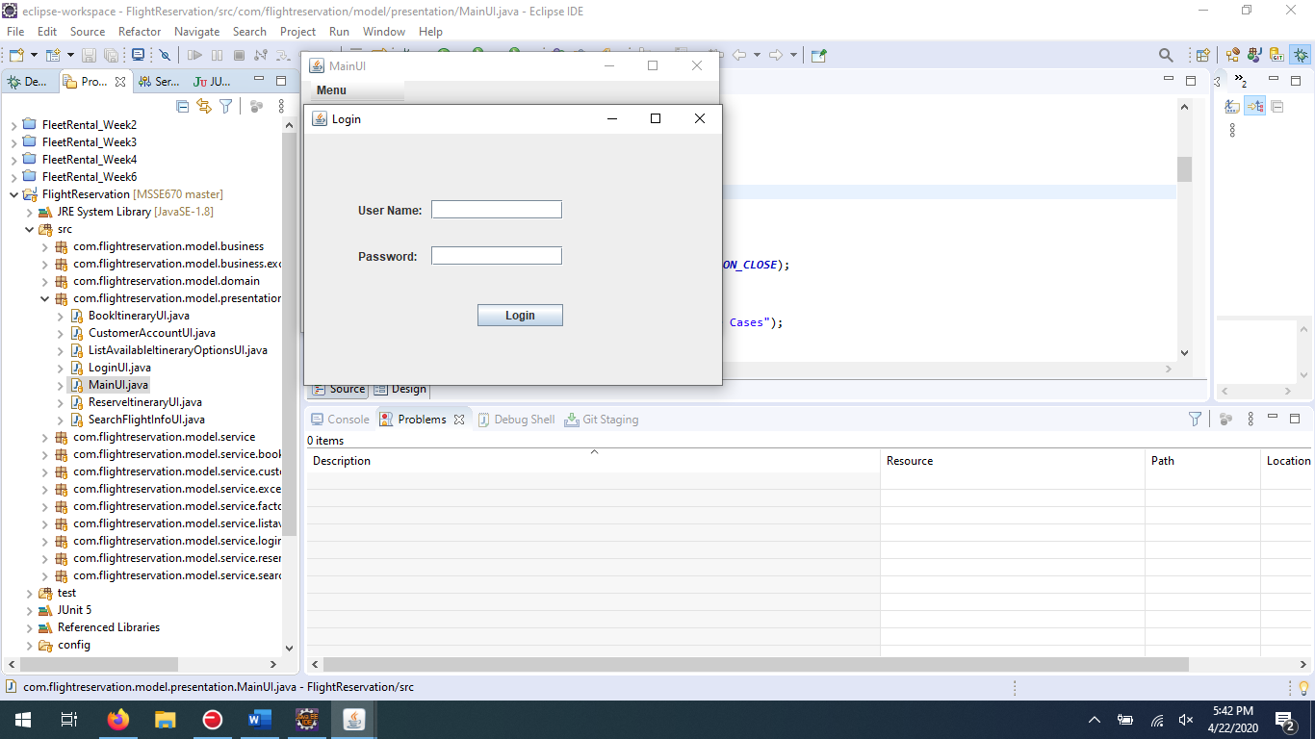

### CustomerAccount Use Case

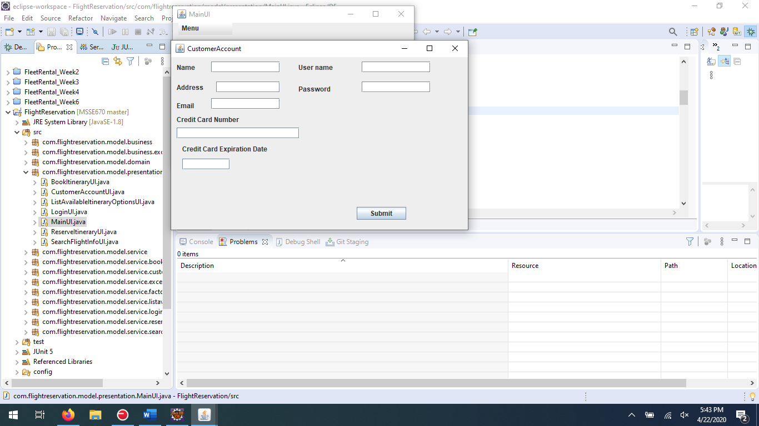

### SearchFlightInfomation Use Case

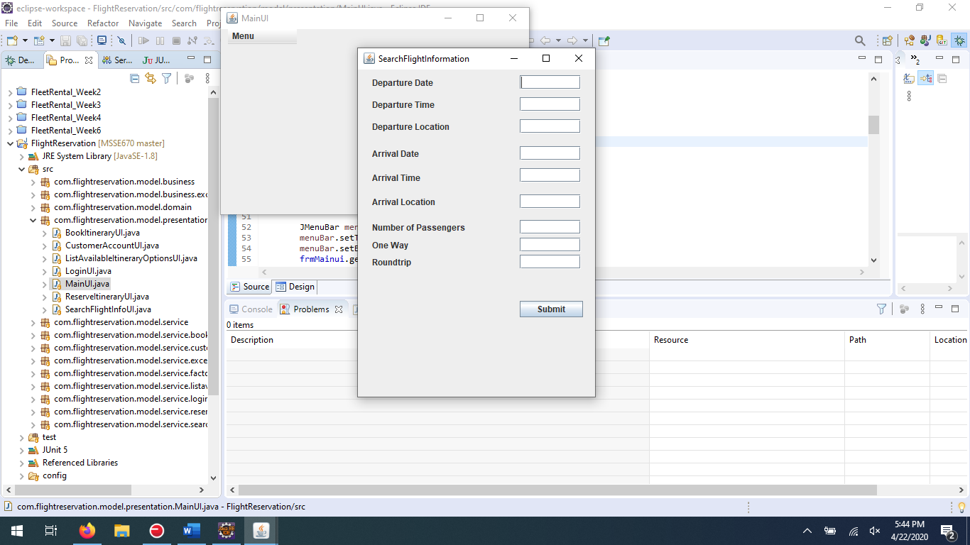

### ListAvailableItineraryOptions Use Case

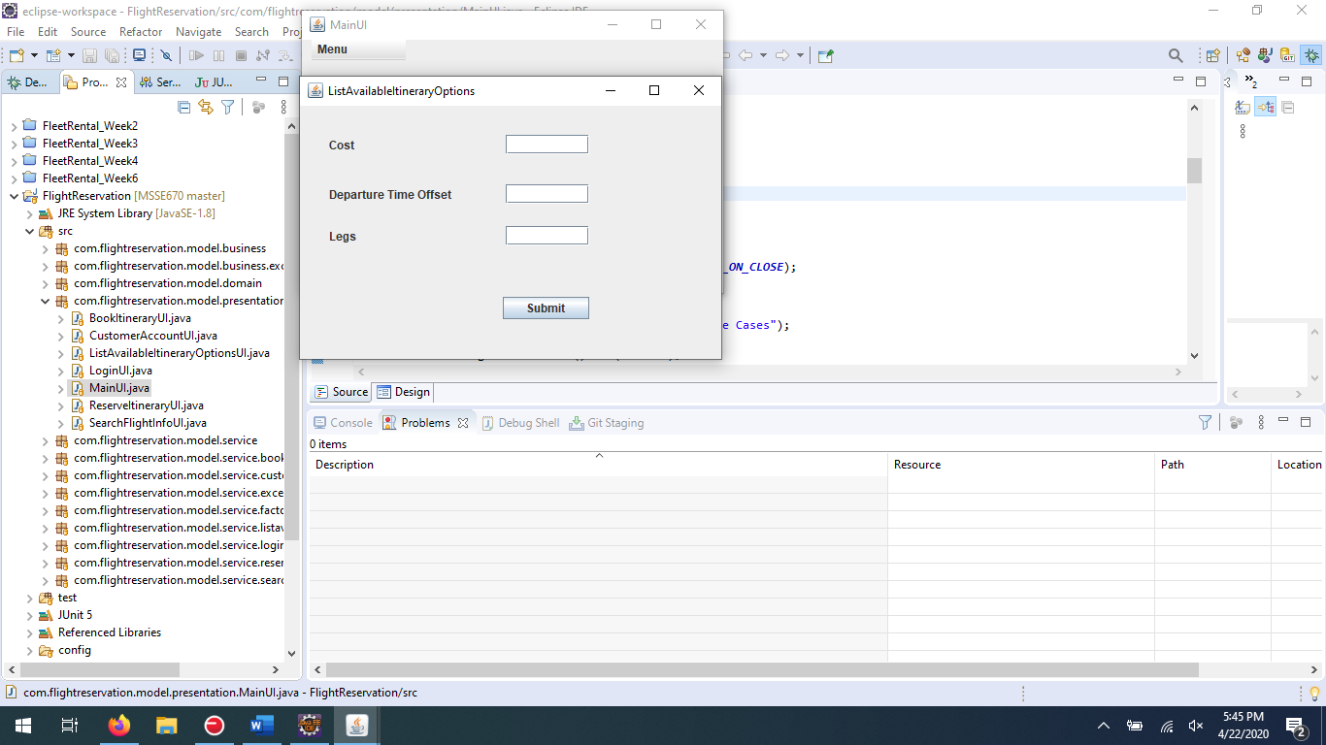

### ReserveItinerary Use Case

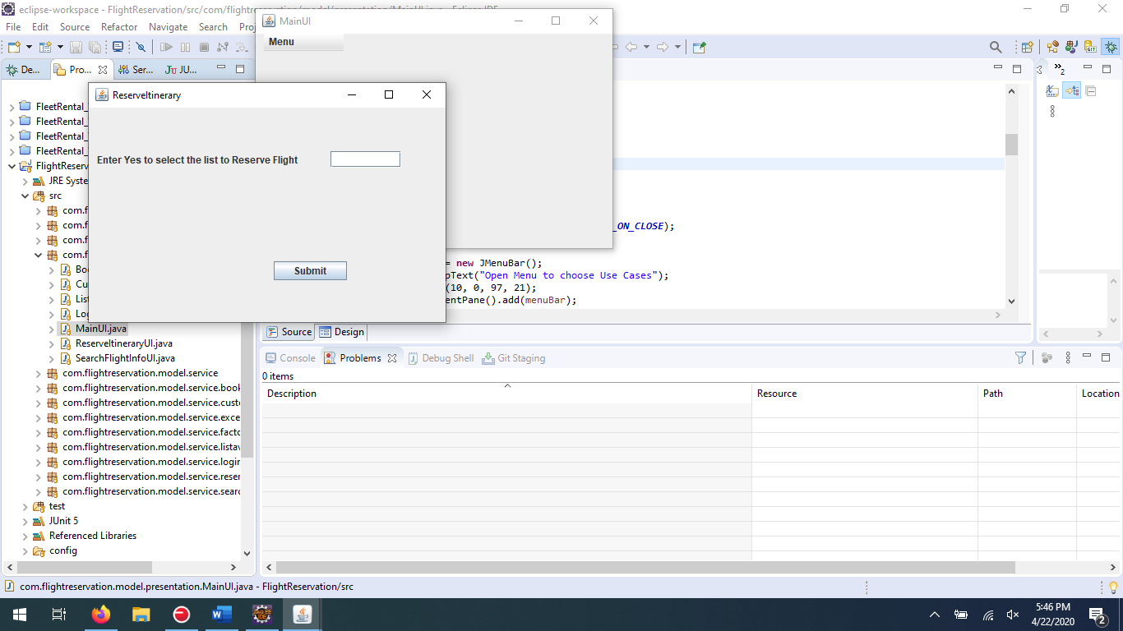

### BookItinerary Use Case

