Java based Flight Reservation System Project

Assignment 8

Regis University

MSSE670 – Java Software Development

Spring 2020 Week 8

05/03/2020

Brenda Palmer

Table of Contents

Introduction 3

Purpose 3

Scope 3

Software Architecture 3

Eclipse Images 4

Eclipse images of MyApp.jar and build.xml with no problems 4

Running java -jar MyApp.jar from cmd prompt 5

Running with Ant build.xml 5

# Introduction

The Packaging and Delivery is used to make the application work outside the development environment. I created two JAR files. One that is within the project to run by command prompt and another outside the project for Ant. I also created the manifest file and put the application.properties file in the config folder.

## Purpose

The purpose of this assignment is to learn how the Packaging and Delivery works, to allow the application to run outside the development environment and then to implement this knowledge into Java code.

## Scope

This week’s assignment is focused only on creating the manifest.txt file, create a config folder and put the application.properties file in this folder, create a JAR and execute it from the command prompt and create an Ant build.xml to execute the JAR.

# Software Architecture

The Packaging and Delivery assignment was created in Eclipse and the following items where created:

**Files:** manifest.txt, MyApp.jar, build.xml and MyAppJar package. MyAppJar is what allows Ant to run using the build.xml. I copied the config folder and manifest.txt to MyAppJar project.

# Eclipse Images

## Eclipse images of MyApp.jar and build.xml with no problems

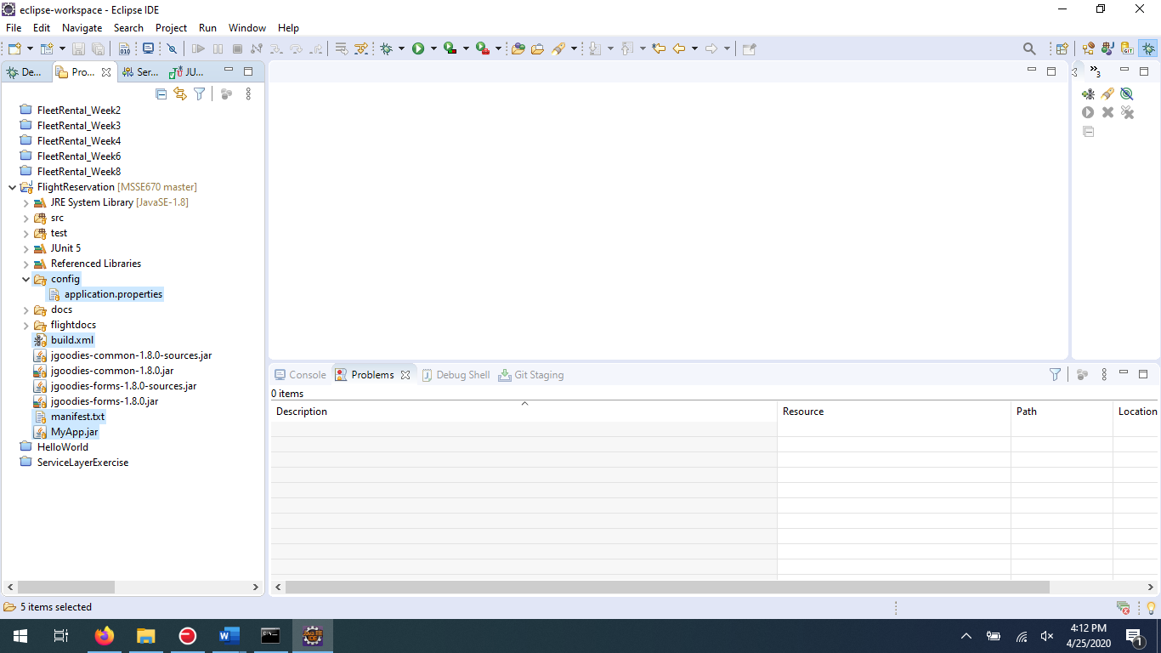

## Running java -jar MyApp.jar from cmd prompt

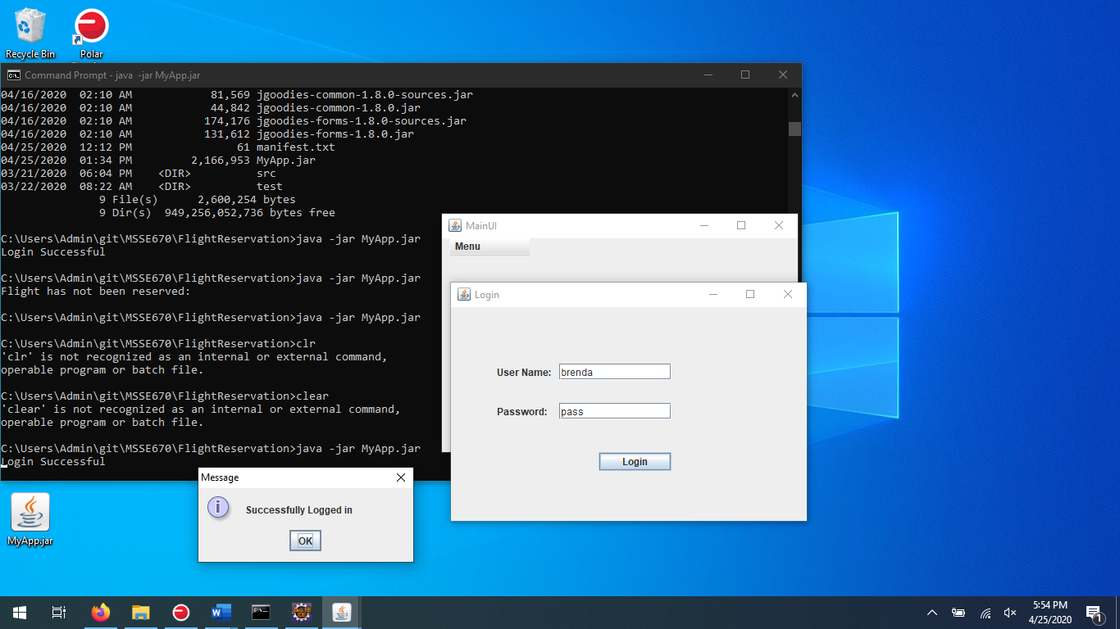

## Running with Ant build.xml

