Project Plan

Flock

Team #11

Ben Pallotti, Victoria Miller, Alex Nguyen, Armando Ortiz, Emmanuel Okafor

**TABLE OF CONTENTS:**

|  |  |
| --- | --- |
| **PAGE** | **CONTENT** |
| **2** | **INTRODUCTION** |
|  | **BUSINESS NEEDS/REQUIREMENTS** |
|  | **PRODUCT OR SOLUTION OVERVIEW** |
| **3** | **MAJOR FEATURES** |
| **4** | **PROJECT PROCESS DESCRIPTION** |
| **5** | **PROJECT SCHEDULE** |
|  | **PROJECT WORK AND PRODUCT ESTIMATES** |
| **6** | **TEAM** |
|  | **PROJECT SCOPE AND LIMITATIONS** |

**1. INTRODUCTION**

Flock is an application that uses an algorithm to find the interests of Twitter users (via Tweets and mutually followed pages), then uses those interests to connect them with other users. This can be used to build new relationships though social media. These relationships are intended to be for dating, friendship, and follower gain. The app will prioritize users who are within proximity to increase the probability of a face-to-face relationship, for both dating and simple friendships. Online relationships are also valued.

**2. BUSINESS NEEDS/REQUIREMENTS**

People are always searching for new friendships, potential partners, and growth in Twitter followers. This can be difficult. Flock can simplify and expedite the process of networking. We believe that Twitter is a great platform to reach new Flock users because Twitter has a large user base. (About 300 million users)

**3. PRODUCT OR SOLUTION OVERVIEW**

-Flock is the solution to Twitter reclusiveness and stagnant follower counts. It is important to grow your online network and to connect with people. Developing all types of relationships is good for personal growth, healthy comradery, and finding a significant other. We are more connected as a species than ever before, and Flock can ride the wave and take it to the next level. It will do this by collecting tweets and saving keywords from those tweets. It will check the frequency of these keywords and save it to the user’s profile. It can then match the user to another user who also tweets similar words, assuming they have an interest.

**4. MAJOR FEATURES**

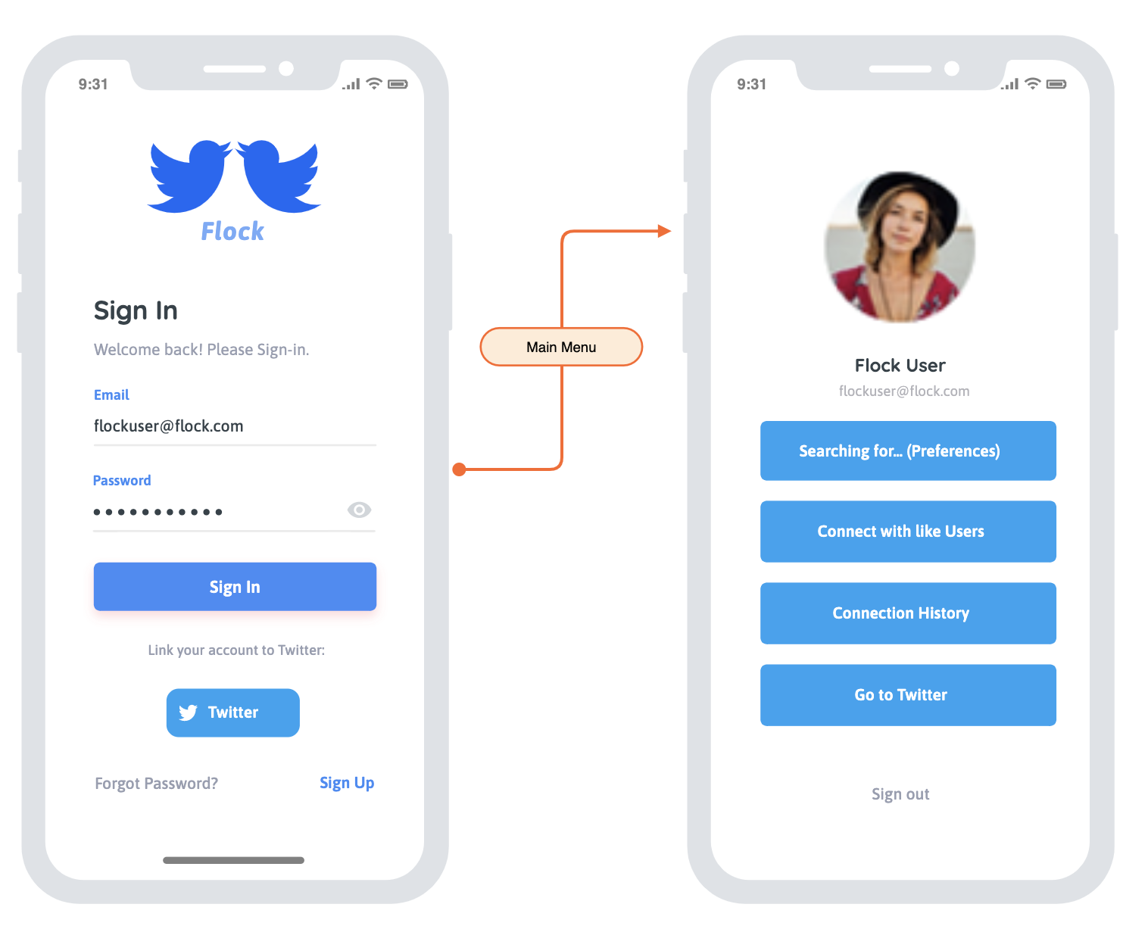

**FEATURES**:

* Log-in
* Profile creation
* Choose what type of relationships you’re searching for (Dating, Friendship, Community, Growth)
* Connecting to users with common interests

**5. PROJECT PROCESS DESCRIPTION**

|  |  |  |  |
| --- | --- | --- | --- |
| **Activity Name** | **Activity Description** | **Entrance Criteria** | **Exit Criteria** |
| **Planning and Analysis** | This includes the original idea and building the framework. We will discuss the programming language we are most comfortable with that can also ensure all the software’s needs can be met. | Team input and a written, officiated plan. | Submission of written plan |
| **Design/Build** Interface | The most demanding phase. There are many steps required to fully implement all the capabilities of the app. This includes the account creation and the menu. | Java (Codename One), JavaScript and potential app hosting software | A working and eye-pleasing interface |
| **Build**  Algorithm | The most challenging phase. We must find an algorithm that collects only keywords from Tweets and stores them. Then these words must be checked for in other profiles stored words. Then we can suggest that the users connect and link their Twitter profiles to each other. | Java (Codename One), | A functioning algorithm within the app |
| **Testing** | After creation, further testing must be done. Dig for errors and potential user mistakes or inconveniences. | Multiple team members looking for errors or improvements. | Perfected app |
| **Deployment and Maintenance** | Final product | Team searching for improvements. | Constantly improving app |

**6. PROJECT SCHEDULE**

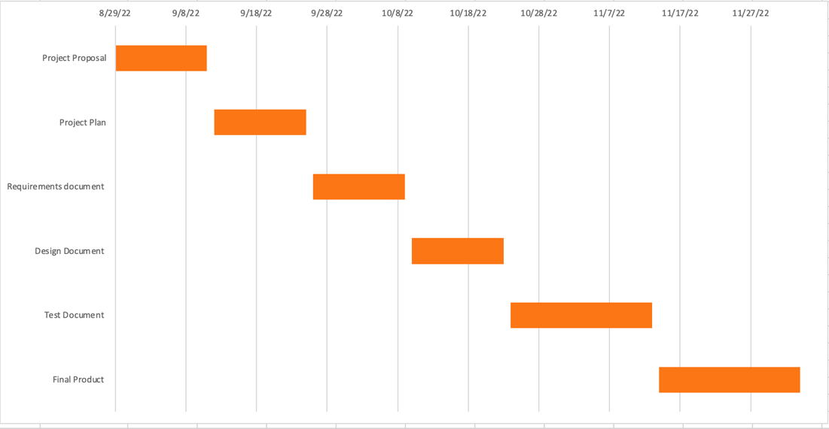

**7. PROJECT WORK AND PRODUCT ESTIMATES**

Estimated hours per member on average: 25-35 hours start to finish

Estimated lines of code: Under 5000

**8. TEAM**

**Ben Pallotti:**

Tech Lead

**Victoria Miller:**

Scrum Master

**Alex Nguyen:**

Software Developer (Full Stack)

**Armando Ortiz:**

Software Developer (Full Stack)

**Emmanuel Okafor:**

Software Developer (Full Stack)

**9. SCOPE AND LIMITATIONS**

The scope will be to the extent of the interface and Twitter. It will contain links to Twitter, but not a relationship where you can edit your Twitter and settings within the app. Flock is independent of Twitter but uses public information on Twitter and saves it and applies it to the algorithm.