Budget Statement 2:
Economic Outlook
The global economic environment has sharply deteriorated. Inflation has risen rapidly across advanced economies and, in many countries, is at levels not seen in decades. Central banks have lifted interest rates quickly in response, constituting the fastest synchronised monetary policy tightening in the inflation targeting era. The risk of recession across major advanced economies has risen and China’s growth outlook has weakened. Australia has withstood the pandemic and global challenges well, but we will not be unaffected, and domestic disruptions including the recent floods will test our resilience further.
High inflation remains the key challenge to the global economy. Global goods demand continues to outstrip supply, reflecting the flow-on effect of extraordinary policy support and pandemic related supply disruptions. The Russian invasion of Ukraine has significantly driven up global energy costs and exacerbated the impact of poor weather on global food prices. Labour markets remain tight in many countries and services inflation is showing signs of increasing in some countries.
Australia is not immune to the global challenges driving higher global inflation and slower global growth. Domestic inflation is forecast to peak at 7¾ per cent in the December quarter of 2022. Supply disruptions have resulted in large price increases in home building, fuel and energy. Food prices remain elevated and have been further exacerbated by recent floods. Some of these pressures are expected to persist into 2023. In particular, electricity and gas bills are expected to rise sharply this year and next. This will keep inflation elevated at 5¾ per cent over 2022–23 and 3½ per cent over 2023–24. Inflation is forecast to gradually ease and return to within the Reserve Bank’s inflation target by 2024–25.
Real GDP is forecast to grow by 3¼ per cent in 2022–23 before slowing to 1½ per cent in
2023–24, as cost of living pressures and rising interest rates increasingly weigh on household disposable income and consumption.
While labour market conditions are expected to remain tight in the near term, employment growth is expected to gradually ease, but remain positive. The unemployment rate is forecast to rise to 4½ per cent by the June quarter of 2024. This is still below its pre-pandemic level of around 5 per cent. Tight labour market conditions are expected to see annual wage growth pick up to 3¾ per cent by June 2023, the fastest pace since 2012. Even so, high inflation is still expected to see real wages fall over 2022–23 before rising slightly over 2023–24.
Despite the forecast for slowing economic growth, unemployment is expected to stay around historic lows and the Government is providing targeted cost-of-living relief to households. While some household groups have built up savings buffers over recent years, others are expected to come under greater pressure. Lower income households are more heavily impacted by price increases for essentials, such as housing costs and energy, as these make up a larger share of their household expenses. Targeted cost of living relief, indexation of government allowances and pensions and the larger than usual minimum wage increase provided by the Fair Work Commission will help to provide relief for many households.
Given the highly uncertain global economic outlook, there are significant risks that could cause a sharper slowdown in domestic activity. Globally, key risks include a ‘hard landing’ or recession across major advanced economies, a sharper-than-expected downturn in China due to COVID-19 outbreaks and the property market downturn, a sudden tightening in financial market conditions and further energy price shocks stemming from the Russian invasion of Ukraine, which could drive inflation even higher.
Domestically, the full impact of recent floods is highly uncertain, as the situation continues to develop. Beyond this, the path of monetary policy and household responses to inflation remain key risks to economic activity. Higher-than-expected inflation may further constrain consumer spending by lowering real incomes, while a potentially weaker economic outlook could see households exhibit precautionary savings behaviour that further weighs on consumption.

Contents
Outlook for the international economy 35
Outlook for global growth 35
Outlook for global inflation 36
Global monetary and fiscal policy 38
Key risks to the international outlook 39
Outlook for major trading partners 40
Outlook for the domestic economy 44
Outlook for real GDP growth 44
Household consumption 48
Dwelling investment 51
Business investment 51
Public final demand 53
Net exports 53
Inflation 56
The labour market 58
Outlook for the terms of trade 64
Sensitivity analysis of iron ore, metallurgical coal and thermal coal prices 65
Outlook for nominal GDP growth 65
Medium-term projections 66

Statement 2: Economic Outlook

Outlook for the international economy

Outlook for global growth
The global economic environment has sharply deteriorated. High inflation is sapping momentum and global growth is slowing by more than expected, with some major economies stalling or contracting. Higher global interest rates have increased the risk of recession across all major advanced economies, and the outlook for China has weakened.
The global growth forecast has been downgraded by ¾ of a percentage point in 2022, 1 percentage point in 2023, and ½ a percentage point in 2024 since Pre-election Economic and Fiscal Outlook (PEFO) (Chart 2.1). This represents a further deterioration since the July Ministerial Statement, with Australia’s growth in 2023 expected to exceed that of the major advanced economies. Global growth is now expected to slow to 3 per cent this year and 2¾ per cent in 2023, before picking up in 2024.
The global recovery from the pandemic has continued to face disruptions and significant shocks, most notably from the Russian invasion of Ukraine driving up food and energy prices, and the impact of continued COVID-19 lockdowns in China.
High inflation resulting from the after-effects of the pandemic and disruptions to global energy supply stemming from Russia’s invasion is proving a more formidable challenge to global growth than anticipated at the time of PEFO. Central banks have signalled that tighter monetary policy will be necessary to return inflation to levels consistent with their targets. The combination of higher inflation and higher interest rates is expected to see a significant slowing in household demand.
Labour markets remain tight with unemployment rates at or below pre-pandemic levels across advanced economies. While wages are showing signs of responding to this extreme tightness in the United States, United Kingdom and to a lesser extent New Zealand, real wages are lower across the board due to persistently higher inflation.
Most advanced and emerging economies have transitioned to public health arrangements that do not impose significant restrictions on normal economic activity. However, China remains reliant on lockdown measures to control the spread of COVID-19. The prospect of ongoing outbreaks and lockdowns in China will weigh on global growth and poses risks for the recovery of global supply chains. China’s property market has also entered a significant downturn. This downturn has lasted much longer than expected and will drag on growth more significantly over the coming year than anticipated at PEFO.
Table 2.1: International GDP growth forecasts^{(a)}
 | Outcome | Forecasts (Calendar Years)
 | 2021 | 2022 | 2023 | 2024
Australia | 4.9 | 4 | 2 | 1 ½
China | 8.1 | 3 | 4 ½ | 4 ½
India | 8.3 | 7 ¼ | 5 ¾ | 6 ¾
Japan | 1.7 | 1 ½ | 1 ½ | 1
United States | 5.9 | 1 ¾ | 1 | 1 ¾
Euro area | 5.3 | 3 | ½ | 1 ½
United Kingdom | 7.5 | 4 ¼ | -¼ | 1 ½
Other East Asia (b) | 4.0 | 4 ½ | 4 | 4 ¼
Major trading partners | 6.2 | 3 | 3 | 3 ¼
World | 6.0 | 3 | 2 ¾ | 3
- World and other East Asia growth rates are calculated using GDP weights based on purchasing power parity (PPP), while growth rates for major trading partners are calculated using goods and services export trade weights.
- Other East Asia comprises Indonesia, Malaysia, the Philippines, Thailand, Vietnam and Singapore, along with Hong Kong, South Korea and Taiwan.
Source: National statistical agencies, IMF, Refinitiv and Treasury.

Chart 2.1: International growth forecasts for 2023
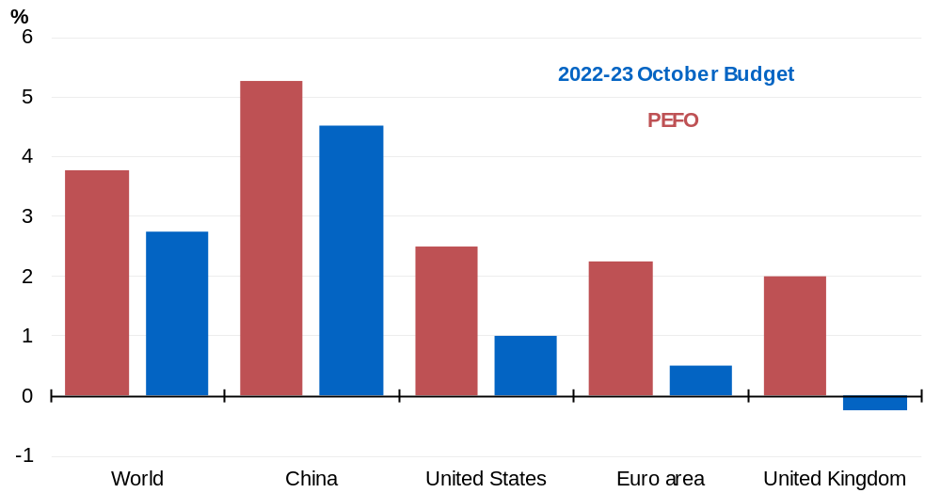
Source: Treasury.

Outlook for global inflation
Inflationary pressures have persisted and intensified in most advanced economies since PEFO, driven in part by recent increases in global energy spot prices (Chart 2.2). Gas prices are a key source of intensifying cost-of-living pressures for many consumers, having risen over 6-fold since March 2021. Food prices remain elevated, driven by Russia’s invasion of Ukraine, widespread adverse weather conditions, and several countries placing restrictions on food exports.
Chart 2.2: G7 inflation forecasts  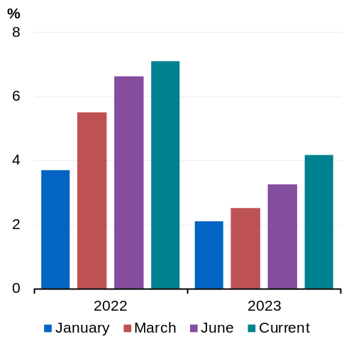 | Chart 2.3: Global energy spot prices  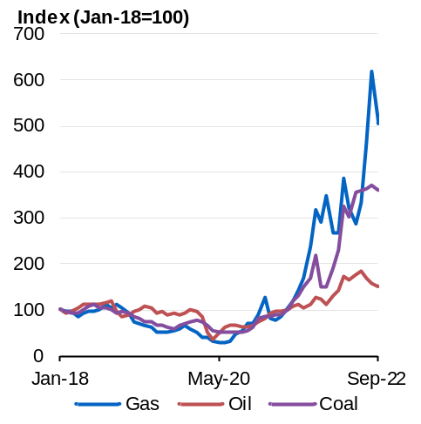
Source: Consensus Economics, Refinitiv and Treasury.  Note: PPP-weighted year-average. | Source: IMF, Refinitiv and Treasury.  Note: Oil prices include Brent, WTI and Dubai Fateh. Gas prices include European, Japanese and American prices. Coal prices include Australian and South African prices.

Russia’s decision to restrict gas supplies to Europe has resulted in extreme increases in wholesale gas prices in the region. Restrictions to gas supplies have had ripple effects, flowing through to broadening price pressures in Europe and higher gas prices in other countries dependent on gas imports, particularly in Asia (Chart 2.3). In a number of European countries, governments have stepped in with large fiscal packages and other interventions to moderate the impact of higher energy prices on businesses and consumers.
Continuing pandemic-related effects on the composition of demand and supply continue to be a source of persistent inflation in advanced economies. Goods demand remains elevated (Chart 2.4). Despite some moderation of global supply chain tensions, goods price inflation is yet to fully unwind.
The recovery in the services sector globally is incomplete and constrained by labour shortages. In the United States, there are signs of building inflationary pressures in the services sector as nominal wages increase in response to the tight labour market. Particularly in industries like accommodation and food services, employers have experienced difficulties in recruiting sufficient staff to meet the returning demand for services, and wages have increased in response (Chart 2.5).
Chart 2.4: G7 real household spending  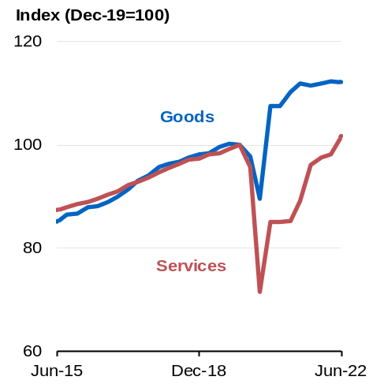 | Chart 2.5: US nominal wage growth  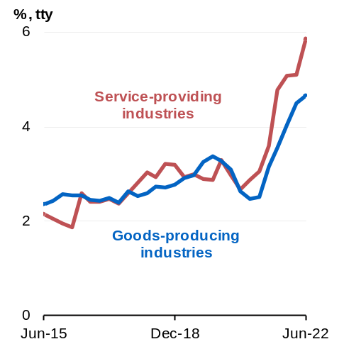
Source: OECD, Refinitiv and Treasury. | Source: Bureau of Labour Statistics, Refinitiv and Treasury.

Global monetary and fiscal policy
Central banks have rapidly tightened monetary policy to slow demand and return inflation to target levels. Policy interest rates have increased more quickly than anticipated at PEFO, including in the United States (Chart 2.6). The increase in interest rates outside China and Japan has been the most rapid and highly synchronised since inflation targeting began. Policy interest rates are expected to rise further, peak in 2023 and remain restrictive into 2024.
The rapid tightening in policy interest rates and concerns about the prospect of an economic slowdown have contributed to a broad tightening in global financial conditions. Government bond yields have increased sharply, credit spreads have widened and equity prices have fallen sharply. Investors are seeking safe-haven currencies and US interest-bearing assets have become more appealing due to the sharp increase in real US yields. The US dollar has appreciated to around a 20-year high against most currencies, including the Australian dollar.
Emerging market economies with large levels of debt denominated in US dollars are at more risk of large or disorderly financial outflows as global financial conditions tighten and the US dollar appreciates. These outflows would place further downward pressure on emerging market currencies, further increasing debt costs and domestic inflation.
The unwinding of extraordinary fiscal policy support provided during the pandemic means that fiscal policy is acting as a drag on global demand. The IMF is forecasting that by 2022 the G7’s combined primary fiscal deficit will contract by around 7 percentage points of GDP from its peak in 2020. This is significantly more rapid than the fiscal consolidation following the Global Financial Crisis (Chart 2.7).
Chart 2.6: Market expectations for the US Federal Reserve funds rate  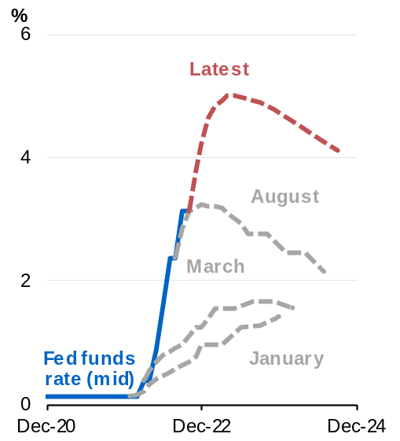 | Chart 2.7: IMF forecasts of G7 primary fiscal balance as a share of GDP  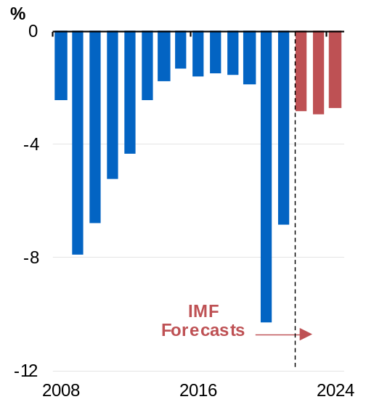
Source: Bloomberg.  Note: Latest market expectations for the fed funds rate is as of 20 October 2022; derived from OIS market pricing. | Source: IMF.

The most significant exception to the tightening of macroeconomic policy globally is China. Chinese authorities have been progressively easing policy settings since late 2021. This has included significant fiscal support via tax relief and additional infrastructure spending, while key policy interest rates have also eased. Japan also remains an outlier, continuing to maintain accommodative monetary policy despite rising inflation.

Key risks to the international outlook
A succession of major and interrelated shocks has hit the global economy since the onset of the pandemic. The international outlook remains highly uncertain as a result. The balance of risks is tilted to lower growth and higher inflation. The risk of recession across major advanced economies has increased in recent months.
Over the coming year, synchronised tightening in monetary policy poses the most significant downside risk to global demand. The baseline forecast is that central banks can navigate slowing demand sufficiently to return inflation to target without tipping the world economy into recession (a ‘hard landing’). However, this is not assured. The risk that monetary policy tightening results in a sharper slowing in global demand is explored in Box 2.1. A sharp tightening in global financial conditions amidst an uncertain global environment may also pose financial stability risks that could further slow global growth.

Global demand is also at risk from a sharper slowing of domestic demand in China. The combined effects of rolling COVID-19 lockdowns and the downturn in the property market has created an uncertain environment for Chinese households. Consumer confidence has fallen to historic lows as a result. This is creating downside risks to the outlook for consumption and housing investment.
There are important risks on the supply side of the global economy. Most prominent is further disruptions to energy supply. This may occur as a direct result of Russia’s invasion of Ukraine, with gas or oil supplies to the global economy being constrained further or cut-off completely. The conflict is also complicating the major climate-related energy transition that is underway globally. This may result in increased volatility in energy prices and financial instability as countries seek to respond to these dual challenges. Recent major drought and flooding events globally pose risks to hydroelectric and nuclear energy production and may further disrupt the supply of energy commodities such as coal.
Further, goods supply disruptions could also result from a large COVID-19 outbreak in China. Widespread and lasting lockdowns in key manufacturing hubs may delay the supply of intermediate goods. Businesses in China appear to have slowly adapted to rolling outbreaks and lockdowns, but this may prove challenging to sustain in the longer term.

Outlook for major trading partners
China’s economy is forecast to grow by 3 per cent in 2022, and 4½ per cent in 2023 and 2024. Outbreaks of COVID-19 between March and May 2022 prompted large lockdowns that severely affected economic growth. Authorities are now more sensitive to small outbreaks, locking down quickly and frequently; however, this is creating uncertainty for consumers (Chart 2.8). With authorities likely to maintain their approach to COVID-19 for an extended period, Chinese consumer spending is likely to remain weak over coming years.
In contrast to the sharp tightening in monetary policy elsewhere, Chinese authorities are easing macroeconomic policy settings to support a slowing economy. Elevated government spending on infrastructure may support growth this year. However, this is likely to be offset by a continuing structural decline in the residential property sector (Chart 2.9). Chances of severe outbreaks, further declines in the property sector, ineffectiveness of fiscal stimulus, and weakening global demand for Chinese exports have tilted risks heavily to the downside.
Chart 2.8: China consumer confidence  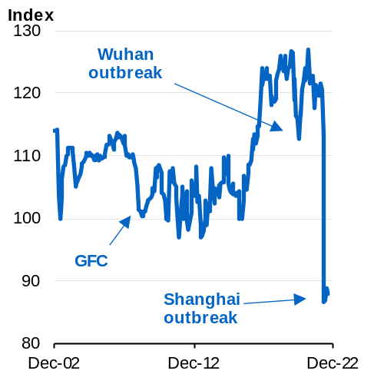 | Chart 2.9: China new residential construction starts  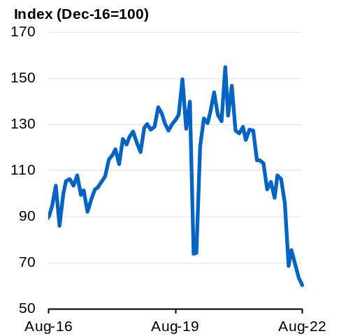
Source: National Bureau of Statistics  China and Refinitiv. | Source: National Bureau of Statistics  China, Refinitiv and Treasury.  Note: Treasury seasonally adjusted.

The United States economy is forecast to grow by 1¾ per cent in 2022, 1 per cent in 2023, and 1¾ per cent in 2024. This is well below the average growth rate over the past 2 decades. Despite recent solid momentum in consumer spending and payrolls, growth prospects have deteriorated significantly as a result of the increased pace of monetary policy tightening in response to stubbornly high inflation.
Inflation is expected to moderate slowly in 2023 as pandemic-related supply and demand imbalances resolve and tighter monetary policy takes effect. Growth is expected to slow significantly in 2023, with unemployment to rise, though the US is expected to avoid the large increase in unemployment that would accompany a deep recession. However, the outlook is uncertain and risks are tilted to the downside.
The euro area economy is forecast to grow by 3 per cent in 2022, ½ per cent in 2023 and 1½ per cent in 2024. Growth has been strong so far in 2022 as the euro area continues to recover from the effects of the pandemic. The pronounced slowing in growth next year is the result of rising energy and food prices stemming from Russia’s invasion of Ukraine. This has driven the highest levels of inflation in the euro area’s history. For some member states inflation rates are the highest in more than 60 years.
Inflation will weigh on real household incomes and spending, although fiscal support is anticipated to somewhat soften its overall impact. Moreover, limited energy supplies will likely see limitations on production in energy-intensive sectors. The war in Ukraine continues to exacerbate these concerns and the prospect of further energy supply or price shocks poses a major downside risk to the outlook, placing the euro area at high risk of recession.
High public indebtedness and some European banks’ exposure to a deteriorating economic outlook, declines in asset prices and rising financing costs are creating heightened risks to financial system stability in the euro area.
Japan’s economy is forecast to grow by 1½ per cent in 2022 and 2023, and 1 per cent in 2024. Growth prospects for 2022 have fallen since February as Japan’s economy has suffered from slowing overseas demand, higher energy prices, and supply issues stemming from China’s strict approach to COVID-19. Japan’s economy is likely to be supported somewhat in 2023 as supply constraints resolve and the border re-opens to international tourists.
Despite experiencing relatively high levels of inflation by Japanese standards, Japan’s central bank has maintained an accommodative monetary policy stance to date that should support growth. However, risks are tilted to the downside, given Japan’s heavy reliance on imported energy. Weakness in the Japanese yen, which hit a 30 year low against the US dollar in October, poses upside risks to inflation.
The United Kingdom’s economy is forecast to grow by 4¼ per cent in 2022, then contract by ¼ per cent in 2023 before growing by 1½ per cent in 2024. While the economy grew strongly in the first quarter of 2022, growth is expected to slow sharply, and the inflation outlook has deteriorated dramatically due to higher gas prices and increasing domestic inflationary pressures.
Economic activity is expected to contract in late 2022 due to high inflation and higher interest rates weighing heavily on real household consumption. However, uncertainty around the outlook is exceptionally high given the unknown size, structure and impact of the Government’s yet-to-be-legislated fiscal package. The package aims to limit increases in household energy bills in the near term and boost investment in the longer term. But unfavourable market reaction to the initial proposal has contributed to financial volatility, and a tightening in financial conditions.
The economies of Other East Asia are forecast to grow collectively by 4½ per cent in 2022, 4 per cent in 2023, and 4¼ per cent in 2024. The recovery in international tourism will support growth. But persistently high inflation, and lower global demand pose risks to activity in the region. Synchronised monetary policy tightening in other parts of the world may lead to financial outflows from the region that could prove disruptive to growth in some economies.
India’s economy is forecast to grow by 7¼ per cent in 2022, followed by 5¾ per cent in 2023 and 6¾ per cent in 2024. A strong recovery in domestic demand with contact-intensive services opening faster than expected, coupled with strong government spending is expected to drive growth. However, stubbornly high inflation, rising interest rates and weaker activity in the US and Europe pose key risks to growth.
Box 2.1: Implications of a weaker global outlook
The international growth outlook is highly uncertain, and the risks are firmly to the downside. The synchronised tightening of monetary and fiscal policy, a risk of further energy price shocks and an uncertain outlook in China are all contributing to the risks of weaker growth.
To explore the impact on Australia of a more pronounced global slowdown, Treasury has modelled a scenario where global inflation and global policy rates are higher than expected. In this scenario, a number of advanced economies, which narrowly avoid recession in the forecasts, do fall into recession. Growth in Australia’s major trading partners troughs at ¾ per cent in the year to March 2024. This compares with 3 per cent in the forecasts, and average major trading partner growth since the global financial crisis of 4 per cent (Chart 1).
Slower global growth mostly affects Australia’s economy through financial market and trade channels, with lower exports due to weaker global demand. Under this scenario, growth in Australia bottoms out at a low of ¾ per cent in the year to June 2024, ¾ of a percentage point below growth in the forecasts (Chart 2).
The unemployment rate would peak at 5 per cent in June 2025, ½ a percentage point higher than the forecasts, and 1½ percentage points higher than the current rate. During the global financial crisis, the unemployment rate rose by around 2 percentage points. Box 2.2 explores the additional downside risks to growth associated with domestic risks, including the prospect that Australian households exhibit increased precautionary consumer behaviour.
Chart 1: Major trading partner GDP growth under a global slowdown scenario | Chart 2: Australia’s GDP growth under a global slowdown scenario
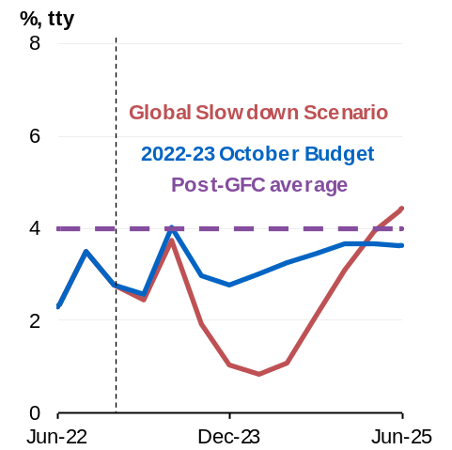 | 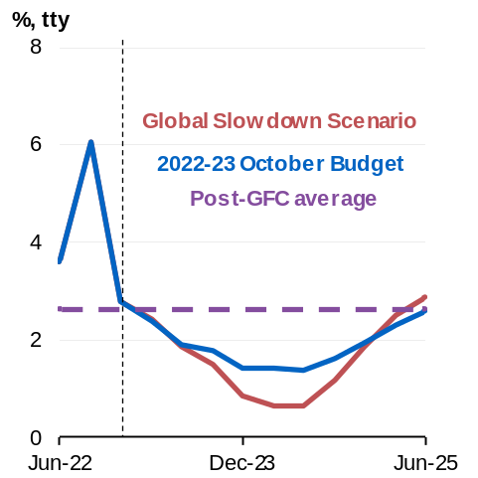
Source: Oxford Economics and Treasury. | Source: Oxford Economics and Treasury.

Outlook for the domestic economy

Outlook for real GDP growth
The Australian economy is facing serious challenges – a sharp global economic slowdown, high inflation, rising interest rates and falling real wages. The global outlook has deteriorated more sharply than expected and inflation has proved more persistent. Recent floods are another headwind expected to weigh on growth and add to price pressure in the near-term. As a result, Australia’s economic growth is forecast to slow from 3¼ per cent in 2022–23, to 1½ per cent in 2023–24, a downgrade of ½ of a percentage point from the July Ministerial Statement and 1 percentage point from PEFO (Chart 2.10).
A rebound in household spending on services following the pandemic and strong employment growth is contributing to solid growth in 2022–23 (Chart 2.11). The return of international students and tourists following the reopening of international borders is expected to further boost the services recovery. Labour market outcomes have been stronger than expected at PEFO, seeing the unemployment rate recently reach a near 50-year low of 3.4 per cent. Business investment is being supported by a large backlog of investment projects, while a record pipeline of work is forecast to hold up residential construction activity.
Recent flooding across eastern states illustrates the risk that devastating weather events may occur more regularly. The October floods and general wet weather are expected to weigh on both exports and investment over coming quarters and are likely to add to inflation. The initial negative impact on economic activity will be largely offset by increased spending and investment to replace and rebuild damaged housing, infrastructure and household goods over the next few years; however, the scale and timing of this is uncertain. The economic implications of the most recent floods to date are considered further in Box 2.3.
Beyond this year, the outlook is increasingly challenging as slowing global growth, high inflation and interest rates weigh on economic activity. Annual inflation is expected to peak at around 7¾ per cent in the December quarter of 2022, consistent with the July Ministerial Statement. However, inflation is now forecast to be more persistent, remaining elevated at around 3½ per cent in the June quarter 2024 before moderating to 2½ per cent in 2024–25.
This pattern of inflation largely stems from higher electricity and gas prices. While global oil prices have come down from recent peaks, elevated LNG and thermal coal prices are expected to have an impact on domestic energy prices. Electricity and gas prices are expected to rise sharply over the next 2 years, as the cost of energy market disruptions are passed through to households. These energy market challenges are also being exacerbated by aging electricity generation assets and inadequate policy certainty to support investment in new energy infrastructure.
More persistent inflation and rising interest rates are forecast to weigh on household spending, increasing mortgage repayments and dampening house prices and asset values. Based on a survey of market economists, the cash rate is now assumed to peak at 3.35 per cent in the first half of 2023, this is both sooner and higher than assumed at PEFO. Many indebted households will come under greater pressure in response to higher interest rates. In particular, low-income households will face pressures as essentials, such as housing costs and energy, make up a larger share of their expenses. A weaker outlook could see households exhibit precautionary savings behaviour, raising the unemployment rate compared with the forecasts (Box 2.2).
Current tight labour market conditions are expected to gradually ease as economic activity slows in response to global and domestic headwinds. Employment growth is forecast to slow to ¾ per cent in 2023–24. The unemployment rate is forecast to increase to 4½ per cent by the June quarter 2024. This is ¾ of a percentage point higher than forecast at PEFO, albeit around ½ a percentage point lower than its pre-pandemic level of around 5 per cent. Given the weaker outlook for activity and employment, labour force participation is expected to fall slightly to 66½ per cent by the June quarter of 2024, from a recent historical high.
Wage growth is forecast to pick up, with wages rising by 3¾ per cent over both 2022–23 and 2023–24, stronger than expected at PEFO. This would mark the fastest pace of wage growth since 2012, around the height of the mining investment boom. In combination with an expected moderation in inflation, real wages are forecast to rise in 2023–24 for the first time since early 2021.
Chart 2.10: Contribution to annual real GDP growth
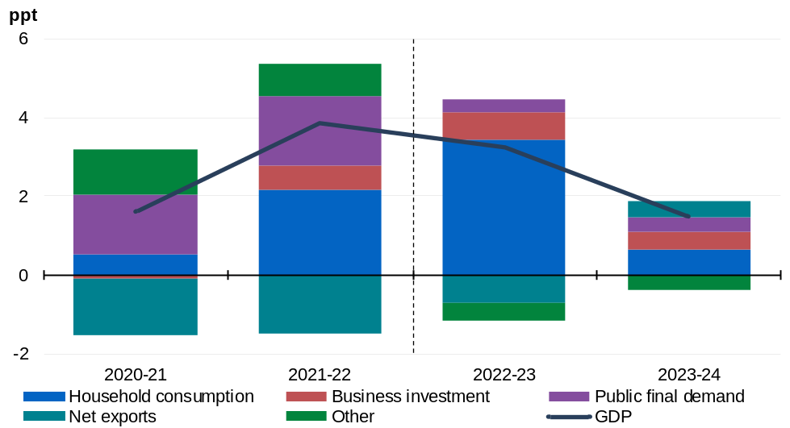
Source: ABS Australian National Accounts: National Income, Expenditure and Product and Treasury.
Note: ‘Other’ here refers to change in inventories, ownership transfer costs, dwelling investment and the statistical discrepancy.

Chart 2.11: Real GDP
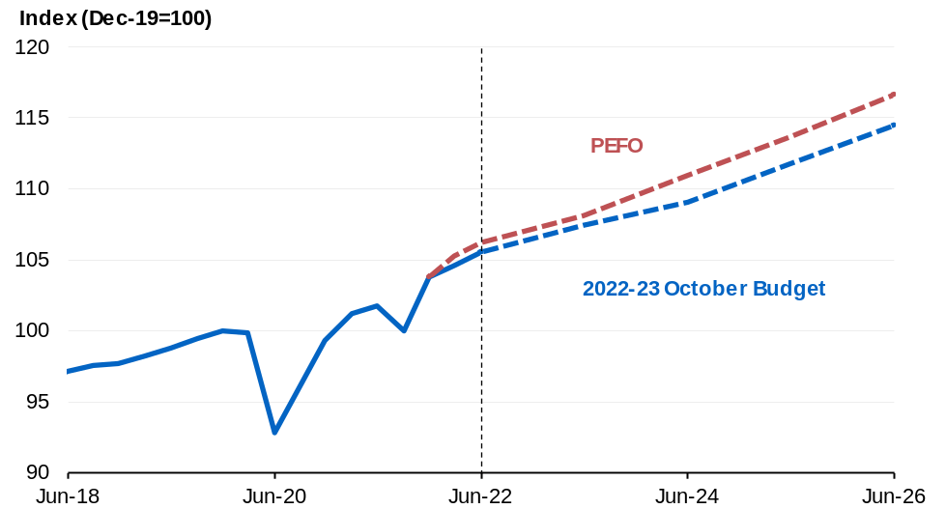
Source: ABS Australian National Accounts: National Income, Expenditure and Product and Treasury.

Table 2.2: Domestic economy – detailed forecasts^{(a)}
 | Outcomes | Forecasts
 | 2021-22 | 2022-23 | 2023-24
Real gross domestic product | 3.9 | 3 1/4 | 1 1/2
Household consumption | 4.1 | 6 1/2 | 1 1/4
Dwelling investment | 2.8 | -2 | -1
Total business investment^{(b)} | 5.2 | 6 | 3 1/2
By industry
Mining investment | -1.7 | 4 | 5 1/2
Non-mining investment | 7.4 | 6 1/2 | 3 1/2
Private final demand^{(b)} | 4.5 | 5 1/4 | 1 1/4
Public final demand^{(b)} | 6.5 | 1 | 1 1/2
Change in inventories^{(c)} | 0.1 | 0 | - 1/4
Gross national expenditure | 5.2 | 4 | 1
Exports of goods and services | 0.0 | 7 | 5
Imports of goods and services | 7.7 | 11 | 3
Net exports^{(c)} | -1.5 | - 3/4 | 1/2
Nominal gross domestic product | 11.0 | 8 | -1
Prices and wages
Consumer price index^{(d)} | 6.1 | 5 3/4 | 3 1/2
Wage price index^{(d)} | 2.6 | 3 3/4 | 3 3/4
GDP deflator | 6.9 | 4 3/4 | -2 1/4
Labour market
Participation rate (per cent)^{(e)} | 66.6 | 66 3/4 | 66 1/2
Employment^{(d)} | 3.3 | 1 3/4 | 3/4
Unemployment rate (per cent)^{(e)} | 3.8 | 3 3/4 | 4 1/2
Balance of payments
Terms of trade^{(f)} | 12.2 | -2 1/2 | -20
Current account balance (per cent of GDP) | 2.2 | 1/2 | -3 3/4
Net overseas migration^{(g)} | 150,000 | 235,000 | 235,000
- Percentage change on preceding year unless otherwise indicated.
- Excluding second‑hand asset sales between the public and private sector.
- Percentage point contribution to growth in GDP.
- Through-the-year growth rate to the June quarter.
- Seasonally adjusted rate for the June quarter.
- Key commodity prices are assumed to decline from current elevated levels by the end of the March quarter 2023: the iron ore spot price is assumed to decline from US$91/tonne to US$55/tonne free on board (FOB); the metallurgical coal spot price is assumed to decline from US$271/tonne to US$130/tonne FOB; the thermal coal spot price is assumed to decline from US$438/tonne to US$60/tonne FOB; the oil price (TAPIS) is assumed to decline from US$108/barrel to US$100/barrel; and the LNG price is assumed to decline from US$934/tonne to US$630/tonne.
- The figure for 2021–22 consists of 3 quarters of preliminary outcomes and one quarter of forecasts. Net overseas migration is assumed to continue in line with pre-pandemic trends at 235,000 from 2022–23.
Note: The exchange rate is assumed to remain around its recent average level – a trade‑weighted index of around 61 and a $US exchange rate of around 65 US cents. Interest rates are informed by the Bloomberg survey of market economists. Population growth is forecast to be 1.1 per cent in 2021–22 and 1.4 per cent in 2022–23 and 2023–24.
Source: ABS Australian National Accounts: National Income, Expenditure and Product; Balance of Payments and International Investment Position, Australia; National State and Territory Population; Labour Force, Australia; Wage Price Index, Australia; Consumer Price Index, Australia; unpublished ABS data and Treasury.

Household consumption
Household consumption has been growing strongly but is expected to slow considerably once the current recovery in discretionary services spending starts to fade and pressures on household budgets begin to mount.
While some household groups have built up savings buffers over recent years, others are expected to come under greater pressure. Higher prices and rising interest rates are expected to drag on consumer spending. These factors, in addition to the Omicron outbreak and the Russian invasion of Ukraine, have seen consumer confidence fall throughout 2022.
Household consumption is forecast to grow by a strong 6½ per cent in 2022–23, underpinned by the ongoing rebound in services spending (Chart 2.12). An increasing share of household spending is expected to shift back to discretionary services as the impact of the pandemic continues to wane. In particular, spending on overseas travel is expected to rise sharply in 2022–23, reflecting pent-up demand for international travel.
Chart 2.12: Consumption growth  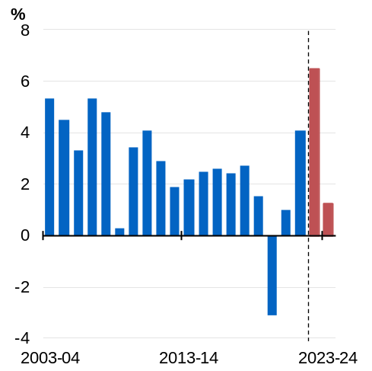 | Chart 2.13: Household savings ratio  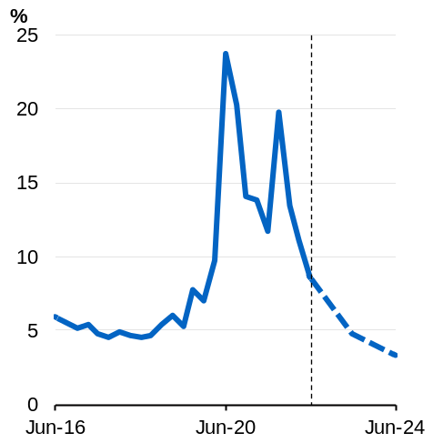
Source: ABS Australian National Accounts: National Income, Expenditure and Product and Treasury. | Source: ABS Australian National Accounts: National Income, Expenditure and Product and Treasury.

The near-term recovery in spending will largely be accommodated through a further sharp decline in the household savings ratio as households spend an increasing share of their income. The normalisation of spending patterns and cost-of-living pressures are expected to see households save less out of their income. As a result, the household savings ratio is expected to fall from elevated levels to 3¼ per cent in the June quarter of 2024 (Chart 2.13).
In response to the pressures on household budgets, consumption growth is expected to slow to 1¼ per cent in 2023–24, a significant downgrade from PEFO. By early 2023, rising interest rates and cost of living pressures will weigh more heavily on households’ real disposable incomes. Since May, monthly repayments on a $500,000 mortgage have increased by almost $700. The impact of higher rates is expected to build further over the next year as more mortgages roll off fixed-rate terms. Rising interest rates have also seen house prices begin to decline and with further falls expected, this will drag on household wealth and contribute to the slowing of consumption growth.
Further sharp rises in the cost of essentials, such as housing costs and energy, are expected to create pressures for families, particularly for those with lower incomes where these expenses make up a larger share of their budgets. The Government’s targeted support to households including an increase to the Child Care Subsidy and broadening the coverage of the pharmaceutical benefits scheme will help to offset some of these pressures. The indexation of government payments and the larger than usual minimum wage increase provided by the Fair Work Commission will also assist in maintaining the real incomes of many lower income households.

Box 2.2: Precautionary consumer behaviour scenario amid higher inflation
The uncertainty around the outlook for inflation and monetary policy creates significant risks to the outlook for households’ consumption behaviour. This box considers a scenario which captures the risk to the economic outlook of precautionary consumer behaviour further constraining real consumer spending in response to higher-than-expected and more persistent inflation.
In this scenario, inflation is assumed to peak at 8¾ per cent in the December quarter of 2022, 1 percentage point higher than forecast, and remain higher through to the June quarter of 2024 (Chart 1). Higher inflation could, for example, reflect a large shock to input prices or greater ‘second-round’ effects as businesses pass through input cost pressures. Under this scenario more persistent inflation is assumed to lead to a higher peak in interest rates than currently expected. Higher inflation and interest rates would lower real household disposable income.
More precautionary household behaviour, in response to these additional negative shocks to household income, would see a further significant slowing in real consumption compared with the forecasts.
Under this scenario, economic growth is estimated to be around a ¼ of a percentage point lower in 2022–23 and around ¾ of a percentage point lower in 2023–24 (Chart 2). Unemployment would be around 5¼ per cent by June 2024, ¾ of a percentage point higher than in the forecasts. This Box explores a downside scenario driven by domestic factors, however, the impact on economic activity and unemployment would be greater if these risks occurred simultaneously with the global risks explored in Box 2.1.
Chart 1: Domestic inflation (tty), central and scenario | Chart 2: Real GDP, central and scenario
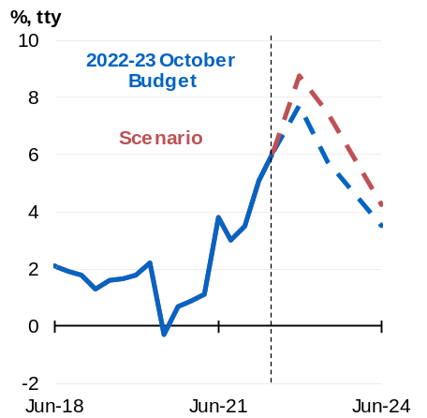 | 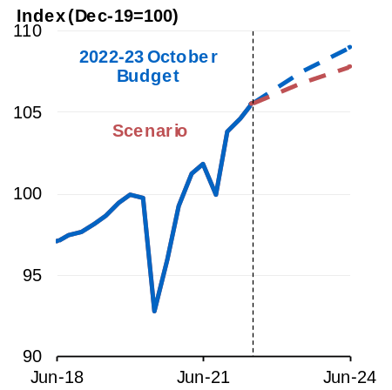
Source: ABS Consumer Price Index and Treasury. | Source: ABS National Accounts: National Income, Expenditure and Product and Treasury.

Dwelling investment
The outlook for dwelling investment in the coming year is dominated by effects of supply disruptions and capacity constraints, which are reflected in rapidly escalating building costs (Chart 2.14). Unseasonably heavy rain, floods and COVID-19 absenteeism have impacted activity to date, adding to existing pressures from both a record pipeline of construction work and global supply chain issues (Chart 2.15).
Capacity constraints and a third consecutive La Niña event are expected to continue to limit activity. As a result, and despite a large backlog of work for detached houses, dwelling investment is expected to be weaker than forecast at PEFO and is now expected to fall by 2 per cent in 2022–23. Rising interest rates and falling housing prices will see activity fall by a further 1 per cent in 2023–24 even as the backlog of houses under construction is worked off.
Chart 2.14: House building input prices  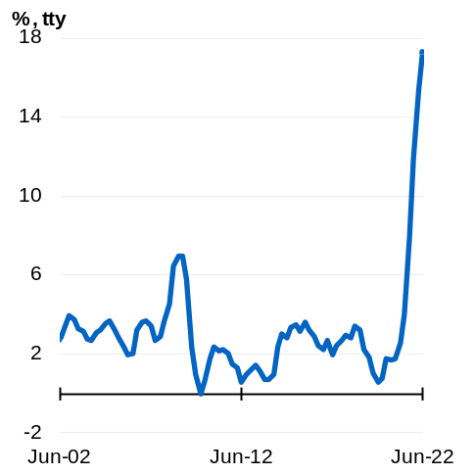 | Chart 2.15: Private detached house construction  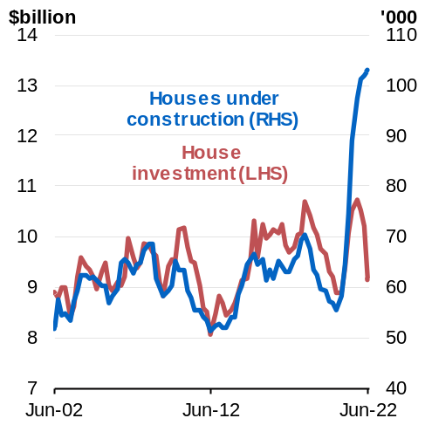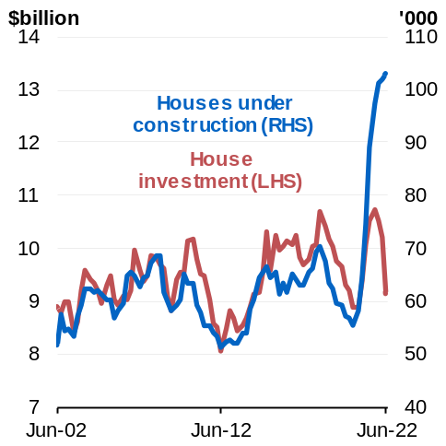
Source: ABS Producer Price Indexes. | Source: ABS Building Activity; Unpublished ABS data.  Note: Data is in original terms for the number of private houses under construction.

Business investment
Growth in business investment is being supported by a large backlog of investment projects. This comes off the back of a period of prolonged lower business investment (Chart 2.16). Supply disruptions and poor weather have hindered commercial construction activity and mining projects recently. Beyond the current La Niña event, these factors are expected to wane, with business investment forecast to grow by 6 per cent in 2022–23 and 3½ per cent in 2023–24.

Non-mining investment is expected to grow strongly by 6½ per cent in 2022–23, consistent with the sharp pick-up in investment expectations (Chart 2.17). As supply constraints ease, commercial building activity is expected to rise, reflecting a large backlog of work, with strong business balance sheets supporting investment. Growth is then forecast to ease to 3½ per cent in 2023–24 as overall demand in the economy softens.
Mining investment is expected to strengthen over coming quarters and is forecast to grow by 4 per cent in 2022–23 and 5½ per cent in 2023–24. As with commercial construction, work on major mining engineering projects is expected to pick up as weather and supply constraints ease. This is consistent with investment expectations for 2022–23 which suggest the highest level of investment in the mining sector since 2015–16. Although commodity prices are currently elevated, the pick-up in mining investment is still expected to be modest compared with the very large increase in investment during the previous mining boom around a decade ago. Business liaison suggests mining firms are only looking to invest to maintain their current production capacity, outside of a small number of significant LNG projects such as Woodside’s Scarborough and Pluto Train 2 developments.
The current high levels of economic uncertainty present risks to the business investment outlook. Supply chain tensions and elevated input costs could further delay projects or prompt a reversal of existing investment decisions. Weakening demand, as interest rate rises pass through to activity, may also discourage investment by more than currently expected.
Chart 2.16: Business investment as a share of GDP (nominal)  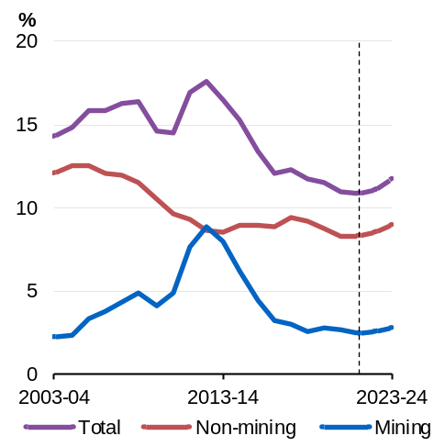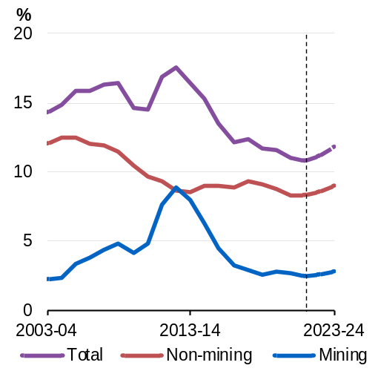 | Chart 2.17: Business investment expectations (nominal)  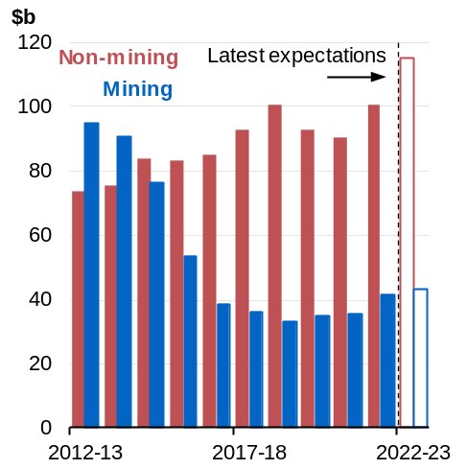
Source: ABS Australian National Accounts: National Income, Expenditure and Product and Treasury. | Source: ABS Private New Capital Expenditure and Expected Expenditure and Treasury.

Public final demand
Real growth in government spending is expected to be negative this year and next as pandemic-related spending unwinds. The Government is committed to repairing the Budget and will focus spending on priority areas and on investments that expand the capacity of the economy and help ease inflation pressures.
Public final demand is forecast to grow by 1 per cent in 2022–23 and 1½ per cent in 2023–24. In the first half of 2022, government spending remained elevated as Commonwealth and state governments continued pandemic-related support and responded to the severe East Coast floods. Public investment is forecast to remain solid, supported by a large pipeline of public infrastructure projects at the state and federal level. Decisions to reschedule the timing of some projects should help ease the significant labour and material shortages which are limiting the speed of the infrastructure rollout.

Net exports
Net exports are expected to detract ¾ of a percentage point from GDP growth in 2022–23 as outbound tourism recovers faster than inbound tourism (Chart 2.18). In contrast, in 2023–24, the contribution of net exports to GDP growth is expected to be positive for the first time since the COVID-19 pandemic, as growth in mining exports and slowing demand for consumption imports contribute to net export growth. Wet weather conditions linked to a third consecutive La Niña event this year present a risk for Australian coal and agricultural exports and could affect returns for producers.
Chart 2.18: Net exports contribution to GDP growth  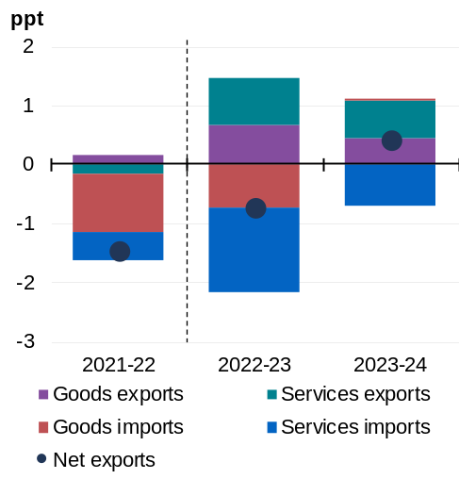 | Chart 2.19: Outbound and inbound tourism and international flights  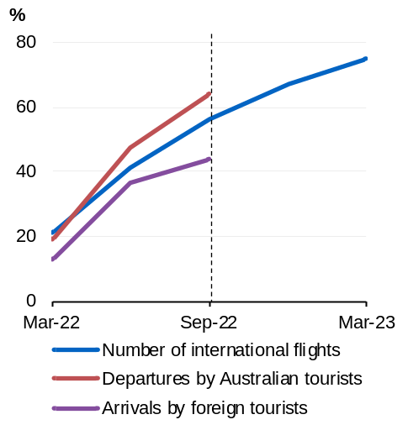
Source: ABS Balance of Payments and International Investment Position, ABS Australian National Accounts: National Income, Expenditure and Product Australia and Treasury. | Source: ABS Overseas Arrivals and Departures, SRS Cirium Analyser and Treasury.  Note: Per cent of corresponding period in 2019.

Exports are forecast to grow by 7 per cent in 2022–23 driven by a rebound in services exports and stronger mining exports as disruptions ease. Exports are forecast to grow by 5 per cent in 2023–24 as tourism and education exports continue to recover toward pre-pandemic levels.
The progressive reopening of Australia’s international borders has supported a recovery in tourism and the return of international students to Australia, with international flights arriving in Australia having increased sharply over the year to September (Chart 2.19). Mining export volumes are expected to contribute to growth in exports as producers seek to take advantage of strong global demand for LNG, coal and non-ferrous metals used in low emission technologies. An increase in capacity at new iron ore mines is also expected to contribute to mining export growth. Rural exports are expected to gradually decline through 2022–23 and 2023–24 as seasonal conditions return to normal, but are expected to remain at near record levels. Recent flooding across the eastern states poses a risk to rural and mining exports.
Imports are forecast to rise by 11 per cent in 2022–23 due to a strong recovery in tourism imports as airline supply and consumer confidence in travelling overseas grows. Robust growth in household consumption is also expected to contribute to higher consumption goods imports. The final year of the Temporary Full Expensing policy will also encourage some businesses to bring forward decisions to import capital goods. In 2023–24 goods imports are expected to decline slightly as slowing growth in household consumption and business investment and a reduction in imports of COVID-19 related products will weigh on demand.
Box 2.3: Economic impacts of the floods across south-eastern Australia
Intense rainfall during September and the first half of October has led to flooding across large areas of Victoria, Tasmania, New South Wales and Queensland. Many individuals and communities affected by the floods face displacement, as well as crop, livestock and property losses. This rainfall event is expected to add to existing cost of living pressures largely by prolonging the increase in fruit and vegetable prices following floods earlier in the year.
As at 20 October, disaster assistance has been made available to 94 Local Government Areas (LGAs) across Victoria, Tasmania and New South Wales, representing around 30 per cent of total agricultural production value in 2020–21. The flooding and persistent wet weather is affecting coal exports with coal shipments from Newcastle, Australia’s largest thermal coal port, 12 per cent lower in the period from January to September of 2022 than the same period last year. It is too early to say what the full impact of the flooding will be on affected areas and communities. The Government has made prudent provision in the Contingency Reserve to assist flood-affected communities.
The preliminary estimate of the direct impact on economic activity of the current floods is a detraction of around ¼ of a percentage point from GDP growth in the December quarter, largely offset by increased activity across the second half of the 2022–23 financial year. The near-term impact will primarily arise from reduced activity in the agriculture, mining, and construction industries. In subsequent quarters, these impacts will be largely offset by increased exports, additional spending to replace damaged goods and restore lost capital, and public sector spending to support affected communities. As the flood event is continuing to unfold, these estimates are preliminary and subject to revision as greater information becomes available.
The October floods are also expected to add to inflation in the near-term, mainly through higher fruit and vegetable prices, while also affecting other agricultural products, such as dairy, and adding to supply chain disruptions. Based on preliminary analysis, the October floods are forecast to add 0.1 percentage points to inflation in the December quarter 2022 and again in the March quarter 2023. This is one of the factors contributing to the estimated peak in inflation remaining at 7¾ per cent in the December quarter 2022, partly offsetting the impact of lower-than-expected automotive fuel prices relative to the July Ministerial Statement.
The floods are also expected to result in a significant damage bill, which does not show up in GDP but can be taken as an indication of the scale of the subsequent rebuilding activity. The current flooding is occurring in the context of several extreme weather events that have occurred throughout 2022, affecting many parts of Australia. There will also be non-economic effects from the floods, including the impacts on mental health, wellbeing and the environment.

Inflation
Australia has been exposed to a range of global price shocks, including pandemic-related supply chain disruptions and the Russian invasion of Ukraine. These shocks have driven global food prices 50 per cent higher and have caused global energy prices to more than double since the start of the pandemic, driving inflation in many countries to levels not seen in 50 years. Global inflationary pressures and energy market disruptions have become more pronounced and are persisting longer than anticipated at the time of the July Ministerial Statement and are having a significant impact on prices in Australia.
Consumer price inflation is forecast to peak at 7¾ per cent in the December quarter of 2022, the same peak as at the July Ministerial Statement, but high inflation is now expected to persist for longer than previously expected largely due to the pass-through of higher energy prices to household bills. Electricity and gas prices are expected to directly contribute ¾ of a percentage point and 1 percentage point to inflation in 2022–23 and 2023–24, respectively. Inflation is expected to ease gradually to 3½ per cent by June 2024 as global supply-side pressures moderate and tighter monetary policy weighs on demand (Chart 2.20). Thereafter inflation is expected to fall back within the target band.
While inflation in Australia has been driven by these global factors, domestic weather events and supply constraints combined with strong demand in residential construction and consumer goods, have also contributed to price growth. Like other countries, inflation has picked up quickly in Australia since the end of 2021, particularly across new dwellings, automotive fuel and food (Chart 2.21). Fresh produce prices were already elevated from local floods and severe weather earlier in the year and are expected to stay elevated and add further to inflation following the October floods and continued wet weather. More broadly, food prices are forecast to contribute 1½ percentage points to the inflation peak in the December quarter of 2022.
Global oil, gas and coal prices have risen sharply following the Russian invasion of Ukraine, driving up energy costs across advanced economies. This resulted in sharply higher petrol prices in Australia earlier this year, where the national average price peaked at 212.5 cents per litre in March and again at 212.1 cents per litre in July. In recent months, falling global oil prices, a rapid contraction in refinery margins and improving production have provided some relief. The return of standard fuel excise rates will add a one-off ½ a percentage point to the expected peak in headline inflation in the December quarter of 2022.
Globally, retail electricity and gas prices have risen considerably as increases in wholesale energy costs flow through to consumers. Domestically, wholesale electricity and gas prices have also risen sharply since early 2022, reflecting higher global prices as well as temporary domestic electricity market disruptions exacerbated by ageing generation assets and inadequate policy certainty to support investment in new energy infrastructure. These pressures are yet to fully flow through to higher consumer prices because electricity retailers typically contract wholesale electricity several years ahead, which has provided a significant buffer through the recent market disruption.
However, this rise in wholesale electricity and gas prices can be expected to flow through to higher consumer prices as wholesale contracts are renewed.
Treasury has assumed retail electricity prices will increase by an average of 20 per cent nationally in late 2022, contributing to higher forecast CPI in 2022–23. Given forward wholesale contract prices for electricity remain elevated, retail electricity prices are expected to rise by a further 30 per cent in 2023–24. Higher electricity prices will have both a direct and indirect impact on inflation, increasing input costs across the CPI basket. Commonwealth and state government actions to accelerate the uptake of renewables and modernise the grid are expected to put downward pressure on wholesale electricity prices over time.
Domestic wholesale gas prices remain more than double their average prior to Russia’s invasion of Ukraine. Retail gas prices are expected to increase less than wholesale prices, by up to 20 per cent in both 2022–23 and 2023–24, as major gas retailers are somewhat insulated from spot prices, either through long-term contracts or investment in gas supplies. Nevertheless, sharply higher spot and forward prices suggests a sizable increase in wholesale costs.
Rental costs are expected to pick-up considerably in the next 2 years, as the rental market remains tight amid stronger population growth and limited housing stock. National advertised rents have risen sharply over the past year, by 10 per cent to September 2022. As new rental agreements are made and existing contracts are renegotiated, overall rental costs as reflected in the CPI are expected to rise, albeit to a lesser extent.
Significant risks remain to the inflation outlook. There may be further or prolonged disruptions in global energy markets as a result of Russia’s ongoing invasion of Ukraine. Recent flooding could drive food prices higher. Tighter labour market conditions than forecast could also add to underlying pressures. In contrast, tighter monetary policy in Australia and globally than is currently expected could have a faster than expected impact, resulting in a quicker return of inflation to target.
Chart 2.20: Headline CPI growth  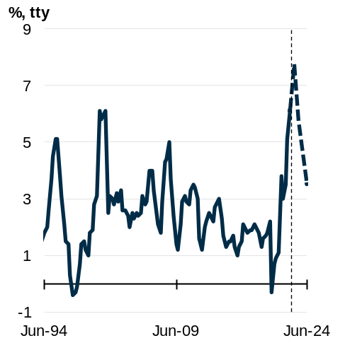 | Chart 2.21: Headline CPI breakdown  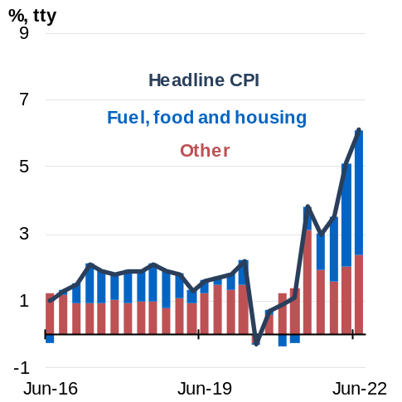
Source: ABS Consumer Price Index and Treasury. |  | Source: ABS Consumer Price Index and Treasury.  Note: Contribution prior to September 2021 are back-cast using 2021 CPI expenditure weights.

The labour market
The labour market has continued to tighten, with strong employment growth driving the unemployment rate to almost a 50-year low of 3.4 per cent in July and encouraging higher workforce participation, which rose to a record high of 66.7 per cent in June. Unemployment is forecast to remain at around 3¾ per cent in the June quarter of 2023 (Chart 2.22).
Illness-related absenteeism has affected the labour market this year, with large numbers of people taking time off due to illness in January and over winter. Treasury liaison with businesses suggests firms are managing elevated absenteeism through a mix of increased staff and increased hours from existing staff. This is consistent with total hours worked in the economy having trended higher since January. While future waves of COVID-19 are likely to sustain increased absenteeism, the overall impact across the economy is expected to be small.
As economic activity slows in the face of global and domestic headwinds, the unemployment rate is forecast to rise to 4½ per cent in June 2024, but remain below pre-pandemic levels of around 5 per cent. The participation rate is also expected to fall slightly to 66½ per cent, from its recent historical highs.

While more Australians are expected to be employed compared to PEFO, the rate of employment growth is forecast to slow over the next 2 years as economic growth slows. Employment growth is still forecast to remain positive, at ¾ per cent in 2023–24. This is ½ a percentage point slower than forecast in the July Ministerial Statement and half the growth rate forecast at PEFO. The easing of border restrictions is expected to return annual growth of the working age (15+) population to 1.6 per cent in 2023-24.
Chart 2.22: The unemployment rate
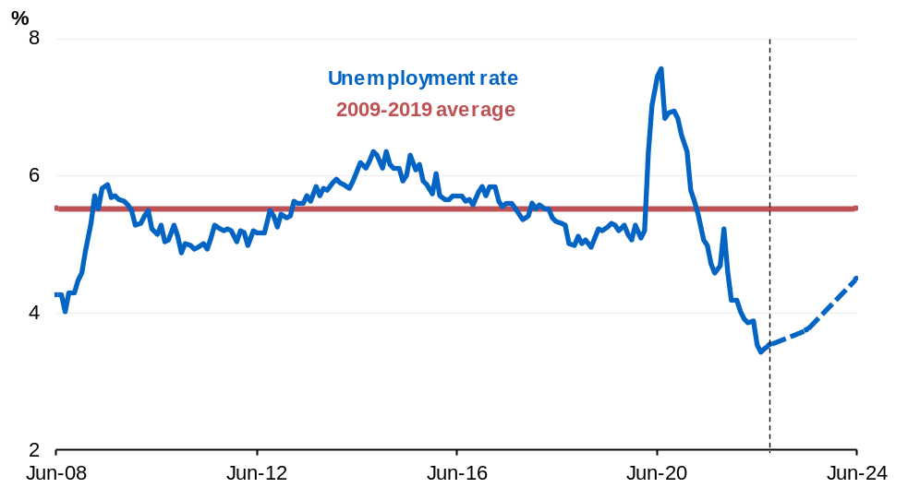
Source: ABS Labour Force and Treasury.

The outlook for the labour market is dependent on the path of economic activity. Uncertainties relating to the economic outlook, prompted by a more abrupt slowdown in demand or a further inflationary shock, could see labour demand slow more quickly than expected. While job vacancies appear to have peaked, they remain elevated, with around one vacancy for every unemployed person. This suggests further strengthening in the labour market remains possible.
Box 2.4: Parenting, early childhood education and care and labour force participation
Rising female participation in paid work has been a key driver of the steady increase in the participation rate over the past 40 years. Since the late 1970s, the female participation rate has increased by 18.8 percentage points whereas the male participation rate has declined by 8.5 percentage points (Chart 1). While the difference between participation rates has narrowed over time, with the female labour force participation rate close to its record high, a gap of 8.7 percentage points remains. Working women are also twice as likely to be employed in part-time work than men (Chart 2).
Chart 1: Participation rate by sex | Chart 2: Part-time employment share by sex
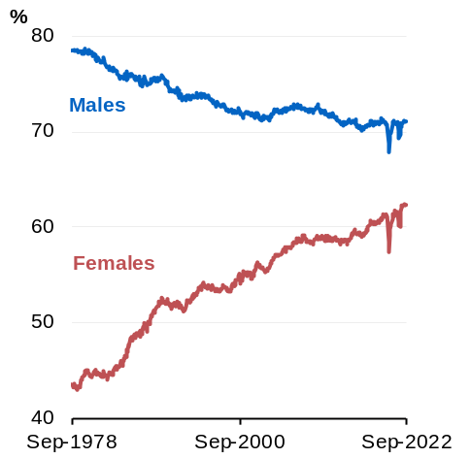 | 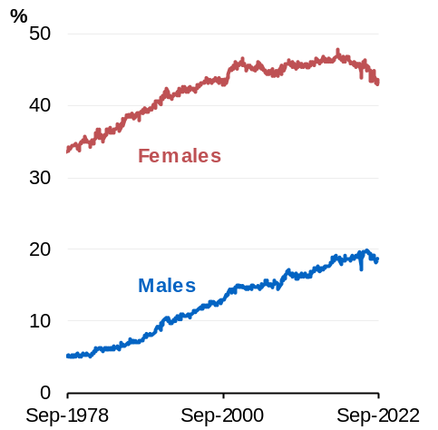
Source: ABS Labour Force. | Source: ABS Labour Force.

Caring for children is reported as the main reason that women work part time or not at all, and is a large contributor to the lifetime earnings gap between men and women. Treasury research estimates that women reduce their hours in paid work by around 35 per cent across the first 5 years following the arrival of children. Men’s hours of paid work drop only in the first month of parenthood before returning to previous levels (Chart 3). Reduced participation in paid work following the arrival of children contributes to a gender gap in earnings averaging 55 per cent in the first 5 years of parenthood. The gap persists for at least a decade.
continued on next page
Box 2.4: Parenting, early childhood education and care and labour force participation (continued)
Chart 3: Average weekly hours worked around the arrival of first child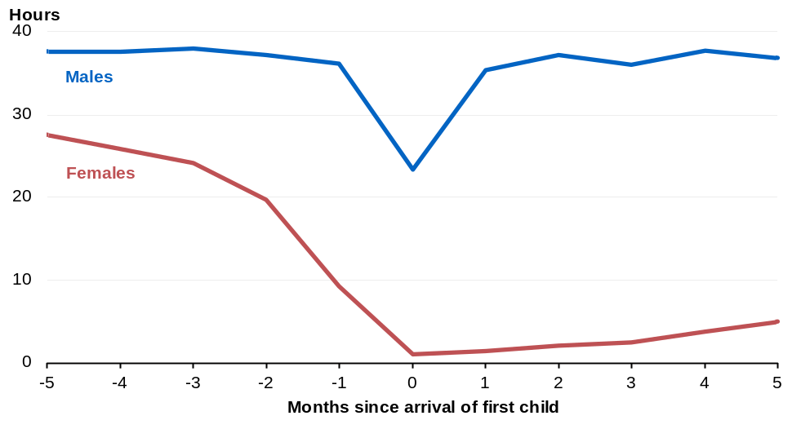
Source: Treasury analysis of ABS Labour Force microdata.

Increasing female labour force participation has a range of economic benefits. Removing barriers to women’s participation allows for better matching between jobs and skills by improving opportunities for career progression and ensuring that women are not restricted to jobs that traditionally accommodate more flexible hours. The boost to earnings helps to strengthen women’s economic security and financial independence, and the improved allocation of talent, together with the gains from diversifying workplaces, can lift productivity growth.
The Government is investing $4.7 billion over 4 years from 2022-23 to make early childhood education and care more affordable for families and reduce barriers to women’s labour force participation. From July 2023, Child Care Subsidy rates will increase for eligible families with annual combined incomes less than $530,000, up to a maximum of 90 per cent. Families will continue to receive the existing higher subsidy rates of up to 95 per cent for any second and subsequent children in care aged 5 and under. Around 96 per cent of families with children in early childhood education and care will benefit and none will be worse off.
continued on next page
Box 2.4: Parenting, early childhood education and care and labour force participation (continued)
The Government is also investing $531.6 million over 4 years from 2022–23 to strengthen the Paid Parental Leave (PPL) scheme. Families will be able to access an additional 6 weeks of PPL, increasing the total leave payable up to 26 weeks of leave from July 2026. The Government will maintain a ‘use it or lose it’ component to encourage more fathers and partners to take leave, with the Women’s Economic Equality Taskforce to examine the optimum model to deliver the best outcomes for families and support women’s economic participation. Single parents will be able to take the full amount.
Together, the changes to the Child Care Subsidy and PPL will support families to better balance paid work and caring responsibilities. Based on analysis of past subsidy increases, Treasury estimates the Government’s Child Care Subsidy changes will increase hours worked by women with young children by up to 1.4 million hours per week, equivalent to an extra 37,000 full-time workers, in 2023–24. The PPL changes incentivise a more equitable distribution of caring responsibilities. This will further support participation and productivity, providing an additional economic dividend. These changes will also assist to improve health and wellbeing outcomes for children and families.
In addition, the Government will direct the Australian Competition and Consumer Commission (ACCC) to conduct an inquiry into the drivers of early childhood education and care prices, and report by the end of 2023. The ACCC’s report will complement a broader Productivity Commission (PC) inquiry into the early childhood education sector in Australia, which will commence in the first half of 2023 and report in 2024. The PC will conduct a comprehensive inquiry into the early childhood education and care sector, which will consider a universal 90 per cent subsidy for all families. It will also consider ways to improve access and flexibility for families, and better support labour force participation, particularly for women.
Recent wage price index (WPI) outcomes indicate that nominal wage growth has been picking up and broadening across sectors after a long period of low wage growth. In-demand workers, including those in industries with a high share of individual agreements, have recorded sizable pay increases. New enterprise agreements suggest wage growth is picking up. Wages are expected to grow by 3¾ per cent in 2022–23, marking the fastest pace of wage growth since 2012 (Chart 2.23).
The combination of high inflation and modest wage growth to date has seen real wages fall sharply, by around 3.5 per cent over 2021–22. This followed a prolonged period of stagnant real wage growth. While there is uncertainty around the outlook for inflation, the expected pick up in nominal wages and forecast easing in inflation over the course of the next 2 years is expected to result in real wages beginning to modestly rise by the end of 2023–24.
Chart 2.23: Annual wage growth, AENA and WPI
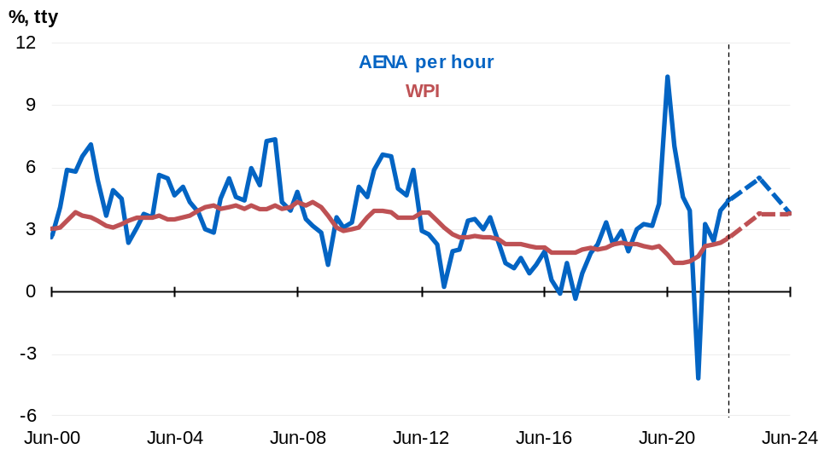
Source: ABS National Accounts: National Income, Expenditure and Product, ABS Labour Force and Wage Price Index and Treasury.
Note: AENA is the national accounts measure of average earnings.

Outlook for the terms of trade
The terms of trade increased by 12 per cent in 2021–22 to its highest level on record due to elevated commodity prices, largely reflecting the disruptions of natural gas flows from Russia to Europe which increased demand in already tight seaborne markets for both liquefied natural gas (LNG) and coal. While the LNG spot price has contributed to the higher terms of trade, only a small proportion of LNG is sold on the spot market with the majority sold on long-term contracts linked to the oil price. The terms of trade are forecast to remain elevated in 2022–23 before declining in line with Treasury’s long-term commodity price assumptions.
Commodity prices are assumed to return to long-term fundamental price levels, causing a fall in the terms of trade in 2023–24. Elevated coal, iron ore, metals and other ore prices are assumed to unwind over 2 quarters, by the end of the March quarter of 2023, to levels consistent with long-term fundamentals. This means long-term prices are reached 2 quarters later than was assumed in PEFO. This approach ensures that the economic and fiscal parameters are grounded in long-term price fundamentals and are not unduly influenced by short-term volatility (Chart 2.24). Nevertheless, in light of the ongoing Russian invasion of Ukraine, there is substantial upside risk to the thermal coal and LNG price assumptions, while China’s weakening growth outlook presents a downside risk for commodity prices, particularly iron ore.
Chart 2.24: Terms of trade
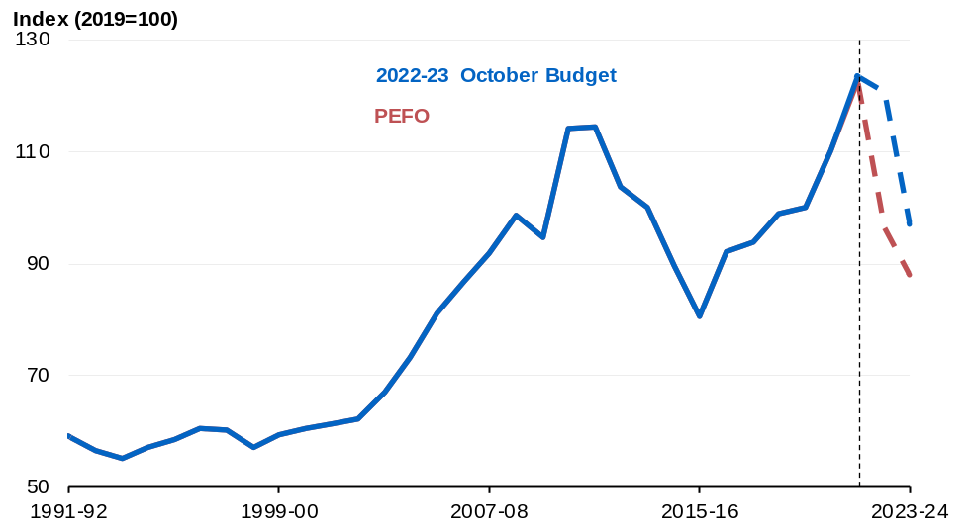
Source: ABS National Accounts: National Income, Expenditure and Product and Treasury.

Sensitivity analysis of iron ore, metallurgical coal and thermal coal prices
Commodity prices are volatile and the outlook for commodity prices remains a key uncertainty in the outlook for nominal GDP and Government tax revenue. The analysis below outlines the direct impacts on nominal GDP and company tax receipts of altering the timing of spot price assumptions for iron ore, metallurgical coal and thermal coal.
The Budget assumes glide paths for iron ore, metallurgical coal and thermal coal start from their recent averages in late September, and glide down over the December 2022 and March 2023 quarters to their assumed long-term fundamental price levels. Table 2.3 presents a sensitivity analysis for commodity prices where they remain elevated over the December quarter of 2022 and then glide down later (that is, over the March and June 2023 quarters). This results in a total increase in nominal GDP of $43.8 billion between 2022–23 and 2024–25, and an increase in company tax receipts of $9.9 billion over the same period. The impact on tax receipts is delayed compared with the impact on nominal GDP, largely owing to lags in tax collections.
Table 2.3: Sensitivity analysis of a later fall in commodity spot prices
 | 2022-23 | 2023-24 | 2024-25 | Total
Nominal GDP ($billion) | 35.0 | 8.8 | 0.0 | 43.8
Tax receipts ($billion) | 2.5 | 6.5 | 0.9 | 9.9
Source: Treasury.
Note: The long-term commodity price assumptions are: iron ore – US$55 per tonne free-on-board (FOB); metallurgical coal – US$130 per tonne FOB; thermal coal – US$60 per tonne FOB.

Further analysis on how permanent movements in the price of iron ore can affect the Australian economy and fiscal estimates is detailed in Budget Statement 8: Forecasting Performance and Sensitivity Analysis.

Outlook for nominal GDP growth
Nominal GDP is forecast to grow strongly, by 8 per cent in 2022–23, reflecting strong employment, an elevated terms of trade and a higher domestic price level. Nominal GDP is then expected to fall by 1 per cent in 2023–24 due to the assumed decline in commodity prices and associated decline in Australia’s terms of trade (as listed in Table 2.2).
The strength in nominal GDP reflects the impact of higher domestic inflation on the general price level and the continuation of higher-than-forecast commodity prices, which now reach their long-term prices in the March quarter of 2023 compared to the September quarter of 2022 in PEFO. In addition, a weaker AUD/USD exchange rate assumption boosts the AUD price of Australia’s key commodity exports contributing to higher nominal GDP (as listed in Table 2.2).

Medium-term projections
The fiscal aggregates in the Budget are underpinned by forecasts of economic activity over the Budget estimates period and projections over the medium term (Chart 2.25).
Chart 2.25: Medium-term projection period
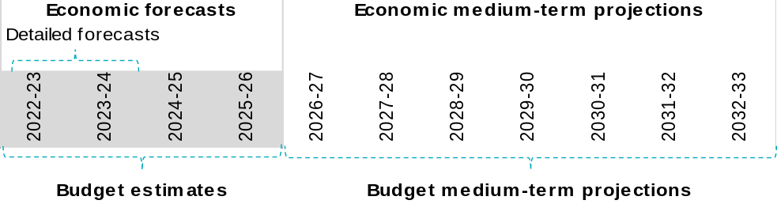
Source: Treasury.

In the Budget year (2022–23) and the subsequent financial year (2023–24), emphasis is placed on detailed forecasts of the expenditure components of economic activity. Beyond this period, estimates are based on expectations for the level of potential output and modelling of the path by which output converges back to this potential level. An output gap exists if actual output is not equal to potential.
A macroeconometric model of the Australian economy is used to inform the path that the economy takes to close the output gap. This model accounts for factors such as the nature and level of spare capacity in the economy, the drivers of potential output growth, and the expected path of international trade prices. The model allows for a considered assessment of the path of output beyond 2023–24.
Potential GDP is estimated based on an analysis of trends for population, productivity, and participation. Since PEFO, the Budget adopts a lower long-term productivity growth assumption of 1.2 per cent, reflecting structurally weaker productivity growth over time. This change represents a more realistic assumption. The unemployment rate is assumed to settle at Treasury’s Non-Accelerating Inflation Rate of Unemployment (NAIRU) assumption of 4¼ per cent. On the nominal side, key non-rural commodity export prices are projected based on cost curve analysis. Domestic price growth returns over time to the midpoint of the RBA’s inflation target band.
Potential real GDP grows at an annual average of around 2½ per cent per annum until the end of the medium term in 2032–33. This is a ¼ of a percentage point lower than projected at PEFO over 2026–27 to the end of the medium term, largely reflecting a permanently lower rate of assumed productivity growth. The terms of trade are projected to remain around their 2023–24 level over the medium term, with key commodity prices being at levels consistent with their long-term fundamentals.

Since PEFO, an updated and lower productivity growth rate assumption has been adopted, reflecting structurally lower productivity over the past 20 years (see Box 3.3). These projections assume that underlying labour productivity converges over a 10-year period to the assumed long-term productivity growth rate, now 1.2 per cent per annum (equivalent to the average growth rate in labour productivity over the 20 years to 2018–19). This changed assumption increasingly lowers potential GDP across the medium term.
These projections also incorporate increases in trend population and participation, and a decrease in average hours worked. Higher population reflects that net overseas migration is forecast to recover to pre‑pandemic trends 2 years earlier than in the March 2022–23 Budget. Recent migration data and strength in new visa issuance are showing an improved outlook for migrant arrivals, especially of students, and a delayed recovery in temporary migrant departures. In sum, the changes to population, participation and average hours imply that there is a larger workforce available to produce goods and services over the medium term. The increase in the workforce is not sufficient to offset lower underlying labour productivity growth. As a result, the level of potential real GDP has been downgraded across the projection period.
Overall, the level of nominal GDP over the medium-term projection period is higher compared to PEFO (Chart 2.26). In 2022–23 this largely reflects stronger non-rural commodity prices and a higher domestic price level. While inflation returns to the midpoint of the RBA target band by the June quarter of 2025, higher forecast inflation is expected to sustain a higher domestic price level. The impact of higher prices on nominal GDP over the medium term is partially offset by lower real output, reflecting a lower assumed growth rate for underlying labour productivity.
Chart 2.26: Projected nominal GDP
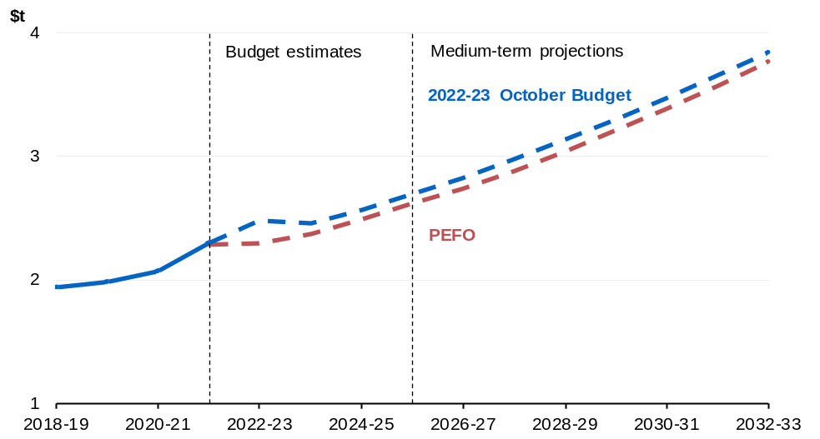
Source: ABS Australian National Accounts: National Income, Expenditure and Product and Treasury.

Bahar E, Deutscher N, Bradshaw N and Montaigne M (2022), ‘Children and the gender earnings gap’, Treasury Round Up, Productivity edition.

