Statement 7:
Debt Statement
The Debt Statement provides information on Government gross debt, net debt, Australian Government Securities (AGS) issuance and interest costs over the forward estimates.
Gross and net debt as a share of GDP are expected to be lower than estimated at the Pre-election Economic and Fiscal Outlook (PEFO) each year over the forward estimates.
Gross debt is estimated to be 37.3 per cent of GDP at 30 June 2023, increasing to 43.1 per cent of GDP at 30 June 2026.
Net debt is estimated to be 23.0 per cent of GDP at 30 June 2023, increasing to 28.5 per cent of GDP at 30 June 2026.
Interest payments on AGS as a share of GDP are expected to be higher than at PEFO by the end of the forward estimates, driven by higher bond yields more than offsetting the lower issuance of AGS.
Interest payments on AGS are estimated to be $18.1 billion in 2022–23, increasing to $31.7 billion by 2025–26. Over the 4 years to 2025–26, interest payments on AGS are expected to be $12.0 billion higher than estimated at PEFO.
Statement 3: Fiscal Strategy and Outlook contains information on debt projections over the medium term. Statement 3 also improves transparency around government funding of climate action and the risks to the fiscal position from climate change.

Contents
Australian Government Securities on issue 217
Changes in AGS on issue since PEFO 218
Breakdown of AGS currently on issue 219
Treasury Bonds 220
Treasury Indexed Bonds 221
Treasury Notes 221
Non-resident holdings of AGS on issue 222
Net debt 223
Changes in net debt since PEFO 224
Interest on AGS 225
Appendix A: AGS issuance 227

Statement 7: Debt Statement

Australian Government Securities on issue
Estimates of AGS on issue are published in both face value and market value terms in this Statement.
- The face value of AGS on issue (also referred to as gross debt) is the amount that the Government pays back to investors at maturity, independent of fluctuations in market prices. The total face value of AGS on issue changes when new securities are issued, or when securities are repurchased or reach maturity.
- The market value of AGS on issue represents the value of securities as traded on the secondary market, which changes continuously with movements in market prices (often quoted as a yield to maturity). Consistent with external reporting standards, the market value of AGS on issue is reported in the Australian Government general government sector balance sheet.
The Commonwealth Inscribed Stock Act 1911 (CIS Act) requires the Treasurer to issue a direction stipulating the maximum face value of relevant AGS that may be on issue. Effective from 7 October 2020, the then Treasurer directed that the maximum face value of AGS that can be on issue is $1,200 billion. The estimates of the face value of AGS on issue subject to the Treasurer’s direction (end-of-year and within-year peak) in each year of the forward estimates remain below $1,200 billion.
Gross debt as a share of GDP is estimated to decrease in 2022–23. The decline is driven by the improved outlook for the underlying cash balance and strong nominal GDP growth in that year. Gross debt as a share of GDP then increases. This primarily reflects the deficit profile of the former Government as presented in PEFO. Higher yields, additional balance sheet commitments, and other changes to the fiscal outlook presented in Statement 3: Fiscal Strategy and Outlook also contribute.
Table 7.1 presents outcomes and estimates of AGS on issue.
Table 7.1: Estimates of AGS on issue subject to the Treasurer’s Direction^{(a)(b)}
 | Actual | Estimates
 | 2021-22 | 2022-23 | 2023-24 | 2024-25 | 2025-26
 | $b | $b | $b | $b | $b
Face value – end-of-year | 895 | 927 | 1,004 | 1,091 | 1,159
Per cent of GDP | 39.0 | 37.3 | 40.8 | 42.5 | 43.1
Face value – within-year peak(c) | 896 | 947 | 1,024 | 1,114 | 1,186
Per cent of GDP(c) | 39.0 | 38.1 | 41.6 | 43.4 | 44.1
Month of peak(c) | Jun-22 | Apr-23 | Apr-24 | Apr-25 | Apr-26
Market value – end-of-year | 848 | 878 | 963 | 1,056 | 1,127
Per cent of GDP | 36.9 | 35.4 | 39.1 | 41.2 | 41.9
- The Treasurer’s Direction applies to the face value of AGS on issue. This table also shows the equivalent market value of AGS that are subject to the Treasurer’s Direction.
- The stock and securities that are excluded from the current limit set by the Treasurer’s Direction are outlined in subsection 51JA(2A) of the CIS Act.
- The precise within-year timing of cash receipts and payments is not known. Estimated peaks of AGS on issue are therefore subject to considerable uncertainty.
Source: The Australian Office of Financial Management (AOFM).

Changes in AGS on issue since PEFO
Gross debt is expected to be lower across each year of the forward estimates than at PEFO. The improvement is primarily driven by the improved outlook for the underlying cash balance in the near term, partially offset by the impact of higher yields on AGS and additional balance sheet commitments.
An increase in yields increases the deficit via higher interest payments but also impacts the face value of AGS the AOFM needs to issue to meet the financing task. The majority of AGS issued by the AOFM are fixed-coupon bonds. As the coupon is fixed, when yields rise, the price investors pay the AOFM for the bonds falls so that the return on the bonds adjusts to the prevailing market yields. The AOFM must then issue more bonds to raise the same volume of funds. It is estimated this dynamic has increased the face value of debt by $30.8 billion over the forward estimates compared with PEFO.
Much of this impact is offset by a run-down of cash balances held by the AOFM. A lower-than-expected deficit in 2021–22 resulted in the AOFM effectively pre-funding some of the 2022–23 financing task. See the 2021–22 Final Budget Outcome for further detail.
By the end of the forward estimates, gross debt as a share of the economy is expected to be 43.1 per cent of GDP at 30 June 2026, 1.6 percentage points lower than estimated at PEFO.
Table 7.2: Estimates of AGS on issue subject to the Treasurer’s Direction – reconciliation from PEFO to the 2022–23 October Budget
 | 2022-23 | 2023-24 | 2024-25 | 2025-26
 | $b | $b | $b | $b
Total face value of AGS on issue subject to the Treasurer’s Direction as at 2022 PEFO | 977 | 1,056 | 1,117 | 1,169
Factors affecting the change in face value of AGS on issue from 2022 PEFO to 2022-23 October Budget(a)
Cumulative receipts decisions | -1.4 | -3.9 | -7.8 | -13.1
Cumulative receipts variations | -57.3 | -91.1 | -114.8 | -144.6
Cumulative payment decisions | 2.5 | 4.2 | 10.2 | 22.9
Cumulative payment variations | 15.1 | 37.2 | 63.1 | 92.2
Cumulative change in net investments in financial assets(b) | 12.9 | 17.7 | 22.9 | 32.5
Other contributors | -22.0 | -16.3 | 0.2 | -0.2
Total face value of AGS on issue subject to the Treasurer’s Direction as at 2022-23 October Budget | 927 | 1,004 | 1,091 | 1,159
- Cumulative impact of decisions and variations from 2022–23 to 2025–26. Increases to payments are shown as positive and increases to receipts are shown as negative.
- Change in net cash flows from investments in financial assets for policy and liquidity purposes.
Note: End-of-year data.

Breakdown of AGS currently on issue
See Appendix A for a detailed summary of the different types of securities.
Table 7.3: Breakdown of current Australian Government Securities on issue
 | On issue as at 14 October 2022
 | Face value | Market value
 | $m | $m
Treasury Bonds | 827,549 | 761,838
Treasury Indexed Bonds | 37,785 | 44,592
Treasury Notes | 27,000 | 26,863
Total AGS subject to Treasurer’s Direction(a) | 892,334 | 833,293
Other stock and securities | 5 | 5
Total AGS on issue | 892,339 | 833,298
- The stock and securities that are excluded from the current limit set by the Treasurer’s Direction are outlined in subsection 51JA(2A) of the CIS Act.
Source: AOFM.

Treasury Bonds
As at 14 October 2022, there were 28 Treasury Bond lines on issue, with a weighted average term to maturity of around 7 years and the longest maturity extending to June 2051. Further information on the AOFM’s strategy that has lengthened the weighted average term to maturity since 2010 can be found in Box 3.2 in Budget Paper No.1 Statement 3: Fiscal Strategy and Outlook in the 2021–22 Budget.
Table 7.4: Treasury Bonds on issue
 |  | On issue as at
Coupon |  | 14 October 2022
Per cent | Maturity | $m | Timing of interest payments(a)
2.25 | 21-Nov-22 | 26,500 | Twice yearly | 21-Nov | 21-May
5.50 | 21-Apr-23 | 34,200 | Twice yearly | 21-Apr | 21-Oct
2.75 | 21-Apr-24 | 35,900 | Twice yearly | 21-Apr | 21-Oct
0.25 | 21-Nov-24 | 41,300 | Twice yearly | 21-Nov | 21-May
3.25 | 21-Apr-25 | 40,100 | Twice yearly | 21-Apr | 21-Oct
0.25 | 21-Nov-25 | 38,000 | Twice yearly | 21-Nov | 21-May
4.25 | 21-Apr-26 | 38,100 | Twice yearly | 21-Apr | 21-Oct
0.50 | 21-Sep-26 | 36,700 | Twice yearly | 21-Sep | 21-Mar
4.75 | 21-Apr-27 | 36,700 | Twice yearly | 21-Apr | 21-Oct
2.75 | 21-Nov-27 | 31,400 | Twice yearly | 21-Nov | 21-May
2.25 | 21-May-28 | 29,700 | Twice yearly | 21-May | 21-Nov
2.75 | 21-Nov-28 | 33,300 | Twice yearly | 21-Nov | 21-May
3.25 | 21-Apr-29 | 33,700 | Twice yearly | 21-Apr | 21-Oct
2.75 | 21-Nov-29 | 33,400 | Twice yearly | 21-Nov | 21-May
2.50 | 21-May-30 | 37,100 | Twice yearly | 21-May | 21-Nov
1.00 | 21-Dec-30 | 38,700 | Twice yearly | 21-Dec | 21-Jun
1.50 | 21-Jun-31 | 38,100 | Twice yearly | 21-Jun | 21-Dec
1.00 | 21-Nov-31 | 41,800 | Twice yearly | 21-Nov | 21-May
1.25 | 21-May-32 | 38,400 | Twice yearly | 21-May | 21-Nov
1.75 | 21-Nov-32 | 27,000 | Twice yearly | 21-Nov | 21-May
4.50 | 21-Apr-33 | 22,200 | Twice yearly | 21-Apr | 21-Oct
3.00 | 21-Nov-33 | 17,600 | Twice yearly | 21-Nov | 21-May
2.75 | 21-Jun-35 | 9,550 | Twice yearly | 21-Jun | 21-Dec
3.75 | 21-Apr-37 | 12,300 | Twice yearly | 21-Apr | 21-Oct
3.25 | 21-Jun-39 | 10,300 | Twice yearly | 21-Jun | 21-Dec
2.75 | 21-May-41 | 13,500 | Twice yearly | 21-May | 21-Nov
3.00 | 21-Mar-47 | 13,600 | Twice yearly | 21-Mar | 21-Sep
1.75 | 21-Jun-51 | 18,400 | Twice yearly | 21-Jun | 21-Dec
- Where the timing of an interest payment falls on a non-business day, the payment will occur on the following business day.
Source: AOFM.

Treasury Indexed Bonds
As at 14 October 2022, there were 7 Treasury Indexed Bond (TIB) lines on issue, with a weighted average term to maturity of around 10.1 years and the longest maturity extending to February 2050.
Table 7.5: Treasury Indexed Bonds on issue
 |  | On issue as at
Coupon |  | 14 October 2022
Per cent | Maturity | $m | Timing of interest payments(a)
3.00 | 20-Sep-25 | 8,043 | Quarterly | 20-Sep | 20-Dec | 20-Mar | 20-Jun
0.75 | 21-Nov-27 | 6,500 | Quarterly | 21-Nov | 21-Feb | 21-May | 21-Aug
2.50 | 20-Sep-30 | 6,543 | Quarterly | 20-Sep | 20-Dec | 20-Mar | 20-Jun
0.25 | 21-Nov-32 | 3,950 | Quarterly | 21-Nov | 21-Feb | 21-May | 21-Aug
2.00 | 21-Aug-35 | 4,350 | Quarterly | 21-Aug | 21-Nov | 21-Feb | 21-May
1.25 | 21-Aug-40 | 4,250 | Quarterly | 21-Aug | 21-Nov | 21-Feb | 21-May
1.00 | 21-Feb-50 | 4,150 | Quarterly | 21-Feb | 21-May | 21-Aug | 21-Nov
- Where the timing of an interest payment falls on a non-business day, the payment will occur on the following business day.
Source: AOFM.

Treasury Notes
As at 14 October 2022, there were 9 Treasury Note lines on issue. Treasury Notes do not pay a coupon.
Table 7.6: Treasury Notes on issue
 | On issue as at 14 October 2022
Maturity | $m | Timing of interest payment
21-Oct-22 | 4,000 | At maturity | 21-Oct-22
11-Nov-22 | 4,500 | At maturity | 11-Nov-22
25-Nov-22 | 4,500 | At maturity | 25-Nov-22
16-Dec-22 | 3,000 | At maturity | 16-Dec-22
27-Jan-23 | 5,000 | At maturity | 27-Jan-23
10-Feb-23 | 3,500 | At maturity | 10-Feb-23
24-Feb-23 | 500 | At maturity | 24-Feb-23
10-Mar-23 | 1,500 | At maturity | 10-Mar-23
24-Mar-23 | 500 | At maturity | 24-Mar-23
Source: AOFM.

Non-resident holdings of AGS on issue
As at the June 2022 quarter, the proportion of non-resident holdings of AGS was around 45 per cent (Chart 7.1). This proportion is down from historical highs of around 76 per cent in 2012. Non-resident holdings of AGS have increased significantly over this time, but the proportion has fallen since the rate of buying by non-resident investors has not matched the rate of issuance. In addition, the Reserve Bank of Australia’s (RBA) bond purchase operations in 2020 and 2021 reduced the amount of AGS available to other investors, including non-residents.
Chart 7.1: Non-resident holdings of AGS
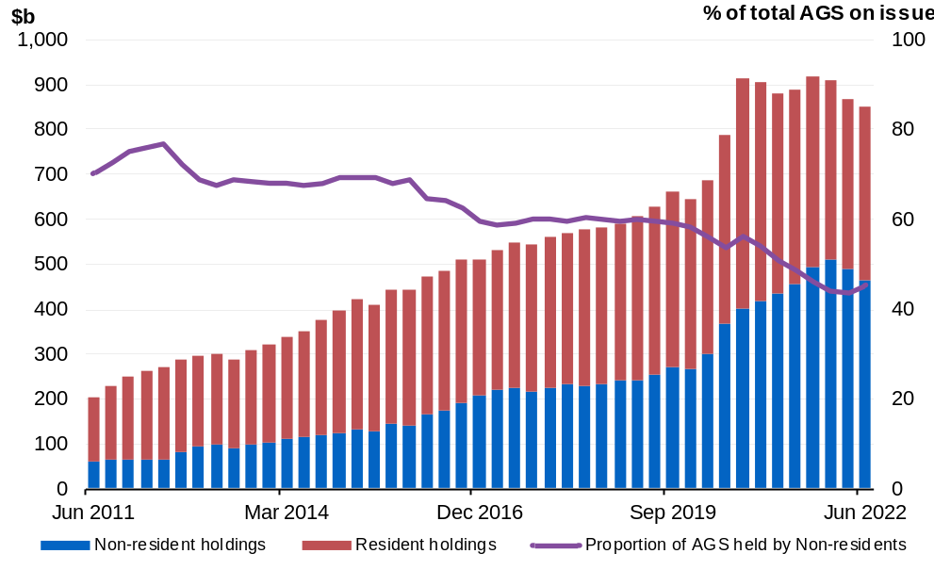
Note: Data refer to the repo-adjusted market value of holdings.
Source: ABS Balance of Payments and International Investment Position, Australia June 2022, AOFM, RBA.

Net debt
Net debt is equal to the sum of interest-bearing liabilities (which includes AGS on issue measured at market value) less the sum of selected financial assets (cash and deposits, advances paid and investments, loans and placement). As net debt incorporates both selected financial assets and liabilities at their fair value, it provides a broader measure of the financial obligations of the Government than gross debt.
Not all government assets or liabilities are included in the measurement of net debt. For example, the Government’s unfunded superannuation liability is not accounted for in net debt, nor are holdings of equities, for example those held by the Future Fund or the Government’s equity investment in the NBN.
Table 7.7: Liabilities and assets included in net debt
 | Actual | Estimates
 | 2021-22 | 2022-23 | 2023-24 | 2024-25 | 2025-26
 | $m | $m | $m | $m | $m
Liabilities included in net debt
Deposits held | 406 | 406 | 406 | 406 | 406
Government securities(a) | 848,455 | 877,947 | 962,871 | 1,056,215 | 1,127,457
Loans | 29,932 | 32,204 | 33,192 | 33,427 | 33,475
Other borrowing | 19,194 | 18,997 | 18,340 | 17,347 | 15,985
Total liabilities included in net debt | 897,988 | 929,554 | 1,014,809 | 1,107,396 | 1,177,322
Assets included in net debt
Cash and deposits | 94,763 | 54,975 | 68,350 | 79,676 | 72,967
Advances paid | 73,119 | 76,622 | 75,412 | 79,894 | 83,616
Investments, loans and placements | 214,456 | 225,772 | 236,975 | 245,029 | 253,954
Total assets included in net debt | 382,338 | 357,369 | 380,736 | 404,599 | 410,536
Net debt | 515,650 | 572,185 | 634,073 | 702,796 | 766,787
- Government securities are presented at market value.

Changes in net debt since PEFO
Net debt is expected to be lower than estimated at PEFO across all years of the forward estimates by an amount larger than the improvement in gross debt. The larger improvement primarily reflects the decrease in the market value of AGS due to higher yields than were assumed at PEFO.
Table 7.8: Net debt – reconciliation from PEFO to the 2022–23 October Budget
 | 2022-23 | 2023-24 | 2024-25 | 2025-26
 | $b | $b | $b | $b
Net debt as at 2022 PEFO | 714.9 | 772.1 | 823.2 | 864.5
Changes in financing requirement | -54.3 | -64.5 | -49.1 | -47.2
Impact of yields on AGS | -72.0 | -60.4 | -47.2 | -31.8
Asset and other liability movements | -16.4 | -13.1 | -24.1 | -18.6
Cash and deposits | -18.9 | -19.0 | -29.0 | -21.5
Advances paid | 9.9 | 8.2 | 7.1 | 5.8
Investments, loans and placements | -8.8 | -4.8 | -5.2 | -6.4
Other movements | 1.4 | 2.5 | 3.1 | 3.5
Total movements in net debt from  2022 PEFO to 2022-23 October Budget | -142.7 | -138.0 | -120.4 | -97.7
Net debt as at 2022-23 October Budget | 572.2 | 634.1 | 702.8 | 766.8

Interest on AGS
The interest costs related to AGS are presented in both cash and accrual accounting terms. The difference between the cash interest payments and accrual interest expense generally relates to the timing of when the interest cost is recognised.
- Interest payments are recognised in the period when they are paid during the life of the security.
- Interest expense is recognised in the period in which an expense is incurred during the life of the security, rather than when it is actually paid.
Estimates of the interest payments and expense of AGS on issue include the cost of AGS already on issue and future AGS issuance.
- The cost of AGS already on issue reflects the actual yield at the time of issuance.
- The expected cost of future AGS issuance is based on a recent average of daily spot rates across the yield curve at the time of a budget estimates update.
Chart 7.2 shows the yield curve assumptions underpinning the March Budget and the October Budget. The recent increase in market yields has resulted in an assumed weighted average cost of borrowing of around 3.8 per cent for future issuance of Treasury Bonds over the forward estimates, compared with around 2.2 per cent at PEFO.
Chart 7.2: Yield curve assumptions from 2022–23 to 2025–26
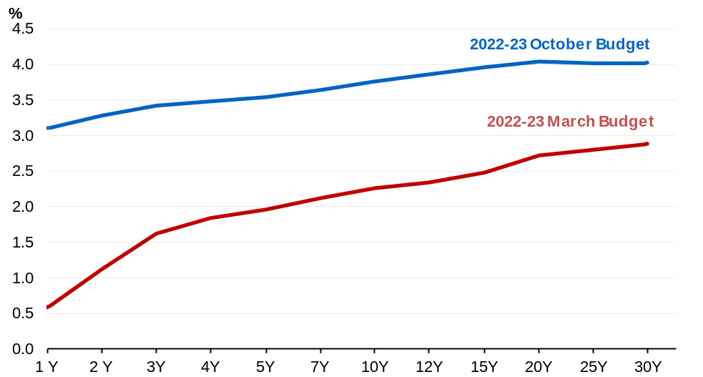
Source: AOFM.

By the end of the forward estimates total interest payments will grow to $32.6 billion in 2025–26, of which $31.7 billion relates to AGS on issue (Table 7.9). Interest receipts have also increased significantly in 2022–23 and across the forward estimates. This is primarily driven by higher-than-expected earnings from the Future Fund, and higher earnings on cash deposits due to the rise in short-term interest rates.
Table 7.9: Interest payments, interest receipts and net interest payments^{(a)}
 | Actual | Estimates
 | 2021-22 | 2022-23 | 2023-24 | 2024-25 | 2025-26
 | $m | $m | $m | $m | $m
Interest payments on AGS | 15,714 | 18,064 | 21,493 | 24,462 | 31,721
Per cent of GDP | 0.7 | 0.7 | 0.9 | 1.0 | 1.2
Interest payments(b) | 17,423 | 18,910 | 22,407 | 25,369 | 32,634
Per cent of GDP | 0.8 | 0.8 | 0.9 | 1.0 | 1.2
Interest receipts | 2,446 | 5,275 | 5,805 | 5,991 | 6,147
Per cent of GDP | 0.1 | 0.2 | 0.2 | 0.2 | 0.2
Net interest payments(c) | 14,977 | 13,635 | 16,602 | 19,378 | 26,487
Per cent of GDP | 0.7 | 0.5 | 0.7 | 0.8 | 1.0
- Interest payments and receipts are a cash measure, with the relevant amount recognised in the period in which the interest payment is made or interest is received.
- Interest payments include interest payments on AGS, loans and other borrowing, as well as interest payments on lease liabilities.
- Net interest payments are equal to the difference between interest payments and interest receipts.

Interest payments as a share of GDP in 2022–23 and 2023–24 are expected to remain consistent with PEFO. Over the remaining forward estimates years, interest payments as a share of GDP are expected to be higher than at PEFO as higher yields more than offset the expected lower issuance of AGS. By 2025–26, interest payments as a share of GDP rise above the 30-year average of just under one per cent.
Table 7.10: Interest expense, interest income and net interest expense^{(a)}
 | Actual | Estimates
 | 2021-22 | 2022-23 | 2023-24 | 2024-25 | 2025-26
 | $m | $m | $m | $m | $m
Interest expense on AGS | 18,502 | 22,396 | 24,155 | 27,691 | 31,983
Per cent of GDP | 0.8 | 0.9 | 1.0 | 1.1 | 1.2
Total interest expense(b) | 19,944 | 26,188 | 27,140 | 34,586 | 35,295
Per cent of GDP | 0.9 | 1.1 | 1.1 | 1.3 | 1.3
Interest income | 4,452 | 8,192 | 7,476 | 6,899 | 7,153
Per cent of GDP | 0.2 | 0.3 | 0.3 | 0.3 | 0.3
Net interest expense(c) | 15,493 | 17,996 | 19,664 | 27,687 | 28,142
Per cent of GDP | 0.7 | 0.7 | 0.8 | 1.1 | 1.0
- Interest expense is an accrual measure, with the relevant amount recognised in the period in which the expense is incurred, but not necessarily paid.
- Total Interest expense includes interest expense on AGS, loans and other borrowing, as well as interest expense on lease liabilities and other financing costs (including debt not expected to be repaid (DNER)).
- Net interest expense is equal to the difference between interest expenses and interest income.

Appendix A: AGS issuance
The AOFM is responsible for issuing AGS and managing the Government’s financing activities. The AOFM currently issues three types of securities:
- Treasury Bonds: medium to long-term securities with a fixed annual rate of interest payable every six months.
- Treasury Indexed Bonds (TIBs): medium to long-term securities for which the capital value of the security is adjusted for movements in the consumer price index (CPI). Interest on TIBs is paid quarterly, at a fixed rate, on the adjusted capital value.
- Treasury Notes: short-term discount securities, which mature within one year of issuance. The volume of Treasury Notes on issue will vary over the course of the year, depending on the size and profile of the within-year funding requirements.
Within these three broad categories of AGS, issuance is undertaken into a limited number of maturities (known as lines). The number of lines on issue is determined by the AOFM as part of its debt portfolio management role. Each line has a fixed maturity date (the date on which the Government repays the principal it has borrowed) and, for Treasury Bonds and TIBs, a coupon rate (the annual fixed interest rate paid on the security).
Concentrating AGS issuance into a limited number of lines (rather than issuing securities with a specific tenor, such as 10 years) ensures each line is sufficiently large that it can be more readily traded in the secondary market. Strong liquidity in the secondary market is attractive to investors and intermediaries, promotes demand for AGS and assists in lowering borrowing costs. All AGS issuance is undertaken in Australian dollars.
The AOFM exercises operational independence in the execution of its duties. Its announced issuance program for each year is determined on the basis of maturing AGS, net new issuance required to fund the Budget and operational considerations.
Operational considerations often mean that the annual issuance program may not be equivalent to the financing task for a particular year. For example, the AOFM may decide there is merit in partially pre-funding the following year’s financing task. Alternatively, the AOFM might choose to smooth issuance across several financial years in order to minimise changes in AGS supply from one financial year to the next.
The AOFM aims to maintain an AGS yield curve out to a 30-year benchmark bond. This facilitates a lower risk profile of maturing debt, broadens the investor base and helps to reduce the impact of interest rate volatility on budget outcomes. Further details on the AOFM’s debt issuance program are available on the AOFM website at www.aofm.gov.au.
The AOFM publishes an issuance program for the budget year only. Estimates beyond the budget year are based on a set of technical assumptions and will vary with changes to these assumptions and budget estimates.

For Treasury Indexed Bonds (TIBs), the final repayment amount paid to investors includes an additional amount to reflect the impact of inflation over the life of the security. This additional amount is not included in the calculation of face value.
End-of-year values are estimates of AGS on issue at 30 June for the particular year. The precise timing and level of within-year peaks of AGS on issue cannot be determined with accuracy. The timing of the within-year peak is therefore reported to the given month in the particular year.
For example, on 7 October 2022 the AOFM issued into an existing bond line with a maturity of 21 November 2025 and coupon rate of 0.25 per cent. The face value of issuance was $700 million, but the proceeds received by the Government was around $636 million. The same bond line was issued on 6 August 2021 when yields were lower, and $693 million was received for $700 million of face value.

