Statement 8:
Forecasting Performance and Sensitivity Analysis
The economic and fiscal forecasts and projections are underpinned by a range of assumptions and judgements based on best available information at time of preparation. However, economic and fiscal conditions are continually evolving and uncertain. Globally, key risks include a ‘hard landing’ or recession in major advanced economies, a sharper-than-expected downturn in China due to COVID-19 outbreaks and the property market downturn, a sudden tightening in financial markets and further energy price shocks stemming from the Russian invasion of Ukraine driving inflation higher. Domestically, the full impact of recent floods is highly uncertain, as the situation continues to develop. Beyond this, the path of monetary policy and household responses to inflation remain key risks to economic activity.
This Statement assesses:
- The performance of past forecasts based on the variance between forecasts and actuals over the past 2 decades.
- The uncertainty around current forecasts via confidence interval analysis.
- The sensitivity of current forecasts to key underlying assumptions: the iron ore price and yields.
Sensitivity of economic forecasts to other variables, including metallurgical and thermal coal prices and inflation, are considered in Budget Statement 2: Economic Outlook. The sensitivity of economic and fiscal forecasts to the productivity growth rate assumption is considered in Budget Statement 3: Fiscal Strategy and Outlook.

Contents
Assessing past forecasting performance 233
Economic forecasting performance 233
Fiscal forecasting performance 235
Assessing current forecasts via confidence interval analysis 240
Economic uncertainty based on historical forecast errors 241
Fiscal uncertainty based on historical forecast errors 242
Assessing current forecasts through sensitivity analysis 245
Movements in the iron ore price 245
Movements in yields 246

Statement 8: Forecasting Performance and Sensitivity Analysis

Assessing past forecasting performance
This section assesses the variance between historical forecasts and outcomes (forecast errors) for real and nominal GDP, receipts, payments and the underlying cash balance.
Forecasts are prepared using a range of techniques:
- Macroeconomic forecasts are prepared consistent with a national accounting framework using econometric models and spreadsheet analysis.
- Tax receipt forecasts are generally prepared using a ‘base plus growth’ methodology. The last outcome for each head of revenue is the base to which growth rates are applied, using appropriate economic parameters.
- Payments forecasts are generally prepared through analysis of payment program data, costings for new policies and historical trends in programs, in consultation with relevant agencies.
Forecasts are based on assumptions and judgements. Forecast accuracy depends on whether assumptions and judgements prove to be correct, and the reliability of the modelled economic and fiscal relationships.

Economic forecasting performance
Real GDP forecasts incorporate assumptions for exchange rates, interest rates, commodity prices and population growth. The forecasts also incorporate judgements about how developments in one part of the economy affect other parts and how the domestic economy is affected by the international economy.
The large forecast error in 2019–20 reflects the onset of the COVID-19 pandemic.
The 2020–21 forecast error reflects the stronger-than-expected economic recovery. The 2021–22 forecast error was primarily due to weaker-than-expected household consumption during the Delta wave of the pandemic (Chart 8.1).
Chart 8.1: Comparison of forecasts and outcomes for real GDP growth
Note: Outcome is as published in the June quarter 2022 National Accounts. Forecast is that published in the Budget for that year.
Source: ABS Australian National Accounts: National Income, Expenditure and Product and Budget papers.

Nominal GDP forecasts include a price component that adds additional uncertainty compared to real GDP forecasts. Price uncertainty relates to the evolution of domestic prices and wages, prices of imported goods and world prices for Australia’s exports, including commodities. Since the early 2000s, nominal GDP forecast errors have largely reflected volatility in global commodity prices (Chart 8.2).
Chart 8.2: Comparison of forecasts and outcomes for nominal GDP growth
Note: Outcome is as published in the June quarter 2022 National Accounts. Forecast is that published in the Budget for that year.
Source: ABS Australian National Accounts: National Income, Expenditure and Product and Budget papers.

In 2021–22, growth in nominal GDP was underestimated reflecting higher-than-assumed commodity prices, with Russia’s invasion of Ukraine pushing up global energy prices and the price of Australian coal and LNG exports. Consequently, over 2021–22, the terms of trade increased 12.2 per cent to its highest level on record, rather than the decline of 8 per cent assumed in the 2021–22 Budget.

Fiscal forecasting performance
Fiscal forecast errors are driven by economic and demographic forecast errors as well as errors associated with forecasts of demand for government programs. For additional information see 2021–22 Final Budget Outcome.

Total receipts
Total receipts are comprised of tax and non-tax receipts (e.g. dividends from investment funds). Tax receipts are the largest element and main driver of total receipts forecasting performance. In 2021–22, tax receipts comprised 91.8 per cent of total receipts.
Total receipts were $102.3 billion higher than forecast in 2021–22. Growth was 12.4 per cent compared to a forecast 7.3 per cent decline. Non-tax receipts were $11.3 billion higher than forecast and grew 3.9 per cent in 2021–22 rather than the 9.6 per cent decline forecast at the 2021–22 Budget.

Tax receipts
Over the past 2 decades, tax receipts growth has been over and underestimated (Chart 8.3).
Chart 8.3: Comparison of forecasts and outcomes for annual tax receipts growth
Source: Budget papers and Treasury.

Tax receipts grew 13.2 per cent in 2021–22 rather than the 3.0 per cent decline forecast at the 2021–22 Budget. The level was $91.0 billion higher than forecast. This outcome reflects growth in most revenue heads, driven by stronger-than-expected economic outcomes and higher-than-expected commodity prices.
There is a correlation between the forecast accuracy of nominal GDP and tax receipts. On average, nominal GDP forecast errors are magnified in receipts forecast errors, owing to the progressive nature of the personal income tax system (Chart 8.4).
Chart 8.4: Forecast errors for nominal non-farm GDP and tax receipts growth^{(a)}
- Excludes CGT.
Source: ABS Australian National Accounts: National Income, Expenditure and Product, Budget papers and Treasury.

Payments
Payments forecasting performance is affected by growth in indexation factors (e.g. CPI growth) and demand for government programs. Demand-driven programs, such as payments to individuals for social welfare, form the bulk of government expenditure. Forecasts of payments associated with these government programs also depend on economic conditions.
Payments declined 5.8 per cent in 2021–22 rather than the 10.9 per cent decline forecast at the 2021–22 Budget (see Chart 8.5). The level was $27.6 billion higher than forecast.
Chart 8.5: Comparison of forecasts and outcomes for annual payments growth
Source: Budget papers and Treasury.

The forecast error in 2021–22 was driven by COVID-19 response measures, further information on these measures can be found in the 2021–22 Mid-Year Economic and Fiscal Outlook.

Underlying cash balance
Underlying cash balance forecasting performance reflects the forecasting performance of its components: total receipts and payments (Chart 8.6).
Chart 8.6: Comparison of forecasts and outcomes for underlying cash balance
Source: Budget papers and Treasury.

Better-than-expected underlying cash balance outcomes in 2020–21 and 2021–22 reflect the challenges in forecasting during the COVID-19 pandemic. Recent higher-than-expected receipts outcomes have been driven by higher-than-expected commodity prices. The underlying cash deficit was 1.4 per cent of GDP ($32.0 billion) in 2021–22 rather than the forecast deficit of 5.0 per cent of GDP ($106.6 billion).
Over the past 2 decades, outside major downturns, receipts forecast errors have generally driven the underlying cash balance forecast errors (Chart 8.7). The two large payments forecast errors reflect the unexpected Government payment assistance in the global financial crisis (2008–09) and in COVID-19 (2019–20). The forecast errors outside these crises, largely reflect the difficulties in forecasting global commodity prices (and hence tax receipts). Underestimates in receipts tend to coincide with overestimates in payments resulting in underestimates in the underlying cash balance (and vice versa).
Chart 8.7: Impact of receipts and payments forecast errors on underlying cash balance forecast error
Source: Budget papers and Treasury.

Assessing uncertainty around current forecasts via confidence interval analysis
This section presents confidence intervals to illustrate the uncertainty around current forecasts. This assumes future forecast errors are consistent with the distribution of past forecast errors (from 1998–99 to 2021–22). Based on past forecasting performance, there is a 70 and 90 per cent probability that forecasts will lie within the respective confidence interval bands.
Future forecast errors may not have the same distribution as historical forecast errors. The large forecast errors in 2019–20 and 2020–21, related to COVID-19, are an example of events not previously captured in the historical error sample. Large disruptive events are not able to be predicted and could occur again in the future.

Economic uncertainty based on historical forecast errors
Based on past forecast errors for real GDP, Chart 8.8 shows the degree of variance around the current forecasts assuming similar magnitude future errors. The average annualised growth in real GDP in the 2 years to 2023–24 is expected to be around 2½ per cent, with the 70 per cent confidence interval ranging from 1¾ per cent to 3¼ per cent. The 90 per cent confidence interval ranges from 1¼ per cent to 3¾ per cent.
Chart 8.8: Confidence intervals around real GDP growth rate forecasts
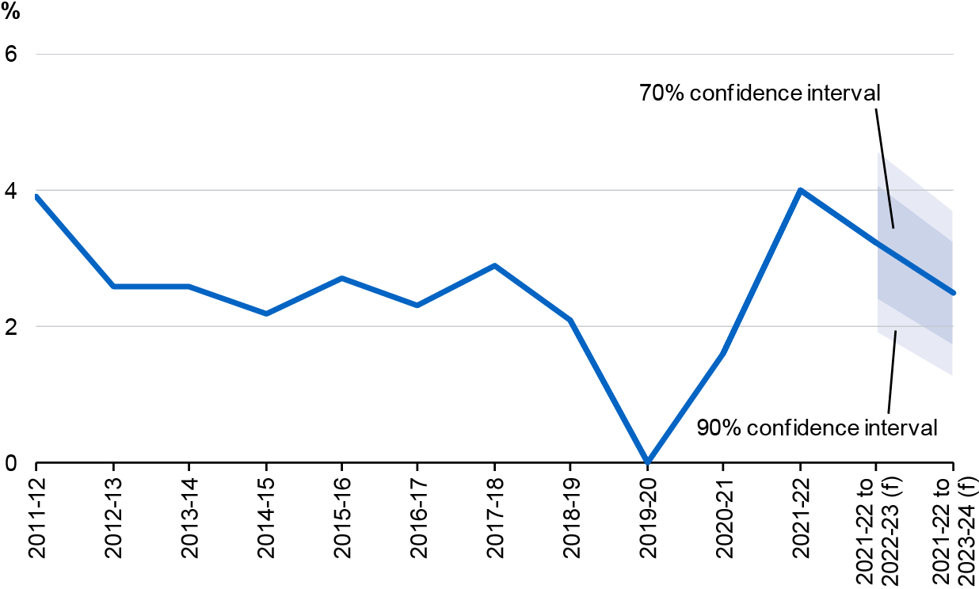
Note: The line shows the outcomes and the 2022–23 Budget forecasts. Annual growth rates are reported for the outcomes. Average annualised growth rates from 2021–22 are reported for 2022–23 onwards. Confidence intervals are based on the root mean squared errors (RMSEs) of MYEFO forecasts from 1998–99 onwards. RMSEs are constructed using MYEFO forecasts to be consistent with the timing of an October Budget. (f) are forecasts.
Source: ABS Australian National Accounts: National Income, Expenditure and Product, Budget papers and Treasury.

The confidence intervals around the nominal GDP forecasts are wider than those around the real GDP forecasts, reflecting the additional uncertainty around domestic prices and commodity prices (Chart 8.9). Average annualised growth in nominal GDP in the 2 years to 2023–24 is expected to be around 3½ per cent, with the 70 per cent confidence interval ranging from 1½ per cent to 5½ per cent. The 90 per cent confidence interval ranges from ½ per cent to 6½ per cent.

Chart 8.9: Confidence intervals around nominal GDP growth rate forecasts
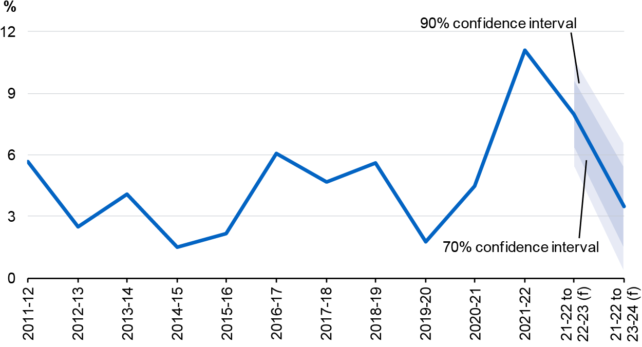
Note: See note to Chart 8.8.
Source: ABS Australian National Accounts: National Income, Expenditure and Product, Budget papers and Treasury.

Fiscal uncertainty based on historical forecast errors
Fiscal estimates are based on, and sensitive to, economic and demographic forecasts as well as estimates of the impact of spending and revenue measures. Historical variations caused by subsequent policy decisions not known at the time of forecast preparation are excluded as these do not relate to the forecasting errors presented in this section. Payments estimates do not exclude the public debt interest associated with these subsequent policy decisions as these are not able to be separately identified.

Total receipts
Total receipts (excluding GST) are expected to be around 21.1 per cent of GDP in 2022–23, with the 70 per cent confidence interval ranging from 20.3 per cent to 22.0 per cent of GDP. The 90 per cent confidence interval ranges from 19.8 per cent to 22.5 per cent. The uncertainty around receipts (excluding GST) increases as the forecast time horizon lengthens (Chart 8.10).

Chart 8.10: Confidence intervals around total receipts forecasts^{(a)}
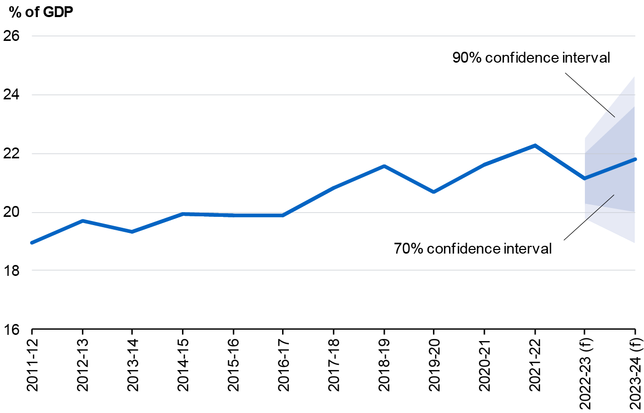
- Excludes GST and includes Future Fund earnings.
Note: The line shows the outcomes and the 2022–23 Budget forecasts. Confidence intervals use RMSEs for MYEFO forecasts from the 1998–99 Budget onwards. RMSEs are constructed using MYEFO forecasts to be consistent with the timing of an October Budget. (f) are forecasts.
Source: Budget papers and Treasury.

Payments
There is less uncertainty around payments forecasts (excluding GST) than around receipts forecasts (Chart 8.11). Payments (excluding GST) are expected to be around 22.6 per cent of GDP in 2022–23, with the 70 per cent confidence interval ranging from 22.0 per cent to 23.2 per cent of GDP. The 90 per cent confidence interval ranges from 21.7 per cent to 23.5 per cent.

Chart 8.11: Confidence intervals around payments forecasts^{(a)}
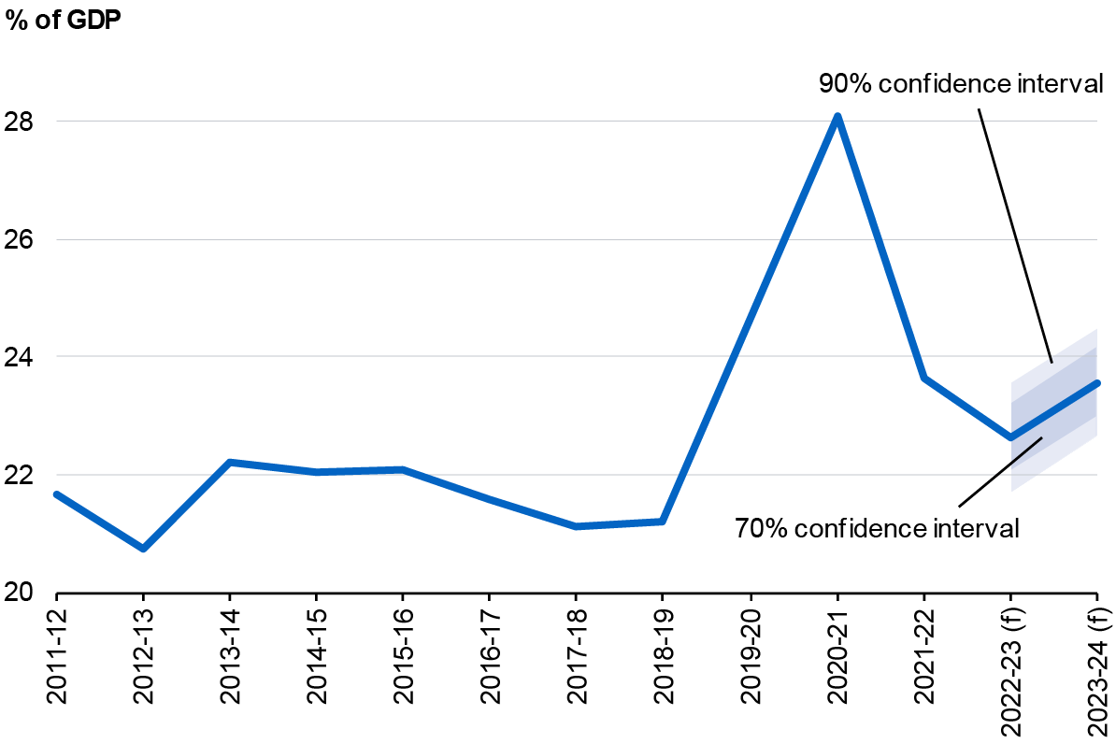
- Excludes GST payments.
Note: See note to Chart 8.10.
Source: Budget papers and Treasury.

Underlying cash balance
The underlying cash deficit in 2022–23 is expected to be 1.5 per cent of GDP, with the 70 per cent confidence interval ranging from a deficit of 2.8 per cent to 0.2 per cent of GDP. The 90 per cent confidence interval ranges from a deficit of 3.6 per cent to a surplus of 0.6 per cent. The uncertainty around underlying cash balance forecasts, reflecting forecast errors in receipts and payments, increases as the forecast time horizon lengthens (Chart 8.12).

Chart 8.12: Confidence intervals around the underlying cash balance forecasts
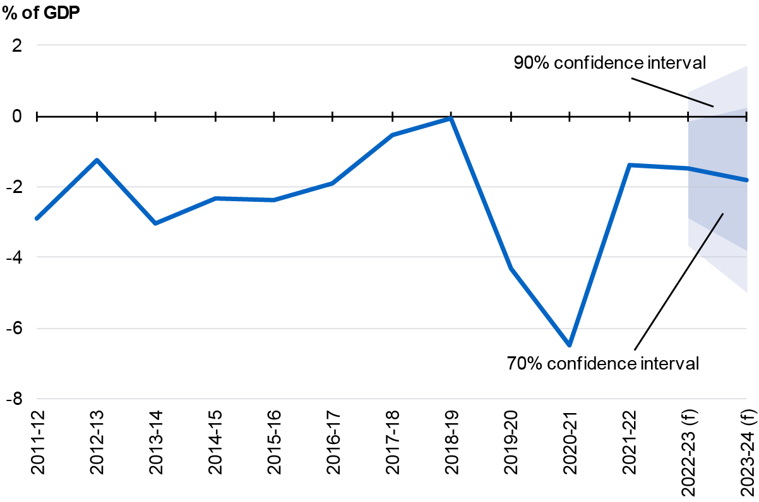
Note: See note to Chart 8.10.
Source: Budget papers and Treasury.

Assessing current forecasts through sensitivity analysis
Sensitivity analysis assesses how sensitive forecasts are to changes in key assumptions. For illustrative purposes the upper and lower sensitivities are broadly symmetric, but not equally probable.
The iron ore price and yields have been chosen for sensitivity analyses due to their significance in economic and fiscal outcomes and variability over time. The economic impact of other key variables, including the recent significant increase in commodity prices due to Russia’s invasion of Ukraine, is considered in Budget Statement 2: Economic Outlook. The fiscal impact of lower productivity is considered in Budget Statement 3: Fiscal Strategy and Outlook.

Movements in the iron ore price
The forecasts for nominal GDP and tax receipts are sensitive to commodity price assumptions, particularly iron ore prices. Iron ore represented around 22.4 per cent of the value of goods and services exports in 2021–22. See Budget Statement 2: Economic Outlook for more information on recent developments in commodity prices. The results of an increase and a decrease in the iron ore price are presented in Table 8.1.
Table 8.1: Sensitivity analysis of a US$10 per tonne movement in iron ore prices
 | US$10/tonne FOB^{(a)} fall |  |  | US$10/tonne FOB increase
 | 2022-23 | 2023-24 |  | 2022-23 | 2023-24
Nominal GDP ($billion) | -4.5 | -2.4 |  | 4.5 | 2.4
Tax receipts ($billion) | -0.5 | -0.5 |  | 0.5 | 0.5
- Prices are presented in free on board (FOB) terms which exclude the cost of freight.
Source: Treasury.

This analysis considers the impact of a permanent US$10 per tonne increase in the iron ore price on nominal GDP and tax receipts relative to the baseline forecast. The effects of a US$10 per tonne decrease and increase in the iron ore price are broadly symmetrical.
The US$10 per tonne increase in the assumed price for iron ore exports is expected to result in an increase in nominal GDP of around $4.5 billion in 2022–23 and around $2.4 billion in 2023–24. The economic response to a permanent change in the price of iron ore is derived from a generic terms of trade shock in Treasury’s Macroeconometric Model of Australia. The model incorporates forward looking financial markets, which anticipate the permanent increase in commodity prices.
An increase in iron ore export prices leads to higher export prices and terms of trade. This is moderated in the model response by an appreciation in the exchange rate, which partially offsets the increase in export prices. The appreciation also reduces import prices across all industries which flows through to lower consumer price inflation. Output, investment and export volumes in the mining sector increase in response to higher iron ore prices, although this is limited over the short term due to adjustment costs in increasing the capital stock.
A US$10 per tonne increase in the assumed price for iron ore exports is expected to result in an increase in tax receipts of around $0.5 billion in 2022–23 and 2023–24. An increase in iron ore export prices increases mining company profits and, as a result, increases company tax receipts. Lower domestic prices result in lower individuals and other withholding taxes and indirect tax receipts, partially offsetting the increase in company tax.

Movements in yields
The cost of government borrowing largely reflects yields on Australian Government Securities and the level of debt. Yields have been volatile but trending up rapidly (see Budget Statement 3: Fiscal Strategy and Outlook). The following analysis illustrates the sensitivity of the underlying cash balance and gross debt projections over the next 10 years to yield assumptions. This analysis illustrates the yield impact in isolation with other economic projections unchanged from baseline. While yields usually do not move in isolation, this analysis shows how yields may impact fiscal aggregates, above and beyond other changes.
Alongside government receipts and payments, fiscal sustainability depends on the difference between yields and economic growth. If the rate of economic growth is greater than the cost of government borrowing, this may be sufficient to improve debt as a share of the economy over time.
Future yields are uncertain, given the many economic factors at play. Given this uncertainty, a technical assumption for baseline yields is adopted. Baseline forecasts assume nominal 10-year bond yields are fixed over the budget year and the following 3 years at the levels observed immediately prior to the Budget update. The 10-year bond yield then converges over 15 years to a long-run yield equal to long-run nominal GDP growth. For bonds with other tenors, their yields are assumed to converge to their historical relativity to the 10-year bond yield in the yield curve.
The lower yield assumption has bond yields declining 150 basis points by the end of the forward estimates before increasing over 15 years to the long-run yield. The higher yield assumption has bond yields increasing 150 basis points by the end of the forward estimates before declining over 15 years to the long-run yield (Chart 8.13).
Chart 8.13: Baseline and alternative movements in the 10-year bond yield
Source: Treasury.

Higher yields increase public debt interest paid and receipts earned on investments. As government interest bearing liabilities usually exceed interest bearing assets, higher yields lead to a deterioration in the underlying cash balance. Lower yields have the reverse effect, improving the underlying cash balance.
The lower yield assumption results in an improvement to the underlying cash balance of around 0.4 percentage points of GDP by 2032–33. Under the lower yield assumption, cumulative improvements to the underlying cash balance reduce gross debt by 2.6 percentage points of GDP at 30 June 2033 (Chart 8.14).
Chart 8.14: Gross debt, impact of alternative yield assumptions
Source: Australian Office of Financial Management and Treasury.

The higher yield assumption results in a deterioration to the underlying cash balance of around 0.4 percentage points of GDP by 2032–33 and increases gross debt by 3.2 percentage points of GDP at 30 June 2033.
Even under the higher yield assumption, projected Commonwealth gross debt as a share of GDP is less than forty per cent of the average general government gross debt in the G7 countries today.

Between 2005–06 and 2019–20, the underlying cash balance is equal to receipts less payments, less net Future Fund earnings.
The confidence intervals methodology is based on the Treasury Working Paper Estimates of Uncertainty around Budget Forecasts. As in the paper, it is assumed forecast errors are normally distributed with zero mean and the past errors are representative of future errors.
GST was not reported as a Commonwealth tax in budget documents prior to the 2008–09 Budget. GST data have been removed from historical receipts and payments data to abstract from any error associated with this change in accounting treatment.

