Statement 2:
Economic Outlook
Global growth is forecast to remain subdued over the next few years and is expected to record the longest stretch of below-average growth since the early 1990s. Tackling inflation remains the primary focus but, as inflationary pressures abate and labour markets soften, the global policy focus will increasingly shift to managing risks to growth.
Several global factors pose risks to the outlook. Monetary policy settings could remain tight for an extended period due to persistent inflation. Heightened geopolitical tensions in the Middle East have added to the risks associated with Russia’s invasion of Ukraine. A further escalation in geopolitical tensions could add to energy costs, disrupt international trade, and slow global growth. The outlook for the Chinese economy, including the property sector, also remains uncertain.
Australia is not immune from global developments and the combination of elevated inflation and high interest rates here has resulted in lower growth over the past year. These factors have put people under pressure, with household consumption flat over the past year. High interest rates and ongoing supply constraints have also weighed on dwelling investment. These factors are expected to see real GDP growth of 1¾ per cent in 2023–24.
The Australian economy is well placed to navigate these economic challenges. Inflation is moderating, the labour market has been resilient, annual real wages are growing for the first time in years and there is a solid pipeline of business investment. This means that Australia can face global and domestic challenges from a position of economic strength.
Although inflation remains elevated, it has moderated substantially and is now less than half of its peak in 2022. The moderation in inflation has occurred more quickly than forecast at MYEFO, with inflation now expected to be lower in 2023–24.
While there remains considerable uncertainty around the outlook for the domestic and global economy, the Government’s responsible cost-of-living measures will provide relief for households. Energy bill relief and rent assistance are estimated to directly reduce headline inflation by ½ of a percentage point in 2024–25 and are not expected to add to broader inflationary pressures. This could see headline inflation return to the Reserve Bank of Australia’s target band by the end of 2024, slightly earlier than expected at MYEFO. This will ease pressure on households and help to keep inflation expectations well anchored.
The labour market has been resilient with the unemployment rate remaining near its 50-year low at 3.8 per cent, the participation rate near its record high at 66.6 per cent, and employment growing faster than any major advanced economy. However, there are clear signs that labour market conditions are softening. So far, a decline in average hours worked has delayed the expected moderation in employment growth and an associated modest increase in the unemployment rate. As labour market conditions continue to ease over 2024–25, the unemployment rate is expected to rise but remain below pre-pandemic levels.
Nominal wages over 2023–24 have grown at their fastest rate in nearly 15 years, reflecting recent labour market strength, as well as Fair Work Commission determinations on the minimum wage and the Aged Care Work Value Case. As the labour market softens, nominal wage growth is expected to soften to 3¼ per cent in both 2024–25 and 2025–26.
The moderation in inflation and pick-up in wage growth have contributed to an improvement in real wages. Real wages have risen for three consecutive quarters and returned to annual growth at the end of 2023, earlier than previously forecast. Real wages are expected to continue to pick up and grow by ½ per cent through the year to the June quarter 2024.
Business investment has withstood the global and domestic pressures, growing by a strong 8.3 per cent last year. The upswing in business investment is expected to continue through to 2025–26 and, if realised, will be the longest sustained increase in business investment since the mining boom.
Growth is expected to remain subdued over the forecast period. Real GDP is forecast to grow by 2 per cent in 2024–25, and 2¼ per cent in 2025–26. Higher wages growth, the forecast moderation in inflation, continuing employment growth and the Government’s cost‑of‑living tax cuts should support real household disposable incomes and a recovery in household consumption (see Box 2.1).
The improvement in household consumption is expected to be complemented by an elevated level of business investment and a gradual pick-up in dwelling investment as cost pressures ease and asset returns improve. Services exports are also expected to contribute to growth as the recovery in the number of international students and tourists continues. Productivity, which has grown for two consecutive quarters, is expected to continue to pick up as economic conditions improve.
Domestically, there is a risk that household consumption may not respond as quickly as expected to the anticipated recovery in real disposable incomes, particularly if households, facing budget constraints, instead seek to replenish savings or if employment growth is slower than forecast. Inflation could also be more persistent than forecast and delay the return of inflation to the target band.

Statement contents
Outlook for the international economy 43
Outlook for global growth 43
Outlook for global inflation 45
Key risks to the international outlook 46
Outlook for major trading partners 48
Outlook for the domestic economy 50
Household consumption 54
Dwelling investment 56
Business investment 57
Public final demand 58
Net exports 59
Inflation 60
The labour market 64
Outlook for the terms of trade 67
Outlook for nominal GDP growth 70
Medium-term projections 70

Statement 2: Economic Outlook

Outlook for the international economy

Outlook for global growth
Global growth is expected to remain subdued over the next few years as the effects of high inflation, restrictive macroeconomic policies, geopolitical tensions, and challenges in the Chinese economy weigh on the outlook. If inflationary pressures continue to ease as expected, the global policy focus will increasingly shift to managing risks to growth.
Most advanced economies recorded subdued outcomes during 2023, with around a third of OECD nations recording a technical recession. The United States has been the notable exception where earlier disinflation and a strong recovery in productivity have contributed to the economy consistently exceeding expectations.
Global growth is forecast to remain flat at around 3¼ per cent in 2024, 2025 and 2026 (Charts 2.1 and 2.2; Table 2.1). If realised, this would represent the longest stretch of below-average growth since the early 1990s. Major trading partner growth is also expected to remain subdued at 3¼ per cent in 2024, 2025 and 2026 as a forecast softening in China offsets a modest pickup elsewhere.
Chart 2.1: Contribution to global GDP growth
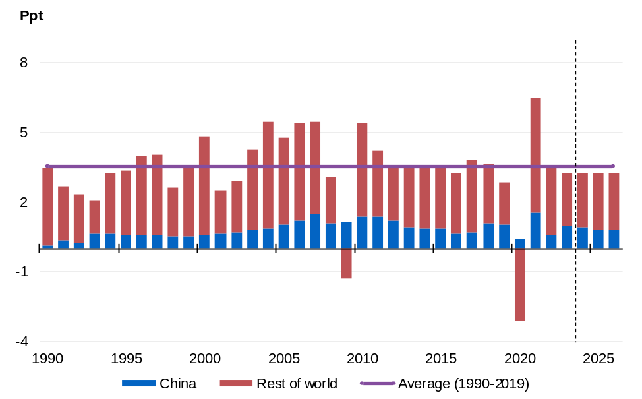
Source: Treasury, IMF.

Market pricing implies that central banks in most advanced economies are likely to have reached the peak in their monetary policy tightening phases (Chart 2.3). An exception is the Bank of Japan, which only began to withdraw longstanding monetary policy stimulus in March 2024 after emerging from decades of deflation and weak growth.
Market pricing also implies that most advanced economy central banks will begin easing monetary policy later this year. However, this policy easing is now expected to occur later than had been priced in earlier in the year given inflation has been more persistent than forecast.
Table 2.1: International GDP growth forecasts^{(a)}
 | Outcome | Forecasts (Calendar Years)
 | 2023 | 2024 | 2025 | 2026
Australia | 2.0 | 1 3/4 | 2 1/4 | 2 1/4
China | 5.2 | 4 3/4 | 4 1/4 | 4 1/4
India | 7.7 | 6 1/2 | 6 1/2 | 6 1/2
Japan | 1.9 | 3/4 | 1 | 1
United States | 2.5 | 2 1/2 | 1 1/2 | 2
Euro area | 0.5 | 3/4 | 1 1/2 | 1 1/2
United Kingdom | 0.1 | 1/2 | 1 1/4 | 1 1/2
Other East Asia^{(b)} | 3.3 | 4 | 4 | 4 1/4
Major trading partners | 3.5 | 3 1/4 | 3 1/4 | 3 1/4
World | 3.2 | 3 1/4 | 3 1/4 | 3 1/4
- World and Other East Asia growth rates are calculated using GDP weights based on purchasing power parity (PPP). Growth rates for major trading partners are calculated using Australian goods and services export trade weights.
- Other East Asia comprises Indonesia, Malaysia, the Philippines, Thailand, Vietnam, Singapore, Hong Kong, South Korea and Taiwan.
Source: National statistical agencies, IMF, Refinitiv and Treasury.

Chart 2.2: 2024 GDP growth forecasts | Chart 2.3: Monetary policy rates
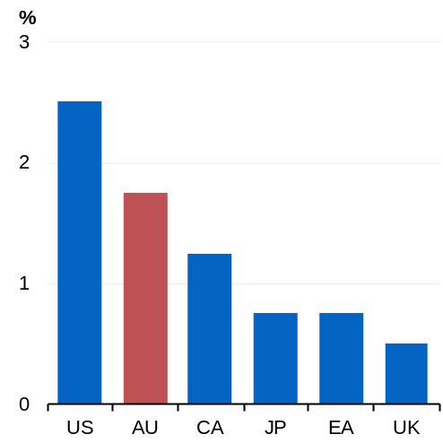 | 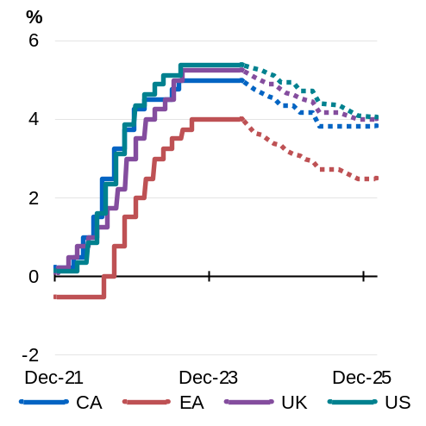
Source: Treasury.  Notes: US is United States. AU is Australia. CA is Canada. JP is Japan. EA is euro area. UK is United Kingdom. | Source: Bloomberg.  Notes: United States based on the midpoint of the target range for the Fed funds rate.  Dotted lines reflect policy rate expectations implied by overnight indexed swaps (7 May 2024).

Outlook for global inflation
Inflation in advanced economies has declined significantly since peaking in mid-to-late 2022 (Chart 2.4). Nonetheless, inflation generally remains elevated and is not expected to return to central bank targets until 2025 (Chart 2.5).
The rapid increase in goods and energy prices associated with earlier supply and demand shocks, including the pandemic and Russia’s invasion of Ukraine, have largely dissipated. With the disinflation in goods and energy prices having mostly run its course, services inflation remains the main driver of above-target inflation.
Strong rental inflation, solid nominal wages growth, and the continued pass-through of earlier increases in other input costs, have contributed to persistent services inflation in many advanced economies.
To date, the decline in inflation in advanced economies has not been associated with a significant increase in unemployment, which is consistent with a soft landing. Nonetheless, wage growth has begun to moderate and medium-term inflation expectations have generally remained well anchored around central bank inflation targets, mitigating the risk of a wage-price spiral.
In contrast to most advanced economies, China has experienced a period of low inflation amid weakness in domestic demand and deleveraging by developers in the property sector.
Chart 2.4: Headline inflation | Chart 2.5: Deviation of inflation from central bank targets
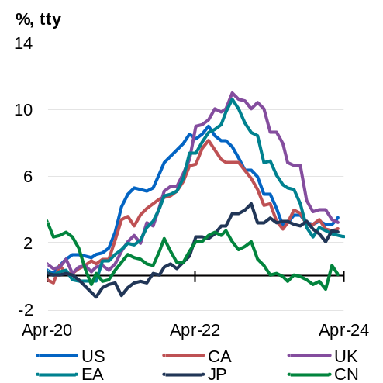 | 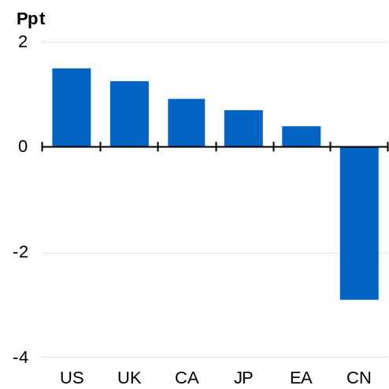
Source: National statistical agencies and Refinitiv.  Note: JP is Japan. US is United States. CA is Canada. EA is euro area. UK is United Kingdom. CN is China. | Source: National statistical agencies and Refinitiv.  Notes: Inflation target reflects mid-point of target range for Canada. US is United States. UK is United Kingdom. CA is Canada. JP is Japan. EA is euro area. CN is China.

Key risks to the international outlook
The global outlook remains complex and uncertain. Heightened geopolitical tensions in the Middle East have added to the risks associated with Russia’s invasion of Ukraine. A further escalation in geopolitical tensions remains a key risk to inflation and global growth, with the potential to disrupt energy and commodity markets and increase shipping costs by compromising traditional trade routes.
Elevated geopolitical risks have been reflected in asset markets during 2024. The price of gold increased sharply to all-time highs supported by safe-haven demand (Chart 2.6), and oil prices firmed to six-month highs in mid-April in response to the escalation of tensions between Iran and Israel (Chart 2.7).
Chart 2.6: Gold spot price | Chart 2.7: Tapis oil spot price
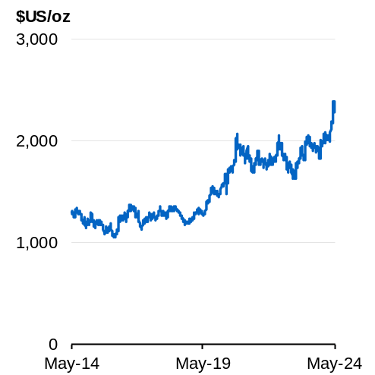 | 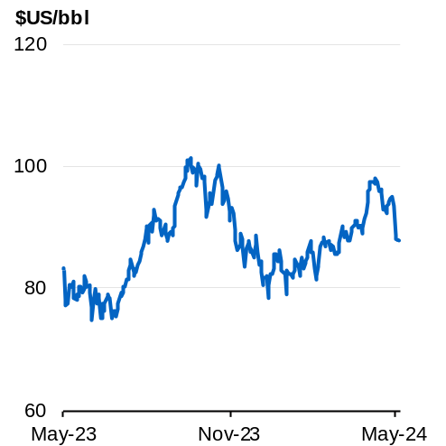
Source: Bloomberg. | Source: Bloomberg.

The evolution of global inflation and associated implications for the timing of monetary policy easing remain a key risk to the outlook. If inflation proves to be more persistent than expected, monetary policy settings may need to remain restrictive for longer. There may also be implications for financial stability. For example, in the United States, a prolonged period of high interest rates could generate additional stress in the commercial real estate sector.
Developments in China also present significant risks to global demand, particularly for key trading partners including Australia. Sharper or more persistent weakness in Chinese domestic demand associated with deleveraging in the residential property sector represents a downside risk to growth, particularly if it leads to more acute pressures in the Chinese financial system that adversely affects the balance sheets of households and local governments. In the near term, stronger-than-expected fiscal policy expansion would present an upside risk to Chinese growth.
Some governments, particularly in Europe, will be under pressure to repair public finances given the considerable expansion in debt and deficits to support growth during the pandemic and, more recently, to ease cost-of-living pressures. Fiscal consolidation may prove difficult due to a deterioration in the outlook for fiscal revenues in some economies, presenting longer-term challenges. At the same time, if consolidation is too rapid, it could disrupt growth.

Outlook for major trading partners
China’s economy is forecast to grow by 4¾ per cent in 2024, broadly in line with the Chinese government’s target of around 5 per cent, and then slow to 4¼ per cent in 2025 and 2026. If realised, this will be the slowest period of economic growth since the Chinese economy began opening up in the late 1970s.
In 2023, the Chinese economy grew by 5.2 per cent as investment in infrastructure and manufacturing offset weakness in residential property investment and consumer spending. Further adjustment in the residential property sector is expected to remain a drag on growth. Falling prices and financial stress in the residential construction sector will continue to weigh on consumer confidence and spending. Local governments also have limited capacity to support growth as finances are strained due to a reliance on property sales for revenue.
The Chinese economy faces increasing structural challenges from slowing urbanisation, an ageing population and lower productivity growth. Authorities are attempting to address these structural challenges by supporting new industries, such as electric vehicles and green energy, while pivoting away from traditional growth drivers, such as property.
The United States is forecast to grow by 2½ per cent in 2024, 1½ per cent in 2025 and 2 per cent in 2026. The US recorded stronger-than-expected growth through 2023, while inflation moderated largely as expected. This reflected buoyant demand and an expansion in supply capacity, given strong employment growth and a rebound in productivity.
Positive momentum in household consumption and business investment has carried over into 2024. Strong employment growth and a lift in real wages have supported consumption growth. Business investment has been boosted by government stimulus and tax incentives, including for investment in renewable energy. The impact of monetary policy tightening on growth has been more muted than expected. Stronger activity in 2023 and 2024 has pushed out the expected timing and quantum of monetary policy easing.
Growth is expected to slow somewhat in the second half of 2024 and into 2025 as an easing in the labour market, diminished household savings buffers that accumulated during the pandemic and less accommodative fiscal policy weigh on activity.
Monetary policy easing in the United States is assumed to commence towards the end of 2024 as inflation returns towards the Federal Reserve’s target. Market pricing implies a slower pace of easing than was expected earlier in the year as progress towards the Federal Reserve’s inflation target has slowed. Monetary policy easing from later this year would support a modest cyclical upswing towards the end of 2025.
Euro area GDP is forecast to grow by ¾ per cent in 2024, 1½ per cent in 2025 and 1½ per cent in 2026. The euro area economy experienced a mild recession in the second half of 2023 and its largest economy, Germany, contracted in 2023. Euro area manufacturers suffered a loss of market share due to sharp increases in energy costs and increased competition from China, particularly in emerging industries such as electric vehicle manufacturing.
Euro area growth is expected to pick up during 2024. Declining inflation is expected to support a recovery in real disposable income growth and household consumption across the region. The European Central Bank is also expected to begin easing monetary policy from mid-2024, which will provide further support for growth into 2025. Fiscal policy across the euro area will, however, drag on growth in 2024 and 2025 as fiscal support to cushion the impact of high energy costs is withdrawn and some member states reduce their deficits to conform with EU fiscal rules.
The United Kingdom is forecast to grow by ½ per cent in 2024, 1¼ per cent in 2025 and 1½ per cent in 2026. The United Kingdom entered a technical recession during the second half of 2023 due to high energy costs, cost-of-living pressures, restrictive monetary policy, and a decline in exports exacerbated by continued EU trade frictions following Brexit. Real income growth driven by moderating inflation will support a recovery in consumption growth across the forecast period, with monetary policy easing also expected to be a tailwind.
Japan is forecast to grow by ¾ per cent in 2024 and 1 per cent in 2025 and 2026. Japan recorded solid growth in the first half of 2023 supported by strong inbound tourism and the resolution of supply chain disruptions in the auto industry. However, growth slowed in the second half of the year as falling real wages weighed on consumption growth.
Recent wage negotiations imply a marked lift in the pace of nominal wages growth in 2024, which is expected to support real wages growth as inflation moderates. This, alongside households’ access to savings accumulated during the pandemic, is expected to support a mild rebound in consumption growth. High corporate profits and the strengthening of supply chains are also expected to support business investment in the near term.
The Bank of Japan began withdrawing extraordinary monetary policy stimulus in March 2024 and is expected to gradually normalise its policy stance. Nonetheless, monetary policy is likely to remain accommodative for some time.
India is forecast to grow by 6½ per cent in 2024, 2025 and 2026. Growth in India was stronger than expected in 2023 and was driven by public investment in transport and energy infrastructure. India is expected to remain one of the world’s fastest growing major economies over the next two years. Public investment is expected to remain a key source of growth though it will be dampened by expected fiscal consolidation. Restrictive monetary policy is expected to weigh somewhat on consumption and private investment growth in the near term.
Other East Asia is forecast to grow by 4 per cent in 2024 and 2025 and 4¼ per cent in 2026. Growth in the region is expected to be supported by rising domestic demand, an upturn in exports of goods and services, and continued recovery in the tourism sector. Foreign direct investment inflows are also expected to remain strong as multinationals continue to diversify their manufacturing supply chains.

Outlook for the domestic economy
The Australian economy has slowed in response to elevated inflation and higher interest rates here and the impact of global economic volatility. These factors have put people under pressure, weighing on consumption growth and dwelling investment (Chart 2.8). However, the economy is well placed to face these global and domestic economic challenges, with moderating inflation, a resilient labour market, a return to annual real wage growth and strong business investment.
Household consumption was flat over the past year, as people have responded to cost-of-living pressure by pulling back on discretionary spending to make room for essentials. Higher interest rates and elevated construction costs are weighing on the demand for new housing, with dwelling investment expected to contract further in
2023–24.
Although inflation remains elevated, it has moderated substantially and is now less than half of its peak in 2022. The moderation in inflation has occurred more quickly than forecast at MYEFO, with inflation now expected to be lower in 2023–24.
While there remains considerable uncertainty around the outlook for the domestic and global economy, the Government’s targeted cost-of-living measures are expected to reduce inflation. Energy bill relief and Commonwealth Rent Assistance is expected to directly reduce inflation by ½ of a percentage point in 2024–25 and is not expected to add to broader inflationary pressures (see Box 2.2). This could see headline inflation return to the target band by the end of 2024, slightly earlier than expected at MYEFO. This will ease pressure on households and help to keep inflation expectations well anchored.
The labour market has been resilient, with faster employment growth than any major advanced economy, near historically low unemployment, and the participation rate near its record high. However, conditions in the labour market are softening and are expected to ease further over 2024–25. The unemployment rate is expected to remain low by historical standards but rise gradually to 4½ per cent by the June quarter 2025.
Nominal wages are growing at 4.2 per cent, their fastest annual rate in nearly 15 years. This has been driven by recent strength in the labour market and administered wage decisions. As labour market conditions ease, annual wage growth is expected to decline to 3¼ per cent in 2024–25 and 2025–26. Moderating inflation and a pick-up in wage growth resulted in a return to positive annual real wage growth at the end of 2023. Real wages are expected to rise by ½ per cent through the year to the June quarter 2024.
Business investment has withstood the global and domestic pressures and grew strongly at 8.3 per cent last year. The upswing in business investment is expected to continue through to 2025–26 and, if realised, will be the longest sustained increase in business investment since the mining boom.
Growth is expected to remain subdued over the forecast period. Real GDP is forecast to grow by 2 per cent in 2024–25, and 2¼ per cent in 2025–26 (Chart 2.9). Higher wages growth, the forecast moderation in inflation, continuing employment growth and the Government’s cost‑of‑living tax cuts should support real household disposable incomes and a recovery in household consumption. The cash rate is assumed to gradually ease from around the middle of 2025 to reach 3.6 per cent by the middle of 2026.
Recent strength in business investment, net exports and public investment is expected to continue and provide further support for the economy. Net exports are expected to contribute to growth in 2024–25 driven by the ongoing recovery of services exports. Public final demand is expected to support activity, driven by a record infrastructure investment pipeline and the Australian and state governments’ strengthening essential government services.
There are substantial risks to the domestic outlook. Inflation could prove more persistent than forecast, with possible implications for policy settings and growth. If productivity does not pick up as expected, price pressures may be more persistent, with potential implications for unemployment and the real economy. There is also significant uncertainty about how quickly aggregate household consumption will respond to the expected recovery in real disposable incomes.
Internationally, there remains a risk that current geopolitical tensions could escalate into larger economic shocks that could derail the global recovery, with implications for Australian exports and supply chains. If downside risks to Chinese growth crystalise, this could directly impact the domestic economy through weaker commodity prices and lower national income. In the medium term, this could also impact activity through weaker mining investment and resources exports.
Chart 2.8 Contribution to GDP growth | Chart 2.9: Real GDP growth
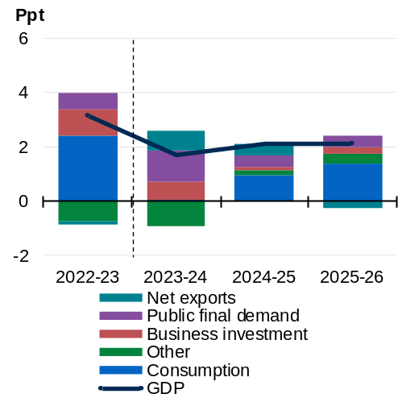 | 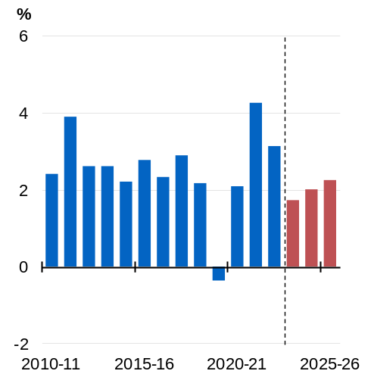
Source: ABS Australian National Accounts: National Income, Expenditure and Product and Treasury.  Note: Other includes dwelling investment, change in inventories, ownership transfer costs and the statistical discrepancy. Data are seasonally adjusted. | Source: ABS Australian National Accounts: National Income, Expenditure and Product and Treasury.

Table 2.2: Domestic economy – detailed forecasts^{(a)}
 | Outcomes | Forecasts
 | 2022-23 | 2023-24 | 2024-25 | 2025-26
Real gross domestic product | 3.1 | 1 3/4 | 2 | 2 1/4
Household consumption | 5.0 | 1/4 | 2 | 2 3/4
Dwelling investment | -3.8 | -3 | 0 | 6 1/2
Total business investment^{(b)} | 8.3 | 5 1/2 | 1 | 2
By industry
Mining investment | 1.7 | 4 1/2 | -3 1/2 | 2
Non-mining investment | 10.5 | 5 1/2 | 2 1/2 | 2
Private final demand^{(b)} | 4.2 | 1 | 1 3/4 | 3
Public final demand^{(b)} | 2.4 | 4 1/2 | 1 1/2 | 1 1/2
Change in inventories^{(c)} | -0.1 | - 1/2 | 1/4 | 0
Gross national expenditure | 3.5 | 1 1/4 | 1 3/4 | 2 1/2
Exports of goods and services | 6.7 | 5 | 5 | 2 1/2
Imports of goods and services | 9.3 | 2 1/2 | 4 | 4 1/2
Net exports^{(c)} | -0.1 | 3/4 | 1/2 | - 1/4
Nominal gross domestic product | 9.9 | 4 3/4 | 2 3/4 | 4
Prices and wages
Consumer price index^{(d)} | 6.0 | 3 1/2 | 2 3/4 | 2 3/4
Wage price index^{(d)} | 3.7 | 4 | 3 1/4 | 3 1/4
GDP deflator | 6.5 | 3 | 1/2 | 1 3/4
Labour market
Participation rate (per cent)^{(e)} | 66.6 | 66 1/2 | 66 1/2 | 66 1/4
Employment^{(d)} | 3.5 | 2 1/4 | 3/4 | 1 1/4
Unemployment rate (per cent)^{(e)} | 3.6 | 4 | 4 1/2 | 4 1/2
Balance of payments
Terms of trade^{(f)} | -0.5 | -3 3/4 | -7 3/4 | -4
Current account balance (per cent of GDP) | 1.1 | 1 1/4 | - 3/4 | -2
Net overseas migration^{(g)} | 528,000 | 395,000 | 260,000 | 255,000
- Percentage change on preceding year unless otherwise indicated.
- Excluding second-hand asset sales between the public and private sector.
- Percentage point contribution to growth in GDP.
- Through-the-year growth rate to the June quarter.
- Seasonally adjusted rate for the June quarter.
- Key commodity prices are assumed to decline from elevated levels over four quarters to the end of the March quarter of 2025: the iron ore spot price is assumed to decline to US$60/tonne; the metallurgical coal spot price declines to US$140/tonne; the thermal coal spot price declines to US$70/tonne; and the LNG spot price converges to US$10/mmBtu. All bulk prices are in free on board (FOB) terms.
- Net overseas migration is forecast to be 235,000 in 2026–27 and 2027–28.
Note: The forecasts for the domestic economy are based on several technical assumptions. The exchange rate is assumed to remain around its recent average level – a trade‑weighted index of around 62 and a $US exchange rate of around 65 US cents. Interest rates are informed by the Bloomberg survey of market economists. World oil prices (Malaysian Tapis) are assumed to remain flat around US$94 per barrel.
Source: ABS Australian National Accounts: National Income, Expenditure and Product; Balance of Payments and International Investment Position, Australia; National state and territory population; Labour Force Survey, Australia; Wage Price Index, Australia; Consumer Price Index, Australia; unpublished ABS data and Treasury.

Household consumption
Households have pulled back sharply on consumer spending in response to sustained cost-of-living pressures and higher interest rates (Chart 2.10). However, higher wages growth, the forecast moderation in inflation, continuing employment growth and the Government’s cost‑of‑living tax cuts are expected to support real household disposable incomes and household consumption from the second half of 2024 (see Box 2.1).
Household consumption was broadly flat over 2023. With subdued growth in real household disposable income, consumption is expected to remain weak in the first half of 2024 (Chart 2.11). A recovery in real disposable income growth is then expected to support household consumption, which is forecast to grow by 2 per cent in 2024–25 and 2¾ per cent in 2025–26.
There remains significant uncertainty around the responsiveness of household consumption to evolving economic conditions. While aggregate real household disposable income is expected to pick up in 2024–25, households will still face tight budgets and may look to replenish savings as their real incomes increase. A faster-than-anticipated softening in labour market conditions could also temper the recovery in consumption.
Chart 2.10: Contribution to consumption growth | Chart 2.11 Growth in consumption
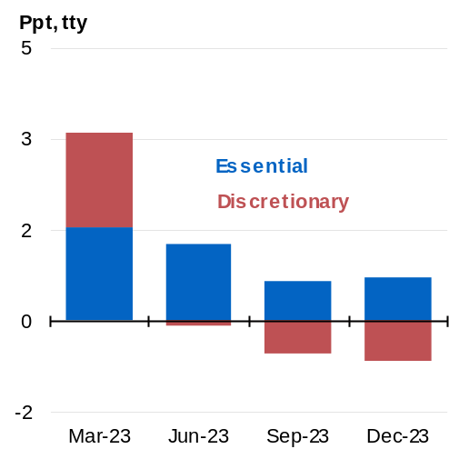 | 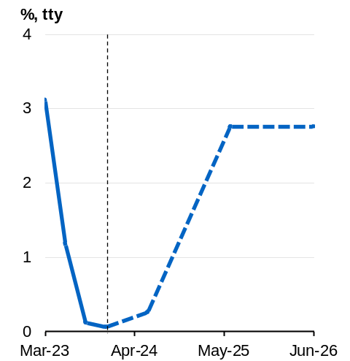
Source: ABS Australian National Accounts: National Income, Expenditure and Product and Treasury. | Source: ABS Australian National Accounts: National Income, Expenditure and Product and Treasury.

Box 2.1: Recovery in real household disposable income
Real disposable income is forecast to grow by 3½ per cent in 2024–25 (Chart 1). This is expected to be driven by a 4½ percentage point contribution from growth in labour incomes and a 1 percentage point contribution from the Government’s cost-of-living tax cuts. Inflation is expected to be a smaller drag on real incomes compared to recent years. If realised, this would be the fastest rate in over a decade (excluding the pandemic).
Australia’s resilient labour market and historically low unemployment rate means more Australians have jobs. Employment in Australia grew faster than in any major advanced economy over the past year, with more Australians now securing meaningful work. Employment is expected to continue to grow next year, even as the labour market softens in response to weaker growth. Nominal wages are now growing at their fastest rate in nearly 15 years. This is due to strength in the labour market and the Fair Work Commission’s wage determinations, which the Government supported. Continued growth in wages will contribute to the improvement in household disposable incomes over the coming year.
The Government’s cost-of-living tax cuts will ensure households keep a greater proportion of their incomes to help navigate cost-of-living pressures. Compared to previously legislated settings, 11.5 million taxpayers will receive a larger tax cut. The Government’s tax cuts deliver a permanent reduction in tax for all taxpayers, with an average tax cut of $1,888 in 2024–25 compared to 2023–24 settings.
In addition, the continued moderation of inflation and the Government’s responsible cost-of-living policies will strengthen the purchasing power of households.
continued over next page
Box 2.1: Recovery in real household disposable income (continued)
Chart 1: Contribution to real household gross disposable income growth
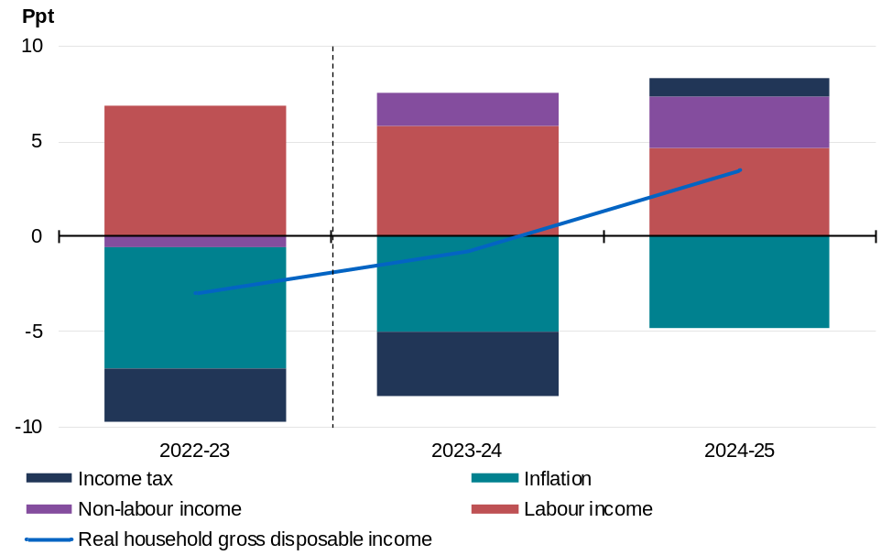
Source: ABS Australian National Accounts: National Income, Expenditure and Product and Treasury.

Dwelling investment
Higher interest rates and elevated construction costs are weighing on the demand for new housing (Chart 2.12). These factors are expected to cause dwelling investment to contract by 3 per cent in 2023–24 and remain flat in 2024–25. Alongside an improvement in household finances and asset returns, growth in new dwelling investment is expected to increase to 6½ per cent in 2025–26 (Chart 2.13).
Government initiatives to increase housing supply will help to support an increase in the stock of dwellings. The Government’s $32 billion housing plan will deliver the biggest investment in social housing in over a decade, enable construction of more homes, reduce red tape and planning hurdles, train the necessary workforce, and support Australians into home ownership and those in the rental market. These initiatives will help support the shared Australian and state governments’ ambition to deliver 1.2 million new homes over the next five years.
Chart 2.12: Private sector residential building approvals | Chart 2.13: Dwelling investment
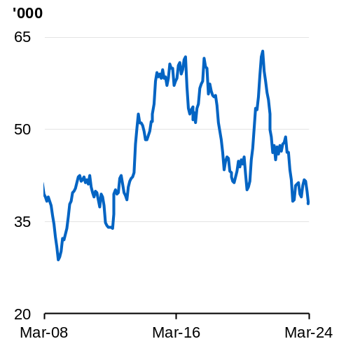 | 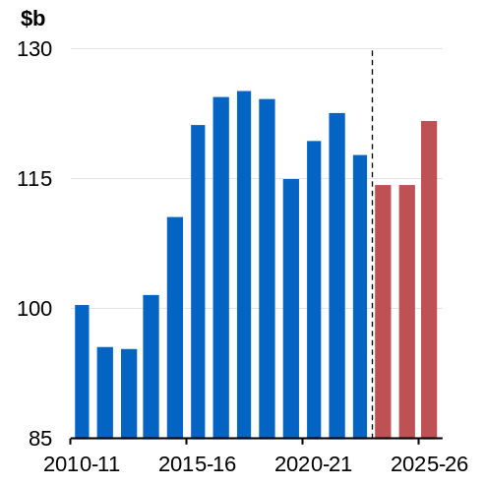
Source: ABS Building Approvals and Treasury.  Note: 3-month rolling average. | Source: ABS Australian National Accounts: National Income, Expenditure and Product and Treasury.

Business investment
Recent growth in business investment has been underpinned by strong business balance sheets, elevated capacity utilisation, and resilient business sentiment. The upswing is expected to continue through to 2025–26 and, if realised, would be the longest sustained increase in business investment since the mining boom (Chart 2.14).
The positive outlook for business investment is reflected in the strength of recent outcomes as well as forward-looking capital expenditure intentions (Chart 2.15). High levels of capacity utilisation and the desire to drive cost efficiencies has, to date, offset the impact of global uncertainty and the drag from the slowdown in household demand. A large pipeline of non-dwelling construction projects should underpin near-term growth with business investment forecast to grow by 5½ per cent in 2023–24.
Business investment is expected to remain at high levels, with growth expected to be 1 per cent in 2024–25 and 2 per cent in 2025–26, as the pipeline of non-dwelling construction projects is worked through. Moderating domestic demand is expected to see investment in machinery and equipment ease, albeit from elevated levels.
At the sectoral level, non-mining investment is expected to be the main driver of growth in business investment over the coming years. Non-mining investment is forecast to increase by 5½ per cent in 2023–24, 2½ per cent in 2024–25 and 2 per cent in 2025–26. Continued expenditure on non-dwelling construction projects is driving growth throughout the profile, with investments focussed on renewable energy infrastructure, data centres and warehouses.
The outlook for mining investment primarily reflects expenditure to maintain existing resource production capacity along with a modest number of new LNG and metal ore projects. Mining investment is expected to grow by 4½ per cent in 2023–24, before falling by 3½ per cent in 2024–25 as large projects are worked through. In 2025–26, growth in mining investment is expected to pick up to 2 per cent.
Chart 2.14: Business investment by component | Chart 2.15: Capital expenditure expectations (CAPEX) by sector (nominal)
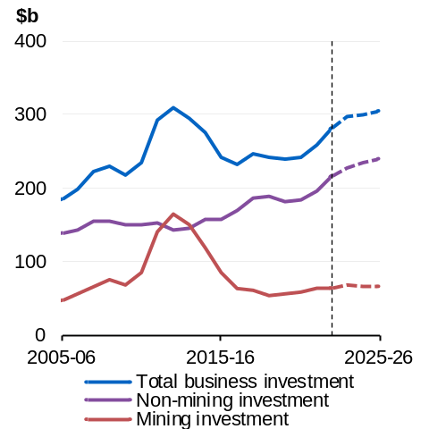 | 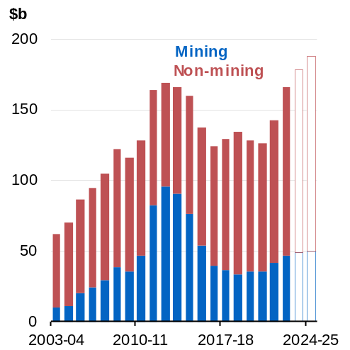
Source: ABS Australian National Accounts: National Income, Expenditure and Product and Treasury. | Source: ABS Private New Capital Expenditure and Expected Expenditure and Treasury.  Note: Last two columns denote new capital expenditure expectations adjusted using long-run average realisation ratios for 2023‍–‍24 and 2024–25.

Public final demand
Public final demand is forecast to rise by 4½ per cent in 2023–24, before slowing to 1½ per cent in 2024–25 and 2025–26 (Chart 2.16). Government expenditure on goods and services is expected to continue to grow, which reflects, in part, an increase in public health spending by all levels of government.
A large pipeline of public infrastructure projects at the state and federal level is expected to support public investment (Chart 2.17). As capacity constraints ease, this will allow the pipeline of projects, including on energy, water and transport infrastructure, to be worked through and support growth.
Chart 2.16: Annual growth in public final demand by component | Chart 2.17: Public sector construction pipeline
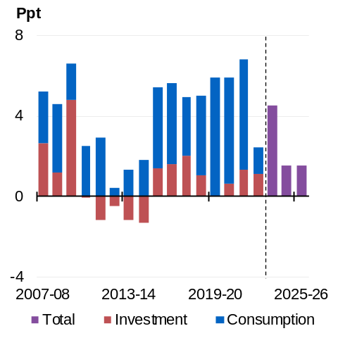 | 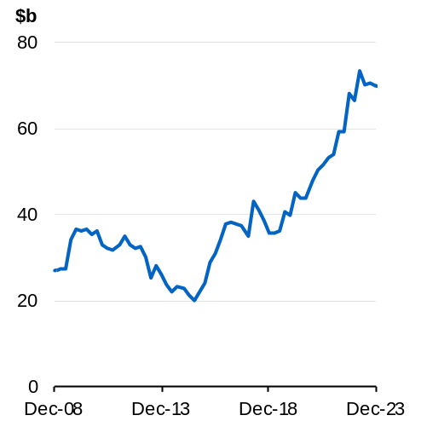
Source: ABS National Accounts: National Income, Expenditure and Product and Treasury. | Source: ABS Building Activity, Engineering Construction Activity and National Accounts: National Income, Expenditure and Product.  Note: Nominal pipeline of public infrastructure work is deflated by non-dwelling construction prices.

Net exports
Net exports are expected to add ¾ of a percentage point to GDP growth in 2023–24 and ½ of a percentage point in 2024–25 (Chart 2.18). This is largely the result of the ongoing rebound in services exports following the pandemic. In 2025–26, net exports are expected to subtract ¼ of a percentage point from GDP growth. This is largely due to the anticipated moderation in mining exports and increase in goods imports, which reflects the forecast upswing in household consumption and strong business investment.
Exports are forecast to grow by 5 per cent in both 2023–24 and 2024–25 (Chart 2.19). This reflects the expected ongoing recovery in tourism and international education exports following the prolonged period of international border closures during the pandemic. A recovery in mining exports from weather and supply disruptions is also forecast to support export growth. Export growth is then expected to slow to 2½ per cent in 2025–26, which is consistent with moderating growth in mining and services exports.
Imports growth is forecast to moderate to 2½ per cent in 2023–24, reflecting weaker domestic demand for goods imports and an expected moderation in service imports growth with Australians prioritising closer and less expensive holiday destinations amid cost-of-living pressures. Growth in imports is expected to pick up to 4 per cent in 2024–25 and then 4½ per cent in 2025–26, as domestic demand improves.
Chart 2.18: Net export contribution to GDP growth | Chart 2.19: Contribution to exports growth
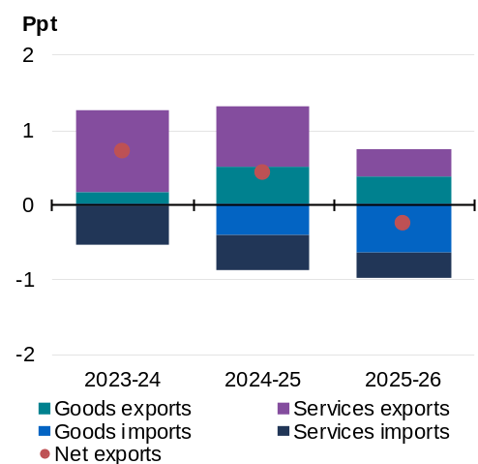 | 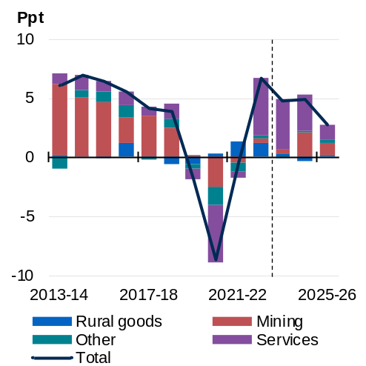
Source: ABS Balance of Payments and International Investment Position, ABS Australian National Accounts: National Income, Expenditure and Product and Treasury. | Source: ABS Balance of Payments and International Investment Position and Treasury.  Note: ‘Other’ includes exports of non-commodity goods and additive differences due to rebasing of volume change measures.

Inflation
Although inflation remains elevated, it has moderated substantially and is now less than half of its peak in 2022. The moderation in inflation has occurred more quickly than forecast at MYEFO. Inflation is expected to be 3½ per cent through the year to the June quarter 2024, ¼ of a percentage point lower than previously forecast. This moderation in inflation has been assisted by a continued easing of goods inflation – and the Government’s cost-of-living policies.
While there remains considerable uncertainty around the outlook for the domestic and global economy, the Government’s responsible cost-of-living measures could see headline inflation return to the target band by the end of 2024, slightly earlier than expected at MYEFO (Chart 2.20). This will ease pressure on households and help to keep inflation expectations well-anchored.
Annual headline inflation moderated to 3.6 per cent in the March quarter 2024, well below its peak of 7.8 per cent (Chart 2.21). The Energy Price Relief Plan and increases to Commonwealth Rent Assistance are estimated to reduce measured inflation in 2023–24 by ¾ of a percentage point. The extension of the Energy Bill Relief Fund (EBRF) and the further increase in Commonwealth Rent Assistance payments announced in this Budget are expected to directly reduce headline inflation by ½ a percentage point in 2024–25 (see Box 2.2).
The peak in services inflation lagged that of goods inflation. Services inflation remains elevated, driven by the increased cost of business inputs. However, services inflation is expected to gradually normalise over the next two years.
Rental market conditions remain very tight, with national vacancy rates persisting at near record lows. National advertised rents grew at over 8 per cent in the year to April 2024. Growth in rental costs is expected to remain elevated as increases in advertised rents flow through with the renewal of existing leases. Over the forecast horizon, rental pressures are expected to gradually ease. The demand for rental accommodation has increased sharply, owing to the reopening of international borders and strong nominal income growth. On the supply side, high interest rates and elevated costs of construction are weighing on activity, limiting the pace at which housing supply catches up to demand.
While inflation expectations over the medium-term have remained well-anchored, there are several risks to the inflation outlook. While productivity has grown for two consecutive quarters, the extent to which productivity growth will recover remains uncertain. A slower recovery in productivity growth could have implications for both inflation and growth. Any further escalation of current geopolitical tensions also present risks to the outlook.
Chart 2.20: Headline inflation | Chart 2.21: Inflation decomposition
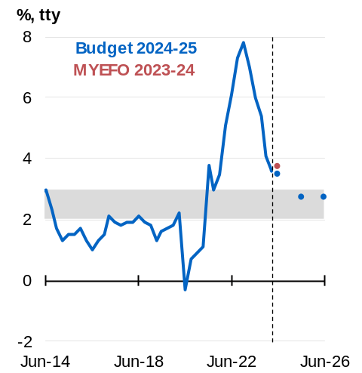 | 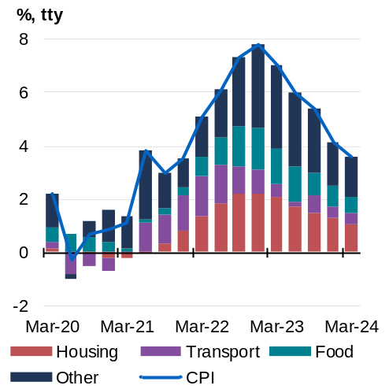
Source: ABS Consumer Price Index and Treasury.  Note: Grey shading denotes the RBA target band.  Forecasts are June quarter through-the-year inflation rates. | Source: ABS Consumer Price Index and Treasury.  Note: Contributions are approximations as they are back cast prior to the December quarter 2023 using the 2023 CPI expenditure weights, and use rounded analytical series contributions.

Box 2.2: The impact of cost-of-living relief on inflation
The Government’s cost-of-living policies are providing responsible relief to households and small businesses with cost-of-living pressures.
The Government’s existing Energy Price Relief Plan (EPRP), Cheaper Child Care and boost to Commonwealth Rent Assistance are directly easing cost-of-living pressures. These targeted polices are expected to take ¾ of a percentage point off inflation in 2023-24. New policies as part of the 2024–25 Budget will provide further cost-of-living relief for households. The Government’s energy bill relief will support all households with their energy bills.
The Government’s EPRP has shielded households from the worst effects of the extraordinary energy price rises in 2022–23 and 2023–24. The EPRP included temporary caps on wholesale coal and gas prices and up to $3 billion of targeted energy bill relief for households and small businesses, jointly funded by the Australian and state and territory governments. From the June quarter 2023 to the March quarter 2024, household energy bill relief directly reduced growth in CPI electricity prices by 12.9 percentage points (Chart 1).
As part of the October Budget 2022–23, the Government invested $4.6 billion to increase Child Care Subsidy rates to make early childhood education more affordable for eligible Australian families. In 2023, child care prices fell by 7.2 per cent; without increases to the child care subsidy, they would have risen by 13.0 per cent.
To alleviate rental pressures on low-income renters, the Government increased the maximum rates of Commonwealth Rent Assistance by 15 per cent at the 2023–24 Budget. This has reduced CPI Rents growth by 1.7 percentage points through the year to the March quarter 2024.
As households continue to face significant cost-of living- pressures, the Government has expanded electricity bill relief to all households and provided further increases to maximum Commonwealth Rent Assistance rates as part of Budget 2024–25. These two policies are estimated to directly reduce headline inflation by around ½ a percentage point in 2024–25 and are not expected to add to broader inflationary pressures in the economy.
Further cost-of-living relief is being delivered through a suite of other policy changes as part of Budget 2024–25. The Government’s decision to redesign tax relief through its cost-of-living tax cuts will provide relief to all 13.6 million taxpayers and will not impact the inflation outlook.
continued over next page
Box 2.2: The impact of cost-of-living relief on inflation (continued)
Chart 1: Impact of Energy Bill Relief Fund (EBRF) on electricity prices in the CPI
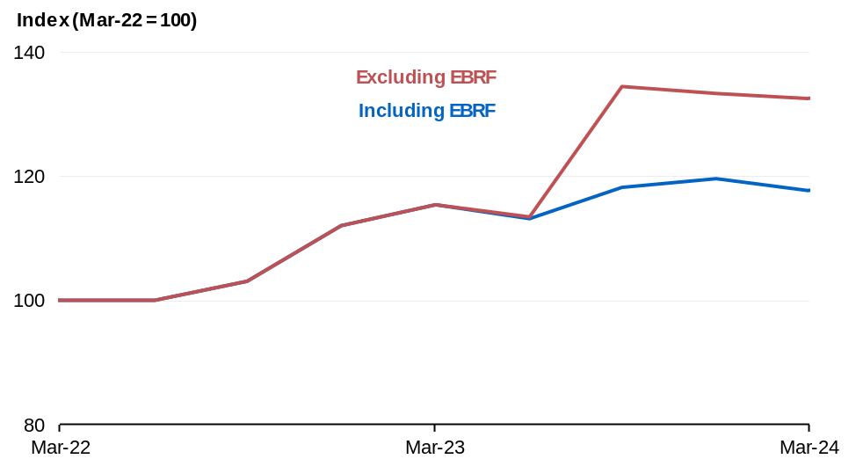
Source: ABS Consumer Price Index and Treasury.
Note: All rebates in this period can be attributed to the EBRF except an additional $50 rebate for ACT concession households in July 2023. The ACT rebate is also included in the ‘including EBRF’ line above.

The labour market
The labour market has so far proven to be highly resilient. The unemployment rate remains low by historical standards, employment growth has been strong, and the participation rate is near record highs (Charts 2.22 and 2.23). The strength in the labour market reflects strong business balance sheets and the expansion of more labour-intensive sectors of the economy.
Despite this resilience, conditions in the labour market have begun to gradually ease and this is expected to continue over the coming year. To date, the moderation in the labour market has mainly occurred through a reduction in average hours.
Employment is forecast to continue to grow, albeit at a more modest pace and by less than the growth in the size of the labour force. Leading indicators of employment growth, such as job advertisements and vacancies, have consistently declined from record highs in mid-2022. This is expected to lead to a gradual rise in the unemployment rate, which is forecast to be 4½ per cent in the June quarter 2025. The participation rate is expected to decline modestly as easing labour market conditions discourage some workers from participating in the labour force. Even as labour market conditions ease, the unemployment rate will remain low by historical standards and is forecast to remain below the pre-pandemic decade average of 5.5 per cent.
Chart 2.22: Unemployment and underemployment rate | Chart 2.23: Employment growth
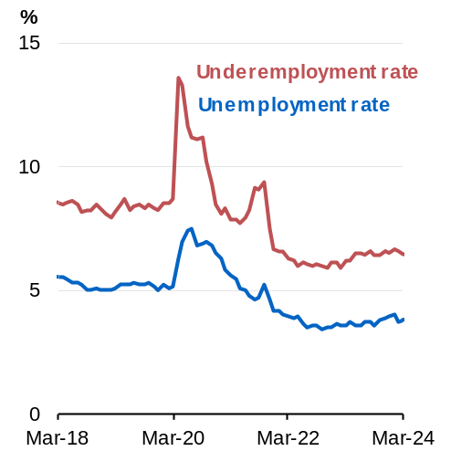 | 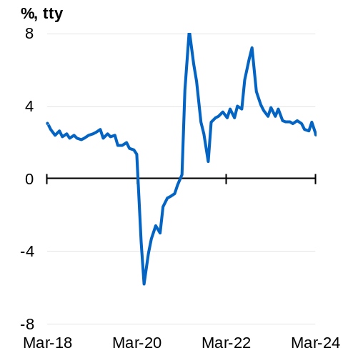
Source: ABS Labour Force Survey. | Source: ABS Labour Force Survey.

Nominal wages have picked up and are growing at their fastest rate in nearly 15 years. Nominal wages, as measured by the Wage Price Index (WPI), grew by 4.2 per cent through the year to the December quarter 2023 (Chart 2.24). Wages are expected to grow by 4 per cent through the year to the June quarter 2024. There are no signs of a wage-price spiral developing and medium-term inflation expectations are well anchored.
The pick-up in wages has been broad-based across both the private and public sectors. The improvement in wage outcomes was initially driven by private sector wages. Administered wage decisions have supported the pick-up in private-sector wage growth, particularly the Fair Work Commission’s determinations on the minimum wage and the Aged Care Work Value Case. More recently, public sector wage outcomes have made a material contribution to wage growth. In both the public and private sector, multi-year enterprise agreements typically respond to higher inflation with a lag and, therefore, are expected to continue to support wages growth over coming years.
Administered wage decisions are expected to continue to support wage growth in the near term. The Government has recommended that the real wages of Australia’s low-paid workers do not go backwards in its submission to the Fair Work Commission’s Annual Wage Review. As a technical assumption, Treasury has assumed that the forthcoming Fair Work Commission determinations on both the Annual Wage Review and the aged care work value case are broadly consistent with the Government’s submissions.
Moving through 2024–25, wage growth is expected to decline as labour market conditions ease in line with aggregate demand. Growth in wages set by individual arrangements is moderating in line with the softening in labour market conditions. Nominal wage growth is expected to ease to 3¼ per cent through the year to the June quarter 2025.
The moderation in inflation and higher nominal wage outcomes lifted real wages through the latter half of 2023. Annual real wages returned to growth at the end of 2023, which was earlier than had previously been expected. Real wage growth is expected to rise to ½ per cent by the June quarter 2024 (Chart 2.25).
Chart 2.24: WPI growth by method of pay-setting | Chart 2.25: Real wage growth by income quintile
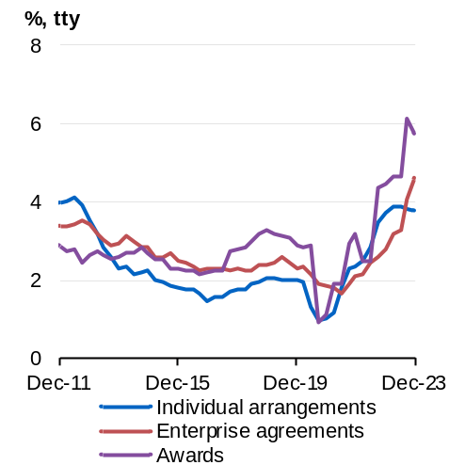 | 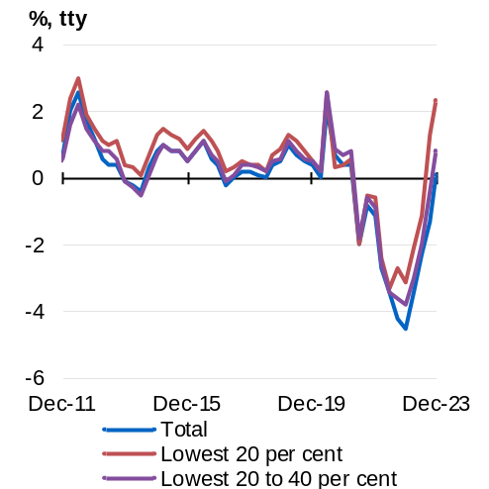
Source: ABS Wage Price Index. | Source: ABS Wage Price Index and Treasury.

Box 2.3: Labour market resilience and employment opportunities
Employment growth in Australia has been stronger than any major advanced economy over the past two years (Chart 1). Strong employment and strong growth in labour supply has translated into a pick-up in the employment-to-population ratio. The share of Australians who have a job is larger than in any major advanced economy (Chart 2). If the employment-to-population ratio was the same level as Canada, the most comparable major economy to Australia, around 600,000 fewer Australians would be employed.
The resilient Australian labour market has provided employment opportunities for a broad section of the community, including cohorts that have traditionally faced barriers to employment. Youth and female employment-to-population ratios reached record highs over the past two years, while their respective unemployment rates reached record lows. Job attachment for these workers will have enduring benefits and ensure employment is more inclusive, despite the expected moderate rise in unemployment.
Chart 1: Employment growth since May 2022 | Chart 2: Employment-to-population ratio
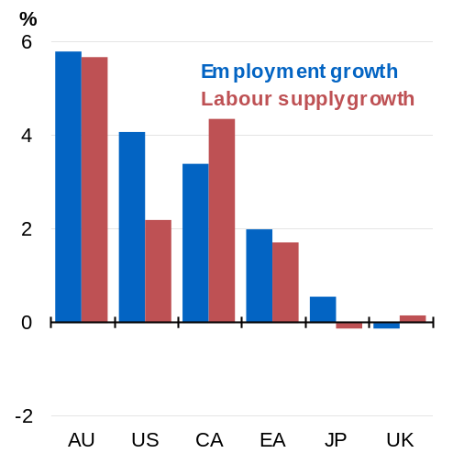 | 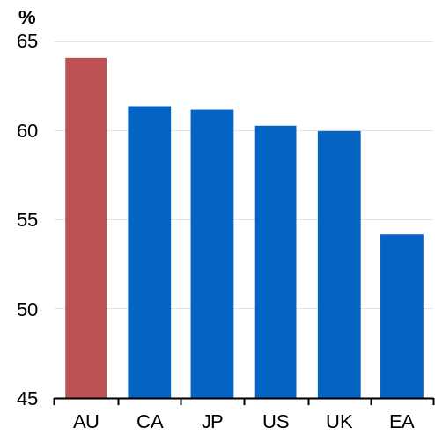
Sources: National statistical agencies, Refinitiv.  Note: Euro area data is since June 2022. US employment growth represents growth in non-farm payrolls. AU is Australia. CA is Canada. US is the United States. EA is euro area. JP is Japan. UK is the United Kingdom. | Source: National statistical agencies, Refinitiv.  Note: AU is Australia. CA is Canada. JP is Japan. US is the United States. UK is the United Kingdom. EA is euro area.

Outlook for the terms of trade
Australia’s terms of trade, the ratio of export to import prices, are forecast to decline by 15 per cent over the next three years. As the terms of trade are falling from a high level, they are expected to stabilise to around the average level of the past 15 years in 2025–26. The decline in the terms of trade primarily reflects the assumption that bulk commodity export prices will trend to their long-run fundamental levels. Commodity prices are assumed to reach their long-run anchors over four quarters by the end of March quarter 2025 (Table 2.2).
The outlook for the terms of trade is highly uncertain, reflecting potential volatility in commodity prices. Recent developments in the outlook for demand for steel in China and a modest improvement in iron ore and metallurgical coal supply has driven a sharp correction in iron ore and metallurgical coal prices. Box 2.4 presents scenarios outlining the sensitivity of nominal GDP and tax receipts to alternative bulk commodity price assumptions.
Box 2.4: Commodity prices
Commodity prices have remained volatile over the past two years. Further volatility in the prices of Australia’s bulk commodity exports remains a key source of uncertainty in the outlook for nominal GDP and Government tax receipts. This box explores the sensitivity of the outlook for nominal GDP and tax receipts to alternative near-term profiles for iron ore and metallurgical coal prices.
Iron ore and metallurgical coal prices have been elevated over the past two years due to strong demand from China and disruptions to supply both in Australia and globally. However, recent indications suggest that steel demand in China has likely peaked and a recovery in the supply of iron ore and metallurgical coal has put downward pressure on prices.
Chinese imports of iron ore reached record levels in 2023 in line with near-record steel production. This was due to strong demand from investment in infrastructure, expanding industrial capacity and exports, which offset weak demand from property investment. However, as property sector demand is expected to remain weak, with residential construction starts in China having fallen to their lowest level in over 15 years, steel production has likely passed its peak and is expected to ease in 2024 (Chart 1). Coinciding with the weak outlook for demand, global supply of iron ore has improved with a recovery in Brazilian supply in recent months (Chart 2).
continued over next page

Box 2.4: Commodity prices (continued)
Chart 1: China crude steel production and residential construction starts | Chart 2: China iron ore imports
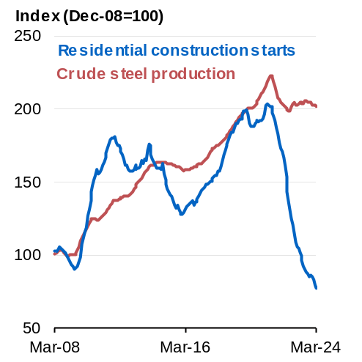 | 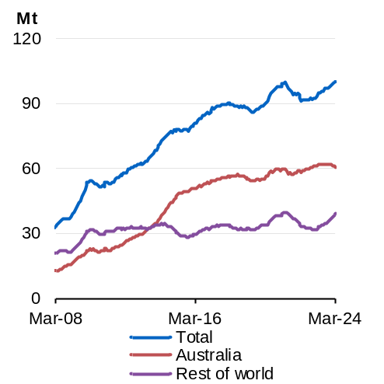
Source: National Bureau of Statistics, China; World Steel Association; Bloomberg; Refinitiv and Treasury.  Note: 12-month rolling average. | Source: General Administration of Customs, China; Bloomberg and Treasury.  Note: 12-month rolling average.

Two alternative price scenarios have been considered to assess the sensitivity of Budget forecasts to alternative profiles for iron ore and metallurgical coal prices (Charts 3 and 4).
- In the upside scenario, iron ore and metallurgical coal prices are assumed to stay at their recent averages until the end of the September quarter 2024, after which they glide to their long-run anchor prices by the end of March quarter 2025.
- In the downside scenario, iron ore and metallurgical coal prices fall to their long-run anchor prices by the end of the September quarter 2024.
Compared with the Budget forecasts, nominal GDP is higher by $16.5 billion in the upside scenario and lower by $18.1 billion in the downside scenario over the forward estimates (Table 1). The level of company tax receipts is $4.1 billion higher in the upside scenario and $4.5 billion lower in the downside scenario over the forward estimates.
continued over next page
Box 2.4: Commodity prices (continued)
Chart 3: Iron ore spot price | Chart 4: Metallurgical coal spot price
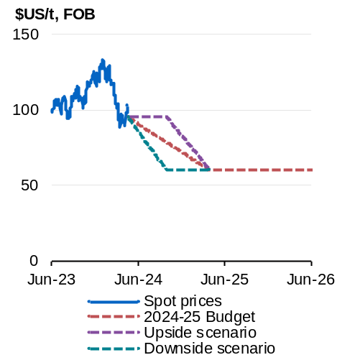 | 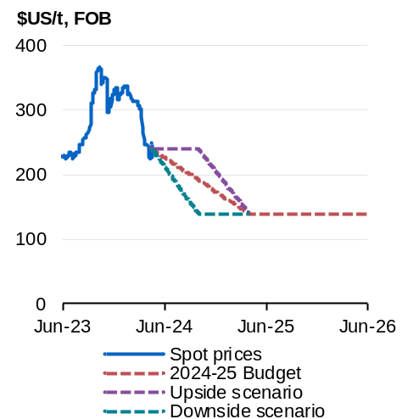
Source: Argus Media and Treasury.  Note: Iron ore – 62% Fe, FOB. | Source: Argus Media and Treasury.  Note: Metallurgical coal – premium-hard low-vol, FOB.
Note: Calculations made by Treasury are based on confidential proprietary data from Argus Media under licence. Argus Media shall not be liable for any loss or damage arising from any party’s reliance on, or use of, the data provided or the Treasury’s calculations.

Table 1 – Changes in nominal GDP and company tax receipts relative to Budget forecast
 | 2023-24 | 2024-25 | 2025-26 | 2026-27 | 2027-28 | Total
Upside scenario
Nominal GDP ($b) | 1.0 | 15.4 | 0.1 | 0.0 | 0.0 | 16.5
Company tax receipts ($b) | 0.1 | 2.2 | 1.9 | 0.0 | 0.0 | 4.1
Downside scenario
Nominal GDP ($b) | -1.1 | -16.9 | -0.1 | 0.0 | 0.0 | -18.1
Company tax receipts ($b) | -0.1 | -2.4 | -2.0 | 0.0 | 0.0 | -4.5
Note: Totals may not sum due to rounding.

Outlook for nominal GDP growth
Nominal GDP is expected to grow 4¾ per cent in 2023–24. This reflects underlying growth in economic output as well as strength in prices for domestic consumption and investment. Nominal GDP growth is then expected to slow to 2¾ per cent in 2024–25, as higher output growth and domestic inflation are offset by the fall in the terms of trade.

Medium-term projections
The fiscal aggregates are underpinned by economic forecasts over the forward estimates period and projections over the medium term (Chart 2.26).
Chart 2.26: Medium-term projection period
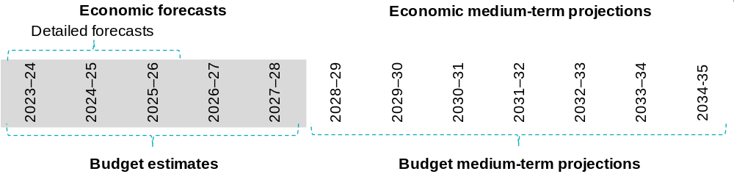
Source: Treasury

Treasury uses a macroeconometric model of the Australian economy for its forecasts and projections beyond the detailed forecast horizon of 2025–26. The model informs how the economy returns to its trend level of output, known as potential GDP, following short-term fluctuations of the business cycle.
Potential GDP is estimated based on an analysis of trends for population, productivity, and participation. Potential GDP growth is projected to average 2½ per cent per annum over the 2028–29 to 2034–35 projection period.
Both the population (aged over 15) and the trend participation rate have been revised up by ¼ of a percentage point by 2034–35. The updated estimates for population and its age structure are reflected in trend participation.
The upgrade in the size of the workforce has been offset by a lower estimated level of trend productivity in the near term. This reflects weak underlying productivity growth, which pre-dated COVID-19 pandemic related disruptions that are largely expected to unwind. In the long run, underlying productivity is assumed to grow at 1.2 per cent per annum. The unemployment rate settles at Treasury’s Non-Accelerating Inflation Rate of Unemployment (NAIRU) assumption of 4¼ per cent by the June quarter 2028 and remains at that rate over the medium-term projection period.
Domestic price growth converges over time to the midpoint of the Reserve Bank of Australia’s inflation target band of 2 to 3 per cent. The terms of trade are projected to remain around their 2025–26 level over the medium term, with key commodity prices being at levels consistent with their long-term fundamentals. Nominal wage growth converges to around 3¾ per cent, reflecting the outlook for labour productivity growth and inflation.

