Statement 4:
Meeting Australia’s Housing Challenge
Australia has a housing shortage. There are not enough homes being built in the right areas to meet the needs of our communities. This statement focuses on the reasons for the current undersupply of housing, how it affects affordability, and the changes required to more quickly unlock supply to meet the housing needs of all Australians. It also sets out how the Government’s policy responds to these drivers of undersupply.
The Government is responding to build more homes for Australia. It has a $32 billion plan, including $6.2 billion of new initiatives in this Budget. It represents a long-term response to a complex structural challenge.
Australia’s housing supply is low by international standards. Australia has among the lowest number of homes as a proportion of the population in the OECD. Undersupply is a key factor that has driven increases in rents, mortgage repayments and house prices.
Australia’s housing system has been too slow to respond to demand. The causes of this are multifaceted, complex and affect all stages of the housing construction process, including all levels of government and industry. Planning and zoning and land release practices are often slow and are not effectively factoring in urgent need for housing in suburban areas. Industry’s capacity to add new supply has been hampered by a lack of essential infrastructure in greenfield developments, a critical shortage of skilled labour and falling productivity in the sector. At the same time, there has been a long-term, chronic under-investment in social housing.
Higher interest rates have added to Australians’ cost of living, particularly through higher mortgage repayments. Supply chain bottlenecks flowing from the COVID-19 pandemic and higher costs of construction and finance have contributed to making new housing supply more expensive, limiting how quickly homes can be built.
Fixing supply and improving affordability will require concerted, cooperative and substantive efforts from all levels of government. The Government has a plan to increase supply, fund more social homes, better support renters, provide a pathway to home ownership and double its dedicated funding for homelessness services.
In recognition of the national leadership needed to address Australia’s housing supply challenges, the Government agreed with states, local government, industry and investors to deliver 1.2 million new, well-located homes in the five years to 30 June 2029 through the National Housing Accord (the Accord). This is being supported by $3 billion in incentive payments to the states, and other investments. This substantial commitment would be the equivalent of adding a city around the size of Brisbane to Australia’s housing supply.
The National Housing Supply and Affordability Council has found the target is suitably ambitious to help galvanise stakeholders into action. But it can be achieved with early, and sustained, policy effort from all levels of government. It requires a significant uplift in the number of homes built in every state and territory. Governments will need to work quickly to identify and clear roadblocks to new supply and ensure homebuyers and renters are able to buy or rent new housing where they want to live.
Addressing undersupply requires more than continued expansion of housing in outer suburbs. State, territory and local governments will need to focus on rebuilding the ‘missing middle’ in Australia’s cities – delivering more medium and high-density housing where infrastructure, transport, jobs, education and community amenities already exist. Regional areas need new approaches to supplying housing. This is needed to break the cycle of housing shortages making it difficult to attract the skills and labour – including construction labour – to support and sustain vital towns and regions.
As part of the Government’s commitment to this target, $1.5 billion will be made available to the states and territories, including $1 billion through the Budget, to help clear infrastructure bottlenecks delaying the construction of new housing. This support, coupled with the work underway through National Cabinet’s Planning Reform Blueprint, provides the mechanism for states and territories to address structural inefficiencies in the planning, zoning and land release systems that prevent the market from responding more efficiently to demand. The Government is also investing $88.8 million in the Budget to train more construction workers to help build more homes more quickly.
The Government is supplementing this long-term structural reform with increased support for those who need it most. Low vacancy rates and falling numbers of rental properties have placed pressure on rental prices over time; while lower income earners have less capacity to absorb higher prices. That is why the Government is increasing Commonwealth Rent Assistance (CRA) as part of this Budget, in addition to the increase in last year’s Budget. Because of these increases and indexation, maximum rates of CRA will be 40 per cent higher than they were in May 2022 which will benefit up to 1 million households.
The Government has committed to an unprecedented program to support an increase in the supply of social and affordable housing by around 55,000 homes through the Accord, the Housing Australia Future Fund, the Social Housing Accelerator Payment and other Housing Australia programs. New investment in this Budget includes $423.1 million in additional funding offered for the new $9.3 billion five-year funding agreement to deliver social housing and homelessness services. The Government has already helped more than 110,000 low- to middle-income Australians overcome the deposit hurdle to get into home ownership and will help more through the expansion of the Home Guarantee Scheme and the new Help to Buy program.
Collectively, the Government’s plan to meet Australia’s housing challenge goes to the heart of problems with structural undersupply, underinvestment in social and affordable housing, fairness for renters and barriers to home ownership.
Statement contents
Statement 4: Meeting Australia’s Housing Challenge 125
Australia has underinvested in housing for too long 125
Australia has a housing shortage – we have too few homes for those who need them 125
Australia’s level of housing supply is low by international standards 127
A lack of supply is making it harder for people to buy or rent 127
Investment by governments in social housing has declined over decades 131
Affordability pressures are high 135
Supply shortages contribute to affordability pressures 135
Long term decline in affordability 136
Affordability challenges have productivity, health and social inclusion implications 139
Barriers to the construction of new homes need to be addressed 140
Faster planning and zoning approval processes can help unlock supply 142
Planning and zoning processes should focus on ensuring housing is delivered where it is needed 142
Action to make construction cheaper will also help more homes be built faster 144
The Government’s plan to meet Australia’s housing challenge 149
Kickstarting construction of more homes 150
Deliver the biggest investment in social and affordable housing in a decade 151
Provide more support to renters 153
Help Australians buy their own homes 154
Double dedicated homelessness funding and provide shelter for people in crisis 155
Australian Government housing measures since May 2022 156

Statement 4: Meeting Australia’s Housing Challenge

Australia has underinvested in housing for too long
Box 4.1. Government’s plan to correct Australia’s housing underinvestment
The Government has committed to $32 billion in new commitments including $6.2 billion in this Budget, to address historic underinvestment in the Australian housing system.
Actions under the Government’s plan include:
- A target for 1.2 million new, well-located homes backed by funding for the states to clear the bottlenecks and red tape preventing new homes from being built.
- Funding 40,000 new social and affordable homes.
- Increasing support to renters by 40 per cent.
- Helping more Australians into home ownership.
- Requiring universities to build more student accommodation.

Australia has a housing shortage – we have too few homes for those who need them
Australia’s housing system has been unable to build enough new housing stock to keep up with the needs of our population. This has caused a growing supply deficit, resulting in worsening affordability for both renters and first-home buyers. Concerted action and national leadership are needed to increase investment in housing and improve supply. Additional supply is necessary to accommodate our population. However, lags between increased demand for housing and additional supply of dwellings can create acute pressures for households. This can include a tighter rental market and upward pressure on rents.
Between 1993 and 2011, steady rates of housing construction were able to meet the needs of a growing population which increased by 27 per cent over the same period. From 2014 to 2018 strong growth in medium-high density dwellings contributed significantly to supply, with low interest rates encouraging a significant pick up in investor activity (Chart 4.1). Supporting the housing market to respond more flexibly to changes in demand – including well-located medium-high density housing – will help address Australia’s housing supply shortage and meet the needs of current and future generations.
Chart 4.1: New private dwelling completions, by type
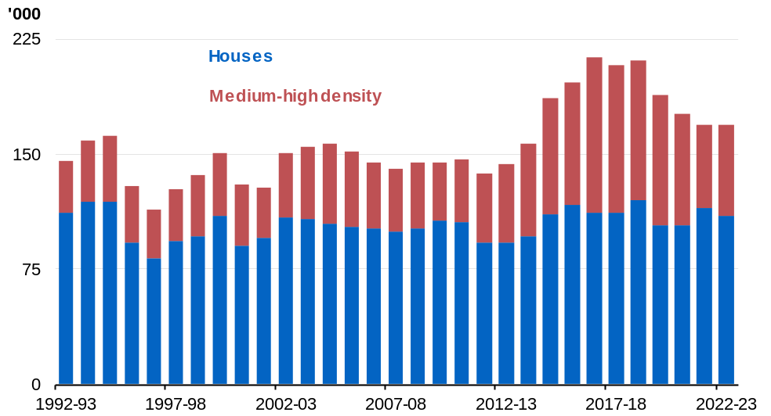Source: ABS Building Activity
Note: Data are original.

Australia’s level of housing supply is low by international standards
Chart 4.2 shows Australia’s housing supply relative to other OECD countries. While differences across OECD countries reflect a range of factors including differences in age structure, population growth, cultural norms, and the size and quality of the housing stock, Australia has fewer dwellings per 1,000 people than the OECD average.
According to the OECD, Australia’s level of housing supply was at 403 per 1,000 people in 2011. This increased to 420 per 1,000 people in 2022. However, this increase in supply was insufficient to keep pace with international peers, falling from around 92 per cent of the OECD average in 2011 to 90 per cent of the OECD average by 2022.
Australia lags behind other countries like Canada, the US and the UK (England) in terms of dwellings per 1,000 people.
Chart 4.2: Dwellings per 1,000 people, Australia and OECD average
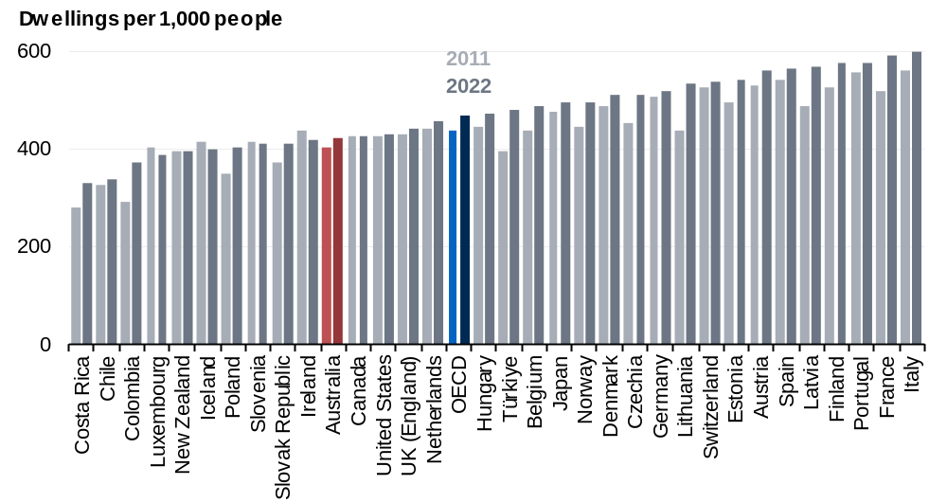Source: OECD, Treasury
Note: Greece, Israel, Mexico, Sweden and the Republic of Korea (OECD members) are not included in this analysis due to missing data points. 2011 data is either from 2011 or nearest available year and 2022 data is either from 2022 or latest available year.

A lack of supply is making it harder for people to buy or rent
A shortage of housing stock is making it difficult to find a property to buy or rent. The number of homes being offered for sale has fallen since 2015 (Chart 4.3), while the number of homes for rent has been falling since early 2020 (Chart 4.4).
Chart 4.3: Total national established property market listings  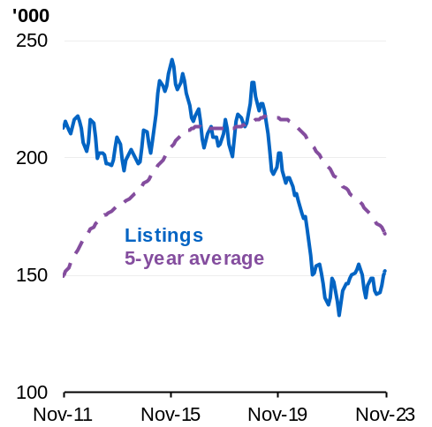 | Chart 4.4: Total national rental market listings  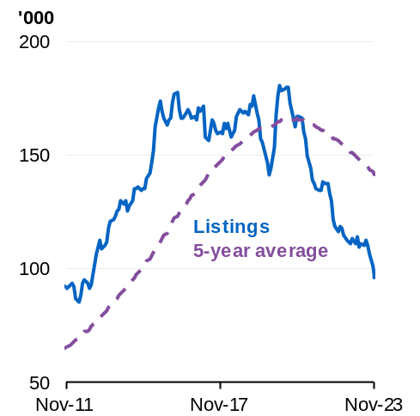
Source: CoreLogic, Treasury  Note: Listings are the total monthly volume of properties available. Listings line is a 3-month rolling average. Average line is a 5-year rolling average. | Source: CoreLogic, Treasury  Note: Listings are the total monthly volume of rental properties available. Listings line is a 3-month rolling average. Average line is a 5-year rolling average.

The rental vacancy rate is well below the rate considered to reflect a balanced rental market of around 3 per cent (Chart 4.5). In some parts of the country, including some capital cities, it is as low as 0.5 per cent.
Chart 4.5: National dwelling rental vacancy rate
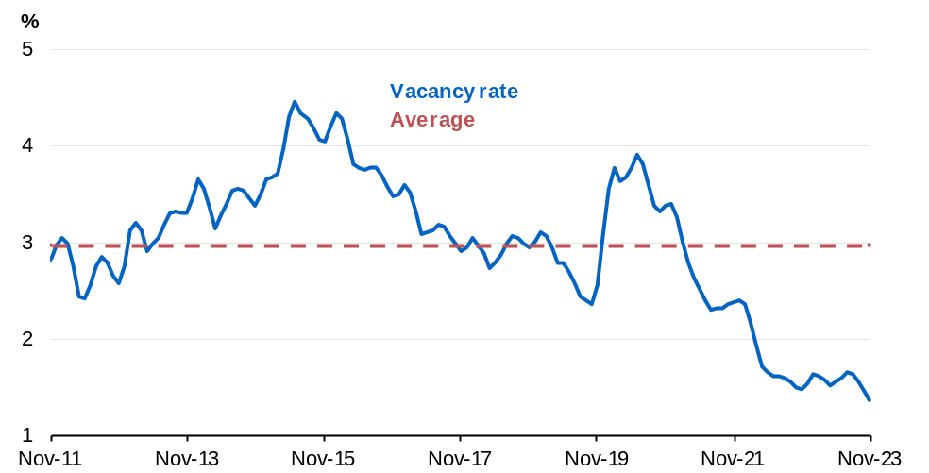
Source: CoreLogic, Treasury
Note: 3-month rolling average.

Box 4.2. Government actions to increase market housing supply
More homes need to be built in the places that households need them, including close to places of work and education for families, workers and students This requires careful planning and better collaboration with non-government partners to meet the changing needs of our communities.
Australia’s growing international education sector requires adequate supply of purpose-built student accommodation to ensure its ongoing sustainability. To deliver more accommodation for students and to reduce pressure on the private rental market, the Government will work with the higher education sector to develop regulations that will require universities to increase their supply of student accommodation.
The Government is also developing the National Housing and Homelessness Plan (the Plan). The Plan will be a 10-year strategy and outline how all levels of government can work together with the private and the community sector to deliver the short-, medium- and long-term actions needed.
The Plan will build on the Accord, where the Government is working with states and territories, local governments, industry and investors to deliver 1.2 million new, well-located dwellings in the five years from 1 July 2024.
New homes are needed in every state and territory – not just in the major population centres that attract most of the population growth. That is why the Government is offering $3 billon in incentive payments through the New Homes Bonus to be shared amongst all states and territories to reach their share of the 1.2 million target.
The Government will provide state, territory and local governments with payments to fund the enabling infrastructure (water and sewage connections, roads and footpaths) needed to develop new homes through the $1.5 billion Housing Support Program.

Investment by governments in social housing has declined over decades
In addition to low levels of aggregate housing stock, rates of construction of social housing (which includes both public housing and community housing) have also fallen steadily. Public housing is defined by the Australian Institute of Health and Welfare (AIHW) as rental housing that state and territory governments provide and manage, and is a subset of social housing. Social housing is rental housing fully or partly funded by government, owned or managed by community organisations or governments, and includes public housing, state owned and managed Indigenous housing, community housing and Indigenous community housing. Public housing completions (Chart 4.6) and the share of social housing stock as a proportion of the total stock has declined for the last three decades (Chart 4.7). Research notes that since 1996, the level of social housing construction has not been enough to keep pace with sales and demolitions of existing social housing stock.
Since 1958, the Australian Government has provided rent assistance which helps people on income support payments with the cost of rental housing. As an income supplement, Commonwealth Rent Assistance is able to respond to recipients’ needs in a timely way, can adapt as their needs change over time, supports housing choice, and can help meet the cost of increases in rent. The National Housing Supply and Affordability Council suggests that renter households receiving Commonwealth Rent Assistance have seen improved affordability in recent years. In March 2024, Commonwealth Rent Assistance helped reduce the percentage of recipient households experiencing rental stress by around 31 percentage points.
Chart 4.6: Public housing completions | Chart 4.7: Social housing stock as a share of housing stock
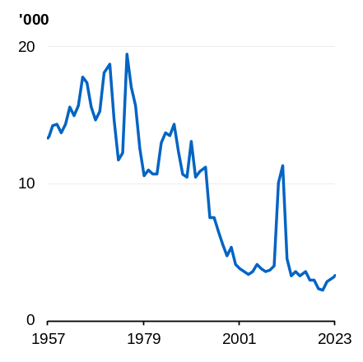 | 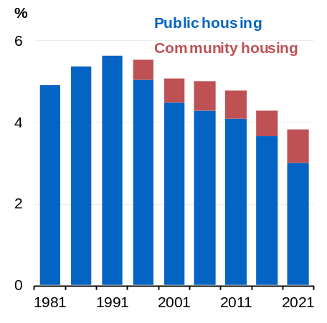
Source: ABS Building Activity, Treasury | Source: National Housing Supply and Affordability Council analysis of ABS Census data, Treasury  Notes: Social housing as a share of occupied private dwellings (excludes visitor-only and other non-classifiable households from 2006 onwards).

Box 4.3 Government actions to increase social and affordable housing
The Government is tackling housing stress for lower income households, with investments expected to support around 55,000 new social and affordable homes, increasing the stock of social and affordable housing by over 12 per cent. This will be achieved through:
- The $10 billion Housing Australia Future Fund (HAFF), which seeks to deliver 30,000 new social and affordable homes over its first five years, including homes for women and children impacted by family and domestic violence.
- The National Housing Accord, under which the Australian Government will deliver 10,000 affordable homes, to be matched by states and territories.
- Additional concessional financing for community housing providers and other charities to support the HAFF and Accord of $1.9 billion.
- The $2 billion Social Housing Accelerator Payment, which will fund 4,000 new and refurbished social homes.
- Expanding the Affordable Housing Bond Aggregator by increasing Housing Australia’s liability cap to $10 billion from $5.5 billion.
- Providing an additional $1 billion to the National Housing Infrastructure Facility, targeted toward crisis and transitional accommodation for women and children fleeing domestic violence, and youth.
Chart 4.8 shows how these measures, coupled with Housing Australia’s existing programs, will affect the level of social and affordable housing.
continued on next page

Box 4.3 Government actions to increase social and affordable housing (continued)
Chart 4.8 Social and affordable housing stock levels and impact of Government’s investment
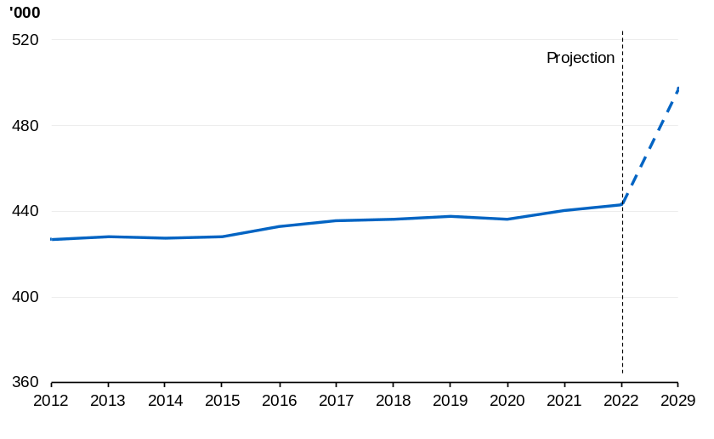
Source: AIHW, Treasury
Notes: This chart measures social housing stock levels from 2012 to 2022 using data from AIHW. For the purposes of this analysis, Treasury is including State Owned and Managed Indigenous Housing, Indigenous community housing, community housing and public housing, in the count of social and affordable housing. This analysis may not include other forms of affordable housing due to unavailable data. It is projected that the Australian Government will help support around 55,000 new social and affordable homes between May 2022 and 2029.

Affordability pressures are high

Supply shortages contribute to affordability pressures
The lag in housing supply responding to changes in population has contributed to rising house prices and worsening affordability. Charts 4.9 and 4.10 show that nominal dwelling prices and advertised rents have more than doubled since the mid-2000s.
Chart 4.9: Median nominal dwelling values | Chart 4.10: Median nominal advertised rents
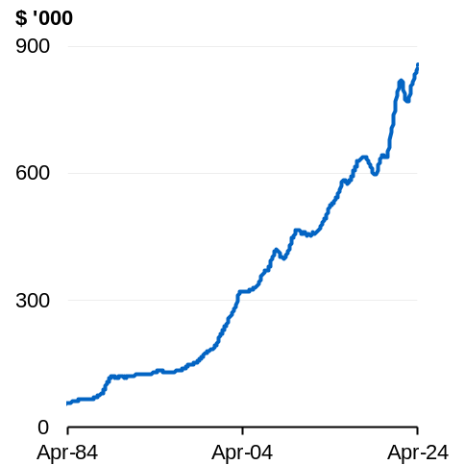 | 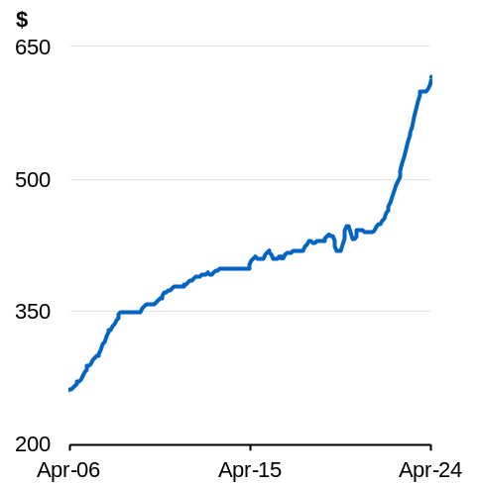
Source: CoreLogic  Note: Median monthly dwelling values are reported for eight capital cities combined. | Source: CoreLogic  Note: Nominal dwelling rents are reported for eight capital cities combined, 3-month rolling average.

As a result of price pressures, an increasing share of household incomes is going towards housing and housing services, particularly for lower-income rental households, with marked growth since 2020 (Chart 4.11). For prospective homebuyers, the portion of income needed to service a new loan has risen from an average of 29 per cent in 2020 to 46 per cent in 2023. This is above the long-run average of 35.7 per cent and above the 30 per cent threshold for mortgage stress (Chart 4.12).
Chart 4.11: Share of income to service rent, by income and rent quartile | Chart 4.12: Share of income to service new loan, dwellings
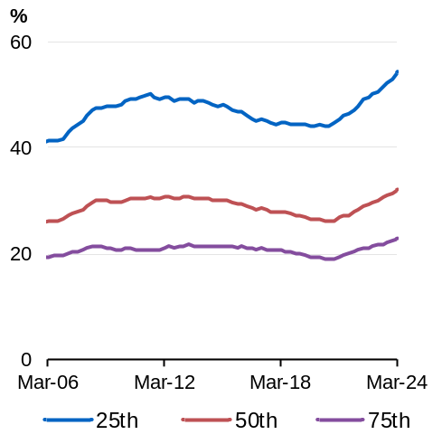 | 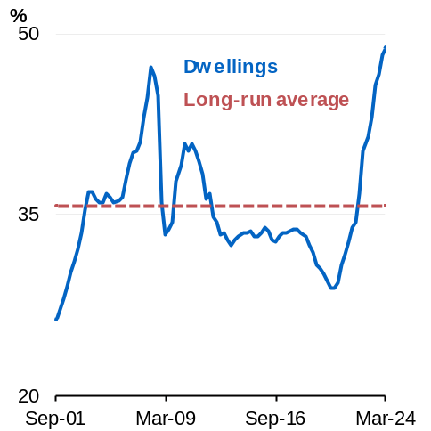
Source: CoreLogic, POLIS@ANU Centre for Social Policy Research  Note: Income refers to median gross disposable household income. Data is for national dwellings, reported quarterly. Households in a given income quartile are matched to the equivalent rent quartile. | Source: CoreLogic, POLIS@ANU Centre for Social Policy Research  Note: Income refers to median gross disposable household income.  Data is for national dwellings, reported quarterly.

Long term decline in affordability
In the March quarter of 2002, the median house price was 4.9 times the median gross disposal household income. By the March quarter of 2024, this had increased to 8.6 times median gross annual income (Chart 4.13). The unit price-to-income ratio has not grown as fast – reflecting recent growth in the supply of medium-high density housing and rising land values, as medium-high density developments contain more dwellings per square metre of land. While there has been short term volatility, Australians are also taking longer to save for a deposit, with the time taken to save a 20 per cent house deposit reaching almost 11.4 years in the March quarter 2024, down from a historic peak of 12.1 years in the March quarter 2022 (Chart 4.14). These factors have contributed to declining rates of home ownership over time, and more people are now renting (Chart 4.15).
Chart 4.13: Price-to-income ratio | Chart 4.14: Time to save for a house deposit
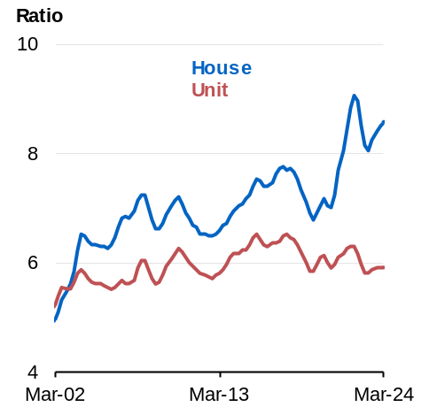 | 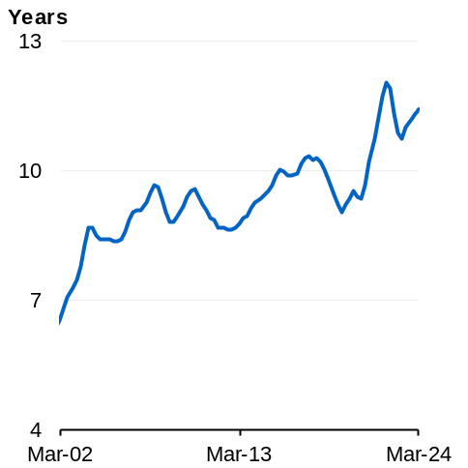
Source: CoreLogic, POLIS@ANU Centre for Social Policy Research  Note: Income refers to median annual gross disposable household income. Data is quarterly for combined capital regions. | Source: Source: CoreLogic, POLIS@ANU Centre for Social Policy Research  Note: Income refers to median gross disposable household income. Chart assumes 20 per cent deposit. Data is quarterly for combined capital regions.

Chart 4.15: Rates of Home Ownership

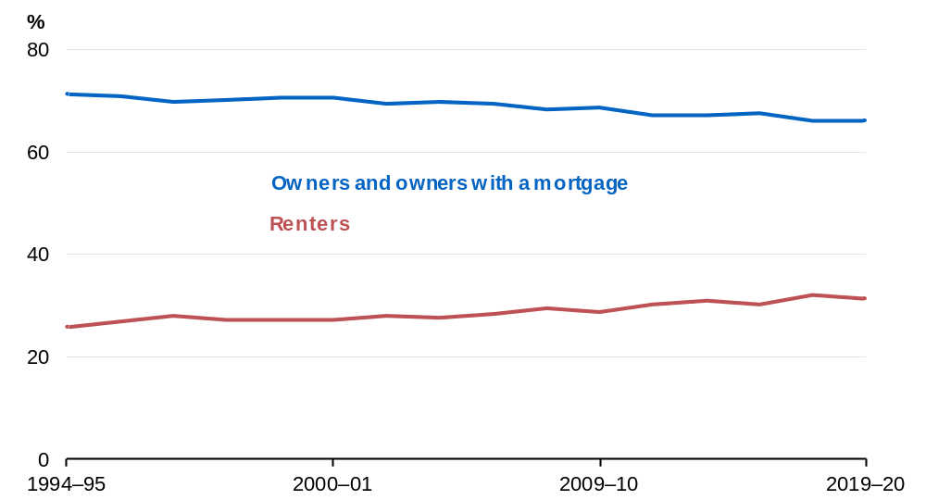Source: ABS Housing Occupancy and Costs, Treasury

Box 4.4 Government actions to help renters and support more people into home ownership
As prices have risen, more Australians are finding it difficult to pay their rent. This is why the Government is stepping in to ease the burden while the housing system is improved to bring on more supply over time.
As part of the Government’s broader responsible and affordable cost-of-living relief package, Commonwealth Rent Assistance (CRA) will be increased by a further 10 per cent. Alongside the 15 per cent increase provided in September 2023 and regular indexation, this will take maximum rates over 40 per cent higher than in May 2022. Outside of regular indexation, the 2023–24 Budget and 2024–25 Budget CRA increases are the first back-to-back increases to maximum rates of CRA in three decades. This will help to address pressure in the rental market caused by low vacancy rates and falling supply.
In recognition of the more challenging situation renters are facing, the Government is also working with states and territories to strengthen renters’ rights through A Better Deal for Renters. As part of this package, all levels of government have agreed to implement a 9-point plan that includes:
- Developing a nationally consistent policy to implement a requirement for genuine reasonable grounds for eviction.
- Moving towards limiting rent increases to once a year.
- Phasing in minimum rental standards.
In addition, the Government is introducing concessional tax treatment to encourage the development of more build-to-rent accommodation to increase the supply of rental properties and increase their affordability. The Government has also lowered foreign investment application fees for new build-to-rent developments to further encourage an increase in the supply of rental properties.
The Government is also helping more renters to transition to home ownership through introducing legislation to establish the Help to Buy scheme. The Help to Buy scheme will support up to 40,000 eligible households to purchase a home by providing them an equity contribution of up to 40 per cent of the purchase price for new homes and 30 per cent for existing homes. Together with the expanded Home Guarantee Scheme, this will help more Australian households achieve home ownership.

Affordability challenges have productivity, health and social inclusion implications
A well-functioning housing system allows workers to be close to their employment, reduces commute times and travel costs, and encourages labour force participation, social mobility and cohesion.
A collective lack of investment in housing – both public and private – can result in a housing system that entrenches adverse health and socio-economic outcomes. Unstable housing prevents workers from finding meaningful employment and creates more disruptions for children’s education. This is especially pronounced for children vulnerable to socioeconomic inequality, living in disadvantaged neighbourhoods or being unable to rely on intergenerational wealth transfers. Quality housing improves children’s development and wellbeing, and can lead to better education outcomes, particularly for those with intergenerational disadvantage.
An undersupplied and underinvested housing system creates more instances of overcrowded and poor-quality dwellings, which Brackertz et al. (2019) identifies as increasing the likelihood of developing chronic physical and mental health conditions, and increasing the risk of domestic and family violence. In 2022–23 around 38 per cent of all specialist homelessness services clients had experienced family and domestic violence.
Increased housing supply and affordability in well-located areas can positively affect wages and productivity by reducing barriers to job switching. Job switching rates in Australia are low and have declined over the past 30 years. Research suggests job switchers are likely to move to more productive firms, with the average productivity gap between origin and destination firms at 13.1 per cent. It can also enable workers to move to a role which better matches their individual skillset. These factors can influence aggregate productivity as they allow firms with higher average productivity to increase output. Workers are also more likely to realise wage gains when switching into a new role, which can improve their standard of living.
As Australia has shifted towards a service-based economy, many firms have set up offices in central business districts. National Housing Supply and Affordability Council research shows workers are living an increasingly further distance from their place of work, associating this with a lack of affordable housing in cities. An increase in well-located housing in urban areas with access to public transport and amenities will make it easier for workers to switch jobs to more productive firms and seek higher wages, and will improve the productive capacity of the Australian economy. A lack of affordable housing in regional areas can also undermine the ability of businesses to attract workers and represents lost economic potential for regions.

Barriers to the construction of new homes need to be addressed
Action is needed to improve housing system responsiveness
Australia’s housing system has been unable to sufficiently respond to demand. Housing requires longer lead times to respond to price signals than many other goods and services. On average, in 2022–23 a house in Australia took around nine months to build, while a block of apartments took over 24 months to complete. Structural factors influence the speed at which new housing can be supplied, with planning and approvals to release land necessary for construction to take place. These are often delayed, and timing can vary significantly between state and territory jurisdictions. In addition, planning and zoning processes, the capacity and productivity of the construction sector and expensive materials costs can further slow the pace of housing construction.

This relationship between supply and prices means that accelerating new supply will help to lower prices and ease affordability pressures. This is supported by empirical research which shows that:
- OECD countries that built more housing between 1990 to 2015 experienced lower growth in real house prices;
- Adding an extra 50,000 homes a year for a decade could reduce house prices up to 20 per cent;
- A 1 per cent increase in the stock of dwellings could lower house prices by 2.5 per cent.
Rates of construction need to be accelerated
Rates of construction are reducing the capacity of the market to respond to increased demand. Apartment, townhouse and detached house completion times increased nationally by 39 per cent, 34 per cent and 42 per cent respectively over the 10-year period to 2022–23. Most of this increase is concentrated over the pandemic period, however there has been a relatively consistent upward trend in apartment construction times since 2018–19.
Modelling from the National Housing Supply and Affordability Council shows Australia’s existing unmet demand for housing will not be satisfied unless the responsiveness of supply to demand is improved. Over the Council’s 6-year projection horizon, new market demand is expected to exceed new market supply by around 39,000 dwellings. While new supply and new demand will roughly be in balance from the 2026–27 financial year onwards, this suggests that without concerted action to reduce barriers to new supply, Australia’s excess demand for housing will continue to go unmet.

Faster planning and zoning approval processes can help unlock supply
Planning and zoning restrictions can limit the speed at which land is made available for development. Development application processes grant approvals for land to be released for development, often at the local government level. Delays in assessment timelines can increase cost and uncertainty for developers. For example, longer approval timeframes may be indicative of aversion to new development in a particular area, particularly for larger developments. Average observed approval times for development application decisions vary by state, with Victoria and New South Wales experiencing the longest average approval wait times at 143.6 and 114 days respectively as at 8 May 2024. Lengthy approval timeframes can increase effective development times for new dwellings and limit the responsiveness of housing supply to demand.

Planning and zoning processes should focus on ensuring housing is delivered where it is needed
Planning and zoning restrictions divert additional housing away from well-located areas where demand is greatest. Medium- to high-density housing in urbanised areas is necessary to ensure Australia’s housing supply efficiently responds to demand. It offers a more efficient use of construction sector resources, can better cater to household location and amenity preferences and reduce demand pressures in inner-city locations.
Dense development in the ‘missing middle’ of major Australian cities, where households can reside closer to jobs in areas with higher quality amenities and infrastructure, has been limited by planning and zoning restrictions and slow release of infill land. Using 2016 data, the gap between the cost of supplying a new apartment and its market value in Sydney was $355,000 (68 per cent of costs), $97,000 in Melbourne (20 per cent of costs) and $10,000 in Brisbane (2 per cent of costs). These gaps are sustained by planning and zoning restrictions, which force additional development outwards rather than where demand is greatest. As a result, recent development has been concentrated in city fringes where detached dwellings are more likely to be constructed, particularly in Melbourne and Brisbane. All jurisdictions except the Australian Capital Territory have approved more detached dwellings than townhouses and apartments over the five years to March 2024 as a result.
Barriers to building homes in well-located areas not only reduce supply in areas of high demand and increase commute times but make new and existing homes less affordable. Building new homes in greenfield areas requires new infrastructure, which can add to the time and cost of development. For example, infrastructure costs in some outer-urban parts of Sydney are up to $75,000 higher per dwelling than for inner-city areas.
Rezoning urban areas to allow greater density can increase the supply of housing. In 2016, Auckland Council upzoned around three quarters of its residential land to permit higher maximum site coverage and height. This led to a significant increase in housing permits and construction in the upzoned areas, particularly in locations close to transport and employment opportunities, which contributed to Auckland rents for three bedroom dwellings being 22 to 35 per cent lower than they otherwise would have been six years on from the introduction of the policy.
It is also important that new medium-high density builds are constructed to a high quality, to maintain consumer confidence and ensure demand for higher density housing.
Box 4.5 Government actions to reform the planning system
Planning and zoning decisions have a significant impact on the rate of land release and where and how quickly new housing supply can be built.
To help the planning system more effectively facilitate the number of new homes needed, National Cabinet has agreed the National Planning Reform Blueprint. The Blueprint brings state and territory planning ministers together to progress 17 reforms to deliver more homes, including:
- Streamlining development approvals.
- Identifying well-located development ready land.
- Increasing housing density in target areas.
- Identifying how housing can be built faster on sites with development approval but where development has not commenced (i.e. activating ‘zombie’ approvals).
- Ensuring that state, regional and local strategic plans reflect their share of the national 1.2 million new homes target.

Action to make construction cheaper will also help more homes be built faster
Global price shocks and supply constraints associated with COVID-19 have added to the costs of construction. Materials input costs, as captured in Producer Price Index, increased significantly over the pandemic, including for timber, concrete, and metal products. Alongside elevated labour costs, these drove a sharp increase in the price of building a new dwelling, as measured in the Consumer Price Index, which contributed to the sharp rise in inflation (Chart 4.16). Although growth in construction costs for new dwellings have eased, they continue to grow from an already elevated level.
Chart 4.16: Residential construction costs and prices | Chart 4.17: Construction sector vacancies as a proportion of employment
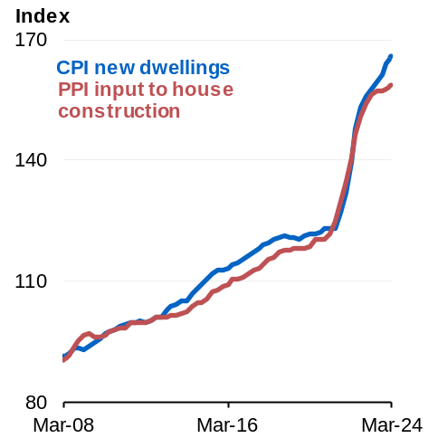 | 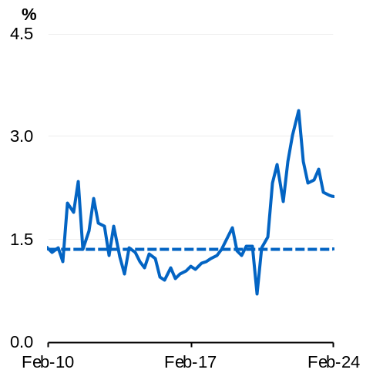
Source: ABS Producer Price Index, ABS Consumer Price Index | Source: ABS Job Vacancies, ABS Labour Force  Note: Dashed lines are pre-COVID long run averages.

Labour shortages have also slowed the pace of construction. A shortage of skills and labour in the construction sector has persisted since the pandemic given high demand and existing shortages. Industry estimates suggest the construction sector is facing a shortfall of around 90,000 workers. The most acute trade shortages in the first quarter of 2024 existed in bricklaying, ceramic tiling, plastering, carpentry and roofing. Construction sector job vacancies have fallen considerably from the peak in 2022 but remain well above historical averages (Chart 4.17).
These labour shortages can partially be explained by an increase in non-dwelling construction activity, that has drawn on the supply of labour available for dwelling construction. The rate of growth of investment in public infrastructure and non-dwelling construction has increased significantly relative to residential construction activity (Chart 4.18). At the same time as labour shortages have worsened, labour productivity in the construction industry has not increased from the level it was in the early 2000s (Chart 4.19), while other sectors have seen significant productivity growth.
Growing costs and lengthening build times have reduced the ability of investors, builders, and developers to add to the housing stock, despite the strong signal provided by market conditions.
Chart 4.18: Construction related investment expenditure | Chart 4.19: Labour productivity in the construction sector
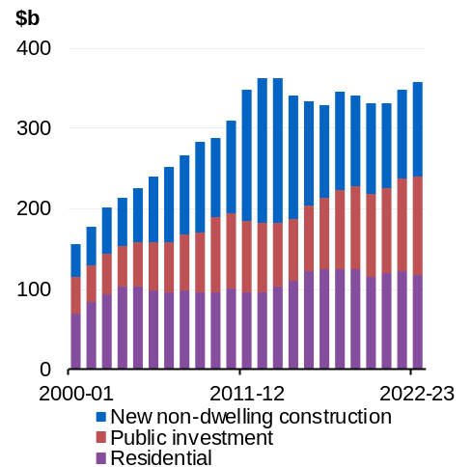 | 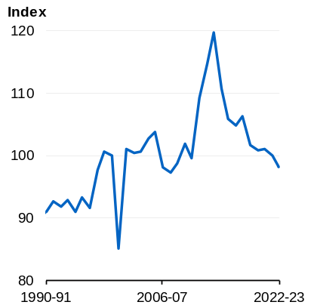
Source: ABS National Accounts: National Income, Expenditure and Product  Note: Public investment is total public investment including infrastructure related investment. | Source: ABS Estimates of Industry Multifactor Productivity, Treasury

Box 4.6 Government actions to invest in more skilled construction workers
Capacity constraints in the construction sector are a key impediment to faster delivery of new homes. According to industry, there has been a significant shortage of construction workers in recent years, driven by a drop off in rates of skilled migration during the COVID-19 pandemic and competition from infrastructure projects. This has slowed the ability of builders to build more homes quickly and driven up the price of labour.
The Government is responding to this challenge by investing $88.8 million to grow the pipeline of construction workers through 20,000 additional fee-free TAFE and pre-apprenticeship places. The Government will also provide $1.8 million to deliver streamlined skills assessments for around 1,900 migrants from comparable counties to work in Australia’s housing construction industry.
The HomeBuilder program provided grants of up to $25,000 to eligible owner-occupiers to build or substantially renovate a home. HomeBuilder was intended to support confidence in the residential construction sector and encourage consumers to proceed with purchases or renovations that may have been delayed due to uncertainty caused by the COVID-19 pandemic.
While HomeBuilder, alongside low interest rates, increased investment in the residential construction sector, it concentrated this demand in the detached sector (Chart 4.20). The program brought forward investment demand ahead of what the detached sector was able to sustainably build (Chart 4.21). The program added to inflation pressures in the sector by placing additional pressure on constrained supply chains. It also contributed to national land price growth of 14 per cent in 2021 and 22 per cent in 2022, alongside reduced greenfield lot releases. This demonstrates the potential risk to affordability presented by programs which stimulate investment demand for housing without addressing supply constraints.
Chart 4.20: Private sector residential building approvals | Chart 4.21: Private sector residential commencements
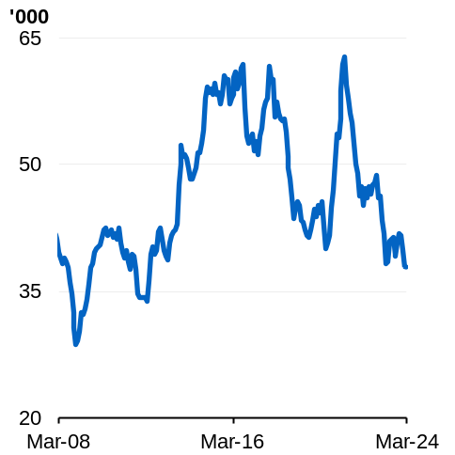  Source: ABS Building Approvals, Treasury  Note: 3-month rolling average. | 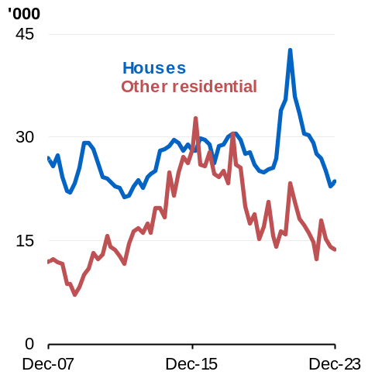  Source: ABS Building Activity

Productivity Commission research has suggested that for government programs assisting households to purchase a home, the assistance is likely to be capitalised into house prices when not accompanied with an increase in supply. This tends to benefit sellers and existing owners, rather than buyers, which in turn further prices low- and middle-income households out of owning their own home. Any support for home ownership should be specific and targeted.
Box 4.7 Targets to increase supply: an alternative to demand stimulation
The initial target of 1 million new, well-located homes set in the Accord in October 2022 aimed to deliver significant new housing supply above that needed to keep pace with demand. Based on estimates at that time, it would have delivered sufficient new homes to achieve this.
Higher interest rates were expected to dampen demand and slow the rate of new household formation. This would have reduced the pressure on the construction sector, allowing it to work through the large pipeline of work in progress that developed through the COVID-19 pandemic due to labour force shortages, supply chain challenges and demand stimulus.
However, the housing market remained resilient despite the changes in interest rates, and demand remained high. In part, this was driven by a recovery in population growth as Australia emerged from the pandemic and international borders reopened and Australians demanding more space for housing to accommodate new activities, such as working from home. This higher-than-expected demand, combined with cost pressures and delays in the construction sector, has contributed to worsening affordability for many Australians.
As a result, the Australian Government agreed with state and territory governments to increase the target under the Accord to 1.2 million new, well-located homes. This higher target will require additional policy reform to be met, but will ensure housing supply grows quickly enough to meet the needs of our population. Housing supply growth at this rate will enable more Australians to find the housing they want and will reduce pressure on prices.
Changes to the supply side of the housing system required to meet this target will have long term benefits beyond the period of the Accord target. They will ensure Australia has a housing supply system responsive to demand as conditions change over time.

The Government’s plan to meet Australia’s housing challenge
The challenges in Australia’s housing system are caused by complex structural factors that have built up over time, and will take long term co-operative effort to address.
That is why the Government is working with all levels of government, industry and investors to reform our housing system to make it fairer and more efficient; a system that delivers more homes and offers more assistance to those who need it. Australia needs a system more attuned to our future than our past.
The Government’s vision is ambitious and deliberately designed to provoke change in the housing system. While change will take time, the Government is laying the foundations and working across all parts of the system to improve affordability and fairness.
It is in this context that the Government has a plan to meet Australia’s housing challenge. It seeks to:
- Kickstart construction of more homes by building infrastructure, training tradies, and cutting planning hurdles.
- Deliver the biggest investment in social and affordable housing in over a decade.
- Provide more support for renters – including the biggest increase to rent assistance in more than 30 years.
- Help Australians buy their own home.
- Double its dedicated homelessness funding and provide shelter for people in crisis – including women and children fleeing domestic violence, veterans, and youth.
This plan is backed up by $32 billion in new commitments. It is backed by an unprecedented level of cooperation with state, territories and local governments, industry and investors through the National Housing Accord. Actions include:
- A target for 1.2 million new, well-located homes.
- Funding 40,000 new social and affordable homes.
- The first back-to-back increase in the maximum rates of Commonwealth Rent Assistance outside of indexation changes in three decades.
- Helping more Australians into home ownership.
The development of the 10-year National Housing and Homelessness Plan (the Plan) is a critical component of the Government’s housing strategy. It seeks to set a shared vision from all levels of government and work with the private and community sector to address housing challenges, including the need to deliver more housing supply.

Kickstarting construction of more homes
Correcting Australia’s housing shortage requires governments to create a policy environment that better enables industry and investors to respond to demand. This means getting the planning system right, fixing labour and skills shortages and providing the infrastructure to enable more homes to come on-line faster and more economically. It means creating the governance arrangements for these cross-jurisdictional issues to be resolved effectively so communities can better hold their governments to account for the homes they deliver.
The National Housing Accord, which creates a framework for inter-government collaboration, is central to the Government’s plan to address the inter-jurisdictional factors affecting supply. It brings together state, territory and local governments, along with industry and investors to work cooperatively to increase the supply of new homes.
The Accord seeks to deliver 1.2 million new, well-located homes from 1 July 2024 to 30 June 2029. It will focus on developing strategies for the planning system to support more homes, to make sure the right skills are available to build more homes and that investors supply more finance to fund more homes. The target is aimed to deliver significant new housing supply above that needed to keep pace with demand, to accommodate our population and support a slow but steady decline in average household size.
Work under the National Housing Accord, including progress under its targets, is regularly monitored by Treasurers through the Council on Federal Financial Relations.
Delivering the enabling infrastructure to support new developments can be costly, and in some cases, uneconomical for private developers. That is why it can often act as a bottleneck preventing new supply from coming on the market. To overcome this barrier to new housing, the Housing Support Program will offer state and local governments $500 million to develop the infrastructure required to enable new homes to be built (for example, connecting sewerage and water and roads). This will be boosted by an additional $1 billion made available in this Budget to states and territories to deliver enabling infrastructure, taking the Government’s total investment in the Housing Support Program to $1.5 billion.
The Australian Government has committed $3 billion in incentive payments to help deliver the 1.2 million new homes target through the New Homes Bonus. This will give states and territories greater financial capacity to fund changes to planning and zoning systems as well as support the land release programs needed to reach the target.
Improving the planning system so it facilitates more homes will also be progressed through the National Planning Reform Blueprint (the Blueprint). The Blueprint brings planning ministers together to progress 17 reforms to deliver more homes. These include:
- Streamlining development approvals.
- Identifying well-located development ready land.
- Increasing density in target areas.
- Identifying how housing can be built faster on sites with development approval but where development has not commenced (i.e. activating ‘zombie’ approvals).
- Ensuring that state, regional and local strategic plans reflect their share of the national 1.2 million new homes target.
Planning ministers will report on their progress in implementing the Blueprint twice a year to National Cabinet.
The structural barriers to new homes will not be overcome unless the skills and labour shortages are addressed. That is why the Government is investing $88.8 million to grow the pipeline of construction workers through 20,000 additional fee-free TAFE and pre-apprenticeship places. This is in addition to the more than 355,000 fee-free TAFE places already delivered in 2023, of which 24,200 were in the construction sector. The Government will also provide $1.8 million to deliver streamlined skills assessments for around 1,900 migrants from comparable countries to work in Australia’s housing construction industry.
The Government will implement regulatory requirements to ensure universities deliver more purpose-built student accommodation (PBSA). This will increase the level of housing supply and help to ensure that increases in international student numbers do not put pressure on the domestic housing market. Following consultation with the sector, the Government will set limits for how many international students can be enrolled by each university based on factors including how much student accommodation they provide. The Government will require universities to establish new, purpose-built student accommodation should they wish to increase their international student enrolments above their initial allocation. Any new accommodation built will be available to both local and international students. This reform will build more student housing, reduce pressure on house prices and rents in our cities and ensure universities continue to benefit from the overseas student market.

Deliver the biggest investment in social and affordable housing in a decade
The Government has been working to address the long-term decline in the delivery of social and affordable housing and to increase support for vulnerable Australians, including women and children leaving family and domestic violence. This would increase the stock of social and affordable housing by over 12 per cent from 2022 levels. It is a significant investment and would mean that the Government would be adding one new social and affordable home for every eight currently available. This would also be the equivalent of adding a city the size of Darwin to Australia’s housing stock.
The Government’s investment will help to overcome the liquidity challenges some construction firms are facing because of the current cyclical downturn in residential building approvals. It will also help to reduce demand at the lower end of the private rental market, which will help to reduce the pressures that some other renters are feeling because of the current low rental vacancy rates.
Central to the Government’s plan to deliver more social and affordable housing is the $10 billion Housing Australia Future Fund (HAFF), which seeks to deliver 30,000 new social and affordable homes over its first five years. Disbursements from the HAFF will also be used to deliver the Government’s commitments to help address acute housing needs. This includes $200 million for the repair, maintenance and improvement of housing in remote Indigenous communities, $100 million for crisis and transitional housing options for women and children impacted by family and domestic violence and for older women at risk of homelessness, and $30 million for veterans who are experiencing or are at risk of homelessness.
This will be supported by the National Housing Accord. In addition to the actions being progressed to increase supply, the Government has agreed to deliver 10,000 affordable homes under the National Housing Accord, which will be matched by states and territories.
This Budget provides additional concessional financing of up to $1.9 billion for community housing providers and other charities to support delivery of new social and affordable dwellings under the HAFF and the National Housing Accord.
The Government will supplement these initiatives by enhancing the programs administered by Housing Australia that provide concessional financing arrangements to facilitate the delivery of more social and affordable homes. This includes an additional $1 billion for the National Housing Infrastructure Facility (NHIF), which will be targeted towards crisis and transitional housing for women and children experiencing domestic violence and youth. The NHIF provides concessional loans and grants for eligible housing enabling infrastructure and social and affordable housing. This assistance is also part of the Government’s plan to provide shelter for people in crisis.
The Government is also expanding the Affordable Housing Bond Aggregator by increasing Housing Australia’s liability cap to $10 billion from $5.5 billion and lending an additional $3 billion to Housing Australia to support ongoing delivery of the program.
These initiatives will be supplemented by existing Housing Australia programs that provide concessional finance to support more social and affordable homes.
The Government has provided states and territories with $2 billion through the Social Housing Accelerator Payment. It will deliver around 4,000 new and refurbished social homes.
As part of the $4 billion, 10-year Northern Territory Homelands and Housing package, the Australian and Northern Territory Governments are working towards a commitment to halve overcrowding in the Northern Territory from 55 per cent to 23 per cent by 2034. The investment package will deliver up to 270 homes each year and continue urgent repairs and maintenance of existing housing and essential infrastructure on homelands.
The Government is also spending $7 million to support building and construction industry firms to gain Work Health and Safety (WHS) accreditation and $6.2 million to support building industry peak employer associations to assist their members in gaining the WHS accreditation required to participate in Government-funded housing projects.

Provide more support to renters
While new housing supply is being brought online, affordability pressures are likely to remain a challenge for many Australians who are renting or looking to rent. The Government recognises that many renters are under pressure and that rising rents are causing hardship for some Australians and pushing some into insecure housing arrangements. The Government is committed to providing more support to the third of Australians who rent. This is being delivered through greater levels of financial assistance, working with states and territories to deliver stronger protections for renters and facilitating the supply of new rental housing.
As part of the Government’s broader responsible and affordable cost-of-living relief package, Commonwealth Rent Assistance (CRA) is increasing by 10 per cent in this Budget. Taken alongside the increases in last year’s Budget and indexation, this will increase the maximum rates of assistance by over 40 per cent. Outside of regular indexation, the 2023–24 Budget and 2024–25 Budget CRA increases are the first back-to-back increases to maximum rates of CRA in three decades. It is also higher than the average increase in market rents in this period. It will provide eligible renters with greater opportunities to participate in the private rental market.
Low rental vacancy rates are posing unique challenges for renters. In addition to being harder to find a suitable place and placing upward pressures on prices, it limits tenants’ bargaining power with landlords. In recognition of these unique challenges, the Government is working with states and territories to strengthen renters’ rights through the Better Deal for Renters package. As part of this package, all levels of government have agreed to implement a 9-point plan that includes:
- Developing a nationally consistent policy to implement a requirement for genuine reasonable grounds for eviction.
- Moving towards limiting rent increases to once a year.
- Phasing in minimum rental standards.
In addition to the broader supply measures the Government is pursuing, the Government has a plan to increase the supply of specialist rental accommodation. This will help to moderate affordability pressures and introduced more equilibrium between renters and landlords.
Build-to-rent accommodation is designed to be supplied exclusively to the rental market. This model, which is much more common in overseas market, is less prevalent in Australia where most new developments are build-to-sell properties (i.e. they are built and sold to investors or owner-occupiers). To encourage more build-to-rent developments, the Government will introduce legislation to offer concessional tax treatment for these developments.
The build-to-rent incentives includes halving the managed investment trust withholding tax rate from 30 per cent to 15 per cent and increasing the capital works tax deduction (depreciation) rate from 2.5 to 4 per cent per year for newly constructed build-to-rent properties. Analysis commissioned by the Property Council of Australia suggest this could unlock 150,000 apartments over the next decade. The Government has also lowered foreign investment application fees for new Build to Rent developments and will also allow foreign investors to purchase established Build to Rent developments and apply lower fees to these applications, conditional on the property continuing to be operated as a Build to Rent development.

Help Australians buy their own homes
The Government recognises that affordability pressures are being felt by people seeking to transition from renting into home ownership. Rising house prices have led to rising deposits. This means more Australians are renting for longer, increasing pressure on the already constrained rental market. It is harder for people to save enough to clear the deposit hurdle and seek the finance necessary to enter home ownership.
To help overcome this challenge, the Government offers potential home buyers the Home Guarantee Scheme (the Scheme). It gives prospective home buyers support to purchase a home sooner by reducing the deposit they need to save to buy a house. Participants can access the Scheme with a deposit as little as 2 per cent. Around one in three first homebuyers in 2022–23 were supported by the Scheme.
The First Home Guarantee component of the Scheme was heavily subscribed by teachers (32 per cent of recipients), nurses (24 per cent of recipients) and social workers (19 per cent of recipients).
Since May 2022, the Scheme has already supported more than 110,000 Australians into home ownership and with an expansion to the eligibility of the Scheme this will continue to grow.
But the Government wants more renters who wish to transition to home ownership to have the opportunity to do so. That is why the government has introduced legislation to establish Help to Buy. Help to Buy will support up to 40,000 eligible households to purchase a home by providing them an equity contribution of up to 40 per cent of the purchase price for new homes and 30 per cent for existing homes. Participants would also not be required to pay Lenders Mortgage Insurance, as the equity contribution and their deposit would decrease the loan to value ratio to 80 per cent or below.

Double dedicated homelessness funding and provide shelter for people in crisis
The Government is taking action to support people experiencing homelessness and help people in crisis who are finding it difficult to access shelter and safety, including women and children fleeing domestic violence, veterans, and youth.
The Government has included $9.3 billion in the Budget for a new National Agreement on Social Housing and Homelessness with the states and territories. This includes a doubling of the Australian Government’s dedicated homelessness funding to $400 million a year.
Further support will be provided through the additional $1 billion for the National Housing Infrastructure Facility (NHIF), which will be targeted towards crisis and transitional housing for women and children experiencing domestic violence and youth. The NHIF provides concessional loans and grants for eligible housing enabling infrastructure and social and affordable housing. This assistance is also part of the Government’s plan to deliver more social and affordable homes.
The Safe Places program provides capital works grants to support the renovation, building or purchase of new emergency accommodation for women and children experiencing family and domestic violence. The Safe Places inclusion round grant opportunity will provide up to 720 new safe places, bringing the total number of safe places to be delivered by the program to around 1,480 across Australia. Projects are expected to commence from mid–2024.

Australian Government housing measures since May 2022
Measure | Description | New Commitments | Impact
2024-25 Budget Measures
Removing barriers preventing new homes being built
Housing Support Program – additional funding for enabling infrastructure (linked to later Housing Support Program measure) | Additional funding for states and territories to deliver more housing-enabling infrastructure. | $1 billion (in 2023-24) | Will support the supply of new homes through delivering enabling infrastructure earlier.
Skilling the construction workforce to support housing supply | Additional funding to develop the future construction workforce, with a focus on additional training and incentives. | $88.8 million (over three years from 2024-25) | Will build the pipeline of critical skills in the construction sector.
Increasing the availability of purpose-built student accommodation | As part of the response to the Australian Universities Accord, the Government will work with universities to increase the availability of student housing, by limiting international student enrolments based on factors including how much student accommodation they provide. | $2.1 million over four years from 2024-25 | Will ensure better provision of student accommodation and help reduce pressure on local housing markets.
National Housing Accord – Commonwealth land release | The Government will undertake feasibility studies on a number of surplus Commonwealth-owned land holdings to determine their suitability for release as housing to support the 1.2 million new, well located homes target under the Accord. | Nil | Subject to findings of the feasibility studies, will support delivery of new housing to meet the Accord’s housing supply target.
Delivering more social and affordable homes for those who need them
National Agreement on Social Housing and Homelessness | Under the new National Agreement on Social Housing and Homelessness, the states and territories will receive $9.3 billion over five years. The new agreement provides $423.1 million in additional funding. | $423.1 million (over five years from 2024-25) in additional funding.  Total funding of $9.3 billion over five years from 2024-25 | The new agreement is outcomes-focused and will enhance support for social housing and homelessness services, in conjunction with other investments by both Commonwealth and state governments.
Housing Australia Future Fund and National Housing Accord – additional finance – concessional Commonwealth loans | Provide additional concessional financing of up to $1.9 billion for community housing providers and other charities to support the delivery of new homes under the HAFF and Accord. | $1.9 billion (up to) | Will support delivery of the 40,000 social and affordable homes the Government committed to under the Housing Australia Future Fund and Accord.
Capacity building support for the social and affordable housing sector | Support to build the capacity of Community Housing Providers and Aboriginal and Torres Strait Islander Community Controlled Housing Organisations to enable them to better engage with available support and improve their delivery of new housing | $2 million (over three years from 2024-25) | Supports eligible organisations to better engage with available support.
Expanding the Affordable Housing Bond Aggregator to support Community Housing Providers | Building on the previous increase, a $2.5 billion increase in the liability cap on the Commonwealth guarantee of Housing Australia’s liabilities to $10 billion and a $3 billion increase in Housing Australia’s line of credit. | Increased Commonwealth balance sheet support for the lending program | Continues Housing Australia’s support to Community Housing Providers through provision of low-cost financing.
10-year Northern Territory Housing and Homelands Agreement | 10-year Agreement to fund delivery of housing and property and tenancy management measures in remote communities when the current one-year NT Remote Housing FFA schedule expires. | $698.4 million (over four years from 2024-25 and $2 billion over ten years) | Deliver up to 270 houses a year to reduce the proportion of overcrowded dwellings.
Remote Housing Northern Territory Federation Funding Agreement | Deliver an additional 49 houses under the existing Remote Housing Northern Territory Federation Funding Agreement, in partnership with and jointly funded by the Northern Territory Government, delivering a total of 206 houses under the one-year agreement | $20 million in 2023-24 | Deliver an additional 49 houses in the current financial year to reduce overcrowding
Northern Territory Homelands funding extension | Funding to continue the delivery of urgent repairs and maintenance of existing housing and essential infrastructure through an extension of the Northern Territory Homelands Federation Funding Agreement | $120 million (over three years from 2024-25) | Will enable an increase in housing supply in remote homelands in the Northern Territory.
Community-controlled housing model development | Work to develop a sustainable Community-controlled housing model. | $1 million (over two years from 2024-25) | Will enable an increase in housing supply.
Targeted assistance to residential builders seeking WHS accreditation | Provide targeted assistance to residential builders seeking to obtain accreditation under the Work Health and Safety Accreditation Scheme | $7 million (over three years from 2023–24) | Increased availability of accredited builders will support delivery of Government-funded housing projects
Grants to building industry peak employer associations to assist residential builders seeking WHS accreditation | Support for building industry peak employer associations to assist residential builders in obtaining accreditation under the Work Health and Safety Accreditation Scheme | $6.2 million (over two years from 2024–25) | Increased availability of accredited builders will support delivery of Government-funded housing projects
Delivering more support to renters
Commonwealth Rent Assistance – 10 per cent increase | An increase of 10 per cent in the maximum rates of Commonwealth Rent Assistance, to be provided from September 2024. | $1.9 billion (over five years from 2023–24)  This measure has an ongoing cost. | Will provide additional payments to nearly one million households to help meet the costs of renting.
Other measures
Improved housing policy, research and data | Additional support for the Australian Housing and Urban Research Institute and for the Treasury to continue its work supporting development of evidence-based housing policy. | $20.8 million (over five years from 2024-25) | Enables provision of evidence-based policy advice to examine existing policies and develop new interventions to improve housing outcomes.
Other new measures since the May 2022 election
Removing barriers preventing new homes being built
National Housing Accord – incentives to meet supply target (New Homes Bonus) | A performance-based payment for states and territories that exceed their share of the original 1 million well-located homes target agreed under the National Housing Accord. | $3 billion (payable after 2028-29) | Will support the delivery of an additional 200,000 homes above the initial National Housing Accord target of 1 million homes.
National Housing Accord – Housing Support Program | Competitive funding program for local and state governments for initiatives such as connecting essential services, amenities to support new housing development, or building planning capability. | $500 million (over two years from 2023-24) | Will support the supply of new homes.
National Housing Accord – National Planning Reform Blueprint | National Cabinet agreed to a National Planning Reform Blueprint with planning, zoning, land release and other measures to improve housing supply and affordability. | Nil | Planning, zoning and land release reform will enable an increase in the supply of housing.

Measure | Description | New Commitments | Impact
Delivering more social and affordable homes for those who need them
National Housing Accord – affordable homes commitment | 10,000 affordable homes over five years from 2024 – states and territories will support the delivery of up to an additional 10,000 affordable homes. | Original allocation of $350 million, updated to an initial $72 million a year by 2028–29, indexed from 2029–30. | Will support the delivery of up to 20,000 new affordable homes.
National Housing Infrastructure Facility (NHIF)* | Since November 2022, the NHIF can support new social or affordable housing projects. In September 2023, the Government committed an additional $1 billion in federal funding which will support housing for women and children experiencing domestic violence and youths. | $1 billion (from 2023-24) | Expanding the role of the NHIF will support the supply of new affordable and social homes. The additional $1 billion will support additional housing for women and children leaving domestic violence; and youth.
Social Housing Accelerator | A one-off payment to states and territories to permanently increase the stock of social housing across the country. | $2 billion (in 2022-23) | Will support the delivery of around 4,000 new and refurbished social homes.
Housing Australia Future Fund | The Government established the $10 billion Housing Australia Future Fund (HAFF) to provide a sustainable funding source to increase the supply of social and affordable housing and to address other acute housing needs. | $10 billion | Will support the delivery of 30,000 social and affordable homes over five years and will provide $330 million to address acute housing needs.
Affordable Housing Bond Aggregator | The cap on the Government guarantee of Housing Australia’s liabilities was increased by $2 billion to $7.5 billion in the 2023-24 Budget to provide lower cost and longer-term finance to community housing providers through the Affordable Housing Bond Aggregator. These loans can be used to acquire, construct, or maintain social and affordable housing, as well as to refinance existing debt. | Increased Commonwealth balance sheet support for the lending program | Will support the ongoing delivery of the program to provide long-term and low-cost finance to community housing providers.
National Housing and Homelessness Agreement – Transitional Funding | The 1-year extension to the National Housing and Homelessness Agreement provides around $1.7 billion to states and territories to 30 June 2024. This includes additional funding of $67.5 million in 2023 24 to support states to meet the homelessness challenges identified in the 2021 Census. | $67.5 million (for 2023-24) | The National Housing and Homelessness Agreement contributes to improving access to affordable, safe and sustainable housing across the housing spectrum, including to prevent and address homelessness, and to support social and economic participation.
Measure | Description | New Commitments | Impact
Northern Territory Remote Housing Partnership | A 1-year partnership over 2023–24 with the Northern Territory Government to accelerate building of new remote housing to reduce overcrowding. | $111.7 million (for 2023-24) | Will increase housing supply in remote communities in the Northern Territory and support the delivery of 157 homes
Restoring funding for Homelands | For housing and essential infrastructure in the Northern Territory Homelands, delivered through a new federal financial agreement with the Northern Territory Government. | $100 million (over two years from 2022-23) | Will enable an increase in housing supply in remote homelands in the Northern Territory.
Delivering more support to renters
Commonwealth Rent Assistance – 15 per cent increase | An increase to the maximum rates of Commonwealth Rent Assistance, payable from September 2023. | $2.7 billion (over 5 years from 2022-23)  This measure has an ongoing cost. | Benefits around 1 million households.
A Better Deal for Renters | National Cabinet agreed to A Better Deal for Renters to harmonise and strengthen renters’ rights across Australia. | Nil | A Better Deal for Renters will make a tangible impact on the rights of the almost one-third of Australians who rent.
Build to Rent tax incentives | Tax incentives to encourage more Build to Rent developments. Includes halving the managed investment trust withholding tax rate from 30 per cent to 15 per cent and increasing the capital works tax deduction (depreciation) rate from 2.5 to 4 per cent a year for newly constructed Build to Rent properties. | $34.3 million (over five years from 2022-23) | Will incentivise Build to Rent developments to increase the supply of rental housing in Australia. Analysis commissioned by the Property Council of Australia suggests this could unlock 150,000 apartments over the next decade.
Foreign investment in Build to Rent | The Government has lowered foreign investment application fees for new Build to Rent developments. The Government will also allow foreign investors to purchase established Build to Rent developments and apply lower fees to these applications, conditional on the property continuing to be operated as a Build to Rent development. | Nil | Additional foreign investment in Build to Rent developments will encourage the construction of Build to Rent developments.

Measure | Description | New Commitments | Impact
Helping low- and middle-income Australians into home ownership
Help to Buy | Help to Buy will assist people on low to moderate incomes to purchase a home with an equity contribution from the Government of up to 40% for new homes and 30% for existing homes. | $5.5 billion (from 2024-25) | Will assist up to 40,000 Australian households to purchase a home.
Home Guarantee Scheme | As part of the Home Guarantee Scheme, the Government has introduced the Regional First Home Buyer Guarantee and broadened eligibility criteria to support eligible citizens and permanent residents to purchase their first home, or their first property in Australia for at least ten years. | Nil | The Home Guarantee scheme is improving affordability of home ownership for up to 50,000 Australian households each year.
Double dedicated homelessness funding and provide shelter for people in crisis
National Agreement on Social Housing and Homelessness* | Under the new National Agreement on Social Housing and Homelessness, the states and territories will receive $9.3 billion over five years. The new agreement provides $423.1 million in additional funding. | $423.1 million (over five years from 2024-25) in additional funding.  Total funding of $9.3 billion over five years from 2024-25 | The new agreement is outcomes-focused and will enhance support for social housing and homelessness services, in conjunction with other investments by both Commonwealth and state governments.
National Housing Infrastructure Facility (NHIF)* | Since November 2022, the NHIF can support new social or affordable housing projects. In September 2023, the Government committed an additional $1 billion in federal funding which will support housing for women and children experiencing domestic violence and youths. | $1 billion (from 2023-24) | Expanding the role of the NHIF will support the supply of new affordable and social homes. The additional $1 billion will support additional housing for housing for women and children leaving domestic violence; and youth.

Measure | Description | New Commitments | Impact
Other measures
National Housing and Homelessness Plan | The Government has committed funding for the development, monitoring and evaluation of a National Housing and Homelessness Plan. The National Housing and Homelessness Plan is being developed in association with states and territories, industry bodies and not-for-profit organisations to identify short, medium and long-term reforms to improve housing and homelessness outcomes. | $38.6 million | The National Housing and Homeless Plan will outline a shared vision to inform future housing and homelessness policy in Australia.  Note: Funding represents costs to develop the Plan.
National Housing Supply and Affordability Council | The National Housing Supply and Affordability Council (the Council) has been established to provide independent, evidence-based expert advice to the Government on housing supply and affordability matters. | $15.2 million (from 2022-23)  This measure has an ongoing cost of $4.4 million a year from 2026-27. | The Council advises on national housing policy matters at the request of the Minister for Housing and on its own initiative.
Improved support for Commonwealth policy making – Treasury funding | Funding to support development of dedicated capability in the Treasury to better support delivery of the Government’s housing agenda. | $2.3 million (in 2023-24) | Improved capacity to develop and implement the Government’s ambitious policy agenda.
*Note: these measures are also counted elsewhere in the table.

+

This publication contains data, analytics, statistics, results and other information licensed to us by RP Data Pty Ltd trading as CoreLogic Asia Pacific (CoreLogic Data) © Copyright 2024. RP Data Pty Ltd trading as CoreLogic Asia Pacific (CoreLogic) and its licensors are the sole and exclusive owners of all rights, title and interest (including intellectual property rights) subsisting in the CoreLogic Data reproduced in this publication. All rights reserved. The CoreLogic Data provided in this publication is of a general nature and should not be construed as specific advice or relied upon in lieu of appropriate professional advice. While CoreLogic uses commercially reasonable efforts to ensure the CoreLogic Data is current, CoreLogic does not warrant the accuracy, currency or completeness of the CoreLogic Data and to the full extent permitted by law excludes all loss or damage howsoever arising (including through negligence) in connection with the CoreLogic Data.
CoreLogic Data.
Australian Institute of Health and Welfare (n.d.), ‘Housing assistance glossary‘, accessed 6 May 2024.
Pawson, H., Milligan, V., & Yates, J. (2020), Housing Policy in Australia: A Case for System Reform, Palgrave Macmillan, p. 95.
Productivity Commission (2022), ‘In need of repair: the National Housing and Homelessness Agreement’, p. 18.
National Housing Supply and Affordability Council (2024), ‘State of the Housing System 2024‘, p. 107.
In this context, rental stress is defined as spending more than 30 per cent of gross income on rent. Commonwealth Rent Assistance data sourced from Department of Social Services administrative data.
Daley, J & B, Coates (2018), ‘Reimagining the Australian dream‘, Grattan Institute, p. 17, 111.
Dockery, M, Ong, R, Colquhoun, S, Li, J & Kendall, G (2013), ‘Housing and children’s development and wellbeing: evidence from Australian data‘, Final Report No. 201, Australian Housing and Urban Research Institute Limited, p. 5.
Brackertz, N, Davidson, J, Borrowman, L & Roggenbuck, C (2019), ‘Overcrowding and severe overcrowding: an analysis of literature, data, policies and programs‘, Australian Housing and Urban Research Institute Limited, p 61, 67-68.
Australian Institute of Health and Welfare (n.d.), ‘Specialist Homelessness Services Annual Report 2022-23‘, accessed 3 May 2024.
Wong, A (2024), ‘Climbing the wage ladder: linking job mobility and wages‘, e61 Institute.
Buckley, J (2023), ‘Productivity in motion: the role of job switching‘, e61 Institute.
Deutscher, N (2019), ‘Job-to-job transitions and the wages of Australian workers‘, Treasury Working Paper 2019-7, Australian Government the Treasury; Wong, A (2024), ‘Climbing the wage ladder: linking job mobility and wages‘, e61 Institute.
National Housing Supply and Affordability Council (2024), ‘State of the Housing System 2024‘, p. 35-37.
Australian Bureau of Statistics (released 18 October 2023), ‘Building activity, average dwelling completion times, Australia’, accessed 30 April 2024.
This empirical research cannot be extrapolated to imply a price impact of the 1.2 million new homes target under the National Housing Accord.
The Centre for Independent Studies (2021), ‘Submission to the Inquiry into Housing Affordability and Supply in Australia‘, submission to the House of Representatives Standing Committee on Tax and Revenue, p. 9; Productivity Commission (2022), ‘In need of repair: the National Housing and Homelessness Agreement’, p. 462.
Daley, J & B, Coates (2018), ‘Reimagining the Australian dream‘, Grattan Institute, p. 3; Productivity Commission (2022), ‘In need of repair: the National Housing and Homelessness Agreement’, p. 462.
Saunders, T & Tulip, P (2019), ‘A model of the Australian housing market’, Research Discussion Paper 2019-01, Reserve Bank of Australia, p .28. Productivity Commission (2022), ‘In need of repair: the National Housing and Homelessness Agreement’, p. 462.
Australian Bureau of Statistics (released 18 October 2023), ‘Building activity, average dwelling completion times, Australia’, accessed 30 April 2024.
National Housing Supply and Affordability Council (2024), ‘State of the Housing System 2024‘, p. 88.
Productivity Commission (2022), ‘In need of repair: the National Housing and Homelessness Agreement’, p. 525.
Productivity Commission (2022), ‘In need of repair: the National Housing and Homelessness Agreement’, p. 468.
Department of Transport and Planning (n.d.), ‘Planning permit activity reporting‘, Victorian Government, accessed 8 May 2024; New South Wales Government (n.d.), ‘NSW Planning Performance Dashboard‘, accessed 27 April 2024.
Daley, J & B, Coates (2018), ‘Reimagining the Australian dream‘, Grattan Institute, p. 56.
Jenner, K & Tulip, P (2020), ‘The apartment shortage’, Research Discussion Paper 2020-04, Reserve Bank of Australia, p. 5.
Australian Bureau of Statistics (released May 2024), ‘Building approvals, Australia’, accessed 6 May 2024.
NSW Productivity Commission (2023), ‘Building more homes where infrastructure costs less‘, p. 13.
Greenaway-McGrevy, R, & Jones, J. A. (2023), ‘Can zoning reform change urban development patterns? Evidence from Auckland’, Working Paper No. 012, Economic Policy Centre, The University of Auckland, p. 26.
Master Builders Australia (2024),’2024-25 Pre-Budget submission: finding Australia’s missing tradies: how to harness the skilled migrant workforce‘, accessed 29 April 2024.
Housing Industry Association (2023), ‘Access to skilled labour a barrier to 1.2 million new homes‘, accessed 29 April 2024.
Urban Development Institute of Australia (2024), ‘State of the land 2024: national residential greenfield and apartment market study’, p. 6.
Productivity Commission (2022), ‘In need of repair: the National Housing and Homelessness Agreement’, p. 381.
EY (April 2023), ‘A new form of housing supply in Australia: build-to-rent housing’, prepared for Property Council of Australia, p. 8

