Statement 7:
Debt Statement
The Debt Statement provides information on Government gross debt, net debt, Australian Government Securities (AGS) issuance and interest costs over the forward estimates.
Gross debt as a share of GDP is expected to be lower each year over the forward estimates compared to the 2023–24 Mid-Year Economic and Fiscal Outlook (MYEFO). Gross debt is estimated to peak at 35.2 per cent of GDP at 30 June 2027, 0.2 percentage points lower and one year sooner than the estimated peak of 35.4 per cent of GDP in 2027–28 at the 2023-24 MYEFO.
- Gross debt is estimated to be 33.9 per cent of GDP at 30 June 2025, 0.3 percentage points lower than estimated at the 2023–24 MYEFO.
- Net debt is estimated to be 20.0 per cent of GDP at 30 June 2025, 0.5 percentage points higher than estimated at the 2023–24 MYEFO.
Interest payments on AGS are estimated to be $22.4 billion in 2024‍–‍25, increasing to $34.1 billion by 2027–28.

Statement contents
Australian Government Securities on issue 239
Changes in AGS on issue since the 2023–24 MYEFO 240
Breakdown of AGS currently on issue 241
Treasury Bonds 242
Treasury Indexed Bonds 243
Treasury Notes 243
Green Treasury Bonds 244
Non-resident holdings of AGS on issue 244
Net debt 245
Changes in net debt since the 2023–24 MYEFO 246
Interest on AGS 247

Statement 7: Debt Statement

Australian Government Securities on issue
Estimates of AGS on issue are published in both face value and market value terms in this Statement.
- The face value of AGS on issue (also referred to as gross debt) is the amount the Government pays back to investors at maturity, independent of fluctuations in market prices. The total face value of AGS on issue changes when new securities are issued, or when securities are repurchased or reach maturity.
- The market value of AGS on issue represents the value of securities as traded on the secondary market, which changes continuously with movements in market prices (often quoted as a yield to maturity). Consistent with external reporting standards, the market value of AGS on issue is reported in the Australian Government general government sector balance sheet.
The Commonwealth Inscribed Stock Act 1911 (CIS Act) requires the Treasurer to issue a direction stipulating the maximum face value of relevant AGS that may be on issue. Effective from 7 October 2020, the then Treasurer directed that the maximum face value of AGS that can be on issue is $1,200 billion. The estimated face value of AGS on issue subject to the Treasurer’s direction (end-of-year and within-year peak) in each year of the forward estimates remains below $1,200 billion.
Gross debt is estimated to be $934 billion (33.9 per cent of GDP) at 30 June 2025, increasing to $1,112 billion (34.9 per cent of GDP) at 30 June 2028.
Gross debt as a percentage of GDP is expected to be lower across each year of the forward estimates than at the 2023–24 MYEFO. The $13.1 billion improvement to the headline cash balance in 2023–24 and the impact of lower yields on AGS contribute to this reduction.

Table 7.1 presents estimates of AGS on issue.
Table 7.1: Estimates of AGS on issue subject to the Treasurer’s Direction^{(a)(b)}
 |  | Estimates
 | 2023-24 | 2024-25 | 2025-26 | 2026-27 | 2027-28
 | $b | $b | $b | $b | $b
Face value – end-of-year | 904 | 934 | 1,007 | 1,064 | 1,112
Per cent of GDP | 33.7 | 33.9 | 35.1 | 35.2 | 34.9
Face value – within-year peak(c) | 922 | 947 | 1,007 | 1,071 | 1,126
Per cent of GDP(c) | 34.3 | 34.4 | 35.1 | 35.4 | 35.4
Month of peak(c) | Apr-24 | Apr-25 | Apr-26 | Feb-27 | May-28
Market value – end-of-year | 848 | 886 | 963 | 1,026 | 1,080
Per cent of GDP | 31.6 | 32.1 | 33.6 | 33.9 | 33.9
- The Treasurer’s Direction applies to the face value of AGS on issue. This table also shows the equivalent market value of AGS that are subject to the Treasurer’s Direction.
- The stock and securities that are excluded from the current limit set by the Treasurer’s Direction are outlined in subsection 51JA(2A) of the CIS Act.
- The precise within-year timing of cash receipts and payments is not known. Estimated peaks of AGS on issue are therefore subject to considerable uncertainty.
Source: The Australian Office of Financial Management (AOFM).

Changes in AGS on issue since the 2023–24 MYEFO
The increase in total face value of AGS on issue primarily reflects the cumulative reduction in the headline cash balance over the four years to 2026–27 since the 2023‍–‍24 MYEFO. Table 3.4 in Statement 3: Fiscal Strategy and Outlook reconciles the net cash flows from investments in financial assets for policy purposes affecting the headline cash balance.
Further details on the changes to the underlying cash balance and headline cash balance since the 2023–24 MYEFO can be found in Statement 3: Fiscal Strategy and Outlook.

Table 7.2: Estimates of AGS on issue subject to the Treasurer’s Direction – reconciliation from the 2023–24 MYEFO to the 2024–25 Budget
 | 2023-24 | 2024-25 | 2025-26 | 2026-27
 | $b | $b | $b | $b
Total face value of AGS on issue subject to the Treasurer’s Direction as at 2023-24 MYEFO | 909 | 934 | 1,007 | 1,058
Factors affecting the change in face value of AGS on issue from 2023-24 MYEFO to 2024-25 Budget(a)
Cumulative receipts decisions | -0.1 | -2.4 | -1.4 | -3.3
Cumulative receipts variations | -6.9 | -12.4 | -21.4 | -24.1
Cumulative payment decisions | 0.3 | 12.0 | 21.3 | 26.6
Cumulative payment variations | -3.7 | 1.7 | 8.2 | 14.8
Cumulative change in net investments in financial assets(b) | -2.7 | 2.1 | 6.5 | 11.6
Other contributors | 8.1 | -1.1 | -13.2 | -20.0
Total face value of AGS on issue subject to the Treasurer’s Direction as at 2024-25 Budget | 904 | 934 | 1,007 | 1,064
- Cumulative impact of decisions and variations from 2023–24 to 2026–27. Increases to payments are shown as positive and increases to receipts are shown as negative.
- Change in net cash flows from investments in financial assets for policy purposes only.
Note: End-of-year data.

Breakdown of AGS currently on issue
Table 7.3 provides a breakdown of the AGS on issue by type of security as at 2 May 2024.
Table 7.3: Breakdown of current Australian Government Securities on issue
 | On issue as at 2 May 2024
 | Face value | Market value
 | $m | $m
Treasury Bonds | 823,849 | 748,718
Treasury Indexed Bonds | 40,435 | 50,922
Treasury Notes | 30,000 | 29,817
Total AGS subject to Treasurer’s Direction (a) | 894,284 | 829,458
Other stock and securities | 5 | 5
Total AGS on issue | 894,289 | 829,463
- The stock and securities that are excluded from the current limit set by the Treasurer’s Direction are outlined in subsection 51JA(2A) of the CIS Act.
Source: AOFM.

Appendix A provides further information on the different types of securities.

Treasury Bonds
As at 2 May 2024, there were 28 Treasury Bond lines on issue, with a weighted average term to maturity of around 6.7 years and the longest maturity extending to June 2054.
Table 7.4: Treasury Bonds on issue
 |  | On issue as at
Coupon |  | 2 May 2024
Per cent | Maturity | $m | Timing of interest payments(a)
0.25 | 21-Nov-24 | 41,300 | Twice yearly | 21-Nov | 21-May
3.25 | 21-Apr-25 | 41,500 | Twice yearly | 21-Apr | 21-Oct
0.25 | 21-Nov-25 | 39,200 | Twice yearly | 21-Nov | 21-May
4.25 | 21-Apr-26 | 39,600 | Twice yearly | 21-Apr | 21-Oct
0.50 | 21-Sep-26 | 39,400 | Twice yearly | 21-Sep | 21-Mar
4.75 | 21-Apr-27 | 37,500 | Twice yearly | 21-Apr | 21-Oct
2.75 | 21-Nov-27 | 32,200 | Twice yearly | 21-Nov | 21-May
2.25 | 21-May-28 | 32,500 | Twice yearly | 21-May | 21-Nov
2.75 | 21-Nov-28 | 35,600 | Twice yearly | 21-Nov | 21-May
3.25 | 21-Apr-29 | 36,600 | Twice yearly | 21-Apr | 21-Oct
2.75 | 21-Nov-29 | 35,500 | Twice yearly | 21-Nov | 21-May
2.50 | 21-May-30 | 37,900 | Twice yearly | 21-May | 21-Nov
1.00 | 21-Dec-30 | 39,500 | Twice yearly | 21-Dec | 21-Jun
1.50 | 21-Jun-31 | 38,100 | Twice yearly | 21-Jun | 21-Dec
1.00 | 21-Nov-31 | 41,800 | Twice yearly | 21-Nov | 21-May
1.25 | 21-May-32 | 39,300 | Twice yearly | 21-May | 21-Nov
1.75 | 21-Nov-32 | 29,000 | Twice yearly | 21-Nov | 21-May
4.50 | 21-Apr-33 | 26,700 | Twice yearly | 21-Apr | 21-Oct
3.00 | 21-Nov-33 | 24,100 | Twice yearly | 21-Nov | 21-May
3.75 | 21-May-34 | 21,200 | Twice yearly | 21-May | 21-Nov
3.50 | 21-Dec-34 | 18,600 | Twice yearly | 21-Dec | 21-Jun
2.75 | 21-Jun-35 | 16,250 | Twice yearly | 21-Jun | 21-Dec
3.75 | 21-Apr-37 | 13,800 | Twice yearly | 21-Apr | 21-Oct
3.25 | 21-Jun-39 | 10,300 | Twice yearly | 21-Jun | 21-Dec
2.75 | 21-May-41 | 14,600 | Twice yearly | 21-May | 21-Nov
3.00 | 21-Mar-47 | 14,200 | Twice yearly | 21-Mar | 21-Sep
1.75 | 21-Jun-51 | 19,600 | Twice yearly | 21-Jun | 21-Dec
4.75 | 21-Jun-54 | 8,000 | Twice yearly | 21-Jun | 21-Dec
- Where the timing of an interest payment falls on a non-business day, the payment will occur on the following business day.
Source: AOFM.

Treasury Indexed Bonds
As at 2 May 2024, there were 7 Treasury Indexed Bond (TIB) lines on issue, with a weighted average term to maturity of around 9.0 years and the longest maturity extending to February 2050.
Table 7.5: Treasury Indexed Bonds on issue
 |  | On issue as at
Coupon |  | 2 May 2024
Per cent | Maturity | $m | Timing of interest payments (a)
3.00 | 20-Sep-25 | 6,042 | Quarterly | 20-Sep | 20-Dec | 20-Mar | 20-Jun
0.75 | 21-Nov-27 | 7,150 | Quarterly | 21-Nov | 21-Feb | 21-May | 21-Aug
2.50 | 20-Sep-30 | 7,042 | Quarterly | 20-Sep | 20-Dec | 20-Mar | 20-Jun
0.25 | 21-Nov-32 | 4,950 | Quarterly | 21-Nov | 21-Feb | 21-May | 21-Aug
2.00 | 21-Aug-35 | 6,050 | Quarterly | 21-Aug | 21-Nov | 21-Feb | 21-May
1.25 | 21-Aug-40 | 4,850 | Quarterly | 21-Aug | 21-Nov | 21-Feb | 21-May
1.00 | 21-Feb-50 | 4,350 | Quarterly | 21-Feb | 21-May | 21-Aug | 21-Nov
- Where the timing of an interest payment falls on a non-business day, the payment will occur on the following business day.
Source: AOFM.

Treasury Notes
As at 2 May 2024, there were nine Treasury Note lines on issue. Treasury Notes do not pay a coupon.
Table 7.6: Treasury Notes on issue
On issue as at 2 May 2024
Maturity | $m | Timing of interest payment
10-May-24 | 5,000 | At maturity | 10-May
24-May-24 | 5,000 | At maturity | 24-May
7-Jun-24 | 4,000 | At maturity | 7-Jun
21-Jun-24 | 4,000 | At maturity | 21-Jun
12-Jul-24 | 4,000 | At maturity | 12-Jul
26-Jul-24 | 3,000 | At maturity | 26-Jul
9-Aug-24 | 2,000 | At maturity | 9-Aug
23-Aug-24 | 2,000 | At maturity | 23-Aug
13-Sep-24 | 1,000 | At maturity | 13-Sep
Source: AOFM.

Green Treasury Bonds
The Government will begin issuing Green Treasury Bonds before 30 June 2024. The initial bond line will be around $7 billion in size and will mature in June 2034. Issuance of green bonds will not impact gross debt estimates as it will replace issuance of other AGS.
Green bonds provide financing or refinancing for specific government programs with positive climate change and environmental outcomes. Green bonds will enable investors to back public projects that drive Australia’s net zero transformation and progress the Government’s environmental agenda. Green bonds will boost the scale and credibility of Australia’s green finance market and attract more green capital to Australia by increasing transparency around climate outcomes and the availability of green investments.
The Government will publish annual Allocation and Impact Reports for green bonds separate to the Budget, commencing no more than 18 months after the first issuance.

Non-resident holdings of AGS on issue
As at the December 2023 quarter, the proportion of non-resident holdings of AGS was around 48 per cent (Chart 7.1). This proportion is down from historical highs of around 76 per cent in 2012. While the value of non-resident holdings of AGS have increased significantly over this time, the proportion has fallen since the rate of buying by non-resident investors has not matched the rate of issuance.
Chart 7.1: Non-resident holdings of AGS
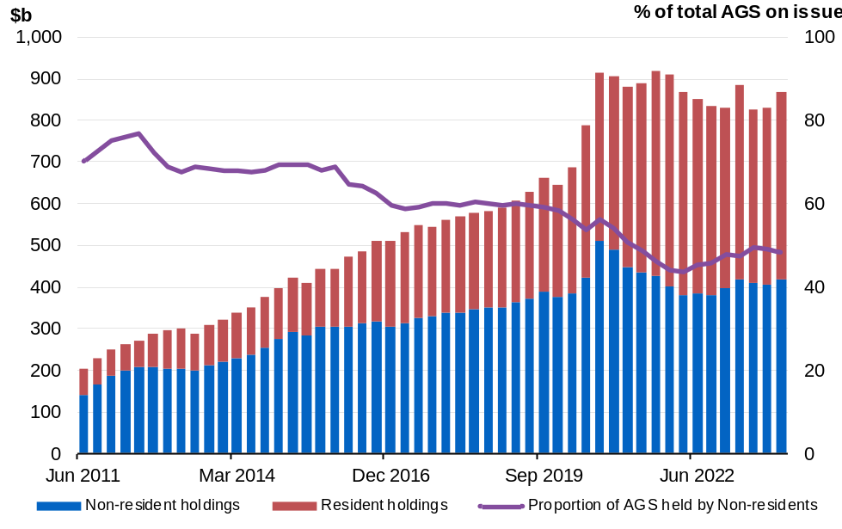
Note: Data refer to the repo-adjusted market value of holdings.
Source: ABS Balance of Payments and International Investment Position, Australia December 2023, AOFM, RBA.

Net debt
Net debt is equal to the sum of interest-bearing liabilities (which include AGS on issue measured at market value) less the sum of selected financial assets (cash and deposits, advances paid and investments, loans and placements). As net debt incorporates both selected financial assets and liabilities at their fair value, it provides a broader measure of the Government’s financial obligations than gross debt.
Not all government assets or liabilities are included in the measurement of net debt. For example, the Government’s unfunded superannuation liability is not accounted for in net debt, nor are holdings of equities, for example those held by the Future Fund or the Government’s equity investment in the NBN.
Table 7.7: Liabilities and assets included in net debt
 |  |  |  | Estimates
 | 2023-24 | 2024-25 | 2025-26 |  | 2026-27 | 2027-28
 | $m | $m | $m |  | $m | $m
Liabilities included in net debt
Deposits held | 415 | 415 | 415 |  | 415 | 415
Government securities(a) | 847,774 | 885,886 | 962,711 |  | 1,026,120 | 1,080,171
Loans | 31,772 | 32,360 | 33,379 |  | 33,786 | 33,779
Lease liabilities | 19,302 | 18,649 | 17,484 |  | 16,508 | 16,115
Total liabilities included in net debt | 899,263 | 937,310 | 1,013,988 |  | 1,076,829 | 1,130,480
Assets included in net debt
Cash and deposits | 89,311 | 61,997 | 57,532 |  | 54,634 | 49,732
Advances paid | 67,539 | 73,193 | 83,592 |  | 94,634 | 105,091
Investments, loans and placements | 242,528 | 249,588 | 257,386 |  | 267,513 | 278,151
Total assets included in net debt | 399,378 | 384,778 | 398,510 |  | 416,781 | 432,974
Net debt | 499,886 | 552,532 | 615,478 |  | 660,048 | 697,505
- Government securities are presented at market value.

Changes in net debt since the 2023–24 MYEFO
Net debt is expected to be higher than estimated at the 2023–24 MYEFO across each year of the forward estimates. This increase primarily reflects the impact of lower yields on AGS, as well as an increase in the financing requirement from 2024–25 onwards.
Table 7.8: Net debt – reconciliation from the 2023–24 MYEFO to the 2024‍–‍25 Budget
 | 2023-24 | 2024-25 | 2025-26 | 2026-27
 | $b | $b | $b | $b
Net debt as at 2023-24 MYEFO | 491.0 | 533.3 | 586.4 | 623.9
Changes in financing requirement | -5.0 | 3.6 | 10.7 | 20.0
Impact of yields on AGS | 20.3 | 16.3 | 12.8 | 8.4
Asset and other liability movements | -6.5 | -0.7 | 5.6 | 7.7
Cash and deposits | -8.8 | -3.1 | 4.5 | 8.8
Advances paid | 4.7 | 6.1 | 5.2 | 3.0
Investments, loans and placements | -2.1 | -3.1 | -4.3 | -4.8
Other movements | -0.3 | -0.5 | 0.1 | 0.7
Total movements in net debt from 2023-24 MYEFO to 2024-25 Budget | 8.8 | 19.2 | 29.1 | 36.1
Net debt as at 2024-25 Budget | 499.9 | 552.5 | 615.5 | 660.0

Interest on AGS
Estimates of the interest payments and expense of AGS on issue include the cost of AGS already on issue and future AGS issuance.
- The cost of AGS already on issue reflects the actual yield at the time of issuance.
- The expected cost of future AGS issuance is based on a recent average of daily spot rates across the yield curve at the time of a budget estimates update.
Total interest payments on AGS across the forward estimates are estimated to be broadly similar compared to the 2023–24 MYEFO. This is primarily due to lower yields and improved terms of borrowing offsetting the change in the headline cash balance across the forward estimates.
Chart 7.2 shows the yield curve assumptions underpinning the 2022 Pre-election Economic and Fiscal Outlook (PEFO), 2023-24 MYEFO and the 2024‍–‍25 Budget. Yields are lower compared to the 2023–24 MYEFO, reflecting a moderation in market expectations for inflation and future cash rates.
Volatility in yields over the past two years has influenced the outlook for interest payments. The supply of bonds, expectations for future monetary policy and perceptions of risks all influence yields. While yields have fallen since the end of 2023, they remain significantly higher than at the 2022 PEFO.
At the 2022 PEFO, the weighted average cost of borrowing was 2.2 per cent, rising to 3.8 per cent at the 2022–23 October Budget. The weighted average yield fell to 3.4 per cent at the 2023–24 Budget, before increasing to 4.7 per cent at the 2023–24 MYEFO. Since then, the assumed weighted average cost of borrowing has fallen to 4.2 per cent for future issuance of Treasury Bonds over the forward estimates in this budget.
Chart 7.2: Yield curve assumptions from 2024–25 to 2027–28
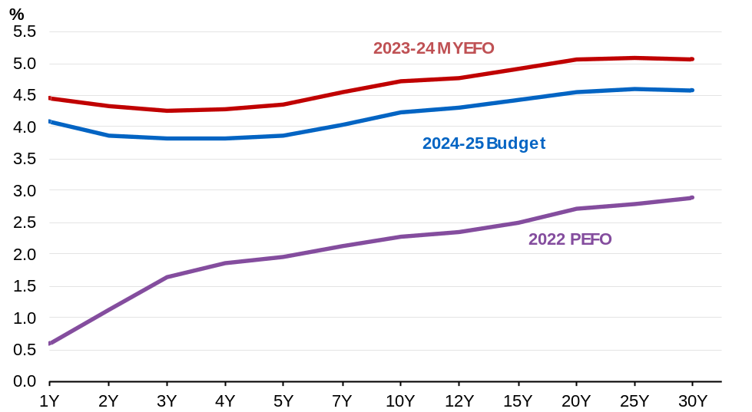
Source: AOFM.

By the end of the forward estimates total interest payments are $35.6 billion, of which $34.1 billion relates to AGS on issue (Table 7.9). Compared with the 2023–24 MYEFO, interest payments as a share of GDP are estimated to be broadly unchanged since the 2023‍–‍24 MYEFO.
Interest receipts are estimated to be higher across each year of the forward estimates than at the 2023–24 MYEFO and broadly unchanged as a share of GDP.
Net interest payments as a share of GDP in 2024–25 are estimated to be broadly similar to the 2023–24 MYEFO. Over the forward estimates, net interest payments as a share of GDP are expected to be 0.5 per cent in 2023–24, reaching 0.8 per cent of GDP by 2027–28.

Table 7.9: Interest payments, interest receipts and net interest payments^{(a)}
 |  | Estimates
 | 2023-24 | 2024-25 | 2025-26 | 2026-27 | 2027-28
 | $m | $m | $m | $m | $m
Interest payments on AGS(b) | 20,967 | 22,364 | 26,052 | 28,339 | 34,057
Per cent of GDP | 0.8 | 0.8 | 0.9 | 0.9 | 1.1
Interest payments(c) | 22,685 | 23,824 | 27,502 | 29,833 | 35,585
Per cent of GDP | 0.8 | 0.9 | 1.0 | 1.0 | 1.1
Interest receipts | 10,404 | 9,275 | 8,705 | 9,051 | 9,591
Per cent of GDP | 0.4 | 0.3 | 0.3 | 0.3 | 0.3
Net interest payments(d) | 12,281 | 14,549 | 18,797 | 20,782 | 25,994
Per cent of GDP | 0.5 | 0.5 | 0.7 | 0.7 | 0.8
- Interest payments and receipts are a cash measure, with the relevant amount recognised in the period in which the interest payment is made or interest is received.
- The increases in 2025–26 and 2027–28 primarily reflect Treasury Indexed Bond lines maturing in those years.
- Interest payments include interest payments on AGS, loans and other borrowing, as well as interest payments on lease liabilities.
- Net interest payments are equal to the difference between interest payments and interest receipts.

As well as cash accounting terms, interest costs related to AGS are also presented on accrual accounting terms. The difference between the cash interest payments and accrual interest expense generally relates to the timing of when the interest cost is recognised.
- Interest payments are recognised in the period when they are paid during the life of the security.
- Interest expense is recognised in the period in which an expense is incurred during the life of the security, rather than when it is actually paid.

The Government’s total interest expense in 2024–25 is estimated to be $33.4 billion, of which $24.1 billion relates to AGS on issue. Table 7.10 shows changes in interest expense, interest income and net interest expense over the forward estimates.
Table 7.10: Interest expense, interest income and net interest expense^{(a)}
 |  |  | Estimates
 | 2023-24 | 2024-25 |  | 2025-26 | 2026-27 | 2027-28
 | $m | $m |  | $m | $m | $m
Interest expense on AGS | 22,533 | 24,083 |  | 28,259 | 32,422 | 35,733
Per cent of GDP | 0.8 | 0.9 |  | 1.0 | 1.1 | 1.1
Total interest expense(b) | 27,667 | 33,414 |  | 34,300 | 39,085 | 41,190
Per cent of GDP | 1.0 | 1.2 |  | 1.2 | 1.3 | 1.3
Interest income | 11,131 | 10,276 |  | 9,998 | 10,573 | 11,338
Per cent of GDP | 0.4 | 0.4 |  | 0.3 | 0.3 | 0.4
Net interest expense(c) | 16,536 | 23,138 |  | 24,302 | 28,511 | 29,853
Per cent of GDP | 0.6 | 0.8 |  | 0.8 | 0.9 | 0.9
- Interest expense is an accrual measure, with the relevant amount recognised in the period in which the expense is incurred, but not necessarily paid.
- Total interest expense includes interest expense on AGS, loans and other borrowing, as well as interest expense on lease liabilities and other financing costs (including debt not expected to be repaid (DNER)).
- Net interest expense is equal to the difference between interest expenses and interest income.

Appendix A: AGS issuance
The Australian Office of Financial Management (AOFM) is responsible for issuing AGS and managing the Government’s financing activities. The AOFM currently issues three types of securities:
- Treasury Bonds: medium to long-term securities with a fixed annual rate of interest payable every six months. This will include the Green Treasury Bonds the Government will begin issuing before 30 June 2024.
- Treasury Indexed Bonds (TIBs): medium to long-term securities for which the capital value of the security is adjusted for movements in the consumer price index (CPI). Interest on TIBs is paid quarterly, at a fixed rate, on the adjusted capital value.
- Treasury Notes: short-term discount securities which mature within one year of issuance. The volume of Treasury Notes on issue will vary over the course of the year, depending on the size and profile of the within-year funding requirements.
Within these three broad categories of AGS, issuance is undertaken into a limited number of maturities (known as lines). The number of lines on issue is determined by the AOFM as part of its debt portfolio management role. Each line has a fixed maturity date (the date on which the Government repays the principal it has borrowed) and, for Treasury Bonds and TIBs, a coupon rate (the annual fixed interest rate paid on the security).
Concentrating AGS issuance into a limited number of lines (rather than issuing securities with a specific tenor, such as ten years) ensures each line is sufficiently large that it can be more readily traded in the secondary market. Strong liquidity in the secondary market is attractive to investors and intermediaries, promotes demand for AGS and assists in lowering borrowing costs. All AGS issuance is undertaken in Australian dollars.
The AOFM exercises operational independence in the execution of its duties. Its announced issuance program for each year is determined on the basis of maturing AGS, net new issuance required to fund the Budget and operational considerations.
Operational considerations often mean that the annual issuance program may not be equivalent to the financing task for a particular year. For example, the AOFM may decide there is merit in holding higher or lower cash balances. The AOFM may also choose to smooth issuance across several financial years in order to reduce changes in AGS issuance from one financial year to the next.
The AOFM aims to maintain an AGS yield curve out to a 30-year benchmark bond. This facilitates a lower risk profile of maturing debt, broadens the investor base and helps to reduce the impact of interest rate volatility on budget outcomes. Further details on the AOFM’s debt issuance program are available on the AOFM website at www.aofm.gov.au.
The AOFM publishes an issuance program for the budget year only. Estimates beyond the budget year are based on a set of technical assumptions and will vary with changes to these assumptions and budget estimates.

For Treasury Indexed Bonds (TIBs), the final repayment amount paid to investors includes an additional amount to reflect the impact of inflation over the life of the security. This additional amount is not included in the calculation of face value.
End-of-year values are estimates of AGS on issue at 30 June for the particular year. The precise timing and level of within-year peaks of AGS on issue cannot be determined with accuracy. The timing of the within-year peak is therefore reported to the given month in the particular year.

