Statement 2:
Economic Outlook
The Australian economy has turned a corner, despite difficult global conditions. Inflation continues to moderate and has returned to the Reserve Bank of Australia’s (RBA) target band without a period of negative growth, the unemployment rate remains low and real wages are rising. Every Australian taxpayer is receiving a tax cut and interest rates have begun to fall. The economy recorded a solid rebound in growth at the end of last year and momentum is expected to gradually improve.
There is heightened uncertainty in the global economy including from trade tensions and conflict in the Middle East and Europe. The escalation of trade tensions has significantly magnified volatility in global markets and could disrupt global and domestic trade, investment flows and economic activity, and push up prices. Global growth is already subdued, and this is expected to continue for the next three years. Around three quarters of OECD nations have recorded a negative quarter of growth over the past 18 months.
Inflation has fallen across most advanced economies but, for some, this has come at the cost of higher unemployment, very weak growth or recession. While global inflationary pressures are abating, disinflation has stalled in some economies. This has led some central banks to exercise more caution in relation to further easing of monetary policy.
The Australian economy has not been immune to challenging conditions at home. Communities and businesses across Australia including in north Queensland, Far North Queensland, southeast Queensland and northern New South Wales have faced natural disasters like ex-Tropical Cyclone Alfred which have curtailed economic activity, harmed industries, and damaged homes and infrastructure. The impact of ex-Tropical Cyclone Alfred could subtract up to ¼ of a percentage point from quarterly growth.
A soft landing in our economy is increasingly likely. Unlike the experience of other advanced economies and previous inflationary episodes, Australia has been able to achieve a substantial moderation in inflation while maintaining a low unemployment rate. Recent outcomes for inflation and unemployment have been better than expected, and the near-term outlook has improved on both fronts. This means that the Australian economy is one of the best placed to navigate this period of heightened uncertainty.
Inflation has moderated significantly from its peak in both headline and underlying terms. Headline inflation returned to the RBA’s target band in the second half of 2024 and is now expected to be 2½ per cent through the year to the June quarter 2025, a ¼ of a percentage point lower than forecast at MYEFO. Excluding the temporary impact of energy rebates and fuel, inflation is expected to sustainably return to the RBA’s target band around the middle of this year, earlier than expected at MYEFO. As a result of the easing inflationary pressures, the Reserve Bank Board reduced its target cash rate to 4.10 per cent in February.
The labour market has outperformed expectations. The unemployment rate has stayed low, the participation rate remains elevated, and employment has grown by more than one million people since May 2022 with around 80 per cent of jobs created in the private sector since the June quarter 2022. Strong employment growth has helped to limit the increase in the unemployment rate from its recent trough. The unemployment rate is forecast to peak at 4¼ per cent, which is ¼ of a percentage point below MYEFO.
The strength of labour market conditions and moderating inflation have continued to drive growth in real wages. Annual real wages have now grown for five consecutive quarters and are forecast to grow by ½ per cent in 2024–25, which is ¼ of a percentage point higher compared to MYEFO, and ¼ per cent in 2025–26. Nominal wages are expected to continue growing above the pre-pandemic average.
Growth picked up at the end of last year, supported by a recovery in private final demand. The economy grew 0.6 per cent in the December quarter, which is more than the average of the previous three quarters. Momentum is expected to continue to build, with growth forecast to continue to pick up from 1½ per cent in 2024–25 to 2¼ per cent in 2025–26 and 2½ per cent in 2026–27.
The improvement in growth is expected to be broad-based and supported by stronger private final demand. After stalling in the middle of last year, consumption grew 0.4 per cent in the December quarter 2024. The Government’s tax cuts, the easing in inflation and strong employment and wage growth have resulted in real household disposable income per capita returning to growth in the second half of 2024, supporting the gradual recovery in consumption growth.
Investment is expected to support activity over the forecast period. Business investment has grown solidly for the past two years. While growth is forecast to moderate over the period ahead, the level of business investment is expected to remain at its recent decade highs. Dwelling investment is expected to grow from this financial year.
Public final demand helped ensure the economy continued to grow. This has been driven by spending on demand-driven programs in health, education and social services, as well as energy bill relief and infrastructure spending by state and federal governments. Growth in public final demand is expected to moderate over the forecast period.
The Australian economy faces a range of domestic risks, including the uncertainty confronting communities recovering from the effect of natural disasters. Growth could also be weaker in the near term if households continue to prioritise savings over consumption as real incomes recover. A continued and sustained depreciation of the exchange rate, or a stalling in the moderation of services inflation could also pose upside risk to inflation.
Global developments also cast a shadow over the Australian economic outlook. Ongoing weaker economic conditions in China could lead to lower service and commodity exports. Policy uncertainty related to trade tensions could weigh on domestic investment and employment. The use of tariffs by major trading partners could lead to higher import prices and temporarily higher inflation and lower growth. Nonetheless, the progress the Australian economy has made over the past couple of years means that it is well placed to manage these challenges.

Statement contents
Outlook for the international economy 37
Outlook for major trading partners 40
Outlook for the domestic economy 42
Household consumption 44
Dwelling investment 44
Business investment 44
Public final demand 45
International trade 46
Labour market and wages 46
Inflation 47
Net overseas migration 50
Nominal GDP and the medium-term outlook 50

Statement 2: Economic Outlook

Outlook for the international economy
The escalation of global trade tensions has contributed to significant market volatility and made the international outlook more uncertain. Tariffs and other trade barriers could weigh on global growth by disrupting trade and investment flows, driving up costs for businesses and consumers (Box 2.1). The related policy uncertainty may exacerbate the risks to business investment, employment and household spending. A slowdown in global growth stemming from these pressures would also adversely affect demand for key Australian exports, domestic business confidence, and investment. These risks compound the uncertainty in the global economy from conflict in the Middle East and Europe and challenges in the Chinese economy.
Against this backdrop of greater uncertainty, the global economy is expected to grow by 3¼ per cent in each of the next three years. If realised, this would represent the longest stretch of below-average growth since the early 1990s. The global outlook remains clouded by uneven risks in the trajectory of growth, inflation and monetary policy.
Globally, inflation has moderated, but disinflation appears to have stalled in many major economies. This has prompted some central banks to adopt a more cautious stance toward further monetary policy easing, which poses a downside risk to the global outlook. Inflation is expected to continue moderating across major advanced economies in 2025, albeit more gradually. Outside of Australia, very few advanced economies have managed to reduce inflation while sustaining a relatively robust labour market and unbroken economic growth.
Table 2.1: International GDP growth forecasts^{(a)}
 | Outcome | Forecasts (Calendar Years)
 | 2024 | 2025 | 2026 | 2027
Australia | 1.1 | 2 1/4 | 2 1/4 | 2 3/4
China | 5.0 | 4 3/4 | 4 1/2 | 4 1/4
India | 6.5 | 6 3/4 | 6 1/2 | 6 1/2
Japan | 0.1 | 1 1/4 | 1 | 3/4
United States | 2.8 | 2 | 2 | 2
Euro area | 0.9 | 1 | 1 1/4 | 1 1/4
United Kingdom | 0.9 | 1 1/4 | 1 1/2 | 1 1/2
Other East Asia^{(b)(c)} | 4.2 | 4 | 4 | 4
Major trading partners^{(b)} | 3.3 | 3 1/2 | 3 1/4 | 3 1/4
World^{(b)} | 3.3 | 3 1/4 | 3 1/4 | 3 1/4
- Percentage change on previous year. The 2024 outcome for India is reported for the fiscal year ending March 2025.
- World and Other East Asia growth rates are calculated using GDP weights based on purchasing power parity (PPP). Growth rates for major trading partners are calculated using Australian goods and services export trade weights.
- Other East Asia comprises Indonesia, Malaysia, the Philippines, Thailand, Vietnam, Singapore, Hong Kong, South Korea and Taiwan.
Source: National statistical agencies, IMF, Refinitiv and Treasury.

Box 2.1: Risks of an escalation in global trade tensions
Tariffs and trade restrictions have become more common in recent years. According to the IMF, restrictions on trade and investment have grown sixfold in the past 15 years. Tariffs generally raise prices for businesses and consumers by increasing the cost of imported goods, which lowers growth.
Tariff reductions since the 1970s have provided significant benefits to the Australian economy. Sectors exposed to trade are typically the most productive, as firms exposed to global competition are forced to innovate and improve efficiency. Even small tariffs create inefficiencies and costs for businesses and consumers. The Government’s 2024–25 Budget included the elimination of around 500 nuisance tariffs, which will lower costs and improve productivity.
Tariffs directly imposed on Australian exports lower demand by making them more expensive to purchase in the country imposing the tariffs. This effect could be offset to some extent by a depreciation of the Australian dollar, which would make Australian exports less expensive in foreign currency terms. Australian firms have also demonstrated that they are very adept at finding alternative markets for Australian exports.
The Australian economy will also be affected indirectly when tariffs are placed on the exports of countries that use Australian exports as inputs. This indirect trade effect can be larger than the direct effect given that Australia exports large volumes of raw materials that are often used to produce goods that are then exported.
A scenario in which the United States imposes a 25 per cent tariff on all imports of durable manufacturing goods, such as steel and aluminium, illustrates these points. The imposition of the tariff leads to a reduction in the real GDP of Australia, China and the United States over time. Overall, the total impact (direct plus indirect) of the tariffs on Australia’s economy by 2030 is expected to be modest (Chart 2.1).
The indirect effect of the tariffs is estimated to be nearly four times as large as the direct effect, reflecting the relative importance of affected trade flows between Australia, China, and the United States. In this scenario, the United States also experiences a persistent increase in inflationary pressures because imports become more expensive, while Australia experiences a small temporary increase in inflation related to a depreciation of the Australian dollar (Chart 2.2).
If all countries, including Australia and China, retaliate by imposing a 25 per cent tariff on all imports of durable manufacturing goods from the United States, the loss in real GDP is amplified for all countries, as is the increase in inflationary pressures (Charts 2.3 and 2.4).
continued on next page

Box 2.1: Risks of an escalation in global trade tensions (continued)
25 per cent tariff on durable manufacturing goods, relative to no tariff scenario
Chart 2.1: Change to real GDP | Chart 2.2: Change to inflation
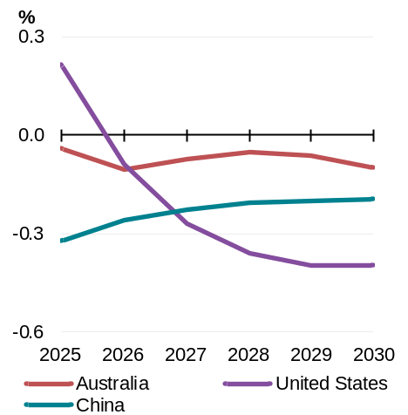 | 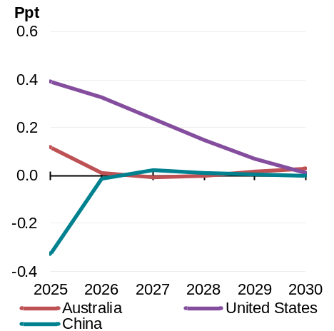
Source: Treasury analysis using G-Cubed. | Source: Treasury analysis using G-Cubed.

25 per cent retaliatory tariff, relative to no tariff scenario
Chart 2.3: Change to real GDP | Chart 2.4: Change to inflation
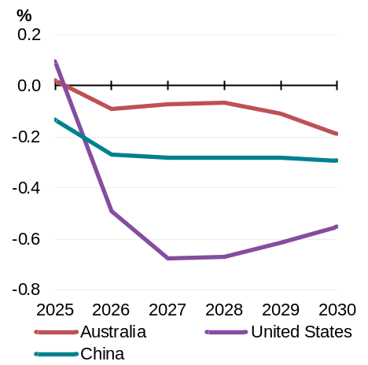 | 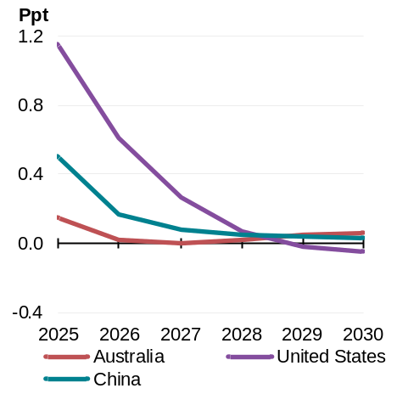
Source: Treasury analysis using G-Cubed. | Source: Treasury analysis using G-Cubed.

Escalating trade tensions have created significant uncertainty and volatility in global financial markets. These factors can compound the direct and indirect effects of tariffs on global growth captured in the scenarios above by discouraging investment and dampening consumer confidence.

Outlook for major trading partners
China’s economy faces growing near-term pressures from the property sector downturn and rising trade tensions with the United States. However, the lagged effects of policy easing in late-2024 plus the announcement of increased fiscal support are expected to support growth in 2025. In the longer-term, structural challenges, including a shrinking workforce and lower productivity growth, will weigh on domestic demand and growth.
In 2024, China’s economy grew by 5 per cent, in line with its official growth target (Chart 2.5). Industrial production and exports picked up late in the year, in part due to orders brought forward in anticipation of the imposition of higher import tariffs in the United States. This growth in exports has helped offset weak consumption and property investment activity.
While Chinese authorities continue to support strategic sectors like electric vehicles and green technology, it will be difficult for China to replace traditional growth drivers like real estate and infrastructure investment. Given the scale of China’s exports to the United States, escalating trade tensions would directly affect exports and have implications for investment in trade-exposed sectors.
Chart 2.5: Chinese GDP growth | Chart 2.6: United States GDP growth
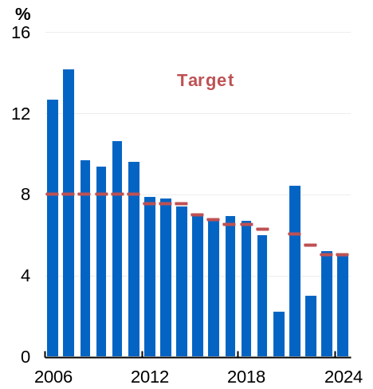 | 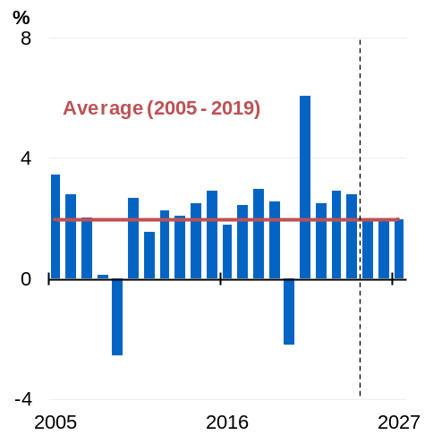
Source: NBS China, Refinitiv and Treasury. | Source: Bureau of Economic Analysis, Refinitiv and Treasury.

The United States economy outperformed other advanced economies in 2024 (Chart 2.6). Robust productivity growth has enabled inflation to fall significantly from its mid-2022 peaks, even with strong consumer demand fuelled by a resilient labour market and strong income growth. However, persistent price pressures in the services sector, alongside early signs of a possible resurgence in goods inflation, have stalled progress towards the Federal Reserve’s target. The Federal Reserve has indicated that it is well positioned but is waiting to see the impact of the US administration’s policy agenda.
Recent trade policies and the associated policy uncertainty are having a negative impact on consumer and business sentiment, increasing inflation expectations, and affecting trade between the United States and the rest of the world. The US administration has also foreshadowed changes to fiscal settings and a focus on deregulation which, depending on how they are approached, have the potential to stimulate spending and investment.
Euro area GDP is forecast to strengthen to 1 per cent in 2025, and 1¼ per cent in both 2026 and 2027. Inflation is expected to decline to the European Central Bank’s target by the end of 2025. Less restrictive monetary policy and rising real wages are expected to support consumption in the near term. The prospect of increased defence and infrastructure spending (particularly in Germany) could also boost growth. However, German industrial weakness and the continuing transition away from Russian energy sources pose downside risk to the outlook.
The scale of the European Union’s trade relationships with both China and the United States offers it substantial influence over the evolution of global trade tensions. In 2024, concerns about state support for China’s electric vehicle supply chain led the European Commission to impose tariffs on Chinese electric vehicle imports. More recently, the European Commission responded to US tariffs on European steel and aluminium exports with an array of countermeasures.
Economic growth in the United Kingdom picked up gradually in 2024, driven by increased household and government spending. However, this was offset by soft business investment and a decline in exports. Growth is expected to be subdued in 2025 as a temporary expansion in government expenditure wanes in the second half of the year. The UK economy is expected to recover moderately in 2026 and 2027 driven by a pick-up in household consumption and business investment.
In Japan, economic momentum slowed in mid-2024 amid temporary supply disruptions in the auto sector, before regaining momentum in the second half of the year as supply disruptions abated. Recent strong wage growth is expected to persist into 2025, and it is expected to contribute to inflation remaining above the Bank of Japan’s 2 per cent target through to 2026. Growth is expected to be around 1¼ per cent in 2025 before easing over the course of 2026 and 2027.
India is forecast to grow by 6¾ per cent in 2025 and 6½ per cent in 2026 and 2027. Private consumption and investment remain crucial drivers of India’s economic growth, with various signs indicating the slowdown in 2024 was transitory. Near-term growth is expected to be driven by ongoing robustness in domestic consumption, increased government spending, easing of monetary policy, and an expansion of the manufacturing sector under key government initiatives.
Other East Asia is forecast to grow by 4 per cent in 2025, 2026 and 2027. Domestic demand of key economies in the region is expected to be bolstered by an easing of monetary policy. However, escalating trade tensions could dampen investor confidence and weigh on growth.

Outlook for the domestic economy
Despite heightened global uncertainty, growth has picked up and a soft landing is looking increasingly likely (Box 2.2). The economy is expected to gain further momentum over 2025 as private final demand gradually recovers. Real GDP is forecast to grow by 1½ per cent in 2024–25, 2¼ per cent in 2025–26 and 2½ per cent in 2026–27.
Ex-Tropical Cyclone Alfred and the subsequent flooding significantly affected communities and businesses in southeast Queensland and northern New South Wales. The disaster curtailed economic activity, harmed industries, and damaged homes and infrastructure. The direct loss of economic activity could temporarily lower quarterly growth by up to ¼ of a percentage point. This reflects impacts on activity in the agricultural, construction, retail, transport and tourism industries. Subsequent reconstruction efforts are expected to add to real GDP growth in following quarters, although the magnitude and timing of the effect on activity is uncertain. It could also add upward pressure to prices through damage to crops and the rebuilding work.
Household consumption growth remained subdued over 2024 with many households continuing to face cost-of-living pressures, including high mortgage costs. However, growth in real household disposable income is forecast to continue to pick up, which is expected to drive a gradual rise in consumption over the forecast period.
Public final demand helped ensure the economy continued to grow over the past two years. Growth in 2024–25 is higher than expected at MYEFO due to mid-year updates to state government budgets and demand-driven programs. However, public demand is expected to moderate as private final demand becomes a more prominent driver of growth in the economy.
Business investment has grown solidly for two years and, although growth is forecast to moderate, is expected to remain at recent decade highs. Non-mining investment is expected to be the main contributor to growth over coming years, supported by investment in renewable energy infrastructure, warehouses and data centres. Dwelling investment is expected to accelerate from 2025–26 in response to robust housing demand and an easing to both supply-side constraints and financing costs.
Employment growth has been strong and the unemployment rate has remained low. The strength of the labour market has contributed to a smaller-than-expected rise in the unemployment rate. The unemployment rate is forecast to peak at 4¼ per cent, which is ¼ of a percentage point lower compared to MYEFO, and nominal wage growth is expected to remain above pre-pandemic rates.
Inflation has moderated substantially, and recent progress has been better than expected. Inflation is now forecast to be 2½ per cent through the year to the June quarter 2025, a ¼ of a percentage point lower than expected at MYEFO. Excluding energy rebates and fuel, inflation is expected to return sustainably to the target band around the middle of this year. The better near-term outlook for inflation means that real wages are now expected to grow ½ per cent in 2024–25, an upgrade of ¼ of a percentage point since MYEFO.
Table 2.2: Domestic economy – detailed forecasts^{(a)}
 | Outcomes^{(b)} | Forecasts
 | 2023–24 | 2024–25 | 2025–26 | 2026–27
Real gross domestic product | 1.4 | 1 1/2 | 2 1/4 | 2 1/2
Household consumption | 1.0 | 3/4 | 2 1/4 | 2 1/4
Dwelling investment | -1.4 | 1 1/2 | 5 1/2 | 7 1/2
Total business investment^{(c)} | 6.0 | 1 | 1 1/2 | 1 1/2
By industry
Mining investment | 7.8 | -3 1/2 | 2 1/2 | 3
Non-mining investment | 5.5 | 2 1/2 | 1 | 1
Private final demand^{(c)} | 1.7 | 1 | 2 1/2 | 2 3/4
Public final demand^{(c)} | 4.2 | 5 | 3 | 2
Change in inventories^{(d)} | -0.5 | 0 | 0 | 0
Gross national expenditure | 1.8 | 2 | 2 1/2 | 2 1/2
Exports of goods and services | 3.8 | 1 | 2 1/2 | 2 1/2
Imports of goods and services | 6.3 | 2 1/2 | 4 | 2 1/2
Net exports^{(d)} | -0.4 | - 1/2 | - 1/4 | 0
Nominal gross domestic product | 4.1 | 4 1/4 | 3 1/4 | 4
Prices and wages
Consumer price index^{(e)} | 3.8 | 2 1/2 | 3 | 2 1/2
Wage price index^{(f)} | 4.1 | 3 | 3 1/4 | 3 1/4
GDP deflator | 2.7 | 2 3/4 | 1 | 1 1/2
Labour market
Participation rate (per cent)^{(g)} | 66.8 | 67 1/4 | 67 | 66 3/4
Employment^{(f)} | 2.2 | 2 3/4 | 1 | 1 1/4
Unemployment rate (per cent)^{(g)} | 4.0 | 4 1/4 | 4 1/4 | 4 1/4
Balance of payments
Terms of trade^{(h)} | -6.3 | -2 1/2 | -6 | -3
Current account balance (per cent of GDP) | -1.3 | -1 3/4 | -3 3/4 | -4 1/4
Net overseas migration^{(i)} | 435,000 | 335,000 | 260,000 | 225,000
- Percentage change on preceding year unless otherwise indicated.
- Calculated using original data unless otherwise indicated.
- Excluding second-hand asset sales between the public and private sector.
- Percentage point contribution to growth in GDP.
- Through-the-year growth rate to the June quarter.
- Seasonally adjusted, through-the-year growth rate to the June quarter.
- Seasonally adjusted rate for the June quarter.
- Some commodity prices are assumed to decline from elevated levels over four quarters to the end of the March quarter of 2026: the iron ore spot price is assumed to decline to US$60/tonne; the metallurgical coal spot price declines to US$140/tonne; the thermal coal spot price declines to US$70/tonne; and the LNG spot price converges to US$10/mmBtu. All bulk prices are in free on board (FOB) terms.
- Net overseas migration is forecast to be 225,000 in 2027–28 and 2028–29. The migration forecast does not incorporate the ABS National, state and territory population released on 20 March 2025.
Note: These forecasts are based on several technical assumptions. The exchange rate is assumed to remain around its recent average level – a trade‑weighted index of around 60 and a $US exchange rate of around 62 US cents. The cash rate assumption is informed by the Bloomberg survey of market economists and is assumed to be around 50 basis points lower by the end of 2025. World oil prices (Malaysian Tapis) are assumed to remain flat around US$81 per barrel. The labour market forecasts do not incorporate the February 2025 release of the ABS Labour Force.
Source: ABS Australian National Accounts: National Income, Expenditure and Product; Balance of Payments and International Investment Position, Australia; National, state and territory population; Labour Force, Australia; Wage Price Index, Australia; Consumer Price Index, Australia; unpublished ABS data and Treasury.

Household consumption
Households continue to face cost-of-living pressures, but these pressures are easing. Lower inflation, continued employment growth, higher wages, tax cuts, and the recent reduction in interest rates will support a pick-up in real household disposable income (Chart 2.7). Real household disposable income in 2026–27 is forecast to be around 8¾ per cent higher compared to 2023–24. This is expected to support a gradual pick-up in household consumption, with consumption forecast to grow by ¾ per cent in 2024–25 and 2¼ per cent in both 2025–26 and 2026–27 (Chart 2.8).
Chart 2.7: Real household gross disposable income growth | Chart 2.8: Household consumption growth
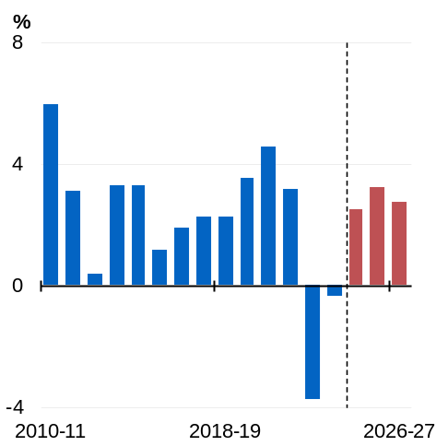 | 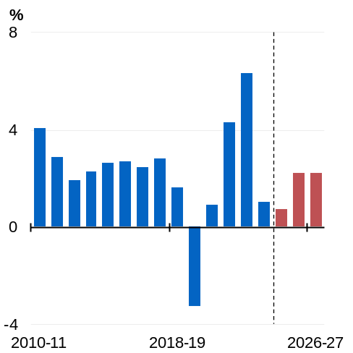
Source: ABS Australian National Accounts: National Income, Expenditure and Product and Treasury. | Source: ABS Australian National Accounts: National Income, Expenditure and Product and Treasury.

Dwelling investment
There are signs that capacity constraints in the construction sector are gradually easing. Inflation in the price of construction materials has fallen and the availability of suitable labour is beginning to improve. Alongside the easing in capacity constraints, financing costs are also expected to moderate. This will enable construction activity to gradually respond to robust housing demand, with dwelling investment expected to grow by 1½ per cent in 2024–25, 5½ per cent in 2025–26 and 7½ per cent in 2026–27 (Chart 2.9).

Business investment
Business investment has grown solidly for two years, supported by resilient business balance sheets and elevated levels of capacity utilisation. While growth in business investment is expected to moderate, the level of business investment is expected to remain elevated at decade highs.
Non-mining investment is expected to be the main contributor to growth in business investment over coming years, with key investments focused on renewable energy infrastructure, warehouses and data centres.
In the near term, mining investment growth is expected to moderate as new LNG projects reach completion. Future mining investment is largely expected to maintain current production levels, alongside a modest number of new small LNG and metal ore projects.

Public final demand
Growth in public demand has helped to ensure the economy has continued to grow but is forecast to moderate over the period ahead as growth in the private sector recovers. Growth in public demand has been driven by spending on essential services, cost-of-living relief and infrastructure at all levels of government. Growth in the most recent quarter was driven entirely by state spending, with the Commonwealth component falling.
Public demand growth is forecast to moderate from 5 per cent in 2024–25 to 2 per cent in 2026–27 (Chart 2.10). Growth in 2024–25 has been revised up since MYEFO reflecting mid-year updates to state budgets and demand-driven programs in health, education and social services. The expected moderation in growth is underpinned by structural reforms to Commonwealth programs taking effect, including the National Disability Insurance Scheme and Aged Care, and the working through of the strong pipeline of infrastructure projects.
Chart 2.9: Dwelling investment  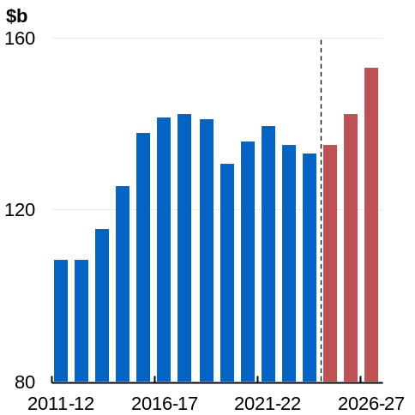 | Chart 2.10: Public demand growth  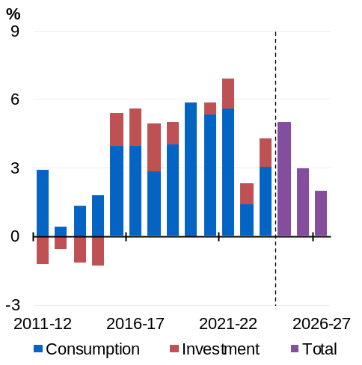
Source: ABS Australian National Accounts: National Income, Expenditure and Product and Treasury. | Source: ABS Australian National Accounts: National Income, Expenditure and Product and Treasury.

International trade
Growth in exports is expected to moderate to 1 per cent in 2024–25, with services exports growth slowing following the sharp rebound in education and tourism exports in recent years. Non-rural commodity exports are expected to remain subdued, reflecting ongoing weak conditions in the Chinese property sector. Exports are forecast to grow by 2½ per cent in both 2025–26 and 2026–27.
Growth in import volumes is expected to moderate to 2½ per cent in 2024–25. This reflects the slowing in service imports, although goods imports are expected to be supported by strength in infrastructure projects. Growth is expected to be 4 per cent in 2025–26 and 2½ per cent in 2026–27.

Labour market and wages
The labour market remains a source of strength with the unemployment rate remaining low at around 4 per cent over the past three quarters, participation remaining elevated and over one million additional people employed since May 2022 (Chart 2.11).
The labour market is forecast to remain robust over the period ahead. Since MYEFO, the outlook for employment growth has been upgraded and the participation rate is now expected to remain higher for longer. The peak in the unemployment rate is expected to be 4¼ per cent, a ¼ of a percentage point lower than forecast at MYEFO.
Nominal wage growth has eased over 2024–25 but, given the stronger labour market and expected improvement in productivity growth, is expected to remain above pre-pandemic rates (Chart 2.12). The Wage Price Index (WPI) grew by 3.2 per cent through the year to the December quarter 2024 and is expected to grow by 3 per cent through the year to the June quarter of 2025 and 3¼ per cent to June 2026.
The strength of labour market conditions and easing in inflation means that real wages are growing again. Real wages, as measured by annual growth in WPI relative to the annual growth in CPI, grew 0.8 per cent through the year to December 2024. Real wages are forecast to grow ½ per cent through the year to June quarter 2025, which is ¼ of a percentage point higher compared to MYEFO, and ¼ per cent through the year to June quarter 2026.
Chart 2.11: Unemployment and underemployment rate | Chart 2.12: Real and nominal wage growth
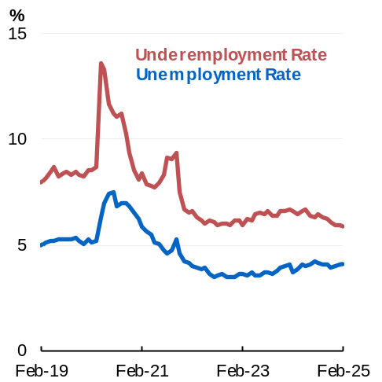 | 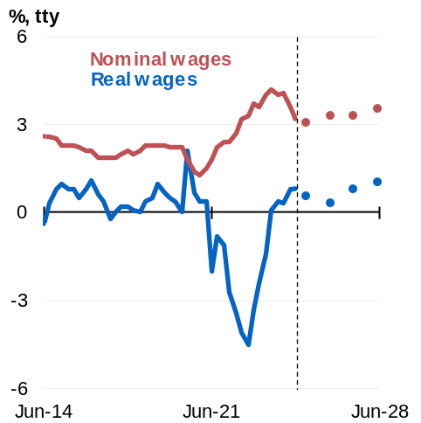
Source: ABS Labour Force. | Source: ABS Wage Price Index, ABS Consumer Price Index and Treasury.

Inflation
Inflation has moderated substantially across both headline and underlying measures. Headline inflation was 2.4 per cent through the year to December 2024, which is less than a third of its 2022 peak. Underlying inflation is now less than half its peak at 3.2 per cent through the year to December quarter 2024 and is 2.7 per cent on a six-month annualised basis.
Recent progress on inflation has been better than anticipated, with inflation now expected to be 2½ per cent through the year to the June quarter 2025, which is a ¼ of a percentage point lower than expected at the time of MYEFO. Headline inflation is forecast to be just below 3 per cent through the year to the June quarter 2026 and then be around the middle of the target band for the remainder of the forecast period (Chart 2.13). Abstracting from the impact of fuel and energy rebates, inflation is expected to sustainably be in the target band around the middle of 2025. This is earlier than was forecast at MYEFO, when inflation was not expected to be sustainably back in the band until late 2025. The Reserve Bank Board reduced the cash rate in February following the moderation in inflation.
Inflationary pressures have eased across a broad range of goods and services. Growth in goods prices normalised rapidly in 2023 and 2024, and services prices have shown signs of moderating (Chart 2.14). In particular, inflation in insurance prices is expected to have passed its peak, although premium prices have increased substantially to reflect major event risks, repair and replacement costs. Growth in rental prices has moderated as demand has softened and vacancy rates have increased. In addition, inflation in new dwelling prices has fallen significantly to be close to a tenth of its peak as capacity constraints in the construction sector ease.
The moderation in inflation has been assisted by cost-of-living relief and the decline in petrol prices around the end of 2024. Electricity rebates from Commonwealth and state governments and the additional indexation of Commonwealth Rent Assistance reduced headline inflation by ¾ of a percentage point through the year to the December quarter of 2024. Without Commonwealth and state government electricity rebates, electricity bills would have been, on average, around 45 per cent higher in the December quarter 2024. The extension of electricity rebates in this Budget will directly reduce annual inflation by ½ of a percentage point through the year to the December quarter 2025.
Chart 2.13: Headline inflation | Chart 2.14: Goods and services inflation
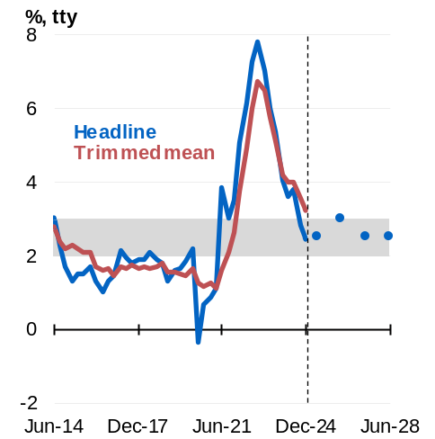 | 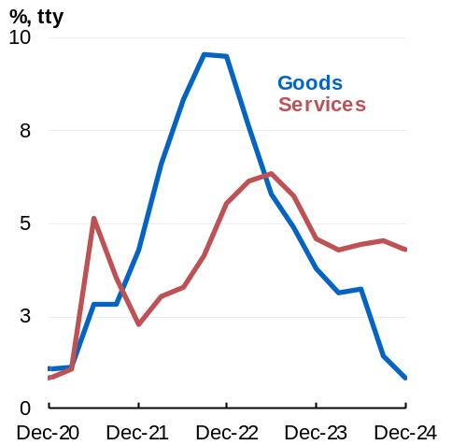
Source: ABS Consumer Price Index and Treasury.  Note: Grey shading denotes the RBA target band.  Forecasts are June quarter through-the-year headline inflation rates. | Source: ABS Consumer Price Index and Treasury.

Box 2.2: Australia’s progress towards a soft landing
The Australian economy remains on track for a soft landing following the sharpest rise in global inflation in recent decades. Macroeconomic policies have been calibrated to bring inflation down while preserving labour market gains, and managing risks to growth.
Headline inflation is now less than a third of its peak in 2022 and is near the middle of the RBA’s target band. Progress on inflation led the RBA to lower interest rates by 25 basis points in February 2025 – the first reduction in over four years. At the same time, the Australian economy has sustained a low unemployment rate of around 4 per cent or less since the start of 2022, and the economy has continued to grow. The December quarter 2024 National Accounts showed that the economy had turned a corner, with growth picking up in the quarter. Importantly, the private sector made a greater contribution to quarterly growth.
Australia’s experience compares favourably to historical and international experiences. The economy has added more than one million jobs since the RBA started raising interest rates in May 2022, with growth in jobs higher than during previous tightening episodes, particularly over the past 16 months (Chart 2.15). The participation rate and employment-to-population ratio in Australia have recently achieved record highs. The unemployment rate has risen by 0.7 percentage points since its low in 2022. By way of comparison, in the early 1990s, the unemployment rate rose by around 5 percentage points.
Despite heightened risks in the global economy, Australia is set to maintain this momentum. Prospects for jobseekers remain positive. The number of vacancies per unemployed person remains elevated, and youth unemployment remains around 3 percentage points lower than pre-pandemic rates. Growth in private demand and market-sector employment are expected to continue to gradually pick up as increases in real household disposable incomes support a recovery in consumption growth.
Unlike every major advanced economy, Australia has sustained positive quarterly economic growth during the most recent phase of monetary policy tightening. Strong policy responses have brought down inflation in peer economies, but in most cases, this has occurred alongside weaker outcomes for economic growth and the labour market (Chart 2.16). The United Kingdom and New Zealand have experienced multiple quarters of negative growth. In New Zealand the unemployment rate is 5.1 per cent and in Canada it is 6.6 per cent. In both of those economies it has increased by nearly 2 percentage points from their 2022 lows, more than two and a half times the increase in Australia.
continued on next page

Box 2.2: Australia’s progress towards a soft landing (continued)
Chart 2.15: Total employment, indexed to start of rate-hiking phase | Chart 2.16: Cumulative GDP and employment growth since late 2021
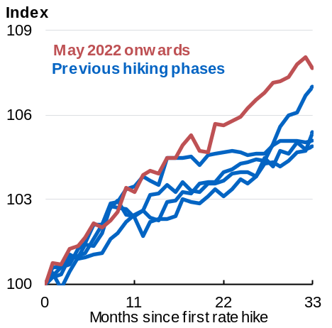 | 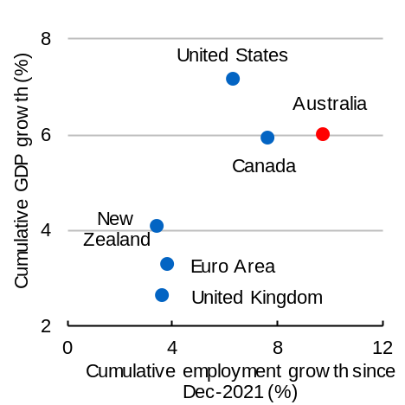
Source: ABS Labour Force and RBA. | Source: ABS Labour Force, ABS Australian National Accounts: National Income, Expenditure and Product, Refinitiv, national statistics agencies.

Net overseas migration
Net overseas migration (NOM) is declining from its peak in 2022–23 reflecting lower migrant arrivals. NOM is forecast to ease further over the forward estimates. Arrivals are expected to continue to decline in 2024–25 before stabilising in 2025–26. Departures are expected to pick up from recent sustained lows as more people who arrived after the pandemic near the expiry of their visa.

Nominal GDP and the medium-term outlook
Nominal GDP is expected to grow by 4¼ per cent in 2024–25. Nominal GDP growth is then expected to slow to 3¼ per cent in 2025–26 as a pick-up in economic growth is offset by a moderation in domestic inflation and sharper fall in the terms of trade.
The fiscal aggregates are underpinned by economic forecasts over the Budget estimates period and projections over the medium term (Chart 2.17).
Chart 2.17: Medium-term projections period
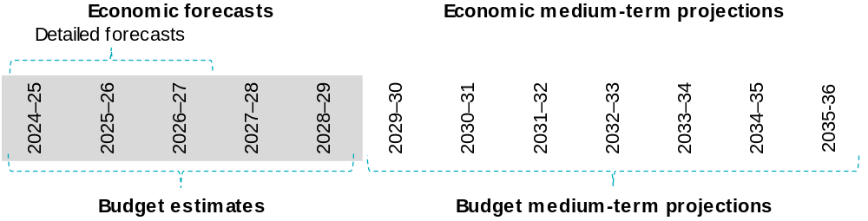
Source: Treasury.

Beyond the detailed forecast horizon of 2026–27, Treasury uses a macroeconometric model of the Australian economy for its forecasts and projections. The model informs how the economy returns to its trend level of output, known as potential GDP.
The long-run level of potential real GDP is ¼ per cent lower than MYEFO. This reflects continuing weak underlying productivity growth, which pre-dated COVID-19 pandemic-related disruptions, that are largely expected to unwind.
In the long run, underlying productivity is assumed to grow at 1.2 per cent per year, the unemployment rate remains at Treasury’s Non-Accelerating Inflation Rate of Unemployment (NAIRU) assumption of 4¼ per cent and domestic inflation converges to the midpoint of the RBA’s target band.

