Statement 3:
Fiscal Strategy and Outlook
This Budget continues the Government’s record of responsible economic and fiscal management. The underlying cash balance has improved by a cumulative $207 billion over the seven years to 2028–29, compared to the 2022 Pre-election Economic and Fiscal Outlook (PEFO). This is the largest nominal budget improvement in a parliamentary term. After delivering the first back-to-back surpluses in nearly two decades, the underlying cash deficit in 2024–25 is almost half what was forecast at the PEFO.
Gross debt is $177 billion lower in 2024–25 than forecast at the PEFO. This will help avoid more than $60 billion in interest costs over the eleven years to 2032–33. Gross debt is expected to peak at 37.0 per cent of GDP in 2029–30, 7.9 percentage points lower than the peak in the PEFO, before declining to 31.9 per cent of GDP by 2035–36.
The Government’s record of finding savings, limiting spending growth, and banking the majority of tax receipt upgrades has helped to deliver a stronger fiscal outlook. The Government has delivered $94.1 billion in savings and reprioritisations since the PEFO. Over the seven years to 2028–29, real payments growth is estimated to average 1.7 per cent per year, around half the average of 3.2 per cent over the past 30 years. The Government has also returned 69 per cent of tax receipt upgrades to the budget since the PEFO.
Fiscal policy has worked with monetary policy to return inflation to the Reserve Bank of Australia’s (RBA’s) target band in the second half of 2024. The Government’s fiscal settings are consistent with inflation sustainably returning to the target band around the middle of 2025.
The Budget position is stronger in every year of the forward estimates than the PEFO and cumulatively stronger over the forward estimates than MYEFO. A deficit of $42.1 billion is forecast in 2025–26, an improvement of $4.8 billion since MYEFO.
The Government has also made significant progress in addressing longer term structural spending pressures including interest costs on debt, the National Disability Insurance Scheme (NDIS) and aged care.
These improvements have been achieved at the same time as the Government has taken pressure off Australians by delivering responsible cost-of-living relief and invested in strengthening Medicare and building a more competitive and dynamic economy.
The Government’s responsible approach is recognised by ratings agencies. Australia remains one of only nine countries with a AAA sovereign credit rating from all three major ratings agencies. This year, Australia’s gross debt-to-GDP (including all levels of government) is expected to be around half the advanced economy average, more than 50 percentage points below the United Kingdom, and more than 70 percentage points below the United States.

Statement contents
Economic and Fiscal Strategy 58
Delivering on the Economic and Fiscal Strategy 59
Addressing unavoidable issues 60
Fiscal outlook 62
Underlying cash balance estimates 62
Receipts estimates 64
Payments estimates 65
Headline cash balance 69
Medium term projections 72
The Government’s balance sheet 76
Gross debt estimates and projections 76
Interest payments 78
Net debt estimates and projections 78
Net financial worth and net worth estimates and projections 79
Fiscal impacts of the net zero transformation 80
Australia’s classification approach 80
New net zero spending measures 83
Appendix A: Other fiscal aggregates 85
Accrual aggregates 85
Structural budget balance 88

Statement 3: Fiscal Strategy and Outlook
A deficit of 1.0 per cent of GDP ($27.6 billion) is forecast for 2024–25 (Table 3.1). This is in line with MYEFO and almost half what was forecast at the PEFO. A deficit of 1.5 per cent of GDP ($42.1 billion) is forecast in 2025–26, an improvement of 0.2 percentage points since MYEFO.
Since MYEFO, 2024–25 forecast payments and receipts have decreased by 0.2 percentage points of GDP. In 2025–26, payments are expected to be 0.2 percentage points lower compared to the MYEFO, with receipts forecast to remain broadly unchanged.
Since the PEFO, the Government has had to commit $51.1 billion in legacy and unavoidable spending to resolve issues inherited from the former Government, extend terminating measures to ensure Australians do not see cuts to the essential services they rely on, and respond to urgent and unforeseen issues.
Table 3.1: Australian Government general government sector budget aggregates
 | Actual |  | Estimates |  |  |  |  |  |  |  | Projections
 | 2023-24 |  | 2024-25 | 2025-26 | 2026-27 | 2027-28 | 2028-29 |  | Total(a) |  | 2035-36
 | $b |  | $b | $b | $b | $b | $b |  | $b |  | % of GDP
Underlying cash balance | 15.8 |  | -27.6 | -42.1 | -35.7 | -37.2 | -36.9 |  | -179.5
Per cent of GDP | 0.6 |  | -1.0 | -1.5 | -1.2 | -1.2 | -1.1 |  |  |  | 0.0
Receipts | 688.6 |  | 703.9 | 735.4 | 766.0 | 797.4 | 840.8 |  | 3,843.5
Per cent of GDP | 25.8 |  | 25.3 | 25.5 | 25.6 | 25.3 | 25.3 |  |  |  | 26.8
Tax receipts | 633.4 |  | 645.2 | 676.1 | 707.6 | 735.9 | 778.3 |  | 3,543.1
Per cent of GDP | 23.7 |  | 23.1 | 23.5 | 23.6 | 23.4 | 23.4 |  |  |  | 24.9
Non-tax receipts | 55.2 |  | 58.7 | 59.3 | 58.4 | 61.4 | 62.6 |  | 300.4
Per cent of GDP | 2.1 |  | 2.1 | 2.1 | 2.0 | 2.0 | 1.9 |  |  |  | 1.9
Payments(b) | 672.8 |  | 731.5 | 777.5 | 801.7 | 834.6 | 877.7 |  | 4,023.0
Per cent of GDP | 25.2 |  | 26.2 | 27.0 | 26.8 | 26.5 | 26.4 |  |  |  | 26.8
Gross debt(c) | 906.9 |  | 940.0 | 1,022.0 | 1,092.0 | 1,161.0 | 1,223.0
Per cent of GDP | 33.9 |  | 33.7 | 35.5 | 36.5 | 36.9 | 36.8 |  |  |  | 31.9
Net debt(d) | 491.5 |  | 556.0 | 620.3 | 676.3 | 714.1 | 768.2
Per cent of GDP | 18.4 |  | 19.9 | 21.5 | 22.6 | 22.7 | 23.1 |  |  |  | 20.2
Net interest payments(e) | 12.3 |  | 14.9 | 18.5 | 21.2 | 26.9 | 28.1 |  | 109.6
Per cent of GDP | 0.5 |  | 0.5 | 0.6 | 0.7 | 0.9 | 0.8 |  |  |  | 1.1
- Total is equal to the sum of amounts from 2024–25 to 2028–29.
- Equivalent to cash payments for operating activities, purchases of non-financial assets and principal payments of lease liabilities.
- Gross debt measures the face value of Australian Government Securities (AGS) on issue and is presented as at the end of the financial year.
- Net debt is the sum of interest-bearing liabilities (which includes AGS on issue measured at market value) less the sum of selected financial assets (cash and deposits, advances paid and investments, loans and placements) and is presented as at the end of the financial year.
- Net interest payments are equal to the difference between interest payments and interest receipts.

Economic and Fiscal Strategy
The Government’s Economic and Fiscal Strategy is making the economy and the budget stronger, more resilient and more sustainable over the medium term (Box 3.1). The Strategy is consistent with the requirements of the Charter of Budget Honesty Act 1998, with progress reviewed each budget update. The Strategy is unchanged since MYEFO.
Box 3.1: The Government’s Economic and Fiscal Strategy
The Government’s Economic and Fiscal Strategy will make the economy more resilient and put the budget on a more sustainable footing over time.
The Strategy is focused on the objectives of strong, inclusive and sustainable economic growth, full employment, growing real wages, ensuring women’s economic participation and equality, and improving living standards for all Australians.
The Government will improve the budget position in a measured way, consistent with the overarching goal of reducing gross debt as a share of the economy over time. This approach enables fiscal policy to respond to changes in economic conditions to support macroeconomic stability, including in times of high inflation.
These objectives will be achieved by investments that grow the economy and expand productive capacity, and budget discipline that restrains spending growth and enhances the quality of spending. The budget will be improved in a manner consistent with the objective of maintaining full employment, while continuing to deliver essential services.
Putting the budget on a more sustainable footing will ensure the Government has the fiscal buffers to withstand economic shocks and better manage the fiscal pressures from an ageing population and climate change.
These commitments will be underpinned by the following elements:
- Allowing tax receipts and income support to respond in line with changes in the economy and directing the majority of improvements in tax receipts to budget repair.
- Limiting growth in spending until gross debt as a share of GDP is on a downwards trajectory, while growth prospects are sound and unemployment is low.
- Improving the efficiency, quality and sustainability of spending.
- Focusing new spending on investments and reforms that build the capability of our people, expand the productive capacity of our economy, and support action on climate change.
- Delivering a tax system that funds government services in an efficient, fair and sustainable way.

Delivering on the Economic and Fiscal Strategy
This Budget delivers on the Government’s Economic and Fiscal Strategy by:
- Improving the budget position.
  - The underlying cash balance has improved by a cumulative $207 billion over the seven years to 2028–29, compared to projections at the PEFO.
  - Since MYEFO, the underlying cash balance has improved by $1.6 billion over the five years to 2028–29.
  - A deficit of 1.5 per cent of GDP ($42.1 billion) is forecast in 2025–26, an improvement of 0.2 percentage points of GDP since MYEFO.
- Reducing debt as a share of the economy over time.
  - Gross debt-to-GDP is expected to peak at 37.0 per cent at 30 June 2030 and then fall to 31.9 per cent at 30 June 2036.
  - Gross debt is lower by $177 billion in 2024–25, and also lower in every year of the projection period than expected at the PEFO.
  - Gross debt-to-GDP is expected to peak 7.9 percentage points lower than the forecast peak at the PEFO. By 30 June 2033, gross debt is projected to be around $76 billion (4.9 percentage points of GDP) lower than at the PEFO.
  - Improvements to the budget position, compared to the PEFO, are expected to save more than $60 billion in interest payments over the 11 years to 2032–33.
- Repairing the budget through $2.1 billion in savings and reprioritisations and $1.8 billion in improvements to the tax system in this Budget. This brings total savings and spending reprioritisations to $94.1 billion, and total budget improvements to $123.8 billion, since the PEFO.
- Limiting spending, with real payments growth over the seven years to 2028–29 averaging 1.7 per cent per year, and 2.7 per cent per year over the five years to 2028–29. This compares to an annual average of 3.2 per cent over the past 30 years.
- Returning the majority of tax receipt upgrades to the budget.
  - Since coming to Government, the Government has returned to the budget 69 per cent of tax receipt upgrades over the seven years to 2028–29.
  - The upgrades returned since the PEFO have improved the underlying cash balance by a cumulative $249.6 billion over seven years to 2028–29, avoiding $111.6 billion in interest payments over the 11 years to 2032–33.
Fiscal policy has worked with monetary policy to return headline inflation to the target band in the second half of 2024. The Government’s fiscal settings continue to be consistent with sustainably returning inflation to the target band, which is expected to occur around the middle of this year. Australia maintains one of the strongest fiscal positions amongst peer economies (see Box 3.2).
The Government’s responsible economic and fiscal management has eased cost-of-living pressures for millions of Australians, delivered the largest nominal budget improvement in a parliamentary term and created the conditions for a stronger, more productive economy. Inflation has fallen substantially, unemployment remains low, since mid-2022 employment has grown by over one million people, with 80 per cent in private sector jobs, real wages are growing, the gender pay gap is near its narrowest on record, and interest rates have begun to fall.

Addressing unavoidable issues
The Government has had to provide $3.5 billion over five years to 2028–29 for unavoidable policy decisions since MYEFO. Investment in these critical areas supports the delivery of essential services and prevents cuts to services Australians rely on. Unavoidable policy decisions since MYEFO include:
- new and amended listings on the Pharmaceutical Benefits Scheme and new and amended items on the Medicare Benefits Schedule.
- addressing unavoidable cost pressures for projects in the Infrastructure Investment Program, including the Bruce Highway – Rockhampton Ring Road in Queensland, Barwon Heads Road Upgrade – Stage 2 in Victoria and Homebush Bay Drive in New South Wales.
- program funding to support the Illicit Tobacco Compliance and Enforcement Package, focused on sustained disruption of the illicit trade in tobacco and associated nicotine products.
- supporting implementation of the Aged Care Act 2024 and funding the outcome of the Fair Work Commission’s decision to increase the minimum award wages of registered and enrolled nurses employed in the aged care sector.
- funding essential government services, including modernising My Health Record, addressing border and biosecurity threats from illegal fishing activities in Australia’s northern waters, and sustaining the Australian Criminal Intelligence Commission, Australian Maritime Safety Authority, Australian Transport Safety Bureau and Civil Aviation Safety Authority.
Since the PEFO, the Government has committed $51.1 billion in unavoidable spending to respond to urgent and unforeseen issues, extend terminating measures to continue essential services and resolve issues inherited from the former Government.
Box 3.2: International comparisons of fiscal performance
Australia has one of the strongest fiscal positions amongst peer economies. Australia is one of only nine countries to maintain a AAA credit rating from all three major ratings agencies.
The International Monetary Fund (IMF) projects Australia’s general government budget deficit (including all levels of government) to be two per cent of GDP in 2025. This represents an improvement in the budget balance of four percentage points since 2021, a larger improvement than in most comparable economies (Chart 3.1). The deficit in Australia in 2025 is expected to be less than half of the advanced economy average.
A stronger budget position has helped to keep Australia’s gross debt levels low by international standards (Chart 3.2). The IMF projects Australia’s gross debt-to-GDP to be nearly 40 percentage points below levels in the euro area, more than 50 percentage points below the United Kingdom, and more than 70 percentage points below the United States. Australia is estimated to have the fifth lowest gross debt-to-GDP ratio in the G20 in 2025.
Chart 3.1: Change in fiscal balance to GDP from 2021 to 2025 | Chart 3.2: Gross debt in 2025
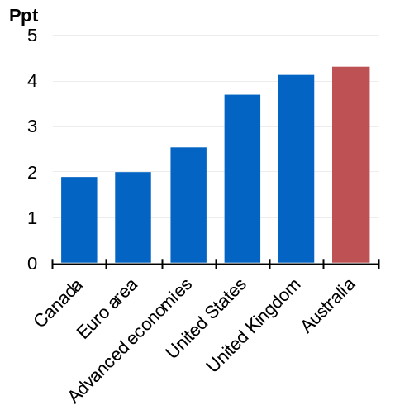 | 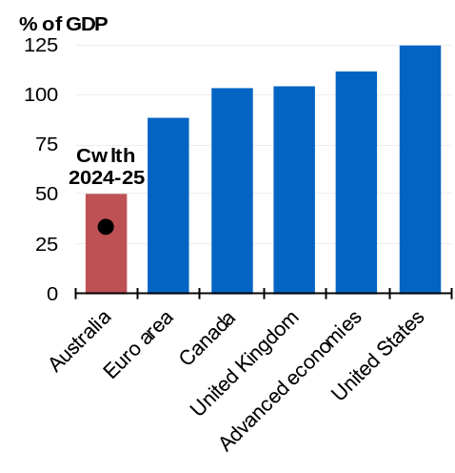
Source: Treasury, International Monetary Fund.
Note: International Monetary Fund fiscal data are produced on a consistent basis across countries. They are produced for calendar years and on a general government basis. They are not directly comparable with fiscal aggregates reported elsewhere in the Budget.

Low levels of government debt ensure that Australia is well placed to navigate a more challenging global environment (see Statement 2: Economic Outlook). It maintains Australia’s capacity to respond to future economic swings should risks materialise. At the same time, it preserves the ability to sustain essential services and maintains lower borrowing costs than otherwise.

Fiscal outlook

Underlying cash balance estimates
The underlying cash balance has improved by a cumulative $1.6 billion over the five years to 2028–29 since MYEFO and by a cumulative $207 billion over the seven years to 2028–29 since the PEFO.
The underlying cash balance is estimated to be a $27.6 billion deficit (1.0 per cent of GDP) in 2024–25, which is $0.7 billion higher than forecast at MYEFO in nominal terms, but broadly equivalent in per cent of GDP terms (Table 3.2). This follows a $15.8 billion surplus in 2023– 24 and a $22.1 billion surplus in 2022–23, the first back-to-back surpluses in nearly two decades and the largest nominal back-to-back surpluses on record.
An underlying cash deficit of $42.1 billion (1.5 per cent of GDP) is forecast for 2025–26, a $4.8 billion improvement from the forecast at MYEFO. The underlying cash deficit is then expected to improve to $36.9 billion (1.1 per cent of GDP) in 2028–29.
Policy decisions since MYEFO have been limited to just $0.1 billion in 2024–25. Over the five years to 2028–29 net policy decisions have increased the underlying cash deficit by $34.9 billion. This includes delivering new tax cuts to every Australian taxpayer from 1 July 2026 and further responsible cost-of-living relief, $3.5 billion in unavoidable spending and $2.2 billion in additional funding for hospitals and public schools. Parameter and other variations since MYEFO have decreased the underlying cash deficit by $36.4 billion over the five years to 2028–29.
In this Budget, $8.3 billion of policy decisions were funded by provisions from previous updates, limiting their impacts on the underlying cash balance in this update.
Table 3.2: Reconciliation of general government sector underlying cash balance estimates
 | Estimates
 | 2024-25 | 2025-26 | 2026-27 | 2027-28 | 2028-29 |  | Total
 | $m | $m | $m | $m | $m |  | $m
2024-25 Budget underlying cash
balance | -28,286 | -42,838 | -26,713 | -24,345 | * |  | *
Per cent of GDP | -1.0 | -1.5 | -0.9 | -0.8 | *
Changes from 2024-25 Budget to
2024-25 MYEFO
Effect of policy decisions(a) | -2,064 | -8,245 | -4,777 | -2,380 | * |  | *
Effect of parameter and other variations | 3,401 | 4,168 | -6,864 | -4,945 | * |  | *
Total variations | 1,337 | -4,077 | -11,641 | -7,325 | * |  | *
2024-25 MYEFO underlying cash
balance(b) | -26,949 | -46,915 | -38,353 | -31,671 | -37,199 |  | -181,087
Per cent of GDP | -1.0 | -1.6 | -1.3 | -1.0 | -1.1
Changes from 2024-25 MYEFO
to 2025-26 Budget
Effect of policy decisions(a)(c)
Receipts | 21 | -103 | -3,425 | -6,129 | -4,542 |  | -14,178
Payments | 158 | 7,141 | 4,230 | 4,533 | 4,644 |  | 20,706
Total policy decisions impact on
underlying cash balance | -137 | -7,244 | -7,655 | -10,662 | -9,186 |  | -34,884
Effect of parameter and other variations(c)
Receipts | -284 | 7,036 | 6,009 | -570 | -3,797 |  | 8,394
Payments | 236 | -5,001 | -4,294 | -5,656 | -13,328 |  | -28,043
Total parameter and other variations
impact on underlying cash balance | -520 | 12,037 | 10,303 | 5,086 | 9,531 |  | 36,437
2025-26 Budget underlying cash
balance | -27,605 | -42,122 | -35,706 | -37,247 | -36,854 |  | -179,534
Per cent of GDP | -1.0 | -1.5 | -1.2 | -1.2 | -1.1
*Data are not available.
- Excludes secondary impacts on public debt interest of policy decisions and offsets from the Contingency Reserve for decisions taken.
- 2028–29 as published in the medium-term projections, page 59 of the Mid-Year Economic and Fiscal Outlook 2024–25.
- A positive number for receipts improves the underlying cash balance, while a positive number for payments worsens the underlying cash balance.

Receipts estimates
Since MYEFO, forecast total receipts have increased by $6.9 billion in 2025–26 and decreased by $5.8 billion over the five years to 2028–29.
Since MYEFO, forecast tax receipts have increased by $6.4 billion in 2025–26 and decreased by $6.6 billion over the five years to 2028–29. Since MYEFO, forecast non-tax receipts have increased by $0.5 billion in 2025–26 and by $2.3 billion over the five years to 2028–29.

Receipts policy decisions over the forward estimates
Total receipts in 2025–26 are broadly unchanged since MYEFO as a result of net policy decisions. Over the five years to 2028–29, policy decisions have decreased total receipts by $14.2 billion, which overwhelmingly reflects tax receipts measures. Key tax receipts measures include:
- delivering new tax cuts to every Australian taxpayer from 1 July 2026 to provide further cost-of-living relief, return bracket creep and boost labour supply. This measure, which adds to the first round of tax cuts that commenced on 1 July 2024, is estimated to decrease receipts by $17.1 billion over the five years from 2024–25.
- strengthening the fairness and sustainability of Australia’s tax system by extending and expanding tax compliance activities. This measure is estimated to increase receipts by $3.2 billion and increase payments by $1.4 billion. The increase in payments includes $999.0 million in additional funding for the Australian Taxation Office (ATO), an increase in GST payments to the states and territories of $402.6 million and $31.0 million in unpaid superannuation to be disbursed to employees.
- strengthening the sanctions available to the Tax Practitioners Board (TPB), modernising the registration framework for tax practitioners and providing funding to the TPB to undertake additional investigation and compliance activity targeting high-risk tax practitioners. This measure is estimated to increase receipts by $47.0 million and increase payments by $27.4 million over the five years from 2024–25.
- pausing indexation on draught beer excise and excise-equivalent customs duty rates for a two-year period, from August 2025, and increasing support available under the existing Excise remission scheme for manufacturers of alcoholic beverages and Wine Equalisation Tax Producer rebate by increasing the maximum remission or rebate cap to $400,000 per financial year, from 1 July 2026. This measure is estimated to decrease receipts by $165.0 million over the five years from 2024–25.
- banning foreign purchases of established dwellings for a two-year period from 1 April 2025, subject to limited exceptions, and implementing an audit program to target land banking by foreign buyers. This measure will increase payments by $14.6 million in additional funding for the Australian Taxation Office and Treasury over the four years from 2025–26 and decrease receipts by $90.0 million over the five years from 2024– 25 due to forgone revenue from foreign investment application fees.
- increasing the Medicare levy low-income thresholds by 4.7 per cent for singles, families, and seniors and pensioners from 1 July 2024. This means more than one million Australians on lower incomes will continue to be exempt from paying the Medicare levy or pay a reduced levy rate. This measure is estimated to decrease receipts by $648.0 million over the five years from 2024–25.
Since MYEFO, policy decisions are expected to increase non-tax receipts by $0.2 billion in 2025–26, and by $0.9 billion over the five years to 2028–29. This increase is largely driven by the standard non-tax revenue impacts of Pharmaceutical Benefits Scheme listings, which partially offset expenditure impacts of these listings.
Further details of Government policy decisions are provided in Budget Paper No. 2, Budget Measures 2025–26.

Receipts parameter and other variations over the forward estimates
Parameter and other variations have increased total receipts since MYEFO by $7.0 billion in 2025–26 and by $8.4 billion over five years to 2028– 29 (Table 3.2).
The change in total receipts due to parameter and other variations since MYEFO primarily reflects tax receipts, which have been revised up by $6.7 billion in 2025–26 and up by $8.5 billion over five years to 2028–29.
Excluding GST and policy decisions, tax receipts have been revised up by $6.7 billion in 2025–26 and $9.4 billion over the five years to 2028–29. Higher employment and continuing strength in the labour market is the main driver of the upgrade since MYEFO. This is supported in the near term by temporary strength in mining sector profits, leading to higher company tax receipts. This is partly offset by a downgraded outlook for excisable tobacco volumes across the forward estimates.
Since MYEFO, parameter and other variations are expected to increase non-tax receipts by $0.3 billion in 2025–26 and by $1.4 billion over the five years to 2028–29. This increase is driven by increases in the number and value of funded benefit transfers to the Consolidated Revenue Fund from the Commonwealth Superannuation Corporation, and in anticipated lodgments of unclaimed monies from financial institutions. This increase is partially offset by lower-than-expected Commonwealth Government interest earnings due to an anticipated decrease in short-term interest rates.
Further information on expected receipts is provided in Statement 4: Revenue. Analysis of the sensitivity of the receipts estimates to changes in the economic outlook is provided in Statement 7: Forecasting Performance and Sensitivity Analysis.

Payments estimates
Since MYEFO, total projected payments have increased by $2.1 billion in 2025–26 and decreased by $7.3 billion over five years to 2028–29 (see Table 3.3). Real payments growth over the seven years to 2028–29 is expected to average 1.7 per cent per year and over the five years to 2028– 29 it is expected to average 2.7 per cent per year.
Table 3.3: Reconciliation of general government sector payments estimates^{(a)}
 |  | Estimates
 | 2024-25 | 2025-26 | 2026-27 | 2027-28 | 2028-29 |  | Total
 | $m | $m | $m | $m | $m |  | $m
2024-25 Budget payments | 726,732 | 762,192 | 786,722 | 826,157 | * |  | *
Changes from 2024-25 Budget to
2024-25 MYEFO
Effect of policy decisions(b) | 2,466 | 8,557 | 5,175 | 2,920 | * |  | *
Effect of parameter and other variations | 1,935 | 4,587 | 9,841 | 6,673 | * |  | *
Total variations | 4,401 | 13,143 | 15,017 | 9,593 | * |  | *
2024-25 MYEFO payments(c) | 731,133 | 775,335 | 801,739 | 835,749 | 886,378 |  | 4,030,334
Changes from 2024-25 MYEFO
to 2025-26 Budget
Effect of policy decisions(b) | 158 | 7,141 | 4,230 | 4,533 | 4,644 |  | 20,706
Effect of parameter and other variations | 236 | -5,001 | -4,294 | -5,656 | -13,328 |  | -28,043
Total economic parameter variations | -109 | -5 | -177 | 389 | * |  | *
Unemployment benefits | -61 | -463 | -582 | -392 | * |  | *
Prices and wages | -133 | -488 | -331 | 34 | * |  | *
Interest and exchange rates | 438 | 952 | 893 | 898 | * |  | *
GST payments to the States | -353 | -5 | -158 | -151 | * |  | *
Interest payments on AGS | -256 | -424 | -771 | -913 | * |  | *
Program specific parameter variations | 916 | 1,643 | 1,727 | 2,956 | * |  | *
Other variations(d) | -315 | -6,215 | -5,073 | -8,087 | * |  | *
Total variations | 394 | 2,140 | -64 | -1,122 | -8,684 |  | -7,337
2025-26 Budget payments | 731,527 | 777,475 | 801,676 | 834,627 | 877,694 |  | 4,022,998
*Data are not available.
- A positive number for payments worsens the underlying cash balance.
- Excludes secondary impacts on public debt interest of policy decisions and offsets from the Contingency Reserve for decisions taken.
- 2028–29 as published in the medium-term projections, page 60 of the Mid-Year Economic and Fiscal Outlook 2024–25.
- Includes changes in the conservative bias allowance component in the Contingency Reserve and impacts of changes in program payments for a range of reasons including movement of funds and reprofiling.

Payment policy decisions over the forward estimates
New policy decisions since MYEFO have increased total payments by $7.1 billion in 2025– 26 and by $20.7 billion over five years from 2024–25 to 2028–29.
Major policy decisions since MYEFO that have increased payments include:
- funding to improve access to affordable health care, including extending eligibility for bulk billing incentives to all Australians, the creation of additional incentives for practices to become fully bulk billed, supporting the digital health reform agenda and ensuring the Medicare Benefits Schedule is modern and clinically appropriate, which is expected to increase payments by $8.4 billion over five years from 2024–25.
- funding for new road and rail infrastructure priority projects within the Infrastructure Investment Program, which is expected to increase payments by $1.8 billion over five years from 2024–25.
- funding for new and amended listings on the Pharmaceutical Benefits Scheme, Repatriation Pharmaceutical Benefits Scheme, Stoma Appliance Scheme and Take Home Naloxone program, which is expected to increase payments by $1.8 billion over five years from 2024–25.
- funding to continue energy bill rebates of $75 per quarter for all Australian households and eligible small businesses until 31 December 2025, which is expected to increase payments by $1.8 billion in 2025–26.
- additional funding for the National Health Reform Agreement in 2025–26, which is expected to increase payments by $1.8 billion in 2025–26.
- funding to lower the Pharmaceutical Benefits Scheme general patient co-payment from $31.60 to $25.00 on 1 January 2026, which is expected to increase payments by $784.6 million over four years from 2025–26.
- additional funding for the Better and Fairer Schools Agreement, which is expected to increase payments by $407.5 million over four years from 2025–26.
Since MYEFO, further reductions in spending on consultants, contractors and labour hire have been applied, which will achieve savings of $718.8 million in 2028–29.

Payment parameter and other variations over the forward estimates
Parameter and other variations since MYEFO have decreased payments by $5.0 billion in 2025–26 and by $28.0 billion over five years from 2024–25 to 2028–29.
This is primarily driven by lower estimated payments for the NDIS, the Commonwealth Debt Management program and on road and rail transport projects under the Infrastructure Investment Program. These are partially offset by higher estimated payments related to the Aged Care Services program and Financial Support for People with Disability program.
Major decreases in payments from parameter and other variations since MYEFO include:
- payments related to road and rail transport projects under the Infrastructure Investment Program, which are expected to decrease by $255.7 million in 2025–26 and by $4.6 billion over five years to 2028–29, largely reflecting revised project delivery schedules and the application of a slippage adjustment. Slippage is a usual occurrence for large and complex capital infrastructure projects. The slippage adjustment takes into account historical experience, including the timing of states claiming payments against milestones and the impact of revised project delivery schedules for some projects. The decrease is partially offset by the Government’s additional investments in road and rail priority projects.
- payments related to the NDIS, which are expected to decrease by $954.0 million in 2025– 26 and $3.9 billion over five years to 2028–29, largely reflecting lower spending over the year to date, and hence lower forecast NDIS payments.
- payments related to Commonwealth debt management, which are expected to decrease by $424.4 million in 2025–26 and $3.3 billion over five years to 2028–29, largely reflecting lower forecasts for interest rates.
- payments related to the Support for Seniors program, which are expected to decrease by $343.7 million in 2025–26 and $1.6 billion over five years to 2028–29, largely reflecting lower-than-expected indexation rates for the Age Pension due to downwards revisions to the near-term outlook for inflation.
- payments related to the Pharmaceutical Benefits Scheme, which are expected to decrease by $5.6 million in 2025–26 and $671.0 million over five years to 2028–29, largely reflecting updated pharmaceutical pricing assumptions, and lower-than-expected prescription volumes for some high-cost listings.
- payments related to the Research and Development Tax Incentive program, which are expected to increase by $55.8 million in 2025–26 and decrease by $640.6 million over five years to 2028–29, largely reflecting lower-than-expected numbers of claims.
- payments related to the Job Seeker Income Support program, which are expected to decrease by $136.7 million in 2025–26 and $616.3 million over five years to 2028–29, largely reflecting lower-than-expected indexation rates, due to downwards revisions to the near-term outlook for inflation, and downward revisions to unemployment beneficiary recipient numbers, reflecting a stronger labour market.
- payments related to the Student Payments program, which are expected to decrease by $134.0 million in 2025–26 and $476.8 million over five years to 2028–29, largely reflecting lower-than-expected Youth Allowance (Student) recipient numbers.
Major increases in payments from parameter and other variations since MYEFO include:
- payments related to the Aged Care Services program, which are expected to increase by $906.1 million in 2025–26 and $3.1 billion over five years to 2028–29. This is largely due to increased funding for wages as a result of the Fair Work Commission’s decision to increase minimum award wages for aged care nurses from 1 March 2025, and increased funding for the Home Care Packages program due to increased package use. The budget impact of this increase is partially offset by funding provisioned in the Contingency Reserve for wage increases for aged care nurses.
- payments related to the Financial Support for People with Disability program, which are expected to increase by $408.5 million in 2025–26 and $2.4 billion over five years to 2028–29, reflecting stronger growth in the Disability Support Pension recipient numbers and average payment rates.
- payments related to the Medical Benefits program, which are expected to increase by $18.2 million in 2025–26 and $668.1 million over five years to 2028–29, largely reflecting higher than expected demand for medical services and more patients than expected reaching the Extended Medicare Safety Net Threshold.
- payments related to the National Partnership Payments – Natural Disaster Relief program, which are expected to increase by $214.9 million in 2025–26 and $487.7 million over five years to 2028–29, largely reflecting updated estimates received from states and territories for payments and changes in the timing of payments.
- payments related to the Australian Screen and Digital Game Production Incentive program, which are expected to increase by $46.0 million in 2025–26 and $478.8 million over five years to 2028–29, largely reflecting an increase in both the quantity and value of large budget project applications expected to be certified.
Consistent with past budgets, the underlying cash balance has been improved by regular draw down of the conservative bias allowance. Details in Statement 5: Expenses and Net Capital Investment.

Headline cash balance
The headline cash balance adjusts the underlying cash balance to include net cash flows from investments in financial assets for policy purposes (IFAPPs). This includes Specialist Investment Vehicles which invest in projects that deliver public value and a financial return to taxpayers. For example, Clean Energy Finance Corporation (CEFC) loans and equity investments impact the headline cash balance but not the underlying cash balance. Table 3.4 details differences between the underlying and headline cash balance estimates.
A headline cash deficit of $65.2 billion (2.3 per cent of GDP) is estimated in 2025–26, compared to an estimated deficit of $70.3 billion at MYEFO. The improvement is predominantly driven by the improvement in the underlying cash balance. The headline cash balance moderates to a deficit of $55.9 billion (1.7 per cent of GDP) in 2028–29.
Estimated net cash outflows for IFAPPs decreased by $4.7 billion over the four years to 2027–28 compared to MYEFO. This is largely due to:
- A $2.8 billion decrease in outflows for the CEFC, reflecting revised timelines across both Rewiring the Nation and the CEFC’s other activities.
- A $776 million decrease in outflows for the Help to Buy scheme, reflecting revisions to the rollout of the program. This is partially offset by additional investment to increase income and property price caps under the program. Further information can be found in the 2025–26 Budget measure Housing support.
- A $317 million decrease in outflows for the Northern Australia Infrastructure Facility, due to proponent-driven changes to loan utilisation.
The decrease in outflows for IFAPPs over the four years to 2027–28 is partially offset by an additional $1.4 billion in cash outflows from the National Reconstruction Fund. This results from an updated investment pipeline which will see more investments made in 2024–25 and 2025–26.
Net cash flows for a number of programs listed in Table 3.4 reflect the inclusion of funding provided by the Government in a prior update. These funds were previously captured within the ‘Net other’ line and are now incorporated in their relevant line items. These include:
- $5.5 billion over the five years from 2024–25 for the Help to Buy scheme. Those amounts are now itemised against Housing Australia, taking into account the revisions to the rollout and the additional investment.
- $1.6 billion over the four years from 2025–26 to recapitalise the CEFC to invest in renewable energy, energy efficiency and low emissions technologies. Further information can be found in the 2025–26 Budget measure Strengthening the Clean Energy Finance Corporation.
- $1.4 billion over three years from 2024–25 to provide additional equity funding to NBN Co as part of the upgrade of the remaining 622,000 NBN premises on the national fibre-to-the-node (FTTN) network. Further information can be found in the 2025–26 Budget measure Building Australia’s Future – completing the NBN fibre upgrades.
- $570 million in 2024–25 for a budget support loan to Papua New Guinea (PNG) to address the PNG Government’s estimated 2024 budget shortfall, with associated repayments totalling $128 million within the forward estimates to 2028–29. Further information can be found in the 2025–26 Budget Measure International Assistance.
Table 3.4: Reconciliation of general government sector underlying and headline cash balance estimates
 | Estimates
 | 2024-25 | 2025-26 | 2026-27 | 2027-28 | 2028-29 |  | Total
 | $m | $m | $m | $m | $m |  | $m
2025-26 Budget underlying
cash balance | -27,605 | -42,122 | -35,706 | -37,247 | -36,854 |  | -179,534
plus Net cash flows from
investments in financial
assets for policy purposes(a)
Student loans | -3,869 | -4,881 | -5,334 | -5,747 | -6,098 |  | -25,928
NBN investment | -1,473 | -1,050 | -186 | 0 | 0 |  | -2,709
Snowy Hydro Limited loan | -150 | -1,450 | -1,450 | -1,450 | 0 |  | -4,500
Snowy Hydro Limited investment | -1,625 | -975 | 0 | 0 | 0 |  | -2,600
Australian apprenticeship
support loans | -114 | -161 | -179 | -186 | -193 |  | -834
CEFC loans and investments | -3,106 | -3,071 | -4,784 | -5,539 | -4,668 |  | -21,168
Northern Australia
Infrastructure Facility | -492 | -959 | -851 | -540 | -295 |  | -3,138
NRFC loans and investments | -1,299 | -1,913 | -2,338 | -2,959 | -3,467 |  | -11,975
Australian Business
Securitisation Fund | -563 | -151 | -101 | -101 | -2 |  | -918
Structured Finance
Support Fund | 153 | 0 | 0 | 0 | 0 |  | 153
Drought and rural assistance
loans | -334 | -281 | 147 | 163 | 60 |  | -244
Official Development Assistance
- Australian Development Investments | -102 | -37 | -8 | 0 | 0 |  | -146
Official Development Assistance
- Multilateral Replenishment | -142 | -195 | -170 | -186 | -176 |  | -869
Home Equity Access Scheme | -179 | -232 | -289 | -335 | -364 |  | -1,399
Housing Australia | -913 | -3,467 | -4,369 | -1,954 | -1,588 |  | -12,291
Indigenous Business Australia
home and business loans | -104 | -217 | -111 | -114 | -114 |  | -660
National Interest Account
loans and investments | -886 | -1,097 | -530 | 9 | 323 |  | -2,181
COVID-19 Support for
Indonesia – loan | 100 | 100 | 100 | 100 | 100 |  | 500
Financial Assistance to
Papua New Guinea – loan | -415 | 169 | 169 | 169 | 169 |  | 262
Net other(b) | -3,561 | -3,209 | -2,476 | -1,292 | -2,688 |  | -13,226
Total net cash flows from
investments in financial
assets for policy purposes | -19,076 | -23,076 | -22,759 | -19,961 | -18,999 |  | -103,871
2025-26 Budget headline
cash balance | -46,681 | -65,198 | -58,465 | -57,209 | -55,853 |  | -283,406
- A positive number denotes a cash inflow; a negative number denotes a cash outflow.
- ‘Net other’ includes amounts that cannot be itemised, including commercial-in-confidence transactions and decisions taken but not yet announced.

Medium-term projections
The underlying cash balance is expected to return to balance in 2035–36 (Chart 3.3). The change in the underlying cash balance over the medium-term since MYEFO primarily reflects the new tax cuts for all Australian taxpayers.
By 30 June 2036, gross debt is expected to be 31.9 per cent of GDP (Chart 3.4). Compared to the PEFO, gross debt is lower every year of the projection period.
Total receipts as a share of GDP are expected to increase from 25.3 per cent of GDP in 2028– 29 to 26.8 per cent of GDP in 2035–36. Total payments as a share of GDP are expected to increase from 26.4 per cent in 2028–29 to 26.8 per cent in 2035–36 (Chart 3.5).
Chart 3.3: Underlying cash balance | Chart 3.4: Gross debt
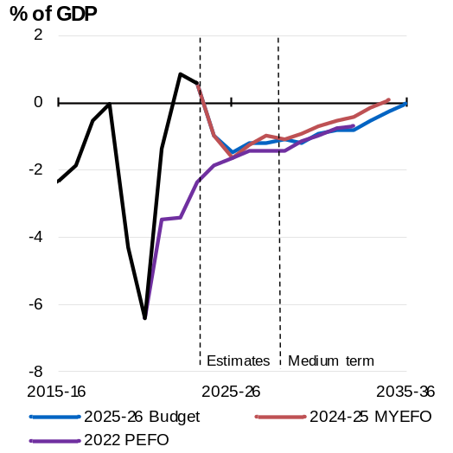 | 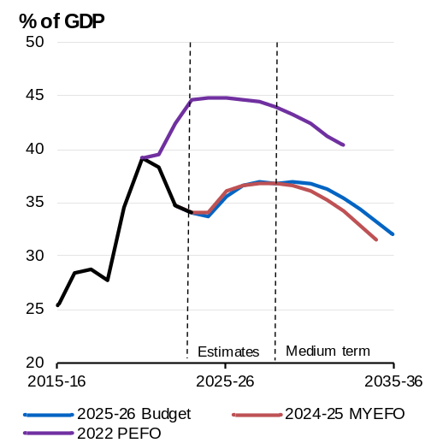
Source: Treasury. | Source: Australian Office of Financial Management, Treasury.

Chart 3.5: Payments and receipts
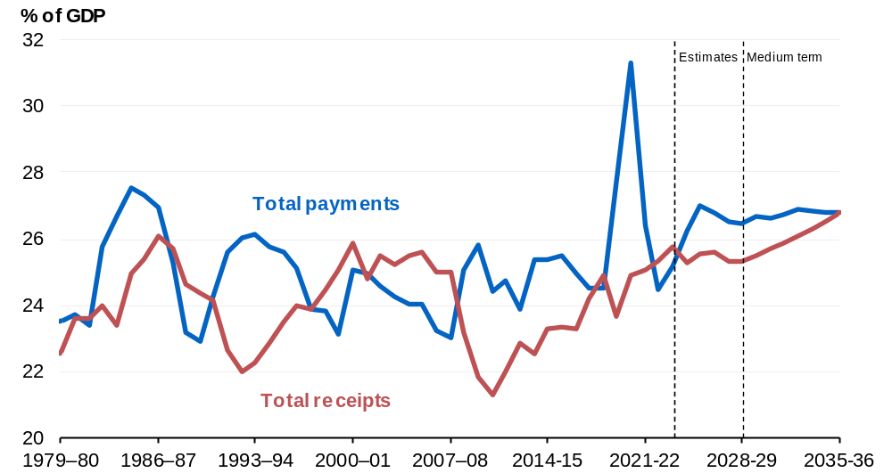
Source: Treasury.

Changes in the medium-term outlook since MYEFO

Receipts over the medium term
Receipts as a share of GDP are lower since MYEFO, including 0.3 percentage points lower in 2034–35 (Chart 3.6).
Chart 3.6: Total receipts | Chart 3.7: Total payments
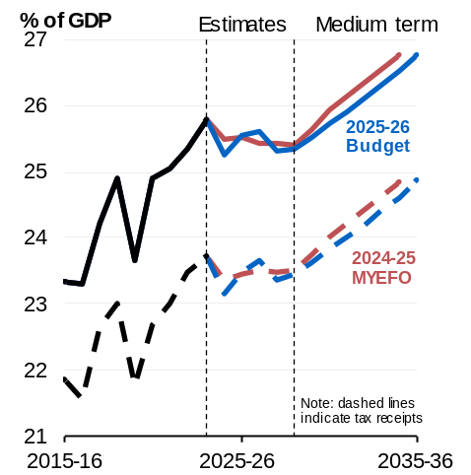 | 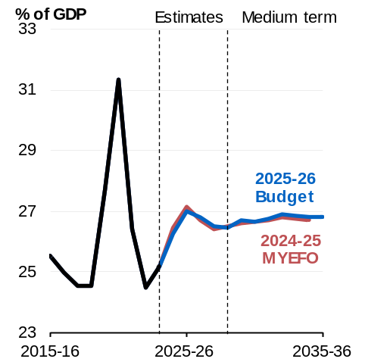
Source: Treasury. | Source: Treasury.

Payments over the medium term
Payments are expected to be 0.1 percentage points of GDP higher than at MYEFO in 2034–35 (Chart 3.7). Nominal GDP is expected to be lower than was projected at MYEFO, increasing payments relative to the size the economy.
The fastest growing major payments over the medium term are interest on government debt, the NDIS, defence, hospitals payments, medical benefits payments, the Child Care Subsidy and aged care payments (Chart 3.8).
Growth in some major payments over the Budget projection period (2025–26 to 2035–36) has changed compared to MYEFO (2024–25 to 2034–35).
- Interest payments growth is expected to average 9.5 per cent per year over the projection period compared to 10.9 per cent at MYEFO. This reflects the impact of a reduction in debt in the early years of the forward estimates period, partially offset by the change in the underlying cash balance.
- Commonwealth funded hospital payments growth is expected to average 5.9 per cent per year over the projection period compared to 6.5 per cent at MYEFO. This reflects the impact of the uplift to the funding contribution for the National Health Reform Agreement in 2025–26. This increases hospital payments at the start of the projection period, resulting in slower growth over the decade.
- Child Care Subsidy payments growth is expected to average 5.1 per cent over the projection period compared to 5.5 per cent at MYEFO, reflecting updated projections of usage in the medium term.
Chart 3.8: Average annual growth in major payments over the medium term
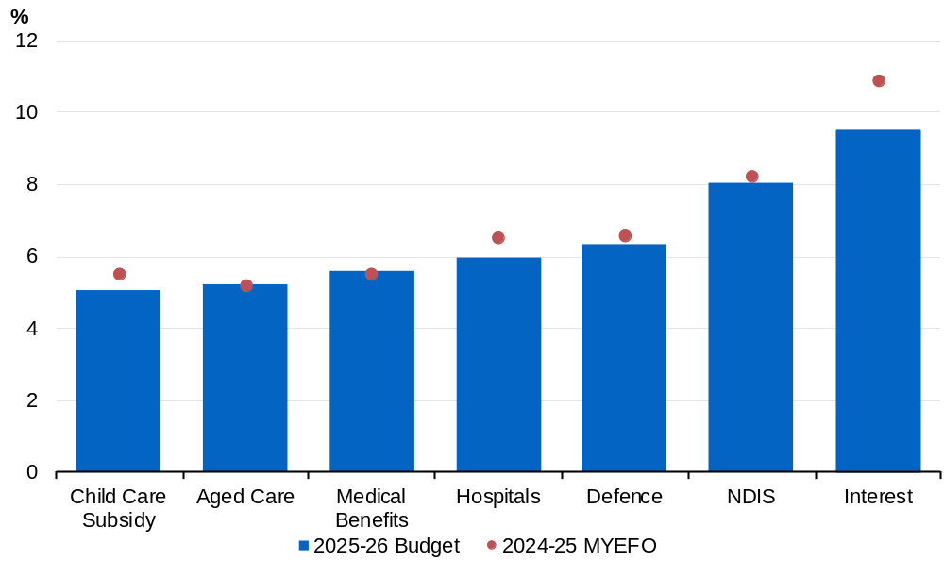
Source: Treasury.
Note: Shows major payments that are growing faster than nominal GDP over the projection period. Interest refers to interest payments on Australian Government Securities. NDIS refers to the Australian Government’s contribution to payments for NDIS participant supports. Growth rate for MYEFO is from 2024–25 to 2034–35. Growth rate for the 2025–26 Budget is from 2025–26 to 2035–36.

The Government’s balance sheet
The balance sheet measures the value of the Government’s assets and liabilities. Changes in the balance sheet reflect movements in the underlying cash balance, additional balance sheet commitments, and market valuation effects, including from changes in yields.
Different balance sheet metrics measure different groupings of assets and liabilities.
- Gross debt measures the face value of Australian Government Securities (AGS) on issue. This is the amount that the Government pays back to investors at maturity, independent of fluctuations in market prices.
- Net debt is measured at market value and incorporates specific financial assets and liabilities and provides a broader measure of the financial obligations of the Government than gross debt.
- Net financial worth is the sum of all financial assets less all liabilities. The assets of the Future Fund and the public sector superannuation liability that the Future Fund will finance are included in net financial worth.
- Net worth is the sum of all assets less all liabilities. It includes non-financial assets such as buildings and plant, equipment, and infrastructure.
Further information on definitions is available in Statement 9: Australian Government Budget Financial Statements.

Gross debt estimates and projections
The Government’s responsible budget management is lowering gross debt-to-GDP compared to the PEFO in every year of the forward estimates period and medium term.
Gross debt is estimated to be $177 billion lower in 2024–25 than estimated in the PEFO.
Gross debt is estimated to be 35.5 per cent of GDP at 30 June 2026 (Table 3.5), 0.5 percentage points and $6 billion lower than estimated at MYEFO and 9.2 percentage points and $147 billion lower than the PEFO.
By the end of the forward estimates, gross debt is lower than MYEFO in nominal terms, driven by the improved budget position. The slight increase in debt-to-GDP since MYEFO reflects the impact of downward revisions to nominal GDP.
Gross debt is expected to peak at 37.0 per cent of GDP at 30 June 2030, 7.9 percentage points lower than the forecast peak at the PEFO.
Table 3.5: Australian Government general government sector balance sheet aggregates^{(a)}
 | Actual |  | Estimates
 | 2023-24 |  | 2024-25 | 2025-26 | 2026-27 | 2027-28 | 2028-29
 | $b |  | $b | $b | $b | $b | $b
Financial assets | 637.9 |  | 637.0 | 677.8 | 715.0 | 752.7 | 789.2
Per cent of GDP | 23.9 |  | 22.9 | 23.5 | 23.9 | 23.9 | 23.8
Non-financial assets | 214.7 |  | 220.6 | 228.3 | 236.4 | 247.6 | 257.3
Per cent of GDP | 8.0 |  | 7.9 | 7.9 | 7.9 | 7.9 | 7.8
Total assets | 852.6 |  | 857.6 | 906.1 | 951.3 | 1,000.3 | 1,046.5
Per cent of GDP | 31.9 |  | 30.8 | 31.5 | 31.8 | 31.8 | 31.5
Total liabilities | 1,384.3 |  | 1,428.1 | 1,527.9 | 1,610.6 | 1,701.0 | 1,786.6
Per cent of GDP | 51.8 |  | 51.2 | 53.1 | 53.8 | 54.0 | 53.8
Net worth | -531.6 |  | -570.5 | -621.8 | -659.2 | -700.7 | -740.1
Per cent of GDP | -19.9 |  | -20.5 | -21.6 | -22.0 | -22.3 | -22.3
Net financial worth(b) | -746.3 |  | -791.1 | -850.1 | -895.6 | -948.3 | -997.4
Per cent of GDP | -27.9 |  | -28.4 | -29.5 | -29.9 | -30.1 | -30.0
Gross debt(c) | 906.9 |  | 940.0 | 1,022.0 | 1,092.0 | 1,161.0 | 1,223.0
Per cent of GDP | 33.9 |  | 33.7 | 35.5 | 36.5 | 36.9 | 36.8
Net debt(d) | 491.5 |  | 556.0 | 620.3 | 676.3 | 714.1 | 768.2
Per cent of GDP | 18.4 |  | 19.9 | 21.5 | 22.6 | 22.7 | 23.1
Total interest payments | 22.8 |  | 24.4 | 27.9 | 30.2 | 36.7 | 38.2
Per cent of GDP | 0.9 |  | 0.9 | 1.0 | 1.0 | 1.2 | 1.2
Net interest payments(e) | 12.3 |  | 14.9 | 18.5 | 21.2 | 26.9 | 28.1
Per cent of GDP | 0.5 |  | 0.5 | 0.6 | 0.7 | 0.9 | 0.8
- Assets, liabilities, net worth, net financial worth, gross debt and net debt are presented as at the end of each financial year.
- Net financial worth equals total financial assets minus total liabilities.
- Gross debt measures the face value of AGS on issue.
- Net debt is the sum of interest-bearing liabilities (which includes AGS on issue measured at market value) less the sum of selected financial assets (cash and deposits, advances paid and investments, loans and placements).
- Net interest payments are equal to the difference between interest payments and interest receipts.

Interest payments
Interest payments have decreased since MYEFO, driven by lower yields and a lower financing task from the improved budget position. Over the forward estimates, bond yields are assumed to remain fixed at a recent average of daily spot rates at the time of the budget update. Since MYEFO, the assumed weighted average cost of borrowing for issuance of Treasury Bonds in the forward estimates has decreased from 4.4 to 4.3 per cent, broadly reflecting movements in yields globally. This remains higher than the weighted average yield of 2.2 per cent at the 2022 PEFO.
Total interest payments are estimated to be 1.0 per cent of GDP in 2025–26, unchanged from the estimate at MYEFO. Interest payments are estimated to peak at 1.6 per cent of GDP in 2032–33. By 2034–35, interest payments are broadly unchanged from the 2024–25 MYEFO.
Statement 6: Debt Statement contains further information on yield assumptions and interest payments. Statement 7: Forecasting Performance and Sensitivity Analysis contains information on the impact on the underlying cash balance and gross debt if the future trajectory for yields is higher or lower than assumed.

Net debt estimates and projections
Net debt is estimated to be 21.5 per cent of GDP ($620.3 billion) at 30 June 2026 (Table 3.5); 11.5 percentage points lower than estimated at the PEFO and 0.2 percentage points higher than estimated at MYEFO. Net debt relative to GDP is expected to be higher in the forward estimates compared to MYEFO, reflecting a reduction in Future Fund investments, loans and placements and the impact of lower yields on AGS.
Chart 3.9: Net debt
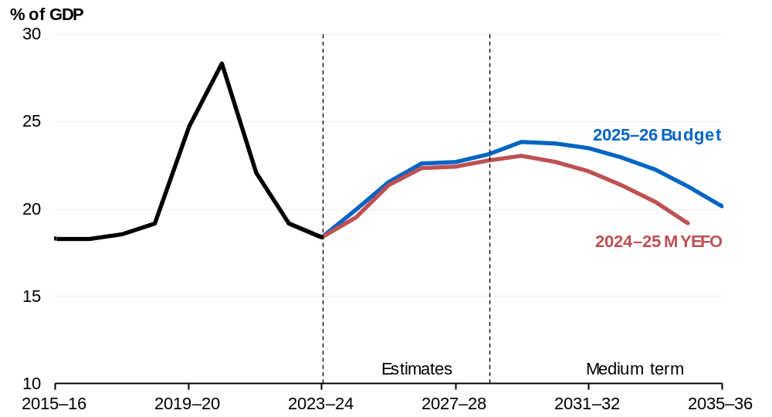
Source: Treasury.

Net debt is higher than estimated at MYEFO over the entire projection period. Net debt is projected to be 20.2 per cent of GDP at 30 June 2036 (Chart 3.9).
Further information on gross debt and net debt estimates across the forward estimates period is provided in Statement 6: Debt Statement.

Net financial worth and net worth estimates and projections
Net financial worth is estimated to be minus 29.5 per cent of GDP (minus $850.1 billion) at 30 June 2026 (Table 3.5), compared with the estimate of minus 30.0 per cent of GDP (minus $856.8 billion) at MYEFO.
Net financial worth is projected to deteriorate to minus 30.1 per cent of GDP at 30 June 2028 before improving to minus 24.3 per cent of GDP by the end of the medium term (Chart 3.10).
Chart 3.10 Net financial worth
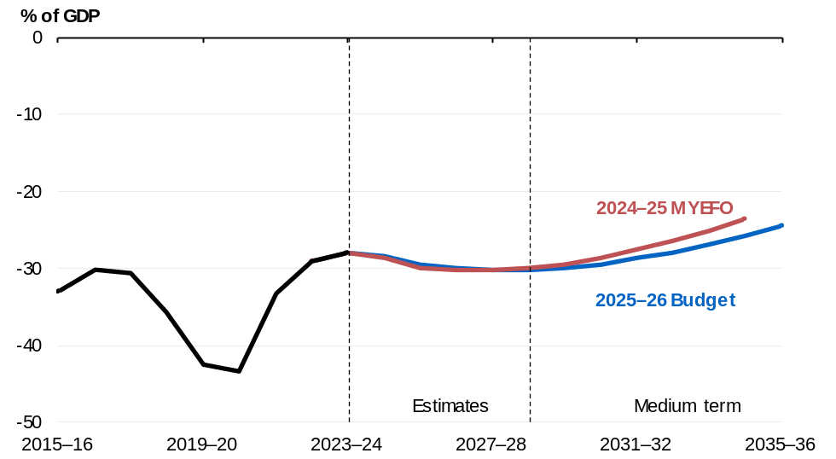
Source: Treasury.

Net worth is estimated to be minus 21.6 per cent of GDP (minus $621.8 billion) at 30 June 2026 (Table 3.5), compared with the estimate of minus 22.0 per cent of GDP (minus $628.9 billion) at MYEFO. Net worth is projected to deteriorate to minus 22.3 per cent of GDP at 30 June 2029 before improving over the medium term.
The improvement in net worth and net financial worth over the forward estimates period relative to MYEFO largely reflects an increase in assets held by the Future Fund.
Net worth and net financial worth as a share of the economy improve over the medium term as debt-to-GDP is reduced.

Fiscal impacts of the net zero transformation
Climate change and global climate action will have profound impacts on the economy, reshaping Australia’s industry mix and requiring effective mitigation and adaptation to manage climate impacts like more severe floods and bushfires. At the same time, the net zero transformation presents new opportunities for Australia’s industries, regions and communities. Achieving Australia’s emissions reduction commitments and realising the opportunities that accompany the transition will require significant investment by governments and the private sector.
The Government is committed to improving the transparency of public money committed to climate action. It recognises the importance of identifying, disclosing, and tracking net zero spending in improving Australia’s response to climate change and aligning with international efforts. Accounting for net zero spending comprehensively is challenging as it cuts across many portfolios, ranging from energy to health. Existing budget systems do not readily facilitate reporting net zero spending on established programs. For this reason, reporting of net zero spending focuses on new measures.

Australia’s classification approach
The 2025–26 Budget continues the practice introduced in the 2022–23 October Budget of transparently reporting new climate-related spending. It adopts the five-part classification outlined in detail in the 2024–25 Budget:
- Reducing emissions in Australia’s energy system and broader economy
- Strengthening net zero industries and skills
- Adapting to climate change and improving climate and disaster resilience
- International climate leadership
- Building Australian Government climate capability
In the 2025–26 Budget, new measures from 2024–25 MYEFO are also reported, to provide a comprehensive update on net zero spending since the 2024–25 Budget.
Where policies contribute to multiple net zero objectives, spending is classified into the most appropriate category based on its primary purpose. Policies that contribute indirectly to net zero objectives are not included in this classification approach.

The 2025–26 Budget leverages established delivery vehicles, such as the Clean Energy Finance Corporation and Rewiring the Nation program, to invest in the next horizon of emissions reduction technologies and additional renewable energy capacity. Additional investments in these programs are included as new spending this Budget. The Government has also made significant new allocations from within existing funds, such as the $750 million for green metals, $500 million for clean energy technology manufacturing capabilities and $250 million for low carbon liquid fuels identified from the Future Made in Australia Innovation Fund. These are not included as new spending.
This reporting framework maintains alignment with international best practice and recent budgets. It will continue to evolve over time as the Government works with and learns from reporting entities and partners around the world. Australian Government green bonds have contributed to financing programs that support climate mitigation, climate adaptation and improved environmental outcomes.
Reporting climate-related spending categories as part of the budget process is complementary to the reporting associated with the issuance of green bonds (see Box 3.3).
Box 3.3: Financing climate programs through green bonds
Green bonds help mobilise capital toward public projects to drive Australia’s net zero transformation and support Australia’s environmental goals.
In June 2024, the Government issued the first Green Treasury Bond. The $7 billion issuance attracted strong demand with more than $22 billion in bids from 105 investor institutions, of which 17 were new to Australian Government syndicated issues. The Australian Office of Financial Management and market participants estimated a green premium of approximately 2 basis points from the inaugural issuance.
The Treasury released the first Green Treasury Bond Allocation and Impact Report in February 2025. This report presents allocation data for eligible projects financed by green bonds in 2022–23 and 2023–24, and the climate and environmental impact of these projects. Green bonds reporting represents a new type of disclosure and increases transparency for the Government’s climate and environmental programs.
Of the $7.0 billion raised, $2.5 billion has been allocated to eligible projects in
2022–23, and $2.9 billion has been allocated to eligible projects in 2023–24. The remaining $1.6 billion will be allocated to eligible projects in future years (Chart 3.11).
Government programs financed through green bonds deliver electric vehicle chargers through the Driving the Nation Fund, support climate change action in the Indo-Pacific region and protect the Great Barrier Reef (Chart 3.12). Green Treasury Bond proceeds have contributed to a range of climate and environmental impacts, including:
- 4,600 GWh of expected renewable energy generation;
- 103.4 km of electric rail track built or upgraded;
- 5,564 hectares of koala habitat improved and managed.
continued on next page

Box 3.3: Financing climate programs through green bonds (continued)
Chart 3.11: Allocation of green bond proceeds by financial years | Chart 3.12: Allocation of proceeds by green bond categories
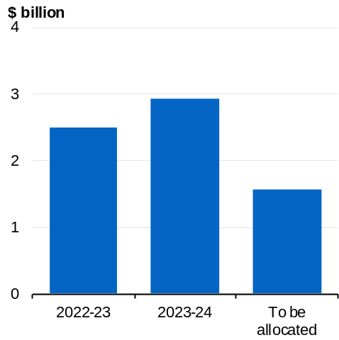 | 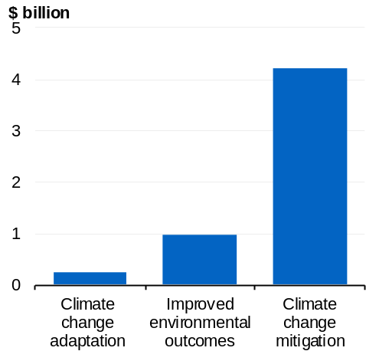
Source: Treasury | Source: Treasury

New net zero spending measures
Table 3.6 sets out $4.3 billion in new net zero spending commitments over the forward estimates period and $6.9 billion over the medium term, across 2024–25 MYEFO and this Budget. This follows net zero spending commitments of $24.3 billion (over the medium term) in the 2024–25 Budget, climate-related spending of $4.6 billion (to 2030) committed in the 2023–24 Budget and the $24.9 billion (to 2030) committed in the 2022–23 October Budget.
Classification of spending is informed by the net zero spending framework. The total commitment includes spending, balance sheet and tax expenditure measures and therefore presents a broader view than the impact on the underlying cash balance.
Reporting new net zero spending measures supports transparency around the fiscal impacts of climate change and the net zero transformation. However, it does not provide a complete summary of climate action. Only measures that entail funding commitments or forgone revenue (such as tax concessions) are captured.
Table 3.6: New measures
 | Total* | Forward Estimates  ($m) | Medium Term  ($m)
 | Reducing Emissions in Australia’s energy system and broader economy | 3,786.6 | 3,791.6
 | Enabling a Reliable and Secure Energy Transition^{(a)} | 40.4 | 45.3
 | Rewiring the Nation – recapitalisation^{(b)} | 1,246.9 | 1,247.0
 | Strengthening the Clean Energy Finance Corporation^{(c)} | 2,000.0 | 2,000.0
 | Expansion of Social Housing Energy Performance Initiative | 499.3 | 499.3
 | Strengthening net zero industries and skills | 166.1 | 2,448.7
 | Future Made in Australia – accelerating investment in Australian industries^{(d)} | 166.1 | 464.1
 | Support for Australian Made Metals^{(e)} | nfp | 1,984.6
Adapting to climate change and improving climate and disaster resilience |  | 354.0 | 632.5
 | Building a Better Future Through Considered Infrastructure Investment^{(f)} | 354.0 | 632.5
 | International climate leadership | nfp | 75.0
 | Southeast Asia Investment Financing Facility – Investment in FAST-P Green Investments Partnership fund^{(g)} | nfp | 75.0
 | Total Net Zero Spending | 4,306.7 | 6,947.8
* This table summarises the Government’s key climate-related spending commitments in the 2024–25 MYEFO and 2025–26 Budget to 30 June 2036 and presents a broader view than the impact on the underlying cash balance. Some measures extend beyond the end of the medium term or include both initial and ongoing funding to the end of the medium term. Figures align with the timeframes for measures reported in the 2024–25 MYEFO and 2025–26 Budget Paper No. 2, but timeframes for figures align with the forward estimates and medium term for the 2025–26 Budget. Spending outlined in these measures for the purposes of this table may differ in some instances from figures reported in the 2024– 25 MYEFO and 2025–26 Budget Paper No. 2 due to the exclusions described in the footnotes.
- The spending outlined in this measure for the purposes of this table excludes funding to support the Australian Energy Market Operator to uplift core digital systems. The cost of this measure will be partially met from savings identified in the Climate Change and Energy and the Environment and Water portfolios.
- This measure contains $1.2 billion in funding for concessional finance.
- This measure contains $2.0 billion in funding for concessional finance.
- The spending outlined in this measure for the purposes of this table excludes funding for the Australian Made Campaign Limited. The cost of this measure will be partially met from savings identified in the Industry, Science, and Resources portfolio and the Climate Change and Energy portfolio.
- The funding profile for this measure is not for publication due to commercial sensitivities. The spending outlined in this measure for the purposes of this table only includes the Green Aluminium Production Credit and the Green Iron Investment Fund related funding.
- The spending outlined in this measure for the purposes of this table includes Infrastructure Investment Program projects that support flood resilience, including upgrades to Townson Road, Burdekin Road and Garfield Road West in New South Wales.
- The funding profile for this measure is not for publication due to commercial sensitivities.

Appendix A: Other fiscal aggregates

Accrual aggregates
Accrual accounting records income and costs at the time they are incurred. Cash accounting records income and costs at the time of the associated actual cash flow. Differences in estimates arise where there is a difference between the timing of an activity and the associated cash flow.

Net operating balance estimates
The net operating balance is an accrual measure, reflecting revenue minus expenses. It excludes the fiscal impact of the Australian Government’s net new capital expenditure.
The net operating balance is expected to be a deficit of $45.2 billion (1.6 per cent of GDP) in 2024–25 (Table 3.7). It is expected to be a deficit of $35.4 billion (1.2 per cent of GDP) in 2025–26, compared to an expected deficit of $41.4 billion at MYEFO.

Fiscal balance
The fiscal balance is the accrual equivalent of the underlying cash balance and equals the net operating balance less net new capital investment.
The fiscal balance is expected to be a deficit of $50.6 billion (1.8 per cent of GDP) in 2024–25 (Table 3.7). It is expected to be a deficit of $44.2 billion (1.5 per cent of GDP) in 2025–26, compared to an expected deficit of $49.7 billion at MYEFO.
Table 3.7: Australian Government general government sector accrual aggregates
 | Actual |  | Estimates
 | 2023-24 |  | 2024-25 | 2025-26 | 2026-27 | 2027-28 | 2028-29 |  | Total(a)
 | $b |  | $b | $b | $b | $b | $b |  | $b
Revenue | 704.5 |  | 717.6 | 750.3 | 783.6 | 815.4 | 862.5 |  | 3,929.3
Per cent of GDP | 26.4 |  | 25.7 | 26.1 | 26.2 | 25.9 | 26.0
Expenses | 685.9 |  | 762.8 | 785.7 | 806.6 | 842.9 | 889.4 |  | 4,087.4
Per cent of GDP | 25.7 |  | 27.4 | 27.3 | 27.0 | 26.8 | 26.8
Net operating balance | 18.6 |  | -45.2 | -35.4 | -23.0 | -27.5 | -26.9 |  | -158.0
Per cent of GDP | 0.7 |  | -1.6 | -1.2 | -0.8 | -0.9 | -0.8
Net capital investment | 6.7 |  | 5.5 | 8.8 | 9.1 | 12.0 | 10.2 |  | 45.6
Per cent of GDP | 0.2 |  | 0.2 | 0.3 | 0.3 | 0.4 | 0.3
Fiscal balance | 12.0 |  | -50.6 | -44.2 | -32.2 | -39.5 | -37.1 |  | -203.6
Per cent of GDP | 0.4 |  | -1.8 | -1.5 | -1.1 | -1.3 | -1.1
- Total is equal to the sum of amounts from 2024–25 to 2028–29.

Table 3.8 provides a reconciliation of fiscal balance estimates, including the impact of policy decisions and parameter and other variations on revenue and expenses since MYEFO. The drivers of movements in the fiscal balance estimates are largely the same as for the underlying cash balance.
Table 3.8: Reconciliation of general government sector fiscal balance estimates
 | Estimates
 | 2024-25 | 2025-26 | 2026-27 | 2027-28 | 2028-29 |  | Total
 | $m | $m | $m | $m | $m |  | $m
2024-25 Budget fiscal balance | -29,316 | -42,604 | -26,514 | -22,026 | * |  | *
Per cent of GDP | -1.1 | -1.5 | -0.9 | -0.7 | *
Changes from 2024-25 Budget to
2024-25 MYEFO
Effect of policy decisions(a) | -12,660 | -8,875 | -6,264 | -4,179 | * |  | *
Effect of parameter and other variations | -3,911 | 1,784 | -3,570 | -7,243 | * |  | *
Total variations | -16,571 | -7,091 | -9,834 | -11,421 | * |  | *
2024-25 MYEFO fiscal balance | -45,887 | -49,695 | -36,347 | -33,448 | * |  | *
Per cent of GDP | -1.7 | -1.7 | -1.2 | -1.1 | *
Changes from 2024-25 MYEFO
to 2025-26 Budget
Effect of policy decisions(a)(b)
Revenue | 21 | -49 | -3,419 | -6,292 | -2,874 |  | -12,613
Expenses | 160 | 7,674 | 4,079 | 4,305 | 4,632 |  | 20,851
Net capital investment | -1 | 122 | 122 | 201 | 18 |  | 463
Total policy decisions impact on fiscal balance | -138 | -7,845 | -7,620 | -10,799 | -7,525 |  | -33,927
Effect of parameter and other variations(b)
Revenue | -706 | 7,100 | 5,949 | -717 | * |  | *
Expenses | 3,949 | -6,622 | -6,466 | -6,003 | * |  | *
Net capital investment | -33 | 360 | 622 | 584 | * |  | *
Total parameter and other variations impact on
fiscal balance | -4,622 | 13,362 | 11,793 | 4,701 | * |  | *
2025-26 Budget fiscal balance | -50,647 | -44,178 | -32,174 | -39,545 | -37,087 |  | -203,631
Per cent of GDP | -1.8 | -1.5 | -1.1 | -1.3 | -1.1
*Data are not available.
- Excludes secondary impacts on public debt interest of policy decisions and offsets from the Contingency Reserve for decisions taken.
- A positive number for revenue improves the fiscal balance, while a positive number for expenses and net capital investment worsens the fiscal balance.

Revenue estimates
Revenue is the accrual accounting equivalent of cash-based receipts. Changes in revenue are generally driven by the same factors as receipts. Revenue amounts can be higher or lower than the cash equivalents as they include amounts that a taxpayer is liable to pay but has not paid. The differences between the accrual and cash amounts generally reflect timing differences.
Total revenue since MYEFO has been revised up by $7.1 billion in 2025–26 and by $1.9 billion over four years from 2024–25 to 2027–28.

Expense estimates
Expenses are the accrual accounting equivalent of cash-based payments.
Total expenses since MYEFO have been revised up by $1.1 billion in 2025–26 and by $1.1 billion over four years from 2024–25 to 2027–28.
Movements in expenses over the forward estimates period are broadly consistent with movements in cash payments. The key exceptions include:
- the NDIS program, where there is an expected time lag between the receipt of reasonable and necessary support services and the lodgment of claims relating to those services.
- superannuation benefits programs (civilian and military), where there is a timing difference with the expense accruing during employment and cash payments occurring during retirement.
- purchases of non-financial assets, which are included in cash payments but not in accrual expenses. The expense estimates include depreciation of non-financial assets rather than recognising the impact at the time of purchase.
Detailed information on expenses can be found in Statement 5: Expenses and Net Capital Investment.

Structural budget balance
The structural budget balance estimate adjusts the underlying cash balance to remove the estimated effects of cyclical factors that have a temporary impact on receipts and payments. These factors include deviations in commodity prices and economic activity from their long-run levels. The structural budget balance can provide insight into the sustainability of fiscal settings.
The structural balance is estimated rather than observed, so it is sensitive to the assumptions and parameters that underpin it. Commodity price volatility has increased the uncertainty around the estimate.
The structural budget position is expected to return to deficit in 2024–25 (Chart 3.13). The deficit is expected to reach around 1.4 per cent of GDP in 2025–26. It averages 1.0 per cent of GDP over the forward estimates, a 0.4 percentage point improvement over the same period at the time of the PEFO. Thereafter, the structural budget position is expected to gradually improve towards balance over the medium term. The structural budget balance was estimated to remain in deficit at the end of the medium-term in 2032–33 at the time of the PEFO.
Chart 3.13: Structural budget balance
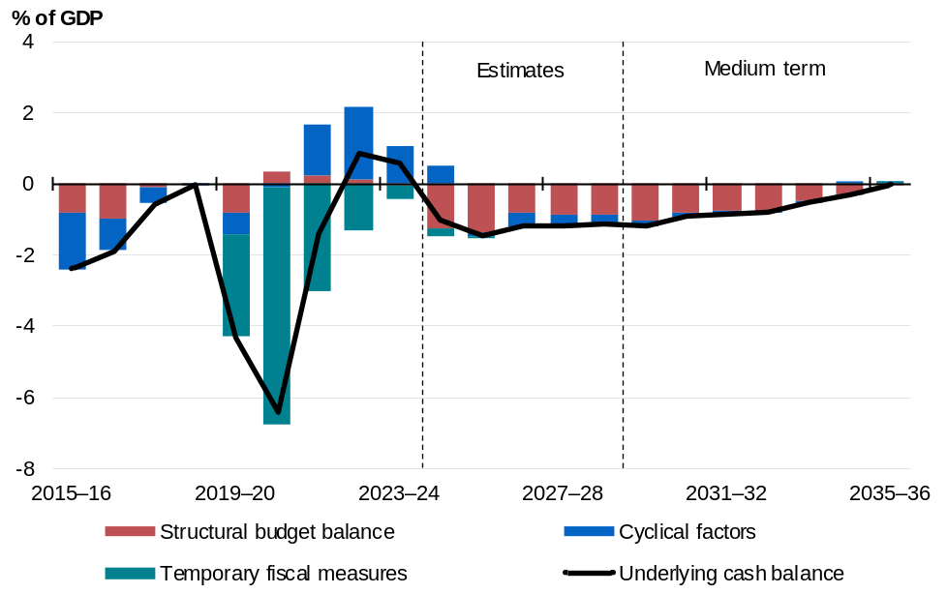
Source: Treasury.
Note: The approach separating the budgetary impact of cyclical factors from structural measures follows the methodology detailed in Treasury Working Paper 2013–01. Cyclical factors measure the estimated impact on the underlying cash balance from automatic stabilisers and cyclical movements in asset and commodity prices. Temporary fiscal measures comprise direct economic and health support measures initiated between the onset of the COVID-19 pandemic and the 2022– 23 October Budget. Underspends in these direct economic and health support measures are not captured in the derivation of the structural budget balance, which may alter the structural budget balance estimate in those years.

