Statement 6:
Debt Statement
Gross debt and net debt are expected to be significantly lower than estimated at the 2022 Pre-election Economic and Fiscal Outlook (PEFO) in every year of the forward estimates.
By the end of 2024–25, gross debt is expected to be 11.1 percentage points of GDP ($177 billion) lower than estimated at PEFO. Gross debt is estimated to be 35.5 per cent of GDP at the end of 2025–26, 9.2 percentage points lower than estimated at the PEFO and 0.5 percentage points lower than estimated at the 2024–25 MYEFO. Gross debt is expected to peak at 37.0 per cent of GDP in 2029–30, 7.9 percentage points lower than the peak at the PEFO, before falling to 31.9 per cent in 2035–36.
Net debt in 2024–25 is expected to be 13.1 percentage points of GDP ($267 billion) lower than estimated at the PEFO.
Interest payments on Australian Government Securities are estimated to be $26.3 billion in 2025–26, increasing to $36.6 billion by 2028–29. Over the 5-years to 2028–29, total interest payments on AGS are expected to be $3.3 billion lower than estimated at MYEFO.

Statement contents
Australian Government Securities issuance 157
Estimates of AGS on issue 157
Changes in AGS on issue since the 2024–25 MYEFO 159
Breakdown of AGS currently on issue 159
Treasury Bonds 160
Treasury Indexed Bonds 161
Treasury Notes 161
Non-resident holdings of AGS on issue 162
Net debt 162
Changes in net debt since the 2024–25 MYEFO 163
Interest on AGS 164

Statement 6: Debt Statement
The Debt Statement provides information on Government gross debt, net debt, Australian Government Securities (AGS) issuance and interest costs.

Australian Government Securities issuance
The Australian Government finances its activities either through receipts or borrowing. When receipts fall short of payments, the Government borrows by issuing AGS.
The Australian Office of Financial Management (AOFM) is responsible for issuing AGS and managing the Government’s financing activities. The AOFM exercises operational independence in the execution of its duties. Further details on the AOFM’s operations can be found on the AOFM website at www.aofm.gov.au.

Estimates of AGS on issue
Estimates of AGS on issue are published in both face value and market value terms in this Statement.
- The face value of AGS on issue (also referred to as gross debt) is the amount the Government pays back to investors at maturity, independent of fluctuations in market prices. The total face value of AGS on issue changes when new securities are issued, or when securities are repurchased or reach maturity.
- The market value of AGS on issue represents the value of securities as traded on the secondary market, which changes continuously with movements in market prices (often quoted as a yield to maturity). Consistent with external reporting standards, the market value of AGS on issue is reported in the Australian Government general government sector balance sheet.
The Commonwealth Inscribed Stock Act 1911 (CIS Act) requires the Treasurer to issue a direction stipulating the maximum face value of relevant AGS that may be on issue. Effective from 7 October 2020, the then Treasurer directed that the maximum face value of AGS that can be on issue is $1,200 billion.

Gross debt is estimated to be $1,022 billion (35.5 per cent of GDP) in 2025–26, increasing to $1,223 billion (36.8 per cent of GDP) in 2028-29. Gross debt relative to GDP is expected to be lower than at the 2024–25 MYEFO from 2024–25 to 2026–27 and higher than MYEFO in 2027–28 and 2028–29.
The decline in gross debt relative to GDP in the first 3-years of the forward estimates since MYEFO reflects improvements in the headline cash balance and upward revisions to nominal GDP. The increase in gross debt relative to GDP in 2027–28 and 2028-29 since MYEFO is primarily driven by downward revisions to nominal GDP in these years.
Table 6.1: Estimates of AGS on issue subject to the Treasurer’s Direction^{(a)(b)}
 | Estimates
 | 2024-25 | 2025-26 | 2026-27 | 2027-28 | 2028-29
 | $b | $b | $b | $b | $b
Face value – end-of-year | 940 | 1,022 | 1,092 | 1,161 | 1,223
Per cent of GDP | 33.7 | 35.5 | 36.5 | 36.9 | 36.8
Face value – within-year peak(c) | 944 | 1,022 | 1,094 | 1,174 | 1,235
Per cent of GDP(c) | 33.9 | 35.5 | 36.6 | 37.3 | 37.2
Month of peak(c) | Oct-24 | Jun-26 | Mar-27 | Apr-28 | Mar-29
Market value – end-of-year | 884 | 968 | 1,044 | 1,118 | 1,189
Per cent of GDP | 31.7 | 33.6 | 34.9 | 35.5 | 35.8
- The Treasurer’s Direction applies to the face value of AGS on issue. This table also shows the equivalent market value of AGS that are subject to the Treasurer’s Direction.
- The stock and securities that are excluded from the current limit set by the Treasurer’s Direction are outlined in subsection 51JA(2A) of the CIS Act.
- The estimated value and timing of within year peaks of AGS on issue are subject to considerable uncertainty.
Source: AOFM

Changes in AGS on issue since the 2024–25 MYEFO
The total face value of AGS on issue is expected to remain broadly unchanged at the end of the 4-years to 2027–28 compared to the 2024–25 MYEFO. The decrease in face value of AGS on issue in 2025–26 and 2026–27 compared to MYEFO primarily reflects cumulative improvements in the headline cash balance.
Table 6.2: Estimates of AGS on issue subject to the Treasurer’s Direction – reconciliation from the 2024–25 MYEFO to the 2025–26 Budget
 | 2024-25 | 2025-26 | 2026-27 | 2027-28
 | $b | $b | $b | $b
Total face value of AGS on issue subject to the Treasurer’s Direction as at 2024-25 MYEFO | 940 | 1,028 | 1,100 | 1,161
Factors affecting the change in face value of AGS on issue from 2024-25 MYEFO to 2025-26 Budget(a)
Cumulative receipts decisions | 0.0 | 0.1 | 3.5 | 9.6
Cumulative receipts variations | 0.3 | -6.8 | -12.8 | -12.2
Cumulative payment decisions | 0.2 | 7.3 | 11.5 | 16.1
Cumulative payment variations | 0.2 | -4.8 | -9.1 | -14.7
Cumulative change in net investments in financial assets(b) | -1.7 | -2.0 | -3.8 | -4.7
Other contributors | 1.1 | -0.3 | 3.0 | 5.9
Total face value of AGS on issue subject to the Treasurer’s Direction as at 2025-26 Budget | 940 | 1,022 | 1,092 | 1,161
- Cumulative impact of decisions and variations from 2024–25 to 2027–28. Increases to payments are shown as positive and increases to receipts are shown as negative.
- Change in net cash flows from investments in financial assets for policy purposes only.
Note: End-of-year data.

Breakdown of AGS currently on issue
Table 6.3 provides a breakdown of the AGS on issue by type of security as at 11 March 2025.
Table 6.3: Breakdown of current AGS on issue
 | On issue as at 11 March 2025
 | Face value | Market value
 | $m | $m
Treasury Bonds | 869,349 | 806,890
Treasury Indexed Bonds | 41,085 | 51,335
Treasury Notes | 41,500 | 41,216
Total AGS subject to Treasurer’s Direction(a) | 951,934 | 899,441
Other stock and securities | 5 | 5
Total AGS on issue | 951,939 | 899,446
- The stock and securities that are excluded from the current limit set by the Treasurer’s Direction are outlined in subsection 51JA(2A) of the CIS Act.
Source: AOFM.

Treasury Bonds
As at 11 March 2025, there were 30 Treasury Bond lines on issue, with a weighted average term to maturity of 6.4 years and the longest maturity extending to June 2054.
One Treasury Bond line is the Green Treasury Bond maturing in June 2034. The Government issued its first Green Treasury Bond in June 2024. Green Treasury Bonds provide financing or refinancing for specific government programs that drive Australia’s net zero transformation and support Australia’s environmental goals. The inaugural Green Treasury Bond Allocation and Impact Report was published in February 2025. The report outlines the allocation of Green Treasury Bond proceeds issued in 2023–24 to eligible government programs in 2022–23 and 2023–24 and the associated climate and environmental impacts.
Table 6.4: Treasury Bonds on issue
Coupon |  | On issue as at
Per cent | Maturity | 11 March 2025 $m | Timing of interest payments^{(a)}
3.25 | 21-Apr-25 | 41,500 | Twice yearly | 21-Apr | 21-Oct
0.25 | 21-Nov-25 | 39,200 | Twice yearly | 21-Nov | 21-May
4.25 | 21-Apr-26 | 39,600 | Twice yearly | 21-Apr | 21-Oct
0.50 | 21-Sep-26 | 39,400 | Twice yearly | 21-Sep | 21-Mar
4.75 | 21-Apr-27 | 39,400 | Twice yearly | 21-Apr | 21-Oct
2.75 | 21-Nov-27 | 36,000 | Twice yearly | 21-Nov | 21-May
2.25 | 21-May-28 | 35,300 | Twice yearly | 21-May | 21-Nov
2.75 | 21-Nov-28 | 40,500 | Twice yearly | 21-Nov | 21-May
3.25 | 21-Apr-29 | 40,200 | Twice yearly | 21-Apr | 21-Oct
2.75 | 21-Nov-29 | 38,700 | Twice yearly | 21-Nov | 21-May
2.50 | 21-May-30 | 40,200 | Twice yearly | 21-May | 21-Nov
1.00 | 21-Dec-30 | 40,200 | Twice yearly | 21-Dec | 21-Jun
1.50 | 21-Jun-31 | 41,500 | Twice yearly | 21-Jun | 21-Dec
1.00 | 21-Nov-31 | 41,800 | Twice yearly | 21-Nov | 21-May
1.25 | 21-May-32 | 39,300 | Twice yearly | 21-May | 21-Nov
1.75 | 21-Nov-32 | 29,700 | Twice yearly | 21-Nov | 21-May
4.50 | 21-Apr-33 | 26,700 | Twice yearly | 21-Apr | 21-Oct
3.00 | 21-Nov-33 | 25,400 | Twice yearly | 21-Nov | 21-May
3.75 | 21-May-34 | 24,200 | Twice yearly | 21-May | 21-Nov
4.25 | 21-Jun-34 | 8,200 | Twice yearly | 21-Jun | 21-Dec
3.50 | 21-Dec-34 | 23,200 | Twice yearly | 21-Dec | 21-Jun
2.75 | 21-Jun-35 | 22,650 | Twice yearly | 21-Jun | 21-Dec
4.25 | 21-Dec-35 | 14,300 | Twice yearly | 21-Dec | 21-Jun
4.25 | 21-Mar-36 | 15,800 | Twice yearly | 21-Mar | 21-Sep
3.75 | 21-Apr-37 | 17,000 | Twice yearly | 21-Apr | 21-Oct
3.25 | 21-Jun-39 | 10,800 | Twice yearly | 21-Jun | 21-Dec
2.75 | 21-May-41 | 15,600 | Twice yearly | 21-May | 21-Nov
3.00 | 21-Mar-47 | 14,200 | Twice yearly | 21-Mar | 21-Sep
1.75 | 21-Jun-51 | 20,200 | Twice yearly | 21-Jun | 21-Dec
4.75 | 21-Jun-54 | 8,600 | Twice yearly | 21-Jun | 21-Dec
- Where the timing of an interest payment falls on a non-business day, the payment will occur on the following business day.
Source: AOFM.

Treasury Indexed Bonds
As at 11 March 2025, there were seven Treasury Indexed Bond (TIB) lines on issue, with a weighted average term to maturity of 8.8 years and the longest maturity extending to February 2050.
Table 6.5: Treasury Indexed Bonds on issue
 |  | On issue as at
Coupon |  | 11 March 2025
Per cent | Maturity | $m | Timing of interest payments^{(a)}
3.00 | 20-Sep-25 | 4,042 | Quarterly | 20-Sep | 20-Dec | 20-Mar | 20-Jun
0.75 | 21-Nov-27 | 7,250 | Quarterly | 21-Nov | 21-Feb | 21-May | 21-Aug
2.50 | 20-Sep-30 | 7,292 | Quarterly | 20-Sep | 20-Dec | 20-Mar | 20-Jun
0.25 | 21-Nov-32 | 5,650 | Quarterly | 21-Nov | 21-Feb | 21-May | 21-Aug
2.00 | 21-Aug-35 | 6,400 | Quarterly | 21-Aug | 21-Nov | 21-Feb | 21-May
1.25 | 21-Aug-40 | 5,900 | Quarterly | 21-Aug | 21-Nov | 21-Feb | 21-May
1.00 | 21-Feb-50 | 4,550 | Quarterly | 21-Feb | 21-May | 21-Aug | 21-Nov
- Where the timing of an interest payment falls on a non-business day, the payment will occur on the following business day.
Source: AOFM

Treasury Notes
As at 11 March 2025, there were nine Treasury Note lines on issue. Treasury Notes do not pay a coupon.
Table 6.6: Treasury Notes on issue
 | On issue as at 11 March 2025
Maturity | $m | Timing of interest payment
14-Mar-25 | 5,000 | At maturity | 14-Mar
28-Mar-25 | 4,000 | At maturity | 28-Mar
11-Apr-25 | 5,000 | At maturity | 11-Apr
9-May-25 | 7,500 | At maturity | 9-May
23-May-25 | 7,500 | At maturity | 23-May
13-Jun-25 | 4,500 | At maturity | 13-Jun
27-Jun-25 | 4,000 | At maturity | 27-Jun
11-Jul-25 | 2,000 | At maturity | 11-Jul
25-Jul-25 | 2,000 | At maturity | 25-Jul
Source: AOFM.

Non-resident holdings of AGS on issue
In the December 2024 quarter, the proportion of non-resident holdings of AGS was 51 per cent (Chart 6.1). This proportion is down from historical highs of 77 per cent in 2012. While the value of non-resident holdings of AGS has increased significantly over this time, the proportion has fallen since the rate of buying by non-resident investors has not matched the rate of issuance. In addition, the Reserve Bank of Australia’s bond purchase operations in 2020 and 2021 reduced the amount of AGS available to other investors, including non-residents.
Chart 6.1: Non-resident holdings of AGS
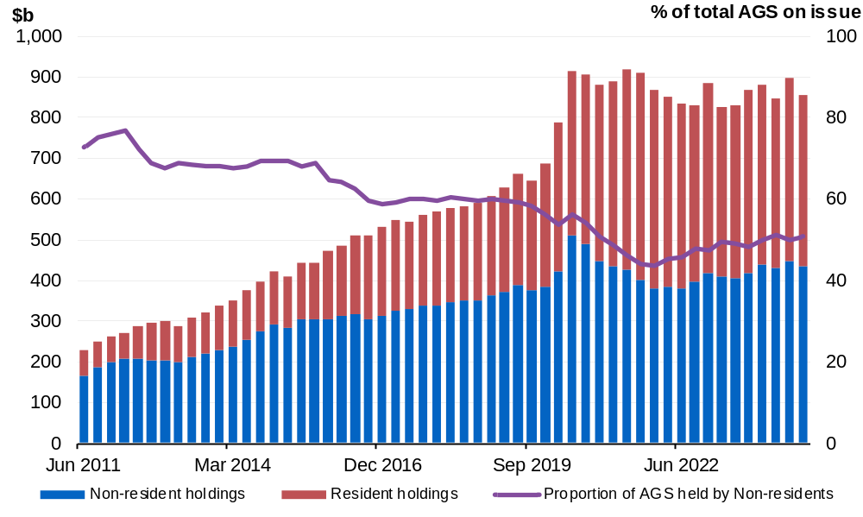
Note: Data refer to the repo-adjusted market value of holdings.
Source: ABS Catalogue Number 5203.0 and the Australian Office of Financial Management.

Net debt
Net debt is equal to the sum of interest-bearing liabilities (which include AGS on issue measured at market value) less the sum of selected financial assets (cash and deposits, advances paid and investments, loans and placements). As net debt incorporates both selected financial assets and liabilities at their fair value, it provides a broader measure of the Government’s financial obligations than gross debt.
Not all government assets or liabilities are included in the measurement of net debt. For example, the Government’s unfunded superannuation liability is not accounted for in net debt, nor are holdings of equities, for example, those held by the Future Fund or the Government’s equity investment in the NBN.
Table 6.7: Liabilities and assets included in net debt
 |  | Estimates
 | 2024-25 | 2025-26 | 2026-27 | 2027-28 | 2028-29
 | $m | $m | $m | $m | $m
Liabilities included in net debt
Deposits held | 418 | 418 | 418 | 418 | 418
Government securities(a) | 883,713 | 968,449 | 1,043,956 | 1,117,991 | 1,189,011
Loans | 32,385 | 33,885 | 34,485 | 34,546 | 34,215
Lease liabilities | 18,584 | 17,689 | 16,773 | 16,634 | 15,573
Total liabilities included in net debt | 935,100 | 1,020,440 | 1,095,631 | 1,169,589 | 1,239,216
Assets included in net debt
Cash and deposits | 73,008 | 73,579 | 70,329 | 68,147 | 61,359
Advances paid | 66,347 | 77,939 | 91,972 | 104,560 | 115,397
Investments, loans and placements | 239,767 | 248,576 | 257,052 | 282,806 | 294,224
Total assets included in net debt | 379,122 | 400,095 | 419,353 | 455,513 | 470,980
Net debt | 555,978 | 620,345 | 676,278 | 714,076 | 768,236
- Government securities are presented at market value.

Changes in net debt since the 2024–25 MYEFO
Net debt is expected to be higher in each year of the forward estimates compared to the 2024–25 MYEFO. This reflects a change in Future Fund investments, loans and placements and the impact of lower yields on AGS.
Table 6.8: Net debt – reconciliation from the 2024–25 MYEFO to the
2025–26 Budget
 | 2024-25 | 2025-26 | 2026-27 | 2027-28
 | $b | $b | $b | $b
Net debt as at 2024-25 MYEFO | 540.0 | 609.3 | 669.2 | 708.6
Changes in financing requirement | -0.6 | -6.9 | -8.4 | -1.6
Impact of yields on AGS | 4.4 | 4.1 | 3.3 | 2.8
Asset and other liability movements | 12.1 | 13.8 | 12.3 | 4.3
Cash and deposits | -0.7 | 0.3 | -2.1 | -3.9
Advances paid | 1.0 | 1.3 | 2.0 | 2.3
Investments, loans and placements | 11.1 | 11.2 | 11.5 | 5.1
Other movements | 0.7 | 1.0 | 0.8 | 0.8
Total movements in net debt from  2024-25 MYEFO to 2025-26 Budget | 15.9 | 11.0 | 7.1 | 5.5
Net debt as at 2025-26 Budget | 556.0 | 620.3 | 676.3 | 714.1

Interest on AGS
Estimates of the interest payments and expense of AGS on issue include the cost of AGS already on issue and future AGS issuance.
- The cost of AGS already on issue reflects the actual yield at the time of issuance.
- The expected cost of future AGS issuance is based on a recent average of daily spot rates across the yield curve at the time of a budget estimates update.
Interest payments on AGS are estimated to be lower across each year of the forward estimates compared to the 2024–25 MYEFO.
Chart 6.2 shows the yield curve assumptions underpinning the 2022 PEFO,
2024–25 MYEFO and the 2025–26 Budget. Yields are generally lower now compared to MYEFO and remain significantly higher than at the PEFO. Since MYEFO, yields have remained volatile, reflecting heightened global economic uncertainty.
The assumed weighted average cost of borrowing in this update has decreased to 4.3 per cent for future issuance of Treasury Bonds over the forward estimates, broadly reflecting global trends in movements of yields. This is lower than the assumed weighted average yield of 4.4 per cent at the 2024–25 MYEFO and higher than the weighted average yield of 2.2 per cent at the 2022 PEFO.
Chart 6.2: Yield curve assumptions from 2024–25 to 2028–29
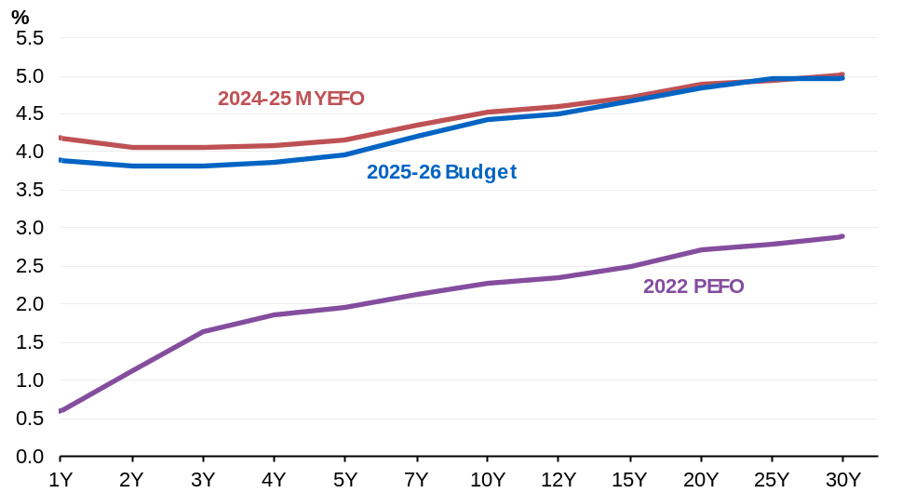
Source: AOFM.

By the end of the forward estimates total interest payments are estimated to be $38.2 billion, of which $36.6 billion relates to AGS on issue (Table 6.9). Compared to the 2024–25 MYEFO, total interest payments as a share of GDP are estimated to remain broadly unchanged across the forward estimates.
Interest receipts as a share of GDP are estimated to remain broadly unchanged across each year of the forward estimates compared to the 2024–25 MYEFO.
Net interest payments as a share of GDP are estimated to remain unchanged in 2025–26 at 0.6 per cent, and across all years of the forward estimates, compared to the
2024–25 MYEFO.
Table 6.9: Interest payments, interest receipts and net interest payments^{(a)}
 |  | Estimates
 | 2024-25 | 2025-26 | 2026-27 | 2027-28 | 2028-29
 | $m | $m | $m | $m | $m
Interest payments on AGS | 22,666 | 26,303 | 28,628 | 35,092 | 36,623
Per cent of GDP | 0.8 | 0.9 | 1.0 | 1.1 | 1.1
Interest payments(b) | 24,413 | 27,885 | 30,159 | 36,724 | 38,224
Per cent of GDP | 0.9 | 1.0 | 1.0 | 1.2 | 1.2
Interest receipts | 9,520 | 9,389 | 8,939 | 9,798 | 10,109
Per cent of GDP | 0.3 | 0.3 | 0.3 | 0.3 | 0.3
Net interest payments(c) | 14,893 | 18,495 | 21,221 | 26,926 | 28,115
Per cent of GDP | 0.5 | 0.6 | 0.7 | 0.9 | 0.8
- Interest payments and receipts are a cash measure, with the relevant amount recognised in the period in which the interest payment is made or interest is received.
- Interest payments include interest payments on AGS, loans and other borrowing, as well as interest payments on lease liabilities.
- Net interest payments are equal to the difference between interest payments and interest receipts.

As well as cash accounting terms, interest costs related to AGS are also presented on accrual accounting terms. The difference between the cash interest payments and accrual interest expense generally relates to the timing of when the interest cost is recognised.
- Interest payments are recognised in the period when they are paid during the life of the security.
- Interest expense is recognised in the period in which an expense is incurred during the life of the security, rather than when it is actually paid.
Table 6.10 shows changes in interest expense, interest income and net interest expense over the forward estimates.
Table 6.10: Interest expense, interest income and net interest expense^{(a)}
 |  | Estimates
 |  | 2024-25 | 2025-26 | 2026-27 | 2027-28 | 2028-29
 |  | $m | $m | $m | $m | $m
Interest expense on AGS |  | 23,914 | 28,419 | 33,081 | 37,491 | 41,705
Per cent of GDP |  | 0.9 | 1.0 | 1.1 | 1.2 | 1.3
Total interest expense(b) |  | 31,157 | 38,696 | 40,350 | 45,082 | 48,448
Per cent of GDP |  | 1.1 | 1.3 | 1.3 | 1.4 | 1.5
Interest income |  | 10,532 | 10,619 | 10,662 | 11,739 | 12,242
Per cent of GDP |  | 0.4 | 0.4 | 0.4 | 0.4 | 0.4
Net interest expense(c) |  | 20,624 | 28,076 | 29,688 | 33,343 | 36,207
Per cent of GDP |  | 0.7 | 1.0 | 1.0 | 1.1 | 1.1
- Interest expense is an accrual measure, with the relevant amount recognised in the period in which the expense is incurred, but not necessarily paid.
- Interest expense includes interest expense on AGS, loans and other borrowing, as well as interest expense on lease liabilities and other financing costs (including debt not expected to be repaid (DNER)).
- Net interest expense is equal to the difference between interest expenses and interest income.

For Treasury Indexed Bonds (TIBs), the final repayment amount paid to investors includes an additional amount to reflect the impact of inflation over the life of the security. This additional amount is not included in the calculation of face value.

