Statement 7:
Forecasting Performance
and Sensitivity Analysis
Economic and fiscal forecasts and projections in the Budget are underpinned by a range of assumptions and judgements based on the best available information at the time of preparation. In practice, economic and fiscal circumstances can evolve in ways that differ from expectations.
This statement assesses:
- The performance of past forecasts based on the variance between forecasts and actuals.
- The uncertainty around current forecasts using confidence interval analysis.
- The sensitivity of current forecasts to changes in key assumptions:
  - Iron ore prices
  - Yields on Australian Government Securities.
The fiscal impact of key developments and Australia’s climate change outlook are considered in Budget Statement 3: Fiscal Strategy and Outlook.
Forecasts are based on assumptions and judgements. Forecast accuracy depends on whether assumptions and judgements prove to be correct, and the reliability of the modelled economic and fiscal relationships.

Statement contents
Assessing past forecasting performance 171
Economic forecasting performance 172
Fiscal forecasting performance 173
Assessing forecast uncertainty – confidence interval analysis 178
Economic uncertainty based on historical forecast errors 179
Fiscal uncertainty based on historical forecast errors 181
Assessing current forecasts through sensitivity analysis 184
Movements in iron ore prices 184
Movements in yields 186

Statement 7: Forecasting Performance and Sensitivity Analysis

Assessing past forecasting performance
This section assesses the variance between historical forecasts and outcomes (forecast errors) for real and nominal GDP, tax receipts, non-tax receipts, payments and the underlying cash balance.
Forecasts are prepared using a range of techniques:
- Macroeconomic forecasts are prepared consistent with a national accounting framework using econometric models, analysis and professional judgement.
- Tax receipts forecasts are generally prepared using a ‘base plus growth’ methodology. The last outcome for each head of revenue is the base to which growth rates are applied, using appropriate economic parameters. Forecasts are then updated to include costings of new policy.
- Payments forecasts are generally prepared through analysis of payment program data, costings for new policies and historical trends in programs, in consultation with relevant agencies.

Economic forecasting performance
Real GDP forecasts incorporate technical assumptions for exchange rates, interest rates and commodity prices. The forecasts are informed by a macroeconomic model and incorporate long-term trend assumptions, and judgements about how domestic and international developments might affect Australia’s economy.
Real GDP grew by 1.4 per cent in 2023–24, which is broadly consistent with the 1½ per cent growth forecast at the 2023–24 Budget (Chart 7.1).
Chart 7.1: Comparison of forecasts and outcomes for real GDP growth
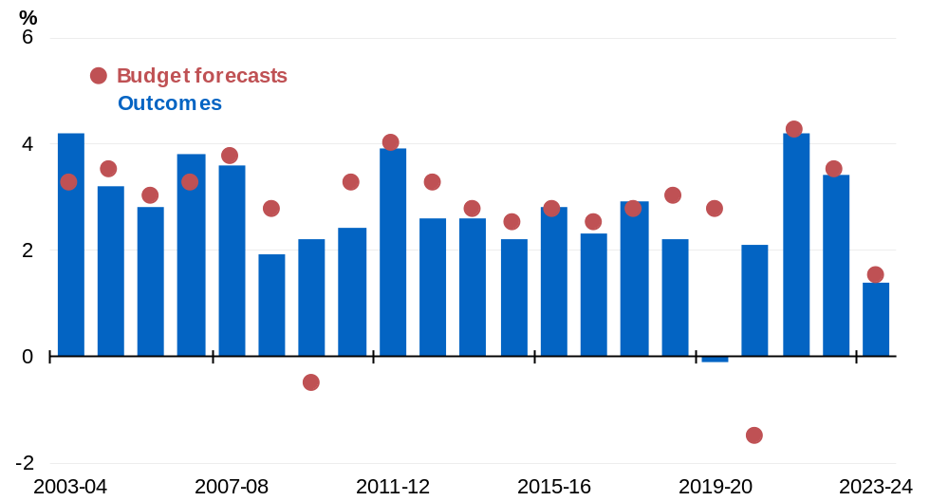
Note: Outcome is as published in the December quarter 2024 National Accounts. Forecast is that published in the Budget for that year. For 2022–23, the forecast is from the March 2022–23 Budget.
Source: ABS Australian National Accounts: National Income, Expenditure and Product and Budget papers.

Price movements underpinning nominal GDP forecasts create greater uncertainty compared with real GDP forecasts. Price uncertainty relates to domestic prices and wages, exchange rates, prices of imported goods, and world prices for Australia’s exports including commodities. Since the early 2000s, nominal GDP forecast errors have largely reflected volatility in global commodity prices. Recent years have experienced higher-than-usual volatility in commodity export prices, which generally remained above assumed conservative anchor prices and glide paths for an extended period, partly due to the ongoing tensions in the Middle East and Ukraine.
Nominal GDP grew by 4.1 per cent in 2023–24 rather than the 1¼ per cent growth forecast at the 2023–24 Budget (Chart 7.2). This underestimation of nominal GDP growth largely reflected higher-than-expected commodity prices.

Chart 7.2: Comparison of forecasts and outcomes for nominal GDP growth
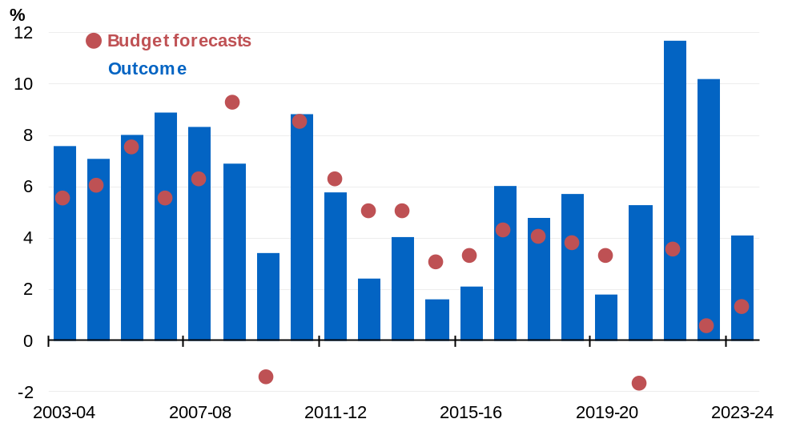
Note: Outcome is as published in the December quarter 2024 National Accounts. Forecast is that published in the Budget for that year. For 2022–23, the forecast is from the March 2022–23 Budget.
Source: ABS Australian National Accounts: National Income, Expenditure and Product and Budget papers.

Fiscal forecasting performance
Fiscal forecast errors are driven by economic and demographic forecast errors, along with unanticipated changes in demand for government programs. Government policies announced after the Budget can also affect fiscal forecast errors. Further information on Budget outcomes can be found in the 2023–24 Final Budget Outcome.

Total receipts
Total receipts are comprised of tax and non-tax receipts (for example, dividends from investment funds). Tax receipts account for over 90 per cent of total receipts and are therefore the main driver of forecasting performance.
Total receipts grew 6.0 per cent in 2023–24 rather than the 5.1 per cent increase forecast at the 2023–24 Budget. Total receipts were $20.4 billion higher than forecast.

Tax receipts
Tax receipts grew 5.3 per cent in 2023–24 rather than the 4.8 per cent increase forecast at the 2023–24 Budget (Chart 7.3). Tax receipts were $17.1 billion higher than forecast. This outcome reflected higher-than-expected company tax receipts and gross income tax withholding receipts partially offset by weaker-than-expected excise and customs duty receipts and superannuation fund taxes.
Chart 7.3: Comparison of forecasts and outcomes for tax receipts growth
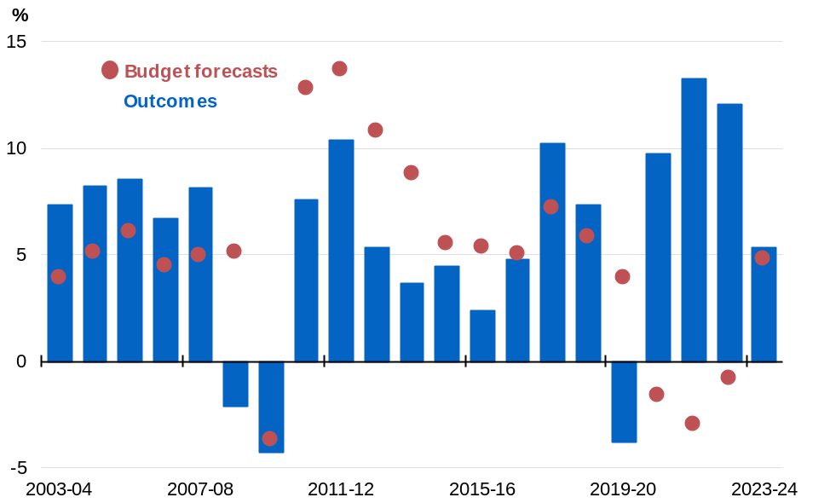
Source: Budget papers and Treasury.

On average, nominal GDP forecast errors magnify tax receipts forecast errors, owing to Australia’s progressive personal income tax system (Chart 7.4).
Chart 7.4: Forecast errors for nominal non-farm GDP and tax receipts growth^{(a)}
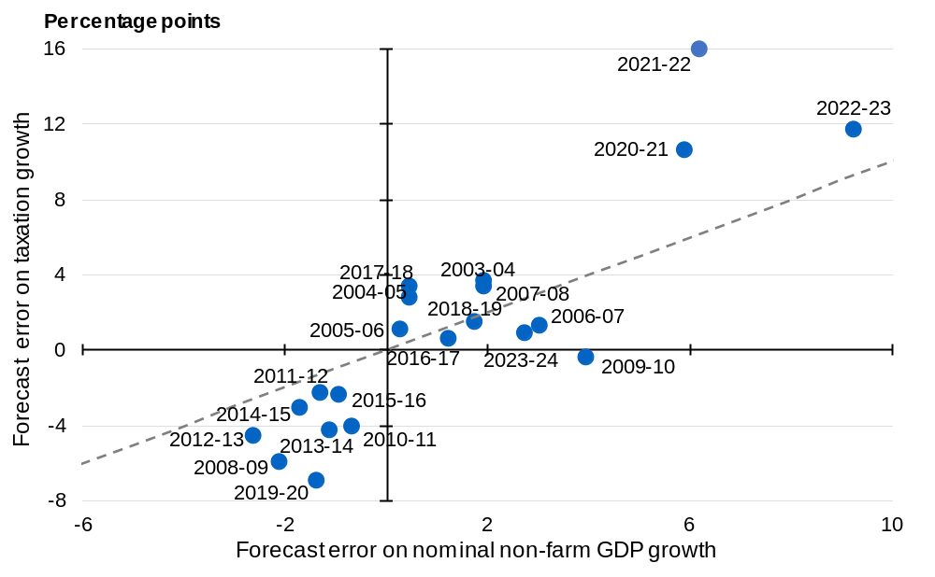
- Excludes capital gains tax.
Source: ABS Australian National Accounts: National Income, Expenditure and Product; and Treasury.

Non-tax receipts
Forecast variances in non-tax receipts are generally driven by financial market volatility which impacts investment earnings and resource royalties.
Non-tax receipts grew by 14.5 per cent in 2023–24 rather than the 9.1 per cent forecast at the 2023–24 Budget (Chart 7.5). Non-tax receipts were $3.3 billion higher in 2023–24 than forecast in the 2023–24 Budget. This increase largely reflects variations in returns on investments, including higher-than-estimated earnings from interest on cash deposits due to the rise in short-term interest rates, and higher-than-estimated earnings from the Future Fund and other Australian Government Investment Funds. The sale of non-financial assets through the 3.4/3.7 GHz Spectrum Auctions also contributed to the increases in non-tax receipts.
Chart 7.5: Comparison of forecasts and outcomes for non-tax receipts growth
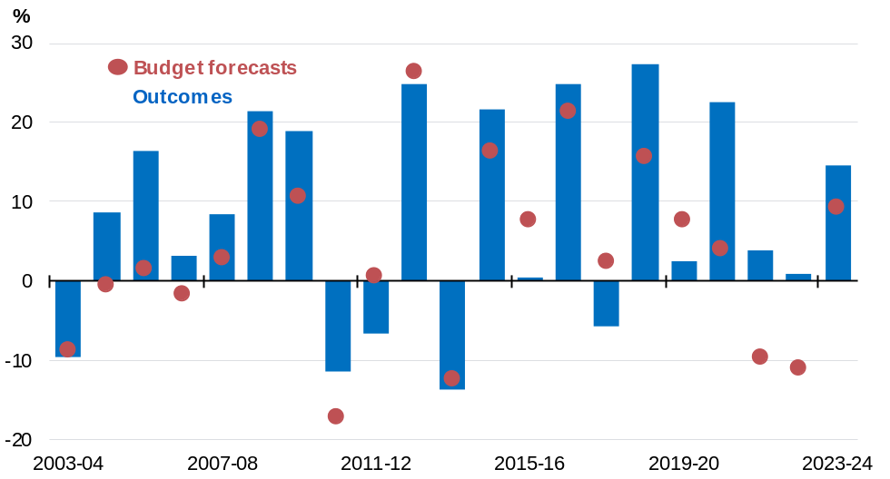
Source: Budget papers and Treasury.

Payments
Payments forecasting performance is affected by growth in indexation factors (for example, CPI growth) and demand for government programs. Demand-driven programs, such as payments to individuals for social welfare, form the bulk of Australian Government expenditure and vary with economic conditions.
Payments increased by 7.2 per cent in 2023–24 rather than the 8.0 per cent forecast at the 2023–24 Budget (Chart 7.6). Payments were $9.3 billion lower in 2023–24 than forecast in the 2023–24 Budget. This decrease largely reflects delays in milestone payments under National Partnership Payment programs. Decreases to payments also resulted from a decline in the expected number of recipients and average payment rates across a number of programs including Student Payments and Family Tax Benefits, reflecting strong labour market performance. In addition, lower than projected demand for medical services contributed to a decrease in payments under the Medical Benefits program.
Chart 7.6: Comparison of forecasts and outcomes for payments growth
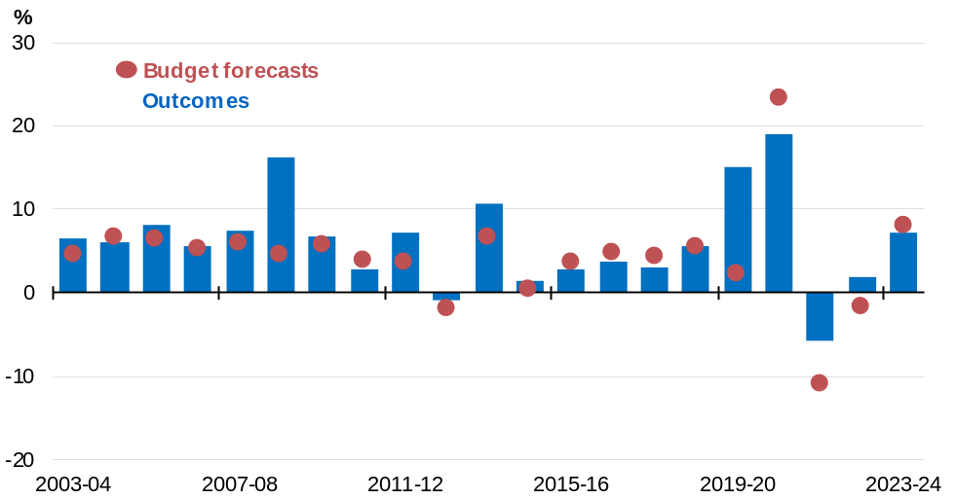
Source: Budget papers and Treasury.

Underlying cash balance
Underlying cash balance forecasting performance is driven by the forecast errors of total receipts and payments.
The underlying cash surplus was 0.6 per cent of GDP in 2023–24 rather than the forecast deficit of 0.5 per cent of GDP (Chart 7.7). The underlying cash balance was $29.7 billion higher than forecast. The better-than expected underlying cash balance outcome in 2023–24 largely reflected higher-than-expected receipts ($20.4 billion) and lower-than-expected payments ($9.3 billion).
Chart 7.7: Comparison of forecasts and outcomes for underlying cash balance
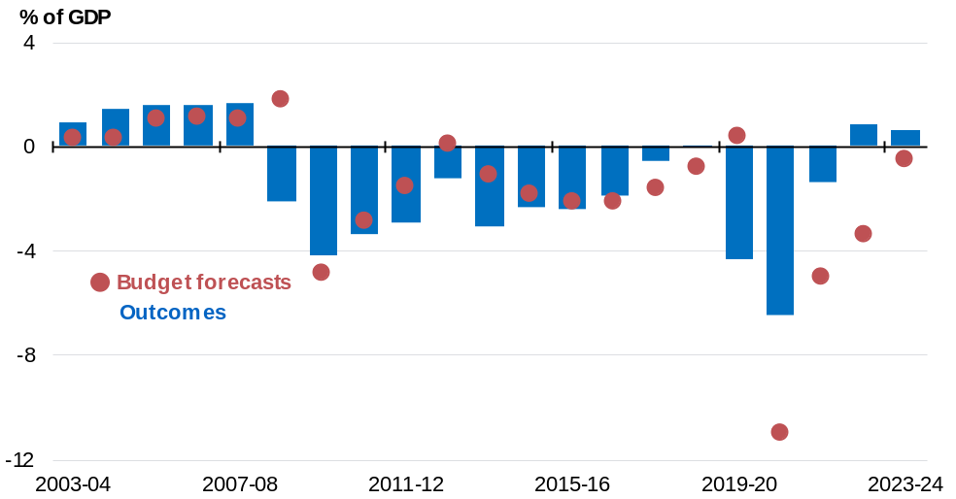
Source: Budget papers and Treasury.

In the past two decades, outside major downturns, the underlying cash balance forecast error largely reflected forecast errors of total receipts (Chart 7.8).
Large forecast errors for payments in 2008–09 and 2019–20 reflected unexpected Government payment assistance during the Global Financial Crisis and COVID–19. Overestimates of receipts tend to coincide with underestimates of payments during economic shocks, magnifying underlying cash balance forecast errors.
Chart 7.8: Total receipts, payments, and underlying cash balance forecast errors
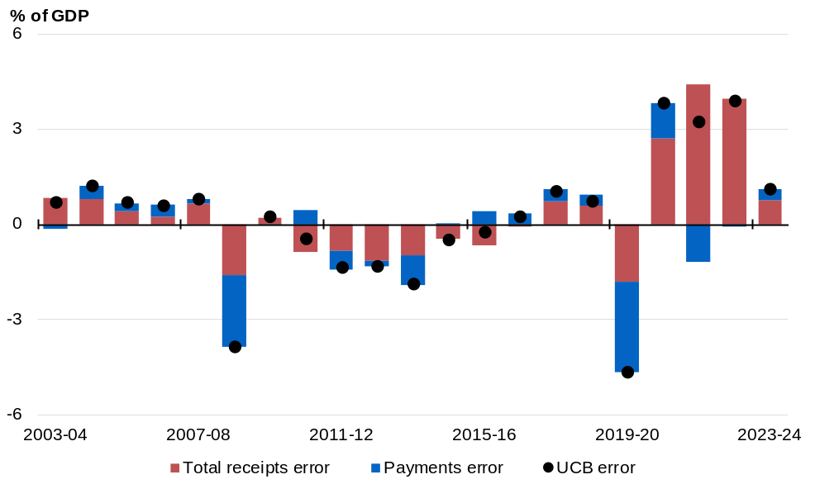
Source: Budget papers and Treasury.

Assessing forecast uncertainty – confidence interval analysis
Confidence intervals illustrate the uncertainty around current forecasts based on the historical distribution of forecast errors. Confidence interval analysis assumes that future forecast errors are consistent with the distribution of past forecast errors. Based on past forecasting performance, there is a 70 and 90 per cent probability that the actual outcome will lie within the 70 and 90 per cent confidence interval bands.
Future forecast errors may not have the same distribution as historical forecast errors. The large forecast errors in 2019–20 and 2020–21, related to the COVID–19 pandemic, are an example of events not previously captured in the historical error sample. Large disruptive events are difficult to predict and could occur again in the future.

Economic uncertainty based on historical forecast errors
Average annualised growth in real GDP in the three years to 2026–27 is expected to be around 2 per cent. The 70 per cent confidence interval ranges from 1¼ per cent to 2¾ per cent. The 90 per cent confidence interval ranges from 1 per cent to 3 per cent (Chart 7.9).
Chart 7.9: Confidence intervals around real GDP growth rate forecasts
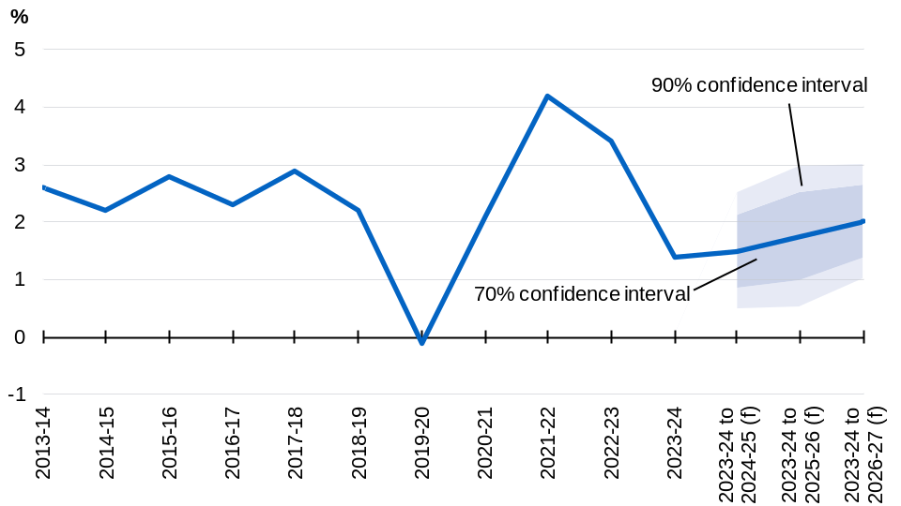
Note: The line shows the outcomes and the 2025–26 Budget forecasts. Annual growth rates are reported for the outcomes. Average annualised growth rates from 2023–24 are reported for 2024–25 onwards. Confidence intervals are based on the root mean squared errors (RMSEs) of Budget forecasts from 1998–99 onwards and are a statistical assessment that does not take account of any change in circumstance in the economic outlook. (f) are forecasts.
Source: ABS Australian National Accounts: National Income, Expenditure and Product and Treasury.

The confidence intervals around the nominal GDP forecasts are wider than those around the real GDP forecasts, reflecting the additional uncertainty around domestic prices and commodity prices. Average annualised growth in nominal GDP in the three years to
2026–27 is expected to be around 3¾ per cent, with the 70 per cent confidence interval ranging from 1½ per cent to 6 per cent. The 90 per cent confidence interval ranges from zero to 7½ per cent (Chart 7.10).
Chart 7.10: Confidence intervals around nominal GDP growth rate forecasts
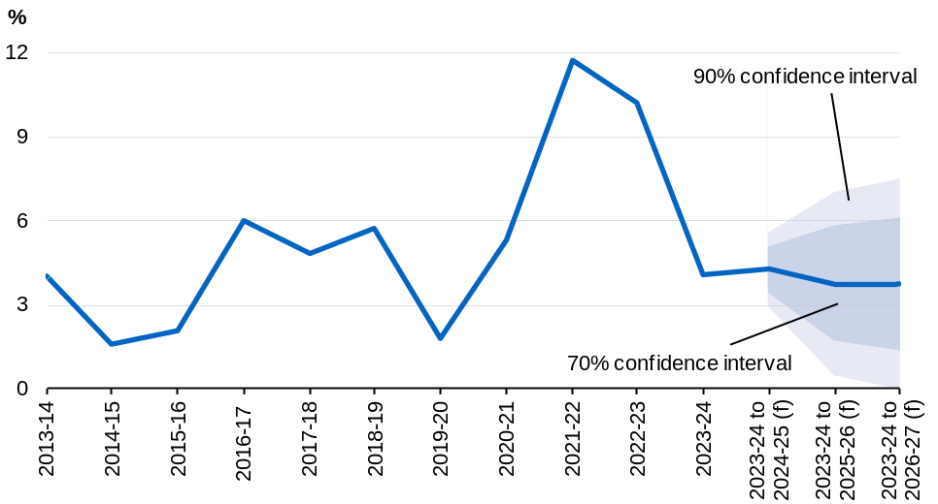
Note: The line shows the outcomes and the 2025–26 Budget forecasts. Annual growth rates are reported for the outcomes. Average annualised growth rates from 2023–24 are reported for 2024–25 onwards. Confidence intervals are based on the root mean squared errors (RMSEs) of Budget forecasts from 1998–99 onwards and are a statistical assessment that does not take account of any change in circumstance in the economic outlook. (f) are forecasts.
Source: ABS Australian National Accounts: National Income, Expenditure and Product and Treasury.

Fiscal uncertainty based on historical forecast errors
Fiscal estimates are based on economic and demographic forecasts as well as estimates of spending and revenue measures.
Historical variations caused by subsequent policy decisions not known at the time of forecast are excluded because these decisions do not reflect forecasting errors based on available information at the time of preparation. Payment estimates do not exclude the public debt interest associated with these subsequent policy decisions because this cannot be separately identified.

Total receipts
Total receipts (including GST) are expected to be around 25.5 per cent of GDP in 2025–26, with the 70 per cent confidence interval ranging from 24.0 per cent to 27.1 per cent of GDP. The 90 per cent confidence interval ranges from 23.1 per cent to 28.0 per cent in 2025–26.
The uncertainty around receipts forecasts increases with time (Chart 7.11).
Chart 7.11: Confidence intervals around total receipts forecasts^{(a)}
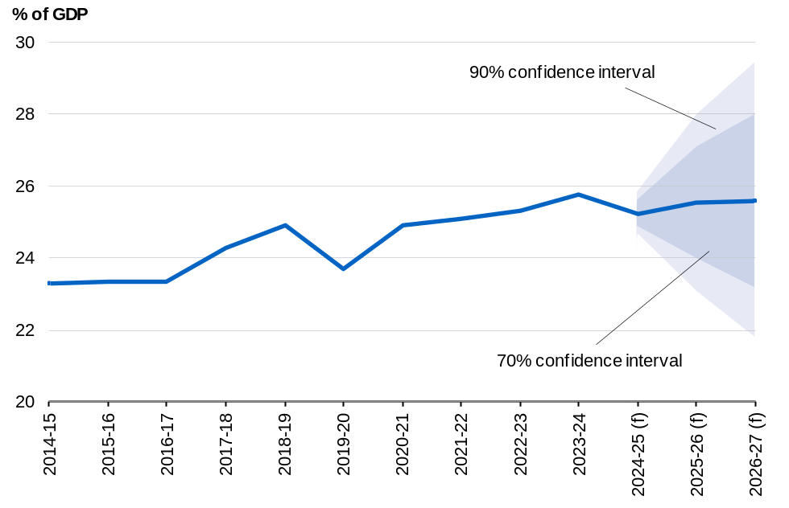
- Includes Future Fund earnings from 2020–21 onwards.
Note: The central line shows outcomes and the 2025–26 Budget forecasts. Confidence intervals use Root Mean Square Errors (RMSE) for Budget forecasts from the 1999–2000 Budget onwards.
(f) are forecasts.
Source: Budget papers and Treasury.

Payments
The confidence interval for payments is narrower than receipts because there is greater certainty around payments forecasts. Payments (including GST) are expected to be around 27.0 per cent of GDP in 2025–26, with the 70 per cent confidence interval ranging from 26.5 per cent to 27.5 per cent of GDP. The 90 per cent confidence interval ranges from 26.2 per cent to 27.8 per cent in 2025–26 (Chart 7.12).
Chart 7.12: Confidence intervals around payments forecasts^{(a)}
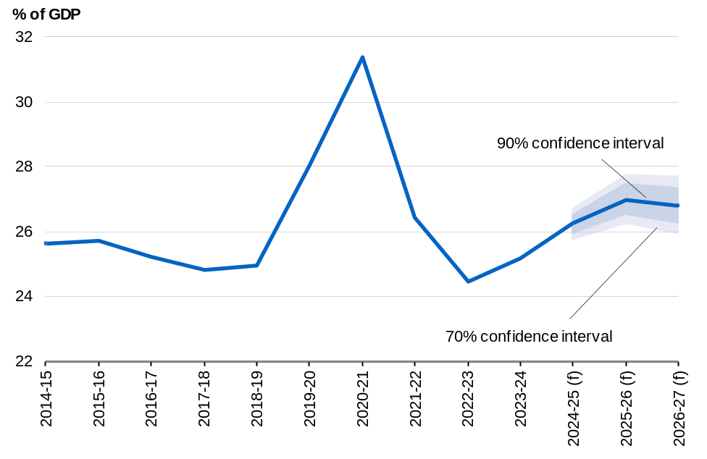
- Includes GST payments.
Note: The central line shows outcomes and the 2025–26 Budget forecasts. Confidence intervals use Root Mean Square Errors (RMSE) for Budget forecasts from the 1999–2000 Budget onwards.
(f) are forecasts.
Source: Budget papers and Treasury.

Underlying cash balance
The underlying cash deficit in 2025–26 is expected to be 1.5 per cent of GDP, with the 70 per cent confidence interval ranging from a deficit of 3.3 per cent to a surplus of 0.3 per cent of GDP. The 90 per cent confidence interval ranges from a deficit of 4.3 per cent to a surplus of 1.4 per cent in 2025–26.
The uncertainty around underlying cash balance forecasts reflects forecast errors in receipts and payments which increase further out in time (Chart 7.13).
Chart 7.13: Confidence intervals around the underlying cash balance forecasts
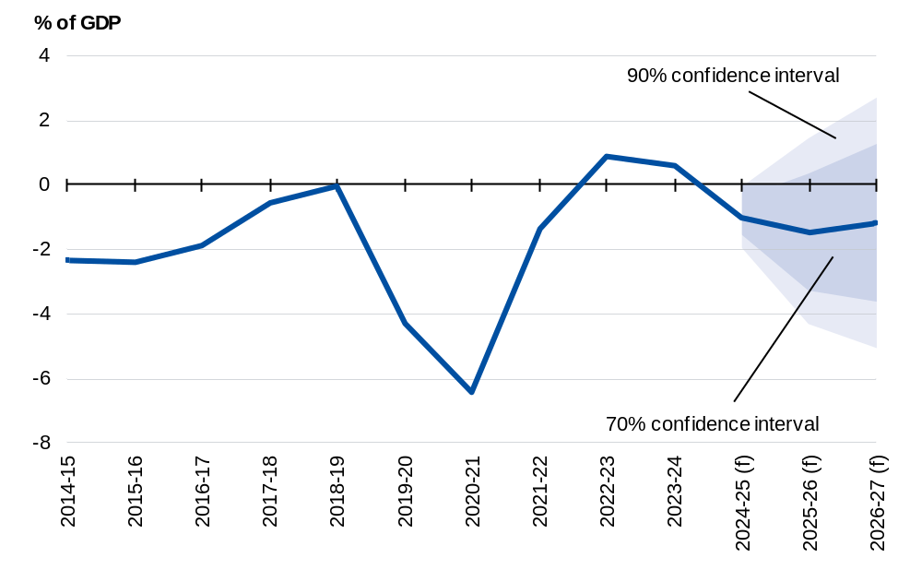
Note: The central line shows outcomes and the 2025–26 Budget forecasts. Confidence intervals use Root Mean Square Errors (RMSE) for Budget forecasts from the 1999–2000 Budget onwards.
(f) are forecasts.
Source: Budget papers and Treasury.

Assessing current forecasts through sensitivity analysis
Sensitivity analysis allows for an assessment of the impact of key assumptions. The following sensitivity analyses are considered due to their variability and importance for the Budget:
- Higher and lower iron ore prices.
- Higher and lower yields over the medium term.
For illustrative purposes, the upper and lower sensitivities are broadly symmetric, even where not equally probable.

Movements in iron ore prices
The forecasts for nominal GDP and tax receipts are sensitive to commodity price assumptions, particularly iron ore prices. Iron ore is Australia’s largest export by value, representing 21 per cent of the total value of goods and services exports in 2023–24. See Budget Statement 2: Economic Outlook for more information on the commodity price assumptions incorporated into the economic outlook.
Iron ore prices are volatile and sensitive to global market developments. Table 7.1 considers the impact of a permanent US$10 per tonne increase and decrease in the iron ore spot price on nominal GDP and tax receipts relative to the Budget baseline forecast.
Table 7.1: Scenario analysis of a US$10 per tonne movement in iron ore prices
 | US$10/tonne FOB^{(a)} increase |  |  |  |  | US$10/tonne FOB decrease
 | 2025-26 | 2026-27 | 2027-28 | 2028-29 |  | 2025-26 | 2026-27 | 2027-28 | 2028-29
Nominal GDP ($billion) | 5.2 | 2.7 | 5.6 | 10.4 |  | -5.2 | -2.7 | -5.6 | -10.4
Tax receipts ($billion) | 0.4 | 0.5 | 0.5 | 2.1 |  | -0.4 | -0.5 | -0.5 | -2.1
a) Prices are presented in free-on-board (FOB) terms which exclude the cost of freight.
Source: Treasury.

The effects of a US$10 per tonne increase and decrease in the iron ore price are broadly symmetric. The following discussion focuses mainly on an increase for illustrative purposes. A US$10 per tonne increase in the iron ore price increases nominal GDP by around $5.2 billion in 2025–26, rising to around $10.4 billion in 2028–29.
The economic response to a permanent change in the price of iron ore is derived from a generic terms of trade shock using a forward-looking macroeconomic model. Higher iron ore export prices lead to a higher terms of trade, which leads directly to higher output prices and nominal GDP. The volume of output and exports in the mining sector increase in response to higher iron ore prices. However, an appreciation in the exchange rate leads to a substitution to imports which partially offsets the increase in exports and GDP. This change in the exchange rate also acts to reduce domestic inflation through lower import prices.
A US$10 per tonne increase in the assumed price for iron ore exports is expected to result in an increase in tax receipts of around $0.4 billion in 2025–26 and $0.5 billion in both 2026–27 and 2027-28, before increasing to $2.1 billion in 2028–29. An increase in iron ore prices increases mining company profits and therefore company tax receipts. This builds over time as tax receipts incorporate the full impact of the iron ore price increase on nominal GDP and due to the lag between when profits are realised and tax is paid by companies. The lower domestic prices result in lower individuals and other withholding taxes and indirect tax receipts, partially offsetting the increase in company tax receipts.

Movements in yields
Government borrowing costs are sensitive to yields on Australian Government Securities and the level of debt. See Budget Statement 6: Debt Statement for further information on yields. Given the uncertainty surrounding the global and domestic outlook and the impact on yields, Treasury makes the following technical assumptions:
- Over the forward estimates, government bond yields are fixed at rates observed immediately prior to the Budget update.
- After the forward estimates, the 10-year bond yield converges linearly towards the long-run nominal GDP growth rate over 15 years. This is broadly consistent with the approaches of comparable advanced economies. The yields on other bond tenors are assumed to maintain their historical relativity to the 10-year bond yield.
The higher yield assumption has bond yields increasing by 100 basis points by 30 June 2026. Yields are then held constant over the remainder of the forward estimates to 2028–29, before linearly converging to the long-run yield assumption of nominal GDP growth over 15 years. The lower yield sensitivity is symmetric (Chart 7.14). Other economic parameters are assumed to remain unchanged from baseline forecasts to isolate the direct impact on fiscal aggregates.
Chart 7.14: Baseline and alternative movements in the 10-year bond yield
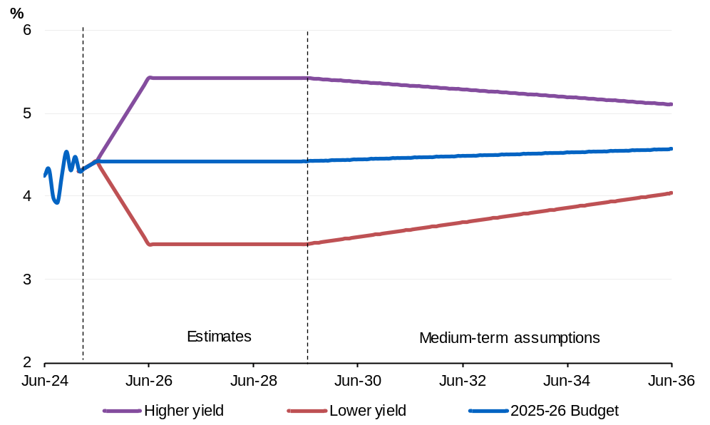
Source: Treasury.

Higher yields increase public debt interest payments and receipts earned on investments. As government interest bearing liabilities usually exceed interest bearing assets, higher yields lead to a deterioration in the underlying cash balance. Lower yields have the reverse effect, improving the underlying cash balance.
The higher yield assumption results in a deterioration to the underlying cash balance of 0.3 percentage points of GDP by 2035–36 and increases gross debt by 2.1 percentage points of GDP at 30 June 2036 (Chart 7.15).
The lower yield assumption results in an improvement to the underlying cash balance of 0.2 percentage points of GDP by 2035–36. Under the lower yield assumption, cumulative improvements to the underlying cash balance reduce gross debt by 2.1 percentage points of GDP at 30 June 2036.
Chart 7.15: Gross debt
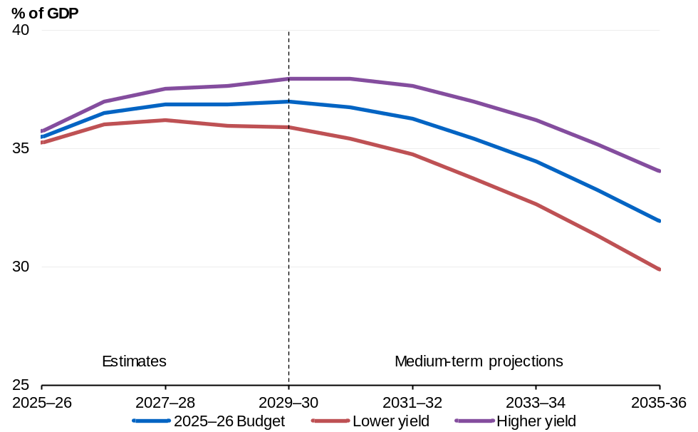
Source: Australian Office of Financial Management and Treasury.

See Treasury Working Paper: Estimates of uncertainty around budget forecasts (2013).

