Statement 10:
Australian Government Budget Financial Statements
Consistent with the Charter of Budget Honesty Act 1998 (the Charter), the Government has produced a set of financial statements for the Australian Government general government sector (GGS), the public non-financial corporations (PNFC) sector, the total non-financial public sector (NFPS) and the public financial corporations (PFC) sector. The financial statements comply with both the Australian Bureau of Statistics’ (ABS) accrual Government Finance Statistics (GFS) and Australian Accounting Standards (AAS), with departures disclosed. These statements are:
- an operating statement, including other economic flows, which shows net operating balance and net lending/borrowing (fiscal balance)
- a balance sheet, which shows net worth, net financial worth, net financial liabilities and net debt
- a cash flow statement, which includes the calculation of the underlying cash balance.
In addition to these general purpose statements, notes to the financial statements are required. These notes include a summary of accounting policies, disaggregated information and other disclosures required by AAS.
The statements reflect the Government’s policy that the ABS GFS remains the basis of budget accounting policy, except where AAS is applied because it provides a better conceptual basis for presenting information of relevance to users of public sector financial reports.
The Australian, state and territory governments have an agreed framework – the Uniform Presentation Framework (UPF) – for the presentation of government financial information on a basis broadly consistent with the Australian Accounting Standard AASB 1049. The financial statements are consistent with the requirements of the UPF.

Statement 10 contents
Australian Government Budget Financial Statements 363
Notes to the general government sector financial statements 378
Note 1: External reporting standards and accounting policies 378
Note 2: Departures from external reporting standards 379
Note 3: Taxation revenue by type 382
Note 3(a): Taxation revenue by source 383
Note 4: Sales of goods and services revenue 383
Note 5: Interest and dividend and distribution revenue 384
Note 6: Other sources of non-taxation revenue 384
Note 7: Employee and superannuation expense 385
Note 8: Depreciation and amortisation expense 385
Note 9: Supply of goods and services expense 386
Note 10: Interest expense 386
Note 11: Current and capital grants expense 387
Note 12: Personal benefits expense 387
Note 13: Advances paid and other receivables 388
Note 14: Investments, loans and placements 388
Note 15: Non-financial assets 389
Note 16: Loans 390
Note 17: Employee and superannuation liabilities 390
Note 18: Provisions and payables 391
Note 19: Reconciliation of cash 392
Appendix A: Financial reporting standards and budget concepts 393
AASB 1049 Conceptual framework 393
Operating statement 394
Balance sheet 395
Cash flow statement 397
Appendix B: Assets and Liabilities 401
Overview 401
The Australian Government’s assets and liabilities 401
Assets 401
Liabilities 414

Statement 10: Australian Government Budget Financial Statements
Table 10.1: Australian Government general government sector operating statement
 |  | Estimates
 |  | 2025-26 | 2026-27 | 2027-28 | 2028-29 | 2029-30
 | Note | $m | $m | $m | $m | $m
Revenue
Taxation revenue | 3 | 716,622 | 756,283 | 775,492 | 800,955 | 845,780
Sales of goods and services | 4 | 22,213 | 23,821 | 24,939 | 25,066 | 25,094
Interest income | 5 | 10,216 | 11,224 | 11,697 | 12,433 | 13,339
Dividend and distribution income | 5 | 7,591 | 7,805 | 8,338 | 9,134 | 9,904
Other | 6 | 16,439 | 16,195 | 15,822 | 15,884 | 16,031
Total revenue |  | 773,081 | 815,328 | 836,287 | 863,473 | 910,148
Expenses
Gross operating expenses
Wages and salaries(a) | 7 | 31,790 | 33,406 | 32,886 | 32,674 | 32,652
Superannuation | 7 | 9,287 | 9,443 | 9,534 | 9,806 | 10,206
Depreciation and amortisation | 8 | 13,888 | 14,771 | 15,151 | 15,682 | 16,171
Supply of goods and services | 9 | 232,351 | 242,121 | 244,748 | 252,551 | 259,733
Other operating expenses(a) | 7 | 16,018 | 14,265 | 15,484 | 17,309 | 17,770
Total gross operating expenses |  | 303,334 | 314,007 | 317,803 | 328,022 | 336,531
Superannuation interest expense | 7 | 14,803 | 15,884 | 16,336 | 16,708 | 17,092
Interest expenses | 10 | 38,310 | 43,364 | 48,806 | 51,533 | 55,720
Current transfers
Current grants | 11 | 224,901 | 236,419 | 246,885 | 256,592 | 267,920
Subsidy expenses |  | 19,424 | 19,733 | 19,500 | 19,715 | 20,796
Personal benefits | 12 | 171,296 | 181,397 | 191,416 | 200,086 | 213,775
Total current transfers |  | 415,621 | 437,548 | 457,801 | 476,392 | 502,491
Capital transfers | 11
Mutually agreed write-downs |  | 13,206 | 2,517 | 2,639 | 2,770 | 2,898
Other capital grants |  | 26,790 | 19,942 | 20,273 | 20,648 | 18,995
Total capital transfers |  | 39,996 | 22,459 | 22,912 | 23,418 | 21,893
Total expenses |  | 812,063 | 833,262 | 863,659 | 896,074 | 933,727
Net operating balance |  | -38,982 | -17,934 | -27,371 | -32,601 | -23,579
Other economic flows –
included in operating result
Net write-downs of assets |  | -7,578 | -10,495 | -12,564 | -12,048 | -12,847
Assets recognised for the first time |  | 570 | 408 | 429 | 449 | 467
Actuarial revaluations |  | 1,433 | -99 | -106 | -112 | -118
Net foreign exchange gains |  | 84 | -151 | 0 | 0 | 0
Net swap interest received |  | 562 | 14 | 9 | 0 | 0
Market valuation of debt |  | 24,015 | -14,354 | -13,232 | -12,157 | -10,950
Other gains/(losses) |  | 13,884 | 10,819 | 11,500 | 12,271 | 13,084
Total other economic flows –
included in operating result |  | 32,969 | -13,859 | -13,965 | -11,597 | -10,364
Operating result(b) |  | -6,012 | -31,793 | -41,336 | -44,198 | -33,943
Table 10.1: Australian Government general government sector operating statement (continued)
 |  | Estimates
 |  | 2025-26 | 2026-27 | 2027-28 | 2028-29 | 2029-30
 | Note | $m | $m | $m | $m | $m
Non-owner movements in equity
Revaluation of equity investments |  | -433 | -169 | 0 | 0 | 0
Actuarial revaluations |  | -1,771 | -240 | -240 | -238 | -235
Other economic revaluations |  | 92 | 163 | 2,106 | 175 | 2,747
Total other economic flows -
included in equity |  | -2,111 | -246 | 1,866 | -63 | 2,512
Comprehensive result -
Total change in net worth |  | -8,124 | -32,039 | -39,470 | -44,261 | -31,431
Net operating balance |  | -38,982 | -17,934 | -27,371 | -32,601 | -23,579
Net acquisition of non-financial assets
Purchases of non-financial assets |  | 24,487 | 26,014 | 26,662 | 26,360 | 27,733
less Sales of non-financial assets |  | 446 | 141 | 2,246 | 1,389 | 3,159
less Depreciation |  | 13,888 | 14,771 | 15,151 | 15,682 | 16,171
plus Change in inventories |  | 1,005 | 884 | 916 | 900 | 944
plus Other movements in non-financial assets |  | 0 | 0 | 0 | 0 | 0
Total net acquisition of
non-financial assets |  | 11,158 | 11,986 | 10,181 | 10,188 | 9,348
Fiscal balance
(Net lending/borrowing)(c) |  | -50,139 | -29,920 | -37,552 | -42,789 | -32,927
- Consistent with the ABS GFS classification, other employee related expenses are classified separately from wages and salaries under other operating expenses. Total employee expenses equal wages and salaries plus other operating expenses.
- Operating result under AAS.
- The term fiscal balance is not used by the ABS.

Table 10.2: Australian Government general government sector balance sheet
 |  | Estimates
 |  | 2025-26 | 2026-27 | 2027-28 | 2028-29 | 2029-30
 | Note | $m | $m | $m | $m | $m
Assets
Financial assets
Cash and deposits |  | 73,677 | 63,669 | 67,839 | 69,962 | 71,879
Advances paid | 13 | 72,420 | 88,350 | 100,936 | 113,722 | 123,233
Investments, loans and placements | 14 | 261,106 | 271,315 | 278,493 | 289,210 | 300,983
Other receivables | 13 | 96,739 | 106,461 | 113,137 | 119,665 | 127,025
Equity investments
Investments in other public sector
entities |  | 51,763 | 59,299 | 64,048 | 67,162 | 69,606
Equity accounted investments |  | 6,762 | 6,829 | 6,832 | 6,832 | 6,810
Investments - shares |  | 127,854 | 135,852 | 144,719 | 155,250 | 164,413
Total financial assets |  | 690,320 | 731,775 | 776,003 | 821,802 | 863,948
Non-financial assets | 15
Land |  | 15,576 | 15,712 | 15,884 | 15,653 | 15,681
Buildings |  | 54,872 | 56,515 | 58,259 | 57,949 | 57,555
Plant, equipment and infrastructure |  | 124,227 | 131,694 | 140,534 | 150,544 | 161,878
Inventories |  | 13,586 | 14,029 | 14,487 | 14,914 | 15,373
Intangibles |  | 15,851 | 17,258 | 17,195 | 16,457 | 15,823
Investment properties |  | 225 | 225 | 225 | 226 | 226
Biological assets |  | 5 | 5 | 5 | 5 | 5
Heritage and cultural assets |  | 13,195 | 13,213 | 13,232 | 13,242 | 13,252
Assets held for sale |  | 40 | 35 | 35 | 35 | 35
Other non-financial assets |  | 6 | 6 | 6 | 6 | 6
Total non-financial assets |  | 237,582 | 248,693 | 259,864 | 269,032 | 279,835
Total assets |  | 927,902 | 980,469 | 1,035,867 | 1,090,833 | 1,143,783
Liabilities
Interest bearing liabilities
Deposits held |  | 416 | 416 | 416 | 416 | 416
Government securities |  | 910,584 | 987,626 | 1,063,702 | 1,147,053 | 1,214,034
Loans | 16 | 32,987 | 33,670 | 34,340 | 34,424 | 34,360
Lease liabilities |  | 19,215 | 18,243 | 17,574 | 16,517 | 15,087
Total interest bearing liabilities |  | 963,202 | 1,039,955 | 1,116,032 | 1,198,411 | 1,263,897

Table 10.2: Australian Government general government sector balance sheet (continued)
 |  | Estimates
 |  | 2025-26 | 2026-27 | 2027-28 | 2028-29 | 2029-30
 | Note | $m | $m | $m | $m | $m
Provisions and payables
Superannuation liability | 17 | 317,789 | 326,908 | 336,151 | 344,125 | 352,061
Other employee liabilities | 17 | 97,182 | 99,429 | 102,443 | 106,515 | 110,636
Suppliers payables | 18 | 14,124 | 14,444 | 16,763 | 18,785 | 19,635
Personal benefits payables | 18 | 4,840 | 4,860 | 4,534 | 4,929 | 5,401
Subsidies payables | 18 | 632 | 612 | 612 | 612 | 612
Grants payables | 18 | 6,204 | 5,819 | 6,278 | 6,348 | 5,995
Other payables | 18 | 6,747 | 6,359 | 6,263 | 6,179 | 6,149
Provisions | 18 | 132,078 | 129,016 | 133,196 | 135,596 | 141,493
Total provisions and payables |  | 579,596 | 587,447 | 606,239 | 623,088 | 641,982
Total liabilities |  | 1,542,798 | 1,627,403 | 1,722,272 | 1,821,499 | 1,905,879
Net worth(a) |  | -614,895 | -646,934 | -686,404 | -730,666 | -762,096
Net financial worth(b) |  | -852,477 | -895,627 | -946,268 | -999,698 | -1,041,931
Net financial liabilities(c) |  | 904,240 | 954,927 | 1,010,316 | 1,066,859 | 1,111,537
Net debt(d) |  | 555,999 | 616,621 | 668,765 | 725,518 | 767,803
- Net worth equals total assets minus total liabilities.
- Net financial worth equals total financial assets minus total liabilities.
- Net financial liabilities equals total liabilities less financial assets other than investments in other public sector entities.
- Net debt is the sum of interest bearing liabilities less the sum of selected financial assets (cash and deposits, advances paid and investments, loans and placements).

Table 10.3: Australian Government general government sector cash flow statement^{(a)}
 | Estimates
 | 2025-26 | 2026-27 | 2027-28 | 2028-29 | 2029-30
 | $m | $m | $m | $m | $m
Cash receipts from operating activities
Taxes received | 699,529 | 737,101 | 756,961 | 782,898 | 826,240
Receipts from sales of goods and services | 21,760 | 23,299 | 24,847 | 25,024 | 25,042
Interest receipts | 9,329 | 9,636 | 9,696 | 10,056 | 10,538
Dividends, distributions and
income tax equivalents | 7,630 | 7,768 | 8,304 | 9,098 | 9,868
Other receipts | 21,313 | 20,117 | 20,777 | 19,883 | 19,912
Total operating receipts | 759,562 | 797,922 | 820,586 | 846,959 | 891,600
Cash payments for operating activities
Payments to employees(b) | -50,824 | -53,690 | -54,309 | -54,578 | -55,415
Payments for goods and services | -228,322 | -241,434 | -242,742 | -249,997 | -258,264
Grants and subsidies paid | -272,284 | -284,106 | -290,202 | -299,657 | -307,795
Interest paid | -27,058 | -29,566 | -36,364 | -38,026 | -42,264
Personal benefit payments | -171,517 | -182,086 | -191,860 | -200,248 | -213,861
Other payments(b) | -12,544 | -12,000 | -12,150 | -13,331 | -13,745
Total operating payments | -762,549 | -802,882 | -827,627 | -855,838 | -891,344
Net cash flows from operating activities | -2,987 | -4,960 | -7,041 | -8,878 | 256
Cash flows from investments in
non-financial assets
Sales of non-financial assets | 210 | 176 | 2,281 | 1,424 | 3,194
Purchases of non-financial assets | -22,676 | -23,900 | -23,429 | -24,242 | -25,973
Net cash flows from investments in
non-financial assets | -22,466 | -23,724 | -21,149 | -22,818 | -22,779
Net cash flows from investments in
financial assets for policy purposes | -19,629 | -32,544 | -23,334 | -22,785 | -15,704
Net cash flows from investments in
financial assets for liquidity purposes | -3,899 | -5,371 | -2,683 | -6,281 | -6,642
Cash receipts from financing activities
Borrowing | 291,910 | 808,451 | 936,667 | 1,020,484 | 1,005,163
Other financing | 9,863 | 123 | 70 | 11 | 3
Total cash receipts from financing
activities | 301,773 | 808,574 | 936,736 | 1,020,495 | 1,005,166
Cash payments for financing activities
Borrowing | -243,840 | -747,312 | -875,411 | -954,779 | -956,206
Other financing | -14,147 | -4,670 | -2,950 | -2,830 | -2,173
Total cash payments for financing
activities | -257,987 | -751,982 | -878,361 | -957,609 | -958,379
Net cash flows from financing activities | 43,786 | 56,592 | 58,375 | 62,886 | 46,787
Net increase/(decrease) in cash held | -5,196 | -10,007 | 4,169 | 2,123 | 1,917

Table 10.3: Australian Government general government sector cash flow statement (continued)^{(a)}
 | Estimates
 | 2025-26 | 2026-27 | 2027-28 | 2028-29 | 2029-30
 | $m | $m | $m | $m | $m
GFS cash surplus(+)/deficit(-)(c) | -25,453 | -28,684 | -28,189 | -31,696 | -22,524
plus Principal payments of
lease liabilities(d) | -2,831 | -2,858 | -2,810 | -2,749 | -2,735
Equals underlying cash balance(e) | -28,284 | -31,542 | -31,000 | -34,445 | -25,259
plus Net cash flows from investments in
financial assets for policy purposes | -19,629 | -32,544 | -23,334 | -22,785 | -15,704
Equals headline cash balance | -47,913 | -64,086 | -54,333 | -57,230 | -40,963
- A positive number denotes a cash inflow; a negative number denotes a cash outflow.
- Consistent with the ABS GFS classification, other employee related payments are classified separately from wages and salaries under other payments.
- GFS cash surplus/deficit equals net cash flows from operating activities and investments in non-financial assets.
- Principal payments of lease liabilities, which are financing cash payments, are deducted in the calculation of the underlying cash balance to maintain consistency of measure following the implementation of AASB 16.
- The term underlying cash balance is not used by the ABS.

Table 10.4: Australian Government public non-financial corporations sector operating statement
 | Estimates
 | 2025-26 | 2026-27
 | $m | $m
Revenue
Grants and subsidies | 183 | 100
Sales of goods and services | 24,165 | 25,137
Interest income | 45 | 33
Other | 69 | 70
Total revenue | 24,462 | 25,340
Expenses
Gross operating expenses
Wages and salaries(a) | 5,539 | 5,367
Superannuation | 661 | 672
Depreciation and amortisation | 4,514 | 4,889
Supply of goods and services | 12,287 | 12,395
Other operating expenses(a) | 877 | 908
Total gross operating expenses | 23,879 | 24,230
Interest expenses | 2,349 | 2,601
Other property expenses | 151 | 106
Current transfers
Tax expenses | 119 | 49
Total current transfers | 119 | 49
Total expenses | 26,499 | 26,987
Net operating balance | -2,038 | -1,646
Other economic flows | -1,249 | -924
Comprehensive result - Total change in net worth
excluding contribution from owners | -3,287 | -2,570
Net acquisition of non-financial assets
Purchases of non-financial assets | 13,454 | 12,608
less Sales of non-financial assets | 455 | 460
less Depreciation | 4,514 | 4,889
plus Change in inventories | 11 | -1
plus Other movements in non-financial assets | 20 | 6
Total net acquisition of non-financial assets | 8,517 | 7,264
Fiscal balance (Net lending/borrowing)(b) | -10,554 | -8,910
- Consistent with the ABS GFS classification, other employee related expenses are classified separately from wages and salaries under other operating expenses. Total employee expenses equal wages and salaries plus other operating expenses.
- The term fiscal balance is not used by the ABS.

Table 10.5: Australian Government public non-financial corporations sector balance sheet
 | Estimates
 | 2025-26 | 2026-27
 | $m | $m
Assets
Financial assets
Cash and deposits | 1,252 | 2,457
Investments, loans and placements | 918 | 843
Other receivables | 6,792 | 6,859
Equity investments | 390 | 415
Total financial assets | 9,352 | 10,573
Non-financial assets
Land and other fixed assets | 87,849 | 94,147
Other non-financial assets(a) | 4,468 | 4,566
Total non-financial assets | 92,318 | 98,713
Total assets | 101,670 | 109,286
Liabilities
Interest bearing liabilities
Deposits held | 0 | 0
Advances received and loans | 42,921 | 46,277
Lease liabilities | 14,628 | 14,762
Total interest bearing liabilities | 57,549 | 61,039
Provisions and payables
Superannuation liability | 7 | 7
Other employee liabilities | 2,023 | 2,047
Other payables | 6,795 | 7,000
Other provisions(a) | 1,048 | 1,161
Total provisions and payables | 9,874 | 10,214
Total liabilities | 67,423 | 71,253
Shares and other contributed capital | 34,247 | 38,033
Net worth(b) | 34,247 | 38,033
Net financial worth(c) | -58,071 | -60,680
Net debt(d) | 55,379 | 57,739
- Excludes the impact of commercial taxation adjustments.
- Under AASB 1049, net worth equals total assets minus total liabilities. Under the ABS GFS, net worth equals total assets minus total liabilities minus shares and other contributed capital. The AASB 1049 method is used in this table.
- Under AASB 1049, net financial worth equals total financial assets minus total liabilities. Under the ABS GFS, net financial worth equals total financial assets minus total liabilities minus shares and other contributed capital. The AASB 1049 method is used in this table.
- Net debt is the sum of interest bearing liabilities less the sum of selected financial assets (cash and deposits and investments, loans and placements).

Table 10.6: Australian Government public non-financial corporations sector cash flow statement^{(a)}
 | Estimates
 | 2025-26 | 2026-27
 | $m | $m
Cash receipts from operating activities
Receipts from sales of goods and services | 26,451 | 28,734
Grants and subsidies received | 37 | 152
GST input credit receipts | 148 | 90
Other receipts | 53 | 35
Total operating receipts | 26,688 | 29,011
Cash payments for operating activities
Payments to employees(b) | -6,021 | -6,024
Payments for goods and services | -14,337 | -15,471
Interest paid | -2,675 | -2,990
GST payments to taxation authority | -407 | -545
Distributions paid | -154 | -106
Other payments(b) | -1,072 | -901
Total operating payments | -24,666 | -26,037
Net cash flows from operating activities | 2,022 | 2,975
Cash flows from investments in non-financial assets
Sales of non-financial assets | 243 | 460
Purchases of non-financial assets | -12,028 | -11,111
Net cash flows from investments in non-financial assets | -11,785 | -10,651
Net cash flows from investments in financial assets
for policy purposes | -4 | 0
Net cash flows from investments in financial assets
for liquidity purposes | 113 | 32
Net cash flows from financing activities
Borrowing (net) | 3,985 | 3,208
Other financing (net) | 4,552 | 5,641
Net cash flows from financing activities | 8,537 | 8,849
Net increase/(decrease) in cash held | -1,115 | 1,205
Cash at the beginning of the year | 2,368 | 1,252
Cash at the end of the year | 1,252 | 2,457
GFS cash surplus(+)/deficit(-)(c) | -9,762 | -7,676
plus Principal payments of lease liabilities(d) | -406 | -609
Adjusted GFS cash surplus(+)/deficit(-)(d) | -10,168 | -8,285
- A positive number denotes a cash inflow; a negative number denotes a cash outflow.
- Consistent with the ABS GFS classification, other employee related payments are classified separately from wages and salaries under other payments.
- GFS cash surplus/deficit equals net cash flows from operating activities and investments in non-financial assets.
- Principal payments of lease liabilities, which are financing cash payments, are deducted in the
calculation of the GFS cash surplus/deficit to maintain consistency of measure following the
implementation of AASB 16.

Table 10.7: Australian Government total non-financial public sector operating statement
 | Estimates
 | 2025-26 | 2026-27
 | $m | $m
Revenue
Taxation revenue | 716,215 | 756,056
Sales of goods and services | 44,105 | 46,721
Interest income | 10,200 | 11,062
Dividend and distribution income | 7,443 | 7,701
Other | 16,490 | 16,245
Total revenue | 794,455 | 837,784
Expenses
Gross operating expenses
Wages and salaries(a) | 37,304 | 38,741
Superannuation | 9,948 | 10,115
Depreciation and amortisation | 18,402 | 19,660
Supply of goods and services | 242,440 | 252,332
Other operating expenses(a) | 16,898 | 15,175
Total gross operating expenses | 324,993 | 336,024
Superannuation interest expense | 14,803 | 15,884
Interest expenses | 40,599 | 45,770
Current transfers
Current grants | 224,901 | 236,419
Subsidy expenses | 19,174 | 19,470
Personal benefits | 171,296 | 181,397
Total current transfers | 415,371 | 437,286
Capital transfers | 39,854 | 22,402
Total expenses | 835,619 | 857,366
Net operating balance | -41,164 | -19,581
Other economic flows | 29,715 | -14,489
Comprehensive result - Total change in net worth | -11,449 | -34,070
Net acquisition of non-financial assets
Purchases of non-financial assets | 37,864 | 38,571
less Sales of non-financial assets | 900 | 601
less Depreciation | 18,402 | 19,660
plus Change in inventories | 1,016 | 883
plus Other movements in non-financial assets | 20 | 6
Total net acquisition of non-financial assets | 19,598 | 19,199
Fiscal balance (Net lending/borrowing)(b) | -60,762 | -38,780
- Consistent with the ABS GFS classification, other employee related expenses are classified separately from wages and salaries under other operating expenses. Total employee expenses equal wages and salaries plus other operating expenses.
- The term fiscal balance is not used by the ABS.

Table 10.8: Australian Government total non-financial public sector balance sheet
 | Estimates
 | 2025-26 | 2026-27
 | $m | $m
Assets
Financial assets
Cash and deposits | 74,929 | 66,126
Advances paid | 70,792 | 83,826
Investments, loans and placements | 261,985 | 272,119
Other receivables | 102,531 | 112,153
Equity investments | 137,508 | 147,318
Total financial assets | 647,745 | 681,542
Non-financial assets
Land and other fixed assets | 309,186 | 325,141
Other non-financial assets | 20,367 | 21,867
Total non-financial assets | 329,552 | 347,007
Total assets | 977,298 | 1,028,550
Liabilities
Interest bearing liabilities
Deposits held | 416 | 416
Government securities | 910,584 | 987,626
Advances received and loans | 74,240 | 75,384
Lease liabilities | 33,843 | 33,005
Total interest bearing liabilities | 1,019,084 | 1,096,431
Provisions and payables
Superannuation liability | 317,795 | 326,914
Other employee liabilities | 99,205 | 101,476
Other payables | 38,840 | 38,415
Other provisions | 132,754 | 129,763
Total provisions and payables | 588,594 | 596,568
Total liabilities | 1,607,678 | 1,693,000
Net worth(a) | -630,380 | -664,450
Net financial worth(b) | -959,932 | -1,011,457
Net debt(c) | 611,378 | 674,360
- Under AASB 1049, net worth equals total assets minus total liabilities. Under the ABS GFS, net worth equals total assets minus total liabilities minus shares and other contributed capital. The AASB 1049 method is used in this table.
- Under AASB 1049, net financial worth equals total financial assets minus total liabilities. Under the ABS GFS, net financial worth equals total financial assets minus total liabilities minus shares and other contributed capital. The AASB 1049 method is used in this table.
- Net debt is the sum of interest bearing liabilities less the sum of selected financial assets (cash and deposits, advances paid and investments, loans and placements).

Table 10.9: Australian Government total non-financial public sector cash flow statement^{(a)}
 | Estimates
 | 2025-26 | 2026-27
 | $m | $m
Cash receipts from operating activities
Taxes received | 699,441 | 737,105
Receipts from sales of goods and services | 43,685 | 47,232
Interest receipts | 9,297 | 9,457
Dividends, distributions and income tax equivalents | 7,479 | 7,664
Other receipts | 21,277 | 19,971
Total operating receipts | 781,180 | 821,429
Cash payments for operating activities
Payments to employees(b) | -56,819 | -59,683
Payments for goods and services | -238,420 | -252,573
Grants and subsidies paid | -272,232 | -283,836
Interest paid | -29,655 | -32,343
Personal benefit payments | -171,517 | -182,086
Other payments(b) | -13,501 | -12,892
Total operating payments | -782,145 | -823,415
Net cash flows from operating activities | -965 | -1,985
Cash flows from investments in non-financial assets
Sales of non-financial assets | 454 | 636
Purchases of non-financial assets | -34,704 | -35,011
Net cash flows from investments in non-financial assets | -34,251 | -34,375
Net cash flows from investments in financial assets
for policy purposes | -13,124 | -23,293
Net cash flows from investments in financial assets
for liquidity purposes | -3,786 | -5,339
Net cash flows from financing activities
Borrowing (net) | 50,614 | 61,452
Other financing (net) | -4,799 | -5,262
Net cash flows from financing activities | 45,815 | 56,190
Net increase/(decrease) in cash held | -6,311 | -8,803
Cash at the beginning of the year | 81,240 | 74,929
Cash at the end of the year | 74,929 | 66,126
GFS cash surplus(+)/deficit(-)(c) | -35,216 | -36,360
plus Principal payments of lease liabilities(d) | -3,237 | -3,467
Adjusted GFS cash surplus(+)/deficit(-)(d) | -38,452 | -39,827
- A positive number denotes a cash inflow; a negative number denotes a cash outflow.
- Consistent with the ABS GFS classification, other employee related payments are classified separately from wages and salaries under other payments.
- GFS cash surplus/deficit equals net cash flows from operating activities and investments in non-financial assets.
- Principal payments of lease liabilities, which are financing cash payments, are deducted in the
calculation of the GFS cash surplus/deficit to maintain consistency of measure following the
implementation of AASB 16.

Table 10.10: Australian Government public financial corporations sector operating statement
 | Estimates
 | 2025-26 | 2026-27
 | $m | $m
Revenue
Grants and subsidies | 279 | 295
Sales of goods and services | 1,702 | 1,835
Interest income | 9,609 | 8,874
Other | 7 | 8
Total revenue | 11,598 | 11,012
Expenses
Gross operating expenses
Wages and salaries(a) | 469 | 453
Superannuation | 49 | 55
Depreciation and amortisation | 60 | 63
Supply of goods and services | 1,411 | 1,717
Other operating expenses(a) | 102 | 99
Total gross operating expenses | 2,092 | 2,386
Interest expenses | 9,990 | 9,526
Other property expenses | 40 | 244
Current transfers
Tax expenses | 13 | 12
Total current transfers | 13 | 12
Total expenses | 12,134 | 12,168
Net operating balance | -536 | -1,156
Other economic flows | 1,390 | 3,481
Comprehensive result - Total change in net worth
excluding contribution from owners | 853 | 2,325
Net acquisition of non-financial assets
Purchases of non-financial assets | 209 | 0
less Sales of non-financial assets | 0 | 0
less Depreciation | 60 | 63
plus Change in inventories | -103 | 0
plus Other movements in non-financial assets | 0 | 0
Total net acquisition of non-financial assets | 46 | -63
Fiscal balance (Net lending/borrowing)(b) | -582 | -1,094
- Consistent with the ABS GFS classification, other employee related expenses are classified separately from wages and salaries under other operating expenses. Total employee expenses equal wages and salaries plus other operating expenses.
- The term fiscal balance is not used by the ABS.

Table 10.11: Australian Government public financial corporations sector balance sheet^{(a)}
 | Estimates
 | 2025-26 | 2026-27
 | $m | $m
Assets
Financial assets
Cash and deposits | 1,140 | 1,205
Investments, loans and placements | 386,003 | 392,440
Other receivables | 334 | 334
Equity investments | 1,871 | 1,676
Total financial assets | 389,348 | 395,655
Non-financial assets
Land and other fixed assets | 835 | 826
Other non-financial assets(b) | 50 | 49
Total non-financial assets | 885 | 875
Total assets | 390,232 | 396,529
Liabilities
Interest bearing liabilities
Deposits held | 364,808 | 364,808
Borrowing | 9,923 | 13,609
Total interest bearing liabilities | 374,730 | 378,417
Provisions and payables
Superannuation liability | 0 | 0
Other employee liabilities | 211 | 213
Other payables | 12,257 | 12,270
Other provisions(b) | 4,833 | 4,989
Total provisions and payables | 17,302 | 17,473
Total liabilities | 392,032 | 395,889
Shares and other contributed capital | -1,800 | 640
Net worth(c) | -1,800 | 640
Net financial worth(d) | -2,685 | -235
Net debt(e) | -12,412 | -15,228
- Assumes no valuation or currency movement.
- Excludes the impact of commercial taxation adjustments.
- Under AASB 1049, net worth equals total assets minus total liabilities. Under the ABS GFS, net worth equals total assets minus total liabilities minus shares and other contributed capital. The AASB 1049 method is used in this table.
- Under AASB 1049, net financial worth equals total financial assets minus total liabilities. Under the ABS GFS, net financial worth equals total financial assets minus total liabilities minus shares and other contributed capital. The AASB 1049 method is used in this table.
- Net debt is the sum of interest bearing liabilities less the sum of selected financial assets (cash and deposits and investments, loans and placements).

Table 10.12: Australian Government public financial corporations sector cash flow statement^{(a)}
 | Estimates
 | 2025-26 | 2026-27
 | $m | $m
Cash receipts from operating activities
Receipts from sales of goods and services | 1,864 | 1,828
Grants and subsidies received | 279 | 295
GST input credit receipts | 4 | 5
Interest receipts | 9,139 | 8,833
Other receipts | 160 | 35
Total operating receipts | 11,447 | 10,995
Cash payments for operating activities
Payments to employees(b) | -513 | -510
Payments for goods and services | -1,244 | -1,973
Interest paid | -10,047 | -9,237
GST payments to taxation authority | 0 | 0
Distributions paid | -56 | -255
Other payments(b) | -101 | -97
Total operating payments | -11,961 | -12,071
Net cash flows from operating activities | -514 | -1,076
Cash flows from investments in non-financial assets
Sales of non-financial assets | 0 | 0
Purchases of non-financial assets | -147 | 0
Net cash flows from investments in non-financial assets | -147 | 0
Net cash flows from investments in financial assets
for policy purposes | -1,218 | -3,704
Net cash flows from investments in financial assets
for liquidity purposes(c) | 28,145 | 1,060
Net cash flows from financing activities
Borrowing and deposits received (net)(c) | -31,543 | 3,691
Other financing (net) | 5,080 | 94
Net cash flows from financing activities | -26,463 | 3,785
Net increase/(decrease) in cash held | -197 | 65
Cash at the beginning of the year | 1,337 | 1,140
Cash at the end of the year | 1,140 | 1,205
GFS cash surplus(+)/deficit(-)(d) | -661 | -1,076
plus Principal payments of lease liabilities(e) | -34 | -3
Adjusted GFS cash surplus(+)/deficit(-)(e) | -695 | -1,079
- A positive number denotes a cash inflow; a negative number denotes a cash outflow.
- Consistent with the ABS GFS classification, other employee related payments are classified separately from wages and salaries under other payments.
- Assumes no cash flows associated with valuation or currency movements.
- GFS cash surplus/deficit equals net cash flows from operating activities and investments in non-financial assets.
- Principal payments of lease liabilities, which are financing cash payments, are deducted in the
calculation of the GFS cash surplus/deficit to maintain consistency of measure following the
implementation of AASB 16.

Notes to the general government sector financial statements

Note 1: External reporting standards and accounting policies
The Charter of Budget Honesty Act 1998 (the Charter) requires that the Budget be based on external reporting standards and that departures from applicable external reporting standards be identified.
The external standards used for Budget reporting purposes are:
- the Australian Bureau of Statistics’ (ABS) accrual Government Finance Statistics (GFS) publication, Australian System of Government Finance Statistics: Concepts, Sources and Methods, 2015 (cat. no. 5514.0), which is based on the International Monetary Fund (IMF) accrual GFS framework
- the Australian Accounting Standards (AAS), issued by the Australian Accounting Standards Board (AASB), which includes International Financial Reporting Standards as adopted in Australia for use by the not-for-profit sector and specific standards such as AASB 1049 Whole of Government and General Government Sector Financial Reporting (AASB 1049).
The financial statements have been prepared on an accrual basis that complies with both the ABS GFS and AAS, except for departures disclosed at Note 2. A more detailed description of the AAS and the ABS GFS frameworks, in addition to definitions of key terms used in these frameworks, can be found in Appendix A. Detailed accounting policies, as well as a set of notes and other disclosures as required by AAS, are disclosed in the Australian Government Consolidated Financial Statements.
Fiscal reporting focuses on the general government sector (GGS). The GGS provides public services that are mainly non-market in nature and for the collective consumption of the community, or involve the transfer or redistribution of income. These services are largely financed through taxes and other compulsory levies. This sector comprises all government departments, offices and some other bodies. In preparing financial statements for the GGS, all material transactions and balances between entities within the GGS have been eliminated.
The Government’s key fiscal aggregates are based on the ABS GFS concepts and definitions, including the ABS GFS cash surplus/deficit and net financial worth. AASB 1049 requires the disclosure of other ABS GFS fiscal aggregates, including the net operating balance, net lending/borrowing (fiscal balance) and net worth. In addition to these ABS GFS aggregates, the Uniform Presentation Framework (UPF) requires disclosure of net debt, net financial worth and net financial liabilities.
AASB 1049 and the UPF also provide a basis for reporting the public non-financial corporations (PNFC) and public financial corporations (PFC) sectors and the total non-financial public sector (NFPS).
AASB 1049 requires disaggregated information, by ABS GFS function, for expenses and total assets to be disclosed where they are reliably attributable. The ABS GFS does not require total assets to be attributed to functions. In accordance with the ABS GFS, disaggregated information for expenses and net acquisition of non‑financial assets by function is disclosed in Statement 6: Expenses and Net Capital Investment. In accordance with the UPF, purchases of non‑financial assets by function are also disclosed in Statement 6.
AASB 1055 Budgetary Reporting requires major variances between original budget estimates and outcomes to be explained in the financial statements. Explanations of variances in fiscal balance, revenue, expenses, net capital investment, cash flows, net debt, net financial worth and net worth since the 2025–26 Budget are disclosed in the Pre-election Economic and Fiscal Outlook 2025 (PEFO), Mid‑Year Economic and Fiscal Outlook 2025–26 (MYEFO), and
Statement 3: Fiscal Strategy and Outlook, with decisions taken since the 2025–26 MYEFO disclosed in Budget Paper No. 2 Budget Measures 2026–27. All policy decisions taken between the 2025–26 Budget and the 2025–26 MYEFO are disclosed in PEFO or Appendix A of MYEFO.
Details of the Australian Government’s fiscal risks, contingent liabilities and assets, and government loans are disclosed in Statement 9: Statement of Risks.

Note 2: Departures from external reporting standards
The Charter requires that departures from applicable external reporting standards be identified. The major differences between AAS and the ABS GFS treatments of transactions are outlined in Table 10.13.
AASB 1049 requires AAS measurement of items to be disclosed on the face of the financial statements with reconciliation to the ABS GFS measurement of key fiscal aggregates, where different, in notes to the financial statements. Only one measure of each aggregate has been included on the face statements to avoid confusion.
Further information on the differences between the two systems is provided in the ABS publication Australian System of Government Finance Statistics: Concepts, Sources and Methods, 2015 (cat. no. 5514.0).
Table 10.13: Major differences between AAS and ABS GFS
Issue | AAS treatment | ABS GFS treatment | Treatment adopted
Circulating coins – seigniorage | The profit between the cost and sale of circulating coins (seigniorage) is treated as revenue. | Circulating coins is treated as a liability, and the cost of producing the coins is treated as an expense. | AAS
Valuation of loans | Changes in the valuation of loans are treated as a revenue or an expense.  In some circumstances recognition as a revenue or an expense is delayed until the loan ends or is transferred. | Changes in the valuation of loans (excluding mutually agreed write-downs) are treated as an ‘other economic flow’. | ABS GFS
Leases | Right of use assets and lease liabilities are recognised on the balance sheets for leases that were previously accounted for as operating expense. | The distinction between operating leases and finance leases is continued for lessees. | AAS
Concessional loans | Concessional elements are treated as an expense on initial recognition and unwound over the loan term. | Concessional elements are treated as an ‘other economic flow’. | AAS
Investment in other public sector entities | Valued at fair value in the balance sheet as long as it can be reliably measured, otherwise net assets is used. | Unlisted entities are valued based on their net assets in the balance sheet. | AAS
Provision for restoration, decommissioning and make-good | Capitalised when the asset is acquired. | Capitalised when make-good activity takes place. | AAS
Renewable Energy Certificates (RECs) | The issuance and registration of RECs is considered to be an administrative function and does not result in the recognition of assets or liabilities and, consequently, no revenue or expenses are recognised. | The issuance and registration of RECs is considered to be government financial transactions resulting in the recognition of assets, liabilities, revenue and expenses. | AAS
Dividends paid by public corporations | Treated as an equity distribution. Equity distributions are treated as a distribution of profits, as opposed to an expense. | Dividends are treated as an expense. | ABS GFS
Dividends paid by the Reserve Bank of Australia | Dividends are recognised in the year profit was earned. | Dividends are recognised when the Treasurer makes a determination. | AAS

Table 10.13: Major differences between AAS and ABS GFS (continued)
Issue | AAS treatment | ABS GFS treatment | Treatment adopted
National Disability Insurance Scheme (NDIS) revenue | Funding contributions by the state and territory governments to NDIS are treated as sales of goods and services revenue.  In-kind disability services provided by the state and territory governments are treated as other revenue. | Funding contributions by the state and territory governments to NDIS are treated as grants revenue.  In-kind disability services provided by the state and territory governments are treated as sales of goods and services revenue. | AAS
Commercial tax effect accounting assets and liabilities | Corporations in the PNFC and PFC sectors record tax expenses on a commercial basis. | Deferred tax assets and liabilities are reversed so that corporations record tax expenses on a consistent basis to the Australian Taxation Office. | ABS GFS
Regional Broadband Scheme | The revenue from the levy on internet service providers (ISPs) and the associated subsidy expense to NBN Co for the provision of regional broadband services are recorded separately on a gross basis. | The revenue from the levy on ISPs and the associated subsidy expense to NBN Co are recorded on a net basis. | AAS
Fiscal aggregates differences
Net worth of PNFC and PFC sectors | Calculated as assets less liabilities. | Calculated as assets less liabilities less shares and other contributed capital. | AAS
Net financial worth of PNFC and PFC sectors | Calculated as financial assets less total liabilities. | Calculated as financial assets less total liabilities less shares and contributed capital. | AAS
Classification differences
Prepayments | Treated as a non-financial asset. | Treated as a financial asset. | ABS GFS
Spectrum sales | Recognise non-financial asset sale for fiscal balance when licences take effect, which may be after the auction of licences, as this is regarded as the point at which control is transferred. Recognise cash at the time of receipt. | Recognise non-financial asset sale for fiscal balance at time of auction as this is regarded as the point at which control is transferred. Recognise cash at the time of receipt. | AAS
Classification of Australian Government funding of non-government schools | Direct grants to states and territories made in accordance with bilateral agreements with the Commonwealth and consistent with section 96 of the Constitution. | Personal benefit payments – indirect included in goods and services expenses. | AAS

Note 3: Taxation revenue by type
 | Estimates
 | 2025-26 | 2026-27 | 2027-28 | 2028-29 | 2029-30
 | $m | $m | $m | $m | $m
Individuals and other withholding taxes
Gross income tax withholding | 317,700 | 333,600 | 351,100 | 369,600 | 393,900
Gross other individuals and trusts | 95,500 | 100,100 | 103,300 | 107,900 | 120,400
less: Refunds | 40,400 | 42,800 | 46,800 | 49,700 | 55,100
Total individuals and other withholding tax | 372,800 | 390,900 | 407,600 | 427,800 | 459,200
Fringe benefits tax | 5,560 | 5,830 | 6,060 | 6,360 | 6,780
Company tax | 151,300 | 157,000 | 154,600 | 150,600 | 153,900
Superannuation fund taxes | 33,050 | 31,590 | 31,240 | 32,340 | 34,590
Petroleum resource rent tax | 1,670 | 1,950 | 1,620 | 1,550 | 1,240
Income taxation revenue | 564,380 | 587,270 | 601,120 | 618,650 | 655,710
Goods and services tax | 100,750 | 109,150 | 113,820 | 120,700 | 127,030
Wine equalisation tax | 1,060 | 1,170 | 1,210 | 1,250 | 1,300
Luxury car tax | 1,160 | 1,110 | 1,070 | 1,120 | 1,160
Excise and Custom duty
Petrol | 6,320 | 7,720 | 7,850 | 7,980 | 8,080
Diesel | 14,960 | 18,820 | 19,670 | 20,520 | 21,420
Other fuel products | 1,500 | 1,720 | 1,750 | 1,780 | 1,830
Tobacco | 4,130 | 3,560 | 3,020 | 2,530 | 2,140
Beer | 2,720 | 2,830 | 2,920 | 3,010 | 3,120
Spirits | 3,270 | 3,300 | 3,330 | 3,360 | 3,380
Other alcoholic beverages(a) | 1,840 | 1,920 | 1,990 | 2,070 | 2,150
Other customs duty(b) | 1,910 | 1,850 | 1,430 | 960 | 1,020
less: Refunds and drawbacks | 1,940 | 730 | 730 | 730 | 730
Total excise and customs duty | 34,710 | 40,990 | 41,230 | 41,480 | 42,410
Major bank levy | 1,940 | 2,040 | 2,120 | 2,210 | 2,320
Agricultural levies | 673 | 671 | 710 | 737 | 727
Visa application charges | 4,668 | 6,181 | 6,742 | 6,989 | 7,095
Other taxes | 7,281 | 7,700 | 7,470 | 7,819 | 8,029
Mirror taxes | 1,060 | 1,112 | 1,168 | 1,229 | 1,286
less: Transfers to states in relation to
mirror tax revenue | 1,060 | 1,112 | 1,168 | 1,229 | 1,286
Mirror tax revenue | 0 | 0 | 0 | 0 | 0
Indirect taxation revenue | 152,242 | 169,013 | 174,372 | 182,305 | 190,070
Taxation revenue | 716,622 | 756,283 | 775,492 | 800,955 | 845,780
Memorandum:
Total excise | 27,960 | 33,670 | 34,890 | 36,130 | 37,410
Total customs duty | 6,750 | 7,320 | 6,340 | 5,350 | 5,000
Capital gains tax(c) | 33,600 | 34,200 | 34,000 | 34,600 | 35,900
- ‘Other alcoholic beverages’ are those not exceeding 10 per cent by volume of alcohol (excluding beer, brandy and wine).
- ‘Other customs duty’ includes duty paid on textiles, clothing and footwear, passenger motor vehicles and other imports that are not subject to excise equivalent duty.
- ‘Capital gains tax’ is part of gross other individuals and trusts, company tax and superannuation fund taxes.

Note 3(a): Taxation revenue by source
 | Estimates
 | 2025-26 | 2026-27 | 2027-28 | 2028-29 | 2029-30
 | $m | $m | $m | $m | $m
Taxes on income, profits and capital gains
Income and capital gains levied on individuals | 378,360 | 396,730 | 413,660 | 434,160 | 465,980
Income and capital gains levied on enterprises | 186,020 | 190,540 | 187,460 | 184,490 | 189,730
Total taxes on income, profits and
capital gains | 564,380 | 587,270 | 601,120 | 618,650 | 655,710
Taxes on employers' payroll and labour force | 1,935 | 1,741 | 1,723 | 1,811 | 1,784
Taxes on the provision of goods and services
Sales/goods and services tax | 102,970 | 111,430 | 116,100 | 123,070 | 129,490
Excises and levies | 28,633 | 34,341 | 35,600 | 36,867 | 38,137
Taxes on international trade | 6,750 | 7,320 | 6,340 | 5,350 | 5,000
Total taxes on the provision of
goods and services | 138,353 | 153,091 | 158,040 | 165,287 | 172,627
Taxes on the use of goods and performance of
activities | 11,954 | 14,180 | 14,609 | 15,207 | 15,659
Total taxation revenue | 716,622 | 756,283 | 775,492 | 800,955 | 845,780

Note 4: Sales of goods and services revenue
 | Estimates
 | 2025-26 | 2026-27 | 2027-28 | 2028-29 | 2029-30
 | $m | $m | $m | $m | $m
Sales of goods | 1,863 | 1,747 | 1,912 | 1,967 | 1,952
Rendering of services | 17,062 | 18,560 | 19,651 | 19,635 | 19,582
Lease rental | 431 | 429 | 467 | 481 | 500
Fees from regulatory services | 2,856 | 3,085 | 2,908 | 2,983 | 3,060
Total sales of goods and services revenue | 22,213 | 23,821 | 24,939 | 25,066 | 25,094

Note 5: Interest and dividend and distribution revenue
 | Estimates
 | 2025-26 | 2026-27 | 2027-28 | 2028-29 | 2029-30
 | $m | $m | $m | $m | $m
Interest from other governments
State and territory debt | 8 | 6 | 3 | 2 | 1
Housing agreements | 57 | 53 | 48 | 43 | 38
Total interest from other governments | 65 | 58 | 51 | 44 | 39
Interest from other sources
Advances | 807 | 1,298 | 1,735 | 2,104 | 2,393
Deposits | 3,359 | 2,965 | 2,717 | 2,686 | 2,819
Indexation of HELP receivable and other
student loans | 1,115 | 1,368 | 1,195 | 1,238 | 1,337
Other | 4,870 | 5,535 | 5,999 | 6,361 | 6,751
Total interest from other sources | 10,151 | 11,166 | 11,646 | 12,389 | 13,300
Total interest | 10,216 | 11,224 | 11,697 | 12,433 | 13,339
Dividends and distributions
Dividends from other public sector entities | 173 | 117 | 248 | 585 | 859
Other dividends and distributions | 7,418 | 7,688 | 8,090 | 8,550 | 9,045
Total dividends and distributions | 7,591 | 7,805 | 8,338 | 9,134 | 9,904
Total interest and dividend and distribution revenue | 17,807 | 19,029 | 20,035 | 21,567 | 23,243

Note 6: Other sources of non-taxation revenue
 | Estimates
 | 2025-26 | 2026-27 | 2027-28 | 2028-29 | 2029-30
 | $m | $m | $m | $m | $m
Industry contributions | 114 | 111 | 120 | 134 | 137
Royalties | 653 | 644 | 533 | 450 | 367
Seigniorage | 56 | 62 | 59 | 51 | 51
Other | 15,617 | 15,379 | 15,110 | 15,249 | 15,476
Total other sources of non-taxation revenue | 16,439 | 16,195 | 15,822 | 15,884 | 16,031

Note 7: Employee and superannuation expense
 | Estimates
 | 2025-26 | 2026-27 | 2027-28 | 2028-29 | 2029-30
 | $m | $m | $m | $m | $m
Wages and salaries expenses | 31,790 | 33,406 | 32,886 | 32,674 | 32,652
Other operating expenses
Leave and other entitlements | 4,124 | 4,199 | 4,223 | 4,144 | 4,171
Separations and redundancies | 137 | 121 | 124 | 86 | 85
Workers compensation premiums and claims | 8,622 | 6,745 | 7,871 | 9,649 | 9,992
Other | 3,134 | 3,199 | 3,266 | 3,431 | 3,521
Total other operating expenses | 16,018 | 14,265 | 15,484 | 17,309 | 17,770
Superannuation expenses
Superannuation | 9,287 | 9,443 | 9,534 | 9,806 | 10,206
Superannuation interest cost | 14,803 | 15,884 | 16,336 | 16,708 | 17,092
Total superannuation expenses | 24,090 | 25,327 | 25,871 | 26,514 | 27,298
Total employee and superannuation expense | 71,898 | 72,998 | 74,241 | 76,497 | 77,719

Note 8: Depreciation and amortisation expense
 | Estimates
 | 2025-26 | 2026-27 | 2027-28 | 2028-29 | 2029-30
 | $m | $m | $m | $m | $m
Depreciation
Specialist military equipment | 5,086 | 5,619 | 5,845 | 6,064 | 6,272
Buildings | 4,366 | 4,546 | 4,757 | 4,755 | 4,856
Other infrastructure, plant and equipment | 3,151 | 3,203 | 3,214 | 3,523 | 3,718
Heritage and cultural assets | 60 | 64 | 63 | 63 | 63
Other | 10 | 9 | 10 | 10 | 10
Total depreciation(a) | 12,674 | 13,440 | 13,888 | 14,416 | 14,920
Total amortisation | 1,214 | 1,331 | 1,263 | 1,266 | 1,251
Total depreciation and amortisation expense | 13,888 | 14,771 | 15,151 | 15,682 | 16,171
Memorandum:
Depreciation relating to right of use assets
Specialist military equipment | 39 | 39 | 39 | 39 | 39
Buildings | 2,543 | 2,558 | 2,533 | 2,498 | 2,559
Other infrastructure, plant and equipment | 321 | 310 | 296 | 289 | 293
Other | 10 | 9 | 10 | 10 | 10
Total depreciation of right of use assets | 2,913 | 2,916 | 2,878 | 2,836 | 2,901
- Includes depreciation of right of use (leased) assets, resulting from implementation of AASB 16.

Note 9: Supply of goods and services expense
 | Estimates
 | 2025-26 | 2026-27 | 2027-28 | 2028-29 | 2029-30
 | $m | $m | $m | $m | $m
Supply of goods and services | 56,419 | 56,874 | 54,272 | 56,358 | 58,864
Lease expenses | 138 | 153 | 150 | 146 | 143
Personal benefits – indirect | 165,068 | 174,460 | 179,832 | 185,790 | 190,787
Health care payments | 7,737 | 8,046 | 7,911 | 7,775 | 7,475
Other | 2,989 | 2,588 | 2,584 | 2,481 | 2,464
Total supply of goods and services expense | 232,351 | 242,121 | 244,748 | 252,551 | 259,733

Note 10: Interest expense
 | Estimates
 | 2025-26 | 2026-27 | 2027-28 | 2028-29 | 2029-30
 | $m | $m | $m | $m | $m
Interest on debt
Government securities(a) | 27,619 | 31,876 | 36,911 | 41,855 | 46,863
Loans | 169 | 210 | 231 | 235 | 247
Other | 1,149 | 1,163 | 1,014 | 1,036 | 1,069
Total interest on debt | 28,937 | 33,250 | 38,156 | 43,126 | 48,179
Interest on lease liabilities | 543 | 536 | 544 | 546 | 522
Other financing costs | 8,829 | 9,578 | 10,106 | 7,861 | 7,019
Total interest expense | 38,310 | 43,364 | 48,806 | 51,533 | 55,720
- Public debt interest estimates are calculated using the contract interest rates incurred on existing Australian Government Securities (AGS), previously referred to as Commonwealth Government Securities, when issued and on technical assumptions, based on prevailing market interest rates across the yield curve, for yields on future AGS issuance.

Note 11: Current and capital grants expense
 | Estimates
 | 2025-26 | 2026-27 | 2027-28 | 2028-29 | 2029-30
 | $m | $m | $m | $m | $m
Current grants expense
State and territory governments | 182,664 | 191,166 | 201,845 | 211,667 | 222,474
Private sector | 5,330 | 5,721 | 5,105 | 5,516 | 5,960
Overseas | 5,631 | 4,846 | 5,106 | 5,366 | 5,018
Non-profit organisations | 13,958 | 14,396 | 13,388 | 13,046 | 13,309
Multi-jurisdictional sector | 14,274 | 14,769 | 15,207 | 15,839 | 16,339
Other | 3,044 | 5,521 | 6,234 | 5,157 | 4,820
Total current grants expense | 224,901 | 236,419 | 246,885 | 256,592 | 267,920
Capital grants expense
Mutually agreed write-downs | 13,206 | 2,517 | 2,639 | 2,770 | 2,898
Other capital grants
State and territory governments | 20,656 | 15,850 | 16,129 | 15,803 | 14,755
Local governments | 1,091 | 805 | 1,127 | 1,120 | 947
Non-profit organisations | 1,323 | 1,075 | 889 | 1,184 | 677
Private sector | 195 | 213 | 308 | 660 | 652
Multi-jurisdictional sector | 4 | 35 | 73 | 38 | 0
Overseas | 70 | 120 | 0 | 0 | 0
Other | 3,450 | 1,843 | 1,747 | 1,843 | 1,964
Total capital grants expense | 39,996 | 22,459 | 22,912 | 23,418 | 21,893
Total grants expense | 264,896 | 258,878 | 269,797 | 280,010 | 289,813

Note 12: Personal benefits expense
 | Estimates
 | 2025-26 | 2026-27 | 2027-28 | 2028-29 | 2029-30
 | $m | $m | $m | $m | $m
Social welfare - assistance to the aged | 65,315 | 68,727 | 71,651 | 74,460 | 77,020
Assistance to veterans and dependants | 4,441 | 4,219 | 4,107 | 4,078 | 4,079
Assistance to people with disabilities | 37,519 | 39,677 | 41,443 | 43,106 | 44,813
Assistance to families with children | 32,936 | 34,465 | 35,440 | 36,031 | 36,642
Assistance to the unemployed | 17,641 | 18,304 | 17,864 | 17,662 | 18,069
Student assistance | 2,884 | 3,044 | 3,276 | 3,451 | 3,646
Other welfare programs | 1,022 | 1,115 | 1,648 | 1,657 | 1,663
Financial and fiscal affairs | 1,186 | 977 | 908 | 918 | 917
Vocational and industry training | 417 | 345 | 355 | 435 | 463
Other | 7,936 | 10,524 | 14,722 | 18,288 | 26,462
Total personal benefits expense | 171,296 | 181,397 | 191,416 | 200,086 | 213,775

Note 13: Advances paid and other receivables
 | Estimates
 | 2025-26 | 2026-27 | 2027-28 | 2028-29 | 2029-30
 | $m | $m | $m | $m | $m
Advances paid
Loans to state and territory governments | 1,283 | 1,776 | 2,220 | 2,707 | 2,905
Student loans | 45,392 | 48,567 | 52,263 | 56,329 | 60,724
Other | 26,800 | 39,272 | 48,011 | 56,437 | 61,415
less Impairment allowance | 1,055 | 1,265 | 1,558 | 1,750 | 1,811
Total advances paid | 72,420 | 88,350 | 100,936 | 113,722 | 123,233
Other receivables
Goods and services receivable | 1,335 | 1,346 | 1,329 | 1,244 | 1,189
Recoveries of benefit payments | 6,959 | 7,194 | 7,278 | 7,338 | 7,396
Taxes receivable | 52,139 | 59,218 | 64,734 | 69,581 | 75,018
Prepayments | 6,803 | 7,029 | 7,277 | 7,577 | 7,947
Other | 33,844 | 36,064 | 36,944 | 38,371 | 39,944
less Impairment allowance | 4,340 | 4,390 | 4,424 | 4,447 | 4,470
Total other receivables | 96,739 | 106,461 | 113,137 | 119,665 | 127,025

Note 14: Investments, loans and placements
 | Estimates
 | 2025-26 | 2026-27 | 2027-28 | 2028-29 | 2029-30
 | $m | $m | $m | $m | $m
Investments - deposits | 9,783 | 9,216 | 5,960 | 5,803 | 5,532
IMF quota and SDR holdings | 25,351 | 25,099 | 25,184 | 25,278 | 25,343
Structured finance securities | 528 | 869 | 970 | 1,072 | 1,075
Collective investment vehicles | 143,484 | 152,225 | 161,217 | 170,810 | 181,016
Other interest bearing securities | 53,451 | 55,264 | 56,406 | 57,354 | 58,121
Other | 28,509 | 28,643 | 28,757 | 28,893 | 29,896
Total investments, loans and placements | 261,106 | 271,315 | 278,493 | 289,210 | 300,983

Note 15: Non-financial assets
 | Estimates
 | 2025-26 | 2026-27 | 2027-28 | 2028-29 | 2029-30
 | $m | $m | $m | $m | $m
Land and buildings
Land | 15,576 | 15,712 | 15,884 | 15,653 | 15,681
Buildings | 54,872 | 56,515 | 58,259 | 57,949 | 57,555
Total land and buildings | 70,447 | 72,227 | 74,143 | 73,602 | 73,236
Plant, equipment and infrastructure
Specialist military equipment | 99,627 | 105,316 | 112,517 | 122,127 | 133,210
Other plant, equipment and infrastructure | 24,599 | 26,378 | 28,017 | 28,417 | 28,668
Total plant, equipment and infrastructure | 124,227 | 131,694 | 140,534 | 150,544 | 161,878
Inventories
Inventories held for sale | 376 | 427 | 437 | 515 | 555
Inventories not held for sale | 13,210 | 13,603 | 14,051 | 14,399 | 14,819
Total inventories | 13,586 | 14,029 | 14,487 | 14,914 | 15,373
Intangibles
Computer software | 7,572 | 8,056 | 8,018 | 7,401 | 6,916
Other | 8,279 | 9,202 | 9,177 | 9,056 | 8,907
Total intangibles | 15,851 | 17,258 | 17,195 | 16,457 | 15,823
Total investment properties | 225 | 225 | 225 | 226 | 226
Total biological assets | 5 | 5 | 5 | 5 | 5
Total heritage and cultural assets | 13,195 | 13,213 | 13,232 | 13,242 | 13,252
Total assets held for sale | 40 | 35 | 35 | 35 | 35
Total other non-financial assets | 6 | 6 | 6 | 6 | 6
Total non-financial assets(a) | 237,582 | 248,693 | 259,864 | 269,032 | 279,835
Memorandum:
Total relating to right of use assets
Land | 354 | 346 | 337 | 328 | 317
Buildings | 15,255 | 14,492 | 13,828 | 12,899 | 11,567
Specialist military equipment | 143 | 118 | 93 | 68 | 42
Other plant, equipment and infrastructure | 1,194 | 955 | 927 | 756 | 530
Total right of use assets | 16,945 | 15,912 | 15,185 | 14,050 | 12,456
- Includes right of use (leased) assets, resulting from implementation of AASB 16.

Note 16: Loans
 | Estimates
 | 2025-26 | 2026-27 | 2027-28 | 2028-29 | 2029-30
 | $m | $m | $m | $m | $m
Promissory notes | 9,727 | 9,725 | 9,725 | 9,725 | 9,725
Special drawing rights | 19,140 | 18,886 | 18,886 | 18,886 | 18,886
Other | 4,120 | 5,058 | 5,728 | 5,813 | 5,748
Total loans | 32,987 | 33,670 | 34,340 | 34,424 | 34,360

Note 17: Employee and superannuation liabilities
 | Estimates
 | 2025-26 | 2026-27 | 2027-28 | 2028-29 | 2029-30
 | $m | $m | $m | $m | $m
Total superannuation liability(a) | 317,789 | 326,908 | 336,151 | 344,125 | 352,061
Other employee liabilities
Leave and other entitlements | 11,428 | 11,711 | 11,930 | 12,176 | 12,364
Accrued salaries and wages | 1,196 | 1,127 | 753 | 788 | 820
Workers compensation claims | 2,104 | 2,155 | 2,209 | 2,322 | 2,440
Military compensation | 81,593 | 83,551 | 86,657 | 90,321 | 94,088
Other | 861 | 885 | 894 | 908 | 923
Total other employee liabilities | 97,182 | 99,429 | 102,443 | 106,515 | 110,636
Total employee and
superannuation liabilities | 414,970 | 426,337 | 438,594 | 450,640 | 462,698
- For budget reporting purposes, a discount rate of 5.0 per cent determined by actuaries in preparing the 2023 Long Term Cost Reports is used to value the superannuation liability. This reflects the average annual rate estimated to apply over the term of the liability and it reduces the volatility in reported liabilities that would occur from year to year if the spot rates on long-term government bonds were used. Consistent with AAS, the superannuation liability for the 2024–25 FBO was calculated using the spot rates on long-term government bonds as at 30 June 2025 that best matched each individual scheme’s liability duration. These rates were between 3.8 and 5.0 per cent per annum.

Note 18: Provisions and payables
 | Estimates
 | 2025-26 | 2026-27 | 2027-28 | 2028-29 | 2029-30
 | $m | $m | $m | $m | $m
Suppliers payables
Trade creditors | 8,770 | 9,256 | 9,663 | 10,210 | 10,790
Lease rental payable | 11 | 11 | 11 | 11 | 11
Personal benefits payables - indirect | 3,414 | 3,264 | 4,486 | 5,980 | 6,247
Other creditors | 1,929 | 1,913 | 2,603 | 2,584 | 2,587
Total suppliers payables | 14,124 | 14,444 | 16,763 | 18,785 | 19,635
Total personal benefits payables - direct | 4,840 | 4,860 | 4,534 | 4,929 | 5,401
Total subsidies payable | 632 | 612 | 612 | 612 | 612
Grants payables
State and territory governments | 127 | 39 | 38 | 33 | 29
Non-profit organisations | 186 | 187 | 190 | 184 | 182
Private sector | 307 | 277 | 284 | 312 | 387
Overseas | 2,018 | 1,738 | 2,140 | 2,186 | 1,756
Local governments | 1 | 1 | 1 | 1 | 1
Other | 3,565 | 3,576 | 3,626 | 3,633 | 3,641
Total grants payables | 6,204 | 5,819 | 6,278 | 6,348 | 5,995
Total other payables | 6,747 | 6,359 | 6,263 | 6,179 | 6,149
Provisions
Provisions for tax refunds | 1,739 | 1,734 | 1,729 | 1,724 | 1,719
Grants provisions | 17,360 | 9,975 | 6,084 | 3,844 | 3,338
Personal benefits provisions - direct | 7,073 | 7,235 | 7,857 | 8,042 | 8,185
Personal benefits provisions - indirect | 4,346 | 4,880 | 5,356 | 5,758 | 6,157
Provisions for subsidies | 7,944 | 7,688 | 7,992 | 7,195 | 7,642
Other | 93,617 | 97,504 | 104,178 | 109,032 | 114,453
Total provisions | 132,078 | 129,016 | 133,196 | 135,596 | 141,493

Note 19: Reconciliation of cash
 | Estimates
 | 2025-26 | 2026-27 | 2027-28 | 2028-29 | 2029-30
 | $m | $m | $m | $m | $m
Net operating balance (revenues less expenses) | -38,982 | -17,934 | -27,371 | -32,601 | -23,579
less Revenues not providing cash
Other | 2,384 | 3,082 | 3,357 | 3,695 | 4,171
Total revenues not providing cash | 2,384 | 3,082 | 3,357 | 3,695 | 4,171
plus Expenses not requiring cash
Increase/(decrease) in employee entitlements | 13,236 | 11,028 | 11,912 | 11,696 | 11,705
Depreciation/amortisation expense | 13,888 | 14,771 | 15,151 | 15,682 | 16,171
Mutually agreed write-downs | 13,206 | 2,517 | 2,639 | 2,770 | 2,898
Other | 8,529 | 9,743 | 8,313 | 9,166 | 9,198
Total expenses not requiring cash | 48,859 | 38,059 | 38,015 | 39,314 | 39,972
plus Cash provided/(used) by working
capital items
Decrease/(increase) in inventories | -1,005 | -884 | -916 | -900 | -944
Decrease/(increase) in receivables | -13,081 | -16,051 | -16,153 | -14,916 | -16,475
Decrease/(increase) in other financial assets | -1,589 | -2,117 | -1,088 | -1,719 | -1,714
Decrease/(increase) in other non-financial
assets | 77 | -419 | -468 | -543 | -601
Increase/(decrease) in benefits, subsidies and
grants payable | 951 | -7,329 | -1,471 | -296 | 1,056
Increase/(decrease) in suppliers' liabilities | -379 | 429 | 239 | 350 | 299
Increase/(decrease) in other provisions and
payables | 4,545 | 4,367 | 5,528 | 6,128 | 6,413
Net cash provided/(used) by working capital | -10,481 | -22,004 | -14,329 | -11,896 | -11,966
equals (Net cash from/(to) operating activities) | -2,987 | -4,960 | -7,041 | -8,878 | 256
plus (Net cash from/(to) investing activities) | -45,994 | -61,639 | -47,166 | -51,885 | -45,126
Net cash from operating activities and
investment | -48,981 | -66,599 | -54,206 | -60,763 | -44,870
plus (Net cash from/(to) financing activities) | 43,786 | 56,592 | 58,375 | 62,886 | 46,787
equals Net increase/(decrease) in cash | -5,196 | -10,007 | 4,169 | 2,123 | 1,917
Cash at the beginning of the year | 78,872 | 73,677 | 63,669 | 67,839 | 69,962
Net increase/(decrease) in cash | -5,196 | -10,007 | 4,169 | 2,123 | 1,917
Cash at the end of the year | 73,677 | 63,669 | 67,839 | 69,962 | 71,879

Appendix A: Financial reporting standards and budget concepts
The Budget primarily focuses on the financial performance and position of the general government sector (GGS). The GGS provides public services that are mainly non-market in nature and for the collective consumption of the community, or involve the transfer or redistribution of income. These services are largely financed through taxes and other compulsory levies. AASB 1049 recognises the GGS as a reporting entity.

AASB 1049 Conceptual framework
AASB 1049 seeks to ‘harmonise’ the ABS GFS and AAS.
The reporting framework for AASB 1049 requires the preparation of accrual-based general purpose financial reports, showing government assets, liabilities, revenue, expenses and cash flows. GGS reporting under AASB 1049 aims to provide users with information about the stewardship of each government in relation to its GGS and accountability for the resources entrusted to it; information about the financial position, performance and cash flows of each government’s GGS; and information that facilitates assessments of the macroeconomic impact. AASB 1049 also provides a basis for whole-of-government reporting including for the PNFC and PFC sectors.
AASB 1049 has adopted the AAS conceptual framework and principles for the recognition of assets, liabilities, revenues and expenses and their presentation, measurement and disclosure. In addition, AASB 1049 has broadly adopted the ABS GFS conceptual framework for presenting government financial statements. In particular, AASB 1049 requires the GGS to prepare a separate set of financial statements, overriding AASB 10 Consolidated Financial Statements. AASB 1049 also follows the ABS GFS by requiring changes in net worth to be split into either transactions or ‘other economic flows’ and for this to be presented in a single operating statement. AASB 1049 is therefore broadly consistent with international statistical standards and the International Monetary Fund’s (IMF) Government Finance Statistics Manual 2014.

All financial data presented in the financial statements are recorded as either stocks (assets and liabilities) or flows (classified as either transactions or ‘other economic flows’). Transactions result from a mutually agreed interaction between economic entities. Despite their compulsory nature, taxes are transactions deemed to occur by mutual agreement between the government and the taxpayer. Transactions that increase or decrease net worth (assets less liabilities) are reported as revenues and expenses respectively in the operating statement.
A change to the value or volume of an asset or liability that does not result from a transaction is an ‘other economic flow’. This can include changes in values from market prices, most actuarial valuations and exchange rates, and changes in volumes from discoveries, depletion and destruction. All ‘other economic flows’ are reported in the operating statement.
Consistent with the ABS GFS framework, and in general AAS, the financial statements record flows in the period in which they occur. As a result, prior period outcomes may be revised for classification changes relating to information that could reasonably have been expected to be known in the past, is material in at least one of the affected periods and can be reliably assigned to the relevant period(s).

Operating statement
The operating statement presents details of transactions in revenues, expenses, the net acquisition of non-financial assets (net capital investment) and other economic flows for an accounting period.
Revenues arise from transactions that increase net worth and expenses arise from transactions that decrease net worth. Revenues less expenses gives the net operating balance. The net operating balance is similar to the National Accounts concept of government saving plus capital transfers.
The net acquisition of non-financial assets (net capital investment) equals gross fixed capital formation, less depreciation, plus changes (investment) in inventories, plus other transactions in non-financial assets.
‘Other economic flows’ are presented in the operating statement and outline changes in net worth that are driven by economic flows other than revenues and expenses. Revenues, expenses and ‘other economic flows’ sum to the total change in net worth during a period. The majority of ‘other economic flows’ for the Australian Government GGS arise from price movements in its assets and liabilities.

Net operating balance
The net operating balance is the excess of revenue from transactions over expenses from transactions. The net operating balance excludes expenditure on the acquisition of capital assets but includes non-cash costs such as accruing superannuation entitlements and the consumption of capital (depreciation). By including all accruing costs, including depreciation, the net operating balance encompasses the full current cost of providing government services. This makes it a measure of the sustainability of the government’s fiscal position over time and provides an indication of the sustainability of the existing level of government services.

Fiscal balance
The fiscal balance (or net lending/borrowing) is the net operating balance less net capital investment. The fiscal balance includes the impact of net expenditure (effectively purchases less sales) on non-financial assets rather than consumption (depreciation) of non-financial assets.
The fiscal balance measures the Australian Government’s investment-saving balance. It measures in accrual terms the gap between government savings plus net capital transfers and investment in non-financial assets. As such, it approximates the contribution of the Australian Government GGS to the balance on the current account in the balance of payments.

Balance sheet
The balance sheet shows stocks of assets, liabilities and net worth. In accordance with the UPF, net debt, net financial worth and net financial liabilities are also reported in the balance sheet.

Net worth
The net worth of the GGS, PNFC and PFC sectors is defined as assets less liabilities. This differs from the ABS GFS definition for the PNFC and PFC sectors where net worth is defined as assets less liabilities less shares and other contributed capital. Net worth is an economic measure of wealth, reflecting the Australian Government’s contribution to the wealth of Australia.

Net financial worth
Net financial worth measures a government’s net holdings of financial assets. It is calculated from the balance sheet as financial assets minus liabilities. This differs from the ABS GFS definition of net financial worth for the PNFC and PFC sectors, defined as financial assets, less liabilities, less shares and other contributed capital. Net financial worth is a broader measure than net debt, in that it incorporates provisions made (such as superannuation) as well as equity holdings. Net financial worth includes all classes of financial assets and all liabilities, only some of which are included in net debt. As non-financial assets are excluded from net financial worth, this is a narrower measure than net worth. However, it avoids the concerns inherent with the net worth measure relating to the valuation of non-financial assets and their availability to offset liabilities.

Net financial liabilities
Net financial liabilities comprises total liabilities less financial assets but excludes equity investments in the other sectors of the jurisdiction. Net financial liabilities is a more accurate indicator than net debt of a jurisdiction’s fiscal position as it includes substantial non-debt liabilities such as accrued superannuation and long service leave entitlements. Excluding the net worth of other sectors of government results in a purer measure of financial worth than net financial worth as, in general, the net worth of other sectors of government, in particular the PNFC sector, is backed by physical assets.

Net debt
Net debt is the sum of interest bearing liabilities less the sum of selected financial assets (cash and deposits, advances paid and investments, loans and placements). Financial assets include the Future Fund’s investments in interest bearing securities and collective investment vehicles (CIVs). CIVs enable investors to pool their money and invest the pooled funds, rather than buying securities directly. Net debt does not include superannuation related liabilities. Net debt is a common measure of the strength of a government’s financial position. High levels of net debt impose a call on future revenue flows to service that debt.
The 2015 ABS GFS Manual presents debt in a matrix format, with no single net debt aggregate identified. The Australian Government continues to report net debt in accordance with the UPF as described above.

Cash flow statement
The cash flow statement identifies how cash is generated and applied in a single accounting period. The cash flow statement reflects a cash basis of recording (rather than an accrual basis) where information is derived indirectly from underlying accrual transactions and movements in balances. This, in effect, means that transactions are captured when cash is received or when cash payments are made. Cash transactions are specifically identified because cash management is considered an integral function of accrual budgeting.

Underlying cash balance
The underlying cash balance is the cash counterpart of the fiscal balance, reflecting the Australian Government’s cash investment-saving balance.
For the GGS, the underlying cash balance is calculated as shown below:
Net cash flows from operating activities
plus
Net cash flows from investments in non-financial assets
equals
ABS GFS cash surplus/deficit
plus
Principal payments of lease liabilities
equals
Underlying cash balance
Under the Future Fund Act 2006, earnings are required to be reinvested to meet the Government’s future public sector superannuation liabilities. The Government excluded net Future Fund cash earnings from the calculation of the underlying cash balance between 2005–06 and 2019–20. From 2020–21 onwards, net Future Fund cash earnings have been included in the calculation of the underlying cash balance because the Future Fund became available to meet the Government’s superannuation liabilities from this year.
In contrast, net Future Fund earnings have been included in the net operating balance and fiscal balance for all years because superannuation expenses relating to future cash payments are recorded in the net operating balance and fiscal balance.
Net Future Fund earnings are separately identified in the historical tables in Statement 11: Historical Australian Government Data.

Headline cash balance
The headline cash balance is calculated by adding net cash flows from investments in financial assets for policy purposes to the underlying cash balance.
Net cash flows from investments in financial assets for policy purposes include equity transactions and advances paid. Equity transactions include equity injections into controlled businesses and privatisations of government businesses. Advances paid include net loans to the states and net loans to students.

Sectoral classifications
To assist in analysing the public sector, data are presented by institutional sector as shown in Figure 10.1. The ABS GFS defines the GGS, PNFC and PFC sectors. AASB 1049 has also adopted this sectoral reporting.
Figure 10.1: Institutional structure of the public sector
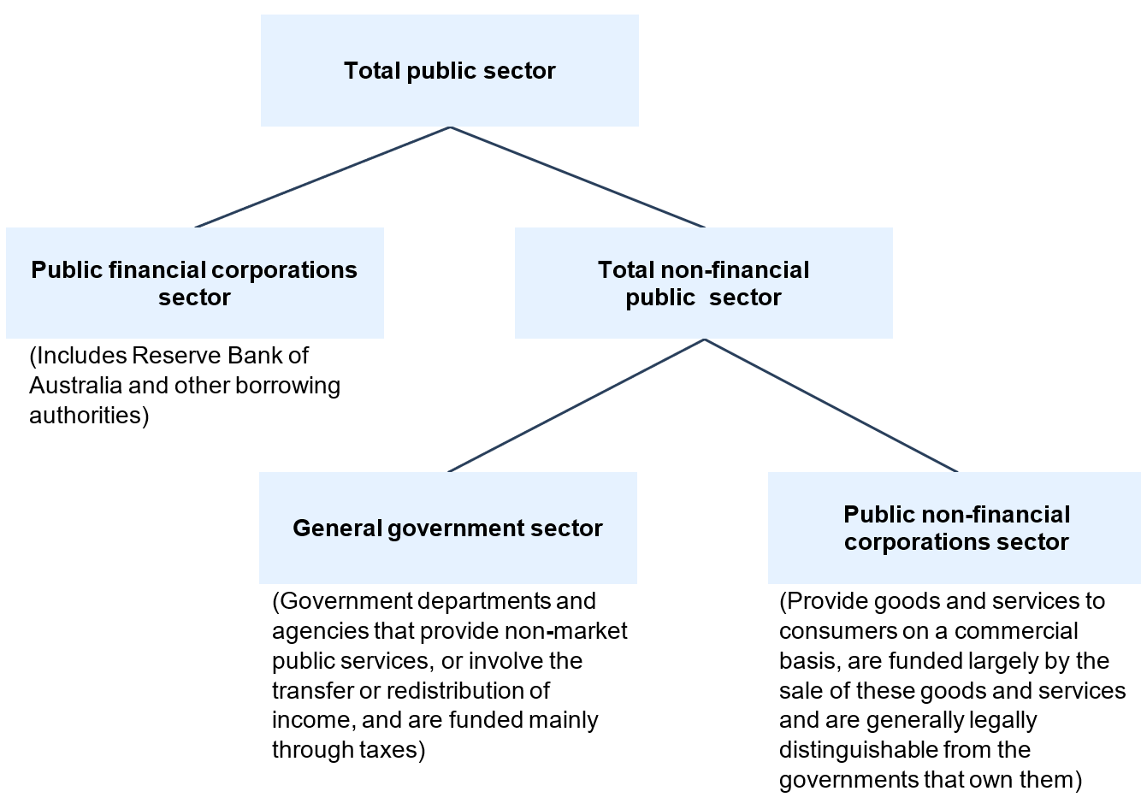
All entities are classified as GGS entities except for the following list of portfolio entities that are classified as PFC or PNFC (Table 10.14).
A table which provides a full list of public sector principal entities under the current portfolio structure is available on the Department of Finance website at: https://www.finance.gov.au/government/managing-commonwealth-resources/structure-australian-government-public-sector/pgpa-act-flipchart-and-list.
Table 10.14: Entities outside of the general government sector – 2025–26
Public financial corporations
Employment and Workplace Relations Portfolio
- Coal Mining Industry (Long Service Leave Funding) Corporation
Foreign Affairs and Trade Portfolio
- Export Finance and Insurance Corporation (Export Finance Australia)
Industry, Science and Resources Portfolio
- CSIRO Coinvestment Fund Pty Ltd
- CSIRO FollowOn Services Pty Ltd
- CSIRO FollowOn Services 2 Pty Ltd
- CSIRO General Partner Pty Ltd
- CSIRO General Partner 2 Pty Ltd
- CSIROGP Fund 2 Pty Ltd
- MS GP Fund 3 Pty Ltd
- MS NGS Pty Ltd
- MS Opportunity Fund Pty Ltd
- MS Parallel Fund Pty Ltd
Treasury Portfolio
- Australian Reinsurance Pool Corporation
- Housing Australia – Australian Housing Bond Aggregator (AHBA)*
- Reserve Bank of Australia

Table 10.14: Entities outside of the general government sector – 2025–26 (continued)
Public non-financial corporations
Climate Change, Energy, the Environment and Water Portfolio
- Snowy Hydro Limited
Finance Portfolio
- ASC Pty Ltd
- Australian Naval Infrastructure Pty Ltd
- CEA Technologies Pty Limited
Health, Disability and Ageing Portfolio
- Australian Hearing Services (Hearing Australia)
Infrastructure, Transport, Regional Development, Communications, Sport and the Arts Portfolio
- Airservices Australia
- Australian Postal Corporation (Australia Post)
- Australian Rail Track Corporation Limited
- National Intermodal Corporation Limited
- NBN Co Limited
- WSA Co Ltd
Prime Minister and Cabinet Portfolio
- Voyages Indigenous Tourism Australia Pty Ltd†
* Housing Australia, a corporate Commonwealth entity, operates an affordable housing bond aggregator to encourage greater private and institutional investment and provide cheaper and longer term finance to registered providers of affordable housing. The Housing Australia Bond Aggregator is a PFC. Other Housing Australia programs, including the National Housing Infrastructure Facility, are included in the GGS.
† Sale of Voyages Indigenous Tourism Australia Pty Ltd was completed effective 27 February 2026.

Appendix B: Assets and Liabilities

Overview
This appendix provides an overview and commentary on Statement 10: Australian Government Budget Financial Statements including estimates of the Australian Government’s budgeted assets and liabilities at 30 June for the current year, budget year and three forward years.
Changes in the balance sheet reflect movements in the budgeted operating result and balance sheet transactions.
A more detailed explanation of major assets and liabilities held by Commonwealth entities, which form part of the Australian Government’s balance sheet, can be found in the Commonwealth Balance Sheet User Guide, published on the Finance website.
Further information on the Government’s fiscal strategy in relation to the balance sheet can be found in Statement 3: Fiscal Strategy and Outlook.

The Australian Government’s assets and liabilities

Assets
The Government’s total assets were $893.0 billion at 30 June 2025, and are estimated to be $927.9 billion at 30 June 2026 and $1,143.8 billion at 30 June 2030.
The composition of Australian Government general government sector assets at 30 June 2026 is presented below in Chart 10.B.1.
Chart 10.B.1: Australian Government general government sector asset composition
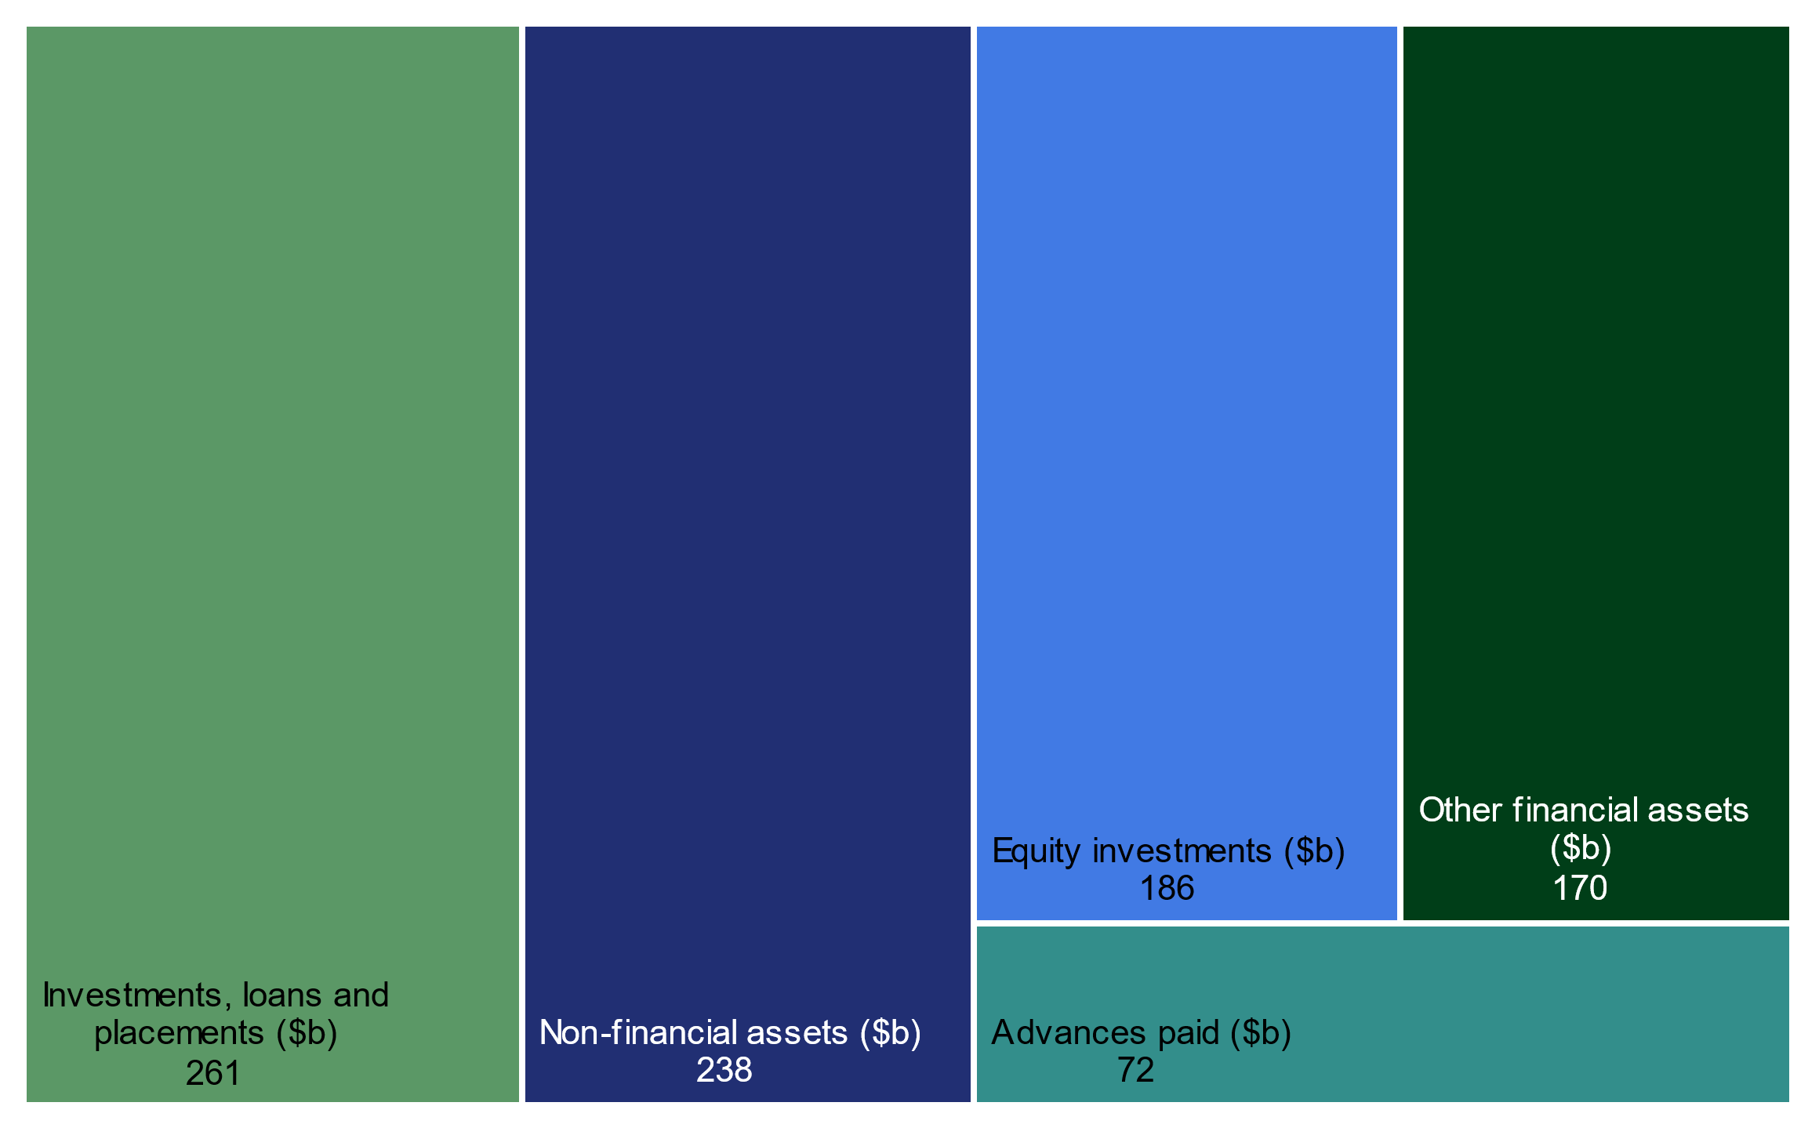
Note: Other financial assets includes cash and deposits and other receivables.

Australian Government assets over the forward estimates
The Government’s total assets are expected to grow over the forward estimates due to increased advances paid, investments and acquisitions of non-financial assets.
The budgeted composition of assets on the Australian Government’s balance sheet is provided in Chart 10.B.2 below.
Chart 10.B.2: Australian Government assets over the forward estimates
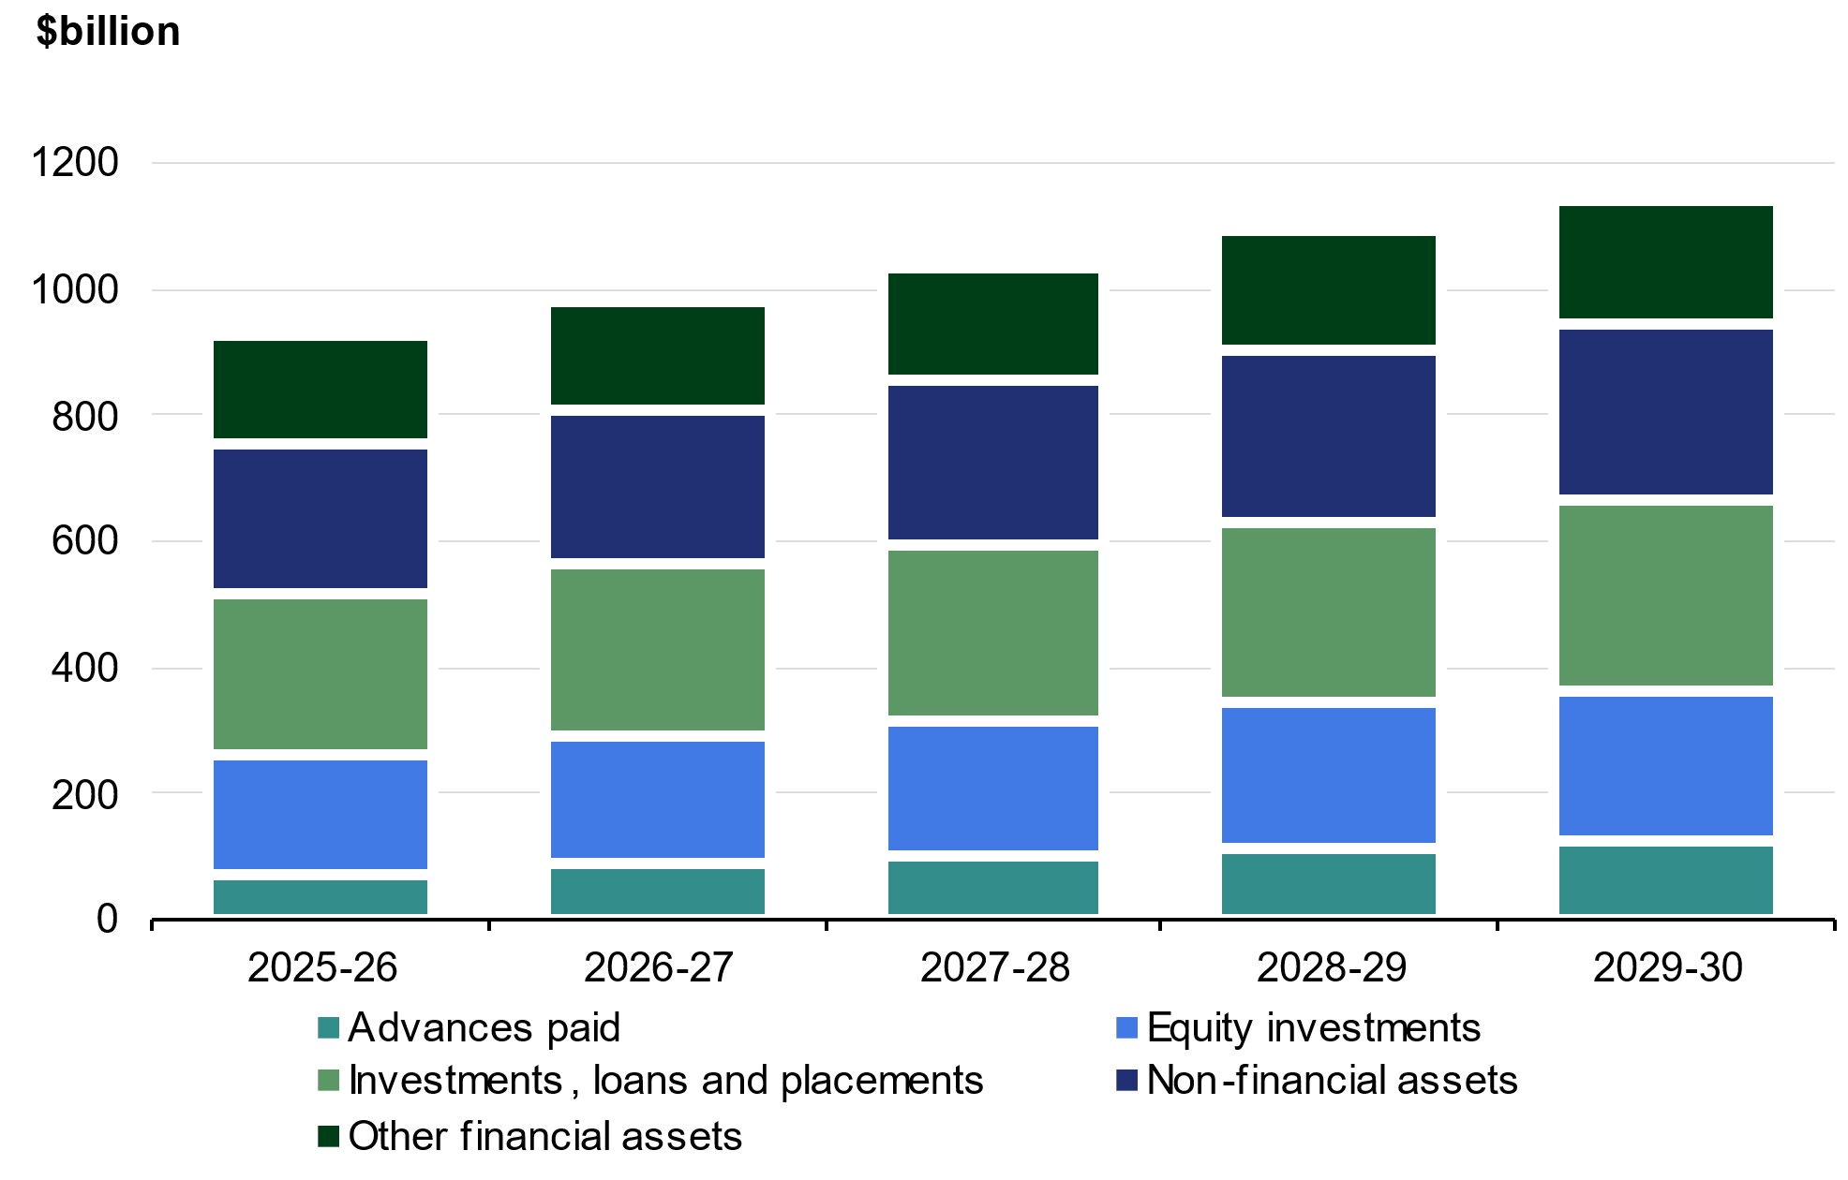
Note: Other financial assets includes cash and deposits and other receivables.

Financial assets
The Government’s financial assets are estimated to be $690.3 billion at 30 June 2026, increasing to $863.9 billion by 30 June 2030.
Chart 10.B.3: Financial assets over the forward estimates
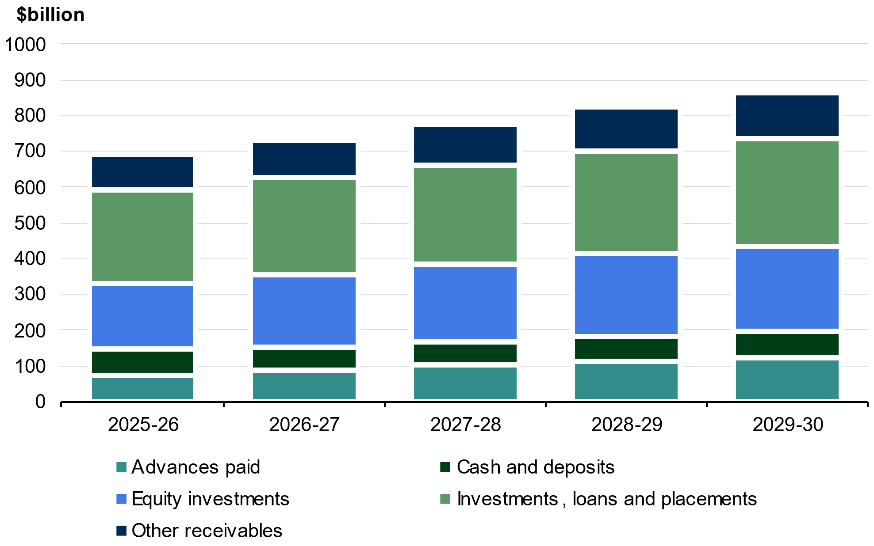

Advances paid
Advances paid is comprised of the Higher Education Loan Program and other student loan schemes and loans to state and territory governments. The value of advances paid is estimated to grow over the forward estimates predominantly due to expected growth in student loans.
Further details on loans made by the Government are provided in Statement 9: Statement of Risks.

Investments, loans and placements
Investments, loans and placements is predominantly comprised of investments held in relation to the Australian Government Investment Funds, which includes the Future Fund, as well as by other entities, such as the Australian Office of Financial Management, the Treasury and Specialist direct Investment Vehicles.
Specialist direct Investment Vehicles include the National Reconstruction Fund Corporation, Clean Energy Finance Corporation, Northern Australia Infrastructure Facility and the Regional Investment Corporation, which provide loans, guarantees and equity injections for projects that deliver public value.
The value of total Australian Government investments, loans and placements is expected to increase steadily over the forward estimates due to forecast investment returns and the investment activities of the Australian Government Investment Funds and Specialist direct Investment Vehicles.
A breakdown of investments, loans and placements is provided in Note 14 to Statement 10: Australian Government Budget Financial Statements and further information on the Australian Government Investment Funds is provided below. Further details on loans made by the Government is provided in Statement 9: Statement of Risks.

Australian Government Investment Funds
The Australian Government Investment Funds are the: Future Fund, DisabilityCare Australia Fund, Medical Research Future Fund, Aboriginal and Torres Strait Islander Land and Sea Future Fund, Future Drought Fund, Disaster Ready Fund and the Housing Australia Future Fund. Investments held in relation to the Australian Government Investment Funds are predominantly collective investment vehicles, other interest-bearing securities and equity investments.
The budgeted value of Australian Government Investment Funds is provided in Table 10.B.1.
Table 10.B.1: Australian Government Investment Funds balances
 | Estimates
 | 2025-26 | 2026-27 | 2027-28 | 2028-29 | 2029-30
 | $m | $m | $m | $m | $m
Future Fund | 276,545 | 294,926 | 314,530 | 335,441 | 357,749
DisabilityCare Australia Fund | 14,418 | 11,004 | 7,450 | 3,746 | -
Medical Research Future Fund | 25,533 | 26,373 | 27,287 | 28,252 | 29,303
Aboriginal and Torres Strait  Islander Land and Sea Future  Fund | 2,558 | 2,627 | 2,683 | 2,741 | 2,800
Future Drought Fund | 5,640 | 5,859 | 6,048 | 6,266 | 6,491
Disaster Ready Fund | 5,112 | 5,394 | 5,660 | 5,941 | 6,236
Housing Australia Future Fund | 11,271 | 11,376 | 11,420 | 11,471 | 11,512
Total investment funds | 341,077 | 357,559 | 375,078 | 393,858 | 414,091

Future Fund
The Future Fund was established in 2006 to accumulate financial assets and invest them on behalf of the Australian Government to address the Government’s unfunded superannuation liability. The Government provides guidance to the Future Fund Board of Guardians (the Future Fund Board) in relation to its investment strategy through the issuance of an investment mandate. The Board is independently responsible for the investment decisions of the Future Fund.
The investment mandate for the Future Fund sets a benchmark rate of return of at least CPI plus 4.0 to 5.0 per cent per annum over the long-term. It requires the Future Fund Board to have regard to national priorities in performing its investment functions. National priorities comprise: supporting an energy transition as part of the net zero transformation of the Australian economy, increasing the supply of residential housing in Australia, and delivering improved infrastructure located in Australia. The investment mandate also requires the Board to take an acceptable, but not excessive, level of risk, measured in terms such as the probability of losses in a particular year.
Between establishment and 31 March 2026, the average return has been 8.0 per cent per annum against the benchmark return of 7.0 per cent. For the 12-month period ending 31 March 2026, the Future Fund return was 11.7 per cent against a benchmark return of 8.1 per cent. The Future Fund was valued at $269.1 billion as at 31 March 2026.
Table 10.B.2 shows changes in the asset allocation of the Future Fund since 31 March 2025.
Table 10.B.2: Asset allocation of the Future Fund
 | 31-Mar-26 | 31-Mar-26 | 31-Mar-25 | 31-Mar-25
Asset class | $m | % of Fund | $m | % of Fund
Australian equities | 28,723 | 10.7 | 26,144 | 10.9
Global equities
Developed markets | 77,566 | 28.8 | 65,057 | 27.0
Emerging markets | 11,768 | 4.4 | 13,926 | 5.8
Private equity | 34,211 | 12.7 | 33,284 | 13.8
Property | 10,731 | 4.0 | 11,604 | 4.8
Infrastructure & Timberland | 30,373 | 11.3 | 24,633 | 10.2
Debt securities | 22,472 | 8.4 | 22,439 | 9.3
Alternative assets | 41,185 | 15.3 | 36,183 | 15.0
Cash | 12,026 | 4.5 | 7,492 | 3.1
Total Future Fund assets | 269,055 | 100.0 | 240,762 | 100.0
Note: Figures may not sum due to rounding.

DisabilityCare Australia Fund
The DisabilityCare Australia Fund (DCAF) was established on 1 July 2014 to assist the Commonwealth and the state and territory governments with spending directly related to the National Disability Insurance Scheme.
The DCAF is funded by revenue raised from the 0.5 per cent increase in the Medicare levy to 2.0 per cent, set in 2014–15. As at 31 March 2026, the DCAF had received credits totalling $46.9 billion. Since inception to 31 March 2026, $32.7 billion has been paid from the DCAF.
The investments of the DCAF are managed by the Future Fund Board. The Investment Mandate for the DCAF provides guidance to the Future Fund Board in relation to its investment strategy for the DCAF. The DCAF Investment Mandate sets a benchmark return of the Australian 3-month bank bill swap rate plus 0.3 per cent per annum calculated on a rolling 12-month basis (net of fees). In achieving its objectives, the Board must invest in a way that minimises the probability of capital losses over a 12-month horizon.
For the 12-month period ending 31 March 2026, the DCAF return was 4.3 per cent against the benchmark return of 4.1 per cent. The DCAF was valued at $18.2 billion as at 31 March 2026.

Medical Research Future Fund
The Medical Research Future Fund (MRFF) was established on 26 August 2015 to provide additional funding for medical research and medical innovation.
The investments of the MRFF are managed by the Future Fund Board. The Investment Mandate for the MRFF provides broad direction to the Future Fund Board in relation to its investment strategy. The MRFF Investment Mandate sets a benchmark return of the Reserve Bank of Australia’s Cash Rate target plus 1.5 to 2.0 per cent per annum, net of costs, over a rolling 10-year term.
Since inception to 31 March 2026, MRFF investments have returned 5.2 per cent per annum against a benchmark return of 3.5 per cent. For the 12-month period ending 31 March 2026, the MRFF’s return was 8.7 per cent against the benchmark return of 5.3 per cent. The MRFF was valued at $25.4 billion as at 31 March 2026.

Aboriginal and Torres Strait Islander Land and Sea Future Fund
The Aboriginal and Torres Strait Islander Land and Sea Future Fund (ATSILSFF) was established on 1 February 2019 to support payments to the Indigenous Land and Sea Corporation.
The ATSILSFF was seeded with the capital of the former Aboriginal and Torres Strait Islander Land Account (Land Account) – approximately $2.0 billion. The Land Account was abolished on the establishment of the ATSILSFF.
The investments of the ATSILSFF are managed by the Future Fund Board. The Investment Mandate for the ATSILSFF provides broad direction to the Future Fund Board in relation to its investment strategy. The ATSILSFF Investment Mandate sets a long-term benchmark return of CPI plus 2.0 to 3.0 per cent per annum, net of costs.
Since inception to 31 March 2026, ATSILSFF investments have returned 6.4 per cent per annum against a benchmark return of 5.7 per cent. For the 12-month period ending 31 March 2026, the ATSILSFF returned 10.0 per cent against a benchmark return of 6.1 per cent. The ATSILSFF was valued at $2.5 billion as at 31 March 2026.

Future Drought Fund
The Future Drought Fund (FDF) was established on 1 September 2019 to fund initiatives that enhance future drought resilience, preparedness and response across Australia.
The FDF provides disbursements of $100.0 million per annum, with the first disbursement made in July 2020.
The investments of the FDF are managed by the Future Fund Board. The Investment Mandate for the FDF provides broad direction to the Future Fund Board in relation to its investment strategy. The FDF Investment Mandate sets a long-term benchmark return of CPI plus 2.0 to 3.0 per cent per annum, net of costs.
Since inception to 31 March 2026, FDF investments have returned 7.8 per cent per annum against a benchmark return of 5.9 per cent. For the 12-month period ending 31 March 2026, the FDF returned 10.0 per cent against the benchmark return of 6.1 per cent. The FDF was valued at $5.5 billion as at 31 March 2026.

Disaster Ready Fund
The Disaster Ready Fund (DRF) was initially established as the Emergency Response Fund (ERF) on 12 December 2019 and provided up to $150.0 million per year for emergency response and recovery, and up to $50.0 million per year for natural disaster resilience and risk reduction.
On 1 March 2023, legislative changes took effect that renamed the ERF as the DRF and allowed up to $200.0 million per annum to be drawn from the DRF to fund natural disaster resilience and risk reduction from 2023–24 onwards.
The investments of the DRF are managed by the Future Fund Board. The Investment Mandate for the DRF provides broad direction to the Future Fund Board in relation to its investment strategy. The DRF Investment Mandate sets a long-term benchmark return of CPI plus 2.0 to 3.0 per cent per annum, net of costs.
Since inception to 31 March 2026, DRF investments have returned 7.8 per cent per annum against a benchmark return of 5.9 per cent. For the 12-month period ending 31 March 2026, the DRF returned 9.9 per cent against the benchmark return of 6.1 per cent. The DRF was valued at $5.0 billion as at 31 March 2026.

Housing Australia Future Fund
The Housing Australia Future Fund (HAFF) was established on 1 November 2023 and credited with $10.0 billion. The HAFF is an investment vehicle dedicated to supporting and increasing social and affordable housing, as well as supporting other acute housing needs such as Indigenous communities and housing services for women, children and veterans.
The investments of the HAFF are managed by the Future Fund Board. The Investment Mandate for the HAFF provides broad direction to the Future Fund Board in relation to its investment strategy. The HAFF Investment Mandate sets a long-term benchmark return of CPI plus 2.0 to 3.0 per cent per annum, net of costs.
Since inception to 31 March 2026, HAFF investments have returned 8.1 per cent per annum against a benchmark return of 4.9 per cent. For the 12-month period ending 31 March 2026, the HAFF returned 9.7 per cent against the benchmark return of 6.1 per cent. The HAFF was valued at $11.5 billion as at 31 March 2026.

Specialist direct Investment Vehicles
Specialist direct Investment Vehicles make investments in projects, businesses and joint ventures to deliver Australian Government policy objectives. Each Specialist direct Investment Vehicle has discrete policy objectives and uses a specific set of financial instruments to achieve them, including concessional loans, debt issuances and equity investments.
Specialist direct Investment Vehicles are usually corporate Commonwealth entities (CCEs) established by enabling legislation that define the entity’s functions and the roles and responsibilities of the independent board as the accountable authority. The only exception is the Australian Infrastructure Financing Facility for the Pacific, which is part of the Department of Foreign Affairs and Trade (a non-corporate Commonwealth entity).
The Australian Government has eight Specialist direct Investment Vehicles:

Australian Infrastructure Financing Facility for the Pacific
The Australian Infrastructure Financing Facility for the Pacific (AIFFP) commenced on 1 July 2019 and provides grants, loans and guarantees to sovereign, state owned enterprise and private sector partners for infrastructure investments in Pacific island countries and Timor-Leste.
The objective of AIFFP is to advance Australia’s national interest by contributing to a stable, secure and prosperous Pacific.​ AIFFP prioritises projects that assist countries to respond and adapt to climate change risks and impacts, as part of the Government’s Pacific Climate Infrastructure Financing Partnership.
As at 30 June 2025, AIFFP administered $1 billion in grants of which $520.0 million had been committed to projects. AIFFP also provides up to $3 billion in loans and guarantees issued by Export Finance Australia on its behalf via the National Interest Account.

Australian Renewable Energy Agency
Established as a CCE by the Australian Renewable Energy Agency Act 2011, the Australian Renewable Energy Agency (ARENA) provides grant funding to support research, development and early commercialisation for renewable energy technology projects.
ARENA invests in priority sectors including ultra low-cost solar, renewable electricity, renewable hydrogen, low-emissions metals, low-emissions transport, low-carbon liquid fuels and clean energy manufacturing.
As it provides grants ARENA does not generate a return on funds invested, however, some projects include contingent recoupment rights. Grants are determined by an independent board based on maximum impact and value.
As at 30 June 2025, ARENA was responsible for administering up to $13 billion in grants.

Clean Energy Finance Corporation
The Clean Energy Finance Corporation (CEFC) was established as a CCE by the Clean Energy Finance Corporation Act 2012 (CEFC Act). The CEFC Act defines complying investments as including:
- clean energy technologies: energy efficiency, low-emission and renewable energy technologies
- solely or mainly Australian based: determined by the Board and consistent with the investment mandate
- not in prohibited technology; carbon capture and storage, nuclear technology and nuclear power.
The CEFC performs its investment functions in accordance with the Clean Energy Finance Corporation Investment Mandate Direction 2023. The investment mandate broadly requires the CEFC to facilitate increased flows of finance into the clean energy sector and to facilitate the achievement of Australia’s greenhouse gas emissions reduction target. The investment mandate also sets out investment direction, benchmark rates of return, portfolio risk and limits on concessionality for the General Portfolio, the Rewiring the Nation Fund and the Specialised Investment Funds.
As at 30 June 2025, CEFC had $34.9 billion made available to it for investment, of which $12.1 billion had been committed to projects.

Export Finance Australia
Export Finance Australia (EFA) was established as a CCE by the Export Finance and Insurance Corporation Act 1991. EFA is the Australian Government’s export credit agency and supports Australian export trade and overseas infrastructure development that benefits Australia, through loans, bonds, guarantees, insurance and equity investments. EFA is a self-funding entity and operates on a commercial basis, charging customers fees and premiums as well as earning interest on loans and investments.
EFA provides financial support to exporters on one of two accounts: the Commercial Account, where EFA carries all risks and losses, and retains all margins and fees; and the National Interest Account, where the responsible Minister can direct EFA to support transactions that are in the national interest.
As at 30 June 2025, EFA had $8.3 billion in committed funding.

Housing Australia
Established as a CCE by the Housing Australia Act 2018 (Housing Australia Act), Housing Australia improves social and affordable housing outcomes for Australians through loans and grants, guarantees and capacity development for community housing providers, and delivering programs to help more Australians access social and affordable housing. Housing Australia performs its investment functions in accordance with its investment mandate.
The investment mandate for Housing Australia outlines the activities and allocation of funds for the Affordable Housing Bond Aggregator (AHBA), the National Housing Infrastructure Facility (NHIF), the Housing Australia Future Fund Facility, the National Housing Accord Facility, the Help to Buy Scheme and the Home Guarantee Scheme. For the AHBA, Housing Australia must target an average return that covers the operating costs of the AHBA and allows it to build an adequate capital reserve. For the NHIF it must target a rate of return that allows it to maintain the value of funds allocated to it plus the Commonwealth cost of capital.
As at 30 June 2025, Housing Australia had committed $26.7 billion to projects. This does not include investments of the HAFF, which is administered by the Future Fund.

National Reconstruction Fund Corporation
The National Reconstruction Fund Corporation (NRFC) was established as a CCE by the National Reconstruction Fund Corporation Act 2023. The NRFC makes investment decisions to support, diversify and transform Australia’s industry and economy, help to create secure, well-paid jobs, secure future prosperity, and drive sustainable economic growth. The NRFC provides debt, equity and guarantees to facilitate increased flows of finance into the following priority areas of the Australian economy identified in regulation: renewables and low emission technologies, value-add in agriculture, forestry and fisheries, transport, medical science, renewables and low emission technologies, defence capability, and enabling capabilities.
The NRFC must target an average return of between 2 and 3 per cent above the 5-year Australian Government bond rate.
As at 30 June 2025, NRFC had $15.0 billion available to it for investment.

Northern Australia Infrastructure Facility
The Northern Australia Infrastructure Facility (NAIF) was established as a CCE by the Northern Australia Infrastructure Facility Act 2016 to provide finance to businesses and infrastructure projects for the development of Northern Australia’s economy. NAIF’s area of operation includes all of the Northern Territory and those parts of Queensland and Western Australia above or directly below or intersecting with the Tropic of Capricorn. NAIF’s projects stimulate economic growth by attracting private investment and fostering infrastructure development.
The NAIF is required to make investments to support one or more of five Government policy priorities, including: sustainable and resilient economic development and the alleviation of economic or social disadvantage; key infrastructure projects; sustainability, climate change and circular economy principles; realising the Critical Minerals Strategy; and materially improving the lives of Indigenous people and communities.
When providing financial assistance, which is primarily through loans, the NAIF must be satisfied that the return is likely to cover at least its administrative costs and the Commonwealth’s cost of borrowing. For equity or equity-like investments the NAIF must target a return of at least the 5-year Australian Government bond rate plus a premium of 3 per cent per annum.
As at 30 June 2025, NAIF had $7.0 billion made available to it for investment of which $3.7 billion had been committed to projects.

Regional Investment Corporation
Established as a CCE by the Regional Investment Corporation Act 2018, the Regional Investment Corporation (RIC) administers concessional loans for farm businesses. These loans support the resilience and sustainability of Australia’s agricultural economy, with a focus on assisting eligible farm businesses and farm-related businesses to remain prosperous and grow.
RIC loans can be used to prepare for, manage through, and recover from severe financial disruption outside of a farmer’s control such as drought, natural disasters, biosecurity and market issues. RIC loans can also be used to help new and next generation farmers set up farms and keep farms in the family through succession planning. The majority of RIC loans provide up to 5 years interest-only and a 10-year loan term, allowing borrowers to generate positive cashflows before repayment of principal. The RIC sets the variable interest rates on its loan products with reference to the average Australian Government 10-year bond rate plus a margin.
As at 30 June 2025, RIC had $3.5 billion made available to it for investments of which $3.2 billion had been provided as loans to customers.

Equity investments
Equity investments is comprised of three components:
- investments in those Government Business Enterprises that are public non-financial corporations including NBN Co, Snowy Hydro Limited and the Australian Rail Track Corporation.
- investments in other public sector entities outside the general government sector, including certain components of Specialist direct Investment Vehicles such as Export Finance Australia and Housing Australia, and investments held by Specialist direct Investment Vehicles inside the general government sector, such as the Clean Energy Finance Corporation and the National Reconstruction Fund Corporation.
- investments held in relation to the Australian Government Investment Funds, such as shares, which are expected to increase steadily over the forward estimates due to additional contributions from Government and expected investment returns over time.

Government Business Enterprises
Government Business Enterprises (GBEs) represent a significant proportion of equity investments held by the Australian Government.
These are commercially focused government owned businesses that are established to fulfil an Australian Government purpose. They make a substantial contribution to the Australian economy by supporting productivity, job creation and Government policy objectives.
Further information on the financial performance of individual GBEs is included in the annual report for each entity, including details of equity contributed by the Australian Government. GBE valuations are updated annually in accordance with Australian Accounting Standards and reported by the relevant portfolio department in its annual report.

Non-financial assets
The Government’s non-financial assets are estimated to be $237.6 billion at 30 June 2026, increasing to $279.8 billion by 30 June 2030.
Non-financial assets comprise assets such as land, buildings and property, plant and equipment and right-of-use lease assets. Non-financial assets are expected to grow consistently over the forward estimates predominantly due to increased investments in Specialised Military Equipment.

Liabilities
The Government’s total liabilities were $1.5 trillion at 30 June 2025, and are expected to increase to around $1.9 trillion by 30 June 2030.
The composition of Australian Government general government sector liabilities at 30 June 2026 is presented below in Chart 10.B.4.
Chart 10.B.4: Australian Government liabilities composition
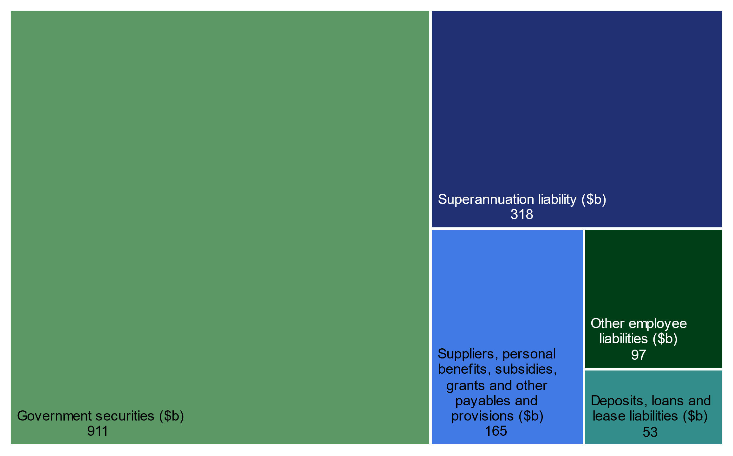

The Government’s major liabilities are Australian Government securities on issue (see Statement 7: Debt Statement for further information) and public sector employee superannuation liabilities.
Further information on the Government’s borrowings is provided in Statement 7: Debt Statement.

Australian Government liabilities over the forward estimates
The budgeted composition of liabilities on the Australian Government’s balance sheet is provided in Chart 10.B.5 below.
Chart 10.B.5: Composition of Australian Government liabilities over the forward estimates
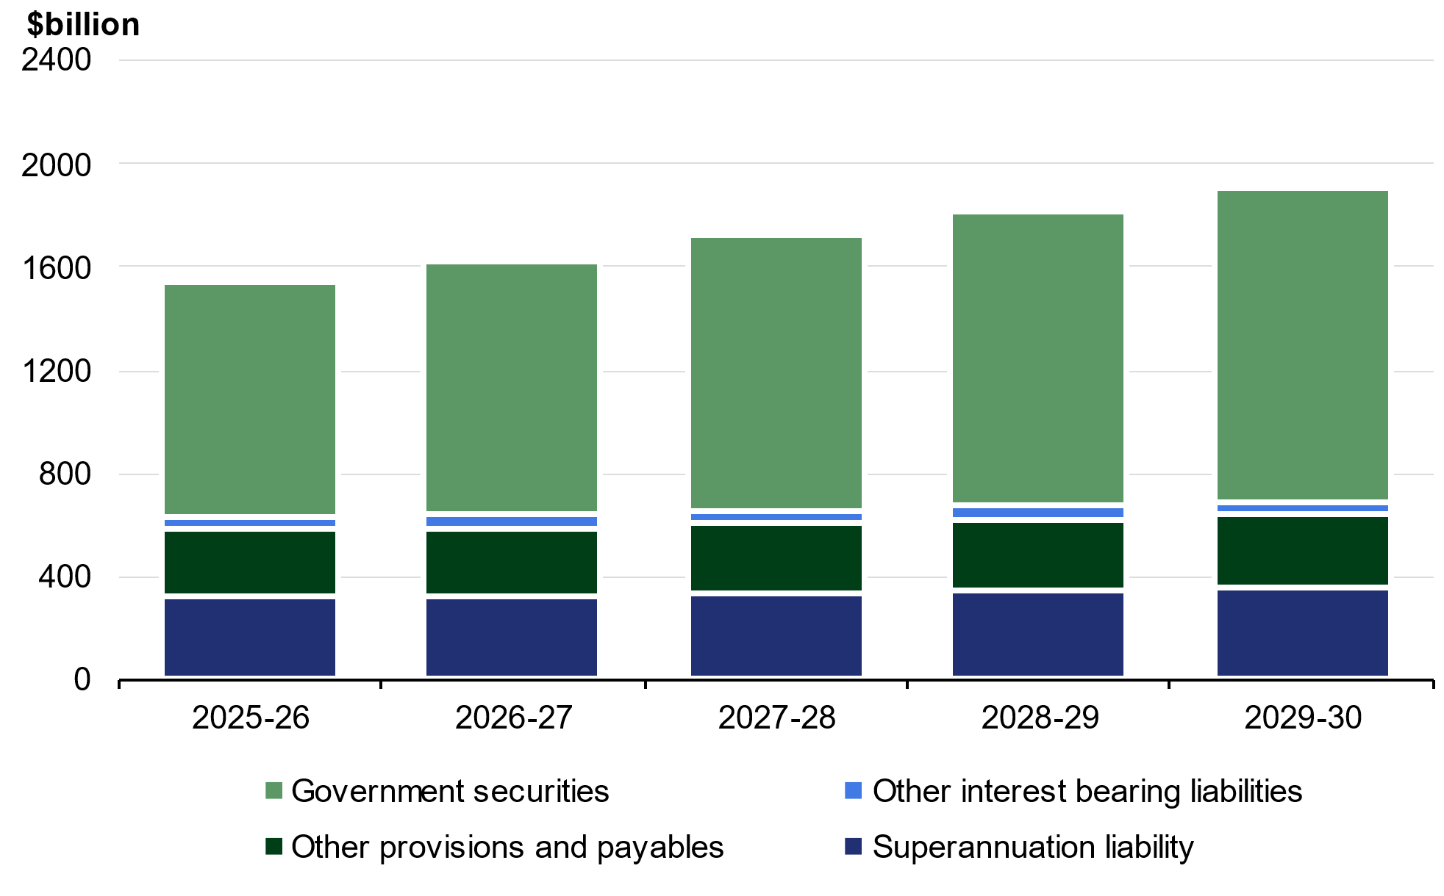
Note: Other interest-bearing liabilities includes deposits held, loans and lease liabilities. Other provisions and payables includes other employee liabilities, suppliers payable, personal benefits payable, subsidies payable, grants payable, other payables and provisions.

Total liabilities are expected to grow consistently over the forward estimates, which is predominantly due to growth in government securities on issue and superannuation liabilities.

Government securities
Government securities on the Australian Government’s balance sheet reflect the market value of the Australian Government securities on issue, consistent with external reporting standards. Further detail on the face value of Australian Government securities can be found in Statement 7: Debt Statement.

Public sector employee superannuation liabilities
Public sector employee superannuation entitlements relating to past and present civilian employees and military personnel are a financial liability on the Government’s balance sheet. Total superannuation liabilities are projected to be $317.8 billion at 30 June 2026, $352.1 billion at 30 June 2030 and approximately $454.7 billion at 30 June 2060.
These liabilities represent the present value of future unfunded superannuation benefits relating to past and present employees and are based on an actuarially determined discount rate. The long-term nature of the unfunded superannuation liabilities requires the use of a discount rate that best matches the duration of the liabilities. The use of a long-term discount rate for budget purposes avoids the volatility that would occur by using current market yields on Government bonds. The value recorded on the balance sheet is highly sensitive to the discount rate used.
In preparing the latest Long Term Cost Reports for the civilian and military schemes, the scheme actuaries determined that a discount rate of 5.0 per cent should be applied.
The Australian Government has never fully funded its defined benefit scheme superannuation liabilities. However, the Future Fund was established in 2006 to help finance the Government’s unfunded superannuation liabilities.
For civilian employees, the major defined benefit schemes are the Commonwealth Superannuation Scheme and the Public Sector Superannuation Scheme. These schemes were closed to new members in 1990 and 2005 respectively. The Public Sector Superannuation Accumulation Plan was introduced on 1 July 2005 and provides fully funded accumulation benefits for new civilian employees from that date.
For military personnel, the defined benefit schemes are the Defence Force Retirement and Death Benefits Scheme, the Defence Forces Retirement Benefits Scheme and the Military Superannuation and Benefits Scheme (MSBS). Following the closure of the MSBS on 30 June 2016, all defined benefit military schemes are now closed to new members. A new military superannuation accumulation scheme, Australian Defence Force (ADF) Super, commenced on 1 July 2016. ADF Super is accompanied by a statutory death and disability arrangement ADF cover.
While there have not been any new members to the public service and military defined benefit schemes since closure in 2005 and 2016 respectively, the Government’s unfunded superannuation liabilities are expected to grow as current members continue to accrue benefits prior to retirement. Consistent with the 2023 Long Term Cost Reports, the unfunded liability for public service defined benefit schemes is projected to peak in the mid-2030’s, whilst the unfunded liability for military defined benefit schemes is projected to continue to increase over time to 2060. The present value of the superannuation liability is also sensitive to changes in the discount rate.
As the superannuation liabilities are included in the Government’s net worth and net financial worth aggregates, revaluations of the liabilities have an impact on these aggregates.
The value of superannuation liabilities by scheme is provided in Table 10.B.3 below.
Table 10.B.3: Superannuation liabilities by scheme
 | Estimates
 | 2025-26 | 2026-27 | 2027-28 | 2028-29 | 2029-30
 | $m | $m | $m | $m | $m
Civilian superannuation schemes
Commonwealth Superannuation Scheme | 60,760 | 59,018 | 57,188 | 55,277 | 53,290
Public Sector Superannuation Scheme | 110,121 | 115,187 | 120,529 | 124,589 | 128,410
Parliamentary Contributory Superannuation
Scheme | 791 | 779 | 767 | 753 | 737
Governors-General Scheme | 20 | 20 | 20 | 20 | 31
Judges' Pensions Scheme | 1,337 | 1,386 | 1,439 | 1,490 | 1,539
Division 2 Judges of the Federal Circuit and
Family Court of Australia Death and Disability
Scheme | 5 | 6 | 7 | 7 | 8
Total civilian schemes | 173,034 | 176,396 | 179,950 | 182,136 | 184,015
Military superannuation schemes
Military Superannuation and Benefits Scheme | 106,604 | 110,618 | 114,372 | 117,858 | 121,346
Defence Force Retirement and Death Benefits | 28,758 | 28,228 | 27,655 | 27,039 | 26,383
Scheme
Defence Forces Retirement Benefits Scheme | 265 | 245 | 226 | 207 | 188
Australian Defence Force Cover | 8,880 | 11,170 | 13,783 | 16,711 | 19,949
Total military schemes | 144,508 | 150,261 | 156,036 | 161,816 | 167,865
Other schemes | 247 | 251 | 165 | 173 | 181
Total | 317,789 | 326,908 | 336,151 | 344,125 | 352,061

Other provisions and payables
Other provisions and payables includes all other Government liabilities including liabilities, provisions for other employee entitlements such as leave, unpaid grants, subsidies, personal benefits, and payments to suppliers.

Additional information on the Australian accrual GFS framework is available in the ABS publication Australian System of Government Finance Statistics: Concepts, Sources and Methods, 2015 (cat. no. 5514.0).
Not all transactions impact net worth. For example, transactions in financial assets and liabilities do not impact net worth as they represent the swapping of assets and liabilities on the balance sheet.
The net operating balance includes consumption of non-financial assets because depreciation is an expense. Depreciation is deducted in the calculation of net capital investment as the full investment in non-financial assets is included in the calculation of fiscal balance.

