Statement 2:
Economic Outlook
The conflict in the Middle East has severely disrupted global oil supplies, creating extreme global volatility and uncertainty and weighing heavily on the global economic outlook. The conflict will result in higher global inflation and lower growth, with the scale of the impact dependent on its duration and severity. The conflict has disrupted around one-fifth of the world’s seaborne oil and gas supply. It has also impacted many other global supply chains, including for fertiliser, chemicals, aluminium and plastics.
The economic impacts of the conflict in the Middle East are likely to linger beyond the resolution of the conflict. For markets and supply chains to normalise once the conflict ends, damaged infrastructure will need to be repaired so production in the region can restart, refiners will need time to process raw inputs into fuel and refined products, and shipping and global trade will need to resume and stabilise.
Australia is not immune from the impacts of the conflict, and the economic consequences will continue to be felt for some time. The conflict has compounded cost pressures for households and businesses, and is straining some supply chains.
Headline inflation rose to 4.6 per cent in the 12 months to March 2026, driven by a 32.8 per cent rise in automotive fuel prices in the month. The impact of higher fuel prices is expected to broaden in the coming months, as prices flow through to other goods and services. This is expected to add to several pre-existing temporary and persistent inflationary pressures.
As a result, headline inflation is forecast to be 5 per cent through the year to the June quarter 2026. Headline inflation is forecast to decline to 2½ per cent through the year to the June quarter 2027, supported by an assumed decline in global oil prices from the middle of 2026, a resolution of temporary pressures, and a moderation in services inflation. Abstracting from the impact of fuel prices, inflation is forecast to sustainably return to the RBA’s target band in the middle of 2027.
The conflict, high global oil prices and resulting inflationary pressures are expected to weigh on growth in real incomes and household consumption in the near-term. As a result, growth in the Australian economy is forecast to slow from 2¼ per cent in 2025–26 to 1¾ per cent in 2026–27. While the economic outlook remains highly uncertain, the Australian economy is expected to grow by 2¼ per cent in 2027–28. This recovery assumes that global oil prices begin to decline from the middle of 2026 and largely stabilise from the middle of 2027, informed by current market expectations.

Despite the substantial economic impacts of the global oil shock, Australia confronts these challenges from a position of relative strength. The Australian economy is growing faster than every major advanced economy, unemployment remains low, the labour force participation rate remains high, wages growth is solid, and public finances are among the strongest in the developed world, with gross debt lower than every major advanced economy.
Economic activity strengthened over 2025, driven by the recovery in the private sector. Rising momentum in private demand was supported by strong growth in investment and household consumption. Private final demand exceeded public final demand’s contribution to growth in every quarter of 2025. Growth in business investment picked up substantially in 2025, driven by non-mining business investment.
The momentum in business investment growth is expected to continue with capital expenditure intentions for 2025–26 nearing $200 billion, despite substantial global uncertainty. Dwelling investment growth also improved in 2025. Dwelling investment has grown for eight consecutive quarters, the longest run of quarterly growth in a decade.
The labour market remains resilient and is well placed to withstand slower economic growth in 2026–27. The unemployment rate remains low by historical standards, employment has continued to grow, and the labour force participation rate remains near its recent record high.
The unemployment rate has been broadly stable over the past year and is expected to remain low by historic standards, rising only gradually from 4¼ per cent in the June quarter 2026 to 4½ per cent in the June quarter 2027 and the June quarter 2028. Labour market conditions are continuing to support solid wage growth, with growth in the Wage Price Index forecast to remain above its 10-year pre-pandemic average.
There are significant risks surrounding the economic forecasts, particularly in relation to the duration of the conflict and the extent of the disruption in the Middle East. If the resolution to the conflict and sustained reopening of the Strait of Hormuz is quicker than market expectations, this could result in upside to the forecasts. Sustained domestic supply chain disruptions could emerge, even in the case of a shorter conflict. While global financial markets have so far been resilient, a more protracted conflict may suddenly weigh on market sentiment and asset valuations.
Domestically, inflation could remain persistently high, especially if the impact of the conflict in the Middle East is more severe than expected. There is also a risk that the conflict could weigh more heavily on economic growth, particularly if households and businesses become more cautious. Reduced consumption and investment have the potential to flow into weaker employment growth and higher unemployment.
There are other potential risks to the outlook. Rising global protectionism continues to drive shifts in global trade flows and place upward pressure on prices, particularly in the United States. On the upside, strong investment in AI and technology could be a potential source of productivity growth in the medium-term.

Statement 2 contents
International economic outlook 51
Domestic economic outlook 57
Household consumption 63
Dwelling investment 64
Business investment 65
Public final demand 71
International trade 72
Labour market and wages 73
Inflation 74
Net overseas migration 78
Nominal GDP and the medium-term outlook 78

Statement 2: Economic Outlook

International economic outlook
The conflict in the Middle East has created extreme uncertainty and volatility and had a substantial impact on the global economy. The conflict has disrupted around one-fifth of the world’s seaborne oil and gas supply. Many other global supply chains have also been impacted, including for fertiliser, chemicals, aluminium and plastics. This will result in higher global inflation and lower global growth, with the scale of impact depending on the duration and severity of the conflict.
The Middle East is a significant global producer of crude oil, refined petroleum products, LNG and LPG, and the Strait of Hormuz is central to global supply chains (Chart 2.1). Gulf countries account for around 8 per cent of global aluminium production and around 10 per cent of global ethylene production (a feedstock used to manufacture plastics and clothing). Around one-third of global seaborne fertiliser supply also transits the Strait of Hormuz, placing additional pressure on input costs for businesses in all economies.
Chart 2.1: Share of global commodity trade transiting the Strait of Hormuz | Chart 2.2: Fall in global oil production following major geopolitical shocks
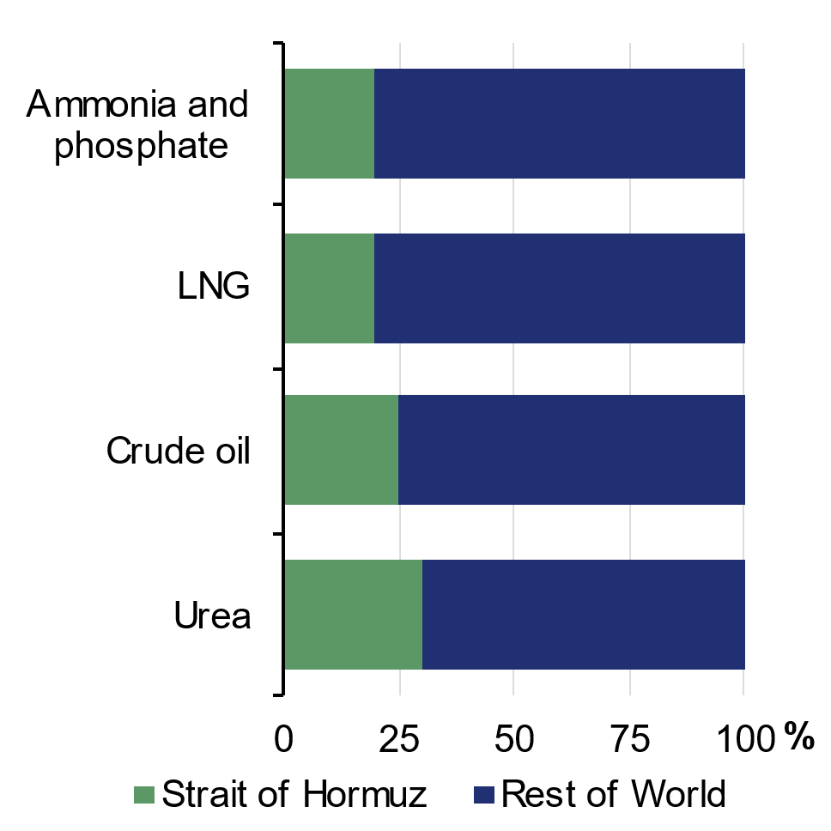 | 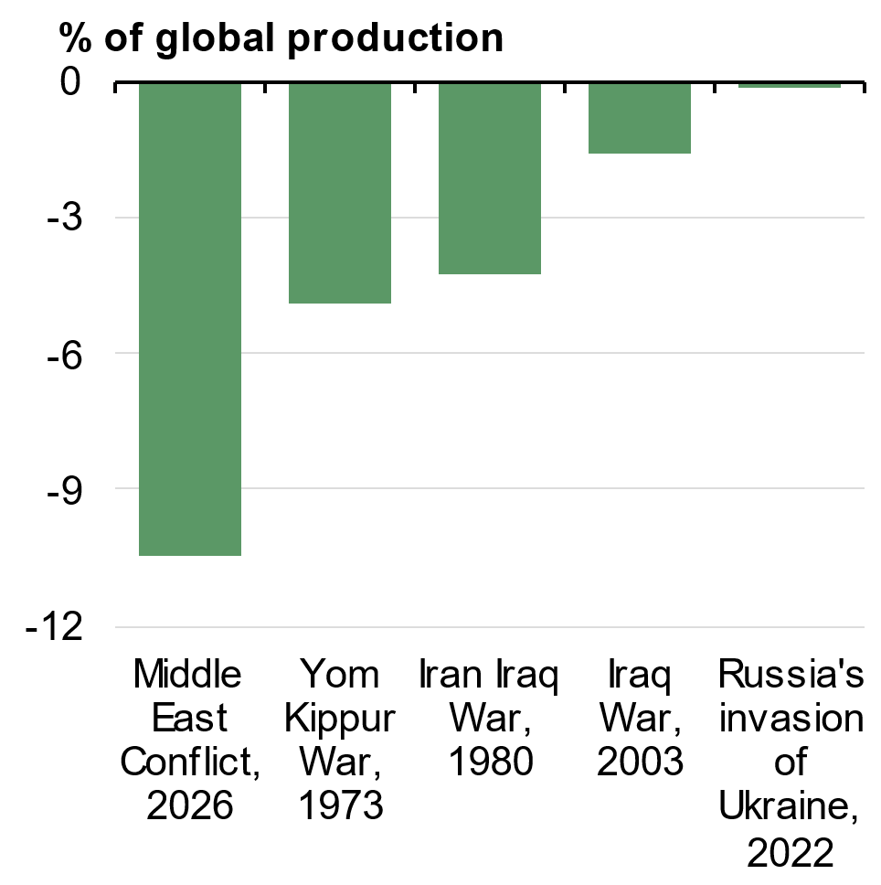
Source: IEA and Treasury.  Note: Strait of Hormuz shares are approximate, based on IEA estimates. Oil represents share of seaborne trade. | Source: IEA and Treasury.  Note: Fall in global crude oil production as a share of total global production, one month after the onset of each conflict.

The duration and severity of the conflict in the Middle East will determine the time it takes for production and shipping routes to recover. This will be critical to how the global economic outlook evolves. The current conflict has already resulted in the largest global oil supply disruption on record (Chart 2.2). Global growth is forecast to be 3 per cent in 2026, following growth of 3.5 per cent in 2025. Assuming an easing in global oil prices from mid-2026, global growth is expected to pick up to be 3¼ per cent in 2027 and 2028.
Asia is being particularly affected by the global price and supply chain impacts of the conflict in the Middle East. Prior to the conflict, around 80 per cent of the crude oil flows that transited through the Strait of Hormuz were destined for Asia. China, Japan, the Republic of Korea and India are all large net importers of oil and rely heavily on Middle East supplies. A significant increase in energy costs is also constraining economic activity in the Philippines, Vietnam, Indonesia, Thailand and Malaysia. Many of these countries have implemented measures to preserve domestic supply of oil and refined fuel.
While the conflict has added to an already uncertain global backdrop, the global economy displayed more resilience than expected in 2025. Global monetary and fiscal policy settings were broadly supportive of growth in 2025, although inflation remained a challenge. Prior to the Middle East conflict, headline inflation was above central bank targets in the United States and the United Kingdom, and core inflation measures remained persistently above target across many major advanced economies, including the United States and the Euro area.
United States’ trade restrictions were implemented later and at lower rates than initially announced on ‘Liberation Day’ in April 2025. Further, the United States entered into a number of trade agreements and the global economy managed to divert trade flows to alternative markets. Chinese exports to the United States fell by almost 30 per cent over the course of 2025, while exports to ASEAN and the European Union increased by 30 per cent and 7 per cent, respectively. While the United States Supreme Court nullified some aspects of the United States Administration’s tariff authority in January 2026, effective United States tariff rates remain at their highest level since the 1940s. The effects of this more protectionist United States stance are still unfolding across the global economy.
Globally, technology-driven investment is expected to continue supporting growth over the coming years and may deliver productivity gains in the medium-term. The United States is a key driver of this, with investment in information processing equipment growing by around 20 per cent in 2025. This comes on top of substantial global investment in renewable energy technologies and infrastructure (Charts 2.3 and 2.4).
Chart 2.3: Global installed data centre capacity | Chart 2.4: Global clean energy investment
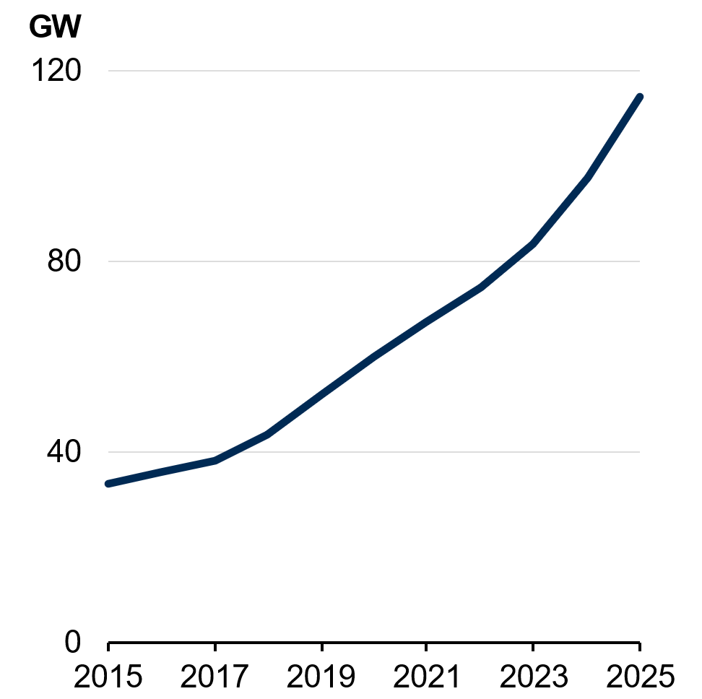 | 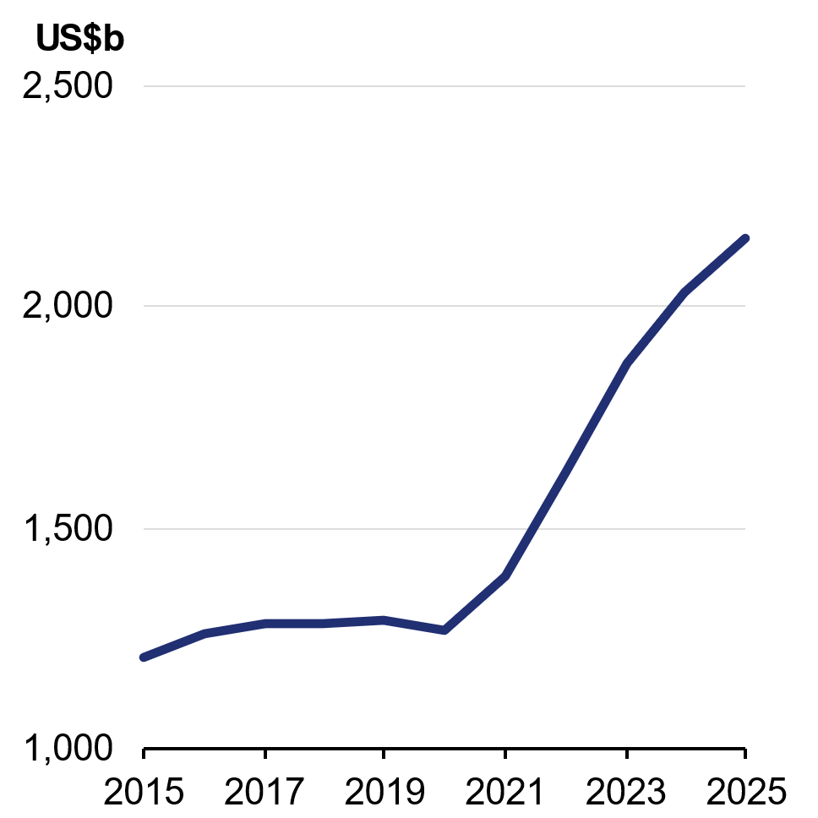
Source: IEA and Treasury.  Note: GW refers to gigawatts, a unit of power equal to one billion watts. | Source: IEA and Treasury.  Note: Figures are expressed in 2024 US dollars.

The risks to the global economic outlook are largely contingent on the duration and severity of the conflict in the Middle East. If the resolution to the conflict and sustained reopening of the Strait of Hormuz is quicker than market expectations, this could result in upside to the global economic growth forecasts. The prospect of a more protracted conflict poses a significant downside risk, with sharper and broader global supply chain pressures. Energy and chemical products originating from the Middle East are inputs across the global supply chain, including plastics used in the construction industry and fertilisers relied upon by agriculture.
Financial markets have been resilient to date, but a more protracted conflict risks weighing on confidence and financial conditions. Increased uncertainty is contributing to volatility in asset valuations and is pushing credit spreads wider, which threatens to compound existing concerns surrounding private credit markets. Rising sovereign bond yields signal that financial conditions are tightening in response to concerns about the inflationary effects of higher energy prices. If the conflict adds to concerns about fiscal sustainability in heavily indebted economies, there is a risk that borrowing costs will begin to constrain the ability of some countries to use fiscal policy effectively to deal with the global energy shock.
Structural uncertainties also remain for the global economic outlook, on both the upside and the downside. The continued momentum in technology-led investment and investment in the renewable energy transition poses an upside, while fiscal vulnerabilities, more protectionist trade policy settings and continued heightened uncertainty and geopolitical risk all pose a downside to the global economic outlook.

Table 2.1: International GDP growth forecasts^{(a)}
 | Outcomes | Forecasts (Calendar Years)
 | 2025 | 2026 | 2027 | 2028
Australia | 2.0 | 2 | 2 | 2 1/2
China | 5.0 | 4 3/4 | 4 1/2 | 4 1/2
India | 7.5 | 6 1/4 | 6 1/2 | 6 1/2
Japan | 1.2 | 3/4 | 3/4 | 3/4
Republic of Korea | 1.0 | 1 3/4 | 2 | 2
United States | 2.1 | 2 1/4 | 2 | 2
Euro area | 1.5 | 1 | 1 1/4 | 1 1/4
United Kingdom | 1.4 | 3/4 | 1 | 1
Other East Asia^{(b)(c)} | 4.5 | 3 3/4 | 3 3/4 | 3 3/4
Major trading partners^{(b)} | 3.8 | 3 1/4 | 3 1/4 | 3 1/4
World^{(b)} | 3.5 | 3 | 3 1/4 | 3 1/4
- Percentage change on previous year.
- World and Other East Asia growth rates are calculated using GDP weights based on purchasing power parity (PPP). Growth rates for major trading partners are calculated using Australian goods and services export trade weights.
- Other East Asia includes Indonesia, Malaysia, the Philippines, Thailand, Vietnam, Singapore, and Taiwan.
Source: National statistical agencies, IMF, Refinitiv and Treasury.

China’s economic growth is forecast to slow to 4¾ per cent in 2026 and 4½ per cent in 2027 and 2028. This is consistent with the recent downgrade of the official growth target to 4.5 to 5 per cent in 2026. China achieved its official growth target of 5 per cent in 2025, with strong exports helping to offset persistent weakness in the property sector and subdued household consumption. This is expected to continue in the near-term. Policy support is also stabilising growth, with recent easing measures boosting infrastructure investment.
China is relatively well positioned to navigate the effects of the Middle East conflict, with its longstanding focus on energy security resulting in substantial energy reserves and diversified supply. Higher energy prices will place upward pressure on subdued domestic inflation and may boost demand for Chinese products such as electric vehicles and solar panels. In the medium term, structural headwinds including an ageing population, slower urbanisation and property sector weakness will continue to weigh on growth.
The United States economy grew by 2.1 per cent in 2025, driven by strong household consumption and technology-related investment. It is expected to face headwinds in 2026, including from higher energy prices, softer labour market conditions and protectionist trade policy settings. However, economic growth in the United States is well positioned to outperform that of other advanced economies. While still exposed to global energy prices, the United States faces limited risk of near-term energy supply disruption given it is a major oil and gas producer. Household consumption is expected to be supported by expansionary fiscal policy, while a strong pipeline of AI-related investment is expected to support business investment. Growth is forecast to be 2¼ per cent in 2026 and 2 per cent in 2027 and 2028.

Inflation in the United States remains above target. Higher energy prices stemming from the Middle East conflict are expected to place further upward pressure on inflation. Despite signs of a cooling labour market and greater AI adoption, services inflation remains well above the Federal Reserve’s 2 per cent inflation target.
Japan’s economy was supported by robust business investment and household consumption in 2025. However, the conflict in the Middle East poses a major headwind to growth. Japan is a net energy importer, sourcing over 90 per cent of its crude oil from the Middle East prior to the conflict. With rising wages and fiscal policy providing some support for domestic demand, growth is forecast to be ¾ per cent in 2026, 2027 and 2028. Higher global energy prices will place upward pressure on inflation, even if fuel price caps and electricity subsidies limit some of the pass through to consumers. The energy shock may also weigh on industrial output.
The Republic of Korea grew by 1 per cent in 2025, with growth forecast to pick up to 1¾ per cent in 2026 and 2 per cent in 2027 and 2028. Expansionary fiscal policy, rising real wages and strong exports are expected to support activity in the near-term. However, the Middle East conflict poses a significant risk to growth. Around two-thirds of the Republic of Korea’s crude oil imports and around one-quarter of its naphtha requirements were sourced from the Middle East prior to the conflict. Beyond rising energy and other input prices, the semiconductor and shipbuilding industries also remain exposed to unfavourable shifts in United States trade policy and weaker technology investment abroad.
India is forecast to grow by 6¼ per cent in 2026, and 6½ per cent in 2027 and 2028. Consumption tax cuts are expected to support economic growth. Capital investment is anticipated to reach record levels in 2026, with continued state investment in freight corridors, defence and waterways. The Middle East conflict is expected to weigh on growth, especially in 2026. India is dependent upon imported energy and fertiliser, with around half of India’s imported crude oil and around 40 per cent of fertiliser imports being sourced from the Middle East prior to the conflict.
The Euro area is forecast to grow by 1 per cent in 2026 and 1¼ per cent in 2027 and 2028, underpinned by fiscal stimulus led by Germany, particularly infrastructure and defence spending. Energy market disruptions from the Middle East conflict present a downside risk to growth. Although Europe is less reliant on Gulf energy than Asia, it remains a net energy importer and is exposed to shifts in global energy prices. Higher global energy prices will add to the input cost pressures European industry has faced since Russia’s invasion of Ukraine and weigh on household consumption.
Growth in the United Kingdom slowed over 2025 and is forecast to be ¾ per cent in 2026 and 1 per cent in 2027 and 2028. Fiscal vulnerabilities, subdued business investment and a softening labour market are expected to drag on activity. Inflation has been above target for an extended period, with higher global energy prices adding renewed inflationary pressure given the United Kingdom is a net importer of energy.

Other East Asian economies face a mixed outlook. Some countries, like Vietnam, have become important manufacturing hubs as bilateral trade between China and the United States has fallen. Other countries, like Taiwan, have benefitted from strong United States demand for technology goods. However, the conflict in the Middle East will have a significant impact on low-income, energy-importing countries facing higher fuel costs and weaker external demand. Potential shortages of manufacturing inputs sourced from the Middle East, such as naphtha used in plastics and helium used in semiconductors, also pose a risk to growth in regional manufacturing hubs. Growth is forecast to be 3¾ per cent in 2026, 2027 and 2028.

Domestic economic outlook
The conflict in the Middle East has had a substantial impact on the Australian economy, and the domestic outlook remains highly uncertain. Like many other countries around the world, the conflict has compounded cost pressures for households and businesses, straining supply chains, and weighing on growth. The economic consequences are expected to be felt for some time, even beyond the resolution of the conflict.
Disrupted global production and shipping of fuel, petrochemicals and other products have led to higher domestic prices. Retail petrol prices grew sharply over March, although by the end of April national average prices had returned to around pre-conflict levels, supported by the temporary reduction in the fuel excise. At the end of April, national average diesel prices were up by over 70 cents per litre since the start of the conflict in the Midde East. Global urea prices have increased by more than 70 per cent on pre-conflict levels at their peak, driving up domestic fertiliser prices by a similar amount. Prices for certain plastics have also surged, peaking over one-third higher than pre-conflict levels, with food and industrial packaging and construction particularly affected.
As a result, the conflict is adding to inflationary pressures and supply constraints in parts of the economy. Prior to the conflict, inflation was already above the RBA’s target band, and the economy was operating close to its maximum capacity. Inflation is forecast to be 5 per cent through the year to the June quarter 2026, with most of the pick-up attributable to the sharp rise in fuel prices.
The economic forecasts are underpinned by the assumption that the Tapis oil price averages around US$100 per barrel in the June quarter 2026 before declining and largely stabilising from the middle of 2027, informed by current market expectations. This sees the Tapis oil price average around US$80 per barrel in the June quarter 2027. Abstracting from the impact of fuel prices, inflation is forecast to sustainably return to the RBA’s target band in the middle of 2027. A modest easing in labour market conditions is expected to support a moderation in services inflation.
As a result of the conflict and the global oil shock, economic growth in Australia is forecast to slow from 2¼ per cent in 2025–26 to 1¾ per cent in 2026–27 as higher prices across the economy weigh on activity. Higher fuel prices are expected to dampen consumption and put pressure on business operations. In sectors like agriculture and construction, these impacts will be exacerbated by higher fertiliser and plastic prices.

While Australia is not immune from the impacts of the conflict, the Australian economy confronts these challenges from a position of strength. The economy grew strongly through the year in 2025, with broad growth underpinned by a pick-up in private sector activity across both household consumption and private investment. Private final demand made a stronger contribution to growth than public final demand in every quarter of 2025. The unemployment rate has increased but remains low by historical standards, employment has continued to grow, the participation rate remains near its record high and wage growth remains resilient. Australia’s public finances are among the strongest in the developed world, with gross debt lower than every major advanced economy. These fundamentals mean Australia is one of the best placed economies to manage the current challenges.
Box 2.1: Price impacts from the conflict in the Middle East
The conflict in the Middle East has caused significant price movements in key products. National average petrol prices increased by around 40 per cent over the first month of the conflict, while national average diesel prices increased by around 70 per cent. Prices then declined, with the decline being much more significant for petrol. Petrol prices returned to around pre-conflict prices by the end of April, while national average diesel prices were around 40 per cent above pre-conflict levels. These movements reflect shifts in global markets, as well as reductions in the fuel excise in Australia.
Since the start of the conflict, global benchmark oil prices have varied due to the disruption of Middle East supply, the global release of strategic reserves, demand management measures in several Asian economies, and re-routing of the global oil trade. Historically, the Singaporean petrol and diesel benchmarks (Mogas 95 and Gasoil (Platts)) have been important predictors of Australian fuel prices. Since the outbreak of the Middle East conflict, Australian petrol prices have continued to closely track Singaporean Mogas 95. However, Australian diesel prices have recently diverged from Singaporean Gasoil as Australian importers have begun to source cargoes from new suppliers.
Continued on next page

Box 2.1: Price impacts from the conflict in the Middle East (continued)
Higher petrol and diesel prices affect both households and businesses. Fuel prices make up around three per cent of household expenditure, with the majority of this being for petrol. On average, liquid fuels make up less than one per cent of business costs (mostly through diesel), although the diesel share is larger for sectors like road transport (around 10 per cent), agriculture (around three per cent) and mining (around two per cent) (Chart 2.5 and Chart 2.6). For this reason, higher fuel prices are expected to flow through to prices of other products and services.
Chart 2.5: Cost share of diesel in production | Chart 2.6: Share of economy wide diesel use
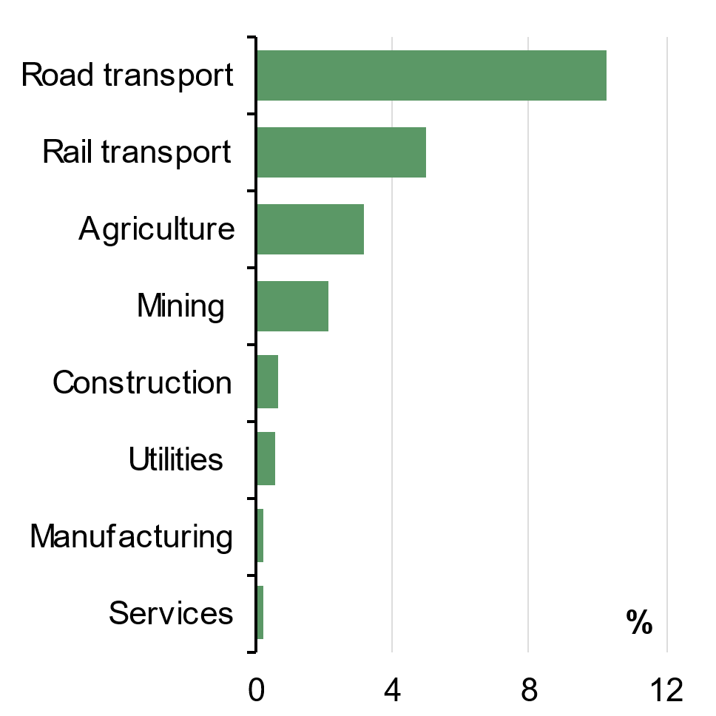 | 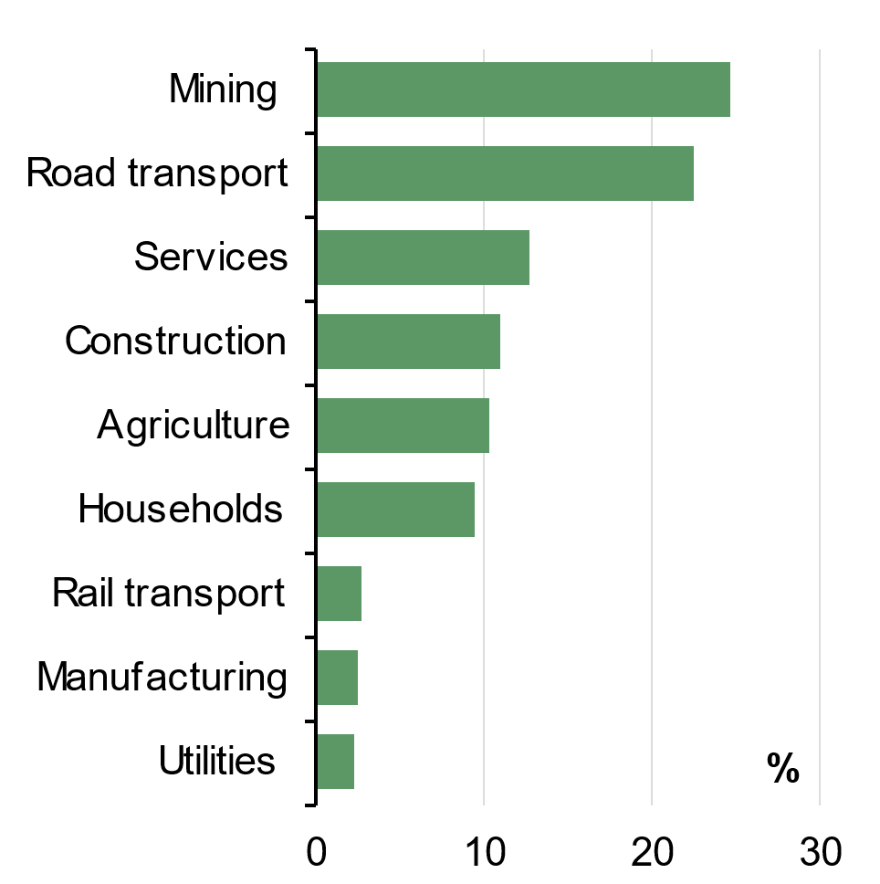
Source: ABS Australian National Accounts: Input-Output Tables (2023–24 financial year). | Source: ABS Australian National Accounts: Input-Output Tables (2023–24 financial year).

Global and domestic urea prices have risen by more than 70 per cent since the outbreak of the conflict in the Middle East – around 40 per cent of global urea exports originate from the Middle East. Higher urea and fertiliser prices will place upward pressure on global food prices, although this will occur with a lag due to planting cycles. For example, it took around six to twelve months for the increase in global urea prices that occurred as a result of Russia’s invasion of Ukraine in 2022 to flow through to increased food inflation across the world, including in Australia (Chart 2.7).
Continued on next page

Box 2.1: Price impacts from the conflict in the Middle East (continued)
Chart 2.7: Urea prices and global food inflation
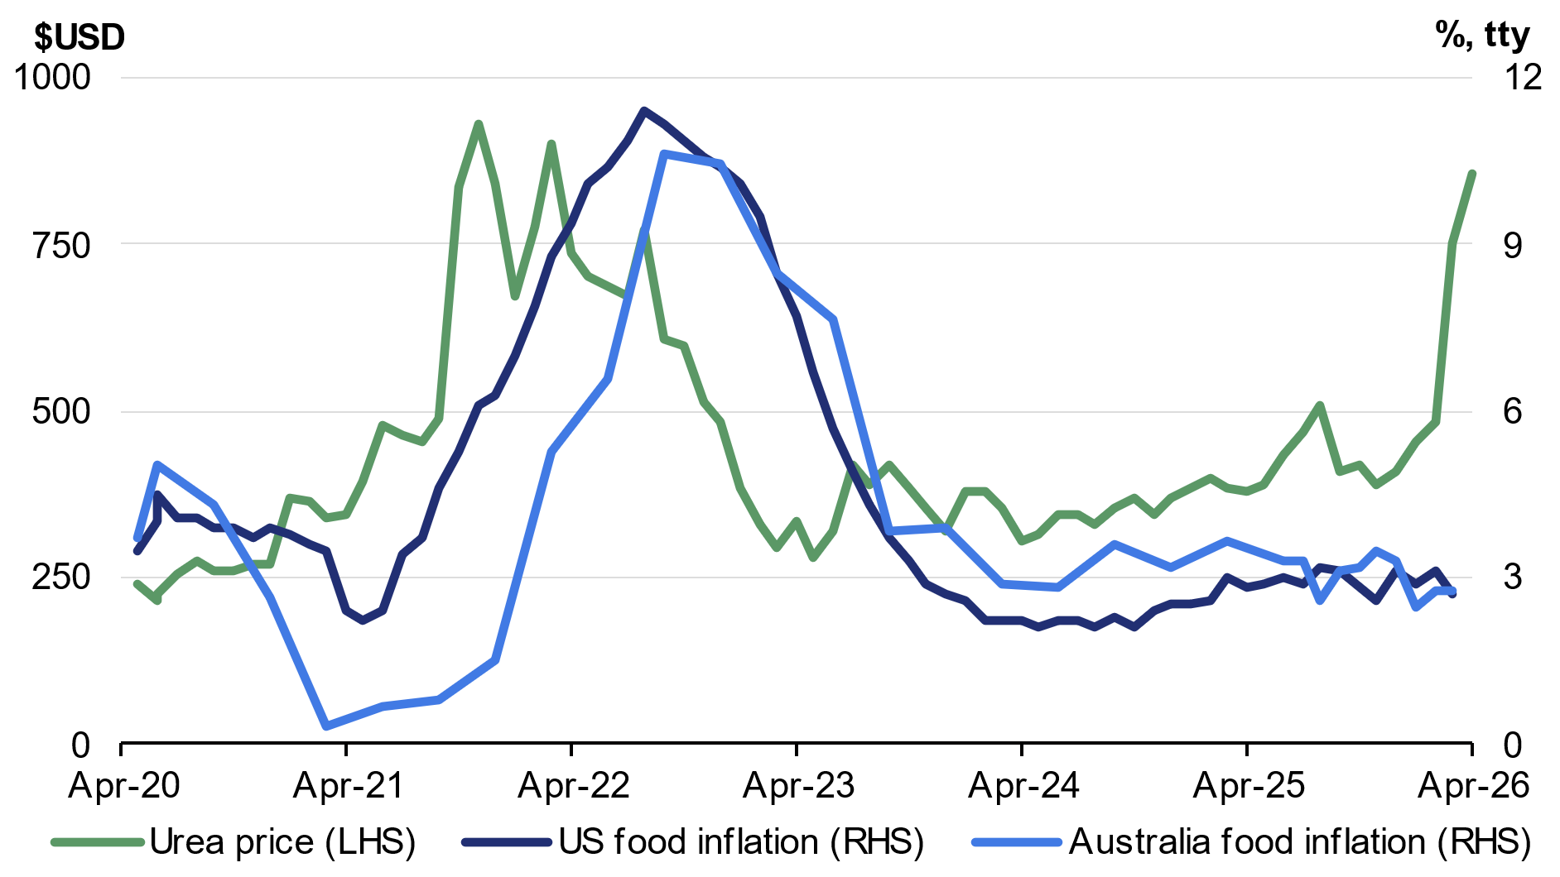
Source: ABS, Bloomberg, BLS and Treasury.
Note: Urea prices to April 2026. US and Australian food inflation data to March 2026. Urea uses granular FOB Middle East prices.

Other cost pressures are also expected to emerge. Gulf countries are important suppliers of the petrochemicals used to manufacture plastics and synthetic materials. The price of naphtha has already increased by more than 50 per cent since the outbreak of conflict. Qatar alone accounts for one-third of global helium supply, which is a byproduct of natural gas production and used in semiconductor manufacturing.
Asian manufacturing hubs which use these chemicals as inputs to plastic and semiconductor production are particularly exposed, given their dependence on Middle Eastern supply chains. Plastics are widely used in construction materials, medical supplies and packaging. Increases in polyvinyl chloride (PVC) prices are likely to flow through to dwelling construction costs, while increased packaging costs could impact a broad range of consumer goods.

While the economic impacts of the conflict in the Middle East are likely to endure for some time, growth in the Australian economy is expected to recover in 2027–28, with economic growth forecast to be 2¼ per cent that year, driven by a pick-up in household consumption as real household incomes recover.
The Australian labour market is expected to remain resilient and is well placed to withstand slower economic growth in 2026–27 due to its strong fundamentals. Market sector employment growth continued to build momentum over 2025, and aggregate employment is expected to continue to grow over the forecast period. The participation rate has been strong and is forecast to remain near its record high, and the unemployment rate is forecast to remain low by historical standards. These conditions are expected to support solid wage growth, with real wage growth expected to return in 2026–27.
The economic outlook remains highly uncertain and heavily contingent on the severity of the conflict in the Middle East. A relatively quick resolution to the conflict and reopening of the Strait of Hormuz presents an upside risk to growth, while a more protracted conflict could weigh more heavily on the outlook. The economic impacts of the conflict could be significantly more severe if supply chain disruptions persist or if sourcing of key inputs becomes a challenge. Box 2.2 considers the potential economic implications for Australia of a more severe conflict scenario.

Table 2.2: Domestic economy – detailed forecasts^{(a)}
 | Outcomes^{(b)} | Forecasts
 | 2024-25 | 2025-26 | 2026-27 | 2027-28
Real gross domestic product | 1.3 | 2 1/4 | 1 3/4 | 2 1/4
Household consumption | 1.2 | 2 1/4 | 1 3/4 | 2 1/2
Dwelling investment | 4.3 | 5 | 4 | 3 1/2
Total business investment^{(c)} | -0.1 | 4 | 2 1/2 | 2
By industry
Mining investment | -1.0 | 1/2 | 1 | 0
Non-mining investment | 0.2 | 5 | 3 | 2 1/2
Private final demand^{(c)} | 1.3 | 3 | 2 | 2 1/2
Public final demand^{(c)} | 4.2 | 2 3/4 | 2 3/4 | 2 1/2
Change in inventories^{(d)} | -0.1 | 0 | 0 | 0
Gross national expenditure | 1.9 | 2 3/4 | 2 1/4 | 2 1/2
Exports of goods and services | 0.7 | 3 1/2 | 1 | 2
Imports of goods and services | 3.3 | 5 | 3 1/2 | 3
Net exports^{(d)} | -0.6 | - 1/4 | - 1/2 | - 1/4
Nominal gross domestic product | 3.6 | 6 3/4 | 4 1/4 | 2 3/4
Prices and wages
Consumer price index^{(e)} | 2.1 | 5 | 2 1/2 | 2 1/2
Wage price index^{(f)} | 3.4 | 3 1/4 | 3 1/2 | 3 1/2
GDP deflator | 2.3 | 4 1/4 | 2 1/2 | 1/2
Labour market
Participation rate (per cent)^{(g)} | 67.0 | 66 3/4 | 67 | 67 1/4
Employment^{(f)} | 2.1 | 1 1/2 | 1 1/2 | 1 3/4
Unemployment rate (per cent)^{(g)} | 4.2 | 4 1/4 | 4 1/2 | 4 1/2
Balance of payments
Terms of trade^{(h)} | -4.1 | 4 1/2 | - 1/4 | -7 1/4
Current account balance (per cent of GDP) | -2.5 | -1 3/4 | -2 3/4 | -4
Net overseas migration^{(i)} | 305,000 | 295,000 | 245,000 | 225,000
- Percentage change on preceding year unless otherwise indicated.
- Calculated using original data unless otherwise indicated.
- Excluding second-hand asset sales between the public and private sector.
- Percentage point contribution to growth in GDP.
- Through-the-year growth rate to the June quarter.
- Seasonally adjusted, through-the-year growth rate to the June quarter.
- Seasonally adjusted rate for the June quarter.
- Key assumptions were set at the end of April 2026. Spot prices for key commodities are assumed to decline from elevated levels over four quarters to the end of the March quarter 2027 as follows: iron ore declines to US$60/tonne; metallurgical coal declines to US$140/tonne; thermal coal declines to US$70/tonne; and LNG declines to US$10/mmBtu. The gold price is assumed to decline over eight quarters to the end of the March quarter 2028 to US$3,325/troy ounce. All bulk commodity prices are in free on board (FOB) terms
- Net overseas migration is forecast to be 225,000 in 2028–29 and 2029–30.
Note: The forecasts for the domestic economy are based on several technical assumptions. The exchange rate is assumed to remain around 70 US cents and a trade-weighted index of around 65. Interest rates are assumed to move in line with expectations derived from financial market pricing. The Tapis oil price is assumed to average around US$100/barrel in the June quarter 2026 before declining and largely stabilising from the middle of 2027, informed by market expectations. It averages around US$80/barrel in the June quarter 2027 and is assumed to follow the trajectory of the Brent oil futures curve thereafter. It averages around US$77/barrel at the end of the detailed forecast period.
Sources: ABS Australian National Accounts: National Income, Expenditure and Product; Balance of Payments and International Investment Position, Australia; National, state and territory population; Labour Force, Australia; Wage Price Index, Australia; Consumer Price Index, Australia; unpublished ABS data and Treasury.

Household consumption
Growth in household consumption is forecast to be 2¼ per cent in 2025–26 before slowing to 1¾ per cent in 2026–27 as higher prices from the conflict in the Middle East weigh on real incomes and spending (Chart 2.8). The conflict has compounded cost of living pressures on households, including from higher interest rates. Household consumption is then forecast to recover and grow by 2½ per cent in 2027–28.
Despite heightened uncertainty, strong recent real income growth is expected to provide support to household consumption across 2025–26. Real household gross disposable income grew by 4.0 per cent in 2024–25, exceeding the 10-year pre-COVID average growth rate of 2.5 per cent per year. Real income growth has allowed many households to increase the share of income they save, increasing the net household saving rate and providing a partial buffer to the effects of higher prices on household budgets (Chart 2.9). Real household gross disposable income growth is forecast to be 3¼ per cent in 2025–26 before moderating to ½ per cent in 2026–27 due to the impacts of the conflict in the Middle East. Real household gross disposable income is forecast to grow by 2¼ per cent in 2027–28. Consistent with market expectations, the forecasts assume an additional increase in the cash rate in the September quarter 2026.
The conflict in the Middle East poses a downside risk if uncertainty weighs on household consumption by more than expected. Further, more sustained price increases would add to income pressures which could dampen spending, particularly on discretionary goods and services.
Chart 2.8: Household consumption growth | Chart 2.9: Net household saving ratio
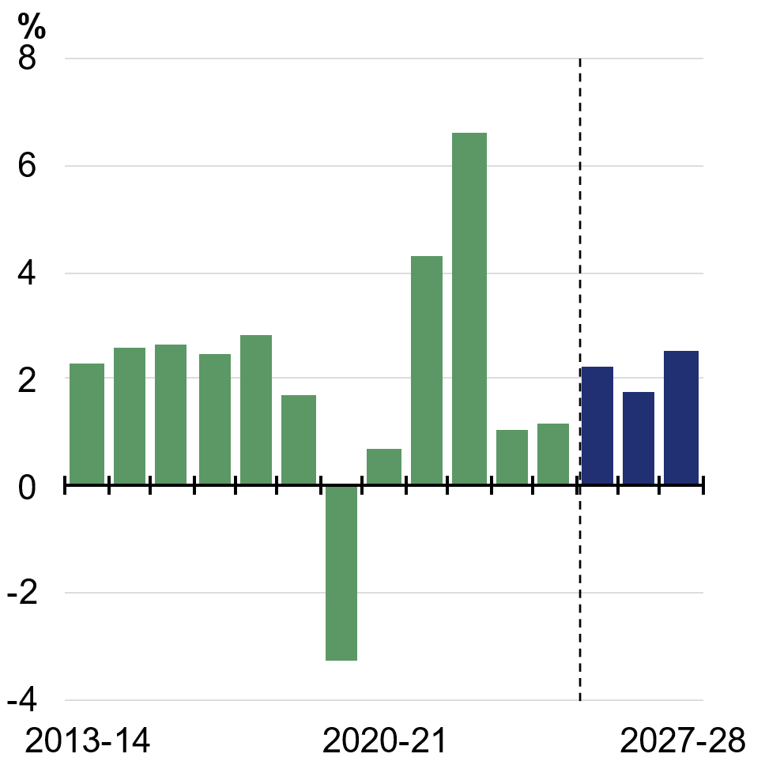 | 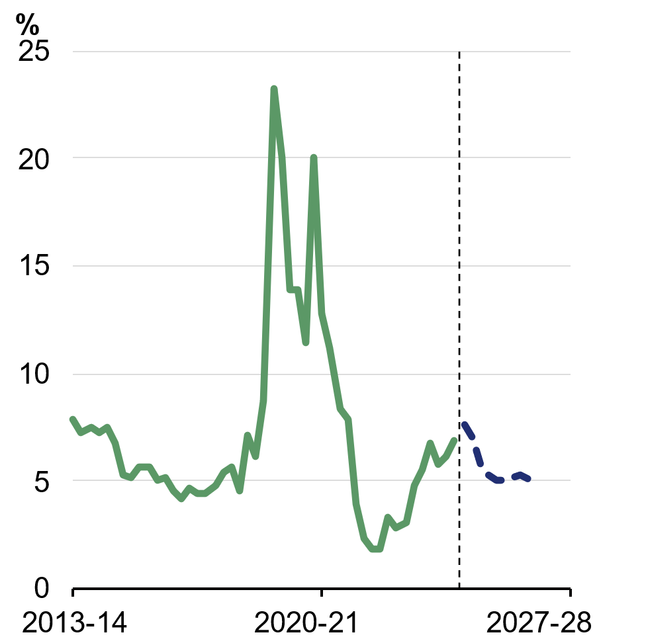
Source: ABS Australian National Accounts: National Income, Expenditure and Product and Treasury. | Source: ABS Australian National Accounts: National Income, Expenditure and Product and Treasury.

Dwelling investment
Dwelling investment is forecast to grow by 5 per cent in 2025–26 as strong commencements increase the pipeline of work under construction (Chart 2.10). Growth in dwelling investment is expected to continue, albeit at a more moderate pace. Dwelling investment is forecast to grow by 4 per cent in 2026–27 and 3½ per cent in 2027–28 (Chart 2.11). This moderation reflects the effects of higher interest rates and construction cost growth, including because of the conflict in the Middle East.
Dwelling investment indicators, including building approvals, dwelling commencements, and housing credit grew strongly over 2025. Solid demand for housing and growth in asset prices are expected to continue to support additional building approvals. However, higher interest rates and the conflict in the Middle East present downside risk to demand. A sharper-than-expected dampening in demand and building approvals would weigh on dwelling investment growth.
The conflict in the Middle East also poses significant supply-side risk to the pace of dwelling construction through higher cost growth and supply chain disruption. Polyvinyl chloride (PVC) prices increased significantly in March and resulted in an increase in some plumbing material prices by around 30 per cent in April. Sustained increases in fuel and other construction input costs across the housing supply chain will create challenges for project feasibility and cashflow management for businesses in the industry, particularly those with fixed-price contracts.
Government initiatives are supporting dwelling investment. The combination of Government’s policies in this Budget will add to housing supply (see Statement 4).
Chart 2.10: Number of private sector dwellings under construction | Chart 2.11: Dwelling investment
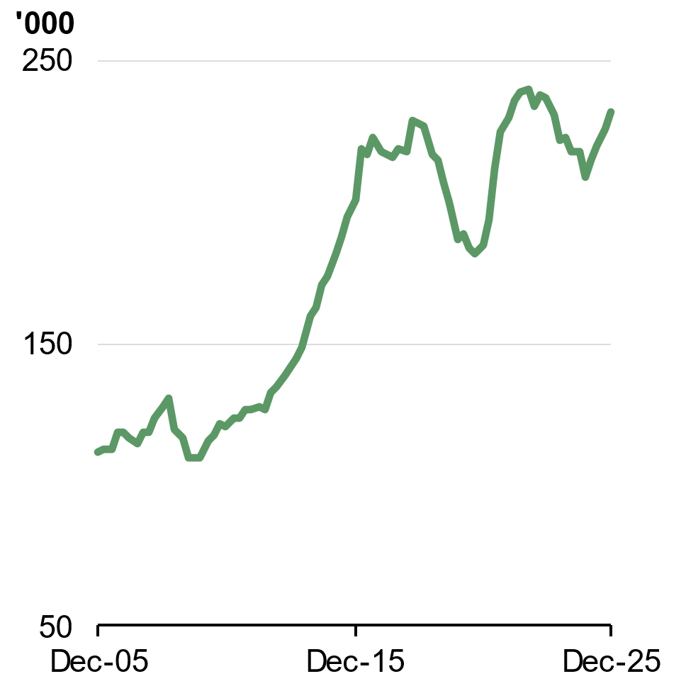 | 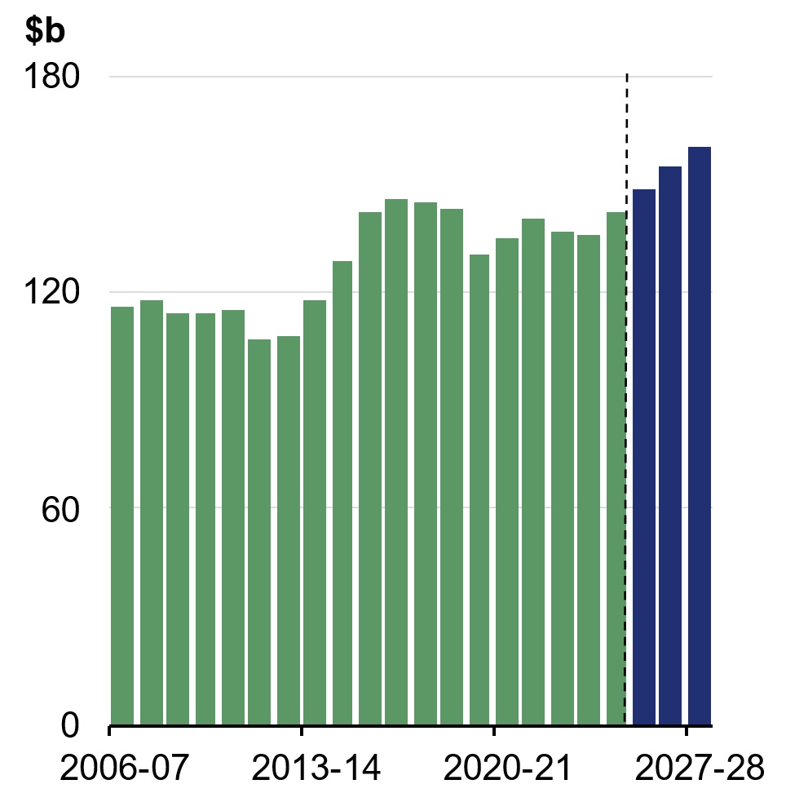
Source: ABS Building Activity and Treasury. | Source: ABS Australian National Accounts: National Income, Expenditure and Product and Treasury.

Business investment
Business investment growth picked up substantially in the second half of 2025. Momentum is expected to continue, with business investment forecast to grow by 4 per cent in 2025–26, 2½ per cent in 2026‑27 and 2 per cent in 2027–28. Recent capital expenditure expectations have been revised upwards, but these could be unwound as businesses factor in the impact of higher input prices as a result of the conflict in the Middle East. Higher borrowing costs could weigh on profitability.
Business capacity utilisation remains above its long-run average (Chart 2.12). Combined with strong demand for goods and services, this is incentivising businesses to keep investing. Businesses are expected to continue to find ways to improve their business operations and systems through digitalisation, including greater adoption of technology and AI (Chart 2.13). Investment in information media and technology equipment has grown by over 50 per cent since the beginning of 2025.
A strong pipeline of data centre and renewables projects is expected to support underlying growth in non-mining investment. This momentum is expected to continue, with non-mining investment forecast to grow by 5 per cent in 2026–27, 3 per cent in 2026–27 and 2½ per cent in 2027–28.
Mining investment is forecast to grow by ½ per cent in 2025–26, before growing by 1 per cent in 2026–27, as elevated global commodity prices support a pick-up in mineral exploration activity, particularly in gold and critical minerals.
Supply chain disruptions caused by the conflict in the Middle East pose a downside risk to business investment. Over 80 per cent of all capital goods are imported from overseas. The Middle East produces around one-quarter of the world’s sulphur and around one-third of the world’s commercial helium, which are critical inputs to metal processing and high-tech production chains, including for data centres. Supply of these key inputs could be disrupted or delayed. Combined with higher fuel prices, this could delay investment plans. At the end of April, national average diesel prices had risen by more than 70 cents per litre since the outbreak of conflict. Diesel is used widely across the economy, particularly by the transport, mining, agriculture, construction and manufacturing industries.
Chart 2.12: NAB capacity utilisation | Chart 2.13: Share of nominal non-mining business investment by component
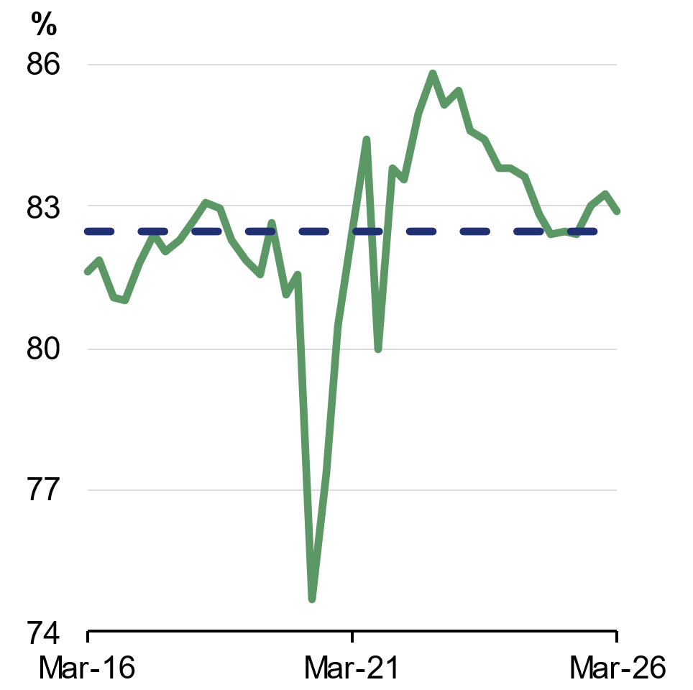 | 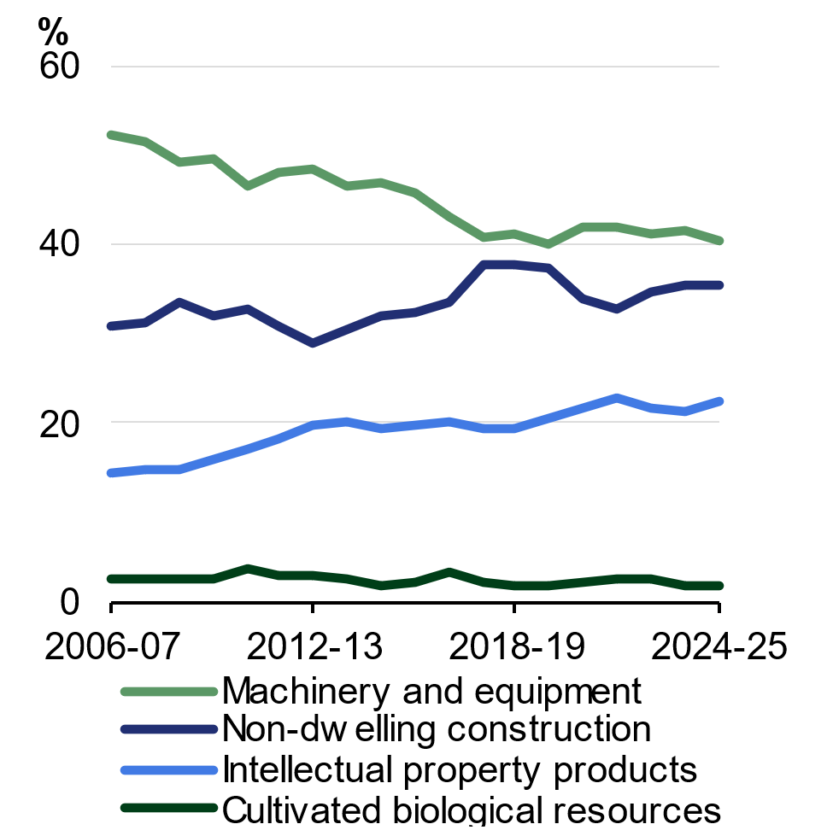
Source: NAB and Treasury.  Note: Dashed line indicates ten year long-run average. | Source: ABS Australian National Accounts: National Income, Expenditure and Product and Treasury.

Box 2.2: Risks of a more severe Middle East conflict
The economic forecasts assume that global oil prices begin to decline from the middle of 2026 and largely stabilise from the middle of 2027. However, there is significant uncertainty around the duration and severity of the conflict in the Middle East and its disruption of global supply chains. If the conflict in the Middle East is more protracted or escalates, global prices for oil, LNG, fertiliser, petrochemicals and other derivative products will remain elevated for longer. This will result in more severe economic impacts for the global and Australian economies.
To illustrate the potential impacts of a more severe disruption, Treasury has modelled a scenario in which global oil prices peak as high as US$200 per barrel during the September quarter 2026 (Chart 2.14). This could occur if the conflict is protracted or if an escalation further damages energy and export infrastructure across the Middle East and shuts off oil supply from the region, including through the Red Sea trade route.
The scenario assumes that global oil prices decline from the US$200 per barrel peak as global demand for oil adjusts in response to the higher price and some higher-cost oil producers begin production. Prices then gradually normalise as time is needed to repair damaged infrastructure across the Middle East and for shipping to normalise. Global oil prices are assumed to reach around US$80 per barrel by the June quarter 2029. The scenario assumes there are corresponding price increases for related commodities, including LNG, fertiliser and petrochemicals. Global risk premia are also expected to be higher, and household and business confidence are expected to be lower.
Continued on next page

Box 2.2: Risks of a more severe Middle East conflict (continued)
Chart 2.14: Oil price assumptions and futures curve
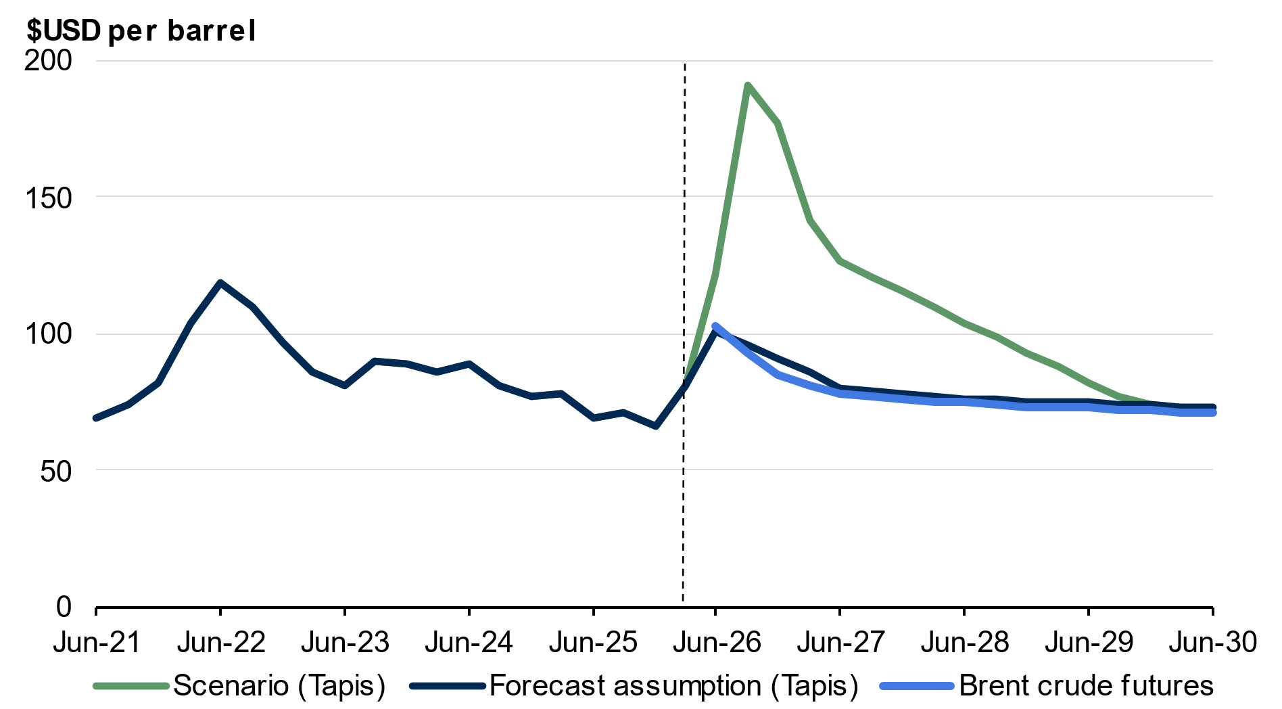
Source: Bloomberg and Treasury.
Note: Brent futures data from the week of 20 April 2026. Quarterly data are an average of three monthly contracts. The most recent peak in the quarterly average Tapis price was US$118.8 per barrel in the June quarter 2022 following Russia’s invasion of Ukraine. The highest daily Tapis price in 2022 occurred in the March quarter and was US$138.4 per barrel.

Continued on next page

Box 2.2: Risks of a more severe Middle East conflict (continued)
This scenario results in one quarter of negative real GDP growth in the September quarter 2026 and persistent weakness in the economy. The level of real GDP is ½ of a per cent lower across both 2026–27 and 2027–28 and remains lower by ¼ per cent across 2028–29, compared to the forecasts (Chart 2.15).
Inflation peaks at around 7¼ per cent through the year to the December quarter 2026, below the 2022 peak of 7.9 per cent (Chart 2.16), and takes two quarters longer to return to the RBA’s target band compared to the forecasts. The unemployment rate peaks at around 5 per cent in 2027–28 before gradually declining to 4½ per cent by the first half of 2030 (Table 2.3).
This scenario shows a more severe conflict will have a significant impact on both households and businesses. For households, real incomes fall in the face of rising prices, exacerbating cost of living challenges. This places pressure on household budgets at a time when workers may also be facing weaker job prospects as the labour market deteriorates due to slowing economic activity. These impacts will likely vary across different regions of Australia.
For businesses, higher prices for diesel, fertiliser, and other petrochemical products increase input costs, placing pressure on margins and, potentially in some cases, on viability. This will exacerbate the impact on domestic inflation. However, higher global prices for commodities such as LNG and thermal coal will provide support to some sectors, reflecting Australia’s status as a net energy exporter.
The impacts of a more severe conflict in the Middle East are highly uncertain and depend on global and domestic price dynamics, how demand is reduced globally to accommodate lower supply, and how households, businesses and financial markets respond globally and domestically. This uncertainty could prompt a more profound and protracted slowdown.
Additionally, the scenario assumes global oil prices initially decline rapidly from the US$200 peak as global demand and production respond. There is a risk that extremely high prices could be sustained for longer — for example, if higher-cost oil producers take longer than expected to come online. There is also a risk that a permanently higher geopolitical risk premium could be applied to global oil prices as a result of market disruption due to the conflict. This would result in even more severe economic impacts. It would also increase the risk of sustained or disorderly supply disruptions. Disruptions to the physical supply of products throughout supply chains would have significant adverse economic impacts.
Continued on next page

Box 2.2: Risks of a more severe Middle East conflict (continued)
Table 2.3: Modelled impacts of a more severe Middle East conflict
 | 2025-26 | 2026-27 | 2027-28 | 2028-29 | 2029-30
Impact on real GDP level^{(a)} | 0 | - 1/2 | - 1/2 | - 1/4 | 0
Unemployment rate^{(b)} | 4 1/2 | 5 | 5 | 4 3/4 | 4 1/2
Consumer price index^{(c)} | 5 1/4 | 5 | 1 1/2 | 3/4 | 1 1/2
- Per cent deviation to forecast level in the financial year.
- Seasonally adjusted rate for the June quarter.
- Through-the-year growth rate to the June quarter.

Chart 2.15: Scenario impact on real GDP level | Chart 2.16: Consumer price index growth in scenario
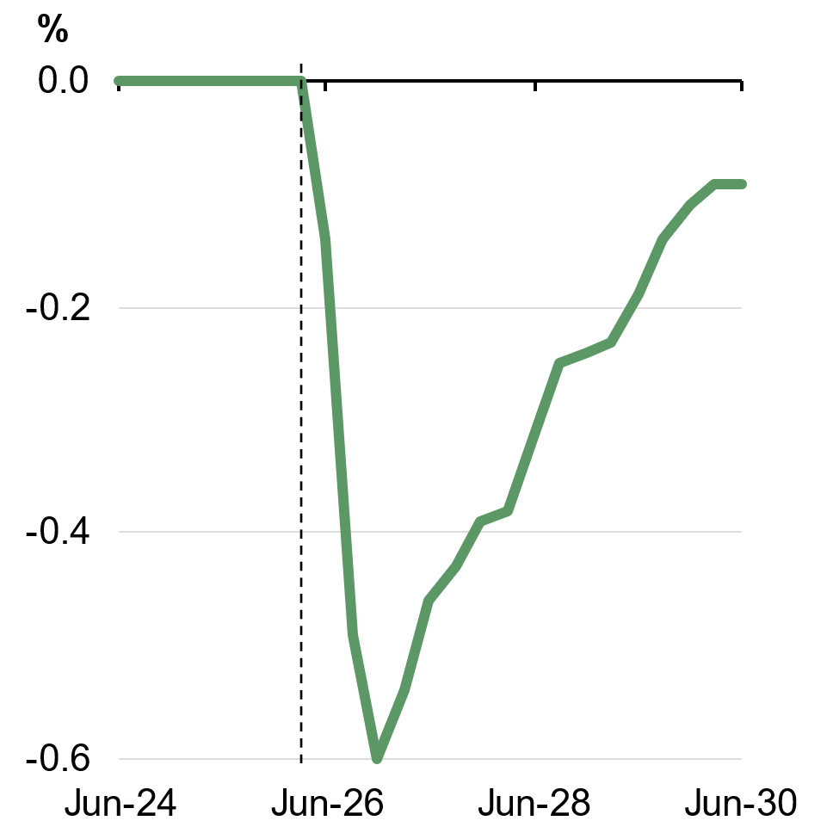 | 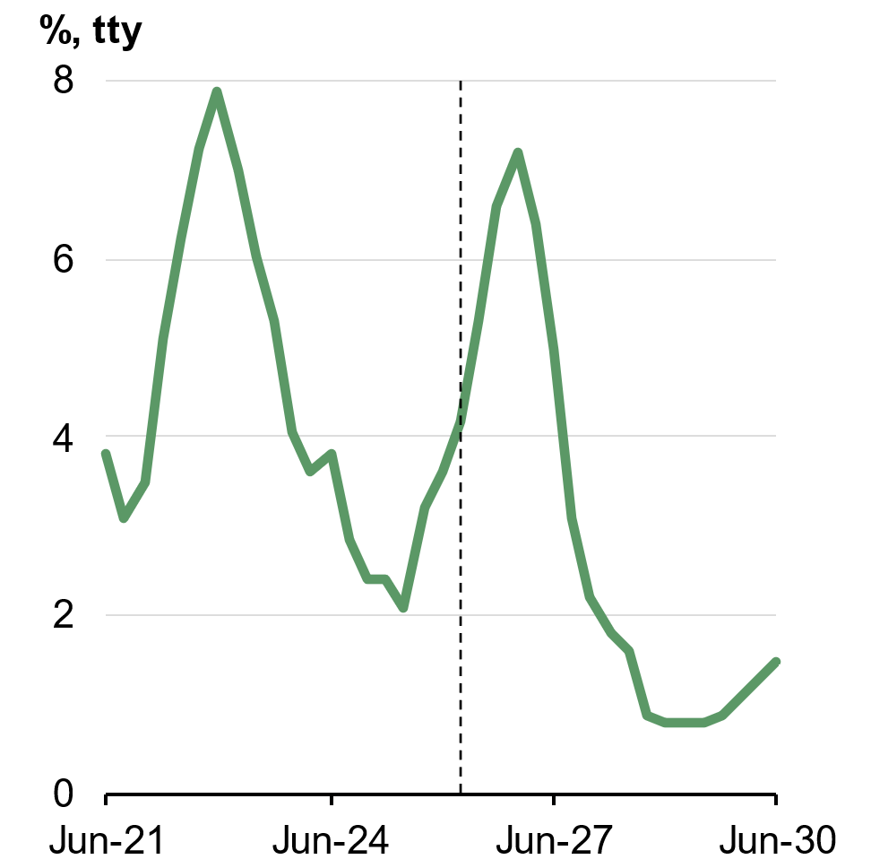
Source: ABS Australian National Accounts: National Income, Expenditure and Product and Treasury. | Source: ABS Consumer Price Index and Treasury.

Public final demand
Growth in public final demand is forecast to moderate from 2¾ per cent in 2025–26 and 2026–27 to 2½ per cent in 2027–28 (Chart 2.17). The moderation reflects softer growth in both public investment and public consumption. Public final demand is forecast to make a smaller contribution to growth than private final demand in each year of the forecast period (Chart 2.18).
Public investment growth is projected to slow as the pipeline of new infrastructure projects declines. Public consumption growth is also forecast to slow from its pace in recent years. This reflects reforms to Commonwealth programs, particularly the National Disability Insurance Scheme (NDIS). Nominal growth in the NDIS is projected to decline from over 10 per cent in 2024–25 to an average of around 2 per cent between 2025–26 and 2029–30. As a share of GDP, NDIS expenditure is expected to decline from 1.7 per cent in 2025–26 to 1.6 per cent in 2028–29 and 1.5 per cent in 2029–30. Without the Government’s recent changes, NDIS expenditure as a share of GDP would have been projected to exceed 2 per cent by 2029–30. Spending growth across other levels of government is also expected to moderate.
Chart 2.17: Public final demand growth | Chart 2.18: Contributions to domestic final demand growth
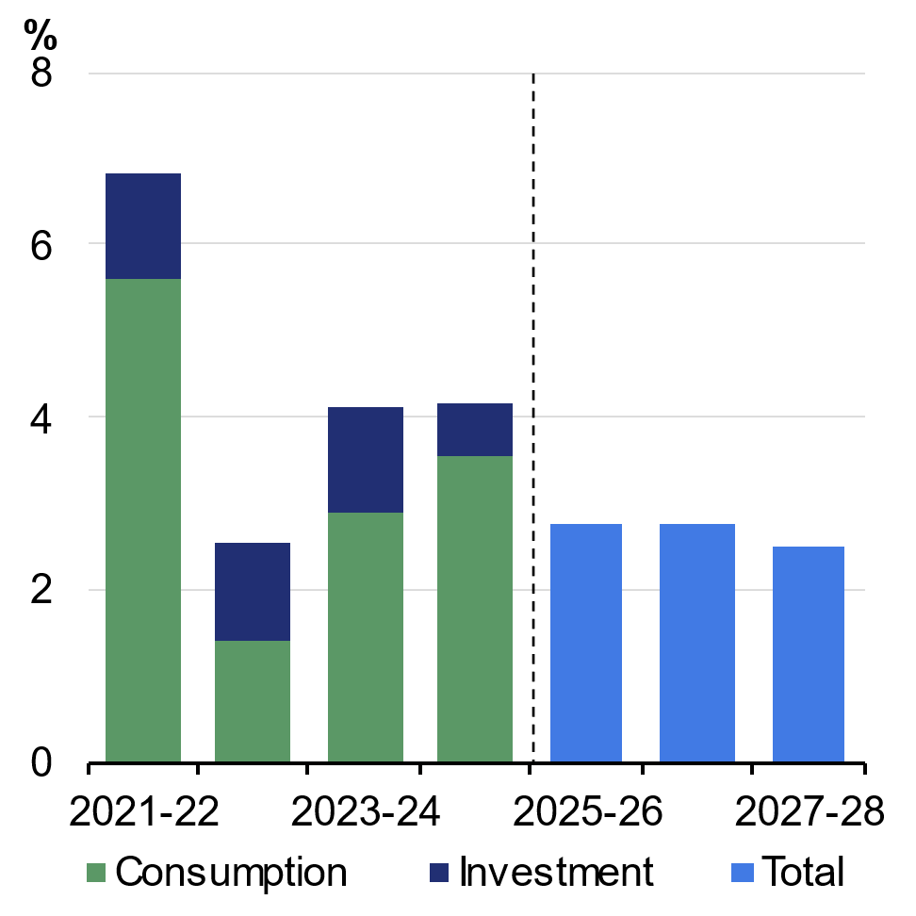 | 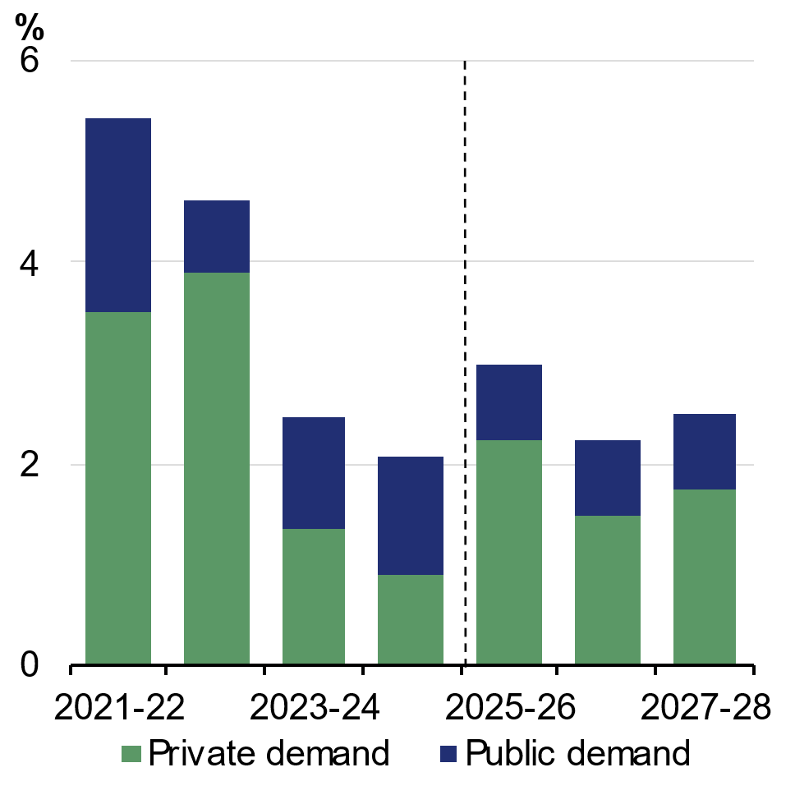
Source: ABS Australian National Accounts: National Income, Expenditure and Product and Treasury. | Source: ABS Australian National Accounts: National Income, Expenditure and Product and Treasury.

International trade
The conflict in the Middle East poses significant uncertainty for the external sector, with implications for both trade prices and volumes. Higher energy prices will have a positive impact on the terms of trade given Australia’s position as a net energy exporter. Increased energy prices and sustained export demand are expected to drive up LNG and thermal coal export values. By contrast, higher input and transportation costs because of higher oil prices will place upward pressure on import prices. The conflict in the Middle East is expected to weigh on the outlook for both inbound and outbound tourism due to higher travel prices, tighter airline capacity and weaker traveller sentiment.
Exports are forecast to grow by 3½ per cent in 2025–26, underpinned by strong growth in commodities and services, particularly in late 2025. Export growth is forecast to moderate to 1 per cent in 2026–27, before rising to 2 per cent in 2027–28. Mining exports are expected to continue to underpin export growth (Chart 2.20). However, mining export growth is forecast to ease in line with slowing demand from China for key commodities, particularly iron ore, as China continues to transition towards less steel-intensive economic activity. Services exports are forecast to grow modestly, with global uncertainty dampening overseas travel demand, while growth in the student stock remains subdued.
Imports are forecast to grow by 5 per cent in 2025–26, supported by robust growth in domestic demand and a stronger Australian dollar. Investment in software, automatic data processing equipment, defence capability and materials for large state and renewable infrastructure projects is expected to continue to underpin solid goods imports growth. Imports are forecast to continue to grow solidly at 3½ per cent in 2026–27 and 3 per cent in 2027–28, in line with investment and consumption.

Chart 2.19: Net exports contribution to GDP growth | Chart 2.20: Contribution to exports growth by component
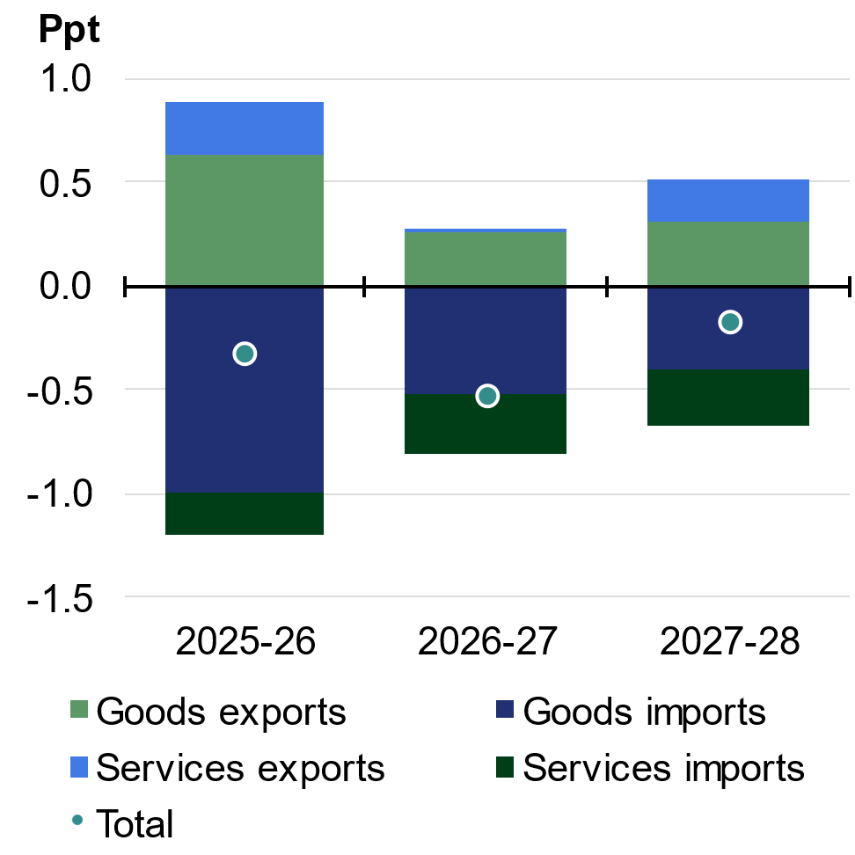 | 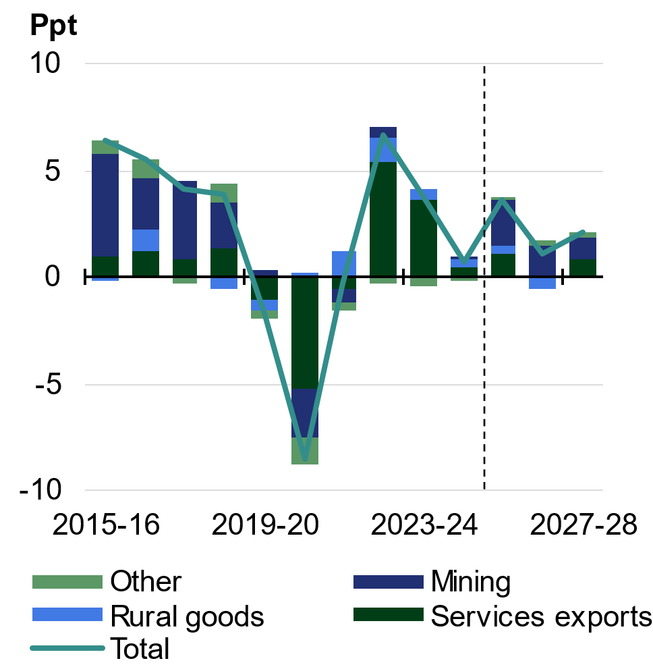
Source: ABS Balance of Payments and International Investment Position, ABS Australian National Accounts: National Income, Expenditure and Product and Treasury. | Source: ABS Balance of Payments and International Investment Position, ABS Australian National Accounts: National Income, Expenditure and Product and Treasury.

Labour market and wages
The labour market is expected to remain resilient despite the impacts of the Middle East conflict. Employment is expected to continue to grow, and the participation rate is expected to remain close to its recent record high. The unemployment rate is forecast to remain low by historical standards, gradually increasing from 4¼ per cent in the June quarter 2026 to 4½ per cent in the June quarter 2027 and the June quarter 2028. The unemployment rate is expected to remain well below its average in the decade before the pandemic (Chart 2.21).
Employment is expected to continue growing over the forecast period. Employment is forecast to grow by 1½ per cent through the year to the June quarter 2026 and the June quarter 2027 and 1¾ per cent through the year to the June quarter 2028. Market sector employment growth continued to build momentum over 2025, but the impact of the Middle East conflict is expected to result in a moderation in growth. Employers facing reduced demand for their products are expected to respond initially by cutting hours for existing staff and delaying hiring of new staff.
Structural factors will continue to support labour force participation. These include continued increases in female participation, a greater propensity for migrants to participate in the labour market, and a continued trend towards later retirements. The participation rate is forecast to remain around 67 per cent until 2027–28.

The Wage Price Index is forecast to grow by 3¼ per cent through the year to the June quarter 2026, before increasing to 3½ per cent through the year to the June quarter 2027 and the June quarter 2028. The Wage Price Index has grown at an annual rate above 3 per cent since the September quarter 2022. This is the longest period in more than a decade and a half that annual growth has been above 3 per cent, and this is expected to continue over the forecast period (Chart 2.22).
Wages set through enterprise agreements are expected to moderate over the forecast period. Award wage growth is expected to continue to be supported by several recent Fair Work Commission decisions, including the junior pay rates determination and the Gender Undervaluation – priority awards review.
The recent increase in inflation is expected to result in a decline in real wages over 2025–26. Real wages, as measured by annual growth in the Wage Price Index relative to the annual growth in the headline Consumer Price Index, are forecast to grow again in 2026–27 and 2027–28 as inflationary pressures ease.
Chart 2.21: Unemployment rate | Chart 2.22: Nominal wages growth
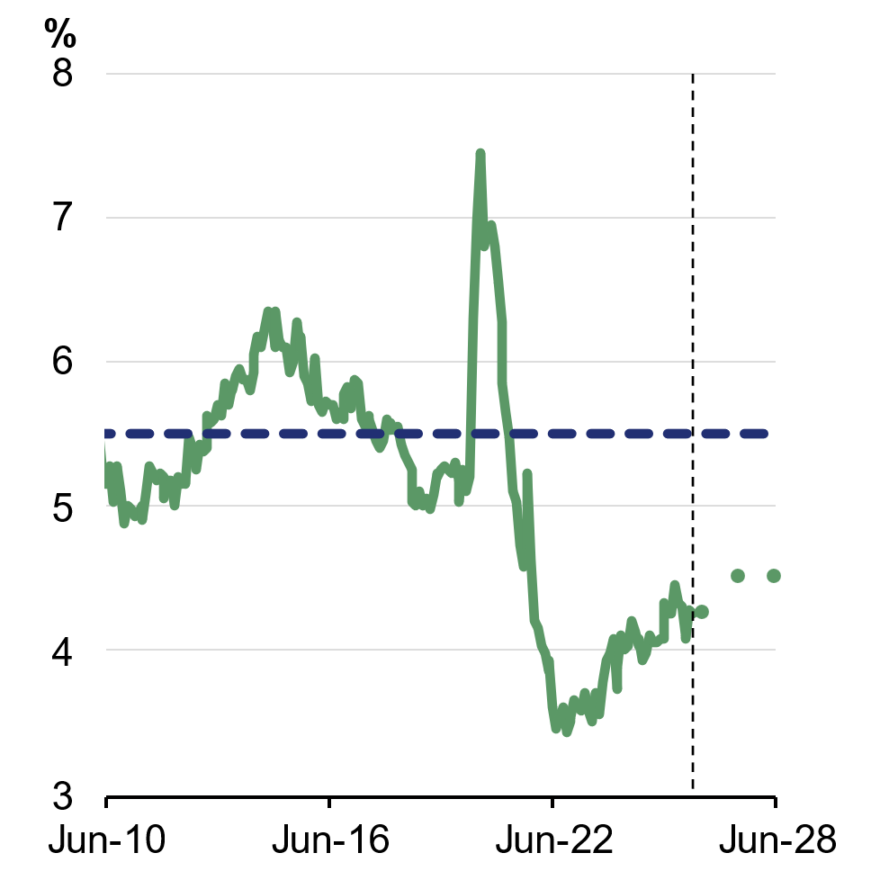 | 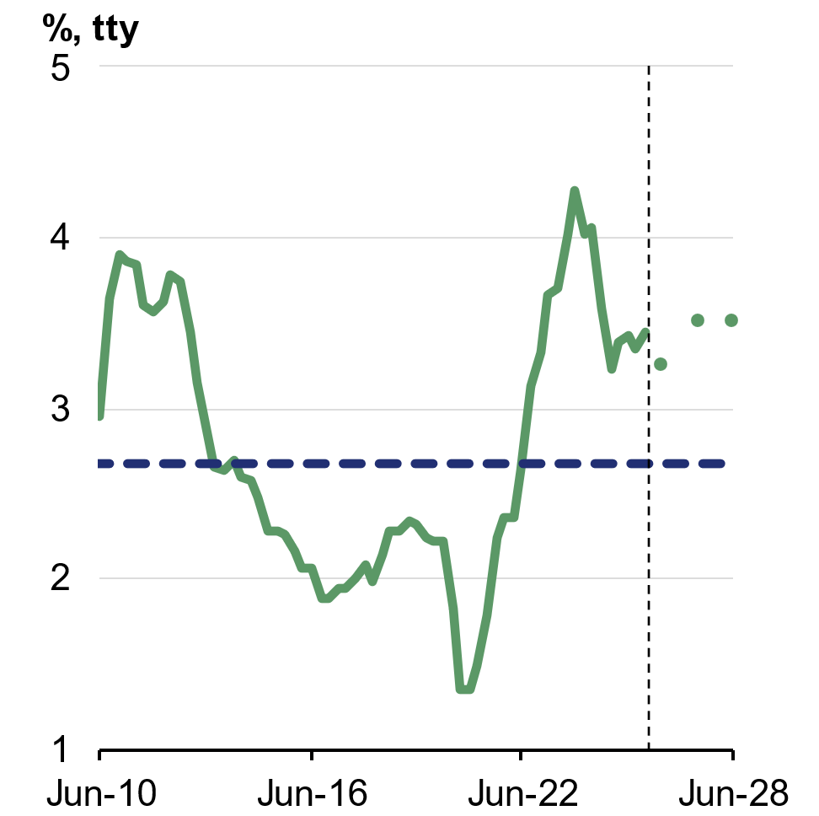
Source: ABS Labour Force Survey and Treasury.  Note: Dashed line indicates 2010–19 average. | Source: ABS Wage Price Index and Treasury.  Note: Dashed line indicates 2010–19 average.

Inflation
The conflict in the Middle East has substantially added to inflationary pressures in the Australian economy. Automotive fuel prices increased by 32.8 per cent in the month of March (Chart 2.23), driving an increase in headline inflation to 4.6 per cent through the year. Trimmed mean inflation was 3.3 per cent through the year to March 2026. The Government’s temporary cut to the fuel excise is limiting the impact of higher petrol and diesel prices on households and headline inflation.
Price pressures stemming from the conflict are expected to broaden in the coming months, as price increases for petroleum-dependent products are passed through supply chains. Food prices will be particularly affected, reflecting higher fuel and fertiliser prices. The prices of newly constructed dwellings are also likely to increase, as higher fuel and plastics costs increase the price of building materials. While there is significant uncertainty around the severity and duration of the conflict, the prices of oil-dependent products are unlikely to normalise quickly, contributing to price pressures over much of 2026–27.
Headline inflation is forecast to peak at 5 per cent through the year to the June quarter 2026. It is then expected to decline, in line with the assumption that global oil prices ease over 2026–27, to 2½ per cent through the year to the June quarter 2027 (Chart 2.24). Abstracting from the impact of fuel prices, inflation is forecast to sustainably return to the RBA’s target band in the middle of 2027.
Australia was facing inflationary pressures immediately prior to the Middle East conflict. Headline and underlying inflation both returned to the RBA’s target band briefly in 2025 but increased again to be above 3 per cent towards the end of the year. These developments reflected a mix of temporary and persistent factors (Box 2.3).
Chart 2.23: Monthly automotive fuel inflation | Chart 2.24: Headline and underlying inflation
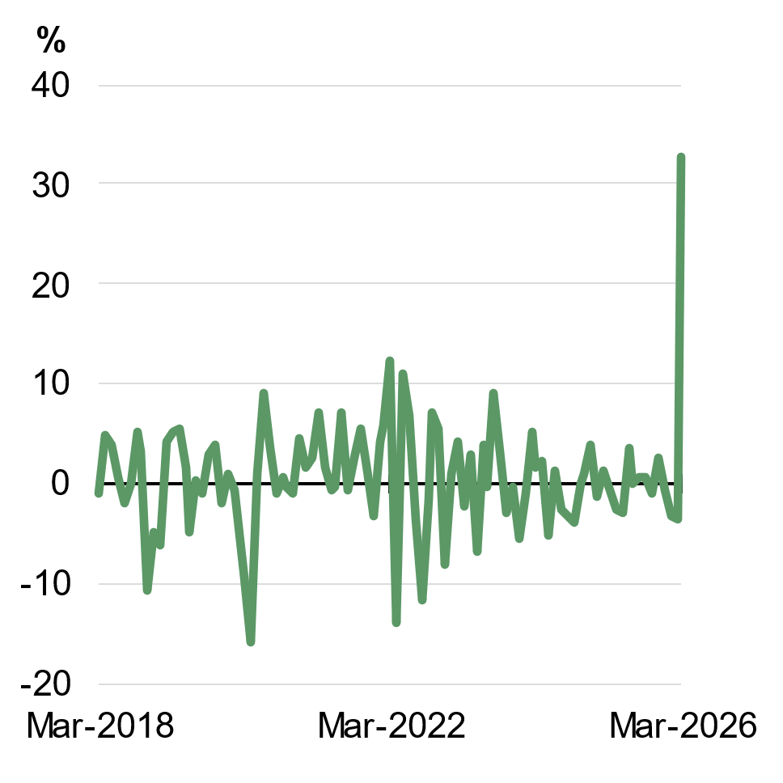 | 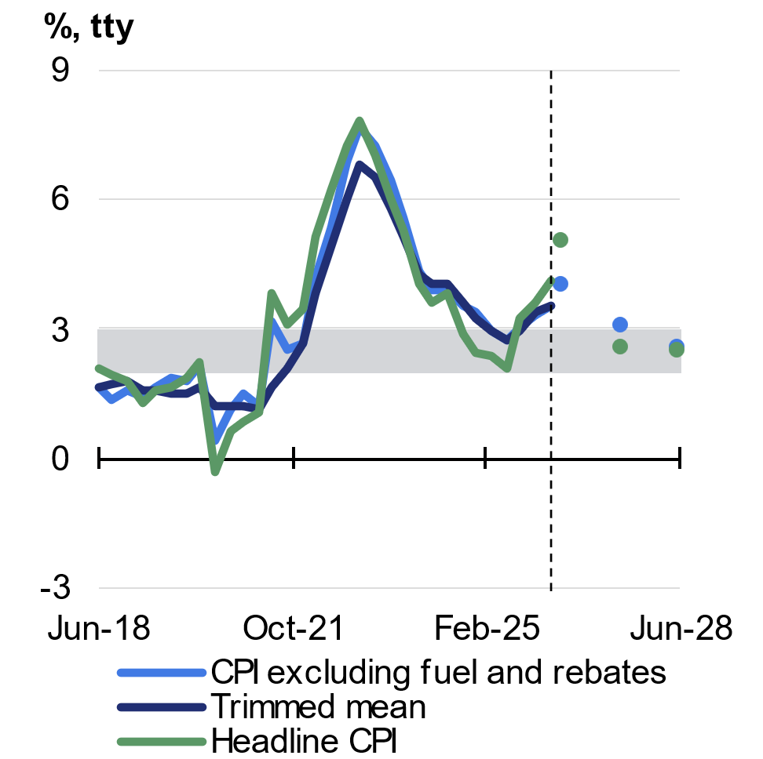
Source: ABS Consumer Price Index and Treasury. | Source: ABS Consumer Price Index and Treasury.  Note: Grey shading denotes the RBA’s target band.

Box 2.3: Drivers of the recent increase in inflation
The conflict in the Middle East is already having a significant impact on inflation, which increased to 4.6 per cent in the 12 months to March 2026, driven by a 32.8 per cent increase in automotive fuel prices in March. Abstracting from the impact from fuel prices, headline inflation decreased slightly in March.
The impact of the Middle East conflict on prices is expected to peak in the June quarter 2026, as price pressures stemming from the conflict broaden and price increases for petroleum-dependent products are passed through supply chains. At this point, the conflict is expected to add around one percentage point to headline inflation through the year to the June quarter 2026. The inflationary effects from the conflict are then expected to continue through the coming year.
Even before the developments in the Middle East, both headline and underlying inflation had risen to be above the RBA’s target band in 2025, reflecting a combination of temporary and more enduring factors.
Temporary factors included the end of government electricity rebates, which are estimated to add around ½ of a percentage point to annual headline inflation across 2026. Increases in some administered prices as a result of periodic reviews, combined with volatility in travel prices, have also added to inflation. Together, these factors temporarily contributed around 0.9 percentage points to the increase in annual inflation between the June quarter 2025 and the March quarter 2026 (Chart 2.25).
There have also been more persistent pressures. Underlying inflation has increased since mid-2025 and an increasing share of the CPI basket is exhibiting elevated inflation (Chart 2.26). Persistent services inflation and sector-specific supply constraints have contributed to this.
As has been the case in many overseas jurisdictions, services inflation has persistently remained above its long run average. Services prices are closely linked to domestic conditions, and can reflect the resilience in Australia’s labour market.
Continued on next page

Box 2.3: Drivers of the recent increase in inflation (continued)
Supply constraints have persisted in food and rental markets since the pandemic. In 2025, there were strong increases in the prices of cocoa, coffee and meat. While some pressures are easing, higher fuel and fertiliser costs linked to the disruption in the Middle East are expected to keep global food prices elevated in the coming months. In the rental market, record low vacancy rates and construction costs have both contributed to rental inflation. Over time, growth in dwelling investment will add to the dwelling stock and help ease these pressures.
Chart 2.25: Contributions to annual headline inflation | Chart 2.26: Annual price growth for CPI expenditure classes
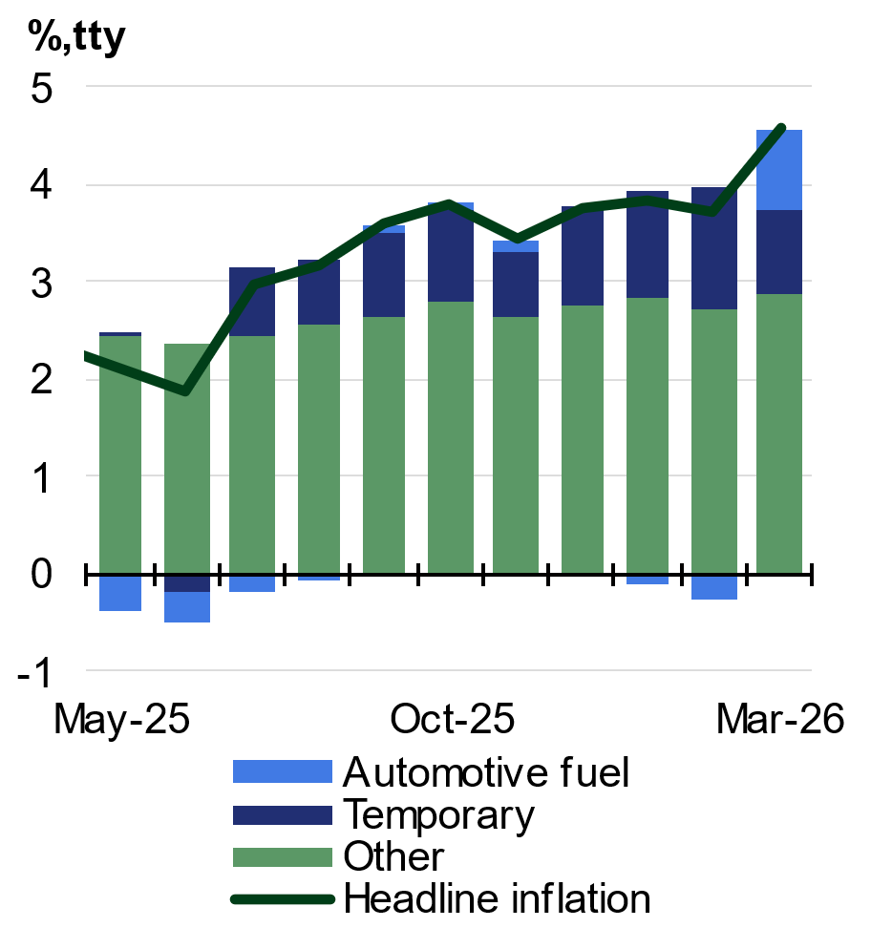 | 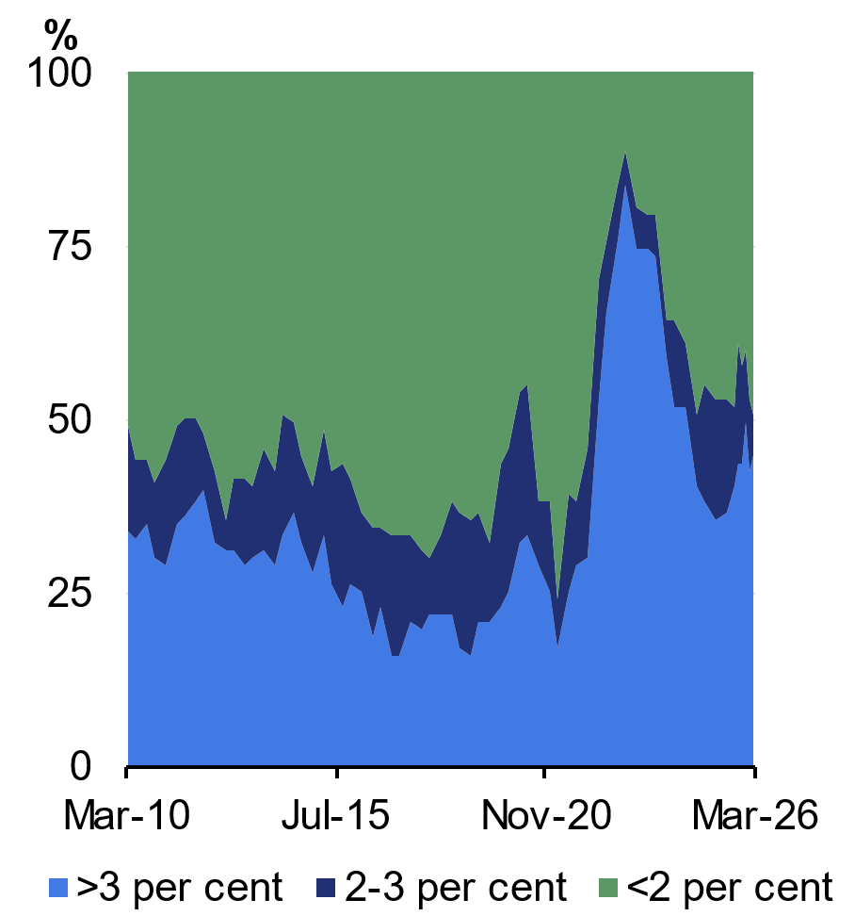
Source: ABS Consumer Price Index and Treasury.  Note: Temporary includes the contribution of electricity, holiday travel, fruit and vegetables, water and sewerage and property rates and charges. | Source: ABS Consumer Price Index and Treasury.  Note: Chart shows the share of CPI expenditure classes growing at different annual rates. Data are not weighted.

Net overseas migration
Net overseas migration (NOM) has declined by around 45 per cent from its peak in 2022–23 and is forecast to continue declining through to 2027–28. NOM is forecast to be moderately higher than previously expected in 2025–26 and 2026–27, which reflects that migrants on temporary visas are departing Australia at lower rates than in the past. Arrivals of New Zealand citizens are also expected to remain strong, reflecting Australia’s relatively favourable labour market conditions. Migration policy changes in this Budget will place downward pressure on NOM.

Nominal GDP and the medium-term outlook
Nominal GDP is forecast to grow by 6¾ per cent in 2025–26, reflecting the impact of higher commodity prices and inflationary pressures. Nominal GDP is then forecast to grow by 4¼ per cent in 2026–27, as economic growth and domestic inflation moderate and the terms of trade are assumed to fall.
The pathway for key commodity prices is based on a technical assumption that commodity markets return to relatively conservative anchor prices over time. This approach reduces the risk that near-term price fluctuations result in overstating medium-term nominal GDP.
The fiscal aggregates are underpinned by economic forecasts over the Budget estimates period and projections over the medium term (Chart 2.27).
Chart 2.27: Medium-term projections period
Source: Treasury.

Beyond the detailed forecast horizon of 2027–28, Treasury uses a macroeconometric model of the Australian economy for its forecasts and projections. The model informs how the economy returns to its trend level of output, known as potential output.
Potential output is the output that can be produced when an economy operates at maximum sustainable employment. It depends on the number of people in the economy, the number of people who are part of the labour force, how many hours they work, and labour productivity. The level of potential GDP is estimated using the 3Ps of population, participation and productivity.
In the long term, the labour force participation rate is expected to rise owing to increases in participation among females, migrants and older cohorts, while average hours worked per employee is expected to decline as more workers take up part-time work. Total hours worked per person remains around 20 hours per week, a level consistent with what has been seen over more than 40 years in Australia. The long-term Non-Accelerating Inflation Rate of Unemployment (NAIRU) is assumed to be 4¼ per cent.
The long-term underlying productivity assumption is 1.2 per cent per year. The transition to the long-term rate of underlying productivity growth is assumed to occur over a period of around five years (Box 2.4). Domestic inflation converges to the midpoint of the RBA’s target band. The terms of trade are assumed to be broadly flat from the end of the detailed forecast period.
Box 2.4: Productivity transition
Productivity growth is influenced by innovation, diffusion, investment and policy settings, across both private businesses and government and reflects both domestic and global factors. This makes productivity growth difficult to predict. Accordingly, Treasury uses an assumption for long-term productivity growth that is informed by long-term domestic and global trends.
The long-term productivity growth assumption was revised from 1.5 per cent to 1.2 per cent per annum in the October 2022–23 Budget. This reflected the persistence of weaker global and domestic productivity outcomes.
Developments in recent years have added more uncertainty to the long-term assumption. For example, pandemic-related volatility in the first half of this decade has made underlying trends more difficult to interpret. Downside risks, including climate change and rising barriers to trade, have the potential to hamper long-term productivity growth. The upside potential of technological innovations, including artificial intelligence, is potentially very significant, but uncertain. Balancing these uncertainties, the long-term productivity growth assumption remains at 1.2 per cent in the 2026–27 Budget.
Internationally, long-term productivity growth assumptions vary from country to country. They tend to be informed by historical averages and are periodically reassessed with reference to productivity trends and prospects. Like Australia, others have revised down their assumptions over the past five years.
Continued on next page

Box 2.4: Productivity transition (continued)
Australia’s long-term productivity assumption remains broadly consistent with the range used by other open market economies with similar institutional features. The United Kingdom’s Office for Budget Responsibility uses a long-term assumption of 1.5 per cent, the United States’ Congressional Budget Office uses a long-term assumption of 1.4 per cent, the New Zealand Treasury uses a long-term assumption of 0.9 per cent, and the Canadian Department of Finance uses a long-term assumption of 0.8 per cent.
Treasury’s Budget forecasts are based on an assumption that underlying productivity growth transitions to its long-run growth rate over time. From the first year of the forward estimates, Treasury projects that underlying productivity growth transitions to its long-term growth assumption over around five years. Underlying productivity growth is assumed to be 1.2 per cent in 2031–32.
This is a more gradual transition than used in the 2025–26 Budget. Previously, underlying productivity growth was projected to transition to the long-term assumption after two years from the first year of the forward estimates. If the previous methodology was used in this Budget, this would have seen underlying productivity growth reach 1.2 per cent by the end of 2028–29.
Treasury considers a gradual transition to be appropriate, reflecting uncertainty around productivity trends and consistent with international practice. In advanced economies, including the United States and the United Kingdom, independent and government fiscal agencies tend to assume that convergence to long-term productivity growth assumptions takes place over five to ten years. The gradual transition adopted in this Budget is more in line with these other approaches to the long-run productivity assumption.

