Statement 3:
Fiscal Strategy and Outlook
The Government has delivered a stronger and more sustainable budget, with lower deficits and less debt. The budget is $44.9 billion stronger over the forward estimates than at the mid-year update, and more than a quarter of a trillion dollars better over the eight years to 2029–30 than the Government inherited.
Since MYEFO, the underlying cash balance has improved in each year of the forward estimates and medium term. In 2026–27, the deficit is $31.5 billion, $2.8 billion lower than at MYEFO. In 2029–30, the deficit is $25.3 billion, less than half the projection at MYEFO. As a share of the economy, the deficit is expected to be 1.0 per cent in 2026–27 to 2028–29 and then improve to 0.7 per cent in 2029–30. The deficits over the forward estimates are half the average between the GFC and COVID-19 pandemic. The budget is projected to return to balance in 2034–35 and to a surplus of 0.8 per cent of GDP in 2036–37, supported by structural savings and reforms to the tax system.
The improvement in the budget position is underpinned by savings and reprioritisations, spending restraint, and banking revenue upgrades; putting the budget in a stronger position in every year compared to the mid-year update. This budget update helps to take the pressure off inflation, delivers substantial improvements in the fiscal position, and cuts taxes for workers and businesses.
The Government is delivering $63.8 billion of savings and reprioritisations. These savings help build fiscal buffers at a time of heightened global uncertainty and make more room to return bracket creep in future budgets.
The Government has made net policy decisions that improve the budget position for the second consecutive update. Over the five years to 2029–30, net policy decisions improve the budget by $26.1 billion, when accounting for previously made provisions. By saving more than spending, the Government is again returning every dollar of the tax receipts upgrade to the budget.
The Government’s fiscal discipline means that real payments growth averages 1.1 per cent over the four years to 2029–30, and 1.5 per cent over the eight years to 2029–30, less than half the 30-year average. Payments as a share of the economy are forecast to decline from 26.8 per cent in 2026–27 to 26.2 per cent in the last year of the forward estimates. Payments–to–GDP are lower than at MYEFO in every year of the medium term and is 0.4 percentage points lower by 2035–36.
The Government continues to build fiscal buffers, which is even more important during times of heightened global economic uncertainty. At 30 June 2027, gross debt is forecast to be $1,051 billion, $18.0 billion below MYEFO and $173.0 billion below the 2022 PEFO. It is now forecast to peak within the forward estimates at 35.8 per cent of GDP in 2028–29, 1.2 percentage points lower and two years earlier than at MYEFO. Compared to at MYEFO, gross debt is lower in every year of the forward estimates and medium term.
This Budget introduces a range of tax reform measures designed to deliver tax reductions for working Australian taxpayers, help more Australians to realise the goal of home ownership, and strengthen incentives for investment and innovation. These reforms ensure that the Government can continue to fund essential services Australians rely on, while lowering the tax burden on working Australians and creating room for further tax relief over time.
The Budget is delivering a comprehensive productivity package that helps reduce regulatory costs and supports higher living standards for all Australians. Improving productivity is central to the Government’s economic plan to grow Australia’s economy.
The fiscal improvements in this Budget have been achieved while ensuring funding goes to those who need it most. This Budget includes $11.8 billion in increased social security payments to people with a disability, carers, pensioners, young people, families and those who are unemployed. This is in part driven by higher automatic payment indexation, which will help shield the most vulnerable from the impacts of the global oil shock.
The decisions in this Budget build on this Government’s strong fiscal credentials. Compared to the 2022 PEFO, the budget is $263.8 billion better over the eight years to 2029‍–‍30, gross debt is $173.0 billion lower in 2026–27 and the peak in gross debt as a share of GDP is 9.1 percentage points lower. This will help avoid more than $70.0 billion in interest costs over the eleven years to 2032–33.
Australia remains one of only nine countries with a AAA sovereign credit rating from all three major ratings agencies. For 2027, the International Monetary Fund (IMF) expects Australia (including all levels of government) to have the third highest budget balance among G20 countries and for gross debt-to-GDP to be less than half the advanced economy average, more than 50 percentage points below the United Kingdom, and more than 75 percentage points below the United States (Box 3.3).

Statement 3 contents
Economic and Fiscal Strategy 86
Delivering on the Economic and Fiscal Strategy 88
Addressing unavoidable issues 91
Fiscal outlook 94
Underlying cash balance estimates 94
Receipts estimates 96
Payments estimates 98
Headline cash balance 104
Medium-term projections 107
The Government’s balance sheet 111
Gross debt estimates and projections 113
Net debt estimates and projections 115
Net financial worth and net worth estimates and projections 115
Appendix A: Other fiscal aggregates 117
Accrual aggregates 117
Net operating balance estimates 117
Fiscal balance 117
Revenue estimates 119
Expense estimates 119
Structural budget balance 120
Appendix B: Fiscal impacts of the net zero transformation 121
Australia’s classification approach 121
The role of electrification and decarbonisation in improving resilience 122
New net zero spending measures 124

Statement 3: Fiscal Strategy and Outlook
A deficit of 1.0 per cent of GDP ($28.3 billion) is expected in 2025–26 (Table 3.1), an improvement of 0.3 percentage points ($8.5 billion) since MYEFO. A deficit of 1.0 per cent of GDP ($31.5 billion) is forecast for 2026–27, an improvement of 0.1 percentage points ($2.8 billion) since MYEFO. Over the forward estimates period there has been a $44.9 billion improvement in the underlying cash balance since MYEFO.
Since MYEFO, expected payments–to–GDP have reduced by 0.3 percentage points in 2025–‍26, 0.1 percentage points in 2026–27 and 0.7 percentage points at the end of the forward estimates. Receipts–to–GDP are broadly unchanged in 2025–26 and 2026–27.
Since MYEFO, the Government has committed $14.0 billion in unavoidable spending, to strengthen essential services that Australians rely on, and address urgent and unforeseen issues.
Table 3.1: Australian Government general government sector budget aggregates
 | Actual |  | Estimates |  |  |  |  |  |  |  | Projections
 | 2024-25 |  | 2025-26 | 2026-27 | 2027-28 | 2028-29 | 2029-30 |  | Total(a) |  | 2036-37
 | $b |  | $b | $b | $b | $b | $b |  | $b |  | % of GDP
Underlying cash balance | -10.0 |  | -28.3 | -31.5 | -31.0 | -34.4 | -25.3 |  | -150.5
Per cent of GDP | -0.4 |  | -1.0 | -1.0 | -1.0 | -1.0 | -0.7 |  |  |  | 0.8
Receipts | 717.0 |  | 759.8 | 798.1 | 822.9 | 848.4 | 894.8 |  | 4,123.9
Per cent of GDP | 25.8 |  | 25.6 | 25.8 | 25.9 | 25.4 | 25.5 |  |  |  | 27.0
Tax receipts | 657.8 |  | 699.5 | 737.1 | 757.0 | 782.9 | 826.2 |  | 3,802.7
Per cent of GDP | 23.7 |  | 23.6 | 23.8 | 23.8 | 23.5 | 23.6 |  |  |  | 25.2
Non-tax receipts | 59.1 |  | 60.2 | 61.0 | 65.9 | 65.5 | 68.6 |  | 321.2
Per cent of GDP | 2.1 |  | 2.0 | 2.0 | 2.1 | 2.0 | 2.0 |  |  |  | 1.8
Payments(b) | 726.9 |  | 788.1 | 829.6 | 853.9 | 882.8 | 920.1 |  | 4,274.4
Per cent of GDP | 26.2 |  | 26.6 | 26.8 | 26.8 | 26.5 | 26.2 |  |  |  | 26.2
Gross debt(c) | 928.6 |  | 982.0 | 1,051.0 | 1,120.0 | 1,193.0 | 1,249.0
Per cent of GDP | 33.4 |  | 33.1 | 34.0 | 35.2 | 35.8 | 35.6 |  |  |  | 27.2
Net debt(d) | 532.3 |  | 556.0 | 616.6 | 668.8 | 725.5 | 767.8
Per cent of GDP | 19.2 |  | 18.8 | 19.9 | 21.0 | 21.8 | 21.9 |  |  |  | 15.1
Net interest payments(e) | 13.7 |  | 17.7 | 19.9 | 26.7 | 28.0 | 31.7 |  | 124.0
Per cent of GDP | 0.5 |  | 0.6 | 0.6 | 0.8 | 0.8 | 0.9 |  |  |  | 1.0
- Total is equal to the sum of amounts from 2025–26 to 2029–30.
- Equivalent to cash payments for operating activities, purchases of non-financial assets and principal payments of lease liabilities.
- Gross debt measures the face value of Australian Government Securities (AGS) on issue as at the end of the financial year.
- Net debt is the sum of interest-bearing liabilities (which includes AGS on issue measured at market value) less the sum of selected financial assets (cash and deposits, advances paid and investments, loans and placements) as at the end of the financial year.
- Net interest payments are equal to the difference between interest payments and interest receipts.

Economic and Fiscal Strategy
The Government’s Economic and Fiscal Strategy is consistent with the requirements of the Charter of Budget Honesty Act 1998, with progress reviewed each budget update.
An update to the Fiscal Strategy (Box 3.1) and the Government’s savings package are important further steps by the Government to manage the economy responsibly and ensure fiscal sustainability in an environment of heightened uncertainty and elevated inflationary pressures.
The Government’s responsible fiscal management is underpinned by savings and reprioritisations, spending restraint and banking revenue upgrades. These actions mean that the budget position is stronger and the fiscal position is more constrained compared to the MYEFO projections. This budget update is helping to take the pressure off inflation and deliver substantial improvements in the fiscal position over time.
Fiscal policy has a range of instruments that can be calibrated for a specific policy response. This makes fiscal policy better suited than monetary policy to respond to supply shocks, such as the global oil shock. Therefore, the Government has deployed targeted policies to support the economy’s productive capacity and ease adjustment pressures (Box 1.1).
This has not come at the expense of the Government exercising fiscal restraint. This Budget builds fiscal buffers and retains the capacity to respond flexibly if needed.

Box 3.1: The Government's Economic and Fiscal Strategy
The Government's Economic and Fiscal Strategy will make our economy more resilient and deliver a stronger and more sustainable budget.
The Strategy is focused on the objectives of strong, inclusive and sustainable economic growth, full employment, growing real wages, ensuring women's economic participation and equality, and improving living standards for all Australians.
The Strategy provides necessary flexibility for the budget balance to vary in line with economic conditions. This approach enables fiscal policy to respond to changes in economic conditions to support macroeconomic stability, including in times of high inflation.
Putting the budget on a more sustainable footing will ensure the Government has the fiscal buffers to withstand economic shocks and better manage fiscal pressures.
The Fiscal Strategy
The overarching goal of the fiscal strategy is to reduce gross debt as a share of the economy over time. This will be underpinned by the following actions:
- Returning the budget to balance in a measured way, over time.
- Limiting growth in spending until gross debt as a share of GDP is on a downwards trajectory, while growth prospects are sound and unemployment is low.
- Working to put downward pressure on payments-to-GDP, including by taking action on structural fiscal pressures.
- Allowing tax receipts and income support to respond in line with changes in the economy and directing the majority of improvements in tax receipts to budget repair.
- Finding savings and reprioritisations to strengthen the budget over time and improve the quality of spending, focusing spending on investments and reforms to make the economy more productive and improve resilience, and helping fund government services in a sustainable way.
- Delivering a more efficient, fairer and simpler tax system, that lowers the tax burden on working Australians, and creates room for further tax relief over time.

Delivering on the Economic and Fiscal Strategy
This Budget delivers on the Government’s Economic and Fiscal Strategy by:
- Reducing gross debt as a share of the economy over time.
  - Compared to projections at MYEFO, gross debt as a share of GDP is lower in every year of the forward estimates and medium term (Chart 3.9).
  - Gross debt at 30 June 2027 is forecast to be $18.0 billion lower than estimated at MYEFO and $173.0 billion lower than estimated at the 2022 PEFO.
  - Gross debt-to-GDP is expected to peak at 35.8 per cent at 30 June 2029 and then fall to 27.2 per cent at 30 June 2037. Gross debt is expected to peak two years earlier and 1.2 percentage points lower than at MYEFO, and 9.1 percentage points lower than the forecast peak at the 2022 PEFO.
  - The cumulative improvements to the budget position, compared to the 2022 PEFO, are expected to save more than $70.0 billion in interest costs over the eleven years to 2032–33.
- Returning the budget to balance in a measured way.
  - The underlying cash balance has improved by $8.5 billion in 2025–26 and by $2.8 billion in 2026–27 since MYEFO. The underlying cash balance has improved in every year of the forward estimates since MYEFO, resulting in a cumulative budget improvement of $44.9 billion.
  - The underlying cash balance improves over the medium term, returning to balance in 2034–35 and to a surplus of 0.8 per cent of GDP in 2036–37 (Chart 3.4).
  - Compared to projections at the 2022 PEFO, the underlying cash balance has improved by $14.7 billion in 2025–26 and by a cumulative $263.8 billion over the eight years to 2029–30.
- Limiting growth in spending and putting downward pressure on payments-to-GDP.
  - Payments as a share of GDP decline to 26.2 per cent in 2029–30, 0.4 percentage points lower than 2025–26.
  - Payments-to-GDP are lower than at MYEFO in every year of the medium term and are 0.4 percentage points lower in 2035–36.
  - Real payments growth over the eight years to 2029–30 averages 1.5 per cent per year, and 1.1 per cent per year over the four years to 2029–30. This compares to an annual average of 3.3 per cent over the past 30 years.
- Directing the majority of improvements in tax receipts to budget repair.
  - For the second consecutive update, 100 per cent of tax receipt upgrades have been returned to the budget.
  - Since the 2022 PEFO, the Government has returned to the budget 76 per cent of tax receipt upgrades over the eight years to 2029–30.
- Finding savings and reprioritisations to strengthen the budget over time (Box 3.2).
  - This Budget provides $63.8 billion in savings and reprioritisations and a total of $75.9 billion of budget improvements.
  - This brings total savings and spending reprioritisations since the 2022 PEFO to $177.9 billion and total budget improvements to $220.9 billion.
  - Net policy decisions improve the budget position. Including policies already provisioned in previous updates, policy decisions improve the budget by $26.1 billion (Table 3.2). Excluding provisions, net policy decisions improve the budget by $8.2 billion.
- Delivering a more efficient, fairer and simpler tax system that will help more Australians into the housing market, lower the tax burden on working Australians, and create room for further tax relief over time.
  - The Working Australians Tax Offset will deliver a tax cut for more than 13.0 million Australian workers.
  - The Government’s reforms to negative gearing and capital gains taxation are expected to support an additional 75,000 Australians to become owner occupiers over the next decade.
  - The Government will support a more dynamic and resilient economy by introducing $3.5 billion of new measures that lower taxes for business.
  - The Government is also introducing simplification measures to reduce compliance costs for businesses and individuals by $540.0 million per year.

Box 3.2: Delivering structural improvements to the Budget
The Government is finding responsible long-term structural savings that are helping to build fiscal buffers. Importantly, the savings package is driven by long-term structural improvements to major spending programs, building on measures in previous Budgets to limit growth in the NDIS and aged care. In this Budget, savings from spending measures are almost three times savings from revenue measures. Structural improvements that directly improve the underlying cash balance and secure the future of important social programs include:
- Putting the NDIS on a sustainable growth trajectory. Scheme growth will average around 2 per cent over the forward estimates as design features are reset, before returning to 5 per cent from 2030–31 in line with National Cabinet’s agreement and in line with other care and support programs like aged care, medical benefits and the child care subsidy. These changes are projected to lower Scheme payments by $184.9 billion from 2025–26 to 2036–37, with $32.5 billion of this accruing to states and territories as lower Scheme contributions.
- Removing age as a determinant of the private health insurance rebate, saving $11.0 billion from 2025–26 to 2036–37.
- Reducing funding from the Hydrogen Headstart, Solar Sunshot and Battery Breakthrough Initiative programs to achieve savings of $1.3 billion from 2025–26 to 2035–36.
- The tax package which, over time, improves the underlying cash balance by $77.2 billion from 2025–26 to 2036–37.
These direct improvements to the budget balance help to avoid interest payments of $55.6 billion from 2025–26 to 2036–37. By 2036–37, the underlying cash balance is 1.3 percentage points of GDP better than it would have been had these improvements not been made (Chart 3.1). Gross debt is 7.3 percentage points of GDP lower by 2036–37.

Box 3.2: Delivering structural improvements to the Budget (continued)
Chart 3.1: Structural improvements to the Budget
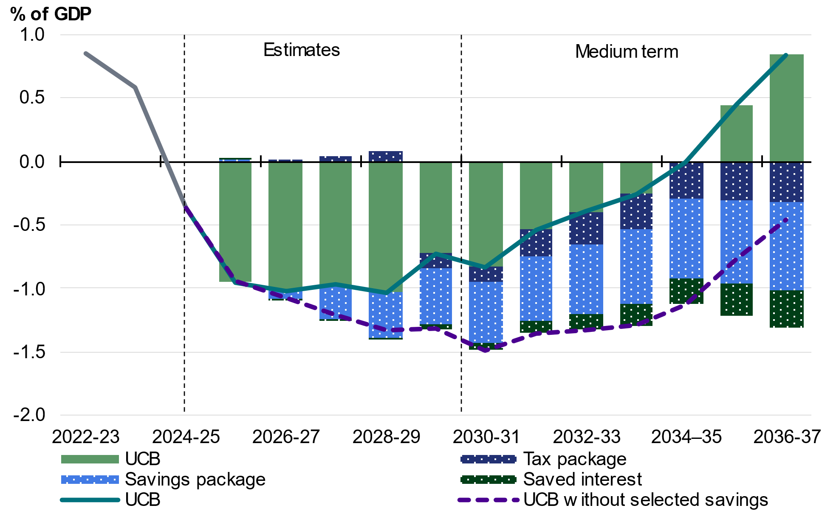
Source: Treasury.

Addressing unavoidable issues
The Government has provided $14.0 billion over five years to 2029–30 for unavoidable policy decisions in this budget update. Investments in these critical areas support the delivery of essential services and prevent cuts to services Australians rely on, and address urgent and unforeseen issues, including funding to:
- provide new and amended PBS listings and vaccinations
- respond to the antisemitic Bondi terrorist attack in December 2025
- support security and frontline service delivery in Services Australia centres, and improve cybersecurity in the agency’s ICT systems
- extend and provide ongoing funding for Medicare Urgent Care Clinics
- maintain essential capability of CSIRO, the National Measurement Institute and the Australian Centre for Disease Preparedness
- sustain critical ICT investments such as My Health Record, stabilise and uplift Australia’s business registers, and extend and provide ongoing funding for Digital ID
- extend and provide ongoing funding for public dental services and the National Medical Stockpile
- extend terminating programs in the Health, Disability and Ageing portfolio, including funding to eliminate HIV transmission and support aged care provider viability
- extend and provide ongoing funding for the Commonwealth Fraud Prevention Centre and the Fraud Fusion Taskforce to continue to detect and respond to fraud and non-compliant payments in the NDIS and across other government payments
- extend terminating funding for the National Disability Insurance Agency to ensure it is appropriately resourced to continue to support NDIS participants
- sustain essential government services, including critical safety and regulatory functions at the Civil Aviation Safety Authority, Australia’s consular and overseas crisis management and response capability within the Department of Foreign Affairs and Trade, and Australia’s agricultural export and trade functions at the Department of Agriculture, Fisheries and Forestry.
Since the 2022 PEFO, the Government has spent $71.8 billion in addressing unavoidable pressures and preventing cuts to services Australians rely on.

Box 3.3: International comparisons of the fiscal position
The IMF’s projections show Australia’s public finances are strong relative to our peers (Chart 3.2).
Australia’s general government budget deficit as a share of GDP is expected to narrow to 2.1 per cent of GDP in 2027. This compares with a deficit of 2.5 per cent of GDP for Canada, 3.1 per cent for the United Kingdom, 3.4 per cent for the Euro Area, and 7.4 per cent for the United States. Australia is estimated to have the third highest budget balance among G20 countries in 2027, up from fourteenth in 2021.
A stronger budget position has helped to keep Australia’s gross debt low by international standards. The IMF projects Australia’s gross debt to be 50.7 per cent of GDP in 2027, which is less than half of the advanced economy average (Chart 3.3). The IMF projects Australia’s gross debt-to-GDP to be about 38 percentage points below levels in the Euro Area, more than 50 percentage points below levels in the United Kingdom, and more than 75 percentage points below levels in the United States. Australia is estimated to have the fifth lowest gross debt-to-GDP ratio among G20 countries in 2027.
Chart 3.2: International fiscal  balance-to-GDP | Chart 3.3: International gross debt-‍to-GDP in 2027
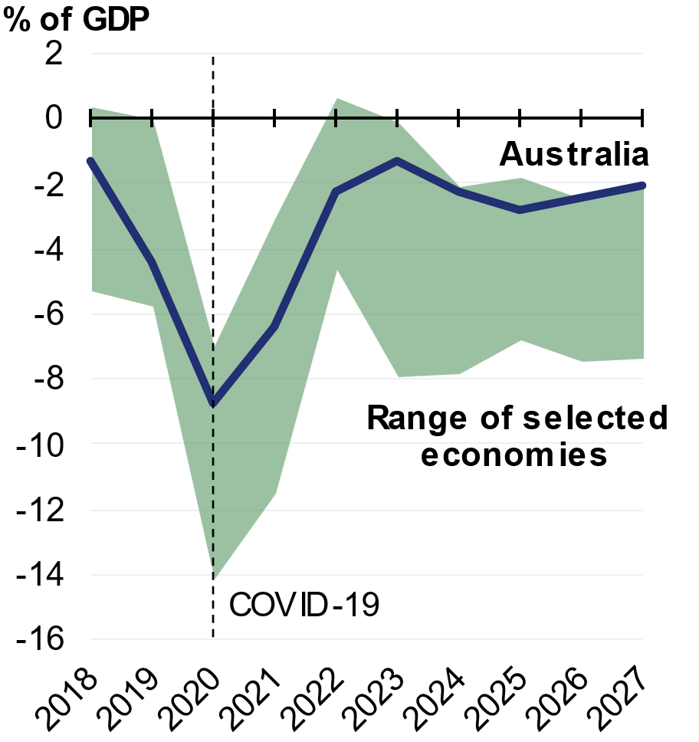 | 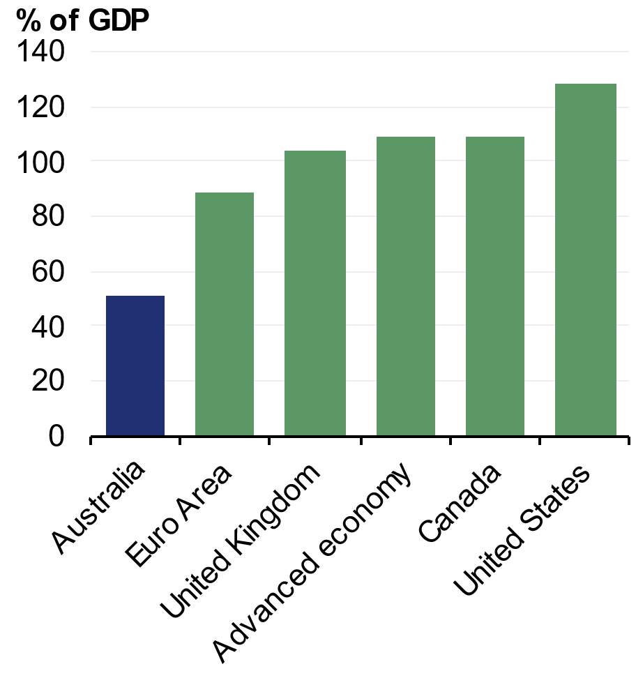
Note: IMF fiscal data are produced on a consistent basis across countries. They are produced for calendar years and on a general government basis, which includes state, territory and local governments. They are not directly comparable with fiscal aggregates reported elsewhere in the Budget. The range has been calculated using a subset of selected advanced economies: Canada, the Euro Area, United Kingdom and United States.
Source: Treasury, IMF.

Fiscal outlook

Underlying cash balance estimates
The underlying cash balance has improved since MYEFO by $2.8 billion in 2026–27 and a cumulative $44.9 billion over the five years to 2029–30.
The underlying cash balance is estimated to be a deficit of $28.3 billion (1.0 per cent of GDP) in 2025–26, which is an $8.5 billion improvement compared to the forecast at MYEFO (Table 3.3).
An underlying cash deficit of $31.5 billion (1.0 per cent of GDP) is forecast for 2026–27, a $2.8 billion improvement from the forecast at MYEFO. The underlying cash deficit is then expected to improve to $25.3 billion (0.7 per cent of GDP) in 2029–30, an improvement of $26.9 billion compared to the forecast at MYEFO.
In this Budget, $17.9 billion of policy decisions were funded by provisions made in previous updates, limiting their impacts on the underlying cash balance in this update. These provisions included $15.9 billion to fund the National Health Reform Agreement (NHRA) and $1.6 billion to fund Thriving Kids foundational supports. Taking provisions into account, the impact of policy decisions on the underlying cash balance at the 2026– 27 Budget is $26.1 billion (Table 3.2).
Over the five years to 2029–30, net policy decisions excluding provisions improve the underlying cash balance by $8.2 billion and parameter and other variations since MYEFO improve it by another $36.6 billion.
Table 3.2: Net impact of policy decisions on the Underlying Cash Balance after accounting for provisions
 | Estimates
 | 2025-26 | 2026-27 | 2027-28 | 2028-29 | 2029-30 |  | Total
 | $m | $m | $m | $m | $m |  | $m
Effect of policy decisions including previously made provisions | -5,264 | -3,655 | 363 | 6,662 | 28,033 |  | 26,139
Subtract: Provisions made for expenditure | 34 | 2,866 | 2,690 | 3,574 | 8,734 |  | 17,896
Effect of policy decisions since 2025–‍26 MYEFO | -5,298 | -6,520 | -2,327 | 3,088 | 19,299 |  | 8,242

Table 3.3: Reconciliation of general government sector underlying cash balance estimates
 | Estimates
 | 2025-26 | 2026-27 | 2027-28 | 2028-29 | 2029-30 |  | Total
 | $m | $m | $m | $m | $m |  | $m
2025 PEFO underlying cash
balance | -42,165 | -35,366 | -37,087 | -37,028 | * |  | *
Per cent of GDP | -1.5 | -1.2 | -1.2 | -1.1 | *
Changes from 2025 PEFO to
2025-26 MYEFO
Effect of policy decisions(a) | -1,909 | -147 | 1,337 | 2,888 | * |  | *
Effect of parameter and other variations | 7,310 | 1,210 | -439 | -1,852 | * |  | *
Total variations | 5,401 | 1,063 | 898 | 1,036 | * |  | *
2025-26 MYEFO underlying cash
balance(b) | -36,764 | -34,303 | -36,189 | -35,993 | -52,138 |  | -195,386
Per cent of GDP | -1.3 | -1.1 | -1.1 | -1.1 | -1.5
Changes from 2025-26 MYEFO
to 2026-27 Budget
Effect of policy decisions(a)(c)
Receipts | -3,570 | 2,226 | 961 | 862 | 8,299 |  | 8,777
Payments | 1,728 | 8,747 | 3,288 | -2,226 | -11,000 |  | 535
Total policy decisions impact on
underlying cash balance | -5,298 | -6,520 | -2,327 | 3,088 | 19,299 |  | 8,242
Effect of parameter and other variations(c)
Receipts | 13,551 | 18,842 | 16,352 | 598 | -8,228 |  | 41,116
Payments | -228 | 9,561 | 8,836 | 2,139 | -15,808 |  | 4,501
Total parameter and other variations
impact on underlying cash balance | 13,778 | 9,281 | 7,516 | -1,541 | 7,580 |  | 36,615
2026-27 Budget underlying cash
balance | -28,284 | -31,542 | -31,000 | -34,445 | -25,259 |  | -150,530
Per cent of GDP | -1.0 | -1.0 | -1.0 | -1.0 | -0.7
*Data are not available.
- Excludes secondary impacts on public debt interest of policy decisions and offsets from the Contingency Reserve for decisions taken.
- 2029–30 as published in the medium-term projections, page 57 of the Mid-Year Economic and Fiscal Outlook 2025–26.
- A positive number for receipts improves the underlying cash balance, while a positive number for payments worsens the underlying cash balance.

Receipts estimates
Since MYEFO, forecast total receipts have increased by $10.0 billion in 2025–26, $21.1 billion in 2026–27 and by $49.9 billion over the five years to 2029–30.
Since MYEFO, forecast tax receipts have increased by $8.4 billion in 2025–26, $18.6 billion in 2026–27 and by $38.4 billion over the five years to 2029–30. Since MYEFO, forecast non-tax receipts have increased by $1.6 billion in 2025–26, $2.5 billion in 2026–27 and by $13.8 billion over the five years to 2029–30.

Receipts policy decisions over the forward estimates
As a result of policy decisions since MYEFO, total receipts decrease by $3.6 billion in 2025-26, increase by $2.2 billion in 2026–27 and increase by $8.8 billion over the five years to 2029–30. This reflects increases from non-tax receipts measures outweighing the decrease from tax receipts measures. As a result of policy decisions, tax receipts will increase by $583.9 million in 2026–27 and decrease by $1.8 billion over the five years from 2025–26 to 2029–30.
Key tax receipts measures include:
- introducing a Working Australians Tax Offset from 2027–28 to increase the effective tax-free threshold for income derived from work by nearly $1,800 to $19,985. This measure is estimated to decrease receipts by $6.4 billion over the five years from 2025– 26.
- reforming negative gearing and capital gains tax from 1 July 2027. This measure is estimated to increase receipts by $3.6 billion over five years from 2025–26.
- introducing a minimum 30 per cent tax on discretionary trusts to improve the fairness of the tax system. This measure is estimated to increase receipts by $4.5 billion over the five years from 2025–26.
Since MYEFO, policy decisions are expected to increase non-tax receipts by $0.3 billion in 2025–26, $1.6 billion in 2026–27, and by $10.6 billion over the five years to 2029–30. This increase is largely driven by the standard non-tax receipts impacts of Pharmaceutical Benefits Scheme listings, amounts for which are not for publication, and which partially offset expenditure impacts of these listings; and receipts expected from the divestment of selected properties in the Defence estate, also not for publication due to commercial sensitivities.
Further details of Government policy decisions are provided in Budget Paper No. 2, Budget Measures 2026–27.

Receipts parameter and other variations over the forward estimates
Parameter and other variations have increased total receipts since MYEFO by $13.6 billion in 2025–26, $18.8 billion in 2026–27 and by $41.1 billion over five years to 2029– 30 (Table 3.3).
The change in total receipts due to parameter and other variations since MYEFO primarily reflects tax receipts, which have been revised up by $18.0 billion in 2026–27 and by $40.2 billion over five years to 2029–30.
Excluding GST and policy decisions, tax receipts have been revised up by $11.5 billion in 2025–26, $16.2 billion in 2026–27 and $34.5 billion over the five years to 2029–30. Tax receipts have been revised up in the near-term driven by higher superannuation fund, personal income and company taxes. However, tax receipts excluding GST and policy decisions have been revised down by $7.6 billion in 2029–30 alongside the projected decline in the prices for key commodities as well as lower, but still positive, labour income growth.
Since MYEFO, parameter and other variations are expected to increase non-tax receipts by $1.3 billion in 2025–26, $0.8 billion in 2026–27 and by $3.2 billion over the five years to 2029–30. A forecast increase in earnings from the Future Fund and other Australian Government Investment Funds is partially offset by reduced funding contributions from states and territories to the NDIS as a result of lower NDIS growth rates from reforms included in the 2026–27 Budget measure Securing the National Disability Insurance Scheme for future generations.
Further information on expected receipts is provided in Statement 5: Revenue. Analysis of the sensitivity of the receipts estimates to changes in the economic outlook is provided in Statement 8: Forecasting Performance and Sensitivity Analysis.

Payments estimates
Since MYEFO, total projected payments have increased by $1.5 billion in 2025–26, $18.3 billion in 2026–27 and by $5.0 billion over five years to 2029–30 (Table 3.4). Real payments growth over the four years to 2029–30 is expected to average 1.1 per cent per year, compared to the 30–year average of 3.3 per cent.
Table 3.4: Reconciliation of general government sector payments estimates^{(a)}
 |  | Estimates
 | 2025-26 | 2026-27 | 2027-28 | 2028-29 | 2029-30 |  | Total
 | $m | $m | $m | $m | $m |  | $m
2025 PEFO payments | 777,523 | 801,340 | 834,471 | 877,873 | * |  | *
Changes from 2025 PEFO to
2025-26 MYEFO
Effect of policy decisions(b) | 1,758 | 44 | -2,156 | -3,399 | * |  | *
Effect of parameter and other variations | 7,275 | 9,948 | 9,428 | 8,442 | * |  | *
Total variations | 9,033 | 9,992 | 7,272 | 5,043 | * |  | *
2025-26 MYEFO payments(c) | 786,556 | 811,332 | 841,743 | 882,916 | 946,860 |  | 4,269,407
Changes from 2025-26 MYEFO
to 2026-27 Budget
Effect of policy decisions(b) | 1,728 | 8,747 | 3,288 | -2,226 | -11,000 |  | 535
Effect of parameter and other variations | -228 | 9,561 | 8,836 | 2,139 | -15,808 |  | 4,501
Total economic parameter variations | 270 | 4,067 | 4,947 | 4,137 | * |  | *
Unemployment benefits | 7 | 776 | 861 | 788 | * |  | *
Prices and wages | -37 | 2,536 | 4,020 | 3,740 | * |  | *
Interest and exchange rates | -498 | -1,047 | -1,168 | -1,307 | * |  | *
GST payments to the States | 798 | 1,802 | 1,234 | 916 | * |  | *
Interest payments on AGS | -267 | 17 | -484 | -483 | * |  | *
Program specific parameter variations | 1,365 | 5,016 | 5,424 | 5,131 | * |  | *
Other variations(d) | -1,595 | 462 | -1,051 | -6,646 | * |  | *
Total variations | 1,500 | 18,308 | 12,124 | -87 | -26,808 |  | 5,037
2026-27 Budget payments | 788,056 | 829,640 | 853,867 | 882,829 | 920,052 |  | 4,274,444
*Data are not available.
- A positive number for payments worsens the underlying cash balance.
- Excludes secondary impacts on public debt interest of policy decisions and offsets from the Contingency Reserve for decisions taken.
- 2029–30 as published in the medium-term projections, page 57 of the Mid-Year Economic and Fiscal Outlook 2025–26.
- Includes changes in the conservative bias allowance component in the Contingency Reserve and impacts of changes in program payments for a range of reasons including movement of funds and reprofiling.

Payment policy decisions over the forward estimates
New policy decisions since MYEFO have increased total payments by $1.7 billion in 2025– 26, by $8.7 billion in 2026–27, and by $0.5 billion over five years from 2025–26 to 2029– 30.
Major policy decisions since MYEFO that have had a net increase in payments include:
- funding to the states and territories for public hospital services and the implementation of the 2026–2031 Addendum to the National Health Reform Agreement, which is expected to increase payments by $18.1 billion over the four years to 2029–30. The Government had already provisioned for the majority of this funding.
- funding to support the delivery of the 2026 National Defence Strategy and Integrated Investment Program to enhance Defence capability, preparedness and resilience, which is expected to increase payments by $6.8 billion over the five years to 2029–30 in addition to alternative financing opportunities in the Defence portfolio through public and private sector financing.
- funding for new and amended listings on the Pharmaceutical Benefits Scheme and Repatriation Pharmaceutical Benefits Scheme, which is expected to increase payments by $5.9 billion over the five years to 2029–30.
- funding to improve the way Services Australia delivers services to the Australian community, including by maintaining frontline and emergency response staff, enhancing safety and security at Services Australia centres, enhancements to myGov and cyber security uplift, which is expected to increase payments by $2.1 billion over the five years to 2029–30.
- funding to support increased housing supply and research, including through the Housing Support Program—Local Infrastructure Fund to support local governments and state utility providers to deliver housing enabling infrastructure, which is expected to increase payments by $2.1 billion over the four years to 2029–30.
- funding to ensure all Australians have affordable access to high quality primary health care services and increase access to bulk billing, including through funding Medicare Urgent Care Clinics ongoing, which is expected to increase payments by $1.9 billion over the five years to 2029–30.
- funding to deliver national services, contribute to state and territory services, and fund enabling supports for the Thriving Kids program, which is expected to increase payments by $1.6 billion over the four years to 2029–30. The Government had already provisioned for this funding.
- funding for the Support at Home program to improve affordability and access to home care supports, which is expected to increase payments by $1.4 billion over the four years to 2029–30.
- funding for priority road and rail infrastructure projects, partially offset by the application of a temporary fuel and other materials disruption slippage adjustment to recognise the uncertain impacts of the Middle East conflict on the availability of key materials for the delivery of projects, which is expected to increase payments by $966.8 million over the five years to 2029–30.
- funding to support economic growth and development across urban and regional Australia by delivering community infrastructure projects, which is expected to increase payments by $734.3 million over the five years to 2029–30.
- funding to continue the Australian Government’s Digital ID System, to support productivity and security by reducing the sharing and storage of personal data, which is expected to increase payments by $654.3 million over the four years to 2029–30.
Major policy decisions since MYEFO that have had a net decrease in payments include:
- measures to restore the NDIS to its original intent and secure the sustainability of the scheme for future generations, which are expected to decrease payments by $37.8 billion over four years to 2029–30, partially offset by the Government’s investment of $1.7 billion to support people with disability and to improve the quality of supports delivered through the NDIS.
- removing the age-based uplift of the Private Health Insurance Rebate from 1 April 2027 to simplify its distribution and make it more equitable, which is expected to decrease payments by $3.0 billion over the four years to 2029–30.
- further reducing spending on external labour and other non-wage expenses like travel, hospitality and property, which is expected to decrease payments by $2.7 billion in 2029–30.
- identifying savings from health, disability and ageing programs, which is expected to decrease payments by $2.7 billion over the five years to 2029–30, to be reinvested in new or expanded health, disability and ageing services.
- reforming the Research and Development Tax Incentive to simplify and better target Government support for business research and development, which is expected to decrease payments by $1.6 billion over the three years to 2029–30. This measure will also decrease receipts by $910.0 million over the same period.
- temporarily reducing fuel excise and the heavy vehicle road user charge, which is expected to decrease payments by $1.3 billion over the two years to 2026–27 through a reduction in Fuel Tax Credits. This measure is also expected to decrease receipts by $3.8 billion over the same period.
- reforming Australian science and research and development capabilities, including by returning uncommitted funding from the Australia’s Economic Accelerator program, which is expected to decrease payments by $759.9 million over the five years to 2029–30.
- identifying savings from across the Climate Change, Energy, the Environment and Water portfolio, which is expected to decrease payments by $727.0 million over the five years to 2029–30, to be redirected to other Government policy priorities within the portfolio.
- better targeting of services for veterans and their families, which is expected to decrease payments to providers by $606.6 million over the five years to 2029–30.

Payment parameter and other variations over the forward estimates
Parameter and other variations since MYEFO have decreased payments by $0.2 billion in 2025–26, but increased payments by $9.6 billion in 2026–27 and by $4.5 billion over the five years to 2029–30.
This is primarily driven by higher estimated payments related to the NDIS and Financial Support for People with Disability program along with higher GST payments to the states and territories. These are partially offset by the drawdown of provisions for policy decisions announced in the 2026–27 Budget and lower estimated payments for road and rail transport projects under the Infrastructure Investment Program.
Major increases in payments from parameter and other variations since MYEFO include:
- payments related to the NDIS, which would have been expected to increase by $1.8 billion in 2026–27 and $13.9 billion over the five years to 2029–30, largely reflecting higher-than-expected participant numbers and payment rates than those modelled by the NDIS Actuary and delays to the commencement of the New Framework Planning from 1 July 2026 to 1 April 2027. This variation has been more than offset by the Government’s reforms under the 2026–27 Budget measure Securing the National Disability Insurance Scheme for future generations, which are expected to reduce growth in NDIS payments by $37.8 billion relative to the NDIS Actuary’s projections.
- payments related to the Financial Support for People with Disability program, which are expected to increase by $867.5 million in 2026–27 and $4.4 billion over the five years to 2029–30, largely reflecting higher-than-expected indexation rates, recipient numbers, and average payment rates.
- GST-related payments to the states and territories, which are expected to increase by $1.7 billion in 2026–27 and $4.2 billion over the five years to 2029–30, and are offset by an increase in GST receipts.
- payments related to the JobSeeker Income Support program, which are expected to increase by $941.4 million in 2026–27 and $3.2 billion over the five years to 2029–30, largely reflecting higher-than-expected indexation rates, recipient numbers, and average payment rates.

- payments related to the National Partnership Payments—Natural Disaster Relief program, which are expected to increase by $458.4 million in 2026–27 and $2.5 billion over the five years to 2029–30, largely reflecting updated estimates for future expenditure on past disaster events.
- payments related to non-government schools, which are expected to increase by $270.1 million in 2026–27 and $2.3 billion over the five years to 2029–30, largely reflecting an increase in non-government school enrolments, and an increase in the number of students with a disability eligible to attract a higher level of funding. The Government is increasing compliance activities to safeguard Australia’s investment in schooling, including mechanisms protecting the integrity of the students with a disability loading to ensure funding is directed based on need, and introducing controls to reduce inaccurate claiming.
- payments related to the Financial Support for Carers program, which are expected to increase by $286.4 million in 2026–27 and $1.5 billion over five years to 2029–30, largely reflecting higher-than-expected indexation rates, average payment rates and recipient numbers.
- payments related to the Support for Seniors program, which are expected to increase by $388.5 million in 2026–27 and $1.5 billion over five years to 2029–30, largely reflecting higher-than-expected indexation rates, partially offset by future expected changes to social security deeming rates.
- payments related to the Military Rehabilitation Compensation Acts—Income Support and Compensation program, which are expected to increase by $47.9 million in 2026–27 and $813.2 million over the five years to 2029–30, largely reflecting increases in the number of eligible veterans and average payment sizes.
- payments related to the Child Care Subsidy program, which are expected to decrease by $300.8 million in 2026–27 and increase by $805.3 million over the five years to 2029–30, largely reflecting increases to the cost of care due to the Fair Work Commission’s Gender-based undervaluation priority review decision and higher-than-expected indexation, and partially offset by lower-than-expected demand for early childhood education and care.
- payments related to the Support for Families program, which are expected to increase by $123.9 million in 2026–27 and $771.0 million over the five years to 2029–30, largely reflecting higher-than-expected indexation rates.
- payments related to the Pharmaceutical Benefits Scheme, which are expected to increase by $123.5 million in 2026–27 and $757.0 million over five years to 2029–30, largely reflecting updated pharmaceutical pricing assumptions and changes to predicted prescription volumes.
Major decreases in payments from parameter and other variations since MYEFO include:
- the drawdown of provisions for policy decisions announced in the 2026–27 Budget, including for the National Health Reform Agreement and Thriving Kids, which have decreased expected payments by $2.9 billion in 2026–27 and $17.9 billion over the five years to 2029–30.
- payments related to road and rail transport projects under the Infrastructure Investment Program, which are expected to increase by $97.4 million in 2026–27 and decrease by $5.8 billion over the five years to 2029–30, largely reflecting revised project delivery schedules and the application of a general slippage adjustment, with slippage a usual occurrence for large and complex capital infrastructure projects. The decrease is partially offset by the Government’s additional funding for existing road and rail priority projects.
- payments related to the National Partnership Payments—Housing program, which are expected to increase by $137.9 million in 2026–27 and decrease by $2.3 billion over the five years to 2029–30, largely reflecting estimates of incentive payments to states who choose to sign up to and meet targets under the New Homes Bonus commitment.
- payments related to Department of Defence programs, which are expected to decrease by $883.8 million in 2026–27 and $2.2 billion over the five years to 2029–30, largely reflecting movements in foreign exchange rates, partially offset by bringing forward funding into 2025–26 from beyond the forward estimates. This variation has been more than offset by the Government’s commitment to additional Defence funding of $6.8 billion over the five years to 2029–30 under the 2026–27 Budget measure 2026 National Defence Strategy and Integrated Investment Program.
- payments related to the Hydrogen Production Tax Incentive, which are expected to decrease by $1.9 billion over the five years to 2029–30, largely reflecting lower-than-expected production forecasts from the renewable hydrogen industry.
- payments related to Commonwealth debt management, which are expected to increase by $17.5 million in 2026–27 and decrease by $1.7 billion over the five years to 2029–30, largely reflecting lower issuance of Australian Government Securities, partially offset by an increase in the expected yields on new issuance.
- payments related to the Research and Development Tax Incentive program, which are expected to decrease by $278.2 million in 2026–27 and $894.9 million over the five years to 2029–30, largely reflecting a lower-than-expected growth rate in claims compared to earlier years.
Consistent with past budgets, the underlying cash balance has been improved by regular drawdown of the conservative bias allowance. Details in Statement 6: Expenses and Net Capital Investment.

Headline cash balance
The headline cash balance adjusts the underlying cash balance to include net cash flows from investments in financial assets for policy purposes (IFAPPs). This includes Specialist Investment Vehicles which invest in projects that deliver public value and a financial return to taxpayers. For example, Clean Energy Finance Corporation (CEFC) loans and equity investments impact the headline cash balance but not the underlying cash balance. Table 3.5 details differences between the underlying and headline cash balance estimates.
A headline cash balance deficit of $47.9 billion (1.6 per cent of GDP) is estimated in 2025–26, $10.6 billion lower than the estimated deficit of $58.6 billion at MYEFO. The improvement predominantly reflects the improvement to the underlying cash balance.
The headline cash deficit increases to $64.1 billion (2.1 per cent of GDP) in 2026 – 27, $1.4 billion higher than the estimated deficit of $62.7 billion at MYEFO. This reflects higher net cash outflows for IFAPPs since MYEFO, partially offset by the improved underlying cash balance. The headline cash balance improves to a deficit of $41.0 billion (1.2 per cent of GDP) in 2029–30.
Net cash outflows for IFAPPs total $114.0 billion over the five years to 2029–30. Estimated net cash outflows for IFAPPs have increased by $4.5 billion over the four years to 2028–29 compared to the 2025–26 MYEFO.
Policy decisions impacting net cash outflows for IFAPPs include:
- The consolidation of the Inland Rail project at Parkes and preservation of the remaining rail corridor and intermodal sites for future investment, with $4.4 billion in equity to be returned to the budget. The ARTC equity profile is included in the ‘net other’ section of Table 3.5 due to commercial sensitivities. Further information can be found in the 2026– 27 Budget measure Building a Better Future through Considered Infrastructure Investment.
- An increase of $600.0 million in 2026–27 from an equity investment in Airservices Australia to support continued provision of critical air navigation, air traffic control, and aviation fire and rescue services at major Australian airports. Further information can be found in the 2026–27 Budget measure Supporting Aviation Priorities.
- An equity injection over four years from 2026–27 for Australian Naval Infrastructure Pty Ltd (ANI), to support construction of the Nuclear-Powered Submarine Construction Yard in South Australia. The financial implications of this injection are not for publication because they would impair ANI’s position in negotiating contracts for these services. Further information can be found in the 2026–27 Budget measure Australian Naval Infrastructure Equity Injection.

Parameter and other variations increasing net cash outflows for IFAPPs include:
- $1.4 billion over five years from 2025–26 for the line of credit provided to the Affordable Housing Bond Aggregator, reflecting the updated and reprofiled lending and repayment estimates due to the timing of certain large transactions by Housing Australia. Further details on the line of credit can be found in Budget Statement 9: Statement of Risks.
- $550.3 million over five years from 2025–26 for the National Reconstruction Fund Corporation, reflecting revised capital deployment for investing activities.
- $286.9 million over five years from 2025–26 for student loans, reflecting various updates for actuarial, program and parameter changes resulting in higher expected loan outflows alongside lower principal repayments.
Parameter and other variations decreasing net cash outflows for IFAPPs include:
- $685.4 million over five years from 2025–26 in lower investments through the Help to Buy scheme, reflecting reduced lending estimates in line with updated actuarial estimates of average loan values eligible under the scheme.
- $293.4 million over five years from 2025–26 in lower investments by the Northern Australia Infrastructure Facility, reflecting adjusted investing cash flows.
In this Budget, Table 3.5 separately identifies funding for three additional programs which were previously captured within the ‘net other’ line. These are:
- 100,000 Homes for First Home Buyers. Funding previously held in the Contingency Reserve as part of the 2025–26 MYEFO measure Support for Homebuyers has now been allocated to QLD, WA, SA, TAS and the ACT, with some reprofiling between years to reflect the outcome of negotiations.
- Finance Procurement Services. Funding for this program was announced as part of the 2023–24 MYEFO measure More Efficient and Effective Vehicle Leasing and Fleet Management Arrangement and was previously not separately identified due to commercial sensitivities.
• Marinus Link investment. The Australian Government funding contribution for this program is provided through the CEFC’s Rewiring the Nation (RtN) program (included as part of the CEFC loans and investments program) and the RtN Special Account, administered by the Department of Climate Change, Energy, the Environment and Water, and was previously not separately identified due to commercial sensitivities.

Table 3.5: Reconciliation of general government sector underlying and headline cash balance estimates
 | Estimates
 | 2025-26 | 2026-27 | 2027-28 | 2028-29 | 2029-30 |  | Total
 | $m | $m | $m | $m | $m |  | $m
2026-27 Budget underlying
cash balance | -28,284 | -31,542 | -31,000 | -34,445 | -25,259 |  | -150,530
plus Net cash flows from
investments in financial
assets for policy purposes(a)
Student loans | -4,745 | -5,272 | -5,850 | -6,299 | -6,673 |  | -28,839
NBN investment | -621 | -902 | 0 | 0 | 0 |  | -1,523
Snowy Hydro Limited loan | -1,450 | -2,900 | 0 | 0 | 150 |  | -4,200
Snowy Hydro Limited investment | -975 | 0 | 0 | 0 | 0 |  | -975
Australian apprenticeship
support loans | -101 | -100 | -86 | -78 | -69 |  | -435
CEFC loans and investments | -939 | -4,143 | -3,683 | -5,712 | -3,007 |  | -17,483
Northern Australia
Infrastructure Facility | -575 | -350 | -361 | -338 | -122 |  | -1,746
NRFC loans and investments | -2,093 | -3,129 | -2,964 | -4,172 | -2,530 |  | -14,888
Australian Business
Securitisation Fund | -311 | -343 | -101 | -101 | -2 |  | -857
Drought and rural assistance
loans | -356 | -101 | -114 | 34 | 710 |  | 173
Official Development Assistance
- Multilateral Replenishment | -202 | -149 | -184 | -195 | -188 |  | -919
Finance Procurement Services | -12 | -84 | -114 | -94 | -65 |  | -368
Historical state and territory loans | 97 | 101 | 100 | 94 | 90 |  | 481
Home Equity Access Scheme | -232 | -289 | -335 | -364 | -381 |  | -1,600
Housing Australia | -2,455 | -6,330 | -3,915 | -2,114 | -1,076 |  | -15,890
100,000 Homes for First Home Buyers | -57 | -768 | -678 | -670 | -318 |  | -2,491
Indigenous Business Australia
home and business loans | -219 | -95 | -102 | -106 | -107 |  | -629
Marinus Link investment | -212 | -53 | 0 | 0 | 0 |  | -265
National Interest Account
loans and investments | -696 | -906 | -624 | 5 | 143 |  | -2,079
COVID-19 Support for
Indonesia — loan | 100 | 100 | 100 | 100 | 100 |  | 500
Financial Assistance to
Papua New Guinea — loan | 169 | 169 | 169 | 169 | 169 |  | 846
Rex Airlines | -65 | -30 | 4 | 9 | 10 |  | -72
Net other(b) | -3,678 | -6,972 | -4,597 | -2,955 | -2,537 |  | -20,739
Total net cash flows from
investments in financial
assets for policy purposes | -19,629 | -32,544 | -23,334 | -22,785 | -15,704 |  | -113,997
2026-27 Budget headline
cash balance | -47,913 | -64,086 | -54,333 | -57,230 | -40,963 |  | -264,526
- A positive number denotes a cash inflow; a negative number denotes a cash outflow.
- ‘Net other’ includes amounts that cannot be itemised, including commercial-in-confidence transactions and decisions taken but not yet announced.

Medium-term projections
The underlying cash balance is expected to return to balance in 2034–35 (Chart 3.4) and then improve to a surplus of 0.4 per cent of GDP in 2035–36 and 0.8 per cent of GDP in 2036– 37. The change in the underlying cash balance over the medium term since MYEFO primarily reflects structural savings, such as the NDIS reforms.
Chart 3.4: Underlying cash balance
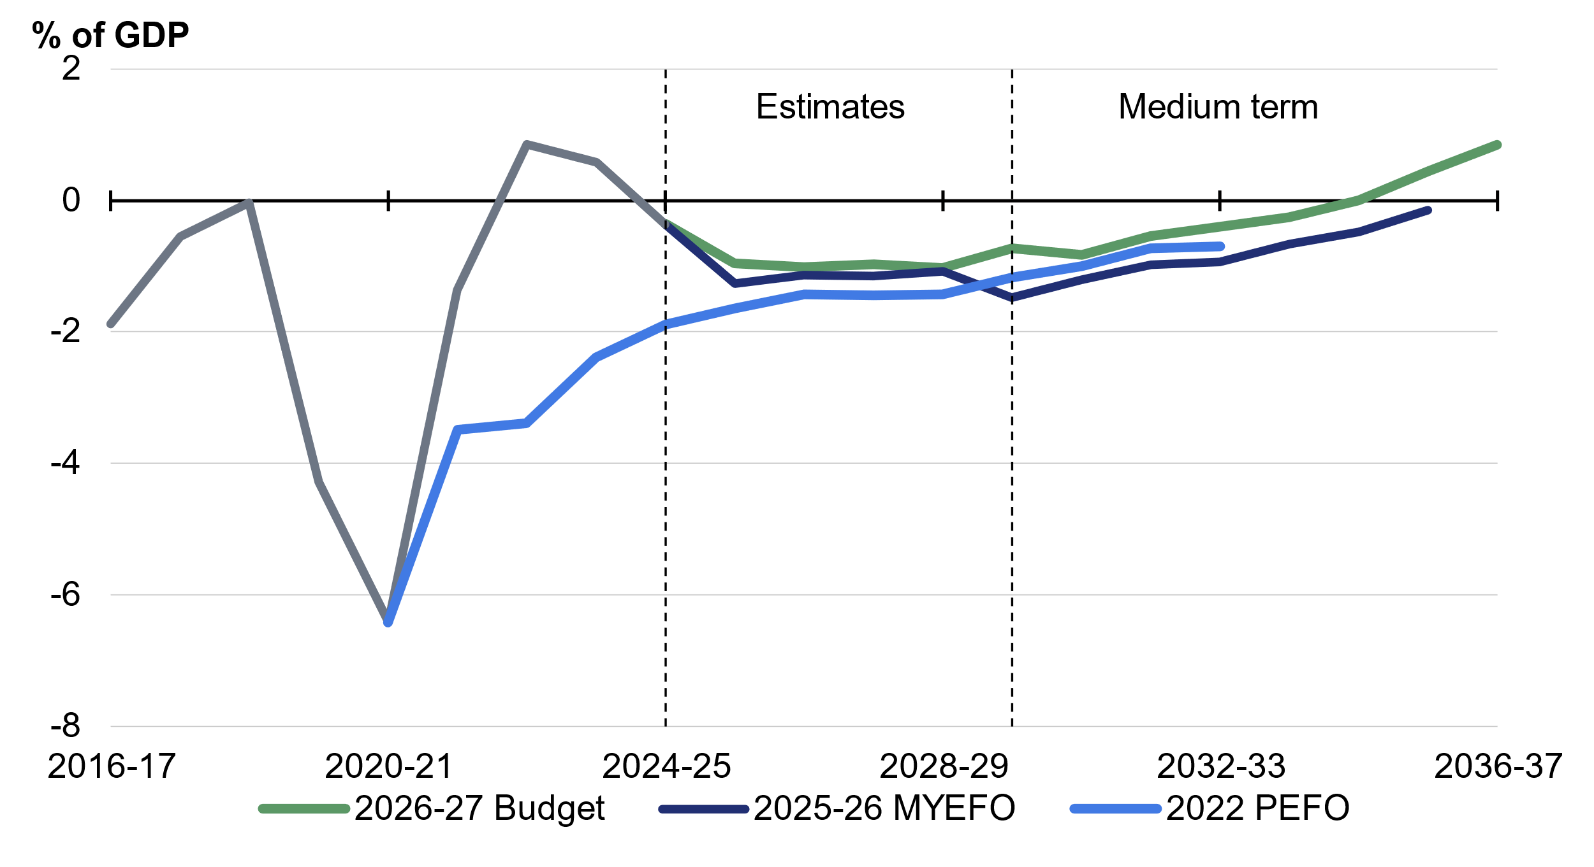
Source: Treasury.

Gross debt as a per cent of GDP is expected to peak in 2028–29 and then decline every year thereafter (Chart 3.9). By 30 June 2037, gross debt is expected to be 27.2 per cent of GDP. Compared to at MYEFO, gross debt is lower every year of the forward estimates and medium term.
Total receipts as a share of GDP are expected to increase from 25.5 per cent of GDP in 2029– 30 to 27.0 per cent of GDP in 2036–37. Total receipts reflect an assumption of no policy change with regards to the personal income tax brackets until the end of the medium term. This modelling approach results in a projected increase in the ratio of tax-to-GDP over time. However, in practice, governments periodically make policy decisions to reduce taxation rates to return this bracket creep. For example, this Government’s next round of tax cuts for every Australian taxpayer will take effect from 1 July 2026.
Total payments as a share of GDP are expected to remain broadly stable at around 26.6 per cent from 2030–31 to 2034–35, before falling to 26.2 per cent by 2036–37 (Chart 3.5).
Chart 3.5: Payments and receipts
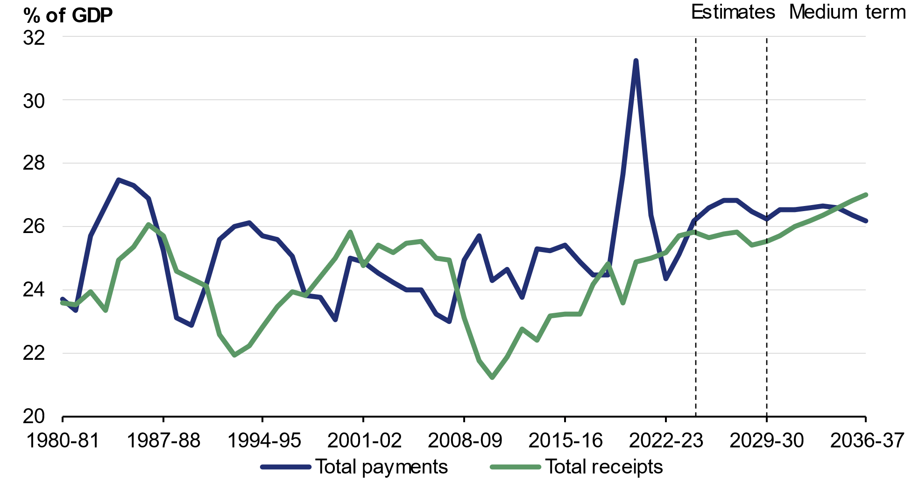
Source: Treasury.

Changes in the medium-term outlook since MYEFO

Receipts over the medium term
Receipts as a share of GDP are higher since MYEFO, including 0.2 percentage points higher in 2035–36 (Chart 3.6).
Chart 3.6: Total receipts | Chart 3.7: Total payments
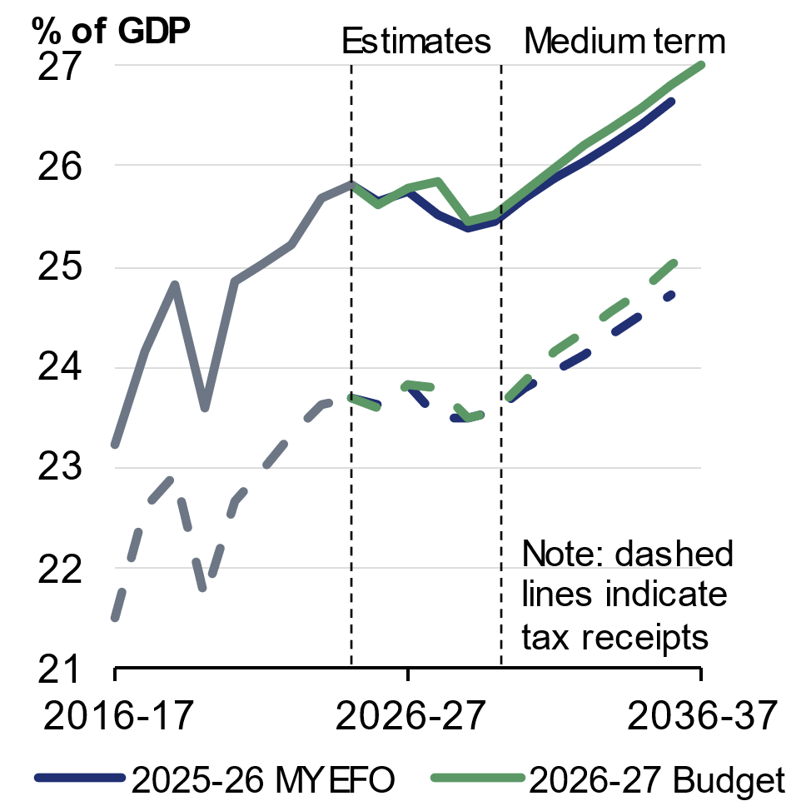 | 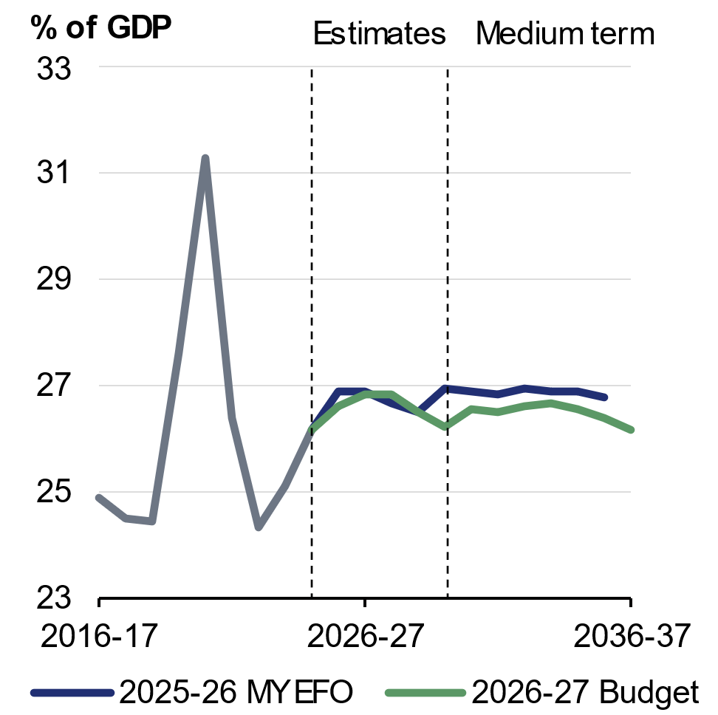
Source: Treasury. | Source: Treasury.

Payments over the medium term
Payments are expected to be 0.4 percentage points of GDP lower than at MYEFO in 2035–36 (Chart 3.7). Nominal GDP is expected to be lower than was projected at MYEFO in the medium term, putting upwards pressure on payments relative to the size of the economy.
The fastest growing major payments over the medium term are public debt interest, hospitals payments, defence, Child Care Subsidy, aged care and medical benefits payments (Chart 3.8).
Growth in some major payments over the Budget projection period (2026–27 to 2036–37) has changed compared to at MYEFO (2025–26 to 2035–36).
- Australian Government NDIS participant costs are projected to grow at an average of 3.6 per cent over the projection period, compared to 7.6 per cent at MYEFO. This reflects a slower rate of growth over the forward estimates as the Government returns the scheme to its original intent, before it returns to growth of 5 per cent over the remainder of the medium term – around nominal GDP and similar to aged care, the Medicare Benefits Schedule and the Child Care Subsidy.
- Public debt interest growth is expected to average 8.8 per cent over the projection period compared to 10.7 per cent at MYEFO. Lower average growth reflects a lower financing task over the projection period and follows strong growth between 2025–26 and 2026‍–‍27. This is partially offset by the impact of higher yields.
- Commonwealth funded hospital payments growth is expected to average 7.3 per cent over the projection period compared to 5.9 per cent at MYEFO. This largely reflects the increased base funding and growth caps agreed in the National Health Reform Agreement 2026–2031 Addendum.
- Defence payments growth is expected to average 6.4 per cent over the projection period compared to 5.9 per cent at MYEFO, reflecting the funding from the National Defence Strategy.
- Child Care Subsidy payments growth is expected to average 5.4 per cent over the projection period compared to 5.7 per cent at MYEFO. Lower average growth reflects slower growth in usage toward the end of the projection period and follows strong growth between 2025–26 and 2026–27.
- Aged care payments growth is expected to average 5.4 per cent over the projection period compared to 4.9 per cent at MYEFO. This reflects additional funding to incentivise the construction of residential aged care beds and to make Support at Home more affordable.

- Medical benefits payments growth is expected to average 5.1 per cent over the projection period compared to 5.8 per cent at MYEFO. This reflects rebalanced interactions between the National Health Reform Agreement and the Medicare Benefits Schedule (MBS), as agreed under the latest NHRA Addendum, in addition to enhanced compliance and fraud prevention in the MBS.
Chart 3.8: Average annual growth in major payments over the medium term
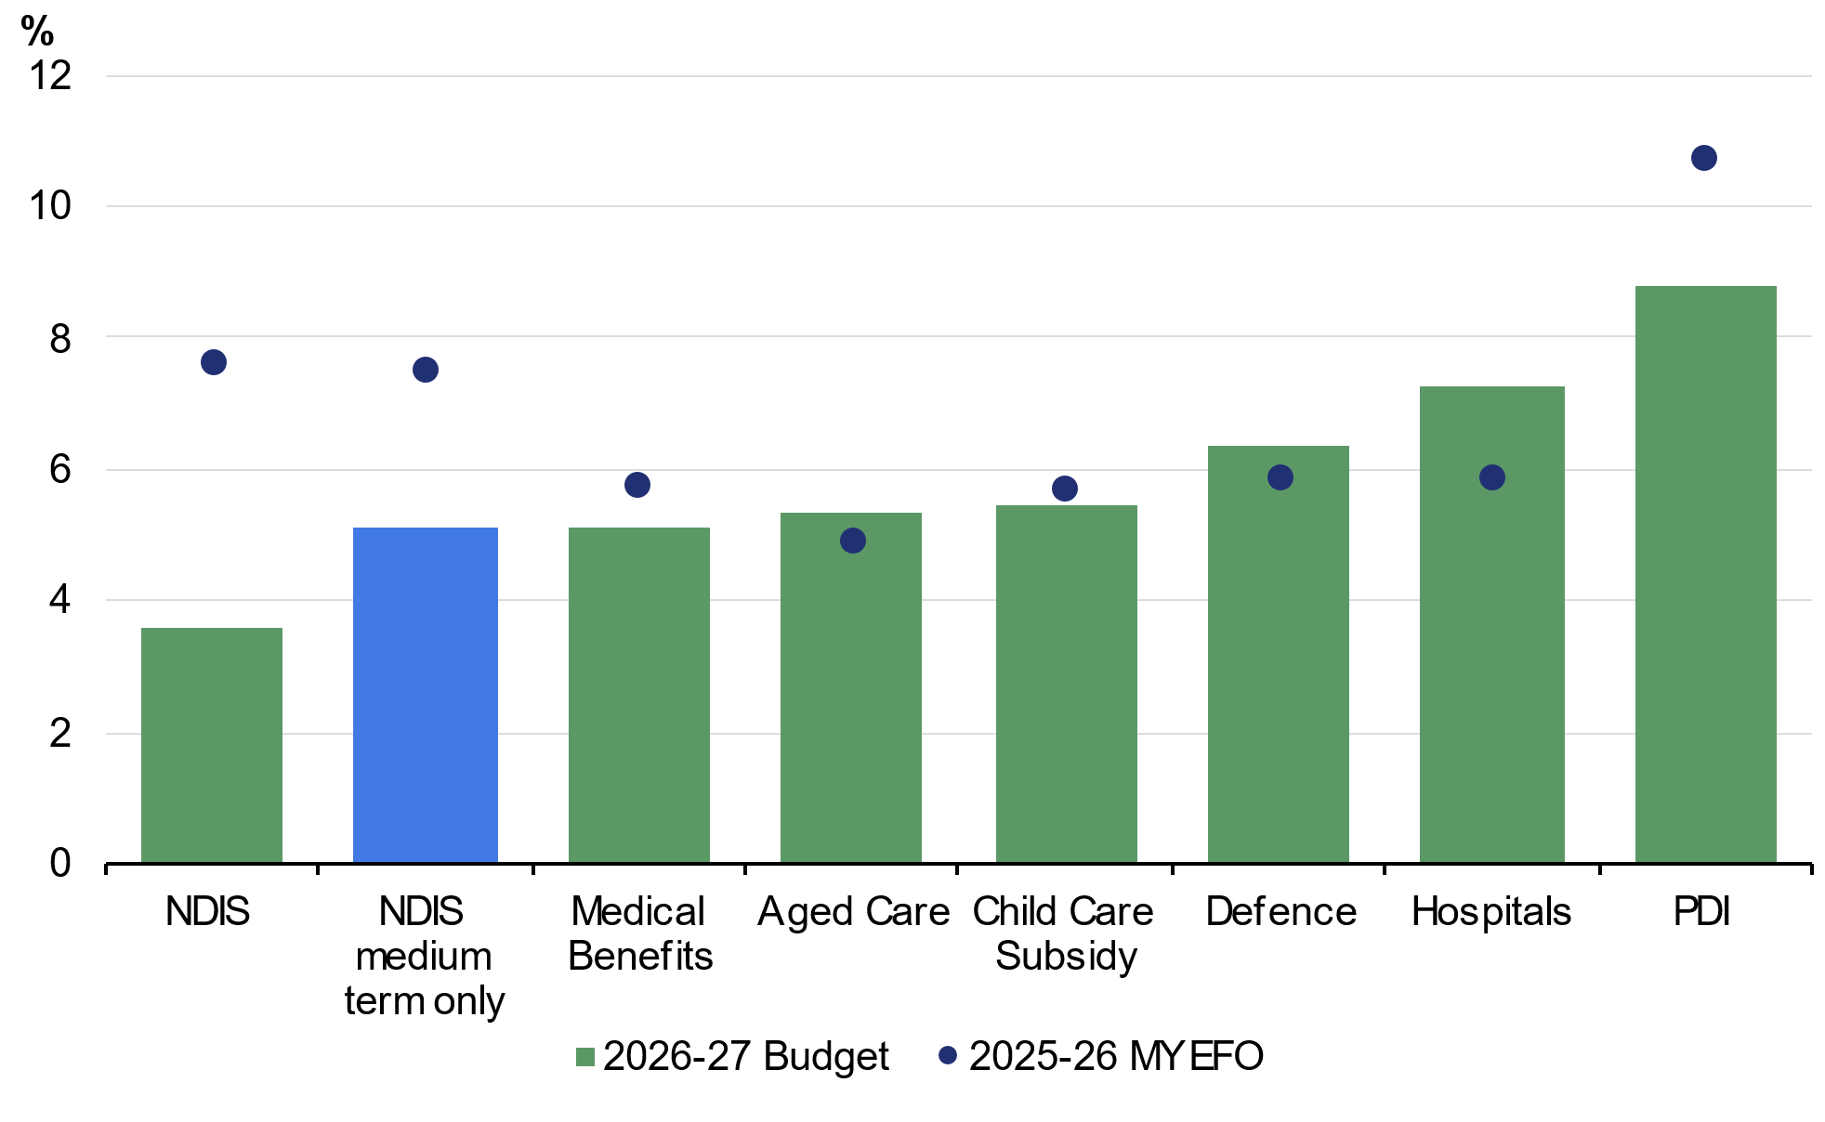
Note: Shows major payments that are growing faster than nominal GDP over the projection period, and the NDIS for comparison. PDI refers to interest payments on AGS. NDIS refers to the Australian Government’s contribution to payments for NDIS participant supports. Growth rate for MYEFO is from 2025–26 to 2035–36. Growth rate for the 2026– 27 Budget is from 2026–27 to 2036–37. Growth rate for NDIS medium term only is from 2029–30 to 2036–37 in Budget and from 2028–29 to 2035–36 in MYEFO.
Source: Treasury.

The Government’s balance sheet
The balance sheet measures the value of the Government’s assets and liabilities. Changes in the balance sheet reflect movements in the underlying cash balance, additional balance sheet commitments, and market valuation effects, including from changes in yields.
Different balance sheet metrics measure different groupings of assets and liabilities.
- Gross debt measures the face value of Australian Government Securities on issue. This is the amount that the Government pays back to investors at maturity, independent of fluctuations in market prices.
- Net debt is measured at market value and incorporates specific financial assets and liabilities and provides a broader measure of the financial obligations of the Government than gross debt.
- Net financial worth is the sum of all financial assets less all liabilities. The assets of the Future Fund and the public sector superannuation liability that the Future Fund will finance are included in net financial worth.
- Net worth is the sum of all assets less all liabilities. It includes non-financial assets such as buildings and plant, equipment, and infrastructure.
Further information on definitions is available in Statement 10: Australian Government Budget Financial Statements.

Table 3.6: Australian Government general government sector balance sheet aggregates^{(a)}
 | Actual |  | Estimates
 | 2024-25 |  | 2025-26 | 2026-27 | 2027-28 | 2028-29 | 2029-30
 | $b |  | $b | $b | $b | $b | $b
Financial assets | 665.4 |  | 690.3 | 731.8 | 776.0 | 821.8 | 863.9
Per cent of GDP | 24.0 |  | 23.3 | 23.6 | 24.4 | 24.6 | 24.6
Non-financial assets | 227.4 |  | 237.6 | 248.7 | 259.9 | 269.0 | 279.8
Per cent of GDP | 8.2 |  | 8.0 | 8.0 | 8.2 | 8.1 | 8.0
Total assets | 892.8 |  | 927.9 | 980.5 | 1,035.9 | 1,090.8 | 1,143.8
Per cent of GDP | 32.1 |  | 31.3 | 31.7 | 32.5 | 32.7 | 32.6
Total liabilities | 1,507.4 |  | 1,542.8 | 1,627.4 | 1,722.3 | 1,821.5 | 1,905.9
Per cent of GDP | 54.3 |  | 52.0 | 52.6 | 54.1 | 54.6 | 54.4
Net worth | -614.5 |  | -614.9 | -646.9 | -686.4 | -730.7 | -762.1
Per cent of GDP | -22.1 |  | -20.7 | -20.9 | -21.6 | -21.9 | -21.7
Net financial worth(b) | -841.9 |  | -852.5 | -895.6 | -946.3 | -999.7 | -1,041.9
Per cent of GDP | -30.3 |  | -28.8 | -28.9 | -29.7 | -30.0 | -29.7
Gross debt(c) | 928.6 |  | 982.0 | 1,051.0 | 1,120.0 | 1,193.0 | 1,249.0
Per cent of GDP | 33.4 |  | 33.1 | 34.0 | 35.2 | 35.8 | 35.6
Net debt(d) | 532.3 |  | 556.0 | 616.6 | 668.8 | 725.5 | 767.8
Per cent of GDP | 19.2 |  | 18.8 | 19.9 | 21.0 | 21.8 | 21.9
Total interest payments | 24.3 |  | 27.1 | 29.6 | 36.4 | 38.0 | 42.3
Per cent of GDP | 0.9 |  | 0.9 | 1.0 | 1.1 | 1.1 | 1.2
Net interest payments(e) | 13.7 |  | 17.7 | 19.9 | 26.7 | 28.0 | 31.7
Per cent of GDP | 0.5 |  | 0.6 | 0.6 | 0.8 | 0.8 | 0.9
- Assets, liabilities, net worth, net financial worth, gross debt and net debt are as at the end of each financial year.
- Net financial worth equals total financial assets minus total liabilities.
- Gross debt measures the face value of AGS on issue.
- Net debt is the sum of interest-bearing liabilities (which includes AGS on issue measured at market value) less the sum of selected financial assets (cash and deposits, advances paid and investments, loans and placements).
- Net interest payments are equal to the difference between interest payments and interest receipts.

Gross debt estimates and projections
Gross debt is now expected to peak at 35.8 per cent of GDP in 2028–29, two years earlier and 1.2 percentage points lower than projected at MYEFO (Table 3.6). By 30 June 2037, gross debt is expected to be 27.2 per cent of GDP (Chart 3.9).
At 30 June 2027, gross debt is expected to be $1,051 billion (34.0 per cent of GDP), $18.0 billion (1.4 percentage points of GDP) lower than estimated at MYEFO.
By the end of the forward estimates, gross debt is lower than at MYEFO in both nominal terms and as a percentage of GDP, driven by the improved budget position and lower end-of-year cash holdings by the AOFM, partially offset by the impact of higher yields.
Chart 3.9: Gross debt
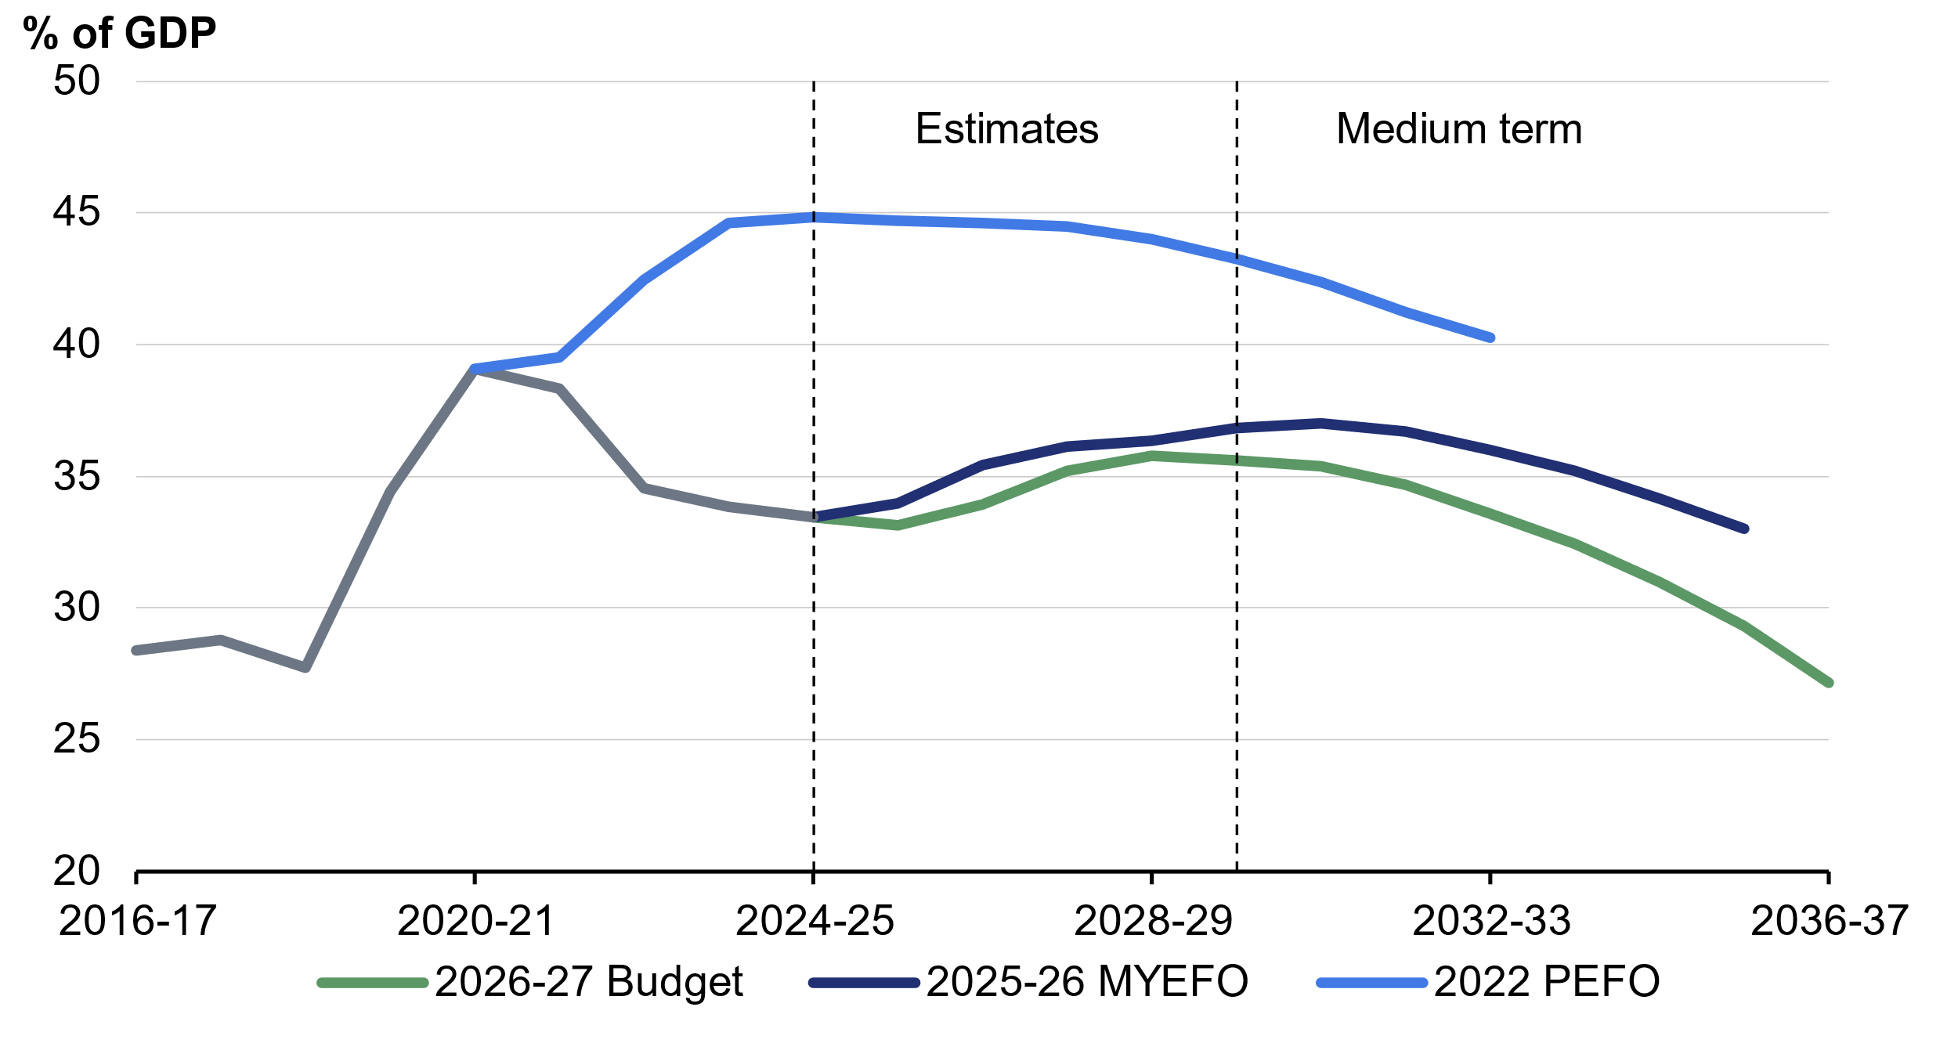
Source: Treasury.

Interest payments
Interest payments over the forward estimates have decreased slightly in nominal terms since MYEFO, largely driven by a reduction in interest payments on Australian Government Securities.
Total interest payments are estimated to be 1.0 per cent of GDP in 2026–27, unchanged from MYEFO. Interest payments are estimated to peak at 1.6 per cent of GDP in 2032–33. Interest payments in 2035–36 are 1.5 per cent of GDP, unchanged from MYEFO.
Over the forward estimates, bond yields are assumed to remain fixed at a recent average of daily spot rates at the time of the budget update. Since MYEFO, the assumed weighted average cost of borrowing for issuance of Treasury Bonds in the forward estimates has increased from 4.4 to 4.8 per cent, reflecting shifts in market expectations and broader economic uncertainty, compounded by the impacts of the conflict in the Middle East (Box 3.4).
Statement 7: Debt Statement contains further information on yield assumptions and interest payments. Statement 8: Forecasting Performance and Sensitivity Analysis contains information on the impact on the underlying cash balance and gross debt if the future trajectory for yields is higher or lower than assumed.
Box 3.4: Impact of higher interest rates on the budget
Yields have a significant impact on the budget, primarily through changes in projected interest paid on Australian Government Securities. There are additional impacts, such as interest earnings on term deposits held at the Reserve Bank of Australia and interest earnings from the Future Fund and other Australian Government Investment Funds.
Due to the increase in yields since MYEFO, the assumed weighted average costs of borrowing have increased to 4.8 per cent over the forward estimates, compared with 4.4 per cent at MYEFO. Weighted average costs of borrowing are also higher over the medium term. If yields had remained at the same level as at the 2025–26 MYEFO, the underlying cash balance would be improved by 0.1 percentage points of GDP in 2036–37 and gross debt would be 0.9 percentage points of GDP lower at 30 June 2037 (Charts 3.10 and 3.11).
Chart 3.10: Underlying cash balance | Chart 3.11: Gross debt
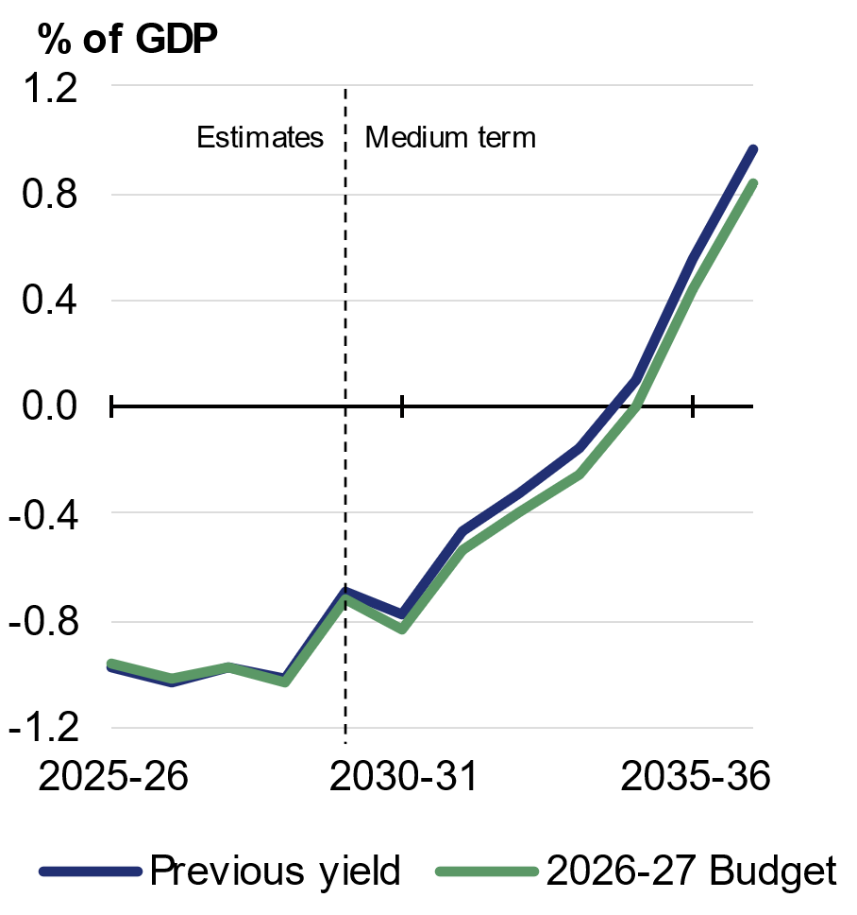 | 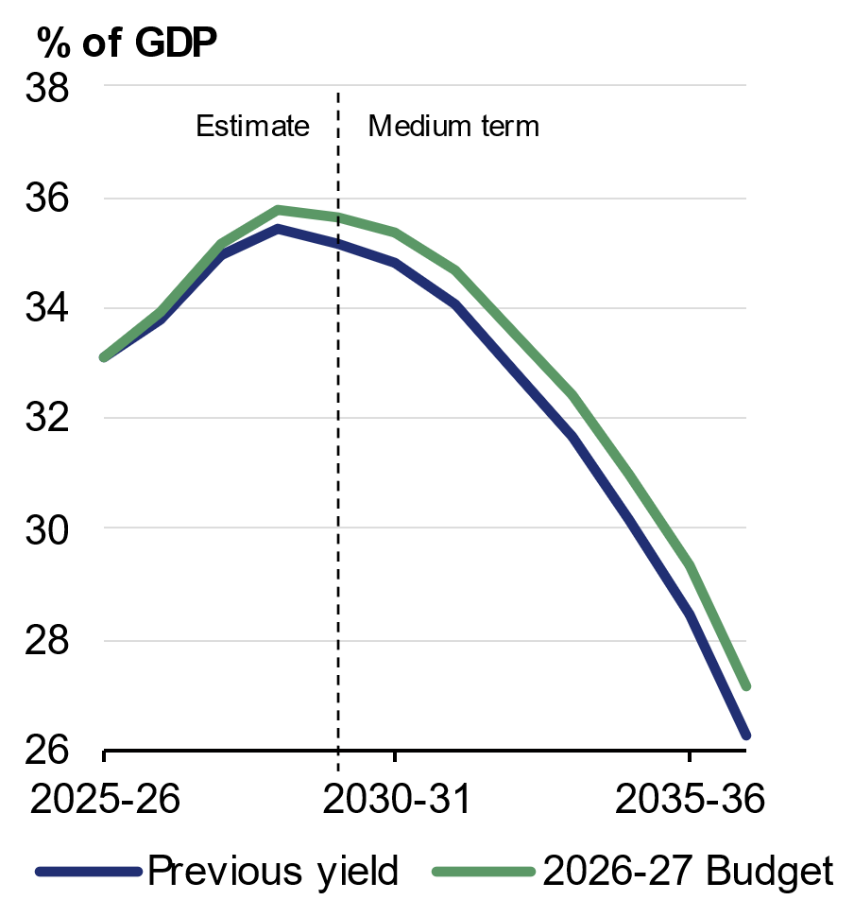
Source: Treasury. | Source: Australian Office of Financial Management, Treasury.

Net debt estimates and projections
Net debt is estimated to be 19.9 per cent of GDP ($616.6 billion) at 30 June 2027 (Table 3.6), 1.5 percentage points lower than estimated at MYEFO. Net debt relative to GDP is expected to be lower in all years of the forward estimates compared to at MYEFO, largely reflecting a lower market value of Australian Government Securities on issue due to both lower issuance and higher yields.
Chart 3.12: Net debt
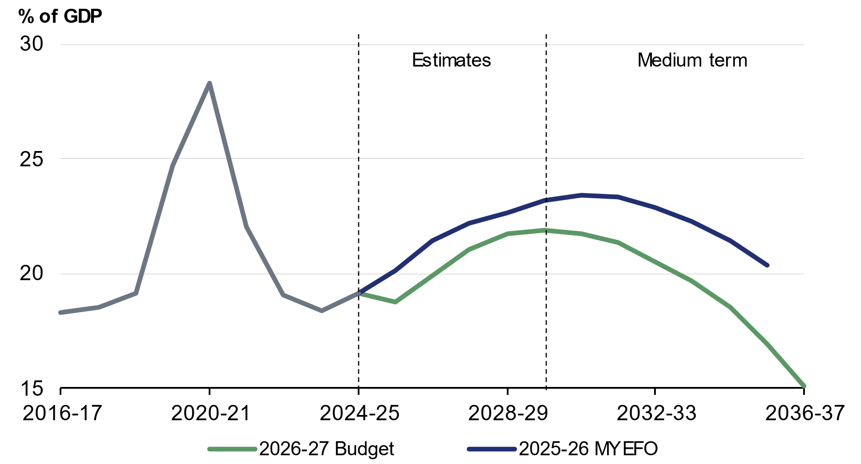
Source: Treasury.

Net debt is lower than estimated at MYEFO over the medium term. Net debt is projected to be 15.1 per cent of GDP at 30 June 2037 (Chart 3.12).
Further information on gross debt and net debt estimates across the forward estimates period is provided in Statement 7: Debt Statement.

Net financial worth and net worth estimates and projections
Net financial worth is estimated to be minus 28.9 per cent of GDP (minus $895.6 billion) at 30 June 2027 (Table 3.6), compared with the estimate of minus 30.8 per cent of GDP (minus $930.2 billion) at MYEFO.
Net financial worth is projected to deteriorate to a low of minus 30.0 per cent of GDP at 30 June 2029 before improving to minus 21.2 per cent of GDP by the end of the medium term (Chart 3.13).
Chart 3.13 Net financial worth
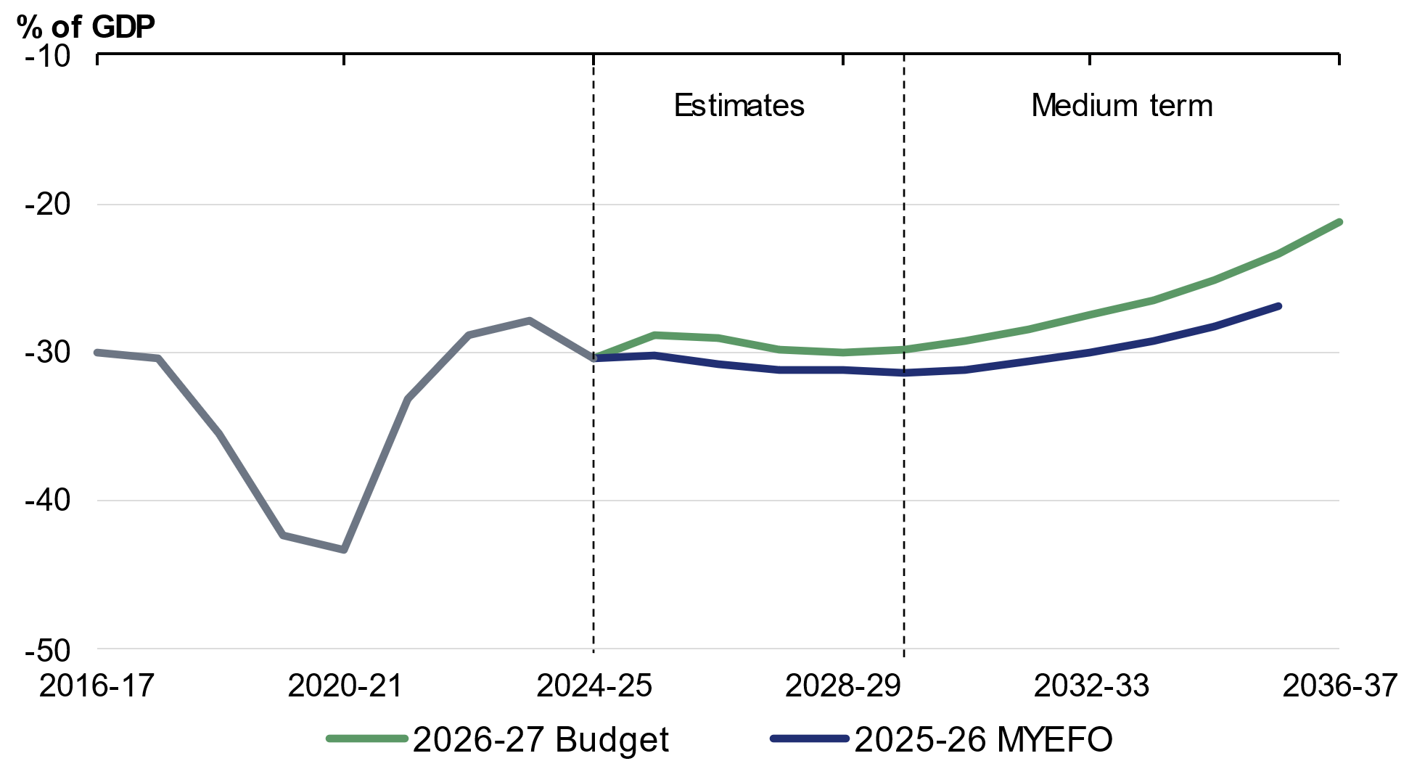
Source: Treasury.

Net worth is estimated to be minus 20.9 per cent of GDP (minus $646.9 billion) at 30 June 2027 (Table 3.6), compared with the estimate of minus 22.7 per cent of GDP (minus $683.4 billion) at MYEFO. Net worth is projected to deteriorate to a low of minus 21.9 per cent of GDP at 30 June 2029 before improving over the medium term.
The improvement in net worth and net financial worth over the forward estimates period relative to MYEFO largely reflects a lower market value of Australian Government Securities on issue due to both lower issuance and higher yields.
Net worth and net financial worth as a share of the economy improve over the medium term as debt-to-GDP is reduced.

Appendix A: Other fiscal aggregates

Accrual aggregates
Accrual accounting records income and costs at the time they are incurred. Cash accounting records income and costs at the time of the associated actual cash flow. Differences in estimates arise where there is a difference between the timing of an activity and the associated cash flow.

Net operating balance estimates
The net operating balance is an accrual measure, reflecting revenue minus expenses. It excludes the fiscal impact of the Australian Government’s net new capital expenditure.
The net operating balance is expected to be a deficit of $39.0 billion (1.3 per cent of GDP) in 2025–26 (Table 3.7). It is expected to be a deficit of $17.9 billion (0.6 per cent of GDP) in 2026–27, compared to an expected deficit of $25.4 billion at MYEFO.

Fiscal balance
The fiscal balance is the accrual equivalent of the underlying cash balance and equals the net operating balance less net new capital investment.
The fiscal balance is expected to be a deficit of $50.1 billion (1.7 per cent of GDP) in 2025–26 (Table 3.7). It is expected to be a deficit of $29.9 billion (1.0 per cent of GDP) in 2026–27, compared to an expected deficit of $35.8 billion at MYEFO.
Table 3.7: Australian Government general government sector accrual aggregates
 | Actual |  | Estimates
 | 2024-25 |  | 2025-26 | 2026-27 | 2027-28 | 2028-29 | 2029-30 |  | Total(a)
 | $b |  | $b | $b | $b | $b | $b |  | $b
Revenue | 733.0 |  | 773.1 | 815.3 | 836.3 | 863.5 | 910.1 |  | 4,198.3
Per cent of GDP | 26.4 |  | 26.1 | 26.3 | 26.3 | 25.9 | 26.0
Expenses | 770.1 |  | 812.1 | 833.3 | 863.7 | 896.1 | 933.7 |  | 4,338.8
Per cent of GDP | 27.7 |  | 27.4 | 26.9 | 27.1 | 26.9 | 26.6
Net operating balance | -37.1 |  | -39.0 | -17.9 | -27.4 | -32.6 | -23.6 |  | -140.5
Per cent of GDP | -1.3 |  | -1.3 | -0.6 | -0.9 | -1.0 | -0.7
Net capital investment | 7.7 |  | 11.2 | 12.0 | 10.2 | 10.2 | 9.3 |  | 52.9
Per cent of GDP | 0.3 |  | 0.4 | 0.4 | 0.3 | 0.3 | 0.3
Fiscal balance | -44.8 |  | -50.1 | -29.9 | -37.6 | -42.8 | -32.9 |  | -193.3
Per cent of GDP | -1.6 |  | -1.7 | -1.0 | -1.2 | -1.3 | -0.9
- Total is equal to the sum of amounts from 2025–26 to 2029–30.

Table 3.8 provides a reconciliation of fiscal balance estimates, including the impact of policy decisions and parameter and other variations on revenue and expenses since MYEFO.
Table 3.8: Reconciliation of general government sector fiscal balance estimates
 | Estimates
 | 2025-26 | 2026-27 | 2027-28 | 2028-29 | 2029-30 |  | Total
 | $m | $m | $m | $m | $m |  | $m
2025 PEFO fiscal balance | -44,221 | -32,116 | -39,385 | -37,261 | * |  | *
Per cent of GDP | -1.5 | -1.1 | -1.3 | -1.1 | *
Changes from 2025 PEFO to
2025-26 MYEFO
Effect of policy decisions(a) | -2,165 | -2,805 | 65 | 2,681 | * |  | *
Effect of parameter and other variations | -8,426 | -871 | -3,893 | -9,161 | * |  | *
Total variations | -10,590 | -3,677 | -3,828 | -6,479 | * |  | *
2025-26 MYEFO fiscal balance | -54,812 | -35,792 | -43,213 | -43,741 | * |  | *
Per cent of GDP | -1.9 | -1.2 | -1.4 | -1.3 | *
Changes from 2025-26 MYEFO
to 2026-27 Budget
Effect of policy decisions(a)(b)
Revenue | -3,918 | 2,537 | 692 | -589 | 7,618 |  | 6,340
Expenses | 2,278 | 6,358 | 1,157 | -4,777 | -12,169 |  | -7,153
Net capital investment | 3 | 1,667 | 1,616 | -227 | 244 |  | 3,303
Total policy decisions impact on fiscal balance | -6,199 | -5,488 | -2,081 | 4,415 | 19,543 |  | 10,190
Effect of parameter and other variations(b)
Revenue | 11,407 | 19,186 | 14,833 | -33 | * |  | *
Expenses | 553 | 7,934 | 8,506 | 3,391 | * |  | *
Net capital investment | -18 | -108 | -1,414 | 39 | * |  | *
Total parameter and other variations impact on
fiscal balance | 10,872 | 11,360 | 7,741 | -3,463 | * |  | *
2026-27 Budget fiscal balance | -50,139 | -29,920 | -37,552 | -42,789 | -32,927 |  | -193,328
Per cent of GDP | -1.7 | -1.0 | -1.2 | -1.3 | -0.9
*Data are not available.
- Excludes secondary impacts on public debt interest of policy decisions and offsets from the Contingency Reserve for decisions taken.
- A positive number for revenue improves the fiscal balance, while a positive number for expenses and net capital investment worsens the fiscal balance.

Revenue estimates
Revenue is the accrual accounting equivalent of cash-based receipts. Changes in revenue are generally driven by the same factors as receipts. Revenue amounts can be higher or lower than the cash equivalents as they include amounts that a taxpayer is liable to pay but has not paid. The differences between the accrual and cash amounts generally reflect timing differences.
Total revenue since MYEFO has been revised up by $21.7 billion in 2026–27 and by $44.1 billion over the four years to 2028–29.

Expense estimates
Expenses are the accrual accounting equivalent of cash-based payments. The differences between the accrual and cash amounts generally reflect where there is a timing difference between the expense accruing and cash payments occurring. Common examples include employee-related liabilities such as superannuation benefits programs and long service leave, government insurance and guarantee schemes, concessional loans and purchases of non-financial assets.
Since MYEFO, total expenses have been revised up by $14.3 billion in 2026–27 and by $25.4 billion over the four years from 2025–26 to 2028–29. Movements in expenses over the forward estimates period are broadly consistent with movements in cash payments.

Structural budget balance
The structural budget balance estimate adjusts the underlying cash balance to remove the estimated effects of cyclical factors that have a temporary impact on receipts and payments. These include deviations in commodity prices and economic activity from their long-run levels. The structural budget balance can provide insight into the sustainability of fiscal settings.
The structural balance is estimated rather than observed, so it is sensitive to the assumptions and parameters that underpin it. Commodity price volatility stemming from the conflict in the Middle East has increased the uncertainty around the estimate.
The structural budget balance is expected to reach surplus by the end of the medium term. The structural position remains in deficit in the near term, peaking at 1.6 per cent of GDP in 2025–26, before improving gradually to reach surplus in the last two years of the projection period (Chart 3.14).
Cyclical factors are estimated to have a positive contribution to the underlying cash balance in 2025–26 and 2026–27, in large part due to elevated commodity prices. This recedes as commodity prices return to their assumed long-run levels.
Chart 3.14: Structural budget balance
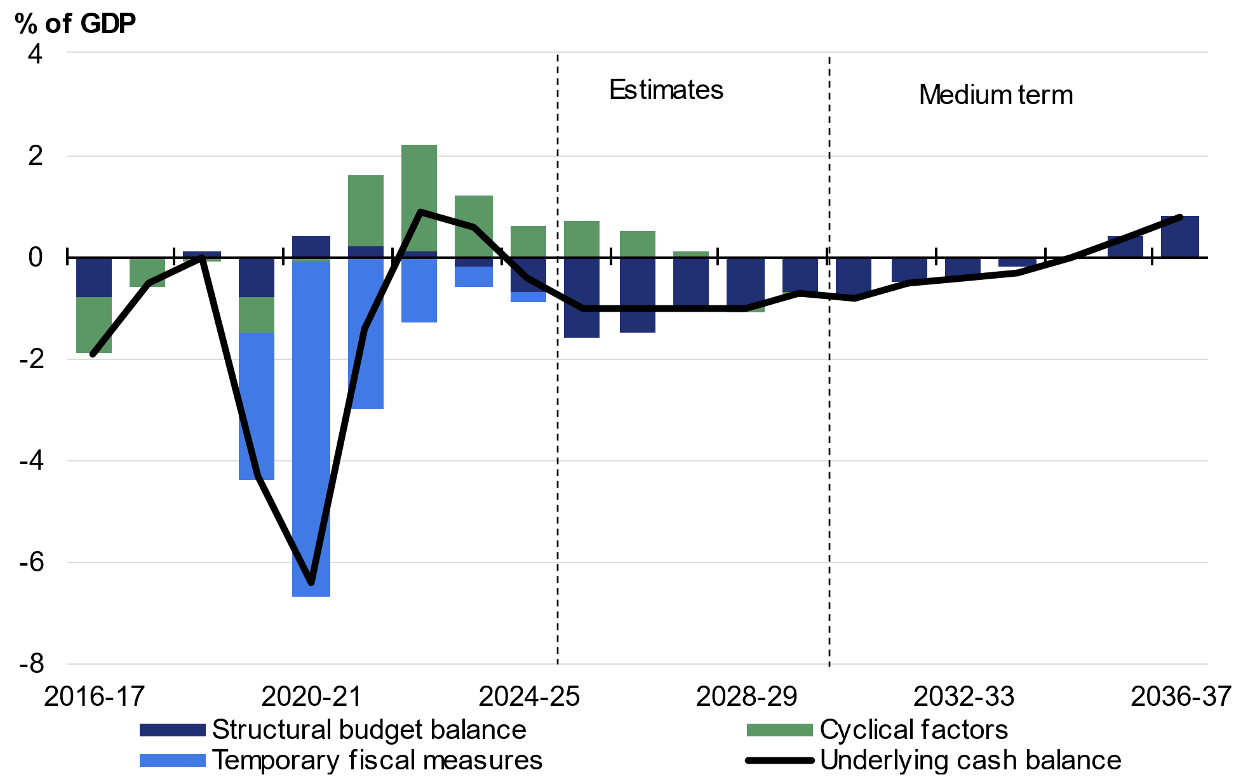
Note: The approach separating the budgetary impact of cyclical factors from structural measures follows the methodology detailed in Treasury Working Paper 2013–01. Cyclical factors measure the estimated impact on the underlying cash balance from automatic stabilisers and cyclical movements in asset and commodity prices. Temporary fiscal measures comprise direct economic and health support measures initiated between the onset of the COVID-19 pandemic and the 2022–23 October Budget. Underspends in these direct economic and health support measures are not captured in the derivation of the structural budget balance.
Source: Treasury

Appendix B: Fiscal impacts of the net zero transformation
Climate change and global climate action will have profound impacts on the economy. Australia is contributing to international climate action through global cooperation, backed by a domestic energy transition that reduces emissions and bolsters energy resilience. The Net Zero Plan and 2035 Target, which guide Australia’s domestic climate mitigation efforts, were released in September 2025. The transition presents new opportunities for Australia’s industries, regions and communities and bolsters energy security. Australia’s clear climate and energy policies, backed by significant public investment, enables the private sector to drive the investment needed to meet Australia’s emissions reduction commitments, enhance energy resilience, and realise the opportunities arising from the transition.
The Government is committed to improving the transparency of public money committed to climate action. It recognises the importance of identifying, disclosing, and tracking net zero spending in improving Australia’s response to climate change and aligning with international efforts. Accounting for net zero spending comprehensively is challenging as it cuts across many portfolios, ranging from energy to health. Existing budget systems do not readily facilitate reporting net zero spending on established programs. For this reason, reporting of net zero spending focuses on new measures.

Australia’s classification approach
The 2026‍–‍27 Budget continues the practice introduced in the October 2022‍–‍23 Budget of transparently reporting new climate-related spending. It adopts the five-part classification outlined in detail in the 2024‍–‍25 Budget:
- reducing emissions in Australia’s energy system and broader economy
- strengthening net zero industries and skills
- adapting to climate change and improving climate and disaster resilience
- international climate leadership
- building Australian Government climate capability.
In the 2026‍–‍27 Budget, new measures from the 2025‍–‍26 MYEFO are also reported to provide a comprehensive update on net zero spending since the 2025‍–‍26 Budget.
Where policies contribute to multiple net zero objectives, spending is classified into the most appropriate category based on its primary purpose. Policies that contribute indirectly to net zero objectives are not included in this classification approach.
This reporting framework maintains alignment with international best practice and recent budgets. It will continue to evolve over time as the Government works with and learns from reporting entities and partners around the world. Australian Government green bonds have contributed to financing programs that support climate mitigation, climate adaptation and improved environmental outcomes.

The role of electrification and decarbonisation in improving resilience
The 2026‍–‍27 Budget leverages established delivery vehicles, such as the Capacity Investment Scheme and the Cheaper Home Batteries program, to support the energy transition, especially the expansion of renewable electricity, supported by consumer energy resources. Additional investments in these programs since the 2025‍–‍26 Budget are reported as new net zero spending in this Budget, including further support for the network infrastructure underpinning the renewables rollout and promoting a low carbon liquid fuels industry in Australia. These will take pressure off more volatile international energy sources while decarbonising Australia’s energy mix. The Government has also made considerable investments in Australia’s liquid fuel security and energy resilience in response to the energy supply shock resulting from the conflict in the Middle East.
Box 3.5: Building resilience to future energy shocks
Australia’s transition to net zero is improving the resilience of our energy system, while reducing energy supply risks associated with recent conflicts in Ukraine and the Middle East. Australia’s net zero transition and the ongoing rollout of renewable technologies has provided Australians with more alternative energy sources compared to previous energy crises, building economic resilience to energy shocks.
The Government is currently supporting the diversification and modernisation of Australia’s energy system through the Capacity Investment Scheme, Rewiring the Nation and the Cheaper Home Batteries policy. Since the last energy shock following Russia’s invasion of Ukraine, low-cost renewables, batteries and hydroelectric power are setting the wholesale market price more often. In the June quarter 2022, black coal and gas set the price in the National Electricity Market 44 per cent of the time, whereas in the March quarter 2026, they set the price 25 per cent of the time.
Households and businesses that have installed rooftop solar, batteries, heat pumps and energy efficient appliances have better insulated themselves from recent energy shocks. ACCC analysis found that Australian households with rooftop solar and a home battery have electricity bills that are on average 40 per cent less than customers whose electricity comes entirely from the grid. Overall, the rollout of renewable generation and storage in Australia’s electricity system is reducing volatility in electricity prices, with an 82 per cent year-on-year drop in high-price events in the September quarter 2025.
continued on next page

Box 3.5: Building resilience to future energy shocks (continued)
A well-functioning energy market is essential for incentivising continued investment in cleaner, cheaper energy. In November 2024, the Australian Government commissioned an independent review of the NEM wholesale market settings. In December 2025, the Government welcomed the expert panel’s recommended range of reforms, which are focused on strengthening market incentives and preserving competition to support an orderly and efficient transition to renewable energy.
The Australian Government is working collaboratively with states and territories to progress the reform directions identified in the NEM Review. A strong majority of the Energy and Climate Change Ministerial Council (ECMC) have agreed to develop a legislative package to implement measures recommended by the NEM review panel and continue the preparatory work related to the establishment of the Electricity Services Entry Mechanism (ESEM) and Market Making Obligation (MMO).
The Government is also releasing $40.0 million of funding to accelerate the rollout of kerbside and fast electric vehicle (EV) charging infrastructure to support a growing electrified transport fleet. Australians are benefitting from an increasing variety of EVs in the Australian market which is helping moderate demand for fuel. As noted in the Electric Car Discount Review, the total lifetime savings of fuel costs were estimated to be around $2.0 billion from EV purchases attributable to the Electric Car Discount in its first three years. The Government’s policies are providing the certainty and backing needed for industry, capital markets and households to invest in onshore energy infrastructure necessary to stabilise our electricity grids and build our resilience to future energy shocks.

New net zero spending measures
Table 3.9 sets out $12.3 billion in new net zero spending commitments over the forward estimates period and $18.2 billion over the medium term, across the 2025‍–‍26 MYEFO and this Budget. This follows net zero spending commitments of $6.9 billion (over the medium term) reported in the 2025‍–‍26 Budget, $24.3 billion (over the medium term) in the 2024‍–‍25 Budget, climate-related spending of $4.6 billion (to 2030) committed in the 2023‍–‍24 Budget and $24.9 billion (to 2030) committed in the October 2022‍–‍23 Budget.
Classification of spending is informed by the net zero spending framework. The total commitment includes spending, balance sheet and tax expenditure measures and therefore presents a broader view than the impact on the underlying cash balance.
Reporting new net zero spending measures supports transparency around the fiscal impacts of climate change and the net zero transformation. However, it does not provide a complete summary of climate action. Only new measures that entail funding commitments or forgone revenue (such as tax concessions) are captured.
There are significant savings reported in this Budget, with resources reprioritised to support priority areas of Government action that includes important measures to support Australia through the net zero transition. Given reporting on net zero measures reflects new spending commitments, it does not account for these savings, which are detailed elsewhere in the Budget.

Table 3.9: New measures
 | Total* | Forward Estimates  ($m) | Medium Term  ($m)
 | Reducing emissions in Australia’s energy system and broader economy | 8,281.5 | 10,296.0
 | Support for the Net Zero Plan - CEFC, Game On, EV Charging, Mainstreaming Energy Performance and Unlocking Household Retrofits^{(a)(b)} | 174.6 | 2,174.6
 | Finalising Fixed Delivery Carbon Contract Exit Arrangements^{(a)(c)} | nfp | nfp
 | Boosting Consumer Energy Resources and Delivering Bill Savings^{(d)} | 127.8 | 128.5
 | A Rapidly Transforming Energy System^{(a)} | 487.5 | 501.3
Sustaining the Cheaper Home Batteries Program^{(a)(e)} |  | 7,237.0 | 7,237.0
Building a Future Made in Australia – Boyer Mill Transition to Renewables^{(a)} |  | 24.0 | 24.0
Expanding the Capacity Investment Scheme^{(a)(c)} |  | nfp | nfp
Boosting Productivity – Accelerating Approvals^{(f)} |  | 157.9 | 157.9
Energy Sovereignty – Fuel Security and Resilience^{(g)} |  | 44.5 | 44.5
National Solar Panel Recycling Pilot^{(h)} |  | 24.7 | 24.7
Supporting Transport Priorities^{(i)} |  | 3.6 | 3.6
 | Strengthening net zero industries and skills | 3,701.2 | 7,528.0
 | Support for the Net Zero Plan – National Reconstruction Fund and Low Carbon Liquid Fuels^{(a)(j)} | 3,239.2 | 6,116.0
 | Supporting Australian Industry – Closing the energy price gap for green aluminium at Boyne Smelter and Whyalla Steelworks Further Funding^{(k)} | 436.0 | 1,386.0
 | Building Australia's Future - delivering priority housing and energy sector training^{(a)(l)} | 20.0 | 20.0
Building a Future Made in Australia – Master Plan for Hunter Mines and Locally Made Steel^{(a)(m)} |  | 6.0 | 6.0
Adapting to climate change and improving climate and disaster resilience |  | 117.2 | 117.2
 | Disaster Support^{(n)} | 36.6 | 36.6
 | South Australian Marine Algal Bloom Response^{(a)(o)} | 68.5 | 68.5
 | Weather Radar for Regional Queensland^{(a)(p)} | 12.1 | 12.1
 | International climate leadership | 178.5 | 178.5
Extending Australia’s International Climate Change Engagement (COP31)^{(a)} |  | 19.9 | 19.9
 | Standing with our partners in the Pacific^{(q)} | 147.8 | 147.8
 | Supporting Trade and Tourism – Australia-Singapore Green Economy Agreement^{(r)} | 10.8 | 10.8
Building Australian Government climate capability |  | 37.7 | 37.7
Strengthening Australia’s Carbon Crediting and Emissions Reporting |  | 23.3 | 23.3
Finance Portfolio - continue supporting entities with acting on climate change in government operations^{(a)} |  | 5.0 | 5.0
Table 3.9: New measures (continued)
 | Total* | Forward Estimates  ($m) | Medium Term  ($m)
Finance Portfolio – Additional Resourcing – continue supporting entities with acting on climate change in government operations^{(s)} |  | 5.0 | 5.0
Productivity – Additional Measures – climate sustainability reporting^{(t)} |  | 4.4 | 4.4
Total Net Zero Spending |  | 12,316.0 | 18,157.4
* This table summarises the Government’s key climate-related spending commitments in the 2025 PEFO, 2025‍–‍26 MYEFO and 2026‍–‍27 Budget to 30 June 2037 and presents a broader view than the impact on the underlying cash balance. Some measures extend beyond the end of the medium term or include both initial and ongoing funding to the end of the medium term. Figures align with the forward estimates and medium term for the 2026‍–‍27 Budget unless otherwise noted. Spending outlined in these measures for the purposes of this table may differ in some instances from figures reported in the 2025‍– ‍26 MYEFO and 2026‍–‍27 Budget Paper No. 2 due to the exclusions described in the footnotes.
- The spending outlined in this measure was committed at 2025‍–‍26 MYEFO.
- The spending outlined in this measure for the purposes of this table includes Clean Energy Finance Corporation Recapitalisation, Accelerating Rollout of Electric Vehicle Charging, Game On: Teaming Up for Climate Action, Mainstreaming Energy Performance and Unlocking Household Retrofits with Home Energy Ratings. This measure contains $2.0 billion in funding for concessional finance.
- The funding profile for this measure is not for publication due to commercial sensitivities.
- The spending outlined in this measure for the purposes of this table excludes funding to support reprofiling funding for the Driving the Nation – Dealership and Repairer Initiative for Vehicle Electrification Nationally Program.
- The spending outlined in this measure for the purposes of this table includes funding committed in 2025‍–‍26 PEFO and the revised profile as published in the 2025‍–‍26 MYEFO save measure.
- The spending outlined in this measure for the purpose of this table includes funding the Department of Climate Change, Energy, the Environment and Water and the National Environmental Protection Agency to accelerate environmental approvals.
- The spending outlined in this measure for the purposes of this table includes only Accelerating Electrification of Australia Post’s Delivery Fleet and Maritime Fuel Resilience and Decarbonisation. The cost of this measure has been partially met through the existing resources of the Department of Infrastructure, Transport, Regional Development, Communications, Sport and the Arts.
- The cost of this measure has been met from a reprioritisation of funding from the Recycling Modernisation Fund – Plastics Technology stream and from the 2025‍–‍26 MYEFO measure titled Climate Change, Energy, the Environment and Water – reprioritisation.
- The spending outlined in this measure for the purposes of this table includes only the Real-World Testing program.
- Spending for the National Reconstruction Fund Corporation Net Zero Fund reflects deployment of the Net Zero Fund not UCB impacts. The medium-term total for the low carbon liquid fuel measure is to 2039‍–‍40.
- The spending outlined in this measure for the purposes of this table includes Closing the Energy Price Gap for Green Aluminium at Boyne Smelter and Further Funding for the Whyalla Steelworks, which is intended to help transition the steelworks to renewable energy. The medium-term total for this measure is to 2039‍–‍40.
- The spending outlined in this measure for the purposes of this table includes establishing a National Training Centre in New Energy Skills to train workers for priority new energy occupations. The cost of this measure will be partially offset by funding reprioritised from the Clean Energy Capital Investment Fund.
- The spending outlined in this measure for the purposes of this table includes funding for a master plan for re-zoned mine sites in the Hunter region to aid the net zero transition and the development of a roadmap to boost Australian content in renewable energy infrastructure.
- Profile reflects total committed funding in 2025‍–‍26 MYEFO and 2026‍–‍27 Budget. The cost of this measure will be partially met through existing resources in the National Emergency Management Agency.
- The cost of this measure will be partially met through existing resources in the Department of Climate Change Energy, the Environment and Water.
- The cost of this measure will be partially met through existing resources in Bureau of Meteorology.
- The cost of this measure will be fully met from a reprioritisation of funding from the Strategic International Partnerships Investment Stream program and from the existing resources of the Department of Foreign Affairs and Trade. The measure includes funding committed in the Portfolio Additional Estimates Statements 2025‍–‍26.
- The spending outlined in this measure for the purposes of this table includes funding for the implementation of the Australia-Singapore Green Economy Agreement. The cost of this measure is partially met from within the Department of Foreign Affairs and Trade’s existing resources.
- The spending outlined in this measure for the purposes of this table includes only funding to support entities with acting on climate change in government operations and is further to the funding provided at 2025–26 MYEFO outlined in the table above.
- The spending outlined in this measure for the purposes of this table includes the component which includes support for climate sustainability reporting.

