Statement 4:
Tax reform for workers, businesses and future generations
The Government’s tax reform package represents the most significant transformation of Australia’s tax system in more than a quarter of a century.
The reform package includes measures that will reduce the tax burden on 13 million workers, support an additional 75,000 owner occupiers to enter the housing market, deliver over $3.5 billion of new measures that lower taxes for businesses to support jobs and economic growth, and includes simplification measures that reduce compliance costs for businesses and individuals by $540 million per year.
The tax changes form part of a package of housing reforms in the Budget that will support supply overall, and part of a package of productivity reforms in the Budget that will help lift the speed limit on Australia’s economy over the long term.
The tax package is built around the three principles for tax reform agreed at the Economic Reform Roundtable in August 2025, and responds to the urgent need for more reform to address intergenerational equity, productivity and the sustainability of the tax system.
These reforms rebalance the tax system by reducing the burden on workers and ensuring a fairer, more consistent treatment of income from assets.
The package delivers the first broad-based tax cuts in Australia’s history that directly target income earned from work. From 1 July 2027, the Government will introduce a $250 Working Australians Tax Offset (WATO), delivering a new tax cut for more than 13 million Australian workers for the 2027–28 income year. This is complemented by the introduction of a $1,000 instant tax deduction, making tax time easier and further reducing taxes for 6.2 million Australians for the 2026–27 income year.
The Government will also reform the taxation of income earned on assets through changes to negative gearing, capital gains tax (CGT) and discretionary trusts. Reforming negative gearing and CGT will help more Australians get into the housing market and reduce distortions that favour highly leveraged investment in existing housing over other assets. A minimum tax on discretionary trusts will better align the tax rates on trust income with the tax rates paid by workers. These reforms will also fund more tax relief for workers.
In addition, the package delivers significant reforms to the taxation of businesses that support investment, innovation and resilience across the economic cycle. Improvements to the treatment of tax losses, expansion of venture capital incentives, a permanent small business instant asset write-off (IAWO) and a more targeted Research and Development Tax Incentive will encourage sensible risk-taking and enhance firms’ ability to grow and withstand shocks. These reforms will support productivity, jobs and economic growth and help lift the speed limit on Australia’s economy.
The package also makes the tax system simpler for workers and businesses, including by removing more nuisance tariffs and modernising tax administration, and puts in place sustainable long-term tax settings to support the take-up of electric cars.
Taken together, the tax reform package is broadly revenue-neutral over the forward estimates and strengthens budget sustainability over the medium term. These reforms ensure that the Government can continue to fund essential services Australians rely on while lowering the tax burden on working Australians and creating room for further tax relief over time.
These reforms will mean more Australians have the opportunity to buy a home, help millions of Australian workers earn more and keep more of what they earn, and ensure our tax system is simpler and more sustainable for the long term.

Statement 4 contents
The Government’s tax reform agenda 133
The need for a better tax system 136
Home ownership is out of reach for many young Australians 137
The tax system is under pressure from demographic and economic shifts 139
Current tax concessions on assets reduce equity 141
Impacts of the tax system on productivity and dynamism 143
Reforming the tax system will support a more resilient economy 145
A fairer system for workers, homebuyers and future generations 146
Reforming negative gearing and the capital gains tax 146
Introducing a minimum tax on discretionary trusts 159
Delivering a new round of tax cuts for every working Australian taxpayer 163
Tax reform will benefit workers and improve housing affordability 165
Supporting investment, innovation and dynamism 166
Reforming loss refundability for businesses 168
Expanding venture capital concessions 170
Better targeting the Research and Development Tax Incentive 172
A simpler, more sustainable tax system 178
Simplifying tax for individuals through an instant deduction 178
Helping businesses spend less time on tax 179
Modernising the tax system for a new economy 181
Making the tax system simpler and more sustainable 184
Impact of the Government’s tax reform package 185
Revenue impacts 185
Economic impacts 187

Statement 4: Tax reform for workers, businesses and future generations

The Government’s tax reform agenda
The Government’s tax reform package represents the most significant transformation of Australia’s tax system in more than a quarter of a century. Together with the tax reforms already implemented by the Government including three rounds of tax cuts for every taxpayer, this package builds a better tax system for workers, businesses and future generations.
In August 2025, the Government convened the Economic Reform Roundtable to build consensus around future reforms to improve productivity, enhance economic resilience and strengthen budget sustainability. The Roundtable brought together key leaders from business, unions, civil society, government and policy experts. The Roundtable process included over 40 consultations and forums and received nearly 900 submissions from across the community.
The urgent need for tax reform was a clear area of consensus at the Roundtable. Participants agreed that future reforms should be guided by three principles: a fairer system for workers and intergenerational equity; responsible, affordable ways to support business investment; and making the system simpler and more sustainable.
The tax reform package in this Budget delivers on these principles and builds on the Government’s achievements to date.
These reforms deliver tax cuts for working Australians, enable more Australians to realise the goal of home ownership, and strengthen incentives for investment and innovation to support jobs and economic growth. They create a more modern tax system that is simpler for workers and businesses while ensuring governments can sustainably fund the services Australians rely on.
The Government’s reforms in this Budget will:
- Make it easier for people to own their own home by reforming taxation of capital gains and negative gearing, with an additional 75,000 owner-occupiers expected to enter the housing market over the next decade.
- More closely align tax rates on income from discretionary trusts with rates paid by workers and families who earn a living from wages. The additional revenue gained from this reform will help fund tax cuts for workers and make the Budget more sustainable.
- Reduce the tax burden on workers by introducing a $250 WATO and a $1,000 instant tax deduction. After three rounds of tax cuts, the WATO and the instant tax deduction, an Australian worker on average earnings would receive a combined benefit of up to $2,816 from the 2027–28 income year, relative to 2023–24 tax settings.
- Support a more dynamic and resilient economy by encouraging sensible risk-taking, helping firms manage temporary shocks and supporting investment and innovation. The package includes over $3.5 billion of new measures that lower taxes for businesses to support jobs and economic growth.
- Support small businesses to invest and grow by making the $20,000 IAWO permanent, with sole traders also benefiting from the WATO.
- Reduce compliance costs for businesses and individuals by $540 million per year by introducing a $1,000 instant tax deduction, making the $20,000 IAWO permanent, removing more nuisance tariffs and simplifying pay as you go (PAYG) instalment calculations.
The uncertain global environment highlights the importance of acting now to build resilience to future economic shocks and to address longer-term economic and social challenges. Without action, structural pressures and the impact of future shocks are more likely to have permanent effects on the living standards of future generations. Well-calibrated tax changes will better align the system with long-term economic and demographic trends, support a more sustainable revenue base and improve resilience to respond to future shocks.
These reforms build on the Government’s agenda to create a fairer, simpler and more sustainable tax system (Box 4.1).
Box 4.1: The Government’s tax reform achievements
- Delivering two more tax cuts to every Australian taxpayer in 2026 and 2027, adding to the first round delivered in July 2024, which will provide meaningful cost-of-living relief, return bracket creep and boost labour supply.
- Making the superannuation system more equitable and sustainable by reducing tax concessions available to individuals whose total superannuation balances exceed $3 million and increasing the Low Income Superannuation Tax Offset for 1.3 million Australians.
- Supporting the construction of homes, including affordable homes, through new tax breaks for the Build to Rent sector.
- Ensuring the Australian community receives a fair return from natural resources through reforms to the Petroleum Resource Rent Tax (PRRT).
- Ensuring large companies and multinationals pay their fair share through multinational tax reform, including the global minimum tax, and investment in tax compliance programs.

The need for a better tax system
Australia’s public finances are among the strongest in the developed world, with gross debt lower than every major advanced economy. For 2027, the International Monetary Fund (IMF) expects Australia’s gross debt-to-GDP (including all levels of government) to be less than half the advanced economy average, more than 50 percentage points below the United Kingdom, and more than 75 percentage points below the United States. Further, Australia is estimated by the IMF to have the third highest budget balance among G20 countries in 2027, up from fourteenth in 2021.
However, Australia’s tax system is under growing pressure from demographic and economic change. As the population ages and some indirect tax bases erode, under current tax settings the Commonwealth will become more reliant on personal income tax, particularly taxes on salaries and wages – increasing the tax burden on a declining share of working-age Australians.
At the same time, many young Australians have less opportunity than their parents to build wealth and own their own home. Supply of housing is an important factor in affordability, but other settings including tax can play a significant role, including by influencing the balance of demand between investors and owner occupiers and the incentives to borrow and invest in different kinds of assets.
Current settings, such as negative gearing and the capital gains tax discount, favour highly leveraged investment in existing housing, putting upward pressure on prices. The concessional treatment of some income earned from assets can also distort decisions, directing capital away from potentially more productive uses and, alongside structures like discretionary trusts, enable higher-income earners or high-wealth individuals to achieve lower tax rates than ordinary workers. Some negatively geared properties receive an effective subsidy over the life of the investment. The use of trusts has also grown significantly, becoming increasingly unsustainable.
Tax settings also play an important role in influencing productivity and an economy’s potential output through their impact on decisions to work, save and invest. Since the mid-2000s, productivity growth has slowed. Sustained productivity growth is the foundation for Australia’s long-term economic prosperity, driving rising real incomes and increasing living standards from one generation to the next. A business environment that supports investment, including in emerging and innovative firms, is central to capital deepening, innovation, technology adoption and knowledge spillovers.
Together, these challenges raise important questions for budget sustainability, productivity and intergenerational equity, and underpin the need for significant further tax reform.

Home ownership is out of reach for many young Australians
Each generation of Australians should have at least the same opportunity to build wealth and a prosperous future as the generations that came before them.
However, today’s younger Australians face weaker prospects of building wealth than earlier generations, and wealth gaps between age groups are growing. While wealth is growing faster for older households, rising house prices have made home ownership harder for young Australians.
Slower productivity growth since the 2000s has coincided with slower income growth for young adults. The proportion of children who grow up to earn more than their parents has fallen from around 80 per cent for Baby Boomers, to a little under 70 per cent for Millennials. Those born in the 1990s earn only marginally more than those born the decade before – around 2 per cent more, rather than the double digit gain typically experienced by earlier birth cohorts.
At the same time, housing prices have diverged from incomes, rising 407 per cent between April 1999 and April 2026 – more than twice as fast as average incomes. As a result, median housing prices have risen from four times the average full-time earnings in 1999 to eight times (Chart 4.1).
As housing prices rise faster than income, access to home ownership increasingly depends on the wealth of the previous generation – ‘the bank of mum and dad’. This entrenches higher levels of wealth inequality across generations. Home ownership has declined, with 3 per cent fewer Australians owning a home than in 1981 (Chart 4.1).
Chart 4.1: Earnings, housing prices and home ownership since 1981
Housing prices-to-earnings ratio | Share of households owning home
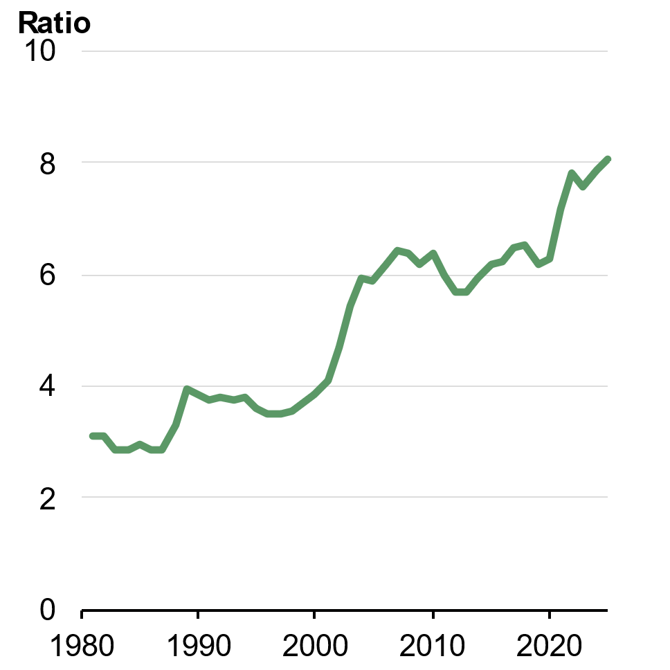 | 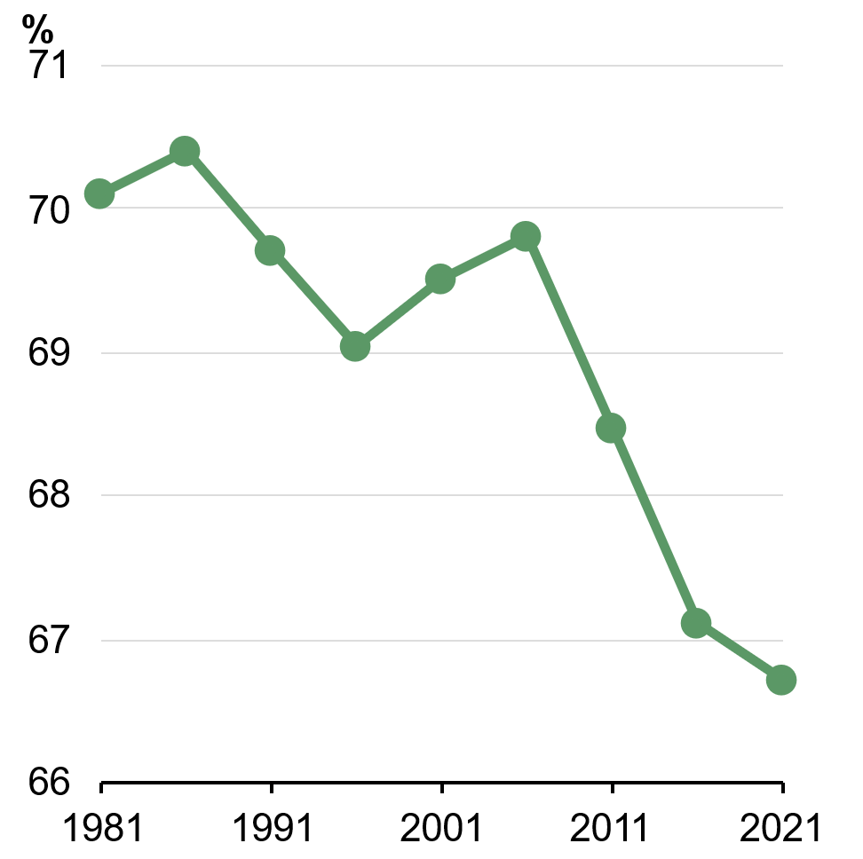
Note: Housing prices are median sales AVM value (Cotality Data) and earnings are average adult full-time ordinary time earnings (ABS).  Source: ABS Average Weekly Earnings, Australia, Cotality Data and Treasury. | Source: ABS Census and Treasury.

Declines in home ownership have been most significant for younger Australians. Home ownership for people aged 25–34 fell by 7 percentage points in the two decades from 2001 to 2021 and 17 percentage points since 1981. In 2021, only half of people aged 30–34 and about one-third of those aged 25–29 owned their own home (Chart 4.2).
Chart 4.2: Home ownership rates are declining, particularly for younger Australians
Home ownership rates, by age group
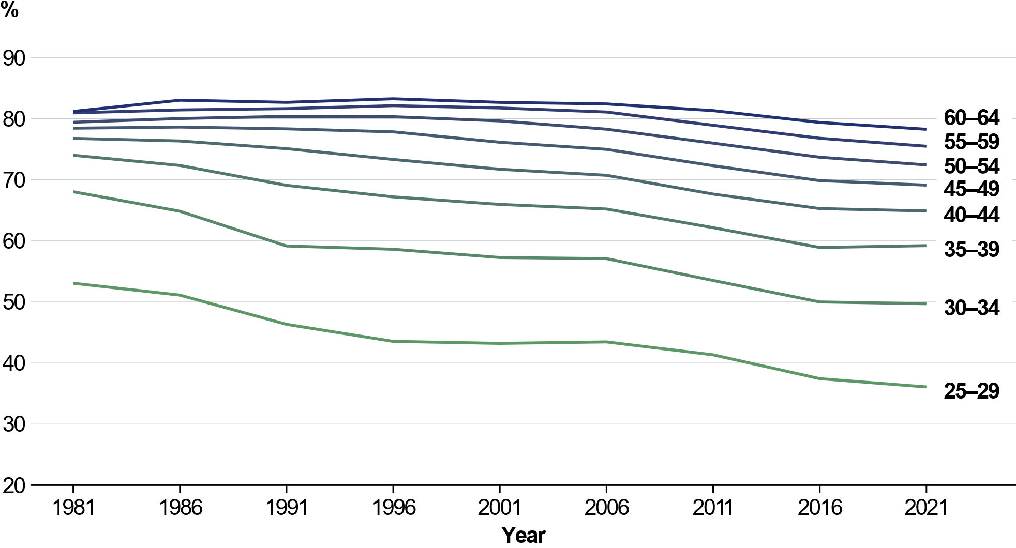
Source: ABS Census (various).

The key reason housing has become less affordable is that housing supply has not kept pace with rising demand from both homeowners and investors, pushing up prices.
However, tax settings have also exacerbated affordability issues. The combination of the 50 per cent capital gains tax discount and negative gearing reduces effective tax rates on investment properties, making housing assets particularly attractive investments. These tax advantages have increased the share of housing owned by investors, at the expense of Australians looking to buy a home.

The tax system is under pressure from demographic and economic shifts
Australia’s largest single source of Commonwealth revenue is personal income tax, mostly composed of taxes on salaries and wages. As wages grow, bracket creep tends to raise tax rates on this income over time.
To combat rising tax rates, governments have periodically returned bracket creep to workers through personal income tax cuts. The Government’s cost-of-living tax cuts returned bracket creep to workers hit hardest by cost-of-living pressures, and the tax cuts announced in the 2025–26 Budget will provide additional support for Australians.
However, as the population ages, the share of working-age Australians is expected to fall, and the tax burden will become more concentrated on a smaller cohort of workers. In 1982– 83, there were 6.6 working-age Australians for each Australian over the age of 65. Over the 40 years to 2022–23, this ratio has fallen to 3.8 and it is projected to fall further to 2.6 by 2062–63. This impact is exacerbated because fewer older Australians pay income tax today compared to the past. As of 2022–23, around 15 per cent of Australians aged 70 and over paid income tax, compared with around 30 per cent in the 1990s. Structural spending needs are increasing, particularly on care and support services linked to population ageing, at the same time the tax base of workers is shrinking.
Over the Intergenerational Report period, personal income tax receipts are projected to grow from 50.5 per cent of total tax receipts in 2022–23 to 58.4 per cent in 2062–63 (Chart 4.3). A greater tax burden on salaries and wages limits the ability of younger Australians to save and accrue wealth. High tax rates on wages also reduce incentives for people to work and invest in developing their skills. This is particularly a risk for low-income and secondary earners with children, mostly women, who are most likely to reduce their hours worked, or leave the labour force in response to high tax rates.
Chart 4.3: Personal income tax is expected to rise as a share of revenue
Composition of tax receipts, actual and projected
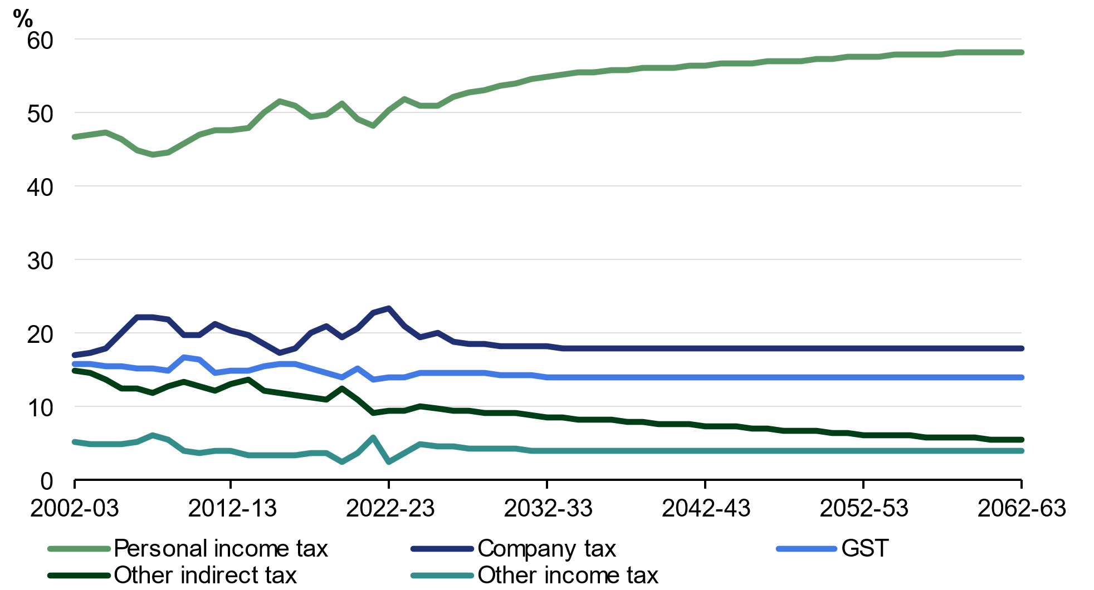
Note: Data beyond 2023–24 are projections.
Source: Treasury.

Current tax concessions on assets reduce equity
At the same time that younger workers are facing a less affordable housing market and the prospect of shouldering an increasing share of the tax burden, the tax arrangements for income earned from other sources – such as income earned on assets – are inconsistent and often result in lower tax rates than the taxes paid by workers.
Inconsistent taxation of asset income distorts how and where people save and can create opportunities to reduce tax paid. These settings disproportionately benefit higher income earners and give these earners more opportunity to reduce their taxes. These concessions can be particularly inefficient when linked to real assets that are restricted in supply, such as housing.
Not all Australians have the same opportunity to access asset-based tax concessions. While some taxpayers can structure their affairs to reduce the taxes they pay, many taxpayers cannot. Compared to people who earn most of their incomes from salary and wages, people who earn a larger share of their income from non- wage sources (excluding benefits) generally pay significantly lower tax rates for the same level of gross income (Chart 4.4).
Chart 4.4: Salary and wage earners face higher tax
Average tax rate, by gross annual income and whether individual is predominantly salary earner or not, 2022–23 (people under 65)
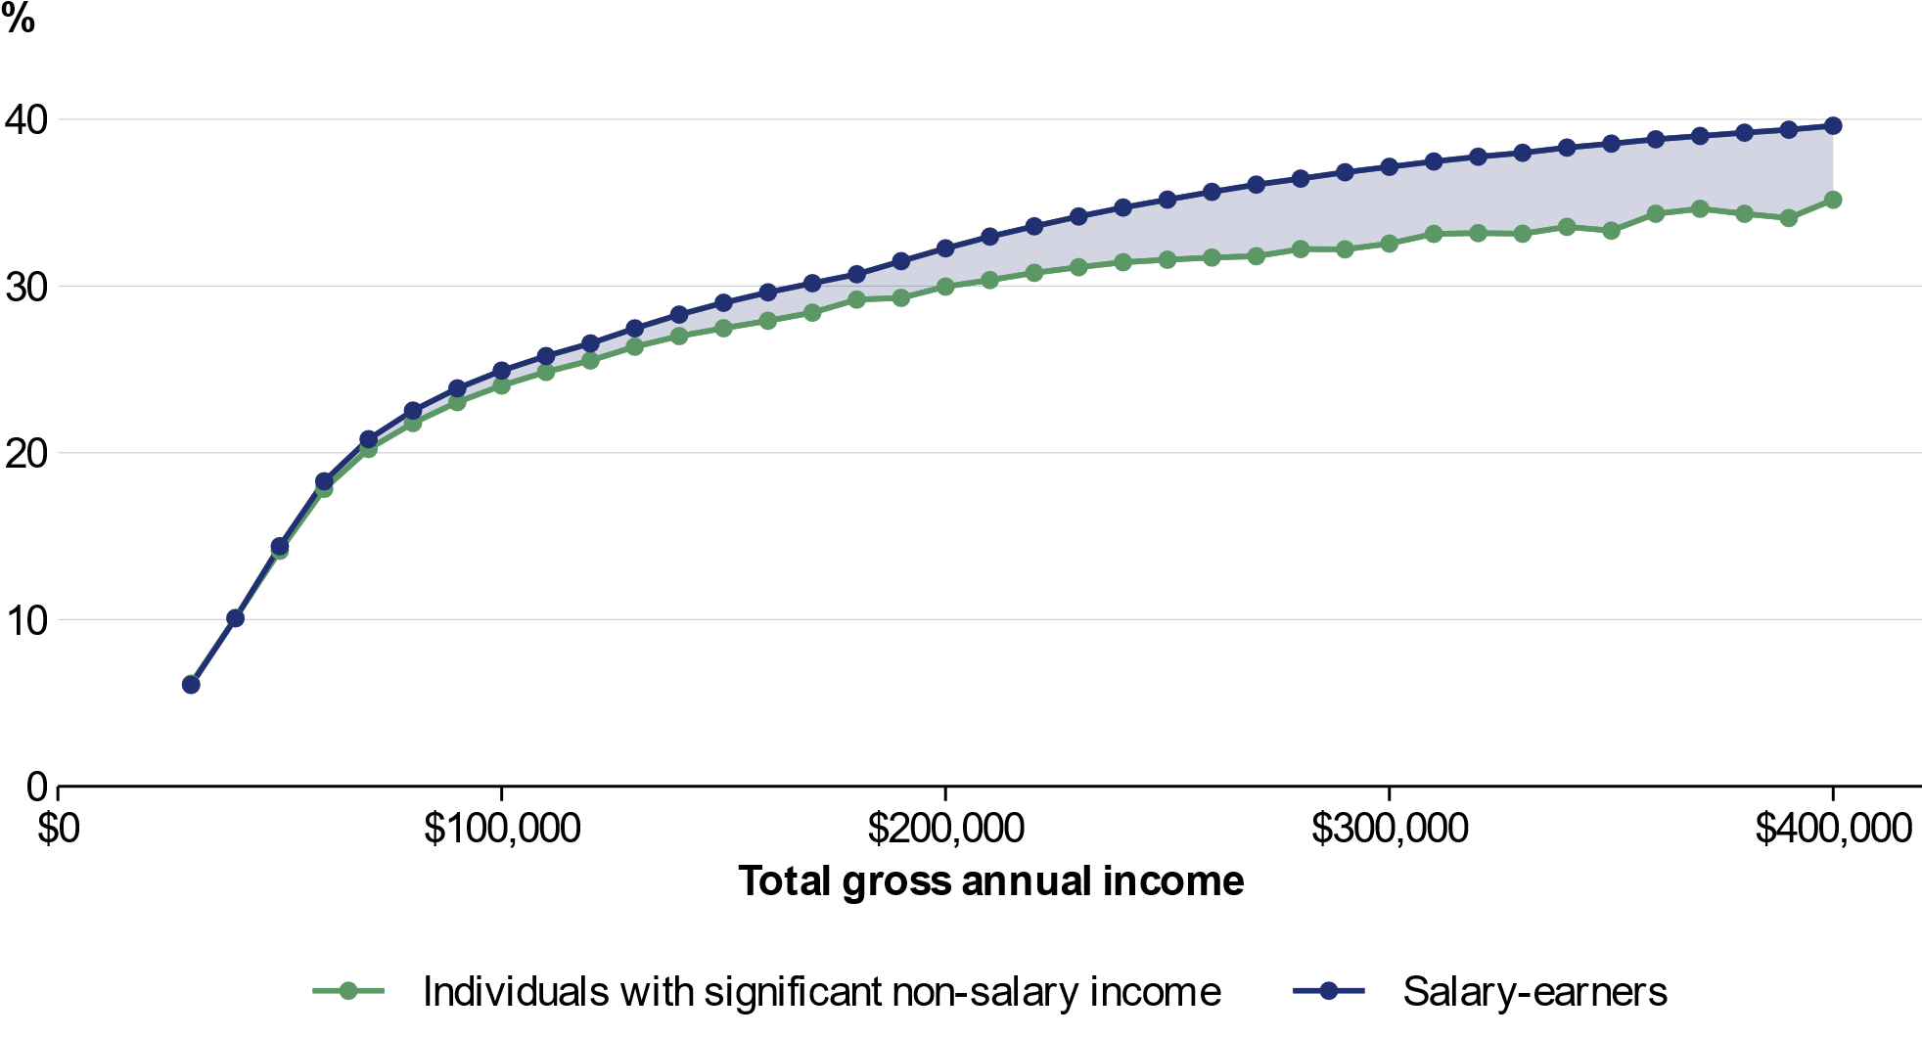
Note: Individuals who earn more than 90 per cent of their income (excluding benefits) as salary or wages are considered ‘salary-earners’. Individuals who mostly earn income from benefits are excluded. Gross annual income includes undiscounted capital gains, apportioned income from discretionary trust distributions and all other taxable income. Income from trust distributions and the tax paid on that income is apportioned between adult members of each family, based on their lifetime share of the family’s non-trust income.
Source: ATO and Treasury.

This inequity is driven by features of the tax system including the capital gains tax discount, negative gearing and discretionary trusts that are primarily available to people who own or have access to substantial assets.
The cumulative tax benefits of these arrangements have overwhelmingly flowed to those with very high lifetime incomes. Chart 4.5 shows that, since 2000, the top 1 per cent by lifetime income – with average real incomes of about $800,000 per year during their peak earning years – benefitted from tax concessions worth more than $700,000 over their working life from a combination of the capital gains tax (CGT) discount, negative gearing and discretionary trusts.
In many cases, these concessions mean that higher earning Australians can pay less tax than those with lower means, substantially undermining the progressivity of the tax system. Without reform, the forgone revenue will continue to grow as the population ages, increasing pressure on the Budget to fund services Australians rely on and limiting the Government’s ability to sustainably return bracket creep to Australian workers.
Chart 4.5: The combined savings tax benefits are heavily concentrated among the highest earners
Average cumulative tax benefit from the capital gains tax discount, negative gearing and discretionary trusts, between 1999–00 and 2022–23
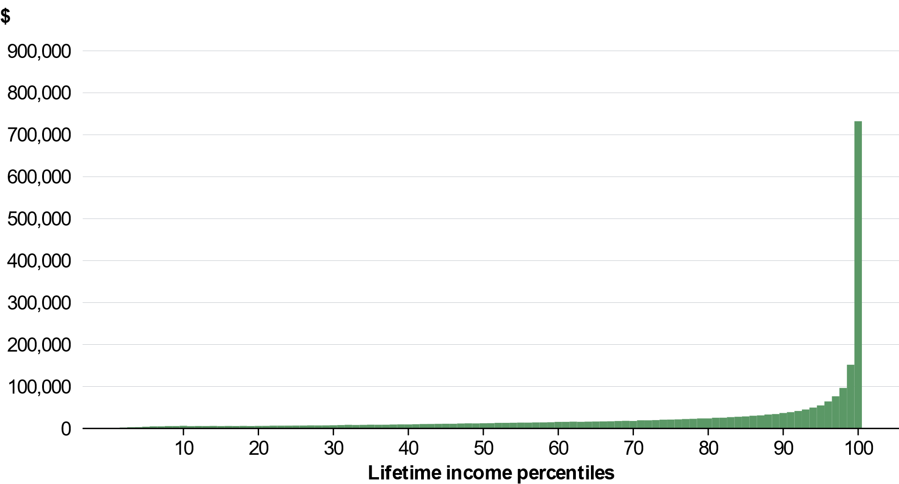
Note: This analysis follows people aged 35–45 in 1999–00 through to 2022–23. Lifetime income (from which the percentile is derived) is the sum of each individual’s total income or loss relative to contemporaneous AWOTE over this period. This chart shows how much tax would have been due over that period if the full nominal value of capital gains were included in taxable income, if rental losses were excluded from the calculation of taxable income, and if each discretionary trust concentrated its annual distributions solely to the person who had the highest lifetime income among its observed beneficiaries. As such, it does not indicate a magnitude of revenue that could be raised from reforms (see Budget Paper 2: Budget Measures for expected revenue impacts of these reforms).
Source: ATO and Treasury.

Impacts of the tax system on productivity and dynamism
Tax settings are not only a key factor in the fairness and sustainability of the system – they also shape the incentives for investment and innovation that drive productivity and economic growth.
Sustained productivity growth is the foundation for Australia’s long-term economic prosperity and is the main driver of real wage growth and living standards in the long term. Since the mid‑2000s, productivity growth has slowed in Australia. This slowdown has occurred in most advanced economies, which suggests there are some common structural factors.
Labour productivity grew by 1.0 per cent through the year to the December quarter 2025, above the 20-year average. The market sector drove the growth. Market sector productivity has grown for five consecutive quarters and rose 1.5 per cent through the year to the December quarter 2025. While these recent trends are encouraging, productivity growth is volatile on a quarterly basis, and more needs to be done to sustain this momentum.
Business investment and adoption of new technologies are two key drivers of productivity growth, and both are closely connected to business ‘dynamism’. Dynamism describes the extent to which labour and capital are reallocated to their most productive uses.
Alongside the slowdown in productivity growth, indicators of business dynamism have also slowed across the OECD and in Australia (Chart 4.6). For instance, there have been fewer firms entering and exiting the market, lower rates of new job creation and slower movement of labour and capital toward more productive firms. Lower business dynamism reduces incentives for investment, slows innovation and hampers the efficient allocation of resources, ultimately reducing productivity.
Chart 4.6: Dynamism has declined over the last two decades
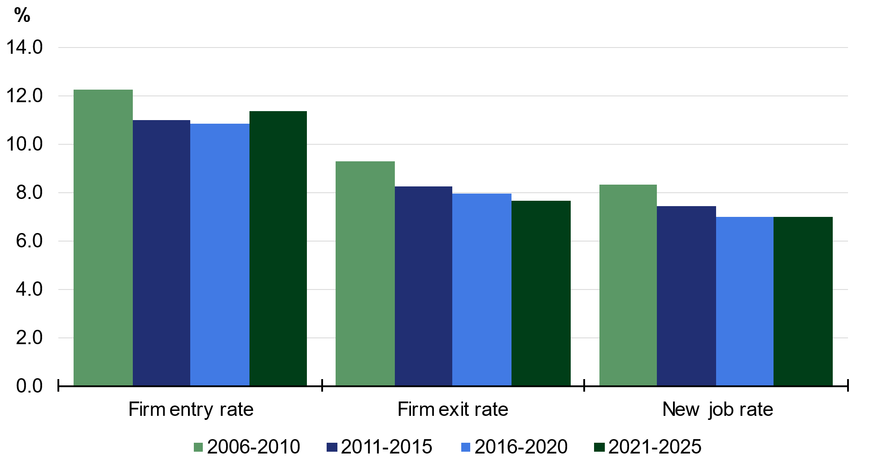
Note: Entry and exit rates are for employing firms.
Source: Treasury analysis of ABS Counts of Australian Businesses data, ABS Labour Force microdata and ABS System of National Accounts.

Productivity growth is predominantly driven by the private sector, but governments can influence productivity by fostering a business environment and policy settings that support investment, innovation, competition and business dynamism. This includes maintaining macroeconomic stability to support investor confidence and expected returns, regulatory and institutional settings that strengthen competition and business dynamism, and tax settings that reduce frictions for new investment, including for emerging and innovative firms.
Changes to the corporate tax system can encourage a more dynamic and resilient economy by lowering barriers to productive investment, minimising distortions that advantage large and incumbent firms, encouraging sensible risk taking, promoting the diffusion of innovation through the economy and better supporting firms’ resilience during economic shocks.

Reforming the tax system will support a more resilient economy
Recent years have underscored how exposed economies are to global disruption. Geopolitical fragmentation, supply chain shocks and more recent cost-of-living pressures are not isolated events, but part of a broader shift towards a world characterised by greater volatility and uncertainty. These forces are increasingly becoming the norm rather than the exception, placing sustained pressure on households and businesses.
Against this backdrop, reforms that support a more resilient, productive and equitable economy are more important than ever to make sure Australia is well placed to manage these challenges, seize opportunities and share the benefits of gains from changing economic conditions.
This means that tax reform is a critical component of the Government’s response to the current economic context. Reforms that improve the efficiency, sustainability and equity of the tax system can strengthen Australia’s capacity to navigate current and future disruptions, while supporting productivity and better living standards over time. This requires taking a system-wide view of the tax system, ensuring settings remain fit for purpose in a rapidly changing global and domestic environment.

A fairer system for workers, homebuyers and future generations
Younger Australians are finding it harder than earlier generations to build wealth and buy a home, as house prices have risen much faster than incomes. At the same time, tax concessions on asset income are adding to housing demand and can encourage speculation in existing dwellings, while also weakening the fairness and resilience of the tax system.
To address these issues, the Government is implementing significant reforms ensuring income from assets is taxed more fairly and consistently, while reducing taxes on income earned from work through the Working Australians Tax Offset.
These reforms include replacing the CGT discount with indexation and limiting negative gearing for residential property to new builds so tax support is better targeted to housing supply rather than existing homes. These changes are prospective, will support more first homebuyers to enter the housing market over time, exempt new builds, and form part of a package of reforms that will support supply overall.
The Government is also implementing a 30 per cent minimum tax on real capital gains and on the taxable income of discretionary trusts to make the tax system fairer and more sustainable.

Reforming negative gearing and the capital gains tax

The 50 per cent capital gains tax discount
Capital gains are the income earned from an increase in asset values over time – such as for shares or investment properties. Under current rules, capital gains income earned by individuals, partnerships and trusts is taxed when an asset is sold and generally attracts the 50 per cent CGT discount.
Taxing capital gains with some level of concession from the headline rate on other income sources is generally considered appropriate. A portion of any capital gain is attributable to inflation. Taxing nominal gains at full rates leads to high effective rate of tax on real economic returns. This can distort how investment decisions are made, particularly for assets held over long time periods. In addition, capital gains are taxed upon realisation, and high rates of tax can encourage owners to delay asset sales. This ‘lock-in’ effect can discourage investors switching assets where it is efficient to do so and impact revenue collections.
Before the 50 per cent CGT discount was introduced in 1999, capital gains were adjusted for inflation so that only the real component of gains were taxed. The 50 per cent discount was introduced following the Review of Business Taxation, which argued that among other things, the introduction of a generally more generous tax treatment of capital gains would encourage investment in the Australian share market, spur investors to buy and sell assets more frequently, and increase tax revenues.
Over 25 years since its introduction, the share of Australians receiving dividend income has fallen, while the share with investments in property has grown considerably (Chart 4.7).
Chart 4.7: Australians receiving dividend income has declined since 2001
Share of tax filers with dividend or rental income, change from 1999–2000
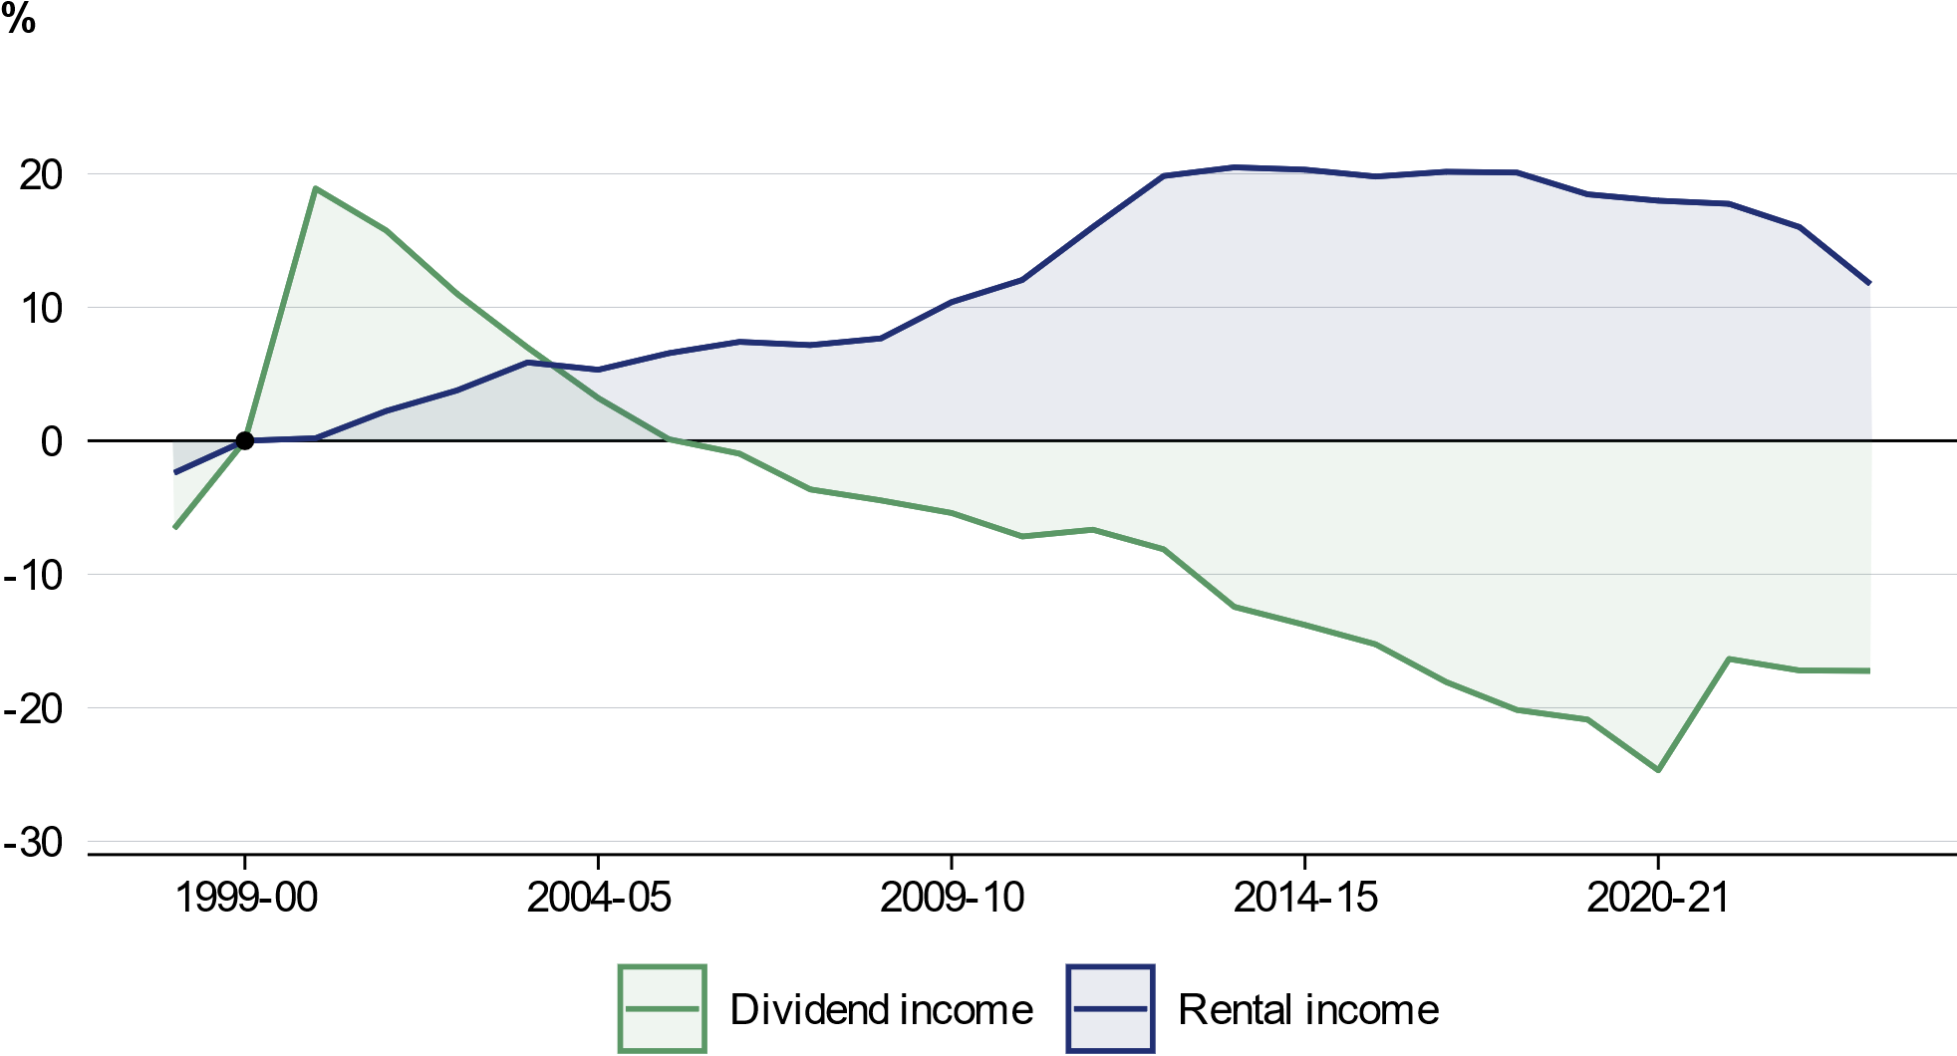
Note: A tax return is classified as having dividend income if the return has franked or unfranked dividend income, or if the return has distributions from non-primary production trust types associated with exchange traded funds, or if the return has franked distributions from non-primary production related trusts. Analysis of HILDA also shows the proportion of households owning shares has fallen since 2001, and the ASX Australian Investor Study shows a decline in ASX exchange investors between 1998 and 2023: ASX (2023).
Source: ATO and Treasury.

Further, the flat discount is arbitrary and does not accurately compensate for inflation. Compared to cost base indexation, the flat discount overcompensates some investors while undercompensating others (Box 4.2).
Over the past 20 years, property has typically been overcompensated for inflation, with the inflation share of capital appreciation averaging 38 per cent for properties held for ten years. At the same time, parts of the property market, such as investments in units especially in regional areas, have been undercompensated for inflation. Australian shares have typically seen inflation account for close to 50 per cent of nominal gains over this period (Box 4.2).
This means the current CGT discount has the potential to significantly distort investment decisions, incentivising investment in existing houses.
Box 4.2: A fixed CGT discount cannot appropriately compensate investors for inflation
Although a key justification of the discount is to compensate investors for the impact of inflation, a fixed-rate discount cannot deliver an accurate inflation adjustment across a varied population of investors and assets.
The capital gain returns to assets vary significantly across different assets and holding periods. Recent analysis of 1.5 million Australian investment property transactions between 2008 and 2025 finds that real annualised returns ranged from a loss of 1.6 per cent at the 25th percentile to a gain of 5 per cent at the 75th percentile (Brennan, Dwyer, Garvin & Nolan, 2026). The difference in returns by asset value is apparent in the property market. Since its introduction, the 50 per cent discount has generally overcompensated investments in detached housing, often by a considerable amount (Chart 4.8, Table 4.1). Investors in units and medium density housing – which play an important role in increasing housing supply – have generally been undercompensated over the past decade.
Indexation of the cost base addresses the inflation component of a capital gain return directly, ensuring that only the real gain enters a person’s taxable income.
Chart 4.8: The CGT discount does not appropriately compensate property investors
10-year house price growth relative to inflation
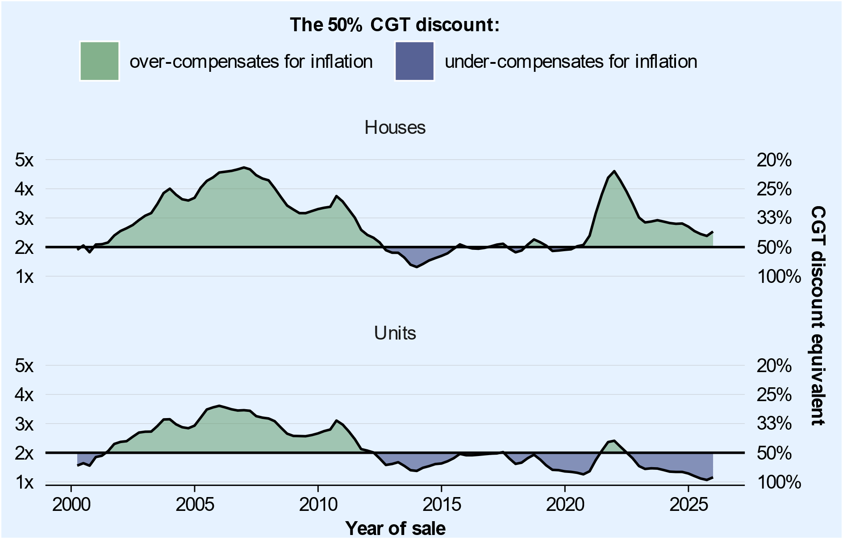
Source: Cotality Data, ABS and Treasury.

continued on next page

Box 4.2: A fixed CGT discount cannot appropriately compensate investors for inflation (continued)
On average, the flat 50 per cent CGT discount has been more neutral relative to inflation for investors in the share market (Table 4.1). However, variation in returns means outcomes depend on the period when they held the asset (Chart 4.9). Over the past 15 years, more often than not, share investors holding for ten years would have been undercompensated for inflation on average.
Chart 4.9: The CGT discount does not appropriately compensate investors in the share market
10-year Australian share price growth relative to inflation
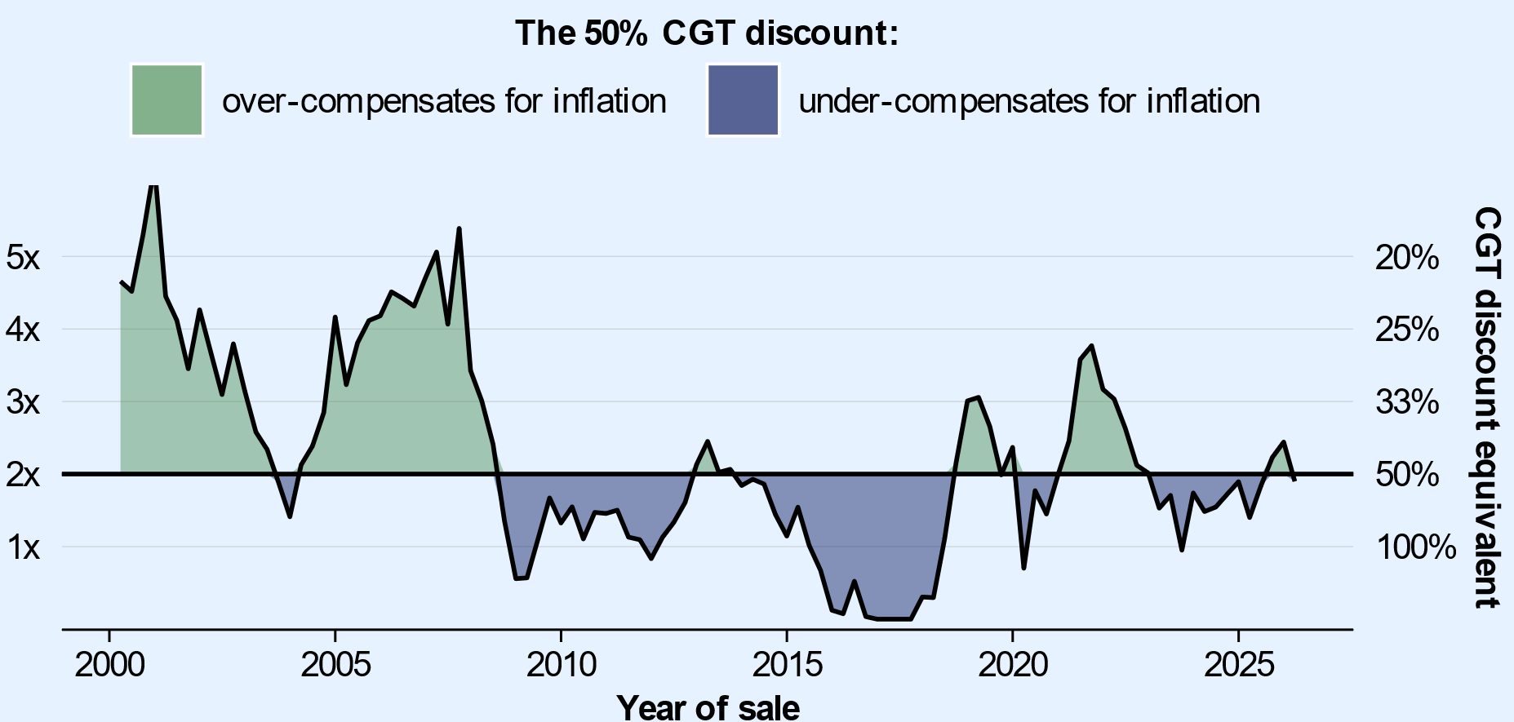
Source: Treasury, ASX and ABS.

Table 4.1: The appropriate CGT discount differs by asset
Inflation share of asset price growth, average over past 20 years (%)
 | 2y hold | 5y hold | 10y hold | 20y hold
All property | 45 | 45 | 38 | 33
House | 43 | 42 | 36 | 31
Unit | 63 | 59 | 50 | 42
Capital cities | 43 | 43 | 37 | 31
House | 40 | 40 | 34 | 29
Unit | 59 | 56 | 48 | 38
Regional property | 56 | 48 | 45 | 42
House | 53 | 45 | 43 | 38
Unit | 77 | 67 | 63 | 59
Shares
All Ordinaries | 53 | 50 | 53 | 43
S&P/ASX 200 | 56 | 53 | 56 | 50
Note: Figures represent inflation over the holding period as a share of nominal capital appreciation over that period for each month between January 2006 and March 2026.
Source: Cotality Data, ASX and Treasury.

The benefits of the capital gains tax discount predominantly flow to Australians who earn among the highest incomes over the course of their lives. One-third of all capital gains are realised by individuals who earn incomes in the highest 1 per cent during their working lives, and more than half of all gains are realised by the highest 10 per cent (Chart 4.10).
The current treatment of capital gains also creates opportunities for taxpayers to time the sale of assets for tax reasons. Unlike most income, capital gains are taxed on realisation, when the asset is sold, not when the gains accrue. As realised capital gains are taxed at an individual’s marginal tax rate, there are strong incentives for investors to hold onto assets and sell them in years when their marginal tax rates are lower than usual, such as after retirement. Choosing to sell assets when marginal rates are low can provide a large tax benefit, compounding the benefits of the CGT discount.
Between 2009–10 and 2022–23, the average marginal tax rate investors faced on net capital gains income was roughly 25 per cent. On average, this was about 7 percentage points lower than in the ten years leading up to asset sale (Chart 4.11). A marginal rate of 25 per cent is lower than that faced by a full-time minimum wage earner.
Chart 4.10: Capital gains typically flow to those with high lifetime income  Share of net capital gains income | Chart 4.11: Marginal tax rates tend to be lower in years with capital gains  Average marginal tax rate
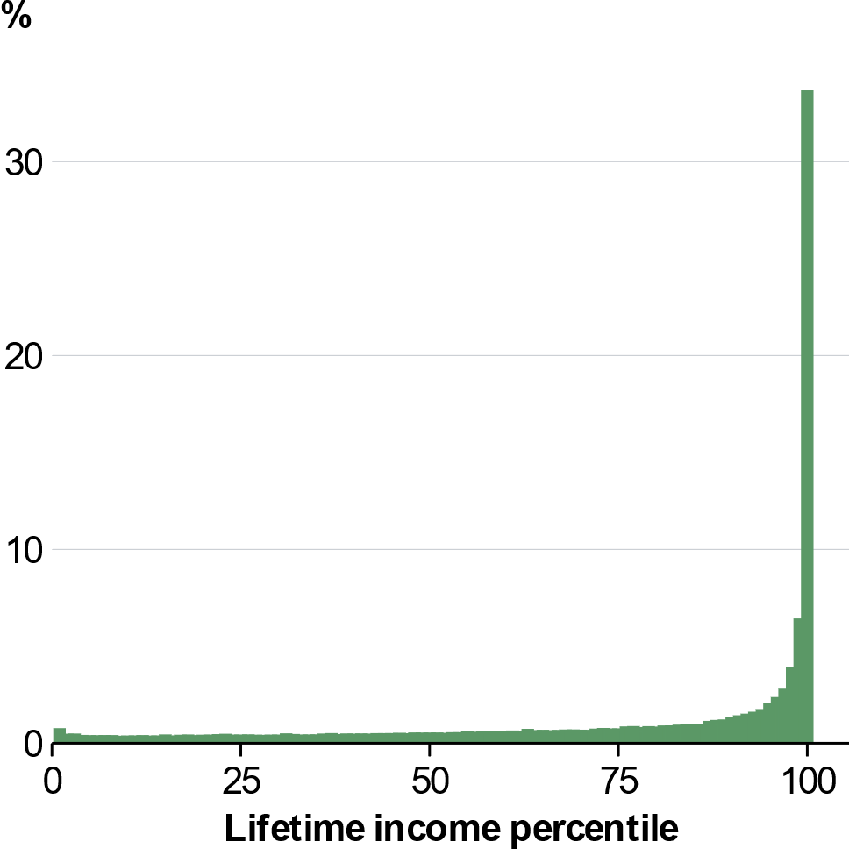 | 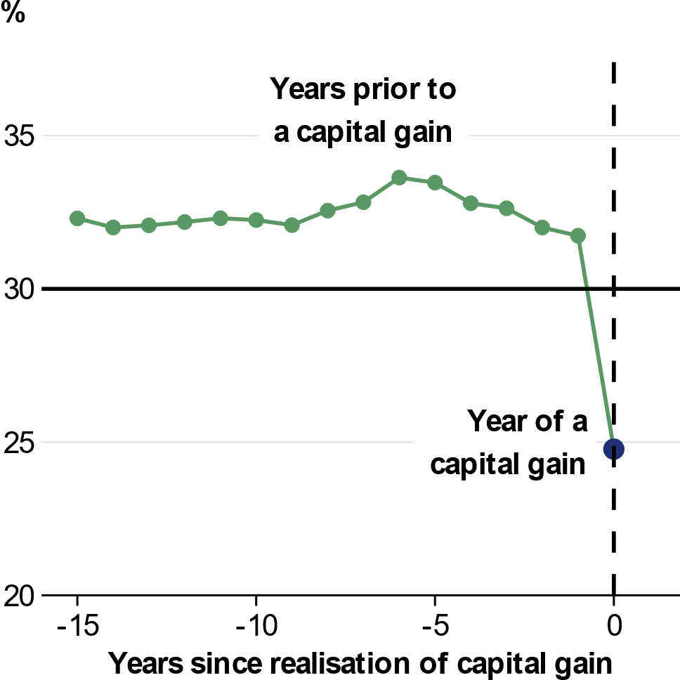
Note: Capital gains are pooled over 2016–17 to 2022–23. Includes individuals aged 34–‍82 at the time of their capital gain.  Source: ATO and Treasury. | Note: Average marginal rates are calculated before any capital gains income and are weighted by the size of the capital gain in the final year. Includes people with capital gains between 2009–10 and 2022–23.  Source: ATO and Treasury.

Negative gearing compounds the effects of the CGT discount on housing
An investment is negatively geared when it runs at a current net loss and these losses are used to reduce the investor’s annual taxable income from unrelated sources, such as wages and salaries. Property investments account for over 98 per cent of the net losses from negatively geared investments, largely reflecting the ready availability of finance for property. Interest costs from financing loans used to buy the property typically drive these losses.
This practice reflects the general principle of taxing net increases in income after deducting related expenses. However, international practice is that net rental losses are often not deductible from unrelated income, such as salary and wages. Australia is in a minority of OECD countries that allow unlimited deduction of rental losses against other income. Further, there are broader international trends toward separating how wages and asset income are taxed. There are strong equity and efficiency arguments for drawing a stronger link between rental losses and the earnings which they can be deducted against.
Negative gearing, in combination with the capital gains discount, contributes to low effective tax rates on property investments. When the capital gains on an investment are taxed differently to losses – as they are in Australia – full deduction of losses against other income creates asymmetry in the tax system. Losses are deducted in full today, often at higher marginal tax rates, while capital gains are taxed at a 50 per cent discount at some point in the future, often when the taxpayer has a lower tax rate.
This asymmetric combination means the income tax rate investors pay on these assets is often very low, or negative, when calculated over the life of the investment. For almost one in three investment properties sold in 2022–23 which were net negatively geared on average throughout the course of the investment, investors paid less income tax than they would have if they had not purchased the property at all – despite also turning a nominal profit (Chart 4.12). This occurs because the tax benefit from rental loss deductions exceeds the capital gains tax investors eventually pay on sale. In these cases, the Government provides an effective subsidy to investors. While the CGT discount contributes to this outcome, an effective subsidy is only possible due to negative gearing and the reduction in income tax it enables. Where investors receive a subsidy, this outcome is more generous than that available to owner occupiers and means that negatively geared properties can be one of the most concessionally taxed assets alongside concessional superannuation.
Chart 4.12: Many negatively geared rental property investors receive a net tax subsidy
Share of negatively geared property investors, by nominal effective lifecycle tax rate
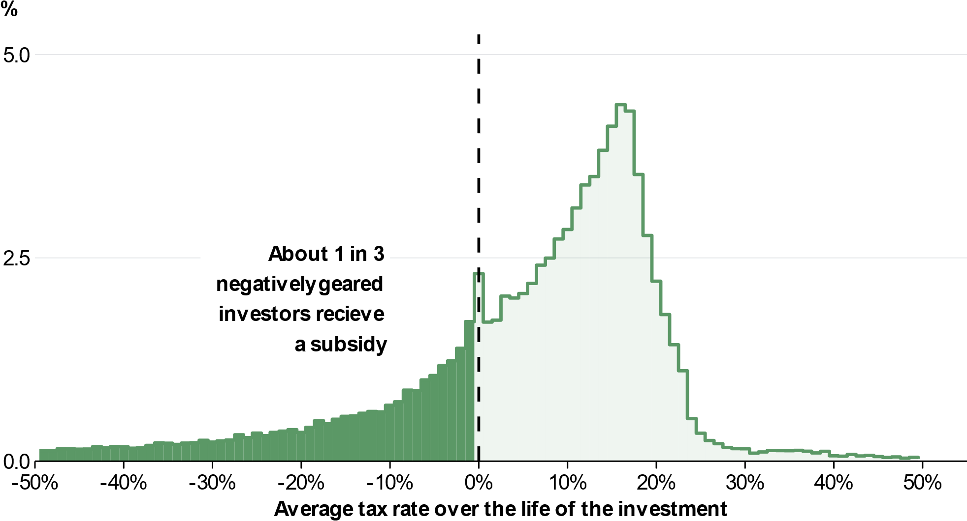
Note: Includes individuals who made a net profit from property income and reported over $25,000 in gross rent over the 15-year period before sale. Tax rates over the lifetime of the investment are estimated by dividing the net real property income tax by net real property income profit over a 15-year period, for individuals who sold an investment property in 2022–23. This includes income taxes only, and does not include stamp duty, land tax, or council rates. This analysis is consistent with the finding that highly leveraged property investors can face negative tax rates (for example, see the Australia’s Future Tax System (AFTS) Review, chart A1-20). The AFTS work used stylised assumptions to estimate prospective real marginal effective tax rate a given investor may face, whereas this chart depicts effective tax rates that are observed in historical data.
Source: ATO and Treasury.

Low effective tax rates on property investments caused by the interaction between the 50 per cent CGT discount and negative gearing create strong incentives for investors to take on highly leveraged housing investments. This leads to higher house prices – as investors bid up the price on a scarce resource to receive the concession. It also distorts investment away from higher income-generating assets with lower capital returns, such as higher density housing, and investments in shares that are less easily funded with leverage (Table 4.1).
Property investments are typically in existing housing, with the share of investor housing lending used for existing dwellings ranging from approximately 80 per cent to 90 per cent since 2019 (Chart 4.13).
Encouraging high leverage can also reduce the economic resilience of households. Around 40 per cent of new investor lending is interest only, compared to less than 10 per cent for owner-occupiers. Investors have loans that exceed six times their income at more than double the proportion of owner-occupiers.
Where Australian households respond to these incentives, they may also hold riskier and less diversified investment portfolios than otherwise, reducing the resilience of households and asset markets to economic and financial shocks.
Chart 4.13: Most investor credit goes to existing housing
Annual credit for property, by investors and property characteristics
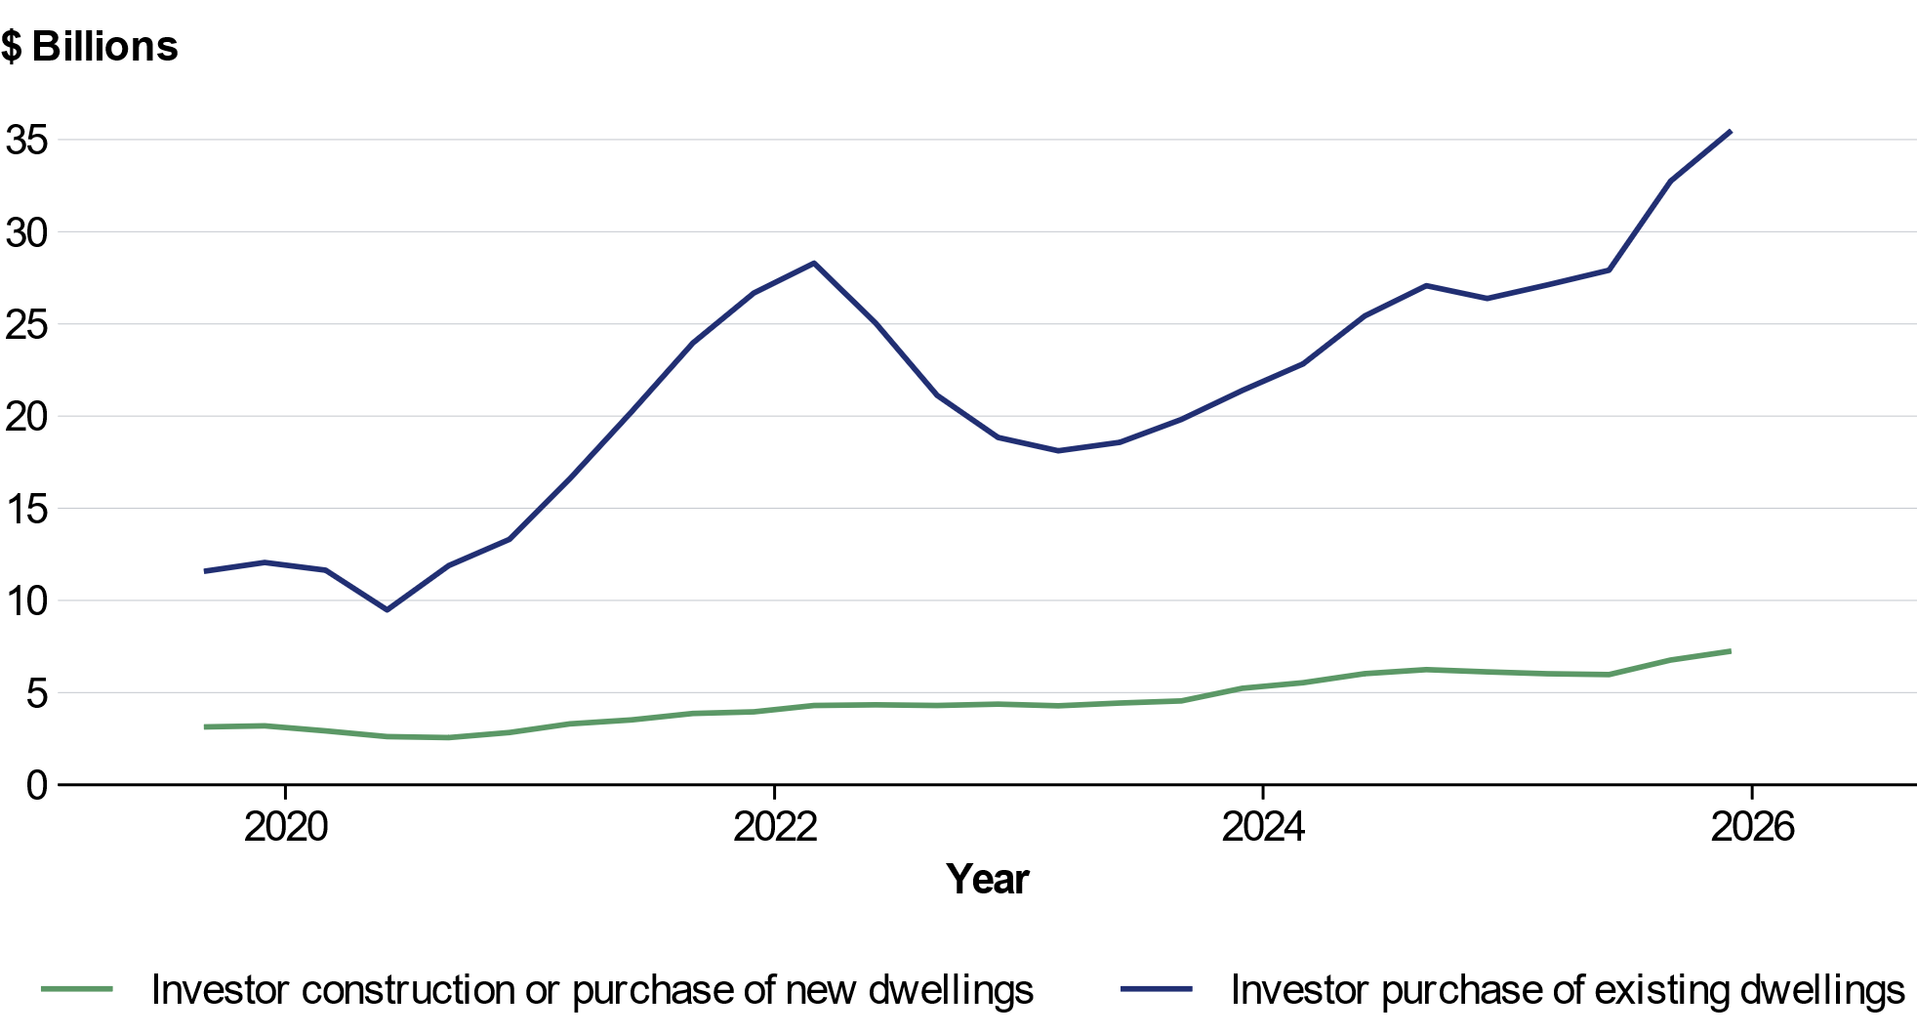
Source: ABS Lending Indicators, 2025.

How the incentives provided by negative gearing affect different taxpayers depends on their means. The ability to borrow correlates with income, and rental losses are most valuable for people facing high marginal tax rates. As such, the tax benefits from negative gearing are concentrated among higher income earners. Around half of tax benefits from negative gearing accrue to the top earning 10 per cent of Australians over their lifetime, while 12 per cent of the benefits accrue to the top percentile (Chart 4.14). Higher income individuals are more likely to invest in property, report larger rental losses, and have more negatively geared property interests.
Over time, rental property investments are also becoming more concentrated among older Australians as property prices continue to rise faster than wages (Chart 4.15). Meanwhile, younger Australians are finding it more challenging to enter the market to buy their first home.
Reflecting these issues the OECD have recommended cutting or eliminating the capital gains tax discount and phasing out negative gearing.
Chart 4.14: Negative gearing tax benefits typically flow those with higher incomes  Share of total tax benefit from rental losses | Chart 4.15: Older Australians area growing share of property investors  Share of property investors by age
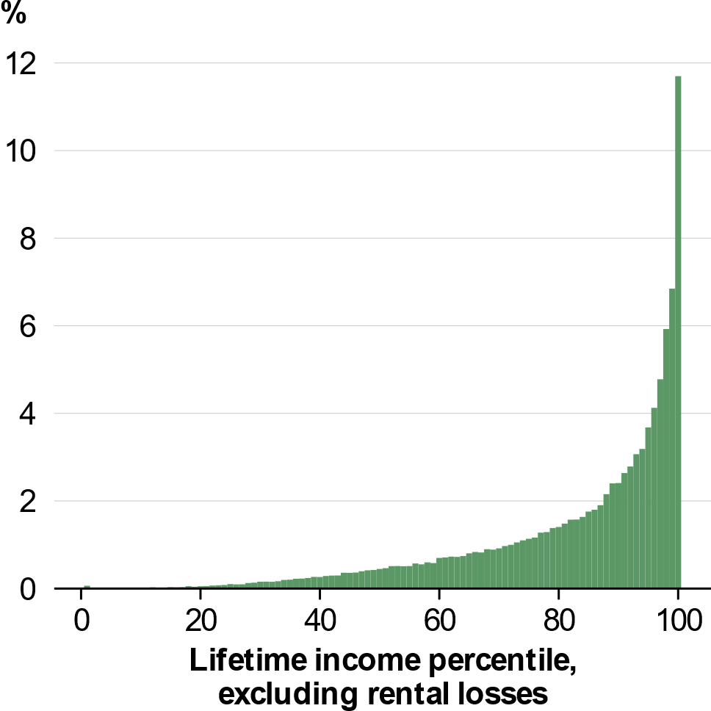 | 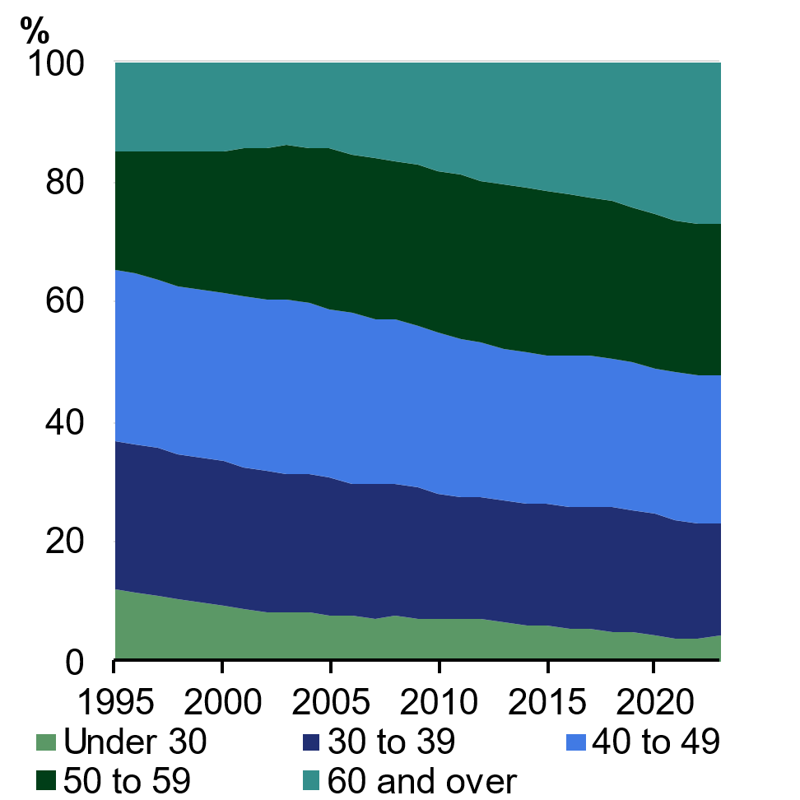
Note: Tax benefits are defined as the reduction in tax paid because of rental losses. Income tax includes the Medicare levy and the low income tax offset.  Source: ATO and Treasury. | Note: Property investors are defined as tax‍ filers with gross rental income.  Source: ATO and Treasury.

The Government’s reforms to the capital gains tax discount and negative gearing
Younger and future generations of Australians face greater economic barriers than many generations preceding them. While not the only driver of these challenges, Australia’s current tax settings are making it harder for younger Australians to get ahead.
That is why, from 1 July 2027, the Government is:
- Returning to inflation indexation of capital gains for assets held by individuals, trusts and partnerships
- Introducing a 30 per cent minimum tax on real capital gains for assets held by individuals, trusts and partnerships; and
- Restricting negative gearing of residential properties to new builds.
Together, these reforms will help to level the playing field for first homebuyers, while maintaining support for investment in new housing supply. Investors who buy new builds will be able to choose either the 50 per cent CGT discount or indexation and the minimum tax when they sell the property and will be unaffected by the changes to negative gearing.
The reforms are expected to raise $3.6 billion in receipts over the forward estimates period. The additional revenue gained from these reforms will help fund tax cuts for workers, make the Budget more sustainable and create room for further tax relief over time.

Returning to indexation of capital gains
The Government is replacing the 50 per cent capital gains tax discount with cost base indexation for CGT assets, from 1 July 2027. This returns the CGT regime to its original intent of taxing real capital gains, appropriately compensating taxpayers for inflation. To maintain support for new supply, investors who buy new builds will be able to choose either the 50 per cent CGT discount or indexation and the minimum tax when they sell the property.
The reintroduction of cost base indexation achieves a more neutral and fairer treatment of capital gains compared with the fixed 50 per cent CGT discount which applied to nominal capital gains. This change is expected to reduce the overall level of concession provided to capital gains which currently flows overwhelmingly to wealthy households, improving the equity of the tax system.
The 50 per cent CGT discount will continue to apply to gains that accrued prior to commencement. For assets held prior to 1 July 2027, but sold thereafter, the 50 per cent CGT discount will apply to the difference between the asset’s value at 1 July 2027 and its cost base, while indexation and the minimum tax will be used to calculate the CGT on gains accruing from 1 July 2027 (the asset’s value at that date will form its cost base). To determine the asset’s value at this date, taxpayers can either seek a valuation or use a specified apportionment formula that estimates the asset’s value based on its average return over the holding period (supported by ATO tools). These transitional arrangements are prospective, applying only to gains that accrue after the start date. Applying the new arrangements to future gains also minimises the disruption to asset markets. If assets held before the start date were indefinitely excluded this would create strong incentives for investors to avoid selling these assets.
The same approach will apply to assets acquired before the beginning of CGT in 1985. Bringing assets held before 1985 into the CGT regime will improve horizontal equity and enhance the intergenerational equity objectives of the package. At the same time, this approach preserves existing treatment of gains on pre-1985 assets earned before 1 July 2027. Gains on pre-1985 assets earned from 1 July 2027 will be taxed under the new arrangements upon realisation. The current small business CGT concessions will continue unchanged.
Under these arrangements, the effective tax rate on capital gains would vary depending on an individual’s marginal rate, their nominal returns and the inflation rate over the period the asset had been held. Any comparison with alternative tax arrangements needs to take these factors into account. Further detail on returns compared to inflation for different asset types is contained in Box 4.2.

Introducing a 30 per cent minimum tax on real capital gains
The Government is also introducing a 30 per cent minimum tax on real capital gains income earned from 1 July 2027. The minimum tax will reduce incentives to defer the sale of assets to periods when other income and marginal tax rates are low. This will support a more consistent taxation of lifetime income by aligning the tax rate on real capital gains with the marginal tax rate faced by the average worker on incomes from $45,000 to $135,000.
Income support recipients, including pensioners, will be exempt from the minimum tax, ensuring people with low income and low wealth are not disadvantaged. The capital gains of people who are already subject to at least the 30 per cent marginal rate on their non-capital gains income will not be affected by the minimum tax. The 30 per cent minimum is aligned with the minimum tax being introduced on discretionary trusts.
The minimum tax rate reduces the benefits of timing the realisation of capital gains to minimise tax paid. This ensures that affected taxpayers are subject to a tax rate that is closer to the marginal rate they faced during their working life. If applied in 2022–23, over 95 per cent of net capital gains income would have been earned by people who are either not affected by the minimum tax or who had a marginal tax rate of more than 30 per cent during their working lives. In 2022–23, about 70 per cent of salary and wage earners faced a marginal rate of 30 per cent or higher.
The minimum tax on real capital gains also mitigates against potential lock-in effects that can result in prolonged holding of assets to reduce tax. The minimum tax reduces incentives for investors to delay selling assets to when they have lower marginal tax rates, for example at retirement, improving the allocation of resources across the economy and supporting productivity growth.

Restricting negative gearing of residential properties to new builds
The Government is limiting negative gearing for residential property to new builds, from 1 July 2027. Net rental losses from established residential properties will only be deductible against rent or the capital gains from residential properties.
Excess losses can be carried forward and offset against residential property income in future years (Box 4.3). This avoids disincentivising investments in maintenance and capital improvement of investment properties which might otherwise be avoided if they would generate rental losses that could not be claimed as a deduction.
In combination with the return to CGT indexation, limiting deductions for rental losses will reduce the tax advantages of leveraged investment in established residential properties. Limiting rental deductions to rental income leads to a more neutral tax treatment, reducing biases to make investments based on tax settings. These changes will also improve fairness in the tax system since the benefits of negative gearing disproportionately flow to higher-income taxpayers.
The limitation on negative gearing will apply only to net rental losses from residential property as the housing sector is where the arrangement predominates and generates the greatest distortions to investment. Commercial property and other asset classes, such as shares, will remain subject to existing arrangements.
Box 4.3: Quarantining the carry forward of rental losses
Jason invests in an existing residential property after 1 July 2027. Since the property was purchased after Budget night, 12 May 2026, it will be subject to the changes to negative gearing. This means deductions from rental losses will be limited to rental income or capital gains from residential property. Any excess losses will be carried forward to future years.
In 2027–28, Jason incurs a net rental loss of $10,000 from his property. Under the quarantining arrangements, the $10,000 cannot offset Jason’s other taxable income in 2027–28 but can offset residential property rental income and/or residential property capital gains, including in future years.
In 2028–29, Jason earns $6,000 in net rental income from his property. As the $10,000 carry forward loss from the previous financial year is applied against this income, Jason would pay no tax on the rental income in this year. Jason now has a $4,000 quarantined loss that can continue to be carried forward.

These changes will help address housing affordability pressures facing first homebuyers, allowing more younger Australians and future generations to own their own home (Box 4.4). These reforms are expected to reduce investor demand for existing properties, while eligible new builds will be exempt from the changes, ensuring the benefits of negative gearing are directed to investment that support growth in Australia’s housing stock.
Transitional arrangements will ensure the arrangements for taxpayers who made investment decisions under current settings do not change. Properties purchased or held prior to announcement will be exempt from the changes until disposed of. This includes properties where a contract has been entered into but not yet settled. Properties purchased after 7:30pm (AEST) on 12 May 2026 and before 30 June 2027 may be able to be negatively geared during this period, but not in subsequent years. In practice, the benefits to existing investors from these transitional arrangements are not expected to continue indefinitely. Over half of negatively geared properties are typically sold or become positively geared within four to five years, and over 75 per cent within ten years.
Box 4.4: Housing measures in this Budget
The measures in this Budget are expected to improve home ownership and increase the overall supply of housing. The reforms to negative gearing and capital gains tax are expected to enable an additional 75,000 Australians to buy their own home over the next decade. Driven by reforms and investment that reduce barriers to housing supply, this Budget will also support up to 30,000 new homes over the next decade, and more as the benefit of productivity-enhancing reform flows through into the housing market.
To achieve lasting improvements in housing affordability, housing supply needs to better respond to demand. This Budget adds a new $2 billion initiative to the Government’s now over $47 billion Homes for Australia plan that fast tracks housing-enabling infrastructure projects. This will support up to 65,000 new homes over the next decade. As part of this initiative, further planning, zoning and productivity reforms will be required of states and territories. Further structural reforms to address barriers will enhance the effectiveness of the supply side of the housing market. This ambitious set of reforms has the potential to support tens of thousands of additional homes.
The tax reform package is expected to reduce investor demand, particularly by highly leveraged investors. This reduced demand will likely lead to a modest and temporary slowing in housing price growth that improves affordability. Treasury modelling suggests housing prices will temporarily grow by around 2 per cent less over a couple of years relative to no tax policy change. For comparison, on average housing prices have grown at 6 per cent per year since 2000. This means that a buyer purchasing a home at the current national median price would save around $19,000.
This improvement in affordability and lower investor demand is expected to shift the ownership mix towards more owner-occupiers. Treasury modelling suggests that the reforms will increase the owner-occupier share of the housing market, resulting in around 75,000 additional owner-occupiers over the next decade. This is equivalent to reversing around ten years of declines in the home ownership rate.
Lower house price growth will have a modest impact on housing supply, with the increase in supply over the next decade expected to be only around 35,000 dwellings fewer compared to no tax policy change, equivalent to around a quarter of a per cent of the current dwelling stock. This modest impact is more than offset by up to 65,000 new homes supported under the new Local Infrastructure Fund, as well as significant other housing supply measures in this Budget and since the Government was elected. Exempting new builds from the tax changes also limits the supply impacts and is expected to encourage investors to rebalance their portfolios towards new builds, while other design features are expected to encourage investment in higher density dwellings.
continued on next page

Box 4.4: Housing measures in this Budget (continued)
The reforms are likely to have a small impact on rents, with an expected increase of less than $2 per week for a household paying the current median rent. For comparison, a single person receiving the maximum rate of Commonwealth Rent Assistance (CRA) received an increased benefit of more than $20 per week due to the 2023 and 2024 increases in CRA.
The combination of the Government’s policies in this Budget will add to housing supply, which will exert downward pressure on rents over time.

Introducing a minimum tax on discretionary trusts
A trust is a legal arrangement where a person (a trustee) holds and manages assets for the benefit of others (the beneficiaries). Trusts are not usually taxed on the income they earn. Instead, beneficiaries are made entitled to income of the trust through distributions and, based on this, pay tax on their share of the trust’s taxable net income at their marginal tax rate.
Trusts can take many different forms, including discretionary trusts – the most common type of trust in Australia. While trusts may be used to support legitimate family and commercial arrangements, including as a collective investment vehicle, for asset protection and for succession planning, the current taxation of discretionary trusts allows some taxpayers to reduce their taxes, weakening progressivity, equity and the sustainability of the tax system. Other types of trusts, such as fixed trusts, do not have the same flexibility and tax advantages as discretionary trusts.
The number of discretionary trust structures has more than doubled over the past 20 years, and Australia now has over 1 million trusts, most of which are discretionary trusts (Chart 4.16). These are largely used by high-income and high-wealth Australians; the wealthiest 10 per cent of Australian households hold over 90 per cent of the value of private trusts (Chart 4.17). Over 95 per cent of Australians do not receive income from a discretionary trust.
Chart 4.16: Australia now has over 1 million trusts  Count of trusts in Australia | Chart 4.17: The wealthiest households hold most private trust wealth  Distribution of total private trust wealth, 2019–20
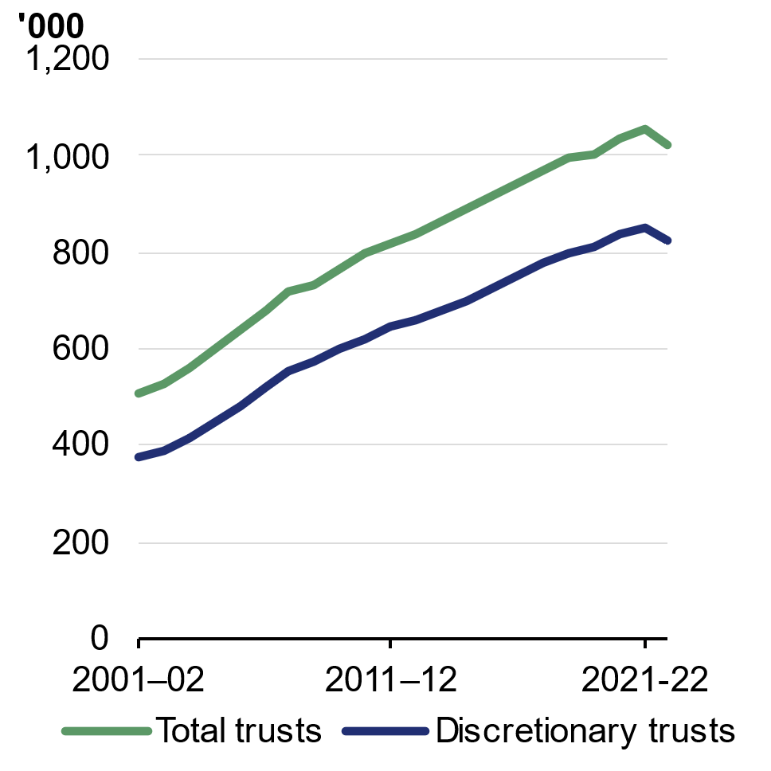 | 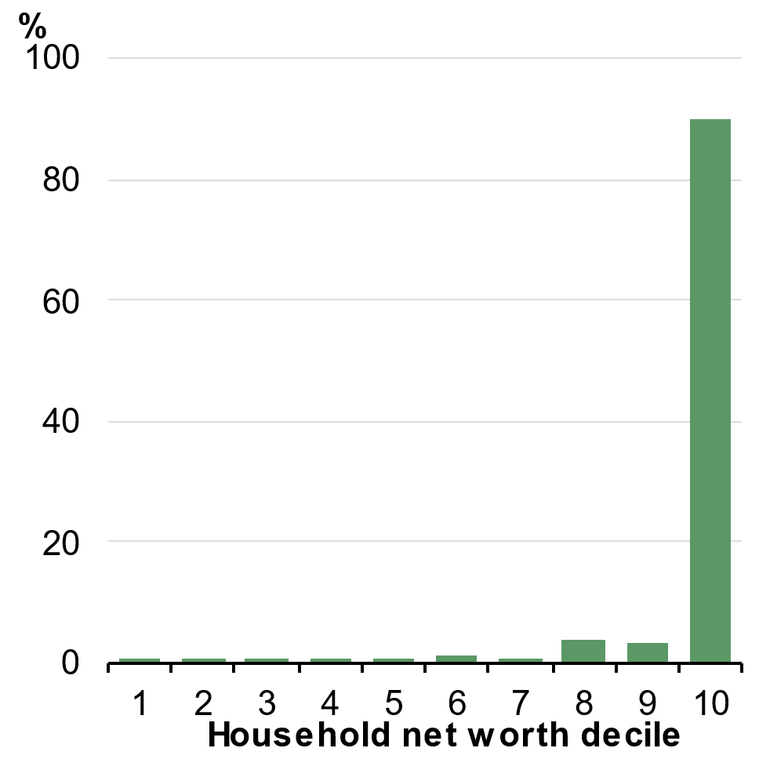
Note: Counts for 2022–23 income year may be revised upwards reflecting late lodgements.  Source: ATO Taxation Statistics and Treasury. | Source: ABS Survey of Income and Housing and Treasury.

Discretionary trusts create tax advantages for some taxpayers, but not others
Discretionary trusts are used for many of the same reasons as other types of trusts but differ in that they allow trustees to distribute income to different beneficiaries each year, rather than those distributions being set by the trust deed. This gives rise to fairness concerns as distributions are often made between family members and other beneficiaries to take advantage of lower tax rates. Bunching of income around tax thresholds suggests that trusts are used to distribute income to individuals such as family members with lower tax rates (Chart 4.18). Some trustees also make payments to corporate beneficiaries to take advantage of the corporate tax rate.
Chart 4.18: Discretionary trust distributions target lower income tax rates
Share of tax filers with income from discretionary trusts
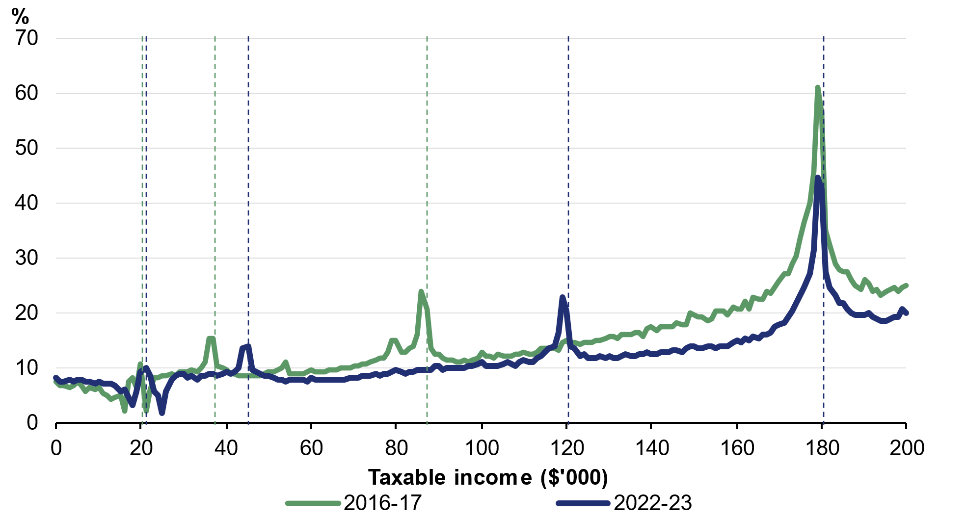
Note: Share of tax filers in each $1,000 income band.
Source: ATO and Treasury.

Some businesses use trust structures rather than operating as a company. In some cases, this involves very complex business structures involving multiple trusts and companies. While discretionary trusts can provide tax benefits, businesses operating through trust structures often miss out on the benefits of corporate structures. Businesses that operate through corporate structures can more easily retain profits for working capital, and business interests can be sold through the sale of company shares. They also have better access to debt and equity financing. Additionally, businesses using corporate structures can access imputation and, in the case of small businesses, the lower 25 per cent corporate tax rate. More complex business structures also significantly increase compliance costs.
Past reviews of the tax system have highlighted concerns with the tax issues posed by trusts including the Asprey Report (1975), A New Tax System (1998), Review of Business Taxation (1999), Australia’s Future Tax System (2009) and Re:think (2015).
Several integrity measures aimed at addressing these concerns regarding trusts have been introduced by successive governments. These include dealing with unpaid trust distributions, imposing the highest marginal tax rate on trustees that do not provide beneficiary details, ensuring concessional treatment for minors is restricted to income derived from deceased estate assets and digitalisation of tax reporting systems as part of the Modernisation of Tax Administration Systems project.
However, more fundamental reform is needed to address the fairness and sustainability concerns raised by discretionary trusts. As of 2022–23, Australia has around 840,000 discretionary trusts, more than doubling from 370,000 in 2001–02 (Chart 4.16). This far exceeds the growth in the number of companies, which has only increased by 70 per cent in the same period. In 2022–23, discretionary trusts distributed $142.4 billion in income, with average annual growth in income of 7.8 per cent since 2011–12.

A minimum tax on discretionary trusts
Building on these past reforms and to further address the issues identified in past reviews, the Government is introducing a 30 per cent minimum tax on the taxable income of discretionary trusts, from 1 July 2028. The tax will be paid by the trustee as it is the trustee that controls distributions. Beneficiaries will still need to declare the income in their tax returns, but beneficiaries, other than corporate beneficiaries, will receive non-refundable credits for the tax payable by the trustee, which can be used to offset current year income tax liabilities.
The minimum tax will mean a fairer rate of tax is paid on income from discretionary trusts, more closely aligning the tax rates for trusts with the rates paid by workers and families who earn a living from wages. This reform supports a fairer and more sustainable tax system.
The introduction of a minimum tax on discretionary trusts will reduce incentives for complex tax structuring and protect the integrity of the tax base. To support adjustment, expanded rollover relief will apply for three years from 1 July 2027 to assist small businesses and other taxpayers to restructure out of discretionary trusts into companies or fixed trusts. This will provide relief from income tax consequences, including capital gains tax, for those who choose to restructure.
From 1 January 2027, the Australian Small Business and Family Enterprise Ombudsman will be available to assist small business understand the options available to them and where they can get further advice. Specific arrangements will be put in place by the Australian Securities and Investments Commission (ASIC) to support small businesses that wish to incorporate and access benefits such as the 25 per cent small business tax rate.
The measure is expected to raise $4.5 billion in receipts over the forward estimates period. The additional revenue gained from these reforms will help fund tax cuts for workers, make the Budget more sustainable and create room for further tax relief over time.
The minimum tax will not apply to primary production income of farms, certain income relating to vulnerable minors, amounts to which non-resident withholding tax applies and income from assets of testamentary trusts existing at announcement.
Other types of trusts, such as fixed and widely held trusts, complying superannuation funds, special disability trusts, deceased estates, and charitable trusts will be excluded from the minimum tax.

Delivering a new round of tax cuts for every working Australian taxpayer
The additional revenue gained from the Government’s reforms to negative gearing, CGT and discretionary trusts provides scope for further rebalancing of the tax system to reduce the tax burden on workers.
The Government will deliver a new round of tax cuts through a $250 Working Australians Tax Offset (WATO), lowering the tax burden for every working Australian taxpayer (Chart 4.19). The WATO will increase the effective tax-free threshold by $1,785 to $19,985 for workers (or to $24,985 for workers receiving the Low Income Tax Offset) from 1 July 2027 for income derived from work. This represents the largest permanent increase to the effective tax-free threshold since 2012–13. This measure is expected to reduce receipts by $6.4 billion over the forward estimates period.
The introduction of the WATO supplements the personal income tax cuts delivered in the 2024–25 Budget and the additional tax cuts for every Australian taxpayer coming over the next two income years, which lower the bottom tax rate from 16 per cent to 14 per cent. An Australian worker on average earnings ($81,245) will receive a combined tax cut of $1,978 in 2026–27 and $2,496 per year from 2027–28, compared to 2023–24 tax settings.
After three rounds of tax cuts, the WATO and the instant tax deduction, an Australian worker on average earnings could receive a combined benefit of up to $2,816 from the 2027– 28 income year relative to 2023–24 tax settings. These changes will provide additional, meaningful cost-of-living help for families by ensuring workers can keep more of what they earn. A worker on average earnings is expected to pay up to $38,977 less tax from 2024–25 to 2036–37, relative to 2023–24 settings.
Chart 4.19: Average tax rate for a worker on average earnings
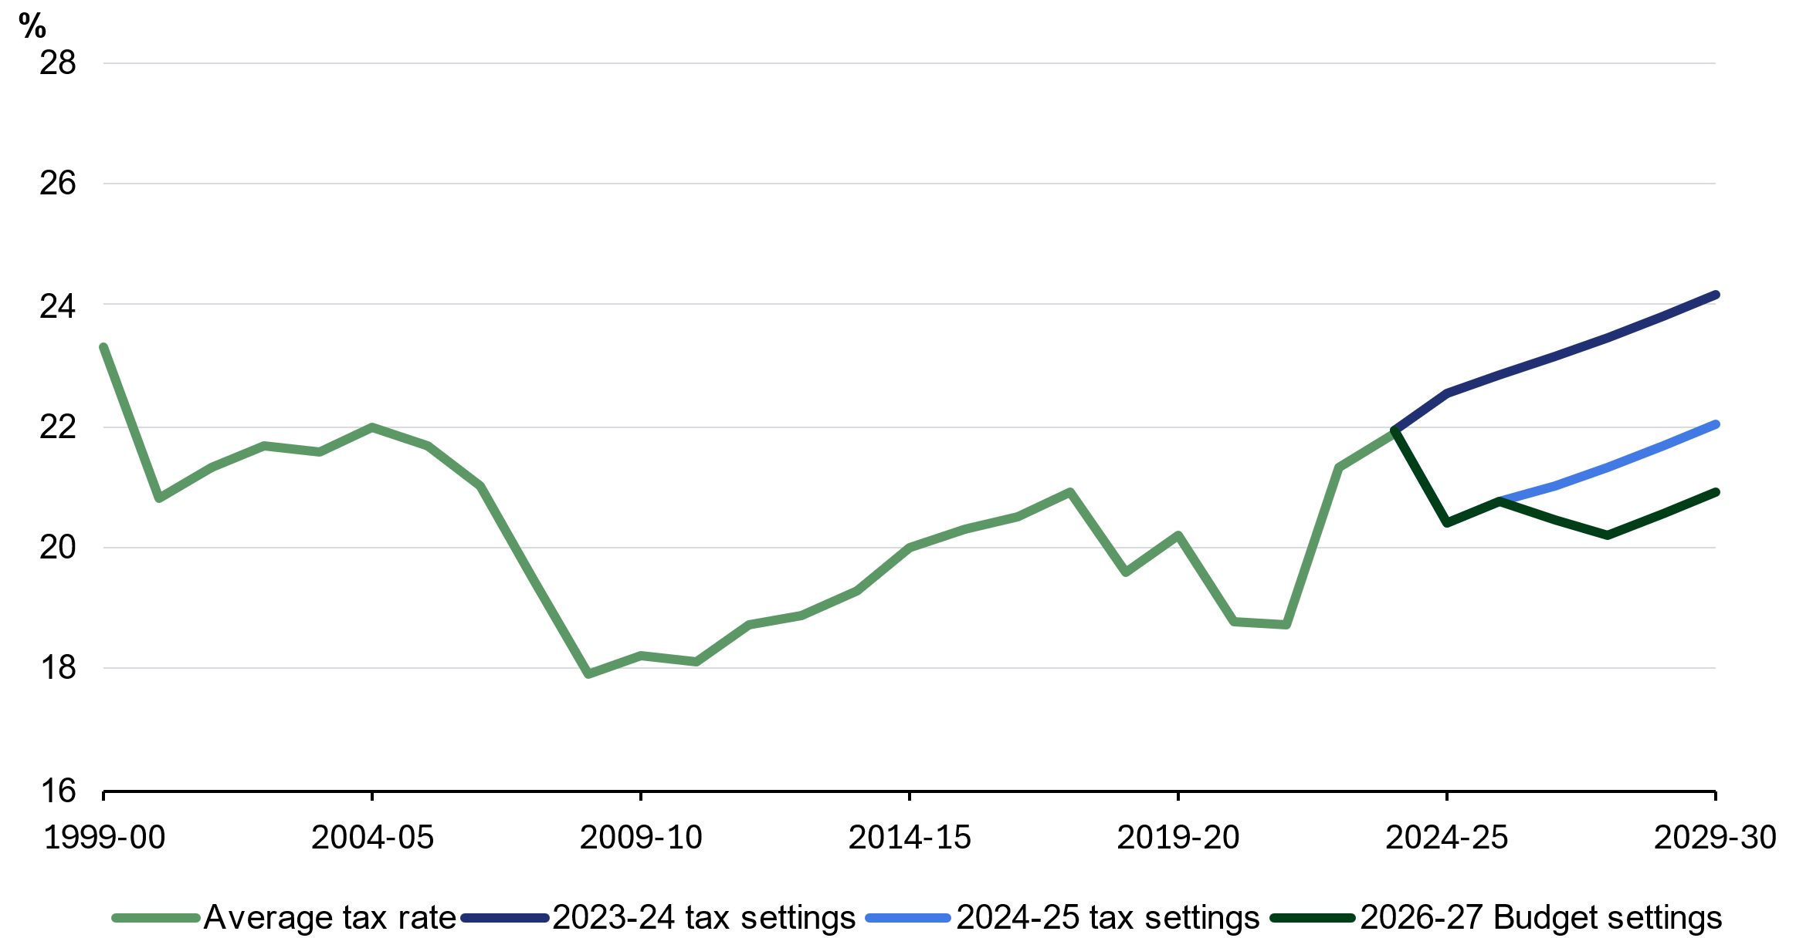
Note: Prior to 2026–27, the worker on average earnings is assumed to have taxable income equal to annualised estimates of average weekly earnings (AWE) after incorporating an annual deduction for work-related expenses of $359. From 2026–27 onwards, the worker’s taxable income is further reduced by the instant tax deduction (providing a tax benefit of $205). From 2027–28 the worker is assumed to benefit from the full Working Australians Tax Offset. Forecasts for AWE are as at the 2026–27 Budget. Average tax rate is defined as the ratio of tax payable to taxable income. Tax payable is calculated accounting for basic tax rates and thresholds and the Medicare levy.
Source: Treasury.

Building on the instant tax deduction for work-related expenses (A simpler, more sustainable tax system section), the WATO will direct relief only to taxpayers for their income earned from work and not their asset income. Further lowering the tax burden on working income can incentivise participation gains among workers and those marginally attached to the labour force.
In 2022–23, women were overrepresented among low labour income earners and secondary labour income earners within families (Chart 4.20). This reflects a range of social and economic factors which influence labour force participation decisions.
When faced with the same percentage change to after-tax wages, women – particularly women with children – are more responsive in the amount they work compared to men. In addition, people with less formal education and those with lower wage potential are more responsive to changes in after-tax income than other individuals. Targeting additional support to these groups of labour income earners is expected to modestly encourage their participation.
Chart 4.20: Labour income earners across the taxable income distribution, 2022–23
Primary earners within families | Other earners within families
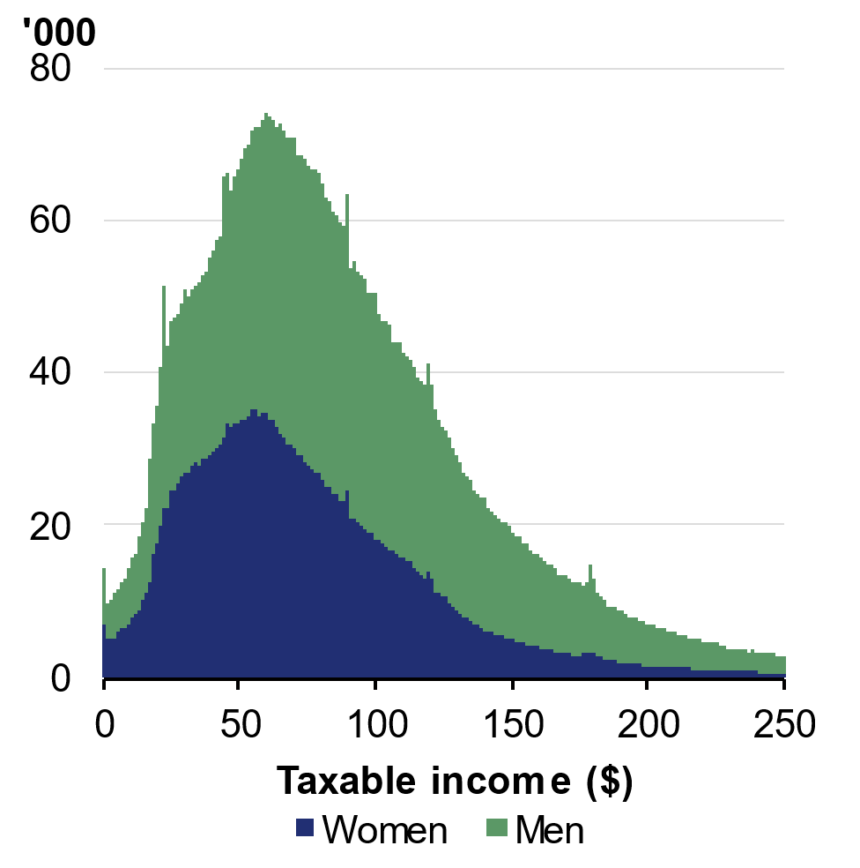 | 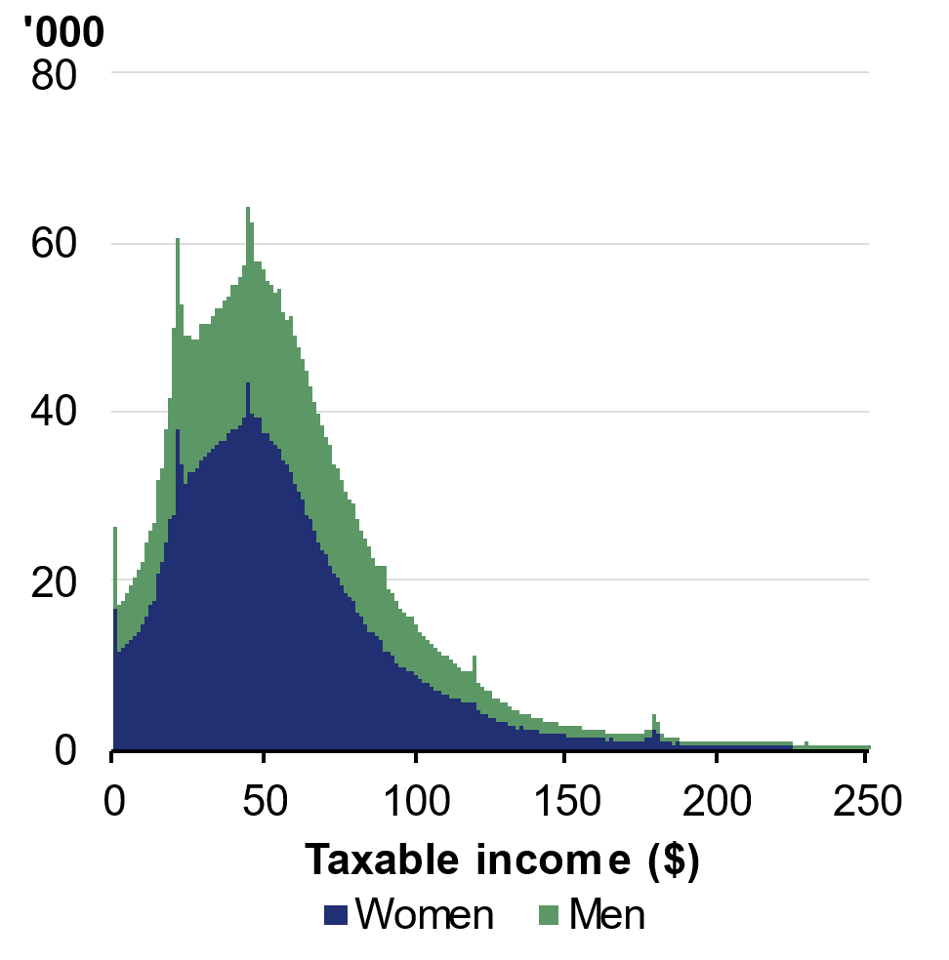
Note: Counts are for $1,000 income bands.
Source: ATO and Treasury.

Increasing Medicare levy low-income thresholds
The Government will also increase the Medicare levy low-income thresholds by 2.9 per cent for singles, families, and seniors and pensioners from 1 July 2025. This means over 1 million Australians on lower incomes will continue to be exempt from paying the Medicare levy or pay a reduced levy rate.

Tax reform will benefit workers and improve housing affordability
The Government’s tax reforms continue efforts to ensure income from assets is taxed more consistently, while taxes on labour income maintain incentives to work. The reforms improve intergenerational equity by boosting home ownership, reducing the tax burden on workers and reducing tax concessions that disproportionately accrue to those on the highest incomes.
The reforms are estimated to increase the home ownership share by around 1 percentage point over the medium term. Over the next decade, the number of owner-occupiers is projected to increase by around 75,000 (Box 4.4). This reallocation of housing stock is a result of reduced investor demand in the existing housing market which increases the share of homes available to owner-occupiers.
Further, tax reform will support fiscal sustainability over the medium term, building Australia’s economic and fiscal resilience, and better positioning Australia to navigate future economic shocks. Ultimately, improved fiscal sustainability and resilience will take the pressure off future generations of working Australians.

Supporting investment, innovation and dynamism
A business environment that supports investment and dynamism can be a significant source of productivity growth and help drive improvements in wages and living standards (Box 4.5).
The Government’s reforms to the business tax system include reintroducing and expanding loss refundability for businesses, expanding venture capital incentives and better targeting the Research and Development Tax Incentive to deliver the greatest economic impact. The Government will also make the $20,000 IAWO permanent for small business.
These reforms provide a more consistent tax treatment for investment, helping facilitate a more dynamic and resilient economy and supporting economic growth and jobs. They lower barriers to productive investment, minimise distortions that advantage large and incumbent firms, encourage sensible risk taking, better support firms’ resilience during economic shocks and promote the diffusion of innovation through the economy.
These reforms will help create a better tax system for business, complementing the Government’s wider productivity reform agenda. The Government has also asked the Productivity Commission to undertake an inquiry into business dynamism in Australia, with a focus on the regulatory barriers faced by firms to innovate and grow, particularly young firms. The inquiry is due to provide a final report to the Government by May 2027.
Box 4.5: The productivity cost of slower dynamism
A dynamic economy is one that innovates, adapts, and efficiently allocates labour and capital towards productive firms and activities, supporting the adoption of new technologies and the diffusion of best-practice methods across the economy.
RBA analysis explored the impact on the Australian economy and living standards from slowing dynamism.
- Specifically, it examined the slowdown in the reallocation of capital from less to more productive firms within industries since the mid-2000s.
- The RBA found that, had the flow of labour and capital towards more productive firms not slowed since the mid-2000s, more productive firms would have been larger.
- By 2017, this would have led to the economy being $13 billion (or ¾ per cent of GDP) larger, equating to around $550 per person or $1,000 per worker.
The tax reforms in this Budget form part of a comprehensive productivity package, which will make it easier to build, invest and do business. Our productivity package will reduce the regulatory burden by $10.2 billion per year, boost long-run GDP by around $13 billion per year through work underway with states and territories, and lift investment in R&D by young firms by $400 million a year.
This package builds on the significant progress made on the Government’s five pillar productivity agenda during our first term, including landmark reforms to Australia’s merger laws, revitalising National Competition Policy, establishing the Capacity Investment Scheme and making meaningful investments in skills and training.

Reforming loss refundability for businesses
The current tax treatment of losses discourages risk taking and entrenches advantages for large and incumbent firms. Firms are taxed on their profits immediately, but do not receive a tax benefit from losses unless (and until) they are profitable (when the real value of the tax loss will have declined). This asymmetry can discourage riskier investments and slow economic dynamism.
The current tax treatment of losses can disproportionately affect start-ups and firms seeking to expand or pivot to new opportunities. Large, established firms are more likely to have profits available to offset losses from risk-taking, which gives them a competitive advantage. This can make it harder for new and innovative firms to compete, reduces their resilience to economic shocks, and increases the risk of premature exit following a downturn with impacts on employment as well as businesses themselves.
The tax system’s bias against risky investments may divert capital to less risky but lower value investments, creating a drag on productivity. Reducing the tax system’s bias against risky investments could increase both the quantity and quality of investment, with positive flow-on effects for productivity, real wages and employment.
For new and growing firms—which often have limited access to finance—the inability to realise the value of losses when they are incurred can exacerbate cash flow pressures at a time when these firms are investing most heavily, hiring staff, and experimenting.
To support improved cash flow for businesses facing temporary losses, the Government will reintroduce permanent 2-year loss carry back for all companies with up to $1 billion in turnover. This will generate a refund of tax paid in those earlier years, providing timely support when losses occur. The measure will take effect for income years after 1 July 2026, providing support to businesses as they manage uncertainty and volatility from the conflict in the Middle East. The measure is estimated to cost $2.3 billion over the five years from 2025–‍26.
OECD research shows that loss carry back is an effective policy to improve the neutrality of corporate taxation across investment projects with different risk profiles and increase the resilience of companies to adverse revenue shocks.
The reintroduction of loss carry back is expected to directly benefit up to 85,000 companies each year. It will be particularly valuable for established businesses that have been profitable in recent years but experience a temporary downturn. It will also support otherwise profitable small companies that incur a tax loss because they have invested in new assets that are eligible for the IAWO. By allowing losses to be used sooner, the measure improves cash flow and helps firms remain resilient through periods of adjustment or broader economic shocks (Box 4.6).
Box 4.6: Companies that previously benefited from loss carry back
Loss carry back was available in 2012–13 and allowed corporate tax entities, regardless of turnover, to carry back up to $1 million of losses for a cash benefit of $300,000. Around 3,800 companies accessed the measure, with around 95 per cent recording aggregated turnover below $10 million.
Loss carry back was reintroduced temporarily during the pandemic and applied from 2020–21 to 2022–23. The measure supported over 70,000 companies, over 95 per cent of which had aggregated turnover below $10 million. These companies accounted for around 40 per cent of total losses carried back.
Treasury analysis indicates that temporary loss carry back provided a timely cash flow boost, averaging around $50,000 per business. The measure delivered around $300 million per year to construction companies, $150 million per year to professional, scientific and technical services companies and $135 million per year to manufacturing companies.

From 1 July 2028, the Government will also introduce loss refundability for small start-up companies, to help new businesses invest and grow in their first two years. Refundability will be capped at the amount of employment-related taxes paid (that is, withholding tax on employee wages and FBT). This is estimated to cost $410 million over the five years from 2025–26.
Young firms are central to generating jobs and driving economic dynamism. Analysis of ABS firm-level microdata in 2025 by the e61 Institute finds that firms aged five years or less have created 59 per cent of all new jobs in Australia over the past 20 years. This is consistent with OECD cross-country evidence, which finds young firms account for around 20 per cent of employment but create close to half of all new jobs on average across OECD countries. Supporting young firms to employ and retain Australian staff through their loss-making early years directly supports and enables job creation. Other research cited by e61 shows that the first two years of a firm’s activity are crucial for their long-term trajectory and positive economic contribution.
Up to 25,000 new small companies could be eligible for the refundable tax offset each year. Around half of these companies are expected to be able to fully offset their losses while the other half would be able to partially offset their losses. The benefits are expected to flow across sectors, but particularly to the construction and professional, scientific and technical services industries.

Expanding venture capital concessions
Young and fast-growing businesses make a disproportionate contribution to productivity growth by introducing new ideas and innovations. Within five years of operation, Australia’s highest-performing young firms achieve productivity around 45 per cent above industry averages. Young firms also create six out of every ten new jobs. However, start₋ups and scaling firms often have products or hold intellectual property that are unproven, or difficult to value or collateralise, limiting access to traditional finance and creating increased reliance on personal savings or informal funding.
Venture capital plays a critical role in supporting these businesses by providing ‘patient capital’, industry expertise, and access to professional networks. Foreign investment further strengthens the sector by connecting Australian firms to global capability.

Venture capital investment in Australia
Venture capital investment in Australia remains modest overall, at 0.16 per cent of GDP in 2024, but has grown strongly over the past two decades (Chart 4.21). Australia now has the highest number of unicorns (startup businesses valued over $1 billion) created relative to venture capital investment, at 1.22 unicorns per $1 billion invested. Venture capital backing has supported growth in the Australian technology sector from $15 billion in 2015 to $360 billion in 2025, while capital committed under Australia’s main venture capital programs has increased from $6 billion to $30 billion over the same period.
Venture capital investors can operate through venture capital limited partnerships (VCLPs) and early-stage venture capital limited partnerships (ESVCLPs), which provide a ‘flow through’ structure and targeted tax incentives. These incentives are capped to focus support on early-stage and expanding businesses, but most caps have not been updated since the programs were introduced in 2002 (VCLPs) and 2007 (ESVCLPs), reducing their effectiveness over time.
Chart 4.21: Investments by ESVCLPs and VCLPs
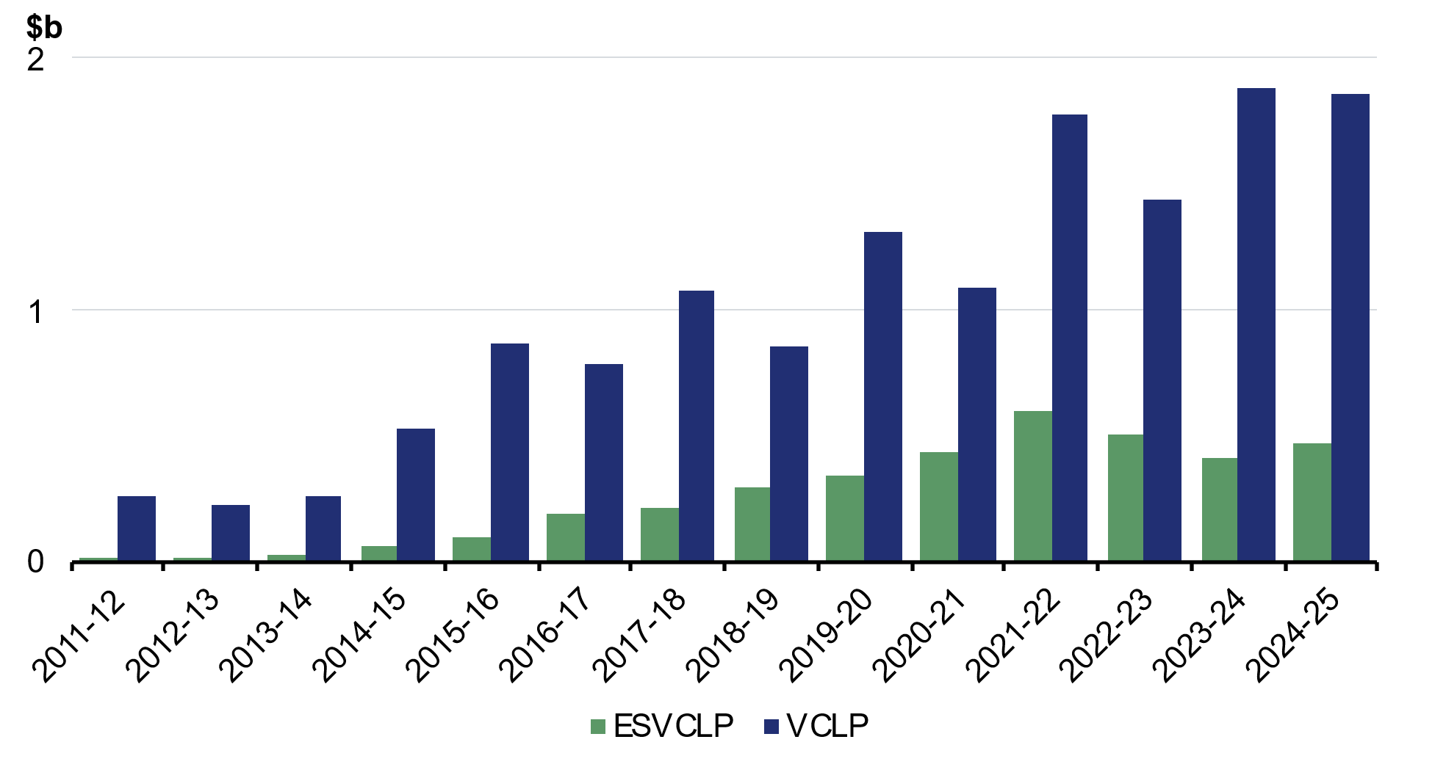
Source: Department of Industry, Science and Resources, Venture Capital Dashboard FY24/25

Expanding venture capital tax incentives
Recent reviews have found that VCLPs and ESVCLPs have supported investment and fund management capability. However, a shift toward larger deal sizes has reduced the incentive to use ESVCLPs for early-stage investment.
As part of its response to the Ambitious Australia – Strategic Examination of R&D Final Report (Ambitious Australia Report) (Box 4.7), the Government will modernise venture capital tax incentives by uplifting caps from 1 July 2027, aligning them for inflation since they were last set. This is estimated to decrease receipts by $10 million over the five years from 2025–26.
- VCLP eligibility will apply to investments in businesses with assets up to $480 million, up from $250 million.
- ESVCLP eligibility will apply to investments in businesses with assets up to $80 million, up from $50 million.
- ESVCLP investors will retain full access to incentives as businesses grow their assets up to $420 million, up from $250 million.
- The maximum committed capital for ESVCLPs will increase to $270 million, up from $200 million.
In 2024–25, the programs supported 784 investments totalling around $2.3 billion. These changes will expand access to venture capital, support later-stage investment, and reduce pressure for early divestment as businesses scale. Capital‑intensive sectors like biotechnology, clean energy and artificial intelligence will benefit from the new settings which will also facilitate greater diversification for investors.
The Department of Industry, Science and Resources will explore options to streamline the administration of these programs, including where statutory drivers of business burden are able to be lowered.
The Government will also strengthen the superannuation performance test to ensure there are no unintended barriers to investment for Australia’s $4.5 trillion superannuation sector, supporting the efficient flow of capital across the economy to drive innovation and economic growth, while helping Australians achieve better retirement outcomes. Concerns have been raised that the test may discourage investment in certain sectors, including venture capital. Reforms will ensure the test remains fit for purpose and supports strong member outcomes.

Better targeting the Research and Development Tax Incentive
High quality research and development (R&D) has the potential to drive productivity growth, with particularly larger impacts over the medium term. Governments in Australia and internationally support business R&D through tax concessions to encourage additional investment, recognising that the benefits of R&D spill over to other firms and the broader economy.
The Research and Development Tax Incentive (R&DTI) is Australia’s largest program supporting business R&D. The R&DTI provides tax offsets for eligible R&D at premium rates above a firm’s tax rate.
- Firms with turnover below $20 million receive a refundable offset equal to their company tax rate plus 18.5 percentage points.
- Firms with turnover above $20 million receive a non-refundable offset, with higher rates for businesses with a higher R&D intensity (see Table 4.2 below).
The R&DTI currently supports both core R&D activities – uncertain, experimental work conducted to generate new knowledge – and supporting activities such as literature reviews and equipment maintenance.
The Ambitious Australia Report found that while the R&DTI supports innovation, it has become increasingly complex for businesses. The cost of the R&DTI has increased rapidly, from $2.6 billion in 2019–20 to $4.4 billion in 2023–24, driven largely by growth in claims for supporting activities and increased payments under the refundable offset (Charts 4.22 and 4.23).
Research commissioned for the Ambitious Australia Report found that additional R&D was driven entirely by incentives for core R&D activities, generating around $1.58 of additional R&D per dollar of offset. In contrast, subsidies for supporting activities did not lead to additional R&D but accounted for 29 per cent of claims in 2023–24, up from 18 per cent in 2012–13. The review also found the program imposes high compliance costs, with 86 per cent of claimants surveyed relying on tax consultants.
Chart 4.22: Index of R&D expenditure growth | Chart 4.23: R&DTI by refundable and non-refundable offset
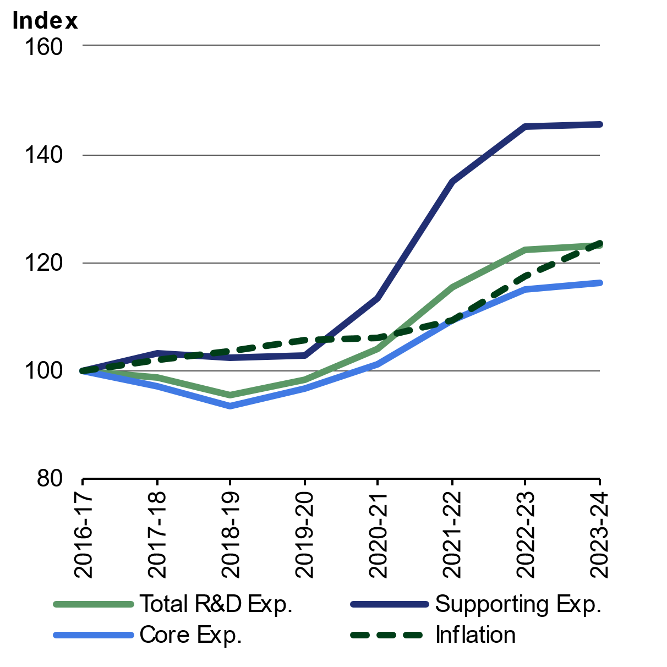 | 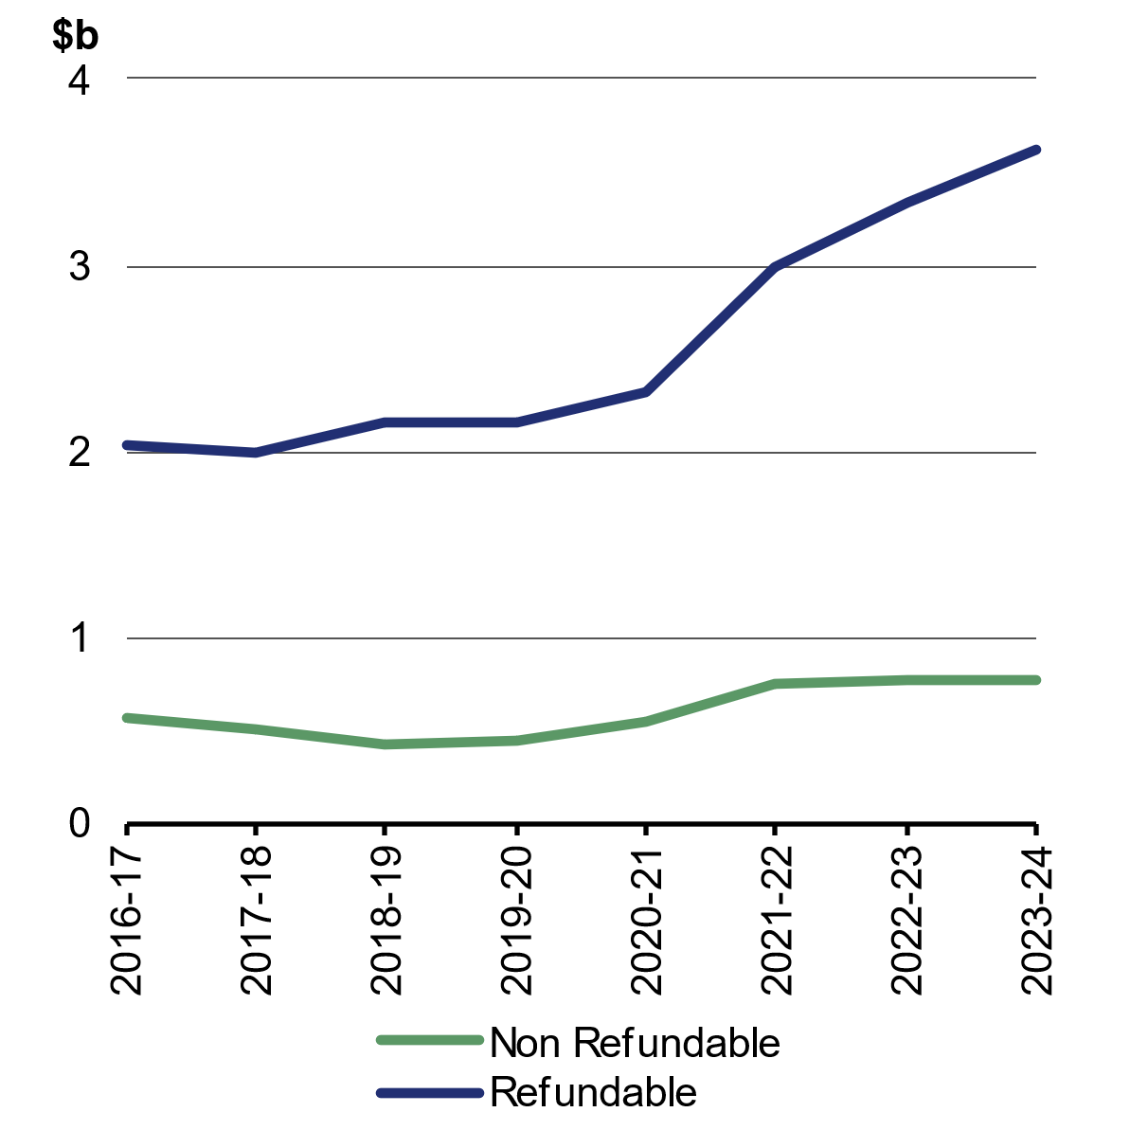
Notes: 2016–17 = 100  Source: Department of Industry Science and Resources R&DTI registration data | Source: 2025–26 Science, Research and Innovation Budget tables

The reforms in this Budget retarget and simplify the R&DTI to better incentivise additional business R&D while improving fiscal sustainability. These reforms will:
- increase the effectiveness of government support for R&D, with each dollar of tax offset generating around 20 per cent more business R&D;
- increase R&D by young firms (those operating less than ten years) by around $400 million per year; and
- ensure the fiscal sustainability of the program for high potential R&D.
Table 4.2: Summary of R&DTI offset changes
 | Current | New
SMEs
Turnover threshold | Less than $20m turnover | Less than $50m turnover
Young SMEs (<10 years) | Offset: 18.5% (refundable) | Offset: 23% (refundable)
Older SMEs | Offset: 18.5% (refundable) | Offset: 23% (non-refundable)
Larger businesses
Turnover threshold | Above $20m turnover | Above $50m turnover
Low R&D intensity | Offset: 8.5% (non-refundable) | Offset: 13% (non-refundable)
High R&D intensity | Offset: 16.5% (non-refundable), available to firms with R&D intensity above 2% of expenditure | Offset: 21% (non-refundable), available to firms with R&D intensity above 1.5% of expenditure
Expenditure
Eligible expenditure | Core R&D and supporting activities | Core R&D only
Minimum expenditure | $20,000 | $50,000
Maximum expenditure | $150 million | $200 million
The Government is better targeting and simplifying the R&DTI by increasing offsets by around 25 to 50 per cent for core R&D, with a 4.5 percentage point increase for all offset rates and removing supporting activities from eligibility. The intensity threshold on the non-refundable offset will also be reduced to 1.5 per cent, offsetting the impact of removing eligibility for supporting activities and allowing more firms who invest significantly in core R&D to claim the R&DTI at a higher rate.
Evidence shows that the effectiveness of R&D tax incentives is greatest for small young firms and they provide the highest boost to aggregate growth per dollar spent on R&D incentives.
Consistent with the findings of the Ambitious Australia Report, the refundable offset will be better targeted to young, growing firms that rely most on cash flow support. Refundability will be limited to firms operating for less than 10 years, with the increased $50 million turnover threshold allowing successful firms to retain access to support for longer as they scale.
To improve integrity of smaller claims, the minimum expenditure threshold for R&D to be eligible for the offset will be lifted from $20,000 to $50,000, with research activities valued below this amount required to be undertaken with a registered Research Service Provider (RSP) or Cooperative Research Centre (CRC) to be eligible for the R&DTI.
While R&D by small firms has been increasing, Australia’s business R&D by large firms has been on a steady decline, falling by 19 per cent between 2011–12 and 2023–24 (from $12.1 billion to $10.2 billion) (Chart 4.24).
Chart 4.24: Australia business R&D expenditure
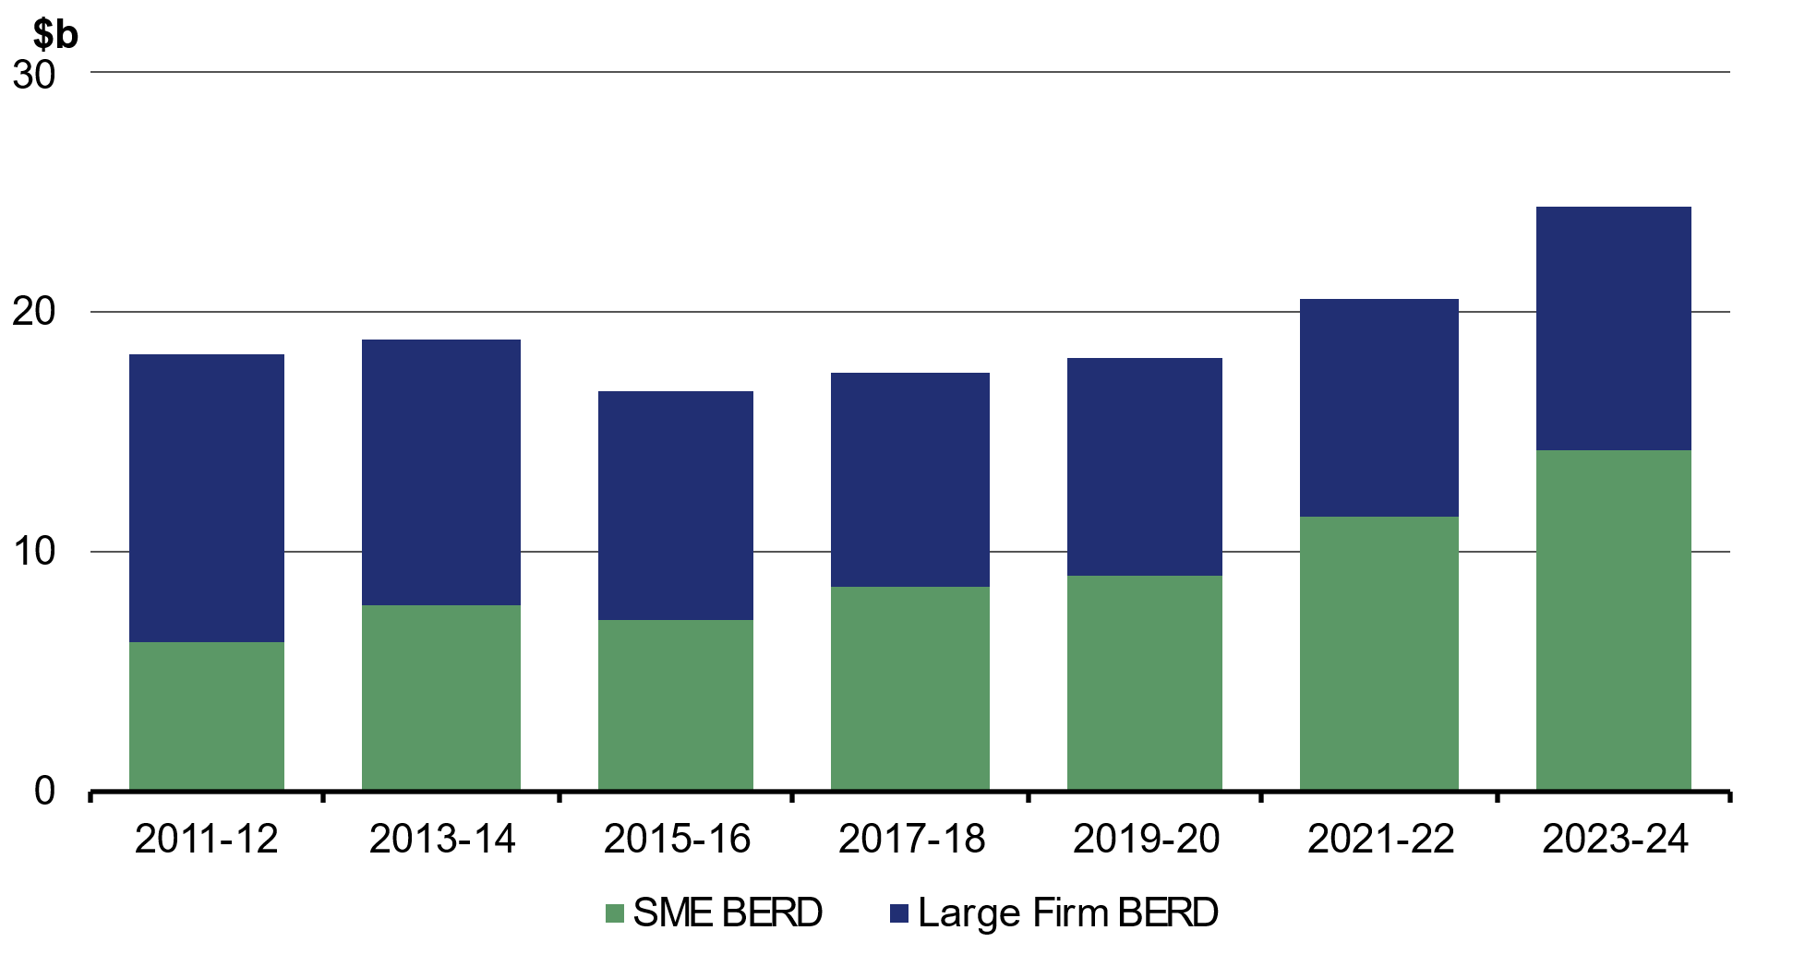
Source: ABS – Research and Experimental Development, Businesses, Australia, 2023–24 financial year. Data are only available every second year, as this survey is conducted biennially.

To encourage larger-scale R&D activity in Australia, the Government is increasing the maximum expenditure threshold on the non-refundable offset to $200 million, up from $150 million, alongside higher offset rates and a lower intensity threshold.
Together, these reforms improve the effectiveness, sustainability and integrity of the R&DTI. They are estimated to deliver $650 million in savings over five years from 2025–26, which will help fund broader business tax reforms supporting innovation and investment across the economy.
These reforms complement the wider package of reforms to support research and development and innovation in the Budget.
Box 4.7: Responding to the R&DTI and ESVCLP recommendations of the Ambitious Australia Report
The Government commissioned a strategic examination of Australia’s R&D system led by an independent expert panel. The Ambitious Australia Report was completed in December 2025 and released in March 2026 and included 20 recommendations to improve the capacity of Australia’s research, development and innovation system to support the economy and create a more prosperous, healthier, safer and equitable Australia.
The Report included recommendations to reform the R&DTI to simplify and focus the scheme for greater impact and to expand ESVCLP incentives to unlock more capital and support the venture capital industry to scale. This package of reforms forms part of the first stage of the Government’s response to the Report.
Ambitious Australia recommendation | Government response
Reform the R&DTI to simplify administration and focus the scheme for greater impact | Increase the offset rate for core R&D spending, remove the offset for supporting activities and reduce the intensity threshold
Incentivise start-ups through a premium R&DTI segment providing streamlined access to improved benefits for high-potential firms  Focus the R&DTI to incentivise SME growth and ambition, and increase the thresholds for access and ongoing support | All R&D companies will benefit from an increased offset rate for core R&D, with young SMEs also supported by refundability  Increase the turnover threshold for the premium SME offset rate and refundability from $20 million to $50 million  Increase minimum R&D expenditure from $20,000 to $50,000, with smaller scale research still supported if undertaken with an RSP or CRC  Loss reforms will support start-ups and other firms undertaking riskier investment, including in R&D
Increase R&DTI for corporates and multinational corporations to undertake local R&D activities | Increase maximum R&D expenditure from $150 million to $200 million
Raise the ESVCLP maximum fund size and the cap on the tax incentive for assets of the investee businesses from $200 million to $500 million and from $250 million to $500 million respectively  Introduce a point-based assessment of ESVCLP investment plans, enable fund managers to excuse individual investors from specific investments | Increase the respective caps to $270 million and $420 million to compensate for inflation since the caps were last set  Further recommendations may be considered by a joint Treasury-Department of Industry, Science and Resources impact assessment in 2032–33
Beyond tax, the Government is also taking initial steps to respond to the Ambitious Australia Report by establishing a National Resilience and Science Council. Further reforms in response to the Report will be considered with the support of the Council.

Making the IAWO permanent
From 1 July 2026, the Government will permanently extend the $20,000 IAWO for businesses with a turnover of up to $10 million, locking in access to this concession for up to 4.1 million businesses. Making the $20,000 asset threshold permanent will provide long-term certainty so small businesses can invest with confidence. The measure is estimated to decrease tax receipts by $890 million over the forward estimates.
The threshold of $20,000 per asset has effectively been in place since 1 July 2023 and will continue to apply. At this level, take-up has been strong. In 2023–24, around 300,000 businesses made use of the IAWO, claiming an average of $14,200. This translates to businesses writing off over $4.2 billion worth of assets. The permanent increase in the IAWO threshold will enable businesses to plan investment decisions with certainty.

Reforms to business tax will support resilience and dynamism
The Government’s business tax reforms will strengthen Australia’s attractiveness as a place to invest, innovate, and grow across the business lifecycle. By supporting sensible risk-taking, enabling investment, and enhancing firms’ ability to withstand temporary losses, these reforms will promote a more dynamic and resilient economy and support productivity growth, higher wages and rising living standards for working Australians. A permanent $20,000 IAWO and the abolition of more nuisance tariffs will further support investment.
Taken together, these reforms provide support for businesses as they invest, innovate, and grow from start-ups to maturity. Start-ups will benefit from early cash flow support as they build and employ, growing firms will gain improved access to venture capital and a permanent $20,000 IAWO, and innovative firms taking sensible risks will also be supported through loss carry back and a more targeted and sustainable R&DTI.

A simpler, more sustainable tax system
Simplifying and modernising the tax system is central to reducing compliance costs and supporting stable and efficient revenue collection. Streamlined tax administration arrangements can lower the time and cost for individuals and businesses to meet their tax obligations and contribute to long-term budget sustainability.
To this end, the Government’s tax reform package includes a significant package of changes that meaningfully improve the simplicity and sustainability of the system.
The Government is introducing a $1,000 instant tax deduction for workers, making the $20,000 IAWO for small business permanent, expanding access to dynamic business tax instalment payments, removing more nuisance tariffs and recalibrating the electric car discount. The Government is also working with the Board of Taxation to identify ways to further reduce red tape in the tax system, and with states and territories to make targeted reforms to administrative arrangements for payroll tax.

Simplifying tax for individuals through an instant deduction
System changes over time have substantially improved the lodgement experience for individual taxpayers. By 2024, nearly 2.4 million taxpayers took less than 15 minutes to lodge their return using myTax, compared to an average of 8.5 hours in the mid-1990s.
Nevertheless, some aspects of the tax system can impose significant compliance costs on taxpayers. For example, claiming deductions for work-related expenses requires individuals to identify, apportion, and keep records to substantiate the amount they include on their tax return. These requirements add complexity and can make it time consuming for taxpayers to manage their tax affairs.
The Government is continuing to simplify the lodgement experience for individuals by introducing a $1,000 instant tax deduction for work-related expenses. From the 2026–27 income year, Australian tax residents who earn income from work will be able to claim an instant deduction instead of needing to itemise and claim work-related expenses. Individuals earning less than $1,000 of work income will be eligible for an instant deduction up to the amount of that income. Taxpayers claiming more in work-related expenses than the instant tax deduction will still be able to do so in the usual way, and other deductions such as for charitable donations will continue to be claimable on top of the instant tax deduction.
The instant tax deduction will save Australian workers time and money. The ATO estimates the measure will collectively save individuals $380 million in compliance costs each year. For 2026–27, 6.2 million workers (42 per cent of taxpayers) are expected to benefit from the change, with an average tax saving of $205.

Helping businesses spend less time on tax
The tax administration of business is more complicated than for individuals. Businesses spend too much time doing their taxes, which diverts time and effort away from running their business.
Compliance costs can be disproportionally high for small businesses. One source of compliance burden for businesses has been tracking depreciation of different assets purchased at different times and with different effective lives. This requires ongoing record‑keeping and calculations over several years for each asset.
As part of a simplified depreciation regime for small businesses, businesses have been able to immediately write off assets under a threshold, known as the IAWO. Successive governments have generally chosen to expand access to the regime by raising the threshold for eligible assets above the base threshold of $1,000. While higher asset thresholds have been in place for more than a decade, these have only been temporary increases, with extensions typically made one year at a time. This contributes to ongoing uncertainty for small businesses wanting to plan their investments. By making the $20,000 IAWO permanent, small businesses will save around $32 million per year in compliance costs.
Current tax administration arrangements also have not evolved to fully harness the potential of modern business software and some aspects of the business tax system are still based on settings designed for a paper-based environment. This results in unnecessary compliance burdens on businesses including the use of paper forms and timing gaps between when economic activity occurs and the reporting and payment of tax.

Simplifying PAYG instalment calculations
Outdated concepts around how tax obligations are calculated remain an impediment to more efficient tax administration.
An example of this is the PAYG instalments system. For most businesses in the instalments system, their instalments are calculated by the ATO using a statutory formula based on the information reported in their most recent income tax return.
This means that, for most small businesses, instalments are not an accurate approximation of their final assessed income tax outcome. In 2023–24, only 12 per cent of small businesses had PAYG instalments that closely matched their assessed income tax outcome that year.
When businesses overpay instalments, this prepayment of tax takes away the ability to use those funds in their business. Underpayment of instalments can result in large tax bills when businesses lodge their returns, which often leads to the accumulation of debt. While businesses can vary their instalments to better reflect current performance, they risk interest charges if they significantly underestimate their instalments.
The ATO is currently piloting a dynamic instalment calculation embedded in business accounting software to draw on real-time business information, so that instalments can be varied to better reflect business performance.
Building on the work the ATO is already doing, the Government will make it easier for businesses to change their PAYG instalments in response to changing business conditions (dynamic instalments).
- From 1 July 2027, businesses will be given the flexibility to opt in to reporting and paying PAYG instalments monthly.
- The Government will provide funding to the ATO to expand access to its dynamic instalment pilot. From 1 July 2027, small and medium businesses will be able to opt in to an ATO-approved calculation embedded in accounting software to calculate and vary their instalments to better reflect their current business performance.
- To complement this, the ATO will implement an administrative safe harbour to ensure that businesses who vary their instalments using the ATO-approved calculation can do so without risk of interest charges, placing them in the same position as if they used the default rate assigned to them by the Commissioner of Taxation.
These changes support businesses to better manage cash flow as conditions change, releasing funds when business conditions are more challenging and preventing debts when conditions improve. They will also reduce the need for businesses to engage with the existing cumbersome variation process, saving them time and money. This measure is expected to save businesses approximately 10,000 hours annually and around $850,000 per year in compliance costs.

Abolishing nuisance tariffs and reducing barriers to trade
Australia’s tariff system and cross-border trade environment are complex. This imposes compliance costs on businesses, puts upward pressure on consumer prices and is a drag on productivity growth.
The Productivity Commission’s Trade and Assistance Review 2023–24 called for further reform to simplify the tariff system, including the removal of ‘nuisance tariffs.’ Nuisance tariffs generate little revenue, provide limited protection and impose high compliance costs on business.
Following decades of trade liberalisation and the conclusion of multiple free trade agreements, many goods now enter Australia under concessional or preferential rates of duty. To access these rates, businesses must correctly classify their goods, identify the applicable rate of duty, assess eligibility for concessions or preferences, and provide supporting evidence.
In addition, Australia has a complex cross-border trade environment. It is overseen by 32 Australian Government agencies, with 145 information and communications technology systems and over 200 regulations for imports and exports. Simplifying this system will boost productivity growth, enhance global competitiveness for businesses and increase trade diversification.
The Government is abolishing a second tranche of 497 nuisance tariffs from 1 July 2026. This will eliminate tariffs on a wide range of imported goods including wine glasses, tyres, air conditioners, margarine and bitumen.
This builds on the removal of 457 nuisance tariffs in July 2024. Together, the Government will have removed around 1,000 tariffs over two years, streamlining approximately $23 billion of trade and saving businesses $157 million per annum in compliance costs.
The Government has also concluded negotiations of the Australia-European Union Free Trade Agreement. This Agreement will reduce barriers to trade, diversify our international trade and deliver dividends for Australia for decades to come. It unlocks access to a high-income market of 450 million people with a GDP of around $30 trillion.
The Government is also pursuing regulatory reform to simplify the trade system. This includes prioritising trade competitiveness by streamlining business interaction with Government at the border and simplifying the administration of trade regulations, while strengthening border integrity. The Government is also investing $7.6 million over four years from 2026–27 to expand the Australian Trusted Trader program to simplify trade and reduce regulatory burden for more businesses.

Modernising the tax system for a new economy
As well as seizing opportunities to reduce compliance burdens, the tax system also needs to adjust to capture changes in economic activity.
Over a long period of time, the tax system has adjusted to economic developments and behavioural changes. This includes the introduction of fringe benefits taxes, capital gains taxes, superannuation taxation and the goods and services tax.
The emergence of electric vehicles represents another significant technology shift with implications for the tax system. Tax settings related to vehicles were developed based on internal combustion engine vehicles. Short-cut methods of calculating car fringe benefits tax (the statutory formula) are broadly based on capital and running cost assumptions for internal combustion engine vehicles that do not account for the different characteristics of electric cars.
Consistent with the Government’s commitment to the transition to net zero, tax initiatives to date have focused on incentivising electric vehicle uptake. The Government’s Electric Car Discount (ECD), which started on 1 July 2022, provides an exemption from fringe benefits tax for electric cars (and for plug-in hybrid electric cars from that date to 1 April 2025). The ECD was one of the first initiatives in the National Electric Vehicle Strategy and was complemented by investments to boost electric vehicle charging infrastructure and the New Vehicle Efficiency Standard (NVES).
The ECD has helped the market for electric cars mature and has helped motorists reduce emissions. Since the introduction of the ECD, electric car sales have increased strongly, accompanied by a wider range of models and price points (Chart 4.25). Lower cost EVs are entering the market. By January 2026, there were 59 EV models available under $60,000, including 13 EV models under $40,000. The second‑hand EV market is also growing. In 2025, sales of used battery EVs comprised 1.5 per cent of the market, up from 0.7 per cent in 2023.
Chart 4.25: New electric vehicle sales as a proportion of new vehicle sales
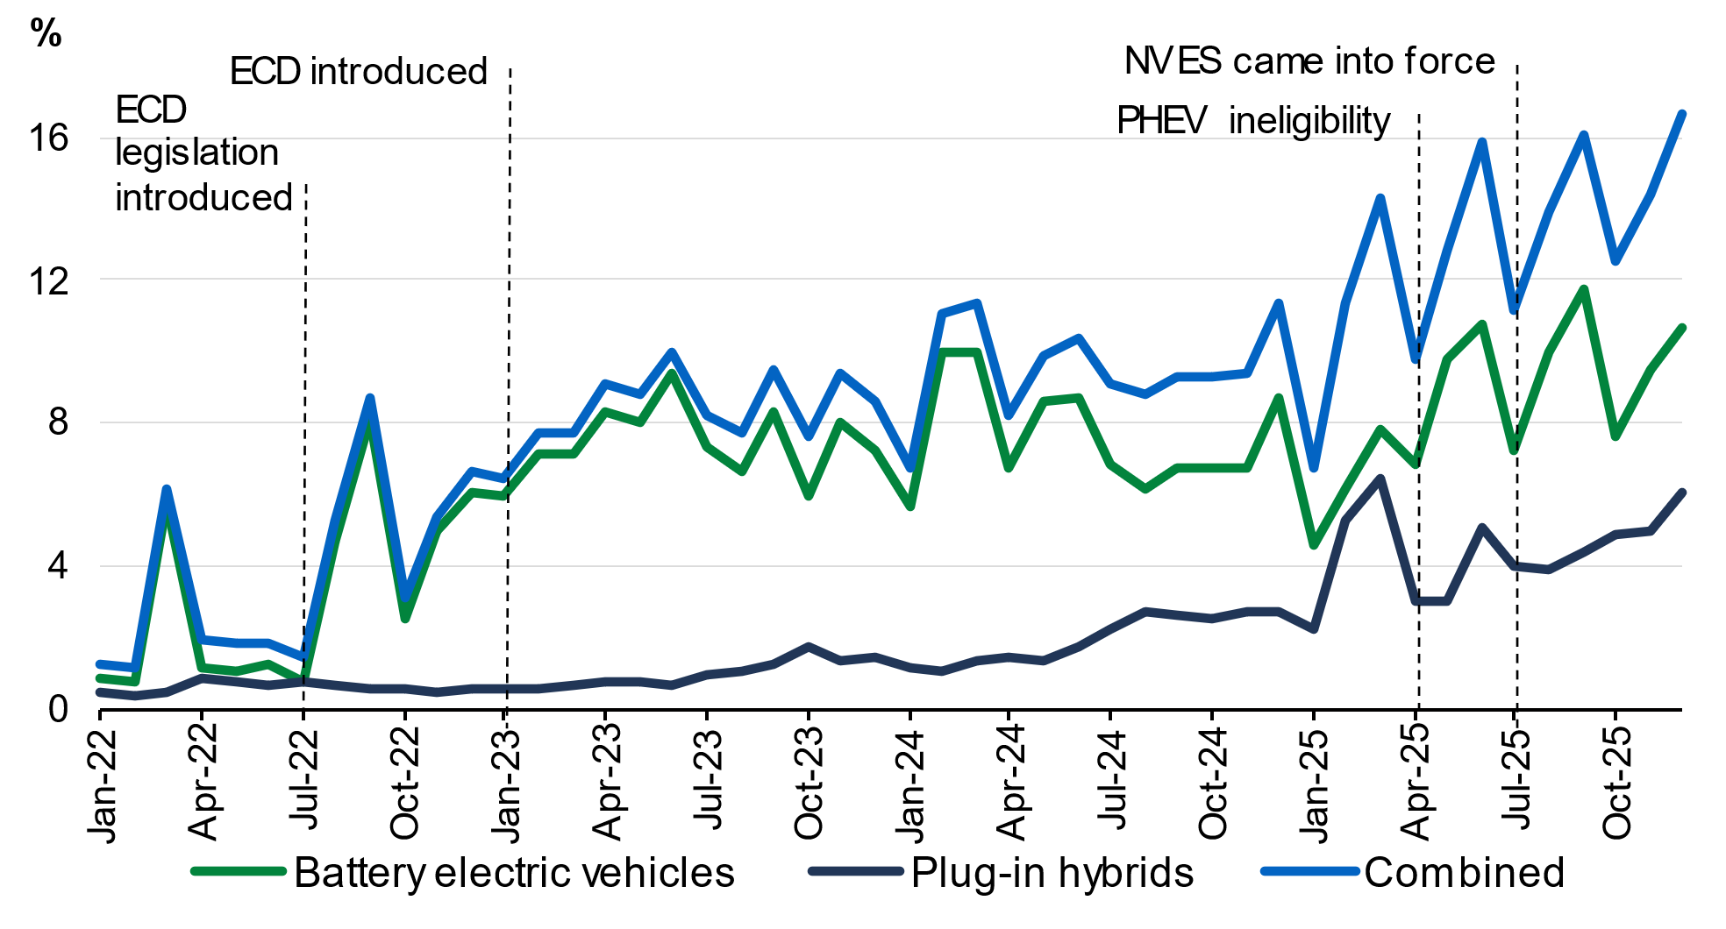
Note: The ECD commencement date is shown as the start of 2023 because this when the legislation came into effect, and hence salary packaging providers would have started to reflect the ECD in their offerings. The NVES effectively started in July 2025, when the first reporting period started, and credits and penalties began to accrue. The data for March 2022 reflect Tesla sales over the first three months of 2022. Xpeng sales figures were not available in the data reported to Federal Chamber of Automated Industries (FCAI) and EV Council.
Source: Treasury and DCCEEW analysis of FCAI VFACTS and EV Council monthly data, various editions.

Over time, however, the tax system will transition from incentivising the early take-up of electric vehicles towards a more sustainable tax treatment. Reflecting the strong uptake of the ECD, the value of the tax expenditure for the FBT exemption is estimated to have grown considerably over time (Box 4.8).
Box 4.8: Statutory Review of the Electric Car Discount
The Electric Car Discount (ECD) Review found that, over the three years to December 2025, car buyers purchased 330,000 vehicles and around one quarter of these would not have been purchased in the absence of the discount. These additional 78,000 EV sales led to a reduction in carbon emissions with an estimated abatement value of around $460 million (at 2023 prices). Additional electric vehicle sales also generated other positive externalities.
- Health benefits, due to lower air pollution, were worth an estimated $500 million.
- A battery electric vehicle is estimated to generate fuel cost savings of around $26,500, on average, over its life. The lifetime savings on fuel costs from additional electric vehicle sales were estimated to be around $2.0 billion in total over the first three years of the ECD.
- The ECD also boosted confidence in the electric vehicle market, helped reduce Australia’s reliance on imported fuels, and reduced noise pollution.
Based on ECD settings at the time of the Review, the revenue costs of the ECD are increasing significantly. The tax expenditure from the fringe benefits tax (FBT) exemption was estimated to be $2.0 billion over the first three years from 2022–23 to 2024–25 and would be expected to grow to $2.8 billion in 2028–29. EV sales have increased strongly since the start of the ECD, due to growing consumer demand, improvements in charging infrastructure and a wider range of models and price points becoming available.
The Review concluded that the changing context in which the ECD operates means that, over time, alternative policy approaches may be more fiscally efficient and equitable. Increasing consumer interest in electric vehicles is being driven by several factors, including declining prices of electric vehicles globally, the New Vehicle Efficiency Standard, and greater awareness of fuel cost savings (made more prominent by the conflict in the Middle East). This is likely to lead to a further decline in electric vehicle prices and increases in electric vehicle purchases in Australia. Without change, the revenue cost of the ECD would have continued to grow.
As the benefits decline and the costs grow, the Review recommended that the Government consider changes to better manage the costs of the ECD.

Recalibrating the Electric Car Discount
As outlined in the statutory review, the increased maturity in the electric vehicle market reduces the need for significant incentives. As such, the Government is adjusting settings for the electric car discount (ECD) to ensure it remains fiscally sustainable and provides more targeted support for the shift to electric vehicles.
The ongoing FBT treatment for electric cars has been designed to provide a broadly neutral tax treatment for electric vehicles and internal combustion engine vehicles. The statutory formula used to calculate the taxable value of the car fringe benefit is based on the upfront cost of the car. As more of the lifetime cost of an electric vehicle is paid upfront compared with internal combustion engine vehicles, it is appropriate for the FBT taxable value of electric cars to be calculated on a lower statutory rate than equivalent internal combustion engine vehicles. This difference narrows with higher vehicle values, so the discount will only apply to vehicles up to the fuel-efficient threshold for the luxury car tax (LCT).
Accordingly, from 1 April 2027, a 25 per cent discount for electric cars up to the fuel-efficient threshold for LCT will be applied to the 20 per cent FBT statutory formula rate that applies to all other cars. To maintain a transitional incentive for the shift to electric vehicles, but in a more cost-effective way, the full FBT exemption will continue to apply to electric cars valued up to $75,000 from 1 April 2027 to 31 March 2029.
The Government is also considering other changes to the tax treatment of vehicles. Consistent with the recommendation of the Economic Reform Roundtable, the Government is continuing to work with states and territories on the development of a road user charge for electric vehicles to ensure fair and sustainable funding for road investment and maintenance.

Making the tax system simpler and more sustainable
Overall, these changes will mean individuals and businesses spend less time complying with tax and tariff obligations while also ensuring the system is set up for the long term.
The combined compliance cost savings from these new measures totals approximately $540 million per year.
With these measures, the Government is continuing the path toward a simpler and more sustainable tax system that works for our modern economy. They will strengthen budget sustainability by supporting the stable and efficient collection of revenue and save workers and businesses valuable time and compliance costs.

Impact of the Government’s tax reform package
Overall, the tax reforms in this Budget rebalance the tax system to reduce the tax burden on work, more consistently tax income from assets, boost home ownership, incentivise productive investment and sensible risk taking, and reduce compliance costs for businesses.
Taken together, these reforms mark a significant step in the Government’s economic reform agenda. The Government’s tax reforms deliver on the three principles set by the Economic Reform Roundtable, while being broadly revenue neutral over the forward estimates period. Over the medium term, the reforms will enhance the sustainability of the budget and create room for further tax relief.

Revenue impacts
The Government’s tax reform package is broadly revenue neutral over the forward estimates, and will not add to the outlook for inflation, with revenue returned to workers and businesses over the next four years.
Over the medium term, the Government’s reforms will support budget sustainability (see Statement 3: Fiscal Strategy and Outlook). By reducing tax concessions for savings income better targeting incentives for research and development and shifting to more sustainable settings to support electric vehicles, the reform package will also support a better balance in the tax system and reduce the reliance on taxation of workers.
Table 4.3: Summary of receipts and administered payments impacts
 | 2026-27 | 2027-28 | 2028-29 | 2029-30 | Total
 | ($m) | ($m) | ($m) | ($m) | ($m)
A fairer system for workers, home buyers and
future generations
Tax Reform – Boosting Home Ownership – reforming | .. | .. | 1,350 | 2,280 | 3,630
negative gearing and capital gains tax
Tax Reform – introducing a minimum tax on | - | - | .. | 4,470 | 4,470
discretionary trusts
Tax Reform – cutting taxes with a Working Australians | - | - | -3,020 | -3,360 | -6,380
Tax Offset
Personal Income Tax – increasing the Medicare levy | -140 | -100 | -100 | -110 | -450
Low-income thresholds
Supporting investment, innovation and dynamism
Tax Reform – loss refundability reforms for | - | -900 | -720 | -1,050 | -2,670
businesses and start-ups (a)
Tax Reform – expanding venture capital tax incentives | - | .. | .. | -10 | -10
Tax Reform – better targeting the Research and | - | - | -30 | 680 | 650
Development Tax Incentive (a)
A simpler, more sustainable tax system
Tax Reform – introducing a $1,000 instant tax | - | - | - | - | -
deduction (b)
Tax Reform – making tax simpler for businesses | - | -320 | -360 | -135 | -815
Boosting Productivity – abolishing more nuisance tariffs | -20 | -20 | -15 | -15 | -70
Electric car discount – more sustainable fringe | -10 | 40 | 290 | 1,420 | 1,740
benefits tax treatment of electric cars
Total | -170 | -1,300 | -2,605 | 4,170 | 95
Note: Figures include administered payments and exclude departmental costs.
- Impacts for these items include refundable tax offsets, which are formally classified and reported elsewhere in the budget as administered payments.
- The $1,000 instant tax deduction was an election commitment, with a cost of $2.6 billion over four years including administered expenses from 2025–26 provisioned in the Mid-Year Economic and Fiscal Outlook 2025–26.

Economic impacts
Overall, this package of tax reforms improves incentives for businesses to innovate, for productive investment including in new housing, and for people to work, build human capital, and invest their savings. The package represents a measured and targeted approach to tax reform that will support innovative businesses and help ensure investment is directed to where it can have the greatest economic returns, while also establishing frameworks that can be used to build on these reforms and economic benefits in the future.
The Government’s tax reform package is broadly revenue neutral over the forward estimates period and will not add to the outlook for inflation.
The impact of the tax package is incorporated into Treasury’s economic forecasts. The reforms to negative gearing and capital gains tax are expected to improve the efficiency of investment decisions, as they are more likely to be made for economic reasons rather than tax outcomes. This is expected to support productivity over time. The business tax reforms are also expected to support investment, innovation, risk-taking and resilience.
The reforms better link tax paid to lifetime opportunities. A more consistent taxation of asset income makes it harder to minimise tax, while reducing taxes on working Australians through the WATO. The WATO builds on the Government’s previous tax cuts and, will help maintain incentives for those on lower incomes (particularly those starting off in the labour market) to participate and accrue human capital.
Better linking tax paid to lifetime income is not only fairer, but more productive. More neutral tax rates on assets reduces incentives for inefficient tax planning that can also distort investment, while greater labour market participation supports growth, particularly over the longer term.

Note about data
This publication contains data, analytics, statistics, results and other information licensed to us by RP Data Pty Ltd trading as Cotality Asia Pacific (Cotality Data). © Copyright 2025. RP Data Pty Ltd trading as Cotality Asia Pacific (Cotality) and its licensors are the sole and exclusive owners of all rights, title and interest (including intellectual property rights) subsisting in the Cotality Data reproduced in this publication. All rights reserved. The Cotality Data provided in this publication is of a general nature and should not be construed as specific advice or relied upon in lieu of appropriate professional advice. While Cotality uses commercially reasonable efforts to ensure the Cotality Data is current, Cotality does not warrant the accuracy, currency or completeness of the Cotality Data and to the full extent permitted by law excludes all loss or damage howsoever arising (including through negligence) in connection with the Cotality Data.

Kennedy, T., Siminski, P., ‘Are We Richer than Our Parents Were? Absolute Income Mobility in Australia’, Economic Record, 2021.
Productivity Commission, ‘Fairly equal? Economic mobility in Australia’, p34, Canberra, 2024.
Ellis, L. ‘Opening Remarks to Plenary Panel at the Australasian Housing researchers Conference’, Australasian Housing Researchers Conference, 2017.
See Cotality Data disclaimer at the end of this Statement.
These structural shifts were the focus of a previous Statement 4 in 2024–25.
Treasury, ‘Economic Reform Roundtable: Budget sustainability and tax reform’, Australian Government, Canberra, 2025.
7 Treasury, ‘Economic Reform Roundtable: Budget sustainability and tax reform’, Australian Government, Canberra, 2025.
These structural shifts were the focus of a previous Statement 4 in 2023–24.
Calvino, F., Criscuolo, C. & Verlhac, R. ‘Changing business dynamism: structural and policy determinants’, OECD Policy Paper, 2020; OECD, ‘OECD Economic Outlook, Volume 2025 Issue 1: Tackling Uncertainty, Reviving Growth’, p. 80, OECD Publishing, 2025.
The 50 per cent discount applies for assets that have been held for longer than 12 months. Discounted gains are taxed at individuals marginal tax rates. In addition to selling an asset, capital gains income may be taxed when assets are exchanged or traded, or when an asset is lost or destroyed. Pre-1985 assets will be subject to CGT on gains after the start date.
For example, as outlined in: Australian Government, ‘Australia’s Future Tax System Review‘, 2010; and Hourani, D. and Perret, S. ‘Taxing capital gains: Country experiences and challenges’, OECD Taxation Working Paper, OECD, 2025.
Review of Business Taxation, ‘A Tax System Redesigned’, Canberra, 1999.
OECD, Taxation of Household Savings, OECD Tax Policy Studies, No. 25, OECD Publishing, Paris, 2018.
ABS, Lending Indicators – December Quarter 2025, 2026.
APRA, Quarterly Authorised Deposit-taking Institutions Property Exposure Statistics – December 2025, 2026.
APRA, Media release: APRA releases quarterly authorised deposit-taking institution statistics for December 2025, 2026.
OECD, OECD Economic Surveys: Australia 2026, OECD Publishing, Paris, 2026
Treasury analysis; ATO.
Hambur, J. and Andrews, D., Doing Less, with Less: Capital Misallocation, Investment and the Productivity Slowdown in Australia, 2023.
See, for example, Langenmayr, D. and Lester, R., Taxation and corporate risk-taking,2014.
Business Tax Working Group, Final report on the tax treatment of losses, 2012.
Hanappi, T., Loss carryover provisions: Measuring effects on tax symmetry and automatic stabilisation, 2018.
Lee, R., Rankin, E., Vass, L., e61, The Young and the Restless: The Contribution of Young Firms to the Economy, e61, 2025.
Lee, R., Rankin, E., Vass, L., e61, The Young and the Restless: The Contribution of Young Firms to the Economy, e61, 2025.
Lee, R., Rankin, E., Vass, L., e61, The Young and the Restless: The Contribution of Young Firms to the Economy, e61, 2025.
Strategic Examination of R&D (SERD) independent expert panel, Ambitious Australia: Strategic Examination of R&D Final Report, SERD independent expert panel, 2025.
Strategic Examination of R&D (SERD) independent expert panel, Ambitious Australia: Strategic Examination of R&D Final Report, SERD independent expert panel, 2025.
Dealroom.co, Australia Venture & Startup Report, Dealroom.co, 2025, accessed April 2026.
Dealroom.co, Australia Venture & Startup Report, Dealroom.co, 2025, accessed April 2026
Department of Industry, Science and Resources (DISR), Venture capital dashboard FY24/25, DISR, 2026.
Treasury and Industry Innovation and Science Australia (TIISA), Venture Capital Tax Concessions Review, TIISA, 2022; Strategic Examination of R&D (SERD) independent expert panel, Ambitious Australia: Strategic Examination of R&D Final Report, SERD independent expert panel, 2025.
SERD independent expert panel, Ambitious Australia: Strategic Examination of R&D Final Report, SERD independent expert panel, 2025.
Department of Industry, Science and Resources (DISR), Venture capital dashboard FY24/25, DISR, 2026.
For example, see: International Monetary Fund (IMF), Country Report No. 21/256, IMF, December 2021.
Centre for Economic Performance (CEP), How effective are R&D Tax incentives? Reconciling the micro and macro evidence, CEP, 2025.
The Productivity Institute, The Bang for the Buck: Aggregate Impact of Firm-Level R&D Incentives, The Productivity Institute, 2025.
ABS, Research and Experimental Development, Businesses, Australia, 2025.

