Statement 5:
Revenue
This Budget includes a range of tax reform measures designed to deliver tax cuts for working Australians, enable more Australians to realise the goal of home ownership, and strengthen incentives for investment and innovation (see Statement 4: Tax reform for workers, businesses and future generations).
These reform measures are broadly offsetting over the forward estimates. Total policy decisions taken since MYEFO decrease tax receipts by $1.8 billion over the five years from 2025–26 to 2029–30. This includes the temporary reduction in fuel excise.
Over the forward estimates, the tax-to-GDP ratio is forecast to fall and remain well below the historical high of 24.2 per cent recorded in 2004–05 and 2005–06. The tax-to-GDP ratio is forecast to fall from 23.8 per cent of GDP in 2026–27 to 23.6 per cent in 2029–30.
Since MYEFO, tax receipts excluding GST and policy decisions have been revised up by $16.2 billion in 2026–‍27 and $34.5 billion over the five years from 2025–‍26 to 2029–‍30. The upgrade is concentrated in the near term, with a downgrade in 2029–30.
The upgrade to tax receipts is driven by superannuation fund, personal income, and company taxes, partly offset by a downgrade in tobacco excise. The near-term revision is expected to unwind over the forward estimates period alongside the projected decline in the prices for oil and other key commodities, as well as lower, but still positive, wage and salary income growth.
While the conflict in the Middle East contributes to the upgrade to receipts in the near term, it also weighs on the outlook. In the near term, higher energy export prices lift mining company tax and petroleum resource rent tax receipts. Over time, lower economic activity, investment, and labour demand contribute to a downgrade to receipts. Overall, the conflict is estimated to result in a $9.5 billion upgrade to tax receipts in net terms over the forward estimates, around a quarter of the upgrade to tax receipts excluding GST and policy decisions.
While economic conditions are currently supporting higher receipts overall, the global economic outlook remains uncertain and volatile. The conflict in the Middle East has created major disruptions in global oil supplies, with risks to domestic inflation and economic activity and the potential for large and negative flow-on implications for the revenue outlook.

Statement 5 contents
Overview 193
Tax receipts outlook 194
Variations in receipts estimates 197
Tax receipts estimates 197
Non-tax receipts estimates 205
Variations in revenue estimates 209
Appendix A: Tax Expenditures 212

Statement 5: Revenue

Overview
Total receipts are expected to be $798.1 billion in 2026–27, growing to $894.8 billion in 2029–‍30. Since MYEFO, total receipts have been revised up $21.1 billion in 2026–‍27 and $49.9 billion over the five years from 2025–‍26 to 2029–‍30. Tax receipts are the main component of total receipts and are expected to be $737.1 billion in 2026–27, growing to $826.2 billion in 2029–30.
Since MYEFO, tax receipts have been revised up by $18.6 billion in 2026–27 and $38.4 billion over the five years from 2025–26 to 2029–30. Excluding GST and policy decisions, tax receipts have been revised up by $16.2 billion in 2026–27 and $34.5 billion over the forward estimates.
The tax-to-GDP ratio is estimated to be 23.8 per cent in 2026–27, falling to 23.6 per cent of GDP by the end of the forward estimates.
More information on total receipts over the forward estimates is shown in Table 5.1.
Table 5.1: Australian Government general government receipts
 | Actual |  | Estimates
 | 2024-25 |  | 2025-26 | 2026-27 | 2027-28 | 2028-29 | 2029-30
 | $b |  | $b | $b | $b | $b | $b
Total taxation receipts ($b) | 657.8 |  | 699.5 | 737.1 | 757.0 | 782.9 | 826.2
Growth on previous year (%) | 3.9 |  | 6.3 | 5.4 | 2.7 | 3.4 | 5.5
Per cent of GDP | 23.7 |  | 23.6 | 23.8 | 23.8 | 23.5 | 23.6
Tax receipts excluding GST ($b) | 567.7 |  | 603.3 | 634.0 | 649.2 | 668.8 | 706.2
Growth on previous year (%) | 3.5 |  | 6.3 | 5.1 | 2.4 | 3.0 | 5.6
Per cent of GDP | 20.4 |  | 20.4 | 20.5 | 20.4 | 20.1 | 20.1
Non-taxation receipts ($b) | 59.1 |  | 60.2 | 61.0 | 65.9 | 65.5 | 68.6
Growth on previous year (%) | 7.1 |  | 1.9 | 1.3 | 8.0 | -0.6 | 4.7
Per cent of GDP | 2.1 |  | 2.0 | 2.0 | 2.1 | 2.0 | 2.0
Total receipts ($b) | 717.0 |  | 759.8 | 798.1 | 822.9 | 848.4 | 894.8
Growth on previous year (%) | 4.1 |  | 6.0 | 5.0 | 3.1 | 3.1 | 5.5
Per cent of GDP | 25.8 |  | 25.6 | 25.8 | 25.9 | 25.4 | 25.5

Tax receipts outlook
Since MYEFO, tax receipts excluding GST and policy decisions have been revised up by $34.5 billion over the five years from 2025–26 to 2029–30. The upgrade is concentrated in the near term, with tax receipts excluding GST and policy decisions revised up by $42.1 billion over the first three years, partly offset by a downgrade of $7.6 billion in 2029–‍30.
The upgrade in tax receipts reflects higher superannuation fund taxes across the forward estimates, and near-term upgrades to personal income and company taxes. Strength in collections are supporting the upgrade to tax receipts in the near term, with collections in the March quarter $7.2 billion above what was expected at MYEFO.
Stronger contributions, alongside higher-than-expected collections in 2025–26, are supporting the upgrade to superannuation fund taxes. Superannuation fund taxes have been revised up by $2.5 billion in 2026–27 and $13.8 billion over the five years from 2025–26 to 2029–30.
Personal income tax receipts have been revised up by $6.6 billion in 2026–27 and $15.0 billion over the five years from 2025–26 to 2029–30. The increase is driven by near-term upgrades in net other individuals, reflecting stronger instalments in 2025–26 and higher expected interest and unincorporated business income.
Company tax has been revised up by $6.7 billion in 2026–27 but by only $4.3 billion in total over the five years from 2025–26 to 2029–30. Higher-than-expected collections, an uplift in corporate profits and elevated commodity prices are supporting the upgrade to receipts in the near term. However, company tax receipts have been downgraded in 2028–29 and 2029–30, in line with lower expected company profits owing to lower commodity prices (in Australian dollar terms) due to an appreciation of the Australian dollar and lower economic activity.
Tax receipts upgrades are partly offset by lower tobacco excise receipts. Tobacco excise has been revised down by $1.2 billion in 2026–27 and $8.0 billion over the five years from 2025–‍26 to 2029–30. The downgrade reflects continued weakness in tobacco excise collections and a weaker outlook for excisable tobacco volumes.
GST receipts have been revised up by $1.7 billion in 2026–27 and $4.6 billion over the five years from 2025–26 to 2029–30. The upgrade reflects stronger-than-expected collections in the near term, and higher nominal consumption subject to GST over the forward estimates.
Box 5.1 Impact of the conflict in the Middle East on the revenue outlook
The conflict in the Middle East is increasing global economic uncertainty and volatility and will impact both the domestic economy and the Budget (see Statement 2: Economic Outlook). The economic forecasts assume global oil prices peak in the June quarter 2026 and then begin to decline and largely stabilise by mid-2027.
The conflict in the Middle East is expected to result in higher revenue in the near term, with lower revenue in later years. Overall tax receipts are expected be around $10.9 billion higher ($9.5 billion excluding GST) over the five years to 2029–30 (Chart 5.1), excluding policy decisions.
In the near term, higher energy export prices, primarily LNG, lift income tax receipts paid by companies by $19.0 billion. Over time, lower forecasts for economic activity, investment, and labour demand lead to a $10.3 billion decline in personal income and superannuation tax receipts. Higher prices and nominal consumption increase GST tax receipts by $1.4 billion.
If the conflict is more protracted than assumed, or it escalates, this would likely lead to lower growth in economic activity, employment and incomes and would provide a further offset to the gains in tax receipts from higher commodity export prices. Further, if the conflict leads to disruptions to the physical supply of products throughout supply chains this would increase the scale of the economic impact and would be detrimental to revenues.
Chart 5.1: Cumulative impact on government revenue
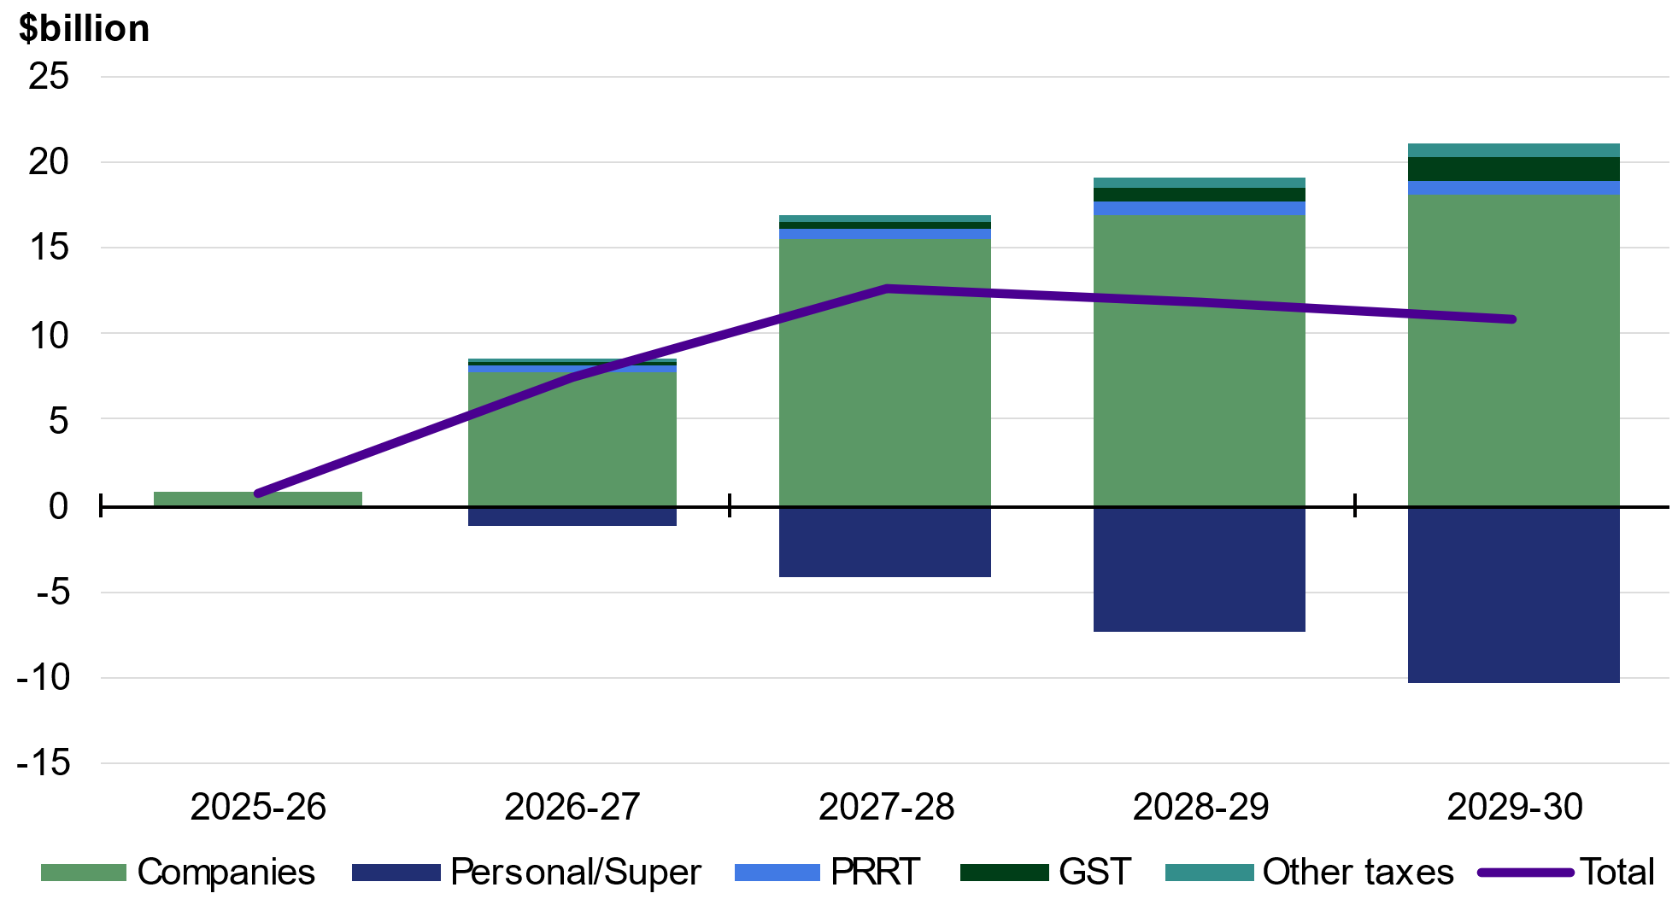
Source: Treasury

Policy decisions taken since MYEFO increase tax receipts by $583.9 million in 2026–27 and decrease tax receipts by $1.8 billion over the five years from 2025–26 to 2029–30. Policy decisions in this Budget focus on the Government’s tax reforms for workers, businesses and future generations; providing cost-of-living relief; and modernising and improving the integrity of the tax system. Key policy decisions include:
- Tax Reform – cutting taxes with a Working Australians Tax Offset
- Tax Reform – Boosting Home Ownership – reforming negative gearing and capital gains tax
- Tax Reform – loss refundability reforms for businesses and start-ups
- Taking Pressure Off Australians – temporary reduction of fuel excise and heavy vehicle road user charge
- Personal Income Tax – increasing the Medicare levy low-income thresholds
For more details on policy decisions, see Statement 1, Statement 4 and Budget Paper No. 2.

Variations in receipts estimates
Since MYEFO, total receipts have been revised up by $21.1 billion in 2026–27 and $49.9 billion over the five years from 2025–26 to 2029–30. Table 5.2 reconciles the 2026–‍27 Budget estimates of total receipts with the 2025–26 MYEFO and the 2025 PEFO.
Table 5.2: Reconciliation of Australian Government general government receipts estimates from the 2025–26 MYEFO and 2025 PEFO
 | Estimates
 | 2025-26 | 2026-27 | 2027-28 | 2028-29 | 2029-30 |  | Total
 | $m | $m | $m | $m | $m |  | $m
Receipts at 2025 PEFO | 735,358 | 765,974 | 797,383 | 840,844 | * |  | *
Changes from 2025 PEFO
to 2025-26 MYEFO
Effect of policy decisions | -151 | -103 | -819 | -511 | * |  | *
Effect of parameter and other variations | 14,585 | 11,158 | 8,989 | 6,590 | * |  | *
Total variations | 14,434 | 11,055 | 8,171 | 6,079 | * |  | *
Receipts at 2025-26 MYEFO | 749,792 | 777,030 | 805,554 | 846,923 | 894,723 |  | 4,074,021
Changes from 2025-26 MYEFO
to 2026-27 Budget
Effect of policy decisions | -3,570 | 2,226 | 961 | 862 | 8,299 |  | 8,777
Effect of parameter and other variations | 13,551 | 18,842 | 16,352 | 598 | -8,228 |  | 41,116
Total variations | 9,980 | 21,068 | 17,313 | 1,460 | 71 |  | 49,893
Receipts at 2026-27 Budget | 759,772 | 798,098 | 822,867 | 848,383 | 894,794 |  | 4,123,914
* Data is not available.

Since MYEFO, parameter and other variations have increased total receipts by $18.8 billion in 2026–27 and $41.1 billion over the five years from 2025–26 to 2029–30. Policy decisions increase total receipts by $2.2 billion in 2026–27 and $8.8 billion over the five years from 2025–‍26 to 2029–30. The change to the outlook for total receipts primarily reflects changes to the outlook for tax receipts.

Tax receipts estimates
Tax receipts have been revised up by $18.6 billion in 2026–27 and $38.4 billion over the five years from 2025–26 to 2029–30 since MYEFO.
Table 5.3 reconciles the 2026–27 Budget estimates of tax receipts with the 2025–26 MYEFO and the 2025 PEFO.
Table 5.3: Reconciliation of Australian Government general government tax receipts estimates from the 2025–26 MYEFO and 2025 PEFO
 | Estimates
 | 2025-26 | 2026-27 | 2027-28 | 2028-29 | 2029-30 |  | Total
 | $m | $m | $m | $m | $m |  | $m
Tax receipts at 2025 PEFO | 676,086 | 707,556 | 735,939 | 778,266 | * |  | *
Changes from 2025 PEFO
to 2025-26 MYEFO
Effect of policy decisions | -17 | -172 | -2,527 | -966 | * |  | *
Effect of parameter and other variations | 15,074 | 11,101 | 8,857 | 6,301 | * |  | *
Total variations | 15,056 | 10,930 | 6,330 | 5,334 | * |  | *
Tax receipts at 2025-26 MYEFO | 691,142 | 718,486 | 742,269 | 783,601 | 828,829 |  | 3,764,326
Changes from 2025-26 MYEFO
to 2026-27 Budget
Effect of policy decisions | -3,871 | 584 | -962 | -1,622 | 4,047 |  | -1,823
Effect of parameter and other variations | 12,257 | 18,031 | 15,655 | 919 | -6,636 |  | 40,226
Total variations | 8,387 | 18,615 | 14,693 | -702 | -2,589 |  | 38,404
Tax receipts at 2026-27 Budget | 699,529 | 737,101 | 756,961 | 782,898 | 826,240 |  | 3,802,730
* Data is not available.

Since MYEFO, parameter and other variations are expected to increase tax receipts by $18.0 billion in 2026–27 and $40.2 billion over the five years from 2025–26 to 2029–30. Policy decisions are estimated to increase tax receipts by $583.9 million in 2026–27 and decrease tax receipts by $1.8 billion over the five years from 2025–26 to 2029–30.
Chart 5.2: Revisions to total tax receipts since 2025–26 MYEFO | Chart 5.3: Parameter and other variations to total tax receipts since 2025–26 MYEFO
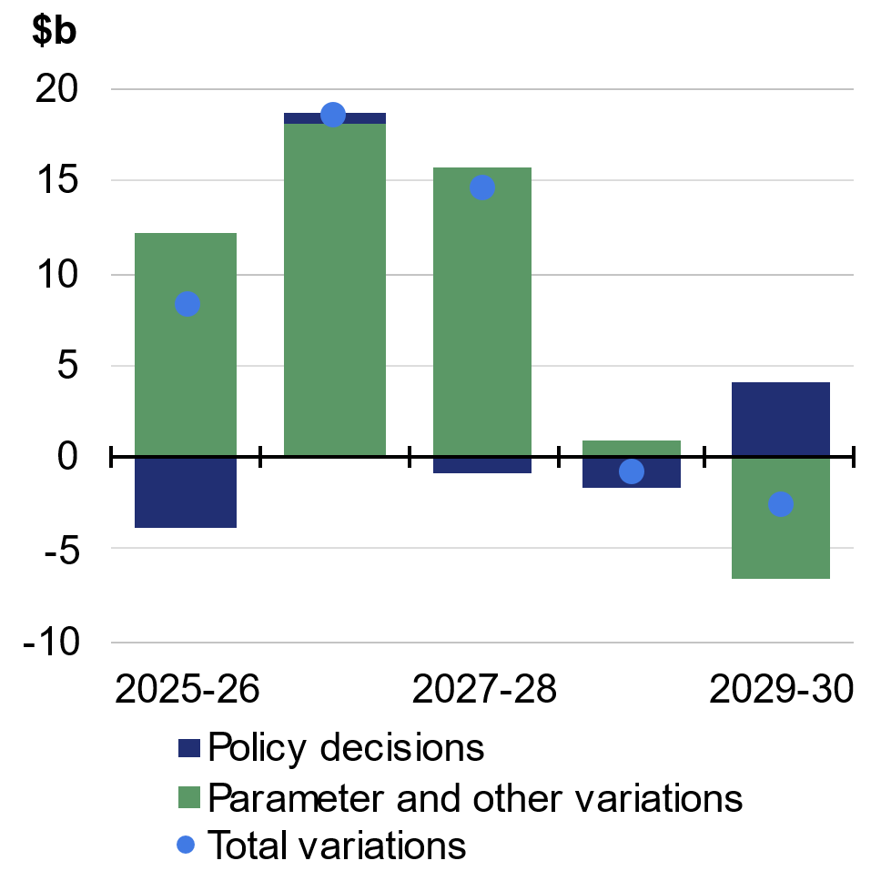 | 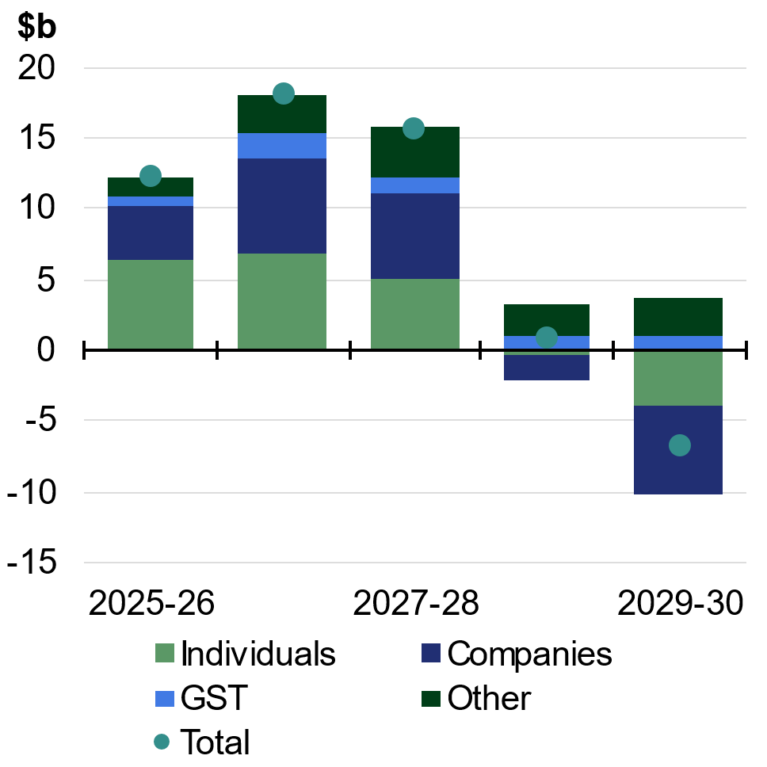
Source: Treasury. | Source: Treasury.

Tax receipts forecasts are based on available information prior to each economic and fiscal update. Growth in the key economic parameters that influence tax receipts is shown in Table 5.4.
Table 5.4: Key economic parameters for tax receipts^{(a)}
 | Outcomes |  | Forecasts
 | 2024-25 |  | 2025-26 | 2026-27 | 2027-28 | 2028-29 | 2029-30
Revenue parameters
Nominal gross domestic product | 3.6 |  | 6 3/4 | 4 1/4 | 2 3/4 | 4 3/4 | 5 1/4
Change since 2025-26 MYEFO |  |  | 1 1/2 | 1 | -2 | - 3/4
Compensation of employees^{(b)} | 6.2 |  | 6 1/4 | 4 1/4 | 4 1/2 | 5 | 5 1/4
Change since 2025-26 MYEFO |  |  | 1/2 | - 1/4 | - 1/2 | - 1/2
Corporate gross operating surplus^{(c)} | -2.9 |  | 8 1/2 | 3 | -2 3/4 | 4 | 5 1/4
Change since 2025-26 MYEFO |  |  | 4 1/4 | 4 | -6 3/4 | -2 3/4
Non-farm gross mixed income | 0.9 |  | 6 1/4 | 7 3/4 | 5 | 5 1/2 | 5 1/2
Change since 2025-26 MYEFO |  |  | 3/4 | 1 | -1 1/2 | -1 1/4
Property income^{(d)} | 8.5 |  | 6 | 8 | 4 | 4 | 3 1/2
Change since 2025-26 MYEFO |  |  | 3 1/4 | 3 | -1 3/4 | -2
Consumption subject to GST | 2.6 |  | 5 1/4 | 5 1/4 | 4 3/4 | 5 3/4 | 5 1/4
Change since 2025-26 MYEFO |  |  | 1/4 | 0 | - 1/2 | 1/4
- Current prices, per cent change on previous year. Changes since 2025–26 MYEFO are percentage points.
- Compensation of employees measures total remuneration earned by employees.
- Corporate gross operating surplus is an Australian System of National Accounts measure of company profits, gross of depreciation.
- Property income measures income derived from rent, dividends and interest.
Source: ABS Australian National Accounts: National Income, Expenditure and Product; and Treasury.

Individuals and other withholding taxes
Since MYEFO, total individuals and other withholding tax receipts have been revised up by $6.6 billion in 2026–27 and $15.0 billion over the five years from 2025–26 to 2029–30.
Excluding new policy decisions, individuals and other withholding tax receipts have been revised up by $6.8 billion in 2026–27 and $13.9 billion over the five years from 2025–26 to 2029–30.
The increase to individuals and other withholding tax receipts is driven by upgrades to net other individuals (gross other individuals and trusts less refunds). Net other individuals has been revised up by $4.2 billion in 2026–27 and $11.3 billion over the five years from 2025–26 to 2029–30, excluding policy decisions. This is in line with recent observed strength in pay-as-you-go instalments and growth in tax owing on 2024–25 returns flowing through to payments in 2025–26. The upgrade to other individuals moderates with interest and business income.
Income tax withholding (predominantly tax on salary and wages) is largely unchanged in total across the forwards estimates since MYEFO. Consistent with changes to the outlook for compensation of employees, income tax withholding has been upgraded in the near term but downgraded in 2028–29 and 2029–30.
New tax policy measures announced since MYEFO are expected to decrease individuals and other withholding tax receipts by $157.2 million in 2026–27 and increase receipts by $1.1 billion over the five years from 2025–26 to 2029–30.
The impact of new measures on total individuals and other withholding tax receipts in this Budget largely reflects the introduction of the Working Australians Tax Offset, as well as the Government’s reforms to negative gearing and capital gains tax concessions and the introduction of a minimum tax on discretionary trusts.

Fringe benefits tax
Since MYEFO, fringe benefits tax receipts have been revised up by $210.0 million in 2026–‍27 and $1.3 billion over the five years from 2025–26 to 2029–30. This reflects the stronger outlook for compensation of employees in the near term.

Company tax
Since MYEFO, company tax receipts have been revised up by $6.7 billion in 2026–‍27 and $4.3 billion over the five years from 2025–26 to 2029–30.
Excluding new policy decisions, company tax receipts have been revised up by $6.7 billion in 2026–‍27 and $8.2 billion over the five years from 2025–26 to 2029–30. The upgrade in the near term reflects stronger-than-expected tax collections, alongside elevated prices for non-rural commodities which are supporting profitability in the resources sector. Company profits are also stronger in the non-mining sectors.
Company profits and tax receipts have been downgraded in 2028–‍29 and 2029–30, driven by lower economic activity and commodity prices (in Australian dollar terms) due to an appreciation of the Australian dollar.
New tax policy measures announced since MYEFO are expected to decrease company tax receipts by $3.9 billion over the five years from 2025–26 to 2029–30.
The impact of new measures on company tax receipts in this Budget largely reflects the reintroduction of permanent two-year loss carry back for companies with up to $1 billion in turnover.

Superannuation fund taxes
Since MYEFO, superannuation fund tax receipts have been revised up by $2.5 billion in 2026–27 and $13.8 billion over the five years from 2025–26 to 2029–30.
The upgrade to superannuation fund taxes reflects higher‑than‑expected current‑year collections and higher contributions across the forward estimates. The upgrade also reflects lower offsets against tax payable due to a weaker outlook for domestic dividend franking credits.
Superannuation fund taxes are volatile, primarily due to year-to-year changes in earnings on investments and the resulting impact on the timing of tax payments.

Petroleum resource rent tax (PRRT)
Since MYEFO, PRRT receipts have been revised up by $400.0 million in 2026–27 and $1.6 billion over the five years from 2025–26 to 2029–30. The upgrade is primarily due to higher oil prices in the near term arising from the conflict in the Middle East and higher production volumes. The higher oil price increases PRRT as most LNG exports are sold under long-term contracts with prices linked to global oil prices.

Goods and services tax (GST)
Since MYEFO, GST receipts have been revised up by $1.7 billion in 2026–27 and $4.6 billion over the five years from 2025–26 to 2029–30.
Excluding new policy decisions, GST receipts have been revised up by $1.8 billion in 2026–‍27 and $5.7 billion over the five years from 2025–26 to 2029–30. This primarily reflects stronger-than-expected collections in the near term, and higher nominal consumption subject to GST over the forward estimates.
New tax policy measures announced since MYEFO have flow-on impacts to the GST head of revenue and are expected to decrease GST receipts by $93.1 million in 2026–27 and $1.1 billion over the five years from 2025–26 to 2029–30.

Excise and customs duty
Since MYEFO, total excise and customs duty receipts have been revised down by $1.1 billion in 2026–27 and $9.7 billion over the five years from 2025–26 to 2029–30.
Excluding new policy decisions, excise and customs duty receipts have been revised down by $813.5 million in 2026–27 and $5.4 billion over the five years from 2025–26 to 2029–30. The downgrade reflects the significant downward revision to tobacco excise receipts, partly offset by an increase in fuel excise receipts. This is due to persistently weaker-than-expected collections and a weaker outlook for excisable tobacco volumes over the forward estimates.
Policy decisions are expected to decrease excise and customs duty receipts by $326.5 million in 2026–27 and $4.3 billion over the five years from 2025–26 to 2029–30. This largely reflects the measure Taking Pressure Off Australians – temporary reduction of fuel excise and heavy vehicle road user charge which will help to reduce the burden of higher fuel prices by more than halving the fuel excise rate for three months from 1 April 2026 to 30 June 2026.
The 2026–27 Budget estimates continue to include provision for the customs duty impact of the Australia-European Union Free Trade Agreement (A-EU FTA). Negotiations for the A-EU FTA concluded on 24 March 2026 and included an announcement of changes to the luxury car tax, which has also been provisioned for in this Budget. The A-EU FTA will be published as a measure following signature.
Box 5.2 Reducing fuel price pressures on households and businesses
The conflict in the Middle East has increased fuel costs for Australian households and businesses. To help alleviate acute cost pressures, the Government has reduced the fuel excise and excise equivalent customs duty by 60.9 per cent from 1 April to 30 June 2026. This equates to a 32 cent per litre reduction for petrol and diesel. As GST is payable on the full retail price, including excise, this reduction in excise also reduces GST payable by 3.2 cents per litre. Since the measure’s introduction, national average petrol prices have fallen by around 30 per cent and diesel prices have fallen by around 20 per cent (Chart 5.4 and Chart 5.5). The Government has also reduced the Heavy Vehicle Road User Charge (RUC) to zero over the three-month period.
Chart 5.4: Petrol prices | Chart 5.5: Diesel prices
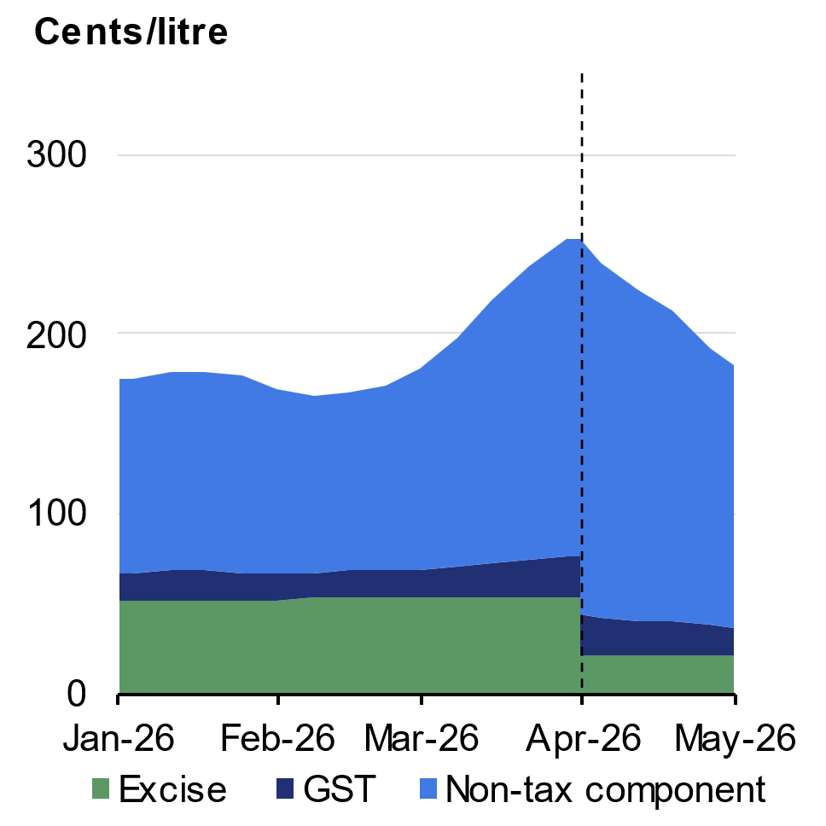 | 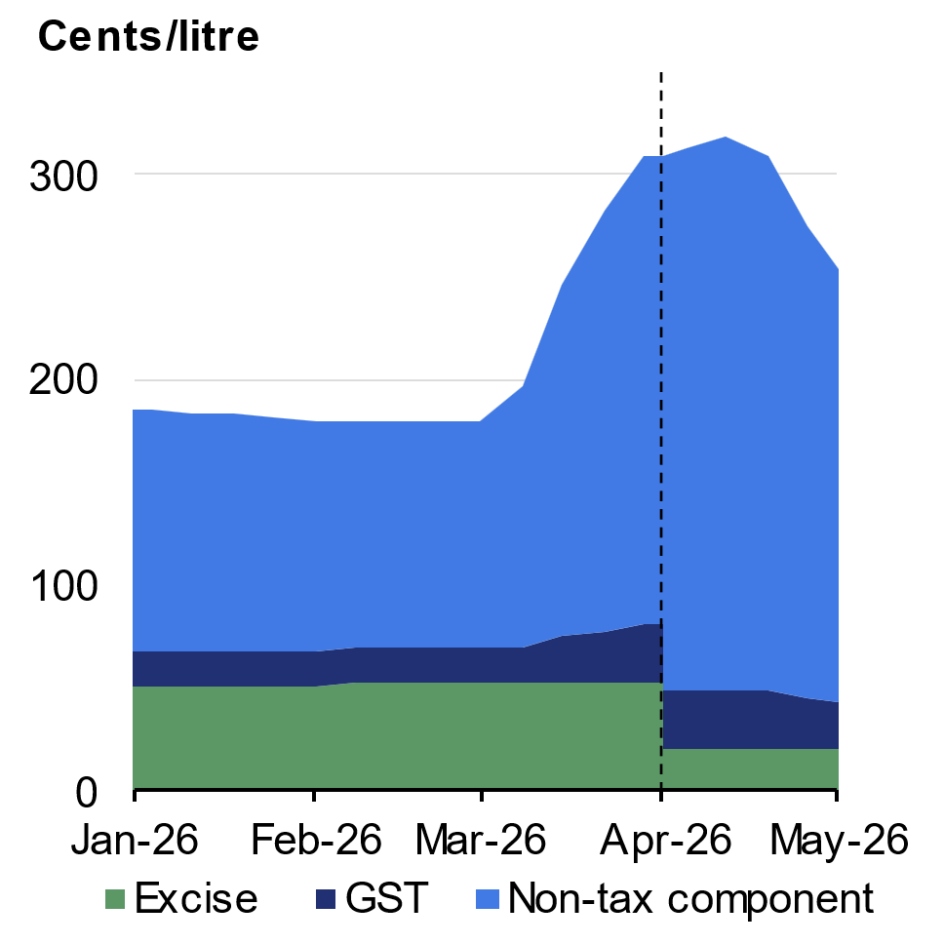
Source: Australian Institute of Petroleum, ATO, and Treasury.  Note: National average prices. | Source: Australian Institute of Petroleum, ATO, and Treasury.  Note: National average prices.

Household benefits
For many households, particularly in regional and outer‑suburban areas with limited transport alternatives, affordable fuel is critical. The excise cut provides timely cost-of-living relief for Australian households directly linked to fuel consumed. For example, the tax payable on a 65-litre tank of petrol has been reduced by nearly $23. A motorist in regional Australia driving 50 kilometres a day, consuming around 10 litres of fuel per 100 kilometres, will save around $160 over three months. Reducing business transport and other energy related costs will also reduce transport cost pressures for critical goods like food and medicines.
continued over next page

Box 5.2 Reducing fuel price pressures on households and businesses (continued)
Petrol, largely consumed by households, is around one third of fuel subject to excise, while diesel, mainly consumed by businesses, is around two thirds (Chart 5.6).
Chart 5.6: Fuel shares | Chart 5.7: Heavy vehicle excise and RUC
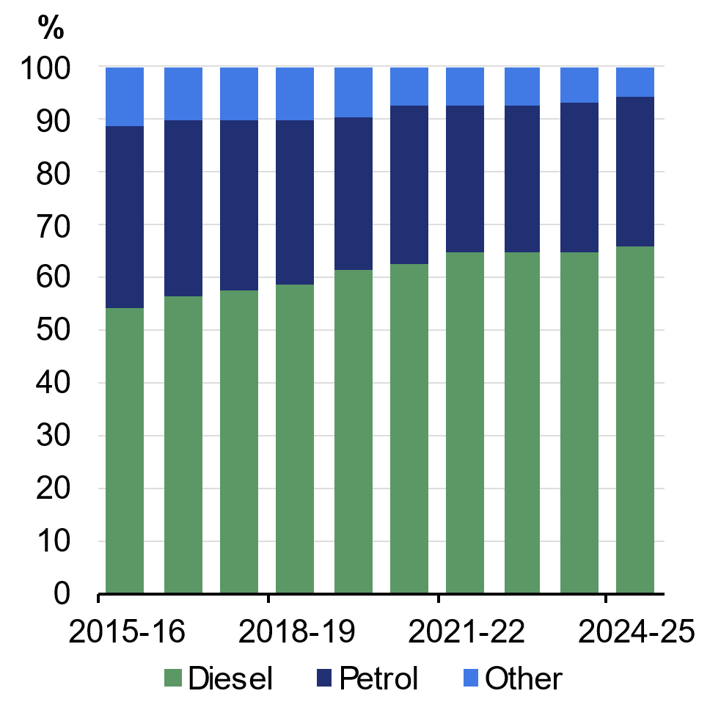 | 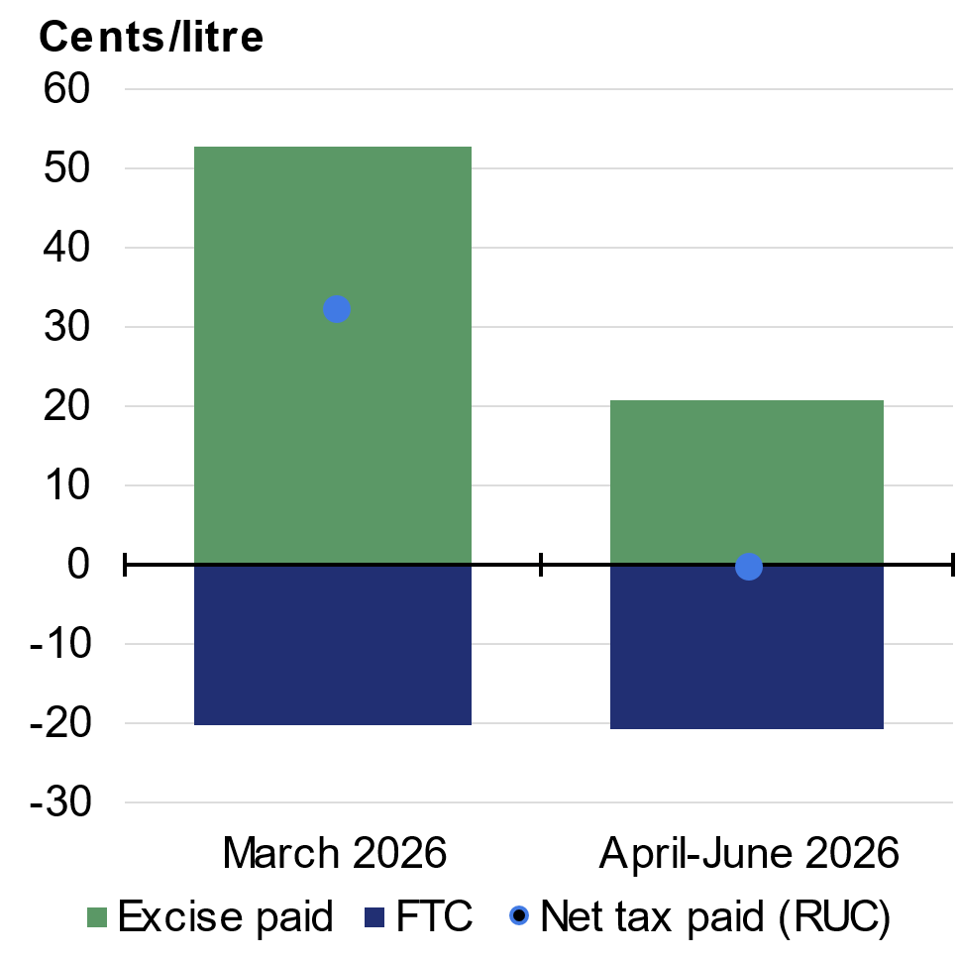
Source: ATO.  Note: Based on gross excisable clearances. | Source: Treasury.

Business benefits
Businesses that use fuel for vehicles that travel off public roads or for machinery and equipment can generally receive a fuel tax credit (FTC) that fully offsets the fuel excise they have paid. However, fuel used in heavy vehicles on public roads is subject to the Heavy Vehicle RUC. Prior to the measure, heavy vehicle operators paid the RUC of 32.4 cents per litre, equivalent to the full excise rate of 52.6 cents less a partial FTC of 20.2 cents (Chart 5.7). Removing the RUC means heavy vehicle operators also now effectively pay no net excise on fuel.
This measure represents a substantial cost saving for many businesses. For example, a truck travelling 25,000 kilometres over the three months, consuming 55 litres of diesel per 100 kilometres, would save around $4,500 in RUC.
Overall, this measure will reduce net fuel excise revenue by around $2.9 billion ($4.2 billion lower tax revenue and $1.3 billion lower expenses, mainly FTCs). The States and Territories are contributing $400 million, with the net cost to the Commonwealth of $2.5 billion.

Other Australian Government taxes
The Australian Government collects a range of other taxes including the major bank levy, luxury car tax, wine equalisation tax, agricultural levies and visa application charges.
Since MYEFO, other tax receipts have been revised up by $1.7 billion in 2026–‍27 and $7.6 billion over the five years from 2025–26 to 2029–30.

Non-tax receipts estimates
Since MYEFO, forecast non-tax receipts have increased by $2.5 billion in 2026–27 and $13.8 billion over the five years from 2025–26 to 2029–30.
Parameter and other variations are expected to increase non-tax receipts by $0.8 billion in 2026–27 and $3.2 billion over the five years from 2025–26 to 2029–30. A forecast increase in earnings from the Future Fund and other Australian Government Investment Funds is partially offset by reduced funding contributions from states and territories to the National Disability Insurance Scheme (NDIS) as a result of lower NDIS growth rates from reforms included in the 2026–27 Budget measure Securing the National Disability Insurance Scheme for future generations. In addition, non-tax receipts have been revised up by $2.3 billion in ‍‍2029–‍30 to account for the differences between the projection methodology at MYEFO and the forward estimate in this Budget.
Policy decisions are expected to increase non-tax receipts by $1.6 billion in 2026–27, and $10.6 billion over the five years from 2025–26 to 2029–30. This increase is largely driven by the standard non-tax receipts impacts of Pharmaceutical Benefits Scheme listings, which partially offset expenditure impacts of these listings, and receipts expected from the divestment of selected properties in the Defence estate.
Table 5.5: Reconciliation of 2025–26 general government (cash) receipts
 | Estimates |  |  | Change on MYEFO
 | MYEFO | Budget
 | $m | $m |  | $m | %
Individuals and other withholding taxes
Gross income tax withholding | 312,500 | 315,300 |  | 2,800 | 0.9
Gross other individuals and trusts | 86,000 | 89,300 |  | 3,300 | 3.8
less: Refunds | 40,600 | 40,400 |  | -200 | -0.5
Total individuals and other withholding tax | 357,900 | 364,200 |  | 6,300 | 1.8
Fringe benefits tax | 5,310 | 5,310 |  | 0 | 0.0
Company tax | 144,700 | 148,500 |  | 3,800 | 2.6
Superannuation fund taxes | 30,010 | 33,060 |  | 3,050 | 10.2
Petroleum resource rent tax | 1,500 | 1,400 |  | -100 | -6.7
Income taxation receipts | 539,420 | 552,470 |  | 13,050 | 2.4
Goods and services tax | 95,654 | 96,341 |  | 688 | 0.7
Wine equalisation tax | 1,160 | 1,110 |  | -50 | -4.3
Luxury car tax | 1,120 | 1,150 |  | 30 | 2.7
Excise and customs duty
Petrol | 7,300 | 6,400 |  | -900 | -12.3
Diesel | 17,610 | 15,110 |  | -2,500 | -14.2
Other fuel products | 1,680 | 1,500 |  | -180 | -10.7
Tobacco | 5,450 | 4,130 |  | -1,320 | -24.2
Beer | 2,710 | 2,710 |  | 0 | 0.0
Spirits | 3,270 | 3,270 |  | 0 | 0.0
Other alcoholic beverages(a) | 1,810 | 1,840 |  | 30 | 1.7
Other customs duty(b) | 2,010 | 1,910 |  | -100 | -5.0
less: Refunds and drawbacks | 1,380 | 1,940 |  | 560 | 40.6
Total excise and customs duty | 40,460 | 34,930 |  | -5,530 | -13.7
Major Bank Levy | 1,880 | 1,920 |  | 40 | 2.1
Agricultural levies | 707 | 673 |  | -34 | -4.8
Visa application charges | 4,576 | 4,668 |  | 92 | 2.0
Other taxes | 6,166 | 6,267 |  | 101 | 1.6
Indirect taxation receipts | 151,722 | 147,059 |  | -4,663 | -3.1
Taxation receipts | 691,142 | 699,529 |  | 8,387 | 1.2
Sales of goods and services | 21,528 | 21,760 |  | 232 | 1.1
Interest received | 9,103 | 9,329 |  | 226 | 2.5
Dividends and distributions | 7,558 | 7,630 |  | 73 | 1.0
Other non-taxation receipts | 20,460 | 21,523 |  | 1,063 | 5.2
Non-taxation receipts | 58,649 | 60,243 |  | 1,593 | 2.7
Total receipts | 749,792 | 759,772 |  | 9,980 | 1.3
Memorandum:
Total excise | 31,680 | 28,180 |  | -3,500 | -11.0
Total customs duty | 8,780 | 6,750 |  | -2,030 | -23.1
Capital gains tax(c) | 31,500 | 33,600 |  | 2,100 | 6.7
- ‘Other alcoholic beverages’ are those not exceeding 10 per cent by volume of alcohol (excluding beer, brandy and wine).
- ‘Other customs duty’ includes duty paid on textiles, clothing and footwear, passenger motor vehicles and other imports that are not subject to excise equivalent duty.
- ‘Capital gains tax’ is part of gross other individuals and trusts, company tax and superannuation fund taxes.

Table 5.6: Reconciliation of 2026–27 general government (cash) receipts
 | Estimates |  |  | Change on MYEFO
 | MYEFO | Budget
 | $m | $m |  | $m | %
Individuals and other withholding taxes
Gross income tax withholding | 328,700 | 331,100 |  | 2,400 | 0.7
Gross other individuals and trusts | 89,500 | 94,100 |  | 4,600 | 5.1
less: Refunds | 42,400 | 42,800 |  | 400 | 0.9
Total individuals and other withholding tax | 375,800 | 382,400 |  | 6,600 | 1.8
Fringe benefits tax | 5,370 | 5,580 |  | 210 | 3.9
Company tax | 147,300 | 154,000 |  | 6,700 | 4.5
Superannuation fund taxes | 29,110 | 31,560 |  | 2,450 | 8.4
Petroleum resource rent tax | 1,500 | 1,900 |  | 400 | 26.7
Income taxation receipts | 559,080 | 575,440 |  | 16,360 | 2.9
Goods and services tax | 101,560 | 103,249 |  | 1,688 | 1.7
Wine equalisation tax | 1,210 | 1,160 |  | -50 | -4.1
Luxury car tax | 1,180 | 1,130 |  | -50 | -4.2
Excise and customs duty
Petrol | 7,550 | 7,600 |  | 50 | 0.7
Diesel | 18,430 | 18,560 |  | 130 | 0.7
Other fuel products | 1,710 | 1,720 |  | 10 | 0.6
Tobacco | 4,800 | 3,560 |  | -1,240 | -25.8
Beer | 2,760 | 2,810 |  | 50 | 1.8
Spirits | 3,280 | 3,300 |  | 20 | 0.6
Other alcoholic beverages(a) | 1,860 | 1,920 |  | 60 | 3.2
Other customs duty(b) | 2,070 | 1,850 |  | -220 | -10.6
less: Refunds and drawbacks | 730 | 730 |  | 0 | 0.0
Total excise and customs duty | 41,730 | 40,590 |  | -1,140 | -2.7
Major Bank Levy | 1,970 | 2,020 |  | 50 | 2.5
Agricultural levies | 697 | 671 |  | -26 | -3.7
Visa application charges | 4,971 | 6,181 |  | 1,211 | 24.4
Other taxes | 6,087 | 6,660 |  | 572 | 9.4
Indirect taxation receipts | 159,406 | 161,661 |  | 2,255 | 1.4
Taxation receipts | 718,486 | 737,101 |  | 18,615 | 2.6
Sales of goods and services | 23,025 | 23,299 |  | 274 | 1.2
Interest received | 9,091 | 9,636 |  | 546 | 6.0
Dividends and distributions | 7,766 | 7,768 |  | 3 | 0.0
Other non-taxation receipts | 18,662 | 20,293 |  | 1,631 | 8.7
Non-taxation receipts | 58,544 | 60,997 |  | 2,453 | 4.2
Total receipts | 777,030 | 798,098 |  | 21,068 | 2.7
Memorandum:
Total excise | 32,900 | 33,270 |  | 370 | 1.1
Total customs duty | 8,830 | 7,320 |  | -1,510 | -17.1
Capital gains tax(c) | 30,700 | 34,200 |  | 3,500 | 11.4
- ‘Other alcoholic beverages’ are those not exceeding 10 per cent by volume of alcohol (excluding beer, brandy and wine).
- ‘Other customs duty’ includes duty paid on textiles, clothing and footwear, passenger motor vehicles and other imports that are not subject to excise equivalent duty.
- ‘Capital gains tax’ is part of gross other individuals and trusts, company tax and superannuation fund taxes.

Table 5.7: Australian Government general government (cash) receipts
 | Actual |  | Estimates
 | 2024-25 |  | 2025-26 | 2026-27 | 2027-28 | 2028-29 | 2029-30
 | $m |  | $m | $m | $m | $m | $m
Individuals and other withholding taxes
Gross income tax withholding | 295,827 |  | 315,300 | 331,100 | 348,600 | 367,000 | 391,100
Gross other individuals and trusts | 81,707 |  | 89,300 | 94,100 | 97,200 | 102,300 | 114,300
less: Refunds | 39,223 |  | 40,400 | 42,800 | 46,800 | 49,700 | 55,100
Total individuals and other withholding tax | 338,312 |  | 364,200 | 382,400 | 399,000 | 419,600 | 450,300
Fringe benefits tax | 4,927 |  | 5,310 | 5,580 | 5,820 | 6,140 | 6,590
Company tax | 138,762 |  | 148,500 | 154,000 | 151,700 | 148,700 | 151,600
Superannuation fund taxes | 25,700 |  | 33,060 | 31,560 | 31,210 | 32,310 | 34,560
Petroleum resource rent tax | 1,420 |  | 1,400 | 1,900 | 1,750 | 1,550 | 1,250
Income taxation receipts | 509,121 |  | 552,470 | 575,440 | 589,480 | 608,300 | 644,300
Goods and services tax | 90,322 |  | 96,341 | 103,249 | 107,868 | 114,263 | 120,191
Wine equalisation tax | 1,134 |  | 1,110 | 1,160 | 1,200 | 1,240 | 1,290
Luxury car tax | 1,088 |  | 1,150 | 1,130 | 1,070 | 1,120 | 1,160
Excise and customs duty
Petrol | 7,306 |  | 6,400 | 7,600 | 7,800 | 7,950 | 8,050
Diesel | 17,262 |  | 15,110 | 18,560 | 19,560 | 20,460 | 21,360
Other fuel products | 1,731 |  | 1,500 | 1,720 | 1,740 | 1,780 | 1,830
Tobacco | 7,767 |  | 4,130 | 3,560 | 3,020 | 2,530 | 2,140
Beer | 2,729 |  | 2,710 | 2,810 | 2,890 | 2,990 | 3,100
Spirits | 3,320 |  | 3,270 | 3,300 | 3,330 | 3,360 | 3,380
Other alcoholic beverages(a) | 1,789 |  | 1,840 | 1,920 | 1,990 | 2,070 | 2,150
Other customs duty(b) | 1,996 |  | 1,910 | 1,850 | 1,430 | 960 | 1,020
less: Refunds and drawbacks | 711 |  | 1,940 | 730 | 730 | 730 | 730
Total excise and customs duty | 43,188 |  | 34,930 | 40,590 | 41,030 | 41,370 | 42,300
Major Bank Levy | 1,768 |  | 1,920 | 2,020 | 2,100 | 2,190 | 2,300
Agricultural levies | 664 |  | 673 | 671 | 710 | 737 | 727
Visa application charges | 4,154 |  | 4,668 | 6,181 | 6,742 | 6,989 | 7,095
Other taxes | 6,403 |  | 6,267 | 6,660 | 6,762 | 6,689 | 6,878
Indirect taxation receipts | 148,723 |  | 147,059 | 161,661 | 167,481 | 174,598 | 181,940
Taxation receipts | 657,844 |  | 699,529 | 737,101 | 756,961 | 782,898 | 826,240
Sales of goods and services | 22,024 |  | 21,760 | 23,299 | 24,847 | 25,024 | 25,042
Interest received | 10,545 |  | 9,329 | 9,636 | 9,696 | 10,056 | 10,538
Dividends and distributions | 7,262 |  | 7,630 | 7,768 | 8,304 | 9,098 | 9,868
Other non-taxation receipts | 19,277 |  | 21,523 | 20,293 | 23,058 | 21,307 | 23,105
Non-taxation receipts | 59,107 |  | 60,243 | 60,997 | 65,906 | 65,485 | 68,554
Total receipts | 716,951 |  | 759,772 | 798,098 | 822,867 | 848,383 | 894,794
Memorandum:
Total excise | 31,294 |  | 28,180 | 33,270 | 34,690 | 36,020 | 37,300
Total customs duty | 11,894 |  | 6,750 | 7,320 | 6,340 | 5,350 | 5,000
Capital gains tax(c) | 30,400 |  | 33,600 | 34,200 | 34,000 | 34,600 | 35,900
- ‘Other alcoholic beverages’ are those not exceeding 10 per cent by volume of alcohol (excluding beer, brandy and wine).
- ‘Other customs duty’ includes duty paid on textiles, clothing and footwear, passenger motor vehicles and other imports that are not subject to excise equivalent duty.
- ‘Capital gains tax’ is part of gross other individuals and trusts, company tax and superannuation fund taxes.

Variations in revenue estimates
The revenue estimates are the accrual accounting equivalent of the cash-based receipts estimates. Changes in revenue are generally driven by the same factors as receipts.
Revenues are usually higher than the cash equivalents because the amounts are generally recognised when they are owed rather than when they are paid. The differences between the accrual and cash amounts therefore generally reflect payment timing differences. Table 5.8 provides a reconciliation of the 2026–27 Budget revenue estimates with those at the 2025–26 MYEFO and 2025 PEFO.
Table 5.8: Reconciliation of Australian Government general government revenue estimates from the 2025–26 MYEFO and the 2025 PEFO
 | Estimates
 | 2025-26 | 2026-27 | 2027-28 | 2028-29 | 2029-30 |  | Total
 | $m | $m | $m | $m | $m |  | $m
Revenue at 2025 PEFO | 750,268 | 783,564 | 815,433 | 862,511 | * |  | *
Changes from 2025 PEFO
to 2025-26 MYEFO
Effect of policy decisions(a) | -895 | -676 | -1,334 | -971 | * |  | *
Effect of parameter and other variations | 16,221 | 10,718 | 6,664 | 2,555 | * |  | *
Total variations | 15,325 | 10,041 | 5,329 | 1,584 | * |  | *
Revenue at 2025-26 MYEFO | 765,593 | 793,605 | 820,762 | 864,094 | * |  | *
Changes from 2025-26 MYEFO
to 2026-27 Budget
Effect of policy decisions(a) | -3,918 | 2,537 | 692 | -589 | 7,618 |  | 6,340
Effect of parameter and other variations | 11,407 | 19,186 | 14,833 | -33 | * |  | *
Total variations | 7,488 | 21,723 | 15,525 | -622 | * |  | *
Revenue at 2026-27 Budget | 773,081 | 815,328 | 836,287 | 863,473 | 910,148 |  | 4,198,317
* Data is not available.
- Excludes secondary impacts on public debt interest of policy decisions and offsets from the Contingency Reserve for decisions taken.

Since MYEFO, total revenue has been revised up by $21.7 billion in 2026–27 and $42.5 billion over the five years from 2025–26 to 2029–30.
The changes in the individual heads of revenue accrual estimates relative to MYEFO are shown in Tables 5.9 and 5.10, for 2025–26 and 2026–27, respectively. For the 5-year accrual table, the accrual equivalent of Table 5.7, see Statement 10, Note 3.
Additional revenue and receipts historical tables are available online and can be accessed at www.budget.gov.au.
Table 5.9: Reconciliation of 2025–26 general government (accrual) revenue
 | Estimates |  |  | Change on MYEFO
 | MYEFO | Budget
 | $m | $m |  | $m | %
Individuals and other withholding taxes
Gross income tax withholding | 315,800 | 317,700 |  | 1,900 | 0.6
Gross other individuals and trusts | 91,600 | 95,500 |  | 3,900 | 4.3
less: Refunds | 40,600 | 40,400 |  | -200 | -0.5
Total individuals and other withholding tax | 366,800 | 372,800 |  | 6,000 | 1.6
Fringe benefits tax | 5,560 | 5,560 |  | 0 | 0.0
Company tax | 147,800 | 151,300 |  | 3,500 | 2.4
Superannuation fund taxes | 29,880 | 33,050 |  | 3,170 | 10.6
Petroleum resource rent tax | 1,820 | 1,670 |  | -150 | -8.2
Income taxation revenue | 551,860 | 564,380 |  | 12,520 | 2.3
Goods and services tax | 101,030 | 100,750 |  | -280 | -0.3
Wine equalisation tax | 1,110 | 1,060 |  | -50 | -4.5
Luxury car tax | 1,130 | 1,160 |  | 30 | 2.7
Excise and customs duty
Petrol | 7,320 | 6,320 |  | -1,000 | -13.7
Diesel | 17,660 | 14,960 |  | -2,700 | -15.3
Other fuel products | 1,680 | 1,500 |  | -180 | -10.7
Tobacco | 5,450 | 4,130 |  | -1,320 | -24.2
Beer | 2,720 | 2,720 |  | 0 | 0.0
Spirits | 3,270 | 3,270 |  | 0 | 0.0
Other alcoholic beverages(a) | 1,810 | 1,840 |  | 30 | 1.7
Other customs duty(b) | 2,010 | 1,910 |  | -100 | -5.0
less: Refunds and drawbacks | 1,380 | 1,940 |  | 560 | 40.6
Total excise and customs duty | 40,540 | 34,710 |  | -5,830 | -14.4
Major bank levy | 1,900 | 1,940 |  | 40 | 2.1
Agricultural levies | 707 | 673 |  | -34 | -4.8
Visa application charges | 4,576 | 4,668 |  | 92 | 2.0
Other taxes | 7,127 | 7,281 |  | 154 | 2.2
Indirect taxation revenue | 158,120 | 152,242 |  | -5,877 | -3.7
Taxation revenue | 709,980 | 716,622 |  | 6,643 | 0.9
Sales of goods and services | 21,987 | 22,213 |  | 226 | 1.0
Interest | 10,159 | 10,216 |  | 57 | 0.6
Dividends and distributions | 7,591 | 7,591 |  | 0 | 0.0
Other non-taxation revenue | 15,876 | 16,439 |  | 563 | 3.5
Non-taxation revenue | 55,613 | 56,459 |  | 846 | 1.5
Total revenue | 765,593 | 773,081 |  | 7,488 | 1.0
Memorandum:
Total excise | 31,760 | 27,960 |  | -3,800 | -12.0
Total customs duty | 8,780 | 6,750 |  | -2,030 | -23.1
Capital gains tax(c) | 31,500 | 33,600 |  | 2,100 | 6.7
- ‘Other alcoholic beverages’ are those not exceeding 10 per cent by volume of alcohol (excluding beer, brandy and wine).
- ‘Other customs duty’ includes duty paid on textiles, clothing and footwear, passenger motor vehicles and other imports that are not subject to excise equivalent duty.
- ‘Capital gains tax’ is part of gross other individuals and trusts, company tax and superannuation fund taxes.

Table 5.10: Reconciliation of 2026–27 general government (accrual) revenue
 | Estimates |  |  | Change on MYEFO
 | MYEFO | Budget
 | $m | $m |  | $m | %
Individuals and other withholding taxes
Gross income tax withholding | 332,200 | 333,600 |  | 1,400 | 0.4
Gross other individuals and trusts | 94,200 | 100,100 |  | 5,900 | 6.3
less: Refunds | 42,400 | 42,800 |  | 400 | 0.9
Total individuals and other withholding tax | 384,000 | 390,900 |  | 6,900 | 1.8
Fringe benefits tax | 5,620 | 5,830 |  | 210 | 3.7
Company tax | 150,500 | 157,000 |  | 6,500 | 4.3
Superannuation fund taxes | 29,140 | 31,590 |  | 2,450 | 8.4
Petroleum resource rent tax | 1,590 | 1,950 |  | 360 | 22.6
Income taxation revenue | 570,850 | 587,270 |  | 16,420 | 2.9
Goods and services tax | 107,240 | 109,150 |  | 1,910 | 1.8
Wine equalisation tax | 1,220 | 1,170 |  | -50 | -4.1
Luxury car tax | 1,180 | 1,110 |  | -70 | -5.9
Excise and customs duty
Petrol | 7,570 | 7,720 |  | 150 | 2.0
Diesel | 18,490 | 18,820 |  | 330 | 1.8
Other fuel products | 1,710 | 1,720 |  | 10 | 0.6
Tobacco | 4,800 | 3,560 |  | -1,240 | -25.8
Beer | 2,780 | 2,830 |  | 50 | 1.8
Spirits | 3,280 | 3,300 |  | 20 | 0.6
Other alcoholic beverages(a) | 1,860 | 1,920 |  | 60 | 3.2
Other customs duty(b) | 2,070 | 1,850 |  | -220 | -10.6
less: Refunds and drawbacks | 730 | 730 |  | 0 | 0.0
Total excise and customs duty | 41,830 | 40,990 |  | -840 | -2.0
Major bank levy | 1,990 | 2,040 |  | 50 | 2.5
Agricultural levies | 697 | 671 |  | -26 | -3.7
Visa application charges | 4,971 | 6,181 |  | 1,211 | 24.4
Other taxes | 6,927 | 7,700 |  | 773 | 11.2
Indirect taxation revenue | 166,055 | 169,013 |  | 2,957 | 1.8
Taxation revenue | 736,905 | 756,283 |  | 19,377 | 2.6
Sales of goods and services | 23,526 | 23,821 |  | 295 | 1.3
Interest | 10,568 | 11,224 |  | 656 | 6.2
Dividends and distributions | 7,808 | 7,805 |  | -3 | 0.0
Other non-taxation revenue | 14,798 | 16,195 |  | 1,397 | 9.4
Non-taxation revenue | 56,699 | 59,045 |  | 2,346 | 4.1
Total revenue | 793,605 | 815,328 |  | 21,723 | 2.7
Memorandum:
Total excise | 33,000 | 33,670 |  | 670 | 2.0
Total customs duty | 8,830 | 7,320 |  | -1,510 | -17.1
Capital gains tax(c) | 30,700 | 34,200 |  | 3,500 | 11.4
- ‘Other alcoholic beverages’ are those not exceeding 10 per cent by volume of alcohol (excluding beer, brandy and wine).
- ‘Other customs duty’ includes duty paid on textiles, clothing and footwear, passenger motor vehicles and other imports that are not subject to excise equivalent duty.
- ‘Capital gains tax’ is part of gross other individuals and trusts, company tax and superannuation fund taxes.

Appendix A: Tax Expenditures
This appendix contains an overview of Australian Government tax expenditures. Section 12 of the Charter of Budget Honesty Act 1998 requires the publication of an overview of estimated tax expenditures.
The Government published the 2025–26 Tax Expenditures and Insights Statement (TEIS) on 17 December 2025 and this will be updated for tax measures in this Budget in the 2026–‍27 TEIS. The TEIS provides an estimate of the revenue forgone from tax expenditures, along with distributional analysis on large tax expenditures and commonly utilised features of the tax system.
Tax benchmarks represent a standard tax treatment that applies to similar taxpayers or types of activities. Policy approaches can apply a tax treatment different from a standard approach, which can give rise to positive or negative tax expenditures. The choice of benchmark unavoidably involves some judgment.
Consistent with most OECD countries, estimates of tax expenditures reflect the extent to which they are used, similar to Budget estimates of outlays on demand-driven expenditure programs. This is known as the ‘revenue forgone’ approach which, in practice, involves estimating the difference in revenue between the actual and benchmark tax treatments but, importantly, assuming taxpayer behaviour is the same in each circumstance. Revenue forgone estimates therefore do not indicate the revenue gain to the Budget if a specific tax expenditure was abolished through policy change, as there may be significant changes in taxpayer behaviour.
Care needs to be taken when comparing tax expenditures with direct expenditures as they may measure different things. In addition, estimates from different editions of previously released Statements are generally not directly comparable, because of changes or modifications to—for example—benchmarks, individual tax expenditures, data used or modelling methodology.
Table A.5.1 lists the largest measured tax expenditures for 2025–26 and several personal deduction categories. It is derived from the 2025–26 TEIS and is based on economic parameters as at the publication of MYEFO. It does not include the impact of policy decisions, or changes in the economic outlook since then on tax expenditures. The TEIS is not a statement of policy intent.
The 2025–26 TEIS also contains distributional analysis on some features of the tax system, including deductions for individuals. The items in the deductions category are not tax expenditures, so they do not result in forgone revenue against the benchmark. However, the difference between tax paid with the deduction and tax that would have been paid if the deduction was not claimed has been included in Table A.5.1 for comparison purposes.
Table A.5.1: Estimates of large measured tax expenditures and deductions
Tax type affected | Code | Title | Revenue forgone 2025-26 ($m)* | Average growth  2021-22 to 2024-25 (%) | Average projected growth over FEs (%)
Positive tax expenditures and deductions
CGT | E8 | Main residence exemption – discount component | 32,000 | 10.3 | 10.5
Super | C2 | Concessional taxation of employer superannuation contributions | 29,450 | 8.2 | 6.2
Deductions |  | Rental deductions | 29,200 | 18.0 | 5.2
CGT | E7 | Main residence exemption | 28,000 | 11.3 | 10.1
Super | C4 | Concessional taxation of superannuation earnings | 25,950 | 3.5 | 5.3
CGT | E15 | Discount for individuals and trusts | 21,790 | 8.1 | 0.8
Deductions |  | Work-related expenses | 12,400 | 8.7 | 5.8
Income | A25 | Exemption for National Disability Insurance Scheme amounts | 12,180 | 30.0 | 7.6
GST | H25 | Food | 9,900 | 5.0 | 4.2
GST | H17 | Health – medical and health services | 6,750 | 11.1 | 6.8
Income | A26 | Exemption of Child Care Assistance payments | 4,600 | 19.5 | 5.6
GST | H14 | Education | 4,450 | 8.5 | 7.1
GST | H2 | Financial supplies – input taxed treatment | 3,800 | 7.4 | 4.5
Income | B61 | Lower tax rate for small companies | 3,800 | -1.9 | 4.1
FBT | D15 | Exemption for public benevolent institutions (excluding hospitals) | 3,150 | 9.3 | 5.4
Income | A23 | Concessional taxation of non-superannuation termination benefits | 3,100 | 18.8 | N/A
Income | A20 | Medicare levy exemption for residents with taxable income below the low-income thresholds | 3,050 | 6.1 | 0.0
Income | B11 | Exemption from interest withholding tax on certain securities | 3,000 | 16.8 | -1.0
Income | A37 | Exemption of certain income support benefits, pensions or allowances | 2,800 | 15.9 | 4.0
Super | C3 | Concessional taxation of personal superannuation contributions | 2,750 | 17.7 | 1.6
GST | H5 | Child care services | 2,570 | 10.3 | 4.6
Super | C1 | Concessional taxation of capital gains for superannuation funds | 2,550 | 0.0 | 4.8
Super | C6 | Deductibility of life and total and permanent disability insurance premiums provided inside of superannuation | 2,450 | 3.7 | 6.3
Income | A39 | Exemptions of certain veterans’ pensions, allowances or benefits, compensation, and particular World War II-related payments for persecution | 2,230 | 31.8 | -4.8
Income | B1 | Local government bodies income tax exemption | 2,090 | 3.1 | 1.3
Table A.5.1: Estimates of large measured tax expenditures and deductions (continued)
Tax type affected | Code | Title | Revenue forgone 2025-26 ($m)* | Average growth  2021-22 to 2024-25 (%) | Average projected growth over FEs (%)
Income | A31 | Seniors and pensioners tax offset | 2,050 | 60.4 | 4.9
Income | B12 | Exemption of inbound non-portfolio distributions from income tax | 1,980 | -6.3 | 0.0
FBT | D11 | Exemption for public and not-for-profit hospitals and public ambulance services | 1,900 | 3.9 | 3.8
Income | A38 | Exemption of Family Tax Benefit payments | 1,860 | 8.4 | 2.4
Other | F6 | Concessional rate of excise levied on aviation gasoline and aviation turbine fuel | 1,820 | 21.9 | 6.5
GST | H18 | Health – residential care, community care and other care services | 1,810 | 7.2 | 6.8
Deductions |  | Cost of managing tax affairs and other deductions | 1,700 | 10.7 | 1.3
Income | A18 | Exemption of the Private Health Insurance Rebate | 1,550 | 3.2 | 1.5
Income | A56 | Philanthropy – deduction for gifts to deductible gift recipients | 1,400 | -4.3 | 4.3
GST | H6 | Water, sewerage and drainage | 1,380 | 6.2 | 3.7
Income | B81 | Capital works expenditure deduction | 1,380 | 3.5 | 2.6
FBT | D33 | Exemption for Electric Vehicles | 1,350 | N/A | 29.4
FBT | D21 | Application of statutory formula to value car benefits | 1,300 | 10.1 | 0.0
Super | C12 | Exemption for small business assets held for more than 15 years | 1,190 | 14.9 | -2.0
CGT | E32 | Small business 50 per cent reduction | 1,180 | 9.0 | -1.0
Negative tax expenditures and deductions
Income | B80 | Accelerated depreciation for business entities | -6,500 | N/A | -24.0
Income | B86 | Simplified depreciation rules | -5,200 | N/A | -25.7
Other | F21 | Customs duty | -2,030 | 0.8 | -13.2
Income | A21 | Medicare levy surcharge | -1,150 | 18.6 | -1.1
Other | F5 | Luxury car tax | -1,130 | 4.2 | 4.8
Super | C11 | Tax on funded superannuation lump sums | -1,050 | 21.8 | 2.8
* For deductions, ‘Revenue forgone’ refers to the reduction in tax in relation to the specified income year due to the utilisation of deductions.

