Statement 7:
Debt Statement
Gross debt and net debt are expected to be lower in every year of the forward estimates and medium term than estimated at the 2025‍‍–‍26 Mid-‍Year Economic and Fiscal Outlook (MYEFO).
Gross debt in 2026‍–‍27 is $18 billion lower than MYEFO and $173 billion lower than the 2022 PEFO. The improvement since the 2022 PEFO means more than $70 billion in avoided interest costs over the 11 years to 2032‍–‍33.
Gross debt is estimated to be 34.0 per cent of GDP at the end of 2026‍‍–‍‍27, 1.4 percentage points lower than estimated at MYEFO. Gross debt is expected to peak at 35.8 per cent of GDP at the end of 2028‍‍–‍‍29, 1.2 percentage points lower than the peak at MYEFO, before falling to 27.2 per cent in 2036‍‍–‍‍37.
Net debt in 2026‍‍–‍‍27 is expected to be 19.9 per cent of GDP, 1.5 percentage points of GDP lower than estimated at MYEFO.
Interest payments on Australian Government Securities are estimated to be $27.7 billion in 2026‍‍–‍‍27, increasing to $40.4 billion by 2029‍‍–‍‍30. Over the five years to 2029‍‍–‍30, total interest payments on AGS are expected to be $1.7 billion lower than estimated at MYEFO. Interest payments are lower because the lower level of gross debt more than offsets the impact of higher yields.

Statement 7 contents
Australian Government Securities issuance 255
Estimates of AGS on issue 255
Changes in AGS on issue since the 2025‍–‍26 MYEFO 257
Breakdown of AGS currently on issue 258
Treasury Bonds 259
Treasury Indexed Bonds 260
Treasury Notes 260
Non-resident holdings of AGS on issue 261
Net debt 261
Changes in net debt since the 2025‍–‍26 MYEFO 262
Interest on AGS 263

Statement 7: Debt Statement
The Debt Statement provides information on Government gross debt, net debt, Australian Government Securities (AGS) issuance and interest costs.

Australian Government Securities issuance
The Australian Government finances its activities either through receipts or borrowing. When receipts fall short of payments, the Government borrows by issuing AGS.
The Australian Office of Financial Management (AOFM) is responsible for issuing AGS and managing the Government’s financing activities. The AOFM exercises operational independence in the execution of its duties. Further details on the AOFM’s operations can be found on the AOFM website at www.aofm.gov.au.

Estimates of AGS on issue
Estimates of AGS on issue are published in both face value and market value terms in this Statement.
- The face value of AGS on issue (also referred to as gross debt) is the amount the Government pays back to investors at maturity, independent of fluctuations in market prices. The total face value of AGS on issue changes when new securities are issued, or when securities are repurchased or mature.
- The market value of AGS on issue represents the value of securities as traded on the secondary market, which changes continuously with movements in market prices (often quoted as a yield to maturity). Consistent with external reporting standards, the market value of AGS on issue is reported in the Australian Government general government sector balance sheet.
The Commonwealth Inscribed Stock Act 1911 (CIS Act) requires the Treasurer to issue a direction stipulating the maximum face value of relevant AGS that may be on issue. Effective from 7 October 2020, the then Treasurer directed that the maximum face value of AGS that can be on issue is $1,200 billion.

Gross debt is estimated to be $1,051 billion (34.0 per cent of GDP) at 30 June 2027, increasing to $1,249 billion (35.6 per cent of GDP) at 30 June 2030. Gross debt relative to GDP is expected to be lower than at the 2025‍‍–‍‍26 MYEFO across each year of the forward estimates.
These declines relative to GDP reflect reductions in the cash financing requirement across the forward estimates, revisions to nominal GDP and lower end-of-year cash holdings by the AOFM.
Table 7.1: Estimates of AGS on issue subject to the Treasurer’s Direction^{(a)(b)}
 | Estimates
 | 2025-26 | 2026-27 | 2027-28 | 2028-29 | 2029-30
 | $b | $b | $b | $b | $b
Face value – end-of-year | 982.0 | 1,051.0 | 1,120.0 | 1,193.0 | 1,249.0
Per cent of GDP | 33.1 | 34.0 | 35.2 | 35.8 | 35.6
Face value – within-year peak | 999.9 | 1,053.0 | 1,133.0 | 1,198.0 | 1,273.0
Per cent of GDP | 33.7 | 34.0 | 35.6 | 35.9 | 36.3
Month of peak | Feb-26 | Apr-27 | May-28 | Apr-29 | May-30
Market value – end-of-year | 910.6 | 987.6 | 1,063.7 | 1,147.0 | 1,214.0
Per cent of GDP | 30.7 | 31.9 | 33.4 | 34.4 | 34.6
- The Treasurer’s Direction applies to the face value of AGS on issue. This table also shows the equivalent market value of AGS that are subject to the Treasurer’s Direction.
- The stock and securities that are excluded from the current limit set by the Treasurer’s Direction are outlined in subsection 51JA(2A) of the CIS Act.
Source: AOFM

Changes in AGS on issue since the 2025‍–‍26 MYEFO
The decrease in total face value of AGS on issue primarily reflects a reduced borrowing requirement, partially offset by a higher yield assumption for new issuance of AGS.
Aggregate improvements to the Government’s fiscal position and lower end-of-year cash holdings by the AOFM have reduced cash borrowing estimates across the forward estimates.
Conversely, recent increases in yields have influenced estimates of AGS on issue. An increase in yields increases the deficit through higher interest payments but also changes the face value of AGS required to meet the Government’s financing requirements. The majority of AGS on issue comprises fixed coupon bonds. When yields rise, the price investors are willing to pay for fixed coupon bonds falls so that the rate of return on the bonds adjusts to the prevailing market price or yield. As a result, a greater face value of bonds needs to be issued to raise the same volume of funds.^{39,}

Table 7.2: Estimates of AGS on issue subject to the Treasurer’s Direction – reconciliation from the 2025‍–‍26 MYEFO to the 2026‍–‍27 Budget^{(a)}
 | 2025-26 | 2026-27 | 2027-28 | 2028-29
 | $b | $b | $b | $b
Total face value of AGS on issue subject to the Treasurer's Direction as at 2025-26 MYEFO | 993 | 1,069 | 1,142 | 1,213
Factors affecting the change in face value of AGS on issue from 2025-26 MYEFO to 2026-27 Budget(b)
Cumulative receipts decisions | 3.6 | 1.3 | 0.4 | -0.5
Cumulative receipts variations | -13.6 | -32.4 | -48.7 | -49.3
Cumulative payment decisions | 1.7 | 10.5 | 13.8 | 11.5
Cumulative payment variations | -0.2 | 9.3 | 18.2 | 20.3
Cumulative change in net investments in financial assets(c) | -2.2 | 2.0 | 3.2 | 4.5
Other contributors | -0.4 | -8.7 | -8.8 | -6.5
Total face value of AGS on issue subject to the Treasurer's Direction as at 2026-27 Budget | 982 | 1,051 | 1,120 | 1,193
- End-of-year data.
- Cumulative impact of decisions and variations from 2025‍–‍26 to 2028‍–‍29. Increases to payments are shown as positive and increases to receipts are shown as negative.
- Change in net cash flows from investments in financial assets for policy purposes only.

Breakdown of AGS currently on issue
Table 7.3 provides a breakdown of the AGS on issue by type of security as at 1 May 2026.
Table 7.3: Breakdown of current AGS on issue
 | On issue as at 1 May 2026
 | Face value | Market value
 | $m | $m
Treasury Bonds(a) | 878,849 | 791,951
Treasury Indexed Bonds | 40,242 | 50,313
Treasury Notes | 47,500 | 47,183
Total AGS subject to Treasurer's Direction(b) | 966,592 | 889,447
Other stock and securities | 5 | 5
Total AGS on issue | 966,597 | 889,452
- Includes Green Treasury Bonds
- The stock and securities that are excluded from the current limit set by the Treasurer’s Direction are outlined in subsection 51JA(2A) of the CIS Act.
Source: AOFM.

Treasury Bonds
As at 1 May 2026, there were 29 Treasury Bond lines on issue, with a weighted average term to maturity of around 6.6 years and the longest maturity extending to June 2054.
One Treasury Bond line is the Green Treasury Bond maturing in June 2034. The Government issued its first Green Treasury Bond in June 2024. Green Treasury Bonds provide financing or refinancing for specific government programs that progress Australia’s net zero transformation and support Australia’s environmental objectives. Annual Allocation and Impact Reports for Green Treasury Bonds are published on the AOFM website.
Table 7.4: Treasury Bonds on issue
Coupon |  | On issue as at
Per cent | Maturity | 1 May 2026 $m | Timing of interest payments^{(a)}
0.50 | 21-Sep-26 | 39,400 | Twice yearly | 21-Sep | 21-Mar
4.75 | 21-Apr-27 | 39,400 | Twice yearly | 21-Apr | 21-Oct
2.75 | 21-Nov-27 | 36,000 | Twice yearly | 21-Nov | 21-May
2.25 | 21-May-28 | 37,900 | Twice yearly | 21-May | 21-Nov
2.75 | 21-Nov-28 | 45,100 | Twice yearly | 21-Nov | 21-May
3.25 | 21-Apr-29 | 43,500 | Twice yearly | 21-Apr | 21-Oct
2.75 | 21-Nov-29 | 44,500 | Twice yearly | 21-Nov | 21-May
2.50 | 21-May-30 | 43,000 | Twice yearly | 21-May | 21-Nov
1.00 | 21-Dec-30 | 45,600 | Twice yearly | 21-Dec | 21-Jun
1.50 | 21-Jun-31 | 46,000 | Twice yearly | 21-Jun | 21-Dec
1.00 | 21-Nov-31 | 45,500 | Twice yearly | 21-Nov | 21-May
1.25 | 21-May-32 | 43,200 | Twice yearly | 21-May | 21-Nov
1.75 | 21-Nov-32 | 32,500 | Twice yearly | 21-Nov | 21-May
4.50 | 21-Apr-33 | 27,700 | Twice yearly | 21-Apr | 21-Oct
3.00 | 21-Nov-33 | 28,200 | Twice yearly | 21-Nov | 21-May
3.75 | 21-May-34 | 25,000 | Twice yearly | 21-May | 21-Nov
4.25 | 21-Jun-34 | 10,000 | Twice yearly | 21-Jun | 21-Dec
3.50 | 21-Dec-34 | 29,200 | Twice yearly | 21-Dec | 21-Jun
2.75 | 21-Jun-35 | 30,850 | Twice yearly | 21-Jun | 21-Dec
4.25 | 21-Dec-35 | 23,900 | Twice yearly | 21-Dec | 21-Jun
4.25 | 21-Mar-36 | 25,300 | Twice yearly | 21-Mar | 21-Sep
4.25 | 21-Oct-36 | 22,400 | Twice yearly | 21-Oct | 21-Apr
3.75 | 21-Apr-37 | 24,000 | Twice yearly | 21-Apr | 21-Oct
4.75 | 21-Oct-37 | 16,900 | Twice yearly | 21-Oct | 21-Apr
3.25 | 21-Jun-39 | 11,200 | Twice yearly | 21-Jun | 21-Dec
2.75 | 21-May-41 | 15,900 | Twice yearly | 21-May | 21-Nov
3.00 | 21-Mar-47 | 14,500 | Twice yearly | 21-Mar | 21-Sep
1.75 | 21-Jun-51 | 20,600 | Twice yearly | 21-Jun | 21-Dec
4.75 | 21-Jun-54 | 11,600 | Twice yearly | 21-Jun | 21-Dec
- Where the timing of an interest payment falls on a non-business day, the payment will occur on the following business day.
Source: AOFM.

Treasury Indexed Bonds
As at 1 May 2026, there were six Treasury Indexed Bond (TIB) lines on issue, with a weighted average term to maturity of around 8.6 years and the longest maturity extending to February 2050.
Table 7.5: Treasury Indexed Bonds on issue
 |  | On issue as at
Coupon |  | 1 May 2026
Per cent | Maturity | $m | Timing of interest payments^{(a)}
0.75 | 21-Nov-27 | 7,350 | Quarterly | 21-Nov | 21-Feb | 21-May | 21-Aug
2.50 | 20-Sep-30 | 7,942 | Quarterly | 20-Sep | 20-Dec | 20-Mar | 20-Jun
0.25 | 21-Nov-32 | 6,800 | Quarterly | 21-Nov | 21-Feb | 21-May | 21-Aug
2.00 | 21-Aug-35 | 7,550 | Quarterly | 21-Aug | 21-Nov | 21-Feb | 21-May
1.25 | 21-Aug-40 | 6,000 | Quarterly | 21-Aug | 21-Nov | 21-Feb | 21-May
1.00 | 21-Feb-50 | 4,600 | Quarterly | 21-Feb | 21-May | 21-Aug | 21-Nov
- Where the timing of an interest payment falls on a non-business day, the payment will occur on the following business day
Source: AOFM.

Treasury Notes
As at 1 May 2026, there were nine Treasury Note lines on issue. Treasury Notes do not pay a coupon.
Table 7.6: Treasury Notes on issue
 | On issue as at 1 May 2026
Maturity | $m | Timing of interest payment
8-May-26 | 6,500 | At maturity | 8-May
22-May-26 | 8,000 | At maturity | 22-May
12-Jun-26 | 7,000 | At maturity | 12-Jun
26-Jun-26 | 6,000 | At maturity | 26-Jun
10-Jul-26 | 5,000 | At maturity | 10-Jul
24-Jul-26 | 6,000 | At maturity | 24-Jul
7-Aug-26 | 2,000 | At maturity | 7-Aug
21-Aug-26 | 4,000 | At maturity | 21-Aug
11-Sep-26 | 3,000 | At maturity | 11-Sep
Source: AOFM

Non-resident holdings of AGS on issue
As at the December 2025 quarter, the proportion of non-resident holdings of AGS was 50 per cent (Chart 7.1), down from historical highs of around 76 per cent in 2012. While the value of non-resident holdings of AGS has increased significantly over this time, the proportion has fallen since the rate of buying by non-resident investors has not matched the rate of issuance. In addition, the Reserve Bank of Australia’s bond purchase operations in 2020 and 2021 reduced the amount of AGS available to other investors, including non-residents.
Chart 7.1: Non-resident holdings of AGS
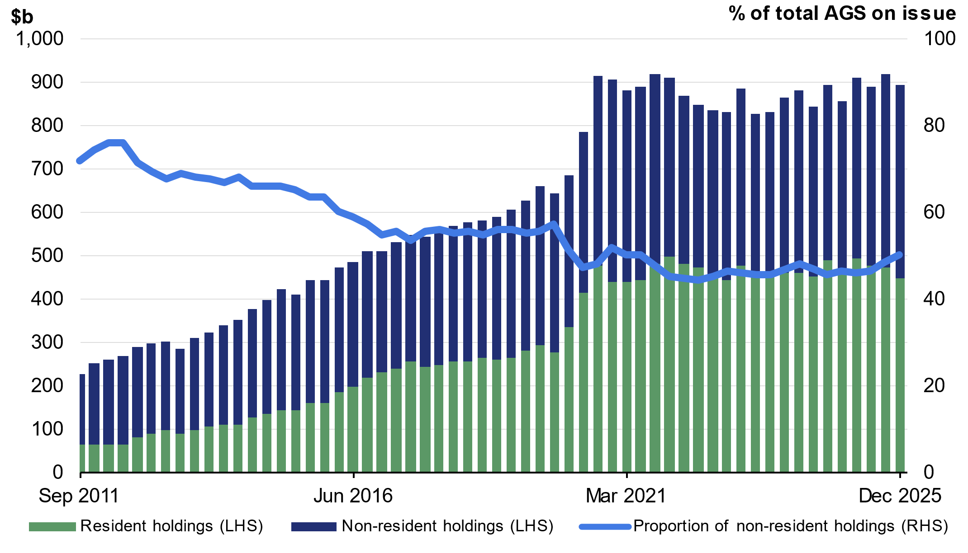
Note: Data refer to the repo-adjusted market value of holdings.
Source: ABS Balance of Payments and International Investment Position, Australia March 2026, AOFM, RBA.

Net debt
Net debt is equal to the sum of interest-bearing liabilities (which include AGS on issue measured at market value) less the sum of selected financial assets (cash and deposits, advances paid and investments, loans and placements). As net debt incorporates both selected financial assets and liabilities at their fair value, it provides a broader measure of the Government’s financial obligations than gross debt.
Not all government assets or liabilities are included in the measurement of net debt. For example, the Government’s unfunded superannuation liability is not accounted for in net debt, nor are holdings of equities, for example, those held by the Future Fund or the Government’s equity investment in the NBN.
Table 7.7: Liabilities and assets included in net debt
 |  | Estimates
 | 2025-26 | 2026-27 | 2027-28 | 2028-29 | 2029-30
 | $m | $m | $m | $m | $m
Liabilities included in net debt
Deposits held | 416 | 416 | 416 | 416 | 416
Government securities(a) | 910,584 | 987,626 | 1,063,702 | 1,147,053 | 1,214,034
Loans | 32,987 | 33,670 | 34,340 | 34,424 | 34,360
Lease liabilities | 19,215 | 18,243 | 17,574 | 16,517 | 15,087
Total liabilities included in net debt | 963,202 | 1,039,955 | 1,116,032 | 1,198,411 | 1,263,897
Assets included in net debt
Cash and deposits | 73,677 | 63,669 | 67,839 | 69,962 | 71,879
Advances paid | 72,420 | 88,350 | 100,936 | 113,722 | 123,233
Investments, loans and placements | 261,106 | 271,315 | 278,493 | 289,210 | 300,983
Total assets included in net debt | 407,203 | 423,335 | 447,267 | 472,893 | 496,094
Net debt | 555,999 | 616,621 | 668,765 | 725,518 | 767,803
- Government securities are presented at market value.

Changes in net debt since the 2025‍–‍26 MYEFO
Net debt is expected to be lower in 2026‍‍–‍‍27, and across each year of the forward estimates compared to the 2025‍‍–‍‍26 MYEFO. The improvement in 2026‍–‍27 primarily reflects changes to the financing requirement and the impact of higher yields, which have reduced the market value of AGS on issue. As yields increase, the fixed income stream from existing Treasury Bonds becomes relatively less attractive to investors, which results in a lower market value.
Table 7.8: Net debt – reconciliation from the 2025‍–‍26 MYEFO to the 2026‍–‍27 Budget
 | 2025-26 | 2026-27 | 2027-28 | 2028-29
 | $b | $b | $b | $b
Net debt as at 2025-26 MYEFO | 587.5 | 646.9 | 700.4 | 754.8
Changes in financing requirement | -10.7 | -21.5 | -29.4 | -32.1
Impact of yields on AGS | -21.2 | -18.7 | -15.1 | -11.3
Asset and other liability movements | 0.5 | 10.0 | 12.9 | 14.1
Cash and deposits | -0.1 | 12.3 | 12.4 | 14.0
Advances paid | 1.4 | -0.4 | -0.1 | -0.7
Investments, loans and placements | -0.2 | -1.1 | 1.8 | 2.1
Other movements | -0.6 | -0.8 | -1.3 | -1.3
Total movements in net debt from  2025-26 MYEFO to 2026-27 Budget | -31.5 | -30.3 | -31.6 | -29.3
Net debt as at 2026-27 Budget | 556.0 | 616.6 | 668.8 | 725.5

Interest on AGS
Estimates of the interest payments and expense of AGS on issue include the cost of AGS already on issue and future AGS issuance.
- The cost of AGS already on issue reflects the actual yield at the time of issuance.
- The expected cost of future AGS issuance is based on a recent average of daily spot rates across the yield curve at the time of a budget estimates update.
Interest payments on AGS are estimated to be lower across the forward estimates compared to the 2025‍‍–‍‍26 MYEFO. The decrease is driven by lower issuance of debt compared to MYEFO, and is partially offset by the impact of higher yields.
Chart 7.2 shows the yield curve assumptions underpinning the 2022 PEFO, 2025‍‍–‍26 MYEFO and 2026‍‍–‍‍‍‍27 Budget. Yields have increased across the yield curve since the 2025‍‍–‍‍26 MYEFO. In addition, the yield curve has flattened as yields on short tenor securities have increased more significantly than those with a longer tenor.
The assumed weighted average cost of borrowing has increased to 4.8 per cent for future issuance of Treasury Bonds over the forward estimates in this update. This is higher than the assumed weighted average yields of 4.4 per cent at the 2025‍‍–‍‍26 MYEFO and 2.2 per cent at the 2022 PEFO.
Chart 7.2: Yield curve assumptions from 2026‍–‍27 to 2029‍–‍30
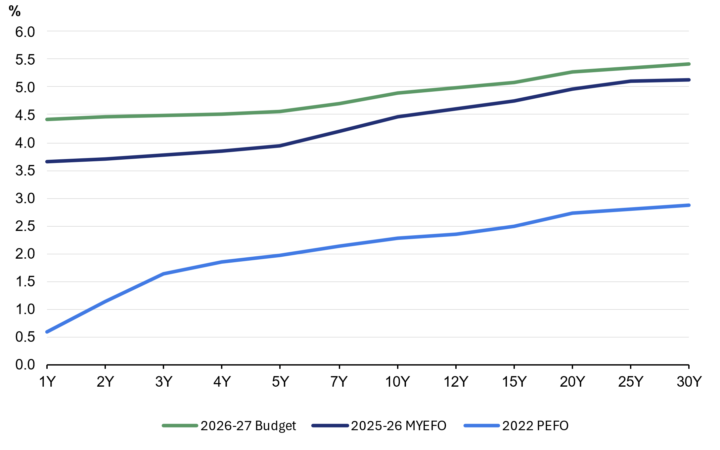
Source: Treasury.

By the end of the forward estimates total interest payments are estimated to be $42.3 billion, of which $40.4 billion relates to AGS on issue (Table 7.9). Compared to the 2025‍‍–‍26 MYEFO, total interest payments as a share of GDP are estimated to improve slightly across the forward estimates.
Interest receipts as a share of GDP are estimated to remain unchanged in each year of the forward estimates compared to the 2025‍‍–‍‍26 MYEFO.
Net interest payments as a share of GDP are estimated to improve to 0.6 per cent in 2026‍‍–‍‍27, and remain lower across the forward estimates, compared to the 2025‍‍–‍‍26 MYEFO.
Table 7.9: Interest payments, interest receipts and net interest payments^{(a)}
 |  | Estimates
 | 2025-26 | 2026-27 | 2027-28 | 2028-29 | 2029-30
 | $m | $m | $m | $m | $m
Interest payments on AGS | 25,220 | 27,690 | 34,589 | 36,226 | 40,425
Per cent of GDP | 0.9 | 0.9 | 1.1 | 1.1 | 1.2
Interest payments(b) | 27,058 | 29,566 | 36,364 | 38,026 | 42,264
Per cent of GDP | 0.9 | 1.0 | 1.1 | 1.1 | 1.2
Interest receipts | 9,329 | 9,636 | 9,696 | 10,056 | 10,538
Per cent of GDP | 0.3 | 0.3 | 0.3 | 0.3 | 0.3
Net interest payments(c) | 17,729 | 19,930 | 26,668 | 27,970 | 31,726
Per cent of GDP | 0.6 | 0.6 | 0.8 | 0.8 | 0.9
- Interest payments and receipts are a cash measure, with the relevant amount recognised in the period in which the interest payment is made or interest is received.
- Interest payments include interest payments on AGS, loans and other borrowing, as well as interest payments on lease liabilities.
- Net interest payments are equal to the difference between interest payments and interest receipts.

Interest costs related to AGS are also presented on accrual accounting terms. The difference between the cash interest payments and accrual interest expense generally relates to the timing of when the interest cost is recognised.
- Interest payments are recognised in the period when they are paid during the life of the security.
- Interest expense is recognised in the period in which an expense is incurred during the life of the security, rather than when it is actually paid.
Table 7.10 shows changes in interest expense, interest income and net interest expense over the forward estimates.
Table 7.10: Interest expense, interest income and net interest expense^{(a)}
 |  | Estimates
 |  | 2025-26 | 2026-27 | 2027-28 | 2028-29 | 2029-30
 |  | $m | $m | $m | $m | $m
Interest expense on AGS |  | 27,619 | 31,876 | 36,911 | 41,855 | 46,863
Per cent of GDP |  | 0.9 | 1.0 | 1.2 | 1.3 | 1.3
Total interest expense(b) |  | 38,310 | 43,364 | 48,806 | 51,533 | 55,720
Per cent of GDP |  | 1.3 | 1.4 | 1.5 | 1.5 | 1.6
Interest income |  | 10,216 | 11,224 | 11,697 | 12,433 | 13,339
Per cent of GDP |  | 0.3 | 0.4 | 0.4 | 0.4 | 0.4
Net interest expense(c) |  | 28,094 | 32,140 | 37,109 | 39,100 | 42,381
Per cent of GDP |  | 0.9 | 1.0 | 1.2 | 1.2 | 1.2
- Interest expense is an accrual measure, with the relevant amount recognised in the period in which the expense is incurred, but not necessarily paid.
- Interest expense includes interest expense on AGS, loans and other borrowing, as well as interest expense on lease liabilities and other financing costs (including debt not expected to be repaid (DNER)).
- Net interest expense is equal to the difference between interest expenses and interest income.

For Treasury Indexed Bonds (TIBs), the final repayment amount paid to investors includes an additional amount to reflect the impact of inflation over the life of the security. This additional amount is not included in the calculation of face value.
This impact is captured in Table 7.2 against ‘Other contributors’.
For example, on 3 September 2025 the AOFM issued into an existing bond line with a maturity date of 21 March 2036 and a coupon rate of 4.25 per cent. The face value of issuance was $1,000 million but the proceeds received was around $1,006 million. The same Treasury Bond line was also issued on 18 March 2026 when yields were substantially higher, and $948 million was received for the same $1,000 million of face value issued.

