Statement 8:
Forecasting Performance and Sensitivity Analysis
Economic and fiscal forecasts and projections in the Budget are underpinned by a range of assumptions and judgements based on the best available information at the time of preparation. In practice, economic and fiscal circumstances can evolve in ways that differ from expectations.
This statement assesses:
- The performance of past forecasts based on the variance between forecasts and actuals.
- The uncertainty around current forecasts using confidence interval analysis.
- The sensitivity of current forecasts to changes in key assumptions:
  - Oil prices
  - Yields on Australian Government Securities.
The fiscal impact of key developments and Australia’s climate change outlook are considered in Budget Statement 3: Fiscal Strategy and Outlook.
Forecasts are based on assumptions and judgements. Forecast accuracy depends on whether assumptions and judgements prove to be correct, and the reliability of the modelled economic and fiscal relationships.

Statement 8 contents
Assessing past forecasting performance 271
Economic forecasting performance 272
Fiscal forecasting performance 273
Assessing forecast uncertainty – confidence interval analysis 278
Economic uncertainty based on historical forecast errors 278
Fiscal uncertainty based on historical forecast errors 280
Assessing current forecasts through sensitivity analysis 283
Movements in oil prices 283
Movements in yields 285

Statement 8: Forecasting Performance and Sensitivity Analysis

Assessing past forecasting performance
This section assesses the variance between historical forecasts and outcomes (forecast errors) for real and nominal GDP, tax receipts, non-tax receipts, payments and the underlying cash balance.
Forecasts are prepared using a range of techniques:
- Macroeconomic forecasts are prepared consistent with a national accounting framework using econometric models, analysis and professional judgement.
- Tax receipts forecasts are generally prepared using a ‘base plus growth’ methodology. The last outcome for each head of revenue is the base to which growth rates are applied, using appropriate economic parameters. Forecasts are then updated to include costings of new policy.
- Payments forecasts are generally prepared through analysis of payment program data, costings for new policies and historical trends in programs, in consultation with relevant agencies.

Economic forecasting performance
Real GDP forecasts incorporate technical assumptions for exchange rates, interest rates and commodity prices. The forecasts are informed by a macroeconomic model and incorporate long-term trend assumptions, and judgements about how domestic and international developments might affect Australia’s economy.
Real GDP grew 1.3 per cent in 2024–25, which is weaker than the growth forecast at the 2024–25 Budget (Chart 8.1). A key driver was weaker than expected growth in household consumption, partially offset by stronger than expected growth in public final demand.
Chart 8.1: Comparison of forecasts and outcomes for real GDP growth
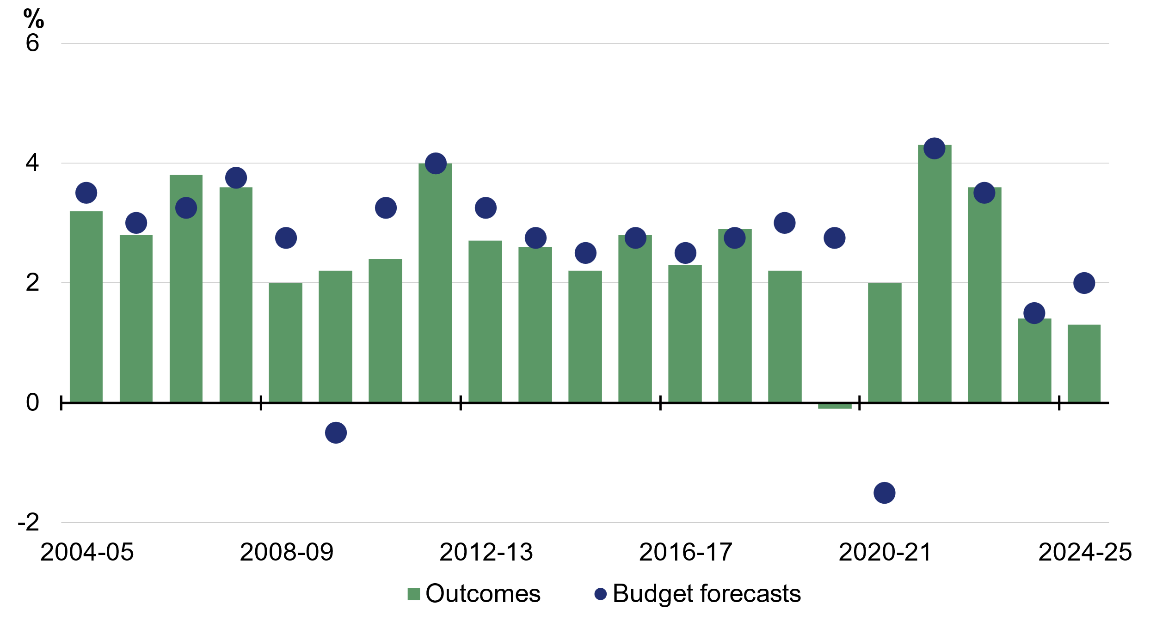
Note: Outcome is as published in the December quarter 2025 National Accounts. Forecast is that published in the Budget for that year. For 2022–23, the forecast is from the March 2022‍–‍23 Budget.
Source: ABS Australian National Accounts: National Income, Expenditure and Product and Budget papers.

Price movements underpinning nominal GDP forecasts create greater uncertainty compared with real GDP forecasts. Price uncertainty relates to domestic prices and wages, exchange rates, prices of imported goods, and world prices for Australia’s exports including commodities. Since the early 2000s, nominal GDP forecast errors have largely reflected volatility in global commodity prices. These prices have exhibited higher-than-usual volatility in recent years, and have generally remained above assumed conservative anchor prices for an extended period. This is partly due to the conflict in the Middle East and Ukraine.
Nominal GDP grew by 3.6 per cent in 2024–25 rather than 2¾ per cent forecast at the 2024–‍25 Budget (Chart 8.2). While real GDP growth was lower than expected, prices across the economy were higher than expected.
Chart 8.2: Comparison of forecasts and outcomes for nominal GDP growth
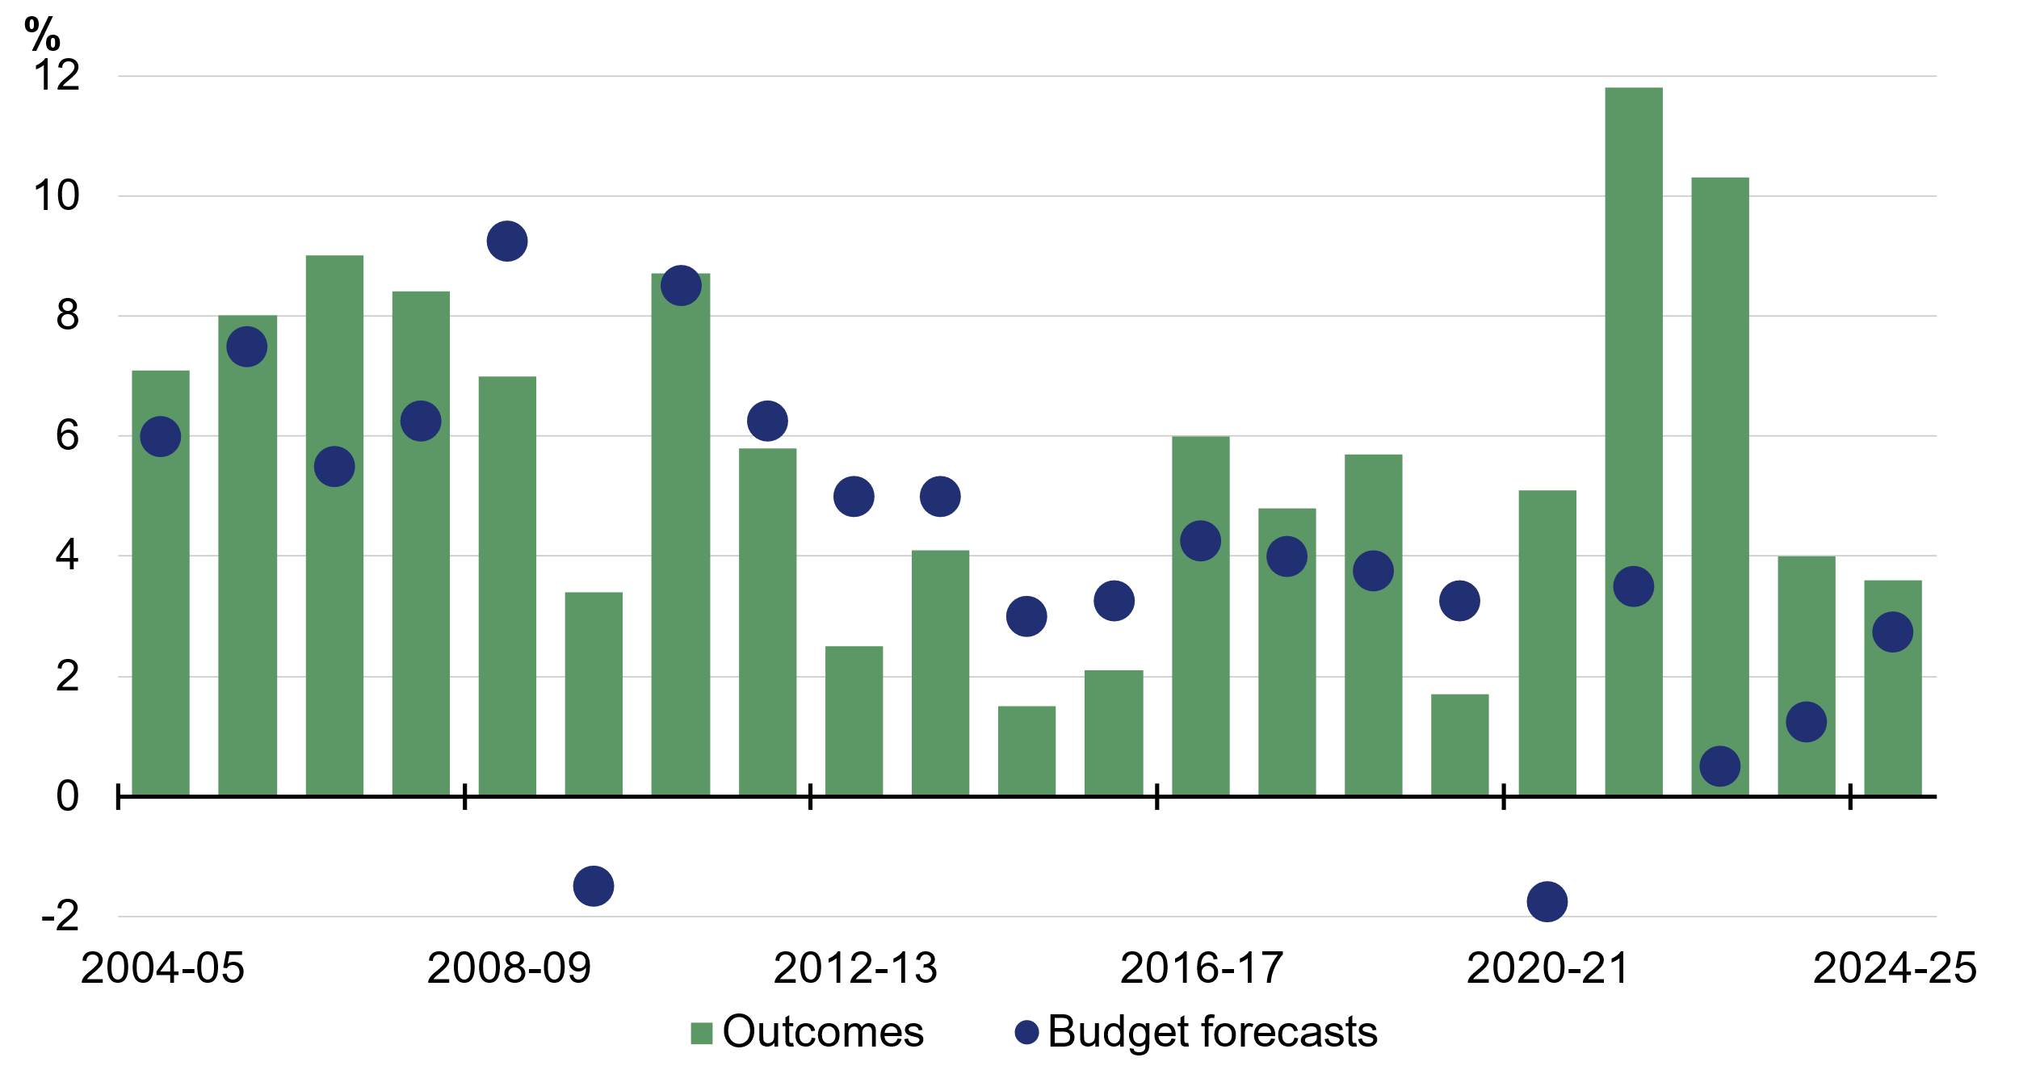
Note: Outcome is as published in the December quarter 2025 National Accounts. Forecast is that published in the Budget for that year. For 2022–23, the forecast is from the March 2022‍–‍23 Budget.
Source: ABS Australian National Accounts: National Income, Expenditure and Product and Budget papers.

Fiscal forecasting performance
Fiscal forecast errors are driven by economic and demographic forecast errors, along with unanticipated changes in demand for government programs. Government policies announced after the Budget can also affect fiscal forecast errors. Further information on Budget outcomes can be found in the 2024–25 Final Budget Outcome.

Total receipts
Total receipts are comprised of tax and non-tax receipts (for example, dividends from investment funds). Tax receipts account for around 90 per cent of total receipts and are therefore the main driver of forecasting performance.
Total receipts grew 4.1 per cent in 2024–25 rather than 0.9 per cent forecast at the 2024–‍25 Budget. Total receipts were $18.5 billion higher than forecast.

Tax receipts
Tax receipts grew 3.9 per cent in 2024–25 rather than 0.6 per cent forecast at the 2024–‍25 Budget (Chart 8.3). Tax receipts were $15.3 billion higher than forecast. This outcome reflected higher-than-expected personal income tax, superannuation fund taxes and GST, due to higher-than-expected nominal wages and consumption. The forecast error for superannuation fund taxes, which is typically more volatile, also reflected higher-than-expected capital gains. These stronger outcomes were partially offset by weaker-than-expected excise and customs duty receipts, primarily reflecting weakness in tobacco excise collections.
Chart 8.3: Comparison of forecasts and outcomes for tax receipts growth
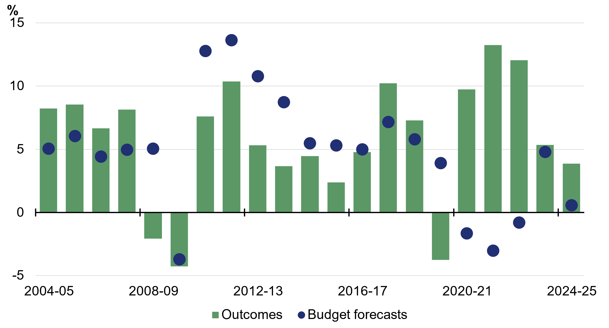
Source: Budget papers and Treasury.

As shown in Chart 8.4, tax receipts forecast errors are correlated with nominal GDP forecast errors. Tax receipts forecast errors typically exceed nominal GDP forecast errors as marginal tax rates are greater than average tax rates.
Chart 8.4: Forecast errors for nominal non-farm GDP and tax receipts growth^{(a)}
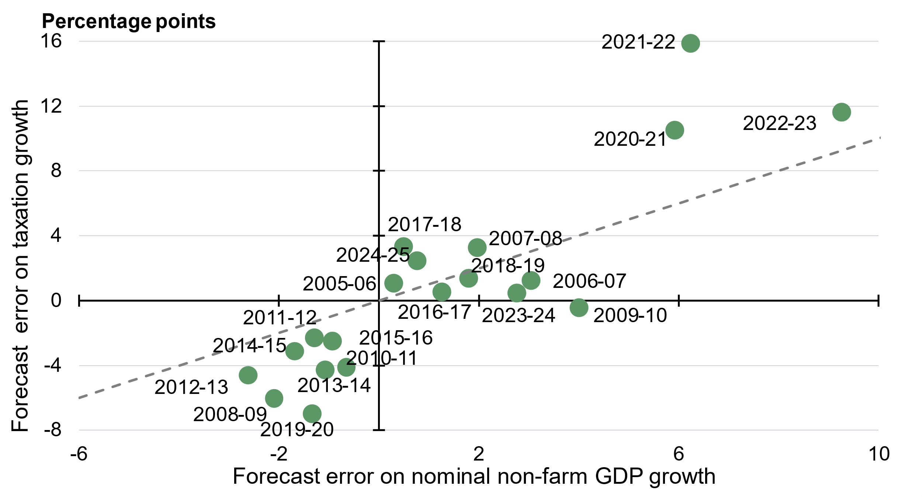
- Excludes capital gains tax.
Source: ABS Australian National Accounts: National Income, Expenditure and Product; and Treasury.

Non-tax receipts
Forecast variances in non-tax receipts are generally driven by financial market volatility, which impacts investment earnings and resource royalties.
Non-tax receipts grew 7.1 per cent in 2024–25 rather than 4.4 per cent forecast at the 2024–‍25 Budget (Chart 8.5). Non-tax receipts were $3.2 billion higher than forecast. This reflected higher-than-expected interest earnings related to Commonwealth Debt Management and higher earnings from the Future Fund and other Australian Government Investment Funds.
Chart 8.5: Comparison of forecasts and outcomes for non-tax receipts growth
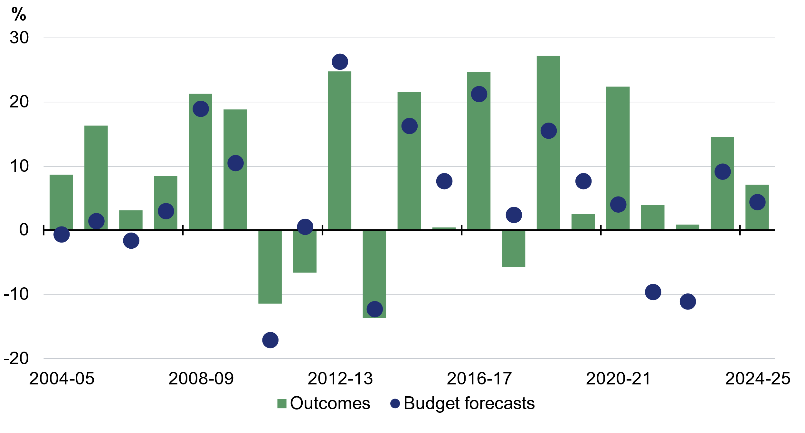
Source: Budget papers and Treasury.

Payments
Payments forecasting performance is affected by growth in indexation factors (for example, CPI growth) and demand for government programs. Demand-driven programs, such as payments to individuals for social welfare, form the bulk of Australian Government expenditure and vary with economic conditions.
Payments grew 8.0 per cent in 2024–25 rather than 6.4 per cent forecast at the 2024–‍25 Budget (Chart 8.6). Payments were $0.2 billion higher than forecast. This outcome reflected increases in payments to veterans related to the Military Rehabilitation Compensation Acts and for the Disability Support Pension.
Chart 8.6: Comparison of forecasts and outcomes for payments growth
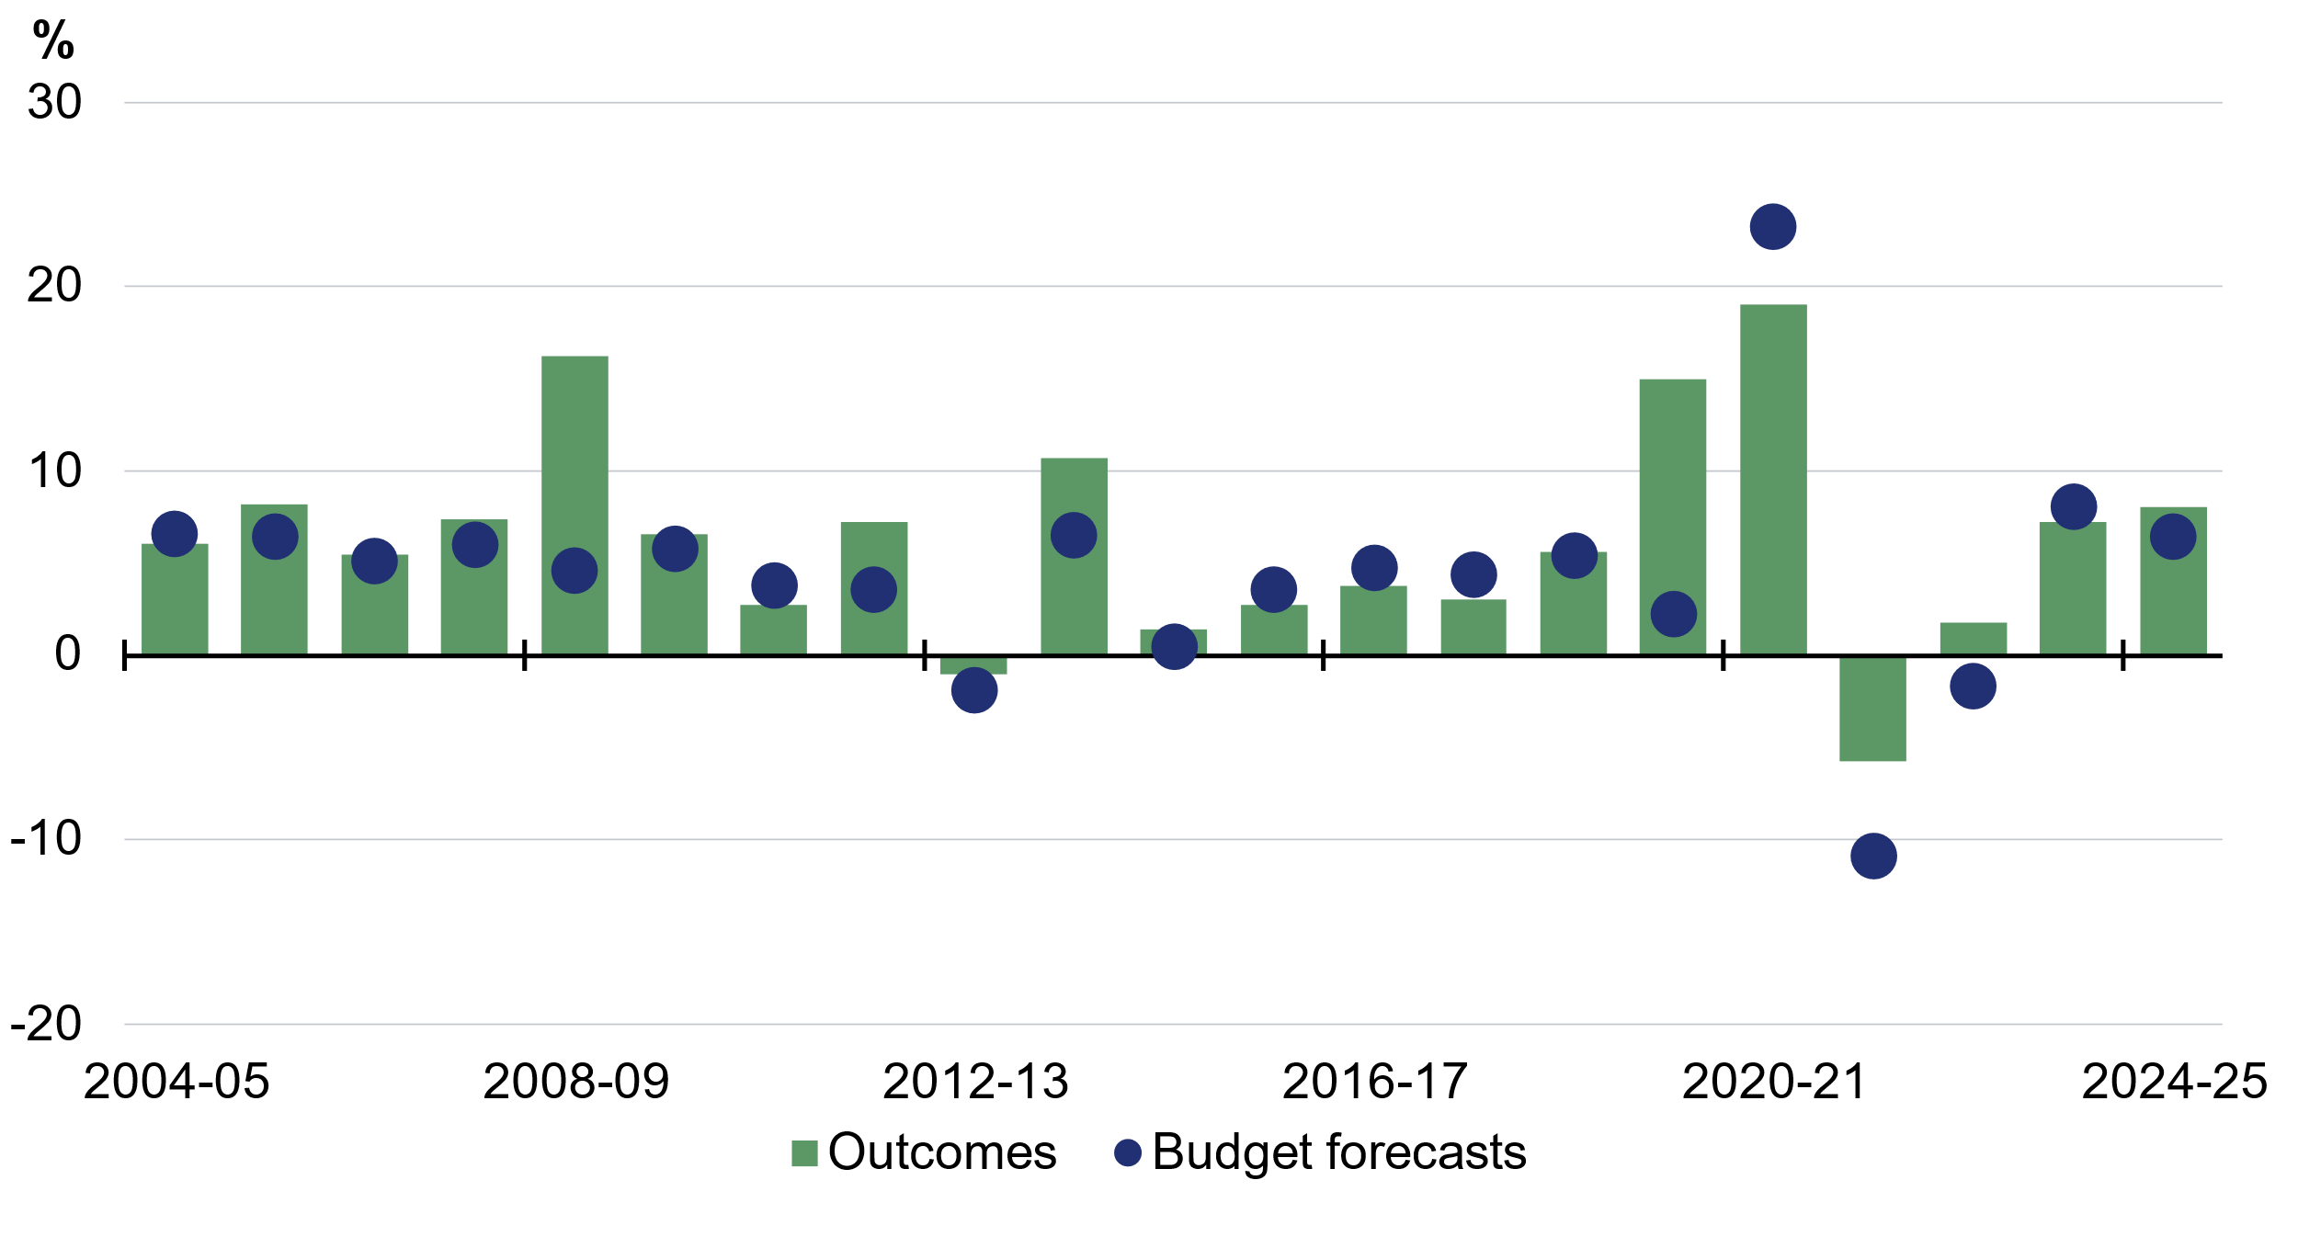
Source: Budget papers and Treasury.

Underlying cash balance
Underlying cash balance forecasting performance is driven by the forecast errors of total receipts and payments.
The underlying cash balance was a deficit of 0.4 per cent of GDP in 2024–25 rather than the forecast deficit of 1.0 per cent of GDP at the 2024–25 Budget (Chart 8.7). The underlying cash balance was $18.3 billion higher than forecast. The better-than expected underlying cash balance outcome in 2024–25 largely reflected higher-than-expected receipts ($18.5 billion), partially offset by higher-than-expected payments ($0.2 billion).
Chart 8.7: Comparison of forecasts and outcomes for underlying cash balance
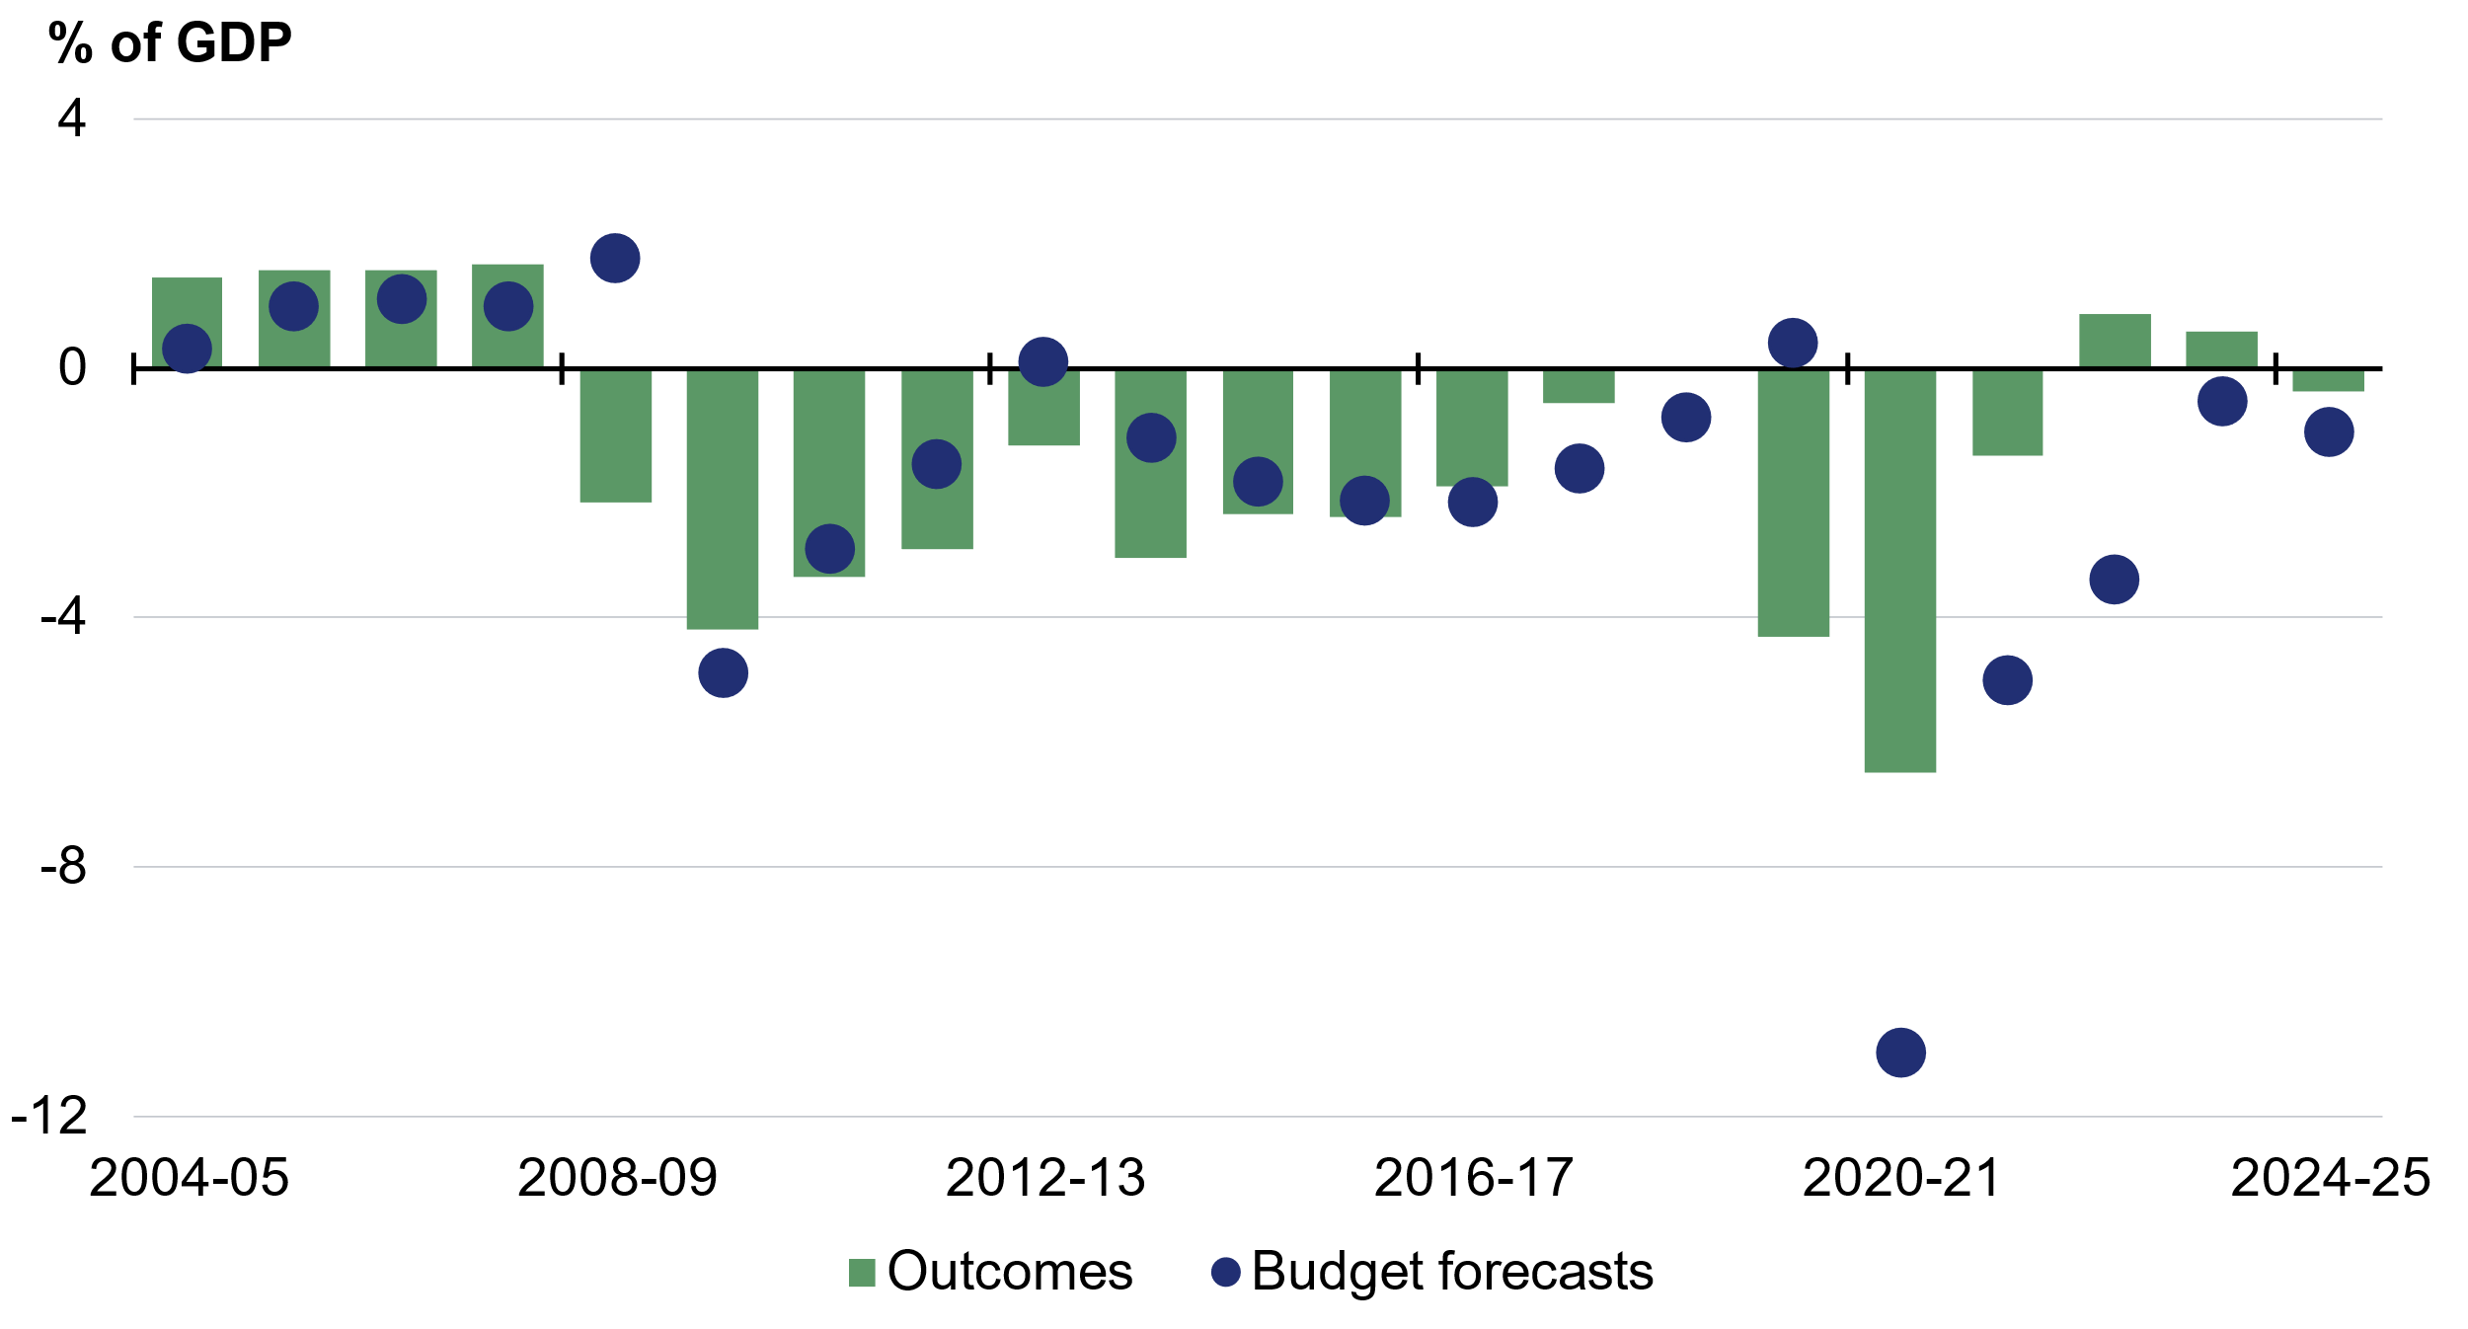
Source: Budget papers and Treasury.

In the past two decades, outside major downturns, the underlying cash balance forecast error largely reflected forecast errors of total receipts (Chart 8.8).
Large forecast errors for payments in 2008–09 and 2019–20 reflected unexpected government payment assistance during the Global Financial Crisis and COVID-19 pandemic. Overestimates of receipts tend to coincide with underestimates of payments during economic shocks, magnifying underlying cash balance forecast errors.
Chart 8.8: Total receipts, payments, and underlying cash balance forecast errors
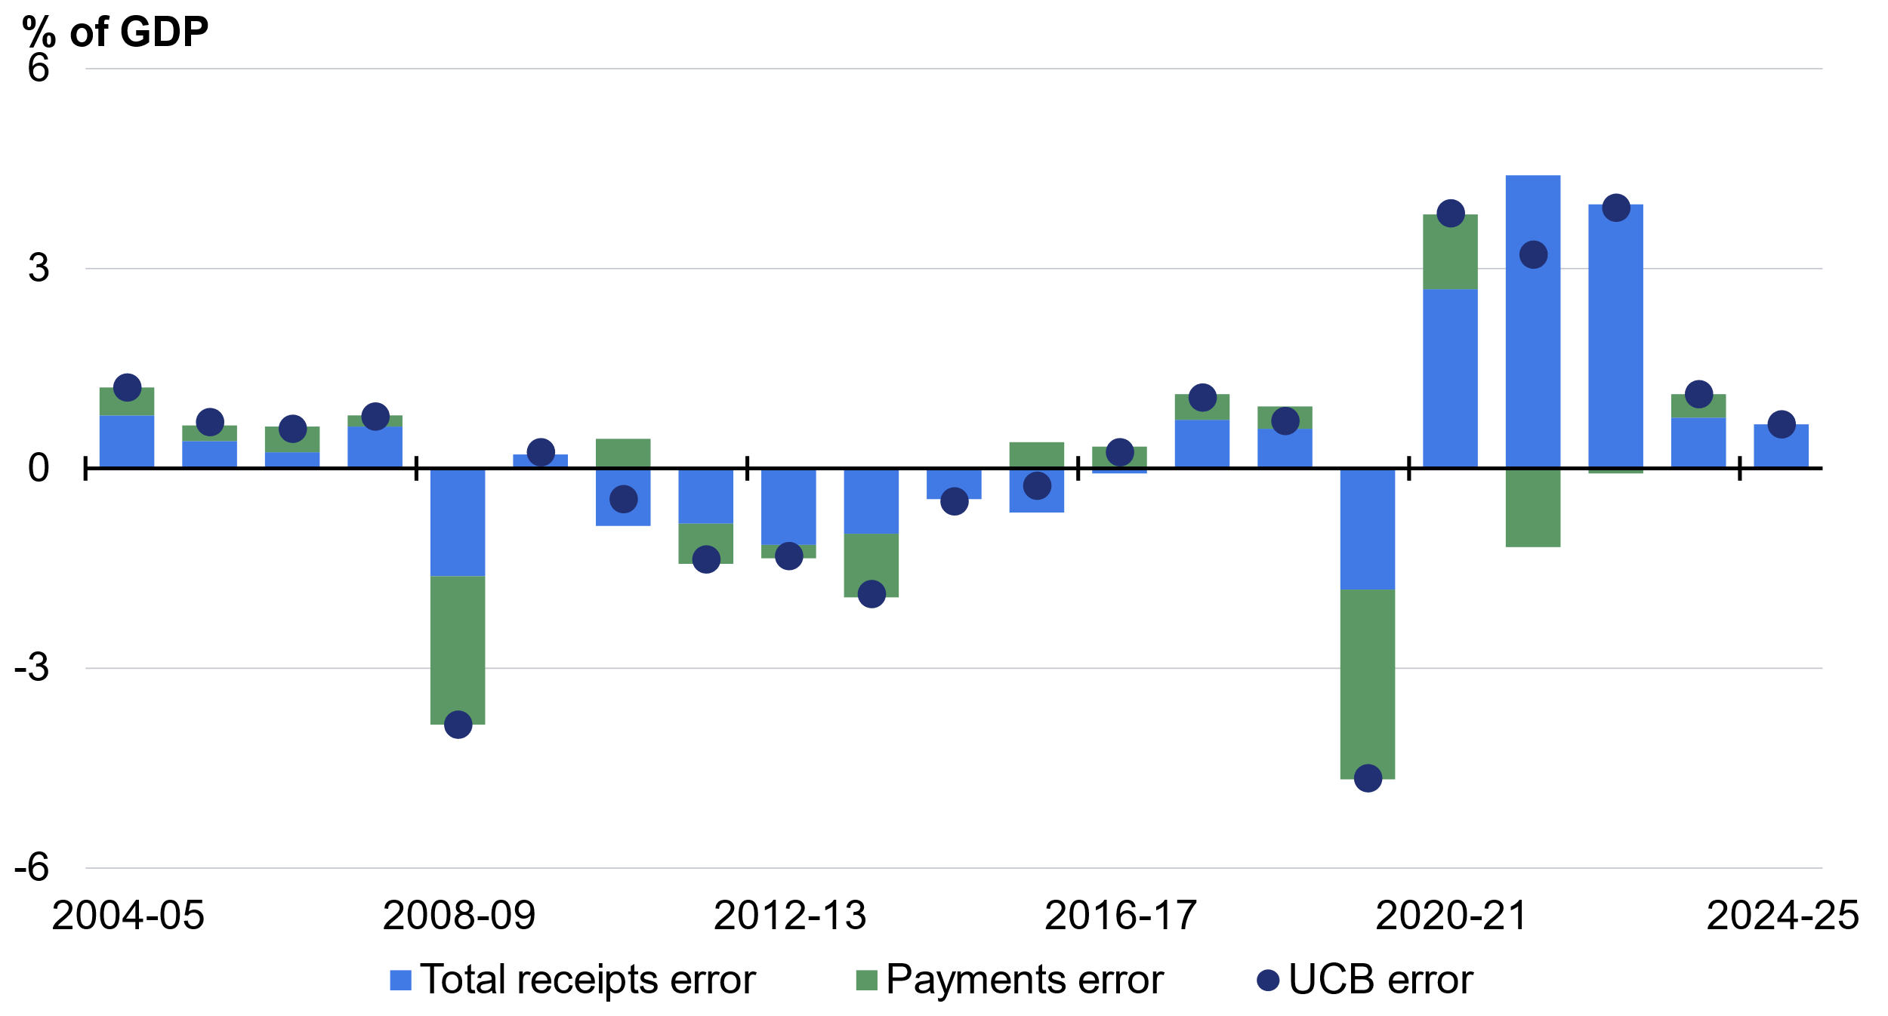
Source: Budget papers and Treasury.

Assessing forecast uncertainty – confidence interval analysis
Confidence intervals illustrate the uncertainty around current forecasts based on the historical distribution of forecast errors. Confidence interval analysis assumes that future forecast errors are consistent with the distribution of past forecast errors. Based on past forecasting performance, there is a 70 and 90 per cent probability that the actual outcome will lie within the 70 and 90 per cent confidence interval bands.
Future forecast errors may not have the same distribution as historical forecast errors. The large forecast errors in 2019–20 and 2020–21, related to the COVID-19 pandemic, are an example of events not previously captured in the historical error sample. Large disruptive events are difficult to predict and could occur again.

Economic uncertainty based on historical forecast errors
Average annualised growth in real GDP in the three years to 2027–28 is expected to be around 2 per cent. The 70 per cent confidence interval ranges from 1½ per cent to 2½ per cent. The 90 per cent confidence interval ranges from 1 per cent to 3 per cent (Chart 8.9).
Chart 8.9: Confidence intervals around real GDP growth rate forecasts
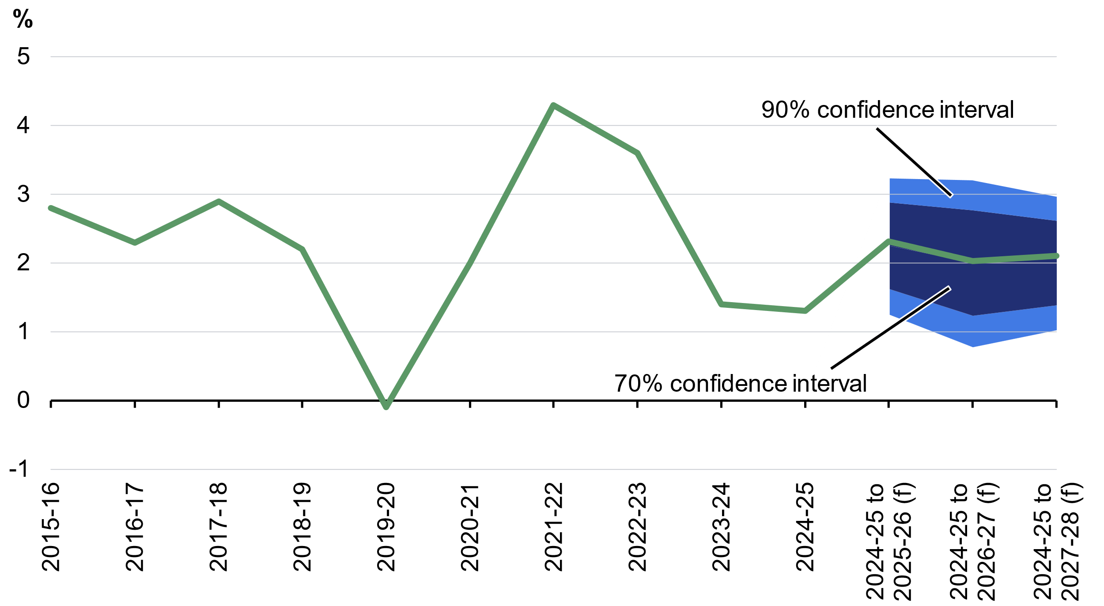
Note: The line shows the outcomes and the 2026–27 Budget forecasts. Annual growth rates are reported for the outcomes. Average annualised growth rates from 2024–25 are reported for 2025–26 onwards. (f) are forecasts. Confidence intervals are based on the root mean squared errors (RMSEs) of Budget forecasts from 1998–99 onwards, with outcomes based on December quarter 2025 National Accounts data.
Source: ABS Australian National Accounts: National Income, Expenditure and Product and Treasury.

The confidence intervals around the nominal GDP forecasts are wider than those around the real GDP forecasts, reflecting the additional uncertainty around domestic prices and commodity prices. Average annualised growth in nominal GDP in the three years to 2027‍–‍28 is expected to be around 4¾ per cent, with the 70 per cent confidence interval ranging from 2½ per cent to 7 per cent. The 90 per cent confidence interval ranges from 1 per cent to 8½ per cent (Chart 8.10).
Chart 8.10: Confidence intervals around nominal GDP growth rate forecasts
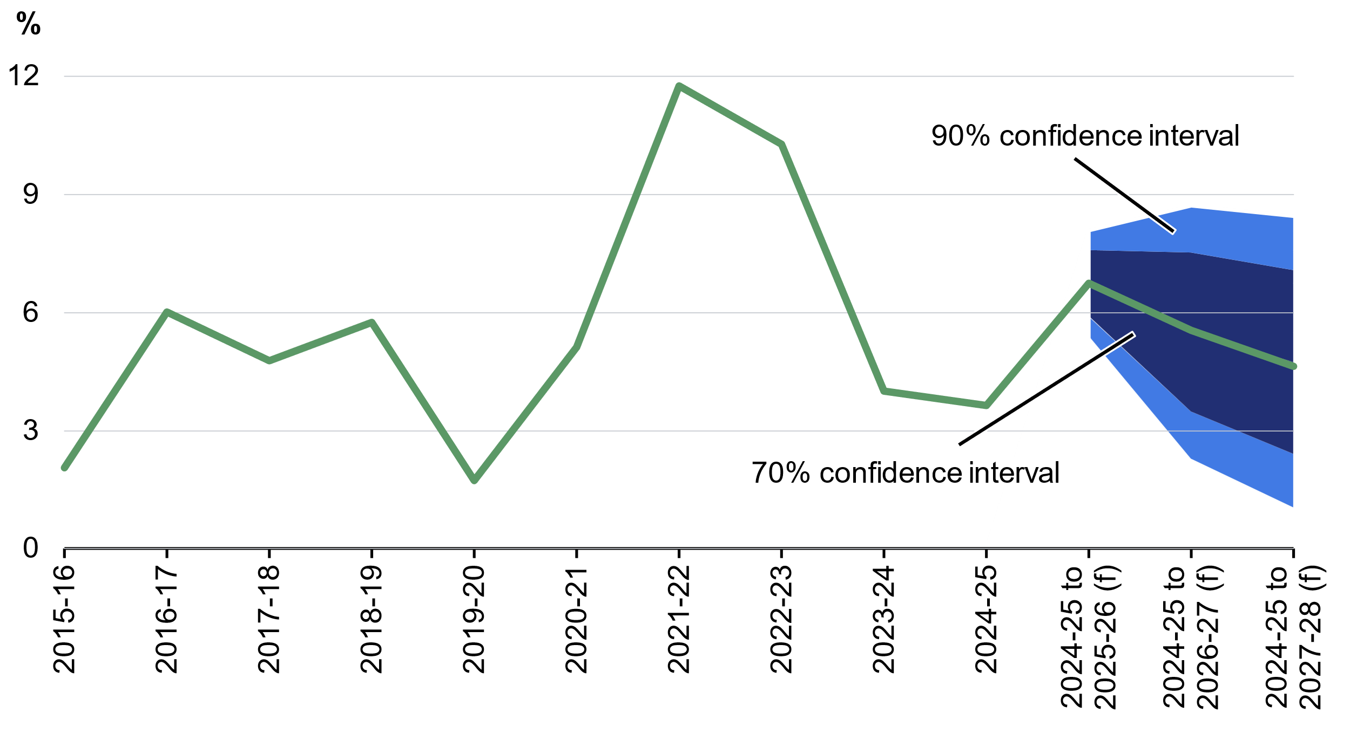
Note: The line shows the outcomes and the 2026–27 Budget forecasts. Annual growth rates are reported for the outcomes. Average annualised growth rates from 2024–25 are reported for 2025–26 onwards. Confidence intervals are based on the root mean squared errors (RMSEs) of Budget forecasts from 1998–99 onwards and are a statistical assessment that does not take account of any change in circumstance in the economic outlook. (f) are forecasts.
Source: ABS Australian National Accounts: National Income, Expenditure and Product and Treasury.

Fiscal uncertainty based on historical forecast errors
Fiscal estimates are based on economic and demographic forecasts as well as estimates of spending and revenue measures.
Historical variations caused by subsequent policy decisions not known at the time of forecast are excluded because these decisions do not reflect forecasting errors based on available information at the time of preparation. Payment estimates do not exclude the public debt interest associated with these subsequent policy decisions because this cannot be separately identified.

Total receipts
Total receipts (including GST) are expected to be around 25.8 per cent of GDP in 2026‍–‍27, with the 70 per cent confidence interval ranging from 24.3 per cent to 27.3 per cent of GDP. The 90 per cent confidence interval ranges from 23.4 per cent to 28.2 per cent in 2026‍–‍27. The uncertainty around receipts forecasts increases with time (Chart 8.11).
Chart 8.11: Confidence intervals around total receipts forecasts^{(a)}
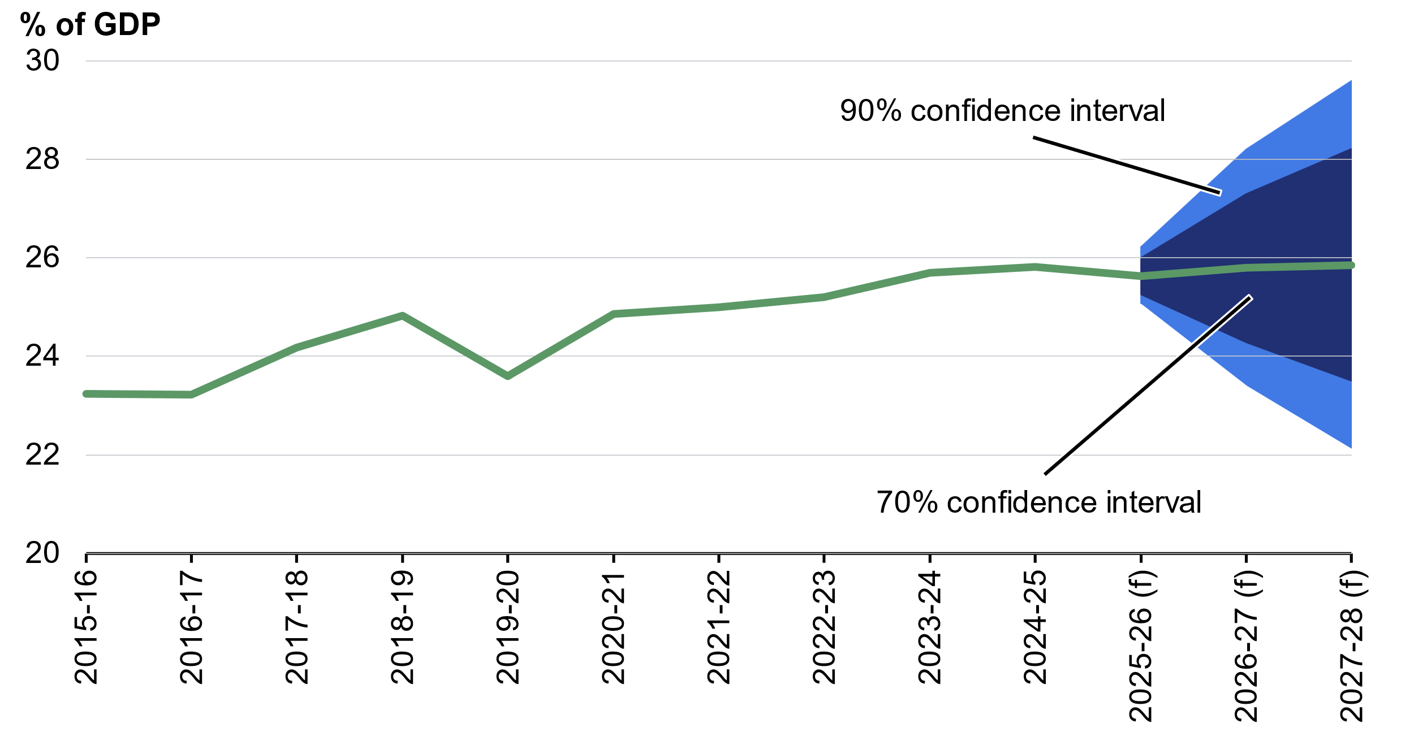
- Includes Future Fund earnings from 2020–21 onwards.
Note: The central line shows outcomes and the 2026–27 Budget forecasts. Confidence intervals use Root Mean Square Errors (RMSE) for Budget forecasts from the 1999–2000 Budget onwards. (f) are forecasts.
Source: Budget papers and Treasury.

Payments
The confidence interval for payments is narrower than receipts because there is greater certainty around payments forecasts. Payments (including GST) are expected to be around 26.8 per cent of GDP in 2026‍–‍27, with the 70 per cent confidence interval ranging from 26.3 per cent to 27.3 per cent of GDP. The 90 per cent confidence interval ranges from 26.0 per cent to 27.6 per cent in 2026‍–‍27 (Chart 8.12).
Chart 8.12: Confidence intervals around payments forecasts^{(a)}
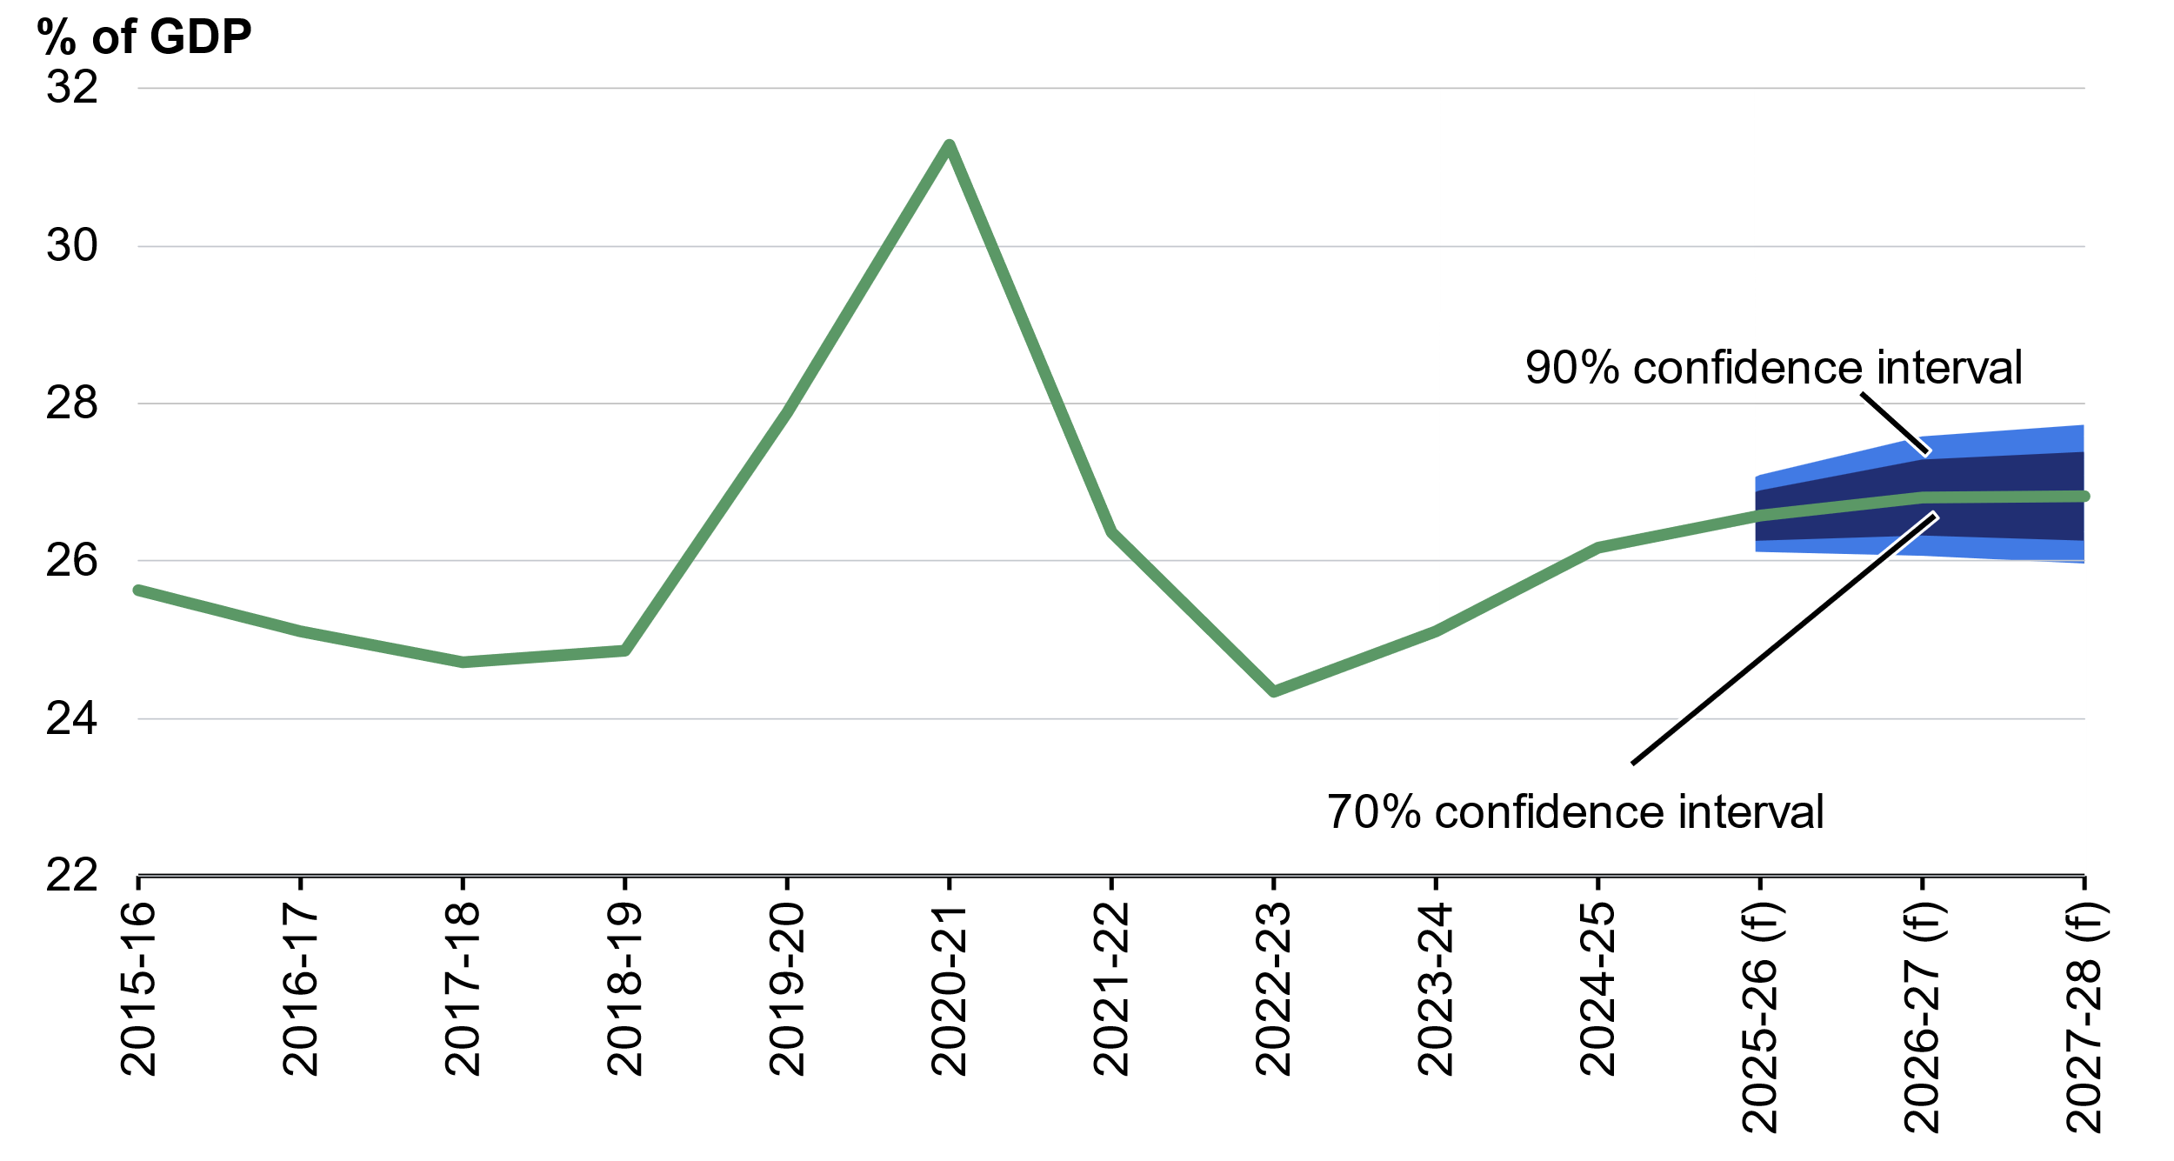
- Includes GST payments.
Note: The central line shows outcomes and the 2026–27 Budget forecasts. Confidence intervals use Root Mean Square Errors (RMSE) for Budget forecasts from the 1999–2000 Budget onwards. (f) are forecasts.
Source: Budget papers and Treasury.

Underlying cash balance
The underlying cash deficit in 2026‍–‍27 is expected to be 1.0 per cent of GDP, with the 70 per cent confidence interval ranging from a deficit of 2.8 per cent to a surplus of 0.8 per cent of GDP. The 90 per cent confidence interval ranges from a deficit of 3.8 per cent to a surplus of 1.8 per cent in 2026‍–‍27.
The uncertainty around underlying cash balance forecasts reflects forecast errors in receipts and payments which increase further out in time (Chart 8.13).
Chart 8.13: Confidence intervals around the underlying cash balance forecasts
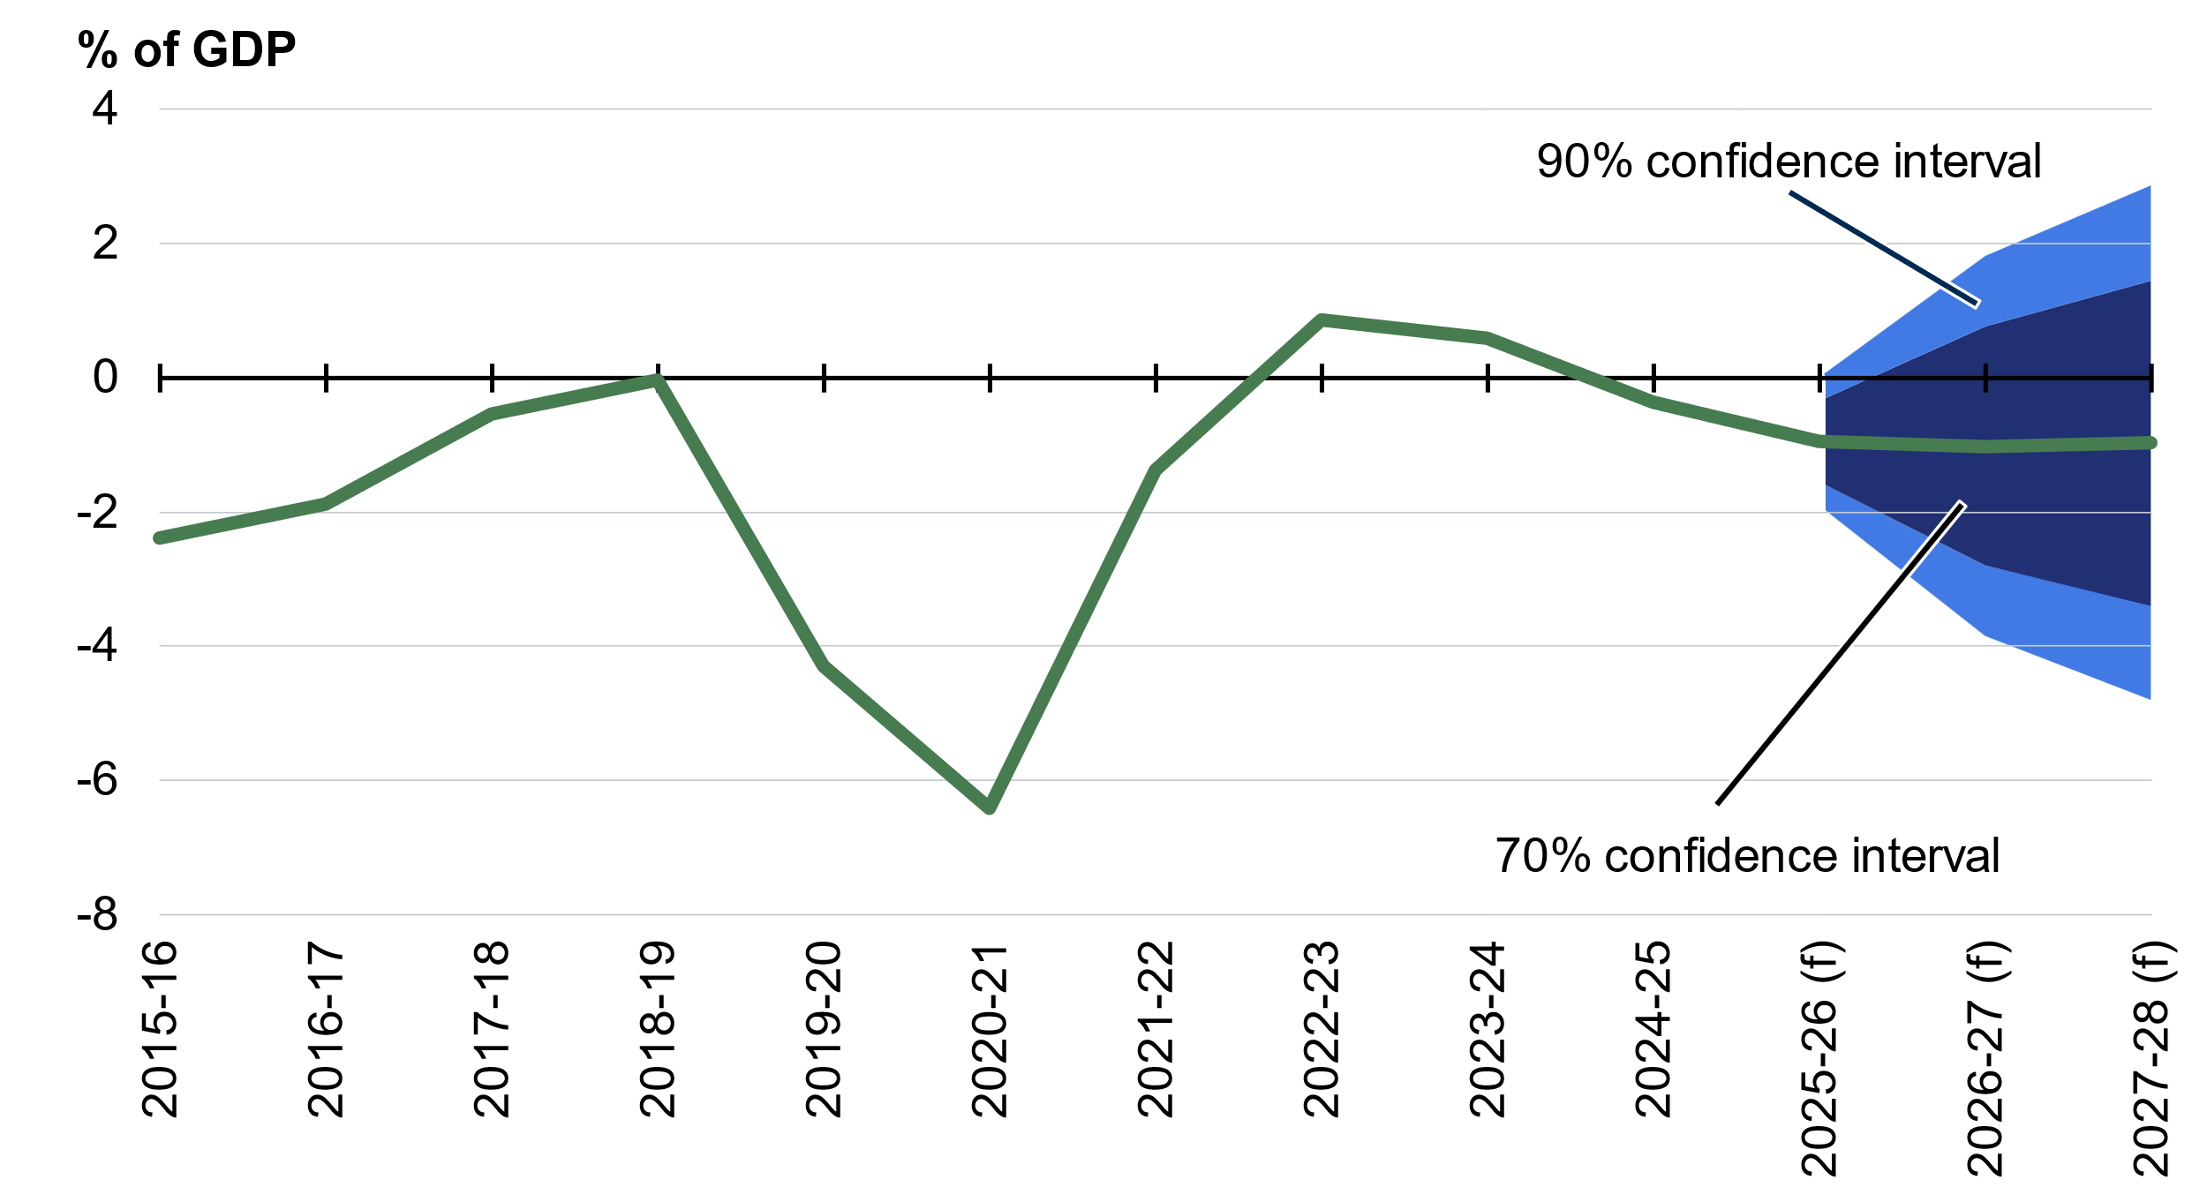
Note: The central line shows outcomes and the 2026–27 Budget forecasts. Confidence intervals use Root Mean Square Errors (RMSE) for Budget forecasts from the 1999–2000 Budget onwards. (f) are forecasts.
Source: Budget papers and Treasury.

Assessing current forecasts through sensitivity analysis
Sensitivity analysis allows for an assessment of the impact of key assumptions. The following sensitivity analyses are considered due to their variability and importance for the Budget:
- Higher oil prices in the estimates period.
- Higher and lower yields over the projection period.
For illustrative purposes, the upper and lower sensitivities are broadly symmetric, even where not equally probable.

Movements in oil prices
Crude oil prices directly influence the price of fuel products such as petrol, diesel and jet fuel that are used by Australian consumers and businesses (see Statement 2: Economic Outlook; Box 2.1 Price impacts from the conflict in the Middle East). Crude oil is also a key input into many products across the economy including plastics and fabrics. Elevated oil prices therefore pose upside risks to domestic inflation and downside risks to activity (see also Statement 2: Economic Outlook; Box 2.2 Risks of a more severe Middle East conflict).
The Budget forecasts assume the tapis oil price averages around US$100 per barrel across the June quarter 2026 before gradually declining to average around US$80 per barrel by the end of the June quarter of 2027. Table 8.1 demonstrates the impact of the oil price remaining elevated at the June quarter 2026 price for one additional quarter before following a similar trajectory as in the forecasts, returning to the Budget assumption by the end of the September quarter 2027. In keeping with the practice for sensitivity analyses, other assumptions, including for other commodity prices, are unchanged.
Table 8.1: Impact of oil prices remaining elevated for one additional quarter
 | 2025-26 | 2026-27 | 2027-28
Deviation in headline inflation (ppt)^{(a)} | 0.0 | 0.3 | -0.3
Deviation in the level of nominal GDP ($b) | 0.0 | -1.0 | -0.2
- Through-the-year growth to the June quarter.

The economic response to the elevated oil price is estimated using a macroeconomic model. The higher oil price reduces household disposable income and increases input costs for businesses. This leads to an increase in inflation which unwinds as the oil price returns to the Budget assumption.
Fiscal impacts from this scenario are uncertain as oil prices can affect a wide range of payments and revenue items at different times. However, with other commodities prices unchanged in the sensitivity, the overall impact on the Budget is likely to be minimal. While revenue increases associated with CPI may offset increases to payments from indexation, reduced economic activity flowing into lower nominal GDP would have a more negative impact on revenues than payments. For more information on the impact of oil price rises and the Middle East conflict on tax receipts, see Statement 5; Box 5.1 Impact of the Middle East conflict on the revenue outlook.

Movements in yields
The cost of Government borrowing reflects yields on Australian Government Securities and the level of debt.
Given the uncertainty surrounding the global and domestic outlook for yields, Treasury makes the following technical assumptions:
- Over the forward estimates, government bond yields are fixed at rates observed prior to the Budget update.
- After the forward estimates, the 10-year bond yield converges linearly towards the long run nominal GDP growth rate over 15-years. This is broadly consistent with the long run approaches of comparable advanced economies. Other tenor yields are assumed to maintain their historical relativity to the 10-year bond yield.
The higher yield sensitivity analysis assumes bond yields transition to 100 basis points higher than baseline by 30 June 2027. Yields are then held constant over the remainder of the forward estimates to 2029‍–‍30, before linearly converging to the long run yield assumption of the nominal GDP growth rate over 15-years (Chart 8.14). The lower yield sensitivity analysis is symmetric. Other economic parameters are assumed to remain unchanged from baseline forecasts to isolate the direct impact on fiscal aggregates.
Chart 8.14: Baseline and alternative movements in the 10-year bond yield
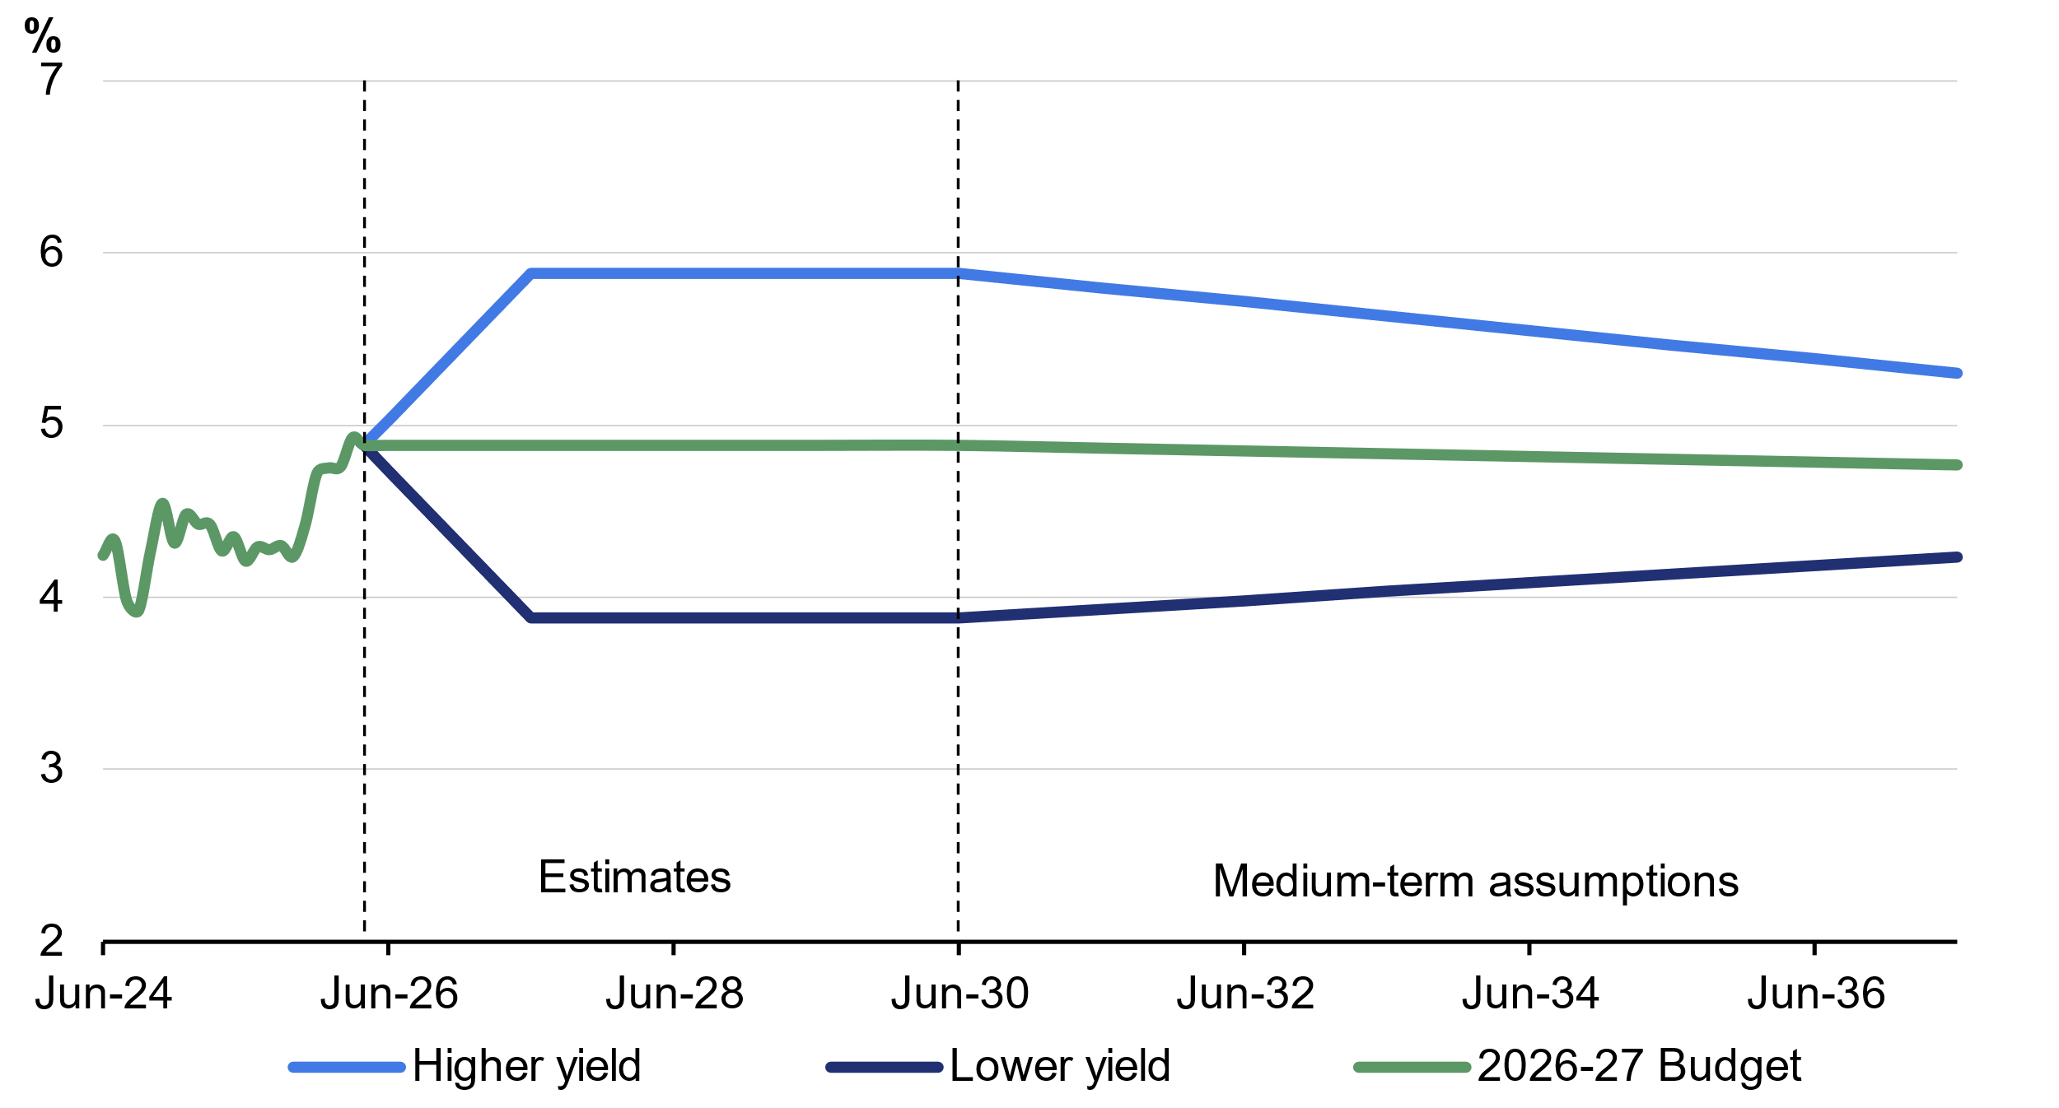
Source: Treasury.
Note: Actual yields as at the end of each calendar month up to March 2026.

Higher yields increase public debt interest payments and receipts earned on investments. As government interest bearing liabilities usually exceed interest bearing assets, higher yields lead to a deterioration in the underlying cash balance. Lower yields have the reverse effect, improving the underlying cash balance.
The higher yield assumption results in a deterioration to the underlying cash balance of 0.3 percentage points of GDP by 2036–37 and increases gross debt by 1.9 percentage points of GDP at 30 June 2037 (Chart 8.15).
The lower yield assumption results in an improvement to the underlying cash balance of 0.3 percentage points of GDP by 2036–37. Under the lower yield assumption, cumulative improvements to the underlying cash balance reduce gross debt by 1.8 percentage points of GDP at 30 June 2037.
Chart 8.15: Gross debt, impact of alternative yield assumptions
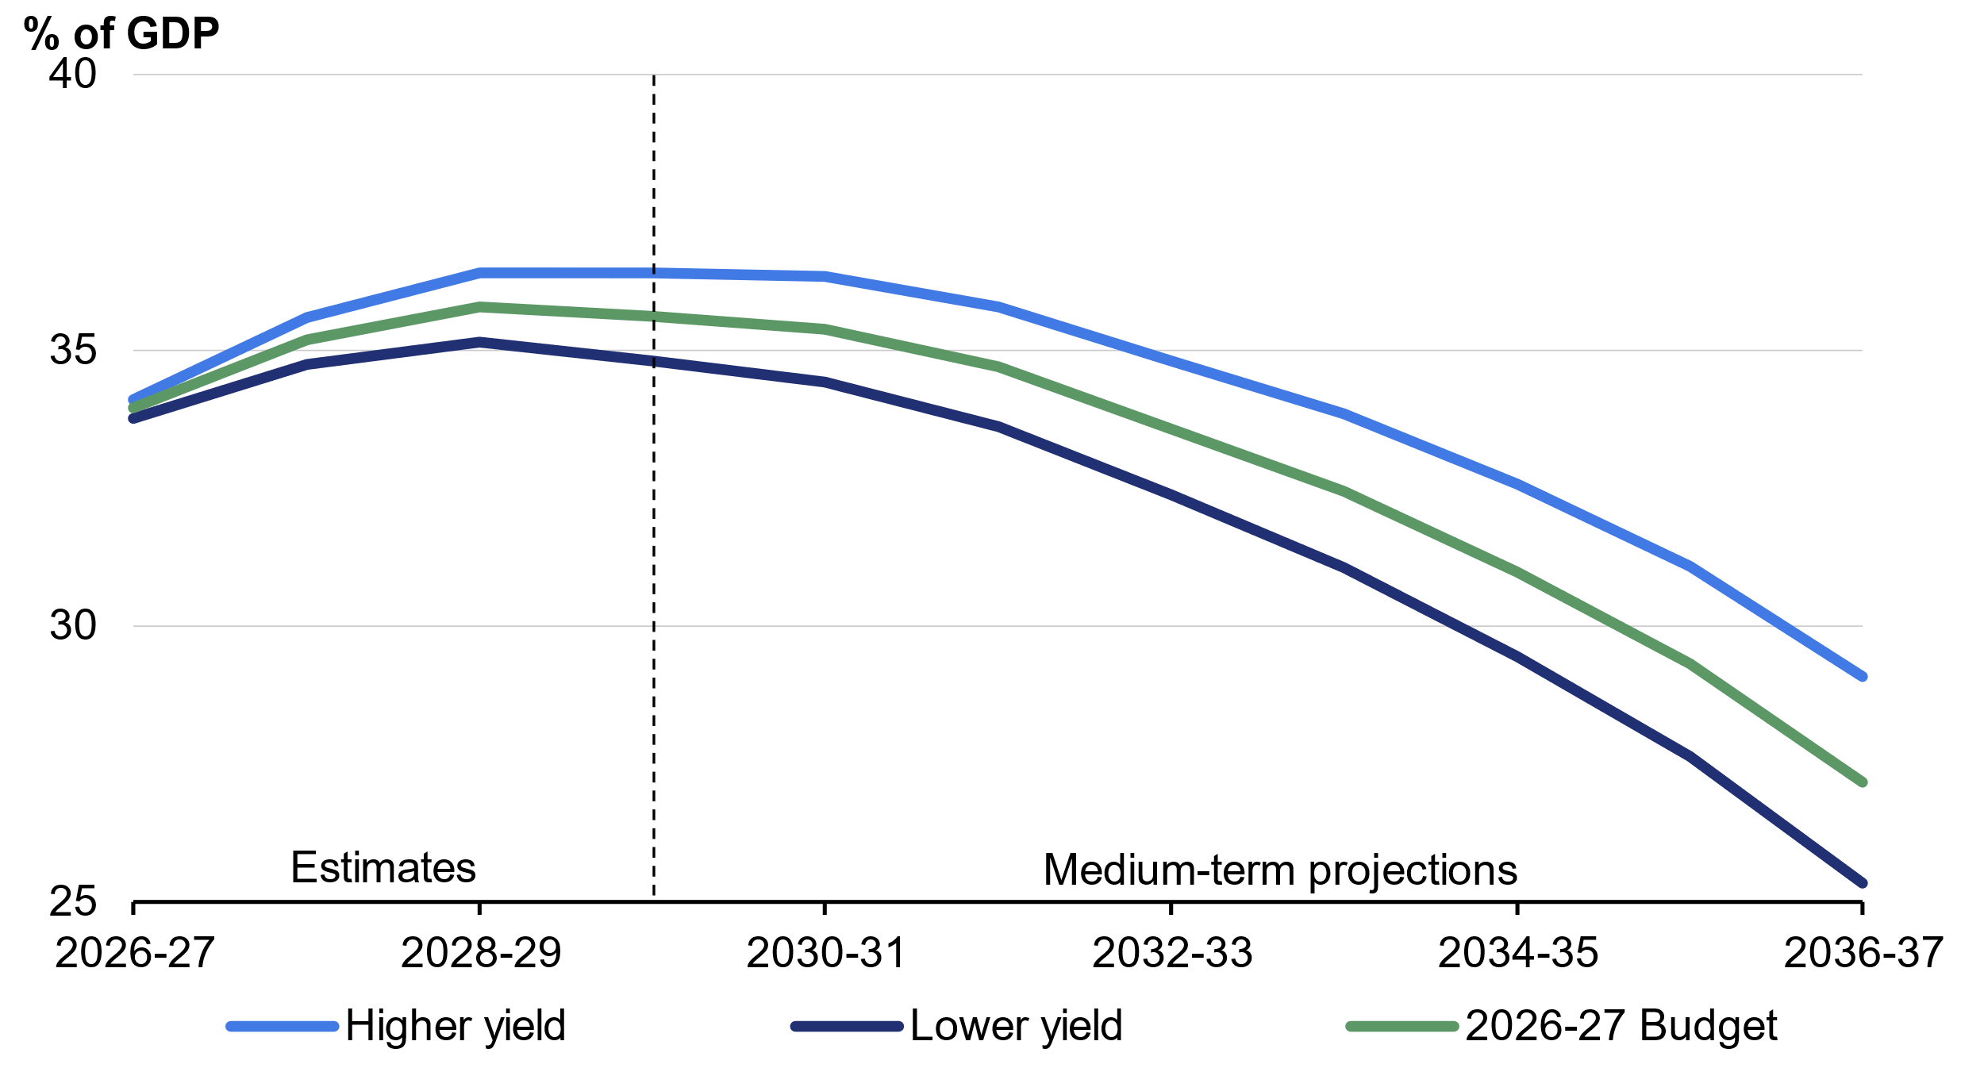
Source: Australian Office of Financial Management and Treasury.

See Treasury Working Paper: Estimates of uncertainty around budget forecasts (2013).
This year a sensitivity analysis of iron ore prices has not been included. The impact of changes in iron ore prices will be broadly similar to those published in the 2025–26 MYEFO.

