**Run Redis server client locally for Lookups**

1) Install Redis server locally. Just follow the instruction on below link download server and then run **redis-server** command**.**

<https://redis.io/topics/quickstart>

2) Also check the command **make test** to check build is successful or not. It will show that all test is passed.

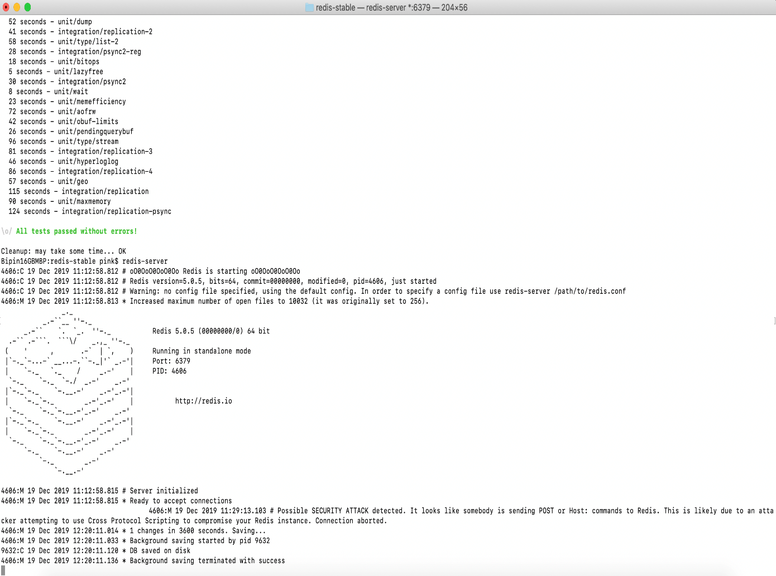

3) Now open another command prompt and run redis client. Run command **redis-cli**

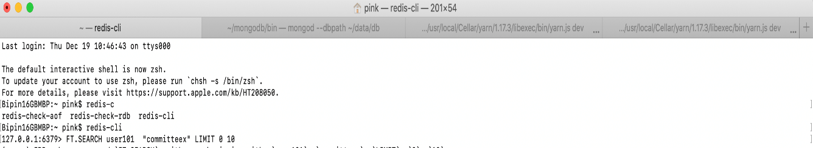

4) Now open look microservice and got to redis.js folder use below code to connect locally:

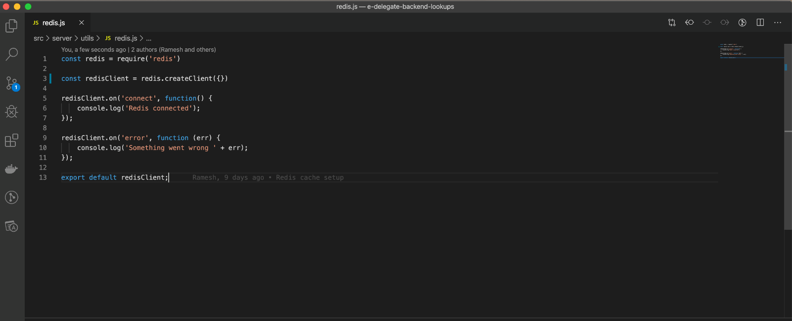

5) Now run the lookup microservice. You will see it connected to local redis server, check the key that is holding cache vale in your local cli(check step 4 for cli).



