Let’s start with the object multi-currency money. We have a report like this:

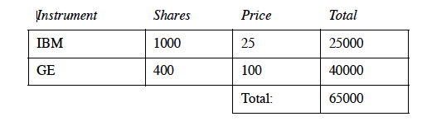
To make a multi-currency report, we need to add currencies:

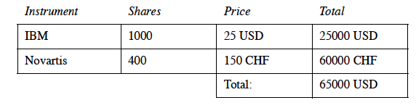
We also need to specify exchange rates:
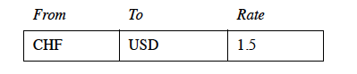
What behavior do we need to produce the revised report?
What is the set of tests which, when passed, will demonstrate the presence of code we are confident will compute the report correctly?

Requirements

We need to be able to add amounts in two different currencies and convert the result given a set of exchange rates.
We need to be able to multiply an amount (price per share) by a number (number of shares) and receive an amount.

To-Do List

$5 + 10 CHF = $10 if rate is 2:1
$5 * 2 = $10

Thinking Process

What test do we need first? Looking at the list, first test looks complicated. Start small or not at all.
Multiplication is easy, we will work on that first.

When we write a test, we imagine the perfect interface for our operation. We are telling ourselves a story about how the operation will look from the outside. Our story won’t always come true, but better to start from the best possible API and work backwards.

Here’s a simple example of multiplication

def test_multiplication
five = Dollar.new(5)
five.times(2)
assert(10, five.amount)
end

Take small steps. Make a note of the stinkiness and move on. We have a failing test and we want it to go green as quickly as possible.

Updated To-Do List

$5 + 10 CHF = $10 if rate is 2:1
$5 * 2 = $10
Dollar side-effects?
Money rounding?

Thinking Process

The test gives us the following error:

Unknown constant Dollar

We can get rid of this error by defining the class Dollar

class Dollar; end;

Now we need the constructor but it doesn’t have to do anything just to get past the current error:

Class Dollar

Def initialize(amount)
End

End

We need a stub implementation of times(). Again we’ll do the least work possible just to get past the current error:

Def times(multiplier)
End

--------------------------------------------------------------------------------------------------------------
We define a null implementation as a temporary empty implementation, introduced to allow the programmer to make progress by deferring effort and intended to be replaced.
- Growing Object Oriented Software Guided by Tests
--------------------------------------------------------------------------------------------------------------

Finally, we need an amount field:

Def initialize(amount)
@amount = amount
End

Now we can run the test and watch it fail. We expected 10 as a result we saw 0. This failure is progress. Now we have a concrete measure of failure. That’s better than just vaguely knowing we are failing. Our programming problem has been transformed from “give me multi-currency” to “make this test work, and then make the rest of the tests work”. Much simpler. Much smaller scope for fear. We can make this test work.

You probably aren’t going to like the solution, but the goal right now is not to get the perfect answer, the goal is to pass the test. Here’s the smallest change that would cause our test to pass:

Xxx

Now we get the green. The cycle isn’t complete. There are very few inputs in the world that will cause such a limited, such a smelly, such a naive implementation to pass. We need to generalize before we move on. Remember, the cycle is:

1. Add a little test
2. Run all tests and fail
3. Make a little change
4. Run the tests and succeed
5. Refactor to remove duplication

Our goal is to be able to write another test that “makes sense” to us, without having to change the code, something that is not possible with the current implementation.

If dependency is the problem, duplication is the symptom. Objects are excellent for abstracting away the duplication of logic. Eliminating duplication in programs eliminates dependency. That’s why the second rule appears in TDD. By eliminating duplication before we go on to the next test, we maximize our chance of being able to get the next test running with one and only one change.

We have run items 1-4. Now we are ready to remove duplication. But where is the duplication? Usually you see duplication between two pieces of code. Here the duplication is between the data in the test and the data in the code.

Amount = 5 * 2

We did the multiplication in our heads and did not notice that 5 and 2 are now in two places. However, what if we move the setting of the amount from object initialization to the times method?

def times(multiplier)
amount = 5 *2
End

The test still passes, we stay in green.

Do these steps seem too small to you? Remember, TDD is not about taking teensy tiny steps, it’s about being able to take teensy tiny steps. I would not code day-to-day with steps this small. But when things get the least bit weird, I’m glad I can. Try teensy tiny steps with an example of your own choosing. If you can make steps too small, you can certainly make steps the right size. If you only take larger steps, you’ll never know if smaller steps are appropriate.

Now, let’s get back to the job of getting rid of duplication between the test code and the working code. Where can we get a 5? That was the value passed to the constructor, so if we save it in the amount variable:

initialize(amount)
@Amount = amount
End

We can use it in times:

Times(multiplier)
Amount = amount * 2
End

The value of the parameter ‘multiplier’ is 2, so we can substitute the parameter for the constant:

def times(multiplier)
amount *= multiplier
end

We can now mark off the first test as done. Next, we’ll take care of those strange side effects. First, let’s review. We:

Made a list of the tests we knew we needed to have working.
Told a story with a snippet of code about how we wanted to view one operation.
Ignored the details of MiniTest for the moment.
Made the test run with stubs
Made the test run by committing horrible sins
Gradually generalized the working code, replacing constants with variables
Added items to our to-do list rather than addressing them all at once

Updated To-Do List

$5 + 10 CHF = $10 if rate is 2:1
$5 * 2 = $10
Dollar side-effects?
Money rounding?
Make ‘amount’ private

