Rhythm of TDD

My goal is for you to see the rhythm of test-driven development:

1. Quickly add a test
2. Run all tests and see the new one fail
3. Make a little change
4. Run all tests and see them all succeed
5. Refactor to remove duplication

The surprises are likely to be:

1. How each test can cover a small increment of functionality
2. How small and ugly the changes can be to make the new tests run
3. How often the tests are run
4. How many teensy tiny steps make up the refactorings

TDD Cycle

The general TDD cycle is :

1. Write a test.

Think about how you would like the operation in your mind to appear in your code. You are writing a story. Invent the interface you wish you had. Include all the elements in the story that you imagine will be necessary to calculate the right answers.

2. Make it run.

Quickly getting that bar green dominates everything else. If a clean, simple solution is obvious, type it in. If the clean, simple solution is obvious but it will take you a minute, make a note of it and get back to the main problem, which is getting the bar green in seconds. This shift in aesthetics is hard for some experienced software engineers. They only know how to follow the rules of good engineering. Quick green excuses all sins. But only for a moment.

3. Make it right.

Now that the system is behaving, put the sinful ways of the recent past behind you. Step back onto the straight and narrow path of software righteousness. Remove the duplication that you have introduced to get to quick green.

The goal is clean code that works. Divide and conquer. First we’ll solve the ‘that works’ part of the problem. Then we’ll solve the ‘clean code’ part.

Arrange Act Assert

Arrange - create some objects
Act - stimulate them
Assert - check the results

Canonical Test Structure

If we write tests in a standard form, they’re easier to understand. We can skim-read to find expectations and assertions quickly and see how they related to the code under test. If we’re finding it difficult to write a test in a standard form, that’s often a hint that the code is too complicated or that we haven’t quite clarified our ideas.

The most common form for a test is:

1. Setup: Prepare the context of the test, the environment in which the target code will run.
2. Execute: Call the target code, triggering the tested behavior.
3. Verify: Check for a visible effect that we expect from the behavior
4. Teardown: Clean up any leftover state that might corrupt other tests.

There are other versions of this form, such as Arrange, Act, Assert, which collapse some of the stages.
For example, no teardown. Tests that set expectations on mock objects use a variant of this structure where some of the assertions are declared before the execute stage and are implicitly checked afterwards (setup, expect, assert, teardown)

Passing the First Test : The Necessary Minimum

Iteration zero requires focus to get the walking skeleton working. The point is to design and validate the initial structure of the end-to-end system - where end-to-end includes deployment to a working environment - to prove that our choices of packages, libraries, and tooling will actually work. A sense of urgency will help the team to strip the functionality down to the absolute minimum sufficient to test their assumptions.

Iteration zero usually brings up project chartering issues as the team looks for criteria to guide its decisions, so the project’s sponsors should expect to field some deep questions about its purpose.

We have something visible we can present as a sign of progress, so we can cross off the first item on our list. Single item join, lose without bidding. The next step is to start building out real functionality.

Software Development as a Learning Process

Everyone involved in a software project has to learn as it progresses. For the project to succeed, the people involved have to work together just to understand what they’re supposed to achieve and to identify and resolve misunderstanding along the way. They all know there will be changes, they just don’t what changes. They need a process that will help them cope with uncertainty as their experience grows - to anticipate unanticipated changes.

Feedback is the Fundamental Tool

The best approach a team can take is to use empirical feedback to learn about the system and its use, and then apply that learning back to the system. A team needs repeated cycles of activity. In each cycle it adds new features and gets feedback about the quantity and quality of the work already done. The team members split the work into time boxes, within which they analyze, design, implement, and deploy as many features as they can.

The fundamental TDD Cycle

As we develop the system, we use TDD to give us feedback on the quality of both its implementation (Does it work?) and design (Is it well structured?).

Writing tests:

Makes us clarify the acceptance criteria for the next piece of work - we have to ask ourselves how we can tell when we’re done (design)
Encourages us to write loosely coupled components, so they can easily be tested in isolation and, at higher levels, combined together (design)
Adds an executable description of what the code does (design)
Adds to a complete regression suite (implementation)

Running tests:

Detects errors while the context is fresh in our mind (implementation)
Lets us know when we’ve done enough, discouraging gold plating and unnecessary features (design)

The Bigger Picture

When implementing a feature, start by writing an acceptance test, which exercises the functionality we want to build. While it’s failing, an acceptance test demonstrates that the system does not yet implement that feature; when it passes, we’re done. When working on a feature, we use its acceptance test to guide us as to whether we actually need the code we’re about to write - we only write code that’s directly relevant. Underneath the acceptance test, we follow the unit level test/implement/refactor cycle to develop the feature; the whole cycle looks like:

Inner and Outer Feedback Loops in TDD

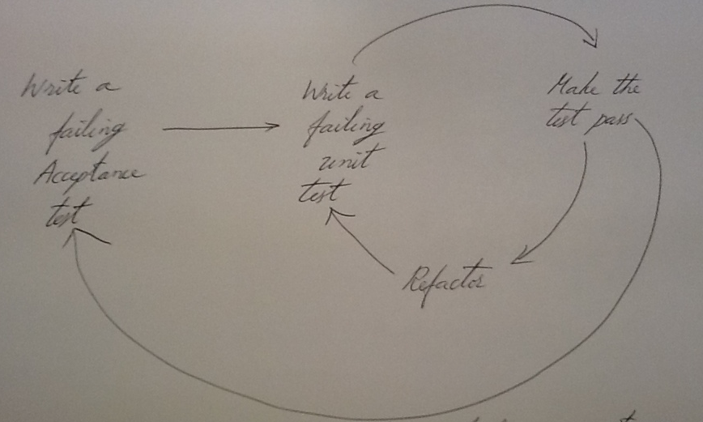

The outer test loop is a measure of demonstrable progress, and the growing suite of tests protects us against regression failures when we change the system. Acceptance tests often take a while to make pass, certainly more than one check-in episode, so we usually distinguish between acceptance tests we’re working on (which are not yet included in the build) and acceptance tests for the features that have been finished (which are included in the build and must always pass).

The inner loop supports the developers. The unit tests help us maintain the quality of the code and should pass soon after they’ve been written.

Testing End-to-End

Wherever possible, an acceptance test should exercise the system end-to-end without directly calling its internal code. An end-to-end test interacts with the system only from the outside: through its user interface, by sending messages as if from third-party systems, by invoking its web services, by parsing reports and so on. The whole behavior of the system includes its interaction with its external environment. This is often the riskiest and most difficult aspect; we ignore it at our peril. We try to avoid acceptance tests that just exercise the internal objects of the system, unless we really need the speed-up and already have a stable set of end-to-end tests to provide cover.

Levels of Testing

Acceptance : Does the whole system work?
Integration : Does our code work against code we can’t change?
Unit : Do our objects do the right thing, are they convenient to work with?

We use acceptance tests to help us, with the domain experts, understand and agree on what we are going to build next. We also use them to make sure that we haven’t broken any existing features as we continue developing.

Integration tests refer to the tests that check how some of our code works with code from outside the team that we can’t change. It might be a public framework or library from another team within our company. The distinction is that integration tests make sure that any abstractions we build over third-party code work as we expect. They help tease out configuration issues and to give quicker feedback than the slower acceptance tests.

A unit test for an objects needs to create the object, provide its dependencies, interact with it, and check that it behaved as expected. So, for a class to be easy to unit-test, the class must have explicit dependencies that can easily be substituted and clear responsibilities that can easily be invoked and verified. This means that the code must be loosely coupled and highly cohesive.

