Security (System) Engineering with Generative AI

Homework Assignment no. 3

Student name: Brehon Parker FAU ID: Z23222679

Algorithm:
- Edit above your student name and homework number.
- Edit below the missing information between < and >.
- During development, for every significant task given to the agent you must:
  - Take a screenshot of your VSCode window clearly showing the prompt you gave to the agent and the response it gave you back. Your FAU ID must be visible on the screenshot.
  - Take a screenshot of your VSCode window clearly showing at least the top few lines of code that were generated or modified by the agent. Your FAU ID must be visible on the screenshot.
  - Insert the screenshots into the homework Word document, along with the task prompt given to the agent pasted as regular text.
- When finished, convert the Word document to PDF and upload on the homework Canvas page.

Screencast Recording URL: PENDING RECORDING

Github Repository URL: https://github.com/bparker2012-cyber/gensec-code

Application name: Incident Compass

Application Description: Incident Compass adds cited policy search, validated incident triage, and a restricted Terminal to a stateful LangChain agent. It uses fictional classroom policy and environment credentials. Fifteen offline tests pass. Live Gemini requires verification. Keyword retrieval can miss synonyms; triage depends on supplied facts; memory resets on exit.

Repeat for each step:
Development evidence: The following pages document genuine follow-up development using the Codex agent in VS Code. Initial implementation was performed in Codex desktop, so this evidence does not claim that every original development task was performed in VS Code.

VS Code Development Evidence
Exact prompt: Brehon Parker / FAU ID Z23222679 / Homework 3. In hw3/tools.py, fix search_policy so a request for an unsupported explicit severity such as Severity 4 returns no policy evidence instead of unrelated Severity 1/2/3 sections. Add focused tests for unsupported severity and empty search queries in hw3/tests/test_agent.py; treat empty queries as no evidence. Preserve the existing tools, Terminal restrictions, and unrelated files. Use docstrings, run uv run pytest -q in hw3, and summarize the exact change and test result. Do not commit or push.
Agent response and task result: 15 tests passed; unsupported severities and blank queries return no evidence.
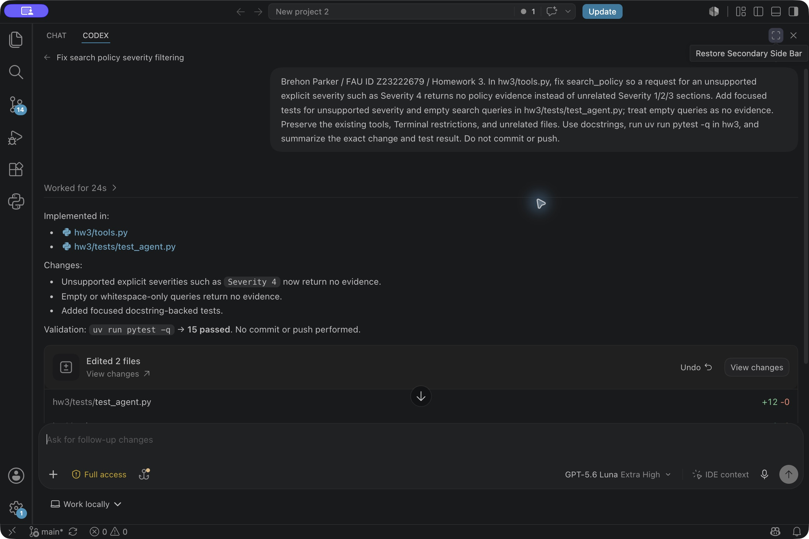

Generated and Modified Code
Brehon Parker / FAU ID Z23222679. Actual VS Code source view showing the modified search_policy function. Name/ID header added for attribution after the agent task.
