15-418 Project: KenKen Puzzle Solver
Johnathan Park (jjp1)
Ben Parr (bparr)

Sources:

KenKen Official Site (http://www.kenken.com/)

NekNek Puzzles (http://www.mlsite.net/neknek/)
- Serial KenKen solver written in Python
- Used for base ideas for serial implementation

“The complexity of completing partial Latin squares” (http://dx.doi.org/10.1016%2F0166-218X%2884%2990075-1)
- Filling in partially filled Latin square is NP-Complete
- So, KenKen is NP-Complete

Sample Puzzles

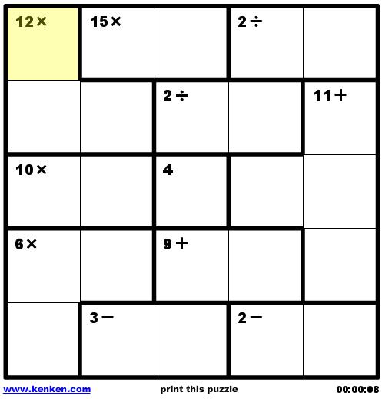
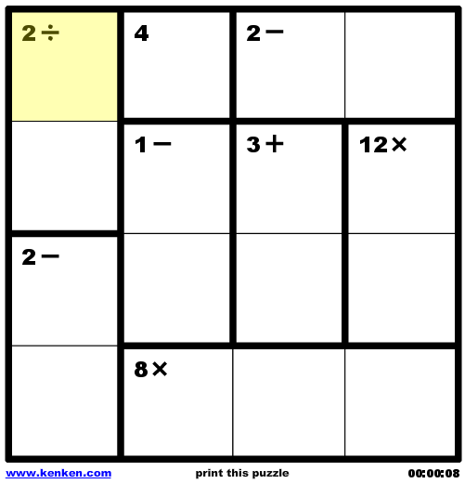

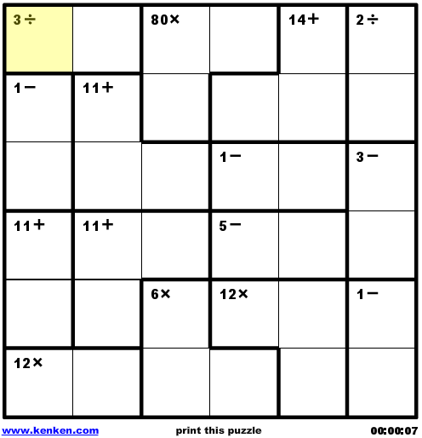

Puzzle 3

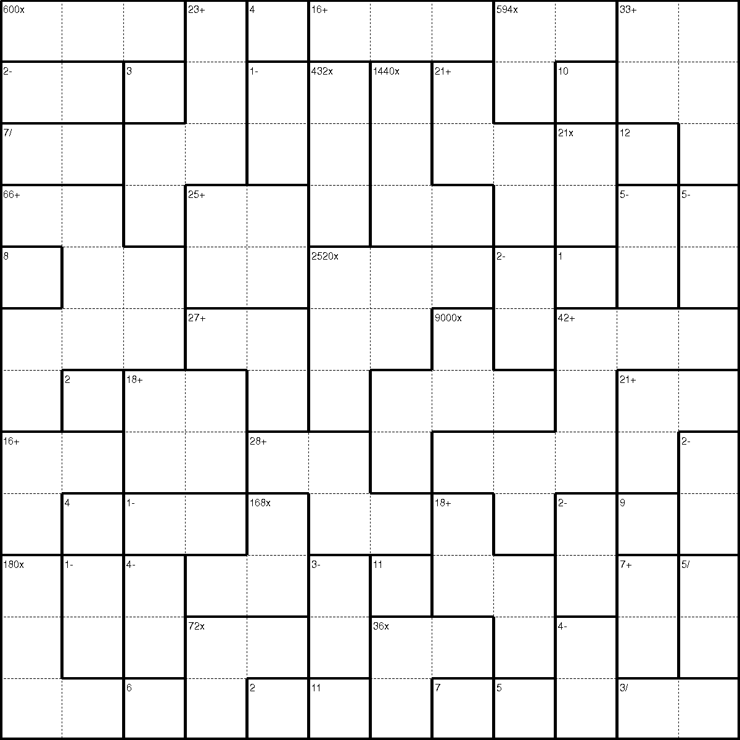

Total and Computational Time Speedup

Blacklight

Pople

Node Speedup

Blacklight

Pople

General KenKen Solve Code

// Return true if solution found
boolean solve (puzzle):
if puzzle.complete:
// Do what you want with solution
return true

nextCell = puzzle.getNextCellToFill()

// No next cell, so puzzle is impossible to solve
if !nextCell:
return false

// Remove cell from puzzle since it now has a concrete value
puzzle.removeCell(nextCell)

for possibleValue in nextCell.possibleValues:
// Assign value to cell, and update the constraints it was in
// e.g. a 5+ constraint --> 2+ constraint when assigning a value of 3
nextCell.assignValue(possibleValue)

if solve(puzzle):
return true

// Unassign value and update the cell's constraints it was in
nextCell.unassignValue()
// Add the cell back to the puzzle so it gets filled again later
puzzle.addCell(nextCell)

return false

Parallel Job Queue/Creation Code

queues[P] // Initialize to contain P new empty circular queues
queues[0].enqueue(initalJob)

// Search queues for a job to complete, starting with your own queue
void getNextJob(pid);

// Solver run by an individual processor
void parallelSolve(pid):
while (job = getNextJob(pid)):
if ADD_TO_QUEUE(queues[pid], job):
partitionJob(queues[pid], job, queues[pid].availableSpots)
else
solve(job)

// Partition a job, and add the partitioned jobs to the queue
// Returns number of spots used, or -1 if failed to split up job
int partitionJob(queue, job, availableSpots):
nextCell = job.getNextCellToFill()
if (!nextCell)
return 0
if (nextCell.numPossibles > availableSpots)
return -1

originalAvailableSpots = availableSpots

// Preemptively assign each possible a spot in the queue, so there is always
// at least room in queue to add the job itself
availableSpots -= nextCell.numPossibles

for possibleValue in nextCell.possibleValues:
nextCell.assignValue(possibleValue)
spotsUsed = partitionJob(queue, job, availableSpots + 1)
nextCell.unassignValue(possibleValue)

// Able to add split up job to queue, so just update available spot count
if spotsUsed >= 0:
availableSpots -= (spotsUsed - 1)
continue

// Failed to add sub-jobs to queue, so add job itself
queue.addJob(job)

// Return the number of spots in the queue that were used
// Note: this value is always in range of [0, originalAvailableSpots]
return (originalAvailableSpots - availableSpots)

Analysis

Speedups measured on 5 puzzles
- Generated with created script
- Chosen based on serial time (20 – 65 minutes)

Speedups measured for P = 1, 2, 4, 8, 16, 24 and 32

Time speedups highly inconsistent
- Puzzle 2 on Blacklight: 15x for 4 processors, 152x for 8 processors and 15x for 16 processors
- Reason: program terminates as soon as finds solution, so time depends heavily on initial guesses

New metric: Node speedup
- Definition: number of nodes traversed (i.e. steps applied) per second
- Consistent speedup

100% Goal: 30x on 32 processors
- Averaged 30.145x
- Goal Met?: Yes

