Brad Pasanek, English (bmp7e@virginia.edu)

Melissa Goldman, A-School (meg3kx@virginia.edu)

Sarah Betzer, Art History (sb4fg@eservices.virginia.edu)

**Puzzle Poesis**

*OuLiPo in C-ville: cutting up puzzle-poems with lasers, solving them with a supercomputer*

Online information about the workshop at <http://puzzlepoesis.org>

**The Ask**

Our working group, launched this fall by Brad Pasanek and Neal Curtis as a short-term experimental endeavor, treats poems as puzzles. A decidedly interdisciplinary group, we apply to the Page-Barbour Fund for money to buy art materials and to host a one-day symposium in the spring semester. A grant would affirm our mission, launching the group as a start-up or pop-up “lab” of the sort encouraged by our current Dean of the College.

**Intellectual Focus**

The Puzzle Poetry group is an emphatically cross-disciplinary one, convening poets, literary critics, computer scientists, Scholars’ Lab and A-School technicians, and artists. Our unifying interest is composition, design, and constraint. Among the undergraduates in the group we have an Engineering and Poetry double major as well as several English/CS majors and minors. We aim to make poetic structure more accessible to students; and our goal is to promote the study of poetry by bringing it into campus maker spaces.

Since September 1st, our group has met three times—thus far relying on IHGC’s support for space and petty cash for refreshments. We’ve been working on a website to show off our efforts and have been brainstorming puzzle projects.

**Current Project**

The group is currently hard at work converting a sequence of sonnets into “pentomino” puzzles. These will be laser cut from wood, acrylic, and other materials, and then assembled as an art object titled *Increase*. The project focuses on the first seventeen of Shakespeare’s *Sonnets* (1609), the so-called “procreation” sonnets, which thematize creativity and multiplication. We plan to assemble seventeen puzzle kits based in the sequence and distribute them nationally, mailing them to favored Shakespeare scholars, critics of concrete poetry, and art galleries. The story of the puzzles and their scattering will be documented on our website and written up as an article for a digital humanities journal.

Workshop leaders have prepared two prototype laser-cut puzzles (one cut from acrylic, the other from plywood) in the A-School Fab Lab. Meanwhile, students are planning their own new puzzles, with one team adopting a James Merrill poem (“Lost in Translation”) and another designing a puzzle based on an abecedarian poem by an alum of the UVa MFA program (Mary Szybist).

To date, the group has been exploiting the geometry of polyminos, in particular pentominos (a pentomino is a polygon in the plane built from five squares) because the squared-off shapes fit neatly in the frame of a 14-line x 10-syllable grid of a sonnet. Preparing our poem-puzzles requires packing the twelve pentomino shapes (shown below) into sonnet-shaped frames.

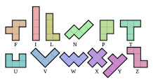 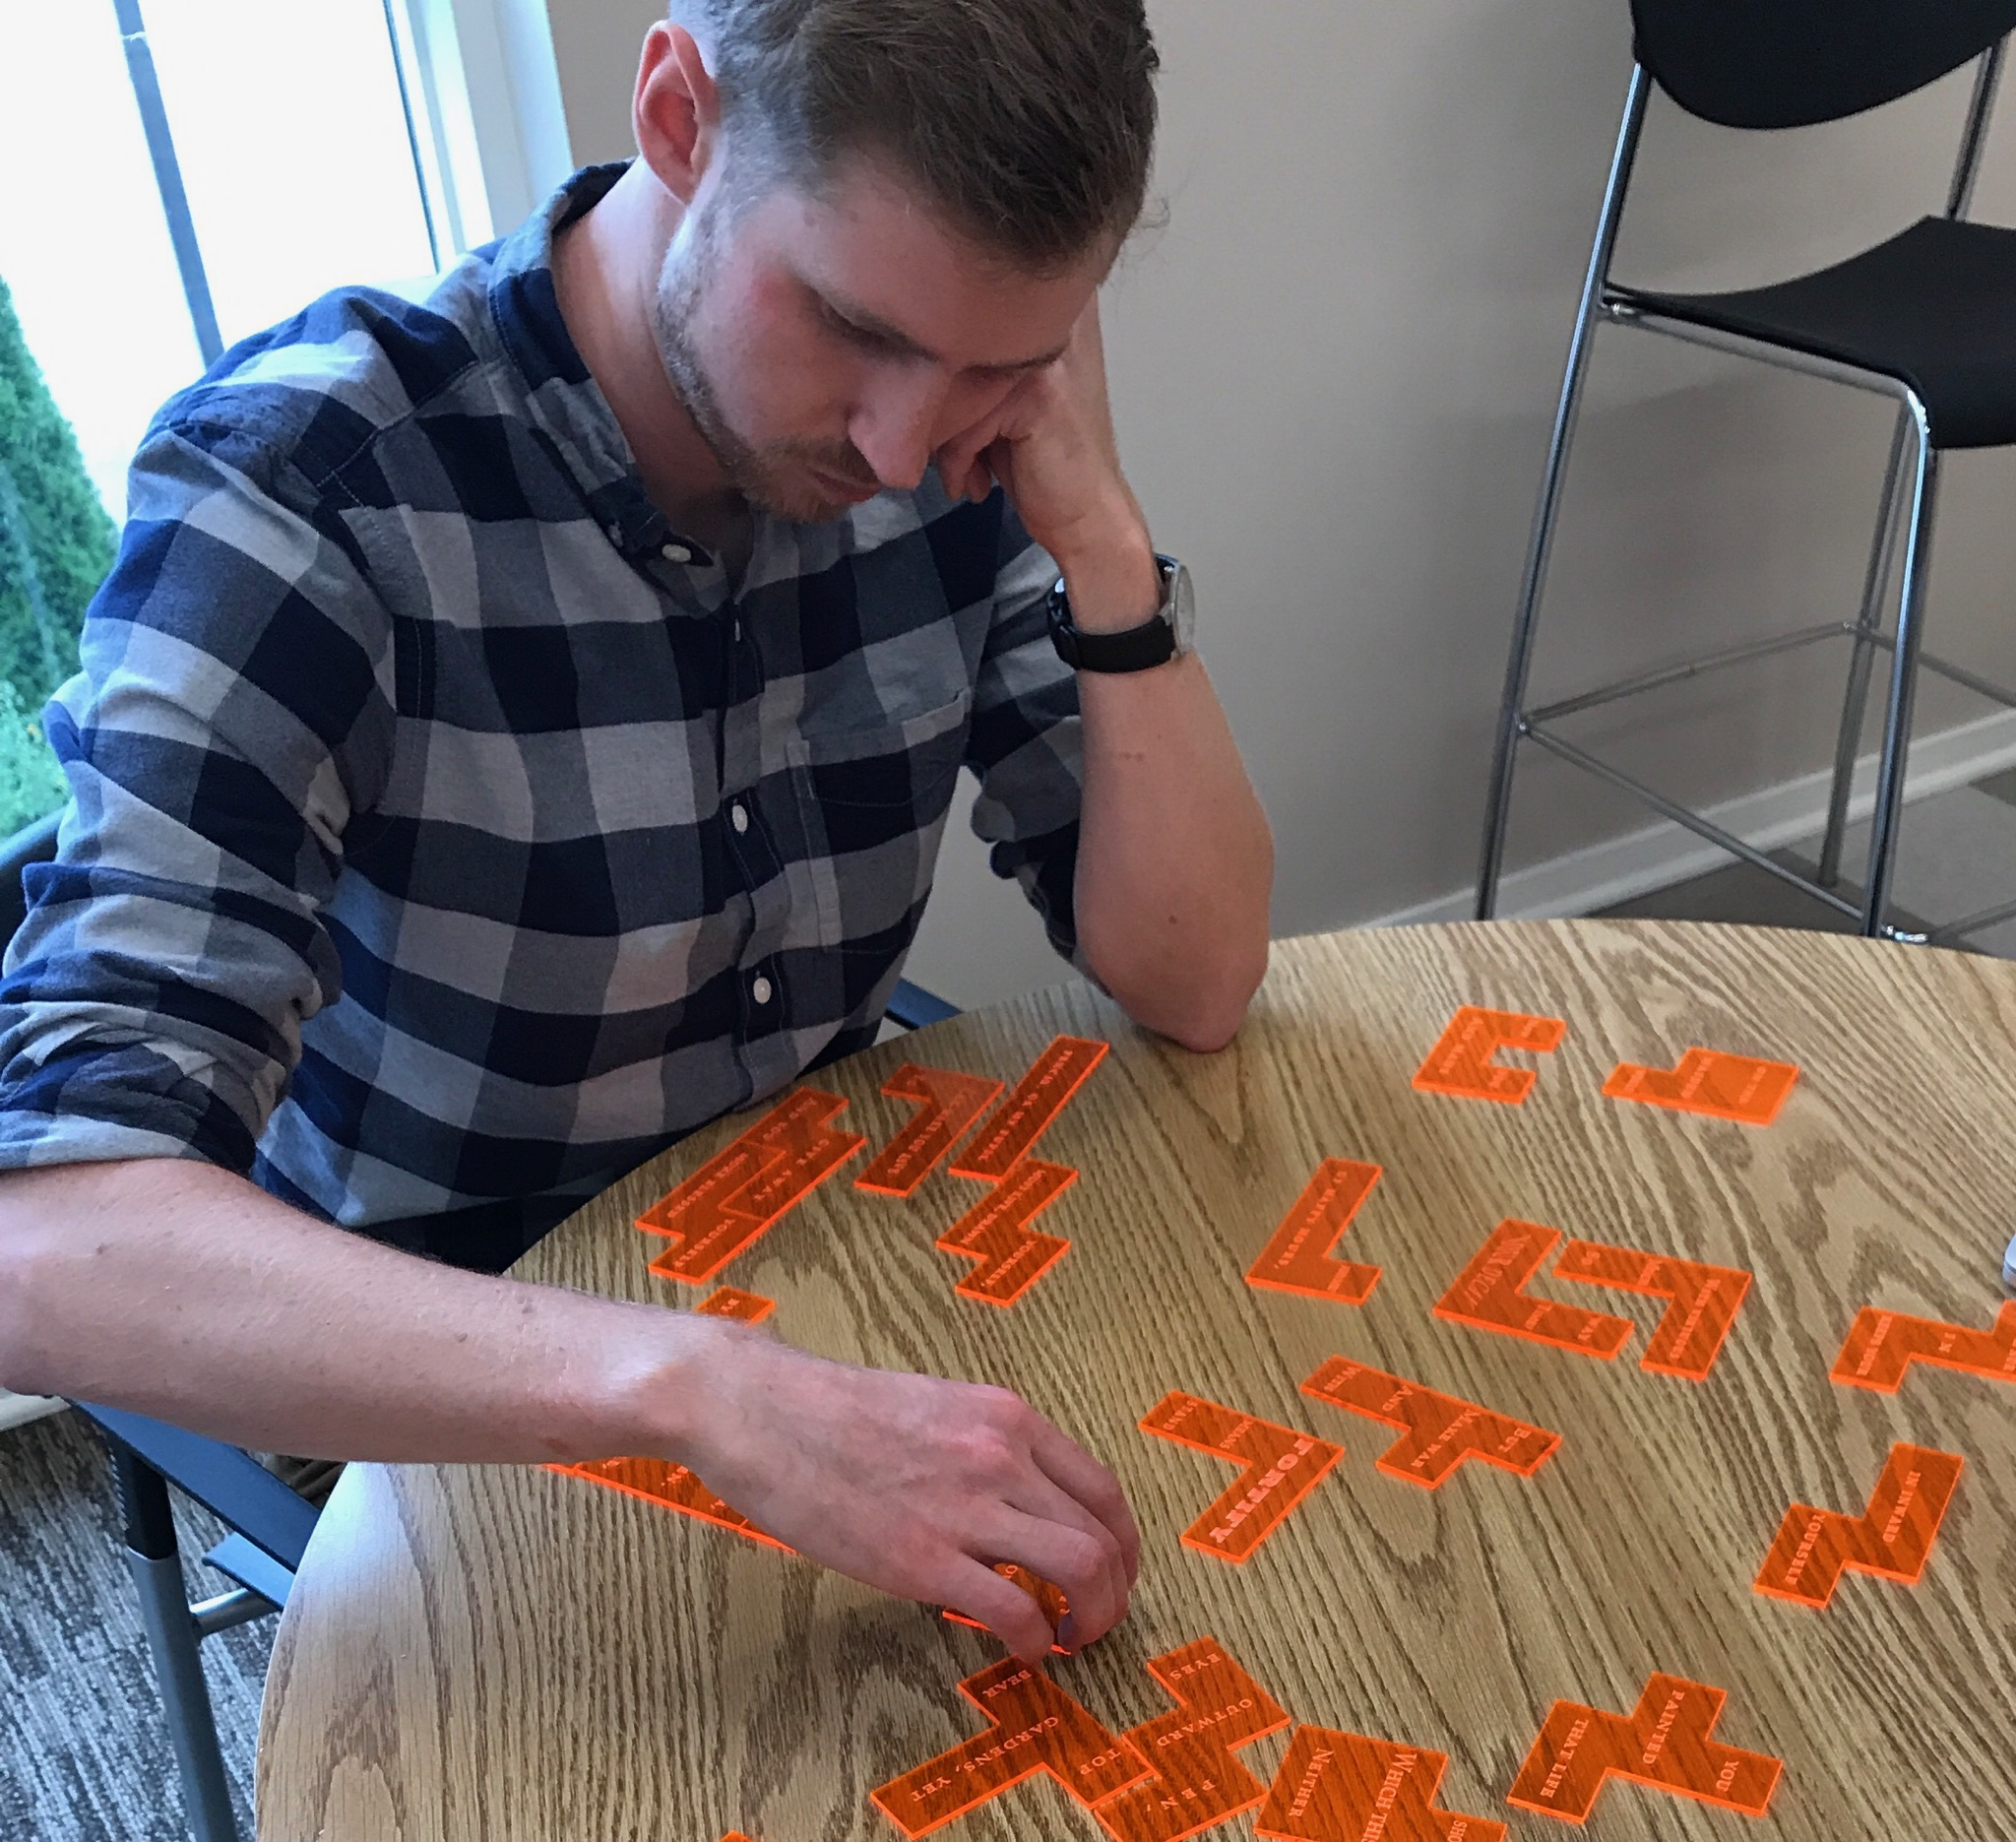

Working by hand, we have carved up several sonnets into a set of pentomino pieces, but we hope to do better, and are employing a walk-back algorithm to find all possible solutions to our sequence of sonnets—that is, all the ways that any given sonnet can be cut up into pentomino shapes. Three CS students are working on adapting code for the computationally intensive problem. After consulting with Katherine Holcomb, director of ARCS, we are cleared to solve for solutions on Rivanna, UVa’s supercomputing cluster.

In the tradition of I.A. Richards’ *Interpretation in Teaching*, three of our puzzles will be distributed in sections of ENGL 3810 for a lecture-wide competition (elimination by brackets: there can only be one puzzlemaster). In the spring, several of our puzzle poems—the most likely candidates for gamification—will be pitched as game ideas to the CS-students’ Gaming Group, organized by David Hall and Mark Sheriff in CS. We imagine *Poem-Puzzle Tetris* and other poetry transmediations.

**The Spring Symposium: Organizational Format and Anticipated Audience**

In addition to funds for puzzle projects, we ask for support for a one-day interdisciplinary symposium on poetics, sculpture, design, and constraint. The symposium aims to bring the Puzzle Poetry group into a larger conversation with colleagues across the College: especially those in Art, Art History, and Archaeology.

At present we have extended preliminary invitations to two academics: Bret Rothstein, an art historian specializing in the history of puzzles and Tony Veale, a computer scientist and builder of twitterbots who specializes in computational creativity. We will also invite Harryette Mullen, a prize-winning writer, whose poems mix Oulipean constraint and African-American identity politics.

We plan to organize the day around three 30-minute presentations, each followed by a discussion of equal time, led by a UVa professor. We will schedule also two panels of local participants, both of which will include UVa graduate students. Participants will be asked to address the central questions of the symposium:

1. What current arts and technologies employ constraint as a design principle?
2. What is the relation of mechanism and algorithm to creativity?
3. What poetics is encouraged by collage, remediation, rearrangement, and computation?
4. What are the constraints and affordances of puzzle poetry? How do these compare to poetry written in a controlled vocabulary—or to verses mechanically generated by twitterbots?

**Appendix — Symposium Details:**

**Proposed Date and Venue:** tentatively scheduled for late April or early May, to be held in Harrison-Small. (Coordinating with Jahan Ramazani, Jane Alison.)

**List of Participants**.

While the proposal originates from the English and Art History Departments, numerous colleagues have been attending workshop meetings and have expressed interest in the symposium:

**Institutional Commitments**

Jane Alison, Director, Creative Writing

We are coordinating with Alison because we would like the poet we bring to offer a reading the day before or after the symposium.

Alison Booth, English, Director of the Scholars’ Lab

Booth has generously put SLab programmers at our disposal. We have also met with their 3D printing experts.

Federico Cuatlacuatl, Art

Cuatlacuatl works in digital art, has trained in animation, and has promised to keep us in touch with Studio Art undergrads at UVa.

Katherine Holcomb, Director of ARCS

She has adapted puzzle-solving software and set the group up on Rivanna.

Worthy Martin, Computer Science, Director of IATH

Martin has much experience in promoting the digital humanities at UVa.

Jahan Ramazani, English

He leads the Center for Poetry and Poetics at UVa.

Tyler Jo Smith, Art/Archaeology

Smith is an expert on ancient art, archaeology, and 3D-printing. She has a background in literary study and remains interested in poetry.

We have also contacted Ted Coffey in Music and Jeanna Ripple in Architecture.

Full list of Current Workshop Attendees (names listed below have attended at least one meeting or contributed in some other way). Core members bolded:

*Co-Leaders*: **Brad Pasanek** (faculty, English) and **Neal Curtis** (grad, English)

*Participants*: **Alison Booth** (faculty, English and SLab), **Jeremy Boggs** (SLab), Vanessa Braganza (grad, English), Jordan Burke (grad, English), **Jordan Buysse** (grad, English), Helena Chung (MFA), **Lucy Fitzgerald** (undergrad, Engineering/English), Adam Friedgen (grad, English), Margaret Goins (undergrad, Physics/English), **Melissa Goldman** (A-School, Fab Lab), Piers Gelly (MFA), **Landis Grenville** (MFA), **David Hall** (undergrad, CS/English), Katherine Holcomb (ARCS), **Lauren Johnson** (undergrad, Archaeology/English), Sam Lemley (grad, English), Chelsea Li (undergrad Bio/English), **Jeremy Little** (undergrad, CS/English), **Julianne McCobin** (grad, English), Worthy Martin (IATH), Katherine Novak (undergrad, English), Indu Ohni (grad, English), Ana Rowan (grad, English), Ammon Shephard (SLab), **Timothy Schott** (undergrad CS/English), Chip Tucker (faculty, English), **Brandon Walsh** (SLab), **Andie Waterman** (grad, English), **Madeline Zehnder** (grad, English)

**Itemized Budget.**

**Art Supplies for *Increase* Puzzle Project**

|  |  |  |  |
| --- | --- | --- | --- |
| Item | Quantity | Unit Price | Cost |
| 12”x12” Cast Acrylic Sheets, 1/8” thick | 190 (including reserves for laser-cutter related contingincies) | $7.84 | $1,489.60 |
| 12”x12” Plywood Sheets, 3/8” thick | 140 (including reserves) | $8.19 | $1,146.60 |
| Undergraduate and Graduate Assistants to help monitor and operate M-300 and X-660 laser cutters | 140 hrs (estimated, shared among multiple assistants) | $10-15/hr | ~$1,900 |
| Additional Supplies for New Puzzle Projects | --- | --- | $500 |
|  |  | **Subtotal** | **$5,036.20** |

**Spring Symposium**

*1) Participants*

* Featured Speaker (Harryette Mullen, English, UCLA)
* Featured Speaker (Bret Rothstein, Art History, Indiana University)
* Featured Speaker (Tony Veale, Computer Science, University College Dublin)

*2) Expenses for Featured Speakers*

|  |  |  |  |
| --- | --- | --- | --- |
| Item | Quantity | Unit Price | Cost |
| Average Travel Expenses | 3 | $800 | $2,400 |
| 2 (or 3) Nights in Local Hotel | 3 | $300-$450 | ~$1,200 |
| Honorarium | 3 | $750 | $2,250 |
| Reimbursement of Incidental Expenses | 3 | $150 | $450 |
|  |  | **Subtotal** | **$6,300** |

*3) Meal Expenses for Participants*

|  |  |
| --- | --- |
| Item | Cost |
| Catered Lunch for Panel Participants | $500 |
| Dinner for Main Participants (12 people) | $1200 |
| Subtotal | **$1700** |

*4) Graduate Student Coordinator:*

|  |  |
| --- | --- |
| Item | Cost |
| 60 hours, $15/hr | **$900** |

**GRAND TOTAL: $13,936.20**