**Sonnet 6**

[9] "Ten times thyself were happier than thou art" # happier elided

[10] "If ten of thine ten times refigured thee;"

[11] "Then what could death do if thou shouldst depart,"

[12] "Leaving thee living in posterity?"

[13] "  Be not self-willed, for thou art much too fair"

[14] "  To be death's conquest and make worms thine heir."

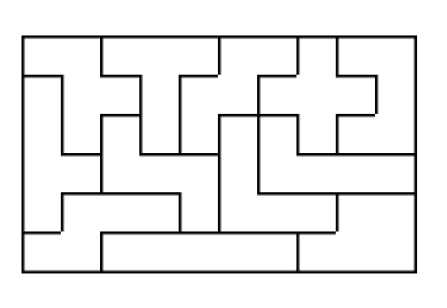

**Sonnet 12**

[9] "Then of thy beauty do I question make"

[10] "That thou among the wastes of time must go,"

[11] "Since sweets and beauties do themselves forsake"

[12] "And die as fast as they see others grow;"

[13] "  And nothing 'gainst Time's scythe can make defense"

[14] "  Save breed, to brave him when he takes thee hence."

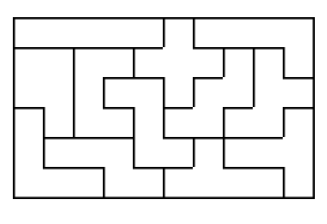

**Sonnet 15**

[9] "Then the conceit of this inconstant stay"

[10] "Sets you most rich in youth before my sight,"

[11] "Where wasteful Time debateth with Decay"

[12] "To change your day of youth to sullied night;"

[13] "  And, all in war with Time for love of you,"

[14] "  As he takes from you, I engraft you new."

