Classy Tutorial

Data Preparation

The first thing you have to do in order to use the Classy classification software is export all your image data from its proprietary format to a single-layered, generic binary file. For the purposes of this tutorial we will assume you are using Erdas Imagine as your GIS software (if you are using other software, please consult your documentation for instructions on performing these steps).

To begin, launch Imagine and click the “Import” button on the toolbar; you should get the following screen. Note that the export radio button has been selected, type is set to “Generic Binary” and media is set to “File”.

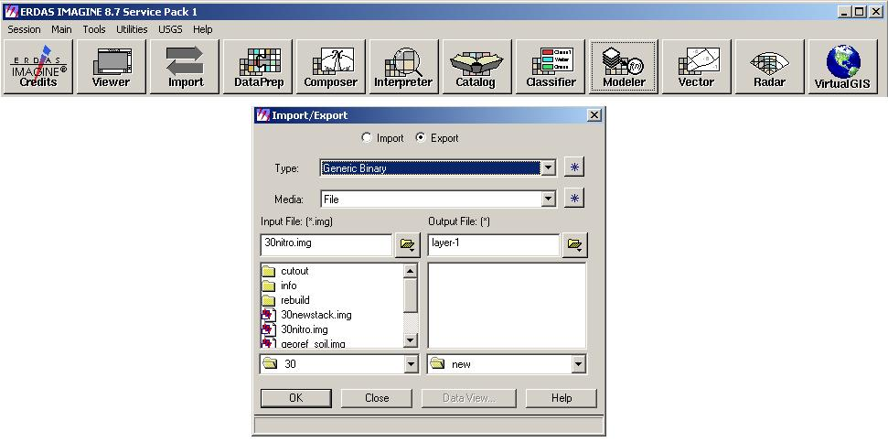
Figure 1. Imagine Export Screen

Once you have chosen the input file (the image you wish to export), and the output file, click the OK button. You should now see a screen like figure 2.

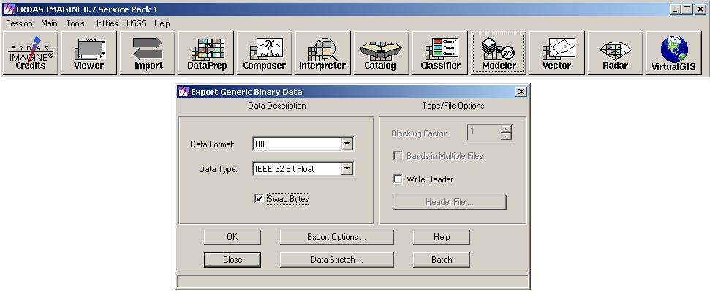
Figure 2. Generic Binary Export Options

Note that the “Swap Bytes” checkbox is checked. This is required, if you do not check this box your classifications will all be wrong. The next thing you have to do is click the “Export Options” button, once you do this a screen similar to figure 3 should appear.

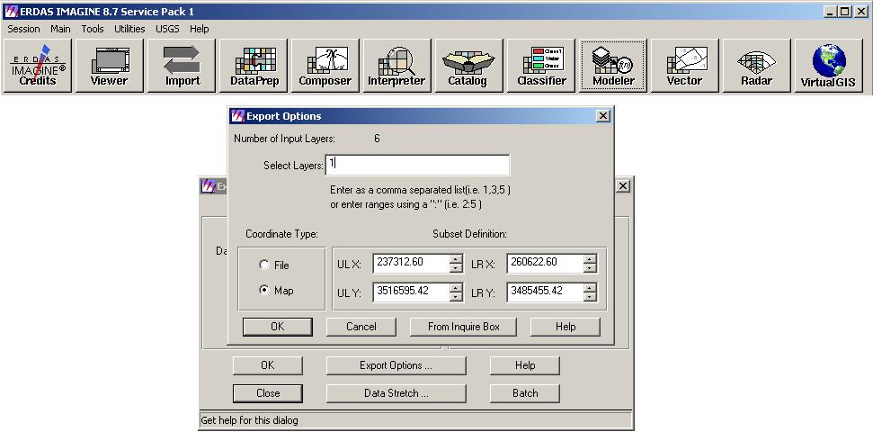
Figure 3. Generic Binary Export Options Contd.

Please take note of the “Select Layer” box. Initially, when you click “Export Options”, all of the layers will be selected; you must only select one layer at a time when exporting, otherwise the classifier won’t work. For our purposes you simply need to type the layer number you wish to export into the “Export Layers” box and click “OK”. Double check again to make sure that the “Swap Bytes” box is checked in the original export screen, and then click “OK” once more to perform the export.

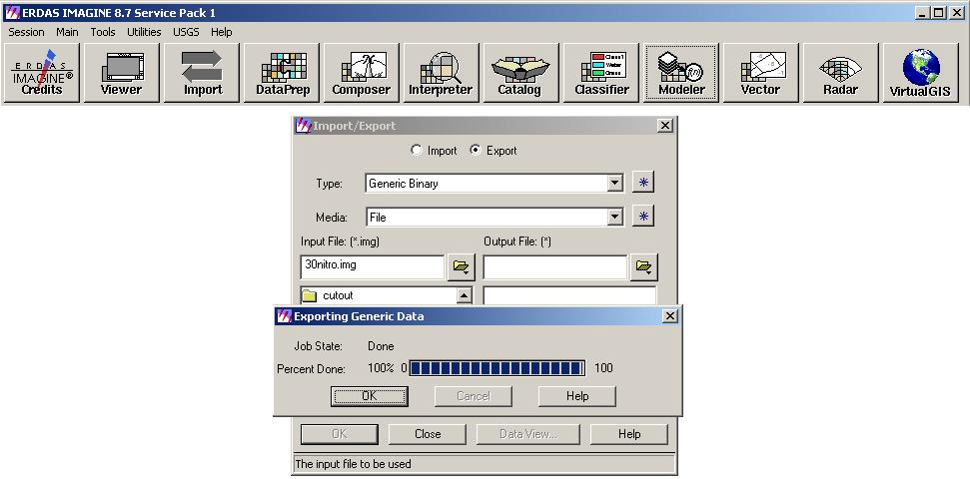
Figure 4. Finished Export

This export process should be repeated for each layer of the file you wish to run through the classifier. Note: it is a good idea to name your export files something sequential (i.e. “layer-1”, “layer-2” etc..), because the files must be input sequentially into the classifier to ensure data validity (this will be discussed in more detail later on).

Running Classy

Now that you have exported all of your image layers to generic binary files, it’s time to load up classy. Double click on “classy.exe” and you should be greeted with a screen like figure 5.

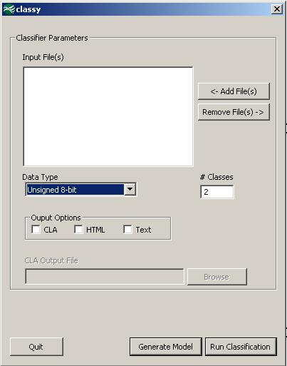
Figure 5. Classy Main Screen

The first thing that you need to do is input all of your image files, to do this, click the “Add Files” button. Note that you can select multiple images to load at once by dragging a selection box around them (this is why its a good idea to use sequential file names for your images, it allows you to preserve the order of the layers when selecting multiple files).

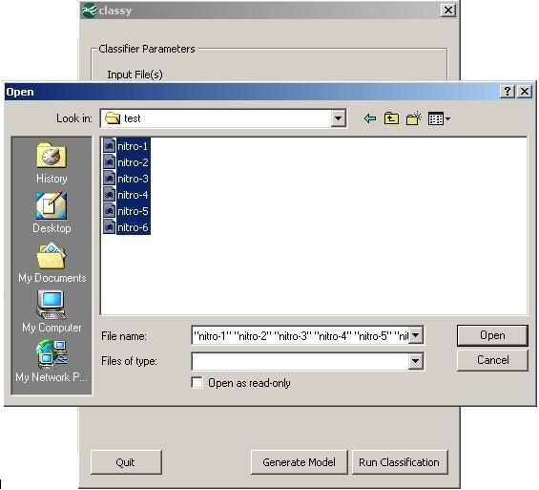
Figure 6. Load Image Files

Once you have selected your files and clicked “Open” you should see a screen similiar to figure 7. Now that you have your input files selected you need to select the input image Data Type from the drop-down menu, input the number of classes you want to generate into the box marked “# Classes”, and select the output formats you would like to generate. As can be seen here, the data type is 32-bit floating point, we are generating five classes, and all three output options have been selected. For the HTML and text output options, a file for each input image will be created with the name of the original input file with “.html” and “.txt” file extensions added, respectfully.

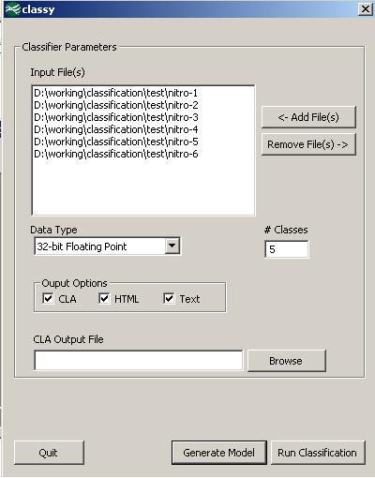
Figure 7. Classification Setup

One thing that you may have noticed is that when the “CLA” output option is selected, the “CLA Output File” edit box and button become active. The CLA file is the most important feature of classy, as it is what we will use to generate the Imagine spatial modeler script that will actually re-classify our original image using the data values generated by the classification algorithm. To generate a CLA file you must give it a filename and location by clicking the “Browse” button. You should see something like figure 8.

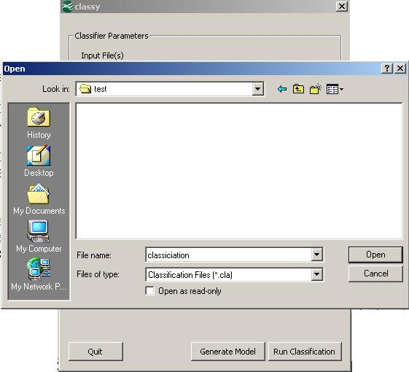
Figure 8. Creating A CLA File

Here we are naming our CLA file “classification.cla”, and until we choose a different file name, all classification results will be appended to this file. This is a very important feature to note: once you create your CLA file in this screen, until you create another one, any classifications that you run will have their results added to this file. So if load another set of input images that correspond to the layers of a completely different image you should always choose another CLA file, otherwise when you generate your spatial modeler script it will most likely not work. There may be situations where you want to choose an existing CLA file to add to, but in most cases you should choose a new file. Now that we have chosen a name for our CLA file, click open and you should see a screen similar to figure 9.

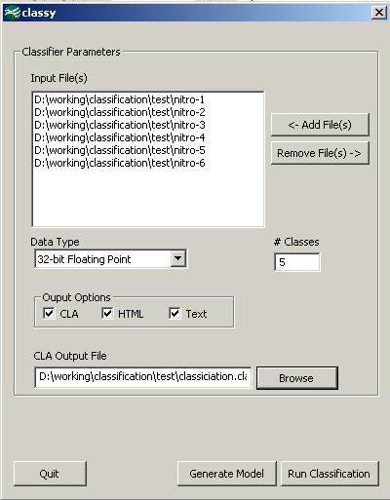
Figure 9. Ready To Run Classification

Now that all of the required fields are filled in, click “Run Classification” to perform the classification and generate all selected output files.

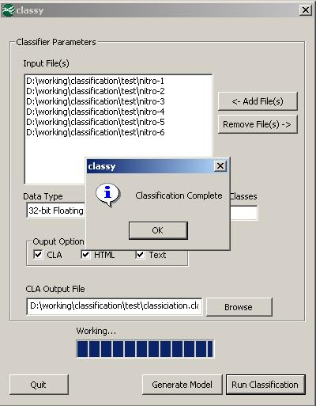
Figure 10. Finished Classification

With classification finished, you can now either view the html or text results, or click “Generate Model” to begin the process of generating an Imagine spatial modeler script. If you choose to click “Generate Model” you should see a screen like that of figure 11.

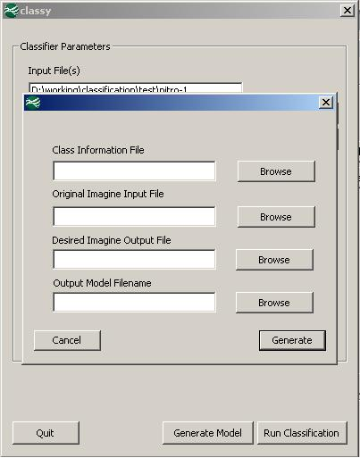
Figure 11. Model Generation Main Screen

As can be seen from figure 11, four input parameters are required to generate the Imagine spatial modeler script: the CLA file you generated in the previous step; the path to the original Imagine file used to create the individual generic binary images; the name and path of the output file you wish the script to generate, and the filename of the script that we are generating.

The first thing we need to do here is select the classification file we want to use, so we have to click browse and navigate to where we saved our CLA file.

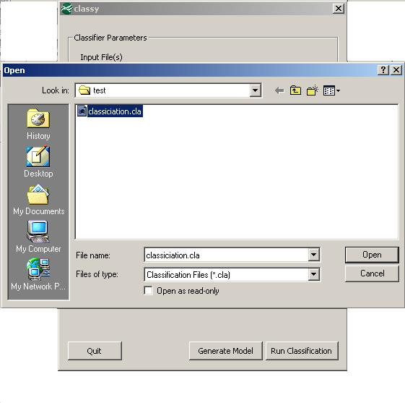
Figure 12. Choosing the CLA File

Clicking “Open” with give you a screen similar to figure 13.

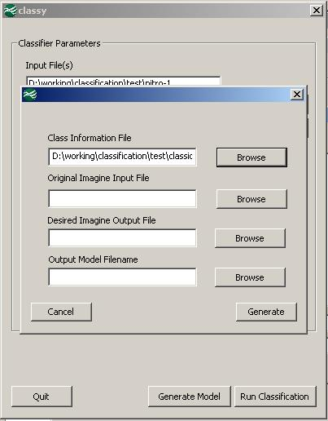
Figure 13. Model Generation Main Screen

All three of the remaining parameters will be chosen the same way, and once you have them all filled in you should get a screen similar to figure 14, simply click “Generate” to make the script.

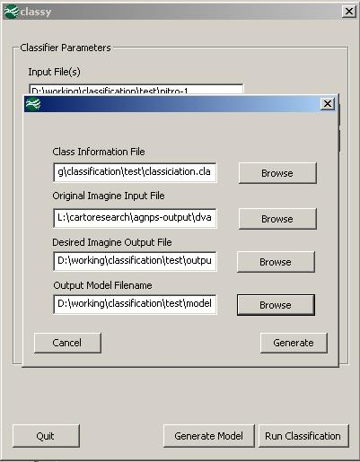
Figure 14. Ready To Generate Model Script

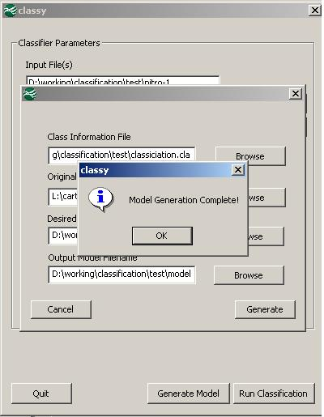
Figure 15. Model Script Generation Complete

- Running the Model Script.

Now that we have completed our classification, and have generated our spatial modeler script, it’s time to launch Imagine and run it. Once Imagine is loaded click the “Modeler” button on the toolbar and in the dialog that comes up click “Model Librarian”, you should see something similar to figure 16.

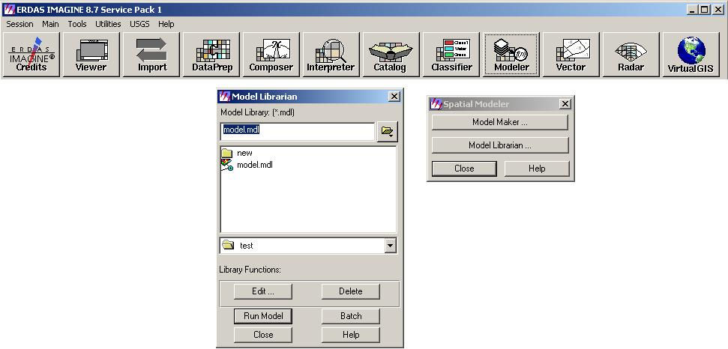
Figure 16. Imagine Model Librarian

In figure 16 we have already selected the script file that we generated earlier, and all we need to do to run it is click “Run Model”.

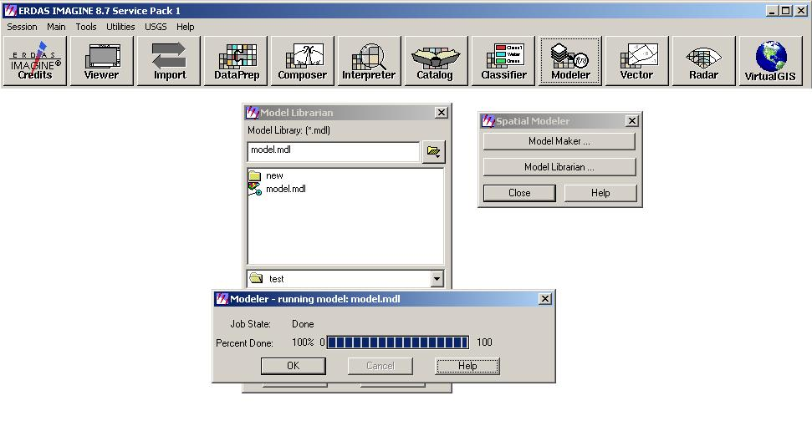
Figure 17. Running The Model

Now you have a newly classified image! Figure 18 shows layer four of an image
we ran classy on, generating five classes (be sure you load your images in pseudo-color or they will look strange).

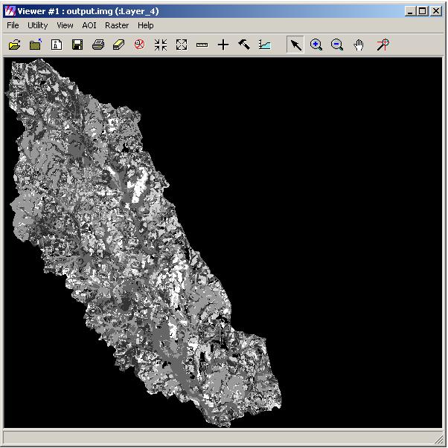
Figure 18. A Single Layer of A Classified Image

