User’s Guide for MapImage
Reprojection Software Package, Version 2.0



DRAFT COPY (Very Incomplete)

By Michael P. Finn
Jason R. Trent
Robert A. Buehler

Open-File Report 2005-XXXX


U.S. Department of the Interior
U.S. Geological Survey
Contents

Contents i
Preface to Version 2.0 1
Background to mapimg (all versions) 2
General Input Information 3
Running mapimg 4
Opening mapimg2 for the First Time 4
Actions Overview 5
Toolbar Buttons 5
Parameter Buttons 5
Other Actions 5
Re-projecting 6
Modifying Parameters 9
Choosing Resample Options 9
Using the Viewer 9
Other Tools 9
References 10

User’s Guide for MapImage Reprojection Software Package, Version 2.0

By Michael P. Finn, Jason R. Trent, and Robert A. Buehler

Preface to Version 2.0
Major changes for version 2.0 include a new user interface to be more similar to standard window applications, a viewer to show loaded files and preview re-projections, different resample methods beyond nearest neighbor, XML as the new format for the metadata files, and author, fill value, and no data value information have been added to the metadata file (see General Input Information for additional details).

mapimg v2.0 has fixed some, but not all, of the projections that were unsupported in mapimg v1.01. However, the control has now been given to the user to run these special projections at his or her risk. Certain projections are marked with a “Bad Projection” tag as shown in Figure 1.

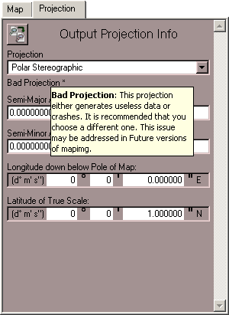
Figure 1. Bad Projection

If the user attempts to continue with this projection an error message will popup
(Figure 2). By clicking “Ignore” the user can continue and mapimg will do it’s best to perform the reprojection. More often than not this course of action will result in a map of zero size, large amounts of extraneous data, or a crash.

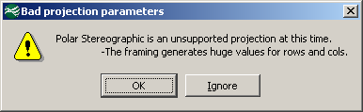
Figure 2. Ignore Message Box

Background to mapimg (all versions)
Scientists routinely accomplish small-scale geospatial modeling in the raster domain, using high-resolution datasets (such as 30-m data) for large parts of continents and low-resolution to high-resolution datasets for the entire globe. Recently, Usery and others (2003a) expanded on the previously limited empirical work with real geographic data by compiling and tabulating the accuracy of categorical areas in projected raster datasets of global extent. Geographers and applications programmers at the U.S. Geological Survey’s (USGS) Mid-Continent Mapping Center (MCMC) undertook an effort to expand and evolve an internal USGS software package, MapImage, or mapimg, for raster map projection transformation (Usery and others, 2003a).

Daniel R. Steinwand of Science Applications International Corporation, Earth Resources Observation Systems Data Center in Sioux Falls, S. Dak., originally developed mapimg for the USGS, basing it on the USGS’s General Cartographic Transformation Package (GCTP). It operated as a command line program on the Unix operating system. Through efforts at MCMC, and in coordination with Mr. Steinwand, this program has been transformed from an application based on a command line into a software package based on a graphic user interface for Windows, Linux, and Unix machines.

Usery and others (2003b) pointed out that many commercial software packages do not use exact projection equations and that even when exact projection equations are used, the software often results in error and sometimes does not complete the transformation for specific projections, at specific resampling resolutions, and for specific singularities. Direct implementation of point-to-point transformation with appropriate functions yields the variety of projections available in these software packages, but implementation with data other than points requires specific adaptation of the equations or prior preparation of the data to allow the transformation to succeed.

Additional constraints apply to global raster data. It appears that some packages use the USGS’s GCTP or similar point transformations without adaptation to the specific characteristics of raster data (Usery and others, 2003b). It is most common for programs to compute transformations of raster data in an inverse fashion. Such mapping can result in an erroneous position and replicate data or create pixels not in the original space. As Usery and others (2003a) indicated, mapimg performs a corresponding forward transformation to ensure the same location results from both methods. The primary benefit of this function is to mask cells outside the domain.

MapImage v2.0 is now on the Web. The User’s Guide, source, and binaries can be downloaded from the following site:
http://carto-research.er.usgs.gov/projection/acc_proj_data.html

General Input Information
The primary file type of mapimg is a generic binary raster file. mapimg uses “.img” as the extension for these files. They contain no header data. The file is composed entirely of values for points sorted in row major order. Currently, mapimg can manipulate and view files with any one of a number of data types used to store the values. These data types are unsigned or signed, 8, 16, or 32 bit integers, and 32 or 64 bit floats.

Along with each of these files is paired an XML file (Figure 3) with the extension “.xml”. Each of these files begins with a brief paragraph on raster information. After that is the author signature. It saves the name, company, and email as entered by user who created the file. The rest of the file is a composition of all the parameter values used by mapimg for re-projection.
Area is the coverage area of the raster as defined by its size and geographical spacing of its upper left coordinate.
Pixel description defines the data type of each pixel, the size of each pixel at the location of true scale for the projection, and any fill or “no data” value if one is defined.
Projection contains the characteristics of which projection is used, the UTM zone code if applicable, the spheroid used, and what units the following GCTP parameters are in.
GCTP parameters are the fifteen parameters used by the GCTP to define the options for each projection.
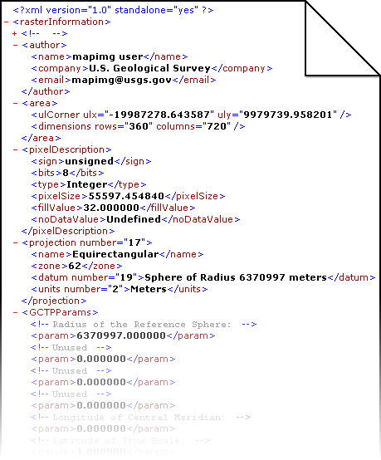
Figure 3. Sample XML File
Running mapimg
MapImage is a stand-alone program available for Windows, Linux, and Solaris. All images are of the Windows version, but Linux and Solaris versions will look similar. Double click the mapimg executable (mapimg2.exe) to begin execution of the program.

Opening mapimg2 for the First Time

On the first time running mapimg v2.0 the Author Properties dialog will appear as shown in Figure 4.
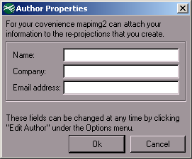
Figure 4. Author Properties Dialog

After filling in the three fields with a name, company, and email address, click “Ok” to save them and continue. Clicking “Cancel” will continue without saving. The mapimg main dialog shown in Figure 5 will appear and mapimg is ready for use.

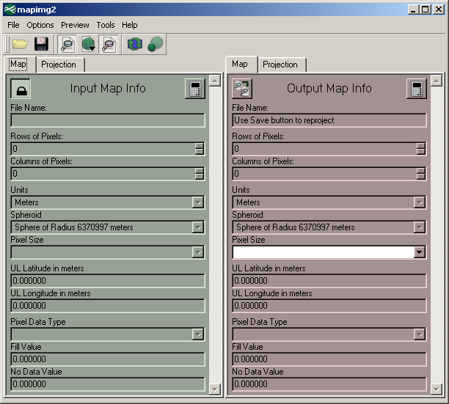
Figure 5. mapimg v2.0 Main Dialog

If at any time the author fields need to be changed then choose Options → Edit Author (Ctrl+A) to display the Author Properties dialog (Figure 4).

Actions Overview

Toolbar Buttons
 | Open: Pressing this button displays the open file dialog and allows the user to select an IMG or TIFF file and load it as input.
 | Reproject and Save: Assuming all parameters are filled and error free, pressing this button will display the save file dialog and allow the user to select a destination for their re-projection and specify resampling options.
 | Show Input Parameters: Pressing this button toggles whether the green panel for input information is shown or not.
 | Show Preview: Pressing this button toggles whether the preview panel is shown or not. Also, if the user clicks on the down arrow then they can select to show input or output previews.
 | Show Output Parameters: Pressing this button toggles whether the red panel for output information is shown or not.
 | Resample: Pressing this button will resample the viewer to the current resolution.  (See “Using the Viewer”: page 9)
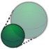 | Preview Reprojection: Pressing this button will hide the input parameters and show the preview panel with a small scale version of what the reprojection will look like.

Parameter Buttons
   | Lock and Unlock: This button is present on the input parameters and allows the user to unlock and edit them. By re-locking the input the parameters are auto-saved.
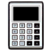 | Calculate: Pressing this button will update the rows, columns, and upper left coordinates with their values based on the GCTP calculations using all projection info and the pixel size.
 | Copy from Input: Pressing this button will copy all the values from the input list to the output list. This is a quick way to make minor adjustments to a projection.

Other Actions
 | Save Input Parameters: This action is redundant to locking the input parameters. It will save the parameters in the list if they are valid and prompt if a file is about to be overwritten.
 | Edit Author: Choosing this action will re-show the Author Properties dialog (Figure 4) so that the user can change their author parameters.
 | Decision Support System: Choosing this action will launch the current machine’s default browser to the USGS website hosting the Decision Support System (DSS).
 | About mapimg2: Choosing this action will show the About mapimg dialog which contains a brief disclaimer, contact info, and a credits section for libraries used.
 | About Qt: Choosing this action will show the About Qt dialog as per request by Trolltech, the authors of Qt.
 | Exit: This action will immediately exit mapimg.  Do not pass GO and do not collect $200.

Re-projecting

The first step in performing a re-projection is to load the desired input file to re-project. This is done by clicking the Open button (), choosing File → Open…, or pressing Ctrl+O. An Open File window (Figure 6) will show up which is used to select an IMG (generic binary) or TIFF file.

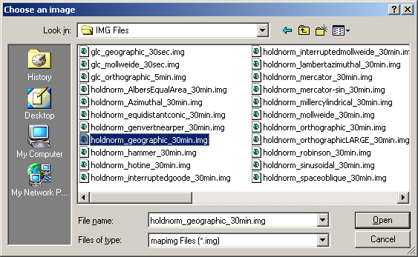
Figure 6. Open File Dialog

Click “Open” and if the selected file has an associated XML file it will automatically be loaded (Figure 7). Otherwise, the input parameters must be entered as outlined in Modifying Parameters.

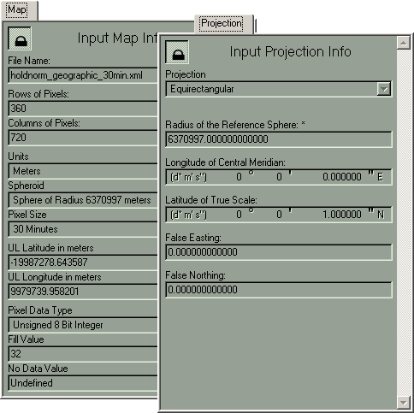
Figure 7. Loaded Input Parameters

Next the output parameters need to be set (Figure 8). Again, this procedure is outlined in Modifying Parameters. This process is streamlined by the Copy from Input button ().

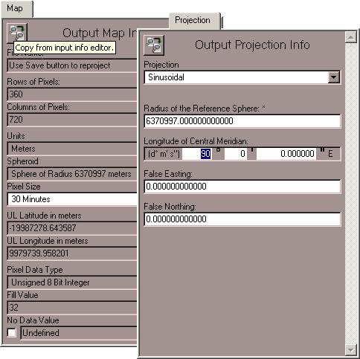
Figure 8. Edited Output Parameters

Once all the parameters have been set, click the Reproject and Save button (), choose File → Reproject and Save…, or press Ctrl+S. Assuming there are no errors or warnings for the parameter choices, the next window shown should be a Save File dialog (Figure 9). This window is used to select the destination and name for the new file created after re-projecting. If “.img” is not typed in to the File name field then it will be automatically appended. Click “Save” to continue.

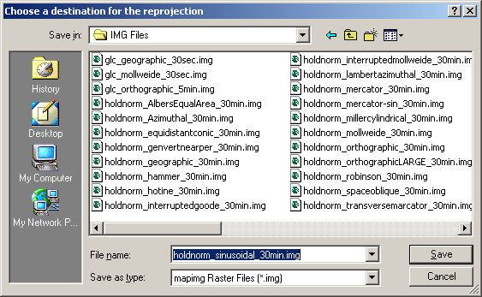
Figure 9. Save File Dialog

The next window to appear is the Resample Options dialog (Figure 10).

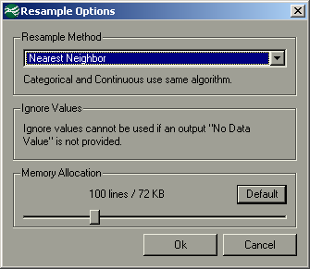
Figure 10. Resample Options Dialog

After clicking “Ok” the reprojection begins. A progress bar (See ) is shown which allows the user to abort the process. The reprojection is complete once the progress bar reaches 100%. If it reaches this point without the user pressing Abort then a “Completed” message box will be show (Figure 12).

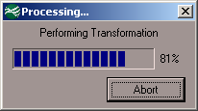  Figure 11. Re-projection Progress | 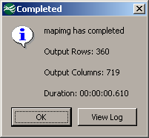  Figure 12. Completed Message Box
By clicking “View Log” the user is shown the MapImage Log dialog (Figure 13) which can be used to save the shown log of the re-projection to a text file.

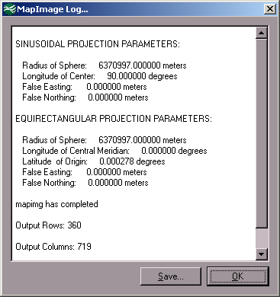
Figure 13. MapImage Log Dialog

Modifying Parameters

Choosing Resample Options

Using the Viewer

Other Tools

References

ERDAS Inc., 1999, ERDAS Field Guide. Fifth Edition: Atlanta, Ga.

Finn, M.P., and Trent, J.R., 2004, Users Guide for the MapImage Reprojection Software Package, Version 1.01: U.S. Geological Survey Open-File Report 2004-1394.

Slater, P.N., 1980, Remote sensing: Optics and optical systems. Reading, Mass.,
Addison-Wesley Publishing Company, Inc.

Usery, E.L., Finn, M.P., Cox, J.D., Beard, T., Ruhl, S. and Bearden, M., 2003a, Projecting global datasets to achieve equal areas. Cartography and Geographic Information Science, v. 30, no. 1., Washington, D.C., ACSM, p. 69-79.

Usery, E.L., Seong, J.C., Steinwand, D., and Finn, M.P., 2003b, Accurate projection of small-scale raster datasets. Proceedings 21st International Cartographic Conference, Durban, South Africa. International Cartographic Association.

