User’s Guide for MapIMG 2
Map Image Re-projection Software Package



DRAFT COPY

By Michael P. Finn
Jason R. Trent
Robert A. Buehler

Open-File Report 2005-XXXX


U.S. Department of the Interior
U.S. Geological Survey
Contents

Contents i
Version History 1
Preface to Version 2.0 2
Background to MapIMG 3
General Input Information 4
Generic Binary Raster Image 4
XML Metadata 5
Parameter Descriptions 6
Running MapIMG 7
Opening MapIMG 2 for the First Time 7
Actions Overview 8
Toolbar Buttons 8
Parameter Buttons 8
Other Actions 8
Re-projecting 9
Modifying Input Parameters 12
Modifying Output Parameters 13
Choosing Resample Options 14
Using the Viewer 14
Other Tools 15
Troubleshooting 15
References 17

User’s Guide for MapIMG 2: Map Image Re-projection Software Package

By Michael P. Finn, Jason R. Trent, and Robert A. Buehler

Version History

Version 0.0 Dan Steinwand 1995
- A command line version for Unix taking four arguments: the input metadata, the output metadata, the input data file, and the output destination path.

Version 1.0 Stephen Posch and Mike Finn 2003
- Added GUI built using the Qt library for cross platform development.

Version 1.01 Jason Trent and Mike Finn 2004
- Suggested bounds for parameters of each projection
- Support for larger input files
- Storage of last used input and output folders
- Support for TIFF/GeoTIFF input images.

Version 2.0 Robert Buehler, Jason Trent, and Mike Finn 2005
- Added Resampling Methods (Mean, Mode, Min, Max, and Sum)
- Updated GUI design
- Added viewer/pre-viewer
- Changed to XML style metadata
- Switched to a new naming convention

Preface to Version 2.0
Major changes for version 2.0 include a new user interface to be more similar to standard window applications, a viewer to show loaded files and preview re-projections, different resample methods beyond nearest neighbor, and XML files (a popular ASCII file structure for containing structured information) as the new format for the metadata files.
Author, fill value, and no data value information have been added to the metadata file (see General Input Information for additional details). A naming convention has also been selected such that MapIMG is the new spelling. No longer will it be referred to as mapimg.

MapIMG 2 supports more projections than were unsupported in MapIMG v1.01, but a few still remain unsupported. However, the control has now been given to the user to run these special projections at his or her risk. Certain projections are marked with a “Bad Projection” tag as shown in Figure 1.

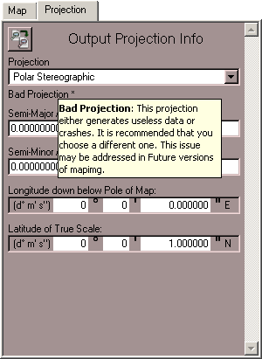
Figure 1. Bad Projection

If the user attempts to continue with this projection an error message will popup
(Figure 2). By clicking “Ignore” the user can continue and MapIMG will do it’s best to perform the re-projection. More often than not this course of action will result in a map of zero size, large amounts of extraneous data, or a crash.

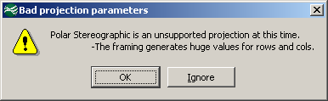
Figure 2. Ignore Message Box

This feature should be quite useful if the user is a developer/programmer that is attempting to tweak a “Bad Projection.” An example would be working with the Polar Stereographic projection. MapIMG transforms points near the opposite pole to be at or near infinite. If the developer re-programs MapIMG to skip points within 10 degrees of the opposite side, then running the projection would only require choosing “Ignore” as opposed to finding and altering the code that labels Polar Stereographic as a “Bad Projection.”

While this user’s guide does make reference to previous versions, it is also complete for the current version of MapIMG. All features of the MapIMG 2 software package are explained in this document.

Background to MapIMG
Scientists routinely accomplish small-scale geospatial modeling in the raster domain, using high-resolution datasets for large parts of continents and low-resolution to high-resolution datasets for the entire globe. Direct implementation of point-to-point transformation with appropriate functions yields the variety of projections available in commercial software packages, but implementation with data other than points requires specific adaptation of the transformation equations or prior preparation of the data to allow the transformation to succeed. It appears that some of these packages use the U.S. Geological Survey’s (USGS) General Cartographic Transformation Package (GCTP) or similar point transformations without adaptation to the specific characteristics of raster data (Usery and others, 2003a).

Usery and others (2003b) compiled and tabulated the accuracy of categorical areas in projected raster datasets of global extent. Based on the shortcomings identified in these studies, geographers and applications programmers at the USGS expanded and evolved a USGS software package, MapIMG, for raster map projection transformation (Finn and Trent, 2004). Daniel R. Steinwand of Science Applications International Corporation, National Center for Earth Resources Observation and Science, originally developed MapIMG for the USGS, basing it on GCTP. Through previous and continuing efforts at the USGS’ National Geospatial Technical Operations Center, this program has been transformed from an application based on command line input into a software package based on a graphical user interface for Windows, Linux, and other UNIX machines.

MapIMG 2 is now on the Web with the User’s Guide, source, and binaries available for download at:
http://carto-research.er.usgs.gov/projection/acc_proj_data.html

General Input Information

Generic Binary Raster Image
The primary file type of MapIMG is a Generic Binary raster file. MapIMG uses .img as the extension for these files. They contain no header data. The file is composed entirely of values for cells sorted in row major order. Currently, MapIMG can manipulate and view files with any one of a number of data types used to store the values. These data types are unsigned or signed, 8, 16, or 32 bit integers, and 32 or 64 bit floats. Single-image TIFF (tagged image file format) or GeoTIFF files may also be used as input; however, it is highly recommended that all images be exported to Generic Binary if at all possible.

If TIFF/GeoTIFF images are used, they are exported to Generic Binary format as soon as they are loaded. The TIFF format stores images as 32-bit color values, which are then extracted to Generic Binary. It is recommended that TIFF input only be used for thematic data; continuous data will lose all actual values and only relative values will remain.

Band interleaved by line (BIL) is a storage format for image data. For a single band of data, BIL is the same as band sequential (BSQ) and band interleaved by pixel (BIP) (Slater, 1980). Generic Binary, as used in MapIMG (consistent with ERDAS Imagine), is any of these single-band formats that store data in a left-to-right, top-to-bottom row order (ERDAS, 1999). It does allow for varying data types—for example, from 8 to 64 bit.

CAUTION: The Generic Binary file must use the same byte ordering (endian) as the computer running MapIMG. The file is a raw image with absolutely no metadata, not even the dimensions of the image, which must be known by the user. The output will also be in the same raw format.

A common naming convention is recommended to keep track of files: in particular, the format (type)_(proj)_(pix_size).img, where type is the type of data (theme) being used, proj is the projection used, and pix_size is the output file’s pixel size. For example, glc_sine_30sec.img would be used to represent a global land cover image in the sinusoidal projection with a pixel size of 30 arc-seconds. Notice that the file name always ends in .img, signifying a generic binary image. Although these conventions are not mandatory for proper program execution, they provide a useful and reliable way to keep track of files.

XML Metadata
Anytime MapIMG is executed on a file, an associated XML file (Figure 3) will be created from the parameters selected by the user for both the input and the output image. For an input/output file called file_name.img, the associated XML file will be named file_name.xml. It is not absolutely necessary to save these files, but it is highly recommended. If the input/output files are to be used again in the future, the XML files will make sure the correct projection parameters are used.

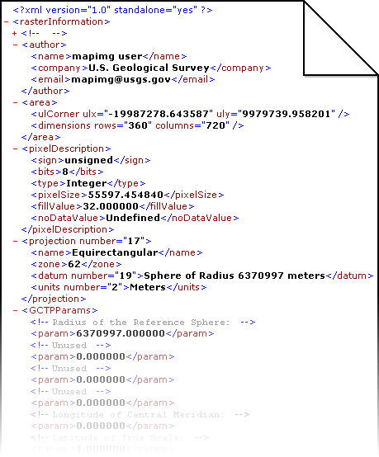
Figure 3. Sample XML File

Parameter Descriptions
Rows and Columns define the pixel dimensions of the generic binary raster image.

Upper Left (UL) Coordinate is the measurement, in meters, that anchors the upper left corner of the image. The meters north measurement of the top-most pixel in the image is the UL Longitude in meters. Likewise, the meters east measurement of the left-most pixel in the image is the UL Latitude in meters.

Units define the units of measurement for each of the parameters. Currently only meters are supported. If changing units is supported in the future then it would be possible to enter parameters such as the upper left coordinate in units other than meters.

Spheroid defines the shape of the earth for use in the projections. This is another parameter that cannot be adjusted at this time. Only a spheroid of radius 6370997 meters is currently supported.

Pixel Size describes the width and height in meters of a pixel at the point of true scale in the image.

Pixel Data Type describes the way each pixel’s value is stored in the image file.
(e.g. 8 Bit Unsigned Integer and 32 Bit Float)

Fill Value is the numeric value that MapIMG places in areas that are not part of the map.

No Data Value is used to determine places in a map where no data is present. This value never occurs outside the map where fill value would be placed. It is used by MapIMG for resampling methods where the sample being pulled from the input is full of ignore values.

Ignore Values are entered on the resample form in a list. All values listed will not be used in calculations during the resample. The no data value and fill value are also ignored.

Running MapIMG
MapIMG is a stand-alone program available for Windows, Linux, and Solaris. All images in this guide are of the Windows version, but other versions will look similar. Double click the MapIMG executable (mapimg2.exe) to begin execution of the program.

Opening MapIMG 2 for the First Time
On the first time running MapIMG 2, the Author Properties dialog will appear as shown in Figure 4.
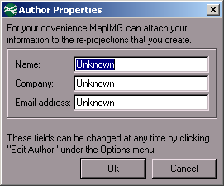
Figure 4. Author Properties Dialog

After entering the three fields with a name, company, and email address click “Ok” to save them and continue. Clicking “Cancel” will continue without saving. The MapIMG main dialog shown in Figure 5 will appear and MapIMG is ready for use.

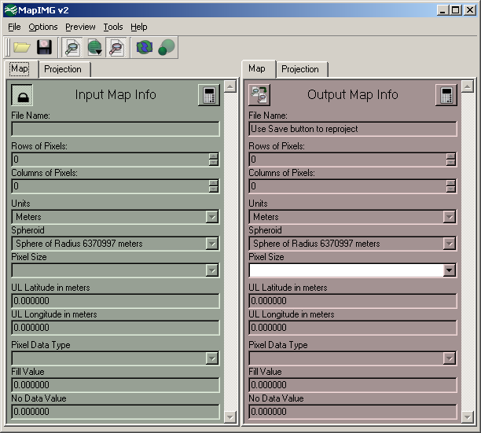
Figure 5. MapIMG 2 Main Dialog
If at any time the author fields need to be changed then choose Options → Edit Author (Ctrl+A) to display the Author Properties dialog (Figure 4).

Actions Overview

Toolbar Buttons
 | Open: Pressing this button displays the open file dialog and allows the user to select an IMG or TIFF file and load it as input.
 | Re-project and Save: Assuming all parameters are filled and error free, pressing this button will display the save file dialog and allow the user to select a destination for their re-projection and specify resampling options.
 | Show Input Parameters: Pressing this button toggles whether the green panel for input information is shown or not.
 | Show Preview: Pressing this button toggles whether the preview panel is shown or not. Also, if the user clicks on the down arrow then they can select to show input or output previews.
 | Show Output Parameters: Pressing this button toggles whether the red panel for output information is shown or not.
 | Resample: Pressing this button will resample the viewer to the current resolution.  (See “Using the Viewer”: page 15)
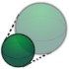 | Preview Re-projection: Pressing this button will hide the input parameters and show the preview panel with a small scale version of what the re-projection will look like.

Parameter Buttons
   | Lock and Unlock: This button is present on the input parameters and allows the user to unlock and edit them. By re-locking the input the parameters are auto-saved.
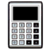 | Calculate: Pressing this button will update the rows, columns, and upper left coordinates with their values based on the GCTP calculations using all projection info and the pixel size.
 | Copy from Input: Pressing this button will copy all the values from the input list to the output list. This is a quick way to make minor adjustments to a projection.

Other Actions
 | Save Input Parameters: This action is redundant to locking the input parameters. It will save the parameters in the list if they are valid and prompt if a file is about to be overwritten.
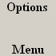 | Edit Author: Choosing this action will re-show the Author Properties dialog (Figure 4) so that the user can change their author parameters.
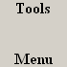 | Decision Support System: This action launches the current machine’s default browser to the USGS website hosting the Decision Support System for Map Projections of Small Scale Data.
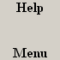 | About MapIMG: Choosing this action will show the About MapIMG dialog which contains a brief disclaimer, contact info, and a credits section for libraries used.
 | About Qt: Choosing this action will show the About Qt dialog as per request by Trolltech, the authors of Qt.
 | Exit: This action will immediately exit MapIMG.  Do not pass GO and do not collect $200.

Re-projecting

The first step in performing a re-projection is to load the desired input file to re-project. This is done by clicking the Open button (), choosing File → Open…, or pressing Ctrl+O. An Open File window (Figure 6) will show up which is used to select an IMG (generic binary) or TIFF file.

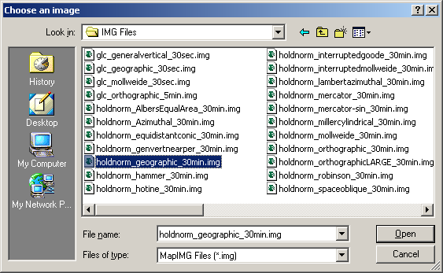
Figure 6. Open File Dialog

Click “Open” and if the selected file has an associated XML file it will automatically be loaded (Figure 7). Otherwise, the input parameters must be entered as outlined in Modifying Input Parameters.

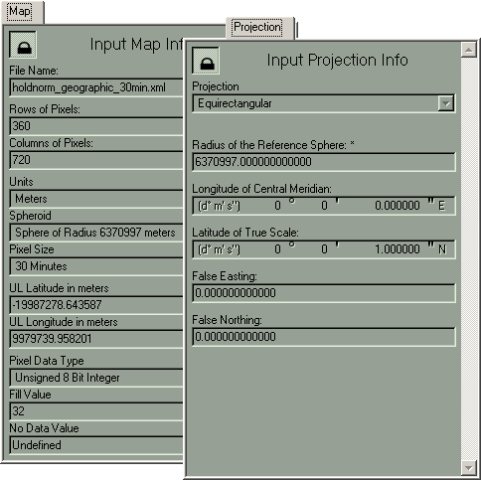
Figure 7. Loaded Input Parameters

Next the output parameters need to be set (Figure 8). Again, this procedure is outlined in Modifying Output Parameters. This process is streamlined by the Copy from Input button ().

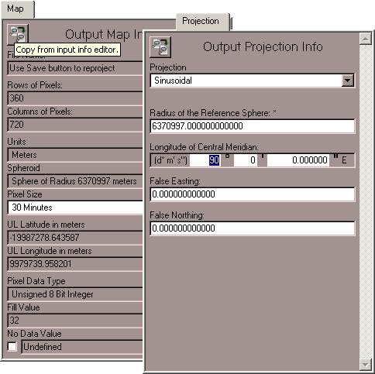
Figure 8. Edited Output Parameters

Once all the parameters have been set, click the Re-project and Save button (), choose File → Re-project and Save…, or press Ctrl+S. Assuming there are no errors or warnings for the parameter choices, the next window shown should be a Save File dialog (Figure 9). This window is used to select the destination and name for the new file created after re-projecting. If “.img” is not typed in to the File name field then it will be automatically appended. Click “Save” to continue.

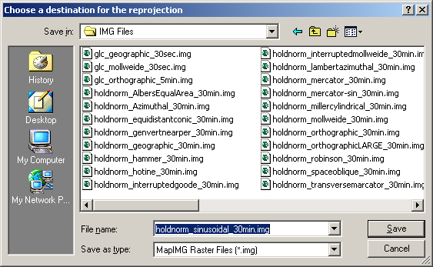
Figure 9. Save File Dialog

The next window to appear is the Resample Options dialog (Figure 10).

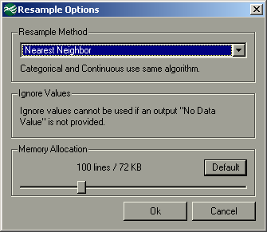
Figure 10. Resample Options Dialog

After clicking “Ok” the re-projection begins. A progress bar (See ) is shown which allows the user to abort the process. The re-projection is complete once the progress bar reaches 100%. If it reaches this point without the user pressing Abort then a “Completed” message box will be show (Figure 12).

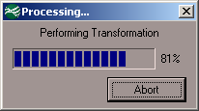  Figure 11. Re-projection Progress | 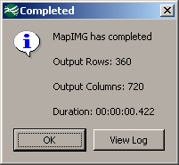  Figure 12. Completed Message Box

By clicking “View Log” the user is shown the MapIMG Log dialog (Figure 13) which can be used to save the shown log of the re-projection to a text file.

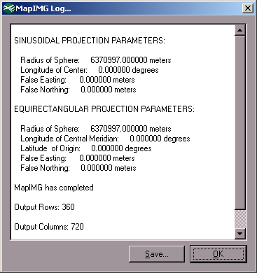
Figure 13. MapIMG Log Dialog

Modifying Input Parameters
The first time a file is loaded, or if the paired XML file becomes corrupt beyond recovery the message shown in Figure 14 will appear. If a valid XML file was found, the values will be loaded. Press the lock/unlock button (,) to change to the unlocked state and then proceed to change parameters as normal.

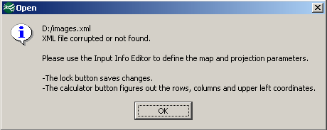
Figure 14. Missing or Corrupt XML

- Setup the Projection parameters
  - Select the Projection tab
  - Select the Projection for the input file from the Projection Drop Down Menu.
  - The area below the Projection Drop Down Menu will change to reflect the parameter relevant to the selected projection. Make all changes required to correspond to the input image. This may include Radius of the Reference Sphere, Longitude of Central Meridian, Latitude of True Scale, False Easting, False Northing, of other relevant parameters.
- Setup the Map parameters
  - Select the Map tab
  - Select the Pixel Size from the Pixel Size Drop Down Menu.
  - Manually enter the number of Rows of Pixels, Columns of Pixels, Upper-left Latitude in meters, and Upper-left Longitude in meters, or press the Calculate button () to calculate these parameters based on the chosen pixel size and projection. Note: Currently MapIMG only supports raster datasets of global extent, therefore calculated values will only be valid if the input is truly to a global extent.
  - Select the Pixel Data Type of the input file from the Pixel Data Type Drop Down Menu. An incorrect data type will not only produce incorrect results, but may also cause instabilities in the MapIMG itself.
  - If the input image has a frame around it check the Fill Value Check Box indicating that a Fill Value is present. Then, enter the value in the Fill Value Edit Box.
  - If the input image has a value corresponding to areas where data are unavailable, check the No Data Value Check Box. Then, enter this value in the No Data Value Edit Box. An example of this may be a population dataset where areas with an unknown population have a set value, -1 for instance.
  - Press the lock/unlock button () or choose File → Save Input Parameters to save the XML file corresponding to the input image. If the lock/unlock button is used the icon should change () and the parameter fields will become read-only. This indicates a successful save of the XML file.

Modifying Output Parameters
Once the desired input file has been loaded and its parameters configured it is time to set up the output projection information. It is suggested that the Copy from Input button () is used. This will copy all of the parameters from the input to the output. Once this is done, only the parameters to be change will require user interaction. Pixel Data Type is set by the input Pixel Data Type and cannot be altered.

- Setup the Projection parameters
- Select the Projection tab
- Select the Projection that the input file represents from the Projection Drop Down Menu. Remember to check for the Bad Projection tag (Figure 1) before continuing. If the tag is present MapIMG may become unstable or produce invalid output if the output projection is used.
- The area below the Projection Drop Down Menu will change to reflect the parameter relevant to your selected projection. Make all changes required to correspond to your input image. This may include Radius of the Reference Sphere, Longitude of Central Meridian, Latitude of True Scale, False Easting, False Northing, of other relevant parameters.
- Make note of any field with an asterisk (*) next to the parameter label. These parameters have additional constraints that should be taken into account before continuing. Placing the mouse cursor over the label for a few seconds will produce a tool-tip with additional information about the particular constraints of that parameter.
- Setup the Map parameters
- Select the Map tab
- Select the Pixel Size from the Pixel Size Drop Down Menu.
- Press the Calculate button () to calculate Rows of Pixels, Columns of Pixels, Upper-left Latitude in meters, and Upper-left Longitude in meters based on the chosen pixel size and projection. Note: Calculated values are for a global extent only.
- If the input image has Fill Value the output Fill Value will be the same, and may not be changed. This prevents having multiple different framing values in the same file. If the input does not have a Fill Value it can be manually entered or the Recommend Fill Value button (?) can be pressed to generate a new Fill Value. This is done by taking a small sample of the image and adding two to the maximum value encountered.
- If the input image has a No Data Value the output No Data Value will be the same, and may not be changed. This prevents having multiple values indicating where no data is available. If the input does not have a No Data Value you may check the output No Data Value Check Box and manually enter a value in the output No Data Value Edit Box. Note: A No Data Value is required if Ignore Values are going to be used during the resample process (see Choosing Resample Options).

Choosing Resample Options
After the output file location has been chosen using save and re-project, the next step is to choose the resampling options. At any point the cancel button may be clicked to end the re-projection process, and the ok button may be clicked to continue on to the re-projection.

  - Choose the resampling method
The currently available options include Nearest Neighbor, Sum, Mean, Median, Mode, Min, and Max. As the method is selected, text under the choice will change to provide a note on this resampling methods performance in categorical vs. continuous data.
  - Enter all ignore values into the list
The ignore values section (Figure 15) has, in the upper left, a text box for entering values. Once the value is fully typed it can be added to the list by clicking New Value. Press enter while typing in the text box will have the same effect. Values can be removed from the list by selecting them with the mouse in clicking Delete Value. All values entered are forced to conform to the pixel data type as defined in the input parameters.
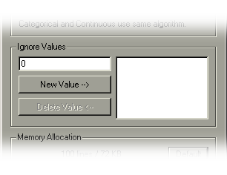
Figure 15. Ignore Values Section

  - Adjust memory allocation
Allowing for a larger line cache by increasing the memory allocation can both speed up the re-projection and improve accuracy in the sum resampling. This memory is used to store lines of the input image. If a pixel value is needed from the input that is on a line that was accessed before, it would be much faster to access it if it was still located in memory and a large line cache will improve the chances of that happening. The sum resampling method marks pixels in the allocated cache that have been used in the output. If a line is pushed out of the cache and then called upon later, the values may potentially be counted twice.
The Default value is 100 lines and the minimum is the ratio of output lines to input lines plus two percent of the output lines.

Using the Viewer
When the viewer is shown with the Show Preview button () it will display a USGS logo by default. Once an input file has been loaded the viewer will be forced to input mode and loading of the preview will begin. This process is completed in two progress bars. The first one is creating a color table by sampling the file, and the second one is loading values from the file and drawing them into a picture. Once they are both complete the preview image will be displayed.

The preview panel will stretch to fill the MapIMG window. As the window is resized its boundaries will change and the preview picture within will be stretched to maintain the original aspect ratio and moved to stay centered in the panel. The image previewed is a down-sampled image using nearest neighbor. Therefore, when the image is stretched the individual pixels become larger without resampling the file. Once a new size for the view is determined, the Resample button () can be clicked and MapIMG will resample the file at the current resolution to produce a higher quality image.

Note that the Show Preview button has a down arrow on the lower right corner. Clicking and holding on this arrow will show a popup menu allowing the user to switch between Preview Input and Preview Output. Choosing preview output is similar to pressing the Preview Re-projection button (). The preview panel will be shown and four progress bars will complete in the process. The first one represents to down-sampling of the original image to a much smaller size. The second one is a fast re-projection to a low resolution version of the output projection parameters. And the final two progress bars are the color table generation and value loading as outlined previously.

Other Tools
Currently, the only extra tool with MapIMG is the Decision Support System for Map Projections of Small Scale Data (DSS). A link can be found under Tools → Web Based → Decision Support System. It will attempt to load the default browser of your operating system to the following address:
http://mcmcweb.er.usgs.gov/research/DSSMain/DSSApplet.html

Troubleshooting
Error, missing or malformed <___> tag under <___>.
XML File corrupt or not found.
These errors occur when there is an issue with the .xml metadata file. The solution is to use the input parameter editor and save changes by using the lock button ().

Tiff Image – Conversion failed for unknown reason.
The Tiff library couldn’t open the chosen Tiff file. Make sure the file pointed to ends in .tif and is truly a Tiff image file.

MapIMG cannot read this file.
Since MapIMG works with Generic Binary files its only way of discrimination file types is by checking the file’s extension. Make sure the file ends in .img. A common error is to use an ERDAS Imagine or Idrisi file, both of which also uses the same extension of .img.

Save Input Parameters – File already exists. Do you want to replace it?
This is a safeguard to protect the metadata file from being replaced if an accidental change is made while unlocked. Click yes to replace the file with the new parameters or click no to undo all changes and revert the parameters back to how they were last saved.

MapIMG – Unable to launch web browser to …
This error occurs when trying to access the DSS using the Tools menu in MapIMG. The solution is to copy and paste the url to your preferred browser.
http://mcmcweb.er.usgs.gov/research/DSSMain/DSSApplet.html

The current spheroid code and/or unit code are unsupported.
The spheroid and unit code somehow became modified. This should not be possible with the current user interface.

Pixel Size must be greater than 0.
Make sure the Pixel Size parameter for both the input and output are blank or zero.

Rows and Columns must be greater than 0.
These values can usually be generated by the calculator button (). If that doesn’t work then you are either in an unsupported “bad projection,” or one of the parameters is set in such a way that the final resolution would be very close to zero (ie. True Scale of Transverse Mercator shouldn’t be zero).

Please select a valid data type for each pixel.
Select a data type using the drop down box in the input parameters.

If you receive any other errors or unexpected results please contact the authors of the MapIMG software package by email at mapimg@usgs.gov.

References

ERDAS Inc., 1999, ERDAS Field Guide. Fifth Edition: Atlanta, Ga.

Finn, M.P., and Trent, J.R., 2004, Users Guide for the MapImage Reprojection Software Package, Version 1.01: U.S. Geological Survey Open-File Report 2004-1394.

Slater, P.N., 1980, Remote Sensing: Optics and Optical Systems. Reading, Mass.,
Addison-Wesley Publishing Company, Inc.

Usery, E.L., Finn, M.P., Cox, J.D., Beard, T., Ruhl, S. and Bearden, M., 2003a, Projecting Global Datasets to Achieve Equal Areas. Cartography and Geographic Information Science, v. 30, no. 1., Washington, D.C., ACSM, p. 69-79.

Usery, E.L., Seong, J.C., Steinwand, D., and Finn, M.P., 2003b, Accurate Projection of Small-Scale Raster Datasets. Proceedings 21st International Cartographic Conference, Durban, South Africa. International Cartographic Association.

