1. Do the Wireshark exercise found here, which will introduce you to the Wireshark tool:
   1. List 3 different protocol s that appear in the protocol column in the unfiltered packet-listing window in step 7 above.
      1. HTTP
      2. UDP
      3. ARP
   2. How long did it take from when the HTTP GET message was sent until the HTTP OK reply was received?
      1. .29384sec
   3. What is the internet address of the gaia.cs.umass.edu? What is the internet address of your computer?
      1. Gaia.cs.umass.edu
         1. 129.119.245.12
      2. Mine:
         1. 128.61.88.199
   4. Print the two HTTP messages (GET and OK) referred to in question 2 above.

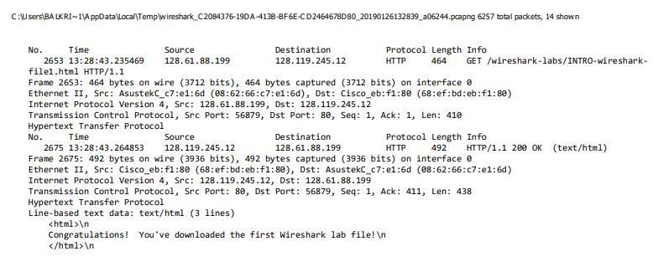

* 1. Is your browser running HTTP version 1.0 or 1.1? What version of HTTP is the server running?
     1. My Browser: HTTP 1.1
     2. Server: HTTP 1.1
     3. Marked in Red
  2. What languages (if any) does your browser indicate that it can accept to the server?
     1. Accept-Language: en-US\r\n
     2. Marked in Yellow
  3. What is the IP address of your computer? Or the gaia.cs.umass.edu server?
     1. Me: 128.61.88.199
     2. Sever: 128.119.245.12
     3. Marked in Green
  4. What is the status code returned from the server to your browser?
     1. 202 OK
     2. Marked in Blue
  5. When was the HTML file that you are retrieving last modified at the server?
     1. Sat, 26 Jan 2019 06:59:01 GMT\r\n
     2. Marked in Orange
  6. How many bytes of content are being returned to your browser?
     1. File Data: 128 bytes
     2. Marked in Purple
  7. By Inspecting the raw data in the packet content window, do you see any headers within the data that are not displayed in the packet-listing window? If so, name one.
     1. All the data can be found in the raw data.

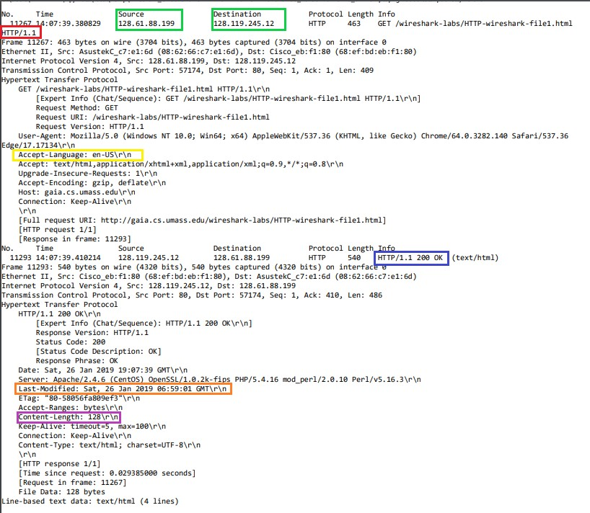

* 1. Do you see an “IF-MODIFIED-SINCE” line in the HTTP GET?
     1. No
  2. Did the server explicitly return the contents of the file? How can you tell?
     1. Yes last line of the server’s first response has the line “Line-based text data”
     2. Marked in Blue

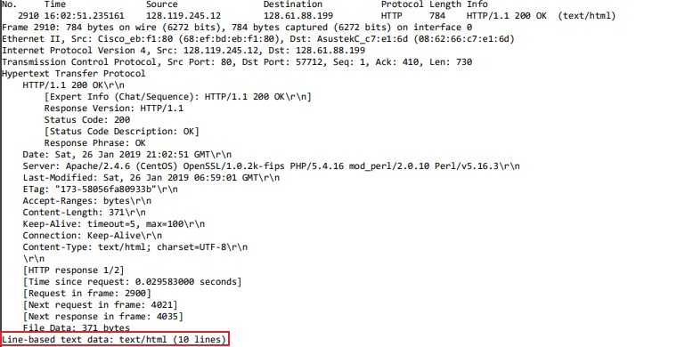

* 1. Do you see an “IF-MODIFIED-SINCE:” line in the HTTP GET? If so what information follows the “IF-MODIFIED-SINCE:” head?
     1. Yes that follows the header is: Sat, 26 Jan 2019 06:59:01 GMT\r\n
     2. Marked in Blue

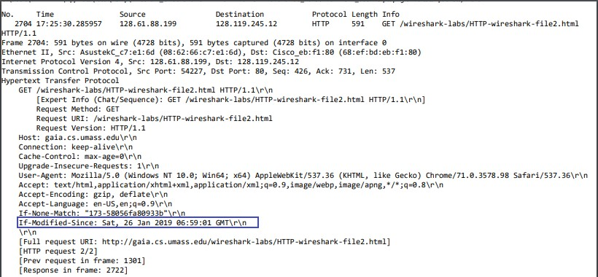

* 1. What is the HTTP status code and phrase returned from the server in response to this second HTTP GET? Did the server explicitly return the contents of the file? Explain.
     1. The status code is: 304 Not Modified
     2. The server did not explicitly return the contents of the files as they were already loaded on to the browser’s cache.
     3. Marked in Green

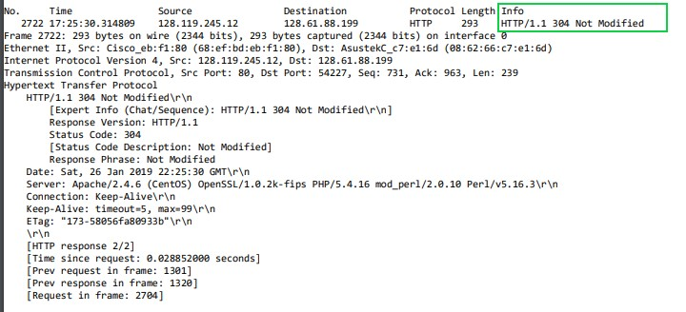

* 1. How many HTTP GET request messages did your browser send? Which packet number in the trace contains the Get message for the Bill of Rights?
     1. One GET request was sent
     2. Packet no: 1782
     3. Marked in Red



* 1. Which packet number in the trace contains the status code and phrase associated with the response to the HTTP GET request?
     1. Packet No. 1813 contains 200 OK
     2. Marked in Green

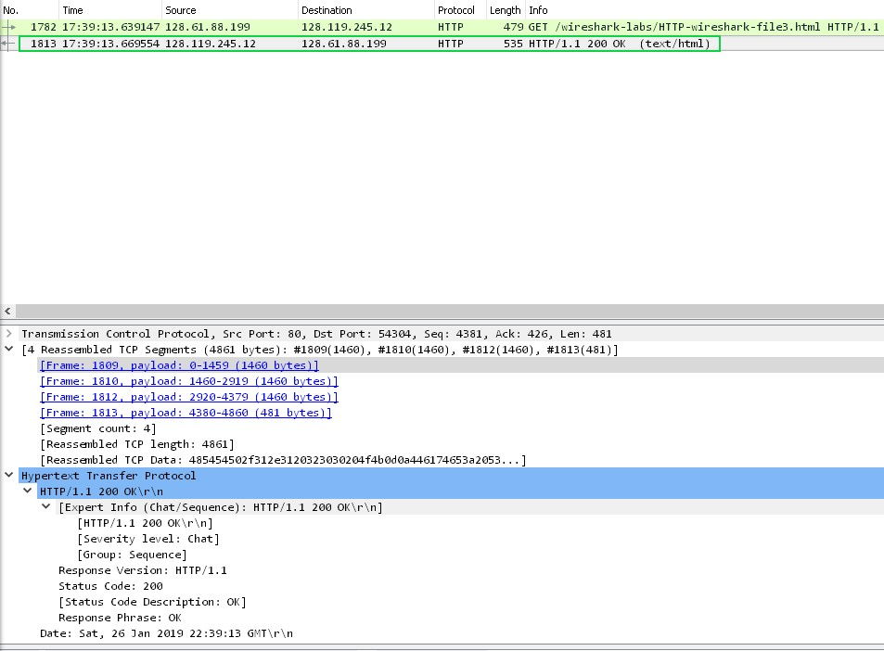

* 1. What is the status code and phrase in the response?
     1. The status code: 200
     2. Phrase: OK
     3. The previous screen shot has the status code and phrase marked in green.
  2. How many data-containing TCP segments were needed to carry the single HTTP response and the text of the Bill of Rights?
     1. 4 segments were needed
     2. Marked in Orange

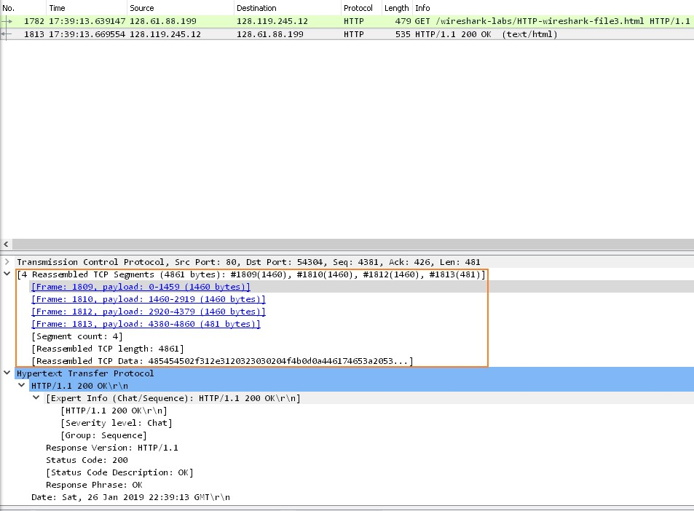

* 1. How many HTTP GET request messages did your browser send? To which Internet addresses were these GET requests sent?
     1. 3 HTTP GET request messages
     2. All 3 requests were sent to: 128.119.245.12
     3. Marked in Red

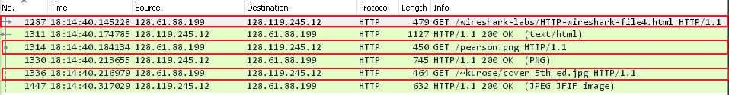

* 1. Can you tell whether your browser download the two images serially, or whether they were downloaded from the two websites in parallel? Explain.
     1. The images were downloaded serially, because the images were transmitted through two separate TCP connections.
     2. Marked in Yellow

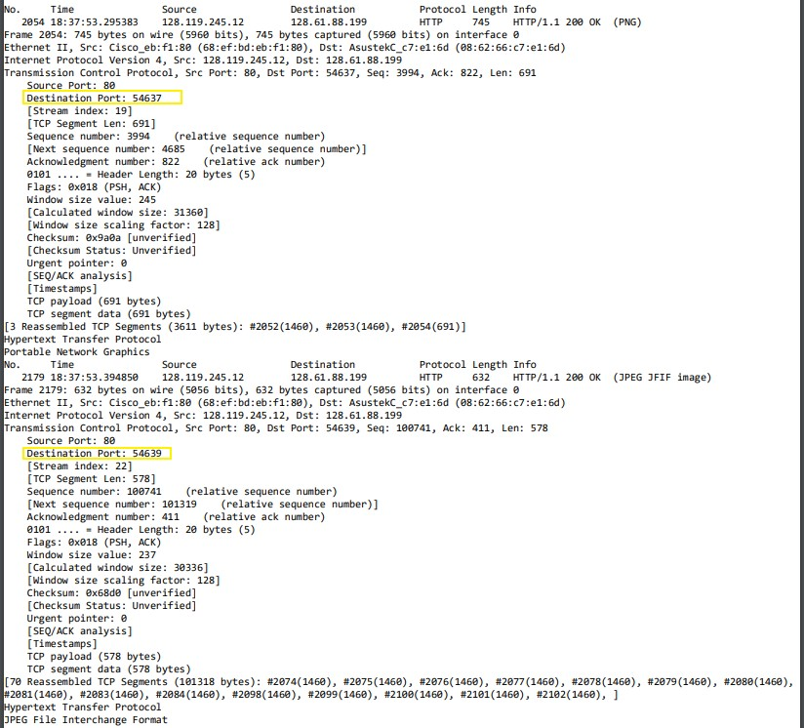

* 1. What is the server’s response (status code and phrase) in response to the initial HTTP GET message from your browser?
     1. The server’s response to the initial GET message is: 401 Unauthorized
     2. Marked in Red

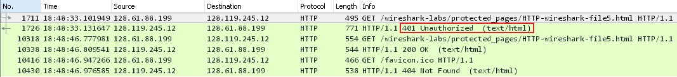

* 1. When your browser’s sends the HTTP GET message for the second time, what new field is included in the HTTP GET message?
     1. An authorization header is has been included with the Credentials that were inputted
     2. Marked in Blue

