1. Determine the IP address blocks for three university. Can the whois services be used to determine with certainty the geographical location of a specific IP address? Determine the locations of the web servers at each of these universities.
   1. The IP address blocks of UC Berkeley:
      1. NetRange: 63.199.8.24 - 63.199.8.31
      2. CIDR: 63.199.8.24/29
   2. The IP address blocks of Stanford University:
      1. NetRange: 64.164.153.16 – 64.164.153.23
      2. CIDR: 64.164.153.16/29
   3. The IP address blocks of MIT
      1. NetRange: 18.0.0.0 – 18.127.255.255
      2. CIDR: 18.0.0.0/9
   4. Can the whois services be used to determine the certainty of the geographical location of a specific IP address?
      1. No, it is not able to determine with certainty of the geographical location of a specific IP address.
   5. Locations of the Web Servers of UC Berkeley: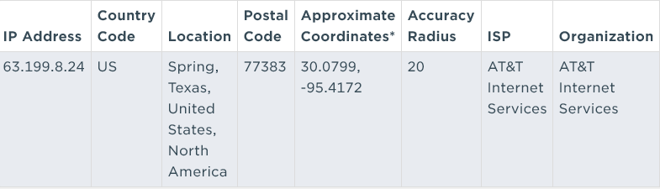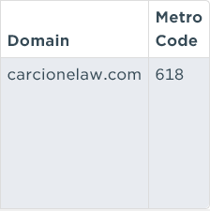
   6. Locations of the Web Servers of Stanford University:

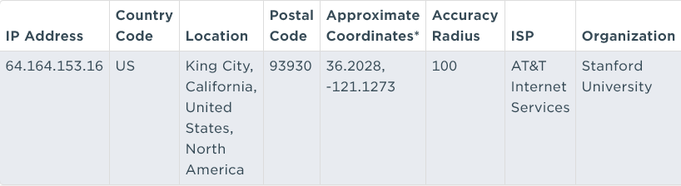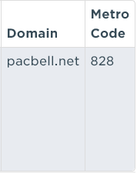

* 1. Locations of the Web Servers of MIT:

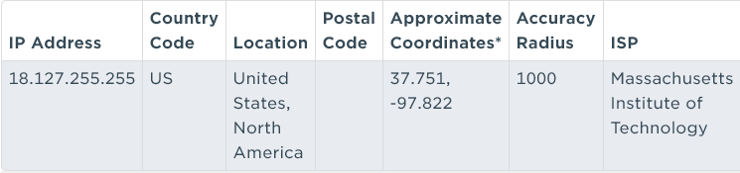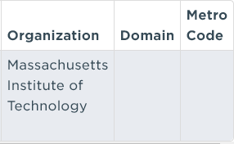

1. Consider the distance-vector algorithm and show the distance (routing) table entries at node z.



1. Give x’s distances vector for destinations w, y, and u. Give a link-cost change for either c (x, w) or c (x, y) such that x will inform its neighbors of a new minimum-cost path to u because of executing the distance-vector algorithm. Give a link-cost change for either c (x, w) or c (x, y) such that x will not inform its neighbors of a new minimum-cost path to u because of executing the distance-vector algorithm.
   1. Give x’s distances vector for destinations w, y, u.
 $D_{x\left(w\right)}=2$

 $D_{x\left(y\right)} = 5$

 $D_{x\left(u\right)}=\min\left(c\left(x,w\right) +d_{w}(u), c\left(x,y\right) + d_{y}\left(u\right)\right) =\left(2+5=7, 2+6=8\right)=7$

2. Give a link-cost change for either c (x, w) or c (x, y) such that x will inform its neighbors of a new min-cost path to u because of executing the distance-vector algorithm.
      1. First, we will consider $c(x, y)$ is less than the $c\left(x,w\right)+d_{w}(u)= 7,$ in other words $c\left(x,y\right)<1$. If $c\left(x,y\right)=α<1$ then the least cost path will be informed to y and has a cost of $α+6$ in this case the cost will be informed to its neighbors.
      2. Now let’s consider $c(x,w)$ changes. If $\left(c\left(x,w\right)=θ\right)≤6$ then the cost through u will pass through w and the change in cost will be $θ+5$ and the neighbors will be informed. If the $\left(c\left(x,w\right)=θ\right)>6$ then the least cost is through y and costs 11, once again informing the neighbors.
   3. Give a link-cost change for either c (x, w) or c (x, y) such that x will not inform its neighbors of a new min-cost path to u because of executing the distance-vector algorithm.
      1. If $c\left(x,y\right)≥1$ the change will not inform its neighbors.
      2. If $c\left(x,w\right)=θ>6$ then x will not inform its neighbors of the new cost.
2. Suppose there is another router w, connected to router y and z. The costs of all links are given as follows: $c\left(x,y\right)=4, c\left(x, z\right)=50, c\left(z,w\right)=1, c\left(y,z\right)=3$. Suppose that poison reverse is used in the distance-vector routing algorithm.
   1. When the distance vector routing is stabilizing, router w, y, and z inform their distances to x to each other.
      1. router $y$ informs $z$: $d_{y}\left(x\right)= 4$

router $y$ informs :

* + 1. router informs :

router informs :

* + 1. router $w$ informs $y$: $d_{w}\left(x\right)=∞$
    2. router $w$ informs z: $d_{w}\left(x\right)=5$
  1. What distance values do they tell each other? Now supposed that the link cost between x and y increases to 60. Will there be a count-to-infinity problem even if poisoned reverse is used? Why or why not? If there is a count-to-infinity problem, then how many iterations are needed for the distance-vector routing to reach a stable state again? Justify our answer.
     1. Because there is a loop between $w,y, z$ and because $c\left(x,y\right)=60$ there will be a count-to-infinity problem. To reach a stable state again 31 iterations will be required.

1. Refer to figure P14 and assume the link from AS2 and AS4 is initially not present. Once router 1d learns about x it will put an entry (x, I) in its forwarding table,
   1. Will I be equal to I1 or I2 for this entry? Explain in one sentence.
      1. Since the I1 interface has the least cost path from 1d to the gateway router 1c then I will equal I1.
   2. Now suppose there is a physical link between AS2 and AS4, shown by the dotted line. Suppose router 1d learns that x is accessible via AS2 as well as via AS3. Will I be set to I1 or I2? Explain in one sentence.
      1. Because I2 has the path with the closest next router hop I will be set to I2.
   3. Now suppose there is another AS, called AS5, that lies on the path between AS2 and AS4 (not shown in the diagram). Suppose router 1d learns that x is accessible via AS2 AS5 AS4 as well as via AS3 AS4. Will I be set to I1 or I2? Explain in one sentence.
      1. Because I1 has the shortest autonomous path length I will be set to I1.
2. Suppose you wanted to peer (connect at the AS level) with Google. Start here to learn about Google’s peering policies: <https://peering.google.com/#/options/peering> . Then follow the pointer to peeringdb.com to figure out where you could peer with them if you want to do so in Atlanta. Does it matter if you want public or private peering? Explain. How many ASes does Google control? Can you peer with all of them?
   1. Does it matter if you want public or private peering?
      1. Based on Google’s policies it matters: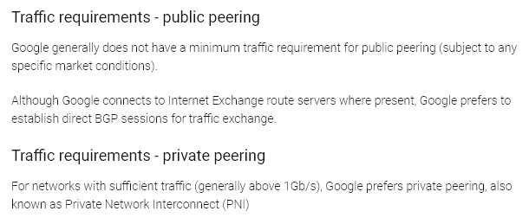

Google prefers to use BGP sessions for public peering and only us private peering with networks that have are about 1Gb/s.

* 1. How many ASes does Google control? And can you peer will all of them?
     1. Google controls 5 ASes

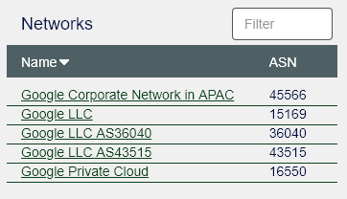

* + 1. It is possible to peer only AS15169 and AS36040; however, you cannot peer with AS43515 and AS19527

