Summary
For Assignment 3 we were asked to train two different classifiers to predict ONTASK and then to train the same classifiers with a 10-fold cross validation. I used Decision Tree and the Linear Support Vector Model Classifier as my two classifiers. I used Kaggle to implement the model; however, Jupyter Notebook would have worked as well. Pandas and Sklearn were the main libraries that I was using in order to make my models on Kaggle. For the first iteration both models got around 71% accuracy which signifies that both models were quite similar in performance. If both models achieved 71% it could be said that our models ended up being overfitted as they fit exactly against our data. I limited the number of features down to 3; however, the output was still overfitting. In my case, everything in the AssignmentData.csv file were all in the first column; consequently, I used Excel’s “import from Text/CSV” option in the “DATA” tab to clean the data. The data set was cleaned in Excel by navigating to the “DATA” tab and then importing the data using the “From Text/CSV” option that is in the top left-hand side of the DATA tab. I then selected the AssignmentData.csv file which once selected will put each attribute in its own column thus cleaning the data.

Approach
I made 4 separate notebooks in order to get all 4 models working. The features that I used were SCHOOL, CLASS, and ACTIVITY which I had to encode to integer values. The initial ‘string’ element was causing me issues when trying to run the model. Cross Validation and the basic 70/30 train/test values are below.
Neg_Mean_Squared_Error was used for accuracy for all 4 classifiers. It seems that 70/30 performed slightly better than cross validation.

Decision Tree Basic 70/30: 71.27%
Decision Tree Cross Validation 67.81%
Linear Basic 70/30: 71.27%
Linear Cross Validation 67.23%

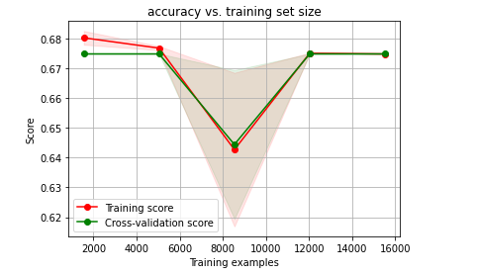
Linear
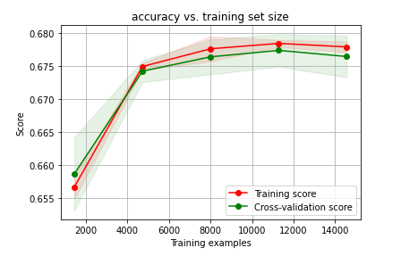
Decision Tree

Conclusion
LinearReg and Decision Tree both performed quite equally in both the basic 70/30 train/test data and in cross validation. If both classifiers are this close to one another than we can assume that overfitting is an issue. This suggest that even at 3 feature values we are still prone to overfitting as you can see in our figures.

