Summary
For assignment 4 we were asked to utilize various visualization techniques in order to improve our knowledge of data and how we can use visualizations to our benefit. I used pandas matplotlib, and seaborn, of the Python programming language, in order to produce my visualizations. Before creating my first model I had to add a new column in the data set that I called “Time Total (Min)”, this would be used for my first visualization. The base dataset has beginning time and ending time in month/day/year with time in a 24-hour format; however, I had to convert these two columns and subtract the two in order to create the total time students spent for each problem. The first model is a histogram using the newly created “Time Total (Min)” column in order to create a visualization that shows time spent on a problem for a student.
Time-Histogram
Time histogram displays the total amount of seconds for each problem level. The column of Problem Name has multiple values for the problem levels with a duration, in seconds, for each entry.
Average Duration for Time Start – Time End

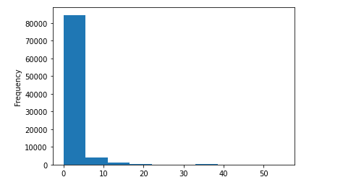

Time Histogram
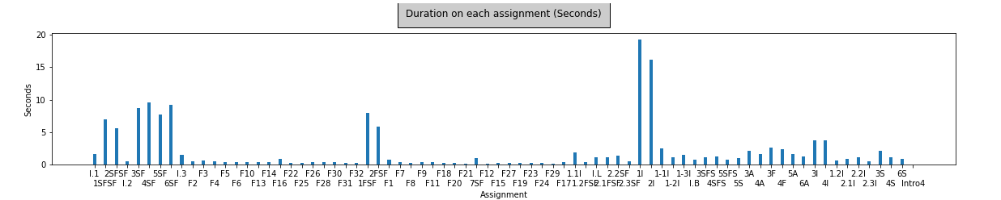

# Of Hints Per Problem Level
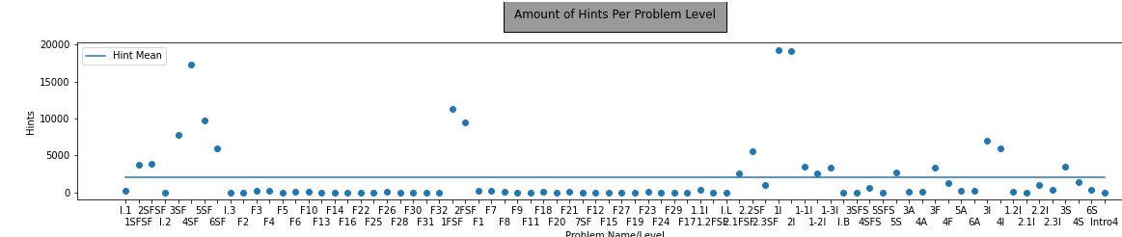

Bar Plot for Duration At Step
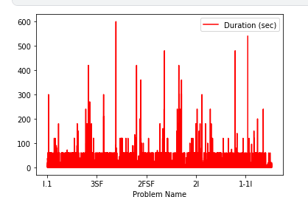

Results
In order to plot the histogram, we needed the two columns of Problem Name and Duration (sec); however, we needed to count the total sum of the duration entries for an entire problem name in order to accurately portray duration for each assignment. Using this method, we were able to distinguish which problem levels required the highest amount of time to complete. The bar graph showed an easier representation of the duration per problem level as it was closer together than the spread-out histogram. By using all three plots we can tell that the number of hints per problem level is proportional to the duration on each assignment step. This means that the harder problem levels required more hints and a long time for students to complete them.

