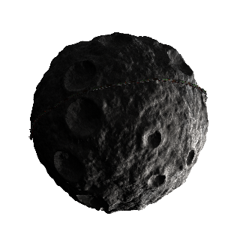

Figure

Figure

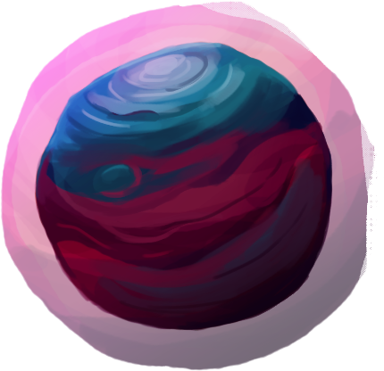

Figure



Figure



Figure

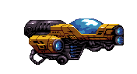

Figure

**What All Objects Are on Screen and Behaviors:**

*Figure 1:* This represents the main obstacle in the game, the formidable asteroid! Try to avoid these obstacles at all costs with your spaceship to avoid losing and abruptly ending the game. They move across the screen coming from right to left and as the game goes on more and more are generated.

*Figure 2:* Indication that the game is over.

*Figure 3:* These larger planets give bonus points (exactly +10) if you collide your spaceship in its hit zone. These also move from right to left and spawn occasionally, about every 10 seconds.

*Figure 4:* Press this reset button when the game is over, and you can restart the game level!

*Figure 5:* These stars also give bonus points (exactly +2) if you collide your spaceship in its hit zone. They spawn more often than the larger planets, about every 2 seconds.

*Figure 6:* This spaceship represents your avatar! Control its direction across space using the WASD controls or the arrow keys on your keyboard.

**Player Controls:**

WASD / Arrow Keys control the movement of the avatar spaceship

Left mouse Click: If you click on the asteroid obstacles, you can instantly destroy them! However, if you utilize this option you lose 20 points so do not be too quick to start clicking away!

**How The Player Scores:**

Every second you survive on screen you gain +1 points. Collecting large planet objects gives you +10 points and collecting stars give you +2 points. You lose 20 points for every asteroid you decide to click on with your mouse. Every time you reach an additional 50 points, a cha-ching sound ensues indicating a new checkpoint reached!

**How The Game Ends:**

The game ends when your spaceship hits an asteroid. The game becomes progressively harder as more asteroid obstacles are generated, so try and stay alive as long as possible and keep increasing your score!