Small and medium-sized companies' contribution to the UN Sustainable Development Goals

Anamarija Delić
Faculty of Economics and Business in Osijek, Josip Juraj Strossmayer University of Osijek, Croatia
Dominika Crnjac Milić
Faculty of Electrical Engineering, Computer Science and Information Technology Osijek, Josip Juraj Strossmayer University of Osijek, Croatia
Bojan Pažek
Faculty of Electrical Engineering, Computer Science and Information Technology Osijek, Josip Juraj Strossmayer University of Osijek, Croatia

Research methodology, data analysis and empirical findings
This chapter presents the methodological framework of the research. We describe the data processing methods and analyse the statistical results obtained from our survey. First, we are going to focus on the important characteristics of the sample. Then, we would implement the key variables used in the statistical analysis. Next, we are going to create derived indicators for SME profiles, motivational factors, and SDG awareness. The section will be concluded with the statistical procedures used to answer our research questions.
The empirical analysis, by itself, is organized around two research questions. At the beginning, we would like to examine which SDG goals dominate the operations and sustainability efforts of Croatian SMEs. After that, our focus is moved to motivators that are associated with higher SDG involvement. In addition to descriptive statistics, correlational, non-parametric, and regression methods were used, with correction for multiple testing where necessary.

Sample characteristics and descriptive overview
The empirical analysis features a sample of 103 business entities. This study specifically targets Croatian SMEs and their relationship with the UN Sustainable Development Goals. Before addressing our research questions, we will begin with a descriptive overview. This step is going to examine the sample's basic structure. It covers respondent demographics, company profiles, and core sustainability characteristics.
We examine the sample through several key variables. First, we will look at the owner or manager. This includes their gender and generation. Next, we are going to analyse the firm itself. We are tracking its legal form, ownership, and foundation year. We also want to note its size, sector, and employee count. The descriptive overview also captures core sustainability features. Furthermore, we will check if firms use measurable indicators. Also, we are looking for sustainability in their mission, vision, and strategy. And finally, we are documenting their standards, goal tracking, dedicated sustainability roles, and prior SDG awareness.
This descriptive overview is designed to serve two main purposes. First, it grounds the subsequent empirical findings in clear context. Second, it highlights key data patterns that directly shaped our statistical choices. For instance, micro and small firms dominate the sample. Additionally, certain categories contain very small subgroups. Moreover, the main SDG involvement indicator shows an asymmetric distribution. In the following table, Table 1, we present the main characteristics of the analysed sample.
Table 1. Sample characteristics and descriptive overview
Characteristic | Category / measure | n | % / value
Analysed firms/respondents | Total sample | 103 | 100.00
Gender of owner/manager | Male | 64 | 62.14
Gender of owner/manager | Female | 39 | 37.86
Generation of manager | Gen X | 60 | 58.25
Generation of manager | Gen Y | 31 | 30.10
Generation of manager | Gen Alpha | 7 | 6.80
Generation of manager | Baby boomers | 5 | 4.85
Firm size | Micro | 77 | 74.76
Firm size | Small | 20 | 19.42
Firm size | Medium | 3 | 2.91
Firm size | Large | 3 | 2.91
Legal form | d.o.o./j.d.o.o. | 60 | 58.25
Legal form | Other legal form | 42 | 40.78
Legal form | Public company | 1 | 0.97
Ownership structure | Croatian ownership | 97 | 94.17
Sector | Administrative and support service activities | 19 | 18.45
Sector | Information and communication | 14 | 13.59
Sector | Other sector | 12 | 11.65
Sector | Manufacturing | 11 | 10.68
Year of foundation | Median | — | 2014
Year of foundation | Minimum–maximum | — | 1854–2025
Number of employees | Median | — | 2
Number of employees | Mean | — | 71.36
Number of employees | Minimum–maximum | — | 0–3500
Business indicators | Yes | 67 | 65.05
Sustainability in strategy | Yes | 94 | 91.26
Quality/sustainability standard or CSR element | Yes | 22 | 21.36
Sustainability goal measurement | Yes | 18 | 17.48
Sustainability-related position | Yes | 86 | 83.50
Prior awareness of UN SDGs | Yes | 43 | 41.75
SDG_count | Mean | — | 2.39
SDG_count | Median | — | 1
SDG_count | Minimum–maximum | — | 0–15
SDG involvement level | Low, 0–1 SDGs | 53 | 51.46
SDG involvement level | Moderate, 2–4 SDGs | 33 | 32.04
SDG involvement level | High, 5+ SDGs | 17 | 16.50

Remark. Percentages reflect the full sample size ($n=103$). The variable $SDG_count$ measures how many SDGs link directly to core business operations.
As we could see from Table 1, several characteristics of the sample should be emphasized. As said earlier, the sample is dominated by micro and small firms. Micro enterprises account for $74.76\%$ of the sample, while small enterprises make up $19.42\%$. This distribution confirms that the empirical findings fundamentally reflect the perspective of SMEs. The sample is heavily dominated by domestic ownership. Specifically, $94.17\%$ of the analysed firms are Croatian-owned. The sectoral structure is highly diverse. The largest categories are administrative and support services, information and communication, manufacturing, and various other sectors.
In the sector variable, $11.65\%$ of firms were classified as “Other sector”. The open-text responses show that this category is spread across several activities. These include business consulting, education, hairdressing, textile rental and maintenance, hospitality, beauty services, EU project preparation, environmental maintenance, and deep cleaning services. Since these responses are highly diverse and each appears only a few times, we kept them combined under the "Other sector" category. Creating further subdivisions would have left us with unstable subgroups for the descriptive and statistical analyses.
An important feature of the sample is the relatively large share of firms classified under “Other legal form” ($40.78\%$). Inspection of the open-text responses shows that this category is also not homogeneous. Most of these responses refer to crafts ($78.57\%$), including regular and flat-rate crafts, while a smaller number refer to family farms ($11.90\%$), institutions ($4.76\%$), associations ($2.38\%$) and secondary occupations ($2.38\%$).
The main dependent variable used in the subsequent statistical analyses is $\vec{Y}=SDG_count$. This variable measures the number of UN Sustainable Development Goals that a firm reported as being directly related to its business operations. For company $i$, the variable is defined as
$$SDG_count_{i}=\sum_{j=1}^{17}{D_{ij}},$$
where:
$$D_{ij}=\left\{\begin{aligned}1, &if firm i reported SDG j as directly related to its business operations \\ 0, &otherwise\end{aligned}\right.$$
And so, the full response vector used in the statistical analyses is
$$\vec{Y}={\left(SDG_count_{1},SDG_count_{2},…,SDG_count_{103}\right)}^{⊺}.$$
Thus, $SDG_count_{i}$ can take values from $0$ to $17$. Note that higher values here indicate broader direct SDG involvement. If a firm $i$ selected the option that none of the SDGs were directly related to its business, then its $SDG_count_{i}$ was coded as $0$.
In our sample, $SDG_count$ has a mean of $2.39$ and a median of $1$. The values are ranging from $0$ to $15$. The first quartile is $0$ and the third quartile is $4$. This indicates a right-skewed distribution. What this means is that many firms reported either no direct SDG connection or only one directly related SDG. Only a smaller group of firms reported broader SDG involvement. For descriptive purposes, firms were grouped into three levels of SDG involvement: low involvement (0–1), moderate involvement (2–4), and high involvement (5+). Based on this classification, $51.46\%$ of firms were classified as having low SDG involvement, $32.04\%$ as having moderate involvement and $16.50\%$ as having high involvement.
The sustainability data shows a major gap between general orientation and formal practices. While $91.26\%$ of firms stated that sustainability should be included in the mission, vision, strategy and goals of the firm, only $17.48\%$ actually measure these goals. Similarly, $78.64\%$ of firms have none of the listed sustainability elements. In contrast, $15.53\%$ report having CSR (corporate social responsibility) goals or activities. For formal certifications, $8.74\%$ hold ISO 9001 and $4.85\%$ hold ISO 14001. These results suggest that sustainability is widely recognized as strategically relevant. However, formal operationalization through standards, CSR, and measurement systems is limited to a much smaller part of the sample.
Overall, the sample structure and the $SDG_count$ distribution offer key guidance for subsequent analyses. First and foremost, we must account for the high predominance of micro and small firms. Second, comparisons involving very small categories, with only few observations, should be handled carefully due to limited reliability. Finally, models must address the right-skewed nature of the main dependent variable.

Operationalization of key variables
In this subsection we are going to describe the operationalization of the key variables used in the empirical analysis. Since the research questions address different aspects of SDG involvement in SMEs, the variables were grouped into two analytical blocks. The first block contains SDG involvement variables. These are used to examine the perceived relevance and direct business connection of individual SDGs. The second block contains motivational and business environment variables. Here we want to capture pressures, support mechanisms, funding sources and improvement motives related to sustainability-oriented business changes.

SDG involvement variables
The first group of variables captures how much and in what way the analysed firms are involved with SDGs. Two survey questions were used to measure this. Question q36 measured the perceived relevance of each of the 17 UN Sustainable Development Goals. Respondents rated this on a five-point Likert scale. Question q37 measured the direct business connection of individual SDGs. For this question, respondents simply selected the goals currently related to their operations.
The distinction between these two questions is important. The relevance question captures the perceived importance of each SDG. In contrast, the direct-connection question captures whether a goal is explicitly linked to current business activities. Hence, a company may rate an SDG as highly relevant. However, that same firm might not report it as directly connected to its daily operations.
For the direct business connection measure, we have already defined in the previous subsection the variable
$$\vec{Y}=SDG_count={\left(SDG_count_{1},SDG_count_{2},…,SDG_count_{103}\right)}^{⊺},$$
by using the binary SDG response vector
$$D_{i}=\left(D_{i1}, D_{i2},…,D_{i17}\right)∈{\left\{0,1\right\}}^{17},$$
and by putting
$$SDG_count_{i}=\sum_{j=1}^{17}{D_{ij}}.$$
The variable $\vec{Y}$ will serve as the main dependent variable in our statistical analyses.
In addition to this direct-involvement measure, relevance-based SDG variables were constructed from Question q36. Let
$$R_{ij}∈\left\{1, 2,3,4,5\right\}$$
denote the relevance score assigned by firm $i$ to SDG $j$. We define the average perceived SDG relevance for firm $i$ as:
$$SDG_mean_relevance_{i}=\frac{1}{17}⋅\sum_{j=1}^{17}{R_{ij}}.$$
This variable measures the overall perceived importance of the SDG framework for each firm. We may now define
$$\vec{Y_{1}}=SDG_mean_relevance=\left(SDG_mean_relevance_{1},…,SDG_mean_relevance_{103}\right).$$
The two metrics, $\vec{Y}$ and ${\vec{Y}}_{1}$, capture different things. While $SDG_count$ measures the breadth of direct operational involvement, $SDG_mean_relevance$ measures the average perceived relevance of all 17 SDGs.
A further relevance-based indicator was constructed by counting the number of SDGs rated as highly relevant. For this purpose, let us define:
$$H_{ij}=\left\{\begin{aligned}1, &if R_{ij}≥4 \\ 0, &if R_{ij}<4\end{aligned}\right.$$
We can now compute the number of highly relevant SDGs for company $i$ as:
$$SDG_high_relevance_count_{i}=\sum_{j=1}^{17}{H_{ij}}.$$
This variable ranges from 0 to 17. It indicates how many SDGs the firm rated as relevant or highly relevant. As before, it could be written:
$$\vec{Y_{2}}=SDG_high_relevance_count$$
to be a vector consisting of the variables $SDG_high_relevance_count_{i}$, for $i=1, …, 103$. Together, these three variables capture complementary aspects of SDG involvement:
Table 2. Operationalization of SDG involvement variables
Variable | Source question | Meaning | Range
$SDG_count$ | q37 | Number of SDGs directly related to business operations | 0–17
$SDG_mean_relevance$ | q36 | Average perceived relevance of all 17 SDGs | 1–5
$SDG_high_relevance_count$ | q36 | Number of SDGs rated as highly relevant | 0–17

Among these variables, $SDG_count$ serves as the main dependent variable in our statistical analyses, especially for RQ2. Meanwhile, the relevance-based variables act as complementary indicators of perceived SDG importance. They enable us to examine whether a firm's perception of SDG relevance matched its reported direct involvement. This distinction is particularly important for RQ1. For this research question, the analysis would not rely solely on the company-level variable $SDG_count$. Instead, it also utilizes SDG-level indicators derived from Question q36. These indicators allow for a highly specific comparison. For each individual SDG, we can now compare its perceived relevance directly against its actual connection to business operations.

Motivational and business environment variables
The second group of variables was constructed to address RQ2. Hence, these variables capture key motivators and business environment factors related to sustainability. They look at the pressures firms face, the support they need, and their reasons for improving. Besides that, they also track funding sources, expected regulations, and company values. We gathered most of this data using multi-select survey questions. Finally, we turned every selected answer into its own binary variable.
For the analysis of sustainability-related pressures, the variable $Pressure_count$ was constructed directly from the Question q15. This variable counts the number of pressure sources reported by firm $i$. This includes legal pressure, consumers, competition, the business environment, employees and banks. Formally:
$$Pressure_count_{i}=\sum_{k=1}^{6}{P_{ik}},$$
where $P_{ik}=1$ if firm $i$ reported pressure of source $k$. Of course, $P_{ik}=0$ otherwise. To this, a binary indicator, $Any_pressure$, was also created since we wanted to see if the company reported at least one source of pressure.
Similarly, the variable $Support_needed_count$ was constructed from Question q27. It measures the number of support mechanisms a firm considered helpful for promoting sustainability goals. These included grants, interest-free loans, expert advice, a clear legislative framework, and digital solutions. Finally, the binary indicator $Any_support_needed$ identifies firms that selected at least one form of support.
Improvment related motivation was captured using Question q31. The variable $Improvement_motivators_count$ tracks the positive motives for change reported by a firm. One survey option stated that nothing had been improved. We treated this as a negative response. Therefore, it was excluded from the positive count. Based on this setup, two additional variables were constructed. These are $No_improvement_indicator$ and $Any_positive_improvement_motivation$.
Data on external financial support came from Question q34. The variable $External_funding_count$ marks the funding sources used by a firm over three years. One option indicated no external funding. We excluded this from the positive count. We then used this excluded option to create the $No_external_funding_indicator$. Lastly, if a firm reported at least one funding source, the $Any_external_funding$ variable was coded as $1$.
We created several additional variables. These capture value orientation and institutional awareness. First, $Sustainable_success_orientation$ came from Question q16. It shows if a firm looks beyond just net profit to measure success through sustainability goals. Second, $Sustainability_report_awareness_count$ was derived from Question q17. This tracks the positive responses regarding sustainability reporting awareness. Third, $Regulatory_SDG_impact_yes$ was created from Question q18. This flags whether a firm believes new SDG legal requirements would impact its business outcomes.
Finally, Questions q20 through q22 measured the perceived importance of sustainability dimensions. These questions used a Likert scale. They captured the importance of economic, environmental, and social sustainability. Using these three variables, the mean sustainability importance score was defined as:
$$Sustainability_importance_mean_{i}=\frac{1}{3}⋅\sum_{k=1}^{3}{S_{k}_sustainability_importance}$$
where $S_{k}∈\left\{Economic, Environmental,Social\right\}$ type of sustainability. In addition, $Sustainability_importance_high_count$ counts the number of sustainability dimensions rated as highly important. This was calculated using a threshold of 4 or higher on the five-point Likert scale.
We validated all derived motivational and business environment variables. The checks included missing values, expected ranges, and consistent binary coding. We also confirmed the logical relationship between count indicators and their matching binary indicators. These validated variables were then applied in RQ2. This analysis examined which motivators and contextual factors were linked to broader direct SDG involvement, measured by $SDG_count$.

Statistical analysis strategy
We developed the statistical analysis strategy based on the two research questions. We also considered the measurement properties of the variables. The analysis combined several methods. These included descriptive statistics, association measures, and non-parametric group comparisons. We also used effect-size estimates and multivariate modeling procedures. We paid special attention to our main dependent variable, $SDG_count$. This variable is a discrete count measure with a right-skewed distribution. Therefore, we did not rely only on methods that assume normally distributed, continuous outcomes.
To begin with, we used descriptive statistics to summarize the sample structure and the main variables. For categorical variables, we reported absolute frequencies and percentages. For numerical and count variables, we used means, standard deviations, medians, quartiles, and observed ranges. We needed to report both mean-based and rank-based measures for two reasons. First, some categorical subgroups had very few observations. Second, the $SDG_count$ values were concentrated on the lower end. Only a small number of firms reported broader direct SDG involvement.

Analytical strategy for RQ1
Here, we analyzed which individual SDGs were the most prominent. We looked at both the perceived relevance and the firms' reported direct business connections. Question q36 measured the relevance of each SDG on a five-point Likert scale. Using this data, we calculated the mean relevance score separately for each SDG across all firms. For each SDG $j$, this indicator was defined as:
$${\overline{R}}_{j}=\frac{1}{n}⋅\sum_{i=1}^{n}{R_{ij}}, n=103,$$
where $R_{ij}∈\left\{1,2,3,4,5\right\}$ represents the relevance score assigned by firm $i$ to SDG $j$. Higher values of ${\overline{R}}_{j}$have a clear meaning. They indicate that the analyzed sample perceived an SDG as more relevant to their business operations. Furthermore, we calculated the median, standard deviation, and the percentage of firms assigning high relevance to each SDG. We defined high relevance as a Likert response of 4 or 5:
$$HighRelPercent_{j}=\frac{1}{n}⋅\sum_{i=1}^{n}{I_{\left(R_{ij}≥4\right)}}⋅100, n=103,$$
where $I_{\left(R_{ij}≥4\right)}$ expresses the indicator function.
We analyzed direct business connections using data from Question q37. This question provided binary responses. For each individual SDG, we looked at how many firms linked the goal directly to their operations. We calculated this percentage as:
$$DirectPercent_{j}=\frac{1}{n}⋅\sum_{i=1}^{n}{D_{ij}}⋅100, n=103,$$
where $D_{ij}=1$ if firm $i$ reported SDG $j$ as directly related to its business operations, and of course $D_{ij}=0$ otherwise. We used this indicator for a specific purpose. It helped us see which SDGs appeared most often in active business operations.
Next, we compared the two dimensions. To do this, we ranked the 17 SDGs twice. First, we ranked them by their mean perceived relevance. Second, we ranked them by their direct-connection percentage. Let $Rank_{j}^{rel}$ be the rank of SDG $j$ for mean relevance. Let $Rank_{j}^{dir}$ be its rank for direct business connection. The difference between these two rankings was calculated as:
$$RankDifference_{j}=Rank_{j}^{dir}-Rank_{j}^{rel}.$$
Positive values have a specific meaning. They show that an SDG ranked higher in perceived relevance than in direct business connection. Negative values show the opposite. They indicate that an SDG ranked higher in direct business connection instead. Absolute rank differences
$$\left|RankDifference_{j}\right|$$
helped us identify major gaps for each SDG. We looked for where perceived relevance and direct connection diverged most strongly. This comparison mattered for a specific reason. An SDG can be viewed as relevant even if a company does not use it in their current operations.
We wanted to evaluate the overall match between perceived relevance and direct business connection. To do this, we calculated correlation measures across all 17 SDGs. We used Spearman’s rank correlation coefficient as our main measure. We chose this method to check for monotonic agreement. In other words, we wanted to see if the ranking of SDGs by relevance moved in the same direction as the ranking by direct connection. Particularly, Spearman’s coefficient was calculated between ${\overline{R}}_{j}$ and $DirectPercent_{j}$:
$$ρ_{S}=SpearmanCorr\left({\overline{R}}_{j},DirectPercent_{j}\right)=\frac{\sum_{j=1}^{17}{\left(U_{j}-\overline{U}\right)⋅\left(V_{j}-\overline{V}\right)}}{\sqrt{{\sum_{j=1}^{17}{\left(U_{j}-\overline{U}\right)}}^{2}}⋅\sqrt{\sum_{j=1}^{17}{{\left(V_{j}-\overline{V}\right)}^{2}}}}$$
where $U_{j}=rank\left({\overline{R}}_{j}\right)=Rank_{j}^{rel}$ and $V_{j}=rank\left(DirectPercent_{j}\right)=Rank_{j}^{dir}$. We additionally calculated two complementary measures. Pearson’s coefficient measured linear association. Kendall’s $τ$ coefficient measured rank agreement. These extra coefficients served a specific purpose. They tested whether the connection between the two SDG dimensions remained consistent when using alternative measures.
Besides ranking the SDGs separately for relevance and direct connection, we also created an exploratory composite dominance index. We used this index to find specific SDGs that scored strongly on both dimensions simultaneously. The two indicators use different numerical scales. To account for this, we first standardized both indicators across the 17 SDGs:
$$Z_{j}^{rel}=\frac{{\overline{R}}_{j}-μ_{\overline{R}}}{s_{\overline{R}}}=\frac{{\overline{R}}_{j}-\frac{1}{17}⋅\sum_{j=1}^{17}{{\overline{R}}_{j}}}{s_{\overline{R}}},$$
where $s_{\overline{R}}$ denotes sample standard deviation of the 17 SDG-specific mean relevance scores. In the same way:
$$Z_{j}^{dir}=\frac{DirectPercent_{j}-μ_{D}}{s_{D}}=\frac{DirectPercent_{j}-\frac{1}{17}⋅\sum_{j=1}^{17}{DirectPercent_{j}}}{s_{D}},$$
where $s_{D}$ represents the corresponding sample standard deviation of the 17 direct-connection percentages. The exploratory dominance index was then defined as:
$$RQ1_dominance_index_{j}=\frac{Z_{j}^{rel}+Z_{j}^{dir}}{2}.$$
Higher values of this index have a clear meaning. They highlight SDGs that scored high in two areas at once. Firms perceived these goals as important, and they frequently linked them to direct business operations. However, we only used this index as a descriptive ranking tool. It should not be viewed as a validated measure of SDG dominance.
We used inferential analyses to check the differences among individual SDGs. This helped us see if these differences were statistically significant within our sample. Each firm rated the relevance of all 17 SDGs on an ordinal Likert scale. Because of this, we used Friedman’s test for related samples to assess the differences in perceived relevance. The null hypothesis was:
$$H_{0} : the distributions of perceived relevance are equal across all 17 SDGs.$$
Friedman’s test only shows if an overall difference exists. It does not show which specific SDG pairs differ. Therefore, if the overall results were statistically significant, we ran pairwise Wilcoxon signed-rank tests. Running multiple pairwise comparisons increases the false discovery rate (FDR). To control this, we applied the Benjamini–Hochberg FDR correction to the resulting $p$-values. Finally, we reported Kendall’s coefficient of concordance $W$ as an effect-size measure for the Friedman analysis:
$$W=\frac{χ_{F}^{2}}{n⋅(k-1)},$$
Where $χ_{F}^{2}$ denotes the Friedman test statistic, $n=103$ is the number of firms and $k=17$ is the number of SDGs.
We also looked at direct business connections. For this, each firm provided binary responses for all 17 SDGs. We wanted to test for overall differences in how often firms connected these goals to their operations. To do this, we used Cochran’s Q test for related binary responses. The corresponding null hypothesis was:
$$H_{0} :P\left(D_{i1}=1\right)=:P\left(D_{i2}=1\right)=…=:P\left(D_{i17}=1\right).$$
If the overall test found differences among the SDGs, we compared them in pairs. We used exact McNemar tests for these pairwise comparisons. Note that comparing all 17 SDGs against each other creates $\left({17 \atop 2}\right)=136$ possible pairs. Running multiple tests can create false-positive findings. To prevent this, we applied the Benjamini–Hochberg FDR correction to the $p$-values, just as we did before.

Analytical strategy for RQ2
For RQ2, we examined motivational and business environment factors. We wanted to see which of these factors were linked to broader SDG involvement among the surveyed firms. RQ1 mainly compared individual goals at the SDG level. In contrast, we conducted the RQ2 analysis at the firm level. Our main outcome variable was $SDG_count$:
$$Y_{i}=SDG_count_{i}, i=1,…, 103.$$
Before starting the RQ2 analysis, we validated all of our variables. These included motivational, institutional, resource-related, and sustainability-value variables. First, we checked that binary variables had correct 0/1 coding and no missing values. Next, we reviewed the sustainability Likert-scale variables to ensure all values fell within the 1 to 5 range. We also checked multi-select questions for logical consistency. This was especially important if a firm chose an exclusive negative option, like "no improvements made." Finally, we checked the derived RQ2 indices for expected ranges, missing values, and consistency between the count measures and their binary indicators.
The first stage of the RQ2 analysis was purely descriptive. We looked at individual indicators for motivation, institutions, financial resources, and sustainability values. We then ranked these indicators based on how frequently they appeared in the sample. Let $X_k$ represents each binary indicator. We calculated the percentage of firms reporting the corresponding factor as:
$$SelectedPercentk_{k}=\frac{1}{103}⋅\sum_{i=1}^{103}{X_{ik}}⋅100.$$
Here $X_{ik}=1$ if firm $i$ selected factor $k$, and $X_{ik}=0$ otherwise.
The descriptive ranking included several different indicators. It looked at sustainability-related pressure sources derived from Question q15. It included forms of support needed for sustainability derived from Question q27. It also looked at positive motives for implemented changes derived from Question q31, and external funding sources derived from Question q34. Finally, it included sustainability-report awareness indicators derived from Question q17 and perceived regulatory SDG impact derived from Question q18. For Question q31 and Question q34, there were exclusive negative responses. These responses indicated that no improvements were made or no external funding was used. We did not interpret these answers as positive motivational or resource factors. Similarly, we analyzed the sustainability importance measures derived from Questions q20 through q22. We summarized these measures using means, medians, standard deviations, and percentages of high responses. This descriptive ranking indicates which factors were reported most frequently. However, we did not view frequency alone as evidence of stronger SDG involvement.
The second stage examined bivariate associations. We looked at the relationship between the RQ2 factors and our primary outcome variable, $SDG_count$. For the binary indicators, we compared two groups of firms. We compared those that selected a specific factor against those that did not. The $SDG_count$ variable is right-skewed, and subgroup sizes were not always large. Because of this, we used the Mann–Whitney $U$ test. This test helped us assess if the distribution of $SDG_count$ differed between the two groups. Finally, we reported these test results alongside the descriptive differences in the mean and median of the $SDG_count$.
We wanted to do more than just show statistical significance. We also needed to measure the effect size. To achieve this, we calculated Cliff’s delta for each binary comparison. Let's look at a binary factor, denoted as $X_{k}$. Let $Y^{(1)}$ represent the $SDG_count$ values for firms that selected this factor. Let $Y^{(0)}$ represent the values for firms that did not select it. Using these groups, we defined Cliff’s delta as:
$$δ_{k}=\frac{\#\left(Y^{\left(1\right)}>Y^{\left(0\right)}\right)-\#\left(Y^{\left(1\right)}<Y^{\left(0\right)}\right)}{n_{1}⋅n_{0}}.$$
Here, $n_{1}$ and $n_{0}$ denote the numbers of firms in the selected and non-selected groups, respectively. A positive value of $δ_{k}$ has a specific meaning. It indicates that firms reporting a given factor generally had higher $SDG_count$ values than firms not reporting it. However, comparing very small groups can lead to overinterpretation. To prevent this, we restricted the binary results used for our substantive ranking. We only included indicators where both groups contained at least five firms.
We also analyzed numerical and ordinal predictors. These included the derived count indices and the sustainability-importance measures. We wanted to evaluate their associations with $SDG_count$. To do this, we used Spearman’s rank correlation coefficient. We also calculated Kendall’s $τ$ as a complementary rank-based measure. We chose these specific procedures for two reasons. First, we did not assume the variables followed a normal distribution. Second, we were looking for monotonic relationships. We wanted to see how motivational or contextual factors related to the breadth of direct SDG involvement. Finally, we ranked the numerical predictors. This ranking was based on the strength of their positive Spearman association with $SDG_count$ variable.
The bivariate stage involved multiple comparisons across a large set of indicators. Because of this, as discussed earlier, we applied the Benjamini–Hochberg false discovery rate correction to the relevant families of $p$-values. We were screening several potential motivational and business environment factors at the same time. This correction reduced the probability of interpreting random chance findings as meaningful associations.
Next, we conducted a multivariate stage. We evaluated the substantively relevant RQ2 factors jointly to see which ones remained linked to $SDG_count$. We then built our main model using four aggregated predictors. These specific predictors were central to the RQ2 framework:
$$Pressure_{count}_{i} \\ External_funding_{count}_{i} \\ Improvement_motivators_{count}_{i} \\ Environmental_sustainability_{importance}_{i}$$
As mentioned earlier, these variables represent four distinct factors. The first is the number of sustainability-related pressure sources reported by a firm. The second is the number of external funding sources used. The third is the number of positive motives for implemented improvements. Finally, the fourth is the perceived importance of environmental sustainability.
The variable $Sustainable_success_orientation$ was derived from Question q16. We did not include it in the main RQ2 multivariate model. This variable indicates whether a firm already measures business success using both profit and sustainable goals. It is certainly related to SDG involvement. However, it represents an internal definition of business success. It is not a motivational, resource-related, or business environment factor in the narrow sense addressed by RQ2. Including it as a primary explanatory variable would make the RQ2 interpretation less informative. It would merely show that firms already defining success through sustainability also report broader SDG involvement. Consequently, we focused the main model on other areas. These included pressure-related, resource-related, improvement-related, and value-related factors.
Before starting the multivariate modeling, we prepared our variables. We took the four predictors included in the main model and standardized them. Let $X$ represent a given predictor. Its standardized value for a specific firm $i$ was defined as:
$$Z_{Xi}=\frac{X_{i}-\overline{X}}{s_{X}}.$$
In this formula, $\overline{X}$ represents the sample mean of predictor $X$. The term $s_{X}$ represents its sample standard deviation. We standardized these predictors for a specific reason. It allowed us to directly compare effects across variables with completely different numerical scales. As a result, each estimated coefficient in the main model has a clear meaning. It shows the expected change in SDG involvement for every one-standard-deviation increase in that predictor, assuming all other predictors stay the same. Therefore, a value of $Z_{Xi}=1$ is easy to interpret. It simply means firm $i$ scored one standard deviation above the average on that predictor.
The $SDG_count$ variable is a non-negative count variable. Because of this, we used count-regression procedures for our multivariate modeling. First, we ran initial checks on the data's distribution. These checks showed that the variance of $SDG_count$ was greater than its mean. This indicates "overdispersion," meaning the data does not fit the standard Poisson assumption. We still estimated Poisson models, including one with robust HC3 standard errors, to use as a diagnostic baseline. However, we chose the Negative Binomial model as our main multivariate model. We used this model because it handles overdispersion by allowing the variance to exceed the mean.
We denoted $Y_{i}=SDG_count_{i}$. Let us look at our main Negative Binomial model. In this model, we needed to represent the conditional mean number of directly connected SDGs for a specific firm $i$. We denoted this value as:
$$μ_{i}=E\left(Y_{i}∣X_{i}\right).$$
The model assumes:
$$Y_{i}∣X_{i}∼NB\left(μ_{i},α\right),$$
with the conditional variance:
$$Var\left(Y_{i}∣X_{i}\right)=μ_{i}+αμ_{i}^{2}, α>0.$$
Here, $α$ is an additional dispersion parameter. We may now model the logarithm of the expected $SDG_count$ as:
$$\log\left(μ_{i}\right)=β_{0}+β_{1}Z\left(Pressure_{count}_{i}\right)+β_{2}Z\left(External_funding_{count}_{i}\right)+β_{3}Z\left(Improvement_motivators_{count}_{i}\right)+β_{4}Z\left(Environmental_sustainability_{importance}_{i}\right).$$
We extracted the regression coefficients from the Negative Binomial model. Next, we exponentiated these values. Finally, we reported them as incidence rate ratios:
$$IRR_{r}=e^{β_{r}}.$$
Take a given predictor $r$. An incidence rate ratio (IRR) above 1 means higher predictor values are linked to more expected SDGs. An IRR below 1 means they are linked to fewer expected SDGs. Since we standardized these predictors, $IRR_{r}$ measures a specific multiplicative difference in the expected $SDG_count$. This difference happens when predictor $r$ increases by exactly one standard deviation, while keeping all other predictors the same.
We took a few steps before interpreting the multivariate model. First, we checked for multicollinearity among the predictors. We assessed this using variance inflation factors. Next, we evaluated how well the model fit the data. We summarized the model fit using log-likelihood, the Akaike information criterion, the Bayesian information criterion, and McFadden’s pseudo-$R^{2}$. Finally, we ran Poisson overdispersion diagnostics. These tests supported our decision to use the Negative Binomial model. We ran three extra analyses to check how robust our main RQ2 model was. First, we built a sensitivity count model. We swapped out the $Environmental_sustainability_importance$ variable for the broader $Sustainability_importance_mean$. However, we retained the indices for pressure, external funding, and improvement motivation. This analysis had a specific goal. We wanted to see if our conclusions relied solely on the environmental aspect of sustainability, or if an average of economic, environmental, and social sustainability produced different results. Second, a logistic sensitivity model was estimated using a dichotomized SDG involvement outcome:
$$SDG_count_ge_2_{i}=\left\{\begin{aligned}1, &SDG_count_{i}≥2 \\ 0, &SDG_{count_{i}}<2\end{aligned}\right.$$
This model used the same four standardized predictors as the main multivariate model. It also reported the exponentiated coefficients as odds ratios:
$$OR_{r}=e^{γ_{r}}$$
We did not use the logistic model as our primary model. Instead, we used it only as a sensitivity analysis. This is because turning $SDG_count$ into a simple binary variable loses valuable information. We preferred to model the original count numbers directly to keep all the data intact. Third, we conducted an exploratory Negative Binomial model with a slightly different setup. In this model, we removed the overall, aggregated pressure count. Instead, we used individual pressure indicators for banks, competition, consumers, and employees. We kept the other three main variables: external funding, improvement motivation, and environmental sustainability importance. We used this model for a specific reason. We wanted to explore if certain specific pressure sources mattered more than the total number of pressures. However, this model includes a large number of predictors compared to our available sample size. Therefore, we treated its findings as purely exploratory, rather than as the primary evidence for RQ2.
Therefore, our analytical strategy for RQ2 separates the evidence into three distinct forms. First, we use descriptive frequency rankings. These identify which motivational or business environment factors firms reported most frequently. Second, we use bivariate analyses. These examine factors one by one to see which individual factors are linked to differences in $SDG_count$. Third, we use the multivariate Negative Binomial model. This model serves as our primary basis for interpretation. It evaluates all the relevant factors together. This helps us see which factors remain associated with broader direct SDG involvement when assessed jointly.
It is important to note that all our RQ2 findings are interpreted primarily as associations, not causal effects. Our survey design cannot prove cause and effect. It does not establish if specific factors actually caused firms to adopt broader SDG involvement. These factors include reported pressures, funding sources, improvement motives, and sustainability-value orientations. Instead, our analysis simply identifies statistical links. It shows which of these factors are associated with a higher $SDG_count$ within our specific sample of surveyed Croatian businesses.

RQ1: Dominant SDGs in Croatian SMEs’ operations and sustainability efforts
Before seeing which SDGs were most popular, we checked our survey data. We looked at responses from 103 firms. The survey had two main SDG Questions: q36 and q37. Question q36 measured how relevant the SDGs seemed. Question q37 measured direct business connections. Both questions correctly included all 17 SDGs. Furthermore, all answers for q36 used the proper five-point scale. All answers for q37 were correctly formatted as binary choices. We did not find any missing, blank, or confusing answers. Because of this, we considered the data ready for analysis.
Initial data shows that many firms had limited direct connection with the SDGs. Specifically, 27 firms ($26.21\%)$ reported zero connected SDGs. Another 26 firms ($25.24\%$) reported only one. Therefore, 53 out of 103 firms ($51.46\%$) had no more than one SDG connected to their daily business. This shows that overall involvement was relatively low. On average, firms connected only $2.39$ SDGs directly to their actual business operations, with a median of just one goal. However, they rated an average of $6.97$ SDGs as highly relevant, with a median of six. In fact, $19.42\%$ of the sample rated at least 15 of the 17 SDGs as highly relevant. This shows that firms understand the importance of a broad range of SDGs, even if they don't apply them to their own work. We will examine this gap in the upcoming rankings and analyses. This context is important for the next part of our analysis.
We used Question 36 to check the perceived relevance of each SDG. SDG 8 (Decent work and economic growth) ranked as the most relevant goal. It had a mean relevance score of $3.47$, and $55.34\%$ of firms gave it a high rating of 4 or 5. Three other goals followed closely behind. These were SDG 9 (Industry, innovation and infrastructure; score: $3.34$, $51.46\%$ high relevance), SDG 4 (Quality education; score: $3.32$, $50.49\%$ high relevance), and SDG 12 (Responsible consumption and production; score: $3.25$, $52.43\%$ high relevance). These top four goals were the only ones to achieve a median relevance score of 4. Therefore, they represent the most consistently relevant sustainability themes for these firms.
Some goals ranked much lower in relevance. SDG 1 (No poverty) had the lowest mean score at $2.46$. It was followed by SDG 2 (Zero hunger) with a mean of $2.66$, and SDG 14 (Life below water) with a mean of $2.71$. Additionally, SDG 1 and SDG 2 were the only goals to have a low median score of 2. These rankings show what matters most to these firms. They strongly connected with goals about employment, economic growth, innovation, infrastructure, education, and responsible consumption. Meanwhile, broader goals focused on poverty and hunger seemed less connected to their everyday business (see Fig. 1).
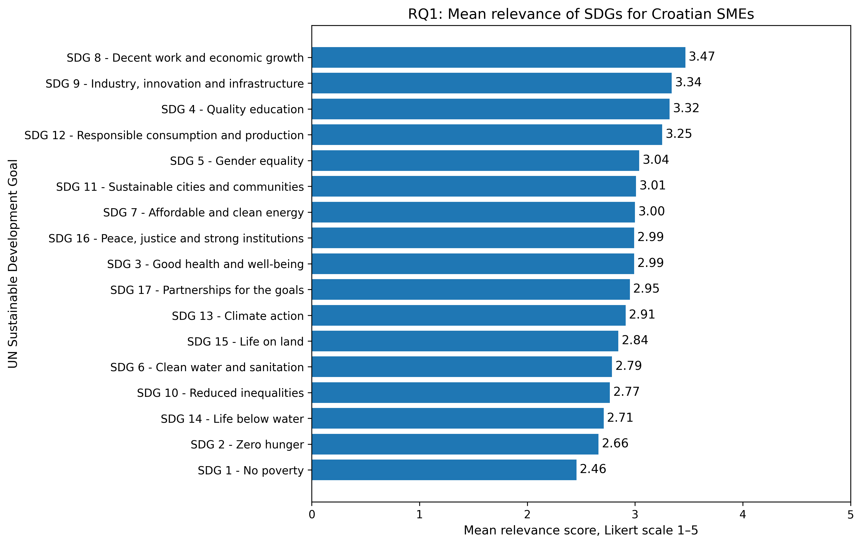
Fig. 1. Mean perceived relevance of individual SDGs among surveyed firms.
The results for direct business connection (q37) produced a slightly different ranking. The most popular goal was SDG 4 (Quality education). It was selected by 37 firms ($35.92\%$). SDG 8 (Decent work and economic growth) followed in second place, chosen by 30 firms ($29.13\%$). Three goals tied next, each selected by 20 firms ($19.42\%$). These were SDG 3 (Good health), SDG 5 (Gender equality), and SDG 12 (Responsible consumption). Finally, 19 firms ($18.45\%$) selected SDG 9 (Industry, innovation and infrastructure). SDG 14 (Life below water) was the least connected goal. Only 1 firm ($0.97\%$) linked it directly to their business. Several other goals also had very low connection rates. These included SDG 10 (Reduced inequalities) at $5.83\%$, and both SDG 15 (Life on land) and SDG 17 (Partnerships for the goals) at $6.80\%$. SDG 16 (Peace, justice and strong institutions) was also low at $7.77\%$. Notably, even the most popular SDG was chosen by just a little more than one third of the surveyed firms. This confirms our broader finding. Across the entire sample, direct operational involvement with the SDGs remained quite limited (see Fig. 2).
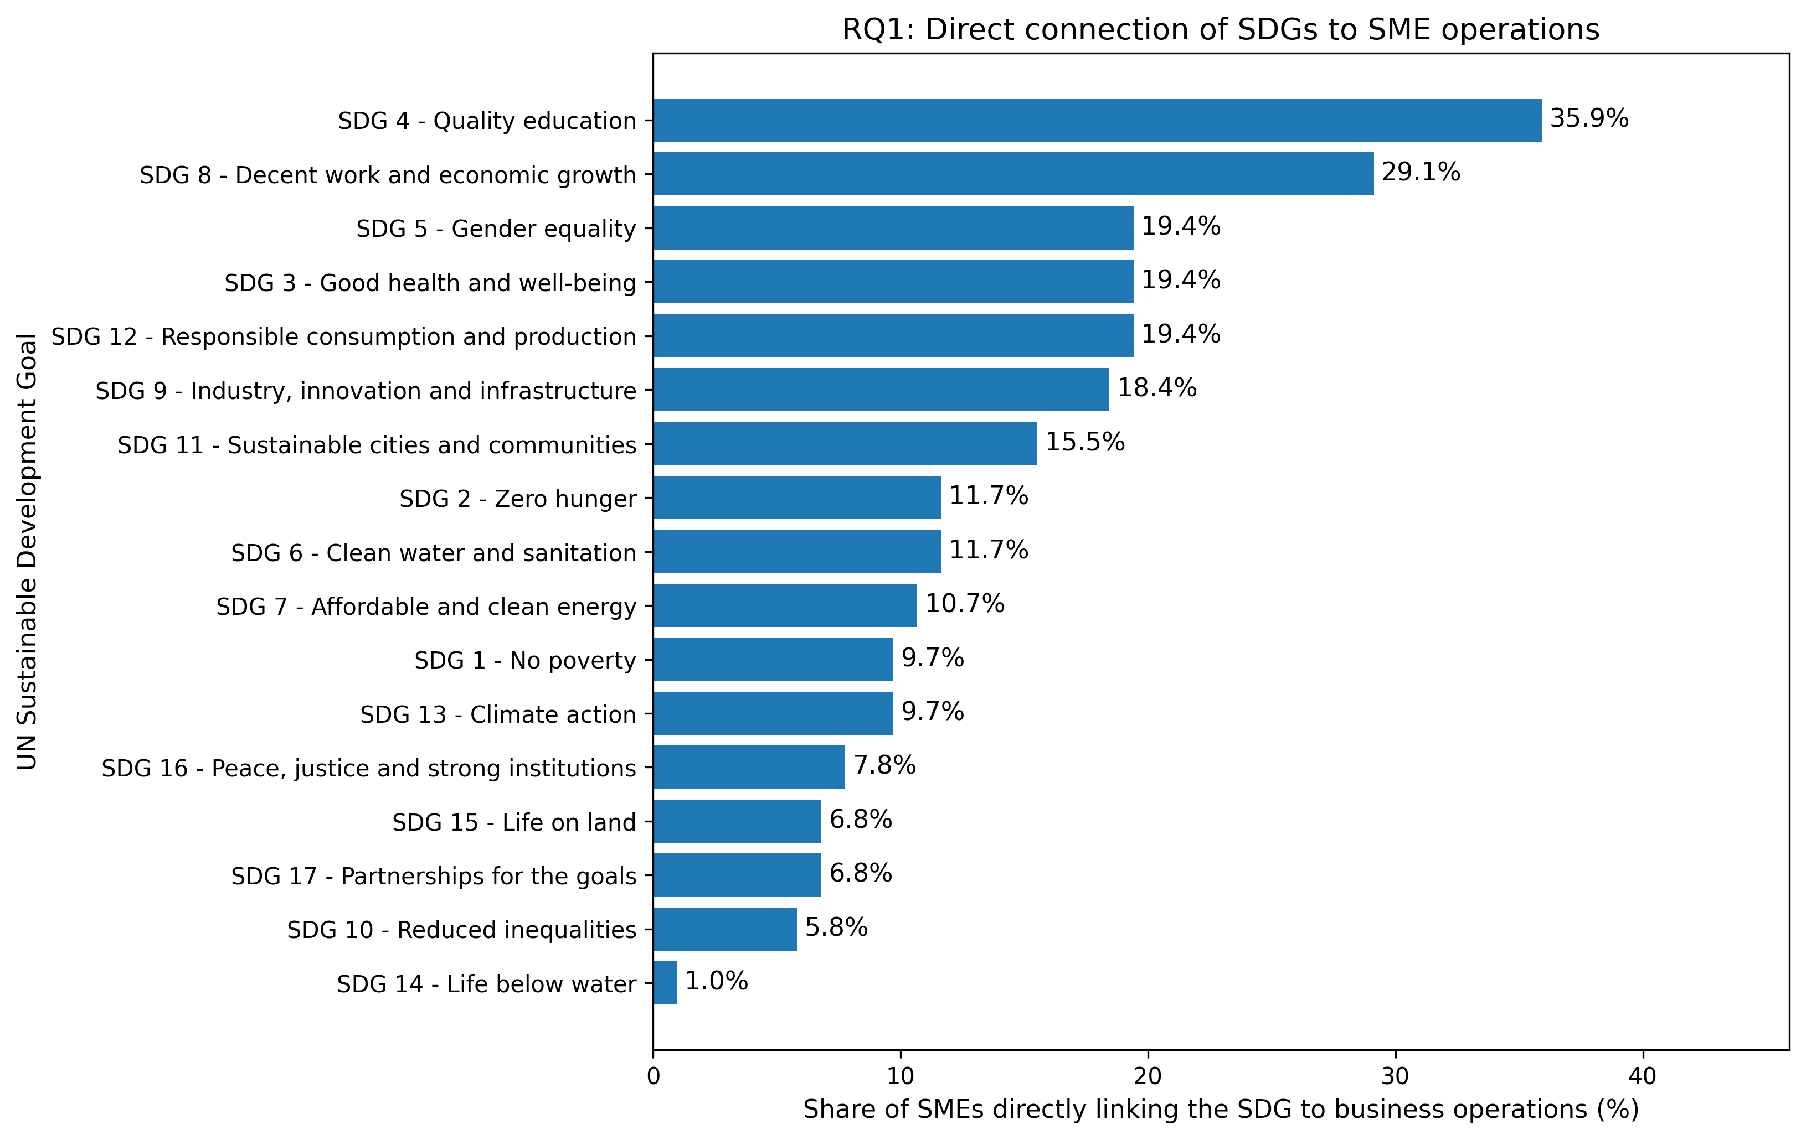
Fig. 2. Percentage of firms reporting each SDG as directly connected to business operations.
Perceived relevance and direct business connection are positively linked, though not exactly the same. We tested this connection across all 17 SDGs. There was a strong, statistically significant association between a goal's mean relevance and how many firms reported a direct connection. To measure this, we calculated Spearman’s rank correlation coefficient. The result was (see Fig. 3):
$$ρ_{S} = 0.736, p = 0.0007.$$
This result means that when firms found an SDG more relevant, they were more likely to use it in their actual business. Extra statistical tests backed this up:
- Pearson’s coefficient showed a strong positive linear connection ($r = 0.758$, $p = 0.0004$).
- Kendall’s coefficient confirmed a positive rank agreement ($τ = 0.581$, $p = 0.0014$).
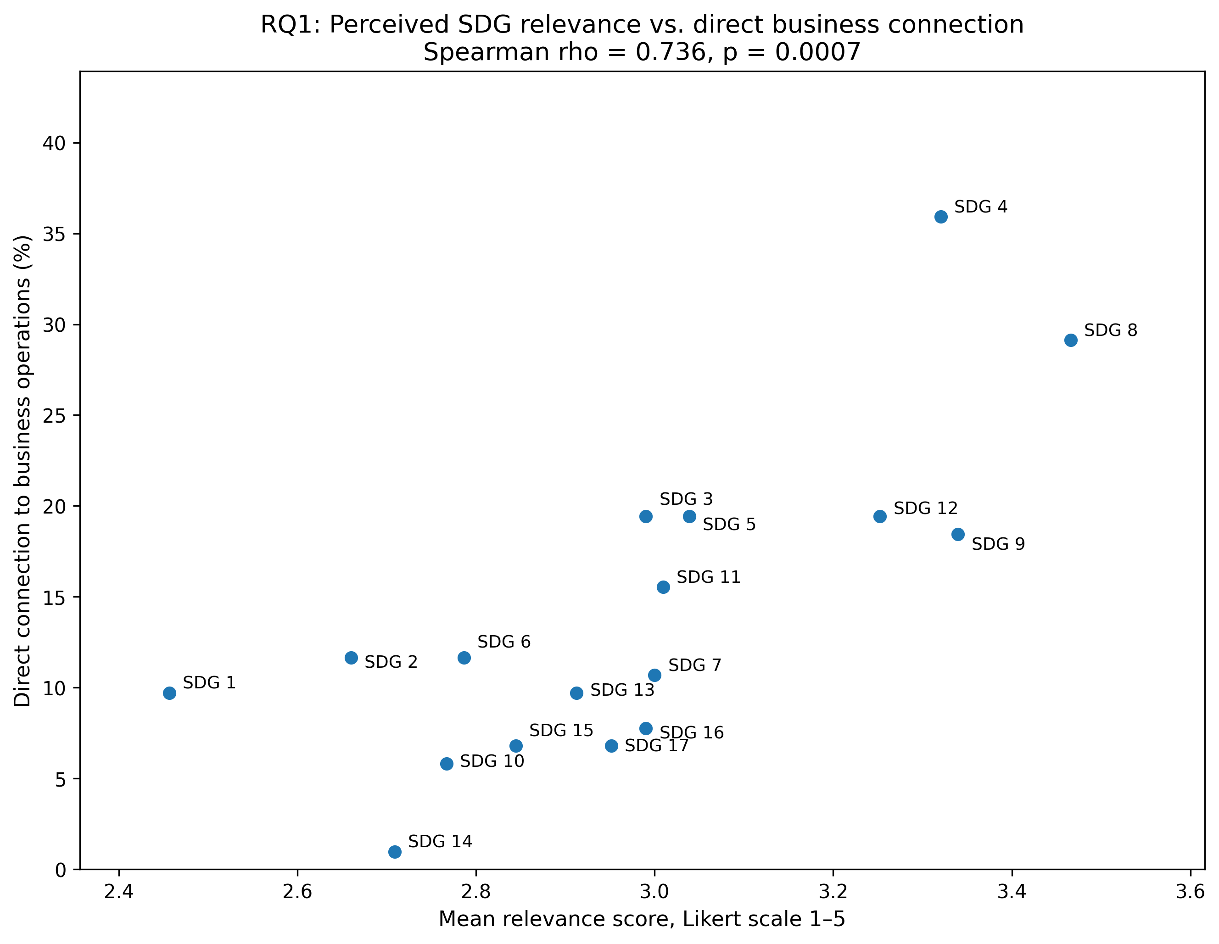
Fig. 3. Relationship between perceived relevance and direct business connection of individual SDGs.
This Fig. 3 confirms a positive relationship between the two measurements. SDG 4 (Quality education) and SDG 8 (Decent work and economic growth) stand out the most. They are prominent because they combine high perceived relevance with high direct business connections. At the same time, several other SDGs are scattered differently on the graph. This shows that believing a goal is important does not automatically translate into direct operational involvement.
Overall, relevance and connection were strongly linked. Still, some SDGs showed big differences between their two rankings. SDG 2 (Zero hunger) had the biggest gap. It ranked only 16th for perceived relevance, but climbed to 8th for direct business connection. SDG 1 (No poverty), SDG 3 (Good health and well-being), and SDG 6 (Clean water and sanitation) showed a similar pattern. They all ranked higher in direct connection than they did in relevance. The opposite was true for three other goals. SDG 16 (Peace, justice and strong institutions), SDG 9 (Industry, innovation and infrastructure), and SDG 17 (Partnerships for the goals) ranked higher in perceived relevance than in direct connection.
We wanted to identify the SDGs that were prominent in both relevance and direct connection. We did this by combining both measures into the exploratory $RQ1_dominance_index$. Based on this index (see Table 3), SDG 4 (Quality education) was the most dominant overall with a score of 1.896. It was followed by SDG 8 (Decent work and economic growth) at $1.789$. Next came SDG 9 (Industry, innovation and infrastructure) at $0.948$, and SDG 12 (Responsible consumption and production) at $0.837$. Two other goals earned positive scores, but they were lower than the leading four. These were SDG 5 (Gender equality) at $0.433$, and SDG 3 (Good health and well-being) at $0.341$.
Table 3. Leading SDGs according to the combined RQ1 dominance index
Rank | SDG | Mean relevance | Direct connection (%) | Dominance index
1 | SDG 4 – Quality education | 3.32 | 35.92 | 1.896
2 | SDG 8 – Decent work and economic growth | 3.466 | 29.13 | 1.789
3 | SDG 9 – Industry, innovation and infrastructure | 3.34 | 18.45 | 0.948
4 | SDG 12 – Responsible consumption and production | 3.252 | 19.42 | 0.837
5 | SDG 5 – Gender equality | 3.039 | 19.42 | 0.433
6 | SDG 3 – Good health and well-being | 2.99 | 19.42 | 0.341

Statistical tests proved that the differences between individual SDGs were genuine. According to Friedman’s test, perceived relevance differed significantly across the 17 SDGs ($χ_{F}^{2}(16) = 144.340, p < 0.001$). We also calculated Kendall’s coefficient of concordance, which was $W = 0.088$. This number means that while the differences were significant, the overall gap between the goals was quite modest. Finally, we ran post-hoc Wilcoxon tests using the Benjamini–Hochberg FDR correction. These confirmed a clear divide. The top goals (SDG 8, SDG 9, SDG 4, and SDG 12) were rated significantly higher than the bottom goals (SDG 1, SDG 2, SDG 10, and SDG 14).
Direct business connection also differed significantly across the 17 SDGs ($Q(16) = 125.315, p < 0.001$). To find the specific differences, we used McNemar comparisons with an FDR correction. The tests revealed a clear pattern. Firms connected SDG 4 (Quality education) to their business significantly more often than several low-ranking goals. These lower goals were SDG 10 (Reduced inequalities), SDG 14 (Life below water), SDG 15 (Life on land), SDG 16 (Peace, justice and strong institutions), and SDG 17 (Partnerships for the goals). SDG 8 (Decent work and economic growth) had a similar result. It was also connected significantly more often than those same five bottom goals (SDG 10, 14, 15, 16, and 17).
Comparing all 17 SDGs against each other resulted in many pairwise comparisons. Because of this, the main text only shows the overall statistical results. It also highlights the patterns most relevant for answering RQ1 (see suplementary data for RQ1, scripts folder).
In general, two main goals dominated the sustainability efforts of the surveyed Croatian firms:
- SDG 4 (Quality education): This was the most frequently reported goal in daily operations. It also earned the highest combined dominance score.
- SDG 8 (Decent work and economic growth): Firms viewed this as the most relevant goal. It ranked second for both direct business connection and combined dominance.
A second important group included SDG 9 (Industry, innovation and infrastructure) and SDG 12 (Responsible consumption and production). Both of these showed high relevance and strong connections to daily operations. Taken as a whole, these results show a strong positive link. Firms usually applied the SDGs they found most relevant to their actual operations. However, some goals had mismatched rankings. This proves that finding a goal important does not always lead directly to using it in operations.

RQ2: Motivators of SDG involvement in SMEs
This section answers RQ2. We studied our sample of 103 surveyed Croatian firms to understand and looked at how motivational and business environment factors affected SDG involvement. This is different from RQ1. While RQ1 looked at the prominence of individual SDGs, RQ2 looks at the firm level. Our primary outcome variable for this was $SDG_count$.
We checked the RQ2 variables before examining their link to $SDG_count$. First, we looked at the binary indicators. These covered motivational, institutional, and resource-related factors. All were coded correctly with zero missing values. Next, we checked the sustainability-importance variables. These used a five-point Likert scale. All responses were valid, and no data was missing. Finally, we checked the multiple-selection questions for logical consistency. For questions about improvements, funding, or reporting, no firm selected both a negative and a positive answer at the same time. Therefore, the RQ2 variables were perfectly suited for the descriptive, bivariate, and multivariate analyses.
We also found the derived RQ2 indicators to be consistent and ready for analysis. First, all count-based indices fell into their expected ranges with no missing values. Second, all binary indicators logically matched their related count measures. For example, if a firm reported sustainability-related pressure, their $Pressure_count$ was greater than zero. The indicators for external funding and positive improvement motivation also perfectly matched their count indices. Overall, these reliable results gave us a solid base. We were ready to explore which motivational and business environment factors encouraged broader direct SDG involvement.
The descriptive analysis started by looking at what firms reported most often. We focused on five areas. These were sustainability pressures, required support, motives for implemented improvements, external funding, and perceived sustainability importance. Together, these numbers describe the general motivations and business environment of the firms. However, we cannot jump to conclusions with this data alone. A frequently reported factor does not automatically mean it was linked to higher direct SDG involvement.
Firms felt pressure to be sustainable from several different sources. There was no single dominant group (see Table 4). The most common source was the business environment, reported by 52 firms ($50.49\%$). Legal or regulatory pressure followed very closely at $49.51\%$. Consumers were right behind them at $48.54\%$. Next came competition, which was identified by $42.72\%$ of the firms. Finally, fewer firms reported pressure from employees ($36.89\%$) and banks ($32.04\%$).
Table 4. Reported sustainability-related pressure sources
Pressure source | (n) | %
Business environment | 52 | 50.49
Legal or regulatory pressure | 51 | 49.51
Consumers | 50 | 48.54
Competition | 44 | 42.72
Employees | 38 | 36.89
Banks | 33 | 32.04

The $Pressure_count$ variable showed that multiple pressure sources were common. On average, firms reported $2.60$ sustainability-related pressure sources. The standard deviation was $2.06$, and the median was $3$. Overall, 79 firms ($76.70\%$) reported at least one source of pressure. Meanwhile, 24 firms ($23.30\%$) reported none. These findings lead to a clear conclusion. Most firms faced sustainability-related pressure, but it came from a combination of different stakeholders and institutions rather than a single dominant force.
A much clearer pattern appeared regarding the support firms needed for sustainability (see Fig. 4). Non-refundable incentives were the most popular choice by far. In total, 69 firms ($66.99\%$) selected this need. Expert advice came next, chosen by $39.81\%$ of the firms. After that, digital solutions and a clear legislative framework tied for the next spot. They were each reported by $37.86\%$ of the firms. Finally, interest-free loans were the least requested, selected by just $15.53\%$ of the firms.
Every analysed firm reported needing at least one type of sustainability support. On average, firms selected $2.01$ forms of support. The standard deviation was $1.20$, and the median was $2$. Almost half of the firms ($48.54\%$) asked for exactly $1$ form of support. In contrast, $12.62\%$ of the firms requested 4 or 5 forms. Because non-refundable incentives were the most popular choice, the conclusion is clear. Financial support was the most obvious need for these firms to achieve their sustainability goals.
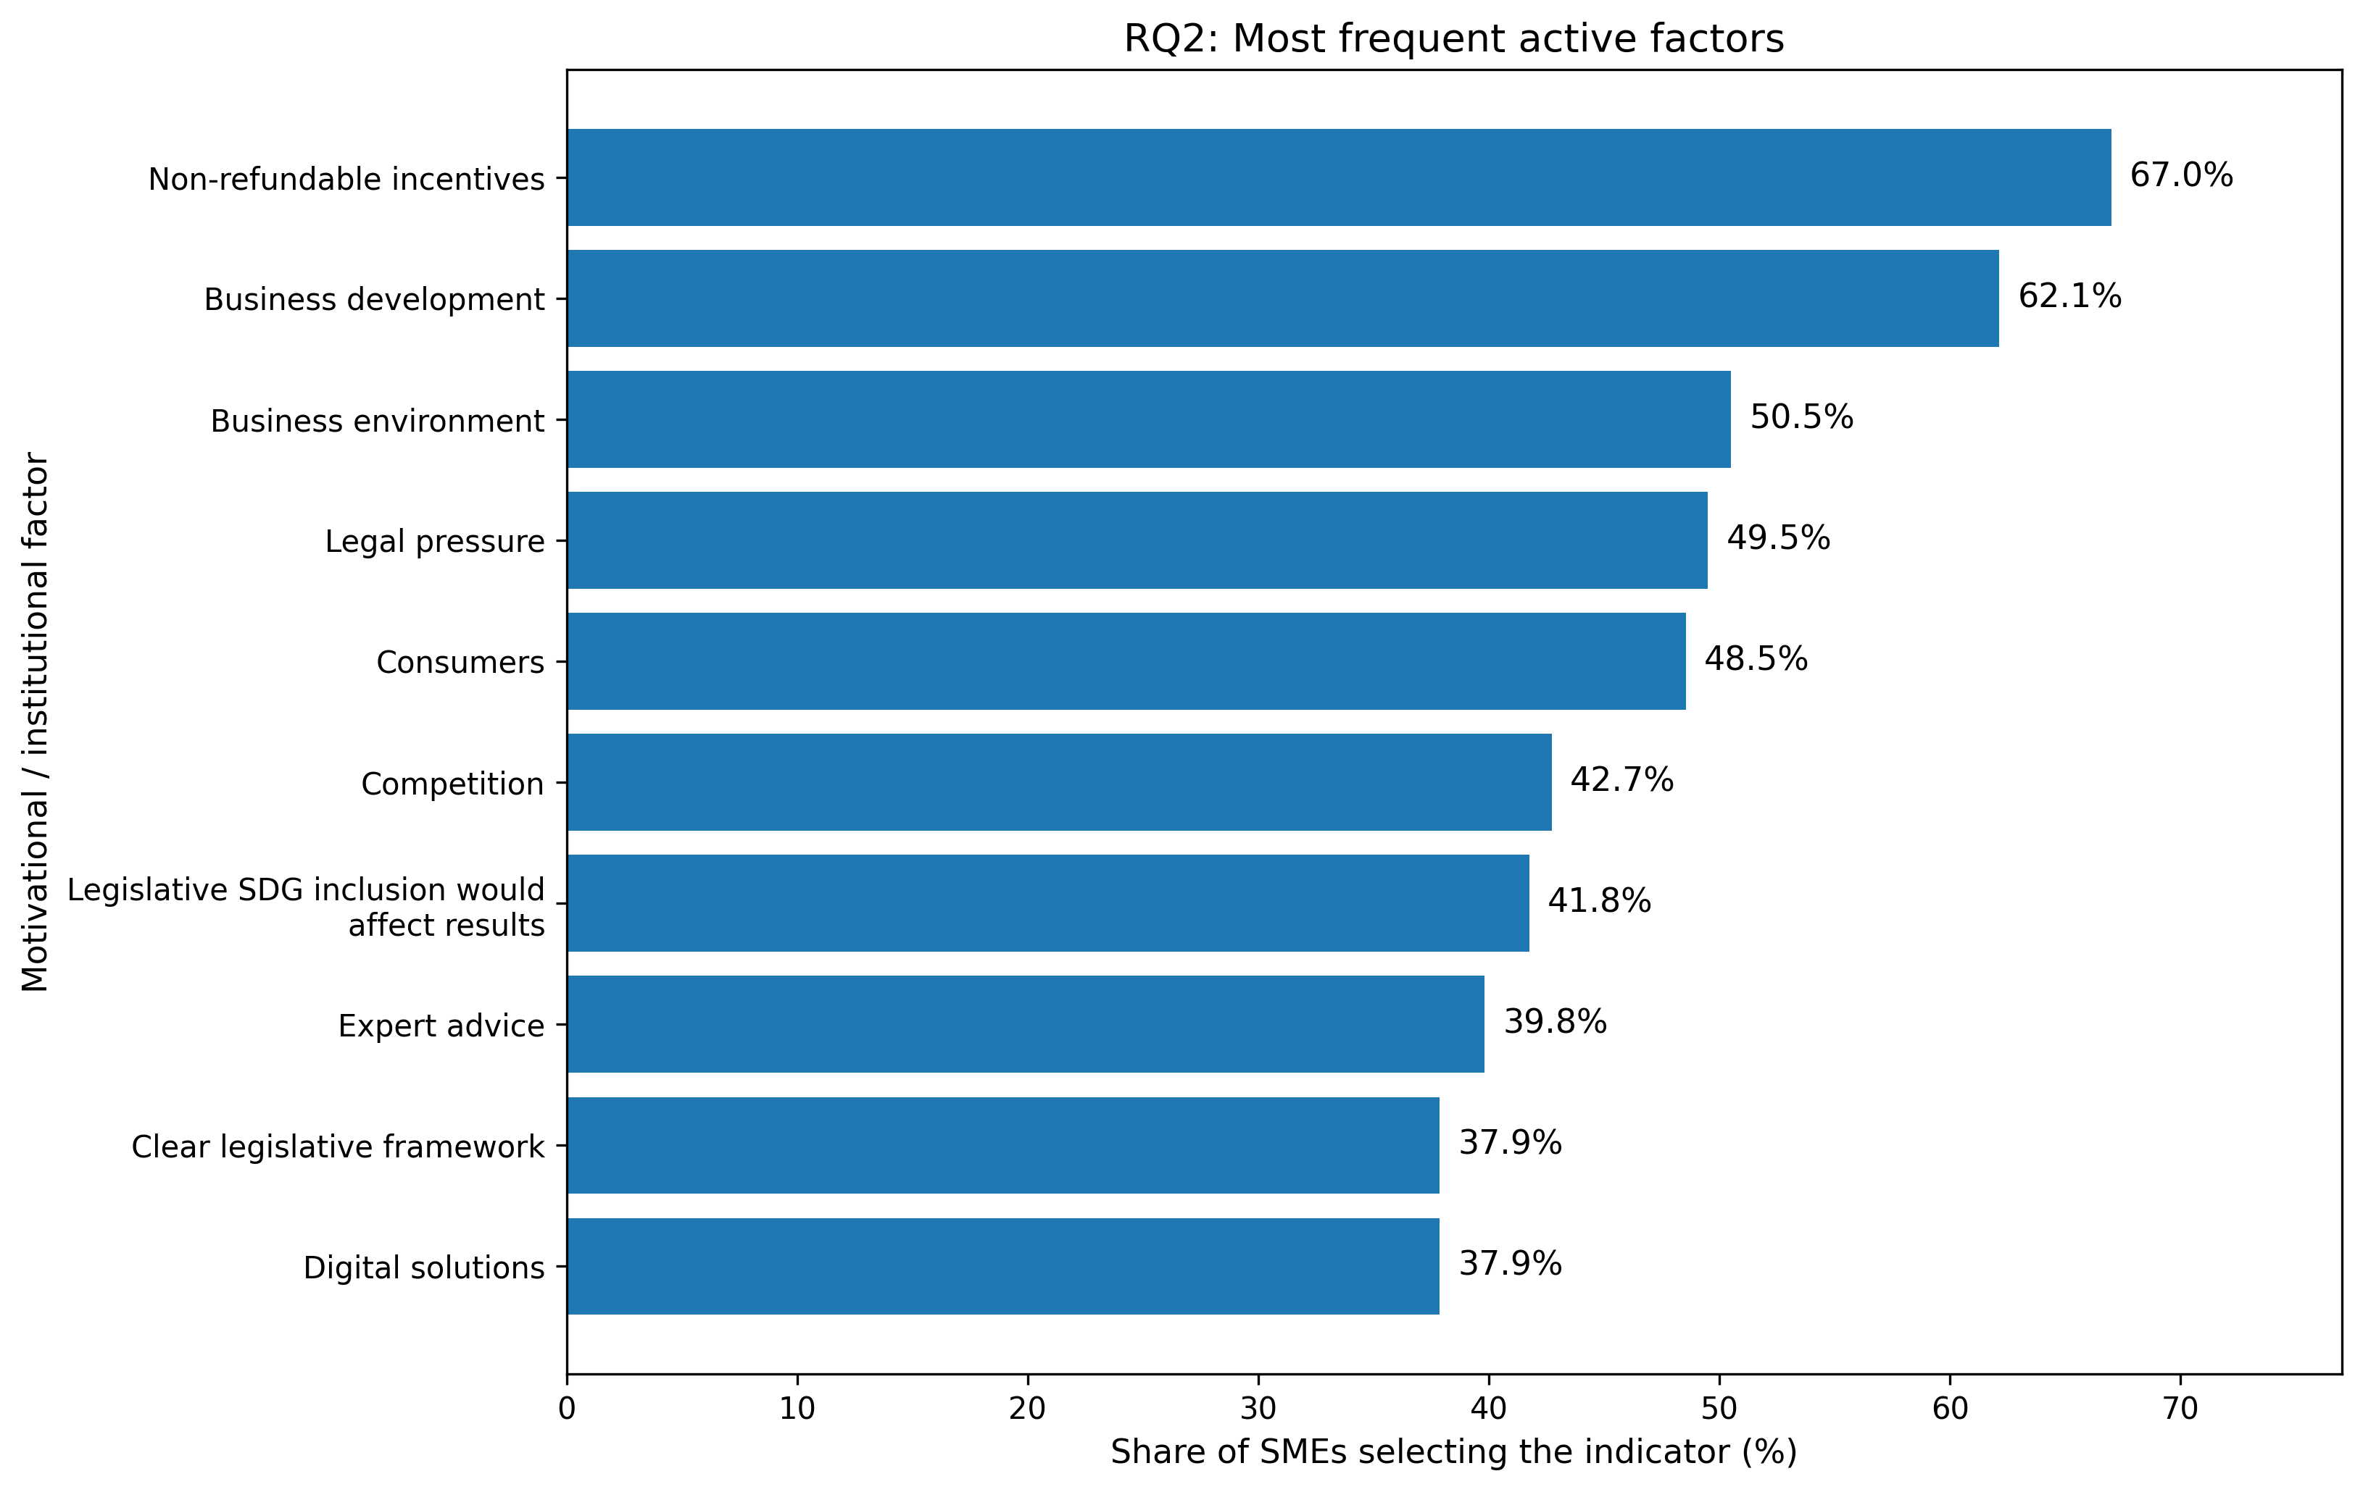
Fig. 4. Most frequent active factors.
Firms shared their positive motives for making business improvements. Business development was the most popular reason. It was selected by 64 firms ($62.14\%$). The next most common motive was modern technologies and innovation at $28.16\%$. Competition followed at $19.42\%$. Energy efficiency motivated $16.50\%$ of the firms. Social goals accounted for $15.53\%$. Finally, environmental concern motivated $13.59\%$ of the firms. When looking at these numbers, an answer stating "nothing had been improved" was not counted as a positive motive but we would like to emphasise that this statement was reported by 28 firms ($27.18\%$).
We measured positive motives using the $Improvement_motivators_count$ index. This index had a mean of $M = 1.80$, a standard deviation of $SD = 1.80$, and a median of $1$. Overall, 75 firms ($72.82\%$) reported at least one positive motive for making improvements. On the other hand, 28 firms ($27.18\%$) reported making zero improvements. This distribution suggests a clear trend. When firms actually made improvements, they focused heavily on business development. They did not focus as much on explicit environmental or social sustainability objectives.
External funding was not used uniformly across the firms. Thirty-eight firms ($36.89\%$) reported using no external funding sources over the past 3 years. Among the active funding options, HZZ employment support was the top choice. It was reported by $26.21\%$ of the firms. Local incentives came next at $22.33\%$. HZZ green or digital support followed at $10.68\%$. After that, NPOO funding was used by $9.71\%$ of the firms. All remaining individual funding sources were small, as each was reported by fewer than $10\%$ of the firms.
We measured active funding using the $External_funding_count$ index. This index does not count the firms that used zero external funding. The index had a mean of $M = 1.16$, a standard deviation of $SD = 1.24$, and a median of $1$. In total, 65 firms ($63.11\%$) reported using at least one external funding source. However, the specific funding options showed relatively low frequencies. This indicates that the use of individual external funding tools was spread out thinly across the sample.
Regarding sustainability reporting, 56 firms ($54.37\%$) reported zero awareness. Another 28 firms ($27.18\%$) stated that sustainability reporting was not applicable to them. Positive awareness responses were much less frequent. Specifically, 11 firms ($10.68\%$) connected reporting to competitiveness. Six firms ($5.83\%$) linked it to regulations, and 4 firms ($3.88\%$) linked it to penalties. Because of this, the $Any_sustainability_report_awareness$ indicator showed that $45.63\%$ of firms gave at least one positive response. Next, we looked at regulatory impact. We found that 43 firms ($41.75\%$) believed that legally including the SDGs would change their business results. On the other hand, 60 firms ($58.25\%$) expected no such impact. These descriptive results show that reporting and regulatory awareness existed in part of the sample, but it was not predominant.
The importance given to different areas of sustainability varied. Economic sustainability scored the highest on average, with a mean of $M = 4.09$, a median of $Md = 5$, and a standard deviation of $SD = 1.18$. Social sustainability came next, with a mean of $M = 3.62$, a median of $Md = 4$, and a standard deviation of $SD = 1.23$. Environmental sustainability received the lowest average rating, scoring a mean of $M = 3.08$, a median of $Md = 3$, and a standard deviation of $SD = 1.39$. Across all economic, environmental, and social areas, the combined overall scores were a mean of $M = 3.60$, a median of $Md = 3.67$, and a standard deviation of $SD = 1.03$. These results show how firms prioritized sustainability. They placed the strongest emphasis on the economic side. Social sustainability followed next. Environmental sustainability received the lowest average rating. This specific order is highly important for our next analysis. In the main RQ2 model, we treated environmental importance as a key value-related factor. We used it to see if it predicted broader direct SDG involvement.
Descriptively, 64 firms ($62.14\%$) reported that they measure business success using both profit and sustainable goals. Meanwhile, 39 firms ($37.86\%$) chose net profit only. As we explained in our analytical strategy, we did not include this specific indicator in the main multivariate RQ2 model. We left it out because it simply reflects a definition of success that is already sustainability oriented. It does not represent an external motivator or a business environment condition.
Overall, the descriptive results show what shaped sustainability efforts in these firms. Multiple pressure sources played a big role. There was also a clear demand for non-refundable incentives. When making improvements, firms focused heavily on business development. In contrast, their use of external funding tools was scattered and uneven. We also saw a clear ranking in values. Firms gave the highest importance to economic sustainability, while environmental sustainability got a lower average rating. However, these basic counts only show how common these factors were. They do not prove a link to deeper actions. The upcoming bivariate and multivariate analyses will test if these factors actually led to broader direct SDG involvement.
Table 5. Most frequently reported indicators
Rank | Construct | Factor | (n) | %
1 | Support needed for sustainability | Non-refundable incentives | 69 | 66.99
2 | Positive improvement motives | Business development | 64 | 62.14
3 | Success measurement orientation | Profit and sustainable goals | 64 | 62.14
4 | Sustainability pressure | Business environment | 52 | 50.49
5 | Sustainability pressure | Legal pressure | 51 | 49.51
6 | Sustainability pressure | Consumers | 50 | 48.54
7 | Sustainability pressure | Competition | 44 | 42.72
8 | Perceived regulatory SDG impact | Legislative SDG inclusion would affect results | 43 | 41.75
9 | Support needed for sustainability | Expert advice | 41 | 39.81
10 | Support needed for sustainability | Clear legislative framework | 39 | 37.86
11 | Support needed for sustainability | Digital solutions | 39 | 37.86
On the other hand, the bivariate analysis revealed a clear pattern. Several sustainability pressures led to broader direct SDG involvement. First, firms facing bank-related pressure had a much higher $SDG_count$ than those without it ($M = 3.82$ vs. $1.71$; $δ = 0.419$; $p_{FDR} = 0.006$). We observed significant positive differences for competition pressure as well ($M = 3.34$ vs. $1.68$; $δ = 0.386$; $p_{FDR} = 0.006$). Consumer pressure also increased scores ($M = 3.08$ vs. $1.74$; $δ = 0.351$; $p_{FDR} = 0.014$). The same was true for employee pressure ($M = 3.29$ vs. $1.86$; $δ = 0.299$; $p_{FDR} = 0.049$). Overall, firms that reported at least one source of pressure scored higher on their $SDG_count$ than firms reporting no pressure at all ($M = 2.70$ vs. $1.38$; $δ = 0.359$; $p_{FDR} = 0.036$).
Two more combined indicators were clearly linked to direct SDG involvement. First, we looked at motivation. Firms with at least one positive motive for making improvements scored higher on their $SDG_count$. They scored significantly higher than firms with zero positive motives ($M = 2.80$ vs. $1.29$; $δ = 0.439$; $p_{FDR} = 0.006$). Second, we looked at funding. Firms using at least one external funding source also had a higher $SDG_count$. They scored higher than firms that used no external funding at all ($M = 2.89$ vs. $1.53$; $δ = 0.336$; $p_{FDR} = 0.023$).
At first, some individual improvement motives and external funding tools seemed positively linked to $SDG_count$. However, this changed after the FDR correction. These individual links did not remain statistically significant. For example, the need for non-refundable incentives was very popular. Yet, it was not significantly linked to a higher $SDG_count$. This is a crucial distinction. It shows that the most frequently reported answers were not always the ones connected to broader direct SDG involvement.
We also looked at numerical and ordinal predictors to clarify the bivariate patterns. We found the strongest positive link involved $SDG_count$ and $Pressure_count$ (see Fig. 5). The $Pressure_count$ index tracks the number of sustainability pressure sources a firm faced ($ρ_{S} = 0.384$; $p_{FDR} = 0.0006$). This finding points to a very clear conclusion. If a firm experienced pressure from a wider range of sources, they usually linked a larger number of SDGs directly to their business operations.
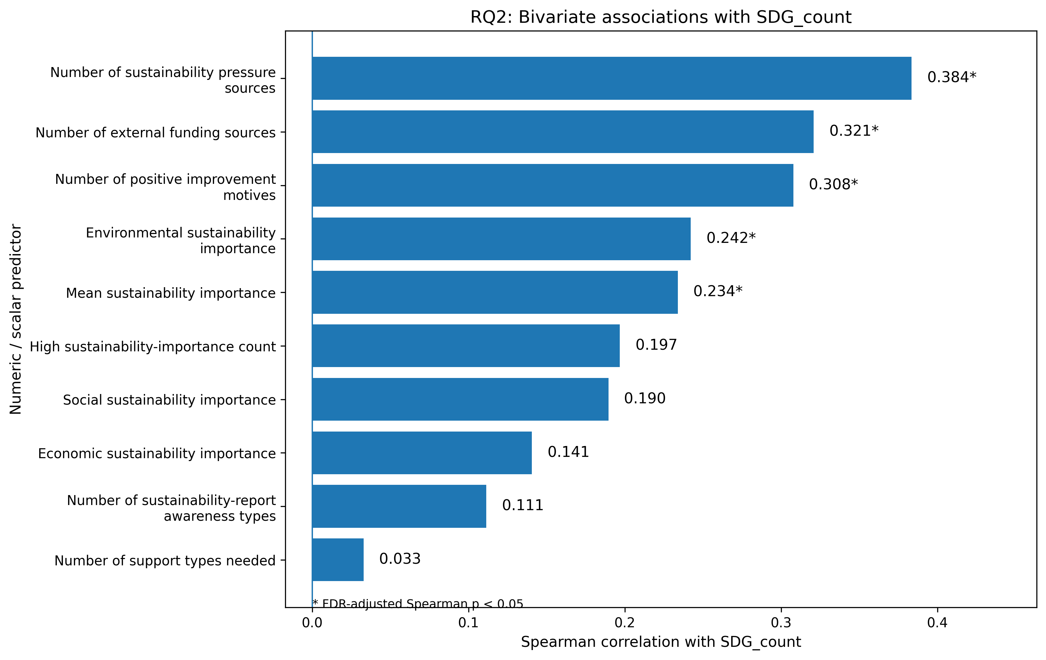
Fig. 5. Bivariate associations.
Furthermore, we found significant positive links for two other factors. First, we looked at external funding. The number of funding sources used was positively connected to SDG involvement ($ρ_{S} = 0.321$; $p_{FDR} = 0.0048$). Second, we looked at improvement motives. The number of positive motives reported was also positively connected ($ρ_{S} = 0.308$; $p_{FDR} = 0.0052$). These results suggest a clear takeaway. Firms that used more outside financial resources and had more reasons to improve also had broader direct SDG involvement.
Next, we examined the sustainability-value indicators. Environmental sustainability importance was positively linked to $SDG_count$ ($ρ_{S} = 0.242$; $p_{FDR} = 0.0342$). The overall average sustainability importance was also positively linked to $SDG_count$ ($ρ_{S} = 0.234$; $p_{FDR} = 0.0348$). In contrast, other factors did not show a statistical link to $SDG_count$ after correcting for multiple tests. These included economic sustainability importance, the number of reported support needs, and the sustainability-report awareness count. Lastly, Kendall's $τ$ coefficients confirmed the same overall pattern. After the FDR correction, five specific factors remained positively linked to $SDG_count$. These were pressure count, external funding count, positive improvement-motivation count, environmental sustainability importance, and mean sustainability importance.
So, importantly, the bivariate findings did not simply copy the most popular survey answers. For example, non-refundable incentives were the most requested support need. However, this need was not significantly linked to a higher $SDG_count$. Instead, other factors showed the clearest positive links to direct SDG involvement. These factors included facing many sustainability pressures, having many positive improvement motives, and using a wide variety of external funding sources. It also included placing a high importance on environmental sustainability. This points to a clear takeaway. Broader SDG involvement depended on facing multiple pressures, actively making improvements, engaging with resources, and valuing the environment. It did not depend on how frequently a specific support need was reported.
The next table, Table 6, presents the factors linked to $SDG_count$, which is the primary RQ2 outcome. These links remained statistically significant after applying the Benjamini–Hochberg FDR correction. Another variable, $Sustainable_success_orientation$, also showed a significant bivariate link to $SDG_count$. However, we report it separately as background context. We do this because it was not included in the main multivariate RQ2 model (since we did not want to build a tautological model).

Table 6: Panel A. Binary indicators
Factor | $M$, selected | $M$, not selected | $$Δ M$$ | Cliff’s $δ$ | Adjusted $p$
Bank pressure | 3.82 | 1.71 | 2.1 | 0.419 | 0.006
Competition pressure | 3.34 | 1.68 | 1.66 | 0.386 | 0.006
Any positive improvement motivation | 2.8 | 1.29 | 1.51 | 0.439 | 0.006
Employee pressure | 3.29 | 1.86 | 1.43 | 0.299 | 0.049
Any external funding | 2.89 | 1.53 | 1.37 | 0.336 | 0.023
Consumer pressure | 3.08 | 1.74 | 1.34 | 0.351 | 0.014
Any sustainability pressure | 2.7 | 1.38 | 1.32 | 0.359 | 0.036

Table 6: Panel B. Numerical and ordinal predictors
Predictor | Spearman $ρ_{S}$ | Adjusted $p$ | Kendall $τ$ | Adjusted p
$$Pressure_count$$ | 0.384 | 0.0006 | 0.307 | 0.0007
$$External_funding_count$$ | 0.321 | 0.0048 | 0.263 | 0.0046
$$Improvement_motivators_count$$ | 0.308 | 0.0052 | 0.249 | 0.0046
$$Environmental_sustainability_importance$$ | 0.242 | 0.0342 | 0.197 | 0.0306
$$Sustainability_importance_mean$$ | 0.234 | 0.0348 | 0.177 | 0.0366

Now we may proceed to multivariate assessment of motivational and business environment factors. As we have mentioned before, the $SDG_count$ is a non-negative count variable. Therefore, we considered count-regression models for the multivariate analysis. The outcome showed clear overdispersion. The variance ($6.848$) was higher than the mean ($2.388$). This resulted in a variance-to-mean ratio of $2.867$. As expected, the main Poisson model yielded a Pearson dispersion ratio of $2.330$. In the Negative Binomial model, the estimated dispersion parameter was positive and statistically significant ($α=0.530$, $p<0.001$). Therefore, we chose the Negative Binomial model as the principal multivariate model for RQ2. The main model included 4 predictors. We tested these predictors and found no problematic multicollinearity. We know this by looking at their variance inflation factors. These scores were low, ranging from $1.135$ to $1.301$.
In the next table, Table 7, we present the main results obtained from the negative Binomial model. As we said, the outcome variable for this model was $SDG_count$. We standardized the predictors before doing the estimation. In these results, the acronym IRR stands for incidence rate ratio.
Table 7 Negative binomial model (results)
Predictor | $$β$$ | SE | IRR | 95% CI for IRR | p
Number of sustainability pressure sources, z-score | 0.322 | 0.104 | 1.38 | [1.127, 1.691] | 0.002
Number of external funding sources, z-score | 0.16 | 0.106 | 1.173 | [0.954, 1.443] | 0.13
Number of positive improvement motives, z-score | 0.123 | 0.102 | 1.131 | [0.926, 1.381] | 0.229
Environmental sustainability importance, z-score | 0.095 | 0.109 | 1.1 | [0.887, 1.363] | 0.384

Now, the main Negative Binomial model used 4 standardized predictors. These were the number of pressure sources, the number of funding sources, the number of positive improvement motives, and the importance of environmental sustainability. Overall, the model was statistically significant ($LLR p < 0.001$). When we evaluated these 4 factors jointly, only one remained statistically significant (see Fig. 6). This was the number of sustainability-related pressure sources. If $Pressure_count$ went up by 1 standard deviation, the expected number of connected SDGs increased by $38.0\%$. This assumes the other factors were held constant ($IRR = 1.380$, $95 \% CI = [1.127, 1.691]$, $p = 0.002$).
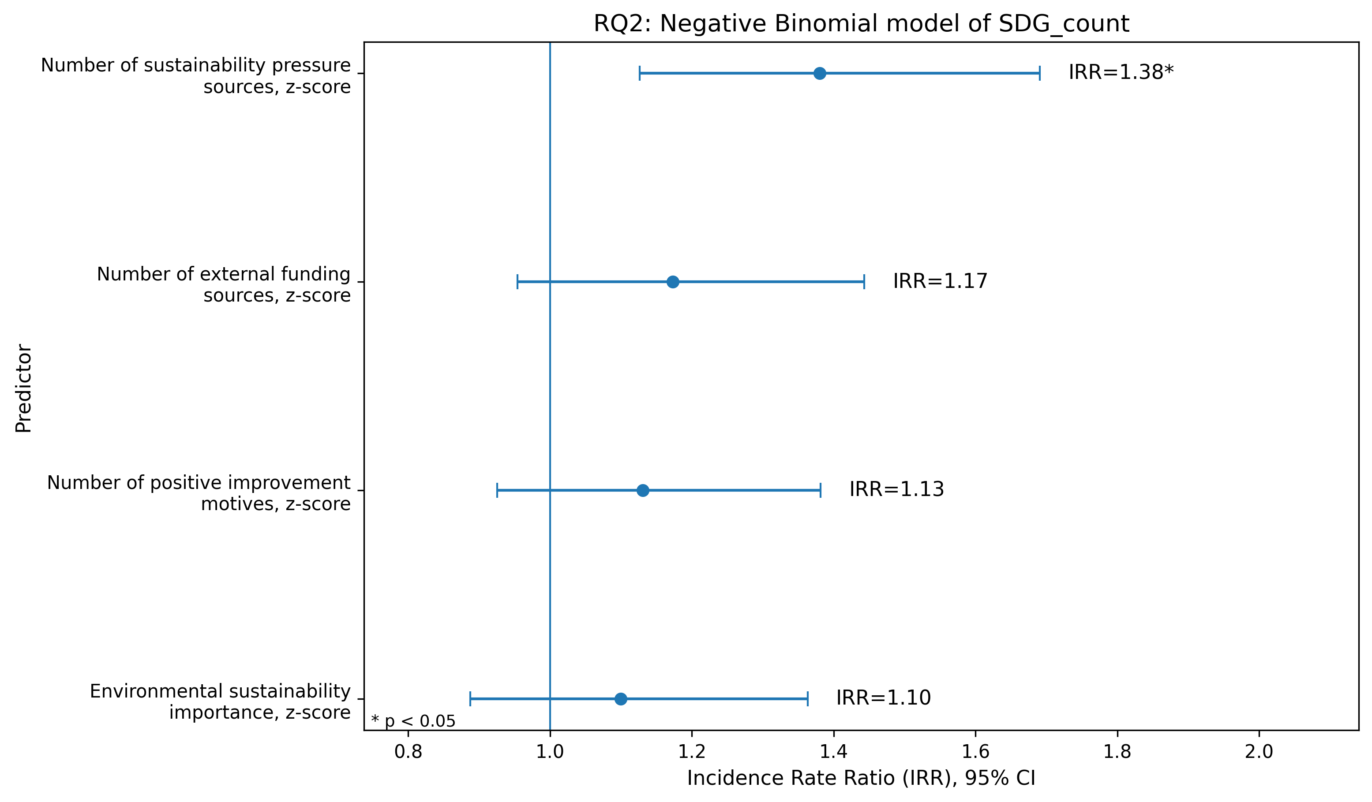
Fig. 6. Negative Binomial model of $SDG_count$.
In contrast, three other variables were not statistically significant in the principal multivariate model. The first was the number of external funding sources ($IRR = 1.173$, $p = 0.130$). The second was the number of positive improvement motives ($IRR = 1.131$, $p = 0.229$). The third was environmental sustainability importance ($IRR = 1.100$, $p = 0.384$). Originally, these variables showed positive bivariate links with $SDG_count$. But their independent links were no longer supported. This happened once we tested them alongside the breadth of sustainability-related pressures and the remaining predictors.
Note that the multivariate findings hence refine the bivariate results. In the bivariate stage, broader use of external funding, a greater number of positive improvement motives and higher environmental sustainability importance were each positively associated with $SDG_count$. However, these associations did not remain statistically significant when assessed jointly in the Negative Binomial model. The breadth of sustainability-related pressure sources was therefore the most robust factor associated with broader direct SDG involvement in the analysed sample.
Next, we also ran a sensitivity model. We replaced environmental sustainability importance with a new measure. This was the average importance given to economic, social, and environmental dimensions. The overall results did not really change. $Pressure_count$ continued to have a positive link with $SDG_count$ ($IRR = 1.364$, $95 \% CI = [1.110, 1.674]$, $p = 0.003$). Meanwhile, external funding count, improvement-motivation count, and mean sustainability importance were not statistically significant. Ultimately, this sensitivity analysis confirms our primary finding. It shows that the effect of having broad sustainability-related pressures is highly reliable.
Hence, we know that the overall pressure-count index was significant. To find out why, we ran an exploratory Negative Binomial model to test specific pressure sources. In this new model, bank-related pressure was the only source significantly linked to $SDG_count$ (see Fig. 7).
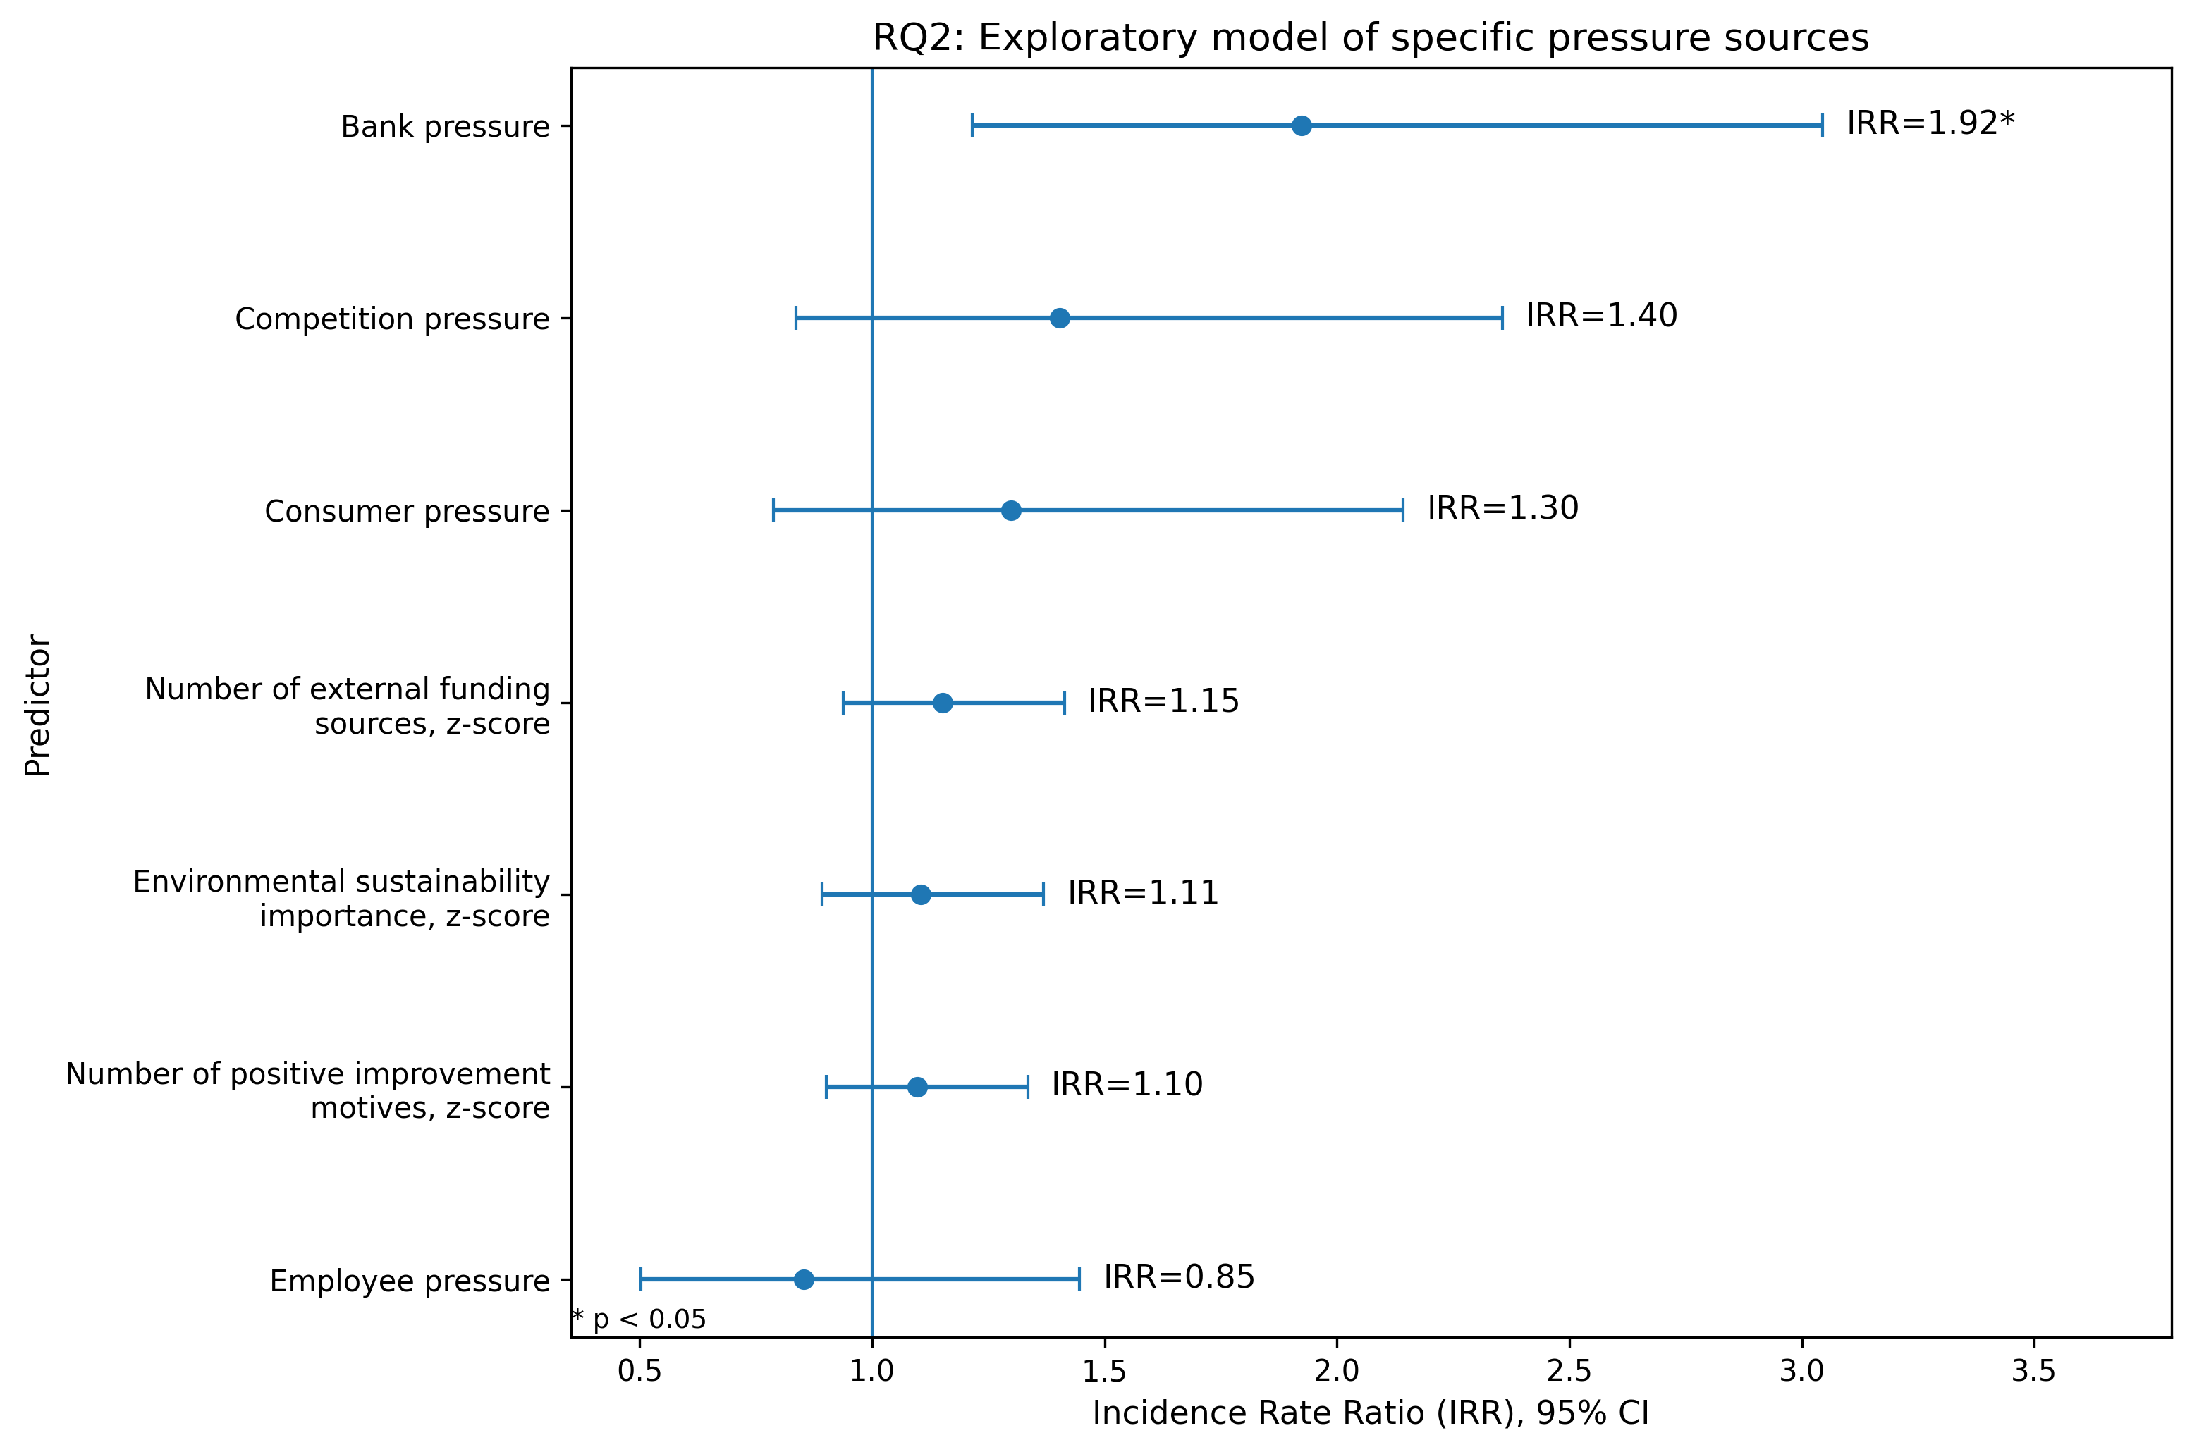
Fig. 7. Exploratory model of pressure sources.
Firms facing bank pressure expected a much higher number of connected SDGs than firms without it ($IRR = 1.924$, $95 \% CI = [1.215, 3.045]$, $p = 0.005$). At the same time, competition, consumer, and employee pressures were not significant when evaluated together. We tested multiple pressures across a sample of 103 firms. Because of this, we treat these results as exploratory evidence. They suggest that bank-related pressure is a key driver of the broader pressure-count association (see the next table, Table 8).
Table 8 Exploratory model
Pressure source | IRR | 95% CI for IRR | $$p$$
Bank pressure | 1.924 | [1.215, 3.045] | 0.005
Competition pressure | 1.404 | [0.837, 2.356] | 0.199
Consumer pressure | 1.300 | [0.788, 2.142] | 0.304
Employee pressure | 0.853 | [0.503, 1.447] | 0.555

Furthermore, we also ran a supplementary logistic sensitivity test (see Fig. 8). For this test, we split the firms into two distinct groups. One group reported at least two connected SDGs. The other group reported fewer than two. This analysis supported our main conclusion about sustainability pressure. When $Pressure_count$ went up by 1 standard deviation, firms had higher odds of reporting at least two SDGs ($OR = 1.943, 95 \% CI = [1.178, 3.202], p = 0.009$). Additionally, external funding count was statistically significant in this test ($OR = 1.686, 95 \% CI = [1.025, 2.774], p = 0.040$). Still, we interpret this funding result as extra evidence rather than a main finding. This is simply because external funding was not significant in the principal count model.
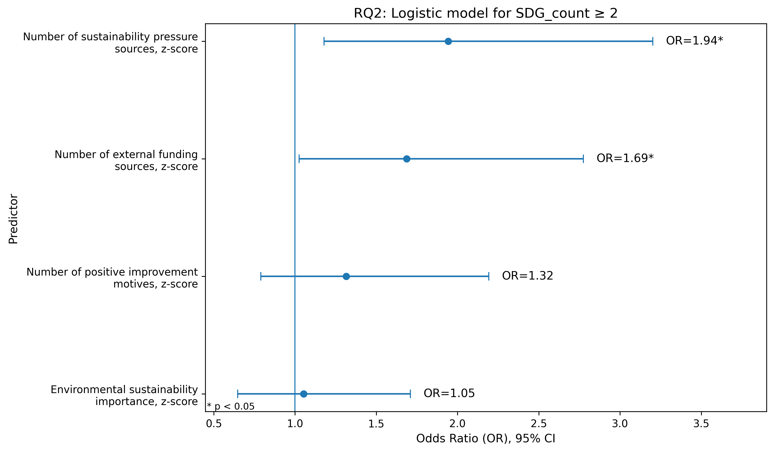
Fig. 8. Logistic sensitivity test.
Overall, RQ2 points to a strong conclusion. Broader direct SDG involvement was most consistently tied to the breadth of sustainability pressures faced by firms. In earlier bivariate analyses, three factors showed a positive link to $SDG_count$. These were external funding use, positive improvement motives, and environmental sustainability importance. However, this changed in the principal multivariate model. There, only the number of reported pressure sources stayed statistically significant. Furthermore, exploratory analysis points to a specific driver. It suggests that bank-related pressure is an especially important piece of this puzzle. Thus, within the analysed sample, broader SDG involvement is primarily linked to exposure to multiple sustainability pressures. It is not linked to any single support need or motivational factor.

Additional correlation analysis between external funding sources and improvement motives
We finished the analyses for the research questions. After that, we kept one additional correlation analysis. This gives supplementary insight into two business-context dimensions from RQ2. These dimensions are the use of external funding sources and the reported motives for implemented improvements. The primary RQ2 analyses checked their associations with $SDG_count$. This supplementary analysis is different. It considers whether these two dimensions were related to each other within the analysed sample. Before starting this supplementary analysis, we revalidated the Question q31 and q34 response blocks. We confirmed they contained no missing values. Furthermore, it showed no logically contradictory combinations between the exclusive negative options and positive responses. We used them to construct the external-funding and improvement-motivator indices used in the subsequent analysis.
Next, we used two previously defined count-based indices in the supplementary analysis.
The first was $External_funding_count$. It represented the number of concrete external funding sources used by each firm during the previous three years. This excluded the negative response indicating no external funding.
The second was $Improvement_motivators_count$. It represented the number of positive motives reported for implemented improvements. This excluded the negative response indicating that no improvements had been made. Both indices were complete and internally consistent with their corresponding binary indicators.
Statistically, $External_funding_count$ had a mean of $1.155$ ($SD=1.235; Md=1; range=0$-$6$). Meanwhile, $Improvement_motivators_count$ had a mean of $1.796$ ($SD=1.801; Md=1; range=0$-$8$). Overall, $63.11\%$ of firms reported at least one external funding source. Similarly, $72.82\%$ of firms reported at least one positive improvement motive. Both variables were discrete count-based indices. They had repeated values. Also, their distributions were concentrated at lower counts. Because of these factors, we used Spearman’s rank correlation coefficient as the primary measure of association. Additionally, we calculated Kendall’s $τ_{b}$. This served as a complementary rank-based measure that accounts for tied observations.
We found a statistically significant positive link between these two things ($ρ_{S}=0.346; p=0.0003; n=103$). The complementary Kendall analysis supported this exact same conclusion ($τ_{b}=0.278; p=0.0006$). This means firms with more concrete external funding sources tended to report more positive motives for implemented improvements. However, the connection shows a moderate positive tendency, not a strong correspondence (see Fig. 9).
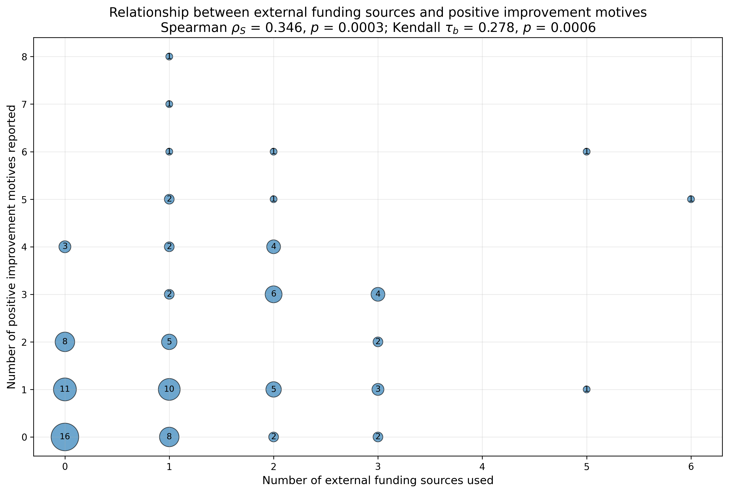
Fig. 9. External funding sources and improvement motives.
We saw the same pattern in a supplementary binary comparison. Firms with at least one external funding source had a higher mean number of positive motives. This is compared to firms reporting no external funding ($M=2.246, Md=2, n=65$ vs. $M=1.026, Md=1, n=38$). The mean difference amounted to exactly $1.220$ additional motives. This difference was statistically supported after correcting for multiple supplementary comparisons ($U=1702.5;δ=0.379; p_{FDR}=0.0014$). Cliff’s delta indicated a medium effect size. Overall, this comparison gives an intuitive, descriptive look at the main count-based correlation.
Additional aggregated comparisons showed more details. The link was particularly visible among firms reporting at least one EU or public funding source (see Fig. 10). These firms reported a higher mean number of positive improvement motives compared to firms without such funding ($M=2.429$ vs. $1.043;Δ M=1.386;δ=0.413; p_{FDR}=0.0009$). On the other hand, firms reporting bank or credit-related support showed a different result. They did not differ significantly from other firms in their number of positive improvement motives ($M=2.063$vs. $1.747;δ=0.128; p_{FDR}=0.408$). Thus, broader external funding use was positively related to improvement motivation overall. Yet, this pattern was not equally evident across all aggregated funding categories.
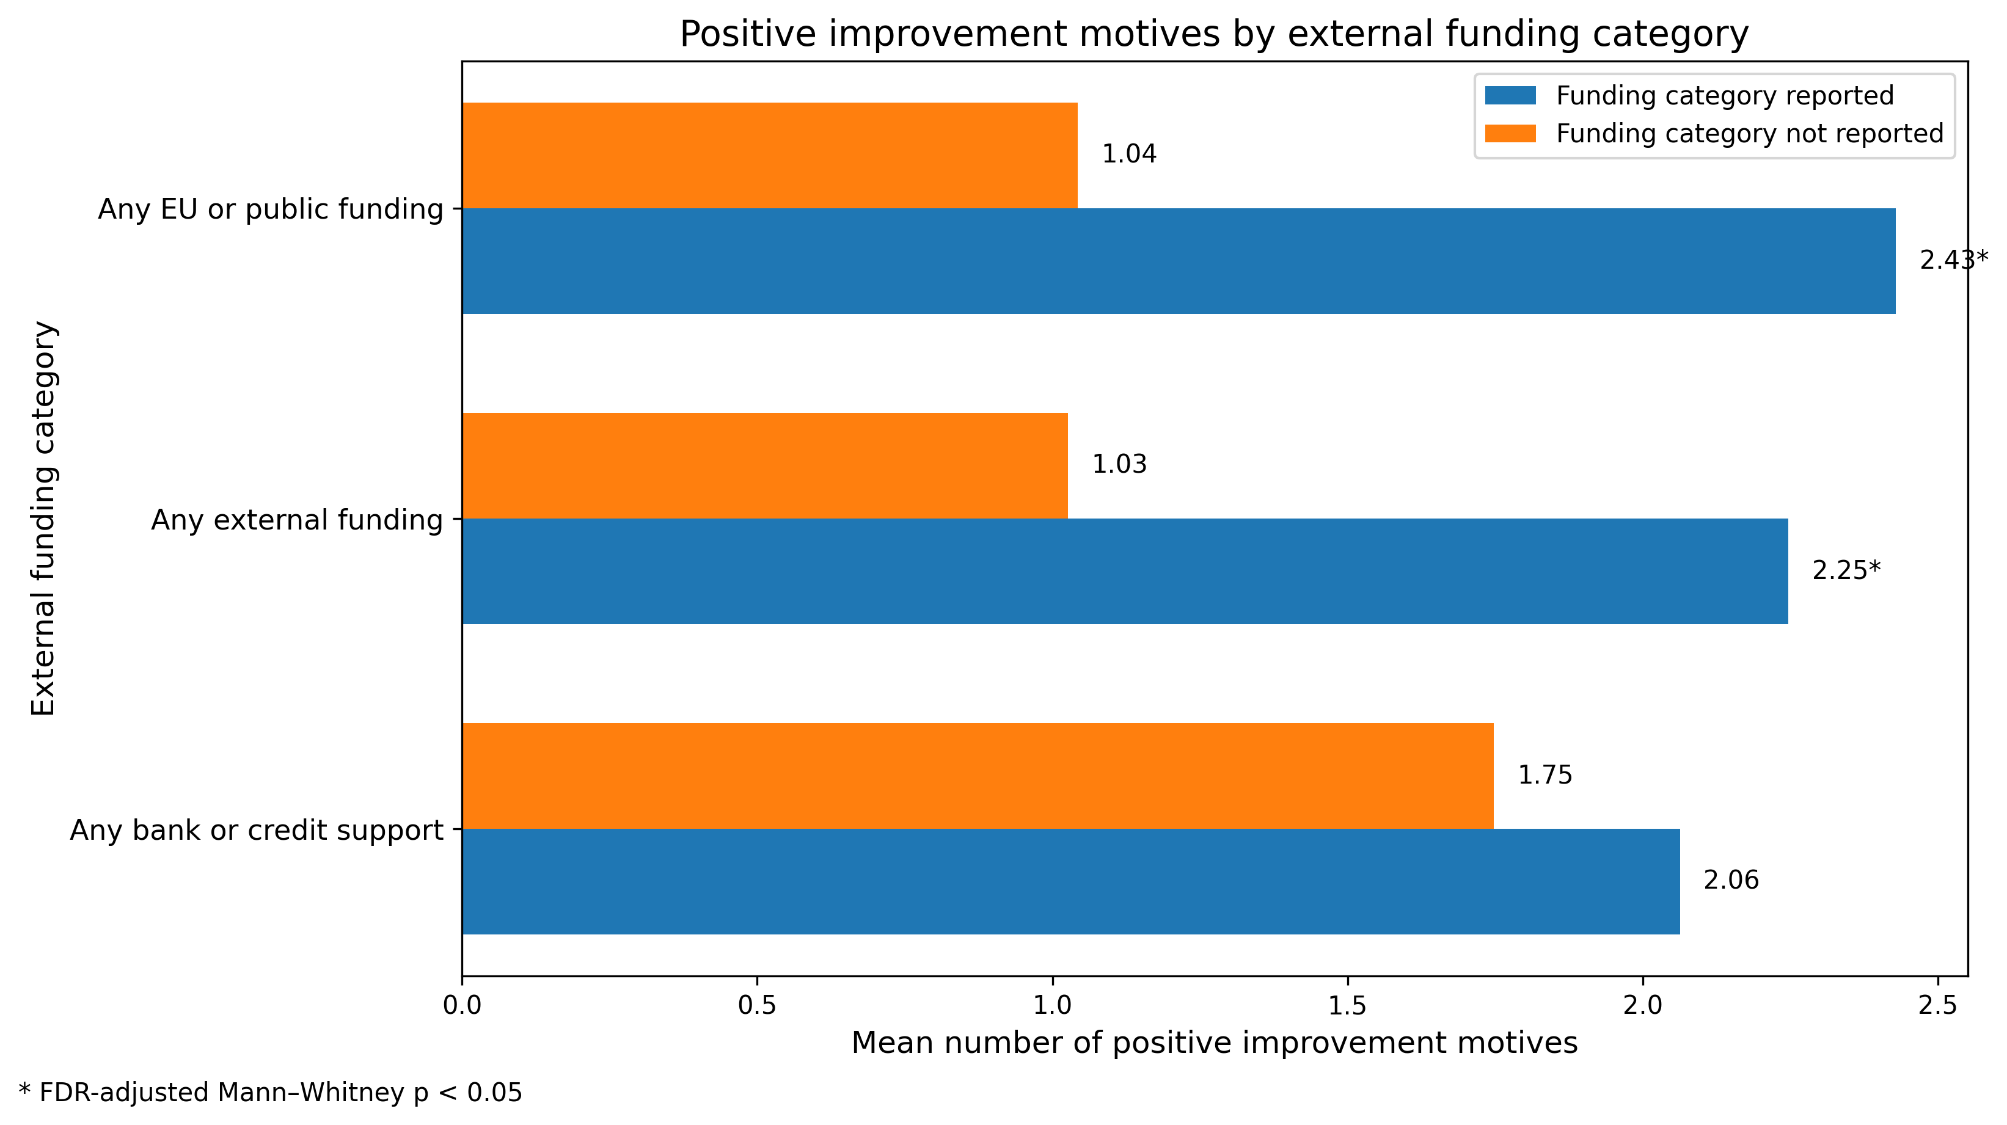
Fig. 10. Improvement motives by funding category.
Finally, an exploratory disaggregated analysis examined individual associations. It compared 12 specific positive external-funding indicators against 11 specific positive improvement motives. The strongest unadjusted relationship involved EU energy-efficiency funds. Firms using these funds were likely to report energy efficiency as an improvement motive ($ϕ=0.418; p=0.0005$). Specifically, $66.67\%$ of firms using these EU funds reported this motive. By comparison, only $11.70\%$ of firms not using that funding source reported it. However, this relationship did not remain statistically significant after FDR correction ($p_{FDR}=0.0705$). More generally, there were 132 individual funding-source–motive combinations tested. None of these remained significant after adjustment for multiple comparisons. As a result, the supplementary findings support an aggregate association. Broader external funding use is linked to broader positive improvement motivation. But they do not identify a statistically confirmed one-to-one relationship between any particular funding source and any particular motive.
Now, to conclude, this supplementary analysis indicates a clear pattern. Firms using more external funding sources tended to report more positive motives for implemented improvements. Also, firms reporting any external funding displayed a higher number of motives than firms without such funding. However, the analysis is strictly correlational. It does not establish direction or causality. It cannot determine whether access to external funding encouraged firms to implement improvements. It also cannot determine whether improvement-oriented firms were more likely to seek or obtain funding. Finally, it cannot tell if both dimensions simply reflected a broader underlying level of organizational activity. Therefore, the result should be interpreted as evidence of a positive association.
Limitations and future directions
The present study provides an empirically grounded analysis of SDG involvement among the surveyed Croatian firms. But several statistical limitations should be considered when interpreting the results. The first limitation concerns the sample size and its composition. The analyses were based on $n=103$ firms. Micro-enterprises represented the dominant part of the sample. This sample size was sufficient for several tests. It allowed for descriptive summaries, rank-based association analyses, non-parametric group comparisons, and a carefully restricted count-regression model. However, it limits the precision of estimates for small subgroups. It also reduces the extent to which the identified patterns can be generalized beyond the analysed sample.
A second limitation involves how we built and interpreted the analytical indicators. We created variables such as $SDG_count$, $Pressure_count$, $External_funding_count$, $Improvement_motivators_count$. These summarize important parts of the questionnaire. They also make the statistical analysis easier to interpret. These indices were useful measures for our study. However, they should not be interpreted as previously validated psychometric scales. Future studies should check the reliability and construct validity of such multi-item measures. They should do this using a larger sample. Where theoretically justified, they should also use exploratory or confirmatory factor-analytic procedures.
Another measurement limitation involves the response validation process. During data preparation, we found isolated inconsistencies in selected multi-response items. Specifically, this happened when an exclusive negative response was combined with a positive response option. There are a few possible reasons for this. Respondents might interpret sustainability-related terminology differently. They might have limited familiarity with the formal SDG framework. Alternatively, the multi-select questionnaire items might just be too complex. Our present data cannot empirically distinguish between these explanations. Because of this, the response inconsistencies should be regarded as a measurement-related limitation. They should not be attributed directly to the respondents’ knowledge. Importantly, we fixed this. The affected variables were validated and logically harmonized before being included in the corresponding statistical analyses.
A third limitation concerns statistical power and multiple testing. The study examined many indicators across RQ1, RQ2, and the additional funding–motivation analysis. We wanted to reduce the risk of false positive findings. To do this, we applied the Benjamini–Hochberg false discovery rate (FDR) correction to the relevant families of statistical tests. This procedure strengthened the credibility of our statistically supported findings. But it also made it harder to confirm weaker associations in a relatively modest sample. For example, some individual associations looked interesting at the unadjusted level. These were links between specific external funding sources and individual improvement motives. Yet, none remained statistically significant after the FDR correction. Because of this, we appropriately retained these pairwise patterns as exploratory indications. We did not interpret them as confirmed relationships.
The multivariate analysis for RQ2 was also intentionally cost-conscious. The primary outcome, $SDG_count$, was a non-negative count variable with variance exceeding its mean, which justified the use of a Negative Binomial model rather than relying solely on a standard Poisson specification. Nevertheless, given the available sample size, only a restricted set of conceptually central aggregated predictors was included in the main model. This reduced the risk of unstable estimation and overfitting, but it also means that potentially relevant interactions and more detailed combinations of organizational, financial and structural characteristics could not be evaluated simultaneously.
More broadly, this study is observational and cross-sectional. Therefore, the statistical relationships represent associations within the sample, not causal effects. For instance, look at the positive relationship between sustainability-related pressure sources and $SDG_count$. This does not prove that external pressures caused firms to engage with a broader set of SDGs. Likewise, consider the positive link between $External_funding_count$ and $Improvement_motivators_count$. This also does not demonstrate whether external funding encouraged improvements. It doesn't show if improvement-oriented firms were simply more likely to get external funding. Instead, both patterns might just reflect a general level of organizational activity. A longitudinal design would be necessary to solve this. It would evaluate changes in SDG involvement over time. It would also examine the exact chronological order among pressures, funding, organizational formalization, and direct SDG involvement.
Despite these limitations, the analytical framework developed in this study provides a strong basis for future statistical research. Previous research on SME sustainability shows a clear pattern. Environmental or green-business practices can be modelled successfully. To do this, researchers use combinations of firm characteristics, financial support, resource-efficiency practices, and organizational factors. For example, (Hoogendoorn, Guerra, and van der Zwan, 2015) analysed data from almost 8,000 SMEs. This massive sample crossed 36 countries and 12 sectors. They found that financial support and firm characteristics were related to different types of environmental practices among SMEs. More recently, (Alfirević, Pavlinović Mršić, and Mlaker Kač, 2025) applied a multinomial logit model. They looked at 2,305 SMEs in the Alps–Adriatic macroregion. Their work showed that greater engagement in resource-efficiency actions was associated with a higher likelihood of offering green products or services. These studies support the statistical logic of the present research. Here, SDG involvement is analysed in relation to business-environment pressures, external resources, organizational formalization, and structural SME characteristics.
Therefore, future research should expand on this design. It should use a much larger and more stratified sample of Croatian SMEs. This new sample must ensure good representation across different firm sizes and sectors. It should also balance ownership structures and different levels of sustainability formalization. With a larger dataset, we could first replicate the current inferential framework. To do this we may use highly interpretable statistical models. In particular, $Y_{i}=SDG_count_{i}$ should remain the primary outcome variable. This is because it preserves clear information about the overall breadth of direct SDG involvement. Our current analysis found overdispersion in this outcome variable. Because of this statistical pattern, a Negative Binomial model is a highly appropriate choice. It should remain the standard benchmark model for future work:
$$Y_{i}∣X_{i}∼NB\left(μ_{i},α\right),$$
with:
$$\log{(μ_{i})}=β_{0}+β_{1}X_{i1}+…+β_{p}X_{ip}.$$
A larger sample would let us test a richer set of predictors and interaction terms. These include interactions between external funding, sustainability pressures, and governance maturity. They also include sustainability measurement practices, sector, and firm size. If the number of potential predictors becomes too large for the data, we could use penalized count-regression procedures. Another future step is building predictive machine-learning models. These would identify firms with broader direct SDG involvement. This direction makes sense methodologically, but we cannot do it with the current sample alone. Our current sample has only $n=103$ firms. It also has many potential predictors and several groups with very few firms. Because of this, flexible machine-learning tools would face a high risk of overfitting. Therefore, treat these findings as a starting point. They help with selecting predictors and designing models. They are not enough to train a reliable predictive system on their own.
Recent literature shows that machine-learning approaches can be highly useful in sustainability research on SMEs. For instance, (Wildnerova et al., 2024) conducted an OECD study. They used machine learning to classify text from company websites. This allowed them to build an indicator of environmental engagement for SMEs. They looked across 15 OECD countries. In total, they applied this indicator to more than one million firm websites. Their work proves that machine learning can pull visible sustainability indicators out of large-scale text data. It can then relate those indicators directly to firm characteristics. Another recent study by (Fabijańska, Wołczek, and Sikacz, 2025) used a different tool. They applied an artificial neural network and feature-selection procedures to ESG ratings data. They showed that ESG scores and rankings could be estimated using a much smaller subset of reported parameters. ESG ratings are not exactly the same as direct SDG involvement. However, this work still supports building simpler, data-driven tools for sustainability assessment. For our current line of research, a great future step would be combining survey data with outside information. For example, we could compare the self-reported $SDG_count$ with actual statements on company websites. We could also check public reports, environmental certificates, or records of sustainability funding. Natural language processing (NLP) methods could find these public sustainability activities. This follows the general logic of the OECD study. Such a design would let us check a key point. We could see if firms reporting more SDG involvement in a survey also communicate more sustainability actions to the public.
Hence, a future predictive framework could follow three stages. First, the current survey-based indicators should be validated. They also need to be replicated in a larger SME sample. Second, clear statistical models should be used. These models will establish strong links between $SDG_count$ and business-environment, organizational, and structural predictors. Third, after an adequate sample and external validation data are ready, then, machine-learning models can be developed. These new models will be compared directly with the statistical baseline. They will be judged on predictive accuracy, calibration, and interpretability. This plan preserves the explanatory value of the current statistical analysis. It also creates a rigorous pathway to predict broader SDG involvement among SMEs.
Overall, this study should be viewed as a starting point, since in Croatia we do not have conducted strong research on this topic yet. It provides an inferential and exploratory foundation for future predictive research. Its main statistical contribution is identifying meaningful relationships within the analysed sample. Specifically, it maps links between direct SDG involvement and motivational, financial, organizational, and SME-profile dimensions.
The future potential of this work is significant. It can turn these empirically supported dimensions into a validated predictive framework. This framework will be capable of identifying firms that are more likely to engage broadly with the SDGs. However, building this tool requires a larger and more diverse sample. It also needs longitudinal or externally validated data. Finally, it requires a careful comparison between clear statistical models and properly validated machine-learning methods.
References
Hoogendoorn, B., Guerra, D., & van der Zwan, P. (2015). What drives environmental practices of SMEs? Small Business Economics, 44(4), 759–781. doi:10.1007/s11187-014-9618-9.
Alfirević, N., Pavlinović Mršić, S., & Mlaker Kač, S. (2025). Multinomial logistic analysis of SMEs offering green products and services in the Alps–Adriatic macroregion. Sustainability, 17(10), 4721. doi:10.3390/su17104721.
Wildnerova, L., Menon, C., Dehghan, R., Kinne, J., & Lenz, D. (2024). Which SMEs are greening? Cross-country evidence from one million websites. OECD SME and Entrepreneurship Papers, No. 60. OECD Publishing. doi:10.1787/ddd00999-en.
Fabijańska, A., Wołczek, P., & Sikacz, H. (2025). Can machine learning bring ESG ratings closer to small and medium-sized enterprises? Oeconomia Copernicana, 16(4), 1615–1663. doi:10.24136/oc.3162.

