**Title:** Using tree-ring records to simultaneously characterize the influence of tree size and climate drivers on annual growth

**Authors:**

Kristina J. Anderson-Teixeira1,2*, Valentine Herrmann1

**Author Affiliations:**

1. Conservation Ecology Center; Smithsonian Conservation Biology Institute; Front Royal, VA 22630, USA
2. Center for Tropical Forest Science-Forest Global Earth Observatory; Smithsonian Tropical Research Institute; Panama, Republic of Panama*corresponding author: [teixeirak@si.edu](mailto:teixeirak@si.edu); +1 540 635 6546

**Running headline:** [45 chars]

# Abstract

* Tree rings
* Here, we

# Introduction

Spanning

# Materials and Methods

## Data sources and preparation

We analyzed

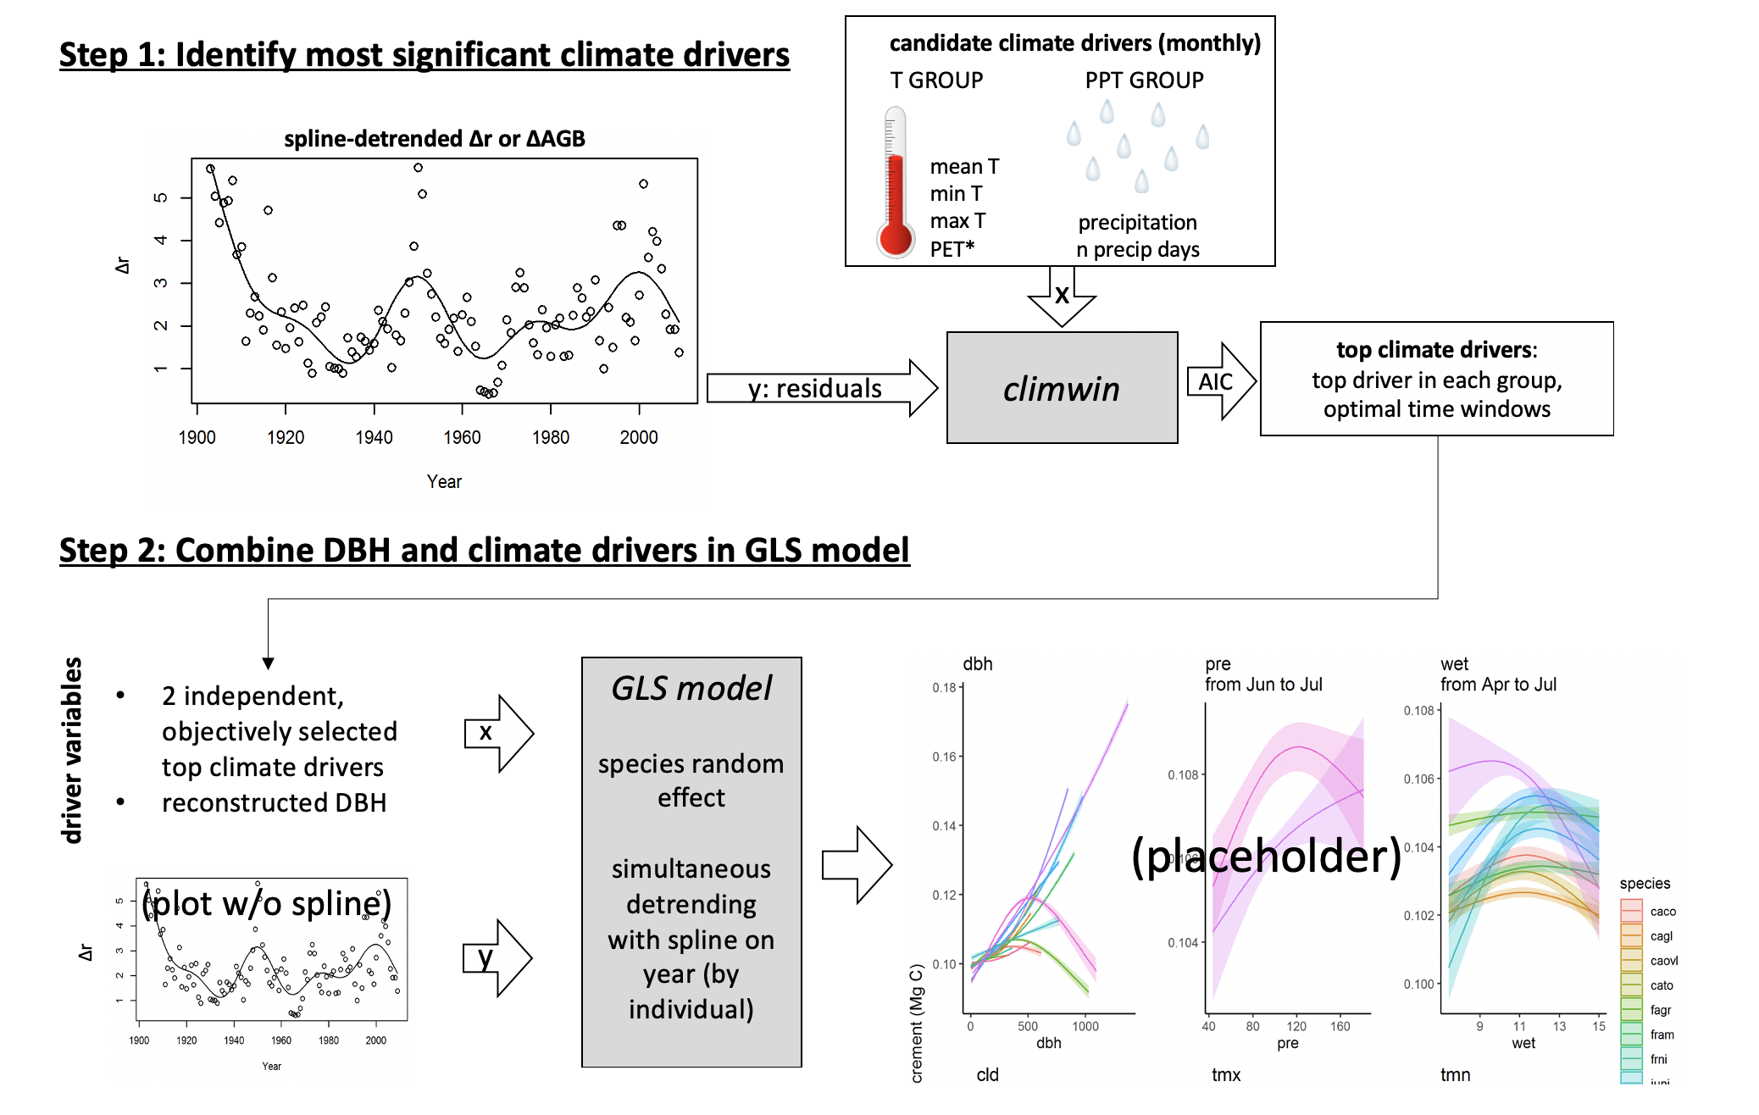

**Figure 1 | DRAFT Schematic illustrating our analysis process.** This analysis is conducted separately for each site.

### Identifying key climate drivers

**We**